Recommendation ITU-R SA.2141-0
(12/2021)
Characteristics of space research
service systems in the frequency
range 14.8-15.35 GHz

SA Series
Space applications and meteorology

Foreword
The role of the Radiocommunication Sector is to ensure the rational, equitable, efficient and economical use of the radio-frequency spectrum by all radiocommunication services, including satellite services, and carry out studies without limit of frequency range on the basis of which Recommendations are adopted.
The regulatory and policy functions of the Radiocommunication Sector are performed by World and Regional Radiocommunication Conferences and Radiocommunication Assemblies supported by Study Groups.

Policy on Intellectual Property Right (IPR)
ITU-R policy on IPR is described in the Common Patent Policy for ITU-T/ITU-R/ISO/IEC referenced in Resolution ITU-R 1. Forms to be used for the submission of patent statements and licensing declarations by patent holders are available from http://www.itu.int/ITU-R/go/patents/en where the Guidelines for Implementation of the Common Patent Policy for ITU-T/ITU-R/ISO/IEC and the ITU-R patent information database can also be found.

Series of ITU-R Recommendations
(Also available online at http://www.itu.int/publ/R-REC/en)
Series | Title
BO | Satellite delivery
BR | Recording for production, archival and play-out; film for television
BS | Broadcasting service (sound)
BT | Broadcasting service (television)
F | Fixed service
M | Mobile, radiodetermination, amateur and related satellite services
P | Radiowave propagation
RA | Radio astronomy
RS | Remote sensing systems
S | Fixed-satellite service
SA | Space applications and meteorology
SF | Frequency sharing and coordination between fixed-satellite and fixed service systems
SM | Spectrum management
SNG | Satellite news gathering
TF | Time signals and frequency standards emissions
V | Vocabulary and related subjects

Note: This ITU-R Recommendation was approved in English under the procedure detailed in Resolution ITU-R 1.

Electronic Publication
Geneva, 2021

© ITU 2021
All rights reserved. No part of this publication may be reproduced, by any means whatsoever, without written permission of ITU.

RECOMMENDATION ITU-R SA.2141-0
Characteristics of space research service systems
in the frequency range 14.8-15.35 GHz
(2021)
Scope
This Recommendation provides technical and operational system characteristics for the space research service in the 14.8-15.35 GHz band. These characteristics should be considered in sharing and compatibility studies.
Keywords
System characteristics, Space Research Service (SRS), space-to-Earth, Earth-to-space, space-to-space, forward feeder link, Data Relay Satellites (DRS)
Related ITU-R Recommendations and Reports
Recommendation ITU-R SA.364-6 – Preferred frequencies and bandwidths for manned and unmanned near-Earth satellites of the space research service
Recommendation ITU-R SA.510-3 – Feasibility of frequency sharing between the space research service and other services in bands near 14 and 15 GHz Potential interference from data relay satellite systems
Recommendation ITU-R SA.609-2 – Protection criteria for radiocommunication links for manned and unmanned near-Earth research satellites
Recommendation ITU-R SA.1018-1 – Hypothetical reference system for systems comprising data relay satellites in the geostationary orbit and user spacecraft in low Earth-orbits
Recommendation ITU-R SA.1019-1 – Frequency bands and transmission directions for data relay satellite networks/systems
Recommendation ITU-R SA.1155-2 – Protection criteria related to the operation of data relay satellite systems
Recommendation ITU-R SA.1414-2 – Characteristics of data relay satellite systems
Recommendation ITU-R SA.1626-1 – Feasibility of sharing between the space research service (space-to-Earth) and the fixed and mobile services in the band 14.8-15.35 GHz.
The ITU Radiocommunication Assembly,
considering
a) that the frequency band 14.8-15.35 GHz is allocated on a primary basis to the fixed and mobile services, and on a secondary basis to the SRS without qualification as to the direction of transmission;
b) that the SRS (passive) and Earth exploration-satellite service (EESS) (passive) are allocated on a secondary basis by No. 5.339 of the Radio Regulations (RR) in the 15.20-15.35 GHz band;
c) that the SRS (passive), EESS (passive), and radio astronomy services are allocated on a primary basis in the 15.35-15.4 GHz band subject to No. 5.340 and No. 5.511 of the RR;
d) that data relay satellite systems operated by multiple administrations make use of the 14.8-15.35 GHz band both for inter-orbit user links (space-to-space) and feeder uplinks (Earth-to-space);
e) that requirements exist for wideband SRS downlinks to transmit future high data rate scientific data;
f) that WRC-23 agenda item 1.13 proposes to consider the upgrade of the SRS allocation in this band from secondary to primary status,
recognizing
a) that the frequency band 14.8-15.35 GHz is currently used by data relay satellites for inter-satellite links, which permits the establishment of communications with satellites in non-geostationary orbits (non-GSO), including crewed flights in the SRS;
b) that the frequency band 14.8-15.35 GHz is also used for existing high-speed data links from non-GSO satellites within the SRS, and is planned for use in future systems;
c) that these satellites are needed for the operation of telescopes and other passive instruments used for measuring such phenomena as the Earth’s magnetosphere and solar flares,
recommends
that the technical and operational system characteristics for the space research service in the 14.8-15.35 GHz band detailed in Annex 1 should be considered in sharing and compatibility studies.

Annex 1
Technical and operational system characteristics
for the space research service in the 14.8-15.35 GHz band

1 Introduction
Space Research Service (SRS) systems use the 14.8-15.35 GHz band for the following applications:
– direct data downlinks from SRS missions (using a variety of orbit types) to earth stations located globally,
– Earth-to-space feeder uplinks from Data Relay Satellite (DRS) system earth stations to GSO data relay system satellites,
– space-to-space inter-orbit links from the user spacecraft to the GSO DRS satellites.
The characteristics of each of these are discussed below.

2 Characteristics of SRS direct data downlinks in the 14.8-15.35 GHz band
It is expected that SRS missions employing direct data downlinks in this band will be limited in number, with an estimated three to five satellites per year worldwide. These will generally be deployed in low-Earth orbit, with either polar or equatorial inclination with some at geostationary altitudes and others at HEO orbits or at the L1 or L2 libration points, as well as in Lunar Orbits or at the Lunar Surface. For most of these SRS mission orbit types, the characteristics of the SRS satellites transmitting direct data downlinks are reflected in the link budgets given in Table 1. For the SRS S/C in Lunar orbits or at the Lunar Surface, link budget parameters will vary depending on operational needs and available advanced modulation and coding techniques; however, the PFD on the Earth’s surface would not exceed levels specified in Recommendation ITU-R SA.1626.
In most cases, the links were assumed to support a data rate of 400 Mbit/s on the space-to-Earth link, although some links support up to 1.2 Gbit/s. The e.i.r.p. spectral density was adjusted so that the pfd limits of Recommendation ITU-R SA.1626 would be satisfied at all elevation angles. The radiation pattern of the receiving antenna of the SRS earth station was assumed to conform to Recommendation ITU-R SA.509. Sharing feasibility was assessed on the basis of the protection criteria given in Recommendation ITU-R SA.609.

TABLE 1
Example high-rate direct data downlink SRS mission link budgets
Case | NGSO 800 km alt @ 5 deg  ES ant elev | NGSO 800 km alt @ 10 deg ES ant elev | NGSO 800 km alt @ 90 deg ES ant elev | GSO  @ 10 deg elev | HEO | HEO | L1/L2 | L1/L2
Frequency (GHz) | 15.0 | 15.0 | 15.0 | 15.0 | 15.0 | 15.0 | 15.0 | 15, 15.2
Wavelength (m) | 0.020 | 0.020 | 0.020 | 0.020 | 0.020 |  | 0.020
Polarization | RHCP or LHCP
Satellite apogee (km) | 800 | 800 | 800 | 35 785 | 300 000 | 300 000 | 1 500 000 | 1 500 000
Satellite perigee (km) | 800 | 800 | 800 | 35 785 | 500 | 500 | 1 500 000 | 1 500 000
Data rate (Mbit/s) | 400 | 400 | 400 | 400 | 400 | 320 | 100 | 600 per channel
Modulation method | QPSK Uncoded |  |  |  |  |  | QPSK Uncoded | 8PSK
S/C transmit power (dBW) | 5 | 5 | 5 | 13 | 13 | 11.8 | 13 | 23
S/C transmit filter, cable loss (dBW) | −0.5 | −0.5 | −0.5 | −0.5 | −0.5 | −0.5 | −0.5 | −0.5
S/C transmit antenna diameter (m) | 0.38 | 0.38 | 0.38 | 0.86 | 1.5 | 1.5 | 1.5 | 2.3
S/C transmit antenna efficiency | 0.55 | 0.55 | 0.55 | 0.55 | 0.6 | 0.6 | 0.6 | 0.6
S/C transmit antenna gain (dBi) | 32.9 | 32.9 | 32.9 | 40.0 | 45.2 | 45 | 45.2 | 49
S/C transmit EIRP (dBW) | 37.4 | 37.4 | 37.4 | 52.5 | 57.7 | 55.8 | 57.7 | 71.5
S/C peak EIRP density (dBW/MHz) | 14.4 | 14.4 | 14.4 | 29.5 | 34.7 | 35.8 | 40.7 | 48.5
Path length (km) | 2 784 | 2 367 | 800 | 40 585 | 20 000 | 20 000 | 1 505 257 | 1 505 257
Free space path loss (dB) | 184.9 | 183.5 | 174.0 | 208.1 | 225.5 | 225.5 | 239.5 | 239.5
10*log(4*pi*d^2) | 139.9 | 138.5 | 129.1 | 163.2 | 157.0 | 157.0 | 194.5 | 194.5
ES receive elevation angle (degree) | 5.0 | 10.0 | 90.0 | 10.0 | 10.0 | 10.0 | 10.0 | 10.0
PFD limit (dBW/m² MHz) | −124 | −121.5 | −114 | −123.5 | −121.5 | −121.5 | −121.5 | −121.5

TABLE 1 (end)
Case | NGSO 800 km alt @ 5 deg ES ant elev | NGSO 800 km alt @ 10 deg ES ant elev | NGSO 800 km alt @ 90 deg ES ant elev | GSO @ 10 deg elev | HEO | HEO | L1/L2 | L1/L2
PFD on Earth's surface (dBW/m² MHz) | −125.5 | −124.1 | −114.7 | −133.7 | −122.3 | −161.7 | −153.8 | −147.3
ES receive antenna diameter | 1.35 | 1.35 | 1.35 | 4.25 | 17.0 | 12.0 | 34.0 | 32.0
ES receive antenna efficiency | 0.7 | 0.7 | 0.7 | 0.7 | 0.7 | 0.7 | 0.7 | 0.7
ES receive antenna gain (dBi) | 45.0 | 45.0 | 45.0 | 54.9 | 67.0 | 64.0 | 73.0 | 72.5
Beam-edge allowance, rain and atmospheric loss (dB) | −3.0 | −3.0 | −3.0 | −3.0 | −4.0 | −4.0 | −4.0 | −4.0
ES receiver system noise temperature (deg K) | 150.0 | 150.0 | 150.0 | 150.0 | 150.0 | 150 | 150.0 | 150
No (dBW/Hz) | −206.8 | −206.8 | −206.8 | −206.8 | −206.8 | −206.8 | −206.8 | −206.8
Receiver losses (dB) | −1.0 | −1.0 | −1.0 | −1.0 | −1.0 | −1.0 | −1.0 | −1.0
Received Eb/No (dB) | 13.9 | 15.3 | 24.7 | 15.6 | 14.5 | 17.7 | 12.5 | 18.5
Theoretical Eb/No (1E-6 BER) (dB) | 10.5 | 10.5 | 10.5 | 10.5 | 10.5 | 10.5 | 10.5 | 15
Required Eb/No (1E-6 BER) (dB) | 11.5 | 11.5 | 11.5 | 11.5 | 11.5 | 11.5 | 11.5 | 16
Eb/No margin (dB) | 2.4 | 3.8 | 13.2 | 4.1 | 3.0 | 6.2 | 1.0 | 2.5
Note: For the SRS S/C in HEO orbit, the PFD margin is calculated at an assumed minimum transmit altitude of 20,000 km and the link margin is calculated at a maximum range of 300 000 km.

3 Data Relay Satellite Systems
As shown in Fig. 1 below, the DRS network consists of several GSO-satellites used to relay signals between centrally located earth stations and low-Earth orbiting user satellites. In some existing DRS networks, the 14.8-15.35 GHz band segment is used both for the ‘forward feeder link’ (from the DRS earth station to the DRS GSO satellite) which is shown as Link D in Fig. 1, and the DRS ‘return inter-orbit link’ (from the user satellite to the DRS GSO satellite) which is shown as link F in Fig. 1.
FIGURE 1
Architecture of a DRS network (Recommendation ITU-R SA.1626)
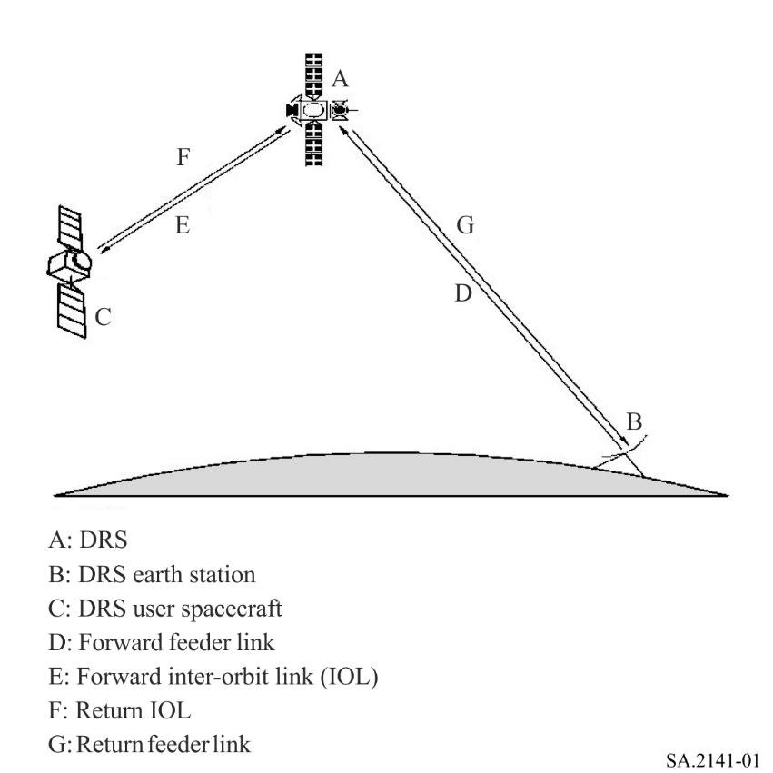

3.1 Characteristics of SRS data relay satellite forward feeder links
Characteristics of DRS forward feeder links (see link D in Fig. 1) operating in the 14.8-15.35 GHz band are given in Table 2 below.
TABLE 2
Earth-to-DRS Ku-band forward feeder link characteristics
Transmitting earth station
Network | Russian Federation | United States of America
Location | Russian Federation⁽¹⁾ | United States of America⁽¹⁾
Frequency range (GHz) | 14.5-15.34  selectable | 14.6-15.25  selectable
Link description | Forward feeder-links ⁽³⁾ | Composite⁽²⁾
Transmission rate | ≤ 105 Mbit/s | ≤ 25 Mbit/s
Modulation | QPSK/SSM⁽⁴⁾, QPSK | PSK
Polarization | Left-hand circular | Linear
Antenna size (m) | 13.1, 3.7, 3.0, 0.9 | 18.3
Tx antenna gain (dBi) | 63.3, 50.8, 49.8, 40.5 | 66.4
Tx antenna radiation pattern | Rec. ITU-R S.580 | RR Appendix 8, Annex III
Necessary bandwidth (MHz) | ≤ 80 per channel | 650 (composite)
Maximum power spectral density (dB(W/Hz)) | −47 | –58
Maximum e.i.r.p. spectral density (dB(W/Hz)) | 10.5 | 8.8
Receiving DRS
Orbital locations | Rec. ITU-R SA.1275 or Rec. ITU-R SA.1276 and 31° E (for Europe)
Antenna size (m) | 0.6 | 1.8
Rx antenna gain (dBi) | 36 | 47.0
Rx antenna radiation pattern | Rec. ITU-R S.672 | Rec. ITU-R S.672
System noise temperature (K) | 550 | 977
Link availability (%) | 99.9 | 99.9
Interference criterion | Rec. ITU-R SA.1155
Notes to Table 2:
⁽¹⁾ The earth stations for the Russian Federation network are located within the territory of the Russian Federation. The earth stations for the United States of America network are located in White Sands (New Mexico), Blossom Point (Maryland) and Guam. The coordinates of the stations are: 32.5° N, 106.60° W for White Sands; 38.43° N, 77.08° W for Blossom Point; and 13.62° N, 144.86° E for Guam.
⁽²⁾ The composite link for the United States of America network is composed of a Ku-band (14/11 GHz) single access link.
⁽³⁾ The Russian Federation DRS employs several independent forward feeder-link channels in Ku-Band, Ku-band single access (Ku-SA) links and differential correction and monitoring system links that are augmented for the GLONASS system (GLONASS/SDCM).
⁽⁴⁾ SSM: Spread-spectrum modulation.

3.2 Characteristics of SRS Data Relay Satellite System Inter-Orbit Return Links
Characteristics of DRS inter-orbit return links (see Link F in Fig. 1) operating in the 14.8-15.35 GHz band are given in Table 3 below.
TABLE 3
Return spacecraft-to-DRS link characteristics
Transmitting spacecraft
Network | Russian Federation | United States of America
Orbital locations | Mainly low-Earth orbit
Frequency range (GHz) | 14.76-15.34 | 14.891-15.116
Link description | Single access (Ku-SA) links
Transmission rate | ≤ 105 Mbit/s | ≤ 300 Mbit/s
Modulation | 8PSK, QPSK | PSK
Polarization | RHC | Circular
Antenna size (m) | ≤ 1.2 | ≤ 1.5
Tx antenna gain (dBi) | ≤ 42.2 | ≤ 43
Tx antenna radiation pattern | Rec. ITU-R S.672
Necessary bandwidth (MHz) | ≤ 80 per channel | ≤ 225
Maximum power spectral density (dB(W/Hz)) | −71.5 | −73.5
Maximum e.i.r.p. spectral density (dB(W/Hz)) | −29.3 | −30.5
Receiving DRS
Network | Russian Federation | United States of America
Orbital locations | Rec. ITU-R SA.1275 or Rec. ITU-R SA.1276
Frequency range (GHz) | 14.76-15.34 | 14.891-15.116
Antenna size (m) | 4 | 4.9
Rx antenna gain (dBi) | 52.6 | 52.6
Rx antenna radiation pattern | Rec. ITU-R S.672
System noise temperature (K) | 550 | 661
Link reliability (%) | 99.9 | 99.9
Interference criterion | Rec. ITU-R SA.1155

