RECOMMENDATION ITU-R SA.1811
Reference antenna patterns of large-aperture space research service earth
stations to be used for compatibility analyses involving a large number
of distributed interference entries in the bands 31.8-32.3 GHz
and 37.0-38.0 GHz

(2007)

Scope
This Recommendation provides two reference antenna patterns, Ja and Jp, for large-aperture earth stations of the space research service (SRS) in the bands 31.8-32.3 GHz and 37.0-38.0 GHz. Ja is to be used for compatibility analyses involving a large number of distributed interference sources. Jp is to be used for compatibility analysis involving a few discrete interference sources.
The ITU Radiocommunication Assembly,
considering
a) that in the analysis of compatibility or sharing between high density fixed service (HDFS) and the space research service (SRS), deep space, it is necessary to determine the levels of interference which may occur at SRS earth stations due to a large number of interference sources distributed in various azimuth directions;
b) that, to determine these levels of interference, a reference antenna pattern needs to be defined;
c) that side-lobe radiation patterns of large aperture SRS earth station antennas, although believed to have similar general shapes, differ in specific gain values, their angular distribution and the locations of the peaks and troughs from antenna to antenna;
d) that if it is desired to represent the radiation patterns of a class of antennas by a single model, the mean and tolerance values are needed for every angle to describe the performance with accuracy and confidence;
e) that an envelope model, such as the model given in Recommendation ITU-R SA.509, provides an upper bound to the side-lobe gain levels at most off-axis angles for the majority of large-aperture antennas (D > 100λ) used in the service;
f) that such an envelope model is especially required where multiple SRS earth station antennas are collocated and every antenna needs to be protected against harmful interference;
g) that, on the other hand, if the peak envelope gain pattern is used in the assessment of the aggregate interference consisting of many interference sources, the predicted interference will result in values that are greater than values that would be experienced in practice;
h) that statistical simulation (also known as Monte Carlo simulation) is often used in compatibility or sharing studies involving many distributed interfering sources;
j) that, given the uncertainty and variation of radiation patterns, an estimate of both mean and tolerance values are desired to obtain accurate and unbiased results in a statistical analysis;
k) that mathematical models of antenna gain patterns of the large-aperture SRS earth stations should closely approximate the physical performance of this class of antennas and be as consistent with the physical principles as possible;
l) that, incorporating physical factors affecting the antenna pattern, Report ITU-R SA.2098 has presented a near-minimum envelope model of large-aperture SRS antennas, Jp, for use in deterministic compatibility analysis and an average gain model, Ja, with tolerance for use in statistical analysis;
m) that among models compared in Report ITU-R SA.2098 only Jp and Ja explicitly account for surface tolerance and include aperture efficiency in a way affecting both peak and side-lobe gains;
n) that, as shown in the Report, models Jp and Ja provide closer approximation to the physical performance of SRS large-aperture antennas and better average gain ratios than the other models compared,
recommends
1 that, in the absence of specific data on the radiation pattern of the SRS earth station affected, the following mathematical gain models should be used in compatibility or sharing analysis involving HDFS systems in the 31.8-32.3 GHz and the 37-38 GHz bands:
1.1 That for compatibility analysis where a single deterministic antenna pattern is to be applied use the envelope model Jp (peak) given below (dBi):

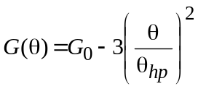 for θ ≤ θ ≤ θ₁
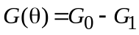 for θ₁ < θ ≤ θ₂
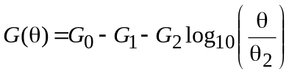 for θ₂ < θ ≤ θ₃
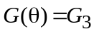 for θ₃ < θ ≤ 80º
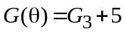 for 80º < θ ≤ 120º
for 120º < θ ≤ 180º

in which θ is the polar angle of the antenna; and

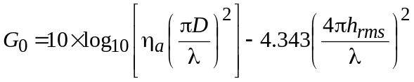

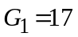

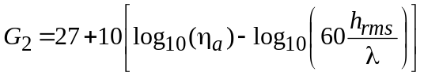

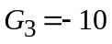
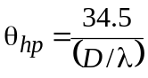

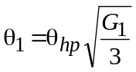

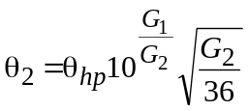

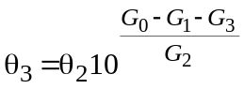

The η_{a} value refers to the pattern-related (aperture illumination, spillover, blockage, etc.) antenna efficiency excluding that associated with surface tolerance. The gain loss due to the surface tolerance is separately included as a function of h_{rms}, the root-mean-squared surface tolerance.
The valid range of surface tolerance for use in the above formulas is:

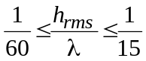

Any value of h_{rms}/λ above 1/15 must be replaced by 1/15; any value below 1/60 must be replaced by 1/60.
In rare cases, for large surface errors, θ₃ might exceed 80º, and an overlap of the sloped side-lobe region with the flat bump at 80-120º region occurs. In such cases, the maximum value of the two at each angle must be selected.
The actual surface tolerance value should be provided by the agency operating the antenna. In the absence of actual numbers a value of h_{rms} = 0.35 mm should be used for the 34 m antennas used in deep space research.
1.2 That for a statistical compatibility analysis involving a large number of distributed interfering sources use the average gain model Ja (average) for mean values and the statistical tolerance described below:
1.2.1 Mean values of gain distribution at every angle (dBi):

for θ ≤ θ ≤ θ₁
for θ₁ < θ ≤ θ₂
for θ₂ < θ ≤ θ₃
for θ₃ < θ ≤ 80º
for 80º < θ ≤ 120º
for 120º < θ ≤ 180º
in which:

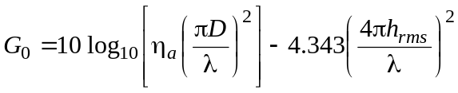

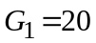

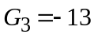

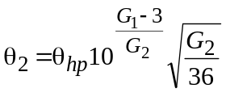

The notes under the Jp model, concerning the valid range of surface tolerance and the resolution of occasional overlap in the 80-120º region, apply equally to the Ja model.
1.2.2 Tolerance of gain distribution at every angle
Assume normal distribution with 3-σ tolerance equal to 3 dB for angles θ₁ to 180º.
Figure 1 depicts these and other models for a 34 m SRS antenna operating at 32 GHz.
Figure 1
Antenna gain models for a 34 m antenna operating at 32 GHz


