RECOMMENDATION ITU-R S.731-1
Reference earth-station cross-polarized radiation pattern
for use in frequency coordination and interference assessment
in the frequency range from 2 to about 30 GHz

(1992-2005)

The ITU Radiocommunication Assembly,
considering
a) that, for coordination studies and for the assessment of mutual interference between radiocommunication-satellite systems and between earth stations of such systems and stations of other services sharing the same frequency band, it may be useful to use a cross-polarized radiation pattern for the earth-station antenna;
b) that, for the determination of coordination distance and for the assessment of interference between earth and terrestrial stations, a cross-polarized radiation pattern based on the level exceeded by a small percentage of the side-lobe peaks may be appropriate;
c) that, a reference earth-station co-polarized radiation pattern for use in frequency coordination and interference assessment is contained in Recommendation ITU-R S.465;
d) that some measurements have been made of the cross-polarized off-axis gain performance of earth stations and radiation patterns have been developed which are quantitively similar;
e) that a single cross-polarized off-axis reference pattern can be used which includes those contained in Annex 1;
f) that the use of antennas with the best achievable radiation patterns will lead to the most efficient use of the radio-frequency spectrum and the geostationary-satellite orbit,
recognizing
1 that further measured information on cross-polarization performance is desirable;
2 that the measured off-axis gain performance of earth-station antennas contains the cross-polarization emission from the source antenna;
3 that the cross-polarized radiation patterns are measured in the main beam of the source antenna,
recommends
1 that, in the absence of particular information concerning the cross-polarized radiation pattern of the antenna for the earth station involved, a single reference radiation pattern may be used for:
1.1 frequency coordination studies and interference assessment between earth stations in the fixed-satellite services and stations of other services sharing the same frequency band;
1.2 coordination studies and interference assessment between networks in the fixed-satellite service;
2 that the following cross-polarized radiation pattern may be used on an interim basis for angles between the directions considered and the axis of the main beam, for frequencies in the range 2-30 GHz:
G_{x}(ϕ) = 23 – 20 log ϕ dBi for ϕ_{r} ≤ ϕ ≤ 7°
G_{x}(ϕ) = 20.2 – 16.7 log ϕ dBi for 7° < ϕ ≤ 26.3°
G_{x}(ϕ) = 32 – 25 log ϕ dBi for 26.3° < ϕ ≤ 48°
G_{x}(ϕ) = –10 dBi for 48° < ϕ ≤ 180°
ϕ_{r} is equal to 1° or 100 λ/D, whichever is greater;
3 that the following Notes should be regarded as a part of this Recommendation.
NOTE 1 – The reference cross-polarized radiation pattern should be assumed to be rotationally symmetrical.
NOTE 2 – The reference cross-polarized pattern should be used for cases involving opposite polarizations.
NOTE 3 – Other cross-polarized radiation patterns of earth stations may be used by mutual agreement between the administrations concerned.
NOTE 4 – The reference radiation pattern should be used with caution over the range of angles for which the particular feed system may give rise to relatively high levels of spill-over and for antennas with D/λ less than 50.
NOTE 5 – This cross-polarized radiation pattern complements the co-polarized pattern of Recommendation ITU-R S.465.
NOTE 6 – Annex 1 contains several cross-polarized off-axis radiation patterns corresponding to the envelopes of the peaks of the measured gain characteristics of various antennas, in support of recommends 2.

Annex 1
Modelling of earth-station antenna cross-polar characteristics
This Annex presents background information used to develop cross-polarized patterns obtained for theoretical and measured patterns. Pattern measurements were obtained for different antenna diameters (1.2 m, 1.8 m, 2.4 m, 3.5 m at 12.625 GHz, and 3.7 m at 10.7 GHz). For each antenna diameter, the relative measured and envelope patterns are described. Equations are then derived which describe the relative cross-polarized envelopes for antennas with D/λ ≥ 100 and D/λ < 100. A single function is developed which can be used to describe the off-axis cross-polarized pattern for all antennas.
Calculated co-polarized and cross-polarized patterns for single offset feed antennas are shown in Figs. 1 and 2 along with the respective envelope functions. The effects of feed supports for axisymmetric arrangements are shown in Fig. 3.
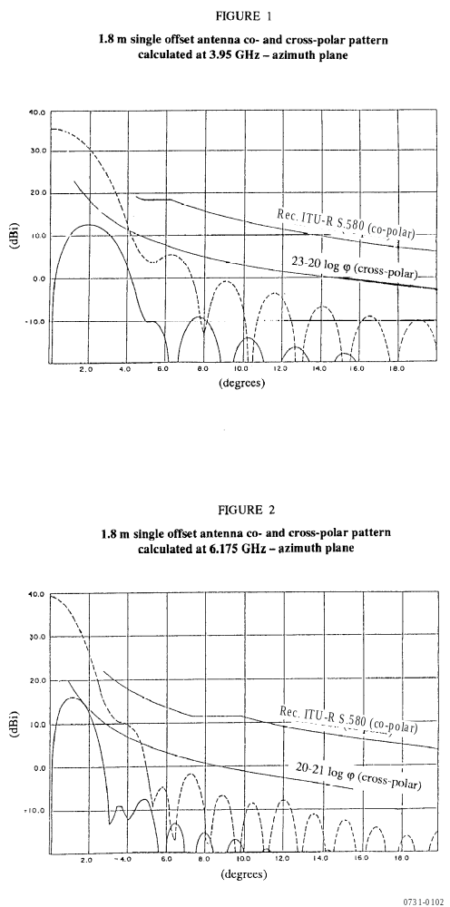
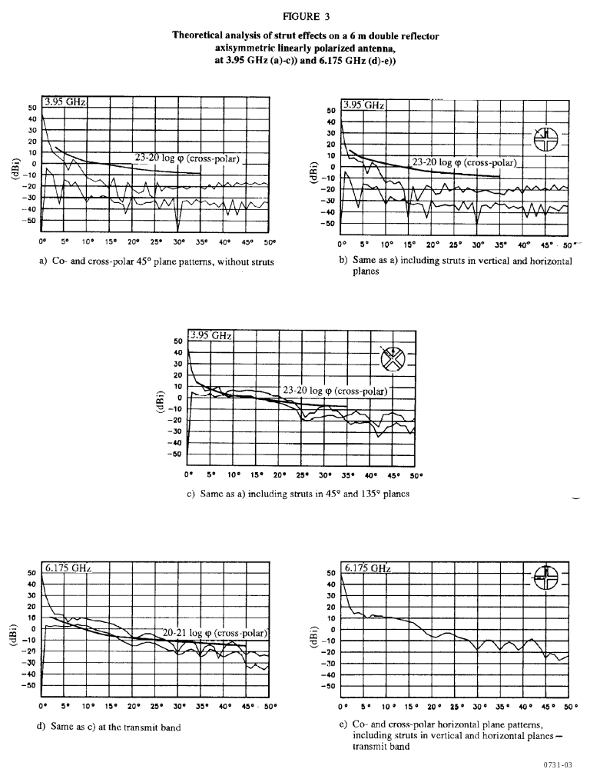
In order to estimate the worst-case polarization discrimination (factor of polarization isolation), the relative co-polarized G//(φ) and cross-polarized G₊(φ) envelopes have been obtained.
a) The relative co-polarized envelope used in this Annex is assumed as follows:
For systems with D/λ ≤ 100:
G//(φ) = 52 – 10 log(D/λ) – 25 log φ – G₀ dBi for (100 λ/D)° ≤ φ ≤ 48°
= 10 – 10 log(D/λ) – G₀ dBi for 48° < φ ≤ 180°
For systems with D/λ > 100:
G//(φ) = 32 – 25 log φ – G₀ dBi for 1° ≤ φ ≤ 48°
= 10 – G₀ dBi for 48° < φ ≤ 180°
b) The cross-polarization level is such that G₊(φ) = G//(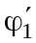) (with = 2.2 φ₁ for small antennas, and = 1.8 φ₁ for large antennas) for 0° < φ < φ₁.
Finally, the relative cross-polarized envelopes could have the following envelopes:

1 Small antennas (D < 100λ)
G₀ = maximum co-polarized gain of antenna (dBi)
G(φ) = 52 – 10 log(D/λ) – 25 log φ – G₀ (dBi)
φ₁ = 100 λ/D (degrees)
= 2.2 φ₁ (degrees)
φ₂ = 25.1º
φ_{ISO} = 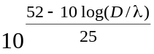 (degrees)
for 0 < φ ≤ φ₁:
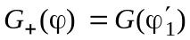 (1)
for φ₁ < φ ≤ φ₂:
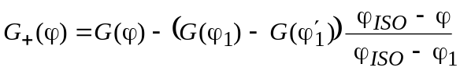 (2)
for φ > φ_{ISO}:
(3)
for φ₂ < φ ≤ 180º:
G₊(φ) = 10 – 10 log(D/λ) – G₀ (4)
The patterns shown in Figs. 4 and 6 are calculated for stations with antenna diameters of 1.2 m and 1.8 m operating at a centre frequency of 12.625 GHz. The patterns measured for these types of antennas are shown in Figs. 5, 7 and 8. In each case one example of the measured co- and cross-polarized pattern is given, but the envelopes shown are averages from measurements on several antennas of the same type.
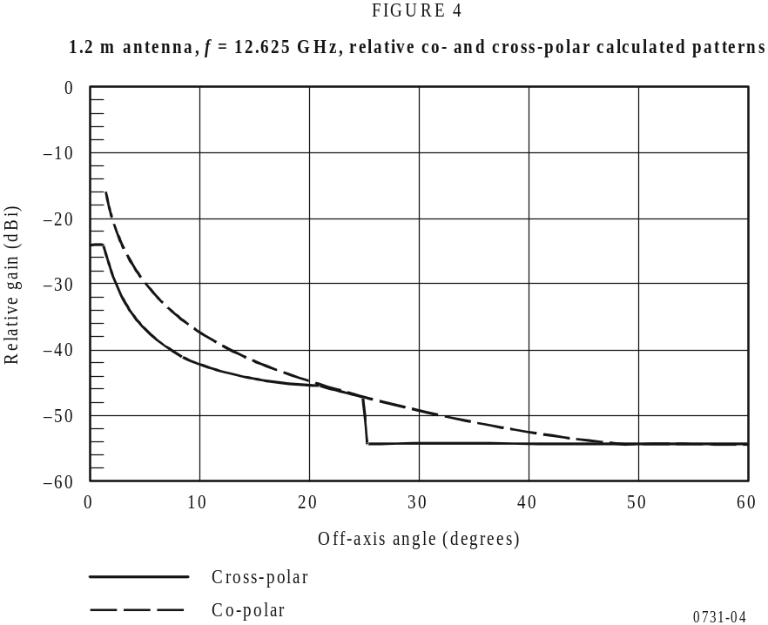

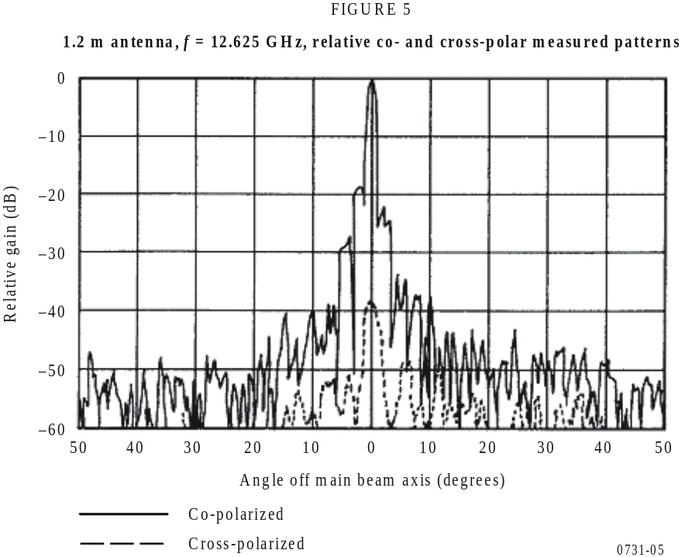
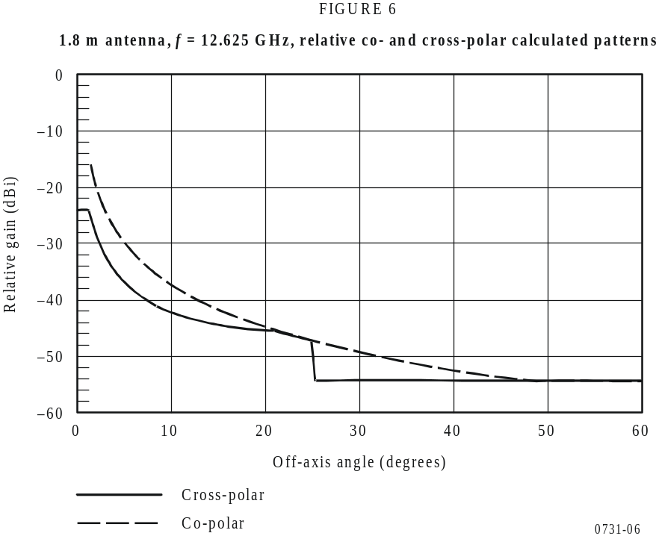

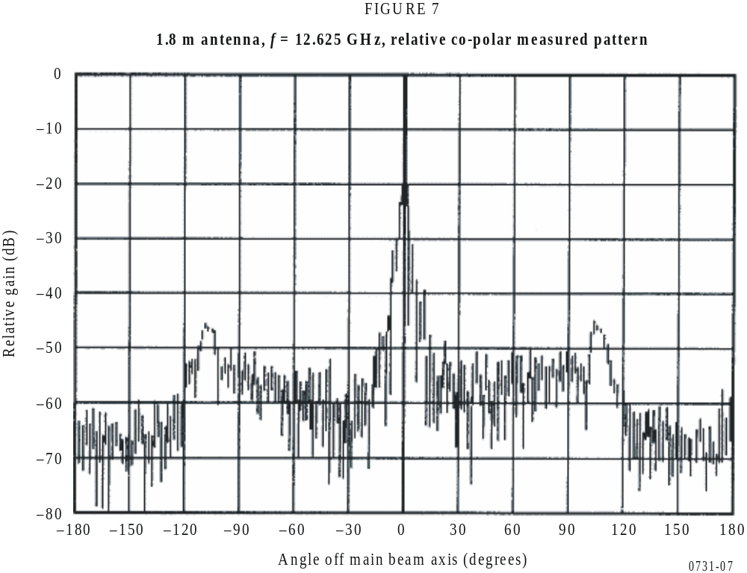
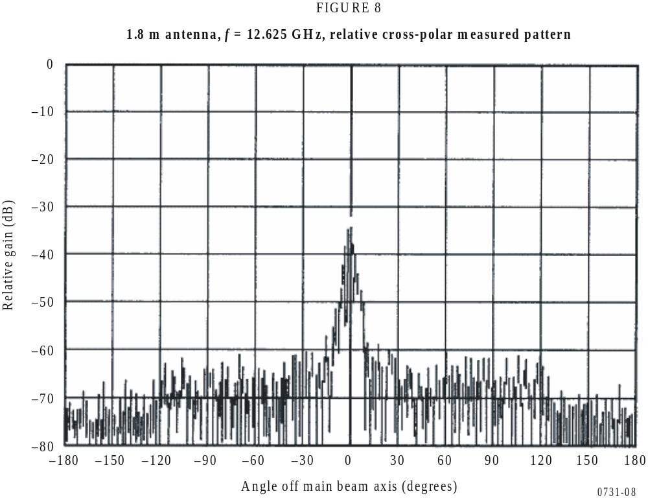

2 Large antennas (D ≥ 100λ)
G₀ = maximum co-polarized gain of antenna (dBi)
G(φ) = 29 – 25 log φ – G₀ (dBi)
φ₁ = 1º
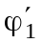 = 1.8 φ₁ (degrees)
φ₂ = 20º
φ₃ = 33.1º
φ_{ISO} = 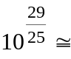 14.45º
for 0 < φ ≤ φ₁:
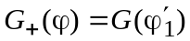 (5)
for φ₁ < φ ≤ φ₂:
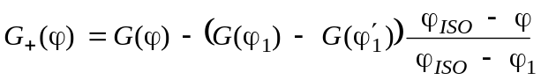 (6)
for φ₂ < φ ≤ φ₃:
G₊(ϕ) = 32 – 25 log ϕ – G₀ (7)
for φ₃ < φ ≤ 180º:
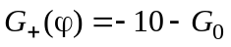 (8)
The patterns shown in the Figures below are calculated for stations with the following antenna diameters and frequencies: 2.4 m and 3.5 m at 12.625 GHz, and 3.7 m at 10.7 GHz. The patterns measured for these types of antennas are shown in Figs. 10, 11, 13, 14, 16 and 17. In each case, one example of the co- and cross-polarized measurements is shown, but the envelopes given were derived from the average of several antennas of the same type.
The functions given above for D < 100λ and D ≥ 100λ can be expressed in terms of absolute gain. The functions given for D < 100λ can be normalized to a (32 – 25 log ϕ) co-polar function by letting (52 – 10 log ϕ) equal 32. Evaluation of these functions as absolute gain for various values of D/λ is as follows:
G_{x}(ϕ) = 22.70 + 0.29 ϕ – 25 log ϕ dBi for D/λ = 25 (9)
= 22.69 + 0.37 ϕ – 25 log ϕ dBi for D/λ = 50 (10)
= 22.87 + 0.42 ϕ – 25 log ϕ dBi for D/λ = 75 (11)
= 22.15 + 0.47 ϕ – 25 log ϕ dBi for D/λ = 100 (12)
The angles at which these gain functions are equal to a co-polar envelope gain of (32 – 25 log ϕ) are 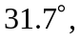 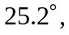 21.4° and 20.8° respectively. Additional functions which have been developed are:
G_{x}(ϕ) = 20 – 21 log ϕ dBi (13)
G_{x}(ϕ) = 23.6 – 20 log ϕ dBi (14)
G_{x}(ϕ) = 22 – 25 log ϕ dBi (15)
Equation (15) is based on a requirement that the cross-polar gain be 10 dB less than the co-polar gain out to 7°.
These functions are plotted in Fig. 18. From this Figure, a single function which adequately covers all the above functions is:
G_{λ}(ϕ) = 23 – 20 log ϕ dBi for ϕ_{r} ≤ ϕ ≤ 7°
= 20.2 – 16.7 log ϕ dBi for 7° < ϕ ≤ 26.3°
= 32 – 25 log ϕ dBi for 26.3° < ϕ ≤ 48°
= –10 dBi for 48° < ϕ ≤ 180°
ϕ_{r} is equal to 1° or 100 λ/D, whichever is greater.
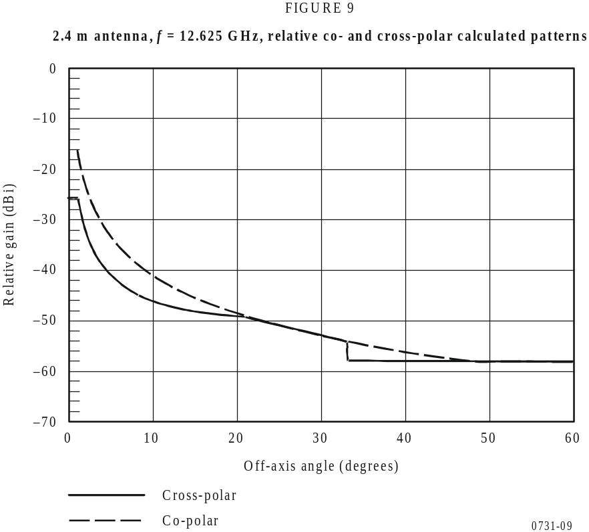

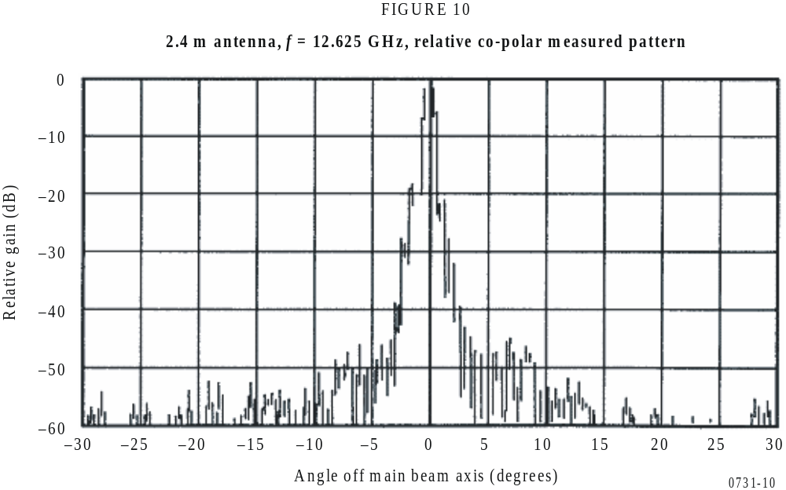
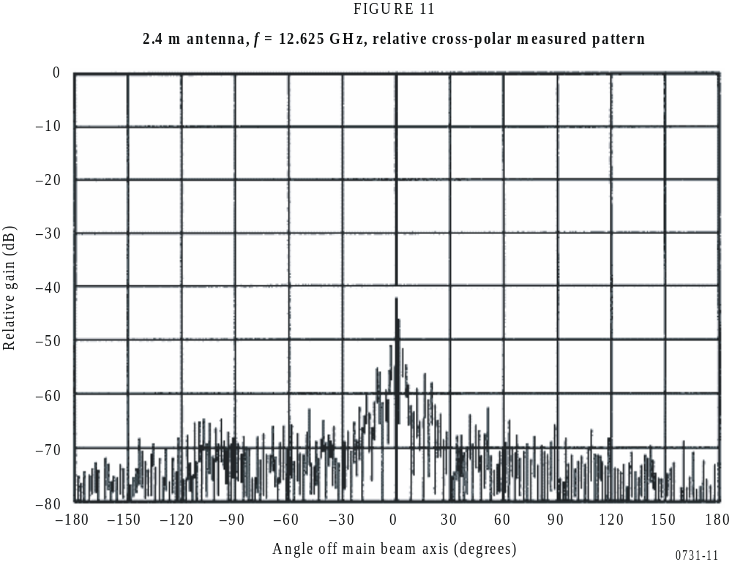

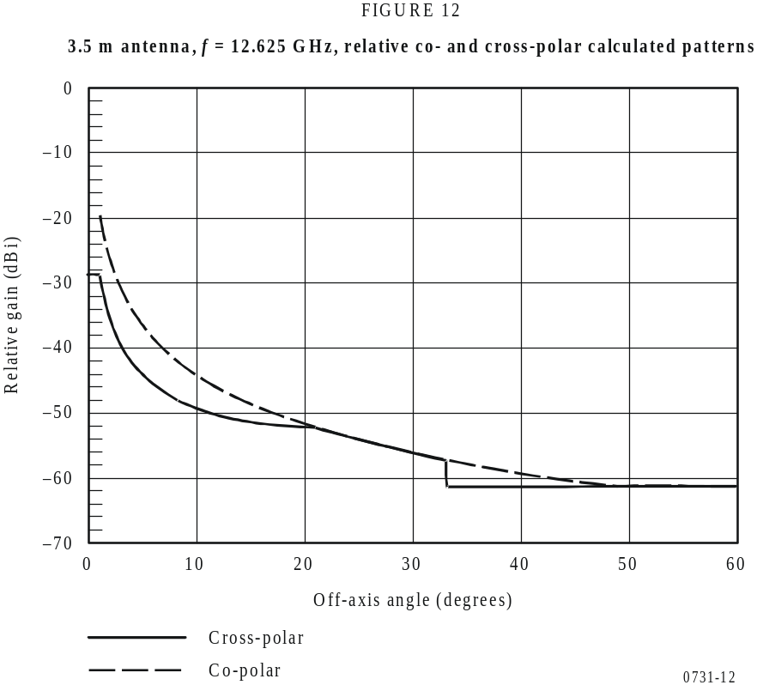
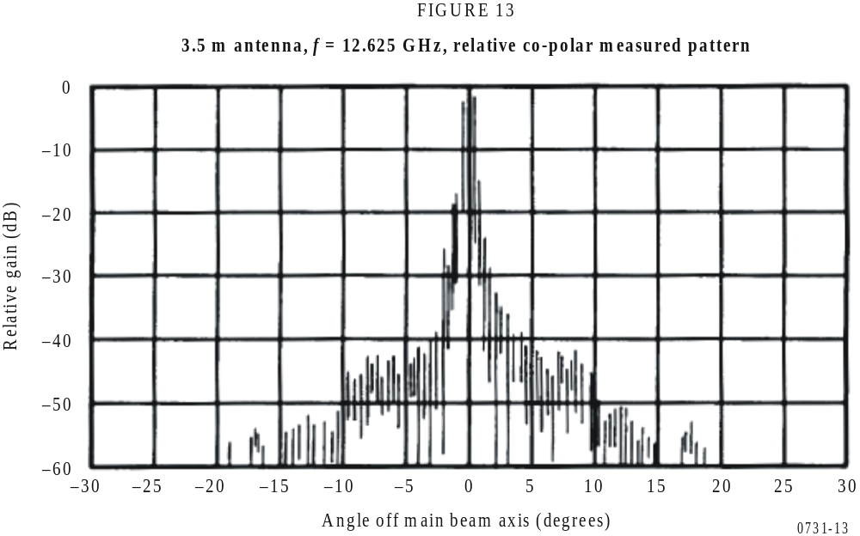

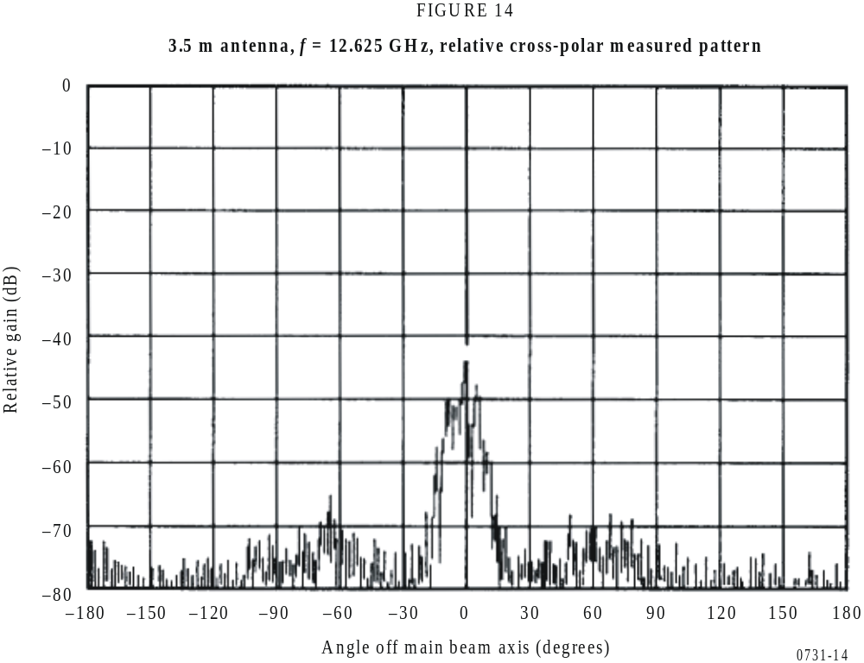
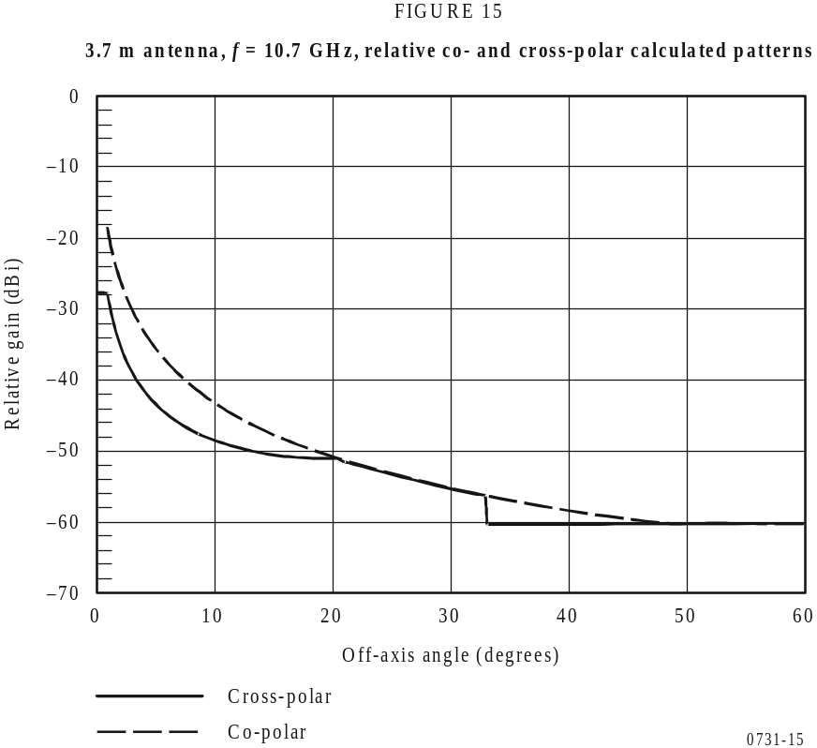

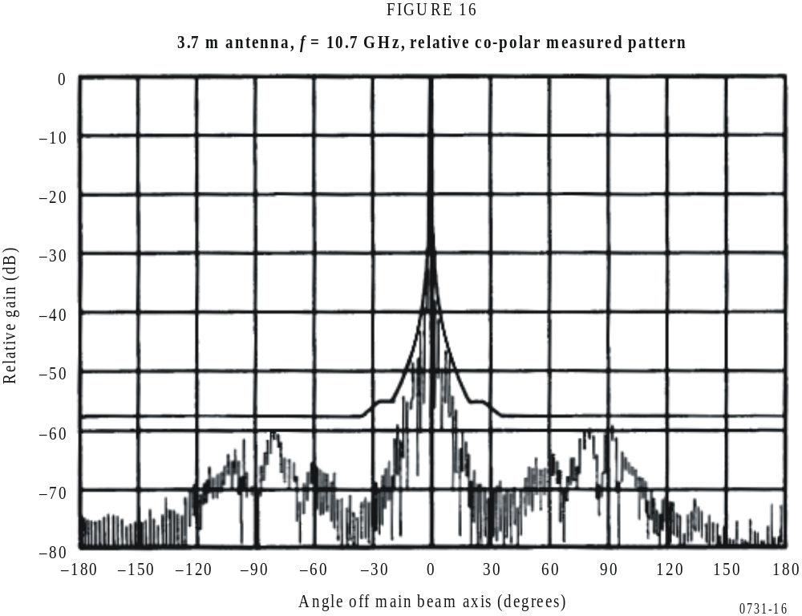
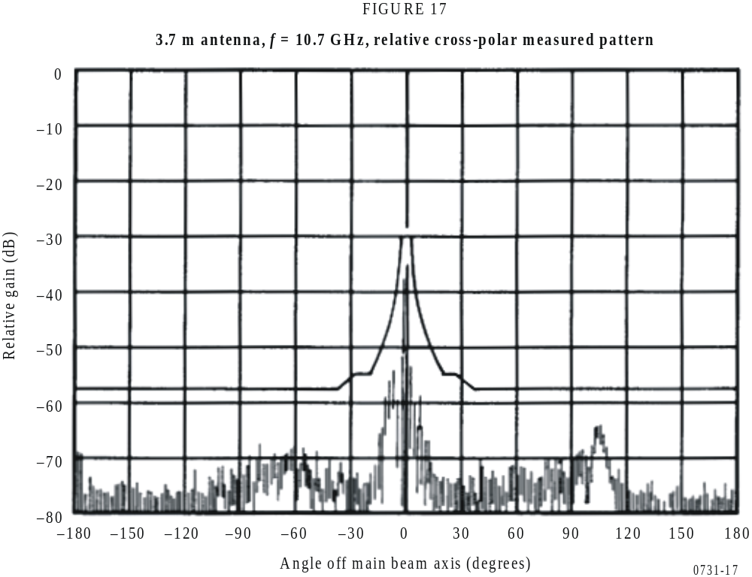
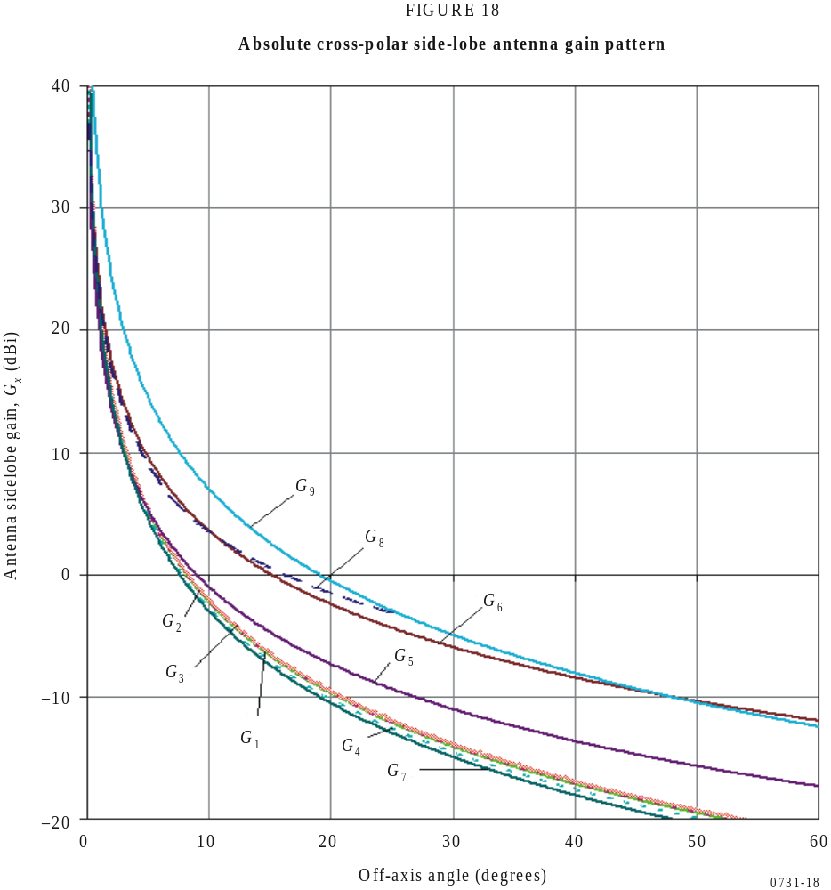
G₁(φ) = 22.70 + 0.29φ – 25 log φ for D/λ = 25
G₂(φ) = 22.69 + 0.37φ – 25 log φ for D/λ = 50
G₃(φ) = 22.87 + 0.42φ – 25 log φ for D/λ = 75
G₄(φ) = 22.15 + 0.47φ – 25 log φ for D/λ = 100
G₅(φ) = 20.0 – 21 log φ
G₆(φ) = 23.6 – 20 log φ
G₇(φ) = 22.0 – 25 log φ
G₈(φ) = 23.0 – 20 log φ for φ_{r} ≤ φ ≤ 7°
= 20.2 – 16.7 log φ for 7° < φ ≤ 26.3°
= 32.0 – 25 log φ for 26.3° < φ ≤ 48°
G₉(φ) = 32 – 25 log φ

