Recommendation ITU-R S.2131-1
(01/2022)
Method for the determination of performance objectives for satellite hypothetical reference digital paths using adaptive coding and modulation

S Series
Fixed-satellite service

Foreword
The role of the Radiocommunication Sector is to ensure the rational, equitable, efficient and economical use of the radio-frequency spectrum by all radiocommunication services, including satellite services, and carry out studies without limit of frequency range on the basis of which Recommendations are adopted.
The regulatory and policy functions of the Radiocommunication Sector are performed by World and Regional Radiocommunication Conferences and Radiocommunication Assemblies supported by Study Groups.

Policy on Intellectual Property Right (IPR)
ITU-R policy on IPR is described in the Common Patent Policy for ITU-T/ITU-R/ISO/IEC referenced in Resolution ITU-R 1. Forms to be used for the submission of patent statements and licensing declarations by patent holders are available from http://www.itu.int/ITU-R/go/patents/en where the Guidelines for Implementation of the Common Patent Policy for ITU-T/ITU-R/ISO/IEC and the ITU-R patent information database can also be found.

Series of ITU-R Recommendations
(Also available online at http://www.itu.int/publ/R-REC/en)
Series | Title
BO | Satellite delivery
BR | Recording for production, archival and play-out; film for television
BS | Broadcasting service (sound)
BT | Broadcasting service (television)
F | Fixed service
M | Mobile, radiodetermination, amateur and related satellite services
P | Radiowave propagation
RA | Radio astronomy
RS | Remote sensing systems
S | Fixed-satellite service
SA | Space applications and meteorology
SF | Frequency sharing and coordination between fixed-satellite and fixed service systems
SM | Spectrum management
SNG | Satellite news gathering
TF | Time signals and frequency standards emissions
V | Vocabulary and related subjects

Note: This ITU-R Recommendation was approved in English under the procedure detailed in Resolution ITU-R 1.

Electronic Publication
Geneva, 2022

© ITU 2022
All rights reserved. No part of this publication may be reproduced, by any means whatsoever, without written permission of ITU.

RECOMMENDATION ITU-R S.2131-1
Method for the determination of performance objectives for satellite hypothetical reference digital paths using adaptive coding and modulation
(Questions ITU-R 275 and ITU-R 277-1/4)
(2019-2022)
Scope
The use of adaptive coding and modulation (ACM) allows maintaining a satellite connection in spite of degradation due to propagation but at lower throughput rates. This Recommendation provides a method for determining the performance objectives for satellite communication systems using ACM.
Keywords
Adaptive coding and modulation, performance objectives, satellite communications
Abbreviations/Glossary
ACM Adaptive coding and modulation
BBER Background block error rate
BEP Bit error probability
BER Bit error ratio
DVB Digital video broadcasting
DVB-S2 Second generation digital video broadcasting via satellite
DVB-S2X Extension of second-generation digital video broadcasting via satellite
EB Errored block
ES Errored second
ETSI European Telecommunications Standards Institute
FER Frame error rate
HRDP Hypothetical reference digital path
HRX Hypothetical reference connection
MODCOD Modulation and coding
MPEG Moving Picture Experts Group
PER Packet error ratio
QEF Quasi error free
SES Severely errored second
TDM Time division multiplex
TDMA Time division multiple access
C/N Carrier to noise ratio γ
E_{s}/N₀ Symbol energy to noise spectral density ratio
η Spectral efficiency in bit/s/Hz
φ_{total} Percent degraded throughput
Related ITU-R Recommendations and Reports
Recommendation ITU-R S.614-4 Allowable error performance for a satellite hypothetical reference digital path in the fixed-satellite service operating below 15 GHz when forming part of an international connection in an integrated services digital network
Recommendation ITU-R S.1061-1 Utilization of fade countermeasure strategies and techniques in the fixed-satellite service
Recommendation ITU-R S.1062-4 Allowable error performance for a satellite hypothetical reference digital path operating below 15 GHz
Recommendation ITU-R S.1878-0 Multi-carrier based transmission techniques for satellite systems
Recommendation ITU-R S.2099-0 Allowable short-term error performance for a satellite hypothetical reference digital path
Report ITU-R S.2173-1 Multi-carrier based transmission techniques for satellite systems
Recommendation ITU-T G.826 End-to-end error performance parameters and objectives for international, constant bit-rate digital paths and connections
The ITU Radiocommunication Assembly,
considering
a) that adoption of ACM and power amplifier linearization has led to improved satellite efficiency and transmission performance;
b) that satellite systems utilizing ACM techniques will adapt to degraded conditions by reducing overall throughput and are, therefore, no longer provide constant bit rate services;
c) that satellite link performance must be sufficient to allow compliance with overall end-to-end performance objectives and end-user requirements;
d) that in defining error performance criteria, it is necessary to take into account all foreseeable error-inducing mechanisms, especially time-varying propagation conditions and interference,
noting
a) that long-term error performance objectives have been provided in Recommendations ITU-R S.614 and ITU-R S.1062;
b) that the definition of the short-term in satellite communications and information on the short-term performance objectives have been provided in Recommendation ITU-R S.2099;
c) that information on adaptive transmission and power control techniques which can be used to counteract time-varying attenuation has been provided in Recommendation ITU-R S.1061, Recommendation ITU-R S.1878, and Report ITU-R S.2173;
d) that the satellite link impairments are caused by degraded propagation, which can be characterized using the models given in Recommendations ITU-R P.618-13 and ITU-R P.1623-1, and these propagation Recommendations are applicable up to 51.4 GHz,
recommends
1 that satellite systems using ACM should be designed to meet the performance objectives given by either the packet error ratio (PER) or the spectral efficiency (bit/s/Hz) as a function of C/N;
2 that the following Notes should be regarded as part of this Recommendation.
NOTE 1 – In the case of using PER, the values given in Table 3 of § 2.2 of the Annex should be used.
NOTE 2 – In the case of using performance objectives given in terms of spectral efficiency, the spectral efficiency, measured at the operating γ value in dB, is assumed to be no less than
η(γ − 1.0), where γ is the carrier-to-noise ratio (C/N) in dB, and η(γ) is the spectral efficiency in bit/s/Hz as a function of γ defined in § 2.3 of the Annex.
NOTE 3 – It was assumed that the system is able to accommodate a 1 dB reduction in C/N, during a 1-second interval when changing modulation and coding (MODCOD) state. This corresponds to about a 10% reduction in spectral efficiency (throughput or capacity) over a nonlinear satellite link. This decrease in C/N may be due to any source of external noise and rain fading.
NOTE 4 – It should be noted that the time-average of the throughput, over any year, does not give sufficient information on the performance of a link for a particular percentage of time of any year. Additional requirements for overall performance may be stated in terms of throughput/spectral efficiency as a function of percentage of a year. Such a potential metric needs to be considered in the overall assessment of the performance of the link using ACM and the above-mentioned percentages may require further studies.

Annex
Example method for the determination of performance objectives for satellite hypothetical reference digital paths using adaptive coding and modulation

1 Background
Existing error performance and availability Recommendations were created while recognizing the satellite link impairments caused by degraded propagation, which can be characterized using the models given in Recommendations ITU-R P.618-13 and ITU-R P.1623-1. The studies conducted by Study Group 3 have indicated that these propagation Recommendations are applicable up to 51.4 GHz, but there are no Recommendations for slant paths using frequencies above 52 GHz. In light of this information, the existing error performance and availability Recommendations, apply on Hypothetical Reference Digital Paths (HRDPs) up to 52 GHz.
The development and adoption of adaptive coding and modulation (ACM) and power amplifier linearization techniques by satellite equipment manufacturers and operators has led to improved satellite efficiency and transmission performance. The use of ACM allows maintaining a satellite HRDP in spite of degraded propagation but at lower throughput rates. The application of ACM techniques to satellite transmission systems is covered in Report ITU-R S.2173 and § 2 of Annex 1 to Recommendation ITU-R S.2099.

1.1 Performance objectives for constant bit rate HRDPs
Recommendation ITU-R S.1062 gives performance objectives for satellite HRDPs providing constant bit rate services. These connections typified satellite traffic in the early 1990s, before the proliferation of fibre-optic, undersea cables. Recommendation ITU-R S.1062 was based on the requirements given in Recommendation ITU-T G.826. These requirements are given in terms of errored blocks as opposed to individual bit errors. Recommendation ITU-T G.826 defines performance objectives in terms of background block error rate (BBER) with a value of 2 × 10⁻⁴ to 1 × 10⁻⁴ depending on the service rate, up to, 3.5 Gbit/s, and this BBER is measured only during available time. Table 1 of Recommendation ITU-T G.826 is partly reproduced below as Table 1 for reference.
TABLE 1
End-to-end error performance objectives for a 27 500 km
International digital HRX or HRDP defined in Recommendation ITU-T G.826
rate | 64 kbit/s | 1.5 to 5  (Mbit/s) | > 5 to 15  (Mbit/s) | > 15 to 55  (Mbit/s) | > 55 to 160  (Mbit/s) | > 160 to 3 500  (Mbit/s)
Bit/block |  | 800-5 000 | 2 000-8 000 | 4 000-20 000 | 6 000-20 000 | 15 000-30 000
ESR | 0.04 | 0.04 | 0.05 | 0.075 | 0.16
SESR | 0.002 | 0.002 | 0.002 | 0.002 | 0.002 | 0.002
BBER |  | 2 × 10⁻⁴ | 2 × 10⁻⁴ | 2 × 10⁻⁴ | 2 × 10⁻⁴ | 10⁻⁴

In communication transport systems operating at any bit rate covered by Recommendation ITU-T G.826, either above or below the primary rate, independent of the actual distance spanned, a satellite hop in the international portion receives a 35% allocation of all the end-to-end objectives. If a satellite link provides a national portion, then it receives an allocation of 42% of all the end-to-end objectives. For example, a BBER objective of 2 × 10⁻⁴ is changed to 2 × 10⁻⁴ × 0.35 = 0.7 × 10⁻⁴ for international connection, while it is changed to 2 × 10⁻⁴ × 0.42 = 0.84 × 10⁻⁴ for a national connection. If a satellite provides the complete path or connection from end-to-end, then the objectives in Table 1 would apply.
The size of a block is also defined depending on the service bit rate. Considering this aspect, Recommendation ITU-R S.1062 defines the performance objectives in terms of BEP/α, where BEP is bit error probability and α is the number of errors per burst. The following is an example of the performance objectives defined for the satellite system operating up to and including 155 Mbit/s.
TABLE 2
Performance objectives defined in Recommendation ITU-R S.1062
Percentage of total time  (worst month) | BEP/α | For α = 10  (BEP)
0.2  2  10 | 1 × 10^{–7}  1 × 10^{–9}  1 × 10^{–10} | 1 × 10^{–6}  1 × 10^{–8}  1 × 10^{–9}

It must be recognized that this type of satellite connection was for a high-rate permanent connection used to provide a high-capacity intercontinental link carrying primarily telephony or low-rate data traffic. These links were most often routed through large earth stations that operated in the 6/4 GHz bands, where the propagation disturbances are very small.
Currently, two-way satellite connections mainly carry Internet traffic. The connections are typically asymmetrical having a hub station transmitting high bit rate streams that can use time division multiplex (TDM) or time division multiple access (TDMA) techniques. The subscriber stations transmit at rate much lower than the hub station and have a low duty cycle. These are the type of systems that will utilize higher frequency links and, to do this effectively, will rely on ACM in order to achieve reliable throughput with high spectral efficiency. At the higher frequencies above 20 GHz, propagation disturbances are far more significant than in the 6/4 GHz bands.

1.2 Experimental results of dynamic rain fading characteristics
It was reported that average fading slope estimated from a Ku band satellite system was 0.24 dB/s. Figure 1 shows fading slope statistics measured on a Ka band satellite communication system in Korea (Rep. of). In Fig. 1, A is the depth of the rain fade in dB, and ΔA is the slope of fading in dB/s, $\overline{A}$ is the average of ΔA and the Figure shows that the average fading slope is less than 1 dB across all the fading ranges.
An experimental study using the DVB-S2 testbed with ACM over a satellite link reported, in § E.3 of DVB Document A171-1, that the maximum fade slope corresponding to heavy rain events at Ka band does not normally exceed 0.5 dB/s, thus, a 1 s ACM loop updating time is usually considered achievable. The experimental results shown here are for a Ka-band system. In addition, in order to limit the number of modulation and coding (MODCOD) changes, a nominal offset of 0.3 dB, considering the typical step size between adjacent MODCOD levels for DVB-S2 has been added on the up threshold compared to the down threshold, resulting in a hysteresis effect.
Figure 1
Average fading slope in a Ka band satellite system
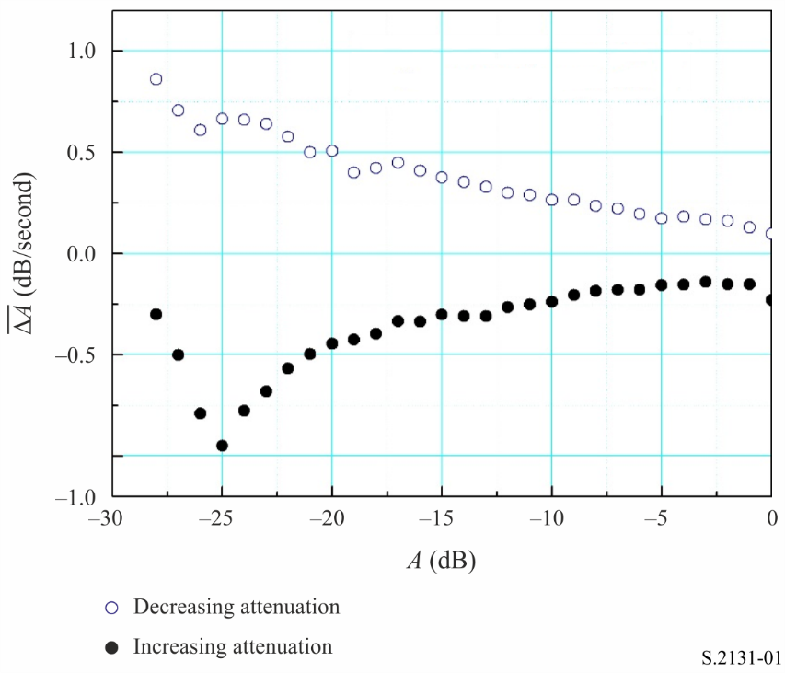

2 Applicable performance parameters

2.1 The need for new performance objectives for variable bit rate HRDPs
The existing error performance Recommendations (e.g. Recommendation ITU-R S.1062-4) cover constant bit rate HRDPs and are, thus, not applicable to systems utilizing ACM techniques. An important aspect of ACM is that the BER characteristics of the various MODCOD modes exhibit a rapid decrease in BER with respect to C/N, where N is the total noise in the link, including thermal noise and interference. The C/N difference between an operating BER of, say, 1 × 10^{–8} and a very degraded BER of 1 × 10⁻³ is approximately 0.25 dB, for a given MODCOD state.
Many modern satellite system performances are specified in terms of packet error rate (PER) by considering packet-based transmissions, and PER characteristics exhibit almost the same rapid decrease in behaviour as in the BER. This behaviour implies that satellite performance in terms of PER as a function of time is not relevant to satellite systems utilizing ACM techniques as such systems will adapt to degraded conditions by reducing overall throughput and are, therefore, no longer constant bit rate systems. The concept of measuring performance of satellite links employing ACM techniques using average or degraded throughput was explored earlier. The referenced paper considers ACM applications tolerant of a reduction in information rate. The concept of degraded throughput as presented in this Annex can be used to evaluate reduction in information rate.
The probability that the PER of a satellite system utilizing ACM will degrade to an unusable level is extremely small until the ACM MODCOD set has depleted its available code alternatives. Therefore, it is no longer necessary to give both an error performance and an availability value to specify satellite HRDP performance. Further, the suitable performance objective would be independent of the channel rate and could be applied to any ‘nominated’ rate utilized.

2.2 Packet error rate
The DVB-S2(X) specification defines the quasi-error free (QEF) condition as a packet error rate (PER) of 10⁻⁷, with a packet length of 188 bytes corresponding to the length of a MPEG packet. This also corresponds to a frame error rate (FER) of 10⁻⁵, with a frame size of 16 200 or 64 800 bits. Due to the very steep PER or FER curve characteristics, C/N differences between PER of 10⁻⁷ and 10⁻⁵ are usually not greater than 0.1 dB, regardless of all the MODCOD states.
A DVB-S2 modem has been implemented in hardware and demonstrated using with an ACM state change condition of a PER of 10⁻⁴. Because of the long round trip time (RTT), the DVB-S2 modem has been designed to change MODCOD state at a QEF condition in advance of this steep PER characteristics.
If a frame (or packet) based transmission is made, then the BBER parameter defined in Recommendation ITU-T G.826 can be mapped to FER or PER, because the size of blocks defined in Table 1 may be compatible to the size of a packet or frame.
The performance objectives of the satellite system using ACM, then can be specified by modifying the performance objectives in Table 2, and using the PER as shown in Table 3.
TABLE 3
Performance objectives for a satellite system using ACM in terms of PER
Percentage of total time | PER
0.04% of year  0.6% of year  4.0% of year | < 10⁻⁴  < 10⁻⁵  < 10⁻⁷ ⁽¹⁾
⁽¹⁾ PER of 10⁻⁷ is assumed to be equivalent value of FER of 10⁻⁴ and it is also assumed to be equivalent to BBER of 10⁻⁴ in Table 1.

2.3 Spectral efficiency as a function of C/N
The channel capacity represented by the Shannon-Hartley bound can provide the spectral efficiency in terms of bit/s/Hz, and this spectral efficiency can be presented as a function of C/N. The spectral efficiency as a function of C/N can be represented as follows in the case of the Shannon-Hartley bound, which is the maximum achievable value.
η(γ) = log₂(10^{γ/10} + 1) (1)
where η is the spectral efficiency in bit/s/Hz and γ is C/N which, in this case, is equivalent to the symbol energy to noise spectral density ratio (E_{s}/N₀) in dB.
If a system uses ACM with multiple MODCOD modes, η(γ) can be derived and the performance objective can be set to maintain η(γ) with a certain amount of margin by considering ACM state changes over approximately a 1 s interval.
Therefore, the performance objective could be based on the spectral efficiency of the system being no less than η(γ – 1.0), for a given γ value in dB.
In order to provide an example of how spectral efficiency can be applied as a performance objective, the characteristics of DVB-S2X are used.
Figure 2 compares the spectral efficiency of ACM MODCOD operations of DVB-S2X and DVB-S2 with the Shannon-Hartley bound.
Figure 2
Spectral efficiency (capacity) comparisons
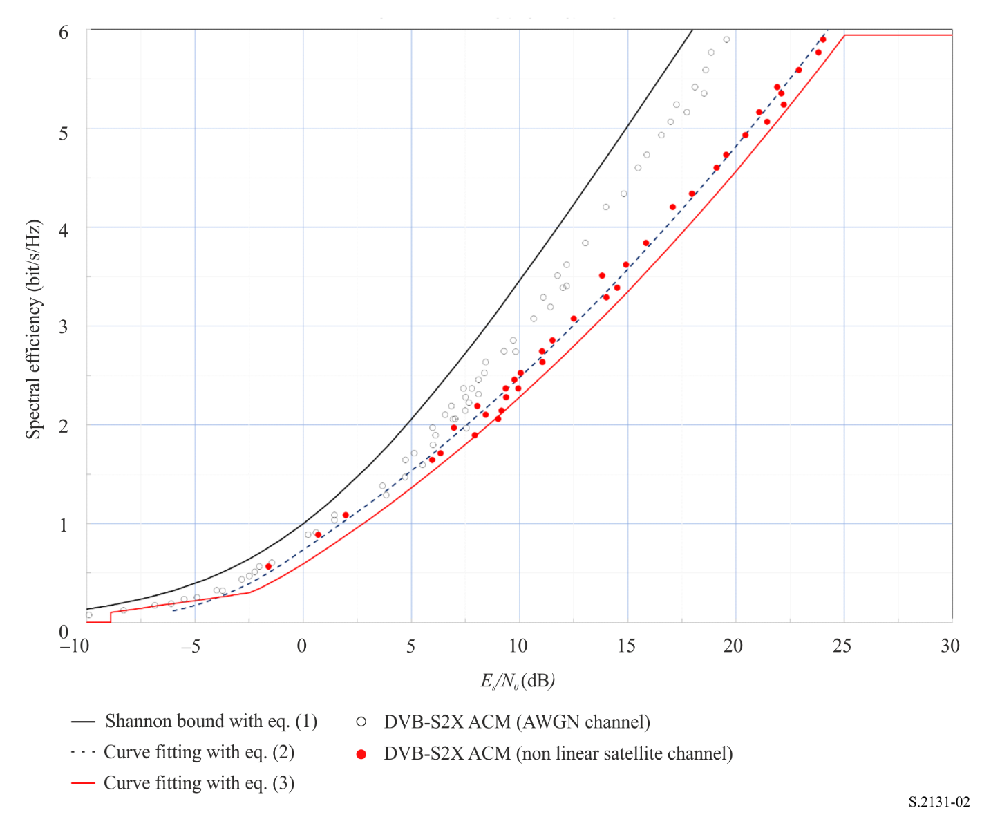
By fitting the spectral efficiency of the DVB-S2X ACM operation over a non-linear satellite channel with two least squared minimum error second order polynomials, the following equations are derived.
η(γ) = 0.8181 + 0.1607γ +0.0096γ² for −5 ≤ γ < 0
(2)
η(γ) = 0.7375 + 0.1433γ + 0.003γ² for γ ≥ 0
To obtain an approximate curve fit for the lower portion of the curve, the constant 0.8181 in the portion (−5 ≤ γ < 0 dB) of the curve was lowered by approximately 0.08 to 0.737 5 such that the upper and lower part of the curve would align at the same value of γ at E_{S}/N₀ = 0. It is also worth noting that in Fig. 2, the DVB-S2X (AWGN Channel) points in the lower left portion of the Figure show that the difference between the spectral efficiency for the AWGN channel and the non-linear channel diminishes as the E_{S}/N₀ drops below zero. Equation (2), with the constant term modified in the portion of the curve from (−2.5 ≤ γ < 0 dB), may be further modified to reflect the minimum spectral efficiency data series. For the lowest portion of the curve (−8.9 ≤ γ < −2.5 dB), a linear function can be used to model the performance. The overall result combined the upper portion of the curve and the lower portion of the curve on either side of γ = 0 and adding the lowest portion of the curve described using a linear function, the minimum spectral efficiency of DVB-S2X (non-linear satellite channel) can be described with a series of functions as follows:
η(γ) = 0, for γ < −8.9,
η(γ) = 0.030337γ + 0.376643, for −8.9 ≤ γ < −2.5,
η(γ) = 0.5933 + 0.1415γ + 0.0096γ², for −2.5 ≤ γ < 0,
(3)
η(γ) = 0.5933 + 0.1388γ + 0.003γ², for 0 ≤γ < 25.02,
η(γ) = 5.944, for γ ≥ 25.02
For systems employing a framing format of DVB-S2X optimized for very low C/N, the entire range of equation (3) applies. For systems not employing a framing format of DVB-S2X optimized for very low C/N, equation (3) applies for a minimum γ of −3 dB, below which n(γ) = 0.
For DVB-S2X, the highest spectral efficiency for the highest MODCOD is 5.944 bit/s/Hz corresponding to γ = 25.02 dB. Therefore, equation (3) has a constant value of 5.944 bit/s/Hz for γ greater than or equal to 25.02 dB, when considering satellite systems using DVB-S2X. Other MODCOD schemes may yield higher spectral efficiencies, when γ is greater than 25.02 dB.
The performance objective provides an increase of 1 dB over the DVB-S2X performance to allow taking into account additional channel impairments in a typical operating environment.
In this example, it is quite apparent from Fig. 2 above that, in an ACM link using DVB-S2X ACM over a non-linear satellite channel, a 1 dB reduction in C/N value results in about 10% reduction in achievable spectral efficiency. The same conclusion may not hold for links using MODCODs different from DVB-S2X. The actual reduction in efficiency depends on the nominal C/N value prior to degradation.
The example system used here was able to accommodate a 1 dB reduction in C/N, during a 1 second interval when changing ACM state. This degradation in C/N would be due to all sources of external noise and rain fading.
Figure 2 and conclusions derived from it are examples of systems using a DVB-S2X implementation of ACM, but the methodology could be applied to the other satellite links using other types of ACM.

2.4 Degraded throughput
The use of ACM in the satellite system allows maintaining a satellite connection, in spite of degraded propagation but at the expense of delivering less throughput. The degradation of the throughput realized at the output of a satellite HRDP that uses ACM can be related to the spectral efficiency by making the reasonable assumption that the throughput varies directly with the spectral efficiency. Using this assumption, the throughput can be computed as a function of C/N which varies depending on the propagation and interference conditions.
The following is an example of the use of DVB-S2X for a satellite link in southern Florida, USA, affected by fading only. Using the method of Recommendation ITU-R P.618, values of C/N exceeded for a certain time over an average year can be computed. As an example, Figure 3 illustrates those values for a satellite link operating at 38.5 GHz in a climatological area similar to southern Florida. For the assumed frequency and location used to compute the curve in Fig. 4, and assuming a 1 dB margin to accommodate any possible interference, attenuation will result in unavailability for the system of 0.3%, which corresponds to an availability of 99.7%. The dynamic range of the above-mentioned link is 33 dB.
The percentage of time for which a link is only subjected to propagation fading and drops below the lowest spectral efficiency depends on:
1 the climatological location of the receiving earth station;
2 the waveform (e.g. DVB-S2X, DVB-S2, etc.) and specifically, the highest coding (most robust MODCOD) available which is implemented by that waveform; and
3 the dynamic range of the link which is a function of the system design. The dynamic range of the link is the difference between the maximum C/N of the link under the most optimum propagation conditions and the C/N of the link when the propagation conditions cause the C/N to drop to the point where the spectral efficiency for the waveform used drops to zero. If the dynamic range of the link is not sufficient, it may not accommodate the entire theoretical dynamic range of the waveform being used.
Implementation of a particular ACM waveform and the capability of the modem at the receiving end of the connection to demodulate and decode very low C/N traffic will impact the dynamic range over which the link can operate. As such, a point may be reached where the modem/codec still maintains synchronization (carrier lock), but the link is unavailable, because the received C/N level is less than the C/N level at which the most robust MODCOD has been implemented.
While a satellite link using ACM can maintain a connection at a reduced throughput, the loss in the achievable throughput stated as a fraction of the maximum throughput for a specific time percentage can be computed as follows:
$\left(T_{\%}\right)=1-\frac{η\left(γ\left(T\%\right)\right)}{η_{max}}$ (4)
where $η_{max}$ denotes the maximum achievable spectral efficiency, $T_{\%}$ represents time percentage, $γ\left(T\%\right)$ is the achievable C/N for time ≥ T% and ϕ$(T_{\%})$ is the degradation in the achievable throughput.
From this, the average of the loss in throughput (ϕ_{total}) can be computed by numerically integrating the spectral efficiency over the time period that the connection is available as follows:
. (5)
The spectral efficiency, η corresponding to a specific time percentage can be found by inserting C/N, i.e. γ value in equation (3). Table 4 represents an example of computing the performance of links using ACM, calculated as the average loss in throughput, ${}_{total}$ for the satellite system as in Fig. 4, based on the cumulative distribution function for the achievable throughput, ϕ$\left(T_{\%}\right)$. In this example, $η_{max}=$ η (24) is about 5.653. A plot of the spectral efficiency, η$(\left(T_{\%}\right))$ and the resulting degradation in the achievable throughput, ϕ$(T_{\%})$ is shown in Fig. 4. For this example, the average of the loss in throughput, ${}_{total}$ estimated using equation (5) is about 4.774% when the dynamic range is approximately 33 dB.
TABLE 4
Degraded throughput estimation example
$$T_{\%}$$ | Total attenuation (dB) | C/N, γ ($T_{\%})$ (dB) | η(γ ($T_{\%})$) | ϕ$(T_{\%})$ | $${∆T}_{\%}$$ | ϕ$(T_{\%}) {∆T}_{\%}$
0.3 | 33.5 | –8.77 | 0.111 | 0.980 = 1 – (0.111/5.653) | 0.1 | 0.098 = 0.980 × 0.1
0.4 | 29.413 | –4.69 | 0.234 | 0.959 = 1 – (0.234/5.653) | 0.1 | 0.096 = 0.959 × 0.1
0.5 | 26.277 | −1.550 | 0.397 | 0.930 | 0.1 | 0.093 = 0.93 × 0.1
0.6 | 23.842 | 0.885 | 0.719 | 0.873 | 0.1 | 0.087
0.7 | 21.893 | 2.834 | 1.011 | 0.821 | 0.1 | 0.082
0.8 | 20.285 | 4.443 | 1.269 | 0.775 | 0.1 | 0.078
0.9 | 18.925 | 5.803 | 1.500 | 0.735 | 0.1 | 0.073
1 | 17.754 | 6.974 | 1.707 | 0.698 | 0.5 | 0.349
1.5 | 14.187 | 10.540 | 2.390 | 0.577 | 0.5 | 0.289
2 | 12.009 | 12.718 | 2.844 | 0.497 | 0.5 | 0.248
2.5 | 10.634 | 14.093 | 3.145 | 0.444 | 0.5 | 0.222
3 | 9.617 | 15.111 | 3.376 | 0.403 | 0.5 | 0.201
3.5 | 8.716 | 16.011 | 3.585 | 0.366 | 0.5 | 0.183
4 | 7.983 | 16.744 | 3.759 | 0.335 | 0.5 | 0.168
4.5 | 7.371 | 17.357 | 3.906 | 0.309 | 0.5 | 0.154
5 | 6.849 | 17.879 | 4.034 | 0.286 | 0.6 | 0.172
5.6 | 6.186 | 18.54 | 4.198 | 0.257 | 1 | 0.257
6.6 | 5.524 | 19.20 | 4.365 | 0.228 | 1.4 | 0.319
8 | 4.861 | 19.87 | 4.535 | 0.198 | 2 | 0.395
10 | 4.199 | 20.529 | 4.707 | 0.167 | 2.2 | 0.368
12.2 | 3.392 | 21.34 | 4.920 | 0.130 | 2.3 | 0.298
14.5 | 2.585 | 22.14 | 5.137 | 0.091 | 2.5 | 0.228
17 | 1.778 | 22.95 | 5.359 | 0.052 | 3 | 0.156
20 | 0.972 | 23.756 | 5.584 | 0.012 | 10 | 0.122
30 | 0.778 | 23.950 | 5.638 | 0.003 | 10 | 0.025
40 | 0.753 | 23.975 | 5.645 | 0.001 | 10 | 0.013
50 | 0.727 | 24.000 | 5.653 | 0.000 | 50 | 0.000
100 | 0.727 | 24.000 | 5.653 | 0.000 | 0 | 0.000
 |  | $${}_{total}$$ |  |  |  | 4.774

Figure 3
Attenuation due to propagation loss based on Recommendation ITU-R P.618 for a satellite connection utilizing ACM and operating in a climatological area similar to South Florida, USA
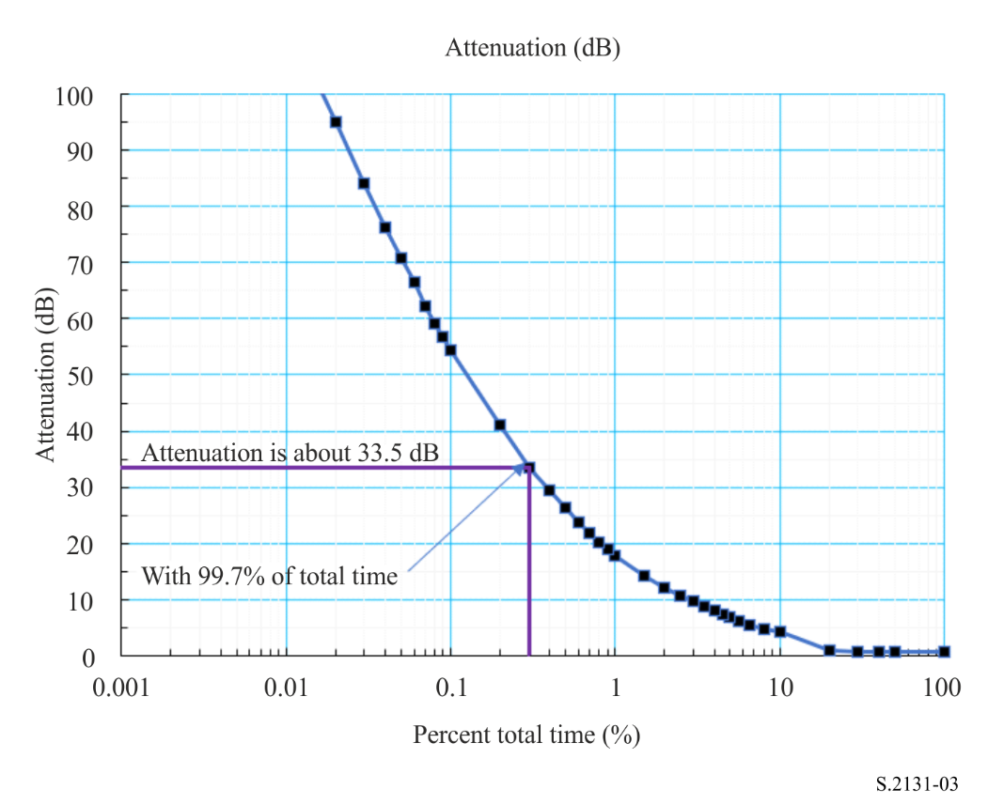
Assuming that the satellite connection would have attenuation as a function of total time as shown in Fig. 4, the average of the loss in throughput that could be expected would be 4.774% of the total possible throughput.
Throughput = Channel rate × Time (6)
Lost throughput = Maximum available throughput – Delivered throughput (7)
% degraded throughput = (Lost throughput/maximum available throughput) × 100 (8)
An example of computing % degraded throughput is given in the Attachment to the Annex.
Figure 4
Spectral efficiency and lost throughput* for a satellite connection utilizing ACM
and operating in a climatological area similar to South Florida, USA
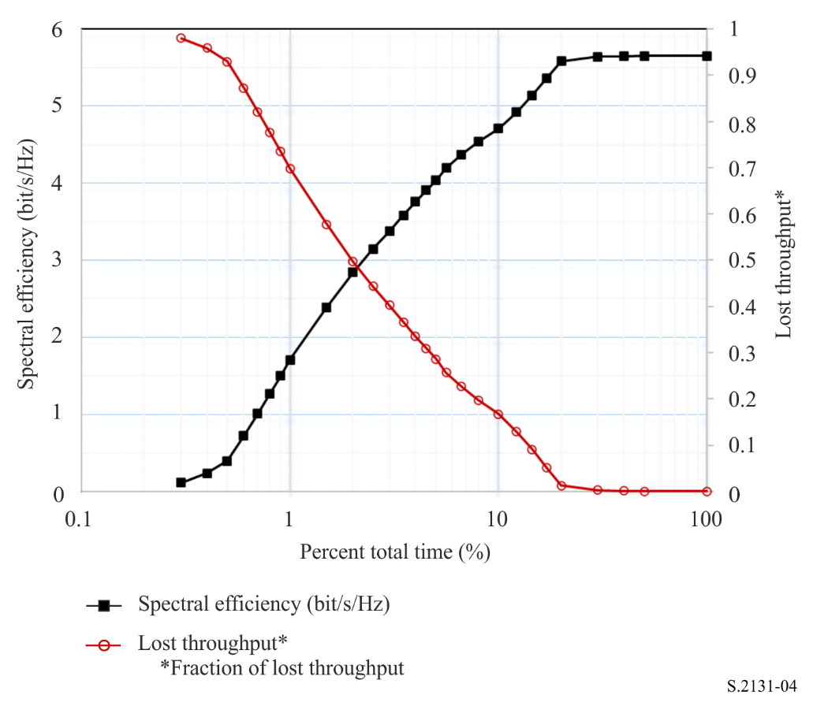

Attachment
to Annex
Example of the computation of % degraded throughput
Assume that the best achievable MODCOD is 16APSK 77/90. Further assume that the channel modulation rate is 34 megabaud per second. Combining these assumptions results in a bit rate of 116.36 Mbit/s. Assume that the connection uses 188-byte packets, where each byte is an octet.
The computation of the Maximum Available Throughput (MAT_{put}), the Delivered Throughput (DT_{put}), Lost Throughput (LT_{put}) and % Degraded Throughput (%DT_{put}) is shown below:
MAT_{put} = Maximum Channel Rate (bit/s) × Time (s) (9)
DT_{put} = Σ Channel Rate (C/N)_{i} (bit/s) × Time_{i} (s) (10)
LT_{put} = MAT_{put} – DT_{put} (11)
%DT_{put} = (LT_{put}/MAT_{put}) × 100 (12)
For the assumed values:
MAT_{put} = 116.36 Mbit/s × 31557600 s/year = 3.67 × 10¹⁵ bit or 2.44 × 10¹² packets per year.
Using the data given in Table 5 and assuming that the channel rate varies in the same manner as the spectral efficiency, the LT_{put} is 1.165 × 10¹¹ packets and the %DT_{put} = 4.774%.
TABLE 5
% Degraded Throughput 34 megabaud per second, 16APSK 77/90, 188-byte packets, 116.36 Mbit/s
Maximum Available Throughput = 2.44 × 10¹² packets/year
% Time | Total attenuation | C/N, γ ($T_{\%})$ (dB) | η(γ ($T_{\%})$) | ΔT% | %DT_{put}, ϕ$(T_{\%})$ | Lost  throughput
0.3 | 33.5 | −8.77 | 0.111 | 0.1 | 0.980 = 1 – (0.111/5.653) | 2392300555.55
0.4 | 29.413 | −4.69 | 0.234 | 0.1 | 0.959 | 2338777860.07
0.5 | 26.277 | −1.550 | 0.397 | 0.1 | 0.930 | 2268593048.04
0.6 | 23.842 | 0.885 | 0.719 | 0.1 | 0.873 | 2129821586.02
0.7 | 21.893 | 2.834 | 1.011 | 0.1 | 0.821 | 2003692375.24
0.8 | 20.285 | 4.443 | 1.269 | 0.1 | 0.775 | 1892136410.30
0.9 | 18.925 | 5.803 | 1.500 | 0.1 | 0.735 | 1792605325.58
1 | 17.754 | 6.974 | 1.707 | 0.51 | 0.698 | 8515408574.43
1.5 | 14.187 | 10.540 | 2.390 | 0.5 | 0.577 | 7042604485.82
2 | 12.009 | 12.718 | 2.844 | 0.5 | 0.497 | 6061899097.19
2.5 | 10.634 | 14.093 | 3.145 | 0.5 | 0.444 | 5411456009.74
3 | 9.617 | 15.111 | 3.376 | 0.5 | 0.403 | 4914264989.65
3.5 | 8.716 | 16.011 | 3.585 | 0.5 | 0.366 | 4462867228.40
4 | 7.983 | 16.744 | 3.759 | 0.5 | 0.335 | 4087795603.11
4.5 | 7.371 | 17.357 | 3.906 | 0.5 | 0.309 | 3769153208.08
5 | 6.849 | 17.879 | 4.034 | 0.6 | 0.286 | 4192406755.67
5.6 | 6.186 | 18.54 | 4.198 | 1 | 0.257 | 6277955694.24
6.6 | 5.524 | 19.20 | 4.365 | 1.4 | 0.228 | 7780079269.90
8 | 4.861 | 19.87 | 4.535 | 2 | 0.198 | 9650151891.10
10 | 4.199 | 20.529 | 4.707 | 2.2 | 0.167 | 8979487209.87
12.2 | 3.392 | 21.34 | 4.920 | 2.3 | 0.130 | 7269900943.64
14.5 | 2.585 | 22.14 | 5.137 | 2.5 | 0.091 | 5558025750.48
17 | 1.778 | 22.95 | 5.359 | 3 | 0.052 | 3806209512.79
20 | 0.972 | 23.756 | 5.584 | 10 | 0.012 | 2974051094.53
30 | 0.778 | 23.950 | 5.638 | 10 | 0.003 | 615903898.01
40 | 0.753 | 23.975 | 5.645 | 10 | 0.001 | 308034447.18
50 | 0.727 | 24.000 | 5.653 | 50 | 0.000 | 0.00
100 | 0.727 | 24 | 5.653 | 0 | 0.000 | 0.00
 |  |  |  |  |  | 116495582824.63
 |  |  | $${}_{total}$$ |  |  | 4.774

Additional performance assessment methodologies and metrics require qualitative and quantitative analysis to determine the efficacy of these methodologies and metrics.
Sooyoung Kim Shin, Kwangjae Lim, Kwonhue Choi, and Kunseok Kang, “Rain attenuation and Doppler shift compensation for satellite communications”, ETRI Journal, Vol. 24, No. 1, Feb. 2002, pp. 31-42.
Meixiang Zhang and Sooyoung Kim, “A Statistical Approach for Dynamic Rain Attenuation Model,” 29th AIAA International Communications Satellite Systems Conference (ICSSC-2011) 28 November – 1 December 2011, Nara, Japan.
DVB Document A171-1. Digital Video Broadcasting (DVB), Implementation guidelines for the second-generation system for Broadcasting, Interactive Services, News Gathering and other broadband satellite applications; Part 1 (DVB-S2), March 2015.
Gerald Shewan, “Alternative Measure of Performance for Satellite Links Employing Adaptive Coding and Modulation”, 30th AIAA International Communications Satellite System Conference (ICSSC-2012), 24-27 September 2012, Ottawa, Canada.
DVB Document A171-2. Digital Video Broadcasting (DVB), Implementation guidelines for the second generation system for Broadcasting, Interactive Services, News Gathering and other broadband satellite applications; Part 2 – S2 Extensions (DVB-S2X), March 2015, for more information on DVB-S2X specification.
Joon-Gyu Ryu, Deock-Gil Oh, Hyun-Ho Kim, and Sung-Yong Hong, “Proposal of an Algorithm for an Efficient Forward Link Adaptive Coding and Modulation System for Satellite Communication”, Journal of Electromagnetic Engineering and Science, Vol. 16, No. 2, Apr. 2016, pp. 80-86.
The use of DVB-S2X characteristics should not be construed as an endorsement of the DVB-S2X system to the detriment of an alternative ACM technique. The characteristics of DVB-S2X are freely available in the public domain and the use of these characteristics is not subject to intellectual property constraints.
DVB-S2X is used as an example given that the standard is widely used and that characteristics are in the public domain. The same derivation may be performed for any alternative ACM technique.
See, for example, Implementation guidelines for the second-generation system for Broadcasting, Interactive Services, News Gathering and other broadband satellite applications; Part 2: S2 Extensions (DVB-S2X), C.2.6.2 Super-frame format 7, p. 160.
DVB-S2X is used as an example given that the standard is widely used and that characteristics are in the public domain. The same derivation may be performed for any alternative ACM technique.
In this purpose, the spectral efficiency should be understood as the useful information rate, excluding error correcting codes, supported by the link.

