Recommendation ITU-R S.1782-1
(09/2019)
Guidelines on global broadband Internet access by fixed-satellite service systems

S Series
Fixed-satellite service

Foreword
The role of the Radiocommunication Sector is to ensure the rational, equitable, efficient and economical use of the radio-frequency spectrum by all radiocommunication services, including satellite services, and carry out studies without limit of frequency range on the basis of which Recommendations are adopted.
The regulatory and policy functions of the Radiocommunication Sector are performed by World and Regional Radiocommunication Conferences and Radiocommunication Assemblies supported by Study Groups.

Policy on Intellectual Property Right (IPR)
ITU-R policy on IPR is described in the Common Patent Policy for ITU-T/ITU-R/ISO/IEC referenced in Resolution ITU-R 1. Forms to be used for the submission of patent statements and licensing declarations by patent holders are available from http://www.itu.int/ITU-R/go/patents/en where the Guidelines for Implementation of the Common Patent Policy for ITU-T/ITU-R/ISO/IEC and the ITU-R patent information database can also be found.

Series of ITU-R Recommendations
(Also available online at http://www.itu.int/publ/R-REC/en)
Series | Title
BO | Satellite delivery
BR | Recording for production, archival and play-out; film for television
BS | Broadcasting service (sound)
BT | Broadcasting service (television)
F | Fixed service
M | Mobile, radiodetermination, amateur and related satellite services
P | Radiowave propagation
RA | Radio astronomy
RS | Remote sensing systems
S | Fixed-satellite service
SA | Space applications and meteorology
SF | Frequency sharing and coordination between fixed-satellite and fixed service systems
SM | Spectrum management
SNG | Satellite news gathering
TF | Time signals and frequency standards emissions
V | Vocabulary and related subjects

Note: This ITU-R Recommendation was approved in English under the procedure detailed in Resolution ITU-R 1.

Electronic Publication
Geneva, 2019

© ITU 2019
All rights reserved. No part of this publication may be reproduced, by any means whatsoever, without written permission of ITU.

RECOMMENDATION ITU-R S.1782-1
Guidelines on global broadband Internet access
by fixed-satellite service systems*
(2007-2019)
Scope
In order to address issues raised by previous World Radiocommunication Conferences and Radiocommunication Assemblies, this Recommendation provides guidelines on global broadband Internet access by fixed-satellite service systems. A first Annex covers a number of general issues on the consideration of suitable frequency bands and a general description of broadband satellite architecture. A second Annex describes both existing and future satellite systems to provide global broadband access directly to small earth station antenna, and includes descriptions of systems characteristics and satellite capacities. It should be noted that fixed-satellite service comprises both GSO and non-GSO networks and systems and are thus both in the scope of this Recommendation.
Keywords
Broadband, Internet access, fixed-satellite service systems
Abbreviations/Glossary
ACM Adaptive coding and modulation
DVB Digital video broadcasting
DVB-S2 Second generation digital video broadcasting via satellite
DVB-S2X Extension of second generation digital video broadcasting via satellite
ETSI European telecommunications standards institute
FSS Fixed-satellite service
GSO Geostationary-satellite orbit
HDFSS High-density fixed-satellite service
HTS High-throughput satellite
VHTS Very high-throughput satellite
Related ITU Recommendations, Reports and Resolutions
Recommendation ITU-R S.1709-1 Technical characteristics of air interfaces for global broadband satellite systems
Recommendation ITU-R S.1783-0 Technical and operational features characterizing high-density applications in the fixed-satellite service
Resolution ITU-R 69 Development and deployment of international public telecommunications via satellite in developing countries
The ITU Radiocommunication Assembly,
considering
a) that satellite technology has the potential to accelerate the availability of high-speed Internet services to all countries;
b) that Radiocommunication Assembly 2015 (RA-15) adopted Resolution ITU-R 69 and noted the contribution broadband satellite technologies could make toward achievement of the United Nations Sustainable Development Goals as well as reduction in the digital divide, particularly in rural and remote areas;
c) that it is desirable to determine the technical and operational characteristics of fixed-satellite service (FSS) systems that could facilitate the mass-production of user terminal equipment at affordable prices;
d) that it is desirable to assess the global capacity that could be provided in FSS frequency allocations by systems having the characteristics determined in considering c);
e) that the determinations in considering c) should take into account both the possibility of designing systems specifically for Internet access at high data-rates via user terminals, and also the fact that some existing systems already include broadband Internet access facilities;
f) that a variety of earth station sizes are being employed for broadband Internet access via existing FSS systems designed to cater also for other applications and using several frequency bands;
g) that development of standards for the satellite technology mentioned in considering a) for Internet applications facilitates the wider use of satellite for Internet access;
h) the need to assist developing countries in deploying and using satellite telecommunications to enable sustainable and affordable access to international public telecommunication services, bearing in mind the RA-15 Resolution ITU-R 69,
noting
a) that Recommendation ITU-R S.1783 describes the characteristics of high-density fixed-satellite service (HDFSS) systems;
b) that Recommendation ITU-R S.1709 describes the technical characteristics of air interfaces of global broadband satellite systems,
noting further
a) that the FSS frequency allocations can be used in the short, medium and long term for the global provision of high-speed Internet services;
b) that the expansion of broadband satellite services is generating growth in developing countries through e-applications such as e-health, e-learning, e-government, teleworking and residential and community Internet access, which can be used as tools for achieving ICT policy objectives,
recommends
1 that the information in the Annexes may be used as guidelines in order to implement global access to the Internet at high data-rates via the FSS;
2 that the information in the Annexes may be considered as guidelines in order to assist developing countries with the development and deployment of global broadband services via satellite in response to resolves 1 and 2 of the RA-15 Resolution ITU-R 69.

Annex 1
General considerations and characteristics of global broadband access
by FSS systems

1 Frequency band considerations
Satellites, with their inherent ability to provide ubiquitous, wide-area coverage, are key to providing broadband connectivity including in remote and underserved areas.
Recent years have seen the deployment of numerous High Throughput Satellite (HTS) systems operating in the 20/30 GHz bands in the fixed-satellite service (FSS) to provide broadband connectivity directly to end-users over small satellite user terminals. To provide high capacity and high spectrum efficiency, HTS systems implement large numbers of satellite spot beams which allows for high multiples of frequency re-use.
Within the range of the 20/30 GHz FSS bands in which HTS systems are generally deployed, there is 500 MHz of spectrum at the top end of the band (19.7-20.2 GHz Earth-to-space and 29.5-30 GHz space-to-Earth) for which satellite services do not share with other primary services in the ITU Table of Frequency Allocations. User terminals operating in these bands can generally be deployed ubiquitously without need for individual coordination of the satellite earth stations.
However, meeting the ever increasing capacity requirements for broadband connectivity requires that HTS systems deploy ubiquitous end-user terminals in FSS frequencies also in the parts of the 20/30 GHz FSS bands where satellite services do not have an exclusive primary allocation.
Meeting the ever increasing capacity demands for global broadband connectivity does not stop simply with a wider use of the 20/30 GHz bands for ubiquitous user terminals. Currently planned HTS systems, including some in the construction phase today, will deploy and operate in the 40/50 GHz FSS bands. This is not only to accommodate gateway feeder links for systems in which user terminals operate in the 30/20 GHz bands, but future HTS systems will also deploy ubiquitous user terminals in portions of the 40/50 GHz FSS bands.
Regulatory approaches, both at the ITU / Radio Regulations level, as well as at regional and national levels to facilitate these wider deployments of ubiquitous user terminals are described in the sections below.

1.1 Suitable bands
“Short term” applies to bands for which satellite technology has already been developed. At the present time this is wholly true of the 4/6 GHz, 11/14 GHz, and 20/30 GHz FSS allocations, and partially true of the 40/50 GHz FSS allocations. There are FSS allocations above 50 GHz in Article 5 of the Radio Regulations (RR), but significant development in them seems unlikely to occur before the long term and they are not considered here.
Preliminary studies ruled out the use of the 4/6 GHz bands for the subject application, on the grounds that low-cost terminals imply very small antennas which would be unlikely to have adequate gain at those frequencies to operate to the wide-beam satellites typically involved. Furthermore, the 4/6 GHz bands are already heavily utilized so, even if spot-beam C-band satellites were provided, it would be difficult for very small-dish earth stations with their correspondingly wide beamwidths to share frequencies with the existing services. Therefore the 4/6 GHz bands are not considered further in this Annex.
The 20/30 GHz FSS allocations are believed to be intrinsically the most suitable for broadband Internet access over user terminals in the near term, because the wavelength is consistent with very small antennas, the technology is reasonably well developed, and utilization is as yet relatively low. Moreover, Internet access by individuals is incompatible with the way in which the great majority of international use of the FSS bands has been regulated up to now, i.e. by coordination of individual earth stations. The likelihood, that the user terminals will be sold by “high street” retailers in large numbers and installed in homes as well as offices, necessitates a regulatory regime such as applicable for the so-called ‘exclusive Ka-band’ (29.5 GHz - 30 GHz in Earth-to-space and 19.7-20.2 GHz in space-to-Earth) and which is being developed to accommodate HDFSS in additional parts of the FSS allocations.
RR No. 5.516B, referenced by WRC-03 in its call for studies on possible global broadband FSS systems for Internet applications, is partially repeated below for convenience:
“The following bands are identified for use by high-density applications in the fixed-satellite service:
17.3-17.7 GHz (space-to-Earth) in Region 1,
18.3-19.3 GHz (space-to-Earth) in Region 2,
19.7-20.2 GHz (space-to-Earth) in all Regions,
39.5-40 GHz (space-to-Earth) in Region 1,
40-40.5 GHz (space-to-Earth) in all Regions,
40.5-42 GHz (space-to-Earth) in Region 2,
47.5-47.9 GHz (space-to-Earth) in Region 1,
48.2-48.54 GHz (space-to-Earth) in Region 1,
49.44-50.2 GHz (space-to-Earth) in Region 1,
and
27.5-27.82 GHz (Earth-to-space) in Region 1,
28.35-28.45 GHz (Earth-to-space) in Region 2,
28.45-28.94 GHz (Earth-to-space) in all Regions,
28.94-29.1 GHz (Earth-to-space) in Region 2 and 3,
29.25-29.46 GHz (Earth-to-space) in Region 2,
29.46-30 GHz (Earth-to-space) in all Regions,
48.2-50.2 GHz (Earth-to-space) in Region 2.”
However, and as reflected in the Final Report on WTDC-14 Resolution 9 approved by WTDC-17, the need for more available spectrum for the operation of user terminals was explicitly noted:
“Satellites, with their inherent ability to provide ubiquitous, wide-area coverage, are key to deliver broadband connectivity including in remote and underserved areas. Recent years have seen the deployment of numerous High Throughput Satellite (HTS) systems operating in Ka-band frequencies in the fixed-satellite service (FSS) to provide broadband connectivity directly to end-users over small satellite user terminals. To provide high capacity and high spectrum efficiency, HTS systems implement large numbers of satellite spot beams which allows for high multiples of frequency re-use.
Within the range of Ka-band FSS frequencies in which HTS systems are generally deployed, there is 500 MHz of spectrum for which satellite services do not share with other primary services in the ITU table of frequency allocations. User terminals operating in these bands can generally be deployed ubiquitously without need for individual coordination of the satellite earth stations.
However, meeting the ever increasing capacity requirements for broadband connectivity requires that HTS systems deploy ubiquitous end-user terminals in FSS frequencies also in the parts of the Ka-band where satellite services do not have an exclusive primary allocation.”
The report also notes significant progress at certain regional and national levels to make available spectrum beyond that specified in bands identified for HDFSS by RR No. 5.516B for satellite user terminals operating in the 20/30 GHz FSS allocations.
And indeed mainly HTS and VHTS systems currently under development and construction are designed to implement, where feasible, HDFSS user terminals in the Ka-band beyond the bands identified above.
Note that similar considerations for operation of HDFSS operation of user terminals in the 40/50 GHz bands are also ongoing.

2 Possible technical characteristics
Looking at the 20/30 GHz bands, where much of the development of HTS satellites to provide regional and global broadband Internet access has occurred to date, the technical evolution in HTS systems is indeed significant.
Number of beams per satellite has increased from 32 beams to hundreds of beams, where now a typical value for the many HTS deployments operating in 20/30 GHz today is on the order of 200 beam and above per satellite.
Net capacity per satellite has increased from 5 Gbit/s to many tens of Gbit/s, where a typical value for today’s HTS deployments is now specified in hundreds of Gbit/s per satellite. Looking only slightly ahead, planned VHTS system deployments in 20/30 GHz, some of which are currently in construction, will soon be providing terabit/s capacity in a single GSO/FSS satellite.
Proportional advances in the 11/12 GHz band are also observed in today’s satellites providing broadband connectivity, while the future satellites in the 40/50 GHz bands will of course employ proportional levels of advancement in the technology.
An updated overview of the technical characteristics of these systems are described in the sections below.

2.1 Satellite beams
Table 1 gives an indication of the dimensions of spot-beams likely to be available either now or in the near future. The parameters are selected as bases for the characterization of the user links of suitable satellite systems. It is assumed here that, for operational convenience, the satellite antenna sub-systems will be designed so that each pair of transmit and receive beams have the same beamwidths and their footprints have the same fixed positions on the Earth’s surface.
TABLE 1
Satellite spot-beam characteristics selected
FSS frequency range | 11/14 GHz | 20/30 GHz | 40/50 GHz
Gain at beam centre (dBi) | 44-46 | 50-53 | 55-58
−3 dB beamwidth (degrees) | 0.8-1.0 | 0.3-0.4 | 0.2
Number (n) of dual-polar transmit/receive beams per satellite | 80-140 | 200-400 | > 500

In the light of spacecraft development in recent years it is reasonable to assume antenna feed arrangements that compensate for the curvature of the Earth’s surface to enable all beams generated by a given satellite to have circular footprints of the same diameter regardless of pointing direction. Thus, with the exception of a beam pointing at the sub-satellite point, each beam will have an approximately elliptical cross-section, and its axial ratio and orientation will depend on its pointing direction relative to the direction of the sub-satellite point. The beamwidths of the major (ϕ_{a}) and minor (ϕ_{b}) axes will be such that ((ϕ_{a})⋅(ϕ_{b}))^{0.5} = (ϕ₀), where (ϕ₀) is the −3 dB beamwidth of the (circular) beam pointing to the sub-satellite point.
For continuous coverage via multiple beams with circular footprints a hexagonal pattern of overlaps may be assumed, as in Fig. 1.
Figure 1
Hexagonal pattern for footprints of overlapping satellite beams
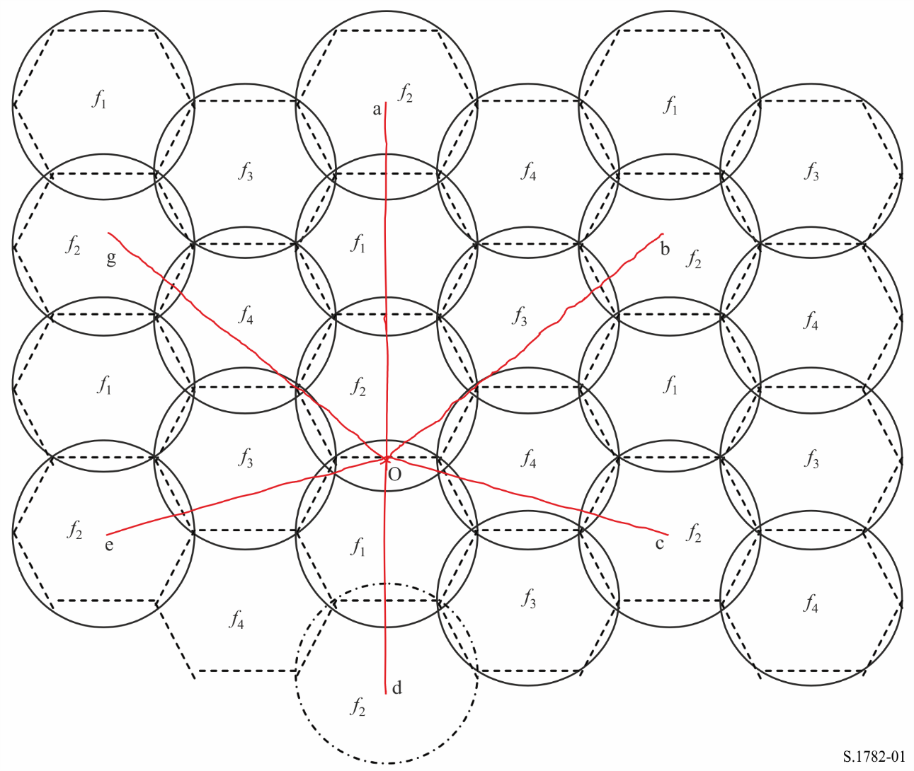
A one-in-four frequency reuse pattern is shown in Fig. 1, and each beam is assumed to be dual-polarized. Given practicable rates of roll-off and first-sidelobe levels such as those described by the equations in Recommendation ITU-R S.672, the discrimination between the centre of a beam and the nearest edge of the next co-frequency beam should be just about adequate to support this mode of operation. For example, at point “o” at the edge of one of the hexagonal areas served by a frequency f₂ beam, the interference contributions from the nearest six co-frequency beams can be calculated from the off-axis angles oa, ob, oc, od, oe, and og, subtended at the satellite. From the geometry of the diagram:
oa = 5(ϕ₀/2) ⋅ cos(30°) = 2.165(ϕ₀)
ob = og = ({2(ϕ₀/4) + ϕ₀}² + {3(ϕ₀/2) ⋅ cos(30°)}²)^{0.5} = 1.984(ϕ₀)
oc = oe = ({(ϕ₀/2) ⋅ cos(30°)}² + {2(ϕ₀/4) + ϕ₀}²)^{0.5} = 1.561(ϕ₀) and
od = 3(ϕ₀/2) ⋅ cos(30°) = 1.299(ϕ₀)
FIGURE 2
Examples of beam arrangements for FSS satellites that could provide high-speed Internet access
in the 11/14 GHz bands and 20/30 GHz bands
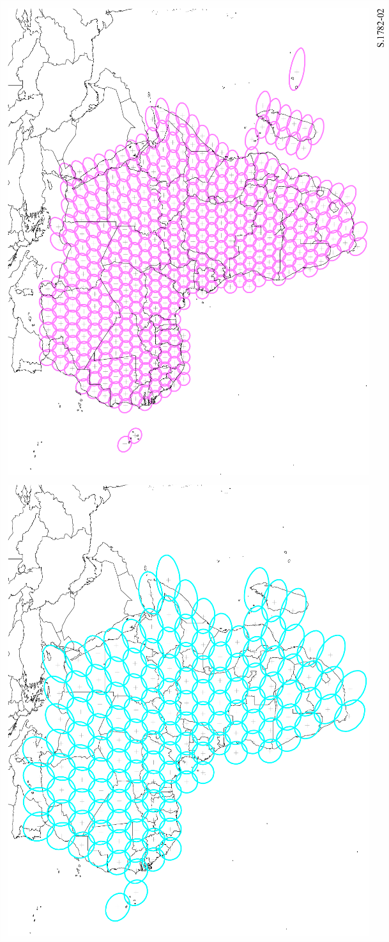
By reference to Recommendation ITU-R S.672 concerning simple circular and elliptical beams it is seen that, if the first sidelobe gain is 25 dB below peak gain then, assuming the same e.i.r.p. at each beam centre and assuming that the co-to-cross-polar ratio of each beam is also 25 dB, the net carrier-to-frequency reuse interference ratio is given by:
(C/I)_{FR} = −10 log(7{10^{−(25/10)}}) = 16.5 dB
In practice (C/I)_{FR} is likely to be rather higher than this, because not all six contributions are likely to correspond to sidelobe peaks.
Examples of the coverages of geostationary satellites having the beam arrangements summarized in Table 1 are illustrated in Fig. 2. It may be noted that the overall coverage reduces roughly in inverse proportion to frequency.

Annex 2
Global broadband Internet access by current and next generation FSS systems
Example of global broadband Internet access by an FSS system designed for small Ka-Band Consumer earth station antennas

1 General
For the present example the scope is to make use of low-cost consumer terminals developed for large scale deployment. State-of-the-art user terminals operating at Ka-band and capable of transmitting and receiving the whole of the Ka-band spectrum are used. The objective is to provide a system offering the best economics based on a cost per bit/s metrics.
A Star Network topology is assumed, terminals transmitting to the satellite in Ka-band, their signal being re-transmitted to gateways in Q-band, and gateways transmitting in V-band, their signals being re-transmitted in Ka-band to the User terminals.
This implementation is the object of several FSS systems currently under construction for service launch in the next two to three years.

2 Frequency band considerations
With regard to the identification of FSS frequency bands suitable for this application in this case the use of the full Ka-band is assumed for the users:
– Transmission within 27.5-30.0 GHz;
– Reception within 17.3-20.2 GHz.
In line with ongoing studies, it is assumed that the sharing of these bands with FS services is made possible on a non-interfering basis, the terminals having ‘cognitive’ functions making them and the System aware of the interference environment.
In order to feed the terminals, and considering the huge demand of bandwidth, the Gateways use V-band for transmission (Feeder-to-Satellite) and Q-band for reception (Satellite-to-Feeder):
– Transmission in the 47.2-50.2 GHz and in the 50.4-51.4 GHz (V-band);
– Reception in the 37.5-40.4 GHz (Q-Band).
Such Frequency Plan is illustrated in Fig. 3 for the Forward Link (Gateway-to-User Terminal) and in Fig. 4 for the Return Link (User Terminal-to-Gateway).
Figure 3
Forward Link Frequency Plan for broadband Internet access by an FSS system
designed for small Ka-Band Consumer earth station antennas
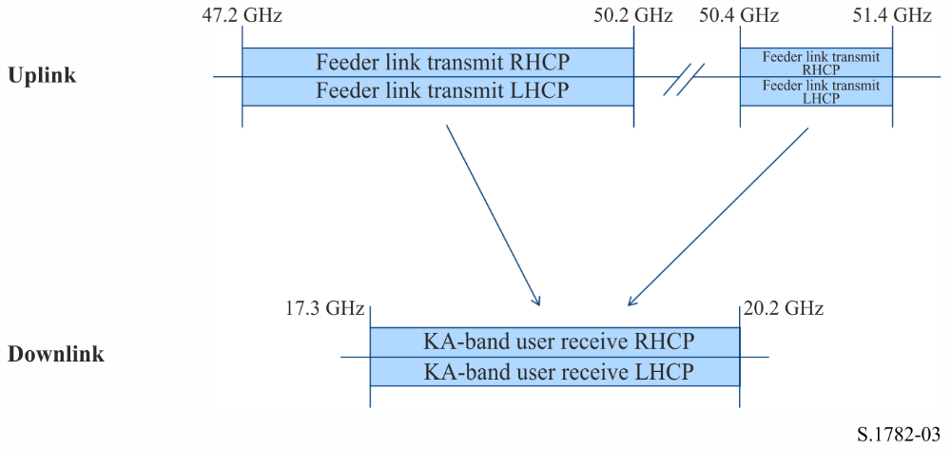
Figure 4
Return Link Frequency Plan for broadband Internet access by an FSS system
designed for small Ka-Band Consumer earth station antennas
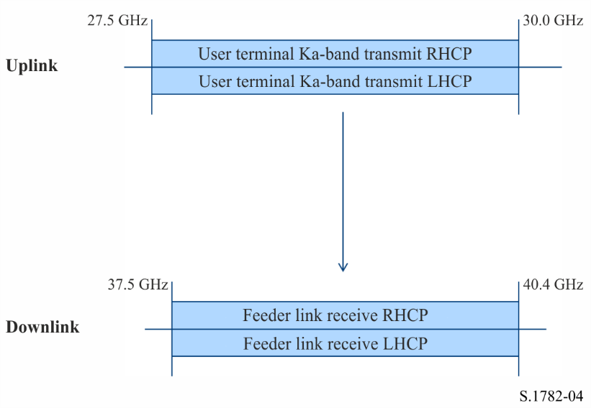

3 Possible technical characteristics

3.1 System architecture
The system architecture for this example is illustrated in Fig. 5.
Figure 5
Example System Architecture global for broadband Internet access by an FSS system
designed for small Ka-Band Consumer earth station antennas
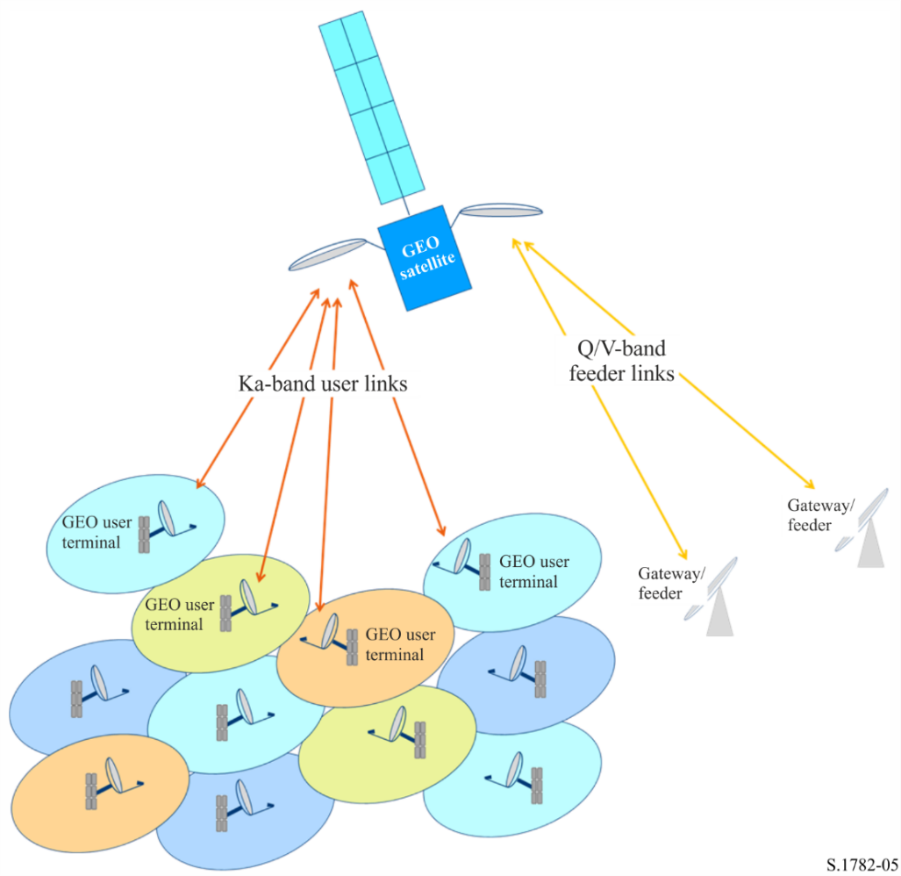

3.2 Satellite links
The Forward Link carriers between Feeder Stations and Users station through the satellite are assumed to employ DVB-S2X the ETSI standard for the extension of the second generation system for Broadcasting, Interactive Services, News Gathering and other broadband satellite applications.
The Return Link carriers uplinked from Users station for the Feeder Stations are assumed to employ DVB-RCS2, the ETSI standard for the second generation DVB Interactive Satellite System.
Both air interfaces can make use of Adaptive Coding and Modulation (ACM), in order to optimize the efficiency of each link, and to cater for atmospheric attenuations which are a particular concern when using very high frequencies such as Ka-, Q- and V-bands.

3.3 Coverage
As an example, coverage of Africa is proposed. State-of-the-art satellites can provide up to ~500 user beams, and this example is based on 420 spots generated from three or four satellite reflectors.
Figure 6
Example Coverage for broadband Internet access by an FSS system
designed for small Ka-Band Consumer earth station antennas over Africa
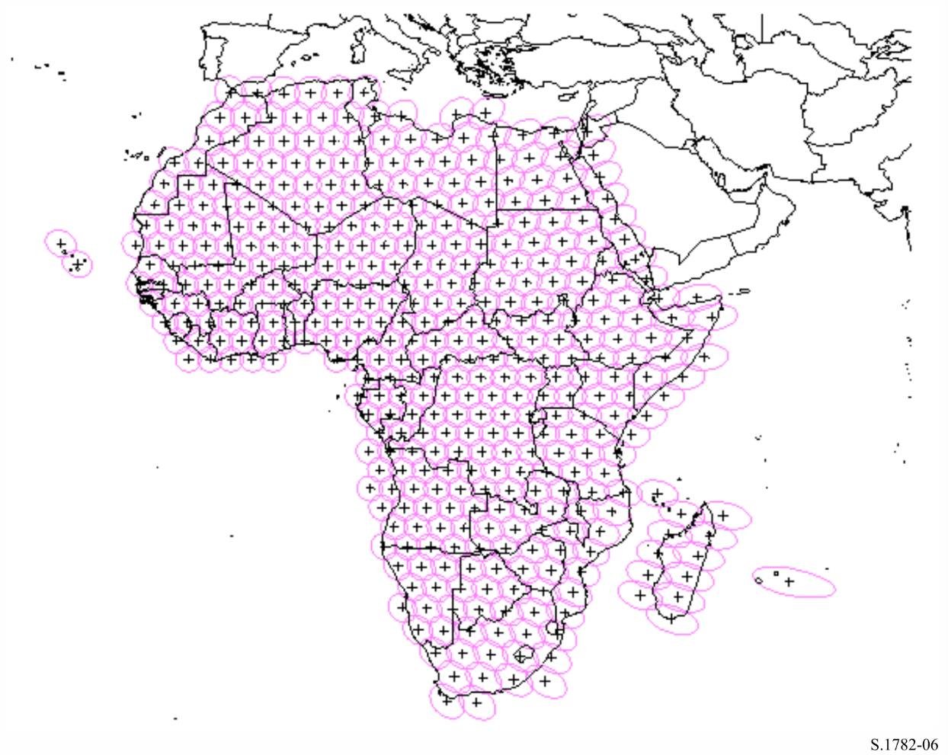

3.4 Satellite payload arrangement
The satellite antenna subsystem can make use of Single Feed per Beam (one feed generates one spot) or Multi Feed per Beam arrangements (each spot is generated from multiple feeds). The trade-offs are made on performance and payload mass parameters. The repeater would be composed of the following sub-systems:
– the input section would use LNA/converters in a fairly classical mode;
– a Digital Transparent Processor (DTP) would provide connectivity between Gateways and User beams and frequency selection on each User beam;
– the amplification section could either make use of TWTAs placed in a redundancy ring for a Single Feed per Beam antenna sub-system, or SSPAs placed at immediate proximity of the feeds in a Multi Feed per Beam arrangement.

4 Capacity per satellite (C_{S})
With the proposed number of beams, the capacity of the satellite would top 0.8 Tbit/s for the Forward Link. The requirements for the Return Link are usually less than that for the Forward Link, the target for overall capacity per satellite is nevertheless more than 1.0 Tbit/s.

* It is expected that there will be no discrimination to have access to global broadband Internet systems described in this Recommendation.

