|  |  |
| --- | --- |
| **Radiocommunication Study Groups** |  |
|  |  |
|  |  |
| Source: Document 7/53(Rev.1)  Subject: WRC-15 agenda item 1.12 | **Document 7/BL/11-E** |
| **4 December 2013** |
| **English only** |
| Radiocommunication Study Group 7 | |
| DRAFT NEW Recommendation ITU-R RS.[EESS-9GHz-CHAR] | |
| Characteristics of synthetic aperture radars operating in the Earth  exploration-satellite service (active) around 9 600 MHz | |

Scope

This Recommendation provides characteristics for synthetic aperture radars operating in the Earth exploration-satellite service (active) allocated around 9 600 MHz. This information should enable sharing and compatibility studies with other radio services coexisting in the same frequency range or nearby frequency ranges. The use of this frequency range comprises remote sensing satellite systems that are implemented with different radar transmission bandwidths ranging from 100 MHz up to 1 200 MHz.

The ITU-R Radiocommunication Assembly,

considering

*a)* that spaceborne active microwave remote sensing requires specific frequency ranges depending on the physical phenomena to be observed;

*b)* that certain frequency bands have been allocated for spaceborne active microwave remote sensing;

*c)* that the transmission bandwidth of a radar sensor is directly related to the achievable measurement resolution;

*d)* that a growing demand for high-resolution radar information exists as shown in Report ITU-R RS.[EESS-9GHz_SpectReq];

*e)* that observations in the 9 GHz frequency range provide data critical to the study of the characteristics of the Earth and its natural phenomena, including data relating to the state of the environment;

*f)* that only the 9 600 MHz frequency range offers the most advantageous situation of highest possible bandwidth in a frequency band which offers good propagation conditions,

recognizing

that Recommendation ITU-R RS.1166 provides performance and interference criteria for EESS (active) sensors including synthetic aperture radars operating around 9 600 MHz,

recommends

that the characteristics of typical space-borne synthetic aperture radar systems operating in the 9 GHz range, as described in the Annex, should be used for sharing and compatibility studies involving EESS (active) around 9 600 MHz.

Annex

Characteristics of synthetic aperture radars operating in the Earth   
exploration-satellite service (active) around 9 600 MHz

# 1 Principles of synthetic aperture radars (SAR)

A synthetic aperture radar (SAR) is a coherent spaceborne side-looking radar system which utilizes a satellites flight path to emulate an extremely large antenna or aperture electronically, and that generates high-resolution remote sensing imagery.

In principle, a SAR is an active phased array antenna. But instead of using a large number of parallel antenna elements, SAR uses one antenna element in time-multiplex. The different geometric positions of the antenna elements are the results of the moving platform.

The satellite travels forward in the flight direction with a nadir pointing towards the center of the Earth. The microwave beam is transmitted obliquely at right angles to the flight direction illuminating a swath. Range refers to the across-track dimension perpendicular to the flight direction, while azimuth refers to the along-track dimension parallel to the flight direction. Swath width refers to the strip of the Earth’s surface from which data is collected as a side-looking radar. It is the width of the imaged scene in the range dimension. The longitudinal extent of the swath is defined by the motion of the aircraft with respect to the surface, whereas the swath width is measured perpendicularly to the longitudinal extent of the swath.

Over time, individual transmit/receive cycles (pulse repetition time, PRT) are completed and the gathered data from each cycle is stored in on-board memory. The signal processing uses magnitude and phase of the received signals over successive pulses from elements of a synthetic aperture. After a given number of cycles, the stored data is recombined to create a high resolution image of the terrain being over flown.

# 2 Modes of operation of synthetic aperture radars (SAR)

## 2.1 Geometry

The SARs operating near 9.6 GHz are controlled via ground command to turn on and off as required to view only specific areas on the Earth. From all SAR modes shown in Figure 1, the full 1 200 MHz chirp bandwidth is only intended for use when operating in spotlight mode.

Other modes may use the frequency band 9 300-9 900 MHz, in accordance with provisions given by RR footnotes Nos. **5.475A**, **5.476A**, **5.478A** and **5.478B**.

The conventional SAR strip map mode assumes a fixed pointing direction of the radar antenna broadside to the platform track. A strip map is an image formed in width by the swath of the SAR and follows the length contour of the flight line of the platform itself. In the scanSAR mode, the SAR can illuminate several sub-swaths by scanning its antenna into different positions.

Figure 1

Modes of operations for SAR system in the 9 GHz EESS allocation



Spotlight is the SAR mode for obtaining highest resolution by electronic steering of the radar beam pointing at a target in the beam thus forming a longer synthetic aperture. The spotlight mode is capable of improving the resolution of SAR imaging capability to less than 30 cm. As more pulses are used, the azimuth resolution also improves.

Spotlight mode of operation is usually at the expense of spatial coverage, as other areas within a given accessibility swath of the SAR cannot be illuminated while the radar beam is spotlighting over a particular target area. Details on the imaging geometries of this mode are shown in Figure 2.

Data will typically be collected by taking between 49 and 65 sub-swaths of 20 km in range by 0.35 km in azimuth. This data can then be used to create a mosaic of sub-swaths in azimuth to process a 5 km by 5 km image.

All SARs are controlled via ground command to turn on and off as required to view specific areas on the Earth. The “on”-command triggers a transmission of radio frequency pulses (chirps) for a short period of around five seconds or less depending on the intended observation.

Figure 2

EESS SAR imaging geometry for high resolution spotlight mode  
(wideband with 1 200 MHz chirp bandwidth)



## 2.2 Timing characteristics for SAR-4 in high resolution mode

As noted in 2.1 above, the maximum bandwidth of 1 200 MHz is only used in spotlight mode of the SAR-4 system, when the highest radar picture resolution is required.

In this mode, SAR-4 transmits for a short period (typically 5 seconds) per event of SAR exposure (“snapshot”). During the five seconds of transmission the satellite travels actually more than 38 km along the orbit track, thus permanently changing the effective incident angle into the exposed spot area as shown in Figure 2. In spotlight mode there can be up to 20 snapshot events per satellite orbit (95 minutes), with a minimum time of 1 second between consecutive events, corresponding to a distance of 45 km on the ground. A graphical representation of the situation is given in Figure 3.

In a sun-synchronous orbit the satellite permanently travels along the day-night terminator. With a typical altitude of 515 km the periodicity of the sun-synchronous orbit results in a track of the sub-satellite point that repeats every 11 days. As a result of orbit requirements, and depending on geographic latitude, a radar location and adjacent areas are not visible more often than twice a day.

Adjacent areas are considered to be areas affected by antenna sidelobe illumination. Peak level areas and adjacent areas are illuminated not more than once per orbit period.

A SAR-4 system transmits pulses at a fixed duty cycle of 50 µsec followed by 120 µsec of silence. The pulse timing is adapted to a fixed pulse repetition rate. During the 50 µsec of each transmission pulse the unmodulated (CW) transmit carrier sweeps over the entire bandwidth of 1 200 MHz (“chirp”). The resulting transmission duty cycle, as shown in Table 1, remains fixed under all conditions of pulse width and pulse repetition rate.

FIGURE 3

Minimum separation distance between two consecutive targets

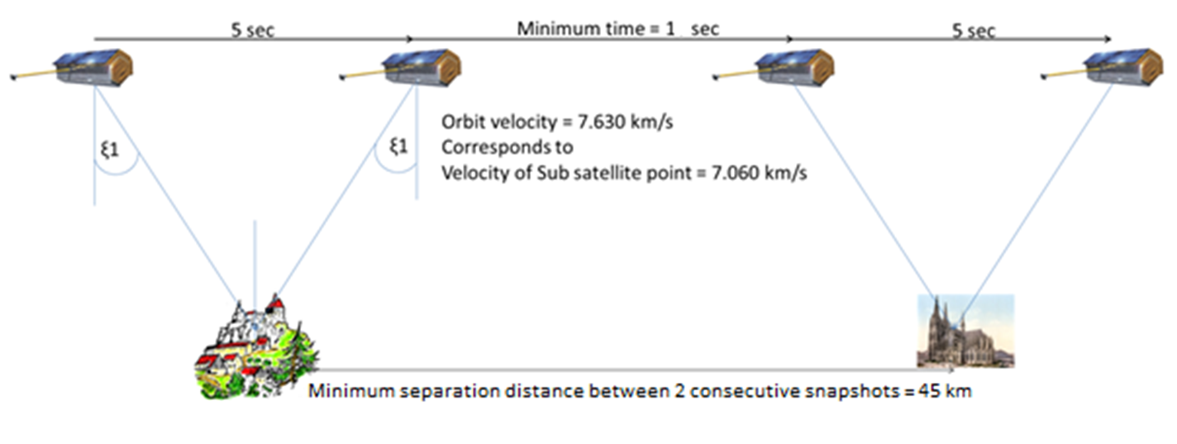

Other SAR modes are described in Report ITU-R RS.2178.

Figure 4 shows the ground tracks of the sub-satellite point for 14 orbital periods of a SAR-4 satellite. During each orbit period the Earth rotates by about 23.7°. In case that there is an overhead   
(90° elevation) path over one location, the orbit before and the orbit thereafter will appear at lower maximum elevation angles (close to the horizons) of the station.

Figure 4

SAR-4 track of sub-satellite points for 14 orbital periods of 1h 34m 49s each (15.19 rev/d)

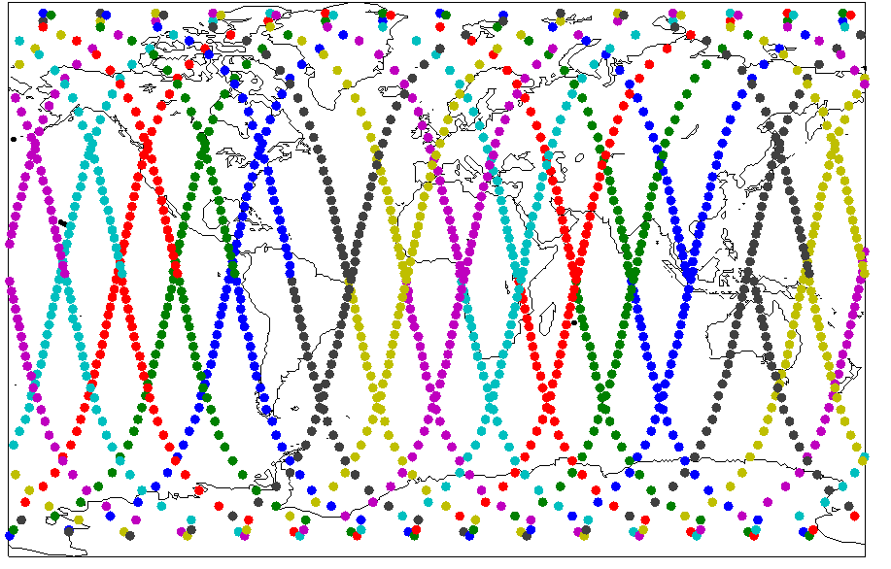

Figure 5 provides examples for overhead paths and their corresponding illumination condition at three typical latitudes. In each of the pictures in Figure 5, an area in blue can be seen on both sides of the satellite track. This shows the domain where a SAR instrument would illuminate an area in spotlight mode at one moment in time.

Due to the movement of the satellite itself, the sub-satellite point moves along the sub-satellite track[1] at 7.06 km/s. The target is only be illuminated when it is within this blue area (within the satellite main beam lobe), with a maximum illumination time of 5 to 7 seconds depending on the actual target location with respect to the satellite track.

When both the main beam and the sidelobes are considered, the maximum illumination time would be longer. The consequences in terms of harmful interference will depend on the service and system considered. The information below is based on the main beam illuminations.

Figure 5

Satellite illumination zone (overhead path of satellite)

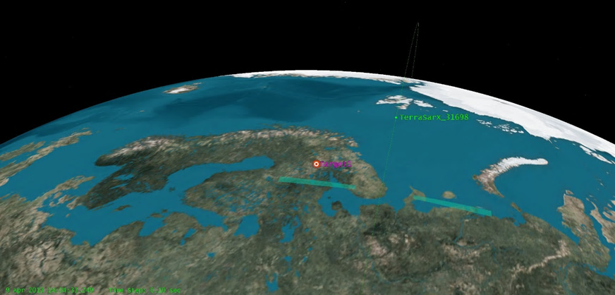

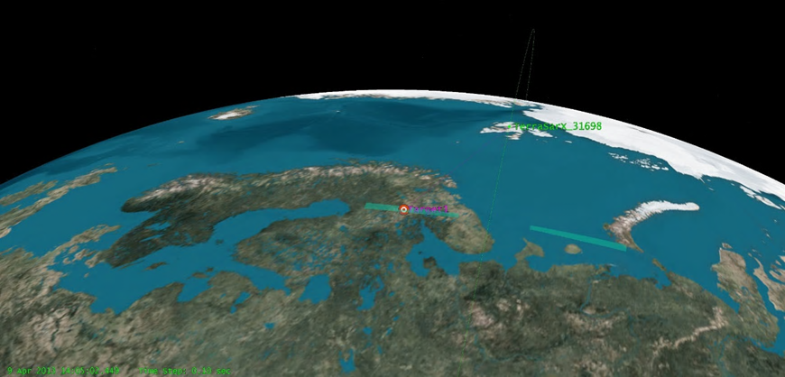

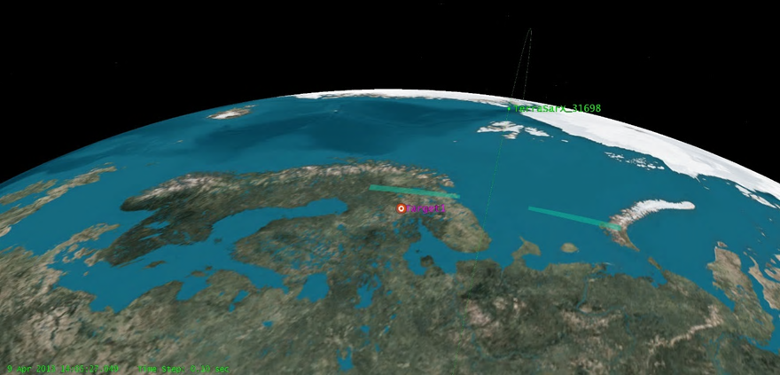

Figure 6 and Table 1 provide, for a given location on Earth, the potential illumination times and accumulation over 11 days after which the track of the sub-satellite points will exactly repeat. There are up to four potential illuminations per day at high latitudes. As shown in Figure 6 the number of illuminations varies per day from zero to four.

Figure 6

Illumination opportunities over a full 11day period at high latitude

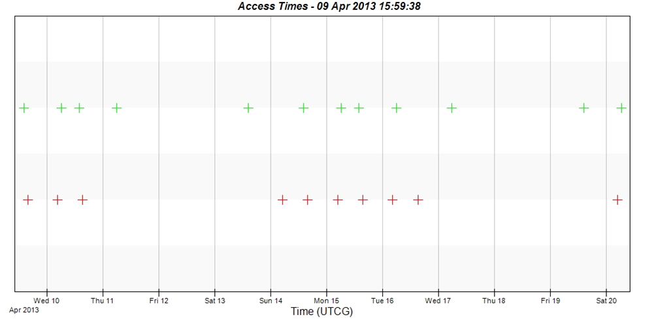

Table 1

Accumulated time of potential illuminations over a full 11day period at high latitude

| Start Time (UTCG) | | | Stop Time (UTCG) | | Duration (sec) |
| --- | --- | --- | --- | --- | --- |
| 9 Apr 2013 14:04:58.246 | | | 9 Apr 2013 14:05:05.008 | | 6.762 |
| 9 Apr 2013 15:38:58.735 | | | 9 Apr 2013 15:39:06.027 | | 7.292 |
| 10 Apr 2013 04:29:51.820 | | | 10 Apr 2013 04:29:58.819 | | 6.999 |
| 10 Apr 2013 06:03:50.310 | | | 10 Apr 2013 06:03:57.310 | | 7.000 |
| 10 Apr 2013 13:47:56.501 | | | 10 Apr 2013 13:48:04.209 | | 7.708 |
| 10 Apr 2013 15:21:49.102 | | | 10 Apr 2013 15:21:55.247 | | 6.145 |
| 11 Apr 2013 05:46:48.240 | | | 11 Apr 2013 05:46:54.287 | | 6.047 |
| 13 Apr 2013 14:30:27.763 | | | 13 Apr 2013 14:30:33.100 | | 5.337 |
| 14 Apr 2013 04:55:30.126 | | | 14 Apr 2013 04:55:35.471 | | 5.345 |
| 14 Apr 2013 14:13:22.852 | | | 14 Apr 2013 14:13:29.144 | | 6.291 |
| 14 Apr 2013 15:47:27.234 | | | 14 Apr 2013 15:47:35.117 | | 7.882 |
| 15 Apr 2013 04:38:19.663 | | | 15 Apr 2013 04:38:26.098 | | 6.435 |
| 15 Apr 2013 06:12:13.167 | | | 15 Apr 2013 06:12:20.630 | | 7.464 |
| 15 Apr 2013 13:56:19.267 | | | 15 Apr 2013 13:56:26.513 | | 7.246 |
| 15 Apr 2013 15:30:15.649 | | | 15 Apr 2013 15:30:22.348 | | 6.699 |
| 16 Apr 2013 04:21:07.202 | | | 16 Apr 2013 04:21:14.804 | | 7.602 |
| 16 Apr 2013 05:55:10.750 | | | 16 Apr 2013 05:55:17.266 | | 6.517 |
| 16 Apr 2013 15:13:05.560 | | | 16 Apr 2013 15:13:11.149 | | 5.589 |
| 17 Apr 2013 05:38:06.586 | | | 17 Apr 2013 05:38:12.148 | | 5.562 |
| 19 Apr 2013 14:21:42.280 | | | 19 Apr 2013 14:21:48.106 | | 5.826 |
| 20 Apr 2013 04:46:41.507 | | | 20 Apr 2013 04:46:47.403 | | 5.896 |
| 20 Apr 2013 06:20:30.148 | | | 20 Apr 2013 06:20:38.073 | | 7.924 |
| Global Statistics | Value | |
| Min Duration (sec) | 5.337 | |
| Max Duration (sec) | 7.924 | |
| Mean Duration (sec) | 6.617 | |
| Total Duration (sec) | 145.568 | |

The total possible illumination time is 145.568 seconds over 11 days, which corresponds to 0.02% of the time.

Figures 7 and Table 2 show the conditions for radar locations at mid-latitudes. In these cases the number of potential illuminations per day varies between 0 and 2.

Figure 7

Illumination opportunities over a full 11day period at medium latitude

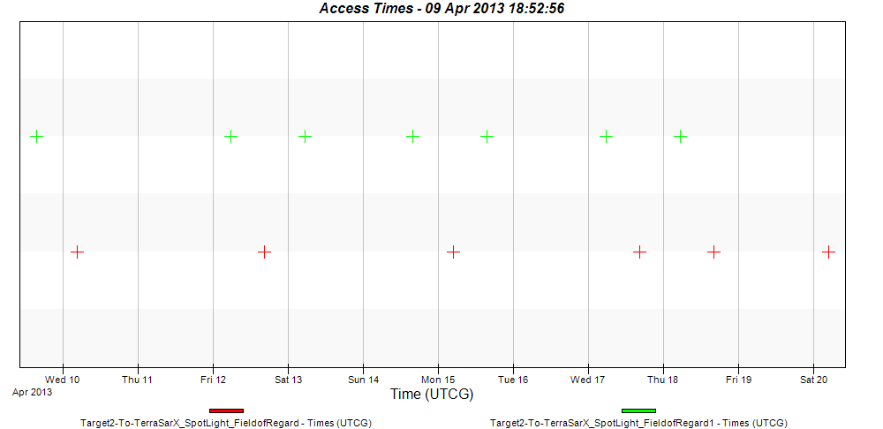

Table 2

Accumulated time of potential illuminations over a full 11day period at medium latitude

| Start Time (UTCG) | | Stop Time (UTCG) | | Duration (sec) |
| --- | --- | --- | --- | --- |
| 9 Apr 2013 15:34:45.714 | | 9 Apr 2013 15:34:52.069 | | 6.355 |
| 10 Apr 2013 04:34:36.995 | | 10 Apr 2013 04:34:44.635 | | 7.639 |
| 12 Apr 2013 05:34:20.860 | | 12 Apr 2013 05:34:27.843 | | 6.983 |
| 12 Apr 2013 16:17:22.834 | | 12 Apr 2013 16:17:29.214 | | 6.38 |
| 13 Apr 2013 05:17:18.746 | | 13 Apr 2013 05:17:23.991 | | 5.246 |
| 14 Apr 2013 15:43:10.577 | | 14 Apr 2013 15:43:16.078 | | 5.501 |
| 15 Apr 2013 04:43:04.397 | | 15 Apr 2013 04:43:11.070 | | 6.673 |
| 15 Apr 2013 15:26:06.532 | | 15 Apr 2013 15:26:13.786 | | 7.255 |
| 17 Apr 2013 05:42:41.045 | | 17 Apr 2013 05:42:48.910 | | 7.865 |
| 17 Apr 2013 16:25:46.303 | | 17 Apr 2013 16:25:53.630 | | 7.327 |
| 18 Apr 2013 05:25:39.006 | | 18 Apr 2013 05:25:45.093 | | 6.088 |
| 18 Apr 2013 16:08:37.576 | | 18 Apr 2013 16:08:43.009 | | 5.433 |
| 20 Apr 2013 04:51:25.641 | | 20 Apr 2013 04:51:31.402 | | 5.761 |
| Global Statistics | Value | |
| Min Duration (sec) | 5.246 | |
| Max Duration (sec) | 7.865 | |
| Mean Duration (sec) | 6.500 | |
| Total Duration (sec) | 84.506 | |

In this case the total access time reduces to 84.5 seconds over the 11 days, which is 0.009% of the time.

Figure 8 and Table 3 show the conditions for potential illuminations at mid-latitudes. In these cases the number of potential illuminations per day varies between 0 and 2.

Figure 8

Illumination opportunities over a full 11day period at low latitudes

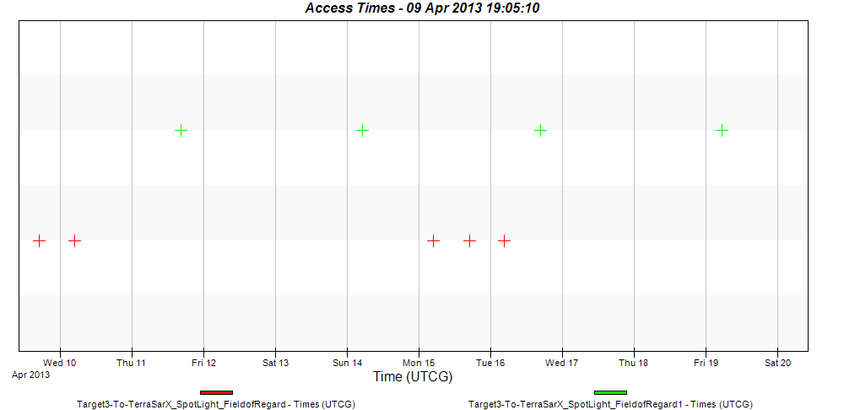

Table 3

Accumulated time of potential illuminations over a full 11day period at low latitudes

| Start Time (UTCG) | | Stop Time (UTCG) | | Duration (sec) |
| --- | --- | --- | --- | --- |
| 9 Apr 2013 17:00:08.771 | | 9 Apr 2013 17:00:15.801 | | 7.03 |
| 10 Apr 2013 04:43:31.960 | | 10 Apr 2013 04:43:38.416 | | 6.456 |
| 11 Apr 2013 16:26:02.928 | | 11 Apr 2013 16:26:09.455 | | 6.528 |
| 14 Apr 2013 05:09:00.363 | | 14 Apr 2013 05:09:06.089 | | 5.725 |
| 15 Apr 2013 04:51:56.973 | | 15 Apr 2013 04:52:02.103 | | 5.13 |
| 15 Apr 2013 16:51:29.517 | | 15 Apr 2013 16:51:35.145 | | 5.628 |
| 16 Apr 2013 04:34:50.485 | | 16 Apr 2013 04:34:58.396 | | 7.911 |
| 16 Apr 2013 16:34:25.460 | | 16 Apr 2013 16:34:30.684 | | 5.224 |
| 19 Apr 2013 05:17:18.707 | | 19 Apr 2013 05:17:25.754 | | 7.047 |
| Global Statistics | Value | |
| Min Duration (sec) | 5.13 | |
| Max Duration (sec) | 7.911 | |
| Mean Duration (sec) | 6.298 | |
| Total Duration (sec) | 56.679 | |

For a target at low latitudes, the number of accesses per day is limited to less than 2, and the total possible illumination time is 56.6 seconds corresponding to 0.006% of the time.

# 3 Technical characteristics of EESS SAR Sensors

Technical characteristics of spaceborne active sensors in the 9 GHz frequency range are given in Table 4.

Corresponding antenna gain patterns of all SAR systems are provided in Tables 5 to 8, respectively.

Table 5 gives the antenna pattern of SAR-4. The antenna patterns of SAR-1 to SAR-3 systems are provided in Report [ITU-R RS.2094](http://www.itu.int/pub/R-REP-RS.2094-2007).

TABLE 4

Technical characteristics of EESS SAR systems

| Parameter | SAR-1 | SAR-2 | SAR-3 | SAR-4 |
| --- | --- | --- | --- | --- |
| Orbital altitude (km) | 400 | 619 | 506 | 510 |
| Orbital inclination (degrees) | 57 | 98 | 98 | 98 |
| RF centre frequency (GHz) | 9.6 | 9.6 | 9.6 | 9.3-9.9 (*) |
| Peak radiated power (W) | 1 500 | 5 000 | 25 000 | 7 000 |
| Pulse modulation | Linear FM chirp | Linear FM chirp | Linear FM chirp | Linear FM  chirp |
| Chirp bandwidth (MHz) | 10 | 400 | 450 | 1 200 |
| Pulse duration (μs) | 33.8 | 10-80 | 1-10 | 50 |
| Pulse repetition rate (pps) | 1 736 | 2 000-4 500 | 410-515 | 6 000 |
| Duty cycle (%) | 5.9 | 2.0-28.0 | 0.04-0.5 | 30 |
| Range compression ratio | 338 | < 12 000 | 450-4 500 | 60 000 |
| Antenna type | Slotted waveguide | Planar array | Planar phased array | Planar array |
| Antenna peak gain (dBi) | 44.0 | 44.0-46.0 | 39.5-42.5 | 47.0 |
| e.i.r.p. (dBW) | 75.8 | 83.0 | 83.5-88.5 | 85.5 |
| Antenna orientation from Nadir | 20˚ to 55˚ | 34˚ | 20˚ to 44˚ | 18.5° to 49.3° |
| Antenna beamwidth | 5.5˚ (El)  0.14˚ (Az) | 1.6-2.3˚ (El) 0.3˚ (Az) | 1.1-2.3˚ (El) 1.15˚ (Az) | 1.13° (El) 0.53° (Az) |
| Antenna polarization | Linear vertical | Linear HH or VV | Linear horizontal/ vertical | Linear horizontal/ vertical |
| System noise temperature (K) | 551 | 500 | 600 | 500 |
| (*) Final value depends on the decision eventually taken under WRC-15 agenda item 1.12. | | | | |

TABLE 5

SAR-1 antenna gain pattern near 9.6 GHz

| Pattern | Gain G(θ) (dBi) as a function of off-axis angle θ (degrees) | Angular range (degrees) |
| --- | --- | --- |
| Vertical (elevation) | G*v* (θ *v* ) = 44.0 – 0.397(θ *v* )2 G*v* (θ *v* ) = 24.5 G*v* (θ *v* ) = 9.5 G*v* (θ *v* ) = 22.5 | θ *v* < 7.1 7.1 < θ *v* < 30 30 < θ *v* < 60  θ *v* > 60 |
| Horizontal (azimuth) | G*h* (θ *h* ) = 0 – 612.2(θ *h* )2  G*h* (θ *h* ) = –12  G*h* (θ *h* ) = 0 – 27.0 (θ *h* )  G*h* (θ *h* ) = –35 | θ *h* < 0.14 0.14 < θ *h* < 0.44 0.44 < θ *h* < 1.3  θ *h* > 1.3 |
| Beam pattern | G(θ) = {G*v* (θ *v* ) + G*h* (θ *h* ), –3} max |  |

TABLE 6

SAR-2 antenna gain pattern near 9.6 GHz

| Pattern | Gain G(θ) (dBi) as a function of off-axis angle θ (degrees) | Angular range (degrees) |
| --- | --- | --- |
| Vertical (elevation) | G*v* (θ *v* ) = 46.0 – 0.835(θ *v* )2 G*v* (θ *v* ) = 31.0 G*v* (θ *v* ) = 26.0 G*v* (θ *v* ) = 10.0 | θ *v* < 3.8 3.8 < θ *v* < 15 15 < θ *v* < 30  θ *v* > 30 |
| Horizontal (azimuth) | G*h* (θ *h* ) = 0 – 444.5(θ *h* )2 G*h* (θ *h* ) = – 16  G*h* (θ *h* ) = – 20.0 (θ *h* ) | θ *h* < 0.3 0.3 < θ *h* < 0.7  θ *h* > 0.7 |
| Beam pattern | G(θ) = {G*v* (θ *v* ) + G*h* (θ *h* ), –3} max |  |

TABLE 7

SAR-3 antenna gain pattern near 9.6 GHz

| Pattern | Gain G(θ) (dBi) as a function of off-axis angle θ (degrees) | Angle range (degrees) |
| --- | --- | --- |
| Vertical (elevation) | G*v* (θ*v* ) = 42.5 – 9.92(θ*v* )2 G*v* (θ*v* ) = 31.4 – 0.83 θ*v* G*v* (θ*v* ) = 10.5 – 0.133 θ*v* | 0 < θ*v* < 1.1 1.1 < θ*v* < 30  θ*v* > 30 |
| Horizontal (azimuth) | G*h* (θ*h* ) = 0.0 – 9.07(θ*h* )2 G*h* (θ*h* ) = +1.9 – 12.08 θ*h* G*h* (θ*h* ) = – 48 | 0 < θ*h* < 1.15 1.15 < θ*h* < 4.13  θ*h* > 4.13 |
| Beam pattern | G(θ) = G*v* (θ*v* ) + G*h* (θ*h* ) |  |

TABLE 8

SAR-4 antenna gain pattern near 9.6 GHz

| Pattern | Gain G(θ) (dBi) as function of off-axis angle θ (degrees) | Angular range (degrees) |
| --- | --- | --- |
| Vertical (elevation) | Gv(θv) = 47.0 – 9.91(θv)² Gv (θv ) = 35.9 – 0.83 θv  Gv(θv) = 11.0 | θv < 1.1 1.1 ≤ θv ≤ 30 θv > 30 |
| Horizontal (azimuth) | Gh(θh) = 0 – 45.53(θh)² Gh(θh) = -10.97-2.00 θh  Gh(θh) = -35.0 | θh ≤ 0.5 0.5 < θh ≤ 12 θh > 12 |
| Beam pattern | G(θ) = Gv(θv) + Gh(θh) |  |

Table 9 provides an alternate antenna pattern to be used when a more precise model for the average sidelobe levels (3dB below the peak sidelobes) should be considered.

TABLE 9

SAR-4 average antenna gain pattern near 9.6 GHz

| Pattern | Gain G(θ) (dBi) as function of  off-axis angle θ (degrees) | Angular range (degrees) |
| --- | --- | --- |
| Vertical (elevation) | Gv(θv) = 47.0 – 9.91 (θv)²  Gv(θv) = 35.189 – 1.944θv  Gv(θv) = 21.043 – 0.468θv  Gv(θv) = 12.562 – 0.185θv  Gv(θv) = 3.291 | θv < 1.149  1.149 ≤ θv ≤ 9.587  9.587 ≤ θv ≤ 29.976  29.976 ≤ θv ≤ 50  50.0 ≤ θv |
| Horizontal (azimuth) | Gh(θh) = 0 – 45.53(θh)²  Gh(θh) = -11.210 – 4.022θh  Gh(θh) = -26.720 – 0.953θh  Gh(θh) = -35.031 – 0.388θh  Gh(θh) = -41.936 – 0.158θh  Gh(θh) = -51.387 | θh ≤ 0.542  0.542 < θh ≤ 5.053  5.053 < θh ≤ 14.708  14.708 < θh ≤ 30.00  30.00 < θh ≤ 59.915  59.915 < θh |
| Beam pattern | G(θ) = Gv(θv) + Gh(θh) |  |

Figure 9

Antenna pattern along track

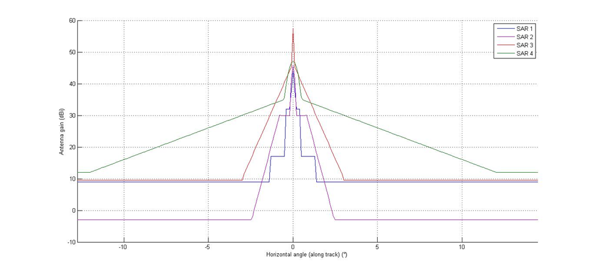

Figure 10

Antenna pattern cross track

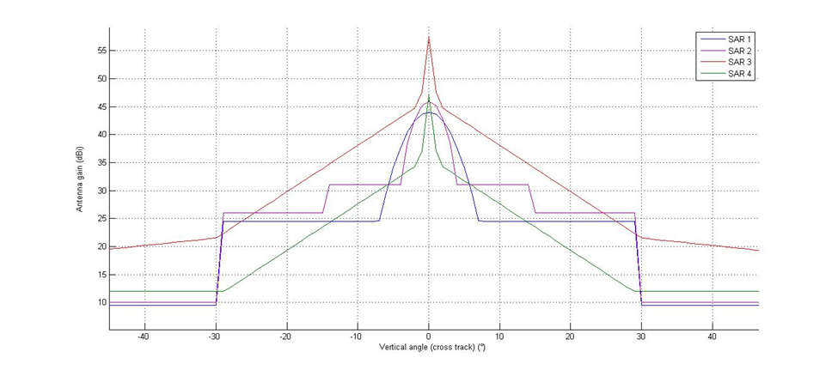

FIGURE 11

Simplified peak and complex average patterns along track for SAR-4

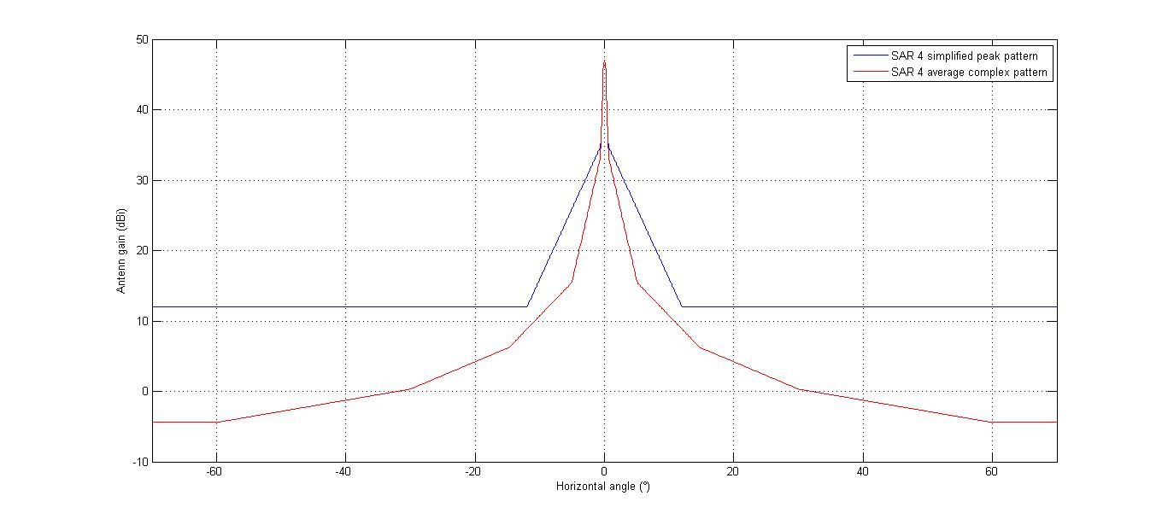

FIGURE 12

Simplified peak and complex average patterns cross track for SAR-4

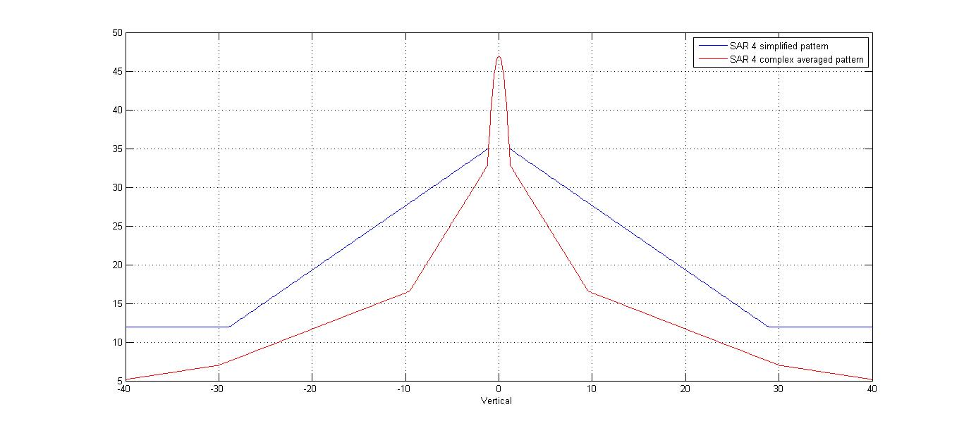

_____________

1. Track of the sub-satellite points on the Earth's surface given by a virtual line between spacecraft and center of the Earth.