Recommendation ITU-R RS.2042-2
(12/2023)
RS Series: Remote sensing systems

Typical technical and operating characteristics for spaceborne radar sounder systems using the 40-50 MHz band

Foreword
The role of the Radiocommunication Sector is to ensure the rational, equitable, efficient and economical use of the radio-frequency spectrum by all radiocommunication services, including satellite services, and carry out studies without limit of frequency range on the basis of which Recommendations are adopted.
The regulatory and policy functions of the Radiocommunication Sector are performed by World and Regional Radiocommunication Conferences and Radiocommunication Assemblies supported by Study Groups.

Policy on Intellectual Property Right (IPR)
ITU-R policy on IPR is described in the Common Patent Policy for ITU-T/ITU-R/ISO/IEC referenced in Resolution ITU-R 1. Forms to be used for the submission of patent statements and licensing declarations by patent holders are available from http://www.itu.int/ITU-R/go/patents/en where the Guidelines for Implementation of the Common Patent Policy for ITU-T/ITU-R/ISO/IEC and the ITU-R patent information database can also be found.

Series of ITU-R Recommendations
(Also available online at https://www.itu.int/publ/R-REC/en)
Series | Title
BO | Satellite delivery
BR | Recording for production, archival and play-out; film for television
BS | Broadcasting service (sound)
BT | Broadcasting service (television)
F | Fixed service
M | Mobile, radiodetermination, amateur and related satellite services
P | Radiowave propagation
RA | Radio astronomy
RS | Remote sensing systems
S | Fixed-satellite service
SA | Space applications and meteorology
SF | Frequency sharing and coordination between fixed-satellite and fixed service systems
SM | Spectrum management
SNG | Satellite news gathering
TF | Time signals and frequency standards emissions
V | Vocabulary and related subjects

Note: This ITU-R Recommendation was approved in English under the procedure detailed in Resolution ITU-R 1.

Electronic Publication
Geneva, 2024

© ITU 2024
All rights reserved. No part of this publication may be reproduced, by any means whatsoever, without written permission of ITU.

RECOMMENDATION ITU-R RS.2042-2
Typical technical and operating characteristics for spaceborne radar
sounder systems using the 40-50 MHz band
(2014-2018-2023)
Scope
This Recommendation provides the technical and operating characteristics of spaceborne radar sounder that would operate in the 40-50 MHz range. This information is to be used for compatibility studies.
Keywords
Earth exploration-satellite service (active), spaceborne active sensor, radar sounder, glacial bed surface, subsurface scattering layers, earth fossil aquifers in desertic environments, Shallow Radar Sounder (SHARAD)
Related ITU-R Recommendations and Reports
Report ITU-R M.2234 – The feasibility of sharing sub-bands between oceanographic radars operating in the radiolocation service and fixed and mobile services within the frequency band 3-50 MHz
Report ITU-R RS.2536 – Sharing and compatibility studies related to spaceborne radar sounders in the 40-50 MHz frequency band
The ITU Radiocommunication Assembly,
considering
a) that spaceborne radar sounders can provide radar maps of subsurface scattering layers to locate water/ice deposits using active spaceborne sensing;
b) that the mission scientific objectives are 1) to understand the global thickness, inner structure, and the thermal stability of the Earth’s ice sheets (e.g. in Greenland and Antarctica) as an observable parameter of earth climate evolution, and 2) to understand the occurrence, distribution and dynamics of the earth fossil aquifers in desertic environments (e.g. in northern Africa and the Arabian peninsula) as key elements in understanding recent paleoclimatic changes;
c) that the measurement of reflectivity from subsurface scattering layers as deep as 10 m to 100 m for shallow aquifers and groundwater conduits, and on the order of 5 km for basal interface topography and ice-sheet thickness, is necessary;
d) that the penetration depth from subsurface scattering layers at microwave wavelengths increases approximately inversely with the frequency;
e) that worldwide, periodic measurements of subsurface water/ice deposits require the use of spaceborne active sensors;
f) that the 40-50 MHz frequency range is preferable to satisfy all requirements for spaceborne radar sounders;
g) that the 40-50 MHz band is allocated to the fixed, mobile and broadcasting services on a primary basis;
h) that the uses of the 40.98-41.015 MHz frequency band by the space research service are on a secondary basis;
i) that country footnotes in the Table of Frequency Allocations for the 40-50 MHz frequency range provide primary or secondary allocations for the broadcasting, fixed and mobile, aeronautical radionavigation and radiolocation services in certain parts of the world;
j) that the Table of Frequency Allocations for the bands adjacent to the 40-50 MHz frequency range provides primary and secondary allocations for the amateur service;
k) that operations of spaceborne radar sounder outside of EESS (active) allocations would be under RR No. 4.4;
l) that a bandwidth of 10 MHz is sufficient for use by spaceborne radar sounders;
m) that operational limitations have been identified as described in Annex 1,
recommends
that the characteristics given in Table 1 of the Annex should be used for sharing and compatibility studies related to spaceborne radar sounders in the 40-50 MHz frequency range.

Annex
Typical technical and operating characteristics for spaceborne radar
sounder systems using the 40-50 MHz band

1 Introduction
There is an interest among climate researchers in remote sensing in the vicinity of 40-50 MHz for remote measurements of the Earth’s subsurface providing radar maps of subsurface scattering layers with the intent of locating water/ice/deposits and examining sub-ice glacial bed surfaces using active spaceborne sensors. This Annex provides the preferred frequency band selection rationale, and typical technical and operating characteristics.
The technical and operating characteristics of active spaceborne sensors operating at 40-50 MHz are described.

2 Frequency band selection rationale
The reason for an allocation between 40 MHz and 50 MHz for a spaceborne sounding radar is based upon the following selection criteria: surface penetration, length scale of observation, region of electromagnetic scattering model, and previous work.

2.1 Surface penetration
Penetration of an incident radar wave is normally many tens of wavelengths. Under the proper conditions of wavelength and composition of the scattering medium, radio waves can readily penetrate the dielectric materials comprising the Earth’s surface and cover. A quantitative estimate of this depth δ_{p} is as follows:
(1)
where:
λ₀ : wavelength
e′ and e″ : real and imaginary parts of the surface dielectric constant.
Using this expression with the soil dielectric constants, Fig. 1 shows the surface penetration depths for 50 MHz, 500 MHz, and 5 000 MHz. From the Figure, it is evident that surface penetration at 50 MHz is deeper than for 500 MHz by a factor of 20 to 30, and is thus most favourable for Earth penetration studies. The objectives would be to provide radar maps of subsurface scattering layers with the intent to locate water/ice/deposits using active spaceborne sensors.
figure 1
Surface penetration depth
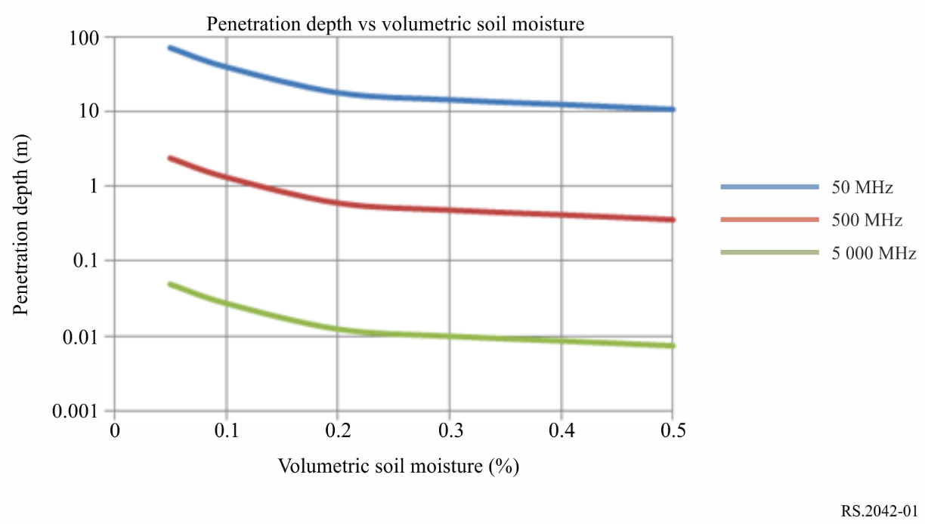

2.2 Length scale of observations
The addition of 50 MHz to the existing 435 MHz and 1 250 MHz bands would extend the range of length scales at which the roughness of the surface is observed. For many geologic surfaces, backscatter is dominated by that harmonic component of the surface whose wavelength is near the projected radar wavelength and longer, whereas, other components of the surface contribute only through second order effects. Thus, radar measurements at as many frequencies as possible over as wide a range of incidence angles as possible increase the ability to accurately describe the surface.

2.3 Region of electromagnetic scattering model
The addition of 50 MHz to the existing 435 MHz and 1 250 MHz bands would expand the region of validity of electromagnetic scattering models. The 50 MHz radar would be more sensitive to subsurface morphology because the rms height of the surface is a smaller fraction of the wavelength, resulting in a lower measured radar backscatter. The greater sensitivity of 50 MHz to subsurface morphology combined with the fact that the 50 MHz signals penetrate deeper into the soil, increases the subsurface volume in which scattering occurs, resulting in a much greater ratio of power received from the subsurface relative to that received from the surface than that at shorter wavelengths. Also, scatterers embedded in the alluvial cover will be smaller relative to 50 MHz than either 435 MHz or 1 250 MHz.

2.4 Previous work and regulatory status between 40-44 MHz band
A considerable amount of work in the form of ground-based and airborne radar systems development and data collection has already been done at 3-50 MHz. Along with this hardware development, computational work has been aimed at studying the surface penetration depth versus soil moisture content at 3-50 MHz and analysis of measuring ocean returns by oceanographic radars.
Airborne radars have made measurements around 50 MHz in the desertic areas in the Arabian Peninsula and Antarctica. Figure 2 shows a radargram with variations in the depth of the water table from 49 to 52 metres with data taken from airborne VHF radar in Kuwait in 2011.
figure 2
Radargram taken from airborne VHF radar in Kuwait in 2011
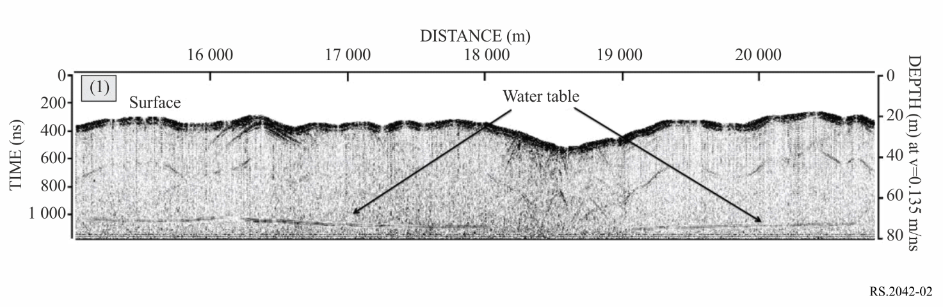
The frequency band 3-50 MHz was considered for the oceanographic radars along the coast (in the radiolocation service (RLS)) under WRC-12 agenda item 1.15 and the sharing studies were documented in Report ITU-R M.2234. WRC-12 agreed to allocate RLS through a combination of secondary and primary allocations on a regional and country basis with footnotes in sub-bands between 4-44 MHz (43.35-44 MHz was the highest frequency range allocating RLS with a country footnote (two countries)) with footnotes to protect the incumbent fixed and mobile services. Applications in the RLS are limited to oceanographic radars operating in accordance with Resolution 612 (Rev.WRC-12). Resolution 612 (Rev.WRC-12) also contains additional limitations to the oceanographic radars such as maximum e.i.r.p. of 25 dBW and a station identification (call sign) on the assigned frequency. In the Radio Regulations, there is no allocation to EESS (active) in the 3-50 MHz range. If the frequencies were chosen for the spaceborne system at higher or lower frequency bands, the hardware and computational work reference would need to be repeated for the airborne radar campaigns in the desertic areas.

3 Technical characteristics of a 40-50 MHz spaceborne sounding radar
The spaceborne sounding radar will operate at a centre frequency of 45 MHz covering a 10 MHz bandwidth. The resulting radar data will be used in the study of the Earth’s subsurface with radar mapping of subsurface scattering layers with the intent to locate water/ice/deposits. The characteristics of the 45 MHz spaceborne sounding radar are shown in Table 1.

3.1 Mission objectives
The spaceborne active sensor operating in the 40-50 MHz range will produce sub-surface data with a vertical resolution of 5-7 m, and will have a surface signal-to-noise ratio (SNR) of approximately 66 dB. The mission scientific objectives are:
1) to understand the global thickness, inner structure, and the thermal stability of the Earth’s ice sheets (e.g. in Greenland and Antarctica) as an observable parameter of Earth climate evolution; and
2) to understand the occurrence, distribution and dynamics of the Earth fossil aquifers in desertic environments (e.g. in northern Africa and the Arabian peninsula) as key elements in understanding recent paleoclimatic changes.
It should be noted that, taking into account the high investment cost associated with this type of sensor observations in the 40-50 MHz band, the number of spaceborne radar sounder missions operating simultaneously is expected to remain very low in number.

3.2 Orbital parameters
The spaceborne active sensors of this type are expected to be deployed on a low-Earth orbiting satellite, an inclination optimized for a sun synchronous orbit and an eccentricity less than 0.001. Orbital parameters of the proposed system can be found in Table 1.

3.3 Design parameters
A proposed system for the Earth orbiting sounding radar is an Earth enhanced duplicate of the Shallow Radar Sounder (SHARAD) which was a Mars orbiting sounding radar operating in the 15-25 MHz frequency range. The spaceborne sounding radar transmits an FM modulated pulse centred at 45 MHz with 10 MHz bandwidth at a pulse repetition frequency of 1 200 Hz. Each pulse has a duration of 85 µs. The peak RF power is 100 W, and the transmitted signal is circularly polarized. These design parameters are shown in Table 1.
TABLE 1
Spaceborne sounding radar characteristics in the 40-50 MHz frequency range
Sensor characteristics
Parameter | Value
Type | Radar Sounder
Orbit characteristics
Type of orbit | Circular, SSO
Altitude (km) | 400
Inclination (degree) | 97
Ascending node LST | 004:00
Eccentricity (degree) | 0
Orbits per day | 15.8
Repeat period (days) | 548
Antenna characteristics
Antenna type | 9 Element Cross Yagi
Number of beams | 1
Antenna Peak Gain (Transmit and Receive  –dBi) | 10
TABLE 1 (end)
Sensor characteristics
Parameter | Value
Antenna characteristics
Polarization | Circular
−3 dB beamwidth (degree) | 40
Antenna beam look angle (degree) | Nadir
Antenna beam azimuth angle (degree) | Nadir
Antenna elevation beamwidth (degree) | 40
Antenna azimuth beamwidth (degree) | 40
Sensor antenna pattern | See Fig. 3
Transmitter characteristics
RF centre frequency (MHz) | 45
RF 3 dB bandwidth (MHz) | 8
RF 20 dB bandwidth (MHz) | 10
Transmit peak power (dBW) | 20
Pulsewidth (μsec) | 85
Pulse repetition frequency (PRF) (Hz) | 1 200
Pulse modulation | Linear FM Chirp
Receiver characteristics
RF centre frequency (MHz) | 45
Gain (dB) | 40-50
SNR (dB) | 30
LNA bandwidth (MHz) | >100
Final IF filter bandwidth (MHz) | 12
Noise figure (dB) | 5
Minimum detectable signal level (dBm) | −132
Dynamic range (dB) | <20
The antenna pattern of the proposed system has a peak gain of 10 dBi, and beamwidth of 40 degrees in range and azimuth as shown in Fig. 3.
figure 3
9-element Yagi antenna pattern
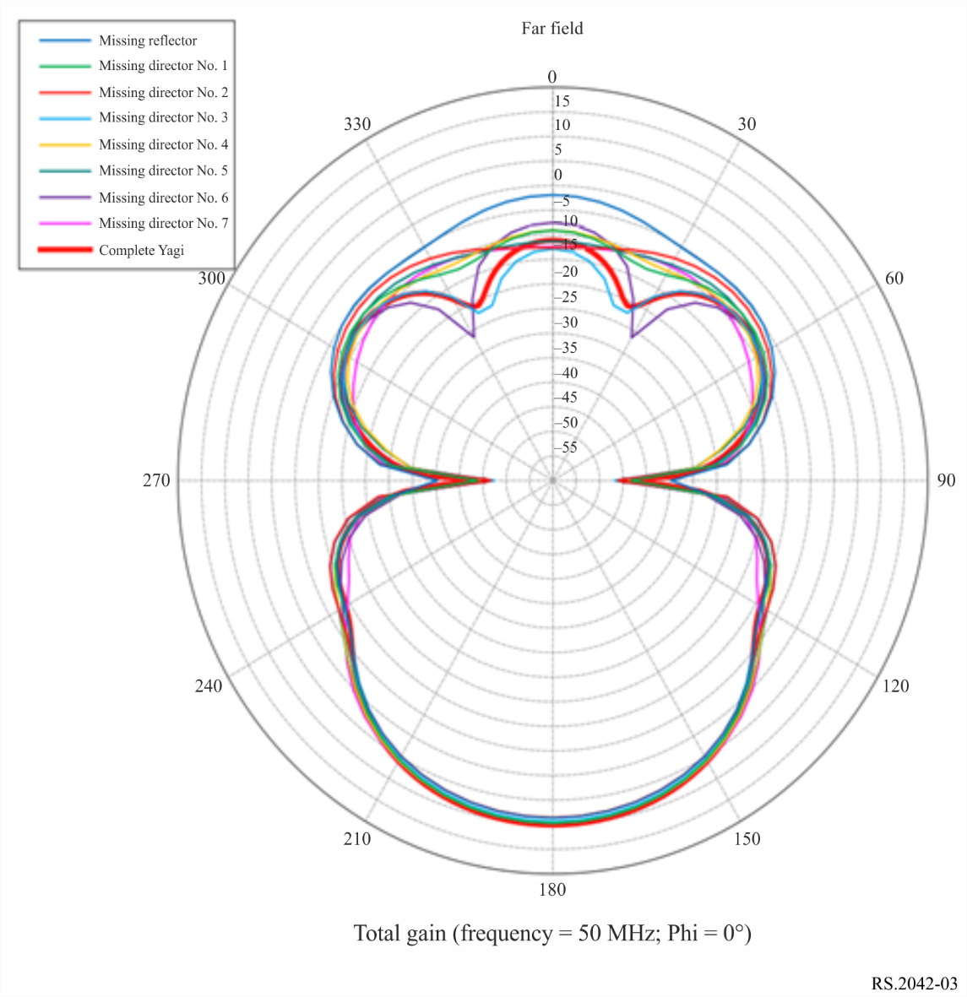

3.4 Operational geographic limitations
Sounding radars in the 40-50 MHz range are designed to operate in un-inhabited or sparsely populated areas of the ice sheets (e.g. in Greenland and Antarctica) and the deserts (e.g. in northern Africa and the Arabian Peninsula) and for limited duration. For example, the operation of the proposed mission is expected not to exceed 10 minutes in duration per 92.7 minute orbit.
Areas of coverage for the proposed regions of operations that depict the geographic area over which the transmitted signal will be propagated are included in Fig. 4.
FIGURE 4
Spaceborne radar sounder coverage
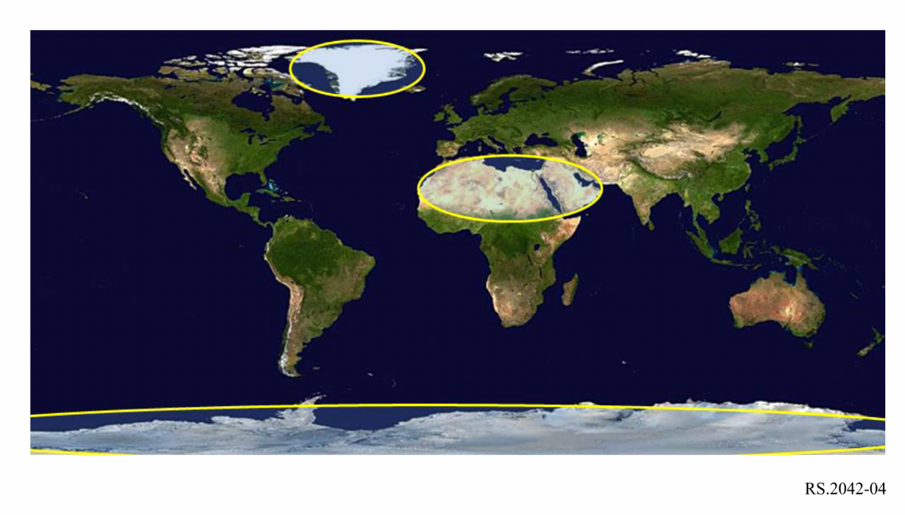
The sounding radars are designed to be operated only in a few hours window centred approximately around 4 a.m. local time. These times were chosen because ionospheric perturbations to the radar signal are at a minimum during this time period and use of the spectrum by other services is expected to be the lightest.

3.5 Emission spectrum
Figure 5 shows the typical chirp emission spectrum waveform that is expected for the radar sounder operating in the frequency range of 40-50 MHz. In practice, bandpass filtering is often applied to attenuate the out-of-band power.
FIGURE 5
Typical chirp emission spectrum
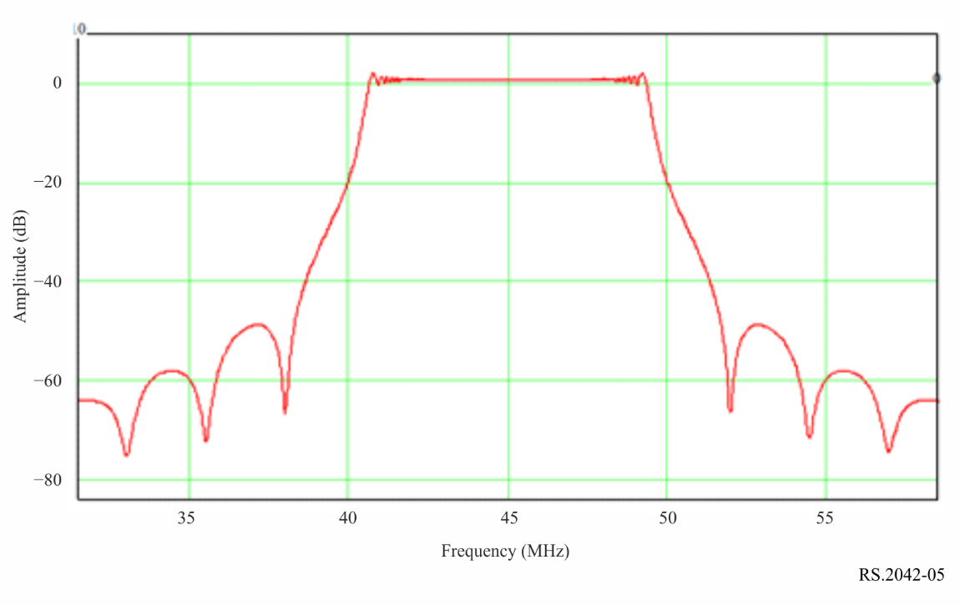

4 pfd levels at Earth’s surface
The mean power flux-density (pfd) at the surface of the Earth is calculated using the formula in RR No. 21.16.8, Edition of 2020.
Similarly, the peak pfd value can be calculated by removing the duty cycle factor from the formula used to calculate the mean pfd value.
For the parameters of the radar sounder in Table 1, the mean pfd values at the surface of the Earth are provided in Fig. 6. From Fig. 6, the maximum mean pfd value is −135.96 dB(W/m² 4kHz) and the resulting maximum peak pfd value is −126.05 dB(W/m² 4kHz).
FIGURE 6
Power flux-density (pfd) as a function of the elevation angle δ for the spaceborne VHF radar sounder
described in Table 1 (reference bandwidth of 4 kHz)
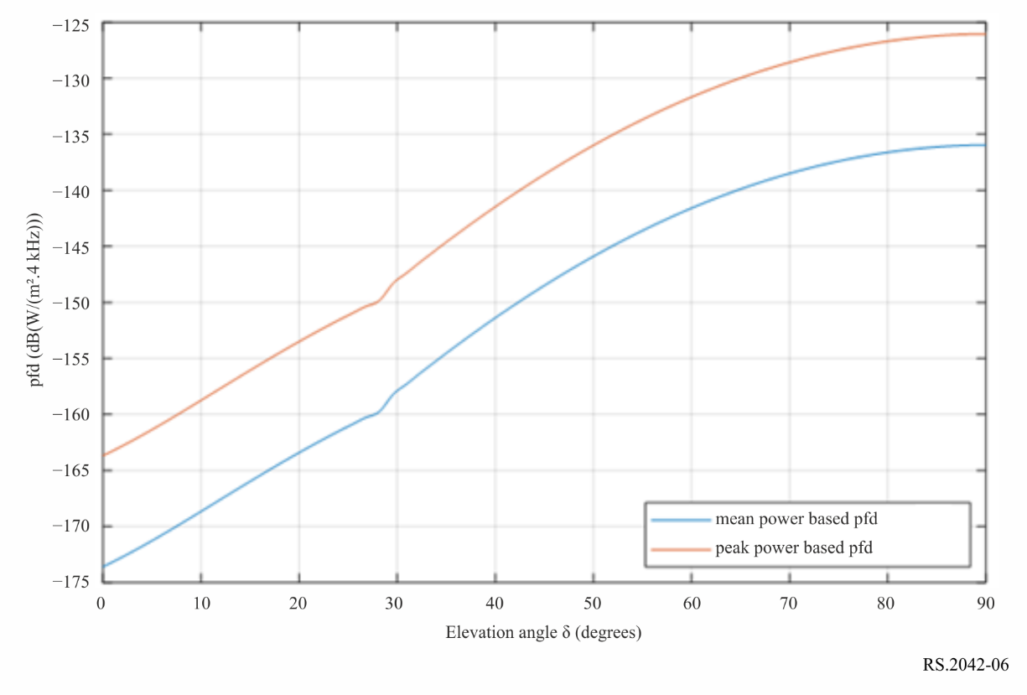

5 Conclusions
There is an interest in remote sensing in the vicinity of 40-50 MHz for remote measurements of the Earth’s subsurface providing radar maps of subsurface scattering layers with the intent to locate water/ice/deposits using active spaceborne sensors. This Annex provides the preferred frequency band selection rationale, and typical technical and operating characteristics for a possible instrument for use in sharing and compatibility studies.

Sun-Synchronous Orbit (SSO).

