Recommendation ITU-R RS.2042-1
(12/2018)
Typical technical and operating characteristics for spaceborne radar
sounder systems using the 40-50 MHz band

RS Series
Remote sensing systems

Foreword
The role of the Radiocommunication Sector is to ensure the rational, equitable, efficient and economical use of the radio-frequency spectrum by all radiocommunication services, including satellite services, and carry out studies without limit of frequency range on the basis of which Recommendations are adopted.
The regulatory and policy functions of the Radiocommunication Sector are performed by World and Regional Radiocommunication Conferences and Radiocommunication Assemblies supported by Study Groups.

Policy on Intellectual Property Right (IPR)
ITU-R policy on IPR is described in the Common Patent Policy for ITU-T/ITU-R/ISO/IEC referenced in Annex 1 of Resolution ITU-R 1. Forms to be used for the submission of patent statements and licensing declarations by patent holders are available from http://www.itu.int/ITU-R/go/patents/en where the Guidelines for Implementation of the Common Patent Policy for ITU-T/ITU-R/ISO/IEC and the ITU-R patent information database can also be found.

Series of ITU-R Recommendations
(Also available online at http://www.itu.int/publ/R-REC/en)
Series | Title
BO | Satellite delivery
BR | Recording for production, archival and play-out; film for television
BS | Broadcasting service (sound)
BT | Broadcasting service (television)
F | Fixed service
M | Mobile, radiodetermination, amateur and related satellite services
P | Radiowave propagation
RA | Radio astronomy
RS | Remote sensing systems
S | Fixed-satellite service
SA | Space applications and meteorology
SF | Frequency sharing and coordination between fixed-satellite and fixed service systems
SM | Spectrum management
SNG | Satellite news gathering
TF | Time signals and frequency standards emissions
V | Vocabulary and related subjects

Note: This ITU-R Recommendation was approved in English under the procedure detailed in Resolution ITU-R 1.

Electronic Publication
Geneva, 2018

© ITU 2018
All rights reserved. No part of this publication may be reproduced, by any means whatsoever, without written permission of ITU.

RECOMMENDATION ITU-R RS.2042-1
Typical technical and operating characteristics for spaceborne radar
sounder systems using the 40-50 MHz band
(2014-2018)
Scope
This Recommendation provides the technical and operating characteristics of spaceborne radar sounders that would operate in the 45 MHz region. This information is to be used for compatibility studies.
Keywords
Earth exploration-satellite service (active), spaceborne active sensor, radar sounder, glacial bed surface, subsurface scattering layers, earth fossil aquifers in desertic environments, Shallow Radar Sounder (SHARAD)
Related ITU-R Recommendations and Reports
Draft new Report ITU-R RS.[VHF_SOUNDER] – Preliminary results of sharing studies between a 45 MHz radar sounder and incumbent fixed, mobile, broadcasting and space research services operating in the 40-50 MHz frequency range
Report ITU-R M.2234 – The feasibility of sharing sub-bands between oceanographic radars operating in the radiolocation service and fixed and mobile services within the frequency band 3-50 MHz.
The ITU Radiocommunication Assembly,
considering
a) that spaceborne radar sounders can provide radar maps of subsurface scattering layers to locate water/ice deposits using active spaceborne sensing;
b) that the mission scientific objectives are 1) to understand the global thickness, inner structure, and the thermal stability of the Earth’s ice sheets such as in Greenland and Antarctica as an observable parameter of earth climate evolution, and 2) to understand the occurrence, distribution and dynamics of the earth fossil aquifers in desertic environments such as northern Africa and the Arabian peninsula as key elements in understanding recent paleoclimatic changes;
c) that measurement of reflectivity from subsurface scattering layers as deep as 10 m to 100 m is necessary;
d) that the penetration depth from subsurface scattering layers at microwave wavelengths increases approximately inversely with the frequency;
e) that worldwide, repetitive measurements of subsurface water deposits in desertic environments such as northern Africa and the Arabian peninsula and worldwide, repetitive measurements of Earth’s ice sheets such as in Greenland and Antarctica require the use of spaceborne active sensors;
f) that the 40-50 MHz frequency range is preferable to satisfy all requirements for spaceborne radar sounders;
g) that the 40-50 MHz band is allocated to the fixed, mobile and broadcasting services on a primary basis;
h) that the uses of the 40.98-41.015 MHz frequency band by the space research service are on a secondary basis;
i) that country footnotes in the Table of Frequency Allocations for the 40-50 MHz frequency range provide primary allocations for the amateur, broadcasting, fixed and mobile, aeronautical radionavigation and radiolocation services in certain parts of the world;
j) that operations of spaceborne radar sounder with other primary and secondary services would be under RR No. 4.4, non-interference basis and shall not cause harmful interference to, and shall not claim protection;
k) that a bandwidth of 10 MHz is sufficient for use by spaceborne radar sounders;
l) that operational limitations have been identified to allow operation under RR No. 4.4 on a non-interference basis such as operating only in either uninhabited or sparsely populated areas of the ice sheets of Greenland and Antarctica and deserts of northern Africa and the Arabian peninsula and operating the radar at night-time only from 3 a.m. to 6 a.m. locally as in Annex 1,
recommends
that the characteristics given in Table 1 of the Annex should be employed in the spaceborne radar sounder and be used for compatibility studies.

Annex
Typical technical and operating characteristics for spaceborne radar
sounder systems using the 40-50 MHz band

1 Introduction
There is an interest among climate researchers in remote sensing in the vicinity of 40-50 MHz for remote measurements of the Earth’s subsurface providing radar maps of subsurface scattering layers with the intent of locating water/ice/deposits and examining sub-ice glacial bed surfaces using active spaceborne sensors. This Annex provides the preferred frequency band selection rationale, and typical technical and operating characteristics.
The technical and operating characteristics of an active spaceborne sensor operating at 40-50 MHz are described and the sharing situation with other services allocated in this frequency range is examined.

2 Frequency band selection rationale
The reason for an allocation between 40 MHz and 50 MHz for a spaceborne sounding radar is based upon the following selection criteria: surface penetration, length scale of observation, region of electromagnetic scattering model, and previous work.

2.1 Surface penetration
Penetration of an incident radar wave is normally many tens of wavelengths. Under the proper conditions of wavelength and composition of the scattering medium, radio waves can readily penetrate the dielectric materials comprising the Earth’s surface and cover. A quantitative estimate of this depth δ_{p} is as follows:
(1)
where:
λ₀: wavelength
e′ and e″: real and imaginary parts of the surface dielectric constant.
Using this expression with the soil dielectric constants, Fig. 1 shows the surface penetration depths for 50 MHz, 500 MHz, and 5 000 MHz. From the Figure, it is evident that surface penetration at 50 MHz is deeper than for 500 MHz by a factor of 20 to 30, and is thus most favourable for Earth penetration studies. The objectives would be to provide radar maps of subsurface scattering layers with the intent to locate water/ice/deposits using active spaceborne sensors.
figure 1
Surface penetration depth

2.2 Length scale of observations
The addition of 50 MHz to the existing 435 MHz and 1 250 MHz bands would extend the range of length scales at which the roughness of the surface is observed. For many geologic surfaces, backscatter is dominated by that harmonic component of the surface whose wavelength is near the projected radar wavelength and longer, whereas, other components of the surface contribute only through second order effects. Thus, radar measurements at as many frequencies as possible over as wide a range of incidence angles as possible increase the ability to accurately describe the surface.

2.3 Region of electromagnetic scattering model
The addition of 50 MHz to the existing 435 MHz and 1 250 MHz bands would expand the region of validity of electromagnetic scattering models. The 50 MHz radar would be more sensitive to subsurface morphology because the rms height of the surface is a smaller fraction of the wavelength, resulting in a lower measured radar backscatter. The greater sensitivity of 50 MHz to subsurface morphology combined with the fact that the 50 MHz signals penetrate deeper into the soil, increases the subsurface volume in which scattering occurs, resulting in a much greater ratio of power received from the subsurface relative to that received from the surface than that at shorter wavelengths. Also, scatterers embedded in the alluvial cover will be smaller relative to 50 MHz than either 435 MHz or 1 250 MHz.

2.4 Previous work and regulatory status between 40-44 MHz band
A considerable amount of work in the form of ground-based and airborne radar systems development and data collection has already been done at 3-50 MHz. Along with this hardware development has been computational work aimed at studying the surface penetration depth versus soil moisture content at 3-50 MHz and analysis of measuring ocean returns by oceanographic radars.
Airborne radars have made measurements around 50 MHz in the desertic areas in the Arabian peninsula and Antarctica. Figure 2 shows a radargram with variations in the depth of the water table from 49 to 52 metres with data taken from airborne VHF radar in Kuwait in 2011.
figure 2
Radargram taken from airborne VHF radar in Kuwait in 2011

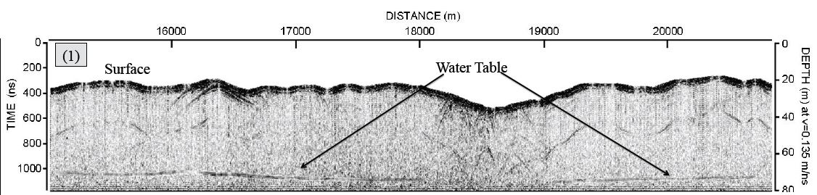
The frequency band 3-50 MHz was considered for the oceanographic radars along the coast (in the radiolocation service (RLS)) under WRC-12 agenda item 1.15 and the sharing studies were documented in Report ITU-R M.2234. WRC-12 agreed to allocate RLS through a combination of secondary and primary allocations on a regional and country basis with footnotes in sub-bands between 4-44 MHz (43.35-44 MHz was the highest frequency range allocating RLS with a country footnote (two countries)) with footnotes to protect the incumbent fixed and mobile services. Applications in the RLS are limited to oceanographic radars operating in accordance with Resolution 612 (Rev.WRC-12). Resolution 612 (Rev.WRC-12) also contains additional limitations to the oceanographic radars such as maximum e.i.r.p. of 25 dBW and a station identification (call sign) on the assigned frequency. In the Radio Regulations, there is no allocation to EESS (active) in the 3-50 MHz range. If the frequency were chosen for the spaceborne system at higher or lower frequency bands, the hardware and computational work reference would need to be repeated for the airborne radar campaigns in the desertic areas.

3 Technical characteristics of a 40-50 MHz spaceborne sounding radar
The spaceborne sounding radar will operate at a centre frequency of 45 MHz covering a 10 MHz bandwidth. The resulting radar data will be used in the study of the Earth’s subsurface with radar mapping of subsurface scattering layers with the intent to locate water/ice/deposits. The characteristics of the 45 MHz spaceborne sounding radar are shown in Table 1.

3.1 Mission objectives
The spaceborne active sensor operating in the 40-50 MHz range will produce sub surface data with a vertical resolution of 5-7 m, and will have a surface SNR of 66 dB. The orbital mapping campaign is planned to include one month of orbital check-out and eighteen months of scientific data collection. The mission scientific objectives are 1) to understand the global thickness, inner structure, and the thermal stability of the Earth’s ice sheets of Greenland and Antarctica as an observable parameter of earth climate evolution, and 2) to understand the occurrence, distribution and dynamics of the earth fossil aquifers in desertic environments such as northern Africa and the Arabian peninsula as key elements in understanding recent paleoclimatic changes. Eighteen months is sufficient to collect data in the interested scientific areas with a 5 km nadir track spacing at the equator, using a 548-day (18 months) exact repeat orbit at 400 km altitude. Due to the inherent temporal instabilities in both the ice fields and the aquifers in desertic environments, it is anticipated that there will be follow-on missions with a frequency of one scientific mission, of eighteen month duration, every ten years.
It should be noted that, taking into account the high investment cost associated with this type of sensor observations in the 40-50 MHz band, the number of spaceborne radar sounder missions operating simultaneously is expected to remain very low; perhaps only one, or two, in number.

3.2 Orbital parameters
The spaceborne active sensor is carried on a low-Earth orbiting satellite at an altitude of 400 km, an inclination optimized for a sun synchronous orbit and an eccentricity less than 0.001. Orbital parameters can be found in Table 1.

3.3 Design parameters
The postulated system for the Earth orbiting sounding radar is an earth enhanced duplicate of the Shallow Radar Sounder (SHARAD) which was a Mars orbiting sounding radar operating in the 15-25 MHz frequency range. The spaceborne sounding radar transmits an FM modulated pulse centred at 45 MHz with 10 MHz bandwidth at a pulse repetition frequency of 1 200 Hz. Each pulse has a duration of 85 µs. The peak RF power is 100 W, and the transmitted signal is circularly polarized. These design parameters are shown in Table 1.

TABLE 1
45 MHz spaceborne sounding radar characteristics
Sensor characteristics
Parameter | Value
Type | Radar Sounder
Orbit characteristics
Type of orbit | Sun-Sync
Altitude (km) | 400 km
Inclination (degree) | 97
Ascending node LST | 004:00
Eccentricity (degree) | 0
Orbits per day | 15.8
Repeat period (days) | 548
Antenna characteristics
Antenna type | 9 Element Cross Yagi
Number of beams | 1
Antenna Peak Gain (Transmit & Receive –dBi) | 10
Polarization | Circular
−3 dB beamwidth (degree) | 40
Antenna beam look angle (degree) | Nadir
Antenna beam azimuth angle (degree) | Nadir
Antenna elevation beamwidth (degree) | 40
Antenna azimuth beamwidth (degree) | 40
Sensor antenna pattern | See Fig. 3
Transmitter characteristics
RF centre frequency (MHz) | 45
RF bandwidth (MHz) | 10
Transmit peak power (dBW) | 20
Pulsewidth (usec) | 85
Pulse Repetition Frequency (PRF) (Hz) | 1200
Pulse Modulation | Linear FM Chirp
Receiver characteristics
RF centre frequency (MHz) | 45
Gain (dB) | 40-50
SNR (dB) | 30
LNA bandwidth (MHz) | >100
Final IF filter bandwidth (MHz) | 12
Noise figure (dB) | 5
Minimum detectable signal level (dBm) | −132
Dynamic range (dB) | <20
The spaceborne sounding radar antenna is a 9 element cross Yagi antenna with antenna gain of 10 dBi, and beamwidth of 40 degrees in range and azimuth as shown in Fig. 3.
figure 3
9-element Yagi antenna pattern

3.4 Operational geographic limitations
The sounding radar is to be operated exclusively in un-inhabited or sparsely populated areas of the ice sheets of Greenland and Antarctica and the deserts of northern Africa and the Arabian Peninsula and will operate for a period not to exceed 10 minutes in duration per 92.7 minute orbit.
Areas of coverage for the proposed regions of operations that depict the geographic area over which the transmitted signal will be propagated are included in Fig. 4.
FIGURE 4
Spaceborne Radar Sounder Coverage
-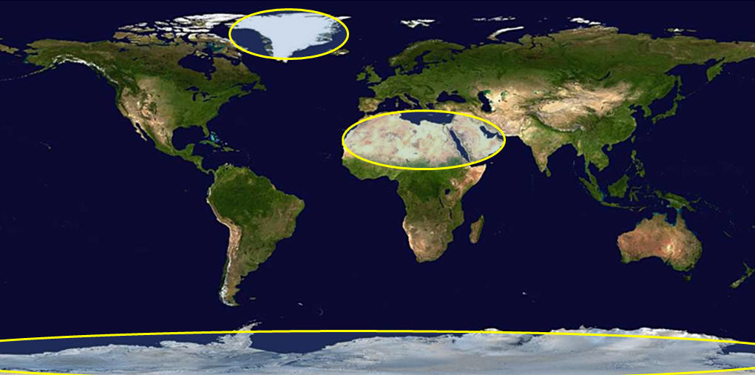
The radar is to be operated only at night-time locally between the hours of 3 a.m. to 6 a.m. These times were chosen because ionospheric perturbations to the radar signal are at a minimum during this time period and use of the spectrum by other services is expected to be the lightest.

4 Pfd and spectral pfd levels at Earth’s surface
For the parameters of the sounding radar in Table 1, the power flux-density (pfd) level at the surface of the earth is calculated to be −93.3 dB(W/m²) at 45 MHz, corresponding to spectral pfd levels of −163.3 dB(W/m²-Hz) at 45 MHz assuming a 10 MHz bandwidth.

5 Conclusions
There is an interest in remote sensing in the vicinity of 40-50 MHz for remote measurements of the Earth’s subsurface providing radar maps of subsurface scattering layers with the intent to locate water/ice/deposits using active spaceborne sensors. This Annex provides the preferred frequency band selection rationale, and typical technical and operating characteristics for a possible instrument.
Characteristics of a spaceborne radar sounder that would operate in the frequency range 40-50 MHz have been developed.

