Recommendation ITU-R RS.1166-5
(12/2023)
RS Series: Remote sensing systems
Performance and interference criteria for active spaceborne sensors

Foreword
The role of the Radiocommunication Sector is to ensure the rational, equitable, efficient and economical use of the radio-frequency spectrum by all radiocommunication services, including satellite services, and carry out studies without limit of frequency range on the basis of which Recommendations are adopted.
The regulatory and policy functions of the Radiocommunication Sector are performed by World and Regional Radiocommunication Conferences and Radiocommunication Assemblies supported by Study Groups.

Policy on Intellectual Property Right (IPR)
ITU-R policy on IPR is described in the Common Patent Policy for ITU-T/ITU-R/ISO/IEC referenced in Resolution ITU-R 1. Forms to be used for the submission of patent statements and licensing declarations by patent holders are available from http://www.itu.int/ITU-R/go/patents/en where the Guidelines for Implementation of the Common Patent Policy for ITU-T/ITU-R/ISO/IEC and the ITU-R patent information database can also be found.

Series of ITU-R Recommendations
(Also available online at https://www.itu.int/publ/R-REC/en)
Series | Title
BO | Satellite delivery
BR | Recording for production, archival and play-out; film for television
BS | Broadcasting service (sound)
BT | Broadcasting service (television)
F | Fixed service
M | Mobile, radiodetermination, amateur and related satellite services
P | Radiowave propagation
RA | Radio astronomy
RS | Remote sensing systems
S | Fixed-satellite service
SA | Space applications and meteorology
SF | Frequency sharing and coordination between fixed-satellite and fixed service systems
SM | Spectrum management
SNG | Satellite news gathering
TF | Time signals and frequency standards emissions
V | Vocabulary and related subjects

Note: This ITU-R Recommendation was approved in English under the procedure detailed in Resolution ITU-R 1.

Electronic Publication
Geneva, 2024

© ITU 2024
All rights reserved. No part of this publication may be reproduced, by any means whatsoever, without written permission of ITU.

RECOMMENDATION ITU-R RS.1166-5
Performance and interference criteria* for active spaceborne sensors
(1995-1998-1999-2006-2009-2023)
Scope
This Recommendation presents the performance and interference criteria for spaceborne active sensors in the bands allocated to the EESS (active). The Annex describes the technical bases for development of performance and interference criteria for various types of spaceborne active sensors. The sensor types include altimeters, scatterometers, precipitation radars, synthetic aperture radars and cloud profile radars.
Keywords
Earth Exploration-Satellite Service (active), remote sensing, active sensors, precipitation radar, synthetic aperture radar (SAR), altimeter, scatterometer, cloud profile radar
Abbreviations/Glossary
DPR Dual precipitation radar
DSD Drop size distribution
GPM Global precipitation measurement
IFOV Instantaneous field of view
ITCZ Inter-tropical convergence zone
PR Precipitation radar
TRMM Tropical rainfall measuring mission
VPRF Variable pulse repetition frequency
The ITU Radiocommunication Assembly,
considering
a) that spaceborne active microwave remote sensing requires specific frequency ranges depending on the physical phenomena to be observed;
b) that certain frequency bands have been allocated for spaceborne active microwave remote sensing;
c) that these bands are also allocated to other radio services;
d) that studies have established measurement sensitivity requirements;
e) that performance requirements for active sensors can be stated in terms of precision of measurement of physical parameters and availability, measured at the satellite, assuming that degradation from other elements in the system is negligible;
f) that definition of performance objectives for active spaceborne microwave sensors is a prerequisite for the establishment of the associated interference criteria;
g) that interference criteria are needed to ensure that systems can be designed to achieve adequate performance in the presence of interference, assess compatibility with systems in other services and, if needed, to assist in developing sharing criteria;
h) that Annex 1 presents the technical bases for performance and interference criteria based on representative active sensors,
recommends
1 that the performance criteria given in Table 1 should be applied to instruments used in active sensing of the Earth’s land, oceans and atmosphere:
TABLE 1
Frequency band | Performance criteria for remote sensing instruments
 | Scatterometer | Altimeter | SAR imager | Precipitation radar | Cloud profile radars
432-438 MHz |  |  | Minimum reflectivity of  ‒36 dB
1 215-1 300 MHz | Minimum reflectivity of −32 dB |  | Minimum reflectivity of  –36 dB
3 100-3 300 MHz |  | Sea level precision  ≤ 3 cm | Minimum reflectivity of  –26 dB
5 250-5 570 MHz | Wind speed  ≥ 2 m/s | Sea level precision  ≤ 2 cm | Minimum reflectivity of  –30 dB over land and –33 dB over ocean
8 550-8 650 MHz | Wind speed  ≥ 3 m/s | Sea level precision  ≤ 3 cm | Minimum reflectivity of  –21 dB
9 200-10 400 MHz | Wind speed  ≥ 3 m/s | Sea level precision  ≤ 3 cm | Minimum reflectivity of  –18 dB
13.25-13.75 GHz | Wind speed  ≥ 3 m/s | Sea level precision  ≤ 2 cm | Minimum reflectivity of  –27 dB | Minimum rain rates from  0.7-0.75 mm/h
17.2-17.3 GHz | Wind speed  ≥ 3 m/s |  | Minimum reflectivity of  –25 dB | Minimum rain rates from  0.7-0.75 mm/h
24.05-24.25 GHz |  |  |  | Minimum rain rates from  0.7-0.75 mm/h
35.5-36 GHz | Wind speed  ≥ 3 m/s | Sea level precision  ≤ 2 cm | Minimum reflectivity of  –22 dB | Minimum rain rates from  0.05-0.2 mm/h | –24 dBZ ± 10%
78-79 GHz |  |  |  |  | –27 dBZ ± 10%
94-94.1 GHz |  |  |  | Minimum rain rates from  0.05 mm/h | –35 dBZ ± 10%
133.5-134 GHz |  |  |  |  | –34 dBZ ± 10%
TABLE 1 (end)
Frequency band | Performance criteria for remote sensing instruments
 | Scatterometer | Altimeter | SAR imager | Precipitation radar | Cloud profile radars
237.9-238 GHz |  |  |  |  | –44 dBZ ± 10%
dBZ: “Unit” radar reflectivity used in meteorology which represents a logarithmic power ratio (in decibels, or dB) with respect to radar reflectivity factor, Z, referred to a value of 1 mm⁶/m³.
SAR: Synthetic aperture radar.

2 that the interference and data availability criteria given in Table 2 be applied for instruments used for active sensing of the Earth’s land, oceans and atmosphere.
TABLE 2
Sensor type | Interference criteria |  | Data availability criteria  (%)
 | Performance degradation | I/N  (dB) | Systematic | Random
Synthetic aperture radar | 10% degradation of standard deviation of pixel power | –6 | 99 | 95
Altimeter | 4% degradation in height noise | –3 | 99 | 95
Scatterometer | 8% degradation in measurement of normalized radar backscatter to deduce wind speeds | –5 | 99 | 95
Precipitation radar | 7% increase in minimum rainfall rate | –10 | 99.8 | 99.8
Cloud profile radar | 10% degradation in minimum cloud reflectivity | –10 | 99 | 95

For bands with secondary allocation, the interference criteria are provided only to indicate performance degradation with regard to primary services.

Annex 1
Performance and interference criteria for
spaceborne active sensors
TABLE OF CONTENTS
1 Introduction 5
1.1 Systematic and Random interference 5
2 Altimeters 5
2.1 Performance criteria 6
2.2 Interference criteria 6
3 Scatterometers 7
3.1 Performance criteria 7
3.2 Interference criteria 9
4 Precipitation radars 11
4.1 Precipitation radars based upon GPM DPR 11
5 Synthetic aperture radars 14
5.1 Performance criteria of SARs 14
5.2 Interference criteria of SAR 15
6 Cloud profile radars 19
6.1 Performance criteria for 94 GHz cloud profile radar 19
6.2 Interference criteria for 94 GHz cloud profile radar 19
6.3 Availability criteria of the cloud profile radar 20
7 Measurement area of interest for the evaluation of systematic interference 20
8 Transient impulse interference considerations 20
8.1 Determination of peak transient power for some modulation schemes 20
9 Typical EESS (active) sensor parameters to be used in determining impact
from differing types of interference 22

1 Introduction
Performance criteria for active spaceborne sensors are needed in order to develop interference criteria. Interference criteria, in turn, can be used to assess the compatibility of radionavigation and radiolocation systems and active sensors in common frequency bands.
This Annex presents the technical basis for development of performance and interference criteria for various types of spaceborne active sensors. The sensor types include altimeters, scatterometers, precipitation radars, synthetic aperture radars, and cloud profile radars.
The criteria are based on current and planned space borne active sensor science system designs and associated operating requirements. Future space borne active sensor science systems, beyond the ones considered in this recommendation, would have to be examined to determine if they could accept the same levels of interfering signals and associated spatial and temporal conditions.

1.1 Systematic and Random interference
recommends 2 states that the interference and data availability criteria given in Table 2 be applied for instruments used for active sensing of the Earth’s land, oceans and atmosphere. Table 2 provides the data availability criteria as it applies to two types of interference: systematic and random.
Systematic interference is defined as interference which occurs repeatedly at the same location. When systematic interference is present, the data availability criteria in Table 2 of 99% should be applied for all sensor types except for the precipitation radar, for which 99.8% applies.
Application of the systematic data availability to sharing and compatibility analyses first involves a determination of the interference under investigation as to its reoccurrence in the repeated sensor measurement of a specific location. If the interference under investigation is found to reoccur repeatedly in sensor measurements of the same location, albeit possibly with different kinds of signal originating from that location (e.g., frequency hopping radars; scanning radars), then the interference is deemed to be systematic interference; therefore, the systematic interference data availability criterion should be used in the evaluation of the study results.
Random interference is described as interference events causing brief individual outages (i.e. most outages lasting 2 s or less) and which are randomly dispersed over all observation time and areas. For the purposes of the sharing and compatibility analyses performed, this would apply to the observation time and the measurement area chosen for evaluation of the data availability criteria. Random interference has less serious consequences than systematic interference so that the random data availability criteria in the presence of random interference is 95% except for precipitation radars, for which it is 99.8%.
Application of the systematic data availability to sharing and compatibility analyses first involves a determination of the interference under investigation as to which type of interference should be evaluated; that is, Systematic or Random. The analysis should then determine the number of interference events exceeding the interference threshold criteria that occur in a measurement area of interest and the summary of results should provide an evaluation of that result in regard to the applicable data availability criteria.

2 Altimeters
This section presents information on the performance and interference criteria for spaceborne altimeters in the frequency bands 3.1-3.3 GHz, 5.25-5.57 GHz, 8.55-8.65 GHz, 9.2-10.4 GHz, 13.25-13.75 GHz and 35.5-36 GHz.

2.1 Performance criteria
Spaceborne altimeters produce, after data processing, measurement of sea level with a precision of at least 2 or 3 cm depending on the band. An increase of 0.1 cm in the height noise due to interference would not materially affect the data and would be acceptable. In other words, a 4% degradation in height noise due to interference could be tolerated as it would not preclude meeting current mission objectives.
A requirement for altimeter missions is acquisition of at least 90% of all possible data over oceans and measurable bodies of water within land masses. The design goal is higher than this minimum requirement and has been established as the acquisition of 95% of all possible measurable data. Observations must be taken to include measurements as close to the land-sea interface as possible (about 15 km from the land-sea interface, altimeter waveform distortions occur and prevent accurate height estimation). The budget for lost data must accommodate all sources of loss including those due to spacecraft systems, the altimeter instrument, manoeuvres, interference, etc.
The availability requirement for altimetry data is 95%, assuming that the associated individual outages are brief and randomly dispersed over all observation time and areas (i.e. most outages lasting 2 s or less). It should be noted that although determining if the 95% availability requirement can be met is a relatively straightforward analysis, it is difficult to analyse outages for its characteristic of random dispersion over all observation time and geographic areas.
The impact of interference that is always present at a given sensor measurement area is much more serious than that of random interference, because valid measurements can never be obtained from those geographical areas. To address this serious concern, the requirement for altimeters is to be able to obtain valid data for a minimum of 99% of the time over each measurement area of interest.

2.2 Interference criteria
Typical altimeters have link budgets that result in S/N of 13 dB (except for 35.5-36 GHz altimeters) in the receiver range resolution bandwidth of 39.9 dB/Hz (9 772.3 Hz). The altimeter height noise varies as 1 + 2 / (S/N). For a return signal having a S/N of 13 dB before interference, the addition of interference causes the following increase in height measurement noise as provided in Table 3:
TABLE 3
Increase of altimeter height measurement noise vs Interference level
Interference level | S /N  (dB) |  | Degradation  (%)
 | Non-white  interference | White  interference | Non-white  interference | White  interference
None | 13 | 13 | Baseline | Baseline
10 dB below noise | 12.6 | 12.99 | 1 | 0.05
3 dB below noise | 11.25 | 12.5 | 4.5 | 1
Equal to noise | 10 | 11.5 | 9 | 3.8
10 dB above noise | 2.6 | 3 | 91 | 82

For 35.5-36 GHz altimeters, atmospheric effects and technological constraints result in a less favourable link budget (S/N close to 10 dB) and so the sensitivity to interference level is higher, the following values have to be taken into account:
TABLE 4
Increase of altimeter height measurement noise vs Interference level
Interference level | S /N  (dB) |  | Degradation  (%)
 | Non-white  interference | White  interference | Non-white  interference | White  interference
None | 10 | 10 | Baseline | Baseline
10 dB below noise | 9.6 | 9.98 | 1.7 | 0.08
6 dB below noise | 9.0 | 9.9 | 4.2 | 0.5
3 dB below noise | 8.2 | 9.5 | 8.4 | 1.2
1.5 dB below noise | 7.7 | 9.1 | 11.8 | 3.8
Equal to noise | 7.0 | 8.5 | 17 | 6.9
10 dB above noise | –0.4 | 0 | 167 | 150

The criterion for harmful interference to these example altimeters is, therefore, an aggregate interfering signal power level of −117 dB(W/320 MHz) at 13-14 GHz and a level of −119 dB(W/450 MHz) at 35.5-36.0 GHz which would cause an unacceptable increase in the height measurement noise. It must be noted that criterion for harmful interference must be calculated according to the system characteristics of the sensor under consideration.
In shared frequency bands, availability of altimeter data should exceed 95% for all locations in the sensor service area where the loss occurs randomly dispersed over all observation time and areas and should exceed 99% for each measurement area where the loss occurs systematically at the same locations.

3 Scatterometers
This section presents information on performance and interference criteria for spaceborne scatterometers in the frequency bands 1.215-1.3 GHz, 5.25-5.57 GHz, 8.55-8.65 GHz, 9.2-10.4 GHz, 13.25-13.75 GHz, 17.2-17.3 GHz and 35.5-36.0 GHz. It provides performance and interference criteria for active spaceborne scatterometers that can be used to analyse the compatibility of active spaceborne scatterometers and radionavigation and radiolocation systems in these bands.
Unwanted radio frequency emissions reaching the scatterometer’s receiver can corrupt the radar’s scatterometer measurement of σ₀, where σ₀ is the normalized radar backscatter coefficient. The amount of degradation will depend on the statistics of the external interference.

3.1 Performance criteria
In scatterometer systems, an estimate of the echo return signal power is made by first measuring the “signal + noise” power (i.e. the echo return plus the system noise contribution), and then subtracting the “noise-only” power (an estimate of the system noise alone, or “noise floor”). The system noise includes thermal emissions from the Earth, as well as those introduced by the antenna, waveguides, and the receiver noise figure. To optimize system performance, the “signal + noise” and the “noise-only” measurements are made over different bandwidths and/or at different times. This strategy relies on the fact that the nominal system noise is inherently white during the measurement sequence (stationary, and with a flat spectral power distribution).
If external interference is present, the new composite background noise is the sum of the interference and the nominal system noise. Given the narrow bands used by scatterometers, it may be possible to approximate the noise as white. However, depending on the strength, modulation, antenna gain pattern, and geometry of the interfering source, the composite noise may not be white over the measurement sequence. The “noise-only” measurement will then not correspond to the noise of the “signal + noise” measurement and errors in the estimation of σ₀ will result.
The estimated σ₀ error that results from a given “noise-only” measurement error can be quantified with the following equation:
σ₀ Error (dB) = 10 log [1 + (α – 1) / SNR σ0] (1)
where:
SNR σ₀ (dB) = 10 log (S/N) = signal-to-noise ratio of the σ₀ estimation process
with:
S: echo return power spectral density
N: nominal noise floor power spectral density (approximately −200 dB(W/Hz) at the scatterometer receiver input for both “fan beam” and “spot beam” antennas).
and
α (dB) = 10 log ([N + (Is + n / Bs + n)] / [N + (In / Bn)]) (2)
with:
I_{s + n} : average power from interfering source in Bs + n during the “signal + noise” measurement period
B_{s + n} : “signal + noise” measurement bandwidth
I_{n} : average power from interfering source in Bn during the “noise-only” measurement period
B_{n} : “noise-only” measurement bandwidth.
The impact of external interference is most severe for winds with low speed. The lowest wind speed to be measured by spaceborne scatterometers is 2 or 3 m/s, depending on the band. Results of computer simulations conducted for non-stationary interference to the NSCAT scatterometer have shown that a maximum value of α (see equation (2)) that will allow performance requirements to be met for 3 m/s wind speeds is 0.7 dB. Interference is defined as non-stationary when its occurrences are dynamic and its statistics vary with time and do not exhibit consistent spectral, amplitude, phase or temporal patterns.
Scatterometers in the future may employ spot beam antennas rather than fan beam antennas as are used for NSCAT. The main differences, besides the antenna pattern, between the two types of scatterometers are the transmitted e.i.r.p. and receive antenna gain. Results of computer simulations conducted for non-stationary interference have shown that a maximum value of α = 6 dB (see equation (2)) can be tolerated with the “spot beam” antenna and still meet the performance requirements for 3 m/s wind speeds.
The allowable loss of scatterometer data due to interference from radio frequency stations randomly dispersed across the oceans is 5% for all the data taken over the global oceans.
It should be noted that determining if the 95% availability requirement can be met is a relatively straightforward analysis; however, it is difficult to analyse outages for its characteristic of random dispersion over all observation times and areas.
The allowable loss for systematic interference is 1%. Systematic interference is defined as the loss of measurement data, i.e. interference exceeding the threshold protection criteria, at the same geological locations where sensor measurements were obtained. These maximum allowable losses have been derived from the NSCAT science requirement for measuring at least 90% of global vector winds over the oceans and taking into consideration other randomly distributed data losses introduced mainly in areas with intense rainfall.

3.2 Interference criteria
Figure 1 is a plot of equation (2) for a scatterometer with a receiver noise floor of N = −200 dB(W/Hz). It shows α as a function of the power spectral density of the interfering signal Is + n / Bs + n). Note that different results for α will be obtained depending on how the interference is changing over time or over bandwidth. Figure 1 contains a family of plots for several values of the parameter $10\log\left[{\left({I_{s+n}}/{B_{s+n}}\right)}/{\left({I_{n}}/{B_{n}}\right)}\right]$.
FIGURE 1
Plots for several values of the parameter 10 log [(Is + n / Bs + n) / (In / Bn)] (white noise)
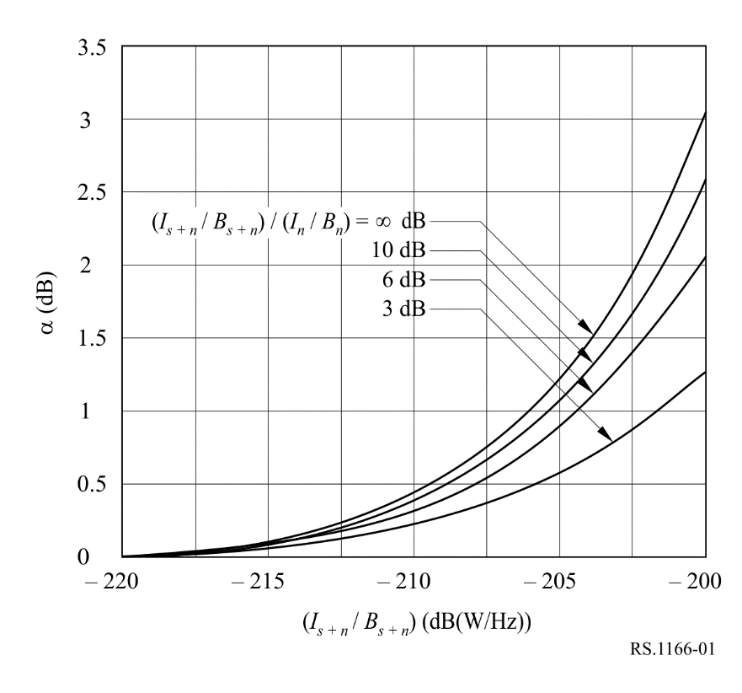
The time separation of the “signal + noise” measurement period from the centre of the “noise-only” measuring period is approximately 0.23 s. During this time the angle from the spacecraft scatterometer to a specific point on the ground will change by approximately 0.1°. Due to the narrow beamwidth of the fan beam antenna (0.42°, 3 dB beamwidth), changes of several dB in received interference levels can be encountered as the scatterometer side lobes move through an interfering transmitter beam. Engineering judgement has led to a value of 6 dB as the assumed maximum expected change in 10 log [(Is + n / Bs + n) / (In / Bn)] during the measurement period when interference is not present. From Fig. 1, it is therefore concluded that the maximum interference power spectral density that any one of the six fan beam antennas of the example NSCAT scatterometer can sustain without degraded measurement accuracy is −207 dB(W/Hz) or −174 dBW over any 2 kHz bandwidth within the 1 MHz bandwidth of the processing channel.
For white-noise like interference, the maximum acceptable interference spectral power density would be approximately −194 dB (W/Hz) at the input of the receiver which, in this example, translates to an interference criterion of −161 dBW over any 2 kHz bandwidth within the 1 MHz bandwidth of the processing channel.
In the case of non-white noise, the interference criterion for a scatterometer which uses a spot beam antenna can be determined for the worst case assumption of 10 log [(Is + n / Bs + n) / (In / Bn)] = ±∞. This situation represents the case in which the interference is present for either the “signal + noise” or the “noise-only” measurement, but not for both simultaneously.
This highlights the fact that the interference event has to be examined in detail in regard to the timing of the sensor sampling. At the interference event transition boundaries, the interference present during each of the “signal noise” and the “noise-only” measurements can vary which amplifies the deleterious impact of the interference on the sensor measurements.
From Fig. 2 it is therefore concluded that the maximum interference power spectral density that the “spot beam” antenna of an NSCAT-like scatterometer can sustain without degradation in the measurement is −195 dB(W/Hz). This requirement must hold for any 10 kHz bandwidth within the overall 1 MHz processing channel. However, it must be noted that these results are provided as an example only based on the NSCAT-like scatterometer and that analysis of the particular EESS systems under consideration is required.
FIGURE 2
Plots for several values of the parameter 10 log [(Is + n / Bs + n) / (In / Bn)] (non-white noise)
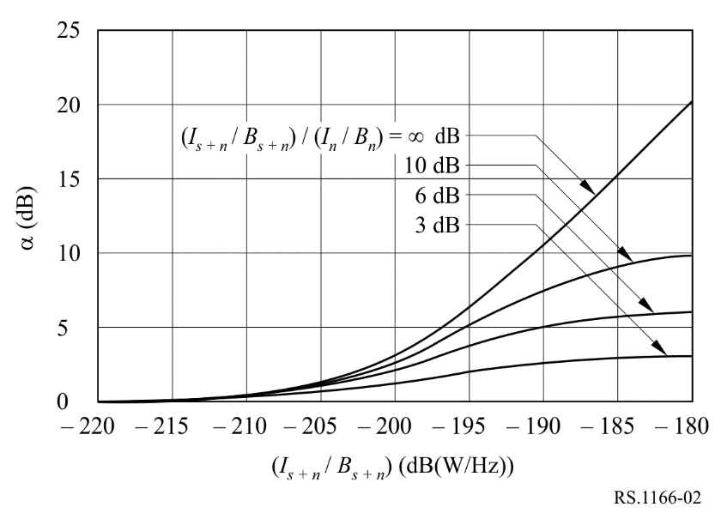
For white-noise like interference, the maximum interference spectral power density would be approximately −185 dB (W/Hz) at the input of the receiver for a scatterometer with a “spot beam” antenna.
In shared frequency bands, availability of scatterometer data should exceed 95% for all locations in the sensor service area where the loss is randomly dispersed and should exceed 99% for each measurement area where the loss occurs systematically at the same locations. It should be noted that determining if the 95% availability requirement can be met is a relatively straightforward analysis; however, it is difficult to analyse outages for its characteristic of random dispersion over all observation times and areas.

4 Precipitation radars
This section presents information on performance and interference criteria for spaceborne precipitation radars in the frequency bands 13.25-13.75 GHz, 17.2-17.3 GHz, 24.05-24.25 GHz, and 35.5-36.0 GHz. The performance and interference criteria for active spaceborne precipitation radars provided in recommends 1 and 2 of this Recommendation can be used to analyse the compatibility of active spaceborne precipitation radar operation with radionavigation and radiolocation systems in these bands. This section provides an example analysis based on the Global Precipitation Measurement (GPM) Dual Precipitation Radar (DPR) which operates at 13.597/13.603 GHz and 35.547/35.553 GHz.
GPM employs a variable pulse repetition frequency (VPRF) radar to increase the number of samples in an instantaneous field of view (IFOV). The 35 GHz transmitter is designed to detect light rain and delineate between rain and snow, and the 13 GHz radar is used to detect heavy rain. The dynamic ranges of both radars were designed to be able to estimate the drop size distribution (DSD) of the precipitation.

4.1 Precipitation radars based upon GPM DPR
The first spaceborne precipitation radar was the Tropical Rainfall Measuring Mission (TRMM) Precipitation Radar (PR) launched in 1997. Following the success of the TRMM, the GPM mission launched in February 2014. The GPM mission currently measures precipitation from space and provides a reference standard to correlate precipitation measurements obtained from other spaceborne sensors.
Mission objectives and the design of the GPM DPR have been examined in order to develop performance and interference criteria that can subsequently be used to assess the compatibility of the PR. Interference criteria are presented which quantify the permissible level of interference and amount of data loss due to interference that would still allow for meeting mission objectives.

4.1.1 Performance criteria at 13.597/13.603 GHz
The science requirement for the GPM DPR is to achieve, after data processing, measurement of rain rates equal to or greater than rain rates of 0.22 mm/h at 13.597/13.603 GHz.
Here is the pdf of rainfall rates from GPM Version 7 (red is V7, black is V6) between 40° S and 40° N. Note that these are Ku-band only retrievals and the minimum detectable rainfall rate is about 0.2 mm/h rather than 0.5 mm/h. Therefore, if interference increases the minimum detectable rainfall to over 0.5 mm/h, it will have a substantial impact.
FIGURE 3
pdf of rainfall rates from GPM Version 7 (red) and 6 (black) (lower latitudes)
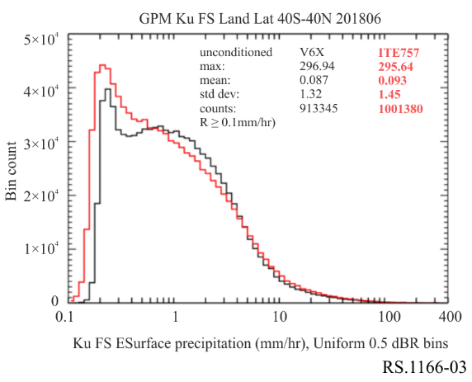
The peak occurs near 0.2 mm/hr. Below is the distribution of rain volume (basically rain*area).
FIGURE 4
Distribution of rain volume (lower latitudes)
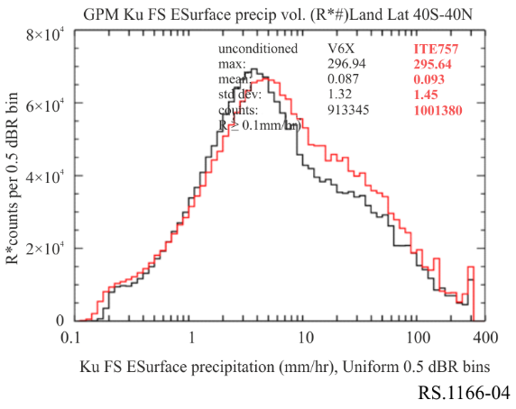
The peak in rain volumes shifts to about 4 mm/hr, but the total to the left of 0.5 mm/hr, while not huge, is still significant. These plots are for lower latitudes. A similar plot for southern high latitudes is shown below.
FIGURE 5
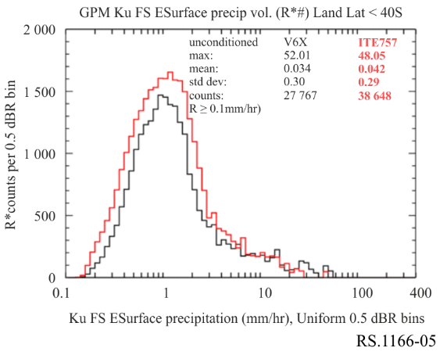
Distribution of rain volume (southern high latitudes) where the contribution from light rainfall is even larger. So it is critically important to know whether interference will shift the minimum detectable rainfall to the right. Shifting the threshold of detectable precipitation to the right could have substantial implications for measuring light rainfall, especially at higher latitudes for GPM and the future AOS Ku-band radar.
The needed availability of rainfall data is a function of where the rainfall occurs. Obtaining all potential rain measurements is important; however, measurements in the Inter-Tropical Convergence Zone (ITCZ) are of particular importance is an area bounded by the Earth’s equator and 10° N latitude, and the wide belt area extending from the Maritime continent to the South Pacific (called Australian Monsoon Trough and South Pacific Convergence Zone or SPCZ). These most important areas are generally bounded by latitudes of 0°-10° N and 50°-180° E and 0°-10° S. Therefore, the most critical area is in the ITCZ. Figure 6 shows the convergence zones of particular interest for precipitation radar measurements. In addition, special “ground truth” sites are employed to correlate the PR data with simultaneous terrestrial measurements. A criterion for loss of data in the ITCZ when interference occurs randomly is 0.2% of the possible data. However, as noted elsewhere in this Recommendation, random interference is difficult (if not impossible) to characterize and account for in an interference analysis.
FIGURE 6
Convergence zones of particular interest for precipitation radar measurements
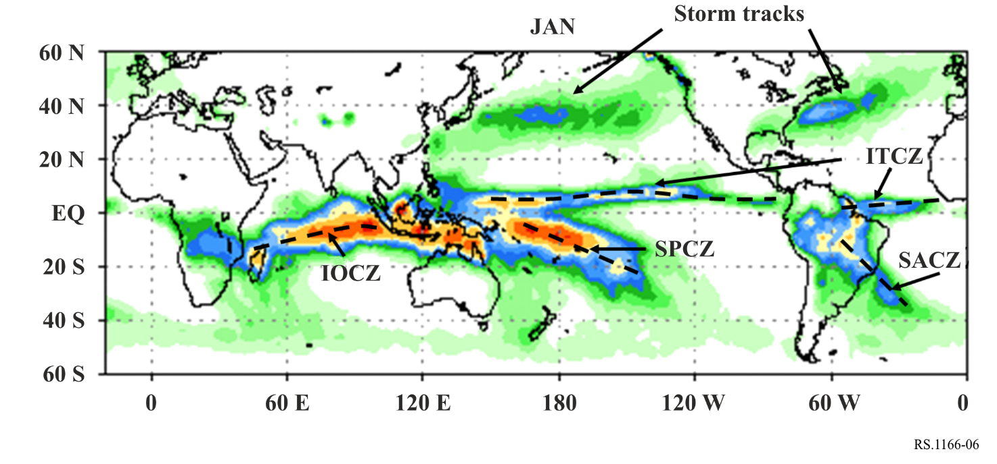

4.1.2 Interference criteria
Noise-like interference resulting in an increase in rain rate measurement from 0.2 to 0.5 mm/h corresponds to a performance degradation of 7%. Therefore, the interference should be 10 dB below the system noise level. Since the system noise level of this example PR is −140 dBW. The noise level is sensor specific and needs to be calculated for each scenario. The equation for calculating the noise level is given:
N =10 log(T*k_{B}*BW) (dBW/BW)
where:
T : system noise temperature in Kelvin
k_{B} : 1.381 × 10⁻²³ (Boltzmann’s constant)
BW : System bandwidth.
In shared frequency bands, availability of precipitation radar data should exceed 99.8% of all locations in the sensor service area in the case where the loss occurs randomly. It should be noted that determining if the 99.8% availability requirement can be met is a relatively straightforward analysis; however, it is difficult to analyse availability loss due to interference for its characteristic of random dispersion over all observation time and areas.

4.1.3 GPM 35 GHz band precipitation radar

4.1.3.1 Performance criteria
The percentage of the weak rainfall in the high latitude region is larger than that in the tropical region. Therefore, it is necessary to measure the weak rain as much as possible in order to obtain a bias-free estimate of the rainfall distribution statistics over the high latitude region. Measurements of 0.2 mm/h rain rate are one of the measurement requirements in the GPM DPR mission. For this reason, a minimum detectable radar reflectivity of less than 12 dBZ is specified as the performance criteria of the 35 GHz precipitation radar.

4.1.3.2 Interference criteria
The radar reflectivity of 12 dBZ corresponds to 0.2 mm/h rain rate. This value may increase to 0.22 mm/h. This performance degradation corresponds to a 10% increase of the system noise temperature, or about a 0.5 dB increase of the system noise level. This criterion is essentially the same for the 13 GHz precipitation radar. As for the criterion of the data loss by interference, the same criteria for the 13 GHz precipitation radar applies to the 35 GHz precipitation radar. The permissible data loss for the 35 GHz GPM precipitation radar is 0.2%.
It should be noted that the permissible interference level provided in this example is correct for only this example. For each Precipitation Radar, their permissible interference levels have to be calculated using the system characteristics of that Precipitation Radar.

5 Synthetic aperture radars
This section presents information on the performance and interference criteria for spaceborne active imaging radar sensors in the frequency bands 432-438 MHz, 1 215-1 300 MHz, 3 100-3 300 MHz, 5 250-5 570 MHz, 8 550-8 650 MHz and 9 200-10 400 MHz. The performance and interference criteria can be used to analyse the compatibility of active spaceborne imaging radar sensor operation with radionavigation and radiolocation systems, as well as systems from other services in these bands.

5.1 Performance criteria of SARs
Space borne synthetic aperture radars (SARs) are typically used to produce radar image maps of the terrain below as the spacecraft motion creates a synthetic aperture over a typical aperture time of 0.2-10 s. Any signals which interfere during this aperture time affect the imaging of that particular feature. Many SARs image mainly land and land/water transitions at the coasts. A finite number of selected sites are chosen by the researchers to image over a range of look angles as the 1-to-14 day repeat orbits drift slightly. Any interference that disrupts SAR measurement data obtained from an observed terrestrial site during any one of the measurements taken at different look angles would adversely affect overall measurement performance. Another use of SARs is to produce topographic maps which can be used for digital elevation models. Some SARs use repeat pass interferometry in order to produce topographic maps over two passes. Interference on either one of the passes would affect the performance adversely.
A requirement for SAR imaging or topography missions is to acquire at least 99% of the possible data from selected sites over land or land/ocean transitions. This budget for lost data is separate from other sources of loss such as those due to the spacecraft systems, the SAR instrument, etc.
The availability requirement for SAR data is 99%, assuming that the losses are of short duration and random over data acquisition time and areas. However, the 99% availability requirement should be applied to both the option based on the percentage of the area of interest that is compromised, as well as that on the observation times during which measurements are compromised. Especially for polar orbiting instruments, significant observation time is spent over the high-latitude regions, which can introduce an underestimation of the interference in other areas if only the observation time serves as availability criterion. It should be noted that determining if the 99% availability requirement can be met is a relatively straightforward analysis; however, it is difficult to analyse outages for its characteristic of random dispersion over all observation time and areas. Interference at a given geographical location on a systematic basis is of a more serious concern, especially when encountered over one of a researcher’s site of interest, where ground truth experiments or validation experiments may be occurring at the same time. Interference at a given geographical location for SAR imaging or topographic missions could create a gap in the global coverage map.

5.2 Interference criteria of SAR
The interference criteria for spaceborne imaging radars have been established as that presented in Table 2. In this Table 2, the interference criterium for synthetic aperture radars is an interference-to-noise ratio (I/N) of −6 dB, which corresponds to a 10% measurement degradation of the standard deviation of SAR pixel power.
This interference level may be exceeded upon consideration of the interference mitigation effect of SAR processing discrimination and the modulation characteristics of the systems operating in the shared band. In order to meet mission objectives these levels may not be exceeded for percentages of the areas of interest of more than 1% for systematic occurrences of interference and more than 5% for random occurrences of interference.
It should be noted that applying the interference criteria to the percentage of images affected may result in an underestimation of interferences in non-polar regions for instruments that spent a significant amount of time over the polar regions due to their orbit. It is therefore suggested to apply the criteria to both percentages of images affected (observation times affected) and areas of interest affected.
SAR raw data are processed both in range and azimuth to produce a radar image. A point target return is spread linearly in frequency both in range and azimuth dimensions. The processor correlates the data in both dimensions, and the processing gain typically ranges from 20 to 40 dB for the return echo. Noise and interference signals have much lower processing gains. The receiver noise has nearly 0 dB gain in range. Interference signals at the same input level as the noise, have different processing gains depending upon the waveform modulation type.

5.2.1 Processing gain of noise and noise-like interference
The system noise, referenced to the antenna port, consists mainly of the antenna noise and front-end receiver noise. This noise can be modelled as a white, stationary, Gaussian noise process. The processor correlator is essentially a matched filter for the linear FM, or chirp, pulses. The range processing gain for noise is 0 dB. The azimuth processing gain is N² for the coherent integration of N returns during a synthetic aperture and N for the noise. The synthetic aperture integration time and appropriate PRF are needed to process the pixels to a certain resolution size in azimuth ρ_{AZ}. This is calculated as follows:
(assuming a stripmap mode)
where:
G_{NAZ}: azimuth processing gain of noise
T_{I}: SAR azimuth integration time
PRF: pulse repetition frequency
λ: wavelength
R_{S}: slant range
v: spacecraft platform velocity
L_{eff}: effective antenna length in azimuth
ρ_{AZ}: azimuth resolution.
As an example, for a 600 MHz bandwidth SAR with a 3 m antenna near 9.6 GHz in stripmap mode, λ = 0.031 25 m, R_{S} = 535.8 km at 20° incidence angle, v = 7.05 km/s, and L_{eff} = 3 m, then T_{I} = 0.8 s. For ρ_{AZ} = 1 m, then PRF = 8 460 Hz, and the azimuth processing gain for noise G_{NAZ} is 38 dB.
For the same SAR using a 1.2 GHz bandwidth in spotlight mode, the integration time in azimuth would be more important. If the SAR main beam is illuminating the target area during 3 s and the PRF is 6 000 Hz, the azimuth processing gain becomes 42 dB.

5.2.2 Processing gain of other interference signals

5.2.2.1 Range processing gain for pulsed CW interference
Assuming that the RF centre frequency of the interference pulsed CW signals is within the processing band frequency, then the processing gain of interference relative to noise varies with the percentage of overlapping width of the CW pulse with respect to the linear FM pulse width as shown in Fig. 7.
Figure 7
Time and frequency characteristics of chirp and pulse
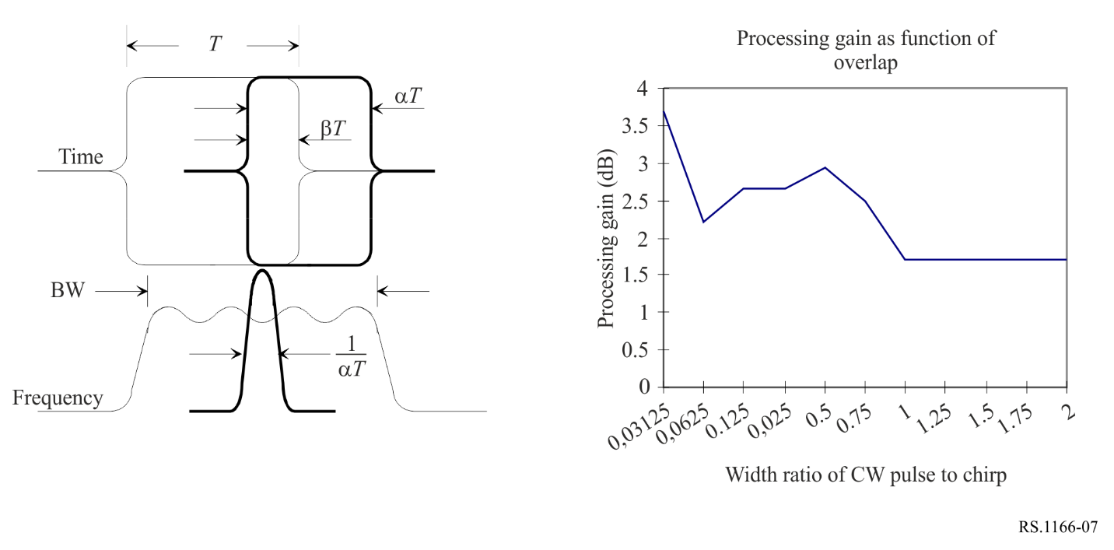
Assuming the interference pulse width is less than the chirp pulse width and is enveloped by the chirp (i.e. α = β), then the processing gain is shown as a function of the fractional pulse width in Fig. 7.

5.2.2.2 Range processing gain for non-pulsed CW interference signals
The RF centre frequency of the non-pulsed CW interference signal is assumed to be in the processing frequency band. For a level of interference signal equal to the noise level, the CW processing gain is 1.7 dB. For each image pixel, this is the same as for a pulsed CW interference signal with the same width as the chirp pulse, the width ratio is unity.

5.2.2.3 Range processing gain for linear FM interference signals
The linear FM interference spectrum is assumed to fall within the processing frequency band, and the interference pulse is assumed to overlap the return echo pulse as shown in Fig. 7.
Let the chirp signal f(t) be represented by the following:

(1)
where:
rect(t): rectangle function of unity width
f₀: RF carrier frequency
μ: slope.
The processing gain of the interference pulse varies as the slope ratio |µ′/µ| for approximately the same pulse width (i.e. α = 1) as shown in Fig. 8. The slope of the interference pulse is μ′ and the slope of the radar chirp is μ.
Figure 8
Processing gain of linear FM interference
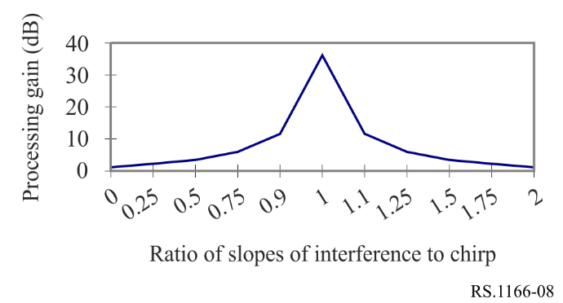

5.2.2.4 Range processing gain for other radar interference waveforms/modulation
Interfering terrestrial radars have various waveforms/ modulations such as Barker codes, non-linear FM, etc. Each of these may be modelled, and processing gains relative to noise calculated. These modulations are not covered herein. It could be noted that the maximum processing gain of other pulsed waveforms or modulations would not be greater than that of the linear FM interference (as shown in Fig. 8) due to the unmatched filtering. However, even though the range processing gain is not covered in detail herein, the azimuth processing gain still pertains to these pulsed waveforms.

5.2.2.5 Azimuth processing gain of pulsed interference signals
The SAR azimuth processing is performed through the summation of echo returns as the antenna beam illumination on the ground passes by the target area. For noise, the azimuth processing gain is N, for the integration of N pulses during a synthetic aperture. For interfering pulses, the phasing of the interfering signal within each range window differs from return to return since the pulsed interference signal and the SAR have different PRFs. For the interfering pulsed signal, previous analyses using simulations for successive range windows and the summation of returns during a SAR integration interval showed that the instantaneous peak powers for azimuth processed interference pulses vary between 0 dB and 9.5 dB.

5.2.3 Calculation of allowable interference
The allowable interference levels as specified above may differ upon consideration of the interference mitigation effect of SAR processing discrimination and modulation characteristics of the systems operating in the band. The allowable interfering signal power P_{I} can be determined from the following:
(2)
where:
I/N : allowable ratio of the interference-to-noise at the processor output
P_{N} : noise power at the antenna port
G_{NAZ} : processing gain of noise in azimuth
G_{IAZ} : processing gain of the interfering signal in azimuth
G_{NRNG} : processing gain of noise in range
G_{IRNG} : processing gain of the interfering signal in range.
The processing gains are the products of the range processing gains and the azimuth processing gains. The range processing gain for interference is normally small, that is, less than 4 dB; however, the azimuth processing gain for interference is normally 20 dB to 40 dB lower than that for noise.
The methodology used to determine the maximum acceptable interfering signal is as follows:
1) Calculate the input noise power P_{N} according to the receiver characteristics of SAR system.
2) Calculate the range processing gain G_{NRNG} and azimuth processing gain G_{NAZ} of the noise as described in § 5.2.1.
3) Calculate the range processing gain G_{IRNG} and azimuth processing gain G_{IAZ} of the interference according to the interference waveform as described in § 5.2.2.
4) In the case that SNR = 0 dB, the output power of the noise equals that of the signal. For allowable interfering criteria I/N = −6 dB, the output power of the maximum interfering signal is obtained by subtracting 6 dB from the output noise power.
5) The maximum allowable input power of the interference signal P_{I} can be determined through equation (2) from the values of P_{N,} G_{IRNG}, G_{IAZ}, G_{IRNG}, G_{IAZ} and I/N computed in Steps 1 to 4 above.
For instance, in the case of a wideband SAR operating at 9.6 GHz and receiving interference from an airborne radar, both the radar and the SAR use linear FM pulses with widely different chirp slopes. The SAR chirp slope is 45-450 MHz/μs and the airborne radar chirp slope is 0.5 MHz/μs. The ratio of the interfering chirp slope to the SAR chirp slope |µ′/µ| is only 0.001 to 0.01, and from Fig. 8 the corresponding range processing gain is about 2.3 dB. For allowable I/N = −6 dB, P_{N} = −83.7 dBm, G_{NAZ}/G_{IAZ} = 38 dB, and G_{NRNG}/G_{IRNG} = −2.3 dB, then P_{I} should not exceed −54 dBm. Considering that the range processing gain of the signal is 44 dB, and the value of the azimuth processing gain is twice that of the noise, then the input power of the minimum desired signal can be calculated as −165.7 dBm. Table 5 shows the calculation results for processor gains for noise, the minimum desired return echo signal (SNR = 0 dB), and the maximum acceptable interfering signal for the case of SAR at 9.6 GHz receiving interfering signals from the airborne radar.
TABLE 5
Range and azimuth processing gains for noise, signal and interference for a 600 MHz SAR
in stripmap mode at 9.6 GHz, with a 50 µs pulse
Signal type | Input power  (dBm) | Range  processing gain  (dB) | Azimuth  processing gain  (dB) | Output power  (dBm)
Noise | −83.7 | 0.0 | 38 | −45.7
Minimum desired signal | −165.7 | 44 | 76 | −45.7
Maximum acceptable  interfering radar signal | −63.5 to −54 | 2.3 | 0.0 to 9.5 | −51.7

It should be noted that, according to equation (2) there is no SAR processing gain impact on noise-like interference such as the interference that would be due to a high density of wideband transmitter on the ground. Indeed, in this case G_{NAZ}/G_{IAZ} = 0 dB and G_{NRNG}/G_{IRNG} = 0 dB leading to a P_{I} which should not exceed –89.7 dBm.

5.2.4 Interference criteria
The criteria for unacceptable degradation in performance for imaging or topographical interferometric SARs can be computed using the procedure in § 5.2.3.
These criteria apply to non-FM pulsed interference sources with pulse durations of 2 μs or less. For other pulse durations, the criteria vary by only ±0.6 dB.
It should be noted that for each SAR, their interference criteria level has to be calculated using the system characteristics of that SAR.

5.2.5 Availability criterion
In shared frequency bands, availability of SAR data should exceed 99% for each selected measurement area site.

6 Cloud profile radars
This section presents information on performance and interference criteria for spaceborne cloud profile radar sensors in the frequency bands 94.0-94.1 GHz.

6.1 Performance criteria for 94 GHz cloud profile radar
The objective of a spaceborne cloud profiling mission is to measure the reflectivity profile for all clouds within the field of view with a minimum reflectivity of –35 dBZ.

6.2 Interference criteria for 94 GHz cloud profile radar
Interference should degrade Z_{min} less than 10% in 95% of the service area. Ten percent degradation in Z_{min} corresponds to an interference-to-noise ratio of −10 dB. This interference criterion corresponds to an interference power level of −160 dBW over 300 kHz.

6.3 Availability criteria of the cloud profile radar
For random interference signals, the interference should degrade Z_{min} less than 10% in 95% of the service area. If the interference signal is not random, it should degrade Z_{min} less than 10% in 99% of the intended service area. It should be noted that it is difficult to analyse interference for its characteristic of random dispersion over all observation time and areas.

7 Measurement area of interest for the evaluation of systematic interference
In order to perform analyses that evaluate interference in regard to its impact on the active sensor’s systematic data availability criteria it is necessary to define 1) the dimensions of the measurement area, 2) the location of the geographical area that should be considered in simulations, and 3) the manner in which the measurement is taken. Together, the size and location of the geographical area that should be considered in sharing analyses has been referred to as “the measurement area of interest”. The manner in which the measurement is taken is dependent on the operational characteristics of the sensor and the method in which the sensor data is used.
In shared frequency bands, availability of all sensor data, with the exception of precipitation radar, should exceed 95% of all locations in the sensor service area in the case where the loss occurs randomly, and it should exceed 99% of all locations in the case where the loss occurs systematically within the measurement area of interest. In the case of precipitation radars, the random and systematic data availability criteria is 99.8%.
In regard to the measurement area of interest, any systematic interference in excess of the applicable interference threshold would result in measurement loss 100% of the time for the specific measurement area of interest.

8 Transient impulse interference considerations
It is important to note that ITU-R sharing and compatibility studies are typically conducted with the mean (average) power of the interfering transmitter rather than the peak transient power. In the case of a peak detecting active spaceborne sensor such as an altimeter, use of the mean power of the interfering transmitter instead of the peak transient power will underestimate the level of interference affecting the peak detecting sensor measurements.
Active spaceborne sensors that detect average return signal power are not affected additionally by transient transmissions of modulation symbols with higher power than the transmitted average power. However, sensors that detect peak return signal power are sensitive to the transient transmission amplitudes that occur above the average power of an interfering signal.

8.1 Determination of peak transient power for some modulation schemes
Figure 9 provides the results of CCDF measurements made of the power peaks of a DVB-S2 single carrier transmitter with five commonly used modulation schemes when presented with a randomly generated data stream. Single carrier transmission operation was considered.
Pulse shape filtering was used in the transmission. Non-linear components and multi-carrier operation were not included in this investigation. As is expected, 50% of the time peak power is 0 dB above the average power. However, 1% of the time, four of the five modulation schemes have power peaks 4 dB higher than the average. Peak impulse power is greater than 5 dB above the mean for all of the commonly used modulation schemes shown in Fig. 9 and peak impulse power is greater than 7 dB above the mean power for 32 APSK and 16 QAM. As an example, Table 6 below tabulates the power peaks for the modulation schemes at the 10%, 1%, 0.1%, and 0.01% of time levels vs bandwidths. Table 6 also provides for each of the bandwidths the number of symbols per second that would occur at those power peaks for the percentage of time levels.
As an example, an altimeter that operates in the 13.4-13.75 GHz band and samples about 2 000 radar echoes per second resulting from about 2 000 chirps. The altimeter detects peak returned power. Table 6 shows the number of symbols/s versus the peak power above the mean expected for various modulations and transmission bit rates. The area highlighted in yellow in Table 6 indicates in the tabulation where the transmission modulation symbols per second rate exceeds the altimeter sample rate. An examination of these highlighted entries indicates that in considering the effect of transient peak impulse power, a minimum additional value of interference transmission power above the mean should be applied.
This examination of the impact of peak power on the altimeter peak detecting sensor was conservative in its estimate of additional power that should be accounted for in interference studies. As indicated in Fig. 9, peaks of higher power symbols occur at lower frequency rates than the example altimeter pulse rate of about 2 000/second.
These higher power symbols will also be detected by the altimeter sensor but since these higher power symbols occur at a lower frequency rate than the sample rate they will not affect every altimeter sample. Further study may provide a method for fully accounting for the impact of all higher power symbols on the degradation of measurement samples taken by peak detecting sensors.
Figure 9 and Table 6 provide power peak/percentage of time results of modulations when considering single carrier transmission per FSS earth station operation. When a transmitting station employs multiple carriers within a transmission (multicarrier operation), the interaction between the multiple carriers within the same filtered bandwidth of the transmitter will increase the peak power of symbols significantly over that of a single carrier ES transmitter. Examination of multicarrier transmission in regards to the peak power of symbols produced will require further study.
FIGURE 9
CCDF of Peak power for common modulations employed
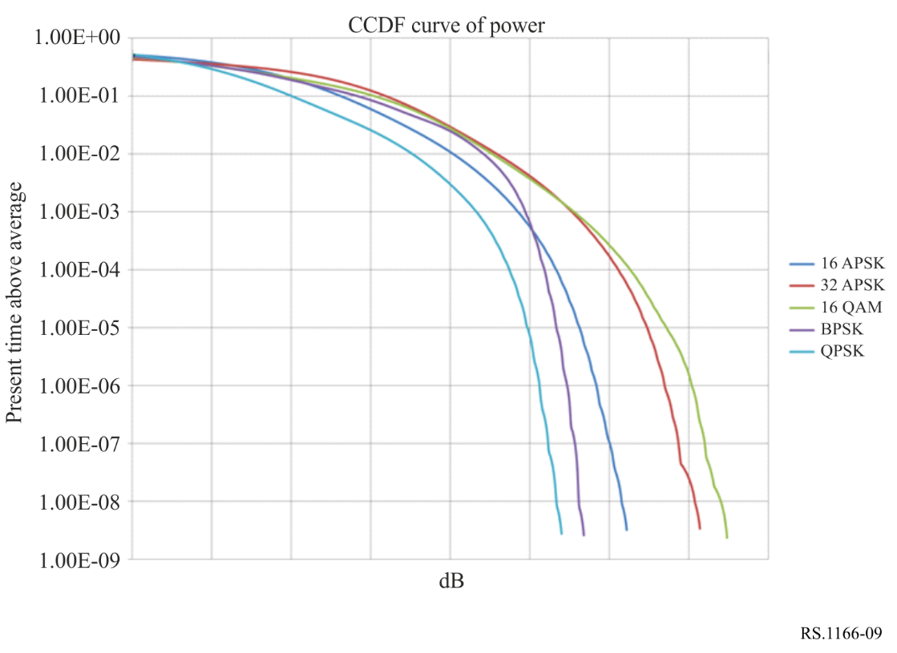
TABLE 6
Tabulation of peak power as a percentage of time and the corresponding symbols/sec
for the FSS transmission types
Transmission bit rate/modulation | 10% of time above average (dB) | Symbols/s  (k) | 1% (dB) | Symbols/s  (k) | 0.1% (dB) | Symbols/s  (k) | 0.01% (dB) | Symbols/  (k)
580 kHz
16 APSK | 2.6 | 232 | 4.0 | 23.2 | 4.8 | 2.3 | 5.3 | 0.2
32 APSK | 3.2 | 290 | 4.6 | 29 | 5.5 | 2.9 | 6.1 | 0.3
16 QAM | 3.1 | 232 | 4.5 | 23.2 | 5.6 | 2.3 | 6.3 | 0.2
BPSK | 2.8 | 58 | 4.4 | 5.8 | 4.9 | 0.6 | 5.2 | 0.1
QPSK | 2.0 | 116 | 3.5 | 11.6 | 4.3 | 1.2 | 4.7 | 0.1
30.84 MHz
16 APSK | 2.6 | 12 336 | 4.0 | 1 232 | 4.8 | 123.2 | 5.3 | 12.4
32 APSK | 3.2 | 15 420 | 4.6 | 1 540 | 5.5 | 154.0 | 6.1 | 15.5
16 QAM | 3.1 | 12 336 | 4.5 | 1 232 | 5.6 | 123.2 | 6.3 | 12.4
BPSK | 2.8 | 3 084 | 4.4 | 308 | 4.9 | 30.8 | 5.2 | 3.1
QPSK | 2.0 | 6 168 | 3.5 | 616 | 4.3 | 61.6 | 4.7 | 6.2
2.94 MHz
16 APSK | 2.6 | 1 176 | 4.0 | 117.6 | 4.8 | 11.8 | 5.3 | 1.2
32 APSK | 3.2 | 1 470 | 4.6 | 147 | 5.5 | 14.7 | 6.1 | 1.5
16 QAM | 3.1 | 1 176 | 4.5 | 117.6 | 5.6 | 11.8 | 6.3 | 1.2
BPSK | 2.8 | 294 | 4.4 | 29.4 | 4.9 | 2.9 | 5.2 | 0.3
QPSK | 2.0 | 588 | 3.5 | 58.8 | 4.3 | 5.9 | 4.7 | 0.6

For ITU-R sharing studies involving peak detecting active spaceborne sensors, an examination of the frequency of symbols with higher power in comparison to the frequency of detection by the active spaceborne sensor is needed to determine the additional level above the mean power of the interfering transmitter that should be taken into account.

9 Typical EESS (active) sensor parameters to be used in determining impact from differing types of interference
The parameters of the five types of spaceborne active sensors listed in Table 7 can be used in evaluating the impact of various types of interference to the measurements obtained by the active sensor. The values given in Table 7 are typical values which can be used for a preliminary evaluation; however, the actual values of the active sensor in the frequency band under consideration should be used in any final determination of interference impact.
TABLE 7
Typical EESS (active) sensor processing parameters for interference impact assessment
Sensor type | Peak/Average power detection | Sub sample size  (ms) | Number of subsamples in a sample | Pixel size  (km²) | Minimum measurement area of interest | Background noise measurement
Altimeter | Peak | 50 | 100 | 1 km² | 10 km²  (consecutive pixels) | yes
Scatterometer | Average |  |  |  |  | yes
Precipitation radar | Average |  |  |  |  | yes
Synthetic aperture radar (SAR) | Average |  |  |  |  | yes
Cloud profile radar | Average |  |  |  |  | yes

* Interference criteria do not imply automatically sharing criteria.
Altimeters operate anywhere in the frequency band 9.2-10.4 GHz with a bandwidth of 300 MHz.
Except for 35.5-36 GHz altimeters.
For 35.5-36 GHz altimeters.
This implies the transmit filter of a RRC with a .25 alpha (α).

