Recommendation ITU-R RA.1031-3
(12/2021)
Protection of the radio astronomy service in frequency bands shared with active services

RA Series
Radio astronomy

Foreword
The role of the Radiocommunication Sector is to ensure the rational, equitable, efficient and economical use of the radio-frequency spectrum by all radiocommunication services, including satellite services, and carry out studies without limit of frequency range on the basis of which Recommendations are adopted.
The regulatory and policy functions of the Radiocommunication Sector are performed by World and Regional Radiocommunication Conferences and Radiocommunication Assemblies supported by Study Groups.

Policy on Intellectual Property Right (IPR)
ITU-R policy on IPR is described in the Common Patent Policy for ITU-T/ITU-R/ISO/IEC referenced in Resolution ITU-R 1. Forms to be used for the submission of patent statements and licensing declarations by patent holders are available from http://www.itu.int/ITU-R/go/patents/en where the Guidelines for Implementation of the Common Patent Policy for ITU-T/ITU-R/ISO/IEC and the ITU-R patent information database can also be found.

Series of ITU-R Recommendations
(Also available online at http://www.itu.int/publ/R-REC/en)
Series | Title
BO | Satellite delivery
BR | Recording for production, archival and play-out; film for television
BS | Broadcasting service (sound)
BT | Broadcasting service (television)
F | Fixed service
M | Mobile, radiodetermination, amateur and related satellite services
P | Radiowave propagation
RA | Radio astronomy
RS | Remote sensing systems
S | Fixed-satellite service
SA | Space applications and meteorology
SF | Frequency sharing and coordination between fixed-satellite and fixed service systems
SM | Spectrum management
SNG | Satellite news gathering
TF | Time signals and frequency standards emissions
V | Vocabulary and related subjects

Note: This ITU-R Recommendation was approved in English under the procedure detailed in Resolution ITU-R 1.

Electronic Publication
Geneva, 2021

© ITU 2021
All rights reserved. No part of this publication may be reproduced, by any means whatsoever, without written permission of ITU.

RECOMMENDATION ITU-R RA.1031-3
Protection of the radio astronomy service in frequency
bands shared with active services
(Question ITU-R 145/7)
(1994-1995-2007-2021)
Scope
This Recommendation gives a practicable guideline for the case when one or more administrations, during negotiation, establish coordination zones around radio astronomy stations to protect the radio astronomy service from interference caused by terrestrial radiocommunication services or transmitting earth stations used for space radiocommunication services that share frequency bands with the radio astronomy service.
The ITU Radiocommunication Assembly,
considering
a) that the radio astronomy service is based on the reception of natural emissions at much lower power levels than are generally used in other radio services, and that the radio astronomy service is therefore particularly vulnerable to interference from transmitters in shared frequency bands;
b) that many frequency bands allocated to the radio astronomy service are also allocated to other services which transmit in those bands;
c) that protection from interference is essential to the advancement of the radio astronomy service, and that the preferred frequency bands for radio astronomy are given in Recommendation ITU-R RA.314;
d) that threshold levels of interference detrimental to the radio astronomy service and levels of data loss criteria are given in the relevant RA Series of ITU-R Recommendations;
e) that the detailed characteristics of the interference and the particular type of radio astronomical measurement may need to be taken into account when developing sharing criteria;
f) that radio astronomy sites are carefully chosen, and that site characteristics may strongly affect the sharing calculations;
g) that frequency sharing is generally impossible for transmitters within direct line-of-sight of a radio astronomy antenna,
recommends
1 that, in making assignments to services which share frequency bands with the radio astronomy service, administrations should take all practicable steps to avoid interference detrimental to the radio astronomy service;
2 that consideration be given to protecting radio astronomy sites from interference from transmitters used for terrestrial radiocommunications or from transmitting earth stations used for space radiocommunications in bands shared with the radio astronomy service with equal rights through the establishment of coordination zones around radio astronomy sites;
3 that the coordination zone may be calculated, taking account of the methodology contained in Annex 1.

Annex 1
Coordination considerations

1 General
Radio astronomy sites are chosen specifically to minimize interference from Earth based transmitters. The sites are usually at a considerable distance from the major fixed sources of terrestrial interference and may be screened by nearby high ground.
Many radio astronomy measurements can tolerate levels of interference from a shared service which exceed these thresholds for 2% of the measurement period, assuming no other data loss mechanism is involved. However, certain other types of measurements such as those involving transient phenomena and those depending upon simultaneous observations at many sites on Earth, may be severely damaged by interference at inopportune times.

2 Separation distances required for sharing
If geographical sharing is to be successful the interfering transmitter and the interfered-with receiver must be separated by a distance at which the interference is not considered harmful. Appendix 7 to the Radio Regulations defines a basic transmission loss Lb( p) as:
Lb( p) = Pt + Gt + Gr – Pr ( p) (1)
where:
L_{b}(p) : minimum permissible basic transmission loss for p% of the time; this value must be exceeded by the actual transmission loss for all but p% of the time (dB)
P_{t} : transmitting power level in the reference bandwidth at the input to the antenna (dBW)
G_{t} : gain of the transmitting antenna in the direction of the radio astronomy antenna (dBi)
G_{r} : gain of the radio astronomy antenna in the direction of the transmitter (dBi)
P_{r} (p) : maximum permissible interference power in the reference bandwidth to be exceeded for no more than p% of time at the receiver input (dBW).
For a radio astronomy observation, however, the power received is integrated over a period of time T, in order to reach a better sensitivity. The result of this integration is called an observation in the following paragraphs.
The power received from an interferer during an observation may be expressed as follows:
(2)
where the following quantities are expressed in linear form:
L p (i) : propagation loss at instant i
Pt(i) : transmitting power level in the radio astronomy service bandwidth at the input to the antenna at instant i (W)
Gt(i) : gain of the transmitting antenna in the direction of the radio astronomy antenna at instant i
Gr(i) : gain of the radio astronomy antenna in the direction of the transmitter at instant i
N : number of samples in the integration time T
I : interference power in the reference bandwidth at the receiver input averaged over the observation period T (W).
Usually the calculation is performed over an integration period T of 2 000 s. During this period of time, some of the parameters may vary. For example, if power control is used by the transmitter or if the transmitter is not in activity during all the observation period (voice activated), P_{t} may vary.
If the transmitter is an earth station following a satellite, then G_{t} may also vary. The radio astronomy station may track a celestial object and therefore G_{r} may also vary. During this period of time atmospheric conditions, such as rain may also make L_{p} vary.
Observations performed over a given integration time are considered lost when the interference power received, I, averaged over T exceeds the value given in Recommendation ITU-R RA.769.
It is then necessary to perform the calculation over several periods of time in order to verify that the percentage of observations lost is lower than the criterion of 2% given in Recommendation ITU-R RA.1513.

2.1 Single constant e.i.r.p. interferer with constant propagation loss
If the e.i.r.p. of the transmitter causing the interference is constant (i.e. P_{t} and G_{t} are constant), the frequency is sufficiently low and the transmitter is fixed, so that we may consider L_{p} constant, then the only variable over all observations is G_{r}. In order to simplify the calculation, we consider that the radio astronomy antenna is fixed during the observation.
It is then possible to apply the methodology given in Recommendation ITU-R M.1583 to derive statistics on the antenna gain of the radio astronomy station.
The curves in Fig. 1 were obtained for the frequency 1.4 GHz, using the large antenna pattern given in Recommendation ITU-R SA.509, and an antenna diameter of 100 m. The elevation angle of the transmitter as seen from the radio telescope has been taken as 0 degree. These curves do not change when considering other frequency bands or antenna diameters.
Figure 1
Radio astronomy service antenna gain towards a transmitter at an elevation angle of 0°
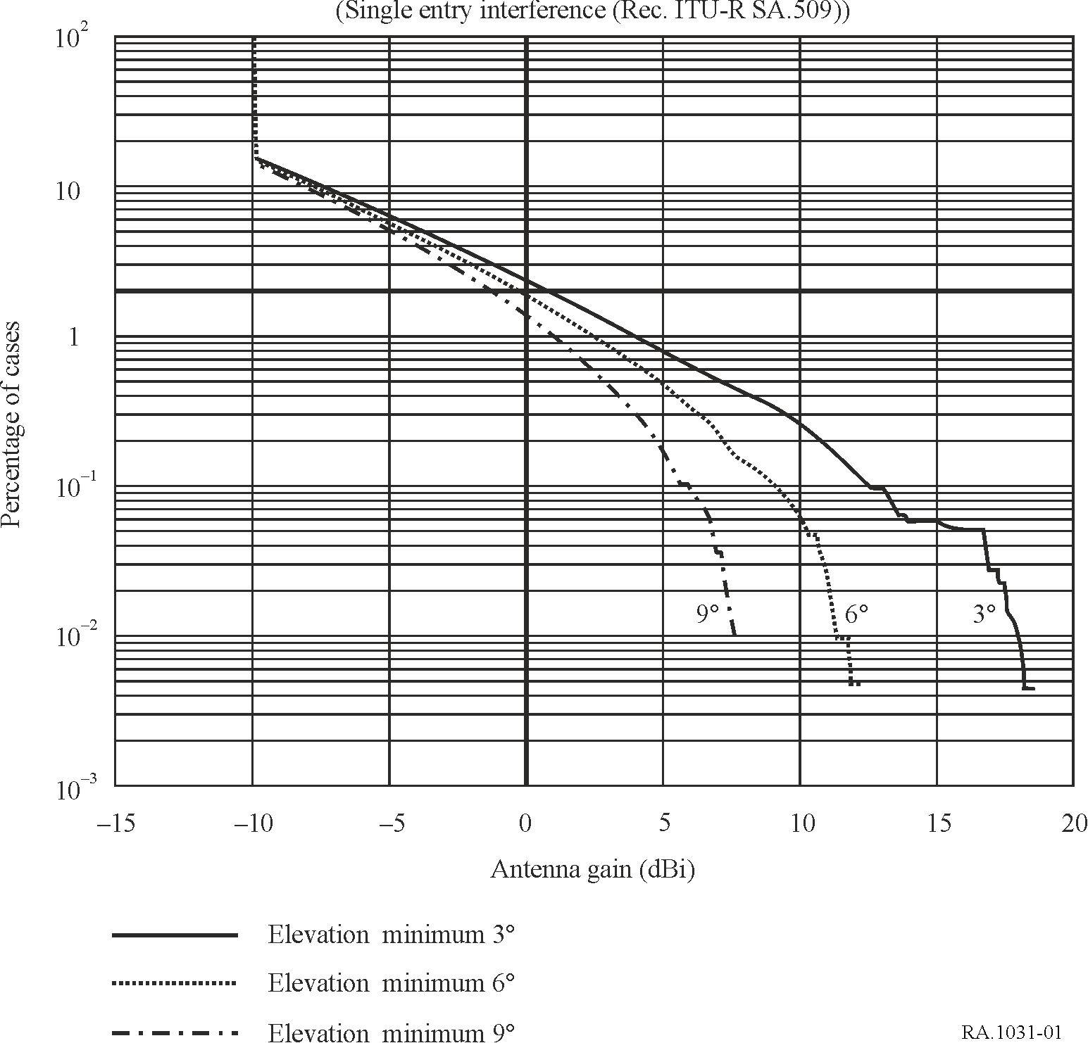
It is shown in Fig. 1 that it is legitimate to consider for the antenna gain corresponding to a 2% data loss the value 0 dBi. The necessary propagation loss is then given by equation (3):

(3)

where:
EIRP: transmitter e.i.r.p. (dBW)
ΔP_{H}: Recommendation ITU-R RA.769 level (dBW).

2.2 Other cases
To cover other cases such as varying propagation losses or varying transmitter power or varying antenna gain towards the radio astronomy station, it may be necessary to use simulation tools such as the Monte-Carlo method.

3 Sharing within the line-of-sight
For an interferer transmitting along the line-of-sight in the same band in which the radio astronomy station observes, Lp has a simple analytical form and equation (3) may be written as:

20 log (4π d) = 20 log λ + EIRP – (4)
where:
d : distance between transmitter and receiver (m)
λ : wavelength (m)
ΔP_{H} : threshold level defined in Recommendation ITU-R RA.769 (dBW).
It is generally impossible for radio astronomy to share successfully with any active services whose transmitters are within line-of-sight of a radio astronomy antenna. Figure 2 illustrates this fact. The maximum e.i.r.p. which would not result in interference detrimental to the radio astronomy service has been calculated using equations (3) and (4) for two distances. One distance is representative of a terrestrial transmitter at a large distance within line-of-sight, namely an airborne transmitter on the horizon at a height of 20 km. The other distance is that of the geostationary orbit, and is thus representative of the maximum distance of most spaceborne transmitters not on deep-space missions. The interference thresholds in Recommendation ITU-R RA.769, Table 1, have been used in the case of the terrestrial transmitter. An additional protection of 15 dB is desirable for the case of the transmitter in the geostationary orbit, to allow observations within 5° of satellites in the orbit. The curves are applicable to a clear dry atmosphere.
It is clear from Fig. 2 that frequency sharing with a terrestrial transmitter within line-of-sight of a radio astronomy antenna is unlikely to be possible at frequencies below 10 GHz because of the severe restriction sharing would impose on the transmitter e.i.r.p. Even for frequencies up to 40 GHz either the transmitter power must be of the order of a few milliwatts, or the transmitting antenna must provide high discrimination towards the direction of the radio astronomy antenna, for sharing to be possible.

4 Sharing beyond the line-of-sight using coordination zones
The establishment of coordination zones around radio astronomy sites provides a method of avoiding interference from transmitters used for terrestrial radiocommunications or in earth stations used for space radiocommunications sharing the band beyond the line-of-sight.
A coordination zone associated with a radio astronomy station is defined as the area for which the sum total of emissions from transmitters outside its boundary meets the levels of data loss criteria given in Recommendation ITU-R RA.1513.
The size of the coordination zone depends upon a number of factors. The type of radio telescope (single dish or very long baseline interferometry (VLBI) being used determines the corresponding interference thresholds given in Recommendation ITU-R RA.769. The number and distribution of the transmitters outside the zone, the e.i.r.p. of the transmissions in the direction of the radio astronomy site, the fraction of the time they are active, and the propagation characteristics determine the interfering power flux-density at the radio astronomy site. The propagation characteristics depend upon factors such as the profile of the terrain, presence of trees, and the atmospheric conditions. The latest available propagation models such as those contained in Recommendations ITU-R P.452, ITU-R P.526 and ITU-R P.617 should be used.
FIGURE 2
e.i.r.p. as a function of frequency
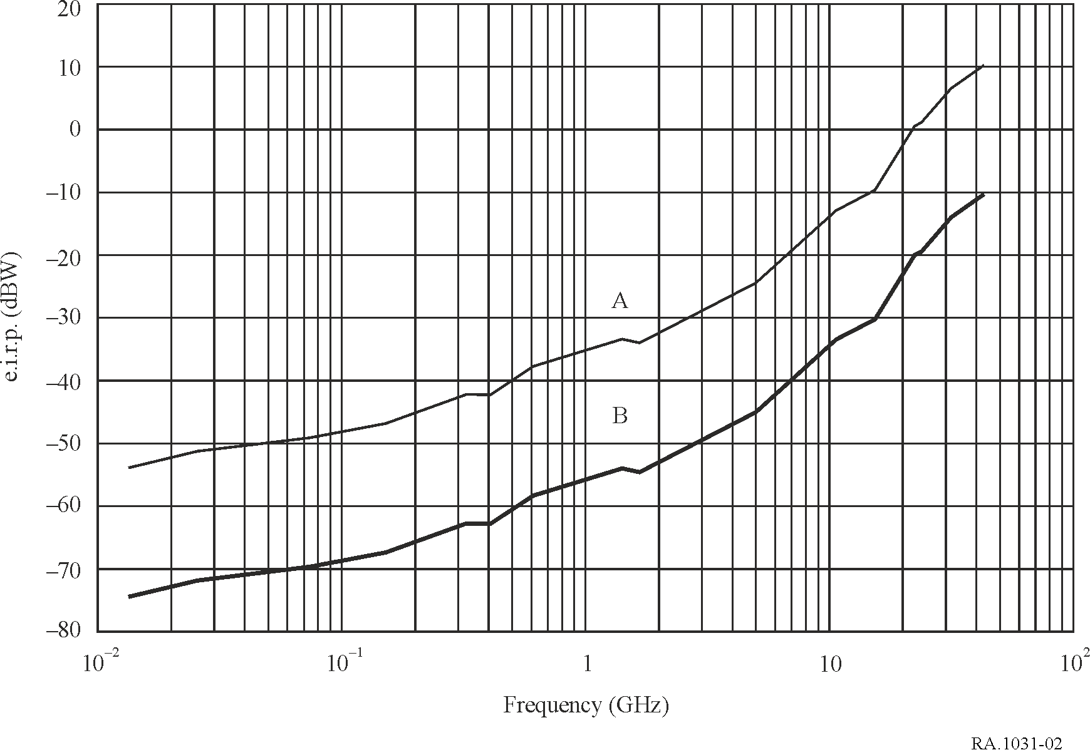
Note to Fig. 2: The e.i.r.p above which sharing is not feasible between radio astronomy and active services with transmitters within line-of-sight of radio astronomy antenna is shown per two cases. The reference bandwidths for the transmitter e.i.r.p and the radio astronomy receiver are those allocated to the radio astronomy service. Curve A shows results for a transmitter in the geostationary orbit, and Curve B shows results for a terrestrial transmitter in line-of-sight at 600 km.
Because of the number of factors involved, the boundaries of the coordination zones should be established individually for each radio astronomy site at which such a zone is required. It should be realized that the coordination distance in some cases may be 100 km or more. For some small countries the coordination zone required may extend beyond the national boundaries into countries where the frequency allocations may be different. Thus special conditions may need to be applied when determining coordination zones to protect radio astronomy.
The coordination zone defines a region around a radio astronomy observatory outside of which the users of the active service can transmit freely without causing interference detrimental to radio astronomy observations. For users within the coordination zone technical means must be found to avoid such interference.
In principle, coordination zones can also be set up to protect radio astronomy sites from mobile transmitters. In this case the mobile user must have some means of determining when the coordination zone is entered, and some means of reducing the power received at the radio astronomy site to a level below the harmful threshold for interference.
For the case of mobile transmitters on aircraft the sizes of the zones need to be much larger than for ground-based transmitters since distances over which line-of-sight propagation conditions occur are much greater, and increase with aircraft height.

