Recommendation ITU-R P.834-6
(01/2007)
Effects of tropospheric refraction
on radiowave propagation

P Series
Radiowave propagation

Foreword
The role of the Radiocommunication Sector is to ensure the rational, equitable, efficient and economical use of the radio-frequency spectrum by all radiocommunication services, including satellite services, and carry out studies without limit of frequency range on the basis of which Recommendations are adopted.
The regulatory and policy functions of the Radiocommunication Sector are performed by World and Regional Radiocommunication Conferences and Radiocommunication Assemblies supported by Study Groups.

Policy on Intellectual Property Right (IPR)
ITU-R policy on IPR is described in the Common Patent Policy for ITU-T/ITU-R/ISO/IEC referenced in Annex 1 of Resolution ITU-R 1. Forms to be used for the submission of patent statements and licensing declarations by patent holders are available from http://www.itu.int/ITU-R/go/patents/en where the Guidelines for Implementation of the Common Patent Policy for ITU-T/ITU-R/ISO/IEC and the ITU-R patent information database can also be found.

Series of ITU-R Recommendations
(Also available online at http://www.itu.int/publ/R-REC/en)
Series | Title
BO | Satellite delivery
BR | Recording for production, archival and play-out; film for television
BS | Broadcasting service (sound)
BT | Broadcasting service (television)
F | Fixed service
M | Mobile, radiodetermination, amateur and related satellite services
P | Radiowave propagation
RA | Radio astronomy
RS | Remote sensing systems
S | Fixed-satellite service
SA | Space applications and meteorology
SF | Frequency sharing and coordination between fixed-satellite and fixed service systems
SM | Spectrum management
SNG | Satellite news gathering
TF | Time signals and frequency standards emissions
V | Vocabulary and related subjects

Note: This ITU-R Recommendation was approved in English under the procedure detailed in Resolution ITU-R 1.

Electronic Publication
Geneva, 2009

© ITU 2009
All rights reserved. No part of this publication may be reproduced, by any means whatsoever, without written permission of ITU.
RECOMMENDATION ITU-R P.834-6
Effects of tropospheric refraction on radiowave propagation
(Question ITU-R 201/3)

(1992-1994-1997-1999-2003-2005-2007)

Scope
Recommendation ITU-R P.834 provides methods for the calculation of large-scale refractive effects in the atmosphere, including ray bending, ducting layers, the effective Earth radius, the apparent elevation and boresight angles in Earth-space paths and the effective radio path length.
The ITU Radiocommunication Assembly,
considering
a) that for the proper planning of terrestrial and Earth-space links it is necessary to have appropriate calculation procedures for assessing the refractivity effects on radio signals;
b) that procedures have been developed that allow the calculation of some refractive propagation effects on radio signals on terrestrial and Earth-space links,
recommends
1 that the information in Annex 1 should be used for the calculation of large-scale refractive effects.

Annex 1

1 Ray bending
A radio ray passing through the lower (non-ionized) layer of the atmosphere undergoes bending caused by the gradient of the refractive index. Since the refractive index varies mainly with altitude, only the vertical gradient of the refractive index is generally considered. The curvature at a point is therefore contained in the vertical plane and is expressed by:

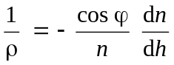 (1)

where:
ρ : radius of curvature of the ray path
n : refractive index of the atmosphere
dn/dh : vertical gradient of refractive index
h : height of the point above the Earth’s surface
ϕ : angle of the ray path with the horizontal at the point considered.
This ray curvature is defined as positive for ray bending towards the Earth’s surface. This phenomenon is virtually independent of frequency, if the index gradient does not vary significantly over a distance equal to the wavelength.

2 Effective Earth radius
If the path is approximately horizontal, ϕ is close to zero. However, since n is very close to 1, equation (1) is simplified as follows:

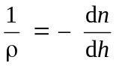 (2)

It is therefore clear that if the vertical gradient is constant, the trajectories are arcs of a circle.
If the height profile of refractivity is linear, i.e. the refractivity gradient is constant along the ray path, a transformation is possible that allows propagation to be considered as rectilinear. The transformation is to consider a hypothetical Earth of effective radius R_{e} = k a, with:

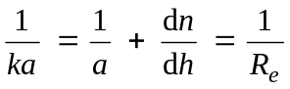 (3)

where a is the actual Earth radius, and k is the effective earth radius factor (k-factor). With this geometrical transformation, ray trajectories are linear, irrespective of the elevation angle.
Strictly speaking, the refractivity gradient is only constant if the path is horizontal. In practice, for heights below 1 000 m the exponential model for the average refractive index profile (see Recommendation ITU-R P.453) can be approximated by a linear one. The corresponding k-factor is k = 4/3.

3 Modified refractive index
For some applications, for example for ray tracing, a modified refractive index or refractive modulus is used, defined in Recommendation ITU-R P.310. The refractive modulus M is given by:

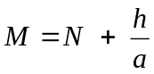 (4)
h being the height of the point considered expressed in metres and a the Earth’s radius expressed in thousands of kilometres. This transformation makes it possible to refer to propagation over a flat Earth surmounted by an atmosphere whose refractivity would be equal to the refractive modulus M.

4 Apparent boresight angle on slant paths

4.1 Introduction
In sharing studies it is necessary to estimate the apparent elevation angle of a space station taking account of atmospheric refraction. An appropriate calculation method is given below.

4.2 Visibility of space station
As described in § 1 above, a radio beam emitted from a station on the Earth’s surface (h (km) altitude and θ (degrees) elevation angle) would be bent towards the Earth due to the effect of atmospheric refraction. The refraction correction, τ (degrees), can be evaluated by the following integral:
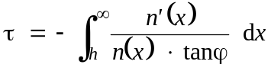 (5)
where ϕ is determined as follows on the basis of Snell’s law in polar coordinates:
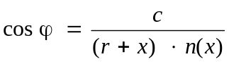 (6)
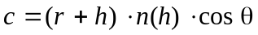 (7)
r : Earth’s radius (6 370 km)
x : altitude (km).
Since the ray bending is very largely determined by the lower part of the atmosphere, for a typical atmosphere the refractive index at altitude x may be obtained from:
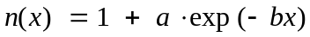 (8)
where:
a = 0.000315
b = 0.1361.
This model is based on the exponential atmosphere for terrestrial propagation given in Recommendation ITU-R P.453. In addition, n' (x) is the derivative of n(x), i.e., n' (x) = –ab exp (–bx).
The values of τ (h, θ) (degrees) have been evaluated under the condition of the reference atmosphere and it was found that the following numerical formula gives a good approximation:
τ (h, θ) = 1/[1.314 + 0.6437 θ + 0.02869 θ2 + h (0.2305 + 0.09428 θ + 0.01096 θ2) + 0.008583 h2] (9)
The above formula has been derived as an approximation for 0 ≤ h ≤ 3 km and θ_{m} ≤ θ ≤ 10°, where θ_{m} is the angle at which the radio beam is just intercepted by the surface of the Earth and is given by:
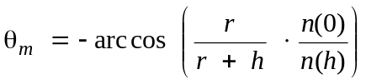 (10)
or, approximately, 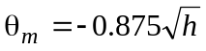 (degrees).
Equation (9) also gives a reasonable approximation for 10° < θ ≤ 90°.
Let the elevation angle of a space station be θ₀ (degrees) under free-space propagation conditions, and let the minimum elevation angle from a station on the Earth’s surface for which the radio beam
is not intercepted by the surface of the Earth be θ_{m}. The refraction correction corresponding to θ_{m} is τ (h, θ_{m}). Therefore, the space station is visible only when the following inequality holds:
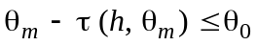 (11)

4.3 Estimation of the apparent elevation angle
When the inequality in equation (11) holds, the apparent elevation angle, θ (degrees), can be calculated, taking account of atmospheric refraction, by solving the following equation:

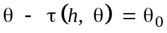 (12)
and the solution of equation (12) is given as follows:
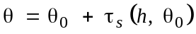 (13)
where the values of τ_{s} (h, θ₀) are identical with those of τ (h, θ), but are expressed as a function of θ₀.
The function τ_{s} (h, θ₀) (degrees) can be closely approximated by the following numerical formula:
τ_{s} (h, θ₀) = 1/[1.728 + 0.5411 θ₀ + 0.03723 θ₀² + h (0.1815 + 0.06272 θ₀
+ 0.01380 θ₀²) + h² (0.01727 + 0.008288 θ₀)] (14)
The value of θ calculated by equation (13) is the apparent elevation angle.

4.4 Summary of calculations
Step 1: The elevation angle of a space station in free-space propagation conditions is designated as θ₀.
Step 2: By using equations (9) and (10), examine whether equation (11) holds or not. If the answer is no, the satellite is not visible and, therefore, no further calculations are required.
Step 3: If the answer in Step 2 is yes, calculate θ by using equations (13) and (14).

4.5 Measured results of apparent boresight angle
Table 1 presents the average angular deviation values for propagation through the total atmosphere. It summarizes experimental data obtained by radar techniques, with a radiometer and a radiotelescope. There are fluctuations about the apparent elevation angle due to local variations in the refractive index structure.
TABLE 1
Angular deviation values for propagation through the total atmosphere
Elevation angle, θ  (degrees) | Average total angular deviation, Δθ  (degrees)
Elevation angle, θ  (degrees) | Polar continental air | Temperate continental air | Temperate maritime air | Tropical maritime air
1  2  4  10  20  30 | 0.45  0.32  0.21  0.10 | –  0.36  0.25  0.11  0.05  0.03 | –  0.38  0.26  0.12  0.06  0.04 | 0.65  0.47  0.27  0.14
 | Day-to-day variation in Δθ (for columns 1 and 4 only)
1  10 | 0.1 r.m.s.  0.007 r.m.s.

5 Focusing and defocusing of a wave for propagation through the atmosphere
Changes in signal level may also result from spreading or narrowing of the antenna beam caused by the variation of atmospheric refraction with the elevation angle. This effect should be negligible for elevation angles above 3°.
The equation below can be used to calculate the signal loss or gain due to refraction effects for a wave passing through the total atmosphere
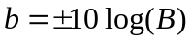
where:
θ₀: elevation angle of the line connecting the transmitting and receiving points, (degrees) (θ₀ < 10°)
h: altitude of the lower point above sea level, (km) (h < 3 km)
b: change in signal level for the wave passing through the atmosphere, compared to free-space conditions, (dB)
the sign in the equation for b will be negative “−” for a transmitting source located near the Earth’s surface and positive “+” for a source located outside the atmosphere.

6 Effective radio path length and its variations
Since the tropospheric refractive index is higher than unity varying as a function of altitude, a wave propagating between the ground and a satellite has a radio path length exceeding the geometrical path length. The difference in length can be obtained by the following integral:
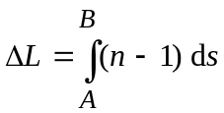 (15)
where:
s : length along the path
n : refractive index
A and B : path ends.
Equation (15) can be used only if the variation of the refractive index n along the path is known.
When the temperature T, the atmospheric pressure P and the relative humidity H are known at the ground level, the excess path length ΔL will be computed using the semi-empirical method explained below, which has been prepared using the atmospheric radio-sounding profiles provided by a one-year campaign at 500 meteorological stations in 1979. In this method, the general expression of the excess path length ΔL is:
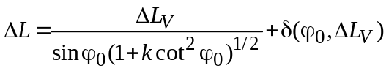 (16)
where:
ϕ₀ : elevation angle at the observation point
ΔL_{V} : vertical excess path length
k and δ (ϕ₀, ΔL_{V}) : corrective terms, in the calculation of which the exponential atmosphere model is used.
The k factor takes into account the variation of the elevation angle along the path. The δ (ϕ₀, ΔL_{V}) term expresses the effects of refraction (the path is not a straight line). This term is always very small, except at very low elevation angle and is neglected in the computation; it involves an error of only 3.5 cm for a ϕ₀ angle of 10° and of 0.1 mm for a ϕ₀ angle of 45°. It can be noted, moreover, that at very low elevation for which the δ term would not be negligible, the assumption of a plane stratified atmosphere, which is the basis of all methods of computation of the excess path length, is no longer valid.
The vertical excess path length (m) is given by:
ΔL_{V} = 0.00227 P + f (T ) H (17)

In the first term of the right-hand side of equation (17), P is the atmospheric pressure (hPa) at the observation point.
In the empirical second term, H is the relative humidity (%); the function of temperature f (T ) depends on the geographical location and is given by:
f (T ) = a 10^{bT} (18)
where:
T is in °C
a is in m/% of relative humidity
b is in °C^{–1}.
Parameters a and b are given in Table 2 according to the geographical location.
TABLE 2
Location | a  (m/%) | b  (°C–1)
Coastal areas (islands, or locations less than 10 km away from sea shore) | 5.5 × 10–4 | 2.91 × 10–2
Non-coastal equatorial areas | 6.5 × 10–4 | 2.73 × 10–2
All other areas | 7.3 × 10–4 | 2.35 × 10–2

To compute the corrective factor k of equation (16), an exponential variation with height h of the atmospheric refractivity N is assumed:
N(h) = N_{s} exp (– h / h₀) (19)
where N_{s} is the average value of refractivity at the Earth’s surface (see Recommendation ITU-R P.453) and h₀ is given by:
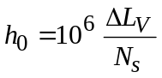 (20)
k is then computed from the following expression:
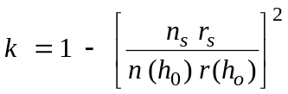 (21)
where n_{s} and n (h₀) are the values of the refractive index at the Earth’s surface and at height h₀ (given by equation (20)) respectively, and r_{s} and r (h₀) are the corresponding distances to the centre of the Earth.
For Earth-to-satellite paths with elevation angle θ greater than 10°, the tropospheric excess path length (m) can be expressed as the sum of dry and wet components:
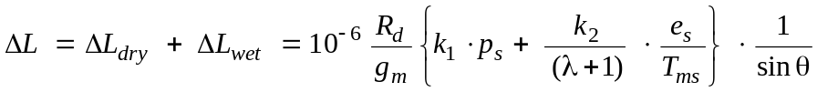 m (22)
where:
p_{s}, e_{s}: air total pressure and water vapour pressure at Earth surface (hPa)
T_{ms}: mean temperature of the water vapour above the surface (K)
λ: vapour pressure decrease factor
R_{d} : R/M_{d} = 287.0 (J/kg K)
R: molar gas constant = 8.314 (J/mol K)
M_{d}: dry air molar mass = 28.9644 (g/mol)
k₁ = 77.604 (K/hPa)
k₂ = 377600 (K²/hPa)
g_{m} = g(lat,h_{s}) = 9.784 ⋅ (1 – 0.00266 ⋅ cos (2 ⋅ lat) – 0.00028 ⋅ h_{s}) = gravity acceleration (m/s²)
lat: latitude of the location (degrees)
h_{s}: height of the location above sea level (km).
For receivers located at height from the mean sea level h (km), different than the surface height h_{s}, the values of the input meteorological parameters can be extrapolated from surface values, T_{ms}, e_{s} and p_{s}, using the following equations:

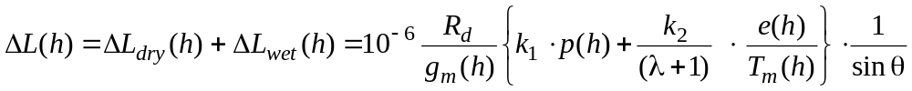 m (23a)

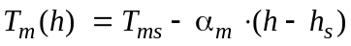 K (23b)

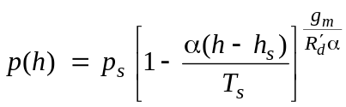 hPa (23c)

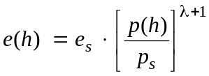 hPa (23d)
where:
αm: lapse rate of the mean temperature of water vapour (K/km).
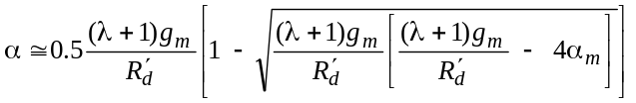 = lapse rate of air temperature K/km (23e)

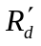 = R_{d} /1 000 = 0.287 J/g K (23f)

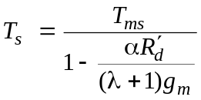 K (23g)

The input to the model can be derived by assuming that the meteorological parameters are characterized by a seasonal fluctuation.

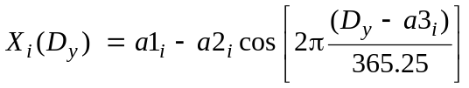 (24)

where:
X_{i}: p_{s}, e_{s}, T_{ms} , λ or αm
a1_{i}: average value of the parameter
a2_{i}: seasonal fluctuation of the parameter
a3_{i}: day of the minimum value of the parameter
D_{y}: day of the year (1 ... 365.25),
1 = 1 January, 32 = 1 February, 60.25 = 1 March.
The coefficients a1, a2 and a3 have been calculated by fitting the harmonic model to monthly statistics of the meteorological parameters derived from the ECMWF ERA15 database.
The values of the parameters of this harmonic model, a₁, a₂, a₃ for each meteorological parameter, are contained in digital maps, for a total of 15 maps, with a resolution of 1.5 × 1.5 (degrees). The coefficients of the harmonic model are contained in files named <met_param>_<mod_par>.dat . Where <met_param> is press, vapr, tmpm, lamd or alfm for p_{s}, e_{s}, T_{ms},  λ or αm respectively, and <mod_par> is a1, a2 or a3. The data are from 0 to 360 in longitude and from +90 to –90 in latitude, with a resolution of 1.5° in both latitude and longitude. Additionally needed by the model are: lat.dat = reference latitude values (90 ... –90), long.dat = reference longitude values (0 ... 360), hreflev.dat = average height of reference level with respect to the sea level (m).
For a receiver located in a position different from the grid points, the excess path length has to be calculated by performing a bilinear interpolation of the excess path length at the four closest grid points, estimated using the same height of the receiver.
The accuracy of the proposed model has been tested using radiosonde and GPS measurements and it results to be within 2 and 6 cm worldwide. Where a higher accuracy is needed, concurrent local measurements of air total pressure and water vapour pressure can be used as input to the model.
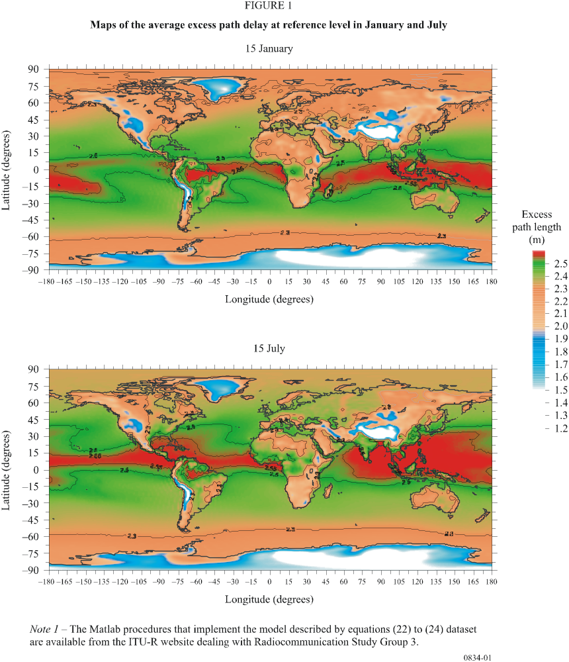

7 Propagation in ducting layers
Ducts exist whenever the vertical refractivity gradient at a given height and location is less than -157 N/km.
The existence of ducts is important because they can give rise to anomalous radiowave propagation, particularly on terrestrial or very low angle Earth-space links. Ducts provide a mechanism for radiowave signals of sufficiently high frequencies to propagate far beyond their normal line-of-sight range, giving rise to potential interference with other services (see Recommendation ITU-R P.452). They also play an important role in the occurrence of multipath interference (see Recommendation ITU-R P.530) although they are neither necessary nor sufficient for multipath propagation to occur on any particular link.

7.1 Influence of elevation angle
When a transmitting antenna is situated within a horizontally stratified radio duct, rays that are launched at very shallow elevation angles can become “trapped” within the boundaries of the duct. For the simplified case of a “normal” refractivity profile above a surface duct having a fixed refractivity gradient, the critical elevation angle α (rad) for rays to be trapped is given by the expression:
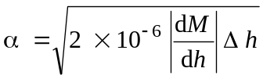 (25)
where dM/dh is the vertical gradient of modified refractivity 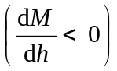 and Δh is the thickness of the duct which is the height of duct top above transmitter antenna.
Figure 2 gives the maximum angle of elevation for rays to be trapped within the duct. The maximum trapping angle increases rapidly for decreasing refractivity gradients below –157 N/km (i.e., increasing lapse rates) and for increasing duct thickness.

7.2 Minimum trapping frequency
The existence of a duct, even if suitably situated, does not necessarily imply that energy will be efficiently coupled into the duct in such a way that long-range propagation will occur. In addition to satisfying the maximum elevation angle condition above, the frequency of the wave must be above a critical value determined by the physical depth of the duct and by the refractivity profile. Below this minimum trapping frequency, ever-increasing amounts of energy will leak through the duct boundaries.
The minimum frequency for a wave to be trapped within a tropospheric duct can be estimated using a phase integral approach. Figure 3 shows the minimum trapping frequency for surface ducts (solid curves) where a constant (negative) refractivity gradient is assumed to extend from the surface to a given height, with a standard profile above this height. For the frequencies used in terrestrial systems (typically 8-16 GHz), a ducting layer of about 5 to 15 m minimum thickness is required and in these instances the minimum trapping frequency, f_{min}, is a strong function of both the duct thickness and the refractive index gradient.
In the case of elevated ducts an additional parameter is involved even for the simple case of a linear refractivity profile. That parameter relates to the shape of the refractive index profile lying below the ducting gradient. The dashed curves in Fig. 3 show the minimum trapping frequency for a constant gradient ducting layer lying above a surface layer having a standard refractivity gradient of – 40 N/km.
FIGURE 2
Maximum trapping angle for a surface duct of constant
refractivity gradient over a spherical Earth
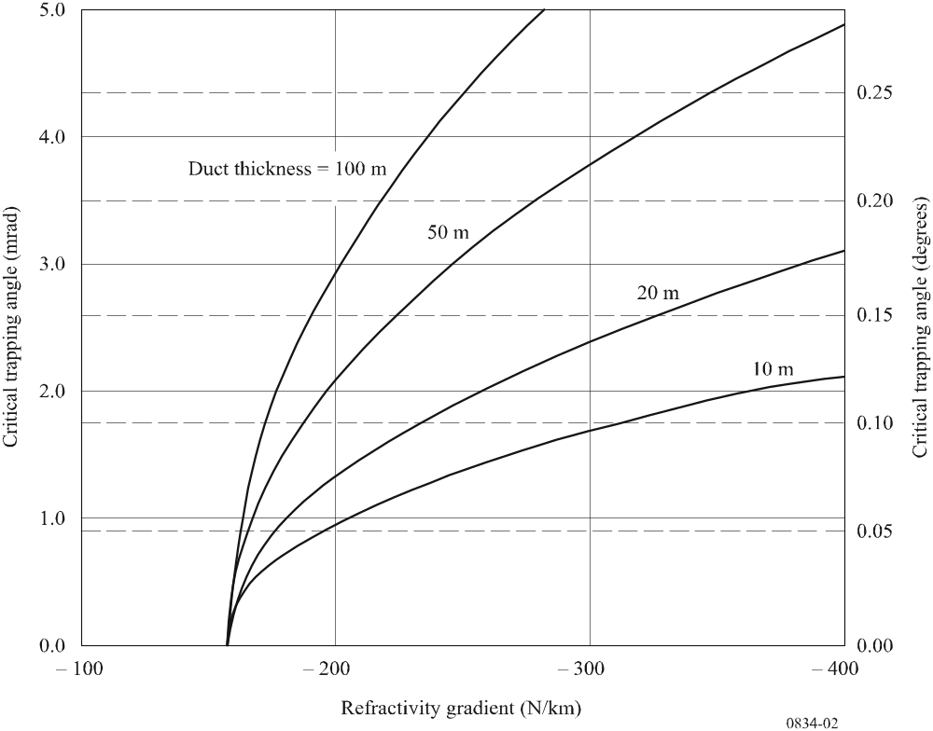

For layers having lapse rates that are only slightly greater than the minimum required for ducting to occur, the minimum trapping frequency is actually increased over the equivalent surface-duct case. For very intense ducting gradients, however, trapping by an elevated duct requires a much thinner layer than a surface duct of equal gradient for any given frequency.
FIGURE 3
Minimum frequency for trapping in atmospheric radio ducts
of constant refractivity gradients
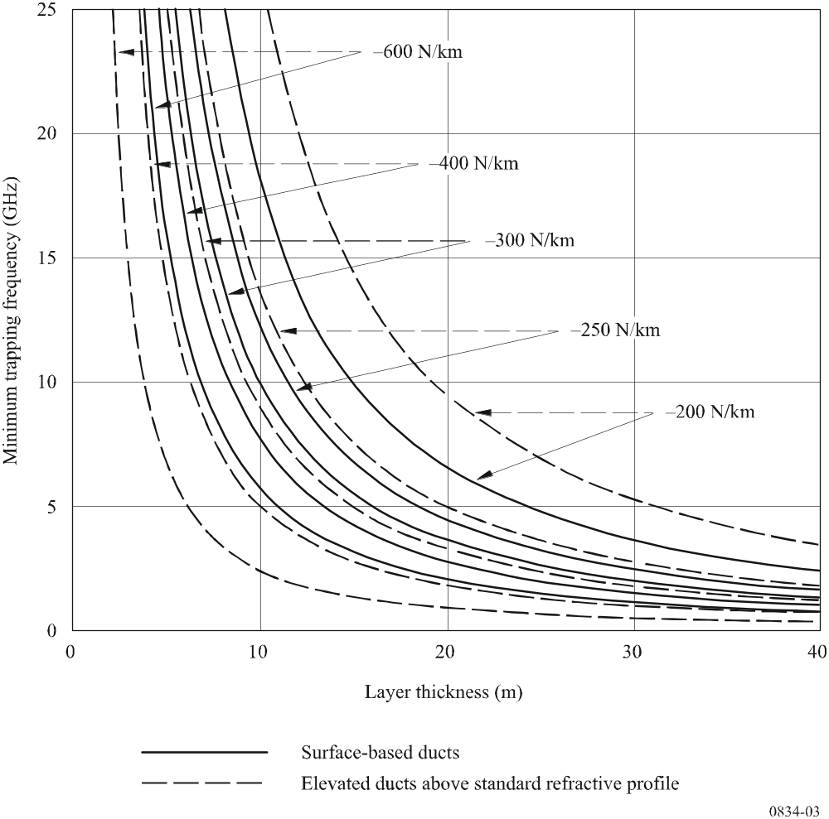

Radiocommunication Study Group 3 made editorial amendments to this Recommendation in 2009 in accordance with Resolution ITU-R 1.

