Recommendation ITU-R P.368-10
(08/2022)
Ground-wave propagation prediction method for frequencies between
10 kHz and 30 MHz

P Series
Radiowave propagation

Foreword
The role of the Radiocommunication Sector is to ensure the rational, equitable, efficient and economical use of the radio-frequency spectrum by all radiocommunication services, including satellite services, and carry out studies without limit of frequency range on the basis of which Recommendations are adopted.
The regulatory and policy functions of the Radiocommunication Sector are performed by World and Regional Radiocommunication Conferences and Radiocommunication Assemblies supported by Study Groups.

Policy on Intellectual Property Right (IPR)
ITU-R policy on IPR is described in the Common Patent Policy for ITU-T/ITU-R/ISO/IEC referenced in Resolution ITU-R 1. Forms to be used for the submission of patent statements and licensing declarations by patent holders are available from http://www.itu.int/ITU-R/go/patents/en where the Guidelines for Implementation of the Common Patent Policy for ITU-T/ITU-R/ISO/IEC and the ITU-R patent information database can also be found.

Series of ITU-R Recommendations
(Also available online at http://www.itu.int/publ/R-REC/en)
Series | Title
BO | Satellite delivery
BR | Recording for production, archival and play-out; film for television
BS | Broadcasting service (sound)
BT | Broadcasting service (television)
F | Fixed service
M | Mobile, radiodetermination, amateur and related satellite services
P | Radiowave propagation
RA | Radio astronomy
RS | Remote sensing systems
S | Fixed-satellite service
SA | Space applications and meteorology
SF | Frequency sharing and coordination between fixed-satellite and fixed service systems
SM | Spectrum management
SNG | Satellite news gathering
TF | Time signals and frequency standards emissions
V | Vocabulary and related subjects

Note: This ITU-R Recommendation was approved in English under the procedure detailed in Resolution ITU-R 1.

Electronic Publication
Geneva, 2022
© ITU 2022
All rights reserved. No part of this publication may be reproduced, by any means whatsoever, without written permission of ITU.

RECOMMENDATION ITU-R P.368-10
Ground-wave propagation prediction method for frequencies
between 10 kHz and 30 MHz
(1951-1959-1963-1970-1974-1978-1982-1986-1990-1992-2005-2007-2022)
Scope
This Recommendation provides information on the field strength and its dependence on ground characteristics due to ground-wave propagation at frequencies less than 30 MHz.
Keywords
Ground-wave propagation, Low Frequency, High Frequency
Related ITU-R Recommendations and Handbook
Recommendation ITU-R P.341
Recommendation ITU-R P.525
Recommendation ITU-R P.526
Recommendation ITU-R P.527
Recommendation ITU-R P.684
Recommendation ITU-R P.1321
Handbook on Radiometeorology (Edition 2013)
NOTE – The latest revision/edition of the Recommendation/Handbook should be used.
List of symbols in Annexes 1 and 2
ε_{r} Relative permittivity
λ Wavelength
σ Conductivity
$L_{b}$, $A_{i}$ Basic transmission loss
E Field strength
k Wavenumber
S_{i} i^{th} Section
d_{i} length of the i^{th} section
σ_{i} Conductivity of the i^{th} section
ε_{i} Permittivity of the i^{th} section
$E_{R}$ Field strength calculated from receiver
$E_{T}$ Field strength calculated from transmitter
$E_{X}$ Field strength on mixed path
The ITU Radiocommunication Assembly,
considering
that, in view of the complexity of calculating ground-wave field strength, it is useful to have a ground-wave prediction method applicable to the frequency range from 10 kHz to 30 MHz and arbitrary ground characteristics,
recommends
1 that the integral software implementation of the prediction method in Annex 1, applicable to the conditions specified below, should be used for the determination of ground-wave field strength at frequencies between 10 kHz and 30 MHz;
2 that, as a general rule, these methods should be used to determine the field strength only when it is known that the amplitude of ionospheric reflections are negligible;
3 that these methods should not be used where the receiving antenna is located well above the surface of the Earth;
NOTE 1 – When ε_{r} << 60λσ this prediction method may be used up to a height h = 1.2 σ^{1/2} λ^{3/2}. Propagation curves for terminal heights up to 3 000 m and for frequencies up to 10 GHz can be found in the separately published ITU “Handbook of curves for radio-wave propagation over the surface of the Earth”;
4 that these prediction methods may also be used to determine the field strength over mixed paths as indicated in Annex 2.

Annex 1
Ground-wave field strength at frequencies between 10 kHz and 30 MHz
The prediction method in this Recommendation are applicable to the following conditions:
– a smooth homogeneous spherical Earth;
– frequency between 10 kHz and 30 MHz;
– in the troposphere, assuming the refractive index decreases linearly with height;
– the transmitting and the receiving antennas are on or near the surface of the Earth;
– the radiating element is a short vertical monopole on the surface of a perfectly conducting plane Earth that radiates 1 kW, and the field strength at a distance of 1 km is 300 mV/m, corresponding to a cymomotive force of 300 V (see Recommendation ITU-R P.525); (refer to Table 1 of Recommendation ITU-R P.341 to refer the field strength to other reference antennas);
– the distance between the transmitter and the receiver is the great circle distance;
– the prediction methods provide the vertical field-strength component of the radiation field, which would be measured in the far-field region of the antenna.
The software implementation of this prediction method is an integral part of this Recommendation and is provided in the zip file R-REC-P.368-10-202208-I!!ZIP-E.zip.
NOTE 1 – The basic transmission loss corresponding to the same conditions for which the curves were computed may be obtained from the value of field strength E(dB(μV/m)) by using the following equation:
$L_{b}=A_{i}=142.0+20\log_{10}{f_{MHz}}-E dB$
For the influence of the environment on both the transmitting and the receiving antenna, refer to Recommendation ITU-R P.341.
NOTE 2 – Even in cases where the distance between locations is much smaller than the distance to the transmitter, the real electrical characteristics of the ground and the condition of reception will not be identical. In many cases the difference in levels of a signal at nearby locations follows a log-normal distribution with a standard deviation within the limits of 3-4 dB; averaging approximately 3.5 dB.
Ground-wave field strength can also vary with seasonal temperature. The average annual difference between winter and summer monthly median field strengths, for 500-1 000 kHz, ranges between 5 dB (where the average northern hemisphere January temperature is +4 °) and 15 dB (where the average northern hemisphere January temperature is −16 °). Seasonal changes have also been observed on frequencies between 150 and 280 kHz in continental Europe. These changes at frequencies between 150 and 280 kHz increase monotonically with frequency, and distance; and can reach 10-20 dB at distances of 1 000-2 000 km (see also Recommendation ITU-R P.1321).
NOTE 3 – The method gives the total field strength at distance, r, with an error less than 1 dB when k r is greater than about 10, where k = 2π/λ. Near-field (i.e. induction and static field) effects may be included by increasing the field strength (in decibels) by:
This gives the total field within ± 0.1 dB for sea and wet ground, and within ± 1 dB for any ground conductivity greater than 10 ^{–3} S/m.
NOTE 4 – For either antenna, if the antenna site location is higher than the average terrain elevation along the path between the antennas, then the effective antenna height is the antenna height above the average terrain elevation along the path. This effective antenna height value should be compared to the computed value of antenna height limit in recommends 3 to determine if the curves are valid for the path.
Figures 1 and 2 are example outputs of field-strength curves as a function of distance with frequency as an input parameter.

Figure 1
LFMF Ground-wave propagation curves; sea water, low salinity, σ = 1 S/m, ε_{r} = 80
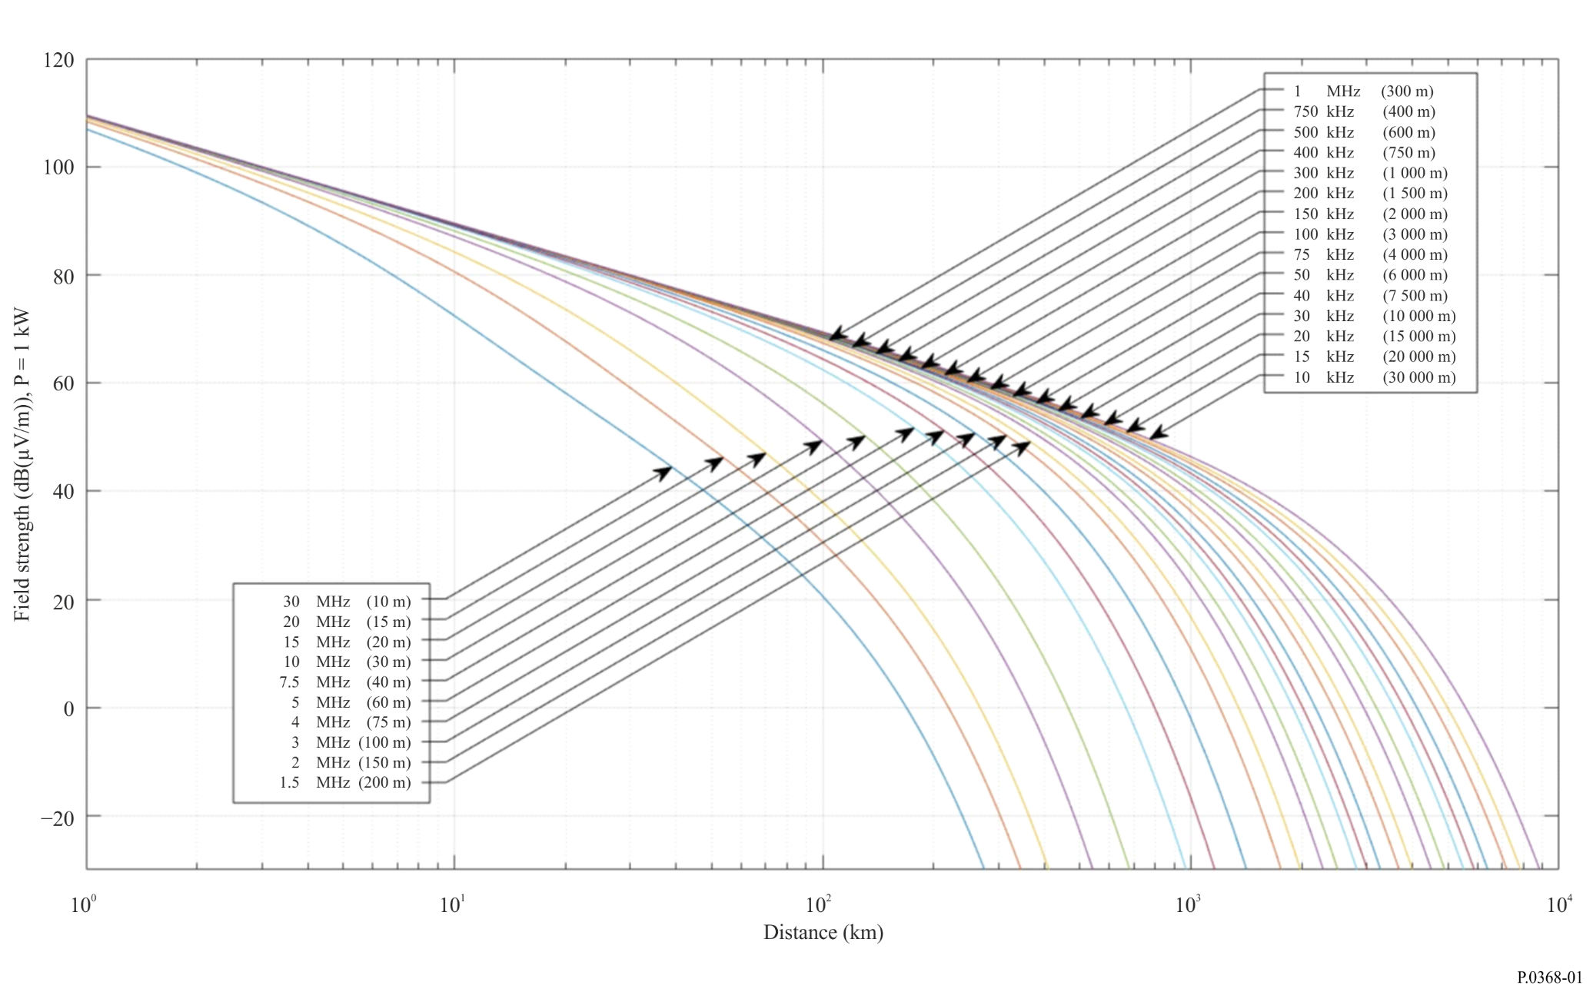
figure 2
LFMF Ground-wave propagation curves; sea water, average salinity, σ = 5 S/m, ε_{r} = 70
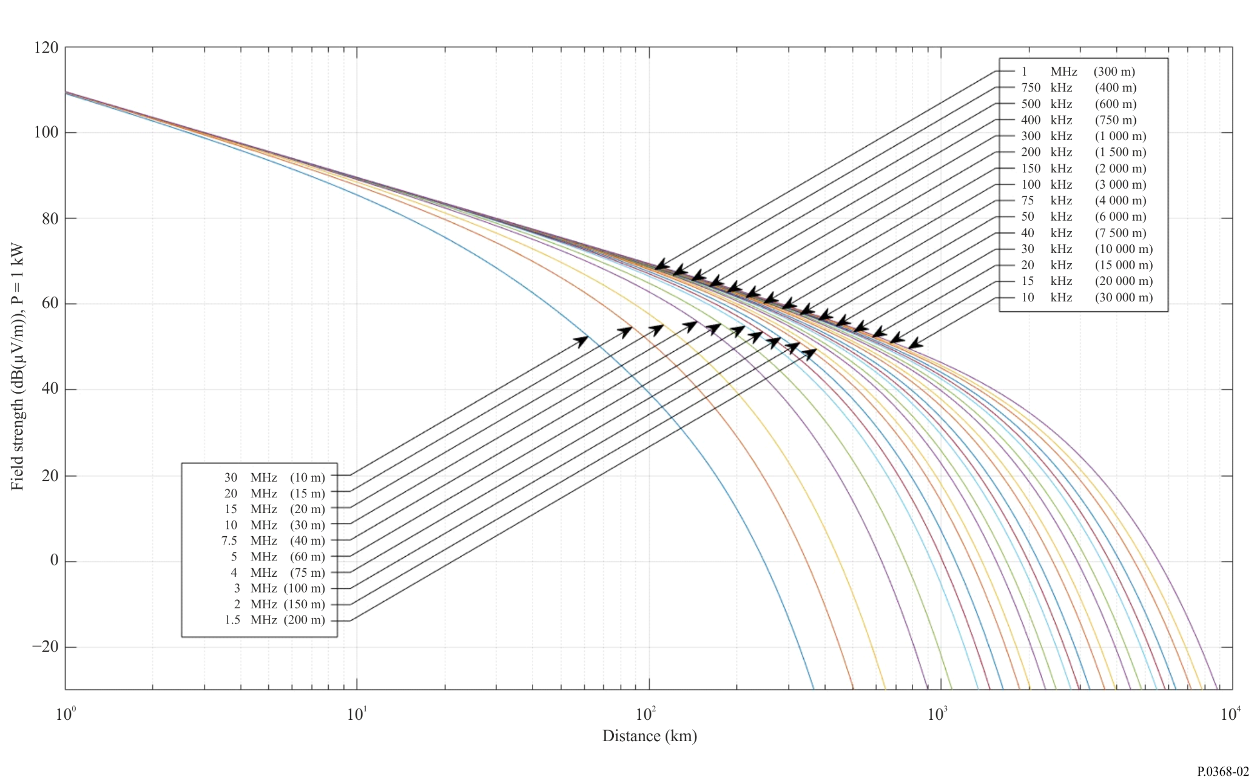

Annex 2
Application to mixed paths (inhomogeneous paths)
1 The method in this Annex may be used to determine the propagation over mixed paths (non-homogeneous smooth Earth) as follows:
Such paths may be made up of sections S₁, S₂, S₃, etc., of lengths d₁, d₂, d₃, etc., having conductivity and permittivity σ₁, ε₁; σ₂, ε₂; σ₃, ε₃, etc., as shown in Fig. 3.
Figure 3
Example of mixed paths
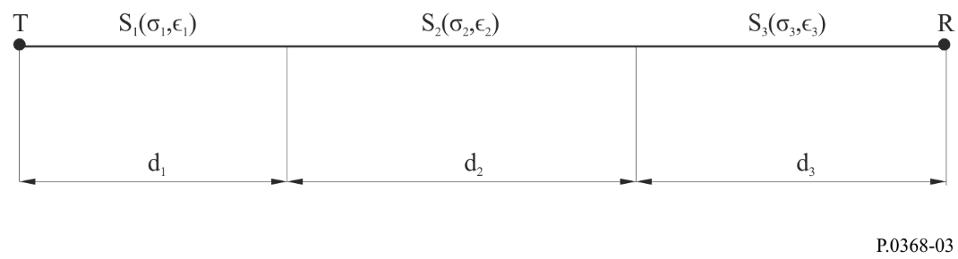
The Millington method used in this Annex for determining propagation over mixed paths is the most accurate available and satisfies the reciprocity condition. The method assumes that the values for field strength, $E$, are available for the different types of terrain in sections S₁, S₂, S₃, etc., assumed to be individually homogeneous, for the source T defined, for instance, by a given inverse-distance curve. The values may then finally be scaled up for any other source.
For a given frequency, the value of the field strength E₁(d1) in dB(μV/m) at the distance d1 is calculated for section $S_{1}$. Similarly, the field strengths E₂(d₁) and E₂(d1 + d₂) are calculated for section $S_{2}$; and the field strengths E3(d₁ + d₂) and E3(d₁ + d₂ + d3) are calculated for section $S_{3}$.
The field strength E_{R} is then calculated as:
(1)
and the field strength E_{T} is calculated as:
(2)
The required field for the mixed path, $E_{X}$, is then:
$E_{X}=\frac{E_{R}+E_{T}}{2}$ (3)
Figures 4 and 5 are example outputs which contain field-strength curves as a function of distance with the electrical characteristics of the ground as an input parameter.

FIGURE 4
LFMF Ground-wave propagation for different values of σ and ε_{r}, f = 30 kHz
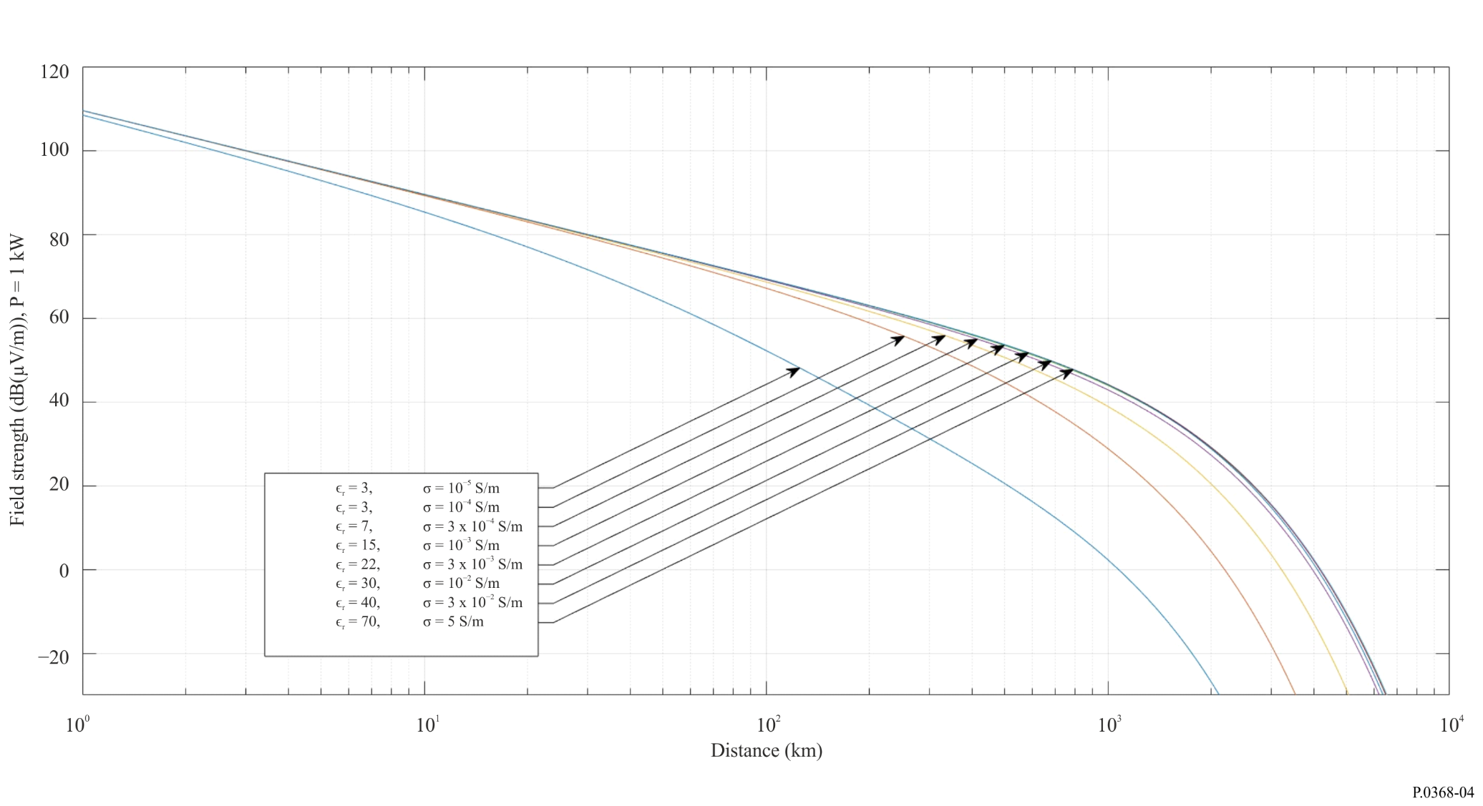
FIGURE 5
LFMF Ground-wave propagation for different values of σ and ε_{r} , f = 60 kHz




