Recommendation ITU-R P.2109-1
(08/2019)
Prediction of building entry loss

P Series
Radiowave propagation

Foreword
The role of the Radiocommunication Sector is to ensure the rational, equitable, efficient and economical use of the radio-frequency spectrum by all radiocommunication services, including satellite services, and carry out studies without limit of frequency range on the basis of which Recommendations are adopted.
The regulatory and policy functions of the Radiocommunication Sector are performed by World and Regional Radiocommunication Conferences and Radiocommunication Assemblies supported by Study Groups.

Policy on Intellectual Property Right (IPR)
ITU-R policy on IPR is described in the Common Patent Policy for ITU-T/ITU-R/ISO/IEC referenced in Resolution ITU-R 1. Forms to be used for the submission of patent statements and licensing declarations by patent holders are available from http://www.itu.int/ITU-R/go/patents/en where the Guidelines for Implementation of the Common Patent Policy for ITU-T/ITU-R/ISO/IEC and the ITU-R patent information database can also be found.

Series of ITU-R Recommendations
(Also available online at http://www.itu.int/publ/R-REC/en)
Series | Title
BO | Satellite delivery
BR | Recording for production, archival and play-out; film for television
BS | Broadcasting service (sound)
BT | Broadcasting service (television)
F | Fixed service
M | Mobile, radiodetermination, amateur and related satellite services
P | Radiowave propagation
RA | Radio astronomy
RS | Remote sensing systems
S | Fixed-satellite service
SA | Space applications and meteorology
SF | Frequency sharing and coordination between fixed-satellite and fixed service systems
SM | Spectrum management
SNG | Satellite news gathering
TF | Time signals and frequency standards emissions
V | Vocabulary and related subjects

Note: This ITU-R Recommendation was approved in English under the procedure detailed in Resolution ITU-R 1.

Electronic Publication
Geneva, 2019

© ITU 2019
All rights reserved. No part of this publication may be reproduced, by any means whatsoever, without written permission of ITU.

RECOMMENDATION ITU-R P.2109-1
Prediction of building entry loss
(2017-2019)
Scope
This Recommendation provides a method for estimating building entry loss at frequencies between about 80 MHz and 100 GHz for probabilities of 0.0 < P < 1.0. The method is not site-specific, and is primarily intended for use in sharing and compatibility studies.
Keywords
Building, indoor, propagation, interference, entry
The ITU Radiocommunication Assembly,
considering
a) that, for system planning and interference assessment it may be necessary to account for the attenuation suffered by radio waves in passing into, or out of, buildings;
b) that there is a need to give guidance to engineers to estimate coverage or predict interference from outdoor to indoor and indoor to outdoor systems,
recognizing
a) that Recommendation ITU-R P.2040 provides guidance on the effect of building materials and structures on radio waves;
b) that Report ITU-R P.2346 contains collated empirical data on building entry loss,
recommends
that the model in Annex 1 should be used to estimate building entry loss.
NOTE – Sharing studies carried out by ITU-R on different agenda items of WRC-19 were based on the text of this Recommendation which was inforce at the time of these activities or at the time which the activity was carried out.

Annex 1

1 Introduction
This Annex provides a model for building entry loss (BEL) as defined in Recommendation ITU-R P.2040. The output of the model is in the form of a cumulative distribution function of the probability that a given loss will not be exceeded.
The model makes no attempt to separate the loss suffered by a signal penetrating the exterior wall and the attenuation suffered in the path through the building. This approach has been adopted as it is felt unlikely that, in the context of ITU-R studies, sufficiently detailed building-specific information would be available.
Building entry loss exhibits great variability, both within any given building and between different buildings. Although techniques such as ray-tracing can provide useful site-specific predictions when coupled with detailed architectural data, such models will usually be inappropriate for generic applications such as spectrum sharing studies.
A statistical model that attempted to describe the entry loss characteristics of the global set of buildings would give a statistical distribution so broad as to be unhelpful. On the other hand, a model that attempted to characterise many different types of building would require more data than currently exists and would be inappropriate for generic sharing studies.
NOTE – Building types referred to in this Recommendation should be considered carefully.
The model is based on the measurement data collated in Report ITU-R P.2346 in the range 80 MHz to 73 GHz. The model can be used within a Monte Carlo method, but it should be noted that the model has only been validated against empirical data over the probability range 0.01 to 0.99.

2 Parameters
The model takes the following input parameters:
– frequency (~0.08-100 GHz);
– the probability with which the loss is not exceeded;
– building class (‘traditional’ or ‘thermally-efficient’);
– elevation angle of the path at the building façade (degrees above the horizontal).
The azimuth of the path to the outdoor terminal with respect to the building surface is not accounted for explicitly. Although theory and measurement show that signals normally incident on a building surface will suffer lower loss than those arriving at oblique angles, the statistical output of the model represents the generality of building orientations with respect to the outdoor terminal.
The basic model assumes that the indoor antenna is omnidirectional and that the building entry loss will therefore take account of all energy arriving at the terminal location. In some cases, the internal terminal may use a directional antenna which will act as a spatial filter, increasing the apparent building entry loss as energy arriving from some directions is rejected. Measurements made in two large buildings in the Republic of Korea at 32 GHz showed that the building entry loss measured with antennas of 10 degree beamwidth was 5.3 dB greater than for the omnidirectional case. Further details may be found in Report ITU-R P.2346.
Following the definition given in Recommendation ITU-R P.2040, building entry loss is here defined in isolation from any surrounding clutter. Should the building be surrounded by local clutter, additional losses may need to be determined for the relevant terminal height and position above ground using Recommendation ITU-R P.2108.
The model makes the implicit assumption that terminals have an equal probability of location at any point within a building.

2.1 Classification of building type
Experimental results, such as those collated in Report ITU-R P.2346, shows that, when characterised in terms of entry loss, buildings fall into two distinct populations: where modern, thermally-efficient building methods are used (metallised glass, foil-backed panels) building entry loss is generally significantly higher than for ‘traditional’ buildings without such materials. The model therefore gives predictions for these two cases.
This classification, of ‘thermally-efficient’ and ‘traditional’, refers purely to the thermal efficiency of construction materials. No assumption should be made on the year of construction, type (single or multi-floors), heritage or building method.
For building entry loss, it is important to consider the thermal efficiency of the complete building (or the overall thermal efficiency). A highly thermally-efficient main structure with poorly insulated windows (e.g. single glazed with thin glass) can make the building thermally-inefficient and vice versa.
Thermal transmittance, commonly referred as U-value, provides a quantifiable description of thermal efficiency. Low U-values represent high thermal efficiency. Typically, the presence of metallised glass windows, insulated cavity walls, thick reinforced concrete and metal foil back cladding is a good indication of a thermally-efficient building.

3 Model
Building entry loss will vary depending on building type, location within the building and movement in the building. The building entry loss distribution is given by a combination of two lognormal distributions. The building entry loss not exceeded for the probability, P, is given by:
$L_{BEL}^{omni}(P)=10log({10}^{0.1A(P)}+{10}^{0.1B(P)}+{10}^{0.1C} )$ dB (1)
where:
$A\left(P\right)={F^{-1}\left(P\right)σ}_{1}+μ_{1}$ (2)
$B\left(P\right)={F^{-1}\left(P\right)σ}_{2}+μ_{2}$ (3)
$C=-3.0$ (4)
$μ_{1}=L_{h}+L_{e}$ (5)
$μ_{2}=w+x log(f)$ (6)
$σ_{1}=u+v log(f)$ (7)
$σ_{2}=y+z log(f)$ (8)
where:
L_{h} is the median loss for horizontal paths, given by:
$L_{h}=r+s log\left(f\right)+t {(log\left(f\right))}^{2}$ (9)
L_{e} is the correction for elevation angle of the path at the building façade:
$L_{e}=0.212 |θ|$ (10)
and:
f = frequency (GHz)
θ = elevation angle of the path at the building façade (degrees)
P = probability that loss is not exceeded (0.0 ≤ P ≤ 1.0)
F⁻¹(P) = inverse cumulative normal distribution as a function of probability.
and the coefficients are as given in Table 1:
TABLE 1
Model coefficients
Building type | r | s | t | u | v | w | x | y | z
Related to: | μ₁ |  |  | σ₁ |  | μ₂ |  | σ₂
Traditional | 12.64 | 3.72 | 0.96 | 9.6 | 2.0 | 9.1 | −3.0 | 4.5 | −2.0
Thermally-efficient | 28.19 | −3.00 | 8.48 | 13.5 | 3.8 | 27.8 | −2.9 | 9.4 | −2.1

For illustration, Fig. 1 plots the median building entry loss returned by the model for the two building classes. In any sharing studies, the entire distribution should always be considered. Figure 2 plots the cumulative distribution function for building entry loss predicted at horizontal incidence.
Figure 1
Median building entry loss predicted at horizontal incidence
Figure 2
Building entry loss predicted at horizontal incidence
(Dashed line: Traditional, Dotted line: Thermally-efficient)
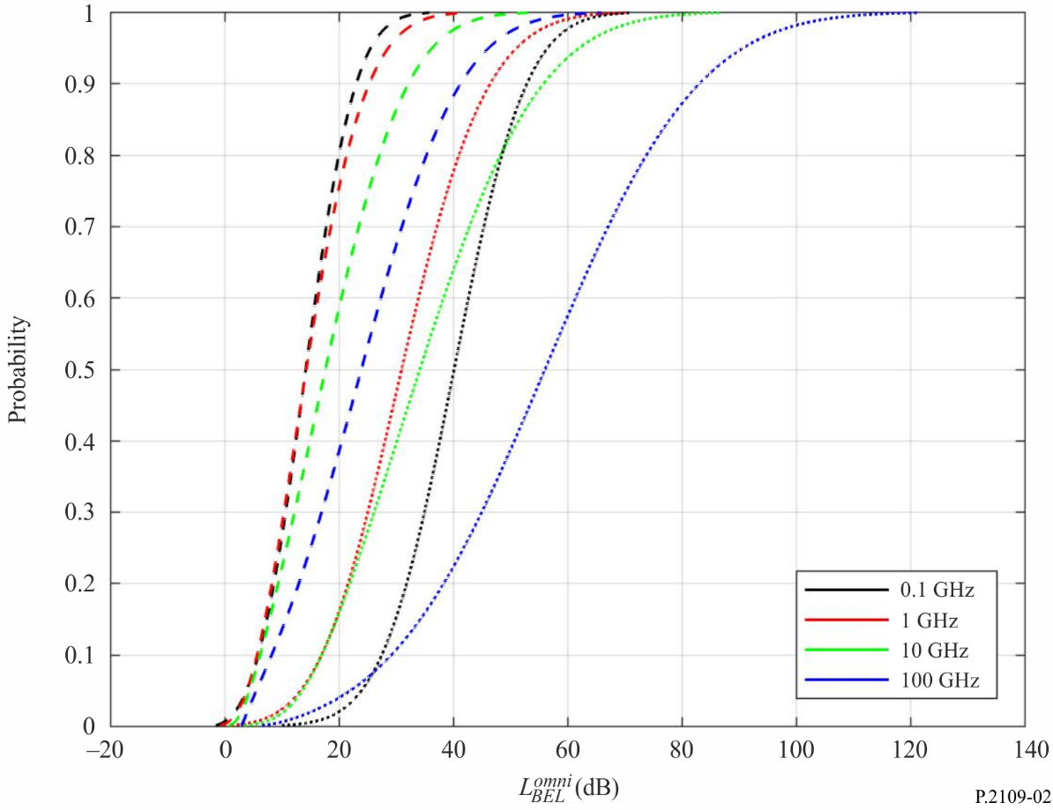

For example, U-values of < 0.3 and < 0.9 are representative of thermally efficient main structure and metallised glass, respectively.

