Recommendation ITU-R P.2108-1
(09/2021)
Prediction of clutter loss

P Series
Radiowave propagation

Foreword
The role of the Radiocommunication Sector is to ensure the rational, equitable, efficient and economical use of the radio-frequency spectrum by all radiocommunication services, including satellite services, and carry out studies without limit of frequency range on the basis of which Recommendations are adopted.
The regulatory and policy functions of the Radiocommunication Sector are performed by World and Regional Radiocommunication Conferences and Radiocommunication Assemblies supported by Study Groups.

Policy on Intellectual Property Right (IPR)
ITU-R policy on IPR is described in the Common Patent Policy for ITU-T/ITU-R/ISO/IEC referenced in Resolution ITU-R 1. Forms to be used for the submission of patent statements and licensing declarations by patent holders are available from http://www.itu.int/ITU-R/go/patents/en where the Guidelines for Implementation of the Common Patent Policy for ITU-T/ITU-R/ISO/IEC and the ITU-R patent information database can also be found.

Series of ITU-R Recommendations
(Also available online at http://www.itu.int/publ/R-REC/en)
Series | Title
BO | Satellite delivery
BR | Recording for production, archival and play-out; film for television
BS | Broadcasting service (sound)
BT | Broadcasting service (television)
F | Fixed service
M | Mobile, radiodetermination, amateur and related satellite services
P | Radiowave propagation
RA | Radio astronomy
RS | Remote sensing systems
S | Fixed-satellite service
SA | Space applications and meteorology
SF | Frequency sharing and coordination between fixed-satellite and fixed service systems
SM | Spectrum management
SNG | Satellite news gathering
TF | Time signals and frequency standards emissions
V | Vocabulary and related subjects

Note: This ITU-R Recommendation was approved in English under the procedure detailed in Resolution ITU-R 1.

Electronic Publication
Geneva, 2021

© ITU 2021
All rights reserved. No part of this publication may be reproduced, by any means whatsoever, without written permission of ITU.

RECOMMENDATION ITU-R P.2108-1
Prediction of clutter loss
(2017-2021)
Scope
This Recommendation provides methods for estimating loss through clutter at frequencies between 30 MHz and 100 GHz.
Keywords
Clutter, attenuation, shielding, terrestrial, Earth-space, aeronautical
The ITU Radiocommunication Assembly,
considering
a) that, for system planning and interference assessment it may be necessary to account for the attenuation suffered by radio waves in passing over or between buildings;
b) that, where a terrestrial station may be shielded by buildings a detailed calculation for a general case can be difficult to formulate and losses due to clutter must be considered dependant on the deployment scenario;
c) that, where terrestrial stations are in motion the clutter environment of the radio path will be variable,
recognizing
a) that Recommendation ITU-R P.1411 contains data and models for short-range radio system, mainly within an urban environment from 300 MHz to 100 GHz;
b) that Recommendation ITU-R P.2040 contains basic expressions for reflection from and penetration through building materials, and a harmonised representation of building material electrical properties above about 100 MHz;
c) that Recommendation ITU-R P.452 contains a prediction method for the evaluation of interference between stations on the surface of the Earth at frequencies from about 0.1 GHz to 50 GHz, accounting for both clear-air and hydrometeor scattering interference mechanisms;
d) that Recommendation ITU-R P.1812 describes a propagation prediction method suitable for terrestrial point-to-area services in the frequency range 30 MHz to 6 000 MHz;
e) that Recommendation ITU-R P.833 presents several models to enable the user to evaluate the effect of vegetation on radiowave signals between 30 MHz and 60 GHz;
f) that Recommendation ITU-R P.2109 provides a statistical model for building entry loss for frequencies between about 80 MHz and 100 GHz,
recommends
that the material in Annex 1 be used to estimate clutter loss.

Annex 1
Clutter loss model
Description of the calculation method

1 Introduction
This Recommendation describes a set of models that can be used for estimating the loss due to clutter for a number of different environments. These models can be used as an end correction to long distance or over the rooftop models.
This Recommendation defines categories for clutter environments and provides methods for estimating losses between the rooftop and a terminal within the clutter.
Statistical models are to be used when precise knowledge of the radio path is not known such as the width of streets, heights of buildings, depth of vegetation.

1.1 Definitions of clutter and clutter loss
“Clutter” is described here in the context of ITU-R P-Series Recommendations.
Clutter refers to objects, such as buildings or vegetation, which are on the surface of the Earth but not actually terrain. Clutter around a radio transmitter/receiver terminal can have a significant effect on the overall propagation. It is normally the clutter closest to the terminal that has most effect on the propagation, but the actual distance will depend on the nature of the clutter and the radio parameters.
Clutter loss models in this Recommendation are statistical in nature. As an end correction for a long-path propagation model, “Clutter loss” is defined as the difference in the transmission loss or basic transmission loss with and without the presence of terminal clutter at either end of the path with all other path details being the same. Short-path propagation models take into account the effect of clutter along the full length of the path.

2 Model selection
The appropriate model should be selected based on frequency, environment around the terminal and path type, a summary of models is given in Table 1.

TABLE 1
Summary of models
Terminal environment | Ref. | Frequency range  (GHz) | Description
Terminal below representative clutter height | § 3.1 | 0.03 – 3 | End loss correction to be added to basic transmission loss calculated to/from the representative clutter height used.  Can be applied to both transmit and receive end of path.
Terrestrial terminal within the clutter | § 3.2 | 0.5 – 67 | A statistical model which can be applied for modelling the clutter loss distribution for urban and suburban environments. This correction may be applied to both ends of the path.
One terminal is within the clutter and the other is a satellite, aeroplane or other platform above the surface of the Earth. | § 3.3 | 10 – 100 | A statistical distribution of clutter loss not exceeded for percentage locations for angles of elevation between 0 and 90 degrees.

3 Clutter loss models
A number of methods are described in the following sections. In each section, there is a description of the model and its appropriate application, the input parameters required and a calculation method.

3.1 Height gain terminal correction model
This method gives the median of losses due to different terminal surroundings. The possible mechanisms include obstruction loss and reflections due to clutter objects at the representative height, and scattering and reflection from the ground and smaller clutter objects. When using a computer implementation, with terrain profile extracted from a digital terrain model, and with the terminal surroundings defined by a clutter category, it is not practicable to identify individual mechanisms. The method used here distinguishes between two general cases: for woodland and urban categories. It is assumed that the dominant mechanism is diffraction over clutter. For other categories, it is assumed that reflection or scattering dominates.
An additional loss, A_{h}, is calculated which can be added to the basic transmission loss of a path calculated above the clutter, therefore basic transmission loss should be calculated to/from the height of the representative clutter height used. This model can be applied to both transmitting and receiving ends of the path.
Frequency range: 0.03 to 3 GHz

3.1.1 Input parameters
Input parameters are given in Table 2.

TABLE 2
Height gain terminal correction model input parameters
Input | Symbol | Default value
Frequency (GHz) | f | –
Antenna height (m) | h | –
Street width (m) | w_{s} | 27
Representative clutter height (m) | R | See Table 3
Clutter type | – | –

The clutter type is used to determine the A_{h} calculation method as shown in Table 3.
TABLE 3
Default information for representative clutter height, R
(where local information is not available)
Clutter type | R (m) | A_{h} calculation method
Water/sea | 10 | Equation (2b)
Open/rural | 10 | Equation (2b)
Suburban | 10 | Equation (2a)
Urban/trees/forest | 15 | Equation (2a)
Dense urban | 20 | Equation (2a)

3.1.2 Model description
The method uses an approximation to the single knife-edge diffraction loss as a function of the dimensionless parameter, ν, given by:
(1)
Note that J(−0.78) 0, and this defines the lower limit at which this approximation should be used. J(ν) is set to zero for ν ≤ −0.78.
When the transmitter or receiver antenna is located below the height R representative of ground cover surrounding the transmitter or receiver, estimates of the additional loss, A_{h}, is calculated as follows. Where available, representative clutter heights based on accurate clutter height information should be used but if this is not available information is given in Table 3. The method for modelling losses at the transmitter and receiver is identical.
If h ≥ R then A_{h} = 0.
If h < R then A_{h} can take one of two forms, depending on clutter type (see Table 3):
$A_{h}=J\left(v\right)-6.03 dB$ (2a)
or:
$A_{h}=-K_{h2}\log{(h/R) dB}$ (2b)
J(ν) is calculated using equation (1).
The terms ν and K_{h2} are given by:
(2c)
m (2d)
degrees (2e)
$K_{h2}=21.8+6.2\log\left(f\right)$ (2f)
$K_{nu}=0.342\sqrt{f}$ (2g)
where:
f: frequency (GHz)
w_{s}: relates to the width of the street (metres). This should be set to 27 unless there is specific local information available.
The form of equation (2a) represents Fresnel diffraction loss over an obstacle and would be applied to clutter categories such as buildings. In particular urban clutter would be of this type.
Equation (2b) represents the height gain function due to the proximity of the ground in more open locations. Where specular ground reflection occurs this is typical of signal variations below the first two-ray interference maximum. Where specular reflection does not occur the variations below R are typical of those due to shadowing by minor objects and irregularities.

3.2 Statistical clutter loss model for terrestrial paths
This section gives equations that gives a statistical distribution of clutter loss. The model can be applied for urban and suburban clutter loss modelling provided terminal heights are well below the clutter height as indicated in Table 1. It is noted that measurements used in the development of this model used terminal heights up to 6 metres above ground.
An additional loss, L_{ctt}, is calculated which can be added to the transmission loss or basic transmission loss. Clutter loss will vary depending on clutter type, location within the clutter and movement in the clutter. If the transmission loss or basic transmission loss has been calculated using a model (e.g. Recommendation ITU-R P.1411) that inherently accounts for clutter over the entire path then the method below should not be applied.
Frequency range: 0.5 to 67 GHz
Minimum path length: 0.25 km (for the correction to be applied at only one end of the path)
1.0 km (for the correction to be applied at both ends of the path)
Percentage locations range: 0 < p < 100

3.2.1 Input parameters
Input parameters are given in Table 4.
TABLE 4
Statistical clutter loss model for terrestrial paths input parameters
Input | Symbol | Unit
Frequency | f | GHz
Distance | d | km
Percentage of locations | p | %

3.2.2 Model description
The clutter loss not exceeded for p% of locations for the terrestrial to terrestrial path, L_{ctt}, is limited by equation (6) and is given by:
$L_{ctt}=-5\text{log}\left({10}^{-0.2L_{l}}+{10}^{-0.2L_{s}}\right)-σ_{cb}Q^{-1}(p/100)$ dB (3a)
$σ_{cb}=\sqrt{{\left({σ_{l}}^{2}{10}^{-0.2L_{l}}+{σ_{s}}^{2}{10}^{-0.2L_{s}}\right)}/{\left({10}^{-0.2L_{l}}+{10}^{-0.2L_{s}}\right)}}$ dB (3b)
where Q^{–1}(p/100) is the inverse complementary normal distribution function, and
$L_{l}=-2\text{log}\left({10}^{-5log\left(f\right)-12.5}+{10}^{-16.5}\right)$ dB (4a)
$σ_{l}=4$ dB (4b)
$L_{s}=32.98+23.9\text{log}\left(d\right)+3\text{log}\left(f\right)$ dB (5a)
$σ_{s}=6$ dB (5b)
where d is the total path length.
The clutter loss must not exceed a maximum value given by:
${L_{ctt}}_{Max}={L_{ctt}}_{2km}$ dB (6)
where ${L_{ctt}}_{2km}$ is the clutter loss calculated for $d=2 km$.
Figure 1 shows the median clutter losses for different frequencies calculated by equation (3).
FIGURE 1
Median clutter loss for terrestrial paths
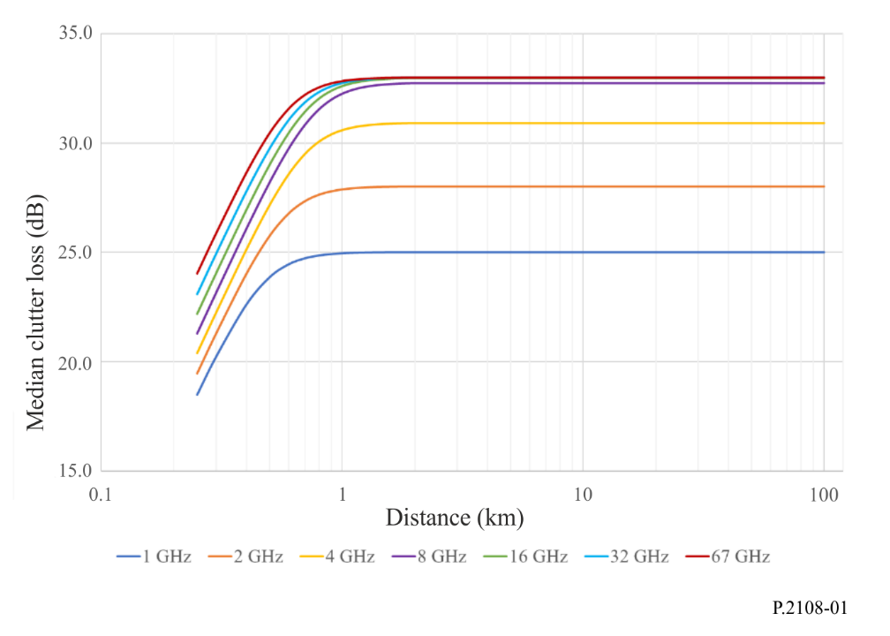

3.3 Earth-space and Aeronautical statistical clutter loss model
This section provides equations to calculate the statistical distribution of clutter loss where one end of the interference path is within man-made clutter, and the other is a satellite, aeroplane, or other platform above the surface of the Earth.
An additional loss, L_{ces}, is calculated which can be added to the basic transmission loss of a path calculated.
This model is applicable to urban and suburban environments. The method used to develop this model is described in Report ITU-R P.2402-0.
Frequency range: 10 to 100 GHz
Elevation angle range: 0 to 90 degrees
Percentage locations range: 0 < p < 100

3.3.1 Input parameters
Input parameters are given in Table 5.
TABLE 5
Earth-space clutter loss model input parameters
Input | Symbol | Unit
Frequency | f | GHz
Elevation angle | θ | degrees
Percentage of locations | p | %

3.3.2 Model description
The clutter loss not exceeded for p% of locations L_{ces} for the terrestrial to airborne or satellite path is given by:
$L_{ces}={\left\{-K_{1}\left[ln\left(1-\frac{p}{100}\right)\right]cot\left[A_{1}\left(1-\frac{θ}{90}\right)+\frac{πθ}{180}\right]\right\}}^{\left[{0.5\left(90-θ\right)}/{90}\right]}-1-0.6 Q^{-1}(p/100)$ dB (7)
with
$K_{1}=93\left(f^{0.175}\right)$, $A_{1}=0.05$
where Q^{–1}(p/100) is the inverse complementary normal distribution function, and the elevation angle, θ, is the angle of the airborne platform or satellite as seen from the terminal.
Figure 2 shows the cumulative distribution of clutter loss not exceeded curves for percentage locations at varying elevation angles for 30 GHz.
FIGURE 2
Cumulative distribution of clutter loss not exceeded for 30 GHz
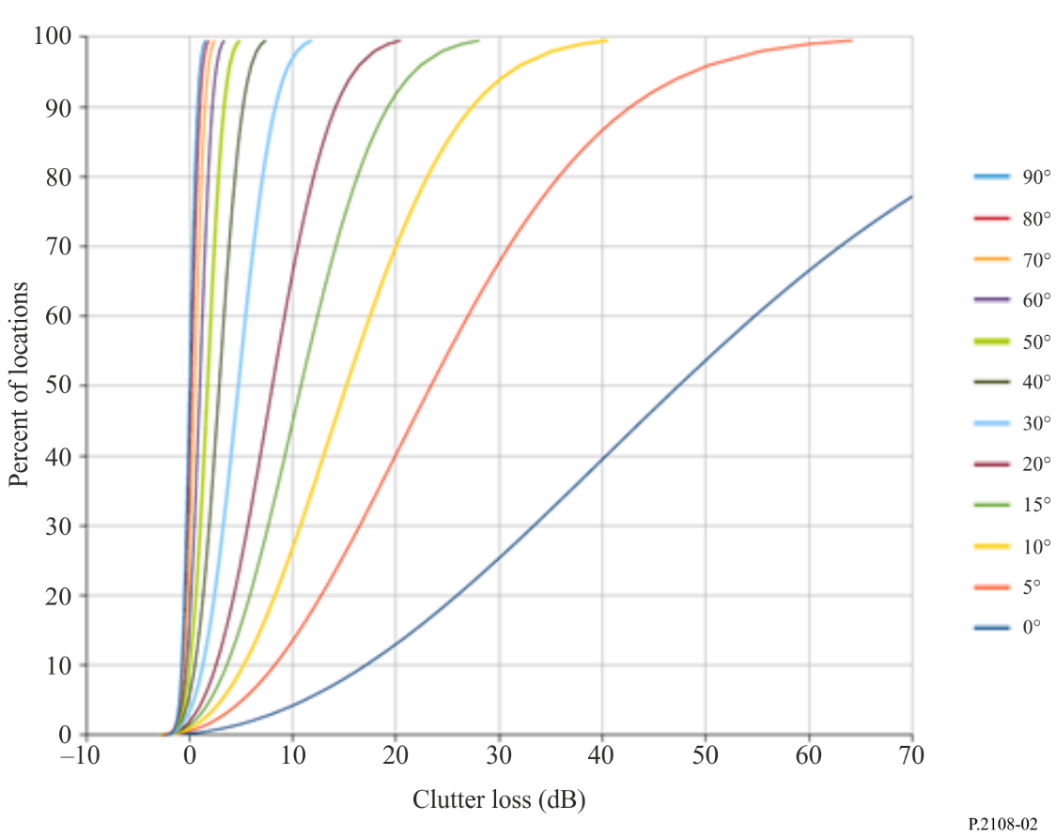

Definitions of “transmission loss” and “basic transmission loss” are given in Recommendation ITU-R P.341.

