Recommendation ITU-R M.2135-1
(02/2023)
Technical and operational characteristics
of autonomous maritime radio devices operating in the frequency band
156-162.05 MHz
M Series
Mobile, radiodetermination, amateur
and related satellite services

Foreword
The role of the Radiocommunication Sector is to ensure the rational, equitable, efficient and economical use of the radio-frequency spectrum by all radiocommunication services, including satellite services, and carry out studies without limit of frequency range on the basis of which Recommendations are adopted.
The regulatory and policy functions of the Radiocommunication Sector are performed by World and Regional Radiocommunication Conferences and Radiocommunication Assemblies supported by Study Groups.

Policy on Intellectual Property Right (IPR)
ITU-R policy on IPR is described in the Common Patent Policy for ITU-T/ITU-R/ISO/IEC referenced in Resolution ITU-R 1. Forms to be used for the submission of patent statements and licensing declarations by patent holders are available from http://www.itu.int/ITU-R/go/patents/en where the Guidelines for Implementation of the Common Patent Policy for ITU-T/ITU-R/ISO/IEC and the ITU-R patent information database can also be found.

Series of ITU-R Recommendations
(Also available online at http://www.itu.int/publ/R-REC/en)
Series | Title
BO | Satellite delivery
BR | Recording for production, archival and play-out; film for television
BS | Broadcasting service (sound)
BT | Broadcasting service (television)
F | Fixed service
M | Mobile, radiodetermination, amateur and related satellite services
P | Radiowave propagation
RA | Radio astronomy
RS | Remote sensing systems
S | Fixed-satellite service
SA | Space applications and meteorology
SF | Frequency sharing and coordination between fixed-satellite and fixed service systems
SM | Spectrum management
SNG | Satellite news gathering
TF | Time signals and frequency standards emissions
V | Vocabulary and related subjects

Note: This ITU-R Recommendation was approved in English under the procedure detailed in Resolution ITU-R 1.

Electronic Publication
Geneva, 2023

© ITU 2023
All rights reserved. No part of this publication may be reproduced, by any means whatsoever, without written permission of ITU.

RECOMMENDATION ITU-R M.2135-1
Technical and operational characteristics of autonomous maritime radio devices operating in the frequency band 156-162.05 MHz
(2019-2023)
Scope
This Recommendation describes autonomous maritime radio devices (AMRD) for use in the maritime environment. The definition and categorization of AMRD are included in Annex 1. Man overboard (MOB) Class M devices – using digital selective calling (DSC) for alerting and automatic identification system (AIS) technology for tracking is described in Annex 2. The technical and operational characteristics of AMRD Group B using AIS technology are detailed in Annex 3. The technical and operational characteristics of AMRD Group B using other than AIS technology are detailed in Annex 4. Annex 5 provides a summary of harmonised messages for AMRD Group B devices using AIS technology.
Keywords
Aid to Navigation (AtoN), automatic identification system (AIS), autonomous maritime radio devices (AMRD), digital selective calling (DSC), Maritime
Accronyms
AIS Automatic identification system
AMRD Autonomous maritime radio devices
AtoN Aid to Navigation
DSC Digital selective calling
e.i.r.p. Equivalent isotropically radiated power
GMDSS Global maritime distress and safety system
IEC International Electrotechnical Commission
IMO International Maritime Organization
MAtoN Mobile Aid to Navigation
MOB Man overboard
RR Radio Regulations
SOLAS International Convention for the Safety of Life at Sea
VHF Very high frequency
Related ITU Recommendations and Reports
Recommendation ITU-R M.493 – Digital selective-calling system for use in the maritime mobile service
Recommendation ITU-R M.541 – Operational procedures for the use of digital selective-calling equipment in the maritime mobile service
Recommendation ITU-R M.585 – Assignment and use of identities in the maritime mobile service; or the revised version
Recommendation ITU-R RA.769 – Protection criteria used for radio astronomical measurements
Recommendation ITU-R M.1371 – Technical characteristics for an automatic identification system using time-division multiple access in the VHF maritime mobile band
Report ITU-R M.2285 – Maritime survivor locating systems and devices (man overboard systems) – An overview of systems and their mode of operation
The ITU Radiocommunication Assembly,
considering
a) that the maritime mobile service is a defined service for the operation of specific types of stations, as defined in Radio Regulations (RR) No. 1.28;
b) that the global maritime distress and safety system (GMDSS) is a maritime mobile service application;
c) that the automatic identification system (AIS) is a technology for maritime safety related applications, providing identification functions, safety of navigation functions, aids to navigation, locating signals and data communications;
d) that autonomous maritime radio devices (AMRD) reflect a new development in the maritime environment;
e) that due to the rapid technical progress, more and more AMRD applications in the maritime environment will be operated;
f) that, in order to enhance safety of navigation, there is a need to identify and categorize AMRD which operate autonomously in the maritime environment;
g) that the operation of AMRD may be for safety-related purposes;
h) that relevant characteristics for the operation of AMRD are also contained in the most recent version of Recommendations ITU-R M.493, ITU-R M.585 and ITU-R M.1371;
i) that AMRD is categorized into Group A and Group B, which are described in Annex 1;
j) that the International Maritime Organization (IMO), International Electrotechnical Commission (IEC) and the International Association of Marine Aids to Navigation and Lighthouse Authorities publish technical documents related to the design and usage of aid to navigation;
k) that channel 2006 (160.9 MHz) is designated in Appendix 18 of the RR for AMRD Group B,
recognizing
a) that AMRD operate with maritime radio technology such as AIS and digital selective calling (DSC);
b) that the use of AMRD should not compromise the integrity of the GMDSS and the operations on AIS1 and AIS2 display and the VHF data link;
c) that the use of AMRD Group B should not compromise the operation of co-frequency incumbent safety applications, as authorized on a primary basis by certain national administrations;
d) that the use of AMRD Group B should not compromise the presentation of AIS information,
recommends
1 that the categorization of AMRD should be in accordance with Annex 1;
2 that the technical and operational characteristics of Man overboard (MOB) devices should be in accordance with Annex 2;
3 that the technical and operational characteristics of AMRD Group A should be in accordance with the most recent version of Recommendation ITU-R M.1371 or ITU-R M.493;
4 that the technical and operational characteristics of AMRD Group B using AIS technology should be in accordance with Annex 3;
5 that the technical characteristics of AMRD Group B using other than AIS technology should be in accordance with Annex 4.

Annex 1
Categorization of autonomous maritime radio devices
An AMRD is a station in the maritime mobile service which is mobile, operates at sea and transmits independently of a ship station or a coast station, which may also be temporarily moored. They are divided into two groups:
Group A AMRD that enhance the safety of navigation.
Group B AMRD that do not enhance the safety of navigation (AMRD which deliver signals or information which do not concern the navigation of the vessel or do not complement vessel traffic safety in waterways). Group B devices may implement AIS technology or technology other than AIS. Technology other than AIS may be implemented only on an experimental basis, and operational use of such devices is not addressed in the RR.
The term ‘enhance safety of navigation’ is derived from the International Convention for the Safety of Life at Sea (SOLAS), as amended by IMO. Within SOLAS, Chapter V is titled “Safety of navigation” and contains the relevant IMO regulations. Consequently, the criterion for distinguishing AMRD Group A from AMRD Group B is their influence on the safety of navigation. Any signal or information originated by an AMRD that reaches the navigator, can impact the navigation of the vessel. This includes AIS (signals which may be shown on radar and navigational displays) and VHF (channel 70 and working channels). The navigator decides how to act on this information. This information may enhance the safety of navigation. However, signals or information which do not concern the navigation of a vessel can distract or mislead the navigator and degrade the safety of navigation.
AMRD that enhance the safety of navigation should be subject to IMO SOLAS regulations for the presentation of information to the navigators on board vessels.
IMO is the responsible organization for the designation of AMRD Group A. AMRD Group A consists of man overboard-AIS class M and Mobile aids to navigation.

Annex 2
Technical and operational characteristics of selected Group A autonomous maritime radio devices

A2-1 Man overboard devices using VHF digital selective calling (Class M) and combined with automatic identification system technology
Man overboard (MOB) devices should operate in accordance with Recommendations ITU-R M.493, ITU-R M.541 and ITU-R M.1371.

A2-1.1 Open and closed loop operation
MOB devices using VHF DSC should be capable of operating as an open loop/all station device (see § A2-1.7) or as a closed loop/designated station device (see § A2-1.8) only, as described in this Recommendation.

A2-1.2 General characteristics
MOB devices should be:
– fitted with an integral electronic position fixing device, a DSC transceiver operating on VHF channel 70 in accordance with Recommendation ITU-R M.493 and combined with an AIS transmitter operating in accordance with Recommendation ITU-R M.1371 (for MOB-devices);
– fitted with visual indicators to designate operation of the device and reception of DSC acknowledgment messages; and
– capable of manual and automatic activation and manual deactivation.

A2-1.3 Identification number
– The identification number of the MOB devices is in accordance with Recommendation ITU-R M.585 and coded by the manufacturer;
– It should not be possible for the user to change the MOB device’s identification number;
– The MOB device’s identification number should be prominently and permanently marked on the exterior of the device.

A2-1.4 Measures to avoid false alerts
Manufacturers should implement measures to avoid false DSC alerts from MOB devices, such as two simple, independent actions needed to start the transmissions:
– where one has to be a manual operation such as an arming function or the protection of a switch by a removable cover;
– and the other which may be an automatic activation such as a water detection system.
Prior to release of the initial transmission a delay for a period not to exceed 30 seconds should be implemented, to allow users to deactivate the MOB device in the case of inadvertent activation. During this period an audible and visual indication has to be provided. These indications are to be activated also at follow up alerts. Equipment designed for intrinsically safe use should provide as a minimum a visual indication.

A2-1.5 Distress self-cancel operation
MOB devices should be capable of transmitting a distress self-cancel message, as described in Recommendation ITU-R M.493, and it is only to be used in the following circumstances: the action of switching off a MOB device that has previously sent a distress alert as specified in Recommendation ITU-R M.493 and that has not been acknowledged, should cause the MOB device to transmit the distress self-cancel message.

A2-1.6 Action on receipt of acknowledgment messages
If a DSC distress alert acknowledgement message, or a DSC distress alert relay acknowledgment message, in accordance with Recommendation ITU-R M.493 is received by the MOB device, the DSC transmitter should be switched off. The MOB device should indicate reception of the acknowledgment message. However, the AIS function of the MOB device should keep transmitting until switched off.

A2-1.7 Open loop operation of man overboard devices
Messages from and to open loop MOB devices using VHF DSC are defined in Recommendation ITU-R M.493. On initial activation, the open loop MOB device should transmit a DSC message formatted as a distress alert.
As soon as the integral electronic position fixing device is able to provide an accurate position and time, the open loop MOB device transmits a further distress alert with the position and time from the position fixing device automatically inserted into the message using the position expansion sequence of Recommendation ITU-R M.821. The AIS transmitter begins transmitting MOB messages at this time. The messages will continue until the MOB device is manually switched off or the battery is exhausted.
After this transmission, the DSC receiver in the open loop MOB device is turned on and monitors the DSC channel for acknowledgment messages for 30 minutes.
If a DSC Distress Alert Acknowledgment message is not received, the open loop MOB device operates with a duty cycle of at least one message every 5 minutes for a period of 30 minutes. The actual transmitter duty cycle is randomly selected duration of between 4.9 and 5.1 minutes.
After 30 minutes have elapsed without an acknowledgment message being received, the open loop MOB device’s duty cycle should then change to 10 minutes. The actual transmitter duty cycle is then a randomly selected duration of between 9.9 and 10.1 minutes. This continues until an acknowledgment message is received, the batteries are exhausted or the MOB device is switched off. After each transmission, the DSC receiver is turned on to monitor the DSC channel for an acknowledgment message for 5 minutes.

A2-1.8 Closed loop operation of man overboard devices
Messages from and to closed loop MOB devices using VHF DSC are defined in Recommendation ITU-R M.493.
On initial activation, the closed loop MOB device should transmit a DSC message formatted as a distress alert relay, as specified in Recommendation ITU-R M.493. The destination maritime identity may be either an individual station or a group. The position and time in the initial DSC message should be updated.
As soon as the integral electronic position fixing device is able to provide an accurate position and time, the closed loop MOB device should transmit a further distress alert relay with the position and time from the position fixing device automatically inserted into the message. The position expansion sequence of Recommendation ITU-R M.821 should be used. The AIS transmitter begins transmitting MOB messages at this time. The messages will continue until the MOB device is manually switched off or the battery is exhausted.
After this transmission, the DSC receiver in the closed loop MOB device should turn on and monitor the DSC channel for acknowledgment messages for 30 minutes. If a DSC distress alert relay acknowledgment message is not received, the closed loop MOB device should operate with a duty cycle of at least one message every 5 minutes using the internal electronic position fixing device and uses position expansion sequence of Recommendation ITU-R M.821.
If a DSC distress alert acknowledgment message is not received, the MOB device should operate with a duty cycle of at least one distress alert every 5 minutes for a period of 30 minutes, i.e. at least one transmission every 5 minutes for a 30 minutes period. The actual transmitter duty cycle should be a randomly selected duration of between 4.9 and 5.1 minutes. After each transmission, the DSC receiver should turn on and monitor the DSC channel for acknowledgment messages for 5 minutes.
If after 30 minutes have elapsed without an acknowledgment message being received, the MOB device’s duty cycle should then change to 10 minutes. The actual transmitter duty cycle should be a randomly selected time of between 9.9 and 10.1 minutes. This will continue until an acknowledgment message is received, the batteries are exhausted or the MOB device is switched off. After each transmission, the DSC receiver should turn on and monitor the DSC channel for acknowledgment messages for 5 minutes.

A2-2 Mobile aid to navigation
Mobile aid to navigation (MAtoN) should operate in accordance with Recommendation ITU-R M.1371. The assignment of identification of MAtoN should be in accordance with Recommendation ITU-R M.585 Annex 1, Section 4.
MAtoN should be operated by the jurisdiction of an administration only.

Annex 3
Technical and operational characteristics of Group B autonomous maritime radio devices using automatic identification system technology

A3-1 Introduction
This Annex specifies general characteristics for AMRD Group B, and how their data should be formatted and transmitted.
An AMRD Group B is a station in the maritime mobile service which is mobile, operates at sea and transmits independently of a ship station or a coast station, which may also be temporarily moored. They are not intended to enhance the safety of navigation or to deliver signals or information which is relevant for the navigator of general shipping. These devices operate on channel 2006 (160.9 MHz) and should not be permitted to use the designated frequencies for DSC and AIS 1 and AIS 2.
Consequently, signals and information originated by AMRD Group B may not always be supported by Radar, electronic chart display and information system. For systems that do, the user should be able to remove such information by a simple operator action.

A3-2 Technical characteristics
a) The transmitter e.i.r.p. should be limited to 100 mW.
b) The nine-digit identity of AMRD Group B devices should be in accordance with Recommendation ITU-R M.585.
c) These devices operate on a non-interference basis, i.e. they should not interfere with nor claim protection from other existing services. If mitigation measures are identified as necessary to protect incumbent services these may include:
– restricting the use in inland waterways and limiting the aggregation of AMRD Group B devices in a local area using geofencing; and
– implementing automated frequency coordination systems, environmental sensing capabilities, and
– any other interference prevention and mitigation tools, as necessary.
d) These devices operate on channel 2006 (160.9 MHz).
e) These devices should have an integrated antenna. The height of the antenna should not exceed 1 m above the surface of the sea.
f) These devices should have a protected external power switch and transmit indicator.

A3-3 General characteristics
AMRD Group B should operate autonomously and determine its own schedule for transmission of messages based on a random selection of transmit slots. The station may transmit messages in either a single transmission or a burst of four identical messages no more than once per minute. If so, the increment between transmission slots within a burst should be 75 slots. See Fig. 2.
Burst transmission behaviour will increase the probability of reception for units that operate on the surface of the sea transmitting at low power levels.

A3-4 Transmitter characteristics
The technical characteristics as specified in Tables 1 and 2 should apply to the transmitter.
TABLE 1
Parameter settings
Parameter name | Setting
Channel (2006) (MHz) | 160.900
Bit rate (bit/s) | 9 600
Training sequence (bits) | 24
Transmitter settling time (transmit power within 20% of final value. Frequency stable to within ±1 kHz of final value). Tested at manufacturers declared transmit power (ms) | ≤ 1.0
Ramp down time (µs) | ≤ 832
Transmission duration (ms) | ≤ 26.6
Transmitter output power (mW e.i.r.p.) | 100
TABLE 2
Minimum transmitter characteristics
Transmitter parameters | Description
Carrier power | 100 mW e.i.r.p. (measured over the burst duration)
Carrier frequency error | ±500 Hz (normal). ±1 000 Hz (extreme)
Transmitter burst duration () | < 26.67 ms
Slotted modulation mask | ∆fc < ±10 kHz: 0 dBc  ±10 kHz < ∆fc < ±25 kHz: below the straight line between –20 dBc at ±10 kHz and –36 dBm at ±25 kHz  ±25 kHz < ∆fc < ±62.5 kHz: –36 dBm
TABLE 2 (end)
Transmitter parameters | Description
Transmitter test sequence and modulation accuracy | < 3 400 Hz for Bit 0, 1 (normal and extreme)  2 400 Hz ± 480 Hz for Bit 2, 3 (normal and extreme)  2 400 Hz ± 240 Hz for Bit 4 ... 31 (normal, 2 400 ± 480 Hz extreme)  For Bits 32 … 199 1 740 ± 175 Hz (normal, 1 740 ± 350 Hz extreme) for a bit pattern of 0101  2 400 Hz ± 240 Hz (normal, 2 400 ± 480 Hz extreme) for a bit pattern of 00001111
Transmitter output power versus time | Power within mask shown in Fig. 1 and timings given in Table 3
Transmitter spurious emissions | < −36 dBm 9 kHz to 1 GHz  < −30 dBm 1 GHz to 4 GHz

TABLE 3
Definitions of timing for Fig. 1
Reference |  | Bits | Time  (ms) | Definition
T₀ |  | 0 | 0 | Start of transmission slot. Power should NOT exceed –50 dB of P_{ss} before T₀
T_{A} |  | 0-6 | 0-0.625 | Power exceeds –50 dB of P_{ss}
T_{B} | T_{B1} | 6 | 0.625 | Power should be within +1.5 or –3 dB of P_{ss}
 | T_{B2} | 8 | 0.833 | Power should be within +1.5 or –1 dB of Pss (start of training sequence)
T_{E} (includes 1 stuffing bit) |  | 233 | 24.271 | Power should remain within +1.5 or –1 dB of P_{ss} during the period T_{B2} to T_{E}
T_{F} (includes 1 stuffing bit) |  | 241 | 25.104 | Power should be –50 dB of P_{ss} and stay below this
T_{G} |  | 256 | 26.667 | Start of next transmission time period
Figure 1
Transmitter output envelope versus time
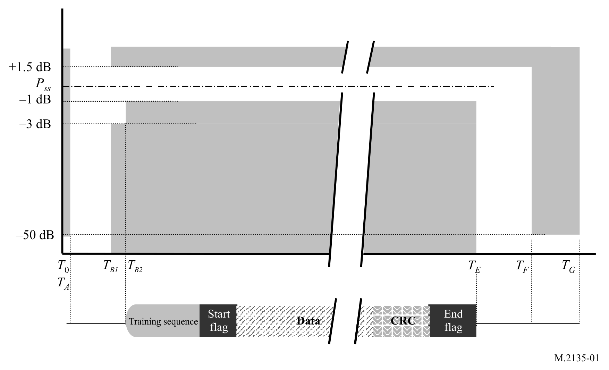

A3-5 Synchronization accuracy
There is no requirement for UTC synchronization.

A3-6 Channel access scheme
Figure 2
Burst transmissions
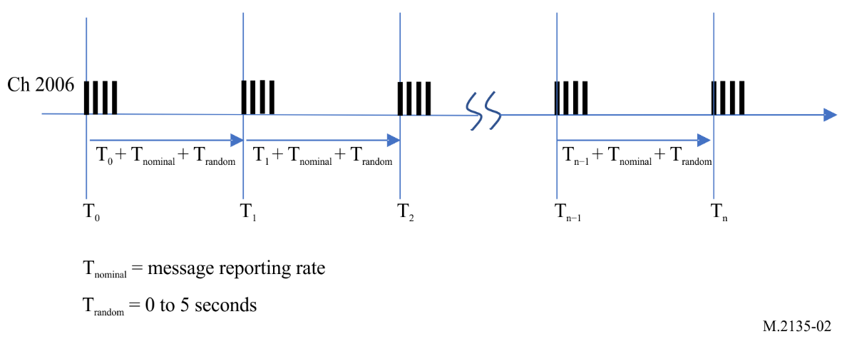

A3-7 User identification (Unique identifier)
The numbering of AMRD Group B devices should be in accordance with Recommendation ITU-R M.585 in combination with unique identity by transmitting Message 61 with activation, prior shutting down and once per 6 minutes.

A3-8 Transmission message behaviour
The messages used by an AMRD Group B device using AIS message structure are described in Annex 5. An AMRD Group B device should transmit at minimum Message 60 Part A, and the identity report Message 61 using the transmission scheme described in § A3-6. The position report should be transmitted once per minute, and the identity report should be transmitted once per 6 minutes. The other available messages may be transmitted by the AMRD Group B device independent of the transmission schedule described above, with a maximum transmission rate of once per 6 minutes.

Annex 4
Technical characteristics of Group B autonomous
maritime radio devices using other than automatic
identification system technology

A4-1 Introduction
All AMRD Group B should use only channel 2006. Experimental devices that use Channel 2006 (other than as operational AMRD Group B using AIS technology) should observe the characteristics below to ensure compatibility with the AMRD Group B.
AMRD Group B described in this Annex are mobile stations operating at sea, transmitting independently of a ship station or a coast station. These AMRD Group B do not enhance the safety of navigation and they deliver signals or information which are not relevant for the navigator of general shipping. These AMRD Group B that use other than AIS technology should not be permitted to use the designated frequencies for AIS, including channels AIS 1 and AIS 2, or for DSC.

A4-2 Technical characteristics to ensure compatibility with the autonomous maritime radio devices Group B using automatic identification system technology
a) The transmitter e.i.r.p. should be limited to 100 mW.
b) The transmitting duty cycle should be as low as possible and not to exceed 0.178%.
c) Duration of any single transmission should not exceed 26.7 ms.
d) These devices operate on a non-interference basis, i.e. they should not interfere with nor claim protection from other existing services. If mitigation measures are identified as necessary to protect incumbent services these may include:
• restricting the use in inland waterways and limiting the aggregation of AMRD Group B devices in a local area using geofencing; and
• implementing automated frequency coordination systems, environmental sensing capabilities, and
• any other interference prevention and mitigation tools, as necessary.
e) These devices should have an integrated antenna. The height of the antenna should not exceed 1 m above the surface of the sea.
f) These devices should have a protected external power switch and transmit indicator.
g) Where authorized by administrations for experimental use, these devices should operate in accordance with this Annex.
TABLE 4
Minimum transmitter characteristics
Transmitter parameters | Description
Carrier power | 100 mW e.i.r.p. (measured over the burst duration)
Carrier frequency error | ±500 Hz (normal). ±1 000 Hz (extreme)
Transmitter burst duration | < 108 ms
Slotted modulation mask | ∆fc < ±12 kHz: 0 dBc  ±12 kHz < ∆fc < ±25 kHz: below the straight line between –20 dBc at ±12 kHz and –36 dBm at ±25 kHz  ±25 kHz < ∆fc < ±62.5 kHz: –36 dBm
Transmitter spurious emissions | < −36 dBm 9 kHz to 1 GHz  < −30 dBm 1 GHz to 4 GHz

Annex 5
Messages used for Group B autonomous maritime radio devices using
automatic identification system technology

A5-1 Introduction
As AMRD are indented to support their user in a specific task, standardised messages, definitive identification and position as well as specific data are relevant for the owner to identify its unit and certain conditions of its operation, the following messages defined in Table 5 have been defined to support these requirements. Message IDs are contained within Recommendation ITU-R M.1371. This Recommendation reserves AIS message ID numbers 60 to 63 for the AMRD Group B communications.

A5-1.1 Autonomous maritime radio devices message summary
TABLE 5
Autonomous maritime radio devices message summary
Message ID | Name | Description
60 | Position report | This multi-page message provides position, navigation and status information
61 | Identity report | Provides the additional information required to uniquely identify the transmitting device.
62 | Static information report | Provides additional information about the transmitting device
63 | Application specific message | Provides for transmitting binary data

A5-1.2 Autonomous maritime radio devices Group B position report
Message 60, Part A is intended to provide position and identification information necessary for the user and the supervising system to identify and locate the transmitting device. This report may provide additional information about the transmitting device using the extended data pages. This report should be transmitted as specified in Annex 3.
TABLE 6
Position report Part A
Parameter | Number  of bits | Description
Message ID | 6 | Identifier for Message 60; always 60
Repeat indicator | 2 | The repeat indicator should always be 0
Source ID | 30 | Identifier for the transmitting station per Rec. ITU-R M.585, Autonomous maritime radio devices Group B
Part number | 2 | Identifier for the message part number; always 0 for Part A
Destination indicator | 1 | 0 = Broadcast (no Destination ID field used)  1 = Addressed (Destination ID uses 30 data bits for Parent MMSI)
Destination ID | 0/30 | Identifier for the receiving station per Rec. ITU-R M.585 (if used). This should be the Parent MMSI of the AMRD.
Longitude | 28 | Longitude in 1/10 000 min (±180°, East = positive (as per 2’s complement), West = negative (as per 2’s complement);  181° (6791AC0_{h}) = not available = default)
Latitude | 27 | Latitude in 1/10 000 min (±90°, North = positive (as per 2’s complement), South = negative (as per 2’s complement);  91 = (3412140_{h}) = not available = default)
Time stamp | 6 | UTC second when the report was generated by the EPFS (0-59 or 60) if time stamp is not available, which should also be the default value or 61 if positioning system is in manual input mode or 62 if electronic position fixing system operates in estimated (dead reckoning) mode or 63 if the positioning system is inoperative)
Nature of the AMRD Device Code | 7 | Nature of the AMRD Group B Device Code per Table 8
Mobile flag | 1 | 0 = anchored, fixed, or unknown, default  1 = mobile (as defined by Extended Data page XX
Position accuracy | 1 | The position accuracy (PA) flag should be determined in accordance with Table 7  1 = high (≤ 10 m)  0 = low (> 10 m)  0 = default
RAIM-flag | 1 | Receiver autonomous integrity monitoring (RAIM) flag of electronic position fixing device; 0 = RAIM not in use = default; 1 = RAIM in use. See Table 7
Extended Data 1 page ID | 3 | Specifies one of the eight Extended Data Pages
Extended Data 1 | 10 | Refer to Tables 9 to 13
TABLE 6 (end)
Parameter | Number  of bits | Description
Extended Data 2 page ID | 3 | Specifies one of the eight Extended Data Pages
Extended Data 2 | 10 | Refer to Tables 9 to 13
Unused bits | 30/0 | These bits are not available for use
Number of bits | 168 | Occupies one-time period

TABLE 7
Determination of position accuracy information
Accuracy status from RAIM  (for 95% of position fixes)⁽¹⁾ | RAIM flag | Differential correction status⁽²⁾ | Resulting value of PA flag
No RAIM process available | 0 | Uncorrected | 0 = low (>10 m)
EXPECTED RAIM error is ≤ 10 m | 1 |  | 1 = high (≤10 m)
EXPECTED RAIM error is > 10 m | 1 |  | 0 = low (>10 m)
No RAIM process available | 0 | Corrected | 1 = high (≤10 m)
EXPECTED RAIM error is ≤ 10 m | 1 |  | 1 = high (≤10 m)
EXPECTED RAIM error is > 10 m | 1 |  | 0 = low (>10 m)
⁽¹⁾ The connected GNSS receiver indicates the availability of a RAIM process by a valid sentence of IEC 61162; in this case the RAIM-flag should be set to “1”. The threshold for evaluation of the RAIM information is 10 m. The RAIM expected error is calculated based on “expected error in latitude” and “expected error in longitude” using the following formula:
$$expected RAIM error= \sqrt{{\left(expected error in latitude\right)}^{2}+{\left(expected error in longitude\right)}^{2}}$$
⁽²⁾ The quality indicator in the position sentences of IEC 61162 received from the connected GNSS receiver indicates the correction status.

A5-1.2.1 Type of autonomous maritime radio devices Group B device
Table 8 is used to specify the AMRD Code Name and Code Number according to the type of application the device is used for.
TABLE 8
Type of autonomous maritime radio devices Group B device
AMRD code name | Code number | Nature description
UNKNOWN | 0 | Default, not specified
FISHNET | 1 | Fishnet marker
STATIC MK | 2 | Static position marker
DYNMIC-MK | 3 | Dynamic/mobile position marker
DIVER | 4 | Diver tracker
RENTAL | 5 | Rental boat tracker
AUTONOMY | 6 | Unmanned Autonomous Vehicle
HYDRO STA | 7 | Meteorological-hydrological station
SURVEYOR | 8 | Survey station
REGATTA | 9 | Regatta participant tracker
BARGE | 10 | Barge locator
FISH POT | 11 | Fish pot marker
FISH AREA | 12 | Fish area
CABLE END | 13 | Marker of the terminus of a cable or pipe
 | 14-127 | Reserved for future use

A5-1.2.2 Autonomous maritime radio devices Group B position report extended data pages
The extended data pages are used to provide additional information about the AMRD Group B device. The Message 60 Part A support two simultaneous pages for a single transmission. The device will provide these pages as required, dependent on the application the device is used for. It is possible to provide more than two pages by alternating pages between transmission. The use of these pages will be dependent on the application for which the device has been deployed.
Note that Extended Page IDs 5 to 6 are reserved for future use.
TABLE 9
Extended data, page ID 0 – Speed over ground
Parameter | Number of bits | Description
SOG | 10 | Speed over ground in 1/10 knot steps (0-102.2 knots)  1 023 = not available, 1 022 = 102.2 knots or higher

TABLE 10
Extended data, page ID 1 – Course over ground
Parameter | Number of bits | Description
COG | 9 | Course over ground in 1 degree = (0-359). 360 (168_{h}) = not available = default. 361-511 should not be used
Reserved | 1 | Reserved for future use

TABLE 11
Extended data, page ID 2 – dynamic status
Parameter | Number of bits | Description
Operational status | 1 | 0 = operating properly, default  1 = operating improperly or erratically
Propulsion mode | 3 | 0 = Propelled no further information, default  1 = Propelled autonomously, under 3 kts, on set parameters  2 = Propelled autonomously, under 3 kts, variably  3 = Propelled autonomously, over 3 kts, variably  4 = Propelled autonomously, over 3 kts, on set parameters  5 = Operated remotely, under 3 kts  6 = Operated remotely, over 3 kts  7 = Tethered from a watercraft (e.g. cable, pipe, net)
Direction Status | 1 | 0 = Unavailable or unknown, default  1 = Direction provided
Direction | 3 | 0 = 000° ± 22.5°  1 = 045° ± 22.5°  2 = 090° ± 22.5°  3 = 135° ± 22.5°  4 = 180° ± 22.5°  5 = 225° ± 22.5°  6 = 270° ± 22.5°  7 = 315° ± 22.5°
Reserved | 2 | Reserved for future use

TABLE 12
Extended data, page ID 3 – health status
Parameter | Number  of bits | Description
Sensor 1 | 3 | 0 = No information or sensor  1 = Sensor Trending Up  2 = Sensor Trending Down  3 = Sensor no change  4 = TBD  5 = TBD  6 = Sensor Degraded  7 = Sensor Inoperative
Sensor 2 | 3 | 0 = No information or sensor  1 = Sensor Trending Up  2 = Sensor Trending Down  3 = Sensor no change  4 = TBD  5 = TBD  6 = Sensor Degraded  7 = Sensor Inoperative
Sensor 3 | 3 | 0 = No information or sensor  1 = Sensor Trending Up  2 = Sensor Trending Down  3 = Sensor no change  4 = TBD  5 = TBD  6 = Sensor Degraded  7 = Sensor Inoperative
Reserved | 1 | Reserved for future use

TABLE 13
Extended data, page ID 4 – unit ID
Parameter | Number  of bits | Description
Unit ID | 6 | Used to identify a specific unit with a range of 1 to 63
Reserved | 4 | Reserved for future use

A5-1.3 Autonomous maritime radio devices Group B proprietary information report
The proprietary information report (Message 60 Part B) should be transmitted as specified in Annex 3.
TABLE 14
Position report Part B
Parameter | Number  of bits | Description
Message ID | 6 | Identifier for Message 60; always 60
Repeat indicator | 2 | The repeat indicator should always be 0
Source ID | 30 | Identifier for the transmitting station per Rec. ITU-R M.585, Autonomous maritime radio devices Group B
Part number | 2 | Identifier for the message part number; always 1 for Part B
Destination indicator | 1 | 0 = Broadcast (no Destination ID field used)  1 = Addressed (Destination ID uses 30 data bits for MMSI)
Destination ID | 0/30 | Identifier for the receiving station per Rec. ITU-R M.585 (if used).  This should be the Parent MMSI of the AMRD.
Proprietary data | 127/97 | For proprietary use
Number of bits | 168 | Occupies one-time period

A5-1.4 Autonomous maritime radio devices Group B additional reports
The Message 60, Part C and D are for future use.

A5-1.5 Autonomous maritime radio devices Group B identity report
The identity report provides the additional information required to uniquely identify the transmitting device. This report should be transmitted as specified in Annex 3.
TABLE 15
Autonomous maritime radio devices identity report
Parameter | Number  of bits | Description
Message ID | 6 | Identifier for Message 61; always 61
Repeat indicator | 2 | The repeat indicator should always be 0.
User ID | 30 | Identifier for the transmitting station per Rec. ITU-R M.585, Autonomous maritime radio devices Group B
Vendor ID | 42 | Unique identification of the Unit by a number as defined by the manufacturer  See Table 16
Parent MMSI | 30 | This should specify the Parent MMSI of the AMRD. A value of 999999999 indicates the AMRD is not associated to a vessel.⁽¹⁾
AMRD code name | 54 | Maximum 9 characters 6 bit ASCII, as defined in Table 8 @@@@@@@@@” = not available = default.
Spare | 4
Number of bits | 168 | Occupies one-time period
⁽¹⁾ The Parent MMSI may be used to associate the AMRD device with the vessel that deployed it.

TABLE 16
Vendor identification field
Bit | Information | Description
(MSB)  41 …...... 24  (18 bits) | Manufacturer’s ID | The Manufacturer’s ID bits indicate the manufacture’s mnemonic code consisting of three 6 bit ASCII characters⁽¹⁾
23 …...... 20  (4 bits) | Unit Model Code | The Unit Model Code bits indicate the binary coded series number of the model. The first model of the manufacture uses “1” and the number is incremented at the release of a new model. The code reverts to “1” after reaching to “15”. The “0” is not used
19 …...... 0  (LSB)  (20 bits) | Unit Serial Number | The Unit Serial Number bits indicate the manufacture traceable serial number. When the serial number is composed of numeric only, the binary coding should be used. If it includes figure(s), the manufacture can define the coding method. The coding method should be mentioned in the manual
⁽¹⁾ NMEA mnemonic manufacturer codes should be used for Message B Manufacturer ID. Manufacturers and or vendors may request this code via NMEA at www.nmea.org.

A5-1.6 Autonomous maritime radio devices Group B static information report
TABLE 17
Autonomous maritime radio devices static information report
Parameter | Number of bits | Description
Message ID | 6 | Identifier for this Message 62; always 62
Repeat indicator | 2 | The repeat indicator should always be 0
User ID | 30 | As defined by Rec. ITU-R M.585-9, Autonomous maritime radio devices Group B
Dimension of area/reference for position | 30 | Dimensions of area in metres and reference point for reported position  (see § A5-1.7.1)  If used it should indicate the maximum dimensions of the area. As default should A = B = C = D be set to “0”.
Battery Status | 2 | 0 = No battery information  1 = Battery Good  2 = Battery Low  3 = Battery Critical
Spare | 96
Number of bits | 124 | Occupies one-time period

A5-1.6.1 Reference point for reported position and overall dimensions of area
The dimension of area field is used to specify the area impacted by the AMRD. The A, B, C and D values are centred around the reference point as depicted in Fig. 3. The dimension values are defined as follows:
TABLE 18
Autonomous maritime radio devices Group B binary message
 | Number  of bits | Bit fields | Distance (m)
A | 10 | Bit 30 – 39 | 0 – 1 023  1 023 = 1 023 m or greater
B | 10 | Bit 20 – 29 | 0 – 1 023  1 023 = 1 023 m or greater
C | 10 | Bit 10 – 19 | 0 – 1 023  1 023 = 1 023 m or greater
D | 10 | Bit 0 – 9 | 0 – 1 023  1 023 = 1 023 m or greater

Figure 3
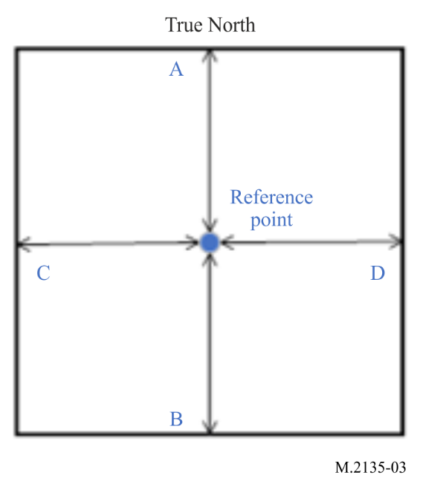

A5-1.7 Autonomous maritime radio devices Group B binary message

TABLE 19
Autonomous maritime radio devices Group B binary message

Parameter | Number  of bits | Description
Message ID | 6 | Identifier for Message 63; always 63
Repeat indicator | 2 | The repeat indicator should always be 0
Source ID | 30 | As defined by Rec. ITU-R M.585-9, Autonomous maritime radio devices Group B
Destination indicator | 1 | 0 = Broadcast (no Destination ID field used)  1 = Addressed (Destination ID uses 30 data bits for MMSI)
Binary data flag | 1 | 0 = unstructured binary data (no Application Identifier bits used)  1 = binary data coded as defined by using the 16-bit Application identifier
Destination ID | 0/30 | Destination ID (if used) |  | If Destination indicator = 0 (Broadcast); no data bits are needed for the Destination ID.  If Destination indicator = 1; 30 bits are used for Destination ID and spare bits for byte alignment.
Spare | 0/2 | Spare (if Destination ID used)
Binary data | Broadcast Maximum 128  Addressed Maximum 96 | Application identifier  (if used) | 16 bits | Should be as described in § A5-1.7.1
 |  | Application binary data | Broadcast maximum 112 bits  Addressed maximum 80 bits | Application specific data
Maximum number of bits | Maximum 168 | Occupies one-time period

A5-1.7.1 Application identifier
Addressed and broadcast binary messages should contain a 16-bit application identifier, structured as follows:
TABLE 20
Bit | Description
15-6 | Designated area code (DAC). This code is based on the maritime identification digits (MID). Exceptions are 0 (test) and 1 (international). Although the length is 10 bits, the DAC codes equal to or above 1 000 are reserved for future use
5-0 | Function identifier. The meaning should be determined by the authority which is responsible for the area given in the designated area code

