Recommendation ITU-R F.637-5
(02/2022)
Radio-frequency channel arrangements
for fixed wireless systems operating
in the 21.2-23.6 GHz band

F Series
Fixed service

Foreword
The role of the Radiocommunication Sector is to ensure the rational, equitable, efficient and economical use of the radio-frequency spectrum by all radiocommunication services, including satellite services, and carry out studies without limit of frequency range on the basis of which Recommendations are adopted.
The regulatory and policy functions of the Radiocommunication Sector are performed by World and Regional Radiocommunication Conferences and Radiocommunication Assemblies supported by Study Groups.

Policy on Intellectual Property Right (IPR)
ITU-R policy on IPR is described in the Common Patent Policy for ITU-T/ITU-R/ISO/IEC referenced in Resolution ITU-R 1. Forms to be used for the submission of patent statements and licensing declarations by patent holders are available from http://www.itu.int/ITU-R/go/patents/en where the Guidelines for Implementation of the Common Patent Policy for ITU-T/ITU-R/ISO/IEC and the ITU-R patent information database can also be found.

Series of ITU-R Recommendations
(Also available online at http://www.itu.int/publ/R-REC/en)
Series | Title
BO | Satellite delivery
BR | Recording for production, archival and play-out; film for television
BS | Broadcasting service (sound)
BT | Broadcasting service (television)
F | Fixed service
M | Mobile, radiodetermination, amateur and related satellite services
P | Radiowave propagation
RA | Radio astronomy
RS | Remote sensing systems
S | Fixed-satellite service
SA | Space applications and meteorology
SF | Frequency sharing and coordination between fixed-satellite and fixed service systems
SM | Spectrum management
SNG | Satellite news gathering
TF | Time signals and frequency standards emissions
V | Vocabulary and related subjects

Note: This ITU-R Recommendation was approved in English under the procedure detailed in Resolution ITU-R 1.

Electronic Publication
Geneva, 2022

© ITU 2022
All rights reserved. No part of this publication may be reproduced, by any means whatsoever, without written permission of ITU.

RECOMMENDATION ITU-R F.637-5
Radio-frequency channel arrangements for fixed wireless systems
operating in the 21.2-23.6 GHz band
(Question ITU-R 247-1/5)
(1986-1992-1994-1999-2012-2022)
Scope
This Recommendation provides radio-frequency (RF) channel arrangements for fixed wireless systems (FWS) operating in the 21.2-23.6 GHz band. The main text of this Recommendation presents RF channel arrangements based on the homogeneous patterns with channel separations of 2.5 and 3.5 MHz. Annexes 1 to 4 present example arrangements of these homogeneous patterns used in some countries.
Keywords
Fixed service, point-to-point, channel bandwidth, channel arrangement, 23 GHz
Abbreviations / Glossary
BSS Broadcasting-satellite service
CEPT European Conference of Postal and Telecommunications Administrations
ENG/OB Electronic news gathering / outside broadcast
FS Fixed service
FWS Fixed wireless systems
IMT International Mobile Telecommunications
SAP/SAB Services ancillary to production / services ancillary to broadcasting
RF Radio-frequency
WARC World Administrative Radio Conference
Related ITU Recommendations and Reports
Recommendation ITU-R F.746 – Radio-frequency arrangements for fixed service systems
The ITU Radiocommunication Assembly,
considering
a) that the band 21.2-23.6 GHz is allocated to the fixed and other services;
b) Resolution 525 of the World Administrative Radio Conference (WARC) for Dealing with Frequency Allocations in Certain Parts of the Spectrum (Malaga-Torremolinos, 1992);
c) that the band is used for differing applications by various administrations and that these applications may require different radio-frequency (RF) channel arrangements;
d) that several types of service with various capacities may be in simultaneous use in this frequency band;
e) that the band allocated to each service or even to each administration may vary from one country to another;
f) that the applications in this frequency band may require differing channel bandwidth;
g) that a high degree of compatibility between RF channels of different arrangements can be achieved by selecting all channel centre frequencies from a homogeneous basic pattern;
h) that the continuously capacity growing request to radio links, especially as part of the mobile network evolution to IMT-2020, has been increasingly addressed in recent years,
recognizing
that Recommendation ITU-R SM.1540 provides guidelines for managing the unwanted emissions in the out-of-band domain falling into adjacent allocated bands,
recommends
1 that RF channel arrangements for the band 21.2-23.6 GHz should be based on a homogeneous pattern;
2 that the homogeneous pattern with a preferred 3.5 MHz interval be defined by the relation:
fp = fr + 3.5 + 3.5 p
where:
1 ≤ p ≤ 685
f$_{r}$ : reference frequency of the homogeneous pattern;
3 that the homogeneous pattern with a preferred 2.5 MHz interval be defined by the relation:
fp = fr + 4 + 2.5 p
where:
1 ≤ p ≤ 959
f$_{r}$ : reference frequency of the homogeneous pattern;
4 that the reference frequency of the homogeneous pattern for international connections should be:
fr = 21 196 MHz
other reference frequencies may be agreed by the administrations concerned;
5 that in each bidirectional link all go channels should be in one half of any band, and all return channels in the other;
6 that the channel spacings, XS, the centre gap, YS, and the distance to the lower and upper band limits, Z1S and Z2S, should be agreed by the administrations concerned, dependent on the application and channel capacity envisaged (see Recommendation ITU-R F.746 for definitions of XS, YS and ZS).
NOTE 1 – Examples of channel arrangements based on this Recommendation are described in Annexes 1, 2, 3 and 4.
NOTE 2 – Due regard has to be taken that, in certain countries, a 3.5 MHz homogeneous pattern, interleaved by 1.75 MHz from that referred in § 2, is used in conjunction with the main pattern.

Annex 1
RF channel arrangements in the band 21.2-23.6 GHz used in some
countries in accordance with recommends 2
The use of the band 21.2-23.6 GHz is based on a homogeneous 3.5 MHz frequency pattern. Various channel spacings from 3.5 MHz to 224 MHz are accommodated as shown in Fig. 1 and interleaved patterns are also used for the various spacings. In some applications, additional channels can be added in the edge and central guardbands using the homogeneous pattern.
The duplex separation is 1 232 MHz
Let f_{r} be the reference frequency of the homogeneous pattern 21 196 MHz;
fn be the centre frequency of a radio-frequency channel in the lower half of the band (MHz);
f ′_{n} be the centre frequency of a radio-frequency channel in the upper half of the band (MHz);
then the frequencies of individual channels are expressed by the following relationships:
a) for systems with carrier spacing of 224 MHz in interleaved arrangement:
lower half of the band: fn = f_{r} + 28 + 112 n MHz
upper half of the band: f ′_{n} = f_{r} + 1 260 + 112 n MHz
where:
n = 1, . . . 9
b) for systems with carrier spacing of 112 MHz:
lower half of the band: fn = f_{r} − 28 + 112 n MHz
upper half of the band: f ′_{n} = f_{r} + 1 204 + 112 n MHz
where:
n = 1, . . . 10
c) for systems with a carrier spacing of 56 MHz:
lower half of the band: fn = f_{r} + 56 n MHz
upper half of the band: f ′_{n} = f_{r} + 1 232 + 56 n MHz
where:
n = 1, . . . 20
d) for systems with a carrier spacing of 28 MHz:
lower half of the band: fn = f_{r} + 14 + 28 n MHz
upper half of the band: f ′_{n} = f_{r} + 1 246 + 28 n MHz
where:
n = 1, . . . 40
e) for systems with a carrier spacing of 14 MHz:
lower half of the band: fn = f_{r} + 21 + 14 n MHz
upper half of the band: f ′_{n} = f_{r} + 1 253 + 14 n MHz
where:
n = 1, . . . 80
f) for systems with a carrier spacing of 7 MHz:
lower half of the band: fn = f_{r} + 24.5 + 7 n MHz
upper half of the band: f ′_{n} = f_{r} + 1 256.5 + 7 n MHz
where:
n = 1, . . . 160
g) for systems with a carrier spacing of 3.5 MHz:
lower half of the band: fn = f_{r} + 26.25 + 3.5 n MHz
upper half of the band: f ′_{n} = f_{r} + 1 258.25 + 3.5 n MHz
where:
n = 1, . . . 320.
figure 1
Radio-frequency channel arrangements for digital and analogue FWS
operating in the 21.2-23.6 GHz band
(All frequencies in MHz)
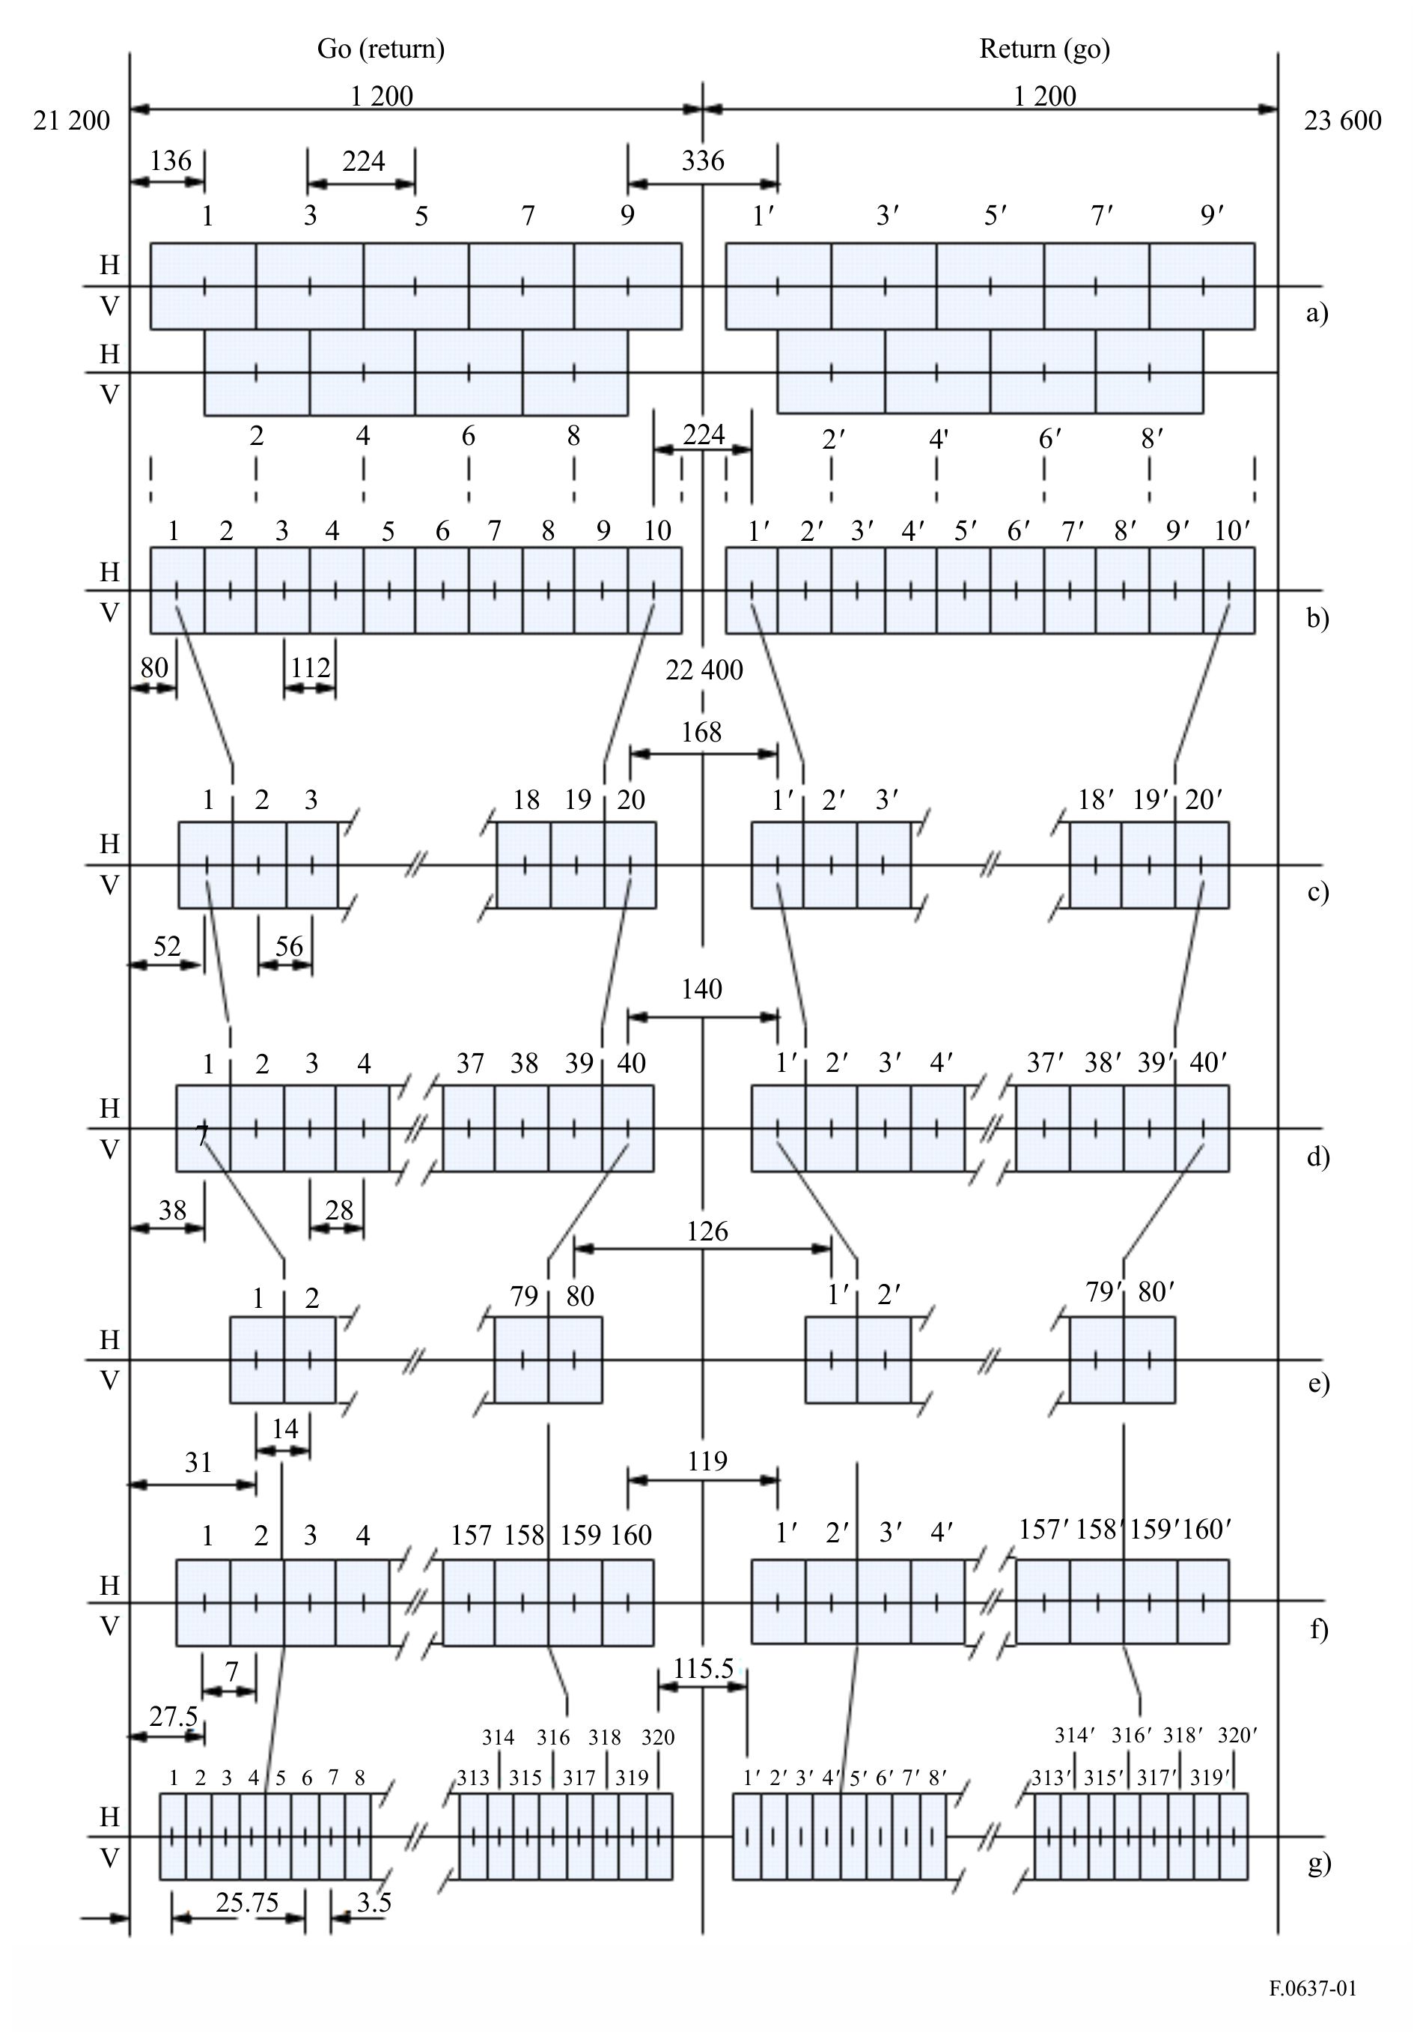
NOTE 1 – The RF channel arrangements of Fig. 1g) are derived by the use of carriers interleaved between those of the homogeneous pattern of recommends 2.
NOTE 2 – Figure 1a) shows the channel arrangement of 224 MHz channel spacing with interleaved arrangement by granularity of 112 MHz.

Annex 2
Radio-frequency channel arrangements for some CEPT administrations
in the band 22.0-23.6 GHz in accordance with recommends 2

1 Frequency bands 22.0-22.6 GHz paired with 23.0-23.6 GHz
An example of radio-frequency channel arrangements in the band 22.0-22.6 GHz paired with 23.0-23.6 GHz for carrier spacings of 224 MHz, 112 MHz, 56 MHz, 28 MHz, 14 MHz, 7 MHz and 3.5 MHz is derived as follows:
The duplex separation is 1 008 MHz.
Let f_{r} be the reference frequency of the homogeneous pattern 21 196 MHz;
fn be the centre frequency of a radio-frequency channel in the lower half of the band (MHz);
f ′_{n} be the centre frequency of a radio-frequency channel in the upper half of the band (MHz);
then the frequencies of individual channels are expressed by the following relationships:
a) for systems with a carrier spacing of 224 MHz in an interleaved pattern:
lower half of the band : f_{n} = f_{r} + 826 + 112 n MHz
upper half of the band : f ′_{n} = f_{r} + 1 834 + 112 n MHz
where:
n = 1, ... 4
b) for systems with a carrier spacing of 112 MHz:
lower half of the band: fn = f_{r} + 770 + 112 n MHz
upper half of the band: f ′_{n} = f_{r} + 1 778 + 112 n MHz
where:
n = 1, . . . 5
c1) for systems with a carrier spacing of 56 MHz providing 9 channels:
lower half of the band: fn = f_{r} + 826 + 56 n MHz
upper half of the band: f ′_{n} = f_{r} + 1 834 + 56 n MHz
where:
n = 1, . . . 9
c2) for systems with a carrier spacing of 56 MHz providing 10 channels:
lower half of the band: fn = f_{r} + 784 + 56 n MHz
upper half of the band: f ′_{n} = f_{r} + 1 792 + 56 n MHz
where:
n = 1, . . . 10
d) for systems with a carrier spacing of 28 MHz:
lower half of the band: fn = f_{r} + 798 + 28 n MHz
upper half of the band: f ′_{n} = f_{r} + 1 806 + 28 n MHz
where:
n = 1, . . . 20
e) for systems with a carrier spacing of 14 MHz:
lower half of the band: fn = f_{r} + 805 + 14 n MHz
upper half of the band: f ′_{n} = f_{r} + 1 813 + 14 n MHz
where:
n = 1, . . . 41
f) for systems with a carrier spacing of 7 MHz:
lower half of the band: fn = f_{r} + 808.5 + 7 n MHz
upper half of the band: f ′_{n} = f_{r} + 1 816.5 + 7 n MHz
where:
n = 1, . . . 83
g) for systems with a carrier spacing of 3.5 MHz:
lower half of the band: fn = f_{r} + 805 + 3.5 n MHz
upper half of the band: f ′_{n} = f_{r} + 1 813 + 3.5 n MHz
where:
n = 1, . . . 168.
NOTE 1 – The radio-frequency channel arrangements of a) to g) above use channel centre frequencies fn and f ′_{n} selected from the homogeneous pattern of recommends 2.
NOTE 2 – Figure 2 gives occupied spectrum in the 22.0-23.6 GHz band.
Figure 2
Radio-frequency channel arrangement in the band 22.0-22.6 GHz paired with 23.0-23.6 GHz
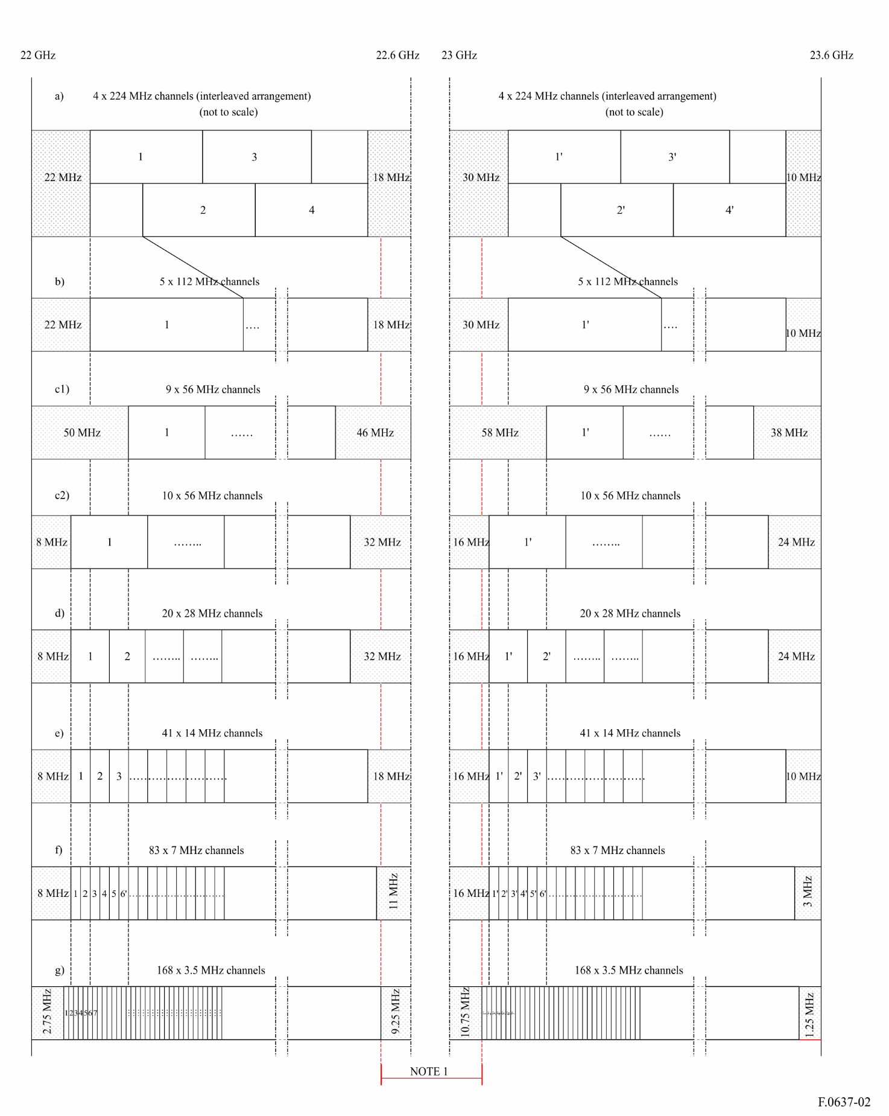
NOTE 1 – For the centre-gap channel arrangements, see §§ 2 and 3 of this Annex.

2 Frequency bands 22.590 75-22.758 75 GHz paired with 22.842 75-23.010 75 GHz
These bands are portions of the centre-gap of the channel arrangement shown in § 1, combined with the innermost guardbands of the 3.5 MHz arrangement (see Fig. 3).
The preferred radio-frequency channel arrangement for digital point-to-point FWS for carrier spacings of 28 MHz, 14 MHz, 7 MHz and 3.5 MHz should be derived as follows:
Let f_{r} be the reference frequency of the homogeneous pattern 21 196 MHz;
f_{n} be the centre frequency of the radio-frequency channel in the lower half of the band (MHz);
f ′_{n} be the centre frequency of the radio-frequency channel in the upper half of the band (MHz);
TX/RX duplex separation = 252 MHz;
centre gap = 84 MHz;
then the frequencies of individual channels (Note 1) are expressed by the following relationships:
a) for systems with a carrier spacing of 28 MHz:
lower half of band: f_{n} = (f_{r} + 1 380.75 + 28 n) MHz
upper half of band: f ′_{n} = (f_{r} + 1 632.75 + 28 n) MHz
where:
n = 1, …. 6
b) for systems with a carrier spacing of 14 MHz:
lower half of band: f_{n} = (f_{r}+ 1 387.75 + 14 n) MHz
upper half of band: f ′_{n} = (f_{r} + 1 639.75 + 14 n) MHz
where:
n = 1, …. 12
c) for systems with a carrier spacing of 7 MHz:
lower half of band: f_{n} = (f_{r} + 1 391.25 + 7 n) MHz
upper half of band: f ′_{n} = (f_{r} + 1 643.25 + 7 n) MHz
where:
n = 1, …. 24
d) for systems with a carrier spacing of 3.5 MHz:
lower half of band: f_{n} = (f_{r} + 1 393 + 3.5 n) MHz
upper half of band: f ′_{n} = (f_{r} + 1 645 + 3.5 n) MHz
where:
n = 1, …. 48
NOTE 1 – The channels are shown as paired; however, administrations may envisage unpaired use of those channels according to the national need (e.g. for ENG/OB- and/or SAP/SAB-applications). Some administrations may also wish to pair some of the channels in the lower half within the 22.6-23.0 GHz band with those in 21.2-21.4 GHz band referred in Annex 4.
NOTE 2 – Figure 3 gives occupied spectrum in the band 22.590 75-22.758 75 GHz paired with the 22.842 75-23.010 75 GHz band.
Figure 3
Radio-frequency channel arrangement in the band 22.590 75-22.758 75 GHz paired
with 22.842 75-23.010 75 GHz
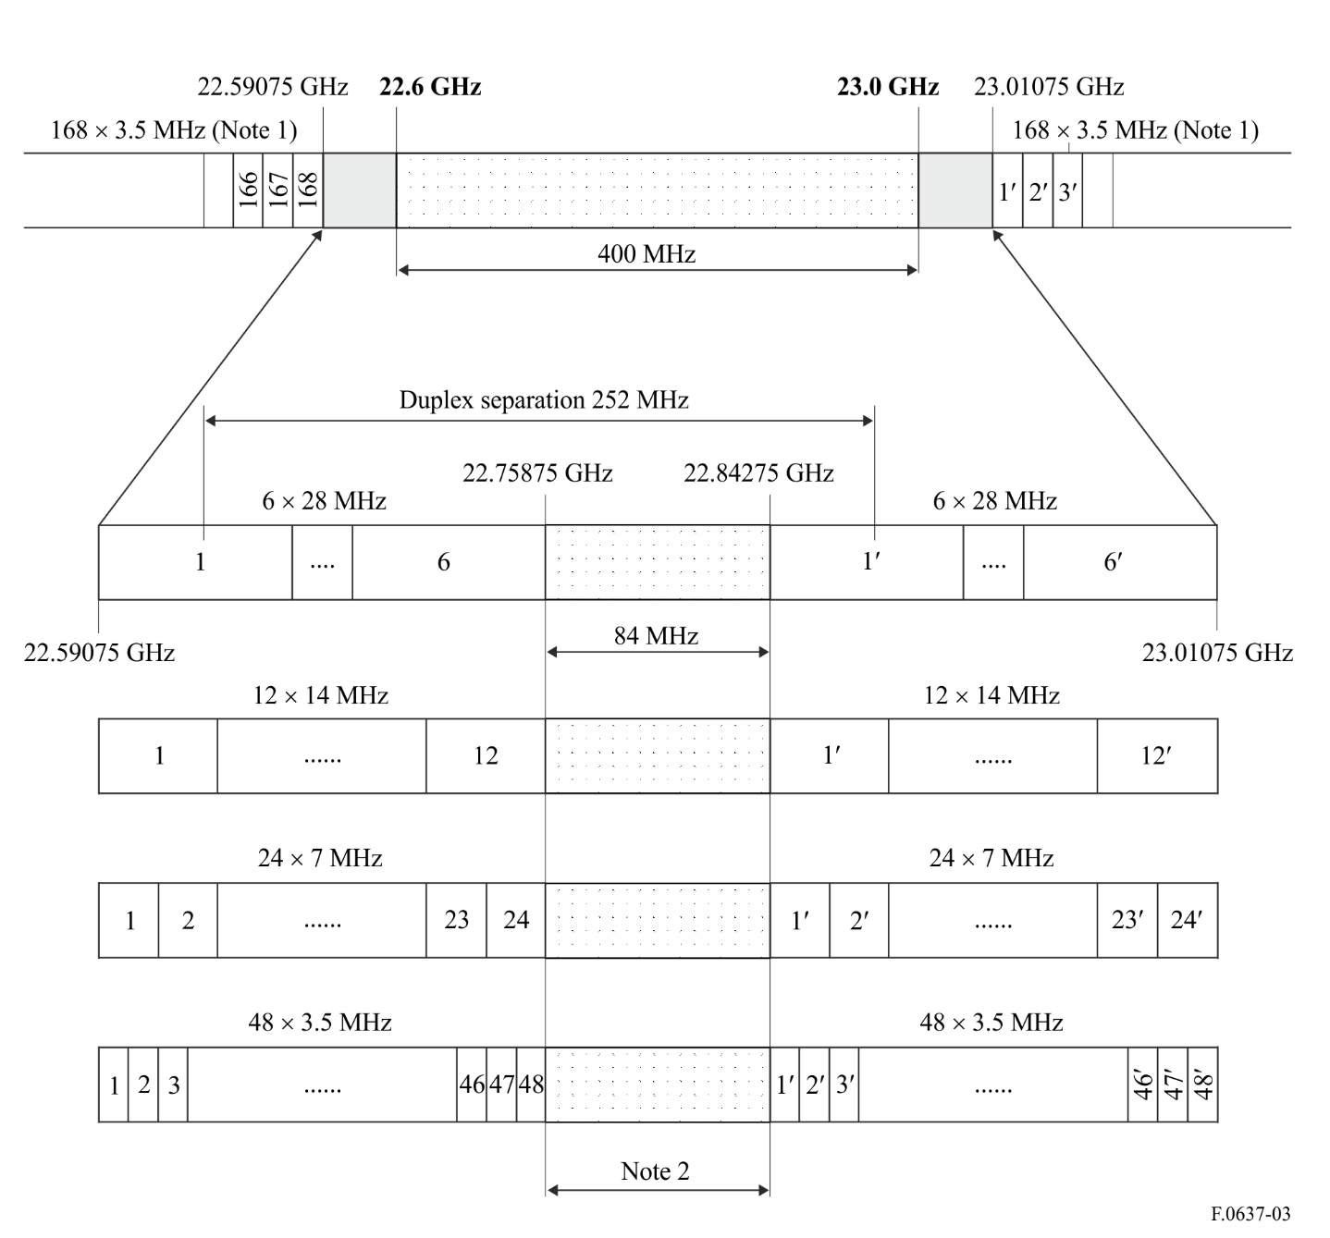
NOTE 1 – This is the 3.5 MHz channel arrangement according to § 1 of this Annex.
NOTE 2 – For the centre-gap channel arrangement, see § 3 of this Annex.

3 Frequency band 22.758 75-22.842 75 GHz
This band is the centre-gap of the channel arrangement in § 2 (see Fig. 3), which may be used for unpaired channels.
The preferred radio-frequency channel arrangement for digital and analogue point-to-point FWS for carrier spacings of 28 MHz, 14 MHz, 7 MHz and 3.5 MHz should be derived as follows:
Let f₀ be a reference frequency of 22 757 MHz;
f_{n} be the centre frequency (MHz) of a radio-frequency channel;
then the frequencies of individual channels are expressed by the following relationships:
a) for systems with a carrier spacing of 28 MHz:
f_{n} = (f₀ − 12.25 + 28 n) MHz
where:
n = 1, 2, 3
b) for systems with a carrier spacing of 14 MHz:
f_{n} = (f₀ − 5.25 + 14 n) MHz
where:
n = 1, 2, …. 6
c) for systems with a carrier spacing of 7 MHz:
f_{n} = (f₀ − 1.75 + 7 n) MHz
where:
n = 1, 2, …. 12
d) for systems with a carrier spacing of 3.5 MHz:
f_{n} = (f₀ + 3.5 n) MHz
where:
n = 1, 2, …. 24
NOTE − Figure 4 gives occupied spectrum in the 22.758 75-22.842 75 GHz band.
Figure 4
Radio-frequency channel arrangement in the band 22.758 75-22.842 75 GHz
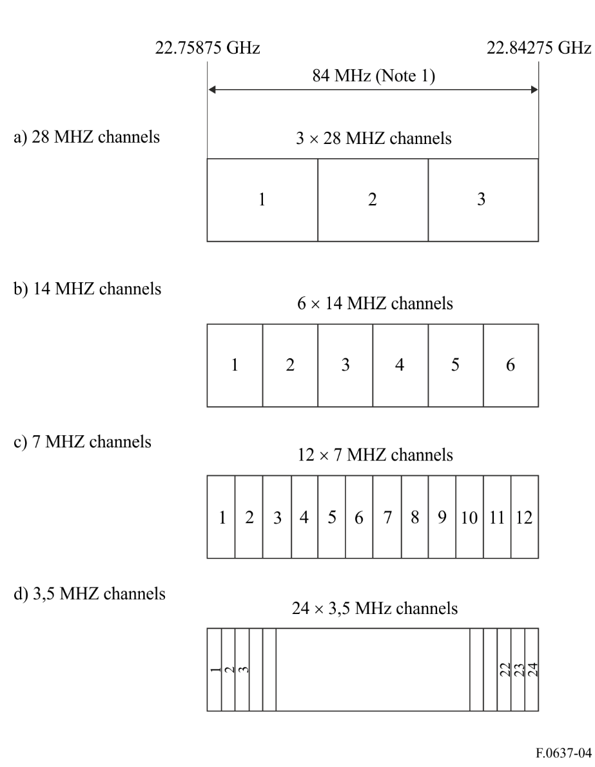
NOTE 1 – This is the centre-gap of the channel arrangement in § 2 (see Fig. 3).

Annex 3
Description of the radio-frequency channel arrangements in the band 21.2-23.6 GHz in accordance with recommends 3 (North America)
In the United States of America, the most widespread use of the 21.2-23.6 GHz band is in the 21.8-22.4 GHz and 23.0-23.6 GHz portions for which a frequency pattern with 50 MHz channels has been adopted. The same pattern is being used in the remainder of the 21.2-23.6 GHz band as usage is spreading. Accordingly, a homogeneous pattern is in use, based on recommends 3 and given by:
fn = fr – 21 + 50 n
where:
n = 1, 2, 3, . . . 48
f$_{r}$ (reference frequency) = 21 196 MHz.
For two-way operation, the go-return separation is about 1 200 MHz. Typical systems in use include digital transmission at data rates between about 1.5 and 8 Mbit/s, and a variety of analogue video systems.
In Canada, the RF channel arrangements for FWS in the band 21.2-23.6 GHz is shown in Fig. 5.
FIGURE 5
Band plan for the band 21.2-23.6 GHz (Canada)
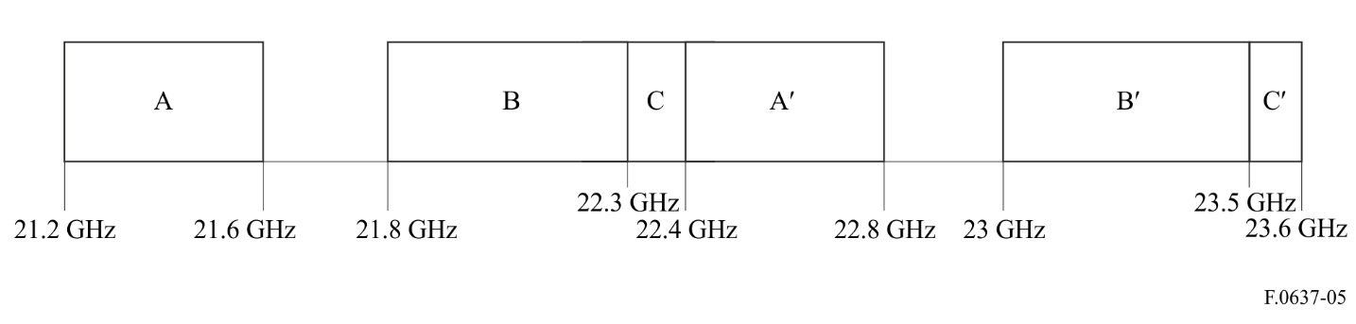
The above channel arrangement contains three paired blocks: Blocks A/A′, Blocks B/B′, and Blocks C/C′. In all three blocks, each paired channel has a frequency separation of 1 200 MHz. The channel widths in each block are as follows:
A/A′: 50 MHz channels (8 in each block).
B/B′: Five available channel widths: 10 MHz, 15 MHz, 20 MHz, 40 MHz and 50 MHz.
C/C′: Three available channel widths: 2.5 MHz, 5 MHz and 7.5 MHz.

Annex 4
Radio-frequency channel arrangements in the band 21.2-23.6 GHz
in accordance with recommends 2 (Germany)
Taking into account the fact, that:
– WARC-92 has allocated the band 21.4-22.0 GHz to the broadcasting-satellite service (BSS) on a primary basis in Regions 1 and 3;
– many individual reception units for the BSS are expected to be used and interference from the fixed service (FS) should be minimized;
the operational use of FWS in the sub-band 21.4-22.0 GHz should be avoided.
The band plan based on WARC-92 decisions is shown in Fig. 6.
FIGURE 6
Band plan for the band 21.2-23.6 GHz based on WARC-92 decisions
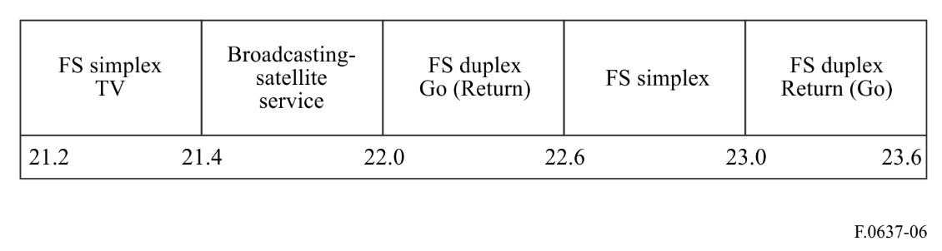
An application of the band plan (Fig. 6) for analogue and digital FWS (2 Mbit/s to 155 Mbit/s) is described in detail in Fig. 7.
NOTE – In Fig. 7 the radio-frequency channel arrangements in the bands 22.0-22.6 GHz paired with 23.0-23.6 GHz are equal to the corresponding ones in § 1 of Annex 2.
FIGURE 7
Radio-frequency channel arrangements for digital and analogue FWS
operating in the band 21.2-23.6 GHz based on WARC-92 decisions
(All frequencies in MHz)
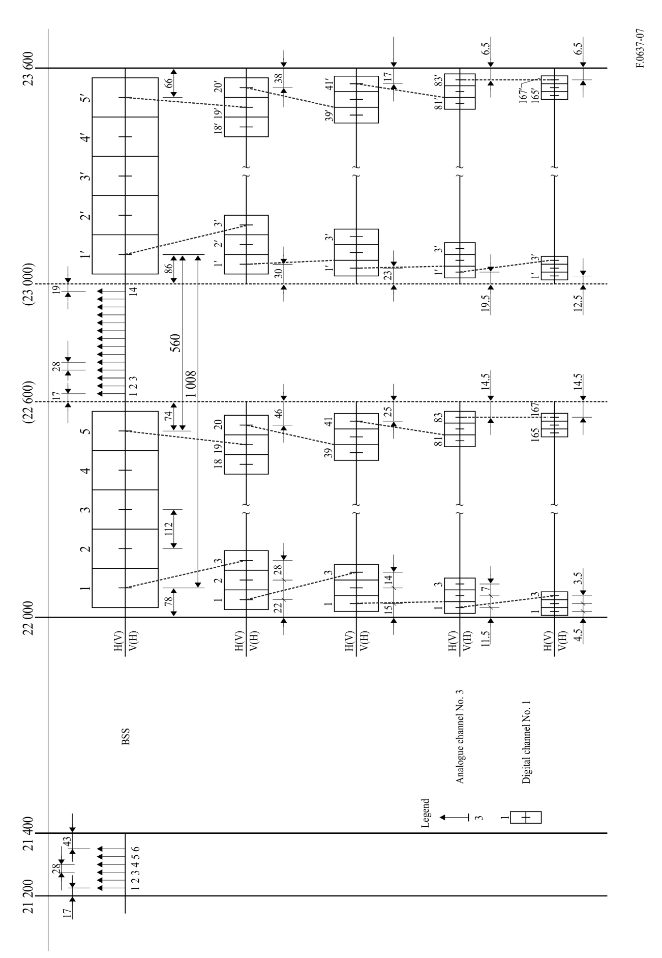

European Conference of Postal and Telecommunications Administrations.

