Recommendation ITU-R F.1105-4
(01/2019)
Fixed wireless systems for disaster mitigation and relief operations

F Series
Fixed service

Foreword
The role of the Radiocommunication Sector is to ensure the rational, equitable, efficient and economical use of the radio-frequency spectrum by all radiocommunication services, including satellite services, and carry out studies without limit of frequency range on the basis of which Recommendations are adopted.
The regulatory and policy functions of the Radiocommunication Sector are performed by World and Regional Radiocommunication Conferences and Radiocommunication Assemblies supported by Study Groups.

Policy on Intellectual Property Right (IPR)
ITU-R policy on IPR is described in the Common Patent Policy for ITU-T/ITU-R/ISO/IEC referenced in Resolution ITU-R 1. Forms to be used for the submission of patent statements and licensing declarations by patent holders are available from http://www.itu.int/ITU-R/go/patents/en where the Guidelines for Implementation of the Common Patent Policy for ITU-T/ITU-R/ISO/IEC and the ITU-R patent information database can also be found.

Series of ITU-R Recommendations
(Also available online at http://www.itu.int/publ/R-REC/en)
Series | Title
BO | Satellite delivery
BR | Recording for production, archival and play-out; film for television
BS | Broadcasting service (sound)
BT | Broadcasting service (television)
F | Fixed service
M | Mobile, radiodetermination, amateur and related satellite services
P | Radiowave propagation
RA | Radio astronomy
RS | Remote sensing systems
S | Fixed-satellite service
SA | Space applications and meteorology
SF | Frequency sharing and coordination between fixed-satellite and fixed service systems
SM | Spectrum management
SNG | Satellite news gathering
TF | Time signals and frequency standards emissions
V | Vocabulary and related subjects

Note: This ITU-R Recommendation was approved in English under the procedure detailed in Resolution ITU-R 1.

Electronic Publication
Geneva, 2019

© ITU 2019
All rights reserved. No part of this publication may be reproduced, by any means whatsoever, without written permission of ITU.

RECOMMENDATION ITU-R F.1105-4*
Fixed wireless systems for disaster mitigation and relief operations
(Question ITU-R 248/5)
(1994-2002-2006-2014-2019)
Scope
This Recommendation provides characteristics of fixed wireless systems (FWS) used for disaster mitigation and relief operations. Several types of such systems including transportable equipment are specified according to channel capacity, operating frequency bands, transmission distance and propagation path conditions.
Detailed descriptions of these systems are also given in Annex 1 as guidance.
Keywords
Fixed service, land mobile service, disaster mitigation, relief operation, backhaul link, transportable system
Related ITU-R Recommendations and Reports
Recommendation ITU-R M.2015 – Frequency arrangements for public protection and disaster relief radiocommunication systems in accordance with Resolution 646 (Rev.WRC-15)
Report ITU-R F.2061 – HF fixed radiocommunications systems
Report ITU-R F.2087 – Requirements for high frequency (HF) radiocommunication systems in the fixed service
Abbreviations
ATM Asynchronous transfer mode
BER Bit error rate
CS Central station
FS Fixed Service
FWS Fixed wireless system
OS Outdoor terminal station
OFDM Orthogonal frequency division multiplex
P-MP Point to Multi Point
P-P Point to Point
QAM Quadrature amplitude modulation
QPSK Quaternary phase shift keying/Quadrature phase shift keying
PPDR Public protection and disaster relief
SHF Super High Frequency
STM Synchronous transfer mode
TDD Time division duplex
TDMA Time division multiple access
UHF Ultra High Frequency
VHF Very High Frequency
The ITU Radiocommunication Assembly,
considering
a) that rapidly deployable telecommunications are essential for disaster mitigation and relief operations in the event of natural disasters, epidemics, famines and similar emergencies;
b) that measures to mitigate the effects of natural disasters should be made available as much as possible;
c) that high speed data and high capacity information are available due to the popularity of fibre-to-the-home, digital subscriber line, mobile phones, etc. in the form of voice, character data, image, or through a variety of Internet Protocol (IP)-based services;
d) that transportable fixed wireless equipment may be used for relief operation of either radio or cable links and may involve multi-hop applications with digital and analogue equipment;
e) that fixed wireless equipment for disaster mitigation and relief operations may be operated in locations with differing terrain and in differing climatic zones, uncontrolled environmental conditions and/or unstable power sources;
f) that fixed wireless equipment for disaster mitigation and relief operations may be used in areas with an unfavourable interference environment;
g) that interoperability and internetworking between fixed wireless system for disaster mitigation and relief operations and other networks would be beneficial in emergency situations as stated in considering a);
h) that communication recovery in disaster situations could be facilitated if both a transportable mobile backhaul link and a transportable mobile base station could be deployed in a vehicle and carried to the disaster hit area when the mobile backhaul link and the base station for normal operation are both damaged by a disaster,
recognizing
a) that Resolution 646 (Rev.WRC-15) invites ITU-R to continue its technical studies and to make recommendations concerning technical and operational implementation, as necessary, to meet the needs of public protection and disaster relief radiocommunication applications, taking into account the capabilities, evolution and any resulting transition requirements of the existing systems, particularly those of many developing countries, for national and international operations;
b) that Resolution 647 (Rev.WRC-15) invites ITU-R to continue conducting studies as necessary, in accordance with its resolves 1 and in support of developing and maintaining appropriate spectrum management guidelines applicable in emergency and disaster relief operations;
c) that Resolution ITU-R 55 requests the concerned ITU-R Study Groups to undertake studies and develop guidelines related to the management of radiocommunications in disaster prediction, detection, mitigation and relief collaboratively and cooperatively within ITU and with organizations external to the Union;
d) that Resolution ITU-R 55 also requests the relevant ITU-R Study Groups to continue studies on new emerging technologies which could support disaster prediction, detection, mitigation and relief;
e) that Recommendation ITU-R M.2015 provides guidance on frequency arrangements for public protection and disaster relief radiocommunication systems in accordance with Resolution 646 (Rev.WRC-15);
f) that Reports ITU-R F.2061 and ITU-R F.2087 address the role of HF radiocommunication systems in public protection and disaster relief (PPDR) operations,
recommends
1 that for disaster mitigation and relief operations in devastated areas or restoration of a break in transmission links the following types of fixed wireless systems (FWS) as given in Table 1 should be considered;
TABLE 1
Types of fixed wireless systems for disaster mitigation and relief operations
Type | Feature | Application
A | A simple wireless link which can be established rapidly for telephone communication with a governmental or international headquarters | (1)  (2)
B | One or more local networks which connect a communications centre and up to about 10 or 20 end-user stations with telephone links | (1)
C | A telephone link for between about 6 and 120 channels or a data link up to the 6.3/8 Mbit/s over a line-of-sight or near line-of-sight path | (1)  (2)
D | A telephone link between 12 and 480 channels or a data link up to 34/45 Mbit/s over a line-of-sight or obstacle or trans-horizon path | (2)
E | A high-capacity telephone link (more than 480 channels) or high-speed data link up to STM-1 | (2)
F | Simultaneous individual or group radiocommunications using point-to-multipoint individual radiocommunications between a central station and a number of terminals in a region | (1), (3)
Types A to E: Transportable system.
Application (1): For devastated areas.
Application (2): For breaks in transmission links.
Application (3): For mitigation of disaster effects.

2 that interconnection of transportable FWS with analogue and digital cable systems at repeater stations should be made at baseband;
3 that interconnection of transportable FWS with fibre-optic systems at repeater stations may be made at points with a significant level of optical power;
4 that for system characteristics, the information contained in § 1 of Annex 1 can be referred to as a guide for administrations and system planners;
5 that performance objectives of links that use transportable fixed wireless equipment as well as separate links formed by the transportable fixed wireless equipment during restoration should have transmission performance values sufficient for normal service (see § 3 of Annex 1);
6 that transportable FWS, Types A to E in Table 1 including Annex 1 describing their characteristics, should be used for the access link to a base station in mobile communications that are operating in disaster relief and emergency situations (see § 2.6 and Attachment 2 in Annex 1).

Annex 1
Descriptions of fixed wireless systems for disaster mitigation
and relief operations

1 System characteristics
For each type of system in Table 1, the channel capacities, frequency bands and path distances given in Table 2 are suitable.
TABLE 2
Basic characteristics
System type | Capacity | Example frequency bands⁽¹⁾ | Transmission  path distance
A | 1-2 channels | HF (2-10 MHz) | Up to 250 km and beyond
B | Local network with 10-20 outstations (several channels) | VHF (50-88 MHz)  (150-174 MHz)  UHF (335-470 MHz) | Up to a few km
C | From 6 to 120 channels  1.5/2 or 6.3/8 Mbit/s | UHF (335-470 MHz)  (1.4-1.6 GHz)  SHF (7-8 GHz)  (10.5-10.68 GHz) | Up to 100 km
D | From 12 to 480 channels  1.5/2, 6.3/8, 4 × 6.3/8 Mbit/s or 34/45 Mbit/s | UHF (800-1 000 MHz)  (1.7-2.7 GHz)  SHF (4.2-5 GHz) | Line-of-sight or obstructed paths
E | 960-2 700 channels  STM-0 (52 Mbit/s) or  STM-1 (155 Mbit/s) | SHF (4.4-5 GHz)  (7.1-8.5 GHz)  (10.5-10.68 GHz)  (10.7-11.7 GHz)  (11.7-13.2 GHz)  (14.4-15.23 GHz)  (17.85-17.97/  18.6-18.72 GHz)  (23 GHz) | Up to several tens of km
F | 6-TDMA channels  e.g. up to 2 000 individual calls  e.g. up to 200 group calls | VHF (54-70 MHz) | Up to 10 km (typical)  Extension with  repeater(s)
TDMA: Time division multiple access
STM: Synchronous transfer mode
⁽¹⁾ Many parts of these bands are shared with satellite services.

In the case of links to an earth station operating in a satellite service, the following additional restrictions should be considered:
– space-to-Earth frequency bands should be avoided;
– problems could arise if Earth-to-space frequency bands are used;
– trans-horizon systems (Type D) should be avoided.
It would be preferable to avoid bands likely to be in use or planned for trunk communications. However, these bands may be used for Type E with careful consideration of interference problems by the administration.

2 Engineering principles

2.1 Low-capacity links (Type A system)
HF transportable equipment for 1 or 2 channels should employ only solid-state components and should be designed to switch off the transmitters when not in use, in order to conserve battery power, and to reduce the potential of interference.
As an example, a solid-state 100 W single-sideband terminal in a band between, say, 2 and 8 MHz operated with a whip antenna, could have a range of up to 250 km. Simplex operation (transmitter and receiver employing the same frequency) with a frequency synthesizer to ensure a wide and rapid choice of frequency when interference occurs and to facilitate setting-up in an emergency, can give up to 24 h operation from a relatively small battery (assuming that use of the transmitter is not excessive). The battery can be charged from a vehicle generator and all units can be hand-carried over rough country.

2.2 Local radio networks (Type B system)
Radio networks of Type B are envisaged as local centres with single-channel radiocommunication with 10 to 20 out-stations, operating on VHF or UHF up to about 470 MHz. Single-channel and multi-channel equipments similar to types used in the land mobile service could be used.

2.3 Links up to 120 channels or 6.3/8 Mbit/s (Type C system)
Equipment which is suitable for transportation by road, railway or helicopter is available. Such equipment, together with power supply equipment, can be easily and quickly installed and put into service. The equipment capacity is from about 1.5/2 to 6.3/8 Mbit/s, depending on the requirements, the topography and other factors.
d.c. operated equipment or a.c. powered equipment automatically switchable to d.c. is preferred. It can be associated with light-weight, high gain Yagi or grid antennas, giving a range of up to 100 km line-of-sight, but capable of accepting some obstruction from trees on shorter paths. Simply erected guyed or telescopic poles which can be rotated from ground level are to be preferred. If separate antennas are used for transmitting and receiving with cross-polarization, it is convenient for the transmitters to be connected to antennas which are polarized at 45 degrees (from top right to bottom left looking along the path from behind the antenna); if transmit and receive antennas are mounted on the same sub-assembly, with male and female connectors, there can then be no confusion over the plane of polarization to be selected, since the received signal will always be cross-polarized with respect to the transmitted one.
In disaster situations, fixed wireless systems may be required to provide links to multiple evacuation centres with a variety of transmission path distances that may increase the risk of harmful interference. Therefore, adaptive modulation and transmit power control may be required. Single frequency or selectable pre-set frequencies are to be preferred to eliminate as many variables as possible during the initial setting-up of the equipment. The ability to appropriately select transmit and receive frequencies in the field over a wide frequency band is an advantage.
In order to shorten the time required for faster intervention, a specific mechanism for selection of appropriate frequency channels should be used to determine appropriate adaptive parameters and/or transmit and receive frequency, in particular under situations of widespread disasters, where there are few or no experts for radio link design.
Foam-filled or solid dielectric flexible cable is to be preferred as this is less liable to mechanical damage and the effects of moisture.
Attachment 3 to Annex 1 provides an example of this Type C system and also shows an example of such a specific mechanism for selection of appropriate frequency channels.

2.4 Links up to 480 channels or 34/45 Mbit/s (Type D system)
Equipment which is suitable for transportation by road or railway or by helicopter is available. Such equipment, together with power supply equipment, can be easily and quickly installed and put into service. The equipment capacity is from about 12 to 480 telephone channels, depending on the requirements, the topography and other factors. The use of receivers with low noise factors and with special demodulators and of diversity reception, enables the size of the antennas, the transmitter power and the size of the power supply equipment, to be smaller than those often used for conventional trans-horizon installations.
In line-of-sight or partially obstructed path conditions, transportable equipment with similar fast deployment capability but with transmission capacities of up to 34/45 Mbit/s is available. d.c. operated equipment or a.c. powered equipment automatically switchable to d.c. is preferred. It can be associated with light-weight grid or flat panel antennas, giving a range of line-of-sight, but capable of accepting some obstruction from trees on shorter paths. Simply erected guyed or telescopic poles which can be rotated from ground level are to be preferred.
The ability to appropriately select transmit and receive frequencies in the field over a wide frequency band is an advantage.

2.5 High capacity links (Type E system)
For higher frequency bands and capacities of 960 telephone channels or STM-0 and above, it is recommended that the radio-frequency equipment is integrated directly to the antennas. For transportable equipment, preference should be given to equipment in which reflectors of diameter less than about 2 m are available. Because IF interconnection at repeaters is a desirable feature, an IF interconnection should be possible between the radio-frequency heads.
However, since the equipment which is to be bypassed in an emergency or for temporary use will most likely be at ground level, the control cable should bring the IF to the control unit at ground level. The antennas of systems used for relief operations are likely to be smaller than those of fixed microwave links and it is therefore important that the output power of the transmitters should be as high as possible and the noise factor of receivers should be as low as possible. Battery operated equipment is preferable: 12 V and/or 24 V supplies are appropriate if the batteries are to be rechargeable from the dynamos or alternators of any vehicles which are available.
An alternative arrangement would be to house the equipment in a number of containers. These would not only facilitate the transport of the equipment but each container could provide facilities for rapidly installing a number of transmitters and receivers. The maximum number of transceivers to be housed in any one container would depend on the dimensions and maximum weight adopted, allowing for transport by helicopter, aeroplane or any other means of transport. Furthermore, it is preferable to take into consideration equipment operating with ordinary commercial power supplies. Fixed wireless systems generally require line-of-sight operation. For digital fixed wireless systems, the interface should be based on the primary rate (2 Mbit/s (E1) or 1.5 Mbit/s (T1)) or 155.52 Mbit/s (STM-1).

2.6 Vehicle-mounted use of transportable FS equipment (Type D or E system) in combination with transportable mobile base stations
One of the main usages of FWS is for mobile backhaul link, which also can be constructed using a cable system such as optical fibre.
In a widespread disaster, not only an access link to a base station (using either FWS or a cable system) but also a mobile base station may be damaged and become unusable. Therefore, both a portable FWS backhaul link and a portable mobile base station should be mounted on a vehicle so that both equipment would be easily interconnected at the disaster hit area. Such an operating condition makes it possible to restore the telecommunication infrastructure effectively and to provide the service to end-users quickly.
As an example, the vehicle-mounted disaster relief operation system developed for the above purpose is provided in Attachment 2 to Annex 1.

2.7 Regional simultaneous communication system (Type F system)
This type operates as a point-to-multipoint system in ordinary time, and, in case of emergency, works in particular for disaster relief communications.
A central station (CS) in a local/municipal office usually provides public information to outdoor terminal stations (OS) or indoor receivers for daily communications between the office and residents. The CS also collects data or information for potential prevention of disasters from OS through the monitoring camera, telemeter, etc., or from disaster prevention systems used in other districts. The above information may include meteorological data or notice of storms and fires. These usual communications are performed in TDMA-TDD.
For OSs far from the CS, a repeater station (or more than one station in series) can be deployed. Repeater stations may work as an OS with a function of interactive communication.
In the case that a disaster occurs or is likely to occur, the CS transmits necessary information or warnings for storm, earthquake or tsunami to the residents by means of loud speakers or character displays that are equipped with the OS and indoor receiver. This downlink information is transmitted in simultaneous distribution mode.
Interactive communications between the CS and an individual OS is possible even when simultaneous distribution is under way, using other time slots in TDMA-TDD. Thus, important information from the damaged area can be efficiently transmitted to the CS, including relief operation status, urgently required resources or residents’ safety information.
For further information, see Attachment 1 to Annex 1.

3 Transmission performance
Systems of Type A will have a noise performance which is critically dependent upon the antennas and path length in a particular case.
Systems of Types B and C are likely to provide similar transmission quality, when in use for relief work, as in normal use. A minimum sustainable < 1 × 10⁻⁸ BER objective can be used as guidance for digital systems.
Systems of Type D would, as with Type A, be very dependent upon the siting of the terminals and the size of antennas. A minimum sustainable < 1 × 10⁻⁸ BER objective can be used as guidance for digital systems.
Transportable microwave equipment of Type E, because of the need to use smaller antennas and lower transmitter powers than for fixed links, would be likely to have a transmission quality below that normally required for trunk connections. Nonetheless this performance should be such that the network can still carry out all normal functions. Guidance for the performance in such emergency conditions is given as follows:
– < 1 × 10⁻8 BER for digital systems.
System of Type F requires:
– < 1 × 10⁻³ BER for indoor receiver terminals.
– < 1 × 10⁻⁴ BER for outdoor terminals with loud speakers.

Attachment 1
to Annex 1
Features and applications of Regional Digital Simultaneous Communication
System for disaster prevention and relief operations
Regional Digital Simultaneous Communication System (RDSCS) based on ARIB STD-T86 has been developed for disaster prevention and relief operations, that is, for collection of data or information for prevention of disaster or damage by disaster, and for transmission of necessary information or alarm to the residents, besides for voice or data communications between the central office and residents.
Locating a central station in the local office and a number of terminals in the region, the system provides simultaneous or group communications besides point-to-multipoint individual communications between the central station and the terminals.
The central station collects data or information for prevention of or damage by disasters; from monitoring cameras, telemeters, human, etc. through the outdoor terminals using TDMA, or from other disaster prevention system through telephone or facsimile. Then the central station transmits necessary information or alarm to the residents through the outdoor terminals and the indoor receivers by means of loudspeakers or character displays with simultaneous distributing mode.
Each outdoor terminal is capable of interactive communications with the central station by TDD mode. 6-time slots TDMA can provide individual communication even during the time where simultaneous distribution is under way.
Up to 2 000 individual calls or up to 200 group calls can be made through 6-TDMA channels, though these capacities depend upon manufactures model.
Through 16-QAM scheme, 45 kbit/s transmission speed is possible with 15 kHz radio channel separation, providing image data collection at the central station, and character display at the terminals.
For terminals far from the central station, a repeater that provides dropout function is installed, enabling terminals to access to a repeater as well as to the central station. Two or more repeaters could be installed in series if necessary. By adopting the repeaters, transmitter power output of each outdoor terminal could become 10 W or less. Together with TDD and TDMA operations, low power consumption of the outdoor-terminal makes it possible to use solar power supply or hybrid of solar and wind generator.
In this standard interoperability between terminals or systems of different suppliers is assured, enabling such equipment in other areas to be brought to the disaster area for relief operations.
In ordinary times, the system is utilized for warning of storm, fire etc. as well as daily communications between the local office and residents.

Summary of technical specifications:
Frequency band: 54-70 MHz
Channel separation: 15 kHz
Transmitter power: 10 W or less
Transmission speed: 45 kbit/s
Modulation scheme: 16-QAM
Communication method: TDMA-TDD
Voice CODEC: 16 kbit/s high efficiency voice CODEC for loud speaker operation.

Attachment 2
to Annex 1
Vehicle-mounted use of transportable FS equipment in combination with
a mobile base station for disaster relief operation
The transportable FWS uses the different frequency bands, i.e. some of the example frequency bands in Table 2 (row E), depending on the interference condition and/or the transmission distance needed in the disaster hit area. In particular, the upper 4 GHz and 18 GHz band systems are light weight and small in size. Therefore, they are easy to install on a vehicle and easy to use. The main specifications of these systems are shown in Table 3.
The main specifications of the transportable mobile base station to be interconnected to the transportable FWS are shown in Table 4. The overall conceptual diagram of such system is shown in Fig. 1.
TABLE 3
Main specifications of transportable FWS for vehicle-mounted use for
disaster relief operation
Frequency band⁽¹⁾ | Capacity | Interface | Antenna type | Transmission distance
Upper 4 GHz band  (4.92-5.0 GHz) | 7-35 Mbit/s | 100BASE-TX ⁽²⁾ | 36 cm flat panel | 10 km
18 GHz band  (17.85-17.97 / 18.6-18.72 GHz) | 155.52 Mbit/s | STM-1 | 0.4-1.2 m diameter dish | 3.5 km
⁽¹⁾ The RF channel is selected within the assigned frequency band.
⁽²⁾ Connected to the MPX (multiplexer) via Ether/ATM convertor.

TABLE 4
Example parameters of transportable mobile base station for vehicle-mounted
use for disaster relief operation
Frequency band | Bandwidth (Carrier number) | Antenna type
800 MHz (830-845/  875-890 MHz)⁽³⁾  2 GHz (1 940-1 960/  2 130-2 150 MHz) | 15 MHz (3 carriers)⁽¹⁾,  20 MHz (4 carriers)⁽¹⁾ | Corner reflector (40 cm × 3 7cm),  Corner reflector  (23 cm × 42cm) ⁽²⁾
⁽¹⁾ The bandwidth of 1 carrier is 5 MHz.
⁽²⁾ Maximum aperture.
⁽³⁾ These frequency bands are used for public communications in the land mobile service.

Figure 1 shows the conceptual diagram of the vehicle-mounted disaster relief operation system for the upper 4 GHz band.
FIGURE 1
Conceptual diagram of the vehicle-mounted disaster relief operation system for the upper 4 GHz band
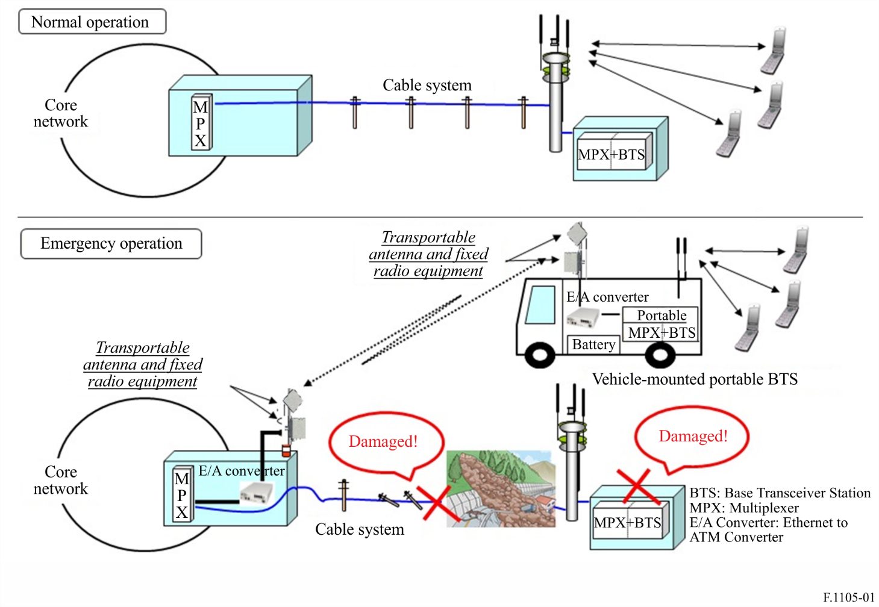

Attachment 3
to Annex 1
Fixed wireless systems for disaster relief operation with a specific mechanism for selection of appropriate frequency channels
FWSs for disaster relief operations use a variety of frequency bands as shown in Table 2 depending on capacity or transmission path distance. Among the systems shown in the Table, the Type C system uses UHF or SHF and transmission path distance is up to 100 km. In this system, both P-P and P-MP topologies are possible and for P-MP topology, one central station can cover up to eight terminal stations. The equipment of this system, which consists of an antenna, a radio frequency unit and an indoor unit, is transportable and easy to mount on a vehicle.
To provide communications in case of widespread disasters which may require communication links with a variety of distances, adaptive modulation and transmission power control mechanisms are adopted. The transmission power control mechanism can also reduce unnecessary interference to other systems and as a result makes it possible to increase the number of emergency centres to be connected. A conceptual diagram of this system is shown in Fig. 2.
TABLE 5
Example of main specifications of FWS for disaster relief operation in Japan
Frequency band | Modulation | Capacity | Topology | Transmission distance
UHF  (417.5-420.0 MHz / 454.9125-457.3625 MHz) | OFDM (QPSK/16QAM/64QAM Adaptive modulation) | 16 channels  1.7 Mbit/s | P-P  P-MP (up to eight terminal stations) | Up to 50 km

Figure 2
Conceptual diagram of the FWS for widespread disasters
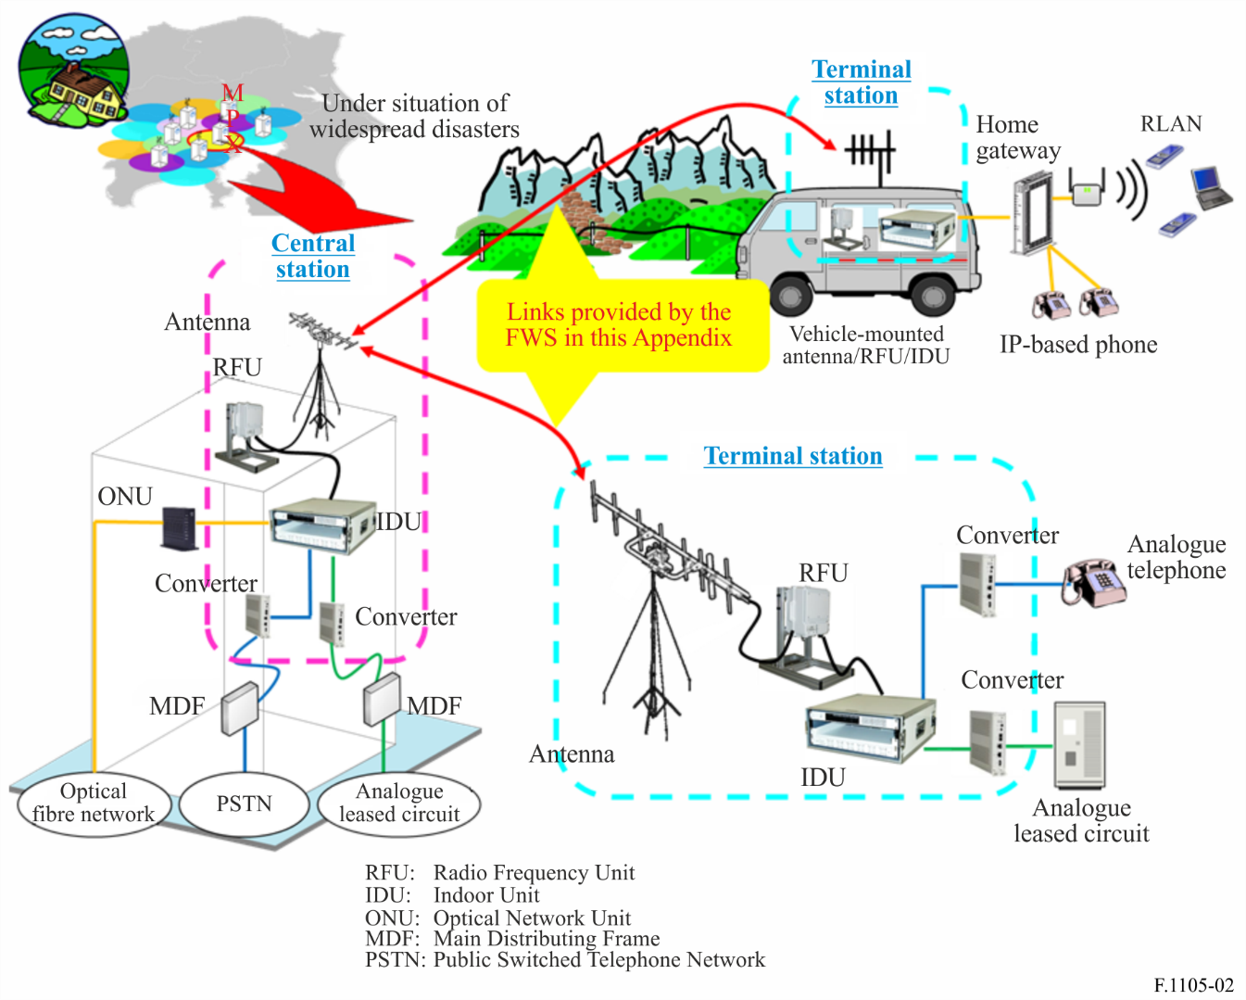
In the case of widespread disasters, there may be a large number of evacuation centres where telephone lines and data communications are urgently required. Usually it is not possible to predict or determine which FS station buildings connected to operator’s networks will survive disasters. For this reason, it is not possible to calculate detailed radio link designs before a widespread disaster occurs. As a result, complex calculations under widespread disaster situations are required to select appropriate transmit and receive frequencies while reducing unnecessary interference to other networks and increasing the number of evacuation centres to be covered with the limited number of frequency channels. Sometimes such calculations will be carried out under situation that there are few or no radio link design experts. For this situation, a specific mechanism has been developed, which has the following functions:
– Selection of an appropriate frequency channel.
– Determination of transmission power of FS stations.
– Determination of antenna directions of FS stations.
– Estimation of throughput between a central station and a terminal station.
This mechanism uses the prediction method in Recommendation ITU-R P.1812 in calculations of propagation loss. Figure 3 shows calculation examples in the Tokyo metropolitan area in Japan. In the figure, circles indicate areas by one central FS station and lines show communication links between a central station and a terminal station. The number of frequency channels is seven and circles of the same colour in Fig. 3 indicate the same transmission and receive frequency channels. According to the results obtained, 25 central stations can cover about 200 evacuation centres with seven transmission/receive frequency channels.
Figure 3
Calculation examples of a specific mechanism for selection of appropriate frequency channels
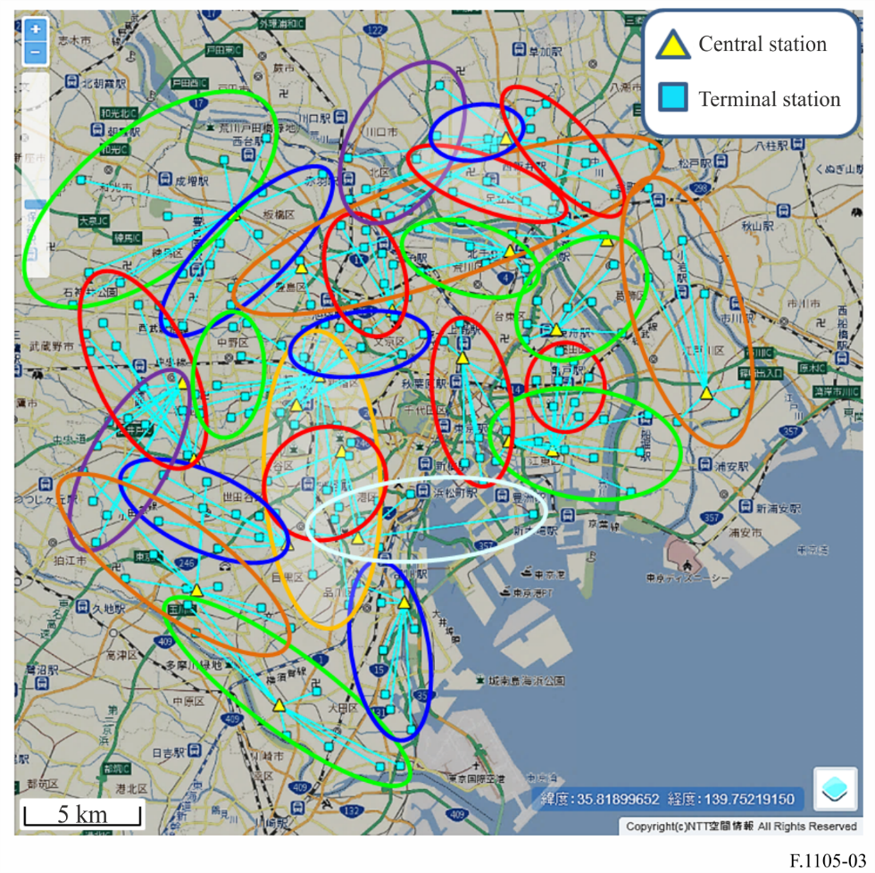

* This Recommendation should be brought to the attention of Telecommunication Development Sector Study Group 2 and relevant ITU-T Study Groups.
Sites where people from the disaster-affected are provisionally living.
http://www.arib.or.jp/english/html/overview/itu/itu-arib_std-t86v1.0_e.pdf.
There is currently no ITU-R Recommendations for FS channel arrangements in the frequency band 454.9125-457.3265 MHz.

