Recommendation ITU-R BT.2153-0
(12/2022)
The use of componentized workflows
for the exchange of non-live
television programmes

BT Series
Broadcasting service (television)

Foreword
The role of the Radiocommunication Sector is to ensure the rational, equitable, efficient and economical use of the radio-frequency spectrum by all radiocommunication services, including satellite services, and carry out studies without limit of frequency range on the basis of which Recommendations are adopted.
The regulatory and policy functions of the Radiocommunication Sector are performed by World and Regional Radiocommunication Conferences and Radiocommunication Assemblies supported by Study Groups.

Policy on Intellectual Property Right (IPR)
ITU-R policy on IPR is described in the Common Patent Policy for ITU-T/ITU-R/ISO/IEC referenced in Resolution ITU-R 1. Forms to be used for the submission of patent statements and licensing declarations by patent holders are available from http://www.itu.int/ITU-R/go/patents/en where the Guidelines for Implementation of the Common Patent Policy for ITU-T/ITU-R/ISO/IEC and the ITU-R patent information database can also be found.

Series of ITU-R Recommendations
(Also available online at http://www.itu.int/publ/R-REC/en)
Series | Title
BO | Satellite delivery
BR | Recording for production, archival and play-out; film for television
BS | Broadcasting service (sound)
BT | Broadcasting service (television)
F | Fixed service
M | Mobile, radiodetermination, amateur and related satellite services
P | Radiowave propagation
RA | Radio astronomy
RS | Remote sensing systems
S | Fixed-satellite service
SA | Space applications and meteorology
SF | Frequency sharing and coordination between fixed-satellite and fixed service systems
SM | Spectrum management
SNG | Satellite news gathering
TF | Time signals and frequency standards emissions
V | Vocabulary and related subjects

Note: This ITU-R Recommendation was approved in English under the procedure detailed in Resolution ITU-R 1.

Electronic Publication
Geneva, 2022

© ITU 2022
All rights reserved. No part of this publication may be reproduced, by any means whatsoever, without written permission of ITU.

RECOMMENDATION ITU-R BT.2153-0
The use of componentized workflows for the exchange
of non-live television programmes
(2022)
Scope
This Recommendation specifies an efficient and flexible approach to accommodate multiple versions of non-live content for programme production and international exchange.
Keywords
Componentized Content, Componentized Workflow, Interoperable Master Format, IMF, International Content Exchange, Global Platform
The ITU Radiocommunication Assembly,
considering
a) that Report ITU-R BT.2400 – Usage scenarios, requirements and technical elements of a global platform, describes scenarios where content in a componentized form can be distributed to a variety of platforms and devices;
b) that due to territorial, regulatory and rights requirements, multiple versions of programmes are often required;
c) that it is desirable that a programme production format is capable of encompassing all audio and text language options, all alternative and extra editorial content, all accessibility options and any static or temporally based data needed to adapt the content to meet the requirements and capabilities of different delivery versions and platforms;
d) that any system able to reduce the need for duplicated storage and processing is desirable to minimise the environmental impact of content exchange for global distribution;
e) that any production workflow technology should enable changes to be made to the content quickly and efficiently at any point before or after exchange (for example, for legal, territorial regulation or local disasters that require changes among others);
f) that content producers demand a high degree of control of the versioning and exchange of their products including any ancillary data associated with the programme,
recognizing
that the Society of Motion Picture and Television Engineers (SMPTE) has defined the Interoperable Master Format (IMF), which is a componentized content format,
recommends
1 that the use of componentized content workflows should be considered for the exchange of finished non-live content between programme makers, distributors and broadcasters;
2 that the parameter rules described in the Annex should be used for componentized workflows.

Annex
Parameter rules for componentized workflows for the exchange
of non-live television programmes

1 Introduction
A componentized content format provides the foundation for business-oriented workflows enabling multiple versions to be extracted from a common set of media essence and data components (audio, video, captions, content related data among others) without the need to store multiple copies of complete programme files. Any system designed for the exchange of finished content should be flexible enough to accommodate a wide range of programme types and technical requirements, both now and in the future. Also, it is important that an exchange system should follow rules that set a framework for interoperability.
The Society of Motion Picture and Television Engineers (SMPTE) has developed such a componentized content format called the Interoperable Master Format (IMF) [1]. This is designed for exchange of finished content components between content owners, content distributors and broadcasters.

2 Normative references
[1] SMPTE ST 2067; Interoperable Master Format (IMF) document suite https://www.smpte.org/standards/st2067.
[2] SMPTE ST 377-1; Material eXchange Format (MFX) – File Format Specification https://ieeexplore.ieee.org/document/8984681.
[3] W3C Recommendation; eXtensible Markup Language (XML) https://www.w3.org/TR/xml/.

3 Definition of componentized content
Componentized content is defined as media that consists of a group or groups of assets (audio, video, captions and others) which can be processed to produce different versions of the media. A component is a discrete audio or video or data element of a programme, which can be the video or audio of the entire programme or a single scene or even a single frame of content.

3.1 Rules for the structure of a componentized exchange format
A componentized system should ideally have two mandatory parameter sets that define the structure and particular use-case scenario rules.
1) A generic parameter set which defines the rules that are mandatory for all applications. The rules apply to the structure of the content package, how the components are named, wrapped and what data files are required to ensure interoperability.
2) A specific parameter set which defines the rules that are mandatory for a particular application of a componentized workflow. The rules define the specific video format, video codec, audio sample frequency and bit depth among others, which are required to ensure interoperability between the content supplier and the recipient based on a content exchange contract.

4 Generic parameter sets
Generic parameters are mandatory and apply to all relevant components. SMPTE IMF mandatory rules that apply to all usage scenarios are defined in the Core Constraint documents.

4.1 File formats
Irrespective of the file type or codec, all audio and video media files are wrapped using the Material eXchange Format (MXF) [2] Generic Container. Time dependant data is described using eXtensible Markup Language (XML) [3] and wrapped using the MXF Generic Container.
The XML is used to describe any static data related to the content material and any processing required for programme exchange.

4.2 Component identification
All components are identified by machine readable Unique IDs (UIDs). The transmission or storage of a component on a file system should not change its identifier unless the contents of the components are modified.
Any filenames and object storage IDs should not be considered permanent and should not be used for identification purposes unless mandated by an underlying standard or required by the Specific Parameter Set for the particular use case.
SMPTE’s IMF adds a human readable prefix to each UID that identifies the content type e.g. VIDEO_UID.MXF.

4.3 Tracks and channels
A track is a representation of a particular group of components that make up a version. Tracks can represent audio, video or time dependent data. A track contains a single set of references to only one homogeneous format of video or audio or data. Figure 1 shows an example of three tracks.
– The video track only references a single video standard (e.g. frame rate image format, colourimetry).
– The audio tracks only reference a single audio format (e.g. sample rate, bit depth). All the channels needed for the audio type are referenced in the track – in the examples below.
• the stereo audio track will reference the two channels (L, R);
• the 5.0 audio track will reference the five audio channels (L, R, C, Ls, Rs).
Figure 1
Tracks and channels
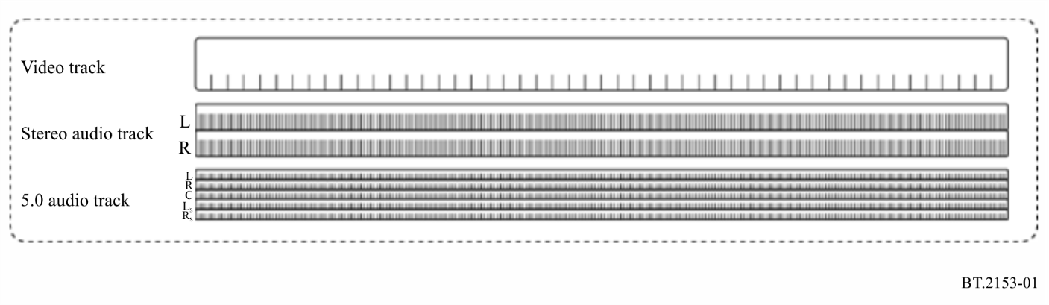
No matter how many audio channels are associated with the audio format used, the track is treated as a single mono container file.
SMPTE IMF defines the structure and treatment of essence track files in the core constraints documents.

4.4 Time representations
Each MXF component uses time intervals based on the smallest unit of time for the essence format,
– for audio components the smallest unit of time is the sample rate;
– for video components the smallest unit of time is the frame rate.
Each separate MXF component starts with a count of zero. The segment or segments of each MXF component used in a version of the content and the location of the component in any version of the finished content, is defined by three separate time counts:
– the time count from the beginning of the component to the start of the segment of the component to be used;
– the time count of the duration of the segment of the component to be used; and
– the time count from the beginning of the finished content version that the segment of the component being used is placed.
Figure 2 shows how two components X and Y are referenced in the timeline of a particular version.
Figure 2
Components timing and positioning
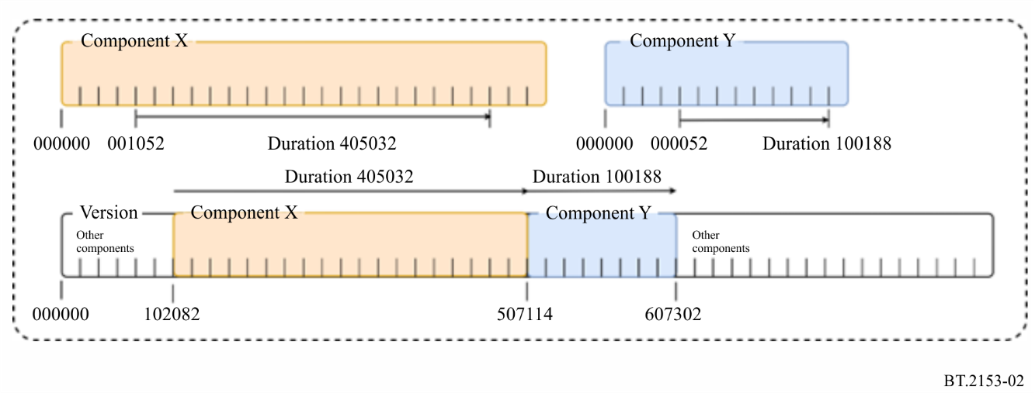
Where time dependent data is wrapped as MXF, the time unit used will depend on the time unit of the essence the data refers to or is used by. Time dependent audio data will be represented by a sample rate count and time dependent video data will be represented by a frame rate count.

4.5 Version creation
In a componentized content system, the version of a programme is a virtual construct which is defined by a playlist. A playlist is an XML instruction set that contains details of which components or segments of components are needed and the order they appear in the final programme version. The Attachment to this Annex gives informative examples of playlists.
In SMPTE IMF this is defined as a Composition Playlist (CPL) in the core constraints.

5 Specific parameter sets
The specific parameter sets define parameters required to describe a specific use case application including:
– video format;
– colour transfer characteristics;
– video compression encoding;
– audio format;
– static and dynamic data requirements;
– optional data file naming conventions among others.
Specific parameters also describe naming conventions for any xml data files unique to the application and if any additional or optional parameter sets or files are required.
Specific parameters sets are defined as ‘Applications’ in SMPTE’s IMF documents, where each scenario describes the mandatory requirements and constraints based on the core constraint rules.

Attachment
to the Annex
(informative)
Details and examples of playlists
To assist in understanding how a componentized workflow can be used to create multiple versions from a single package, this attachment provides a simplified overview of a componentized content workflow relevant to this Recommendation. Annex 2 to Report ITU-R BT.2400 provides an in-depth explanation of component content creation and exchange.

1 Componentized content packaging
The following Figures illustrate how a package of mxf components and xml data files capable of creating multiple technical and editorial versions of a programme can be exchanged or stored pending further processing.
These packages are in effect virtual containers where the physical location of each component is determined by the content owner’s media asset management (MAM) system. There is no preferred method for exchanging the package which could be zipped or sent via media exchange protocols or pulled by the recipient from access-controlled cloud-based services.
Figure 3
Componentized content virtual package – IMP
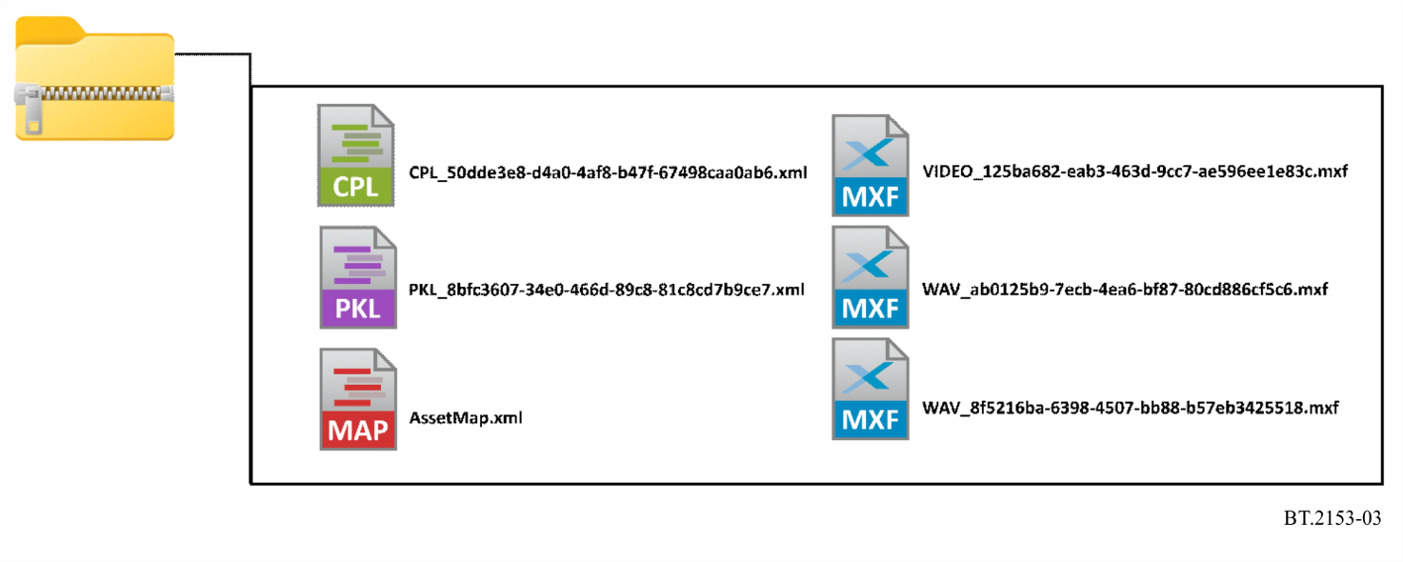
Figure 3 is an example of the content of zipped package. In addition to the audio and video MXF file and the CLP XML file, the package also contains an Asset Map XML file which relates the UIDs with file paths and a Packing List XML file which references all the files in the package.
This example is based on an SMPTE IMF Interoperable Master Package (IMP) shown in Fig. 4, which contains a selection of MXF and XML media and data files. The IMP contains three CPL files which are used to create three different versions of the programme by calling for and arranging the individual components as needed.
Figure 4
Componentized content virtual package – IMP
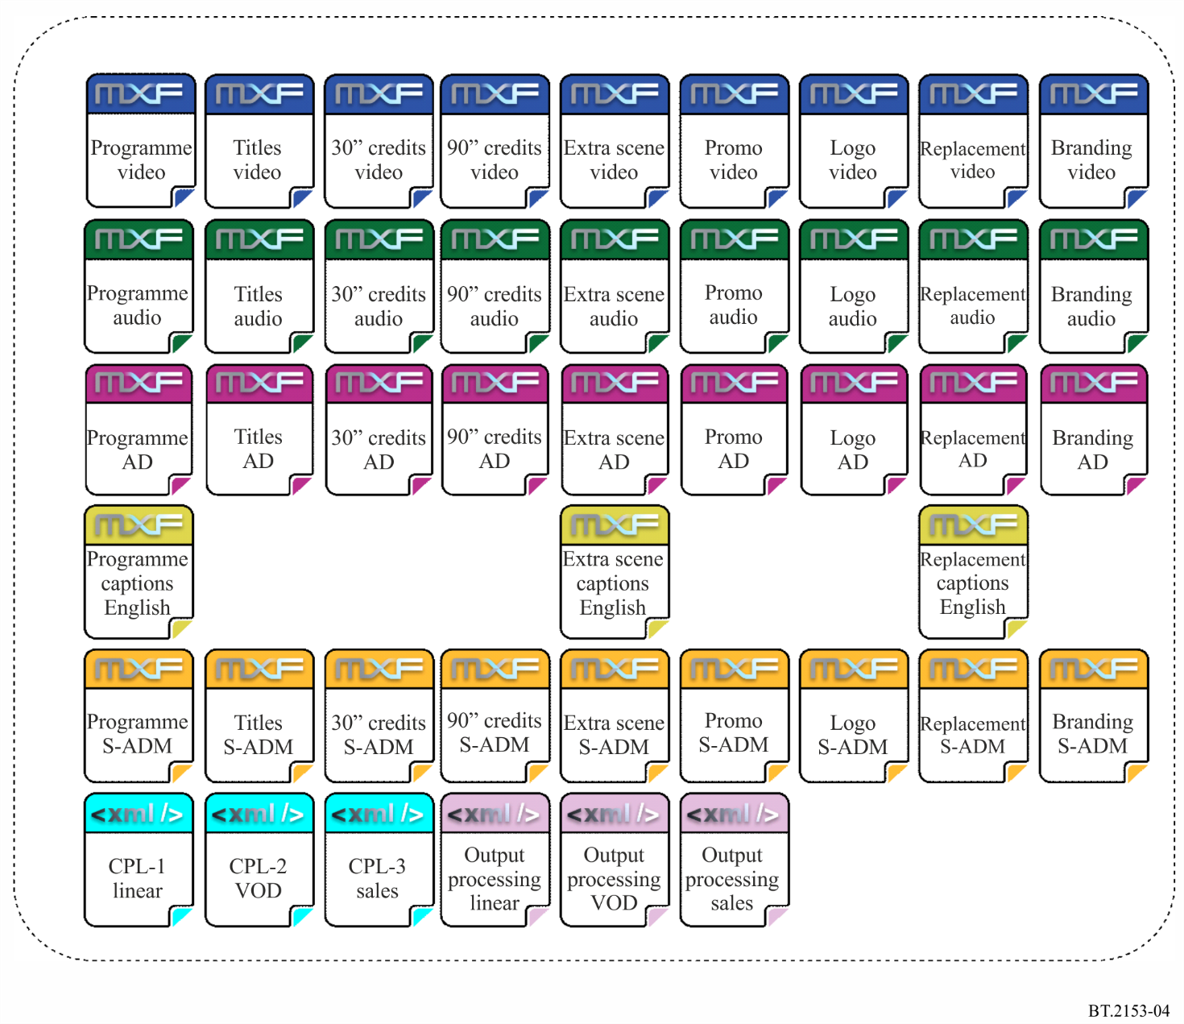
The video content in this example is UHD as described in ITU-R BT.2100 HLG, 3 840 × 2 160 at 50 progressive frames a second. The audio is a multi-channel audio mix with Serial Audio Definition Model (S-ADM) metadata as described in Recommendation ITU-R BS.2125 and a stereo audio description pre-mix.

2 Composition playlist
The example content package contains three CPL which define the components required for three versions. In this example the three versions will be for:
1) a broadcaster’s linear channel play-out and archive services (CPL1);
2) a broadcaster’s or distributor’s video on-demand service (CPL2);
3) international exchange to a specific co-producer or purchaser (CPL3).
Figure 5 shows the processing path of the content owner if exchanging flattened file versions or the content recipient if receiving a componentized package. Here, the play list is linked to an interoperable media package and the broadcaster’s or distributor’s MAM system.
Figure 5
Example output processing
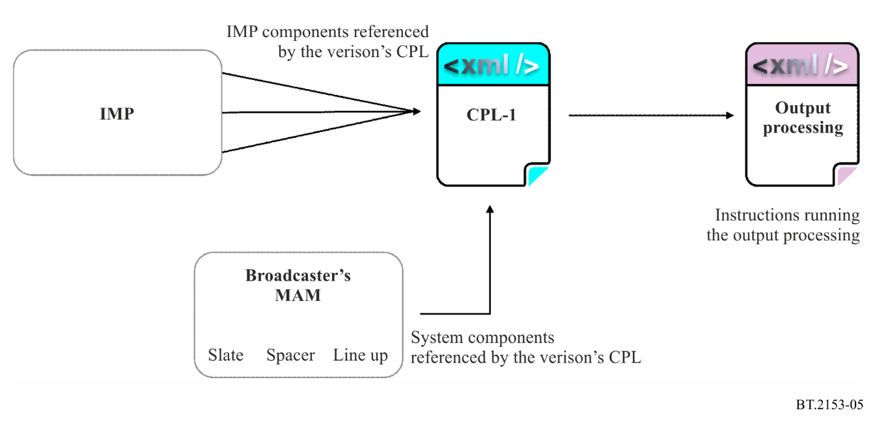

3 Output processing assumptions
The output processing of the content is not described in this Recommendation or informative examples. Processing to produce flattened play-out files, on-demand or international exchange versions is assumed to be specified by the content owner or distributor or broadcaster.
Output processing can include image format conversion, frame rate conversion, HDR format mapping, HDR to SDR down mapping, multi-channel audio down mixing, transcoding and others, as well as organize the different editorial and file layout versions for the targeted delivery options.

4 CPL 1 – Linear play-out version
Supplies the linear play-out and archive services example (see Fig. 6) and requires the following:
– Video; ITU-R BT.709 HD 1 920 × 1 080 at 25i frames per second
– Audio; stereo English
– Video test signal; 20 seconds 100/0/100/0 colour bars
– Audio test signal; 20 seconds EBU Tech 3304 two channel audio identification
– Slate; count down from –10 to –3 (seven seconds mute)
– Spacer; active black level and silence from –3 to first frame of programme
– End credits; 30 seconds maximum hold last credit for five seconds
– Tail; active black and silence for 10 seconds
– First frame of programme; 01:00:00:00 timecode.
Figure 6
CPL 1 Linear play-out version
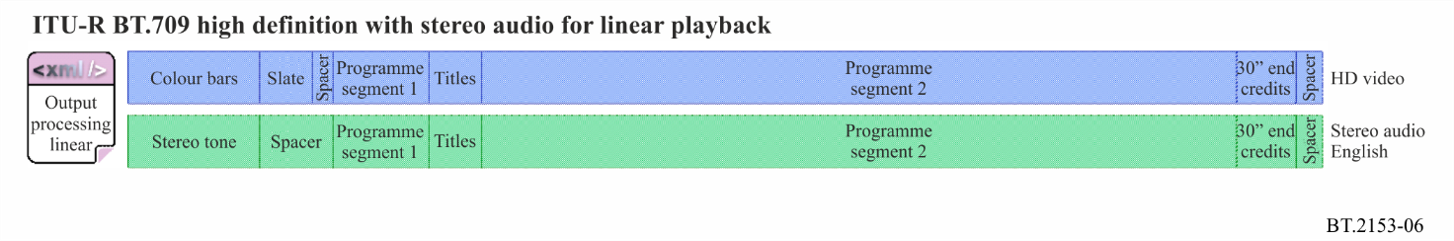
In this case, the CPL references the components in the order required for the linear play-out version. These are then sent to the output processing stage. This can either be carried out by the content owner before sending to the broadcaster or by the broadcaster if they have access to the IMP. The output processing converts the video to ITU-R BT.709 HD, transcoding it to the play-out codec and uses the provided audio data to generate a down mix of the multi-channel audio to stereo. The audio and video are combined into a flat file with traditional timecode starting at 00:59:30:00.

5 CPL 2 – Video on demand version
Supplies an on-demand version (see Fig. 7) – this version contains an extra scene:
– Video; ITU-R BT.2100 UHD HLG 3 840 × 2 160 at 50 frames per second
– Audio 1; stereo English main
– Audio 2; advance audio mix
– Audio 3; Stereo audio description
– End credits; 90 seconds maximum hold last credit for five seconds
– Logo; top and tail five second logo with stereo, advanced audio and AD
– Promo; 30 second trailer with stereo, advanced audio and AD
– Spacers; active black and silence for 1second between each segment and at the end
– File count start; 00 frames
– Chapter markers; only for opening title and 10 seconds after the start of end credit.
Figure 7
CPL 2 Video on demand version
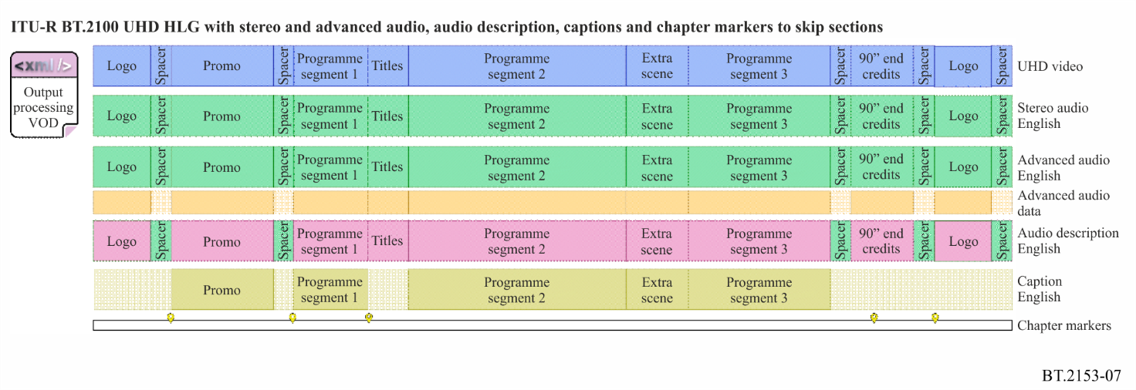
In this case, the CPL references the components in the order required for the VOD version. These are then sent to the output processing stage. This can either be carried out by the content owner before sending to the VOD distributor or by the VOD distributor if they have access to the IMP. No processing is required for the video components before sending to the VOD processing chain as the requirement is the same as the original IMP format. The audio output processing chain uses the provided data to generate a down mix of the multi-channel audio to stereo. The video, stereo audio, multichannel audio with its data track, the audio description audio, the captions and the chapter markers are then presented to the distributors VOD processing chain.

6 CPL 3 – International sales version
Supplies a sales version (see Fig. 8) – this version has a and extra scene and a replacement scene due to rights clearance issues:
– Video; ITU-R BT.2100 UHD PQ 3 840 × 2 160 at 50 frames per second
– Audio 1; advanced audio mix English
– Audio 2; advance audio mix with no dialogue
– Video test signal; 10 seconds ITU-R BT.2111 PQ narrow range colour bars
– Audio test signal; 10 seconds
– Branding; company branding promotion
– Promo; 30 second trailer with stereo, advanced audio and AD
– End credits; 90 seconds maximum hold last credit for five seconds
– Logo; top and tail five second logo with stereo, advanced audio and AD
– Spacers; active black and silence for 1second between each segment and at the end
– File count start; 00 frames
– Skip markers; promo, opening titles and 5 seconds after start of end credits.
Figure 8
CPL 3 International sales version
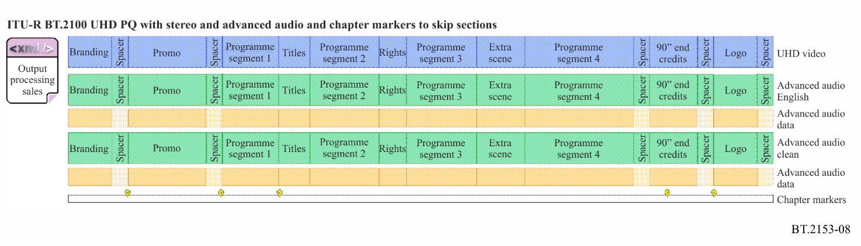
In this case, all processing is usually carried out by the content owner. The CPL references the video components required for the international sales version. These are sent to the output processing stage which only remaps the HLG video components into PQ. The output processing then repackages the required audio, remapped video and data components into a new IMP and generates a new CPL for the sales version. All the required components files are then simply sent to the recipient who will use the new CPL in their own processing chain to generate their output technical and editorial version.
In this example, if the recipient required HLG HDR video, no video processing would be needed and the original components would just be referenced to be repackaged into a new IMP.

7 Supplemental packages
Supplemental packages can be used to supply additional material or replacement material if a change to the content is required after a package has been exchanged. Using a componentized content system only the new or replacement content with a new content play list need be sent to update the original versions. This is especially efficient if the new or replacement media has to be applied to multiple versions sent to many recipients. The supplemental package sent to each recipient need only contain the relevant components and the CPL or CPLs needed to create the corrected version or versions of the content they have the rights to reproduce.
Figure 9 shows a supplemental package with the corrected segments that are to be applied to any of the examples described in Figs 6, 7 and 8 above.
Figure 9
Supplemental exchange package
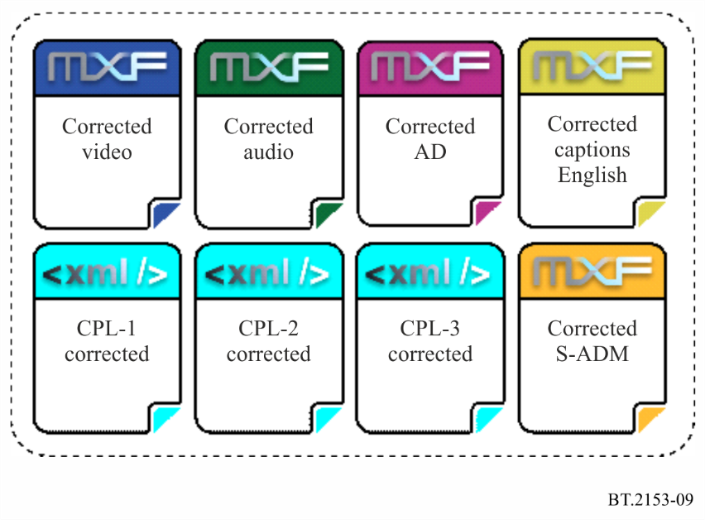

8 Linear play-out corrected version
Figure 10 shows the supplemental IMP for the specific update to the linear play-out version of the content (CPL-1) and the timeline after the correction has been applied.
Figure 10
CPL 1 Linear play-out corrected version
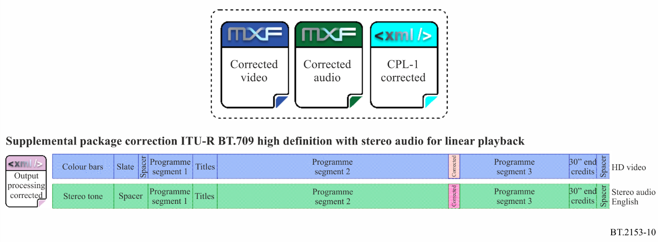

9 Video on demand corrected version
Figure 11 shows the supplemental IMP for the specific update to the video on demand version of the content (CPL-2) and the timeline after the correction has been applied.
Figure 11
CPL 2 Video on demand corrected version
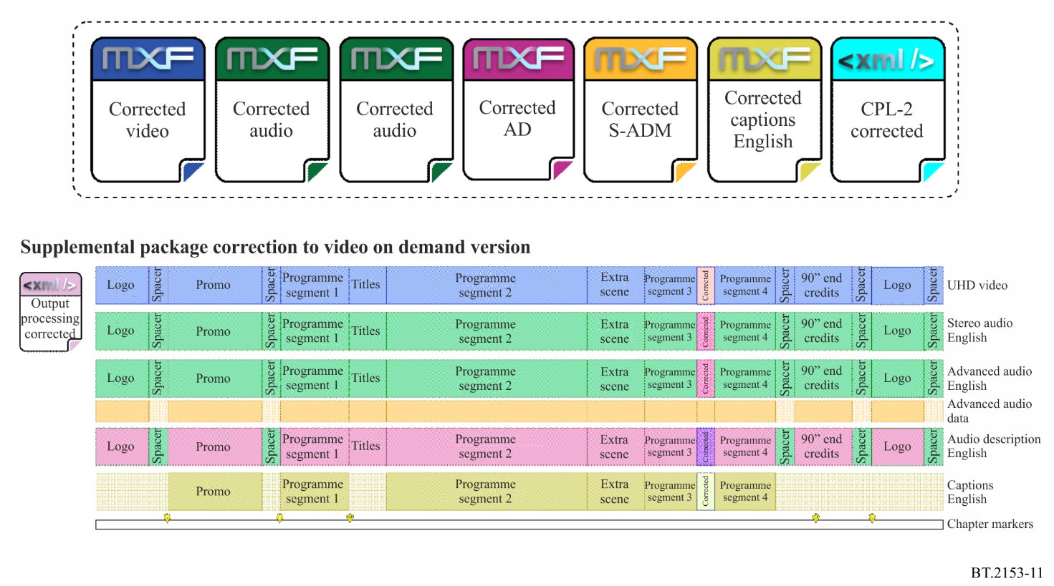

10 International sales corrected version
Figure 12 shows the supplemental IMP for the specific update to the international sales version of the content (CPL-3) and the timeline after the correction has been applied.
Figure 12
CPL 3 International sales corrected version
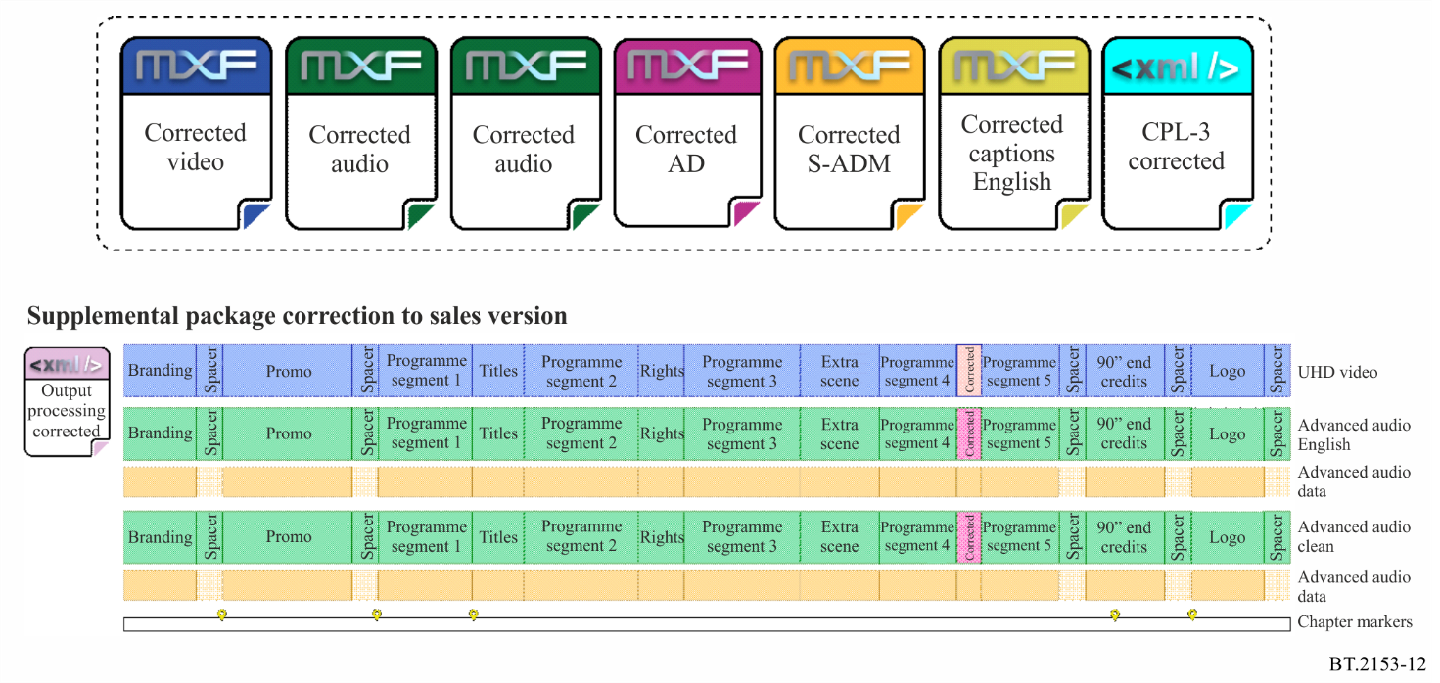

11 Example SMPTE XSD
As part of the SMPTE IMF initiative, examples files are available at https://smpte-ra.org/ns
A specific Application CPL XSD is available at https://smpte-ra.org/sites/default/files/st2067-3a-2016.xsd

