Recommendation ITU-R BT.2073-1
(12/2020)
Use of high efficiency video coding
for UHDTV and HDTV broadcasting

BT Series
Broadcasting service
(television)

Foreword
The role of the Radiocommunication Sector is to ensure the rational, equitable, efficient and economical use of the radio-frequency spectrum by all radiocommunication services, including satellite services, and carry out studies without limit of frequency range on the basis of which Recommendations are adopted.
The regulatory and policy functions of the Radiocommunication Sector are performed by World and Regional Radiocommunication Conferences and Radiocommunication Assemblies supported by Study Groups.

Policy on Intellectual Property Right (IPR)
ITU-R policy on IPR is described in the Common Patent Policy for ITU-T/ITU-R/ISO/IEC referenced in Resolution ITU-R 1. Forms to be used for the submission of patent statements and licensing declarations by patent holders are available from http://www.itu.int/ITU-R/go/patents/en where the Guidelines for Implementation of the Common Patent Policy for ITU-T/ITU-R/ISO/IEC and the ITU-R patent information database can also be found.

Series of ITU-R Recommendations
(Also available online at http://www.itu.int/publ/R-REC/en)
Series | Title
BO | Satellite delivery
BR | Recording for production, archival and play-out; film for television
BS | Broadcasting service (sound)
BT | Broadcasting service (television)
F | Fixed service
M | Mobile, radiodetermination, amateur and related satellite services
P | Radiowave propagation
RA | Radio astronomy
RS | Remote sensing systems
S | Fixed-satellite service
SA | Space applications and meteorology
SF | Frequency sharing and coordination between fixed-satellite and fixed service systems
SM | Spectrum management
SNG | Satellite news gathering
TF | Time signals and frequency standards emissions
V | Vocabulary and related subjects

Note: This ITU-R Recommendation was approved in English under the procedure detailed in Resolution ITU-R 1.

Electronic Publication
Geneva, 2020

© ITU 2020
All rights reserved. No part of this publication may be reproduced, by any means whatsoever, without written permission of ITU.

RECOMMENDATION ITU-R BT.2073-1
Use of high efficiency video coding
for UHDTV and HDTV broadcasting
(2015-2020)
Scope
This Recommendation specifies the use of the high efficiency video coding (HEVC) standard as per Recommendation ITU-T H.265 | ISO/IEC 23008-2 for ultra high definition television (UHDTV) and high definition television (HDTV) broadcasting including high-dynamic range television (HDR-TV).
Keywords
UHDTV, HDR-TV, HDTV, Sub layered coding, parallel coding sub bit stream
The ITU Radiocommunication Assembly,
considering
a) that there are applications where UHDTV, HDR-TV and HDTV programme material is desired to be transported at a highly reduced bit rates with minimal visible degradation in quality;
b) that Recommendation ITU-R BT.2020 specifies the parameters for a family of UHDTV video formats;
c) that Recommendation ITU-R BT.2100 specifies the parameters for HDR-TV video formats;
d) that Recommendation ITU-R BT.709 specifies the parameters for a family of HDTV video formats;
e) that Recommendation ITU-T H.265 | ISO/IEC 23008-2 specifies the high efficiency video coding (HEVC) standard that enables significantly improved compression performance relative to former standards;
f) that HEVC is increasingly adopted for various applications including broadcasting,
recommends
1 that when it is necessary to transport UHDTV, HDR-TV and HDTV programme material at a highly reduced bit rate for broadcasting, the high efficiency video coding (HEVC) standard specified in Recommendation ITU-T H.265 | ISO/IEC 23008-2 should be used.
NOTE 1 – Annex 1 shows basic parameters for UHDTV and HDTV broadcasting including HDR-TV using the HEVC standard.
NOTE 2 – Annex 2 shows a preferred coding scheme for temporal sub-layer coding of UHDTV at 120 or 100 Hz frame frequency using the HEVC standard.
NOTE 3 – Annex 3 shows a preferred coding scheme for interlaced video using the HEVC standard.
NOTE 4 – Annex 4 shows a preferred parallel coding scheme for the 7 680 × 4 320 format of UHDTV using the HEVC standard.
Abbreviations
CVS Coded Video Sequence
DTS Decoding Time Stamp
GOP Group of Pictures
HDR High Dynamic Range
IRAP Intra Random Access Point
PTS Presentation Time Stamp
SEI Supplemental Enhancement Information

Annex 1
Basic parameters for UHDTV and HDTV broadcasting including HDR-TV
using the HEVC standard
This Annex shows basic parameters for UHDTV and HDTV broadcasting using the HEVC standard.
TABLE 1⁽⁴⁾
Basic parameters for UHDTV and HDTV broadcasting using the HEVC standard
Video format |  | Level | Profile | Tier | Maximum bit rate for broadcasting emission ⁽³⁾  (Mbit/s)
Spatial resolution | Frame frequency (Hz)
7 680 × 4 320 | 120*, 100 ⁽¹⁾ | 6.2 | Main 10 | Main | 90-120
 | 60*, 50 | 6.1 | Main 10 | Main | 80-100
3 840 × 2 160 | 120*, 100 ⁽¹⁾ | 5.2 | Main 10 | Main | 35-50
 | 60*, 50 | 5.1 | Main 10 | Main | 30-40
1 920 × 1 080 | 60*, 50 | 4.1 | Main 10 or Main | Main | 10-15
 | 30*, 25 (interlaced) | 4.1 ⁽²⁾ | Main 10 or Main | Main | 10-15
* Those divided by 1.001 are also included.
⁽¹⁾ The use of temporal sub-layer coding is detailed in Annex 2.
⁽²⁾ To allow coding at a sufficient bit rate as needed, level 4.1 (the maximum bit rate is 20 Mbit/s) is preferred to level 4 (the maximum bit rate is 12 Mbit/s).
⁽³⁾ The indicated data rates are maximum values for constant data rate transport for critical test sequences to be rated sufficiently high quality for broadcast emission when assessed by experts. Lower data rates may be used for less critical pictures.
⁽⁴⁾ Video parameters of HDR-TV, including colour primaries and transfer characteristics, can be signalled using the VUI (video usability information) specified in Annex E of ITU T H.265 | ISO/IEC 23008-2.

Annex 2
Preferred coding scheme for temporal sub-layer coding for UHDTV at 120 or 100 Hz frame frequency using the HEVC standard
This Annex shows a preferred coding scheme to achieve temporal sub-layer coding for UHDTV at 120 or 100 Hz frame frequency using the HEVC standard.
Introduction
The purpose of this preferred coding scheme is to enable a decoder with the decoding capability of Level 6.1 (or 5.1) bitstream for 60 or 50 Hz video to correctly decode the 60 or 50 Hz portion of a Level 6.2 (or 5.2) bitstream for 120 or 100 Hz video. Such decoding capability is realized by temporal sub-layer coding specified in the HEVC standard.
To maximize the adaptability of a Level 6.1 (or 5.1) decoder to a Level 6.2 (or 5.2) temporal sub-layer coding bitstream, a further constraint on decoding order is introduced in such a way that the DTS/PTS value of an access unit in Level 6.1 (or 5.1) sub-bitstream can be applied both to Level 6.2 (or 5.2) bitstream decoding and Level 6.1 (or 5.1) sub-bitstream decoding.
Temporal sub-layer coding
Every second frame of a 120 or 100 Hz video is encoded into an access unit of a sub-bitstream. All the other frames of the 120 or 100 Hz video are encoded into access units in a subset.
A Level 6.1 (or 5.1) decoder decodes the sub-bitstream and outputs decoded frames with the frame frequency of 60 or 50 Hz.
A Level 6.2 (or 5.2) decoder decodes both the sub-bitstream and the subset and outputs decoded frames with the frame frequency of 120 Hz.
Constraint on decoding order
It is mandated that the decoding order of each access unit in the sub-bitstream and each access unit in the subset shall be interleaved. That is, an access unit in the sub-bitstream is decoded immediately after an access unit in the subset, and vice versa.
Figure 1 shows an example of the decoding order of an access unit in a Level 6.2 (or 5.2) temporal sub-layer coding bitstream. It is noted that there is no need to overwrite the values of au_cpb_removal_delay_minus1 and pic_dpb_output_delay of an access unit in the sub-bitstream for decoding the sub-bitstream in a Level 6.1 (or 5.1) decoder. That is, a nested picture timing SEI message is not needed.
FIGURE 1
Constraint on decoding order for temporal sub-layer coding bitstream
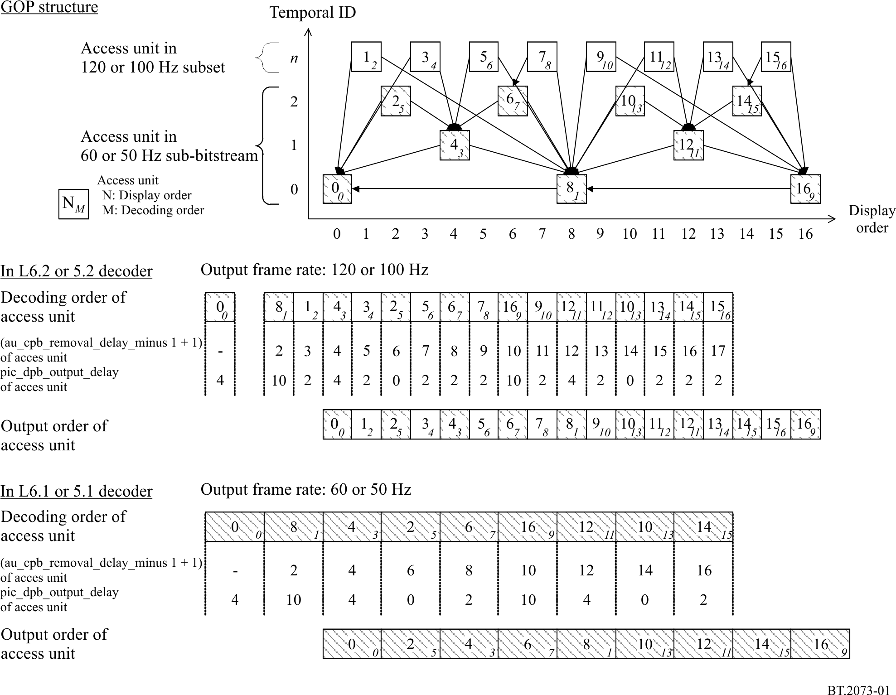

Annex 3
(informative)
Preferred coding scheme for interlaced video using the HEVC standard
This Annex shows a preferred coding scheme for interlaced video using the HEVC standard.
Introduction
The preferred coding scheme in this Annex utilizes the coding capability for interlaced video of the HEVC standard. That is, either frame-based coding or field-based coding is used in each CVS. If a CVS is encoded by field-based coding (i.e. field_seq_flag equal to 1), constraints described below are imposed. Otherwise, if a CVS is encoded by frame-based coding (i.e. field_seq_flag is equal to 0), no further constraints are imposed.
Constraint on GOP structure
It is mandated that the first and second field pictures shall be encoded successively if the two fields are contained in the same frame. Figure 2 shows an example of the GOP structure according to the constraint of this Annex. It is noted that any field in a frame can refer to any previously decoded fields in other frames.
FIGURE 2
Constraint on GOP structure in field-based coding
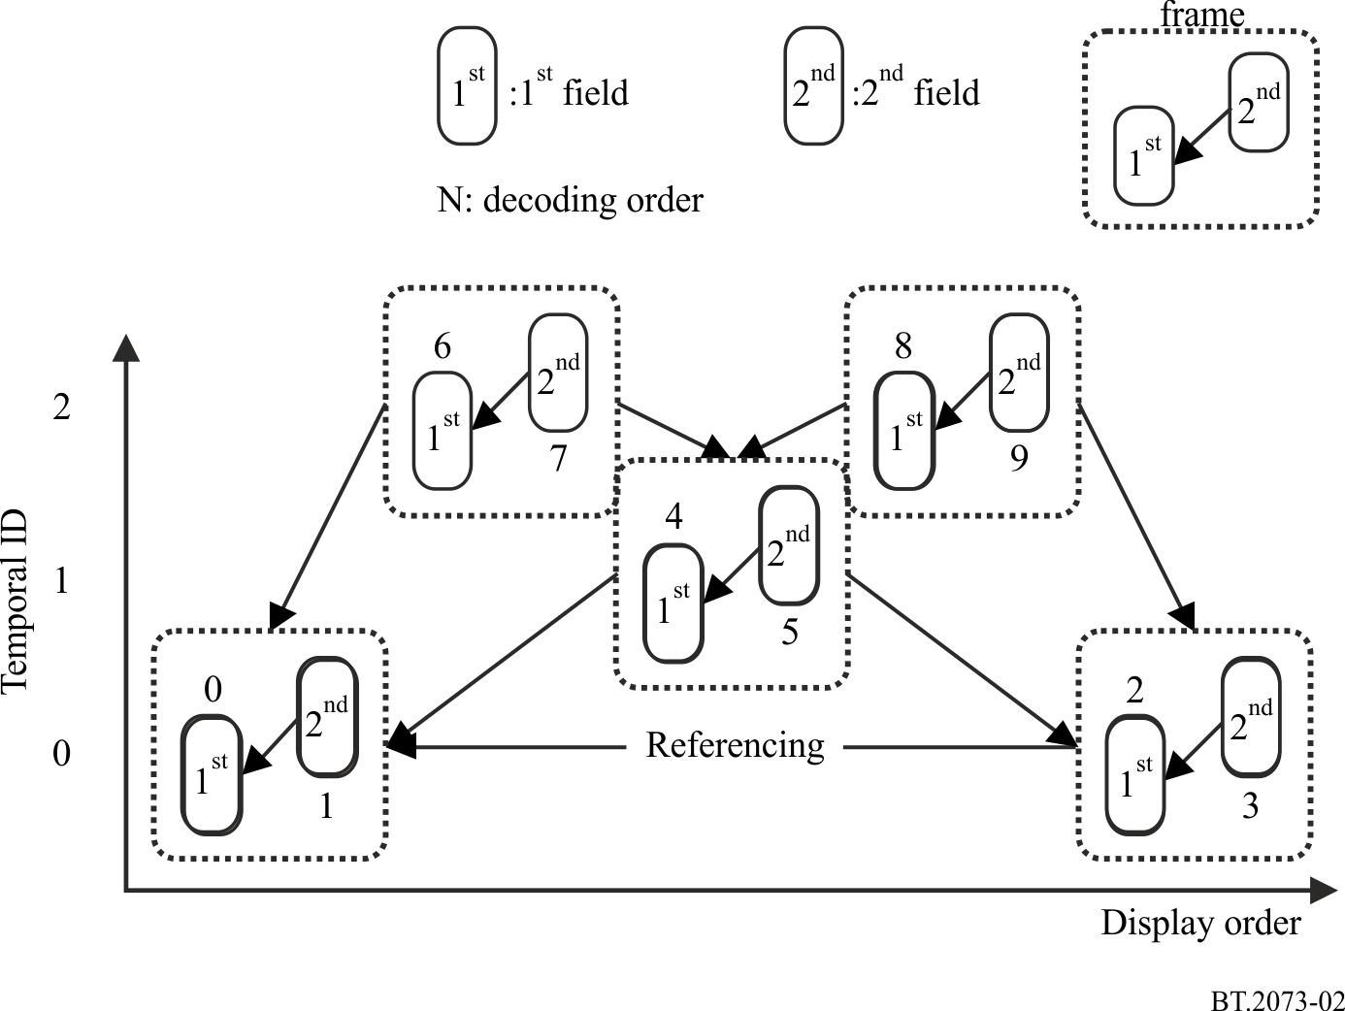
Constraint on IRAP access unit
Since the HEVC standard does not allow encoding a trailing picture access unit before any leading picture access unit that has an earlier display order than the trailing picture access unit, the following constraint is imposed to satisfy the constraint on the GOP structure described above.
When a leading picture access unit appears in a bitstream, an IRAP picture access unit shall appear only at the beginning of a CVS.
To have frequent random access points, multiple access units associated with a recovery point SEI message may be present in a CVS. In this case, it is encouraged to encode a CVS in such a way that recovery_poc_cnt and exact_match_flag of the recovery point SEI message can be set equal to 0 and 1, respectively.

Annex 4
(informative)
Preferred parallel coding scheme for the 7 680 × 4 320 format
of UHDTV using the HEVC standard
This Annex shows a preferred parallel coding scheme for the 7 680 × 4 320 format of UHDTV using the HEVC standard.
Introduction
Considering the latest technology trends in the broadcasting industry, it is strongly hoped that real-time HEVC decoder of 4K video will be implemented on a single-chip LSI in a short period. On the other hand, it is envisaged that it will take another 5-10 years to realize a single-chip LSI that can decode 8K video in real-time. Therefore the structure of an HEVC bitstream of 8K video shall be defined so that it can be decoded by using multiple 4K HEVC LSIs.
This preferred coding scheme for 8K video adopts a parallel coding scheme. An 8K picture is equally partitioned into four sub-pictures. To minimize the loss in coding efficiency caused by the partitioning, sharing reference pictures among sub-pictures and enabling in-loop filters at the boundary of sub-pictures are mandated.
Sub-picture partitioning
An 8K picture is partitioned into four sub-pictures. Each sub-picture is encoded by each processing core as an independent slice segment with the parameters shown in Fig. 3. Each slice segment may be further portioned into multiple slices.
FIGURE 3
Partitioning scheme of 8K picture into four sub-pictures
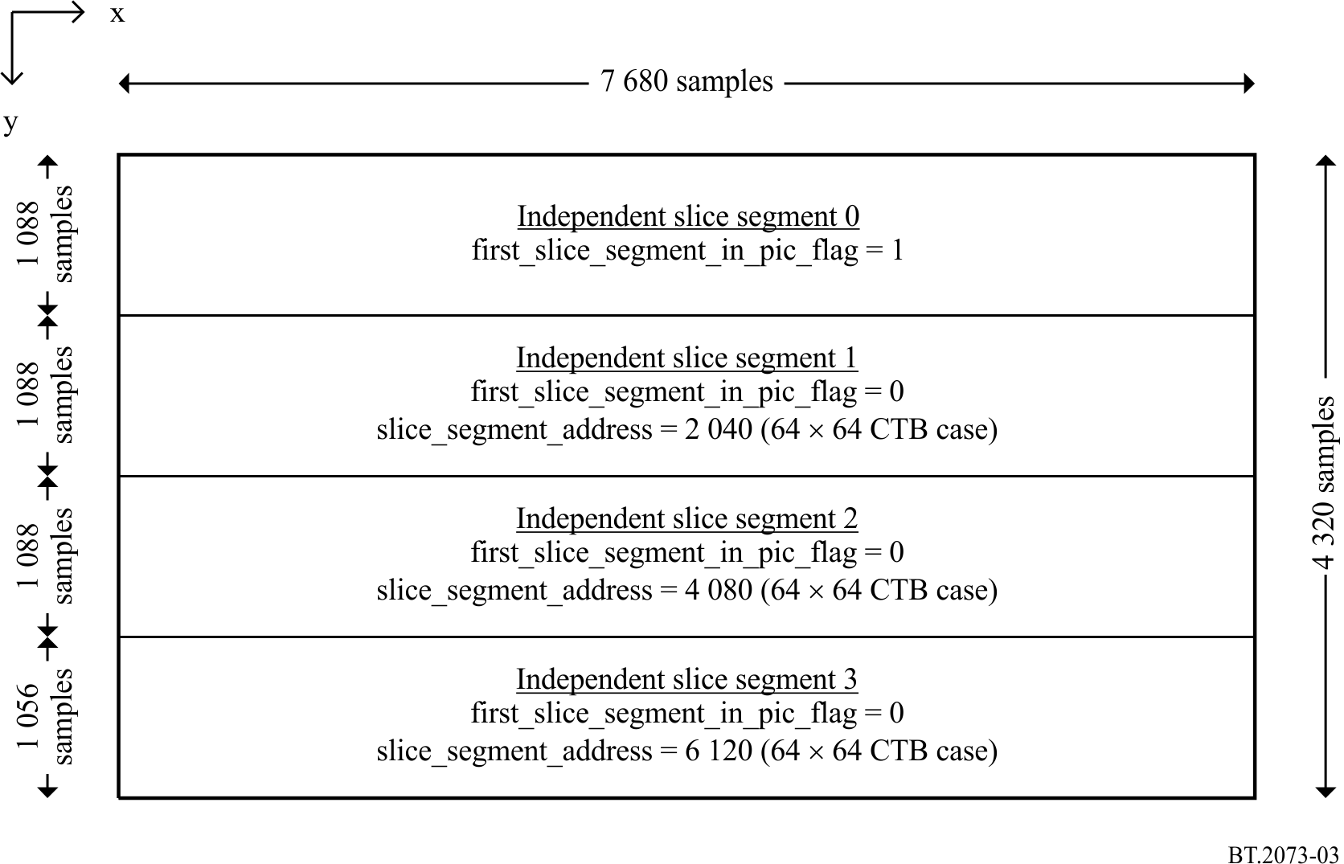
Constraints on parameters
The constraints on parameters in Table 2 are applied.
TABLE 2
Constrains on parameters for slice-based sub-picture partitioning
Parameter | Constraint
pic_width_in_luma_samples | 7 680
pic_height_in_luma_samples | 4 320
first_slice_segment_in_pic_flag  slice_segment_address | Values shown in Fig. 3
pps_loop_filter_across_slices_enabled_flag  slice_loop_filter_across_slices_enabled_flag | 1
tiles_enabled_flag | 0  NOTE – Tile-based partition is not recommended since the vertical partitioning of tile causes significant loss in coding efficiency at typical scenes in programmes that have a large horizontal motion when each processing core shares a limited amount of reference samples for motion compensation.
The range of the vertical component of a motion vector that crosses a slice boundary | It shall be constrained in such a way that any prediction block in an independent slice segment does not refer to samples in a different independent slice segment whose vertical position relative to the boundary of two independent slices is outside the range of (−128, 128) for a luma sample and (−64, 64) for a chroma sample (in the case of 4:2:0 chroma subsampling).  See Fig. 4 for detailed explanation  NOTE – This constraint is introduced to reduce additional bandwidth between processing cores while maintaining coding efficiency at typical scenes in programmes.
FIGURE 4
Constraints on motion vectors crossing the slice boundary
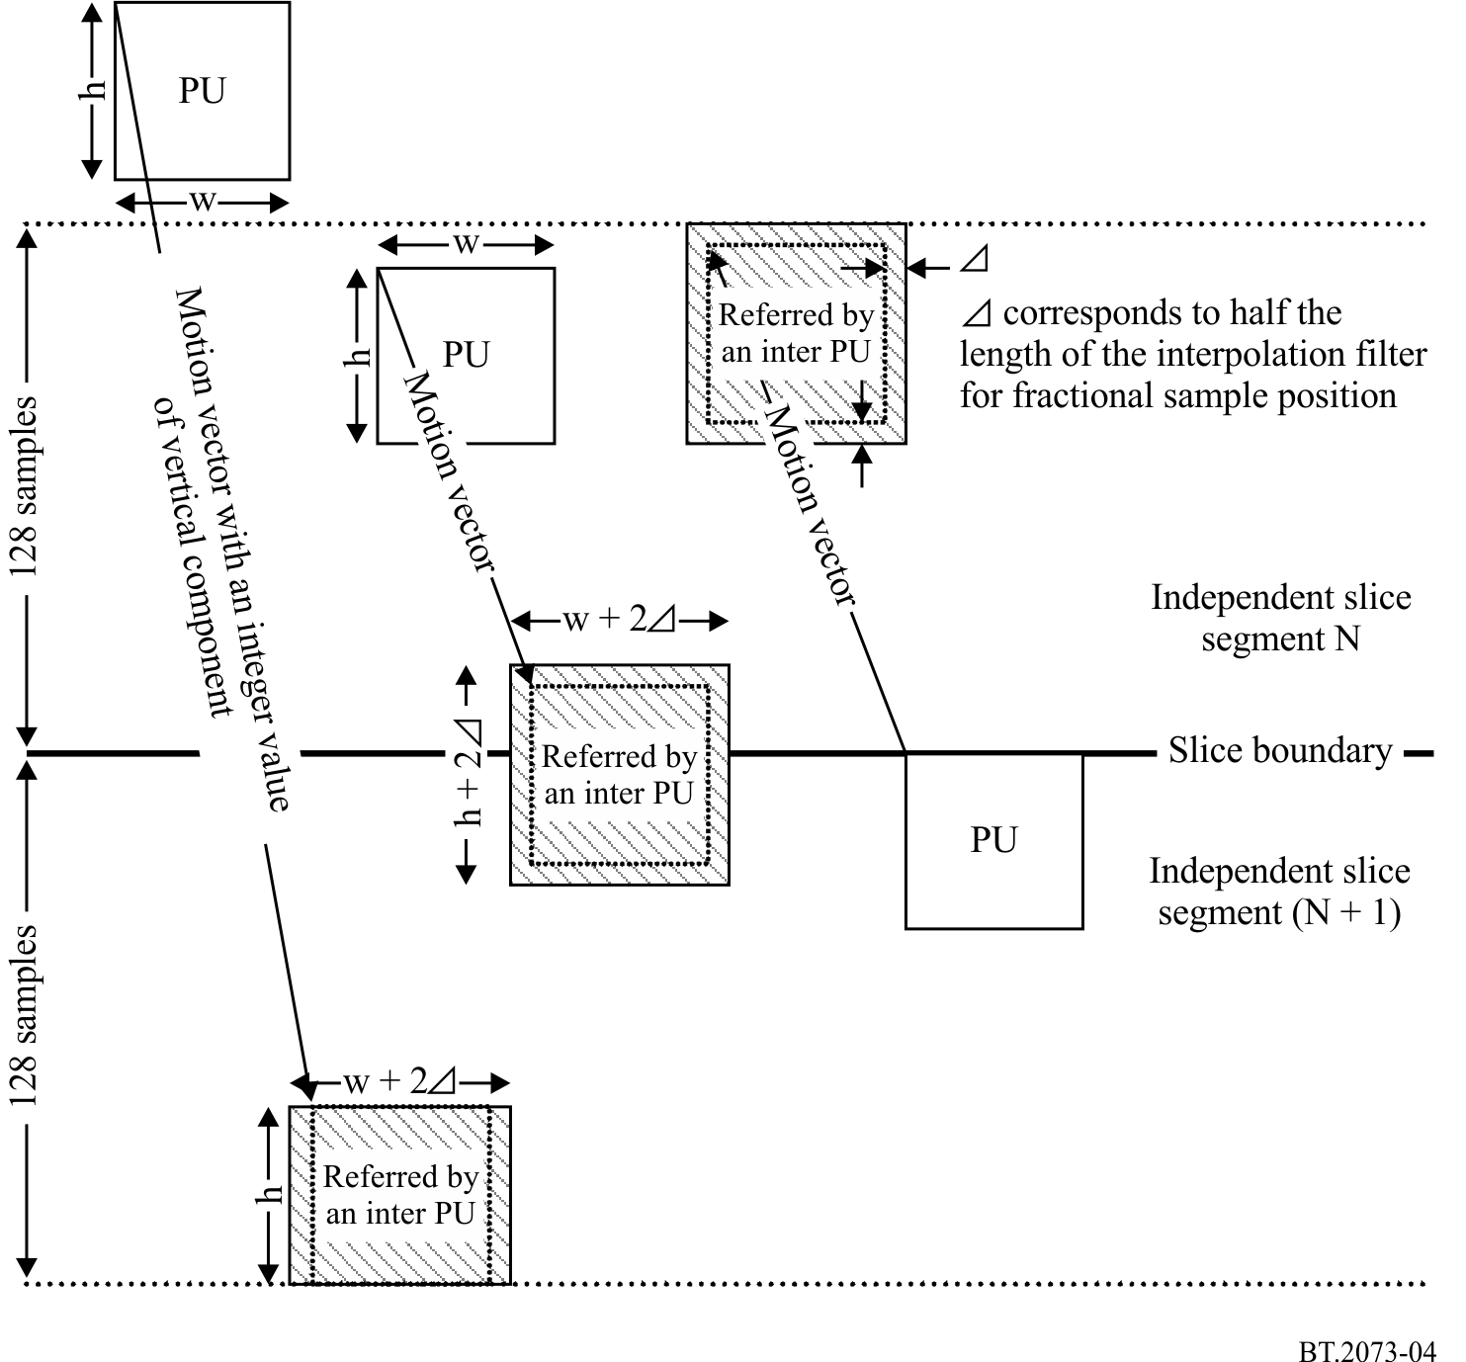

Also includes 120/1.001.

