Recommendation ITU-R BT.2036-4
(06/2021)
Characteristics of a reference receiving system for frequency planning of digital terrestrial television systems

BT Series
Broadcasting service
(television)

Foreword
The role of the Radiocommunication Sector is to ensure the rational, equitable, efficient and economical use of the radio-frequency spectrum by all radiocommunication services, including satellite services, and carry out studies without limit of frequency range on the basis of which Recommendations are adopted.
The regulatory and policy functions of the Radiocommunication Sector are performed by World and Regional Radiocommunication Conferences and Radiocommunication Assemblies supported by Study Groups.

Policy on Intellectual Property Right (IPR)
ITU-R policy on IPR is described in the Common Patent Policy for ITU-T/ITU-R/ISO/IEC referenced in Resolution ITU-R 1. Forms to be used for the submission of patent statements and licensing declarations by patent holders are available from http://www.itu.int/ITU-R/go/patents/en where the Guidelines for Implementation of the Common Patent Policy for ITU-T/ITU-R/ISO/IEC and the ITU-R patent information database can also be found.

Series of ITU-R Recommendations
(Also available online at http://www.itu.int/publ/R-REC/en)
Series | Title
BO | Satellite delivery
BR | Recording for production, archival and play-out; film for television
BS | Broadcasting service (sound)
BT | Broadcasting service (television)
F | Fixed service
M | Mobile, radiodetermination, amateur and related satellite services
P | Radiowave propagation
RA | Radio astronomy
RS | Remote sensing systems
S | Fixed-satellite service
SA | Space applications and meteorology
SF | Frequency sharing and coordination between fixed-satellite and fixed service systems
SM | Spectrum management
SNG | Satellite news gathering
TF | Time signals and frequency standards emissions
V | Vocabulary and related subjects

Note: This ITU-R Recommendation was approved in English under the procedure detailed in Resolution ITU-R 1.

Electronic Publication
Geneva, 2021

© ITU 2021
All rights reserved. No part of this publication may be reproduced, by any means whatsoever, without written permission of ITU.

RECOMMENDATION ITU-R BT.2036-4
Characteristics of a reference receiving system for frequency
planning of digital terrestrial television systems
(Questions ITU-R 114/6 and ITU-R 132-3/6)
(2013-2016-2018-2019-2021)
Scope
This Recommendation defines characteristics of reference receiving systems for various digital terrestrial television systems employed as a basis for frequency planning digital terrestrial television services in the VHF/UHF bands.
Keywords
Digital terrestrial television, receiver characteristics, radio frequency, frequency planning, VHF, UHF, protection ratio, adjacent channel selectivity
The ITU Radiocommunication Assembly,
considering
a) that digital terrestrial television services using a variety of systems are now in widespread use;
b) that the ITU-R has responsibility for international frequency planning and inter-service sharing to ensure equitable and efficient use of the radio spectrum;
c) that the error-correction, data framing, modulation and emission methods for first- and second-generation digital terrestrial television broadcasting (DTTB) systems are defined in Recommendations ITU-R BT.1306 and ITU-R BT.1877, respectively;
d) that the criteria for planning digital terrestrial television services in the VHF/UHF bands are given in Recommendations ITU-R BT.1368 and BT.2033;
e) that frequency planning parameters for Digital video broadcasting – terrestrial (DVB-T) in Region 1 and the Islamic Republic of Iran are defined by the GE06 Agreement which planned Band III (174-230 MHz) for digital sound and television broadcasting and Bands IV/V (470-862 MHz) for digital television broadcasting. The GE06 Agreement gives the framework for television frequency planning coordination among Region 1 countries and the Islamic Republic of Iran;
f) that the International Electrotechnical Commission (IEC) has responsibilities relating to television receiver standards and methods of measurement and definitions;
g) that nominal characteristics of and measurement methods for digital television receivers have been established for the various DTTB systems in the IEC;
h) that while there is a necessary connection between the receiver characteristics required as limit specifications for manufacturing, efficient spectrum use and frequency planning should take account of the complete receiving system and should be based on a representative reference receive system rather than “worst-case” limit specifications,
recommends
1 that the common characteristics of reference television receiving systems given in Annex 1 should be employed as a basis for frequency planning;
2 that the characteristics of reference first-generation television receiving systems given in Annex 2 should be employed as a basis for frequency planning;
3 that the characteristics of reference second-generation television receiving systems given in Annex 3 should be employed as a basis for frequency planning¹.

Annex 1
Digital terrestrial television common receiving system characteristics
for frequency planning
Tables 1 to 5 below provide values for common receiver characteristics applicable to any digital terrestrial television systems in frequency planning.
TABLE 1
Receiver antenna height (m)
Reception mode | Fixed roof top reception | Portable outdoor/  mobile | Portable indoor
Receiver antenna height above ground | 10 | 1.5 | 1.5

TABLE 2
Receiving antenna directivity
Receiving antenna directivity | See Rec. ITU-R BT.419

TABLE 3
Receiver noise figure (dB)
 | Band I | Band III | Bands IV/V
Frequency (MHz) | 47-68 | 174-230 | 470-862
Receiver noise figure | 7 to 10 | 6 to 10 | 6 to 7

TABLE 4
Antenna gain (dBd)
 | Band I | Band III | Band IV | Band V
Frequency (MHz) | 47-68 | 174-230 | 470-582 | 582-862
Fixed roof top reception | 4 | 5 to 7 | 8 to 10 | 9 to 12

TABLE 5
Feeder loss (dB)
 | Band I | Band III | Band IV | Band V
Frequency (MHz) | 47-68 | 174-230 | 470-582 | 582-862
Fixed roof top reception | 1 | 2 | 3 to 4 | 4 to 5

Annex 2
Digital terrestrial television first-generation reference receiving system
characteristics for frequency planning

1 Introduction
The characteristics of reference first-generation television receiving systems given in this Annex are to be employed as a basis for frequency planning.

1.1 Definitions
Adjacent channel selectivity (ACS): it is a measure of the receiver ability to receive a wanted signal at its assigned channel frequency in the presence of an unwanted adjacent channel signal at a given frequency offset from the centre frequency of the assigned channel. It is most often defined as the ratio of the receiver filter attenuation on the adjacent channel frequency to the receiver filter attenuation on the assigned channel frequency.
Radio frequency protection ratio (PR): it is the minimum value of the wanted-to-unwanted signal ratio, usually expressed in decibels, at the receiver input, determined under specified conditions such that a specified reception quality of the wanted signal is achieved at the receiver output (see RR (2004), Art. 1 § 1.170). Usually, PR is specified as a function of the frequency offset between the wanted and interfering signals over a wide frequency range.

1.2 DVB-T reference receiver characteristics
Reference values for the parameters of a DVB-T reference receiving system are defined for three different reception modes:
• Reception mode RM1 for fixed roof top reception.
• Reception mode RM2 for portable outdoor reception or mobile reception.
• Reception mode RM3 for portable indoor reception.
Tables 6 and 7 give the reference DVB-T receiver characteristics for all three RMs for Band III, 7 and 8 MHz channel raster, respectively. Table 8 gives the reference DVB-T receiver characteristics for all three RMs for Bands IV/V.
The reference parameters of the RMs that are given in Tables 6, 7 and 8 are not associated with a particular DVB-T system variant or a real DVB-T network implementation; rather, they stand for a large number of different real implementations.
TABLE 6
Reference DVB-T receiver characteristics in Band III, 7 MHz channel raster
Reception mode | RM1 | RM2 | RM3
Frequency f_{r} (MHz) | 200 | 200 | 200
Equivalent noise bandwidth (MHz) | 6.66 | 6.66 | 6.66
Receiver noise figure (dB) | 7 | 7 | 7
Receiver noise input power (dBW) | −128.7 | −128.7 | −128.7
RF signal/noise ratio reference  C/N (dB) | 21 | 19 | 17
Minimum receiver signal input power (dBW) | −107.7 | −109.7 | −111.7
Minimum equivalent receiver input voltage, 75 Ω (dB(µV) | 31 | 29 | 27
Reference minimum field strength (E_{min})_{ref} (dB(µV/m)) at f_{r} = 200 MHz | 38.5 | 43.5 | 41.5
ACS (dB) | See Note below
NOTE – Information on the calculation of adjacent channel selectivity (ACS) values for DVB-T receivers can be found in Recommendation ITU-R BT.1368-10.

TABLE 7
Reference DVB-T receiver characteristics in Band III, 8 MHz channel raster
Reception mode | RM1 | RM2 | RM3
Frequency f_{r} (MHz) | 200 | 200 | 200
Equivalent noise bandwidth (MHz) | 7.61 | 7.61 | 7.61
Receiver noise figure (dB) | 7 | 7 | 7
Receiver noise input power (dBW) | −128.2 | −128.2 | −128.2
RF signal/noise ratio  Reference C/N (dB) | 21 | 19 | 17
Minimum receiver signal input power (dBW) | −107.2 | −109.2 | −111.2
Minimum equivalent receiver input voltage, 75 Ω (dB(µV) | 31.5 | 29.5 | 27.5
Reference minimum field strength (E_{min})_{ref} (dB(µV/m)) at f_{r} = 200 MHz | 39 | 44 | 42
ACS (dB) | See Note below
NOTE – Information on the calculation of ACS values for DVB-T receivers can be found in Recommendation ITU-R BT.1368-10.

TABLE 8
Reference DVB-T receiver characteristics in Band IV/V, 8 MHz channel raster
Reception mode | RM1 | RM2 | RM3
Frequency f_{r} (MHz) | 650 | 650 | 650
Equivalent noise bandwidth (MHz) | 7.61 | 7.61 | 7.61
Receiver noise figure (dB) | 7 | 7 | 7
Receiver noise input power (dBW) | −128.2 | −128.2 | −128.2
RF signal/noise ratio reference  C/N (dB) | 21 | 19 | 17
Minimum receiver signal input power (dBW) | −107.2 | −109.2 | −111.2
Minimum equivalent receiver input voltage, 75 Ω (dB(µV) | 31.5 | 29.5 | 27.5
Reference Minimum field strength (E_{min})_{ref} (dB(µV/m)) at f_{r} = 650 MHz | 47 | 52 | 50
ACS (dB) | See Note below
NOTE – Information on the calculation of ACS values for DVB-T receivers can be found in Recommendation ITU-R BT.1368-10.

The formula for calculating minimum field strength is given in Attachment 1 to Annex 2 to Recommendation ITU-R BT.1368. For other frequencies, the reference minimum field strength values in Tables 6 and 7 above shall be adjusted by adding the correction factor defined according to the following rule:
(E_{min})_{ref}(f) = (E_{min})_{ref}(f_{r}) + 20 log₁₀ (f/f_{r})
where f is the actual frequency and f_{r} the reference frequency of the relevant band quoted in the Table.
Further planning parameters, including C/N values, protection ratios and overloading thresholds for particular DVB-T system variants, are given in Recommendation ITU-R BT.1368.
Some parameters concerning the receiving DVB-T system are presented in the following Tables 9 and 10 below. Annex 1 provides common receiver characteristics applicable to any digital terrestrial television systems in frequency planning.
TABLE 9
Antenna gain (dBd)
 | Band III | Band IV | Band V
Frequency (MHz) | 174-230 | 470-582 | 582-862
Fixed roof top reception | 7 | 10 | 12
Portable/mobile reception | −2.2 | 0 | 0

TABLE 10
Feeder loss (dB)
 | Band III | Band IV | Band V
Frequency (MHz) | 174-230 | 470-582 | 582-862
Fixed roof top reception | 2 | 3 | 5

1.3 System A (ATSC) reference receiver characteristics
Reference values for the parameters of an advanced television systems committee (ATSC) reference receiving system (System A) with a 6 MHz bandwidth are given in Tables 11 through 15 in the following sections.
The values for the reference receiver in the following sections are intended to assure reliable reception and may differ from the protection criteria for planning and channel allocation in Recommendation ITU-R BT.1368.

1.3.1 RF characteristics
Table 11 tabulates the basic RF performance characteristics.
TABLE 11
RF characteristics for a reference 6 MHz ATSC receiving system
Parameter | Reference guideline
Frequency ranges (MHz) | 47-68, 174-216, 470-806
Equivalent noise bandwidth (MHz) | 6
Minimum bit error rate (BER) for reception | 3 × 10⁻⁶
Maximum receiver sensitivity (dBm) | −83
Minimum receiver overload (dBm) | −5
Minimum S/N (dB) | 15.19
Minimum noise burst duration performance | 165 µs at 10 Hz repetition

1.3.2 Co-channel protection
Table 12 provides the minimum ratios for protection of co-channel interference at a “weak wanted” ATSC signal level (−68 dBm) and a “moderate wanted” ATSC signal level (−53 dBm) at the receiver input. Note that different ratios are required for interference from ATSC digital television signals as opposed to analogue television interference (National television systems committee (NTSC)).
TABLE 12
Co-channel protection ratios for a 6 MHz reference ATSC receiving system
interfered with by a 6 MHz ATSC digital signal or an NTSC analogue signal
Type of Interference | Co-channel wanted/unwanted ratio (dB)
 | Weak wanted  ATSC signal  (−68 dBm) | Moderate wanted  ATSC signal  (−53 dBm)
ATSC interference into ATSC | +15.5 | +15.5
NTSC interference into ATSC | +2.5 | +2.5
NOTE – All ATSC values are average power; all NTSC values are peak power.

1.3.3 First adjacent channel protection ratios
Table 13 tabulates the minimum protection ratios for first adjacent channel interference at various “wanted” signal levels at the receiver input. It is noted that that the DTV into DTV protection ratio values provided in Recommendation ITU-R BT.1368 are −28 and −26 dB, for lower and upper adjacent channel interferences respectively. These protection ratios were based on asymmetric transmitter splatter in the first adjacent channel. For this Recommendation, −27 dB is used and a 6 dB margin is added to reach −33 dB. The margin is added to allow for improvement in DTV transmitter technology.
TABLE 13
First adjacent channel protection ratios for a reference 6 MHz ATSC receiving system
from a 6 MHz interference signal (digital or analogue) in the lower (N – 1) or upper (N + 1)
adjacent channels at given wanted signal average power levels at the receiver input
Type of Interference | Adjacent channel wanted/unwanted ratio (dB)
 | Weak wanted  (−68 dBm) | Moderate wanted  (−53 dBm) | Strong wanted  (−28 dBm)
Lower ATSC interference  into ATSC (N–1) | −33 | −33 | −20
Upper ATSC interference  into ATSC (N+1) | −33 | −33 | −20
Lower NTSC interference  into ATSC (N–1) | −40 | −35 | −26
Upper NTSC interference  into ATSC (N+1) | −40 | −35 | −26
NOTE – All NTSC values are peak power; all ATSC values are average power.

1.3.4 Multiple adjacent channel protection ratios
Multiple adjacent channel protection ratios for a reference 6 MHz ATSC receiving system from a 6 MHz interference signal (digital or analogue) in the multiple adjacent channels, N±2 to N±15, at given wanted signal average power levels at the receiver input can be found in Table 5 of Recommendation ITU-R BT.1368.
Multiple interferers on various adjacent channels significantly impact the adjacent channel protection ratios for a reference 6 MHz ATSC receiving system. Combinations of unwanted signals can cause interference on a wanted channel. In particular, if the wanted channel is N, signals on channels N + K and N + 2K (or N – K and N – 2K), where K is an integer between 1 and 10, will combine to cause interference into the wanted channel N. The ratio between the wanted signal and the unwanted interference signal pairs at the receiver input represents the protection ratio needed to ensure reception. Table 14 summarizes the protection ratios for a reference 6 MHz ATSC receiving system in the presence of pairs of interferers of equal signal strength.
TABLE 14
Protection ratios (dB) for a 6 MHz ATSC signal (wanted channel N) with interference from two 6 MHz ATSC signals (unwanted) of equal signal strength in multiple adjacent channels, N + K and N + 2K (or N − K and N − 2K), where K = 2, 3, ... 10, at given wanted signal average power levels at the receiver input
Type of interference | Ratio of wanted signal level to each unwanted signal level (dB)
 | Very weak wanted  ATSC signal  (−78 dBm) | Weak wanted  ATSC signal  (−68 dBm) | Moderate wanted  ATSC signal  (−53 dBm)
N+1 and N+2  (N–1 and N–2) | −30.0 | −31.5 | −30.5
N+2 and N+4  (N–2 and N–4) | −38.2 | −37.6 | −35.1
N+3 and N+6  (N–3 and N–6) | −42.2 | −38.8 | −35.2
N+4 and N+ 8  (N–4 and N–8) | −41.6 | −38.9 | −35.8
N+5 and N+10  (N–5 and N–10) | −40.8 | −40.8 | −37.1
N+6 and N+12  (N–6 and N–12) | −44.3 | −42.7 | −37.7
N+7 and N+14  (N–7 and N–14) | −47.7 | −43.4 | −38.1
N+8 and N+16  (N–8 and N–16) | −52.3 | −44.2 | −39.4
N+9 and N+18  (N–9 and N–18) | −48.8 | −43.2 | −38.7
N+10 and N+20  (N–10 and N–20) | −50.9 | −43.6 | −37.3

1.3.5 Adjacent channel selectivity
Adjacent channel selectivity (ACS) is expressed in dB and can be calculated according to Recommendation ITU-R BT.1368 as follows:
$ACS \left(dB\right)=-10 log\left({10}^{-\frac{ACIR (dB)}{10}}-{10}^{-\frac{ACLR (dB)}{10}}\right)$ (1)
where:
ACIR: adjacent channel interference ratio
ACLR: adjacent channel leakage power ratio of the unwanted signal.
Note that:
ACIR (dB) = PR_{co-ch} (dB) – PR_{adj-ch} (dB)
where:
PR_{co-ch} (dB): receiver co-channel protection ratio
PR_{adj-ch} (dB): receiver adjacent channel protection ratio.

1.3.6 Channel impulse response
The 6 MHz ATSC reference receiver is expected to have a channel impulse response in the range of −30 µs (pre-echo) to +40 µs (post-echo), with amplitudes decreasing with displacement. Table 15 describes the magnitude of the channel impulse response profile of the receiver under static or quasi-static conditions in the presence of a single static echo. The receiver should be insensitive to the phase of the single echo. The quasi-static condition introduces a phase shift using a slow Doppler of 0.05 Hz.
TABLE 15
Maximum magnitude of the channel impulse response profile for a reference 6 MHz ATSC
receiving system in the presence of a single static echo of varying delay
Echo delay (µs) | Amplitude (dB)
−40.0 | −15
−30.0 | −7
−20.0 | −7
−15.0 | −5
−10.0 | −3
−5.0 | −0.5
+5.0 | −0.5
+10.0 | −1
+15.0 | −1
+20.0 | −2
+30.0 | −3
+40.0 | −4
+50.0 | −15

In addition to the single static echoes found in Table 15, the reference 6 MHz ATSC receiving system is expected to operate in more difficult dynamic environments. A series of multiple dynamic echo laboratory ensembles and actual field ensembles are defined in the ATSC Recommended Practice, A/74.

1.3.7 Planning factors for ATSC reception
TABLE 16
Planning factors for ATSC reception using System A (ATSC)
Parameters | Symbol | Low VHF | High VHF | UHF
Frequency (MHz) | F | 47-68 | 174-216 | 470-806
Dipole factor (dBm to dBµV/m) | K_{d} | −111.8 | −120.8 | −130.8
Dipole factor adjustment | K_{a} | 0.0 | 0.0 | See Note
Thermal noise (dBm) | N_{t} | −106.2 | −106.2 | −106.2
Antenna gain (dBd) | G | 4 | 6 | 10
Download cable loss (dB) | L | 1 | 2 | 4
Receiver noise figure (dB) | N_{s} | 10 | 10 | 7
Required signal/noise ratio (dB) | S/N | 15.19 | 15.19 | 15.19
Antenna front-to-back ratio (digital, ATSC) |  | 10 | 12 | 14
Antenna front-to-back ratio (analogue, NTSC) |  | 6 | 6 | 6
NOTE – The adjustment, K_{a} = 20 log (615/(channel mid-frequency)), is added to K_{d} to account for the higher field strengths required at high UHF frequencies and lower field strengths required at lower UHF frequencies.

The defining minimum field strength for ATSC coverage can be derived from the values in Table 16 and the following equation:

Field Strength (dBµV/m) = S/N + N_{t} + N_{s} + L – G – K_{d} – K_{a} (2)

1.4 ISDB-T reference receiving system characteristics

1.4.1 Receiver characteristics
The parameter values of the Terrestrial integrated services digital broadcasting (ISDB-T) reference receiver operating in Band III, Band IV and Band V are given in Table 17.
The values in the Table are applied for the receivers to be used in planning studies.
The receiver characteristics for a single frequency network are specified, an example of which is shown in Fig. 2 in the form of the guard interval mask.
TABLE 17
Reference ISDB-T receiver characteristics for DTTB planning
Parameters |  | Values
Equivalent noise bandwidth, b (MHz) |  | 5.57 | 6.5 | 7.43
Receiver noise figure, F (dB) |  | 7 | 7 | 7
Receiver noise input voltage (dBµV) for 75 Ω and  290 K |  | 9.2 | 9.9 | 10.5
Reference C/N (dB) ⁽¹⁾ |  | 20.1 | 20.1 | 20.1
Minimum receiver input voltage, V_{min} (dBµV) ⁽¹⁾ |  | 29.3 | 30.0 | 30.6
Receiver overload threshold (dBµV) (all) ⁽²⁾ |  | 109 | 109 | 109
Amplitude proportional noise (APN) (relative to receiver input signal amplitude) (dB) ⁽³⁾ |  | −35 | −35 | −35
Interpolation filter used for carrier recovery (time-domain characteristics (µs)) ⁽⁴⁾ | Flat | −126 to 126 | −108 to 108 | −94.5 to 94.5
 | Transition | −168 to −126  and  126 to 168 | −144 to −108  and  108 to 144 | −126 to −94.5  and  94.5 to 126
FFT window setting margin (µs) ⁽⁵⁾ |  | 6 | 5.1 | 4.5
⁽¹⁾ The values correspond to a system variant of 64-QAM-FEC 3/4, and the reception environment of a fixed reception. The values are different for other system variants or reception environments. For further detail, see Recommendation ITU-R BT.1368.
⁽²⁾ The receiver overload threshold (all) is defined as the allowable limit of receiver input voltage.
⁽³⁾ APN is the noise whose amplitude equivalently increases/decreases in proportion to the receiver input signal level, and is expressed by the value relative to input signal level. See Report ITU-R BT.2209 for a detailed definition.
⁽⁴⁾ Since the ISDB-T system sends scattered pilot signals (SP) that contain reference carrier information via every three OFDM carriers, the receiver needs to recover other OFDM carriers that are not SP. An interpolation filter is used for this recovery. The values are for the system variant of Mode 3 (8k FFT). The values for Mode 2 (4k FFT) are divided by two and those for Mode 1 (2k FFT) are divided by four. See Report ITU-R BT.2209 for further details.
⁽⁵⁾ In SFN environments, the receiver sets up its FFT window at the best position by several measures. Although the adjustment range of the FFT window position is theoretically ±GI/2 (GI denotes guard interval duration), the receiver hardware needs to set some margins against this position. See Report ITU-R BT.2209 for further detail.

TABLE 18
Strong signal interference immunity⁽¹⁾ of reference ISDB-T receiver for DTTB planning
Parameters | Value ⁽²⁾
Nominal channel bandwidth | 6 MHz | 7 MHz | 8 MHz
1st adjacent channel | −30 dB⁽³⁾ | −30 dB⁽³⁾ | −30 dB⁽³⁾
2nd adjacent channel | −45 dB | −45 dB | −45 dB
3rd adjacent channel | −50 dB | −50 dB | −50 dB
4th and higher adjacent channels | −55 dB | −55 dB | −55 dB
⁽¹⁾ Strong signal interference immunity is the receiver ability to receive the wanted signal in the presence of strong unwanted signal, expressed in the ratio of wanted signal level to unwanted signal level.
⁽²⁾ The values are defined for the leakage spectrum of unwanted signal satisfying the spectrum limit mask for critical emission specified in Recommendation ITU-R BT.1206. The values for other system variants than 64QAM FEC-3/4 are provided in Report ITU-R BT.2209.
⁽³⁾ The value of −35 dB is applied for unwanted signal without leakage spectrum.

FIGURE 1
Wanted to interference characteristics for 1st adjacent channel without unwanted signal leakage
spectrum for system variant of 64-QAM FEC 3/4
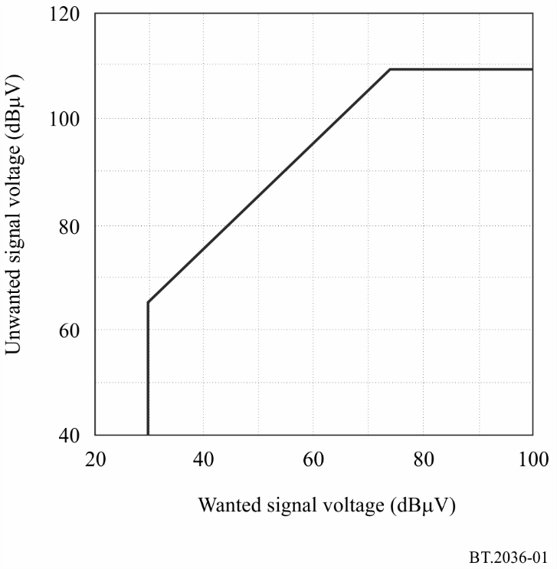
FIGURE 2
Guard interval mask characteristics for 6 MHz
(@GI = 1/8, 64-QAM-FEC 3/4)
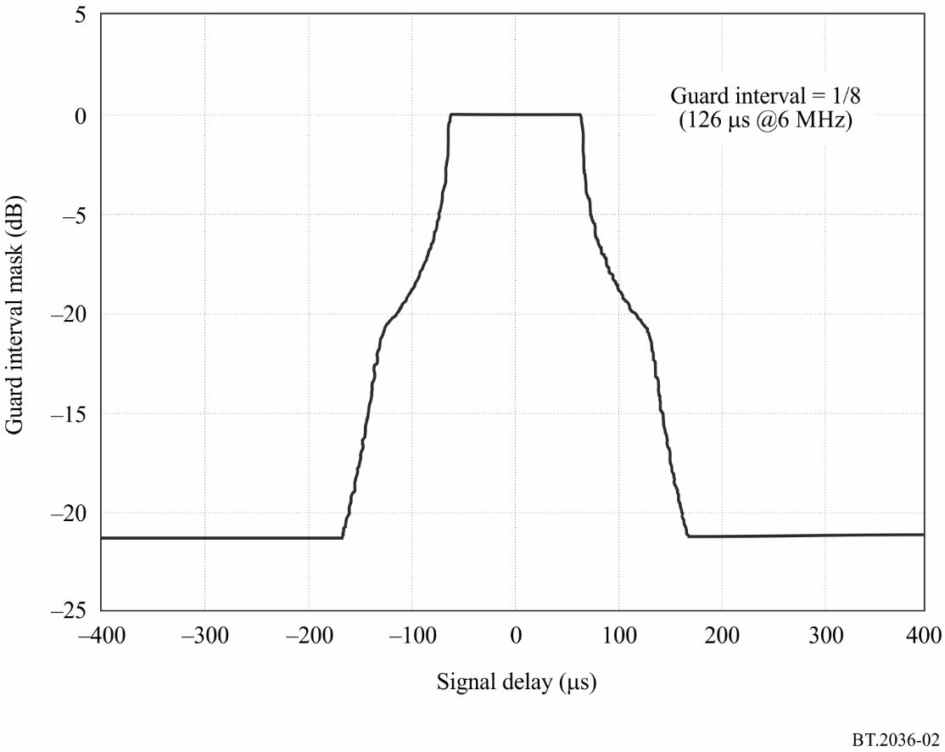

1.4.2 Characteristics of receiving antenna system
The reference receiving antenna gain and cable loss applied in planning studies is given in Annex 1. Values other than those listed in Annex 1 may be applied according to the reception environment.

Annex 3
Digital terrestrial television second-generation reference receiving system
characteristics for frequency planning

1 Introduction
The characteristics of reference second-generation television receiving systems given in this Annex are to be employed as a basis for frequency planning.

1.1 DVB-T2 reference receiver characteristics
Reference values for the parameters of a Digital Video Broadcasting-Second Generation Terrestrial (DVB-T2) reference receiving system are defined for four different reception modes. The reception modes are:
• Reception mode RM1 for fixed roof top reception.
• Reception mode RM2a for portable outdoor reception and RM2b mobile reception. The values for mobile reception are to be included at a later stage when further measurements are performed with DVB-T2 for that reception mode.
• Reception mode RM3 for portable indoor reception.
Reference values for the parameters of a DVB-T2 reference receiving system are given in Tables 19 and 20, 7 and 8 MHz channel raster, respectively. Table 21 gives the reference DVB-T receiver characteristics for Bands IV/V.
The reference parameters of the RMs that are given in Tables 19 to 21 are not associated with a particular DVB-T2 system variant or a real DVB-T2 network implementation; rather, they stand for a large number of different real implementations.
TABLE 19
Reference DVB-T2 receiver characteristics in Band III, 7 MHz channel raster
Reception mode | RM1 | RM2a | RM2b | RM3
Frequency f_{r} (MHz) | 200 | 200 | 200 | 200
Equivalent noise bandwidth (MHz) | 6.66 | 6.66 | 6.66 | 6.66
Receiver noise figure (dB) | 6 | 6 | TBC | 6
Receiver noise input power (dBW) | −129.7 | −129.7 | TBC | −129.7
RF signal/noise ratio reference C/N (dB) | 20 | 18 | TBC | 18
Minimum receiver signal input power (dBW) | −109.7 | −111.7 | TBC | −111.7
Minimum equivalent receiver input voltage, 75 Ω (dB(µV) | 29 | 27 | TBC | 27
Reference minimum field strength (E_{min})_{ref} (dB(µV/m)) at f_{r} = 200 MHz | 36.5 | 41.5 | TBC | 41.5
ACS (dB) | See Note below
NOTE – Information on the calculation of ACS values for DVB-T2 receivers can be found in Recommendation ITU-R BT.2033.

TABLE 20
Reference DVB-T2 receiver characteristics in Band III, 8 MHz channel raster
Reception mode | RM1 | RM2a | RM2b | RM3
Frequency f_{r} (MHz) | 200 | 200 | 200 | 200
Equivalent noise bandwidth (MHz) | 7.77 | 7.77 | 7.77 | 7.77
Receiver noise figure (dB) | 6 | 6 | TBC | 6
Receiver noise input power (dBW) | −129 | −129 | TBC | −129
RF signal/noise ratio  reference C/N (dB) | 20 | 18 | TBC | 18
Minimum receiver signal input power (dBW) | −109 | −111 | TBC | −111
Minimum equivalent receiver input voltage, 75 Ω (dB(µV) | 29.75 | 27.75 | TBC | 27.75
Reference minimum field strength (E_{min})_{ref} (dB(µV/m)) at f_{r} = 200 MHz | 37 | 42.5 | TBC | 42.5
ACS (dB) | See Note below
NOTE – Information on the calculation of ACS values for DVB-T2 receivers can be found in Recommendation ITU-R BT.2033.

TABLE 21
Reference DVB-T2 receiver characteristics in Band IV/V
Reception mode | RM1 | RM2a | RM2b | RM3
Frequency f_{r} (MHz) | 650 | 650 | 650 | 650
Equivalent noise bandwidth (MHz) | 7.77 | 7.77 | 7.77 | 7.77
Receiver noise figure (dB) | 6 | 6 | TBC | 6
Receiver noise input power (dBW) | −129 | −129 | TBC | −129
RF signal/noise ratio  Reference C/N (dB) | 20 | 18 | TBC | 18
Minimum receiver signal input power (dBW) | −109 | −111 | TBC | −111
Minimum equivalent receiver input voltage, 75 Ω (dB(µV) | 29.7 | 27.7 | TBC | 27.75
Reference minimum field strength (E_{min})_{ref} (dB(µV/m)) at f_{r} = 650 MHz | 45.5 | 50.5 | TBC | 50.5
ACS (dB) | See Note below
NOTE – Information on the calculation of ACS values for DVB-T2 receivers can be found in Recommendation ITU-R BT.2033.

The formula for calculating minimum field strength is given in Annex 1 of Report ITU-R BT.2254. For other frequencies, the reference minimum field strength values in Tables 17 and 18 above shall be adjusted by adding the correction factor defined according to the following rule:

(E_{min})_{ref}(f) = (E_{min})_{ref}(f_{r}) + 20 log₁₀ (f/f_{r})
where f is the actual frequency and f_{r} the reference frequency of the relevant band quoted in the Table.
Information on frequency and network planning of DVB-T2, including C/N values, protection ratios and overloading thresholds for particular DVB-T2 system variants, are given in Recommendation ITU-R BT.2033.
Some parameters concerning the receiving DVB-T2 system are presented in the following Tables 22 and 23 below. Annex 1 provides common receiver characteristics applicable to any digital terrestrial television systems in frequency planning.
TABLE 22
Antenna gain (dBd)
 | Band III | Band IV | Band V
Frequency (MHz) | 174-230 | 470-582 | 582-862
Fixed rooftop antenna | 7 | 10 | 12
Portable/mobile reception | −2.2 | 0 | 0

TABLE 23
Feeder loss (dB)
 | Band III | Band IV | Band V | Reception mode
Frequency (MHz) | 174-230 | 470-582 | 582-862
Fixed roof top antenna | 2 | 3 | 5 | Fixed rooftop

1.2 ATSC 3.0 reference receiver characteristics
Reference receiver characteristics for an ATSC 3.0 receiver are provided in Table 24 below for three different reception modes: Urban Indoor, Suburban Indoor and Quasi-Open/Rural. The ATSC 3.0 parameters are as follows: 16QAM, 2/15 LDPC code, 8K FFT.
TABLE 24
Reference ATSC 3.0 receiver characteristics, 8 MHz channel
Reception mode | Urban Indoor | Suburban Indoor | Quasi-Open/Rural
Frequency f_{r} (MHz) | 700 | 700 | 700
Equivalent noise bandwidth (MHz) | 7.78 | 7.78 | 7.78
Receiver noise figure (dB) | 7 | 7 | 7
Receiver noise input power (dBW) | −128 | −128 | -128
RF signal/noise ratio reference C/N (dB) | 1.0 | 1.0 | 1.0
Minimum receiver signal input power (dBW) | −127 | −127 | -127
Reference minimum field strength (E_{min})_{ref} (dB(µV/m)) at f_{r} = 700 MHz | 46.1 | 44.1 | 44.1

Reference receiver characteristics for an ATSC 3.0 receiver are provided in Table 25 below for the use of an external outdoor antenna mounted at a height of 10 metres, using a Ricean channel model. The ATSC 3.0 parameters are as follows: 64 QAM, 11/15 LDPC code, 32K FFT.
TABLE 25
Reference ATSC 3.0 receiver characteristics, 6 MHz channel, outdoor antenna
Channel centre frequency (MHz) | 69 | 195 | 605
Channel bandwidth (MHz) | 6 | 6 | 6
Receiver noise figure (dB) | 7.0 | 7.0 | 7.0
Equivalent noise at the antenna input (dBm) | −89.7 | −99.8 | −102.6
Minimum C/N (dB) | 16.9 | 16.9 | 16.9
Minimum antenna input power (dBm) | −72.8 | −82.9 | −85.7
Minimum required field strength at antenna (dBuV/m) | 39.0 | 38.0 | 44.9
Minimum required field strength at antenna with margin (dBuV/m) | 41.9 | 40.8 | 47.8

Reference receiver characteristics for an ATSC 3.0 receiver are provided in Table 26 below for automotive reception, using a Rayleigh channel model. The ATSC 3.0 parameters are as follows: 16 QAM, 5/15 LDPC code, 16K FFT. The downlead loss is assumed to be that of 10 feet (3.0 m) of RG-59 coaxial cable.
TABLE 26
Reference ATSC 3.0 receiver characteristics, 6 MHz channel, automotive reception
Channel centre frequency (MHz) | 69 | 195 | 605
Channel bandwidth (MHz) | 6 | 6 | 6
Antenna gain (dB) | −4.0 | −2.0 | 0.0
Receiver noise figure (dB) | 7.0 | 7.0 | 7.0
Equivalent noise at the antenna input (dBm) | −88.8 | −95.8 | −97.9
Minimum C/N (dB) | 7.8 | 7.8 | 7.8
Minimum antenna input power (dBm) | −81.0 | −88.0 | −90.1
Minimum required field strength at antenna (dBuV/m) | 30.8 | 32.8 | 40.6

The definitions, methods of measurement and presentation of results used in Annex 1 are consistent with relevant IEC standards/specifications.
As DTTB receive system technology is improving rapidly, administrations are invited to study any improvement of the planning parameters which can result from improved receive system characteristics.
Those reception modes are equivalent to the Reference Planning Configurations for fixed roof-top, portable outdoor/mobile and portable indoor reception of the GE06 Agreement.
System A is defined as the first-generation digital terrestrial television broadcasting system specified in the ATSC Digital Television Standard, A/53-2007, informally referred to as ATSC-1.0.
“ATSC Recommended Practice: Receiver Performance Guidelines”, Document A/74:2010, Advanced Television Systems Committee, Washington, DC, 7 April 2010. http://www.atsc.org/cms/standards/a_74-2010.pdf
See Report ITU-R BT.2209 for detailed definition.
The method of deriving the guard interval mask characteristics is described in detail in Report ITU-R BT.2209. The characteristics depend on the system variant employed.
As DTTB receive system technology is improving rapidly, administrations are invited to study any improvement of the planning parameters which can result from improved receive system characteristics.
ATSC 3.0 is specified in the ATSC Digital Television Standard, A/300-2019 and its constituent standards.
The reception modes are consistent with the Hata propagation-loss model, as described in ETSI TR 143 030 V9.0.0, Annex B, and elsewhere. Quasi-Open/Rural reception is analogous to reception mode RM2 in Section 1.2 of this document, and Indoor reception is analogous to reception mode RM3.

