Recommendation ITU-R BT.2033-2
(01/2022)
Planning criteria, including protection ratios, for second generation of digital terrestrial television broadcasting systems in the VHF/UHF bands
BT Series
Broadcasting service
(television)

Foreword
The role of the Radiocommunication Sector is to ensure the rational, equitable, efficient and economical use of the radio-frequency spectrum by all radiocommunication services, including satellite services, and carry out studies without limit of frequency range on the basis of which Recommendations are adopted.
The regulatory and policy functions of the Radiocommunication Sector are performed by World and Regional Radiocommunication Conferences and Radiocommunication Assemblies supported by Study Groups.

Policy on Intellectual Property Right (IPR)
ITU-R policy on IPR is described in the Common Patent Policy for ITU-T/ITU-R/ISO/IEC referenced in Resolution ITU-R 1. Forms to be used for the submission of patent statements and licensing declarations by patent holders are available from http://www.itu.int/ITU-R/go/patents/en where the Guidelines for Implementation of the Common Patent Policy for ITU-T/ITU-R/ISO/IEC and the ITU-R patent information database can also be found.

Series of ITU-R Recommendations
(Also available online at http://www.itu.int/publ/R-REC/en)
Series | Title
BO | Satellite delivery
BR | Recording for production, archival and play-out; film for television
BS | Broadcasting service (sound)
BT | Broadcasting service (television)
F | Fixed service
M | Mobile, radiodetermination, amateur and related satellite services
P | Radiowave propagation
RA | Radio astronomy
RS | Remote sensing systems
S | Fixed-satellite service
SA | Space applications and meteorology
SF | Frequency sharing and coordination between fixed-satellite and fixed service systems
SM | Spectrum management
SNG | Satellite news gathering
TF | Time signals and frequency standards emissions
V | Vocabulary and related subjects

Note: This ITU-R Recommendation was approved in English under the procedure detailed in Resolution ITU-R 1.

Electronic Publication
Geneva, 2022

© ITU 2022
All rights reserved. No part of this publication may be reproduced, by any means whatsoever, without written permission of ITU.

RECOMMENDATION ITU-R BT.2033-2
Planning criteria, including protection ratios, for second generation of digital terrestrial television broadcasting systems in the VHF/UHF bands
(2013-2015-2022)
Scope
This Recommendation defines planning criteria, including protection ratios, for various methods of providing second generation digital terrestrial television broadcasting (DTTB) systems in the VHF/UHF bands.
Keywords
DTTB, DVB-T2, ISDB-T, ATSC 3.0, DTMB, DTMB-A, planning criteria, protection ratio, second generation
The ITU Radiocommunication Assembly,
considering
a) that the digital terrestrial television systems for use in broadcasting bands have been developed in Recommendation ITU-R BT.1306, which are referred to as the current systems;
b) that these current first generation DTTB systems have been deployed for the transmission of digital terrestrial television services in the VHF/UHF bands;
c) that analogue television services have migrated out of the VHF/UHF television bands within many administrations;
d) that DTTB television services will remain in use for a considerable period of time;
e) that many types of interference, including co-channel and adjacent channel, ignition noise, multipath and other signal distortions exist in the VHF/UHF bands;
f) that recent developments in the field of channel coding and modulation have produced new techniques with performances approaching the Shannon limit;
g) that the error-correction, data framing, modulation and emission methods for the second generation worldwide digital terrestrial television broadcasting systems have been defined in Recommendation ITU-R BT.1877;
h) that these new digital techniques would offer better spectrum and/or power efficiency, in comparison to the current systems, whilst maintaining the possibility to be flexibly configured to cope with the specific broadcasting bandwidth and power resources;
i) that the recommended system makes use of such techniques and thus allows for a wide-ranging trade-off between operation under minimal C/N levels or maximum transmission capacity;
j) that the planning criteria for various methods of providing first generation digital terrestrial television services in the VHF/UHF bands have been defined in Recommendation ITU-R BT.1368;
k) that the availability of consistent sets of planning criteria agreed by administrations will facilitate the introduction of second generation digital terrestrial television services,
recommends
that the relevant planning criteria, including protection ratios (PRs) and the relevant minimum field strength values given in Annexes 1, 2, 7 and 8 should be used as the basis for frequency planning for second generation digital terrestrial television services.
NOTE – Annexes 4 and 6 are an integral part of the Recommendation. Annexes 3 and 5 are provided for information.
Introduction
This Recommendation contains the following Annexes:
Annex 1 – Planning criteria, including protection ratios, for DVB second generation digital terrestrial television systems in the VHF/UHF bands for 7 and 8 MHz channel bandwidth
Annex 2 – Planning criteria, including protection ratios, for DVB second generation digital terrestrial television systems in the VHF/UHF bands for 6 MHz channel bandwidth
Annex 3 – Additional test results from UK and Russian Federation
Annex 4 – Other planning factors such as antenna types and antenna discrimination, height loss, etc.
Annex 5 – Subjective failure point description
Annex 6 – Tropospheric and continuous interference
Annex 7 – Planning criteria, including protection ratios, for ATSC 3.0 second generation digital terrestrial television systems in the VHF/UHF bands
Annex 8 – Planning criteria for DTMB-A digital television systems in the VHF/UHF bands
General
The RF protection ratio is the minimum value of wanted-to-unwanted signal ratio, usually expressed in decibels at the receiver input.
The protection ratios defined in this Recommendation are based on measurements using the test methodology and signal power references defined in [1].
Administrations are invited to contribute with additional results of measurements in order to complete this Recommendation.
Wanted digital terrestrial television systems
The protection ratios for digital terrestrial television systems apply to both continuous and tropospheric interference. The protection ratios refer to the centre frequency of the wanted digital terrestrial television system.
Because a digital television receiver needs to operate successfully in the presence of high level interference signals on nearby channels, a high degree of receiver front-end linearity is required.
The protection ratios for digital terrestrial television systems as the interfering system are those for the case where the wanted and unwanted signals are not synchronized and/or do not have a common programme source.
Protection ratios are measured at based on setting the interference conditions to be at the onset of picture failure using the subjective failure point (SFP) method as defined in [1].

TABLE OF CONTENTS
Page
Policy on Intellectual Property Right (IPR) ii
Annex 1 (normative) Planning criteria, including protection ratios, for DVB second generation digital terrestrial television systems in the VHF/UHF bands for 7 and 8 MHz channel bandwidth 6
1 Protection ratios for DVB-T2 wanted digital terrestrial television signals 6
1.1 Wanted signal configuration 6
1.2 Characteristics of the LTE interfering signal 7
1.3 Notes applying to protection ratio and overload threshold tables 7
1.4 Protection of a DVB-T2 digital terrestrial television signal interfered with by a DVB-T2 digital terrestrial television signal 8
1.5 Protection ratios and overload thresholds for DVB-T2 interfered with by LTE base station and user equipment signals 9
1.6 Correction factors for different wanted DVB-T2 system variants and different reception conditions 15
1.7 Selection of PR and O_{th} for sharing studies 16
1.8 Effect of transient interference on protection ratios 16
2 Minimum field strengths for DVB-T2 terrestrial digital television 17
3 References 20
Attachment 1 to Annex 1 Calculation of minimum field strength and minimum median equivalent field strength 20
Attachment 2 to Annex 1 Can tuner test results 21
Attachment 3 to Annex 1 Effect of transient interference on protection ratios 25
1 Background 25
2 Measurements 26
2.1 Signal sources 26
2.2 Frequency offsets 27
2.3 Measurement procedure 28
2.4 Receivers tested 28
3 Results 28
4 Conclusions 32
Attachment 4 to Annex 1 TV tuner technologies and characteristics 32
Annex 2 (Normative) Planning criteria, including protection ratios, for DVB second generation digital terrestrial television systems in the VHF/UHF bands for 6 MHz channel bandwidth 33
1 Protection ratios for 6 MHz DVB-T2 wanted digital terrestrial television signal 33
1.1 Protection ratios for a wanted DVB-T2 signal interfered with by a digital terrestrial television signal 33
1.2 Protection ratios for a wanted DVB-T2 signal interfered with by an analog terrestrial television signal 36
Annex 3 (Informative) Additional test results 37
1 Additional test result from the UK 37
2 Additional test result from the Russian Federation 38
Annex 4 (Normative) Other planning factors 38
1 Field strength distribution with location 38
2 Reception using portable equipment inside buildings and vehicles 39
2.1 Height loss: L_{h} 39
2.2 Building entry loss: L_{b} 39
2.3 Vehicle entry loss: L_{v} 40
3 Receiving antenna discrimination 40
4 Antennas for portable and mobile receivers 40
4.1 Antennas for portable reception 40
4.2 Antennas for hand-held reception 41
4.3 Antennas for mobile reception 41
5 Man-Made Noise (MMN) 42
Annex 5 (Informative) Failure point assessment methods 42
1 Subjective failure point (SFP) method for protection ratio measurements 42
Annex 6 (Normative) Tropospheric and continuous interference 43
1 Tropospheric and continuous interference 43
Annex 7 (normative) Planning criteria, including protection ratios, for ATSC 3.0 second generation digital terrestrial television systems in the VHF/UHF bands 44
1 Protection ratios for ATSC 3.0 digital terrestrial television signals 44
2 Minimum field strengths for ATSC 3.0 terrestrial digital television 44
3 References 47
Annex 8 (normative) Planning criteria for DTMB-A digital television systems in the VHF/UHF bands 48
1 Protection ratios for DTMB-A wanted digital terrestrial television signals 48
1.1 Protection of a DTMB-A signal interfered with by a DTMB-A signal 48
1.2 Protection of DTMB-A signal interfered with by analogue terrestrial television 49
2 Protection ratios for wanted analogue terrestrial television signals interfered with by unwanted DTMB-A 8 MHz signals 51
2.1 Protection of wanted vision signals interfered with by DTMB-A 8 MHz
signal 51
3 Minimum field strengths for DTMB-A fixed reception 53
4 Minimum median field strength for mobile DTMB-A reception 53
4.1 Required average C/N for mobile reception 53
4.2 Receiver noise figure 55

Annex 1
(Normative)
Planning criteria, including protection ratios, for DVB second generation
digital terrestrial television systems in the VHF/UHF bands
for 7 and 8 MHz channel bandwidth

1 Protection ratios for DVB-T2 wanted digital terrestrial television signals

1.1 Wanted signal configuration
To reduce the number of measurements and tables, it is proposed that protection ratio measurements for DVB-T2 systems should be made with the following mode shown in Table 1. Protection ratio values for the different required operational modes can be calculated from the given measured values. All data in this Annex corresponds to this mode unless stated otherwise.
TABLE 1
Preferable DVB-T2 mode type for measurements on protection ratios
Overall | Parameter value
FFTSIZE | 32 K
GI | 1/128
Data symbols | 59
SISO/MISO | SISO
PAPR | None
Frames per superframe | 2
Bandwidth (MHz) | 8
Extended bandwidth mode | Yes
Pilot pattern | PP7
L1 Modulation | 64-QAM
PLP #0
Type | 1
Modulation | 256-QAM
Rate | 2/3
FEC Type | 64 800
Rotated QAM | Yes
FEC blocks per interleaving frame | 202
TI blocks per frame (N_TI) | 3
T2 frames per interleaving frame (P_I) | 1
Frame interval (I_JUMP) | 1
Type of time-interleaving | 0
Time interleaving length | 3
C/N (AWGN Channel) (dB) | 19.7
Data rate Mbit/s | 40.2

1.2 Characteristics of the LTE interfering signal
The protection ratios and overload thresholds for LTE base stations (BS) and User Equipment (UE) in this Recommendation are based on measurements using recorded 10 MHz wide LTE waveforms from real BS and UE devices with three different traffic loadings. These recordings were filtered to remove out of band recording artifacts and formatted into I/Q data suitable for replay from standard laboratory vector signal generators.
The BS traffic loadings were categorized as:
a) Idle – consisting mainly of synchronization and broadcast signals with occasional data;
b) 50% loading – medium loading;
c) 100% loading – where all the resource blocks were used all the time.
The UE traffic loadings were categorized as:
a) 1 Mbit/s – light loading where only a small number of resource blocks are used for some of the time;
b) 10 Mbit/s – medium loading;
c) 20 Mbit/s – high loading.
There is significantly more time variation in the power of the lighter traffic loaded waveforms which can cause PR and O_{th} degradation in some receivers.

1.3 Notes applying to protection ratio and overload threshold tables
To avoid repetition, unless stated otherwise, the following notes apply to Tables 2 to 11 and Tables 14 to 18.
NOTE 1 – The 90th percentile for the protection ratio value corresponds to the protection of 90% of receivers measured, with respect to the given frequency offset and parameter; whereas the 10th percentile for the overload threshold should be used to protect 90% of receivers measured.
NOTE 2 – Δf is the difference between the centre frequency of the unwanted channel and the centre frequency of the wanted channel.
NOTE 3 – NR: O_{th} is not reached. That is at this frequency offset PR is the predominant criterion.
NOTE 4 – PR is applicable unless the interfering signal level is above the corresponding O_{th}. If the interfering signal level is above the corresponding O_{th}, the receiver is interfered with by the interfering signal whatever the signal to interference ratio is.
NOTE 5 – At wanted signal level close to receiver sensitivity, noise should be taken into account, e.g. at sensitivity +3 dB, 3 dB should be added to the PR.
NOTE 6 − PR for different system variants and various reception conditions can be obtained using the correction factors in Table 10 of this Annex. The overload threshold is assumed to be independent of system variant and reception conditions.
NOTE 7 – Protection ratios are rounded to the nearest integer.
NOTE 8 – The Ricean and static Rayleigh channels are defined in section 14.1 of ETSI TS 102 831 Digital Video Broadcasting (DVB); Implementation guidelines for a second-generation digital terrestrial television broadcasting system (DVB-T2). They are also described in ETSI EN 300 744 Digital Video Broadcasting (DVB); Framing structure, channel coding and modulation for digital terrestrial television (DVB-T).
NOTE 9 – The LTE BS interference signals used in the measurements had ACLRs of 60 dB or greater for N-1, and significantly higher ACLRs for N-2 and beyond.
Tables 2 to 11 and Tables 14 to 18 show protection ratios for the DVB-T2 wanted digital terrestrial television signals interfered with:
− by DVB-T2 digital terrestrial television signals;
− by LTE base station (BS) signals;
− by LTE user equipment (UE) signals.

1.4 Protection of a DVB-T2 digital terrestrial television signal interfered with by a DVB-T2 digital terrestrial television signal
The values in Table 2 are theoretical values calculated for the mode in Table 1 using the method described in Report ITU-R BT.2254.
TABLE 2
Co-channel protection ratios (dB) for a DVB-T2 signal (defined in Table 1)
interfered with by a DVB-T2 signal of similar mode
Modulation | Code rate | Gaussian  channel | Ricean channel Note 8 | Rayleigh channel (static) Note 8
QPSK | 1/2 | 2.4 | 2.6 | 3.4
QPSK | 3/5 | 3.6 | 3.8 | 4.9
QPSK | 2/3 | 4.5 | 4.8 | 6.3
QPSK | 3/4 | 5.5 | 5.8 | 7.6
QPSK | 4/5 | 6.1 | 6.5 | 8.5
QPSK | 5/6 | 6.6 | 7.0 | 9.3
16-QAM | 1/2 | 7.6 | 7.8 | 9.1
16-QAM | 3/5 | 9.0 | 9.2 | 10.7
16-QAM | 2/3 | 10.3 | 10.5 | 12.2
16-QAM | 3/4 | 11.4 | 11.8 | 13.9
16-QAM | 4/5 | 12.2 | 12.6 | 15.1
16-QAM | 5/6 | 12.7 | 13.1 | 15.9
64-QAM | 1/2 | 11.9 | 12.2 | 14.0
64-QAM | 3/5 | 13.8 | 14.1 | 15.8
64-QAM | 2/3 | 15.1 | 15.4 | 17.2
64-QAM | 3/4 | 16.6 | 16.9 | 19.3
64-QAM | 4/5 | 17.6 | 18.1 | 20.9
64-QAM | 5/6 | 18.2 | 18.7 | 21.8
256-QAM | 1/2 | 15.9 | 16.3 | 18.3
256-QAM | 3/5 | 18.2 | 18.4 | 20.5
256-QAM | 2/3 | 19.7 | 20.0 | 22.1
256-QAM | 3/4 | 21.7 | 22.0 | 24.6
256-QAM | 4/5 | 23.1 | 23.6 | 26.6
256-QAM | 5/6 | 23.9 | 24.4 | 28.0

Protection ratios in Table 3 are given for three types of propagation channels (i.e. Gaussian, Ricean and Rayleigh). For fixed and portable reception, the values relevant to the Ricean and Rayleigh channels, respectively, should be adopted.
The same protection ratio corrections in Table 3 should be applied for DVB-T2 systems with 6, 7 and 8 MHz bandwidth.
TABLE 3
Protection ratios (dB) and overload threshold (dBm) for a DVB-T2 signal (defined in Table 1)
interfered with by a DVB-T2 signal (defined in Table 1) in adjacent channels for silicon tuners
Channel offset N  (8 MHz channels) | Centre frequency offset  (MHz) | Number of receivers tested | PR  (dB) |  | O_{th}  (dBm)
 |  |  | Percentile |  | Percentile
 |  |  | 50th | 90th | 10th | 50th
–9 | 72 | 11 | –54 | –50 | –14 | 0
–4 | –32 | 11 | –50 | –44 | –14 | –2
–3 | –24 | 11 | –48 | –44 | –14 | –2
–2 | –16 | 11 | –47 | –43 | –15 | –6
–1 | –8 | 11 | –35 | –33 | –15 | –6
Co-channel | 0 | 11 | 19.0 | 19.0 | – | –
1 | 8 | 11 | –32 | –30 | –15 | –6
2 | 16 | 11 | –46 | –43 | –15 | –5
3 | 24 | 11 | –47 | –43 | –14 | –2
4 | 32 | 11 | –50 | –44 | –13 | 1
9 | 72 | 11 | –54 | –49 | –13 | 1

The values given apply to the case where wanted and unwanted DVB-T2 signals have the same channel width. Other combinations of channel width need further studies.
The interfering signal had the same mode parameters as the wanted signal but was uncorrelated to it.
The protection ratio is given in dB and applies to both continuous and tropospheric interference.

1.5 Protection ratios and overload thresholds for DVB-T2 interfered with by LTE base station and user equipment signals
This section provides protection ratios and overload thresholds for DVB-T2 systems interfered with by LTE OFDMA (base station) and SC-FDM (user equipment) systems. All measurements to derive these parameters were performed on DVB-T2 receivers designed for a frequency tuning range from 470 to 862 MHz, all interfering signals were within the frequency range 759 to 862 MHz.
Only a small number (3) of DVB-T2 receivers with can tuners were available for testing, preventing any statistical analysis of the results. The individual receiver performance is tabulated for reference in Attachment 2 to this Annex.
The characteristics of the LTE signal used in the measurements are given in Report ITU-R BT.2215 – Measurement of protection ratios and overload threshold for broadcast TV receivers.
The sharing between DVB-T2 and the mobile LTE service is an evolving situation where the design of both the television tuners and the implementation of base stations are changing. All parties involved are actively encouraged to improve the performance of their respective equipment so that these tables can be revisited in the near future.
Due to the time variation in the LTE signal, the worst-case degradation of PR and O_{th} in some tuner designs corresponds to very low BS and UE traffic loadings. Three levels of traffic load are provided here as the actual traffic load in the real BS and UE operation is unlikely to be predictable.
The highest level of protection (to protect broadcasting for all BS and UE traffic load cases) is achieved by taking the highest value for the protection ratio and the lowest value for the overload threshold for either tuner technology.
The frequency offset is measured between the centre frequencies of wanted and interfering signals.

1.5.1 Protection of a DVB-T2 digital terrestrial television signal interfered with by a LTE-BS signal
The following Tables show protection ratios and overload thresholds for three different traffic loadings on the LTE base station.
TABLE 4
Measured protection ratios (dB) for a DVB-T2 signal (defined in Table 1)
interfered with by an LTE BS signal in adjacent channels for silicon tuners
Channel Offset N  (8 MHz channels) | Centre frequency offset  (MHz) | Number of receivers tested | 0% BS traffic loading PR  (dB) |  | 50% BS traffic loading PR  (dB) |  | 100% BS traffic loading PR  (dB)
 |  |  | Percentile |  | Percentile |  | Percentile
 |  |  | 50th | 90th | 50th | 90th | 50th | 90th
Co-channel AWGN | 0 | 11 | 19 | 19 | 19 | 19 | 19 | 19
Co-channel LTE | 0 | 11 | 10 | 11 | 18 | 18 | 19 | 19
1 | 10 | 11 | –44 | –24 | –40 | –38 | –38 | –36
2 | 18 | 11 | –50 | –32 | –48 | –44 | –47 | –43
3 | 26 | 11 | –51 | –35 | –49 | –45 | –48 | –44
4 | 34 | 11 | –52 | –39 | –51 | –46 | –50 | –45
5 | 42 | 11 | –53 | –41 | –51 | –47 | –51 | –46
6 | 50 | 11 | –55 | –46 | –54 | –48 | –52 | –47
7 | 58 | 11 | –56 | –46 | –54 | –49 | –54 | –48
8 | 66 | 11 | –57 | –45 | –54 | –50 | –53 | –49
9 | 74 | 11 | –58 | –45 | –55 | –50 | –53 | –49

TABLE 5
Measured overload thresholds (dBm) for a DVB-T2 signal (defined in Table 1)
interfered with by an LTE BS signal in adjacent channels for silicon tuners
Channel offset N  (8 MHz channels) | Centre frequency offset  (MHz) | Number of receivers tested | 0% BS traffic loading  O_{th}  (dBm) |  | 50% BS traffic loading  O_{th}  (dBm) |  | 100% BS traffic loading  O_{th}  (dBm)
 |  |  | Percentile |  | Percentile |  | Percentile
 |  |  | 10th | 50th | 10th | 50th | 10th | 50th
1 | 10 | 11 | –18 | –6 | –15 | –6 | –13 | –8
2 | 18 | 11 | –14 | 1 | –12 | –2 | –13 | –3
3 | 26 | 11 | –12 | 3 | –13 | 0 | –12 | –1
4 | 34 | 11 | –11 | 5 | –12 | 2 | –12 | 0
5 | 42 | 11 | –10 | 6 | –12 | 3 | –12 | 2
6 | 50 | 11 | –10 | 4 | –12 | 2 | –12 | 2
7 | 58 | 11 | –10 | 4 | –11 | 2 | –12 | 1
8 | 66 | 11 | –10 | 4 | –12 | 2 | –12 | 1
9 | 74 | 11 | –10 | 5 | –12 | 3 | –12 | 1

1.5.2 Protection of a DVB-T2 digital terrestrial television signal interfered with by a LTE-UE signal
The following Tables show PR and O_{th} for three different UE traffic loadings:
Table 6 – Uncorrected UE PR results
Table 7 – Estimated UE ACLR based on 3GPP TS 36.101 and ETSI masks
Table 8 – UE PR results corrected for UE out-of-band noise degradation
Table 9 – UE overload threshold results.

TABLE 6
Un-corrected protection ratios (dB) for a DVB-T2 signal (defined in Table 1)
interfered with by an LTE UE signal in adjacent channels for silicon tuners
Channel offset N  8 MHz channels/  (centre frequency offset) | No. of Rx.  tested | 1 Mbit/s UE  traffic loading  Signal generator ACLR = 100 dB all offsets |  | 10 Mbit/s UE  traffic loading  Signal generator ACLR = 100 dB all offsets |  | 20 Mbit/s UE  traffic loading  Signal generator ACLR =  67.8 dB (N+1)  80.4 dB (N+2)  100 dB (N+3 to N+9)
 |  | PR percentile  (dB) |  | PR percentile  (dB) |  | PR percentile  (dB)
 |  | 50th | 90th | 50th | 90th | 50th | 90th
Co-channel AWGN (0) | 11 | 19 | 19 | 19 | 19 | 19 | 19
Co-channel LTE (0) | 11 | 10 | 11 | 18 | 18 | 19 | 19
1/(10) | 11 | –36 | –19 | –41 | –39 | –41 | –39
2 (18) | 11 | –41 | –24 | –47 | –45 | –47 | –43
3 (26) | 11 | –44 | –26 | –48 | –45 | –50 | –44
4 (34) | 11 | –46 | –36 | –48 | –45 | –52 | –45
5 (42) | 11 | –47 | –37 | –48 | –44 | –54 | –46
6 (50) | 11 | –50 | –38 | –49 | –43 | –52 | –45
7 (58) | 11 | –50 | –41 | –49 | –44 | –53 | –44
8 (66) | 11 | –50 | –41 | –49 | –42 | –54 | –45
9 (74) | 11 | –50 | –43 | –49 | –43 | –54 | –47

The UE protection ratios are corrected for the estimated UE ACLR in 8 MHz adjacent and non-adjacent channels to take account of the degradation in protection ratio caused by UE out-of band noise. The ACLR estimates based on the mask in Table 6.6.2.1.1 of 3GPP TS 36.101 v.11.1.0 and the draft ETSI 301-908-13 requirement for −65 dBm out-of-band noise in the band 470-790 MHz. These are shown in Table 7.
TABLE 7
Assumed UE ACLRs for corrected UE PR values
Channel offset N  (8 MHz channels) | Centre frequency offset  (MHz) | ACLR  (dB)
1 | 10 | 25.2
2 | 18 | 32.2
Other offsets (corresponding to  −65 dBm/8 MHz) | 26-74 | 88.0

The co-channel PR₀ values used in the correction calculation were the AWGN figures in Table 8. The ACLR correction method is described below.
The final protection ratio is found in two stages; firstly, for a frequency offset ∆f the adjacent channel selectivity (ACS) of the receiver is calculated from the measured protection ratio at the offset (PR(∆f)), the co-channel protection ratio PR₀ and the ACLR of the interference signal generator:

Secondly, the derived value of the DTT ACS is used to determine the appropriate adjacent channel protection ratios for interfering terminal that may have different ACLR characteristics.
The final protection ratio, PR′(Δf), is a function of the ACS and the ACLR of the LTE device at (Δf), ACLR′:

This method can also be used to reverse the corrected PRs back to the uncorrected PRs to allow the effect of different UE ACLR assumptions to be calculated.
Note that the ACLR and ACLR′ in the equations above are based on power measurements using the channel bandwidth of the LTE interferer (e.g. 10 MHz) and the channel bandwidth of the wanted DVB-T2 signal (e.g. 8 MHz) at the appropriate frequency offsets of the interferer.
TABLE 8
Corrected protection ratios (dB) for a DVB-T2 signal (defined in Table 1)
interfered with by an LTE UE signal in adjacent channels for silicon tuners
Channel offset N  8 MHz channels/ (centre frequency offset) | No. of Rx.  tested | 1 Mbit/s UE  traffic loading  Signal generator ACLR = 100 dB  all offsets |  | 10 Mbit/s UE  traffic loading  Signal generator ACLR = 100 dB  all offsets |  | 20 Mbit/s UE  traffic loading  Signal generator ACLR =  67.8 dB (N+1)  80.4 dB (N+2)  100 dB (N+3 to N+9)
 |  | PR Percentile  (dB) |  | PR Percentile  (dB) |  | PR Percentile  (dB)
 |  | 50th | 90th | 50th | 90th | 50th | 90th
Co-channel AWGN (0) | 11 | 19 | 19 | 19 | 19 | 19 | 19
Co-channel LTE (0) | 11 | 10 | 11 | 18 | 18 | 19 | 19
1/(10) | 11 | –6 | –6 | –6 | –6 | –6 | –6
2 (18) | 11 | –13 | –13 | –13 | –13 | –13 | –13
3 (26) | 11 | –44 | –26 | –48 | –45 | –50 | –44
4 (34) | 11 | –46 | –36 | –48 | –45 | –52 | –45
TABLE 8 (end)
Channel offset N  8 MHz channels/ (centre frequency offset) | No. of Rx.  tested | 1 Mbit/s UE  traffic loading  Signal generator ACLR = 100 dB  all offsets |  | 10 Mbit/s UE  traffic loading  Signal generator ACLR = 100 dB  all offsets |  | 20 Mbit/s UE  traffic loading  Signal generator ACLR =  67.8 dB (N+1)  80.4 dB (N+2)  100 dB (N+3 to N+9)
 |  | PR Percentile  (dB) |  | PR Percentile  (dB) |  | PR Percentile  (dB)
 |  | 50th | 90th | 50th | 90th | 50th | 90th
5 (42) | 11 | –47 | –37 | –48 | –44 | –54 | –46
6 (50) | 11 | –50 | –38 | –49 | –43 | –52 | –45
7 (58) | 11 | –50 | –41 | –49 | –44 | –53 | –44
8 (66) | 11 | –50 | –41 | –49 | –42 | –54 | –45
9 (74) | 11 | –50 | –43 | –49 | –43 | –54 | –47

TABLE 9
Measured overload thresholds (dBm) for a DVB-T2 signal (defined in Table 1)
interfered with by an LTE UE signal in adjacent channels for silicon tuners
Channel offset N  (8 MHz channels) | Centre frequency offset (MHz) | Number of receivers tested | 1 Mbit/s UE traffic loading |  | 10 Mbit/s UE traffic loading |  | 20 Mbit/s UE traffic loading
 |  |  | O_{th}  (dBm) |  | O_{th}  (dBm) |  | O_{th}  (dBm)
 |  |  | 10th | 50th | 10th | 50th | 10th | 50th
1 | 10 | 11 | –37 | –6 | –15 | –5 | –12 | –5
2 | 18 | 11 | –12 | 5 | –11 | 0 | –11 | 0
3 | 26 | 11 | –10 | 6 | –11 | 2 | –11 | 0
4 | 34 | 11 | –24 | 5 | –11 | 2 | –11 | 1
5 | 42 | 11 | –10 | 6 | –11 | 2 | –11 | 1
6 | 50 | 11 | –10 | 6 | –11 | 2 | –11 | 2
7 | 58 | 11 | –10 | 5 | –11 | 2 | –11 | 2
8 | 66 | 11 | –10 | 5 | –11 | 2 | –11 | 2
9 | 74 | 11 | –11 | 6 | –11 | 2 | –11 | 2

1.6 Correction factors for different wanted DVB-T2 system variants and different reception conditions
Table 10 was developed for DVB-T2 signals using other modes interfered with by DVB-T2. It is calculated as the difference in AWGN C/N between other modes and the reference mode in Table 1 and should be used with caution, particularly if the difference in C/N for the required mode compared with the reference mode is large. The values have yet to be verified through measurement. It is proposed to be used for other types of interferers but further studies are required to confirm the values.
TABLE 10
Theoretical correction factor estimates for protection ratios (dB) for different wanted
DVB-T2 system variants relative to the reference mode in Table 1
(interfered with by DVB-T2 or other services)
Modulation | Code rate | Gaussian  channel | Rice channel  Note 8 | Rayleigh channel (static)  Note 8
QPSK | 1/2 | –17.3 | –17.1 | –16.3
QPSK | 3/5 | –16.1 | –15.9 | –14.8
QPSK | 2/3 | –15.2 | –14.9 | –13.4
QPSK | 3/4 | –14.2 | –13.9 | –12.1
QPSK | 4/5 | –13.6 | –13.2 | –11.2
QPSK | 5/6 | –13.1 | –12.7 | –10.4
16-QAM | 1/2 | –12.1 | –11.9 | –10.6
16-QAM | 3/5 | –10.7 | –10.5 | –9.0
16-QAM | 2/3 | –9.4 | –9.2 | –7.5
16-QAM | 3/4 | –8.3 | –7.9 | –5.8
16-QAM | 4/5 | –7.5 | –7.1 | –4.6
16-QAM | 5/6 | –7.0 | –6.6 | –3.8
64-QAM | 1/2 | –7.8 | –7.5 | –5.7
64-QAM | 3/5 | –5.9 | –5.6 | –3.9
64-QAM | 2/3 | –4.6 | –4.3 | –2.5
64-QAM | 3/4 | –3.1 | –2.8 | –0.4
64-QAM | 4/5 | –2.1 | –1.6 | 1.2
64-QAM | 5/6 | –1.5 | –1.0 | 2.1
256-QAM | 1/2 | –3.8 | –3.4 | –1.4
256-QAM | 3/5 | –1.5 | –1.2 | 0.8
256-QAM | 2/3 | 0.0 | 0.3 | 2.4
256-QAM | 3/4 | 2.0 | 2.3 | 4.9
256-QAM | 4/5 | 3.4 | 3.9 | 6.9
256-QAM | 5/6 | 4.2 | 4.7 | 8.3

As compared to a static Rayleigh transmission channel, the time-variant Rayleigh channel which is relevant for portable DVB-T2 reception shows a significantly higher need for protection ratios. Further measurement is needed for evaluation of this effect.

1.7 Selection of PR and O_{th} for sharing studies
Table 11 illustrates recommended values for PR and O_{th} to be used in sharing studies. By applying these values 90 percent of receivers (among all 14 tuners measured), would be protected across all traffic loadings. For the UE, the corrected PR 90th percentiles were used based on the UE ACLR assumptions in Table 7.
TABLE 11
Recommended sharing study values of PR and O_{th} for a DVB-T2 signal (defined in Table 1)
in a clear channel, interfered with by an LTE BS or UE signal in adjacent
channels for 3 can and 11 silicon tuners combined
Channel offset N  (8 MHz channels) | Centre frequency offset  (MHz) | LTE BS |  | LTE UE
 |  | PR  (dB) | O_{th}  (dBm) | Corrected PR  (dB) | O_{th}  (dBm)
Co-channel (AWGN) | 0 | 19 | – | 19 | –
Co-channel (LTE) | 0 | 19 | – | 19 | –
1 | 10 | –25 | –16 | –6 | –30
2 | 18 | –33 | –12 | –13 | –11
3 | 26 | –36 | –11 | –28 | –10
4 | 34 | –40 | –13 | –37 | –20
5 | 42 | –43 | –11 | –38 | –10
6 | 50 | –46 | –11 | –40 | –9
7 | 58 | –47 | –11 | –42 | –9
8 | 66 | –46 | –11 | –43 | –10
9 | 74 | –46 | –10 | –44 | –10

1.8 Effect of transient interference on protection ratios
In the previous sections, the interference has been active at the time the DTT wanted signal is acquired. Recent studies have shown significantly higher protection ratios (10-12 dB) are measured when the interference source is applied after the DTT wanted signal has been acquired. This is particularly relevant when the interference is occasional such as in the case of an LTE UE where the user may have long gaps (many seconds) of no activity allowing the DTT receiver AGC to stabilize in a “no interference” state. Examples include:
– regular polling of data “pull” servers (e.g. email updating, social networking applications);
– “keep alive” messages for stateful applications;
– other network signalling traffic.
Details of these measurements are given in Attachment 3 to Annex 1. These measurements are preliminary pending further study.

2 Minimum field strengths for DVB-T2 terrestrial digital television
The formula for calculating minimum field strength is given in Attachment 1 to Annex 1. For other reception modes (mobile rural, handheld portable outdoor and handheld mobile with integrated antenna) field strength calculations are available in Report ITU-R BT.2254 – Frequency and network planning aspects of DVB-T2.
TABLE 12
Calculation of minimum field strength DVB-T2 8 MHz system at 200 MHz
DVB-T2 in Band III |  |  | Fixed | Portable outdoor/urban | Portable  indoor/urban
Frequency | Freq | MHz | 200 | 200 | 200
Minimum C/N required by system | C/N | dB | 20.0 | 17.9 | 18.3
System variant (example) |  |  | 256-QAM  FEC 2/3, 32k, PP7 Normal | 64-QAM  FEC 2/3, 32k, PP4 Normal | 64-QAM  FEC 2/3, 16k, PP1 Normal
Bit rate (indicative values) |  | Mbit/s | 30-35 | 22-25 | 19-24
Receiver noise figure | F | dB | 6 | 6 | 6
Equivalent noise bandwidth | B | MHz | 6.66 | 6.66 | 6.66
Receiver noise input power | P_{n} | dBW | –128.6 | –128.9 | –128.5
Min. receiver signal input power | P_{s min} | dBW | –109.7 | –111.8 | –111.4
Min. equivalent receiver input voltage, 75 Ω | U_{min} | dBµV | 29.0 | 26.9 | 27.3
Feeder loss | L_{f} | dB | 2 | 0 | 0
Antenna gain relative to half dipole | G_{d} | dB | 7 | –2.2 | –2.2
Effective antenna aperture | A_{a} | dBm² | 1.7 | –7.5 | –7.5
Min power flux-density at receiving location | Φ_{min} | dB(W)/m² | –109.4 | –104.3 | –103.9
Min equivalent field strength at receiving location | E_{min} | dBµV/m | 36.4 | 41.5 | 41.9
Allowance for man-made noise | P_{mmn} | dB | 2 | 8 | 8
Penetration loss (building or vehicle) | L_{b}, L_{h} | dB | 0 | 0 | 9
Standard deviation of the penetration loss |  | dB | 0 | 0 | 3
Diversity gain | Div | dB | 0 | 0 | 0

TABLE 12 (end)
DVB-T2 in Band III |  |  | Fixed | Portable outdoor/urban | Portable indoor/urban
Location probability |  | % | 70 | 70 | 70
Distribution factor |  |  | 0.5244 | 0.5244 | 0.5244
Standard deviation |  |  | 5.5 | 5.5 | 6.3
Location correction factor | C_{l} | dB | 2.8842 | 2.8842 | 3.30372
Minimum median power flux-density at reception height⁽¹⁾; 50% time and 50% locations | Φ_{med} | dB(W)/m² | –104.5 | –93.4 | –83.6
Minimum median equivalent field strength at reception height⁽¹⁾; 50% time and 50% locations | E_{med} | dBµV/m | 41.3 | 52.4 | 62.4
Location probability |  | % | 95 | 95 | 95
Distribution factor |  |  | 1.6449 | 1.6449 | 1.6449
Standard deviation |  |  | 5.5 | 5.5 | 6.3
Location correction factor | C_{l} | dB | 9.04695 | 9.04695 | 10.36287
Minimum median power flux-density at reception height⁽¹⁾; 50% time and 50% locations | Φ_{med} | dB(W)/m² | –98.4 | –87.3 | –77.6
Minimum median equivalent field strength at reception height⁽¹⁾; 50% time and 50% locations | E_{med} | dBµV/m | 47.4 | 58.5 | 69.2
⁽¹⁾ 10 m for fixed reception and 1.5 m for the other reception modes.

TABLE 13
Calculation of minimum field strength DVB-T2 8 MHz system at 650 MHz
DVB-T2 in Band IV/V |  |  | Fixed | Portable outdoor/urban | Portable  indoor/urban
Frequency | Freq | MHz | 650 | 650 | 650
Minimum C/N required by system | C/N | dB | 20.0 | 17.9 | 18.3
System variant (example) |  |  | 256-QAM  FEC 2/3, 32k, PP7 Extended | 64-QAM  FEC 2/3, 32k, PP4 Extended | 64-QAM  FEC 2/3, 16k, PP1 Extended
Bit rate (indicative values) |  | Mbit/s | 35-40 | 26-29 | 23-28
Receiver noise figure | F | dB | 6 | 6 | 6
Equivalent noise bandwidth | B | MHz | 7.77 | 7.77 | 7.77
Receiver noise input power | P_{n} | dBW | –128.0 | –128.3 | –127.9
TABLE 13 (end)
DVB-T2 in Band IV/V |  |  | Fixed | Portable outdoor/urban | Portable  indoor/urban
Min. receiver signal input power | P_{s min} | dBW | –109.1 | –111.2 | –110.8
Min. equivalent receiver input voltage, 75Ω | U_{min} | dBµV | 29.7 | 27.6 | 28.0
Feeder loss | L_{f} | dB | 4 | 0 | 0
Antenna gain relative to half dipole | G_{d} | dB | 11 | 0 | 0
Effective antenna aperture | A_{a} | dBm² | –4.6 | –15.6 | –15.6
Min power flux-density at receiving location | Φ_{min} | dB(W)/m² | –100.5 | –95.6 | –94.2
Min equivalent field strength at receiving location | E_{min} | dBµV/m | 45.3 | 50.2 | 50.6
Allowance for man-made noise | P_{mmn} | dB | 0 | 1 | 1
Penetration loss (building or vehicle) | L_{b}, L_{h} | dB | 0 | 0 | 11
Standard deviation of the penetration loss |  | dB | 0 | 0 | 6
Diversity gain | Div | dB | 0 | 0 | 0
Location probability |  | % | 70 | 70 | 70
Distribution factor |  |  | 0.5244 | 0.5244 | 0.5244
Standard deviation |  |  | 5.5 | 5.5 | 8.1
Location correction factor | C_{l} | dB | 2.8842 | 2.8842 | 4.24764
Minimum median power flux-density at reception height⁽¹⁾; 50% time and 50% locations | Φ_{med} | dB(W)/m² | –97.6 | –91.7 | –79.0
Minimum median equivalent field strength at reception height⁽¹⁾; 50% time and 50% locations | E_{med} | dBµV/m | 48.2 | 54.1 | 66.8
Location probability |  | % | 95 | 95 | 95
Distribution factor |  |  | 1.6449 | 1.6449 | 1.6449
Standard deviation |  |  | 5.5 | 5.5 | 8.1
Location correction factor | C_{l} | dB | 9.04695 | 9.04695 | 13.32369
Minimum median power flux-density at reception height⁽¹⁾; 50% time and 50% locations | Φ_{med} | dB(W)/m² | –91.5 | –85.6 | –72.3
Minimum median equivalent field strength at reception height⁽¹⁾; 50% time and 50% locations | E_{med} | dBµV/m | 54.3 | 60.2 | 75.9
⁽¹⁾ 10 m for fixed reception and 1.5 m for the other reception modes.

3 References
[1] Report ITU-R BT.2215 – Measurements of protection ratios and overload thresholds for broadcast TV receivers.
[2] Report ITU-R BT.2254 – Frequency and network planning aspects of DVB-T2.

Attachment 1
to Annex 1
Calculation of minimum field strength and
minimum median equivalent field strength
The minimum field strength and minimum median equivalent field strength values calculated using the following equations:
P_{n} = F + 10 log (k T₀ B)
P_{s min} = C/N + P_{n}
A_{a} = G + 10 log (1.64λ²/4 π)
φ_{min} = P_{s min} – A_{a} + L_{f}
E_{min} = φ_{min} + 120 + 10 log (120 π)
= φ_{min} + 145.8
E_{med} = E_{min} + P_{mmn} + C_{l} for roof top level fixed reception
E_{med} = E_{min} + P_{mmn} + C_{l} + L_{h} for portable outdoor and mobile reception
E_{med} = E_{min} + P_{mmn} + C_{l} + L_{h} + L_{b} for portable indoor and mobile hand-held reception

C_{l} = µ ⋅ σ_{t}

σ_{t} =

where:
P_{n} : receiver noise input power (dBW)
F : receiver noise figure (dB)
k : Boltzmann’s constant (k = 1.38 × 10^{–23} (J/K))
T₀ : absolute temperature (T₀ = 290 (K))
B : receiver noise bandwidth (B = 7.61 × 10⁶ (Hz))
P_{s min} : minimum receiver input power (dBW)
C/N : RF S/N at the receiver input required by the system (dB)
A_{a} : effective antenna aperture (dBm²)
G : antenna gain related to half dipole (dBd)
λ : wavelength of the signal (m)
φ_{min} : minimum pfd at receiving place (dB(W/m²))
L_{f} : feeder loss (dB)
E_{min} : equivalent minimum field strength at receiving place (dB(μV/m))
E_{med} : minimum median equivalent field strength, planning value (dB(μV/m))
P_{mmn} : allowance for man-made noise (dB)
L_{h} : height loss (reception point at 1.5 m above ground level) (dB)
L_{b} : building or vehicle entry loss (dB)
C_{l} : location correction factor (dB)
σ_{t} : total standard deviation (dB)
σ_{m} : standard deviation macro-scale (σ_{m} = 5.5 (dB))
σ_{b} : standard deviation building entry loss (dB)
µ : distribution factor being 0.52 for 70%, 1.28 for 90%, 1.64 for 95% and 2.33 for 99%.

Attachment 2
to Annex 1
Can tuner test results
LTE BS PR & O_{th}
Tables 14 and 15 give the raw measurement results for three can tuners for the case of LTE BS interference. These values are for guidance and should be used carefully.
TABLE 14
Measured protection ratios (dB) for a DVB-T2 signal (defined in Table 1)
interfered with by an LTE BS signal in adjacent channels for can tuners
Channel offset N  (8 MHz channels) | Centre frequency offset  (MHz) | 0% BS traffic  loading PR  (dB) |  |  | 50% BS traffic  loading PR  (dB) |  |  | 100% BS traffic loading PR  (dB)
 |  | Rx 5 | Rx 6 | Rx 28 | Rx 5 | Rx 6 | Rx 28 | Rx 5 | Rx 6 | Rx 28
Co-channel AWGN (0) | 0 | 19 | 19 | 19 | 19 | 19 | 19 | 19 | 19 | 19
Co-channel LTE (0) | 0 | 11 | 10 | 10 | 18 | 18 | 18 | 19 | 19 | 19
1 | 10 | –43 | –44 | –40 | –41 | –42 | –39 | –40 | –41 | –36
2 | 18 | –58 | –55 | –43 | –57 | –51 | –39 | –56 | –47 | –38
3 | 26 | –55 | –55 | –38 | –42 | –47 | –36 | –41 | –45 | –35
4 | 34 | –50 | –64 | –43 | –45 | –55 | –32 | –45 | –45 | –33
TABLE 14 (end)
Channel offset N  (8 MHz channels) | Centre frequency offset  (MHz) | 0% BS traffic  loading PR  (dB) |  |  | 50% BS traffic  loading PR  (dB) |  |  | 100% BS traffic loading PR  (dB)
 |  | Rx 5 | Rx 6 | Rx 28 | Rx 5 | Rx 6 | Rx 28 | Rx 5 | Rx 6 | Rx 28
5 | 42 | –53 | –71 | –58 | –50 | –65 | –55 | –49 | –67 | –54
6 | 50 | –56 | –72 | –72 | –53 | –69 | –60 | –52 | –67 | –58
7 | 58 | –58 | –73 | –74 | –55 | –70 | –61 | –54 | –68 | –68
8 | 66 | –60 | –72 | –68 | –55 | –67 | –64 | –54 | –66 | –62
9 | 74 | –58 | –63 | –52 | –50 | –56 | –46 | –50 | –55 | –44

TABLE 15
Measured overload thresholds (dBm) for a DVB-T2 signal (defined in Table 1)
interfered with by an LTE BS signal in adjacent channels for can tuners
Channel offset N  (8 MHz channels) | Centre frequency offset  (MHz) | 0% BS traffic  loading  O_{th}  (dBm) |  |  | 50% BS traffic loading  O_{th}  (dBm) |  |  | 100% BS traffic loading  O_{th}  (dBm)
 |  | Rx 5 | Rx 6 | Rx 28 | Rx 5 | Rx 6 | Rx 28 | Rx 5 | Rx 6 | Rx 28
1 | 10 | –12 | –11 | –10 | –15 | –13 | –12 | –16 | –15 | –15
2 | 18 | 0 | –1 | –2 | –5 | –2 | –5 | –4 | –3 | –5
3 | 26 | –2 | –1 | 2 | –3 | –2 | 1 | –4 | –3 | 0
4 | 34 | 1 | –3 | 3 | –5 | –14 | –8 | –3 | –2 | –8
5 | 42 | 4 | 2 | 2 | –2 | –2 | 2 | 2 | –2 | –2
6 | 50 | 5 | 3 | 2 | 0 | 0 | 1 | 5 | –1 | 0
7 | 58 | 5 | 4 | 5 | 1 | 1 | 2 | 5 | 0 | 0
8 | 66 | 5 | 4 | 2 | 1 | 0 | –3 | 4 | 0 | –4
9 | 74 | 5 | 4 | 3 | 5 | 0 | –3 | 4 | –2 | –3

LTE UE PR & O_{th}
Table 16 shows uncorrected UE PR measurements for three can tuners. Table 17 shows the same tuners with the PR values corrected for the assumed UE ACLR values shown in Table 7.
The co-channel PR₀ values used in the correction calculation were the AWGN figures in Table 8. Table 18 shows the overload threshold for the same three can tuners.
Due to the small number of can tuners available on T2 receivers, these values are for guidance only and should be used carefully.
TABLE 16
Uncorrected protection ratios (dB) for a DVB-T2 signal (defined in Table 1)
interfered with by an LTE UE signal in adjacent channels for can tuners
Channel offset N  8 MHz channels/  (centre frequency offset) | No. of Rx.  tested | 1 Mbit/s UE  traffic loading  Signal generator ACLR = 100 dB all offsets |  |  | 10 Mbit/s UE  traffic loading  Signal generator ACLR = 100 dB all offsets |  |  | 20 Mbit/s UE  traffic loading  Signal generator ACLR =  67.8 dB (N+1)  80.4 dB (N+2)  100 dB (N+3 to N+9)
 |  | PR  (dB) |  |  | PR  (dB) |  |  | PR  (dB)
 |  | Rx 5 | Rx 6 | Rx 28 | Rx 5 | Rx 6 | Rx 28 | Rx 5 | Rx 6 | Rx 28
Co-channel AWGN (0) | 11 | 19 | 19 | 19 | 19 | 19 | 19 | 19 | 19 | 19
Co-channel LTE (0) | 11 | 11 | 10 | 10 | 18 | 18 | 18 | 19 | 19 | 19
1/(10) | 11 | –40 | –44 | –28 | –42 | –43 | –41 | –42 | –43 | –40
2 (18) | 11 | –57 | –55 | –31 | –58 | –51 | –35 | –58 | –51 | –39
3 (26) | 11 | –48 | –59 | –39 | –44 | –52 | –38 | -42 | –51 | –38
4 (34) | 11 | –49 | –60 | –41 | –45 | –54 | –33 | –45 | –51 | –33
5 (42) | 11 | –53 | –72 | –52 | –50 | –70 | –65 | –50 | –68 | –66
6 (50) | 11 | –56 | –74 | –64 | –53 | –71 | –65 | –53 | –70 | –66
7 (58) | 11 | –55 | –75 | –63 | –54 | –71 | –65 | –55 | –70 | –70
8 (66) | 11 | –60 | –72 | –68 | –56 | –68 | –65 | –56 | –67 | –65
9 (74) | 11 | –62 | –67 | –56 | –52 | –57 | –47 | –50 | –55 | –45

TABLE 17
Corrected protection ratios (dB) for a DVB-T2 signal (defined in Table 1)
interfered with by an LTE UE signal in adjacent channels for can tuners
Channel offset N  8 MHz channels/ (centre frequency offset) | No. of Rx.  tested | 1 Mbit/s UE  traffic loading  Signal generator ACLR = 100 dB all offsets |  |  | 10 Mbit/s UE  traffic loading  Signal generator ACLR = 100 dB all offsets |  |  | 20 Mbit/s UE  traffic loading  Signal generator ACLR =  67.8 dB (N+1)  80.4 dB (N+2)  100 dB (N+3 to N+9)
 |  | PR  (dB) |  |  | PR  (dB) |  |  | PR  (dB)
 |  | Rx 5 | Rx 6 | Rx 28 | Rx 5 | Rx 6 | Rx 28 | Rx 5 | Rx 6 | Rx 28
Co-channel AWGN (0) | 11 | 19 | 19 | 19 | 19 | 19 | 19 | 19 | 19 | 19
Co-channel  LTE (0) | 11 | 11 | 10 | 10 | 18 | 18 | 18 | 19 | 19 | 19
1/(10) | 11 | –6 | –6 | –6 | –6 | –6 | –6 | –6 | –6 | –6
2 (18) | 11 | –13 | –13 | –13 | –13 | –13 | –13 | –13 | –13 | –13
3 (26) | 11 | –48 | –59 | –39 | –44 | –52 | –38 | –42 | –51 | –38
4 (34) | 11 | –49 | –60 | –41 | –45 | –54 | –33 | –45 | –51 | –33
5 (42) | 11 | –53 | –67 | –52 | –50 | –67 | –64 | –50 | –66 | –64
6 (50) | 11 | –56 | –68 | –63 | –53 | –67 | –64 | –53 | –67 | –64
7 (58) | 11 | –55 | –68 | –62 | –54 | –67 | –64 | –55 | –67 | –66
8 (66) | 11 | –60 | –67 | –65 | –56 | –66 | –64 | –56 | –65 | –64
9 (74) | 11 | –61 | –65 | –56 | –52 | –57 | –47 | –50 | –55 | –45

TABLE 18
Measured overload thresholds (dBm) for a DVB-T2 signal (defined in Table 1)
interfered with by an LTE UE signal in adjacent channels for can tuners
Channel offset N  (8 MHz channels) | Centre frequency offset  (MHz) | 1 Mbit/s UE traffic  loading  O_{th}  (dBm) |  |  | 10 Mbit/s UE traffic  loading  O_{th}  (dBm) |  |  | 20 Mbit/s UE traffic loading  O_{th}  (dBm)
 |  | Rx 5 | Rx 6 | Rx 28 | Rx 5 | Rx 6 | Rx 28 | Rx 5 | Rx 6 | Rx 28
1 | 10 | –6 | –4 | NR | –9 | –7 | –13 | –14 | –7 | –10
2 | 18 | 2 | 2 | NR | –2 | –2 | –3 | –2 | –2 | –6
3 | 26 | 1 | 0 | 5 | –4 | –1 | 1 | –3 | –2 | 1
4 | 34 | 2 | –9 | 0 | –3 | –15 | –8 | –2 | –18 | –8
5 | 42 | 6 | 3 | 5 | 1 | 0 | –4 | 2 | 0 | –3
TABLE 18 (end)
Channel offset N  (8 MHz channels) | Centre frequency offset  (MHz) | 1 Mbit/s UE traffic  loading  O_{th}  (dBm) |  |  | 10 Mbit/s UE traffic  loading  O_{th}  (dBm) |  |  | 20 Mbit/s UE traffic loading  O_{th}  (dBm)
 |  | Rx 5 | Rx 6 | Rx 28 | Rx 5 | Rx 6 | Rx 28 | Rx 5 | Rx 6 | Rx 28
6 | 50 | 8 | 5 | 3 | 4 | 1 | 0 | 4 | 0 | 0
7 | 58 | 8 | 5 | 4 | 4 | 1 | 1 | 4 | 1 | 0
8 | 66 | 8 | 4 | 1 | –4 | 0 | –2 | 4 | 0 | –3
9 | 74 | 8 | 5 | 2 | 4 | 0 | –3 | 4 | 0 | –3

Attachment 3
to Annex 1
Effect of transient interference on protection ratios

1 Background
Initial measurements of protection ratios for DVB-T2 when interfered with a LTE interferer have been made. For these tests, the effect of the interferer starting to transmit in the vicinity of the DVB T2 receiver has been simulated, by using a “gated” test signal. The interfering test signal is stored and played out from a generator, which can be configured to first play out nothing, then play out the required test signal.
This test is most appropriate in the case of interference from a UE, as generally speaking it is expected that the BS will be switched on once and then remain on almost continuously – any transient effects from a BS being switched on can therefore effectively be ignored. Conversely, it is expected that the UE will tend to transmit a short burst of signal whilst communicating with the BS, and then remain off for a period of time. Therefore TV receivers with UEs operating nearby and on close RF channels can expect to see interference from UE starting and stopping repeatedly. Hence the transient effects of interference from UE signals are an important area to study.
In the longer term, LTE devices may be deployed in machine-machine (M2M) applications in domestic environments implying a significant density of UE terminals that are required to activate periodically. It is therefore considered important to understand the effects of this transient interference.
It should be noted that at the time of making this submission, relatively few results had been obtained. However, given that significant degradation in performance had been noted, it was felt important to submit these initial results. It is hoped to submit further results either to a later meeting of WP 6A and/or direct to the JTG in due course.

2 Measurements

2.1 Signal sources
The wanted signal is a DVB-T2 waveform, frequency 706 MHz, provided by a DTT signal generator. The DVB parameters used are those most frequently encountered in the UK (option 6 from the DVB-T2 specification [2]). The parameters are given in Table 19.
TABLE 19
Standard | DVB-T2
Number of OFDM carriers | 27 841 (32KE)
Modulation | 256QAM
Inner coding Rc | 2/3
Guard interval (∆/Tu) | 1/128
Pilot pattern | PP7
Frame length (data symbols) | 59
FEC blocks per interleaving frame | 202
Transport stream data rate | 40.2146452

The LTE interfering signal is a gated version of that used in previous tests [1]. The underlying waveforms represent typical outputs from UEs at 2 traffic levels, captured using prototype LTE equipment. The two traffic levels were generated by connecting a BS and UE pair to form an end-to-end link and using an IP traffic tool to load the link. The waveforms captured represent data transfer rates of 20 Mbit/s and 1 Mbit/s.
To ensure that the measurements were not contaminated by any out-of-band signals captured in the recording process, the test waveforms were band-pass filtered in software prior to playback. A channel bandwidth of 10 MHz was used. This guarantees that the protection ratio measurements are a function only of the receiver selectivity and the adjacent channel leakage ratio (ALCR) of the arbitrary signal generator.
The signal source used to provide the LTE signal was an arbitrary signal generator. The transient nature of the signal was achieved by replaying each of the underlying waveform in sequence with a signal comprising null samples. By looping each of the signals a number of times in turn, it is possible to build a longer sequence with a defined on/off pattern. The final gated signal comprises approximately 4 seconds of silence, followed by around 5 seconds of either the 1 Mbit/s or 20 Mbit/s signal. Time domain plots of the signals are given in Figs 1 and 2.
FIGURE 1
Gated LTE 20 Mbit/s signal
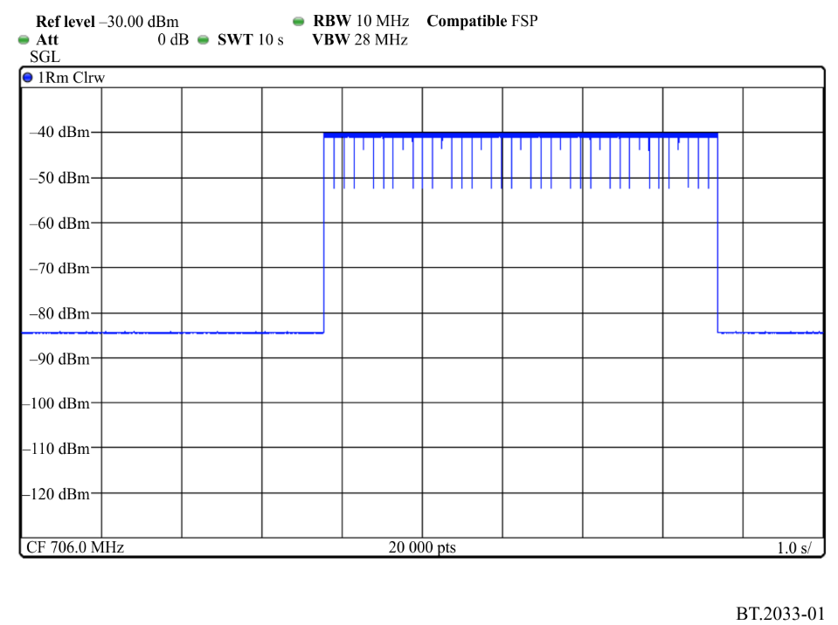
FIGURE 2
Gated LTE 1 Mbit/s signal
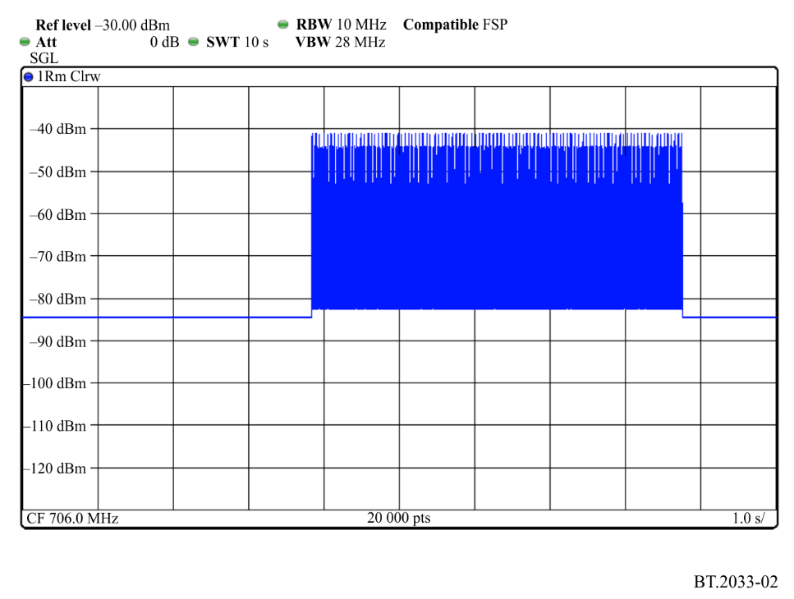

2.2 Frequency offsets
Centre frequency offsets between DVB-T2 and LTE of +11 and +18 MHz have been considered (i.e. interfering signals of 717 and 724 MHz). Assuming an LTE signal of bandwidth 10 MHz, these would represent the LTE UE interference into an adjacent TV channel separated by a guard band of either 2 MHz or 9 MHz from the LTE uplink band.

2.3 Measurement procedure
The protection ratio was found by combing the wanted and interfering signals and presenting them to the DTT receiver under test. The wanted signal was increased until satisfactory signal decoding occurred. Full details of the measurement procedure can be found in [1].

2.4 Receivers tested
In this early phase of work, three receivers were selected for test.
TABLE 20
Receiver | Type | Tuner type
R1 | STB/PVR | Silicon
R2 | STB | Can
R3 | STB | Can

3 Results
The data presented represents the protection ratios measured using the test equipment, which incorporated an arbitrary signal generator with a good adjacent channel leakage ratio (ACLR); better than 50 dB in the first adjacent channel. No correction has been made to account for the likelihood that LTE equipment will have a worse adjacent channel performance than the test equipment used.
Previous results [1] corrected the protection ratios according to the specified out of band performance of LTE equipment, and showed that this can be more significant than the selectivity of the receiver.
Figures 3 to 8 show the performance of the receivers currently tested in the presence of the transient interference provided by the LTE UE 20 Mbit/s and 1 Mbit/s waveforms. For reference, the performance of the receivers with the non-transient waveforms is also plotted.
FIGURE 3
Receiver R1 11 MHz offset
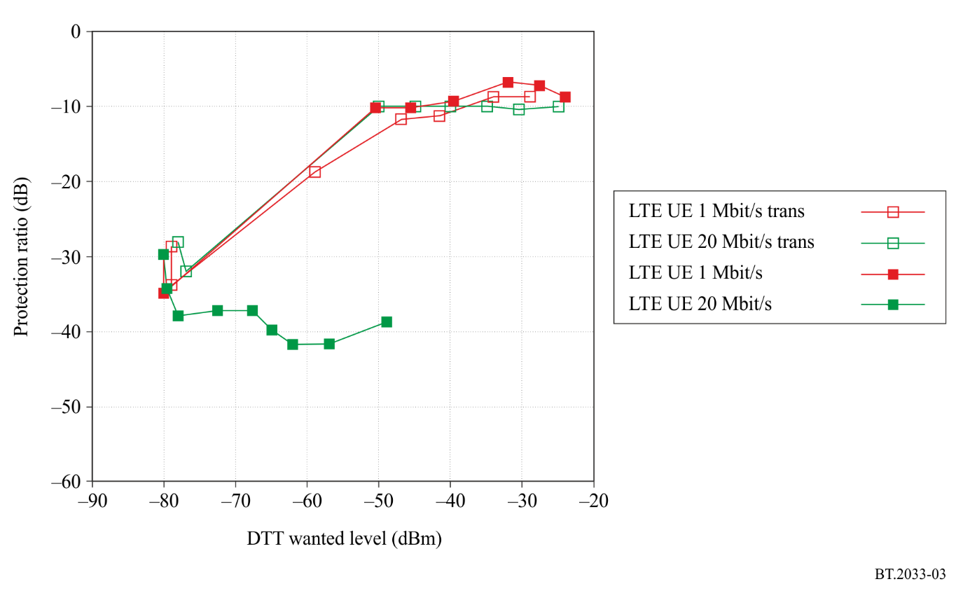
FIGURE 4
Receiver R1 18 MHz offset
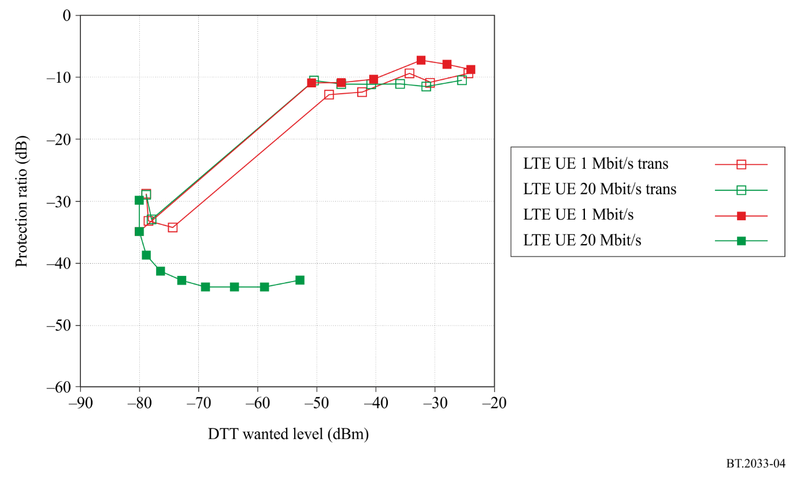
FIGURE 5
Receiver R2 11 MHz offset
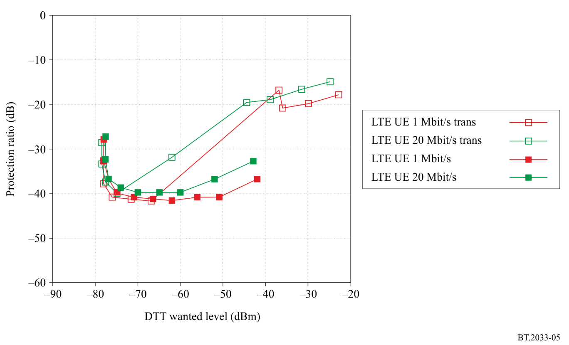
FIGURE 6
Receiver R2 18 MHz offset
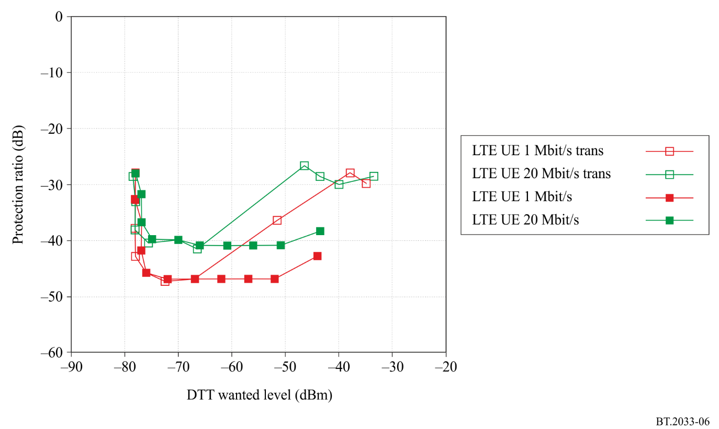
FIGURE 7
Receiver R3 11 MHz offset
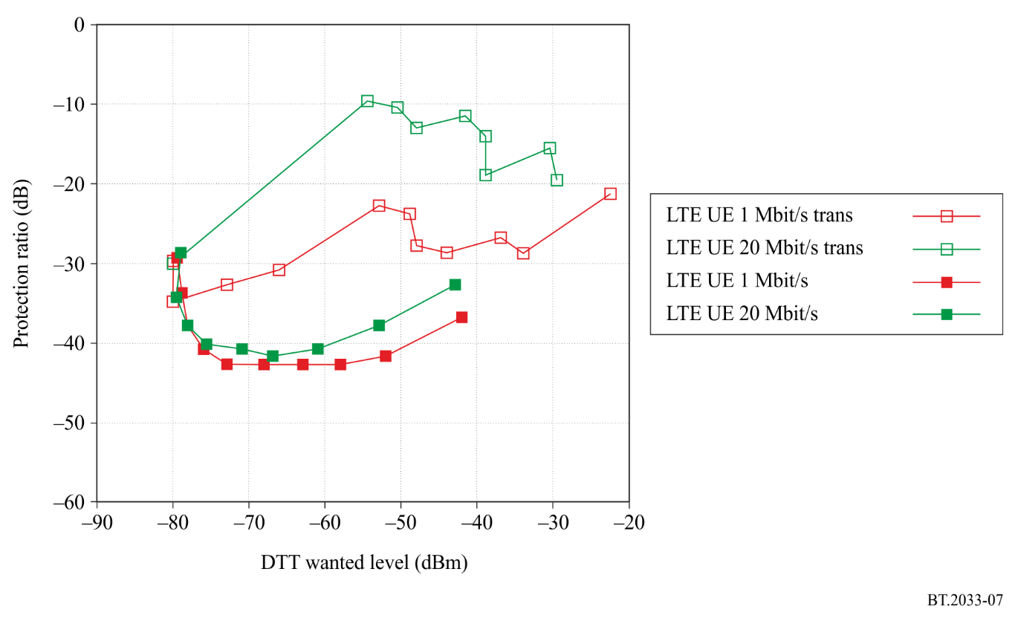
FIGURE 8
Receiver R3 18 MHz offset
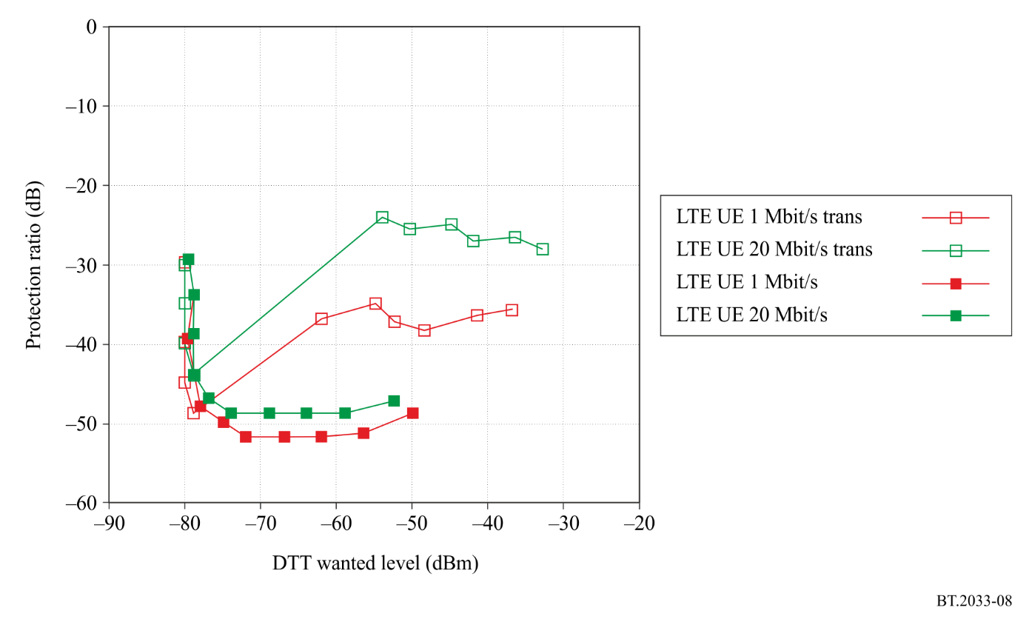

4 Conclusions
R1 is shown to perform poorly with the non-transient version of the low traffic waveform. When the transient version of either waveform is used, similar performance to the non-transient low traffic case is seen. There is no improvement with increased frequency offset.
Receivers R2 and R3’s performance is adequate with the conventional waveforms (even the low traffic version), but suffers when the transient versions are used. The protection ratio is around 10-12 dB better when the offset is increased from 11 MHz to 18 MHz.
In all cases, it is the transient version of the 20 Mbit/s UE waveform which requires greater protection than the 1 Mbit/s version.
The protection ratio numbers presented in this Recommendation are based on measurements made with a signal generator with a good adjacent channel performance and therefore will need to be corrected to take account of the out-of-band emission figures for LTE hardware.
Although only a small set of receivers has been investigated so far, there is an important conclusion to be drawn that certain units that were previously thought to be less vulnerable to low duty cycle traffic are affected by the transient nature of the switched waveform. As this transient waveform is expected to be a feature of future LTE UE equipment deployments, it is considered important that these interim results based on limited measurements are presented now, with a recommendation that further measurements are undertaken.
References
[1] Document 6A/41 – Measured DVB-T protection ratios and overload thresholds in the presence of LTE signals Source: British Broadcasting Corporation (UK).
[2] ETSI EN 302 755 – Frame structure channel coding and modulation for a second generation digital terrestrial television broadcasting system (DVB-T2).

Attachment 4
to Annex 1
TV tuner technologies and characteristics
The protection ratio and overload threshold can be significantly different for silicon tuners and can tuners. Silicon tuners are increasingly being used in TV receiver equipment including high-end products such as iDTVs and PVRs.
As silicon and can tuners have different performance characteristics, planners are advised to consider the relative usage volumes of each tuner type and the difference in characteristics during network planning. Compared to can tuners, silicon tuners do not suffer from degradations in PR and O_{th} when the interferer is at the 36 MHz IF frequency or at the 2 × IF = 72 MHz image frequency; however some have higher protection ratios at other interferer offsets.
It is likely that a mixture of these types of tuners will exist and their proportion is likely to change with time. This Recommendation provides separate results for each type of tuners. (For further information the technical explanation of the differences can be found in Report ITU-R BT.2215 – Measurement of protection ratios and overload threshold for TV receivers.)
For the case of larger guardbands where the can tuner image channel may not coincide with N+9, PR and O_{th} performance can be estimated by using the N+9 figures for the frequency offset when the image channel occurs, and the N+8 figures for the nearby frequency offsets that are close but not on image channel frequency offset.

Annex 2
(Normative)
Planning criteria, including protection ratios, for DVB second generation
digital terrestrial television systems in the VHF/UHF bands
for 6 MHz channel bandwidth

1 Protection ratios for 6 MHz DVB-T2 wanted digital terrestrial television signal
The following Tables show the protection ratios for 6 MHz DVB-T2 digital terrestrial television signal interfered with by:
1) 6 MHz DVB-T2 digital terrestrial television signal;
2) 6 MHz ISDB-T digital terrestrial television signal;
3) 6 MHz NTSC analogue terrestrial television signal.
Ricean channel protection ratios are provided, which models roof fixed reception using a directional antenna.

1.1 Protection ratios for a wanted DVB-T2 signal interfered with by a digital terrestrial television signal
The co-channel protection ratios depend on the modulation and the FEC rate of the desired signal. Neither the FFT size of the interferer signal nor the usage of the extended bandwidth mode affects the co-channel protection ratios.
Recommended values are presented in Table 21. The effect of pilot pattern can be considered negligible because variations are of the order of tenths of a dB.
TABLE 21
Co-channel protection ratios (dB) of a DVB-T2 signal
(Ricean channel) interfered with by a DVB-T2 signal (BW = 6 MHz)
Modulation | FEC rate | Protection ratio | Modulation | FEC rate | Protection ratio
QPSK | 1/2 | 6 | 64-QAM | 1/2 | 13
QPSK | 3/5 | 6 | 64-QAM | 3/5 | 15
QPSK | 2/3 | 7 | 64-QAM | 2/3 | 16
QPSK | 3/4 | 8 | 64-QAM | 3/4 | 18
QPSK | 4/5 | 8 | 64-QAM | 4/5 | 19
QPSK | 5/6 | 9 | 64-QAM | 5/6 | 20
16-QAM | 1/2 | 11 | 256-QAM | 1/2 | 17
16-QAM | 3/5 | 12 | 256-QAM | 3/5 | 20
16-QAM | 2/3 | 13 | 256-QAM | 2/3 | 21
16-QAM | 3/4 | 14 | 256-QAM | 3/4 | 23
16-QAM | 4/5 | 15 | 256-QAM | 4/5 | 24
16-QAM | 5/6 | 16 | 256-QAM | 5/6 | 26

The adjacent channel protection ratios for wanted DVB-T2 signals interfered with by DVB-T2 signals are affected by the modulation and the FEC rate of the wanted signal.
Table 22 shows the protection ratios for the lower and the upper adjacent channel.
TABLE 22
Adjacent channel protection ratios (dB) for wanted DVB-T2 signal
(Ricean channel) interfered with by a DVB-T2 signal (BW = 6 MHz)
Modulation | FEC rate | Protection ratio  N ± 1 | Modulation | FEC rate | Protection ratio  N ± 1
QPSK | 1/2 | –43 | 64-QAM | 1/2 | –39
QPSK | 3/5 | –43 | 64-QAM | 3/5 | –39
QPSK | 2/3 | –42 | 64-QAM | 2/3 | –39
QPSK | 3/4 | –42 | 64-QAM | 3/4 | –39
QPSK | 4/5 | –42 | 64-QAM | 4/5 | –37
QPSK | 5/6 | –42 | 64-QAM | 5/6 | –35
16-QAM | 1/2 | –42 | 256-QAM | 1/2 | –39
16-QAM | 3/5 | –42 | 256-QAM | 3/5 | –38
16-QAM | 2/3 | –41 | 256-QAM | 2/3 | –36
16-QAM | 3/4 | –40 | 256-QAM | 3/4 | –33
16-QAM | 4/5 | –40 | 256-QAM | 4/5 | –31
16-QAM | 5/6 | –40 | 256-QAM | 5/6 | –29

Co-channel protection ratios for wanted DVB-T2 signal interfered with by ISDB-T signal are shown in Table 23. These protection ratios are affected primarily by the modulation and coding rate of the useful signal.
The ISDB-T standard has an optional +1/7 MHz frequency offset. This offset has an effect on the protection ratios as explained in the Note 1 of Table 23 and Note 1 of Table 24.
TABLE 23
Co-channel protection ratios (dB) for wanted DVB-T2 signal (Ricean channel)
interfered with by ISDB-T signal (BW = 6 MHz). (See Note 1)
Modulation | FEC rate | Protection ratio | Modulation | FEC rate | Protection ratio
QPSK | 1/2 | 6 | 64-QAM | 1/2 | 13
QPSK | 3/5 | 6 | 64-QAM | 3/5 | 15
QPSK | 2/3 | 7 | 64-QAM | 2/3 | 16
QPSK | 3/4 | 8 | 64-QAM | 3/4 | 18
QPSK | 4/5 | 8 | 64-QAM | 4/5 | 19
QPSK | 5/6 | 9 | 64-QAM | 5/6 | 20
16-QAM | 1/2 | 11 | 256-QAM | 1/2 | 17
16-QAM | 3/5 | 12 | 256-QAM | 3/5 | 20
16-QAM | 2/3 | 13 | 256-QAM | 2/3 | 21
16-QAM | 3/4 | 14 | 256-QAM | 3/4 | 23
16-QAM | 4/5 | 15 | 256-QAM | 4/5 | 24
16-QAM | 5/6 | 16 | 256-QAM | 5/6 | 26
NOTE 1 – In the case of ISDB-T signal with + 1/7 MHz frequency offset, the co-channel protection ratios should be decreased by 1 dB.

Table 24 shows the adjacent channel protection ratios for wanted DVB-T2 signal interfered with by ISDB-T signal. These protection ratios are affected by the modulation and FEC rate of the useful signal and optional offset used in the interfering signal.
TABLE 24
Adjacent channel protection ratios (dB) for wanted DVB-T2 (Ricean channel) signal interfered with by ISDB-T signal (BW = 6 MHz) (See Note 1)
Modulation | FEC rate | Protection ratio  N ± 1
QPSK | 1/2 | –46
QPSK | 3/5 | –46
QPSK | 2/3 | –45
QPSK | 3/4 | –45
QPSK | 4/5 | –45
QPSK | 5/6 | –45
16-QAM | 1/2 | –45
16-QAM | 3/5 | –45
16-QAM | 2/3 | –44
16-QAM | 3/4 | –43
16-QAM | 4/5 | –43
16-QAM | 5/6 | –43
TABLE 24 (end)
Modulation | FEC rate | Protection ratio  N ± 1
64-QAM | 1/2 | –42
64-QAM | 3/5 | –42
64-QAM | 2/3 | –42
64-QAM | 3/4 | –42
64-QAM | 4/5 | –40
64-QAM | 5/6 | –38
256-QAM | 1/2 | –42
256-QAM | 3/5 | –41
256-QAM | 2/3 | –39
256-QAM | 3/4 | –36
256-QAM | 4/5 | –34
256-QAM | 5/6 | –32
NOTE 1 – In the case of ISDB-T signal with + 1/7 MHz frequency offset, the lower adjacent channel protection ratios should be decreased by 1 dB and the upper adjacent channel protection ratios should be increased by 2 dB.

1.2 Protection ratios for a wanted DVB-T2 signal interfered with by an analogue terrestrial television signal
In the case of a DVB-T2 digital terrestrial television signal interfered with by an analogue television signal, the co-channel protection ratios depend on the modulation and the FEC rate of the DVB-T2 signal.
Table 25 shows values based on the modulation and FEC rate.
TABLE 25
Co-channel protection ratios (dB) for wanted DVB-T2 signal (Ricean channel) interfered with
by NTSC analogue terrestrial television signal (BW = 6 MHz)
Modulation | FEC rate | Protection ratio | Modulation | FEC rate | Protection ratio
QPSK | 1/2 | –13 | 64-QAM | 1/2 | –5
QPSK | 3/5 | –12 | 64-QAM | 3/5 | –3
QPSK | 2/3 | –11 | 64-QAM | 2/3 | –1
QPSK | 3/4 | –9 | 64-QAM | 3/4 | 2
QPSK | 4/5 | –9 | 64-QAM | 4/5 | 4
QPSK | 5/6 | –7 | 64-QAM | 5/6 | 5
16-QAM | 1/2 | –10 | 256-QAM | 1/2 | –3
16-QAM | 3/5 | –8 | 256-QAM | 3/5 | 2
16-QAM | 2/3 | –8 | 256-QAM | 2/3 | 3
16-QAM | 3/4 | –5 | 256-QAM | 3/4 | 6
16-QAM | 4/5 | –4 | 256-QAM | 4/5 | 6
16-QAM | 5/6 | –5 | 256-QAM | 5/6 | 9

In the case of adjacent channel interference, the protection ratios are primarily affected by the same factors as in the case of co-channel. That is, modulation and FEC rate of the useful signal DVB-T2.
In Table 26 are presented the values for the upper and lower adjacent channels N ± 1.
For adjacent channels N ± 2 measurements have been performed for configurations 64-QAM 3/5 and 64-QAM 3/4. The protection ratio values are –39 dB and –35 dB respectively.
TABLE 26
Adjacent channel N ± 1 protection ratios (dB) for wanted DVB-T2 signal (Ricean channel) interfered with by NTSC analogue terrestrial television signal (BW = 6 MHz)
Modulation | FEC rate | Protection ratio  N ± 1 | Modulation | FEC rate | Protection ratio  N ± 1
QPSK | 1/2 | –1 | 64-QAM | 1/2 | –29
QPSK | 3/5 | –39 | 64-QAM | 3/5 | –27
QPSK | 2/3 | –36 | 64-QAM | 2/3 | –25
QPSK | 3/4 | –33 | 64-QAM | 3/4 | –22
QPSK | 4/5 | –32 | 64-QAM | 4/5 | –20
QPSK | 5/6 | –30 | 64-QAM | 5/6 | –19
16-QAM | 1/2 | –34 | 256-QAM | 1/2 | –25
16-QAM | 3/5 | –32 | 256-QAM | 3/5 | –22
16-QAM | 2/3 | –29 | 256-QAM | 2/3 | –20
16-QAM | 3/4 | –27 | 256-QAM | 3/4 | –17
16-QAM | 4/5 | –26 | 256-QAM | 4/5 | –16
16-QAM | 5/6 | –24 | 256-QAM | 5/6 | –14

Annex 3
(Informative)
Additional test results

1 Additional test result from the UK
A set of measurements on the performance of TV receivers in the presence of LTE base station signals were performed by the UK to support a field trial and subsequent modelling analysis and assessment.
The report on the protection ratio measurements for LTE base stations into DVB-T and T2 reception in a comparative way is attached as an embedded word file below.
The testing covered the fixed roof top reception modes in use in the UK. For DVB-T this is 8k at 64-QAM 2/3 using MPEG-2, while for DVB-T2 the mode is 32k at 256-QAM 2/3 with MPEG-4. The transmissions are in the 8 MHz bandwidth channels of the standard European raster. The two transmission modulation modes were chosen to give almost the same transmission coverage, and this has been proven in practice during the ongoing digital switchover in the UK.
The LTE base station signals were recorded from an actual unit in both fully loaded and idle formats and could be played back through a signal generator and amplifier plus filtering. The transmission mask of the 10 MHz LTE signal was set to conform to EC Decision 2010/267/EU for the 800 MHz band.
The units tested included TV sets, set top boxes, and a personal video recorder with twin tuners.

2 Additional test result from the Russian Federation
The attached contribution presents the results of the preliminary comparative evaluation of DVB-T and DVB-T2 system characteristics on the basis of measurements performed in the Russian Federation.

Annex 4
(Normative)
Other planning factors

1 Field strength distribution with location
It is to be expected that the distributions of field strength with location for digital television signals will not be the same as those applicable to analogue television signals. Recommendation ITU-R P.1546 includes the standard deviation for the analogue and for the digital case in Tables 1, 2 and 3 for 100 MHz, 600 MHz and 2 000 MHz, respectively.
The results of propagation studies for digital systems are given in Fig. 9 for the VHF and UHF bands. The figure corresponds to a standard deviation of 5.5 dB. These results may also be used to derive propagation prediction curves for location percentages other than 50%. Refer to Recommendation ITU-R P.1546 for the location percentages other than 50% for analogue and digital systems, where the digital system bandwidth is greater than 1.5 MHz.
FIGURE 9
Ratio (dB) of the field strength for a given percentage of the receiving
locations to the field strength for 50% of the receiving locations
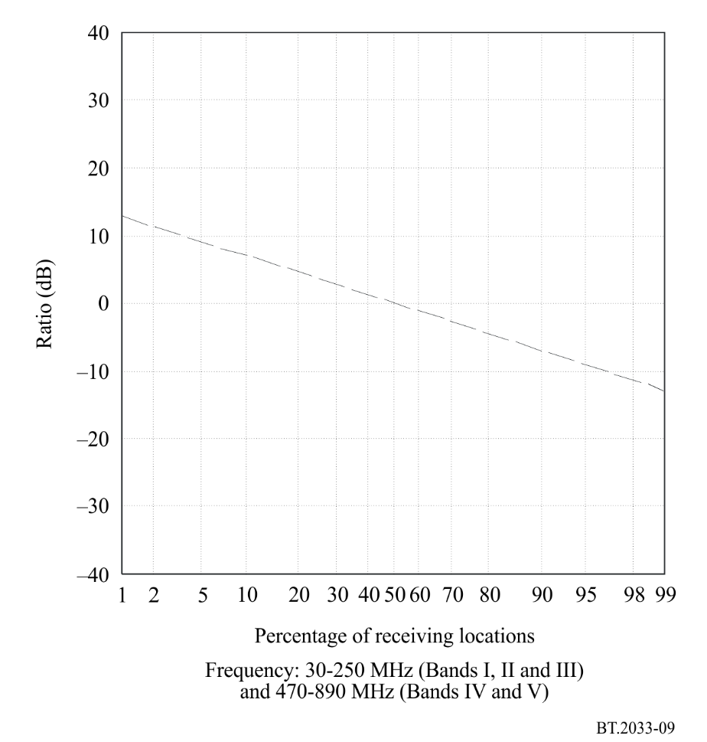

2 Reception using portable equipment inside buildings and vehicles

2.1 Height loss: L_{h}
For land paths, the curves in Recommendation ITU-R P.1546 give field-strength values for a receiving antenna height above ground equal to the representative height of ground cover around the receiving antenna location. Subject to a minimum height value of 10 m, examples of reference heights are 20 m for an urban area, 30 m for a dense urban area and 10 m for a suburban area. (For sea paths, the notional value is 10 m.)
If the receiving antenna height is different from the representative height, a correction is applied to the field strength taken from the curves of Recommendation ITU-R P.1546 according to a procedure given in the Recommendation.

2.2 Building entry loss: L_{b}
Losses due to penetration into a building depend significantly on the building material, angle of incidence and frequency. Consideration should also be given as to whether reception is in an interior room or in one located near an exterior wall. The building entry loss is defined as the difference (dB) between the mean field strength inside a building at a given height above ground level and the mean field strength outside the same building at the same height above ground level.
Whilst no single comprehensive formula is available for computing building entry loss, useful statistical information based on measured losses in several types of building, at frequencies from about 500 MHz to 5 GHz, are given in Recommendation ITU-R P.679. Once inside the building, propagation loss due to walls and floors are dealt with in Recommendation ITU-R P.1238.
A large spread of building entry losses has been measured. Table 27 gives three classes of the relative possibilities to achieve indoor reception and the corresponding mean and standard deviation values of the building entry losses, for the same outdoor field strength, based on UHF measurements.
TABLE 27
Building entry loss variations in the UHF Bands IV/V
Classification of the relative possibilities  to achieve indoor reception | Mean building entry loss  (dB) | Standard deviation  (dB)
High | 7 | 5
Medium | 11 | 6
Low | 15 | 7

Examples of buildings with different relative possibilities to achieve indoor reception:

High:
– suburban residential building without metallised glass windows;
– room with a window on the exterior wall in an apartment in an urban environment.

Medium:
– exterior rooms in an urban environment with metallised glass windows;
– inner rooms in an apartment in an urban environment.

Low:
– inner rooms in office buildings.
If more precise values based on local measurements are available, these could be used as a basis for planning a specific service.

2.3 Vehicle entry loss: L_{v}
For reception with a hand-held device inside a vehicle, the vehicle body loss should be taken into account. A typical vehicle entry loss for the UHF Bands IV/V, based on cellular radio experience, is 6 dB.

3 Receiving antenna discrimination
Information concerning the directivity and polarization discrimination of domestic receiving antennas is given in Recommendation ITU-R BT.419.

4 Antennas for portable and mobile receivers

4.1 Antennas for portable reception
A spread in antenna gain has been measured for different types of antenna. The following antenna gain values are typical:
TABLE 28
Antenna gain (dBd) for portable reception
Band | Gain  (dBd)
VHF Band III | –2
UHF Band IV | 0
UHF Band V | 0

No polarization discrimination is expected.

4.2 Antennas for hand-held reception
The antenna in a small hand-held terminal has to be an integral part of the terminal construction and will therefore be small when compared to the wavelength. Current understanding of the design problem indicates that the worst-case antenna gain is in the lowest part of the UHF band. The antenna gain for three frequencies in the UHF band is given in Table 29. Nominal antenna gain between these frequencies can be obtained by linear interpolation.
TABLE 29
Antenna gain (dBd) for hand-held reception
Frequency  (MHz) | Gain  (dBd)
474 | –12
698 | –9
858 | –7

Generally, no polarization discrimination is expected from this type of portable reception antenna and the radiation pattern in the horizontal plane is omnidirectional.

4.3 Antennas for mobile reception
The practical standard antenna for vehicle reception is l/4 monopole, which uses the metallic roof as a ground plane. The antenna gain for conventional incident wave angles depends on the position of the antenna on the roof. For passive antenna systems the values in Table 30 can be expected.
TABLE 30
Antenna gain (dBd) for mobile reception
Band | Gain  (dBd)
VHF Band III | –5
UHF Band IV | –2
UHF Band V | –1

The polarization discrimination is theoretically about 4 to 10 dB depending on the roof position of the antenna.

5 Man-Made Noise (MMN)
For planning purposes, the man-made noise figures in Tables 31 and 32 are used.
TABLE 31
Allowance for man-made noise used in the calculation for urban areas
Urban | Band III | Bands IV/V
Allowance for man-made noise
Relevant value for integrated antenna in a handheld portable receiver | 0 | 0
Relevant value for external antenna* in a handheld portable receiver | 1 | 0
Relevant value for rooftop antenna | 2 dB | 0 dB
Relevant value for adapted antenna for portable and mobile receivers | 8 dB | 1 dB
* Telescopic or wired handsets.

TABLE 32
Allowance for man-made noise used in the calculation for rural areas
Rural | Band III | Bands IV/ V
Allowance for man-made noise
Relevant value for integrated antenna in a handheld portable receiver | 0 | 0
Relevant value for external antenna* in a handheld portable receiver | 0 | 0
Relevant value for rooftop antenna | 2 dB | 0 dB
Relevant value for adapted antenna for portable and mobile receivers | 5 dB | 0 dB
* Telescopic or wired handsets.

Annex 5
(Informative)
Failure point assessment methods

1 Subjective failure point (SFP) method for protection ratio measurements
For domestic receivers it may not be possible to measure the BER and therefore a new method called the SFP method has been proposed for protection ratio measurements in a unified manner. The quality criterion for protection ratio measurements is to find a limit for a just error-free picture at the TV screen. The RF protection ratio for the wanted DVB-T2 signal is a value of wanted-to-unwanted signal ratio at the receiver input, determined by the SFP method, and rounded to the next higher integer value.
The SFP method corresponds to the picture quality where no more than one error is visible in the picture for an average observation time of 20 s over 30 s. The adjustment of the wanted and unwanted signal levels for the SFP method is to be carried out in small steps, usually in steps of 0.1 dB. For a “noise-like” interferer the difference in a value of wanted-to-unwanted signal ratio between the QEF condition (post BCH BER of 1 × 10–11) and the SFP method is a few points of a dB due to the sharp “waterfall” characteristic of LDPC decoding. Historically, protection ratio values for wanted digital TV signals are measured with a receiver input power of −60 dBm. Where possible, protection ratios for digital TV systems are derived from measurements using a range of signal levels as described in the recommended methodology (Report ITU-R BT.2215).
It is proposed that the SFP method should be adopted for assessment of all DTTB systems. (For the digital system ISDB-T this method will be studied in Japan.)

Annex 6
(Normative)
Tropospheric and continuous interference

1 Tropospheric and continuous interference
When using the protection ratios in planning, it is necessary to determine whether, in particular circumstances, the interference should be considered as tropospheric or continuous. This can be done by comparing the nuisance fields for the two conditions, the nuisance field being defined as the field strength of the interfering transmitter (at its pertinent e.r.p.) enlarged by the relevant protection ratio.
Thus, the nuisance field for continuous interference:

EC = E(50, 50) + P + AC
and the nuisance field for tropospheric interference:

ET = E(50, t) + P + AT
where:
E(50, t) : field strength (dB(μV/m)) of the interfering transmitter, normalized to 1 kW, and exceeded during t % of the time
P : e.r.p. (dB(1 kW)) of the interfering transmitter
A : protection ratio (dB)
C and T : continuous and tropospheric interference, respectively.
The protection ratio for continuous interference is applicable when the resulting nuisance field is stronger than that resulting from tropospheric interference, that is, when EC > ET.
This means that AC should be used in all cases when:
$$E\left(50, 50\right)+A_{C}>E\left(50, t\right)+A_{T}$$

Annex 7
(Normative)
Planning criteria, including protection ratios, for ATSC 3.0 second generation digital terrestrial television systems in the VHF/UHF bands

1 Protection ratios for ATSC 3.0 digital terrestrial television signals
1.1 The co-channel and adjacent channel interference protection ratios (or desired-to-undesired signal ratios, D/U) with respect to other ATSC signals should not exceed the thresholds listed in Table 5.2 of CTA-CEB32.2, reproduced here as Table 33. The 256 QAM and 4096 QAM constellations shown here are representative of one recommended option, and the least-robust modulation option, respectively. The accompanying conditions are, for 256 QAM – 13/15 code rate with 32K FFT and 64 800-bit codelength, and for 4096 QAM – 13/15 code rate with 32K FFT and 64800 bit codelength. The ATSC 1.0 transmission parameters are as given in ATSC RP A/54A, Table 8.1, Terrestrial Mode: 6 MHz channel, 8-VSB modulation, 2/3 rate Trellis code.
TABLE 33
Co-channel rejection thresholds
Interference type | Planning factor co-channel D/U ratio (dB)³  Desired power = sensitivity + 20 dBm
ATSC 1.0 interference into desired ATSC 3.0 | 32.8 dB (256 QAM), < 48.3 dB (optional 4096 QAM)
ATSC 3.0 interference into desired ATSC 1.0 | 15.5 dB
ATSC 3.0 interference into desired ATSC 3.0 | 32.8 dB (256 QAM), < 48.3 dB (optional 4096 QAM)

1.2 The adjacent channel interference protection ratios with respect to LTE base station and user equipment interference for ATSC 3.0 are under investigation. The protection ratios for ATSC 1.0 are shown in § 1.3 of Recommendation ITU-R BT.2036-4, which may be useful for ATSC 3.0 planning.

2 Minimum field strengths for ATSC 3.0 terrestrial digital television
2.1 Table 34 provides the ATSC 3.0 link budget for determining minimum field strengths for urban indoor, suburban indoor and quasi-open/rural propagation environments.
TABLE 34
ATSC 3.0 | Urban indoor | Suburban indoor | Quasi open /rural
Channel BW (MHz) | 8 | 8 | 8
Transmission BW (MHz]) | 7.78 | 7.78 | 7.78
Transmitter /base station
Transmitter antenna height (m) | 30 | 30 | 30
Frequency (MHz) | 700 | 700 | 700
Wavelength (m) | 0.43 | 0.43 | 0.43
Transmitter power (W) | 40 | 40 | 40
TABLE 34 (cont.)
ATSC 3.0 | Urban indoor | Suburban indoor | Quasi open /rural
Transmitter power (dBm) | 46.0 | 46.0 | 46.0
Transmitter antenna gain (dBd) | 8 | 8 | 8
Cable loss (dB) | 2 | 2 | 2
Equivalent radiated power (ERP) (dBm) | 52.0 | 52.0 | 52.0
Receiver (Tablet)
Diversity | No | No | No
ATSC 3 FFT | 8k | 8k | 8k
Total capacity of mode (Mbit/s) | 3.68 | 3.68 | 3.68
Modulation | 16QAM | 16QAM | 16QAM
Code rate | 2/15 | 2/15 | 2/15
C/N required (Rayleigh) static | 0.50 | 0.50 | 0.50
ATSC 3.0 guard interval | GI1_192 | GI1_192 | GI1_192
Receiver noise bandwidth (MHz) | 7.78 | 7.78 | 7.78
Receiver noise figure (dB) | 7 | 7 | 7
Receiver noise input power (dBW) | −128.0 | −128.0 | −128.0
S/N Signal to noise ratio (dB) | 1.0 | 1.0 | 1.0
Minimum receiver input power (dBW) | −127.0 | −127.0 | −127.0
Antenna gain (dBd) [GdBi = GdBd + 2.15] | −9.2 | −9.2 | −9.2
Body loss | −2.0 | −2.0 | −2.0
Effective antenna aperture (dBm²) | −27.4 | −25.4 | −25.4
Feeder loss (dB) | 0.0 | 0.0 | 0.0
Minimum power flux-density (dBW/m²) | −99.7 | −101.7 | −101.7
Equivalent minimum field strength (dBµV/m) | 46.1 | 44.1 | 44.1
Location probability (%) | 95 | 95 | 95
Outdoor standard deviation (dB) | 5.5 | 5.5 | 5.5
Indoor standard deviation (dB) | 6.0 | 6.0 | 0.0
Combined standard deviation (dB) | 8.1 | 8.1 | 5.5
Location correction factor (dB) | 13.4 | 13.4 | 9.0
Interference allowance (Reuse 1) | 0.0 | 0.0 | 0.0
Height loss (dB) | 0.0 | 0.0 | 0.0
Building penetration loss (dB) | 17.0 | 17.0 | 17.0
Minimum median equivalent field strength (dBµV/m) | 76.5 | 74.5 | 70.1
Minimum required power level@rec_antenna (dBm) - no loc. correction | −88.0 | −97.0 | −97.0
Allowed/Planned propagation loss for cell range (dB) | 109.7 | 111.7 | 116.0
Coverage radius (km) | 0.40 | 0.84 | 2.65
TABLE 34 (end)
ATSC 3.0 | Urban indoor | Suburban indoor | Quasi open /rural
Circle cell area (km²) | 0.51 | 2.24 | 22.09
Approx. SFN cell radius (km) | 0.65 | 1.30 | 3.97
SFN circle cell area (km²) | 1.34 | 5.30 | 49.54

2.2 Table 35 provides an ATSC 3.0 link budget scenario for the use of an external outdoor antenna mounted at a height of 10 metres.
There are several relevant features for this link budget. Since the antenna has some directivity, the channel model used for this case is the Rice model. Using the parameters selected for this use case, a minimum C/N value of 16.9 dB is used. This C/N threshold includes the channel model effects as well as margin for other real-world effects such as channel estimation errors. The ATSC 3.0 parameters are as follows: 64 QAM, 11/15 LDPC code, 32K FFT, pilot mode SP8_4. The downlead is assumed to be 75 feet (22.9 m) of RG-59 coaxial cable.
TABLE 35
Outdoor antenna link budget
Channel centre frequency (MHz) | 69 | 195 | 605
Channel bandwidth (MHz) | 6 | 6 | 6
Antenna gain (dB) | 4.0 | 6.0 | 10.0
Downlead loss (dB) | 1.4 | 2.0 | 4.0
Receiver noise figure (dB) | 7.0 | 7.0 | 7.0
Receiver generated noise (dB) | −99.2 | −99.2 | −99.2
Sky noise (dBm) | −90.0 | −102.4 | −106.2
Equivalent noise at the antenna input (dBm) | −89.7 | −99.8 | −102.6
Channel model | Rice | Rice | Rice
Minimum C/N (dB) | 16.9 | 16.9 | 16.9
Minimum antenna input power (dBm) | −72.8 | −82.9 | −85.7
Dipole factor (dB) | 111.8 | 120.8 | 130.7
Minimum required field strength at antenna (dBuV/m) | 39.0 | 38.0 | 44.9
Required area coverage | 70.0 | 70.0 | 70.0
Distribution factor | 0.5 | 0.5 | 0.5
Standard deviation (dB) | 5.5 | 5.5 | 5.5
Location correction factor (dB) | 2.9 | 2.9 | 2.9
Minimum required field strength at antenna with margin (dBuV/m) | 41.9 | 40.8 | 47.8
Required area coverage (%) | 95.0 | 95.0 | 95.0
Distribution factor | 1.6 | 1.6 | 1.6
Standard deviation (dB) | 5.5 | 5.5 | 5.5
Location correction factor (dB) | 9.0 | 9.0 | 9.0
Minimum required field strength at antenna with margin (dBuV/m) | 48.0 | 47.0 | 54.0

2.3 Table 36 provides an ATSC 3.0 link budget scenario for automotive reception. The antenna has no directivity so the Rayleigh channel model is used. The ATSC 3.0 parameters are as follows: 16 QAM, 5/15 LDPC code, 16K FFT, pilot mode SP4_2. The downlead loss is assumed to be that of 10 feet (3.0 m) of RG-59 coaxial cable.
TABLE 36
Automotive reception link budget
Channel centre frequency (MHz) | 69 | 195 | 605
Channel bandwidth (MHz) | 6 | 6 | 6
Antenna gain (dB) | −4.0 | −2.0 | 0.0
Downlead loss (dB) | 0.2 | 0.3 | 0.6
Receiver noise figure (dB) | 7.0 | 7.0 | 7.0
Receiver generated noise (dB) | −99.2 | −99.2 | −99.2
Sky noise (dBm) | −90.0 | −102.4 | −106.2
Equivalent noise at the antenna input (dBm) | −88.8 | −95.8 | −97.9
Channel model | Rayleigh | Rayleigh | Rayleigh
Minimum C/N (dB) | 7.8 | 7.8 | 7.8
Minimum antenna input power (dBm) | −81.0 | −88.0 | −90.1
Dipole factor (dB) | 111.8 | 120.8 | 130.7
Minimum required field strength at antenna (dBuV/m) | 30.8 | 32.8 | 40.6
Required area coverage | 90.0 | 90.0 | 90.0
Distribution factor | 1.3 | 1.3 | 1.3
Standard deviation (dB) | 5.9 | 5.9 | 5.9
Location correction factor (dB) | 7.7 | 7.7 | 7.7
Minimum required field strength at antenna with margin (dBuV/m) | 38.5 | 40.5 | 48.2
Required area coverage (%) | 99.0 | 99.0 | 99.0
Distribution factor | 2.3 | 2.3 | 2.3
Standard deviation (dB) | 5.9 | 5.9 | 5.9
Location correction factor (dB) | 13.6 | 13.6 | 13.6
Minimum required field strength at antenna with margin (dBuV/m) | 44.4 | 46.4 | 54.1

2.4 The adjacent channel interference protection ratios with respect to LTE base station and user equipment interference for ATSC 1.0 are shown in § 1.3 of Recommendation ITU-R BT.2036-4, which may be useful for ATSC 3.0 planning.

3 References
[1] ATSC Standard A/300, ATSC 3.0 System.
[2] ATSC Standard A/322, Physical Layer Protocol.
[3] ATSC Recommended Practice A/327:2020, Guidelines for the Physical Layer Protocol.
[4] CTA-CEB32.2, Recommended Practice for ATSC 3.0 Television Sets, Physical Layer, (May 2018).
[5] ATSC Recommended Practice A/54A: Guide to the Use of the ATSC Digital Television Standard, including Corrigendum No. 1 (2003, 2006).

Annex 8
(Normative)
Planning criteria for DTMB-A digital television systems
in the VHF/UHF bands

1 Protection ratios for DTMB-A wanted digital terrestrial television signals
Tables 37 and 38 show protection ratios for the DTMB-A wanted signals interfered with by DTMB-A signals and by analogue terrestrial television signals; respectively.

1.1 Protection of a DTMB-A signal interfered with by a DTMB-A signal
TABLE 37
Co-channel protection ratios (dB) for a DTMB-A 8 MHz signal
interfered with by a DTMB-A signal
Modulation | Code rate | Gaussian channel | Ricean channel | Rayleigh channel
QPSK | 1/2 | 2.5 | 3.5 | 5.0
16APSK | 1/2 | 8.0 | 9.0 | 11.0
64APSK | 1/2 | 12.0 | 13.0 | 15.0
256APSK | 1/2 | 16.0 | 17.0 | 19.0
QPSK | 2/3 | 4.5 | 5.5 | 8.0
16APSK | 2/3 | 10.0 | 11.0 | 14.0
64APSK | 2/3 | 15.0 | 16.0 | 19.0
256APSK | 2/3 | 19.5 | 20.5 | 23.0
QPSK | 5/6 | 7.0 | 8.0 | 12.0
16APSK | 5/6 | 12.5 | 14.0 | 18.0
64APSK | 5/6 | 18.5 | 19.5 | 24.0
256APSK | 5/6 | 24.5 | 25.5 | 30.5

Protection ratios are given for three types of propagation channels (i.e. Gaussian, Ricean and Rayleigh). For fixed and portable reception, the values relevant to the Ricean and Rayleigh channels, respectively, should be adopted.
TABLE 38
Protection ratios (dB) for a DTMB-A 8 MHz signal interfered with by a DTMB-A 8 MHz
signal in the lower (N – 1) and upper (N + 1) adjacent channels
Modulation | Code rate | Gaussian channel | Ricean channel | Rayleigh channel
QPSK | 1/2 | −37 | −36 | −34
16APSK | 1/2 | −32 | −31 | −30
64APSK | 1/2 | −28 | −27 | −25
256APSK | 1/2 | −27 | −26 | −24
QPSK | 2/3 | −36 | −35 | −32
16APSK | 2/3 | −31 | −30 | −29
64APSK | 2/3 | −27 | −26 | −24
256APSK | 2/3 | −26 | −24 | −23
QPSK | 5/6 | −33 | −32 | −29
16APSK | 5/6 | −30 | −29 | −28
64APSK | 5/6 | −26 | −25 | −22
256APSK | 5/6 | −23 | −22 | −18

The protection ratio is given in dB and applies to both continuous and tropospheric interference.
The values given apply to the case where wanted and unwanted DTMB-A signals have the same channel width. Other combinations of channel width need further studies.
It is known from measurements of existing receivers that they permit lower protection ratios, but for planning purposes it is an advantage to have this value.

1.2 Protection of DTMB-A signal interfered with by analogue terrestrial television

1.2.1 Protection from co-channel interference
TABLE 39
Co-channel protection ratios (dB) for DTMB-A 8 MHz signal interfered with by analogue
television (non-controlled frequency condition) signals
Modulation | Code rate | Gaussian channel | Ricean channel | Rayleigh channel
QPSK | 1/2 | −5 | −4 | −3
16APSK | 1/2 | −3 | −1 | 2
64APSK | 1/2 | 5 | 3 | 7
256APSK | 1/2 | 5 | 7 | 12
QPSK | 2/3 | −1 | 0 | 4
16APSK | 2/3 | 1 | 2 | 8
64APSK | 2/3 | 7 | 10 | 16
256APSK | 2/3 | 11 | 16 | 19
QPSK | 5/6 | 2 | 3 | 9
16APSK | 5/6 | 8 | 11 | 15
TABLE 39 (end)
Modulation | Code rate | Gaussian channel | Ricean channel | Rayleigh channel
64APSK | 5/6 | 15 | 17 | 24
256APSK | 5/6 | 16 | 18 | 27

1.2.2 Protection from lower adjacent channel (N – 1) interference
TABLE 40
Protection ratios (dB) for lower adjacent channel (N – 1) interference for DTMB-A 8 MHz
signal interfered with by analogue television signals including sound
Wanted signal |  | Unwanted signal PAL-D
Constellation | Code rate | Gaussian channel | Ricean channel | Rayleigh channel
QPSK | 1/2 | −43 | −42 | −39
16APSK | 1/2 | −42 | −41 | −38
64APSK | 1/2 | −40 | −38 | −37
256APSK | 1/2 | −36 | −35 | −33
QPSK | 2/3 | −42 | −40 | −36
16APSK | 2/3 | −41 | −40 | −36
64APSK | 2/3 | −37 | −35 | −33
256APSK | 2/3 | −33 | −32 | −30
QPSK | 5/6 | −39 | −38 | −32
16APSK | 5/6 | −38 | −37 | −32
64APSK | 5/6 | −33 | −32 | −25
256APSK | 5/6 | −30 | −29 | −22

All values are applicable for fixed and portable reception conditions.

1.2.3 Protection from upper adjacent channel (N + 1) interference
TABLE 41
Protection ratios (dB) for upper adjacent channel (N + 1) interference for DTMB-A
8 MHz signal interfered with by an analogue television signal
Wanted signal |  | Unwanted signal PAL-D (dB)
Constellation | Code rate | Gaussian channel | Ricean channel | Rayleigh channel
QPSK | 1/2 | −46 | −45 | −44
16APSK | 1/2 | −45 | −44 | −41
64APSK | 1/2 | −43 | −42 | −40
256APSK | 1/2 | −39 | −38 | −36
QPSK | 2/3 | −46 | −45 | −43
16APSK | 2/3 | −44 | −43 | −39
TABLE 41 (end)
Wanted signal |  | Unwanted signal PAL-D (dB)
Constellation | Code rate | Gaussian channel | Ricean channel | Rayleigh channel
64APSK | 2/3 | −41 | −40 | −38
256APSK | 2/3 | −37 | −36 | −30
QPSK | 5/6 | −47 | −45 | −40
16APSK | 5/6 | −40 | −39 | −37
64APSK | 5/6 | −35 | −34 | −29
256APSK | 5/6 | −33 | −32 | −25

2 Protection ratios for wanted analogue terrestrial television signals interfered with by unwanted DTMB-A 8 MHz signals
Tables 42 to 46 show protection ratios for a wanted analogue television signal interfered with by a DTMB-A signal.

2.1 Protection of wanted vision signals interfered with by DTMB-A 8 MHz signal
In this section, the protection ratios for an analogue wanted signal interfered by an unwanted DTMB-A signal relate only to the interference to the vision signal.

2.1.1 Protection from co-channel interference
TABLE 42
Protection ratios (dB) for a wanted analogue vision signal interfered with by
an unwanted DTMB-A 8 MHz signal
Wanted signal:  analogue system | Unwanted signal: DTMB-A, 8 MHz
 | Tropospheric interference | Continuous interference
PAL-D | 34 | 40
D/SECAM | 34 | 40

2.1.2 Protection from lower adjacent channel interference
TABLE 43
Protection ratios (dB) for a wanted analogue vision signal interfered with by
DTMB-A 8 MHz signal (lower adjacent channel)
Wanted signal:  analogue system | Unwanted signal: DTMB-A 8 MHz  (lower adjacent channel)
 | Tropospheric interference | Continuous interference
PAL-D | −9 | −5
D/SECAM | −13 | −9

2.1.3 Protection from upper adjacent channel interference
TABLE 44
Protection ratios (dB) for a wanted analogue vision signal interfered with
by DTMB-A 8 MHz signal (upper adjacent channel)
Wanted signal:  analogue system | Unwanted signal: DTMB-A 8 MHz  (upper adjacent channel)
 | Tropospheric interference | Continuous interference
PAL-D | −8 | −5
D/SECAM | −15 | −12

2.1.4 Protection from image channel interference
TABLE 45
Protection ratios (dB) for a wanted analogue vision signal interfered with by
a DTMB-A 8 MHz signal (image channel)
Wanted signal:  analogue system | Unwanted signal: DTMB-A 8 MHz  (N + 9 channel)
 | Tropospheric interference | Continuous interference
PAL-D | −19 | −15
D/SECAM | −16 | −11

2.1.5 Protection from adjacent and overlapping channel interference
TABLE 46
Protection ratios (dB) for an analogue vision signal interfered with by
a DTMB-A 8 MHz signal (overlapping channels)
Centre frequency of the unwanted DTMB-A signal minus the vision carrier frequency of  the wanted analogue television signal  (MHz) | Protection ratio
 | Tropospheric interference | Continuous interference
− 8.25 | −20 | −15
(N − 1) −5.25 | −13 | −9
− 4.75 | −11 | −4
− 4.25 | 5 | 13
−3.75 | 24 | 30
−3.25 | 29 | 36
−2.25 | 33 | 39
−1.25 | 34 | 40
(N) 2.75 | 34 | 40
4.75 | 34 | 40
TABLE 46 (end)
Centre frequency of the unwanted DTMB-A signal minus the vision carrier frequency of  the wanted analogue television signal  (MHz) | Protection ratio
 | Tropospheric interference | Continuous interference
5.75 | 30 | 37
6.75 | 27 | 34
7.75 | 25 | 32
8.75 | 5 | 11
(N + 1) 10.75 | −15 | −12
12.75 | −15 | −12

3 Minimum field strengths for DTMB-A fixed reception
The formula for calculating minimum field strength is given in Attachment 1 to this Annex.
TABLE 47
Calculation of minimum field strength DTMB-A 8 MHz system
Frequency (MHz) | 65 |  |  | 200 |  |  | 500 |  |  | 700
Receiver noise figure, F (dB) | 5 | 5 | 5 | 5 | 5 | 5 | 7 | 7 | 7 | 7 | 7 | 7
Receiver carrier/noise ratio ⁽¹⁾ (C/N) (dB) | 8 | 14 | 20 | 8 | 14 | 20 | 8 | 14 | 20 | 8 | 14 | 20
Feeder loss A_{f} (dB) | 1 | 1 | 1 | 3 | 3 | 3 | 3 | 3 | 3 | 5 | 5 | 5
Antenna gain, G (dB) | 3 | 3 | 3 | 5 | 5 | 5 | 10 | 10 | 10 | 12 | 12 | 12
Minimum field strength for fixed reception,  E_{min} (dB(µV/m))⁽¹⁾ | 17 | 23 | 29 | 27 | 33 | 39 | 33 | 39 | 45 | 35 | 41 | 47
⁽¹⁾ For formula, see Attachment 1 to this Annex.

4 Minimum median field strength for mobile DTMB-A reception
The equations for calculating the minimum median field strength are given in Attachment 1 to this Annex. The input values to the calculation are found in this section and in Attachment 1. Mobile reception should be calculated with a location probability of 99%.

4.1 Required average C/N for mobile reception
For a given DTMB-A mode the required average C/N for a certain quality level is a function of Doppler frequency only, and a graph like the one presented in Fig. 10.
FIGURE 10
Required average C/N in a mobile propagation channel
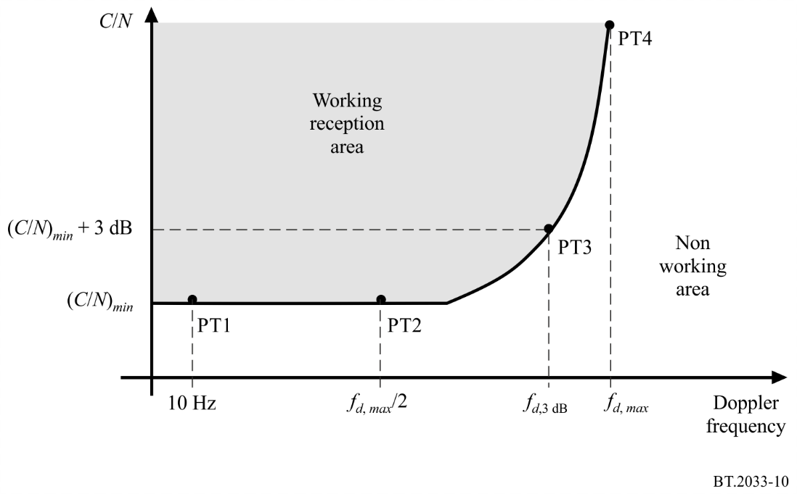
The minimum required average C/N values (C/N_{min}), Doppler frequency for an average C/N equal to C/N_{min} + 3 dB and the maximum Doppler (speed) limits for mobile reception without diversity are given in Table 48. The speed limits for C/N_{min} + 3 dB are given for four frequencies (65 MHz, 200 MHz, 500 MHz and 700 MHz). The average C/N value, C/N_{min} + 3 dB, is suitable for calculation of required field strength. The values are based on the typical channel profile ‘typical urban’ shown in Table 49. Quality criterion is the subjective failure point (SFP) corresponding to erroneous seconds ratio, –ESR = 5% with 5 minutes.
TABLE 48
Required average C/N for 8 MHz DTMB-A system, speed limits for mobile
reception for the non-diversity case
Modulation | Code  rate | Bit rate  (Mbit/s) | C/N_{min}  (dB) at C_{f} =  762 MHz,  F_{d} = 70 Hz | F_{d} at  C/N_{min}  + 3 dB  (Hz) | Speed at F_{d}, 3 dB (km/h)
 |  |  |  |  | 65 MHz | 200 MHz | 500 MHz | 700 MHz
QPSK | 1/2 | 6.71 | 7 | 160 | 2 658 | 864 | 345 | 246
QPSK | 2/3 | 8.94 | 10 | 140 | 2 326 | 756 | 302 | 216
16QAM | 1/2 | 13.41 | 12 | 130 | 2 160 | 702 | 280 | 200
16QAM | 2/3 | 17.88 | 16 | 120 | 1 993 | 648 | 259 | 185
64QAM | 1/2 | 20.12 | 17 | 120 | 1 993 | 648 | 259 | 185
64QAM | 2/3 | 26.82 | 21 | 100 | 1661 | 540 | 216 | 154

TABLE 49
Channel profile for measurement of required average C/N for
mobile reception of DTMB-A reception ‘typical urban’
Tap  number | Delay  (µs) | Power  (dB) | Doppler  category
1 | 0 | –3 | Ricean
2 | 0.2 | 0 | Ricean
3 | 0.5 | –2 | Ricean
4 | 1.6 | –6 | Ricean
5 | 2.3 | –8 | Ricean
6 | 5 | –10 | Ricean

The performance in a mobile channel depends to large extent on the design of the DTMB-A receiver. Improvements may be achieved with receivers particularly designed for mobile reception.

4.2 Receiver noise figure
Noise figure of 7 dB is for integrated vehicle mobile receivers.

Attachment 1
to Annex 8
Calculation of minimum field strength and minimum
median equivalent field strength
The minimum field strength and minimum median equivalent field strength values calculated using the following equations:
P_{n} = F + 10 log (k T₀ B)
P_{s min} = C/N + P_{n}
A_{a} = G + 10 log (1.64λ²/4 π)
φ_{min} = P_{s min} – A_{a} + L_{f}
E_{min} = φ_{min} + 120 + 10 log (120 π)
= φ_{min} + 145.8
E_{med} = E_{min} + P_{mmn} + C_{l} for roof top level fixed reception
E_{med} = E_{min} + P_{mmn} + C_{l} + L_{h} for portable outdoor and
mobile reception
E_{med} = E_{min} + P_{mmn} + C_{l} + L_{h} + L_{b} for portable indoor and mobile
hand-held reception
C₁ = µ ⋅ σ_{t}
σ_{t} =
where:
P_{n} : receiver noise input power (dBW)
F : receiver noise figure (dB)
k : Boltzmann’s constant (k = 1.38 × 10^{–23} (J/K))
T₀ : reference temperature expressed in absolute temperature (T₀ = 290 (K))
B : receiver noise bandwidth (B = 5.67× 10⁶ (Hz) for 6 MHz RF bandwidth, B = 6.62× 10⁶ (Hz) for 7 MHz RF bandwidth and B = 7.56× 10⁶ (Hz) for 8 MHz RF bandwidth)
P_{s min} : minimum receiver input power (dBW)
C/N : RF S/N at the receiver input required by the system (dB)
A_{a} : effective antenna aperture (dBm²)
G : antenna gain related to half dipole (dBd)
λ : wavelength of the signal (m)
φ_{min} : minimum pfd at receiving place (dB(W/m²))
L_{f} : feeder loss (dB)
E_{min} : equivalent minimum field strength at receiving place (dB(μV/m))
E_{med} : minimum median equivalent field strength, planning value (dB(μV/m))
P_{mmn} : allowance for man-made noise (dB)
L_{h} : height loss (reception point at 1.5 m above ground level) (dB)
L_{b} : building or vehicle entry loss (dB)
C₁ : location correction factor (dB)
σ_{t} : total standard deviation (dB)
σ_{m} : standard deviation macro-scale (σ_{m} = 5.5 (dB))
σ_{b} : standard deviation building entry loss (dB)
µ : distribution factor being 0.52 for 70%, 1.28 for 90%, 1.64 for 95% and 2.33 for 99%.

“Silicon” tuners are IC-based tuners integrating all tuner circuitry into a small package directly to be fitted onto main boards. The tuned circuits may be completely absent or can be integrated onto the silicon. The silicon chip may be protected from external electromagnetic interference by a metallic cover. When integrated onto the silicon there are different compromises in performance when compared with discrete classical layouts. The units measured represent a mixture of early and recent generations on the market. This technology is still developing.
“Can” tuners are classical super heterodyne tuners housed in a metal enclosure containing discrete components. Classically, there are fixed and tuneable circuits made up from discrete inductors and transistors usually with varactor diode frequency control. The metal enclosure should minimize RF interference and eliminate crosstalk and stray radiation.

