RECOMMENDATION ITU-R BT.1832*
Digital video broadcast-return channel terrestrial (DVB-RCT)
deployment scenarios and planning considerations
(Question ITU-R 16/6)
(2007)
Scope
This Recommendation sets forth some deployment scenarios and considerations to assist regulators whose task it will be to allocate spectrum for interactive return paths employing the digital video broadcast-return channel terrestrial (DVB-RCT) system.
The ITU Radiocommunication Assembly,
considering
a) that the DVB-RCT is a telecommunication system, designed to operate in conjunction with the digital terrestrial television broadcasting system, DVB-T, to provide it with a return path and interactive application capabilities;
b) that Recommendations ITU-R BT.1306-1 and ITU-R BT.1667, together with the cross-reference ETSI EN 301 958 V.1.1.1 (2002/03), have already identified potential system characteristics for the return path;
c) that the return path can optionally be deployed as described in Annex 1 to provide a high-spectrum efficiency and spectrum reuse;
d) that the orthogonal frequency division multiplex access (OFDMA) technology for the return path of DVB-RCT has an inherent flexibility and scalability, as it enables to trade-off the throughput (per user), capacity (number of users supported), available links and cell size. These features are implemented with adaptive modulation and coding together with power concentration in sub-path assignments, bringing about system gain from user sites;
e) that DVB-RCT performance has been successfully tested in the field with several pilot systems in several countries. These systems involved different interactive applications, deployed to validate sharing of the return path among large numbers of users;
f) that DVB-RCT is capable of high efficiency and large system capacity. It can be an optimum solution for deployment in large cells in underserved and rural areas, thus helping to bridge the digital divide,
recommends
1 that the planning for deployment of DVB-RCT should take into account the planning considerations as described in Annex 1;
2 that the DVB-RCT system performance data and possible deployment scenarios can be used as a basis for future co-existence studies without interference to primary services;
3 that pertinent measurement results, obtained from the field, should be used to update cell capacity and efficiency analysis defined in Annex 1.
Annex 1
DVB-RCT deployment scenarios and planning considerations

1 DVB_RCT system data

1.1 System parameters
The main parameters of the DVB-RCT system, as described in Recommendation ITU-R BT.1667, Annex 1, are:
– Forward broadcasting path frequency VHF: 170 MHz to 230 MHz (174-230 MHz)
UHF: 470 MHz to 860 MHz (470-862 MHz)
– Return transmission power: 20 dBm (typ.) to 30 dBm (max.)
– Return antenna gain: 13 dBi (directional)
User antenna gain: 3 dBi (omnidirectional)
– Base station receiver sensitivity
– Rural fixed, 1 kHz spacing, 4-QAM 1/2: –135 dBm
– Urban/portable 4 kHz spacing, 64-QAM 3/4: –109 dBm
– Base station operational C/N
– Rural fixed, 1 kHz spacing, 4-QAM 1/2: 5 dB
- Urban/portable 4 kHz spacing, 64-QAM 3/4: 22 dB.
The return path transmission power spectrum mask is shown in Fig. 1.
Figure 1
Return path RCT spectrum mask
In Fig. 1, f₀ indicates the central frequency, Δ f₁ = 0.375/Ts and Δ f₂ = 1.2515/Ts, where Δ f = f – f₀; and Du is the duplex spacing and it depends on the chosen non-interference criteria and filtering technology.
In future analysis we suggest that for higher frequency duplex spacing the power can be reduced according to Table 1 (based on data measurements on commercialized user unit):
TABLE 1
Reduction of spectral density power as a function of frequency separation
Δf | 16 MHz | 24 MHz | 32 MHz | 40 MHz | 48 MHz | 56 MHz
Attenuation | 17 dB | 27 dB | 37 dB | 47 dB | 57 dB | 62 dB

Thus the overall RCT relative interference spectral density, as a function of frequency separation, is given in Table 2.
TABLE 2
RCT relative interference spectral density, A_{f} (dBc/kHz)
Δf | < 4 MHz | 8 MHz | 16 MHz | 24 MHz | 32 MHz | 40 MHz | 48 MHz | 56 MHz
Switchedduplexer | 0 | –100 | –117 | –127 | –137 | –147 | –157 | –167
FDD duplexer | 0 | –137 | –154 | –164 | –174 | –184 | –194 | –204

It should be noted that the RCT path spectrum mask was designed to avoid interference between RCT transmission and DVB-T or analogue TV reception (which can operate in adjacent paths without causing any path interference). Commercially available duplexer provides for about 25-30 dB of isolation, so a duplex spacing of 24 MHz is an acceptable figure for a DVB-T/RCT set top box. In case of adjacent path assignment, an additional isolation has to be provided, which is typically achieved by using separate antennas, or outdoor installation as described in § 2.2.

2 Deployment scenarios

2.1 Cell configuration
The DVB-RCT standard describes two cell configurations, depicted hereunder in Fig. 2:
– One or more upstream links in a single cell (Fig. 2a)
– Sectorized cell (Fig. 2b).
Figure 2a | Figure 2b
Single cell | Sectorized cell

2.2 Cellular deployment
In addition to the said scenarios, dense traffic areas can be covered by a cellular deployment, as depicted in Fig. 2c, which shows an identical architecture of both upstream RCT and downstream MFN DVB-T cellular deployments. In this case the DVB-T transmitters are not the powerful transmitters usually used for broadcast DVB-T.
Figure 2c
Cellular deployment
Based on the OFDMA PHY layers, the RCT has an inherent flexibility and scalability, as it enables to trade off throughput (per user), capacity (number of users supported), available paths and cell size. This can be done by adaptive modulation and coding, sub-path assignment and by power concentration at the user’s side.

Table 3 demonstrates the trade-off between RF path assignment and carrier-to-interference (C/I) ratio between cells of the RCT system. It shows the C/I distribution as a function of the
number of frequency paths assigned to the system. This is a result of a simulation of eight hexagonal cells with typical antennas arranged in six sectors per cell. The first column shows the number of paths assigned to the system; the second column shows different ranges of the expected C/I, while the third column shows the percentage of the cell area with that C/I for 2 km cells and 6 km cells. The patterns shown in the last column are typical C/I distributions over that area. The various levels of C/I are shown in colours (red for low levels, purple for high levels) over the cells’ areas. In the centre of each cell, one can see a coloured pie chart, which represents the sectors and colour coded according to the frequency assigned to each sector antenna.
By assigning a suitable number of sub-paths, and by selecting the modulation and coding level, it is possible to operate the RCT system within a large range of C/I values. High level of C/I enables operation with large throughput (using 64-QAM). When the C/I level is low, by choosing the low- rate modulation (QPSK) and appropriate coding as well as by reducing the number of sub-paths assigned to each user, the RCT can be operated at expense of data rate.
TABLE 3
C/I distribution as a function of the number of forward frequency paths and
adjacent path interference rejection capability
Number of frequency paths | C/I  (dB) | C/I distribution |  | Typical pattern
 |  | 2 km | 6 km
1 | –2 to 2  2-6  6-10 | – | – | 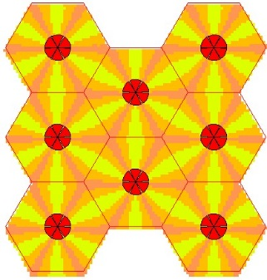
2 | 24-29  22-24  18-22  13-18 | 29%  18%  30%  24% | 27%  19%  30%  24.5% | 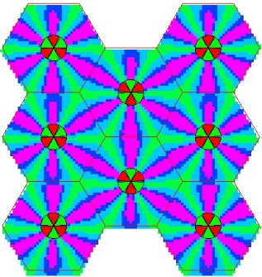

TABLE 3 (end)
Number of frequency paths | C/I  (dB) | C/I distribution |  | Typical pattern
 |  | 2 km | 6 km
3 | >29 dB  24-29  22-24  18-22 | 30.7%  51%  12%  6% | 37.7%  46.6%  13.6%  2% | 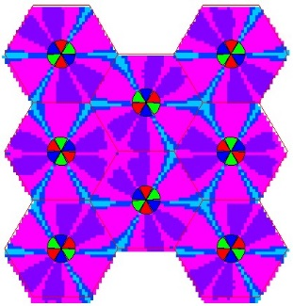
6 | >29 dB  24-29  22-24  18-22 | 72.3%  26.3%  1.3%  0% | 48.53%  43.9%  6.8%  0.68% | 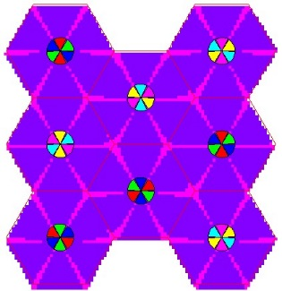

2.2.1 Capacity calculation
The average capacity, supported by a single carrier (SC) system using adaptive modulation, can be calculated according to the area ratios indicated in Table 3, assuming a uniform distribution of users within the area.
For OFDMA, the calculation is more elaborate, thanks to the path splitting and power concentration capabilities. The OFDMA may be operational even in the presence of large interference or low-field strength of received signal.
Table 4 summarizes the average capacity and RF efficiency in terms of the overall capacity per cell sector, the spectral efficiency in bit/s/Hz and the system efficiency in terms of bit/s/Hz/cell.
A typical/theoretical SC system has been used as a reference. For a single frequency path case, it cannot operate, as it requires a minimal C/I level not available in this scenario.
In contrast, the OFDMA splits the bandwidth so that interference is avoided. In this case, although full capacity cannot be supported, some traffic can still be transmitted.
TABLE 4
Capacity per sector and efficiency of SC and OFDMA systems
Number of  forward frequency  paths |  |  | Cell size
 |  |  | 2 km | 6 km
1 | Mbit/s/sector | SC | 0 | 0
 |  | OFDMA | 2.35 | 2.35
 | Bit/s/Hz | SC | 0 | 0
 |  | OFDMA | 0.39 | 0.39
 | Bit/s/Hz/cell | SC | 0 | 0
 |  | OFDMA | 2.35 | 2.35
2 | Mbit/s/sector | SC | 7.4 | 7.3
 |  | OFDMA | 8.96 | 8.92
 | Bit/s/Hz | SC | 0.62 | 0.61
 |  | OFDMA | 0.75 | 0.74
 | Bit/s/Hz/cell | SC | 3.70 | 3.65
 |  | OFDMA | 4.48 | 4.46
3 | Mbit/s/sector | SC | 11.2 | 11.8
 |  | OFDMA | 13.3 | 13.44
 | Bit/s/Hz | SC | 0.62 | 0.66
 |  | OFDMA | 0.74 | 0.75
 | Bit/s/Hz/cell | SC | 3.73 | 3.93
 |  | OFDMA | 4.43 | 4.48
6 | Mbit/s/sector | SC | 13.6 | 12.4
 |  | OFDMA | 15 | 15
 | Bit/s/Hz | SC | 0.38 | 0.34
 |  | OFDMA | 0.42 | 0.42
 | Bit/s/Hz/cell | SC | 2.27 | 2.07
 |  | OFDMA | 2.50 | 2.50

Table 4 shows a consistent advantage of OFDMA between 5% and 25% of higher efficiency.

2.3 Antenna deployment
The RCT standard envisages two antenna deployment scenarios, indoor and outdoor. The RCT antenna can share the downstream DVB-T antenna (which can also be an outdoor or an indoor antenna) using either a switch or a duplexer. Alternatively the two antennas can be separated. Those possibilities are given in the standard and shown here in Fig. 3. Note that BIM is an abbreviation of broadcast interface module (DVB-T), while IIM stands for the interactive interface module (RCT). Dx means duplexer. It is to be noted that the switch options do not enable simultaneous operation of TV reception and DVB-RCT transmissions, therefore it is expected that most deployments would not use them.
Figure 3
Antenna deployment

* Radiocommunication Study Group 6 made editorial amendments to this Recommendation in March 2017 in accordance with Resolution ITU-R 1.
The term “digital divide” is defined as “The disparity of conditions between those populations that have widespread, easy and affordable access to digital broadcasting services and those that have difficult or no access”.

