Recommendation ITU-R BS.412-9
(12/1998)
Planning standards for terrestrial FM sound broadcasting at VHF

BS Series
Broadcasting service (sound)

Foreword
The role of the Radiocommunication Sector is to ensure the rational, equitable, efficient and economical use of the radio-frequency spectrum by all radiocommunication services, including satellite services, and carry out studies without limit of frequency range on the basis of which Recommendations are adopted.
The regulatory and policy functions of the Radiocommunication Sector are performed by World and Regional Radiocommunication Conferences and Radiocommunication Assemblies supported by Study Groups.

Policy on Intellectual Property Right (IPR)
ITU-R policy on IPR is described in the Common Patent Policy for ITU-T/ITU-R/ISO/IEC referenced in Annex 1 of Resolution ITU-R 1. Forms to be used for the submission of patent statements and licensing declarations by patent holders are available from http://www.itu.int/ITU-R/go/patents/en where the Guidelines for Implementation of the Common Patent Policy for ITU-T/ITU-R/ISO/IEC and the ITU-R patent information database can also be found.

Series of ITU-R Recommendations
(Also available online at http://www.itu.int/publ/R-REC/en)
Series | Title
BO | Satellite delivery
BR | Recording for production, archival and play-out; film for television
BS | Broadcasting service (sound)
BT | Broadcasting service (television)
F | Fixed service
M | Mobile, radiodetermination, amateur and related satellite services
P | Radiowave propagation
RA | Radio astronomy
RS | Remote sensing systems
S | Fixed-satellite service
SA | Space applications and meteorology
SF | Frequency sharing and coordination between fixed-satellite and fixed service systems
SM | Spectrum management
SNG | Satellite news gathering
TF | Time signals and frequency standards emissions
V | Vocabulary and related subjects

Note: This ITU-R Recommendation was approved in English under the procedure detailed in Resolution ITU-R 1.

Electronic Publication
Geneva, 2010

© ITU 2010
All rights reserved. No part of this publication may be reproduced, by any means whatsoever, without written permission of ITU.
RECOMMENDATION ITU-R BS.412-9*
Planning standards for terrestrial
FM sound broadcasting at VHF

(1956-1959-1963-1974-1978-1982-1986-1990-1994-1995-1998)
The ITU Radiocommunication Assembly,
recommends
that the following planning standards should be used for frequency modulation sound broadcasting in band 8 (VHF):

1 Minimum usable field strength
1.1 In the presence of interference from industrial and domestic equipment (for limits of radiation from such equipments refer to Recommendation ITU-R SM.433, which gives the relevant CISPR recommendations) a satisfactory service requires a median field strength (measured at 10 m above ground level) not lower than those given in Table 1:
TABLE 1

 | Services
Areas | Monophonic dB(μV/m) | Stereophonic dB(μV/m)
Rural | 48 | 54
Urban | 60 | 66
Large cities | 70 | 74
1.2 In the absence of interference from industrial and domestic equipment, the field strength values (measured at 10 m above ground level) given in Table 2 can be considered to give an acceptable monophonic or stereophonic service, respectively. These field strength values apply when an outdoor antenna is used for monophonic reception, or a directional antenna with appreciable gain for stereophonic reception (pilot-tone system, as defined in Recommendation ITU-R BS.450).
TABLE 2

Services
Monophonic dB(μV/m) | Stereophonic dB(μV/m)
34 | 48
NOTE 1 – The figures of Table 2 are not median values and, consequently, they are not directly comparable with those given in Table 1.
1.3 In a practical plan, because of interferences from other sound broadcasting transmissions, the field strength values that can be protected will generally be higher than those of Table 1. Moreover, in the case of the boundary area between any two countries, the exact values to be used should be agreed between the administrations concerned.

2 Radio-frequency protection ratios

2.1 General
2.1.1 The Radio-Frequency (RF) protection ratio is the minimum value of wanted-to-unwanted signal ratio, usually expressed in decibels at the receiver input, determined under specified conditions such that a specific reception quality is achieved at the receiver output.
The protection ratio curves were originally determined by subjective evaluation of interference effects. As subjective tests are rather time-consuming an objective measuring method was developed (see Annex 1 to Recommendation ITU-R BS.641) and found to yield results which are in fair agreement with those of the subjective tests.
2.1.2 Except where otherwise stated, the values of protection ratio quoted apply to interference produced by a single source. In the case of multiple interferences, appropriate assessment methods are indicated in Report ITU-R BS.945.
2.1.3 It is assumed that wanted and unwanted signals contain different programmes without any correlation. In the case of an identical programme (same modulation), an improvement of the protection ratio is expected at least for monophonic signals.
2.1.4 In the case of same frequency and same modulation, with synchronized signals, the protection ratios for monophonic signals are much lower than those in Fig.1. In the case of stereophonic signals the protection ratios depend on the propagation delay and on the stereophonic content (see Annex 3).
2.1.5 The protection ratio values are given for steady and tropospheric interference respectively. The protection ratios for steady interference provide approximately 50 dB signal-to-noise ratio (weighted quasi-peak measurement according to Recommendation ITU-R BS.468, with a reference signal at maximum frequency deviation. See also Annex 1 to Recommendation ITU-R BS.641). The protection ratios for tropospheric interference correspond closely to a slightly annoying impairment condition and it is considered acceptable only if the interference occurs for a small percentage of the time, not precisely defined but generally considered to be between 1 % and 10 %.
In determining whether the interference is to be regarded as steady or tropospheric, see Annex 1.
Significantly strong wanted signals can require higher protection ratio values than those given in Fig. 1 and Fig. 2, because of non-linear effects in the receiver (see Annex 2).

2.2 Monophonic service
2.2.1 The radio-frequency protection ratios required to give satisfactory monophonic reception, in systems using a maximum frequency deviation of ± 75 kHz, for tropospheric interference, are those given by curve M2 in Fig. 1. For steady interference, it is desirable to provide a higher degree
of protection, shown by the curve M1 in Fig. 1. The protection ratios at important values of the carrier frequency spacing are also given in Table 3.
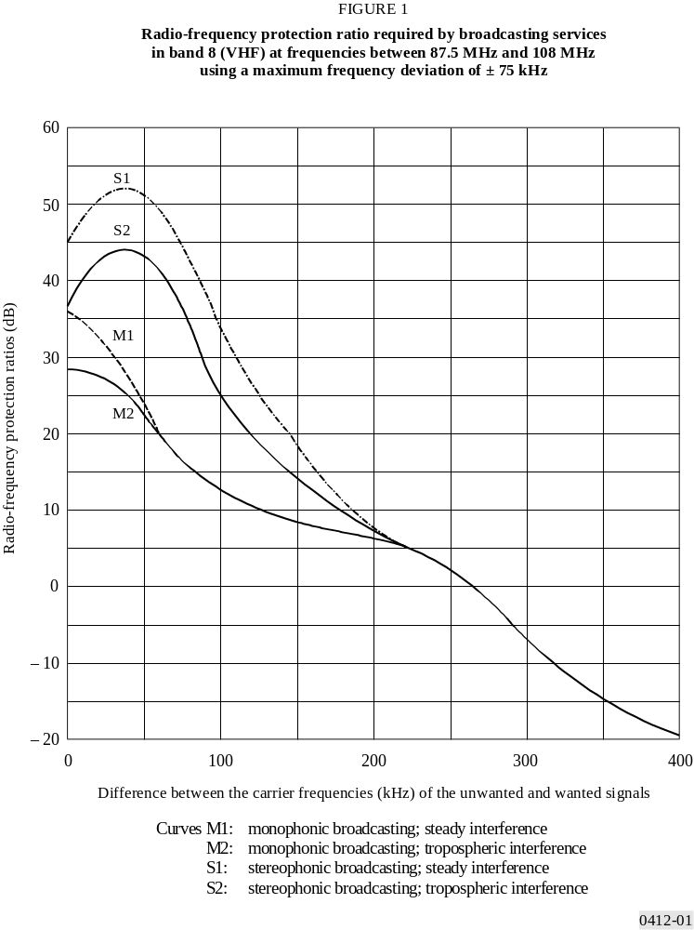
2.2.2 The corresponding values for monophonic systems using a maximum frequency deviation of ± 50 kHz are those given by the curves M2 and M1 in Fig. 2. The protection ratios at important values of the carrier frequency spacing are also given in Table 4.

2.3 Stereophonic service
2.3.1 The radio-frequency protection ratios required to give satisfactory stereophonic reception, for transmissions using the pilot-tone system and a maximum frequency deviation of ± 75 kHz, for tropospheric interference, are those given by curve S2 in Fig. 1. For steady interference it is desirable to provide a higher degree of protection, shown by the curve S1 in Fig. 1.

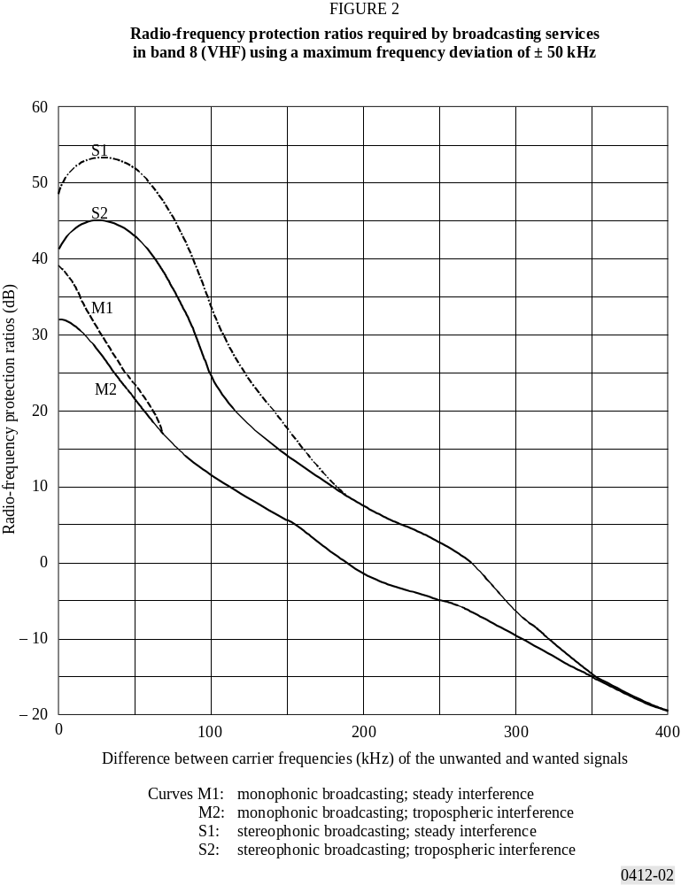
The protection ratios at important values of the carrier frequency spacing, are also given in Table 3.
2.3.2 The corresponding values for stereophonic systems using a maximum frequency deviation of ± 50 kHz are those given by the curves S2 and S1 in Fig. 2. The protection ratios at important values of the carrier frequency spacing are also given in Table 4.
TABLE 3

Radio-frequency protection ratio (dB) using a maximum
frequency deviation of ± 75 kHz
Carrier  frequency | Monophonic |  | Stereophonic
spacing  (kHz) | Steady  interference | Tropospheric  interference | Steady  interference | Tropospheric  interference
000 | –36.0 | –28.0 | –45.0 | –37.0
025 | –31.0 | –27.0 | –51.0 | –43.0
050 | –24.0 | –22.0 | –51.0 | –43.0
075 | –16.0 | –16.0 | –45.0 | –37.0
100 | –12.0 | –12.0 | –33.0 | –25.0
125 | 0–9.5 | 0–9.5 | –24.5 | –18.0
150 | 0–8.0 | 0–8.0 | –18.0 | –14.0
175 | 0–7.0 | 0–7.0 | –11.0 | –10.0
200 | 0–6.0 | 0–6.0 | 0–7.0 | 0–7.0
225 | 0–4.5 | 0–4.5 | 0–4.5 | 0–4.5
250 | 0–2.0 | 0–2.0 | 0–2.0 | 0–2.0
275 | 0–2.0 | 0–2.0 | 0–2.0 | 0–2.0
300 | 0–7.0 | 0–7.0 | 0–7.0 | 0–7.0
325 | –11.5 | –11.5 | –11.5 | –11.5
350 | –15.0 | –15.0 | –15.0 | –15.0
375 | –17.5 | –17.5 | –17.5 | –17.5
400 | –20.0 | –20.0 | –20.0 | –20.0
TABLE 4

Radio-frequency protection ratio (dB) using a maximum
frequency deviation of ± 50 kHz
Carrier  frequency | Monophonic |  | Stereophonic
spacing  (kHz) | Steady  interference | Tropospheric  interference | Steady  interference | Tropospheric  interference
0 | 39.0 | 32.0 | 49.0 | 41.0
25 | 32.0 | 28.0 | 53.0 | 45.0
50 | 24.0 | 22.0 | 51.0 | 43.0
75 | 15.0 | 15.0 | 45.0 | 37.0
100 | 12.0 | 12.0 | 33.0 | 25.0
125 | 7.5 | 7.5 | 25.0 | 18.0
150 | 6.0 | 6.0 | 18.0 | 14.0
175 | 2.0 | 2.0 | 12.0 | 11.0
200 | –2.5 | –2.5 | 7.0 | 7.0
225 | –3.5 | –3.5 | 5.0 | 5.0
250 | –6.0 | –6.0 | 2.0 | 2.0
275 | –7.5 | –7.5 | 0 | 0
300 | –10.0 | –10.0 | –7.0 | –7.0
325 | –12.0 | –12.0 | –10.0 | –10.0
350 | –15.0 | –15.0 | –15.0 | –15.0
375 | –17.5 | –17.5 | –17.5 | –17.5
400 | –20.0 | –20.0 | –20.0 | –20.0

2.4 Carrier frequency differences greater than 400 kHz
The curves of Fig. 1 and Fig. 2 give protection ratio values for carrier frequency differences between unwanted and wanted signals of up to 400 kHz.
For carrier frequency differences greater than 400 kHz, the protection ratio values should be substantially lower than –20 dB. Detailed information on this subject is given in Annex 2.
The radio-frequency protection ratio value for the particular carrier frequency difference of 10.7 MHz (intermediate frequency) should be below –20 dB.

2.5 Technical conditions
2.5.1 For the radio-frequency protection ratios given in Fig. 1 and Table 3, it is assumed that the maximum peak deviation of ± 75 kHz is not exceeded. Moreover, it is assumed that the power of the complete multiplex signal (including pilot-tone and additional signals) integrated over any interval of 60 s is not higher than the power of a multiplex signal containing a single sinusoidal tone which causes a peak deviation of ± 19 kHz.
It is important that the limits for modulation levels given above should not be exceeded, otherwise the radiated power of the transmitter has to be reduced in accordance with the increased figures for protection ratios given in Annex 2.
Examples of measurement results, showing the maximum peak deviation and the power of the complete multiplex signal as a function of time are given in Annex 4.
NOTE – The power of a sinusoidal tone causing a peak deviation of ± 19 kHz is equal to the power of the coloured noise modulation signal according to Recommendation ITU-R BS.641, i.e. a coloured noise signal causing a quasi-peak deviation of ± 32 kHz.
2.5.2 The protection ratios for stereophonic broadcasting assume the use of a lowpass filter following the frequency modulation demodulator in the receiver designed to reduce interference and noise at frequencies greater than 53 kHz in the pilot-tone system and greater than 46.25 kHz in the polar-modulation system. Without such a filter or an equivalent arrangement in the receiver, the protection ratio curves for stereophonic broadcasting cannot be met, and significant interference from transmissions in adjacent or nearby channels is possible.
In determining the characteristics of the filters whose phase response is important in the preservation of channel separation at high audio frequencies, reference should be made to Annex III of Recommendation ITU-R BS.644.
2.5.3 In the case of AM-FM receivers, it is necessary to take measures so that the circuits at the AM intermediate frequency (generally 450-470 kHz) do not worsen the protection ratios when the receiver is operating in FM, particularly for differences between the frequencies of the wanted and interfering carrier greater than 300 kHz.
2.5.4 Data systems or other systems providing supplementary information, if introduced, should not cause more interference to monophonic and stereophonic services than is indicated by the protection ratio curves in Fig. 1. It is not considered practicable in the planning to provide additional protection to data services or other services providing supplementary information signals.

3 Channel spacing
In frequency planning, channels are to be assigned in such a way that:
3.1 the carrier frequencies which define the nominal placement of the RF channels within the band are integral multiples of 100 kHz;
3.2 a uniform channel spacing of 100 kHz applies for both monophonic and stereophonic transmissions.
In those cases where a 100 kHz channel spacing would be difficult to implement, the use of a spacing which is an integral multiple of 100 kHz would also be acceptable, provided that the carrier frequencies are chosen in accordance with § 3.1 above.

ANNEX 1
Determination of whether the interference is to be regarded
as steady or tropospheric
To apply the protection ratio curves of Figs. 1 and 2 it is necessary to determine whether, in the particular circumstances, the interference is to be regarded as steady or tropospheric. A suitable criterion for this is provided by the concept of “nuisance field” which is the field strength of the interfering transmitter (at its pertinent e.r.p.) enlarged by the relevant protection ratio.
Thus, the nuisance field for steady interference:
Es = P + E (50, 50) + As
and the nuisance field for tropospheric interference:
Et = P + E (50, T ) + At
where:
P : e.r.p. (dB(1 kW)) of the interfering transmitter
A : radio-frequency protection ratio (dB)
E (50, T ) : field strength (dB(μV/m)) of the interfering transmitter, normalized to 1 kW, and exceeded during T % of the time
and where indices s and t indicate steady or tropospheric interference respectively.
At the VHF/FM Conference, Geneva 1984, the percentage of time was chosen to be T = 1 %.
The protection ratio curve for steady interference is applicable when the resulting nuisance field is stronger than that resulting from tropospheric interference,
i.e. Es ≥ Et
This means that As should be used in all cases when:
E (50,50) + As ≥ E (50, T ) + At
ANNEX 2
Particular interference cases in FM broadcasting

1 Interference caused by an overmodulated transmitter
Laboratory measurements were made in France to evaluate the sensitivity of several receivers to interference in the case where the interfering transmitter is overmodulated.
Interference was measured as described in Annex 1 to Recommendation ITU-R BS.641, for a stereophonic signal and a wanted RF receiver input level of –50 dB(mW) (0.7 mV/50 Ω).
The –3 dB and – 40 dB bandwidths of the RF filter added at the output of the interfering transmitter were 500 kHz and 2 600 kHz respectively.
Two overmodulation values were used: +3 dB and +6 dB. It was found that, for interfering signals within the receiver passband, the increase of protection ratios was not related to the type of receiver; thus, for a 100 kHz carrier frequency spacing, the increases in protection ratio were 11 dB and 15 dB for increases in modulation depth of 3 dB and 6 dB respectively.
On the other hand, it was found that in the case of interference with a (non-standard) 150 kHz carrier frequency spacing, the change in protection ratios could be as high as 6 dB for a 1 dB change in modulation depth of the interfering transmitter.

2 Interference for large carrier frequency differences
Tests to evaluate the effect of interference from transmissions having large frequency differences, which were carried out under similar conditions to those given in § 1 above, were also made in France.
In this case, measurements were made with normal modulation of the interfering transmitter and for carrier frequency spacing up to 1 MHz. The measurements showed that, beyond 400 kHz, there was no relationship whatsoever between protection ratios, whether or not the unwanted transmitter was modulated.
With a professional receiver, the protection ratios decrease when a narrow-band RF filter (–40 dB bandwidth equal to 1 200 kHz) is inserted at the output of the interfering transmitter. This shows that reception is disturbed only by the residual noise sidebands of the unwanted carrier.
On the other hand for the domestic receivers used, the protection ratios are almost constant from 400 kHz onwards, and have a value of around –40 dB which is practically independent of the type of filtering used on the interfering carrier. In this case, it is only the presence of the interfering carrier which impairs reception, with many possible causes of disturbance, such as desensitization of the input state, local oscillator drive, etc.

3 Interference when the protection ratio is not respected
Tests were carried out in France on three receivers (professional, semi-professional and commercial) when the protection ratio is not respected.
Interference tests on all three receivers were carried out in monophony and stereophony, at a wanted receiver input RF level of –50 dB(mW) (0.7 mV/50 Ω) and for positive frequency offsets. The test conditions described in Recommendation ITU-R BS.641 were followed except as regards the wanted/unwanted AF signal ratios, which were taken as 50 dB (Recommendation ITU-R BS.641 value), 40 dB and 30 dB.
Similar measurements have been made in the Federal Republic of Germany for 31 domestic receivers of different price categories (low, medium and high) and for audio-frequency signal-to-interference ratios of 47 dB, 50 dB, 53 dB, 56 dB and 59 dB.
It was found that for a frequency difference up to (and including) 50 kHz in monophony and 100 kHz in stereophony, an increase of the interfering signal level leads to a similar reduction of the audio-frequency signal-to-noise ratio at the output of the receiver.
On the other hand, for a frequency difference larger than these values but smaller than approximately 250 kHz, a very small increase in RF interference can cause a considerable deterioration in reception quality, more pronounced in monophony than in stereophony. In such cases of offset, it is essential at the planning stage to allow a substantial margin for the uncertainties of propagation, multipath interference, obstacles, etc. Based on the results obtained, a margin of around 10 dB would not appear excessive. Considering the small number and types of receivers tested additional studies should be carried out.

4 RF protection ratios for different wanted signal levels
Measurements were made in the Federal Republic of Germany to evaluate the influence of the wanted signal level on RF protection ratios. The RF protection ratios for 31 domestic and 16 car receivers of different price categories were measured with different wanted signal levels.
The measurements were performed according to Recommendation ITU-R BS.641. Input levels for the wanted signal of 30 dB(pW), 40 dB(pW) and 50 dB(pW) were applied.
The mean value curves of measured RF protection ratios are shown in Figs. 3 and 4. Each Figure shows curves for stereophonic and monophonic reception. For comparison purposes the RF protection ratio curves for steady interference according to Recommendation ITU-R BS.412 are also shown. Figure 3 presents curves for domestic receivers, and Fig. 4 shows the comparable results for car receivers.
The Figures show that the influence of the wanted signal level on measured RF protection ratios is not as large as expected, at least if only mean values and not single receivers are considered. The increase of the measured RF protection ratio is ≤ 5 dB for stereophonic reception with domestic receivers, if the wanted signal level is increased from 40 dB(pW) to 50 dB(pW). For car receivers this value is slightly above 5 dB. For monophonic reception the increase of the measured RF protection ratios above 300 kHz carrier frequency separation is somewhat higher than 5 dB (up to 9 dB). In this case, however, the wanted-to-interfering signal levels are already considerably below the RF protection ratios.

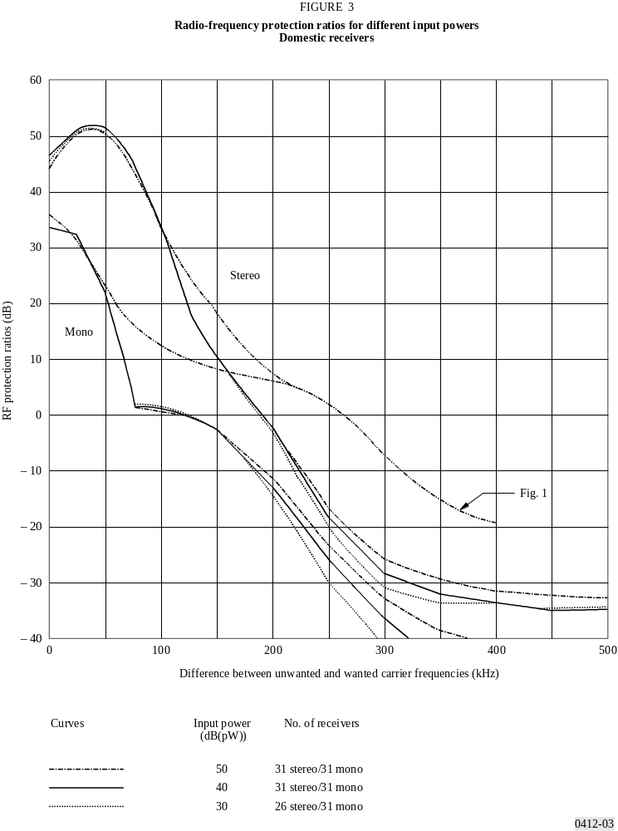

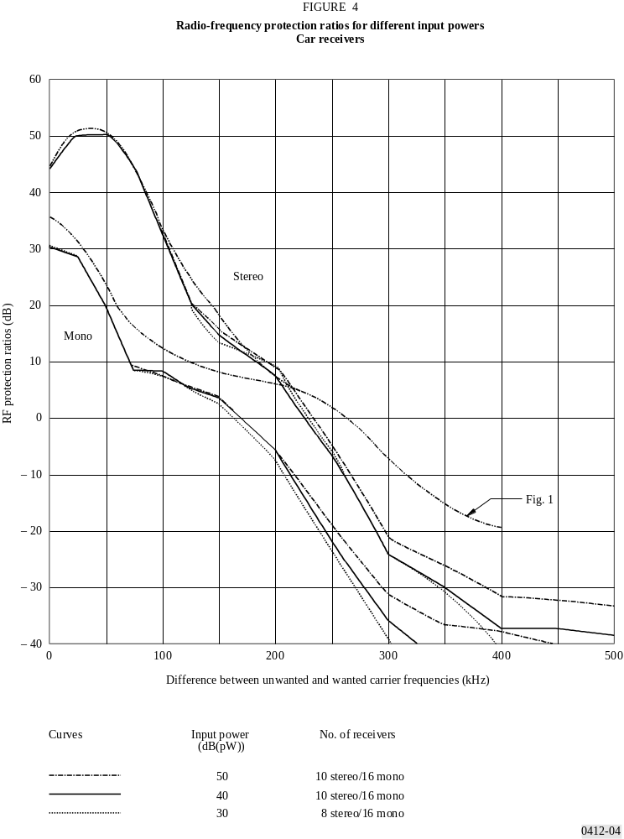

5 Interference caused by intermodulation of strong RF signals
An investigation performed in the Federal Republic of Germany of domestic and car FM radio receivers on their tendency to intermodulate in the presence of strong signals has been made. This receiver performance in the presence of strong RF signals is measured with three RF signals and expressed as a protection ratio.
Thirty-one domestic and 16 car receivers of different price categories were measured. Two interfering signals of equal levels were positioned above or below the frequency of the wanted signal at equal differences of frequencies, i.e.
or 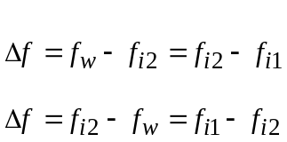

The interfering signal fi2 was unmodulated, and the interfering signal fi1 was modulated with coloured noise according to Recommendation ITU-R BS.641. The RF protection ratios were measured according to Recommendation ITU-R BS.641, the only difference being that two interfering signals were applied as mentioned above. The mean values of the so-called strong signal protection ratios for stereophonic and monophonic reception with domestic and car receivers are presented in Figs. 5 to 8. The standard deviation of the measured receivers ranged from 5 to 7 dB.

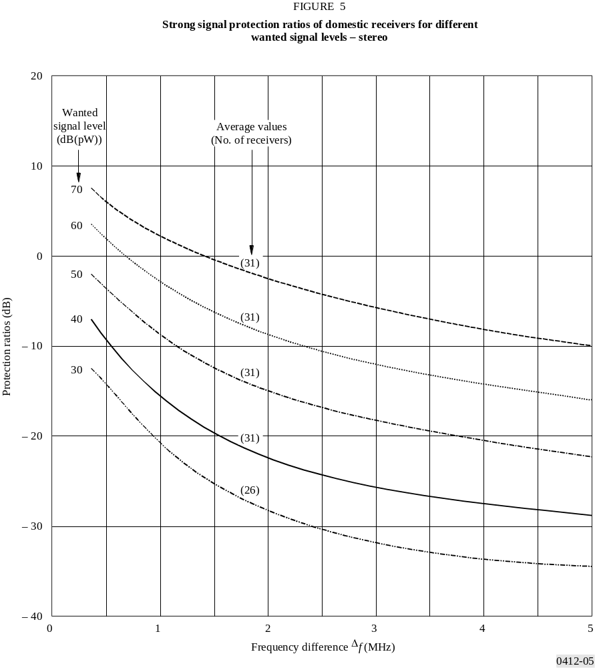

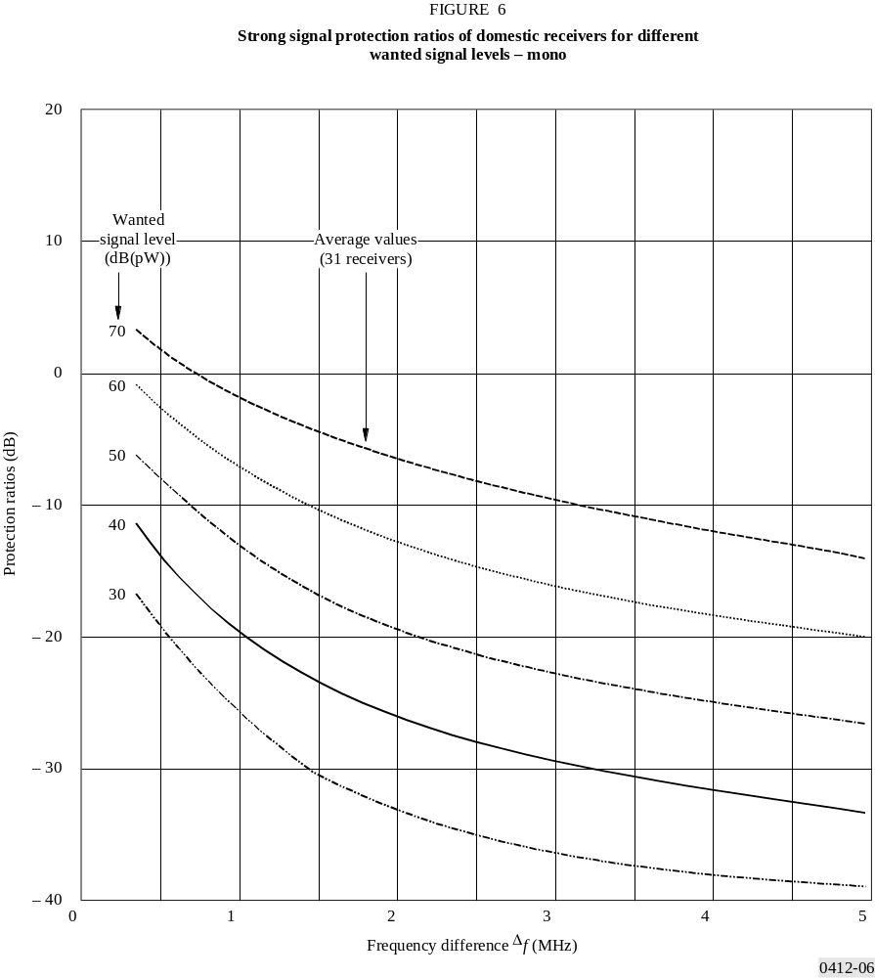

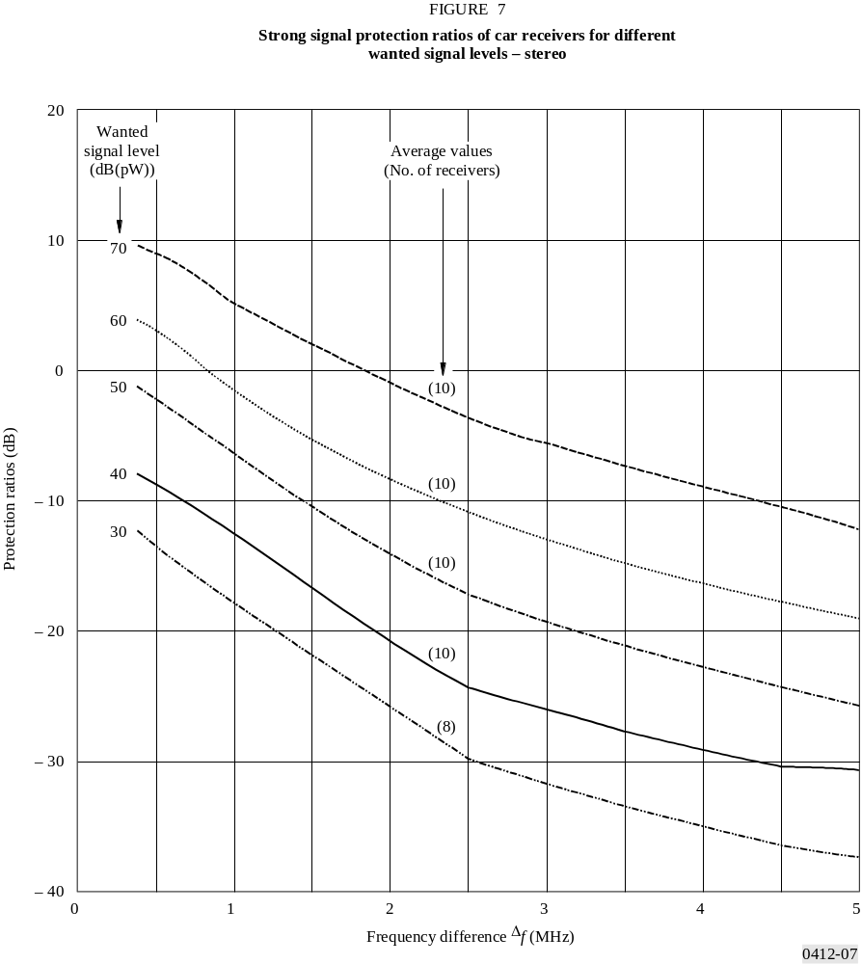

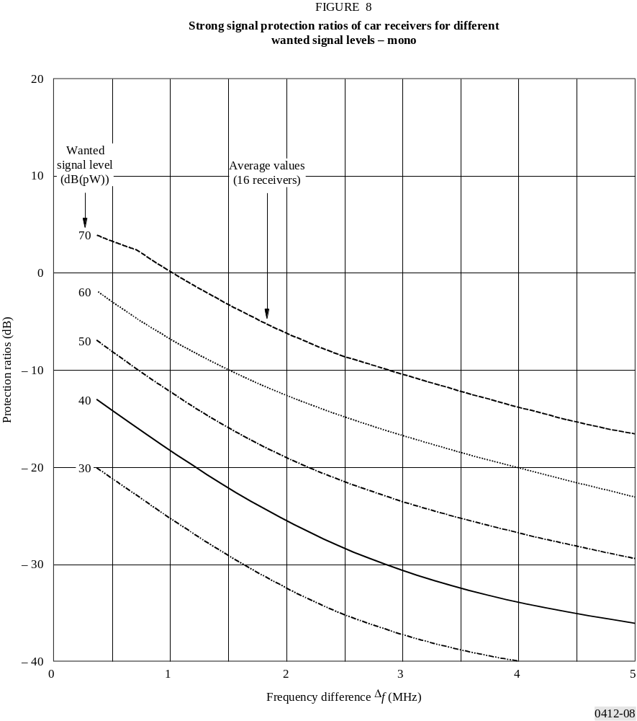
ANNEX 3
Protection ratio for FM sound broadcasting in the case
of the same programme and synchronized signals

1 Introduction
In the case of single frequency operation in which the interfering transmitter broadcasts the same programme as the wanted transmitter, the applicable protection ratio values can be expected to be lower than those given in Fig. 1 for the general case. If, in addition, the wanted and interfering signals are identical in programme, frequency and modulation depth, apart from a slight difference of level and time delay, the interfering signal appears as an echo of the wanted signal, thus reducing further the impairment.
The reception quality is also influenced by the phase between the wanted and interfering signals.
Protection ratios were evaluated in France and Italy having regard to this particular case, in which synchronization of the interfering transmitter with the wanted transmitter guarantees that the instantaneous phases of both signals are identical.

2 Measuring conditions

2.1 Arrangement
The tests were arranged in such a way as to simulate the reception of a signal formed by the combined field strengths of two synchronous transmitters. The parameters for consideration are:
– the level difference between the signals received from both transmitters;
– the time delay between the wanted and interfering signals;
– monophonic and stereophonic transmitter modes (the presence of an RDS subcarrier was not considered);
– the phase shift between the signals received.
The measurements carried out in France and Italy followed, in principle, the same philosophy. An RF signal frequency modulated by a high quality audio frequency source (compact disc) was introduced in two separate channels: one of these channels was equipped in such a way as to permit the attenuation and the time delay of the signal to be varied, step by step, before recombining the two signals.
For the French tests a professional FM stereo receiver was used, and for the Italian tests a commercial good quality FM stereo receiver was used.

2.2 Evaluation
A subjective evaluation procedure was adopted because the interference revealed both noise and distortion; the ITU-R 5-grade impairment scale was adopted.
2.2.1 For the measurements carried out in France, preliminary tests showed that speech was more critical than music for test purposes. Consequently, a “speech sample” was used as the test signal; the duration of each sample was 20 s, making it possible to evaluate the impairment of the worst phase configuration.
To permit practical exploration of all the phase configurations, it was decided to offset the wanted and interfering transmission frequencies by 0.1 Hz (phase shift of 360° in 10 s).
The task of the five listeners participating in the tests was to give scores for the impairment in relation to the reference of 30 samples corresponding to the 30 selected configurations resulting from the combination of operating modes (mono/stereo), time delay values (2, 5 and 10 µs) and the five level ratio values (chosen as a function of the other parameters).
The protection ratio values corresponding to both grades 3 and 4 of the impairment scale were determined from the obtained scores.
2.2.2 For monophonic mode, measurements made in Italy of three types of programme material were employed: piano solo, violin solo and modern music; piano solo was the most critical, whilst the modern music was the most tolerant.
Four delay steps have been examined; 5, 10, 20 and 40 µs. For each delay step and for each type of material, the protection ratio corresponding to grade 4 on the impairment scale was determined by four groups of expert listeners each consisting of 12 people.
In carrying out the subjective tests, the phase shifter was adjusted in each test to obtain the condition of maximum distortion.
It was also noted that the degradation results are proportional to the modulation depth, so that particular care was taken not to exceed the correct modulation limit.
Further tests have been made in Italy in stereophonic mode, considering different modulation types and different delay conditions, since both strongly influence the protection ratios. Three types of programme material were employed: piano stereo, speech level A > level B and bass soloist on channel A only. Four delay steps have been examined: 13.2, 39.5, 197.4 and 802.6 µs.
The choice of the delay step was made considering the influence of the phase shifting of the 19 kHz pilot between wanted and unwanted signals. It has been verified in an experimental study that there is a greater degradation for delay values of odd multiples of a quarter of the pilot tone period, corresponding to the condition when the wanted and unwanted pilot tones are 90° phase shifted.
For each delay step, evaluations have been made of impairment grade versus protection ratios for stereo piano programme material (Fig. 9). Conversely, for the three types of programme material, evaluations have been made of impairment grade versus protection ratios (Fig. 10) for a fixed value of delay 13.2 µs.

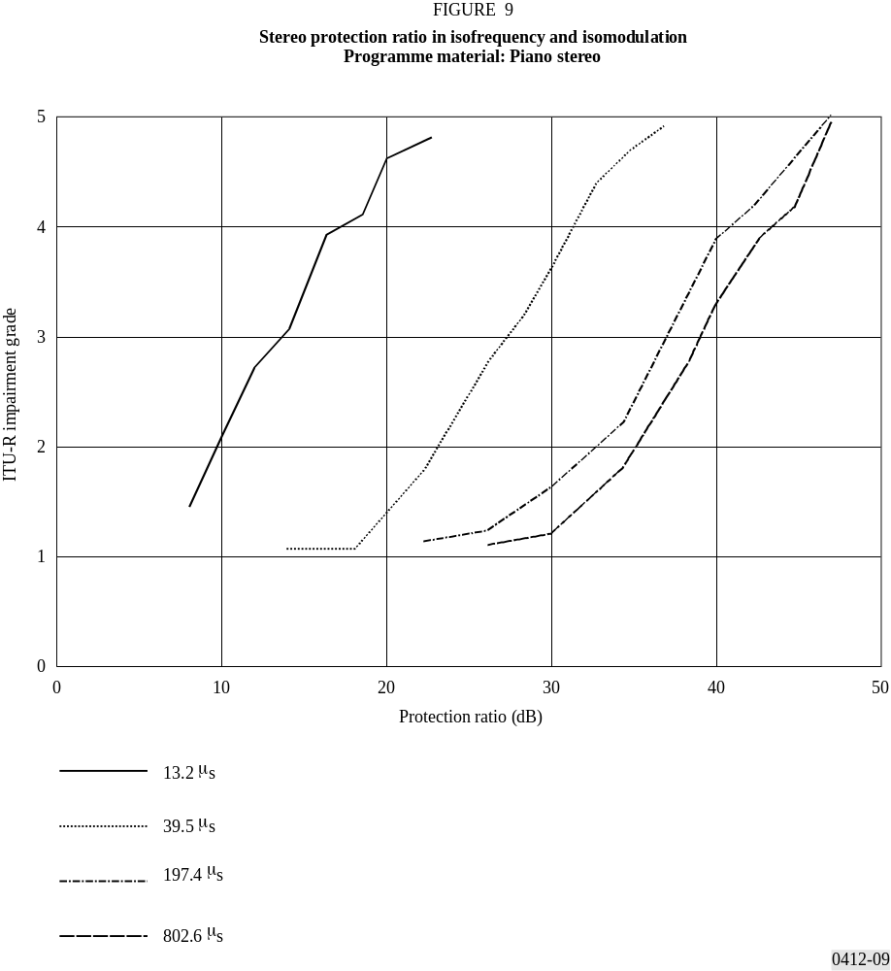

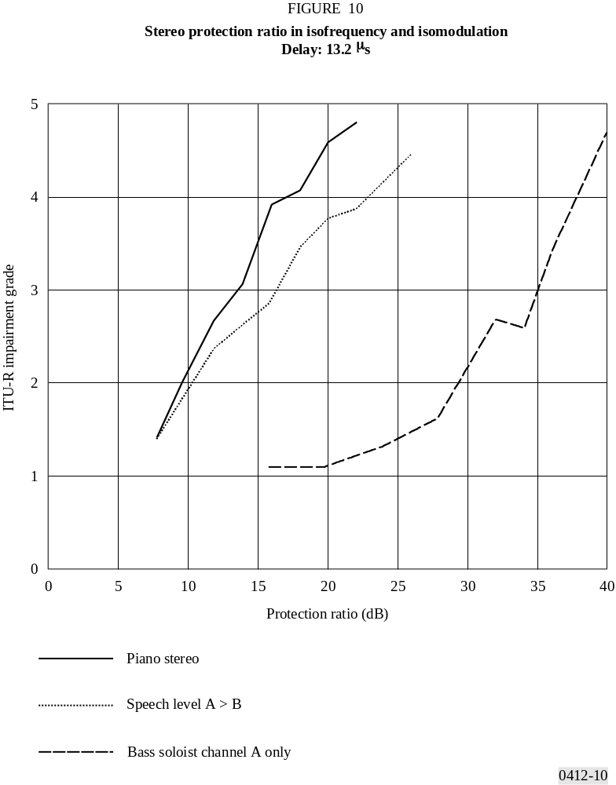
The subjective assessments were carried out according to Recommendation ITU-R BS.562 using the double-stimulus method and the 5-level impairment scale. The presentation of the audio excerpts, in the different pre-recorded isofrequency combinations, and the automatic logging of results were managed by a complex software system, processed at the RAI Research Centre, in the general context of the subjective video quality tests. Each excerpt was evaluated by 16 non-experts in groups of at least two persons at a time.
The phase difference of the modulating signals has not been considered, since all the evaluations have been made with a single source shifted in two separated channels.

3 Results and considerations

3.1 Comparison between monophonic and stereophonic modes
The tests carried out in France (mono and stereophonic modes) and in Italy (monophonic mode) have given identical results comparing the more critical types of material employed (“speech” and “piano solo” respectively). The results obtained during the two series of tests are summarized in Table 5 for both modes of operation (mono and stereo) and for the values of time delay considered.
TABLE 5

Protection ratios
(dB)
Time | Monophonic mode |  | Stereophonic mode
delay  (μs) | Impairment grade |  | Impairment grade
 | 3 | 4 | 3 | 4
2 | < 1 | 1 | 4 | 6
5 | 1 | 2 | 10 | 12
10 | 1 | 3 | 14 | 16
20 | Not evaluated | 11 | Not evaluated | Not evaluated
40 | Not evaluated | 20 | Not evaluated | Not evaluated
The figures in the Table indicate the worst values found during the tests.
The results corresponding to monophonic mode can be considered reliable, whilst those corresponding to stereophonic mode are purely indicative, being based on a limited number of subjective evaluations.
It may be noted that:
– in the most favourable case (monophonic mode, 2 µs time delay) the protection ratio is very close to 0 dB using synchronized transmitters;
– the time delay between wanted and interfering signals creates frequency dependent nulls which worsen as the time delay increases, and stereophonic signals are more sensitive to this;
– at time delays of up to 5 µs, the protection ratio is independent of programme material type; for increasing delay, the protection ratio becomes a function of the programme material type.

3.2 Results and considerations for the stereophonic mode
The results of investigations carried out in Italy for the stereophonic mode are reported in Figs. 9 and 10. They indicate a strong dependence on the delay between the wanted and interfering signals on the stereo content. In fact, from Fig. 9 it is possible to note a difference of more than 10 dB comparing the 13.2 µs curve with the 39.5 µs curve; from Fig. 10, a variation of about 20 dB can be seen by comparing different stereo modulation contents.

4 Application
In the application of such a system in Italy along a mountainous section of one of the main motorways (section Bologna-Florence, of about 85 km) a new FM monophonic synchronized broadcast service, addressed to car drivers, was implemented.
The main purpose was to ensure good in-car reception without retuning along the complete section of the motorway including tunnels, in which a radiating RF cable was employed. It is foreseen that such a service will extend to most parts of the main Italian motorways.

5 Conclusion
On the basis of the collected data and of the results obtained, it is possible to plan a synchronized monophonic network for special applications with protection ratios of only 2 dB, provided that the relative time delay between the modulating signals is maintained within 5 µs over the whole area to be served and that the maximum deviation does not exceed ± 75 kHz.
Thus in the case of co-channel interference, the protection ratio evaluations made for synchronized wanted and interfering transmitters broadcast the same programme, give values very much below those indicated in Fig. 1.
In the case of stereophonic mode there is a much more intense influence of the stereophonic content and the delay value. On the basis of the complementary investigations made in Italy it can be assumed that:
– the minimum reference value of protection ratios for stereo audio signal in isofrequency and isomodulation should not be lower than 16 dB for impairment 4 in the assumption of the delay equalization within 10 µs;
– in the reception areas affected by noticeable propagation delay, or for musical excerpts with a high stereo content, the protection ratio required for quality 4 impairment grows up to about 30 to 38 dB respectively for continuous interference.
Further evaluations should be pursued for a larger number of configurations including transmissions with multiplexed data signals.
ANNEX 4
Measurements of the peak deviation and the power of the complete
multiplex signal of an FM sound broadcasting signal

1 Introduction
Under § 2.3 of this Recommendation it is indicated that the recommended radio-frequency protection ratios assume that the maximum peak deviation of ± 75 kHz and the stated limit for the power of the complete multiplex signal are not exceeded.
Two countries (France and the Federal Republic of Germany) developed measurement equipment in order to check both these specified transmission parameters, frequency deviation and power of the multiplex signal.
During joint measurements three different devices were compared and the measurement results proved to be in good agreement. Such measurement devices are already in operation in both these countries to check the corresponding transmission parameters of broadcasting stations.

2 Measurement results
The measurement results of two different broadcasting stations are presented as examples (Figs. 11 and 12).
The frequency deviation as a function of measurement time is shown in Fig. 11, where the given frequency deviation is the maximum value (peak-hold) during each minute.
The power of the complete multiplex signal as a function of measurement time is shown in Fig. 12 where the power of the multiplex signal is measured according to § 2.5.1 of this Recommendation, i.e. in a floating time interval of 60 s which was shifted in steps of 1 s.
The figures show for one of the measured broadcasting stations (A) that the recommended values are well observed, whereas the other pair of results (B) prove that both of the limiting values are exceeded considerably. On the other hand broadcasting stations were also measured where the maximum frequency deviation was not exceeded, but the power limit for the complete multiplex signal was clearly exceeded, although the results are not shown here.
The measurement of peak deviation was performed with a very short response time. A correlation between the response time and the protection ratios was not investigated.
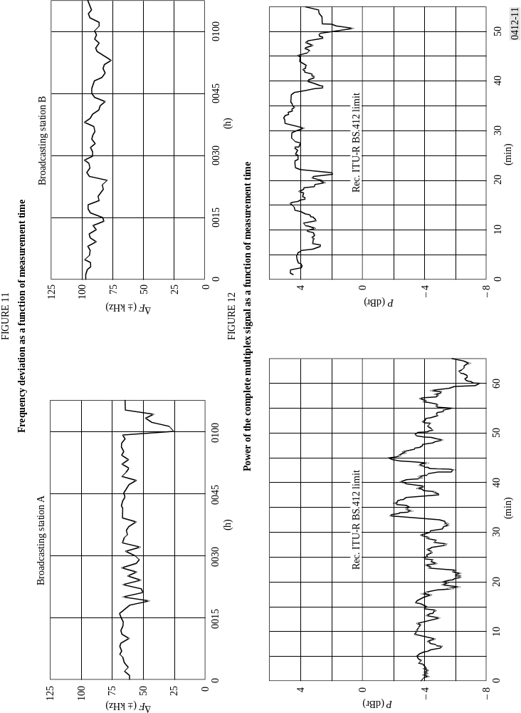

* Radiocommunication Study Group 6 made editorial amendments to this Recommendation in 2002 in accordance with Resolution ITU-R 44.

