Recommendation ITU-R BS.2126-1
(05/2023)
BS Series: Broadcasting service (sound)
Methods for the subjective assessment of sound systems with accompanying picture

Foreword
The role of the Radiocommunication Sector is to ensure the rational, equitable, efficient and economical use of the radio-frequency spectrum by all radiocommunication services, including satellite services, and carry out studies without limit of frequency range on the basis of which Recommendations are adopted.
The regulatory and policy functions of the Radiocommunication Sector are performed by World and Regional Radiocommunication Conferences and Radiocommunication Assemblies supported by Study Groups.

Policy on Intellectual Property Right (IPR)
ITU-R policy on IPR is described in the Common Patent Policy for ITU-T/ITU-R/ISO/IEC referenced in Resolution ITU-R 1. Forms to be used for the submission of patent statements and licensing declarations by patent holders are available from http://www.itu.int/ITU-R/go/patents/en where the Guidelines for Implementation of the Common Patent Policy for ITU-T/ITU-R/ISO/IEC and the ITU-R patent information database can also be found.

Series of ITU-R Recommendations
(Also available online at https://www.itu.int/publ/R-REC/en)
Series | Title
BO | Satellite delivery
BR | Recording for production, archival and play-out; film for television
BS | Broadcasting service (sound)
BT | Broadcasting service (television)
F | Fixed service
M | Mobile, radiodetermination, amateur and related satellite services
P | Radiowave propagation
RA | Radio astronomy
RS | Remote sensing systems
S | Fixed-satellite service
SA | Space applications and meteorology
SF | Frequency sharing and coordination between fixed-satellite and fixed service systems
SM | Spectrum management
SNG | Satellite news gathering
TF | Time signals and frequency standards emissions
V | Vocabulary and related subjects

Note: This ITU-R Recommendation was approved in English under the procedure detailed in Resolution ITU-R 1.

Electronic Publication
Geneva, 2023

© ITU 2023
All rights reserved. No part of this publication may be reproduced, by any means whatsoever, without written permission of ITU.

RECOMMENDATION ITU-R BS.2126-1
Methods for the subjective assessment of sound systems
with accompanying picture
(2019-2023)
Scope
This Recommendation describes methods for the subjective assessment of sound systems with an accompanying picture, the relationships between the distances from the loudspeakers to the central listening position, the display sizes and the viewing distances are clarified.
Keywords
Audio quality, subjective assessment, listening test, video image
The ITU Radiocommunication Assembly,
considering
a) that the perceptual interaction between the sound and picture can affect the assessment of sound quality;
b) that existing methods for the subjective assessment of sound quality may require adjustments for assessing sound systems with an accompanying picture;
c) that the use of standardised methods is important for the comparison, exchange, compatibility and correct interpretation of data derived from subjective tests carried out at different times and/or places,
recognising
a) Recommendations ITU-R BS.775 – Multichannel stereophonic sound system with and without accompanying picture, and ITU-R BS.2051 – Advanced sound system for programme production;
b) Recommendations ITU-R BS.1116 – Methods for the subjective assessment of small impairments in audio systems, ITU-R BS.1283 – Guidance for the selection of the most appropriate ITU-R Recommendation(s) for subjective assessment of sound quality, ITU-R BS.1284 – General methods for the subjective assessment of sound quality, and ITU-R BS.1534 – Method for the subjective assessment of intermediate quality level of audio systems;
c) Recommendations ITU-R BT.709 – Parameter values for the HDTV standards for production and international programme exchange, ITU-R BT.2020 – Parameter values for ultra-high definition television systems for production and international programme exchange, and ITU-R BT.2100 – Image parameter values for high dynamic range television for use in production and international programme exchange;
d) Recommendation ITU-R BT.500 – Methodologies for the subjective assessment of the quality of television images,
recommends
that the testing and evaluation procedures given in the Annex should be used for the subjective assessment of sound systems with an accompanying picture.

Annex

1 General
This Annex is divided into the following sections, giving detailed requirements for various aspects of the tests:
1 General
2 Experimental design
3 Selection of the listening panel
4 Test method
5 Attributes
6 Test material
7 Reproduction conditions
8 Statistical analysis and presentation of results.
The sound and picture are inseparably combined in TV programmes and movie. Under normal circumstances, the observers should perceive the sound and picture with a sense of unity. Therefore, the presentation of pictures may be indispensable for some subjective assessments of sound quality.
Visual stimuli often affect the perception of sound. For example, the apparent direction of a sound image is frequently shifted to that of the corresponding picture, which is well known as the “ventriloquism effect”. Also, visual stimuli sometimes make aural impairments less noticeable.
The following fields of assessment require the presentation of a visual image:
– correlation between picture and sound images;
– effect of visual image on basic audio quality;
– harmony of spatial impressions of picture and sound;
– assessment of listening and viewing arrangements.

2 Experimental design
In designing the tests, § 2 of Recommendation ITU-R BS.1116 and § 3 of Recommendation ITU-R BS.1534 should be taken into account. The use of a reference is not always necessary.

3 Selection of the listening panel
For the selection of the listening panel, Recommendation ITU-R BS.1284 should be taken into account. In cases where the impairments are small, § 3 of Recommendation ITU-R BS.1116, should also be taken into account. In cases of intermediate audio quality, § 4 of Recommendation ITU-R BS.1534 should also be taken into account.

4 Test method
To conduct subjective assessments with an accompanying picture, it is necessary to select appropriate methods based on guidelines specified in Recommendation ITU-R BS.1283.
Subjects should be instructed to assess the sound quality in association with the video presentation, rather than to assess the sound quality alone.

5 Attributes
Appropriate attributes may be selected from those specified in § 5 of Recommendation ITU-R BS.1116. The following additional attribute may also be used:
– Correlation between sound and picture images.
This attribute may include the following characteristics:
– correlation of source positions derived from visual and audible cues (including azimuth, elevation and depth);
– correlation of spatial impressions between sound and picture;
– time relationship between audio and video.

6 Test material
The test material should be selected to stimulate the attributes of interest. Different attributes may need different types of test material.
In general, the aspects described in § 6 of Recommendation ITU-R BS.1116 and § 7 of Recommendation ITU-R BS.1534 are also valid for the assessment of sound systems with an accompanying picture.
The relative timing difference between the sound and picture may be one of the parameters to be assessed. If this is not the case, the relative timing difference should be made as small as possible. In some cases, it may be necessary to adjust the relative delays of the audio and video signals.
NOTE – The permissible time difference between sound and picture is defined in Recommendation ITU-R BT.1359.

7 Reproduction conditions

7.1 Audio
Unless they are included in the attributes under test, the following parameters should conform to Recommendation ITU-R BS.1284 or §§ 7 and 8 of Recommendation ITU-R BS.1116:
– Reference monitor loudspeakers or headphones
– Reference listening room
– Reference sound field conditions
– Reverberation time
– Operational room response
– Listening level
– Listening arrangements
– Listening position
– Loudspeaker base width
– Background noise level – effort should be made to minimise the masking effect due to room noise and reproduction device noise. The total noise level, including the technical equipment, should not exceed NR30.

7.2 Video
The viewing distance should be similar to the listening distance, although no ITU-R Recommendations are available for the combined arrangement of loudspeakers and a display device.
The design viewing distances for various video systems are given in Recommendation ITU-R BT.500 (see Table 1 of Attachment 1). The viewing distance for the reference viewing environment for critical viewing of HDR programme material is given in Recommendation ITU-R BT.2100 (see Table 2 of Attachment 1).
The viewing distance cannot be rigidly fixed and can only be recommended with some degree of flexibility. The recommended ranges of the viewing distance are 0.8 H to 3.2 H for the 7 680 × 4 320 format, 1.6 H to 3.2 H for the 3 840 × 2 160 format, 3.2 H for the 1 920 × 1 080 format, 4.8 H for the 1 280 × 720 format, and 6 H to 7 H for SDTV.
Figures 1 to 5 show the relationship between listening distances and display sizes for five conditions according to the above-mentioned descriptions.
The choice of the display size is limited; for example, for a listening distance of 3 m, an aspect ratio of 16:9 and a viewing distance of 3.2 H (H: picture height), the size of the display placed in line with the left (M+030) and right (M-030) loudspeakers (case A) is 65 inches (see Fig. 3).
An acoustic transparent screen may be used instead of a flat panel display for a large-screen presentation if front loudspeakers, such as the centre loudspeaker (M+000), are closely placed behind the display (see Figs 3 to 5). The loudspeakers around the screen may also be placed away from the spherical loudspeaker layout so as not to obstruct the view of the screen.
Although the distances from the loudspeakers to the central listening point vary, all acoustical distances should be adjusted to the same distance so that the same sound signal is emitted from each loudspeaker with the same level, same delay and same frequency properties.
FIGURE 1
Relationship between the radius of the spherical loudspeaker layout and the size of the video display screen
placed in line with the M+000 loudspeaker for a 4:3 aspect ratio (SDTV)
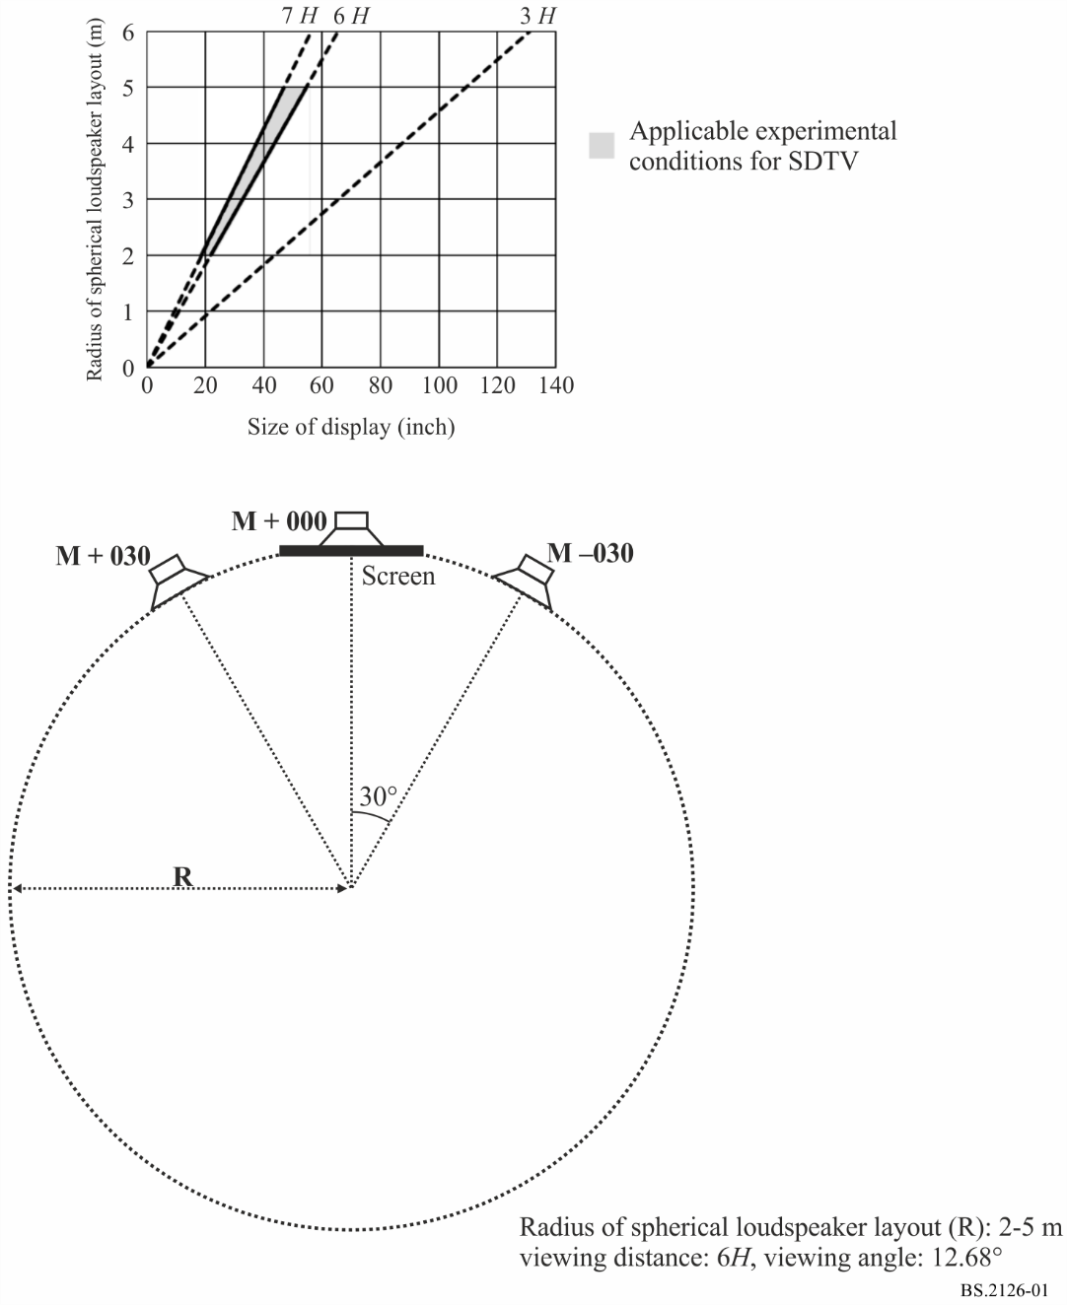
FIGURE 2
Relationship between the radius of the spherical loudspeaker layout and the size of the video display screen
placed in line with the M+030 and M-030 loudspeakers for a 4:3 aspect ratio (SDTV)
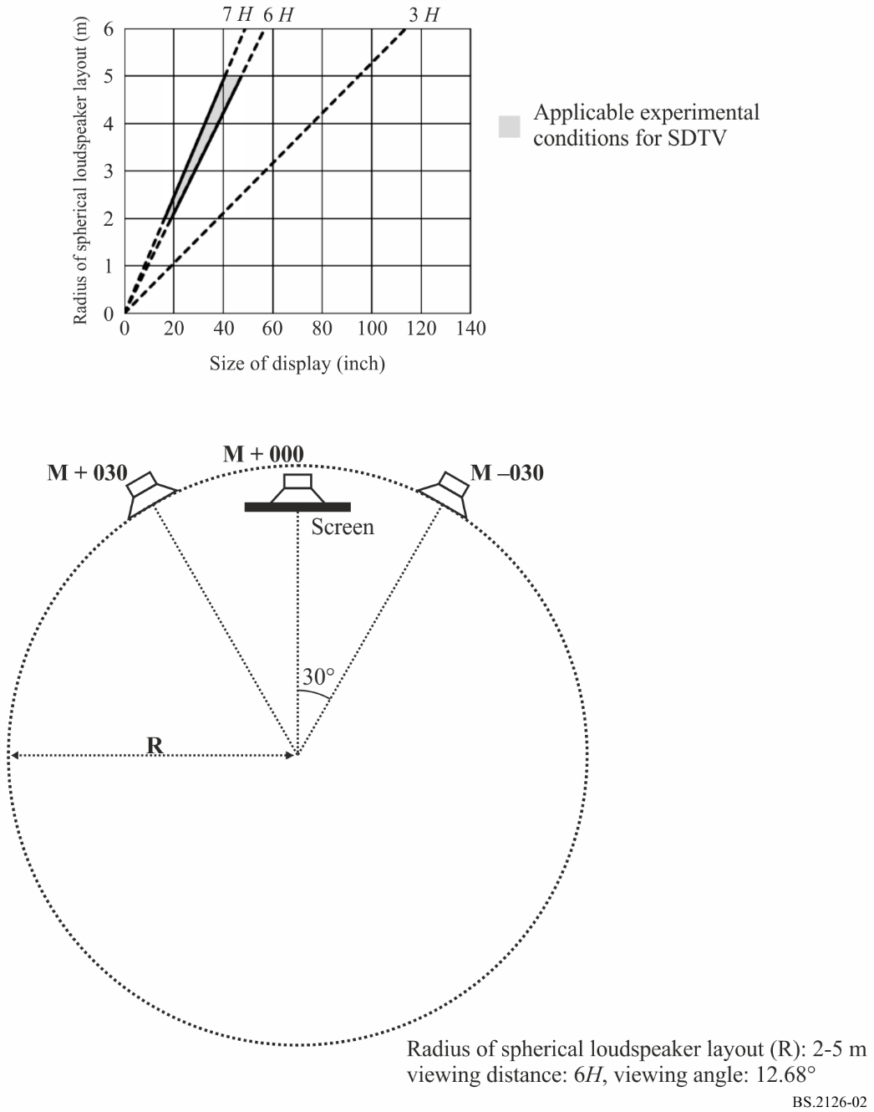
FIGURE 3
Relationship between the radius of the spherical loudspeaker layout and the size of the video display screen
placed in line with the M+000 loudspeaker for a 16:9 aspect ratio
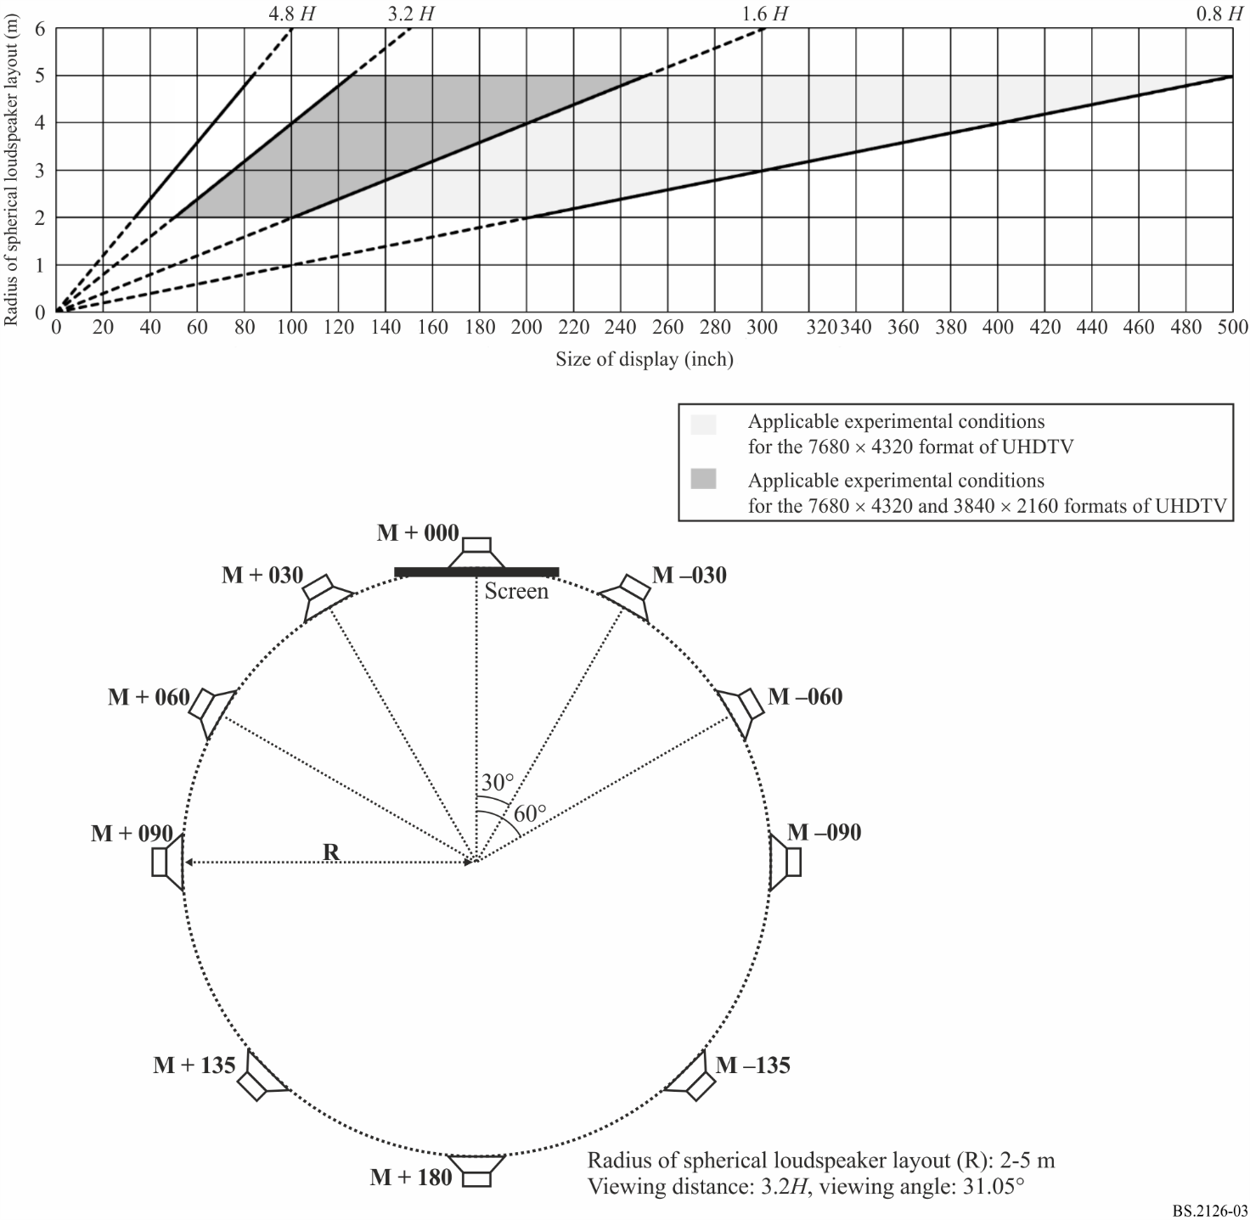
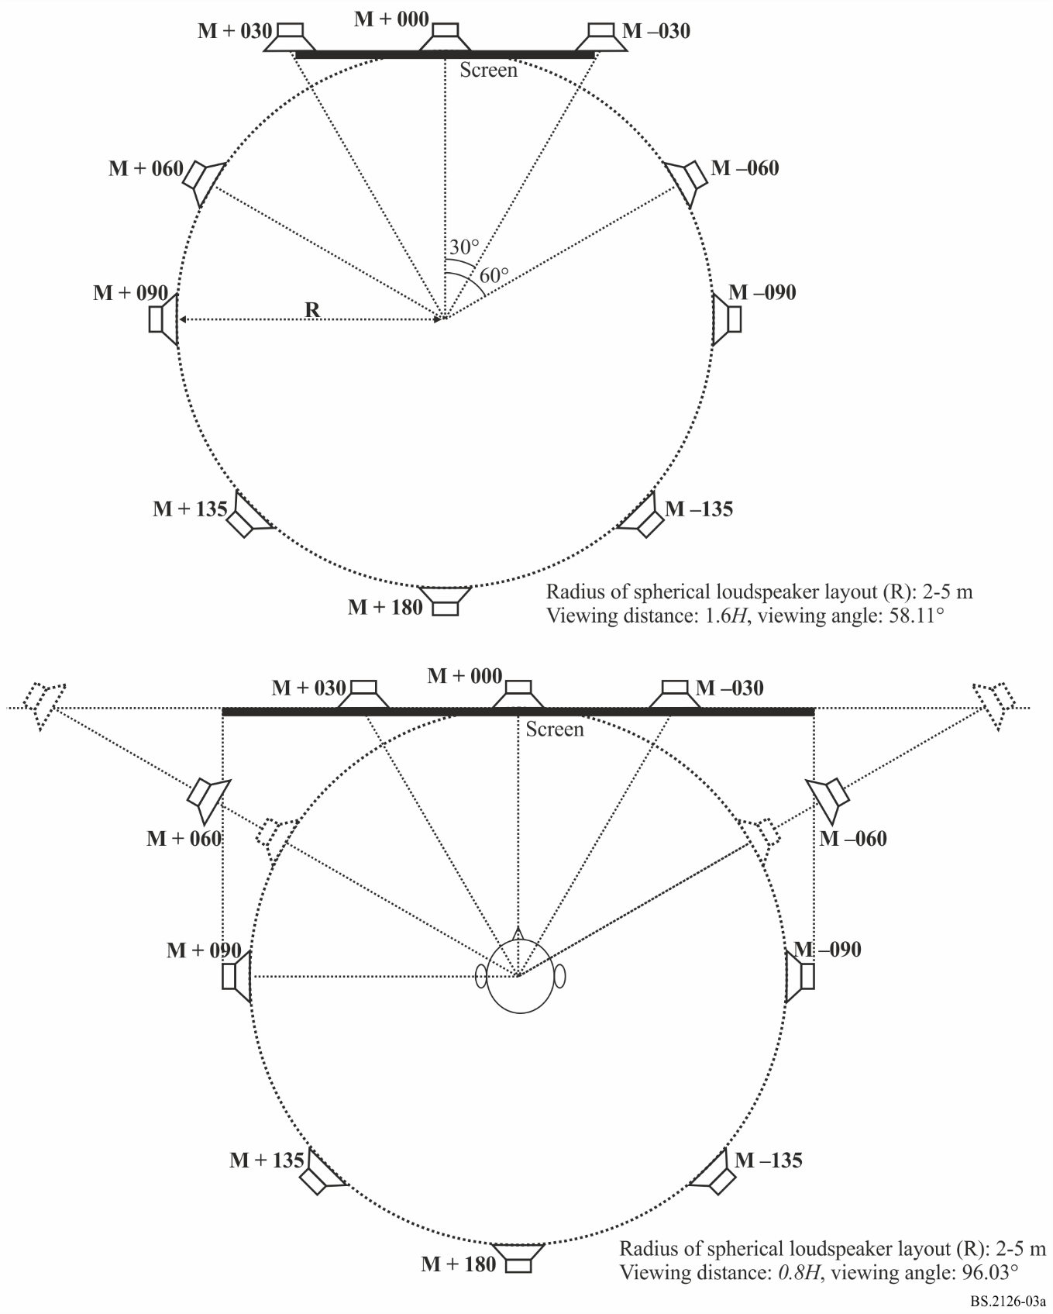
FIGURE 4
Relationship between the radius of the spherical loudspeaker layout and the size of the video display screen
placed in line with the M+030 and M-030 loudspeakers for a 16:9 aspect ratio
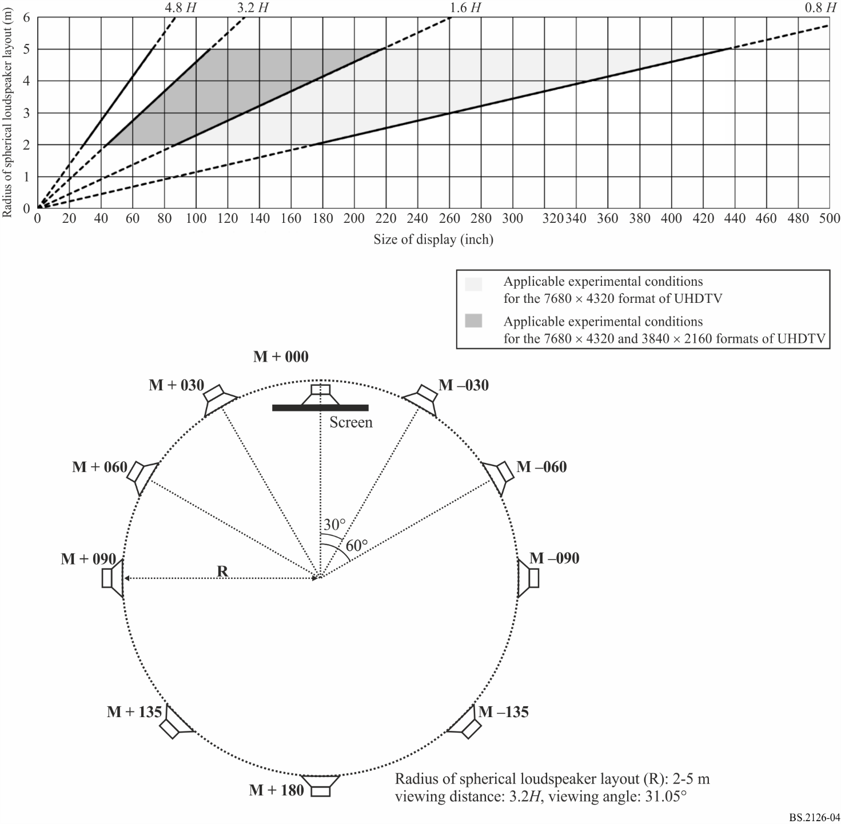
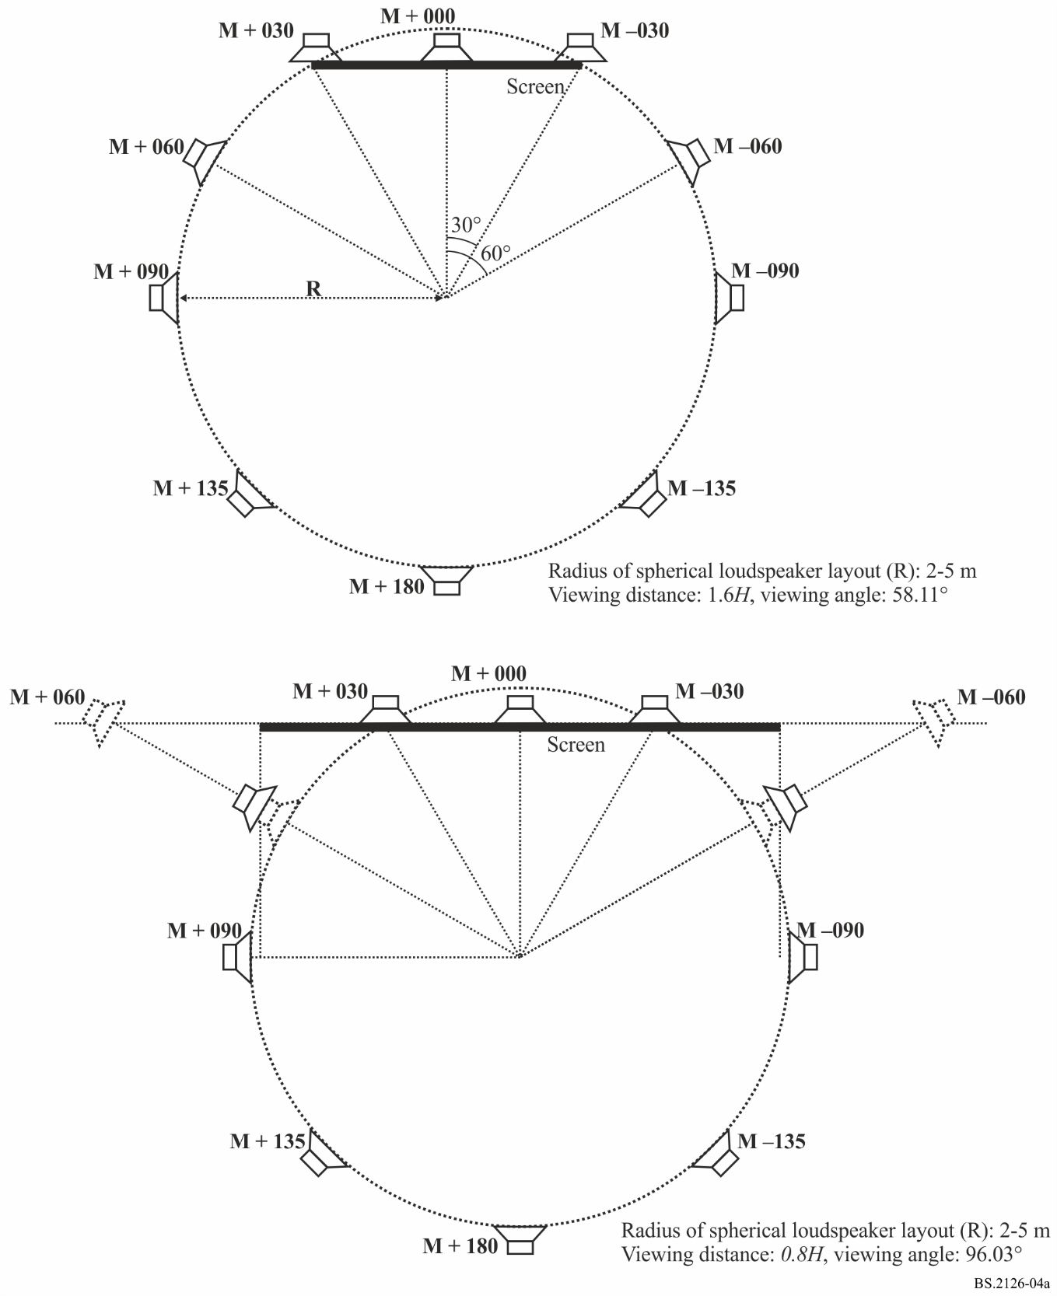
FIGURE 5
Relationship between the radius of the spherical loudspeaker layout and the size of the video display screen
placed in line with the M+060 and M-060 loudspeakers for a 16:9 aspect ratio
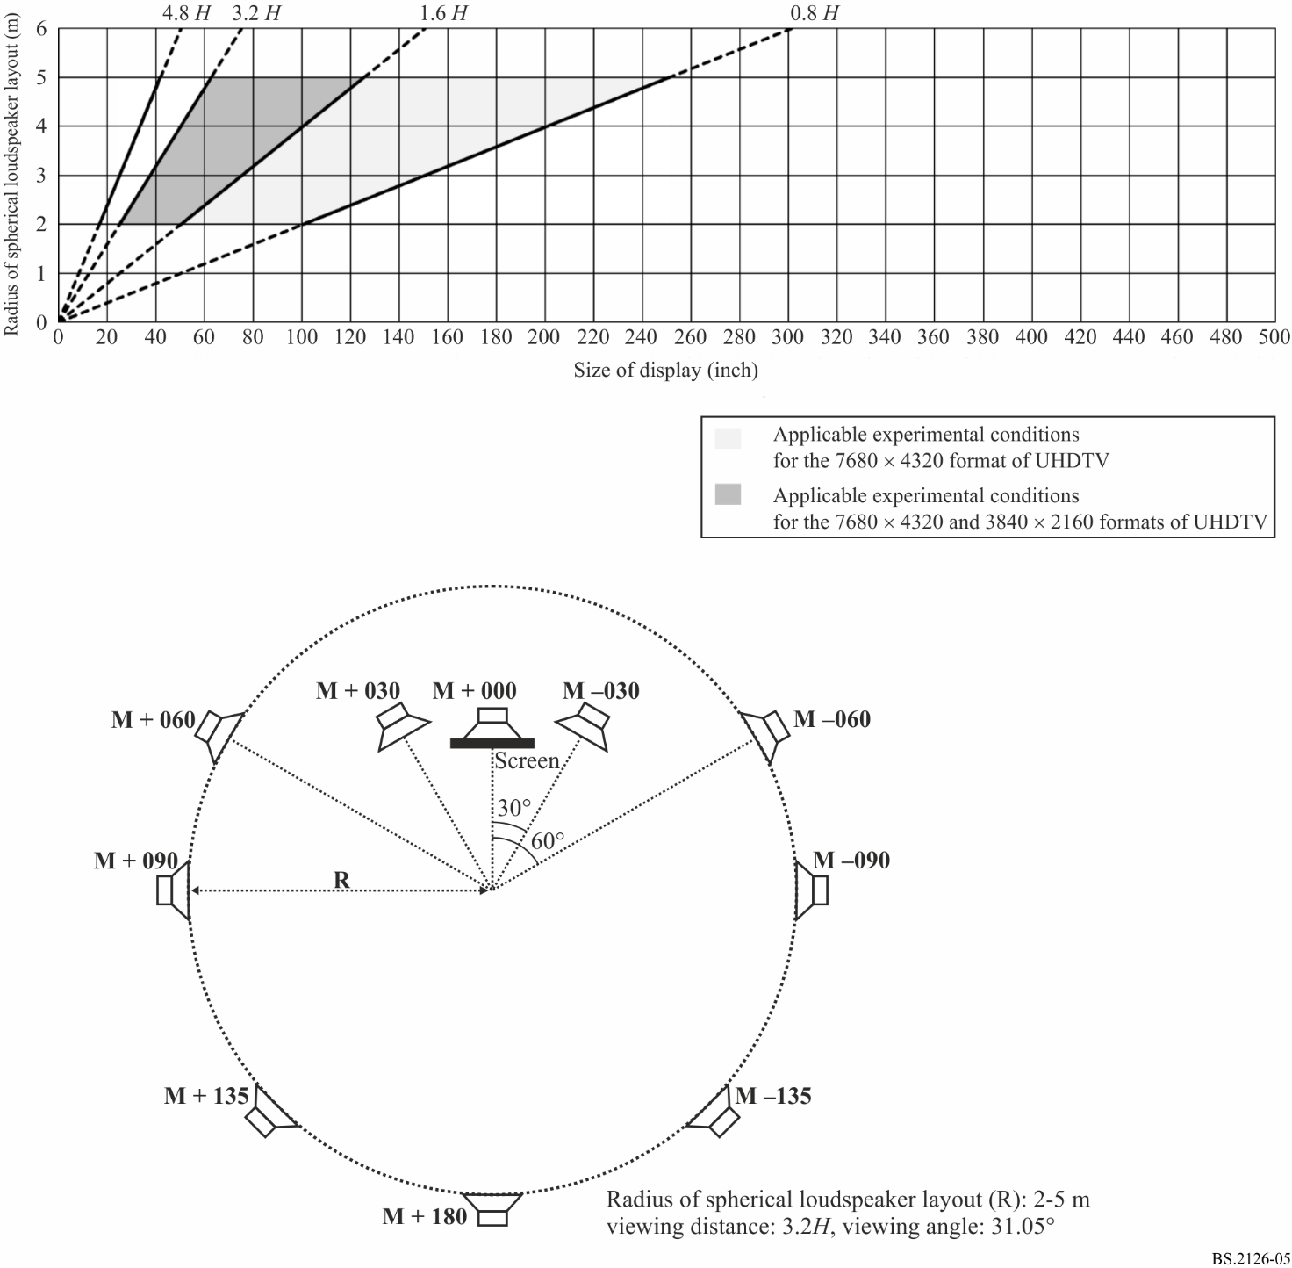
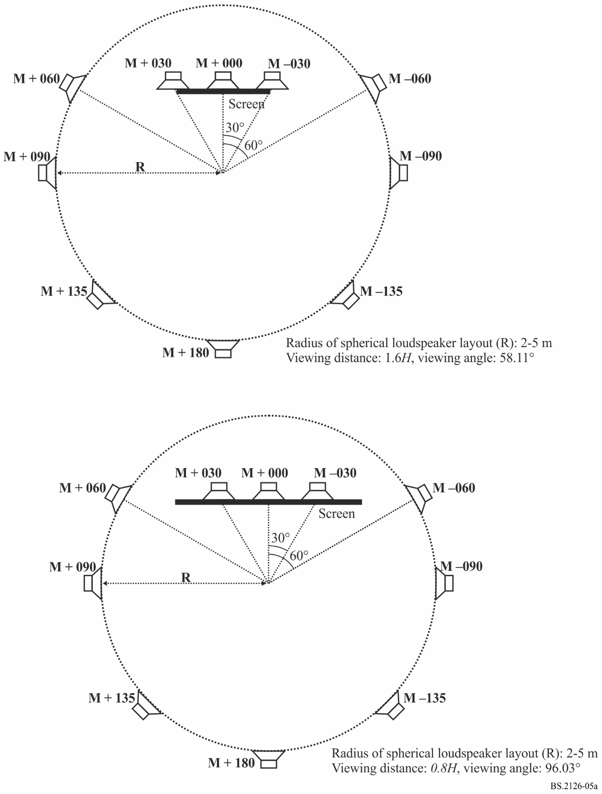

8 Statistical analysis and presentation of results
The analysis of the experimental data and the method of presentation of the results should conform to Recommendation ITU-R BS.1284 or §§ 9, 10 and 11 of Recommendation ITU-R BS.1116 as appropriate.

Attachment
to Annex
Viewing distances described in ITU-R Recommendations
TABLE 1
Design viewing distance described in Recommendation ITU-R BT.500
Image system | Aspect ratio | Optimal horizontal viewing angle | Optimal viewing distance
720 × 483 | 4:3 | 11° | 7 H
640 × 480 | 4:3 | 11° | 7 H
720 × 576 | 4:3 | 13° | 6 H
1 024 × 768 | 4:3 | 17° | 4.5 H
1 280 × 720 | 16:9 | 21° | 4.8 H
1 400 × 1 050 | 4:3 | 23° | 3.3 H
1 920 × 1 080 | 16:9 | 31° | 3.2 H
3 840 × 2 160 | 16:9 | 58° | 1.6 H
7 680 × 4 320 | 16:9 | 96° | 0.8 H

TABLE 2
Viewing distance in the reference viewing environment described
in Recommendation ITU-R BT.2100
Image system | Viewing distance
1 920 × 1 080 | 3.2 H
3 840 × 2 160 | 1.6 to 3.2 H
7 680 × 4 320 | 0.8 to 3.2 H

