Recommendation ITU-R BS.1909-1
(11/2023)
BS Series: Broadcasting service (sound)
Performance requirements for an advanced sound system for use with or without accompanying picture

Foreword
The role of the Radiocommunication Sector is to ensure the rational, equitable, efficient and economical use of the radio-frequency spectrum by all radiocommunication services, including satellite services, and carry out studies without limit of frequency range on the basis of which Recommendations are adopted.
The regulatory and policy functions of the Radiocommunication Sector are performed by World and Regional Radiocommunication Conferences and Radiocommunication Assemblies supported by Study Groups.

Policy on Intellectual Property Right (IPR)
ITU-R policy on IPR is described in the Common Patent Policy for ITU-T/ITU-R/ISO/IEC referenced in Resolution ITU-R 1. Forms to be used for the submission of patent statements and licensing declarations by patent holders are available from http://www.itu.int/ITU-R/go/patents/en where the Guidelines for Implementation of the Common Patent Policy for ITU-T/ITU-R/ISO/IEC and the ITU-R patent information database can also be found.

Series of ITU-R Recommendations
(Also available online at https://www.itu.int/publ/R-REC/en)
Series | Title
BO | Satellite delivery
BR | Recording for production, archival and play-out; film for television
BS | Broadcasting service (sound)
BT | Broadcasting service (television)
F | Fixed service
M | Mobile, radiodetermination, amateur and related satellite services
P | Radiowave propagation
RA | Radio astronomy
RS | Remote sensing systems
S | Fixed-satellite service
SA | Space applications and meteorology
SF | Frequency sharing and coordination between fixed-satellite and fixed service systems
SM | Spectrum management
SNG | Satellite news gathering
TF | Time signals and frequency standards emissions
V | Vocabulary and related subjects

Note: This ITU-R Recommendation was approved in English under the procedure detailed in Resolution ITU-R 1.

Electronic Publication
Geneva, 2023

© ITU 2023
All rights reserved. No part of this publication may be reproduced, by any means whatsoever, without written permission of ITU.

RECOMMENDATION ITU-R BS.1909-1
Performance requirements for an advanced sound system
for use with or without accompanying picture
(Question ITU-R 135-2/6)
(2012-2023)
Scope
This Recommendation specifies the requirements for an advanced sound system with or without accompanying picture.
Keywords
Performance requirement, advanced sound system, channel-based sound system, object-based sound system, scene-based sound system, multichannel audio, loudspeaker layouts, immersive audio
The ITU Radiocommunication Assembly,
considering
a) that Recommendation ITU-R BS.775 – Multichannel stereophonic sound system with and without accompanying picture, specifies the hierarchy of sound systems ranging from monophonic, 2-channel stereophonic and up to 3/2 multichannel of sound;
b) that a wide field of view video presentation requires spatially enhanced sound beyond the 3/2 multichannel sound;
c) that the video presentation should be accompanied with an appropriate sound format,
recognizing
a) that Recommendation ITU-R BS.646 – Source encoding for digital sound signals in broadcasting studios, specifies the sampling frequency and sample resolution for the digital encoding of sound;
b) that Recommendation ITU-R BT.1359 – Relative timing of sound and vision for broadcasting, recommends the timing tolerance between sound and vision signals in broadcasting systems,
recommends
1 that an advanced sound system for use with or without accompanying picture should meet the performance requirements contained in Annex 1;
2 that the appropriate number of channels in programme production should be a choice at the discretion of the programme producer;
3 that the appropriate sound presentation arrangements in the home, such as the number of loudspeakers and the set-up position, should be a choice at the discretion of each member of the public.

Annex 1
Performance requirements

1 Sound quality requirements
1.1 The sound image should be reproduced in all directions around the listener, including the elevation direction, within reasonable limits of stability.
1.2 The sensation of a three-dimensional spatial impression that augments a sense of reality, which is related to ambience and envelopment, should be significantly enhanced over established sound formats in Recommendation ITU-R BS.775.
1.3 For applications with accompanying picture, the directional stability of the frontal sound image should be maintained over the entire area of high-resolution large-screen digital imagery. The coincidence of position between sound images and video images should also be maintained over a wide image and listening area.
1.4 Excellent sound quality should be maintained over a wide viewing/listening area. See Attachment 1.
1.5 For the coding parameters of sound signals, see Recommendation ITU-R BS.646.
1.6 For the relative timing of sound and vision, see Recommendation ITU-R BT.1359. Implementers should note that in large venues where sound and vision timing varies relative to seating location, other adjustments may need to be taken into account.
NOTE 1 – The sound quality is related to timbre, transparency, sound image, and spatial impression. The attributes of sound image and spatial impression include directional stability of the frontal sound image, the sensation of a three-dimensional spatial impression, and the prescribed three-dimensional image locations around the listener, including depth perception. The sound quality has to be defined dependent on the target environments. See Attachment 2.

2 Functional requirements
2.1 Backward compatibility with the 3/2 multichannel sound system and conventional two-channel sound system should be ensured to an acceptable degree.
2.2 Appropriate rendering of the sound format should be ensured for loudspeaker configurations suitable for the range of typical listening environments, to provide an optimum sound field and maintain excellent sound quality at least within a limited area, or alternatively for headphone reproduction. See Attachment 2.

3 Operational requirements
3.1 Live recording, mixing and transmission should be possible, if required.

Attachment 1 (informative)
to Annex 1
Example seating area for a wide field of view video presentation
Figure 1 shows an example seating area for a wide field of view video presentation.
Figure 1
Example seating area for a wide field of view video presentation
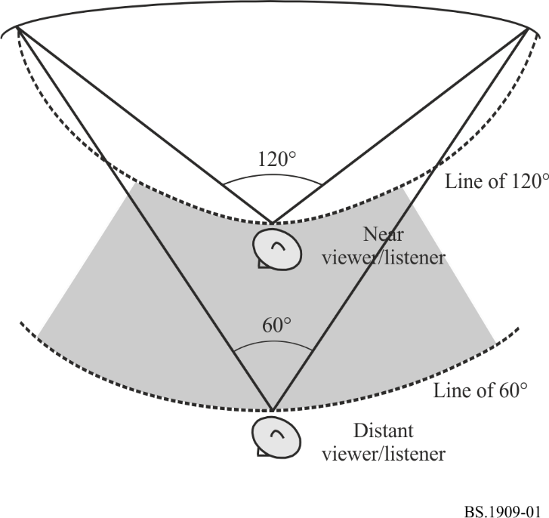

Attachment 2
to Annex 1
Typical viewing/listening environments and assumed
sound reproduction configurations
The following are typical viewing/listening environments and assumed sound reproduction configurations for an advanced sound system with or without accompanying picture.
1. Public environments: A loudspeaker reproduction system is likely to be used in conjunction with a large screen display, but may also be used without accompanying picture. The sound system will be required to produce acceptable quality and directional stability over an extended listening area:
– theatre/outdoor presentation environments;
– large theatre/outdoor presentation environments.
2. Home environments: A loudspeaker reproduction system will be used in conjunction with a display or without accompanying picture. The sound presentation arrangements in a home, such as the number of loudspeakers and the set-up position, are considerably varied. A headphone reproduction system may also be used for individual listening:
– large-to-average size room environment including home theatre environment;
– small size room environment;
– personal environment.
3. Mobile environments: A sound reproduction system will be used in conjunction with a small display or without accompanying picture. The sound presentation arrangements in a mobile environment are likely to vary considerably. In some cases, a headphone reproduction system may be used:
– personal environment;
– in-car environment.

