RECOMMENDATION ITU-R BS.1698
Evaluating fields from terrestrial broadcasting transmitting systems
operating in any frequency band for assessing exposure to
non-ionizing radiation
(Question ITU-R 50/6)

(2005)
Scope
This Recommendation is intended to provide a basis for the derivation and estimation of the values of electromagnetic radiation from a broadcasting station that occurs at particular distances from the transmitter site. Using such information, responsible organizations can then develop appropriate standards that may be used to protect humans from undesirable exposure to harmful radiation. The actual values to be applied in any regulation will naturally depend on decisions reached by responsible health agencies, domestic and worldwide.

The ITU Radiocommunication Assembly,
considering
a) that radio-frequency energy may have unsafe effects on the human body;
b) that radio-frequency energy may induce harmful electric potentials in conducting material;
c) that radio-frequency energy may have harmful effects on apparatus (such as radiocommunication apparatus, navigation instruments, cardiac pacemakers, scientific or medical equipment, etc.);
d) that radio-frequency energy may lead to unintentional ignition of inflammable or explosive material;
e) that determination of hazardous radiation levels and electric potentials, in terms of spectrum content, intensity, cumulative effects, etc., are being made by competent authorities;
f) that determination of areas where radio-frequency fields and electric potentials exceed safe levels are being made by competent authorities;
g) that persons not associated with such systems may be exposed inadvertently to such radiation (including travellers by air) or to such electric potentials;
h) that persons operating and maintaining radio transmitting systems may be required to work in close proximity to the source of such radio-frequency exposures,
recommends
1 that Annex 1 to this Recommendation should be used to evaluate the electromagnetic fields generated by terrestrial broadcasting transmitting systems operating in any frequency band, for assessing exposure to non-ionizing radiation.
Annex 1
Evaluating fields from terrestrial broadcasting transmitting systems
operating in any frequency band for assessing exposure to
non-ionizing radiation

CONTENTS
Page
1 Introduction 3
2 Characteristics of electromagnetic fields 4
2.1 General field characteristics 4
2.1.1 Field components 4
2.1.2 Far field 4
2.1.3 Near field 7
2.1.4 Polarization 7
2.1.5 Modulation 7
2.1.6 Interference patterns 13
2.2 Field-strength levels near broadcasting antennas 13
2.2.1 LF/MF bands (150-1 605 kHz) 13
2.2.2 HF bands (3-30 MHz) 13
2.2.3 VHF/UHF bands (30 MHz-3 GHz) 14
2.2.4 SHF (3-30 GHz) 14
2.3 Mixed frequency field 16
2.4 EMF inside buildings 16
3 Calculation 17
3.1 Procedures 17
3.1.1 Closed solutions 17
3.1.2 Numerical procedures 18
4 Measurements 20
4.1 Procedures 20
4.1.1 LF/MF bands 20
4.1.2 HF bands 21
Page
4.1.3 VHF/UHF bands 21
4.1.4 SHF bands 21
4.2 Instruments 21
4.2.1 Introduction 21
4.2.2 Characteristics of the measurement instruments for electric and magnetic field 22
4.2.3 Narrow-band instrument types and specifications 23
4.3 Comparison between predictions and measurements 24
5 Precautions at transmitting stations and in their vicinity 24
5.1 Precautions to control the direct health effects of RF radiation 24
5.1.1 Employee (occupational) precautionary measures 25
5.1.2 Precautionary measures in relation to the general public 26
5.2 Precautions to control the indirect RF radiation hazards 26
Appendix 1 to Annex 1 – Examples of calculated field strengths near broadcasting antennas 27
Appendix 2 to Annex 1 – Comparison between predictions and measurements 41
Appendix 3 to Annex 1 – Limits and levels 62
Appendix 4 to Annex 1 – Additional evaluation methods 71
Appendix 5 to Annex 1 – Electromedical devices 75
Appendix 6 to Annex 1 – References 76

1 Introduction
For many years the subject of the effects of electromagnetic radiation has been considered and attempts have been made to quantify particular limits that could be used to protect humans from undesirable effects. Studies in many countries by various organizations have resulted in various administrative regulations. It is noteworthy and understandable that no single standard has emerged from all the efforts in this regard.
This Recommendation is intended to provide a basis for the derivation and estimation of the values of electromagnetic radiation from a broadcast station that occur at particular distances from the transmitter site. Using such information, responsible organizations can then develop appropriate
standards that may be used to protect humans from undesirable exposure to harmful radiation. The actual values to be applied in any regulation will naturally depend on decisions reached by responsible health agencies, domestic and worldwide.
It is noted that this ITU-R Recommendation and ITU-T Recommendations cover similar material, but with an emphasis on different aspects of the same general subject. For example, ITU-T Recommendations K.52 (Guidance on complying with limits for human exposure to electromagnetic fields) and K.61 (Guidance to measurement and numerical prediction of electromagnetic fields for compliance with human limits for telecommunication installations) provide guidance on compliance with exposure limits for telecommunication systems. Appropriate reference information is included in Appendix 6.

2 Characteristics of electromagnetic fields

2.1 General field characteristics
This section gives an overview of the special characteristics of electromagnetic (EM) fields that are relevant to this Recommendation, especially the distinction between the near field and the far field. Simple equations are derived for calculating the power density and the field strength in the far field, and the section concludes by defining the terms polarization and interference patterns.

2.1.1 Field components
The EM field radiated from an antenna is comprised of various electric and magnetic field components, which attenuate with distance, r, from the source. The main components are:
– the far field (Fraunhofer), also called the radiation field, in which the magnitude of the fields diminishes at the rate of 1/r;
– the radiating near field (Fresnel), also called the inductive field. The field structure of the inductive field is highly dependent on the shape, size and type of the antenna although various criteria have been established and are commonly used to specify this behaviour;
– the reactive near field (Rayleigh), also called quasi-static field, which diminishes at the rate of 1/r³.
As the inductive and quasi-static components attenuate rapidly with increasing distance from the radiation source, they are only of significance in the vicinity of the transmitting antenna – in the so-called near-field region.
The radiation field, on the other hand, is the dominant element in the so-called far-field region. It is the radiation field which effectively carries a radio or television signal from the transmitter to a distant receiver.

2.1.2 Far field
In the far-field region, an electromagnetic field is predominantly plane wave in character. This means that the electric and magnetic fields are in phase, and that their amplitudes have a constant ratio. Furthermore, the electric fields and magnetic fields are situated at right angles to one another, lying in a plane, which is perpendicular to the direction of propagation.
It is often taken that far-field conditions apply at distances greater than 2D²/λ where D is the maximum linear dimension of the antenna.
However, care must be exercised when applying this condition to broadcast antennas for the following reasons:
– it is derived from considerations relating to planar antennas;
– it is assumed that D is large compared with λ.
Where the above conditions are not met, a distance greater than 10 λ should be used for far field.

2.1.2.1 Power density
The power density vector, the Poynting vector S, of an electromagnetic field is given by the vector product of the electric, E, and magnetic, H, field components:
S = E × H (1)
In the far field, in ideal conditions where no influence of the ground or obstacles is significant, this expression can be simplified because the electric and magnetic fields, and the direction of propagation, are all mutually orthogonal. Furthermore, the ratio of the electric, E, and magnetic, H, field strength amplitudes is a constant, Z₀, which is known as the characteristic impedance of free space1 and is about 377 Ω (or 120π Ω).
Thus, in the far field, the power density, S, in free space is given by the following non-vector equation:
S = E²/Z₀ = H² Z₀ (2)
The power density – at any given distance in any direction – can be calculated in the far field using the following equation:
S = P G_{i} /(4π r²) (3)
where:
S : power density (W/m²) in a given direction
P : power (W) supplied to the radiation source, assuming a lossless system
G_{i} : gain factor of the radiation source in the relevant direction, relative to an isotropic radiator
r : distance (m) from the radiation source.
The product PG_{i} in equation (3) is known as the e.i.r.p. which represents the power that a fictitious isotropic radiator would have to emit in order to produce the same field intensity at the receiving point.
For power densities in other directions the antenna pattern must be taken into account.
In order to use equation (3) with an antenna design whose gain G_{a} is quoted relative to a reference antenna of isotropic gain G_{r}, such as a half-wave dipole or a short monopole, the gain factor G_{i} must be replaced by the product of G_{r} ⋅ G_{a}, as in equation (4). The relevant factor G_{r} is given in Table 1.
S = P G_{r} G_{a} /(4π r²) (4)

TABLE 1
Isotropic gain factors for different types of reference antenna
Reference antenna  type | Isotropic gain  factor, G_{r} | Typical applications where reference antenna type is relevant
Isotropic radiator | 1.0 | Radar, satellite and terrestrial radio link system
Half-wave dipole | 1.64 | Television, VHF and sometimes HF broadcasting
Short monopole | 3.0 | LF, MF and sometimes HF broadcasting
Thus, when the gain of the antenna G_{d} (G_{a} = G_{d}) is expressed relative to that of a half-wave dipole:
S = 1.64 PG_{d} /(4π r²) (5)
where:
G_{d} : gain of the antenna relative to a half-wave dipole.
Similarly, when the gain of the antenna G_{a} = G_{m} is expressed relative to that of a short monopole:
S = 3.0 PG_{m} /(4π r²) (6)
where:
G_{m} : gain of the antenna relative to a short monopole.

2.1.2.2 Field strength
Equations (2)-(10) assume plane wave (far-field) conditions and are not applicable to near-field calculations.
If equation (2) is inserted into equation (3) to eliminate S, and a factor C is introduced to take account of the directional characteristic of the radiation source, then equation (7) is obtained for the electric field strength (E) in the far field of a radiation source:
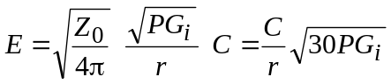 (7)
where:
E : electric field strength (V/m)
Z₀ = 377 Ω, the characteristic impedance of free space
P : power fed to the radiation source (W), assuming a lossless system
C : factor (0 ≤ C ≤1), which takes account of the directional characteristic of the radiation source (in the main direction of radiation, C = 1).
If the gain of the antenna is expressed relative to a half-wave dipole or a short monopole, rather than relative to an isotropic radiator, then the factors G_{d} or G_{m}, respectively, should be used in place of G_{i}, as shown in equations (8) and (9).
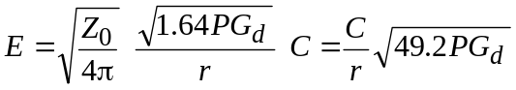 (8)
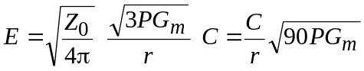 (9)
In order to calculate the magnetic field strength in the far field of a radiation source, equation (10) is used:
H = E/Z₀ (10)
where:
E : electric field strength (V/m)
H : magnetic field strength (A/m)
Z₀ = 377 Ω (120π), the characteristic impedance of free space.

2.1.3 Near field
The field structure in the near-field region is more complex than that described above for the far field. In the near field, there is an arbitrary phase and amplitude relationship between the electric and magnetic field strength vectors, and the field strengths vary considerably from point to point. Consequently, when determining the nature of the near field, both the phase and the amplitude of both the electric and magnetic fields must be calculated or measured. In practice, however, this may prove very difficult to accomplish.

2.1.3.1 Power density and field strength
It is not easy to determine the Poynting vector in the near field because of the arbitrary phase and amplitude relationship mentioned above. The E and H amplitudes, together with their phase relationship, must be measured or calculated separately at each point, making the task particularly complex and time-consuming.
Using analytical formulas, an estimation of the field strength in the near field is only feasible for simple ideal radiators such as the elementary dipole. In the case of more complex antenna systems, other mathematical techniques must be used to estimate field strength levels in the near-field region. These other techniques allow relatively precise estimations of the field strength, the power density and other relevant characteristics of the field, even in the complex near-field region.
Measurement in the near field is even more difficult as no reference calibration method exists. The International Electrotechnical Commission is currently working on the issue of a measurement standard for high frequency (9 kHz to 300 GHz) electromagnetic fields particularly in the near field [1]. In addition, EN 61566 (Measurements of exposure to Radiofrequency electromagnetic field strength in the frequency range 1 kHz-1 GHz – sub-clause 6.1.4) gives more information on this topic.

2.1.4 Polarization
Polarization is defined as the direction of the electric field vector, referenced to the direction of propagation of the wave front.
In broadcasting, different types of polarization are used. The main types are vertical and horizontal (with respect to a wave front which is travelling parallel to the surface of the Earth) although other types of polarization are used such as slant and elliptical.

2.1.5 Modulation
Modulation is a very special characteristic of the emission from a broadcasting transmitter. As certain effects of EM radiation are sensitive to the type of modulation used, it follows that the presence of modulation must be taken into consideration when making safety assessments. Modulation must also be taken into consideration when carrying out measurements or calculations to determine whether or not the limits are being exceeded.
The modulation often results in a signal varying in both amplitude and frequency. For this reason temporal averaging is usually required in determining the values to be used in measurement and calculation. This requirement is also acknowledged in relevant Standards.

2.1.5.1 Characteristics of radio emission
The Radio Regulations (RR) classify the emissions from radio transmitters according to the required bandwidths, and the basic and optional characteristics of the transmission. The complete classification consists of nine characters as follows:
– Characters 1-4 describe the bandwidth, using three digits and one letter;
– Characters 5-7 describe the basic characteristics, using two letters and one digit;
– Characters 8-9 describe any optional characteristics, using two letters.
Only the three basic characteristics are relevant to the consideration of RF safety considerations. These are:
– the type of modulation of the main carrier Character 5
– the nature of the signal(s) which modulate(s) the main carrier Character 6
– the type of information to be transmitted Character 7
Table 2, which is based on information given in the RR, lists the various characters which are used to classify the three basic characteristics of a radio emission. For sound and television broadcasts, the relevant characters are as follows:
– AM radio (LF, MF and HF double sideband) A3E
– AM radio (HF single sideband, reduced/variable carrier) R3E
– AM radio (HF single sideband, suppressed carrier) J3E
– Television pictures C3F
– Television sound F3E or A3E
– FM radio F3E or F9E
– DVB G7F
– DAB G7E

TABLE 2
Characters used to define the class of emission, based on information given in the RR
Character 5  Type of modulation of  the main carrier |  | Character 6  Nature of the signal(s) modulating the main carrier |  | Character 7  Type of information to be transmitted
N | Unmodulated | 0 | No modulating signal | N | No information transmitted
A | Amplitude modulation: double-sideband | 1 | Single channel containing:  quantized or digital information  not using a modulating sub-carrier | A | Telegraphy  for aural reception
H | Amplitude modulation: single-sideband, full carrier | 2 | Single channel containing:  quantized or digital information  using a modulating sub-carrier | B | Telegraphy  for automatic reception
R | Amplitude modulation: single-sideband, reduced or variable-level carrier | 3 | Single channel containing:  analogue information | C | Facsimile
J | Amplitude modulation: single-sideband, suppressed carrier | 7 | Two or more channels containing:  quantized or digital information | D | Data transmission, telemetry and telecommand
B | Amplitude modulation: independent sidebands | 8 | Two or more channels containing:  analogue information | E | Telephony  including sound broadcasting
C | Amplitude modulation: vestigial sideband | 9 | Two or more channels containing:  a mix of analogue and digital channels | F | Television (video)
F | Angle modulation: frequency (i.e. FM) | X | Cases not otherwise covered | W | Combination of the above
G | Angle modulation: phase |  |  | X | Cases not otherwise covered
D | Mixture of amplitude and angle modulation (simultaneously or sequentially)
P | Sequence of pulses: unmodulated
K | Sequence of pulses: modulated in amplitude
L | Sequence of pulses: modulated in width/duration
M | Sequence of pulses: modulated in position/phase
Q | Sequence of pulses: angle-modulation of the carrier during the period of the pulse
V | Sequence of pulses:  combination of K, L, M and Q, or produced by other means
W | Cases not covered above:  Carrier modulated by two or more modes (amplitude, angle, pulse)
X | Cases not otherwise covered

2.1.5.2 Expressing transmitter power and field strength in terms of modulation type
Information about the transmitter power supplied to the antenna and the type of modulation can be obtained from the transmission authority, which is responsible for operating the equipment at a particular site. It is important to know whether the transmitter power is expressed in terms of the carrier power, P_{c}, the mean power, P_{m}, or the peak power, P_{p}, so that the measured or calculated values can be compared accurately with the derived levels.
As an example, an MF sound-broadcasting transmitter (i.e., a type A3E emission) is considered. It is assumed that the calculations or measurements take account of the carrier power only, but the derived levels take account of the modulation components also (in terms of transmitter power, this corresponds to the mean power). Furthermore, it is assumed that only RMS values are used.
In order to compare the calculated or measured values with the derived levels, one of the following transformations must be made:
– the calculated/measured values must be modified to include the modulation components, or
– the derived levels must be modified to correspond with the carrier-only power values, i.e., without modulation components.
Table 3a gives multiplication factors which relate one type of power notation to another (these different notations for power are defined in the RR). In the case of an A3E transmission, shown as A*E in Table 3a, it can be seen that the mean power, P_{m}, is 1.5 times the carrier power, P_{c}.
It should be noted that Table 3a gives “worst-case” values, by assuming a modulation depth of 100%. In practice, the modulation depth of a broadcast transmitter will be less than 100% and, hence, the mean power will actually be less than 1.5 times the carrier power. For this reason, Table 3b gives the factors for a typical modulation depth (70% for an A3E transmission corresponding to a P_{m}/P_{c} ratio of 1.25 instead of 1.5).

TABLE 3a
Relationship between carrier, average, peak and maximum instantaneous power,
for different classes of emission (worst-case figures)
Class of emission  (basic characteristics)  ^{(1), (2)} | Known power type
 | Carrier power, P_{c} |  |  | Mean power, P_{m} |  |  | Peak power, P_{p}
 | Factor for the  determination of: |  |  | Factor for the  determination of: |  |  | Factor for the  determination of:
 | P_{c} | P_{m} | P_{p} | P_{c} | P_{m} | P_{p} | P_{c} | P_{m} | P_{p}
A1A | 1 | 1 | 1 | 1 | 1 | 1 | 1 | 1 | 1
A1B
A*C | 1 | 1.5 | 4 | 0.67 | 1 | 2.67 | 0.25 | 0.38 | 1
A*E
B*B⁽³⁾
B*E⁽³⁾ | – | – | – | – | 1 | 1 | – | 1 | 1
B*W⁽³⁾
C*F⁽⁴⁾  Negative modulation  Positive modulation | – | – | – | – | 1  1 | 1.85  1.42 | – | 0.54  0.87 | 1  1
F*...⁽⁵⁾ | 1 | 1 | 1 | 1 | 1 | 1 | 1 | 1 | 1
H*A
H*B | 1 | 2 | 4 | 0.5 | 1 | 2 | 0.25 | 0.5 | 1
H*E
J*B⁽³⁾
J*C⁽³⁾ | – | – | – | 0 | 1 | 1 | 0 | 1 | 1
J*E⁽³⁾
K*A | 1 | 1.5 | 4/d | 0.67 | 1 | 2.67/d | 0.25d | 0.38d | 1
K*E
L*A
L*E
M*A | 1 | 1 | 1/d | 1 | 1 | 1/d | d | d | 1
H*E
P*N
R*B⁽³⁾
R*C⁽³⁾ | – | – | – | – | 1 | 1 | – | 1 | 1
R*E⁽³⁾
G7E | 1 | 1 | 1 | 1 | 1 | 1 | 1 | 1 | 1
G7F | 1 | 1 | 1 | 1 | 1 | 1 | 1 | 1 | 1
⁽¹⁾ See Table 2 for further information on the 3-symbol code, which is used to describe the three basic characteristics of a transmission type.
⁽²⁾ An * indicates that the 2nd characteristic (i.e. the nature of the modulating signal) is not relevant to the consideration of hazards.
⁽³⁾ It is assumed that the carrier is almost totally suppressed and that, in the case of modulation with a tone, the peak power of the transmitter can be reached in an SSB.
⁽⁴⁾ Carrier power, P_{c}, is not clearly defined.
⁽⁵⁾ The 3rd characteristic is not relevant to the consideration of hazards.
d = pulse duty factor.
These factors are given for DAB and DVB when measuring over the whole channel power (generally 1.5 MHz for DAB and 8 MHz for DVB).

TABLE 3b
Relationship between carrier, average, peak and maximum instantaneous power,
for different classes of emission (typical case modulation)
Class of emission  (basic characteristics) | Known power type
Class of emission  (basic characteristics) | Carrier power, P_{c} |  |  | Mean power, P_{m} |  |  | Peak power, P_{p}
Class of emission  (basic characteristics) | Factor for the  determination of: |  |  | Factor for the  determination of: |  |  | Factor for the  determination of:
Class of emission  (basic characteristics) | P_{c} | P_{m} | P_{p} | P_{c} | P_{m} | P_{p} | P_{c} | P_{m} | P_{p}
A*C (for m = 70%) | 1 | 1.25 | 2.89 | 0.80 | 1 | 2.32 | 0.35 | 0.43 | 1
A*E (for m = 70%)
C*F⁽¹⁾  Negative modulation  Positive modulation | –  – | –  – | –  – | –  – | 1  1 | 4.34  2.7 | –  – | 0.23  0.37 | 1  1
F*... | 1 | 1 | 1 | 1 | 1 | 1 | 1 | 1 | 1
⁽¹⁾ Carrier power, P_{c}, is not clearly defined.
Table 3b can also be used to convert field strength values to other notations; note, however, that the square root of the conversion factors given in Table 3b must be used when dealing with field strengths. Thus, in the above example of AM radio, the carrier-only RMS field-strength should be multiplied by 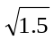 (or 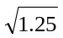) to give the RMS field strength, which includes the modulation components. Conversely, the derived level (including modulation components) should be divided by (or ) to give an equivalent derived level for the carrier only.
The r.m.s. value of the field strength in the far field can be calculated from the known power, using equation (7); the appropriate type of power to use (i.e. P_{m}, or P_{p}) is shown in Table 4.

TABLE 4
Relationship between certain field-strength notations and power notations
To calculate | Use power expressed as
The effective value of the equivalent field-strength | Average transmitter power, P_{m}
The average value of the equivalent field-strength which occurs during a period of peak RF oscillation | Peak power, P_{p}
Peak (maximum) value of the equivalent field-strength | Peak power, P_{p}⁽¹⁾
⁽¹⁾ The peak value of the equivalent field strength is determined from the peak power, P_{p}, using the peak/r.m.s. correction factor. This factor is 21/2 for a sinusoidal carrier.

2.1.6 Interference patterns
Both natural and man-made structures can re-radiate an electromagnetic field (EMF). The re-radiated field adds vectorially to the direct field. This can result in interference patterns, which are comprised of localized maxima and minima of the field strength. The interference pattern is even more complex if there are multiple re-radiations of the field.
Interference patterns depend on the frequency of the radiation source. The higher the frequency, the smaller the wavelength and hence the closer, spatially, the maxima and minima. At UHF television frequencies, the local maxima and minima may be separated by only tens of centimetres.
Several overlapping patterns occur in the case of multiple-radiation sources, e.g. if several radio and television channels are radiated from the same site.

2.2 Field-strength levels near broadcasting antennas
In this section, the field-strength levels which are found in the vicinity of typical LF/MF, HF, VHF and UHF broadcasting antennas are discussed.

2.2.1 LF/MF bands (150-1 605 kHz)
At LF and MF, the frequencies are below whole-body resonance frequencies. In the case of direct effects of the electromagnetic field, the limit (also defined as “derived”) levels for both the electric, E, and magnetic, H, field values are relatively high. However, in many cases, high values are present only very close to the transmitting antenna. This is especially true at the lower end of the LF/MF range, and for those standards/guidelines, which have specified higher derived levels. At the upper end of the band, however, the relevant distances may extend to the order of a few hundred metres. It should be realized that this increase in distance is due, in part at least, to the reduction in reference levels at the upper end of the MF band. During transmissions, access to the mast/tower must be avoided, owing to the high field-strengths and the risk of electric shock.

2.2.2 HF bands (3-30 MHz)
Measurements suggest that in large areas around a high-power HF transmitting station the EMF will exceed the derived electric field-strength levels, especially near open-wire feeders. At many broadcasting stations, these feeders are now being encased by trunking to reduce the field, but this cannot be done around the transmitting antenna arrays themselves. Thus, some parts of the land containing the antenna arrays will have to become “exclusion areas” and maintenance schedules will have to be planned to avoid times when the antenna array is transmitting. This will be difficult on many HF stations where, for programming requirements, the field patterns may change every 15 min. The field-strength in front of an HF array tends to increase with height above the ground. This is partly because the main beam has an angle of elevation of around 10° to 15°, but mainly results from the boundary conditions at the surface of the ground. Most HF broadcast antennas are horizontally polarized, in which case the electric field-strength at the ground would be zero for an infinitely conducting earth. In practice however, owing to the finite conductivity of the ground, there is a small horizontal component of the electric field.
It is important to realize that the near field of an HF antenna array may extend a considerable distance. This is not only because of the size of the antennas, but also because uneven terrain can result in a very large effective aperture for the array. This results in the field-strength measurements falling below the derived levels at locations close to the array, then rising again with increasing distance from the antennas. However, once the far-field region is entered, the field-strength levels follow the normal pattern of decreasing with increased distance from the antenna array.

2.2.3 VHF/UHF bands (30 MHz-3 GHz)
Normally, at high power VHF/UHF sites, the antennas are generally located about 100 m above the ground level, mounted on masts or self-supporting towers. On the ground level, therefore, the field-strengths are relatively low, owing to the distance from the antenna and also to the narrow beamwidth transmitted in the vertical plane.

2.2.4 SHF (3-30 GHz)
This frequency band is used for an enormous number of telecommunication services, such as point-to-point and point-to-multipoint fixed and mobile microwave links, satellite broadcasting, civil and military radars, earth uplink stations, etc.
In the following sub-sections the systems used in broadcasting are treated.

2.2.4.1 Field area definitions
For dish antennas with diameter D >> λ the following definitions are used:
Near-field region – In the near-field, or Fresnel region, of the main beam, the power density can reach a maximum before it begins to decrease with distance. The maximum value of the near field power density on axis depends only on power fed to antenna, the diameter, D, of the antenna, and the efficiency of antenna.
Transition region – The power density in the transition region decreases inversely with distance from the antenna.
Far-field region – The power density in the far-field, or Fraunhofer region, of the antenna pattern decreases inversely as the square of the distance.
The various zones of a parabolic antenna are shown in Fig. 1. The following approach is only valid along the main axis of the antenna.
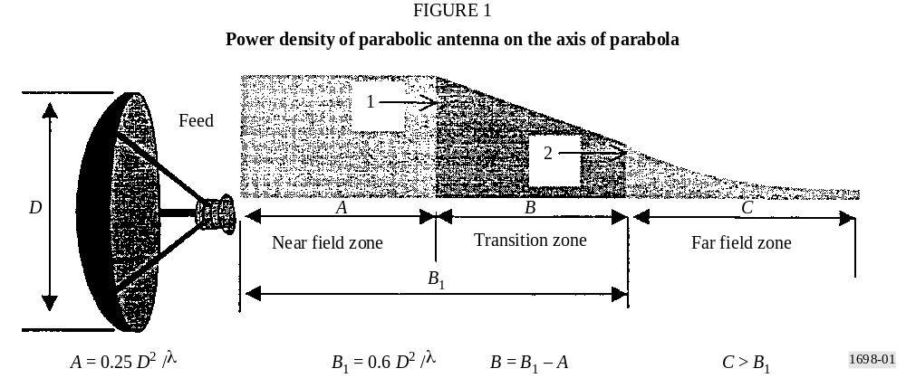
The radiation of a parabolic antenna in the near-field zone occurs along the entire length of the zone in the form of a cylinder with a diameter, D. The maximum of the EMF and its power density are constant throughout the near-field zone.
It is expressed by the equation:
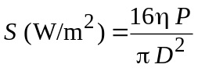
where:
η : efficiency of parabolic antenna (0.55 is used)
P : power of transmitter (W)
D : diameter of parabolic antenna (m).
It should be noted that the density, S, is maximal throughout the near-field zone.
From point 1 (beginning of the transition zone) the density S decreases linearly with the distance r to point 2, where the far-field zone begins.
In the far-field zone, S decreases with the square of distance according to the equation:
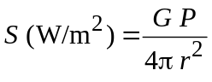
where:
G : gain of parabolic antenna with respect to an isotropic source
r : distance from the parabolic antenna (m).
The density S is maximal on the axis of the parabolic antenna.

2.2.4.2 Fixed and mobile terrestrial microwave links
A typical transmitting-receiving system consists of a transmitter-receiver, a waveguide and a transmitting-receiving parabolic antenna. The transmitter powers are within the range from 0.1 W to 15 W and the parabola sizes within the range from 0.5 m to 4 m, both depending on frequency band used.
The gain of the parabolic antennas used lies within the range of 30 dB to 50 dB.

2.2.4.3 Satellite earth stations
An ideal location for a satellite earth station is in lowland, on flat ground, and valleys far from other objects and industrial zones. In practice, however, such stations are often situated in urban areas, on the roofs of buildings, etc.
Generally, the angle of elevation of the main beam is between 5° and 50°; the radius of dish is usually up to 15 m, although there are a few examples of larger dishes.
In the near field, the field strength of the fixed and mobile terrestrial links can exceed the reference levels, especially when higher powers are involved. Therefore direct access of any unauthorized persons should be prevented physically. The reference levels can also be exceeded in the transition zone in addition to the near field.
In particular, satellite earth stations of higher powers can, to a large extent, produce fields which exceed the recommended levels both in the near field and in the transition zones. Since these regions can be quite extended, the location of the satellite earth station should be carefully selected. Since the radiation is emitted at a certain elevation angle, safety mechanisms should be included so as to mechanically prevent any alteration of the elevation angle into the position which would allow radiation to be directed in the space where any people may be present.

2.3 Mixed frequency field
It is common to have more than one transmitter (using different transmitting frequencies) located at the same transmitter site. In this case it is necessary to consider a total (combined) effect of human exposure to RF energy. On the other hand, effects are frequency dependent, and therefore, after calculation of the relevant parameters (S, E and H ), the combined effect should be taken into account.
For thermal effects, exposure limits are given in terms of specific absorption rate (SAR) (see Appendix 4), which means that appropriate power-densities should be determined. In the case of the multi-frequency transmitter site, the total power-density is recommended to be the sum of the power-density at each transmitting frequency:
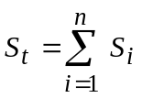 (11)
where S_{i} is power density at the frequency f_{i} (i = 1, 2, … n), with the condition that:
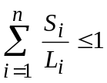 (12)
where L_{i} is the power-density reference level, at the frequency f_{i} (i = 1, 2, … n).
This is the basic principle, but there are some differences in how the principle is applied (see Appendix 4).

2.4 EMF inside buildings
The materials of a building and infrastructure inside a building have a very strong influence on the field, causing variations of the resulting field, from point to point, even in the same room. Spatial variations in the electromagnetic field are caused by multiple reflections of the incident wave, and therefore, the polarization of the resulting field may differ from that of the incident wave.
Metallic objects and ducts (lines and tubes), cause re-radiation (acting as secondary source), and change intensity of the fields in their vicinity.
All these conditions make assessment of the exposure difficult. A rather large number of parameters should be taken into consideration when carrying out calculations or measurements.
To have acceptable accuracy in calculation of exposure it is necessary to choose appropriate model for representing the environment.
Accuracy of measurement depends on the+ size and detection type of the probe, as well as the location of the person who is doing measurements relative to radiation source and probe.
There are no international standards for calculation and measurement methods yet.
The critical issue is not simply the value of the exposure limits themselves, but the way in which calculations and measurement should be carried out and that is the main goal of this Recommendation.

3 Calculation

3.1 Procedures
Analytical and numerical calculation methods can predict the external or internal fields from an electromagnetic radiator. Calculations are useful to estimate the level of the field strengths in a certain exposure situation in order to determine if measurements are needed and what equipment should be used. Calculations can also be a complement to measurements and be used to verify that the results from the measurements are reasonable.
In some situations, for example for complicated near-field exposure conditions when expensive SAR measurement equipment is not available, calculations can replace measurements.
The accuracy and quality of the calculations will depend on the analytical or numerical method used and on the accuracy of the description of the electromagnetic source(s) and physical objects between the radiator and the prediction point that may affect the fields. For SAR calculations, the accuracy of the body model will also affect the quality of the results.
To be able to make a calculation, the source parameters have to be known or estimated.
Example of source parameters are frequency, mean power, peak power, pulse width, pulse length, pulse repetition rate, antenna pattern, gain and geometry.

3.1.1 Closed solutions
In the far-field region of a transmitting source, where the EMF are predominantly plane wave in character, analytical expressions can be used to estimate the field strengths. In the main direction of an antenna, the Friis free space equation can be used to calculate the power density:
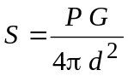
where:
S : power density in (W/m²)
P : mean output power (W)
G : antenna far-field gain relative to an isotropic radiator
d : distance from radiator (m).
The relation between power density and electric and magnetic field strengths is given by the following equation:
S = 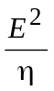 = 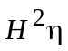
where:
E : electric field strength (V/m) (RMS)
H : magnetic field strength (A/m) (RMS)
η : The intrinsic impedance of free space, 377 Ω.
Hence, using the above formulas the field strengths can be calculated:
E = 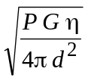 = 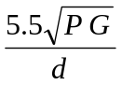
H = 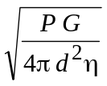 = 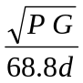
These relations are only valid in the far-field region of the radiating source, i.e. when d > 2D²/λ, where D is the largest dimension of the radiating structure and λ is the wavelength. Field strength attenuation or enhancement due to reflection, material transmission, and diffraction is not taken into account. Using the relations above in the near-field region, or in directions other than the main direction, will generally give too large values unless a near field correction factor or a radiation pattern factor is introduced.

3.1.2 Numerical procedures
Analytical procedures can only be used to calculate the electromagnetic properties for a few special cases and geometries. To solve general problems, numerical techniques have to be applied. The most common numerical procedures to calculate the EMF from a transmitting source or the internal fields and the specific absorption rate in biological bodies, are listed below. Which of the numerical techniques that is most appropriate for a certain problem, depends on the frequency range considered, the geometrical structures to be modelled, and the type exposure situation (near-field or far-field).
Some usual numerical modelling methods are given below:
– physical optics (PO)
– physical theory of diffraction (PTD)
– geometrical optics (GO)
– geometrical theory of diffraction (GTD)
– uniform theory of diffraction (UTD)
– method of equivalent currents (MEC)
– method of moments (MOM)
– multiple multipole method (MMP)
– finite-difference time-domain method (FDTD)
– finite element method (FEM)
– impedance method.
An assessment must be carried out, for each application, to establish which one of the above methods is the most suitable for solving a given problem.
Each of these procedures enables the amplitude and phase of the following EMF field quantities to be determined, at every point in space, where the radiating and scattering elements may be either ideal conductors or dielectric bodies:
– electric field-strength;
– magnetic field-strength;
– power-density;
– current;
– voltage;
– impedance.
Method of moments (MOM)
The method of moments is often used in the design of broadcast antenna systems (transmitter output power, antenna gain, etc.) and in calculating their resultant electromagnetic fields. It enables calculations to be made at both the transmitting and receiving ends, as well as in the near and far fields of the antenna.
Technical structures with up to three dimensions can be modeled, taking into account their material parameters (complex dielectric constant) as well as that of the ground. The modelling works with wires that are thin with respect to the wavelength and, in principle, is able to represent surfaces too. The limitation of this method lies in the fact that the modelling of extended and complicated structures may become too time – and memory – consuming for the computer.
The method of moments is a technique which has been extensively used to solve electromagnetic problems and to make SAR calculations in block models of biological bodies. In MOM, the electric fields inside a biological body are calculated by means of a Green’s function solution of Maxwell’s integral equations.
Fast Fourier transform/Conjugate gradient method (FFT/CG)
The FFT/CG method is a further development of the method of moments. Iterative algorithms based on FFT and the gradient procedure are used to solve linear equations derived from the method of moments.
Finite-difference time-domain method (FDTD)
FDTD is a numerical method to solve Maxwell’s differential curl equations in the time domain. It can be used to calculate internal and external EMF and SAR distribution in biological bodies for both near-field or far-field exposures. In FDTD, both time and space are discretized, and a biological body is modelled by assigning the permittivity and conductivity values to the space cells it occupies. The computer memory required is proportional to the number of space cells. FDTD is considered the most promising SAR calculation method, but for accurate calculations very powerful computers are needed.
Multiple multipole method (MMP)
MMP is based on analytical solutions to field equations which have a multipole at one point in space, and is used in conjunction with the generalized multipole technique (GMP). The MMP procedure is especially suitable for the simulation of so-called “lossy scattering” bodies, which are near to radiation sources, i.e. within the immediate near-field.
Impedance method
The impedance method has been successfully used to solve dosimetric problems where quasistatic approximations can be made. For calculations of SAR in human bodies, this method has proven to be very effective at frequencies up to 40 MHz. In the impedance method, the biological body is modelled by a three-dimensional network of complex impedances.

3.1.2.1 Field strength calculations
Most of the methods listed above can be used to calculate field strength levels from electromagnetic radiators. The accuracy of the results depends very much on how well the radiator (for example antenna) is modelled. If objects near the radiator, between the radiator and the prediction point, or close to the point of field strength prediction affect the field strength levels significantly, such objects should also be modelled.

3.1.2.2 Specific absorption rate calculations
Due to the difficulty of measuring the whole-body averaged or local peak SAR in many exposure situations, numerical calculations, several of the numerical techniques mentioned above can be used for estimation of the specific absorption rate distribution in a biological body exposed to either near-field or far-field electromagnetic radiation, for example the FDTD, MOM, and the MMP.
Which of these methods that is most appropriate for a particular problem, depends e.g. on the frequency, the exposure conditions, the size of the exposed object, the required accuracy, and the maximum tolerable calculation time. Each method requires experience in biophysics and numerical analysis.
To use any of these models, a three-dimensional geometric numerical model of the exposed body, or part of the body, is required. The electrical properties at the exposure frequency should be known for the different parts of the body. Depending on the required accuracy, models with different complexity may be used. In some situations, simple shapes like spheres and cylinders are appropriate to model the body. The dielectric properties of human tissues are given in the literature. Using magnetic resonance (MR) images of a human body, very complex and accurate numerical body models can be developed. MR models with several different tissue types and a spatial resolution of less than a few millimetres have been used for FDTD calculations of the SAR distribution in humans exposed to electromagnetic fields from handheld radio transmitters.

4 Measurements

4.1 Procedures
It should be noted that measurement methods are critical, especially for near and low frequency fields. For the lower frequency bands the method of measurement is a very sensitive and complex matter, since the distance of the test point (from the source of radiation) usually is much smaller than wavelength. For this reason, the frequency range of 10 kHz-30 GHz is divided in four main broadcasting bands: LF/MF, HF, VHF/UHF and SHF bands.

4.1.1 LF/MF bands
In order to verify the theoretical results, field strength measurements in the near zone shall be made using special instruments (field strength meters) with three orthogonal positioned short dipoles. It is recommended not to use any instrument requiring power supply cable.
To prevent a disturbing influence of the person performing the measurement, the measuring instrument shall be attached to insulated rod. The distance between instrument and operator should be determined by taking into account whether there are any changes on the instrument scale caused by any movement of the operator. That distance is dependent of the frequency of the measured signal.
In performing this kind of measurement it is necessary to take into account the possible influences of all objects in the vicinity and, particularly, those that may create re-radiation effects.
When the purpose of a measurement is to verify results obtained from theoretical computation, the test points should be selected along a radial direction and at height between 1 and 2 m.
More detailed explanation is given in Recommendation ITU-R BS.1386.

4.1.2 HF bands
Detailed explanation is given in Recommendation ITU-R BS.705.

4.1.3 VHF/UHF bands
Detailed explanation is given in Recommendation ITU-R BS.1195.

4.1.4 SHF bands
Taking into account the wavelength and distances from the radiation sources, standard method of measurement shall be applied.

4.2 Instruments

4.2.1 Introduction
The measurement of exposure fields, in the frequency range 10 kHz-300 GHz, requires significant effort for the spatial and time variability of the field to be determined.
It is necessary to use adequate instrumentation and valid measurement set up. It is important to know the characteristics of measurement instruments because these characteristics determine the appropriate choice of instrument. Frequency dependent characteristics, such as cable interactions, out-of-band uncalibrated responses, and shaped frequency response are particularly important for broadband instruments. Other field properties need to be matched with instrument characteristics; for example, reactive or radiative, polarization and modulation, or number of field sources.
Human exposures to electromagnetic fields are commonly measured in units of power density, but other measures such as the induced current in the body, may be more relevant, and theses are some of the critical aspects for protection or control that the engineer must resolve. In many cases there is no simple mathematical ration between electric and magnetic field and therefore, in this situation, each must be measured.
The measurement instruments to use in this case are:
– instruments to measure the value of the field strengths E and H;
– instruments to measure current.

4.2.1.1 General
The base equipments of these instruments are:
– the probes;
– the connection cables, that transfer the signal from the probe to the reading and calculation unit;
– the reading and calculation unit.

4.2.1.2 Probes
Most probes are isotropic, or omnidirectional in three dimensions, to measure the energy from all directions.
The probes must exhibit the following characteristics:
– respond to the intended fiels, E or H, without responding to the unintended fields;
– generally, the probe is electrically small and less than λ/10 for the maximum frequency of operation; however, special evaluations have shown that some probes may be electrically large;
– respond predictably to variations of environmental conditions, such as temperature and humidity.
It is very important that isotropic probes, during the measurement, are positioned such that the connection can decrease field perturbation at the probe by the connection cables. This field perturbation is more commonly a problem when measuring medium wave or lower frequency electric fields.

4.2.1.3 Cables
The cables used to connect the probe and the reading and calculating instrument must be noise free and prevent coupling of field to the measurement unit.
It is very important to note that it is possible for the cables to act as an antenna and modify the field at the probe to cause an incorrect reading. It is sometimes possible to resolve this problem by setting the cables, during the test, perpendicular to the electric field.

4.2.2 Characteristics of the measurement instruments for electric and magnetic field
Generally the measurement of exposure to EMF is executed in the frequency domain. There are two principal groups of instruments.

4.2.2.1 Wideband instruments types and specifications
With broadband instruments (see Fig. 2) we can measure the total field in a given frequency range (i.e. bandwidth), but it is not possible to distinguish the contribution of a single frequency source, when several sources are radiating simultaneously.
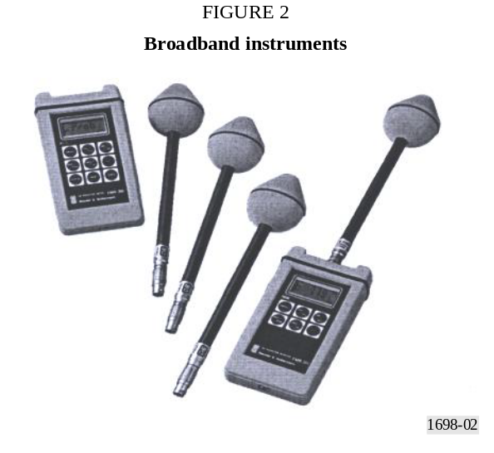
Broadband instruments are made with sensors that can be non-isotropic to measure a single spatial component of the field, or can be isotropic to measure all three components of the field at the same time. These instruments can measure the total level of the instantaneous electric or magnetic field, or the RMS field value or the average power density value in a time period, typically 6 min in accord with exposure standards.
Broadband instruments can be divided in the following classes, depending on the detector used:
– diode,
– bolometer,
– thermocouple.
These instruments can be used in both situations, near field and far field.

4.2.3 Narrow-band instrument types and specifications
Narrow-band instruments are selective in frequency and can measure the electromagnetic field strength at a range of different frequencies. By means of non-isotropic sensor or antenna it is possible to evaluate the direction and the polarization of the field. Care must be taken in the set up since fields can change high frequency rapidly in space relative to the antenna size, especially in the presence of reflective objects like walls, earth, metallic poles and structures. It is important to observe that by changing the measurement point the detected field strength may be completely different. Also the measurement can be influenced by the antenna position and connecting cables.
When the measurement of the EMF in high frequency is executed in the time domain, it is necessary to use instruments with appropriate characteristic of analysis (for frequency and resolution answer) to obtain good results in the spectral analysis by Fourier’s transform.
Figure 3 shows the block diagram of a narrow-band measurement system.

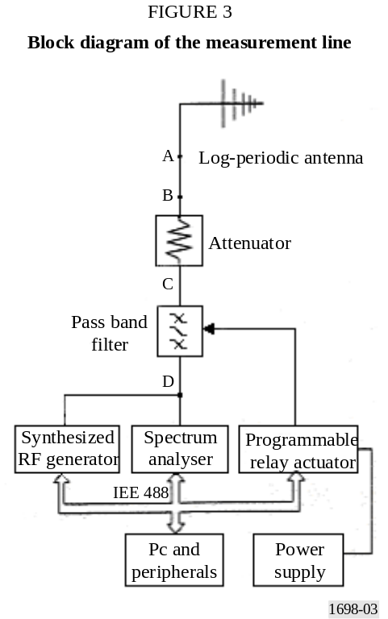

The system consists of the following basic components:
– A calibrated antenna, that converts the electric field for a dipole antenna or magnetic field for a loop antenna to a wave on the transmission line.
– A calibrated connecting transmission line or coaxial cable.
– A selective receiver, typically a spectrum analyser (see Fig. 4), that measures using a tuning circuit, the signal strength received as a function of frequency. The spectrum analyser gives the values of the voltage or power in the frequency domain.

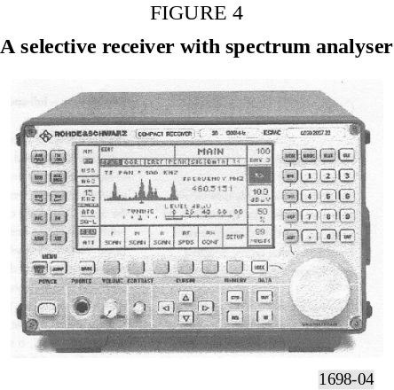

It is very important to use care during these measurements, so that the measuring instruments do not disturb the field being measured.

4.3 Comparison between predictions and measurements
The comparison between predictions and measurements indicate that results of measurements are in good agreement with results obtained by theoretical computation. For more details, see Appendix 2.

5 Precautions at transmitting stations and in their vicinity
This section outlines the precautions that should be taken at high-power broadcasting transmitting stations to control the potential risks due to RF radiation. These risks fall into two main categories, the first being the direct risk to health due to human exposure to high levels of RF radiation, including shocks, burns and the possible malfunctioning of medical implants. The second category comprises indirect risks where RF radiation could cause explosions, fires or interfere with the safe working of machines, cranes, vehicles, etc.

5.1 Precautions to control the direct health effects of RF radiation
Two groups of people are considered in terms of the precautions that can reasonably be taken. The first group is employees at, or regular official visitors to, transmitting stations. Whilst this group may be at a more frequent risk, the extent to which control measures can be applied is much greater than that for the second group, being members of the general public.

5.1.1 Employee (occupational) precautionary measures

5.1.1.1 Physical measures
If appropriate, some form of protective barrier should be provided to restrict access to any area where either the exposure limits are exceeded or contact with exposed RF conductors is possible. Access to such areas must only be possible with the use of a key or some form of tool. Mechanical or electrical interlocking should be provided to enclosures where access for maintenance is needed.
Other physical measures such as warning lights or signs should also be used in addition to, but not instead of, protective barriers.
The risk of shock or burns from RF voltages induced on conducting objects, such as fences and support structures, should be minimized by efficient and properly maintained RF earthing or grounding arrangements. Particular attention should be paid to the earthing of any temporary cables or wire ropes, such as winch bonds, etc.
Where such objects need to be handled in an RF field, additional protection from shocks or burns should be provided by the wearing of heavy-duty gloves and through effective labelling.

5.1.1.2 Operational procedures
RF radiation risk assessments must be carried out by suitably trained and experienced staff at construction and also when any significant changes are made to a transmitting station. The initial objective must include the identification of the following:
– the areas where people may be exposed to “derived” or “investigation” levels;
– the different groups of people, e.g. employees, site sharers, general public etc., who may be exposed;
– the consequences of fault conditions, such as leakage from RF flanges, antenna misalignment or operational errors.
An initial check on the RF radiation levels can be done by calculation or mathematical modelling, but some sample measurements should also be carried out for verification purposes. In most cases, however, measurements will be needed to determine RF radiation levels more accurately. The actual quantities to be measured (E field, H field, power density, induced current) should be determined based on the specific circumstances. These include station frequencies, field region (near/far field) being measured and whether it is proposed to check compliance with basic restrictions (SAR) or only “derived/investigation” levels. These circumstances will also largely determine whether the three individual field components should be measured separately or whether an isotropic instrument should be used. RF radiation surveys should then be carried out by staff trained in the use of such instruments, following prescribed measurement procedures, and recording results in a specified format.
A nominated competent person should be made responsible for the identification and provision of suitable instruments within any organization or company. Such measuring instruments must always be used in accordance with manufacturers instructions and be subject to regular functional (operation with a check source) and calibration. Labels showing expiration dates must be fixed to instruments following such tests or calibration. Records of calibration should be kept, including whether adjustments and/or repairs were needed on each occasion. This information should then be used to determine the interval between calibrations.
Work procedures should be implemented that ensure that RF radiation limits are not exceeded. Employees should be trained regarding appropriate RF safety procedures. Maintenance work, in areas subject to access restrictions due to high RF radiation levels, should be planned around scheduled transmission breaks or radiation pattern changes where possible. However, there should always be a balance between exposure to RF radiation and other risks, such as working on masts at night, even when floodlit. Where necessary, transmitters should be switched to reduced power or turned off to allow safe access for maintenance or repair work.
Prohibited areas on transmitting stations must be clearly defined and marked, and “permit to work” systems should be implemented. Appropriate arrangements should be put in place for any systems, antennas, combiners or areas shared by other organizations. All staff who regularly work in areas with high levels of RF radiation should be issued with some form of personal alarm or RF hazard meter.
Records must be kept of exposure above specified RF radiation levels. Companies or organizations responsible for operating transmitting stations should monitor the health of staff who regularly work in areas with high levels of RF radiation and take part in epidemiological surveys, where appropriate.
Details of general policies and procedures relating to RF radiation safety should be included in written safety instructions and given to all appropriate staff. In addition, local instructions for each transmitting station should be issued to ensure compliance with such policies and procedures.
Safety training should also include the nature and effects of RF radiation, the medical aspects and safety standards.

5.1.2 Precautionary measures in relation to the general public

5.1.2.1 Physical measures
Similar considerations apply to the general public, as those detailed in § 5.1.1.1 for employees. Particular attention should be given to areas where RF radiation limits could be exceeded under fault conditions. Protective barriers should be provided in the form of perimeter fencing, suitably earthed where needed. Additional hazard warning signs will probably be necessary.

5.1.2.2 Operational procedures
Risk assessments, carried out under § 5.1.1.2, must take into account the possibility of members of the public having medical implants. A procedure for providing health hazard information to such potential visitors should be adopted with appropriate restricted access procedures. Basic RF safety instructions should be provided for regular site visitors.
The need to carry out RF radiation surveys beyond site boundaries must be considered, in particular where induced voltages in external metallic structures (cranes, bridges, buildings etc.) may cause minor burns or shock. In carrying out such surveys the possibility of the field strength increasing with distance, usually due to rising terrain, should be taken into account. Where necessary, a procedure for monitoring planning applications or other development proposals should be implemented.
An example which illustrates the text above is given in Appendix 3 (Fig. 43 and 44).

5.2 Precautions to control indirect RF radiation hazards
Indirect effects of RF radiation, such as ignition hazards to flammable substances, may occur at levels well below the “derived/investigation” levels particularly at MF/HF. This is because flammable substances may be stored on a site having associated conducting structures, such as pipe work, that could act as a fairly efficient receiving antenna. Actual risks are, however, rare, but may
include industrial processing plants, fuel storage facilities and petrol filling stations. Detailed evaluation is, however, far from simple. The general procedure recommended below is, therefore, based on progressive elimination. The detailed precautions adopted will however need to take account of any national standards or legislation in the country concerned.
An initial assessment should be carried out, based on practical, worst case estimates, of the minimum separation needed between a particular type of transmitter and a conducting structure to avoid such a hazard. The first step in doing this is to determine the minimum field strength that might present an ignition hazard for the particular transmitter frequencies in use. This is a function of the type of flammable substance and the perimeter of any loop formed by metallic structures, usually pipe work, and can most easily be determined from tables or graphs. The vulnerable area should then be determined from this minimum field strength by calculation, mathematical modelling or from tables/graphs.
If the vulnerable area, as determined above, contains any such sites on which flammable substances are stored, or if any are being planned, a more detailed assessment should then be made. This should be based on the actual dimensions of any metallic structures, the gas category of the flammable substance(s) being stored and the measured field strength. This detailed assessment should be carried out by calculation of the extractable power from the metallic structure to determine whether this exceeds the minimum ignition energy of the flammable substance. Should this be the case, then the extractable power should be measured and any necessary modifications to the structure and/or other safeguards implemented.
In a similar category to ignition hazards, is the possible detonation of explosive materials. This will very rarely be encountered but detailed guidance is available from national standards, such as BS 6657 in the United Kingdom. Other indirect effects that should be considered include interference to the safety systems of vehicles, machines, cranes etc. close to, or within the boundaries of, transmitting stations. The immunity of these systems is covered by electromagnetic compatibility (EMC) regulations (see Appendix 3).
Where necessary, precautions similar in principle to those described in § 5.1.2 may need to be applied.

Appendix 1
to Annex 1
Examples of calculated field strengths near broadcasting antennas

1 Example A – Electric and magnetic field-strength plots
According to § 3, numerical calculations of electric and magnetic field-strength distribution near broadcasting transmitting antennas can be done in order to determine how the field strengths at certain points or areas. This includes, especially, the near-field zone where the field structure is
generally very complicated. Calculations can also be done in order to verify the field contours (lines or surfaces with constant field strength) where relevant limiting values (levels) of EMF restrictions are kept. In this way it is possible (e.g. for planning purposes) to estimate how extended relevant zones may be, where protection measures may or must be performed.
In a technical document of the European Broadcasting Union (EBU) [2] many calculation results are given. In the following Figures some calculation results of these examples (MF and HF broadcasting transmitting antennas) are given as plots.

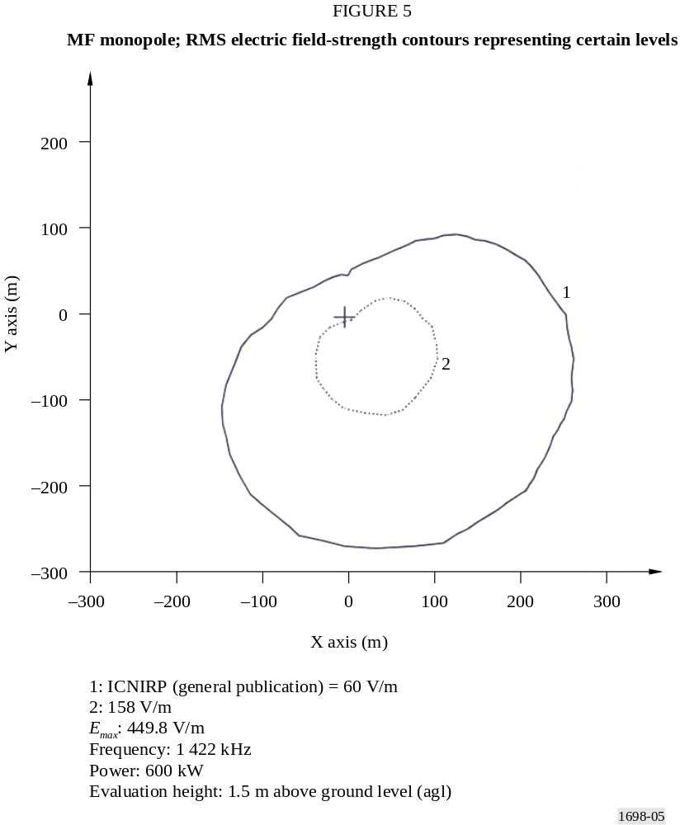

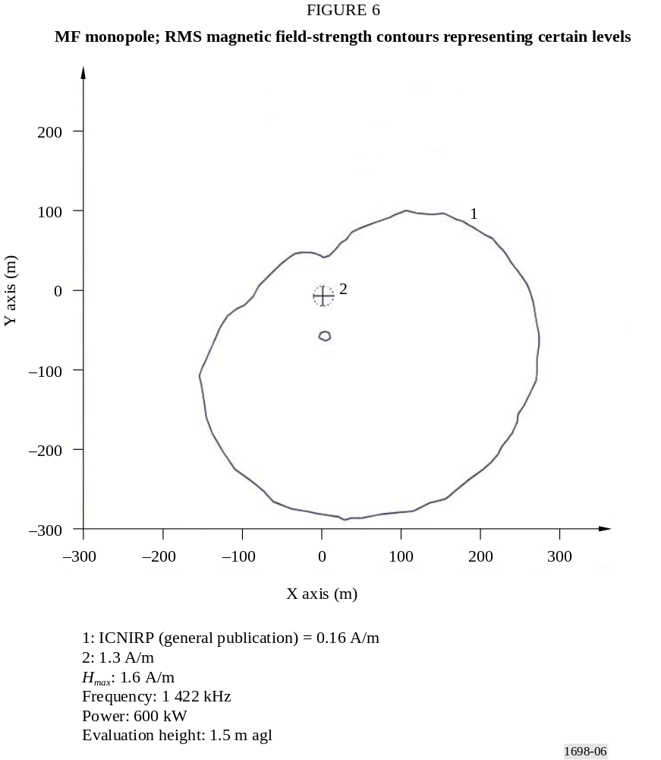

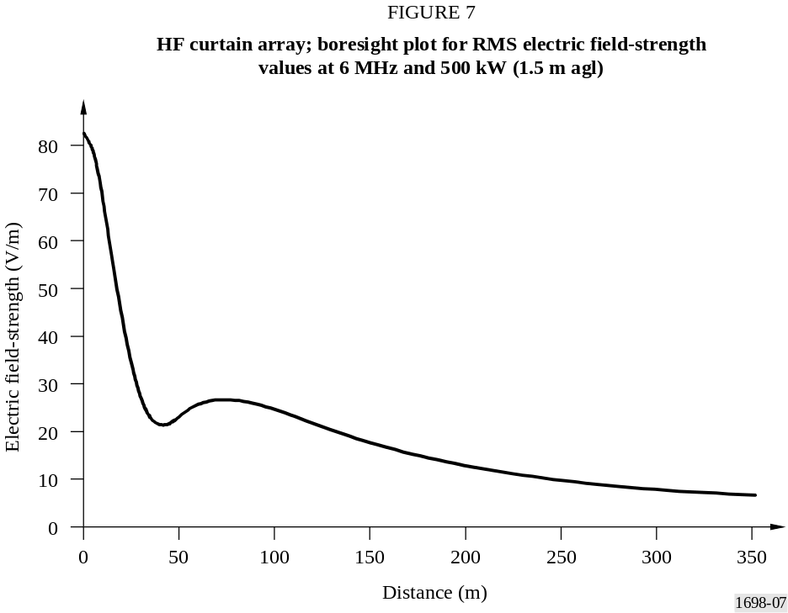

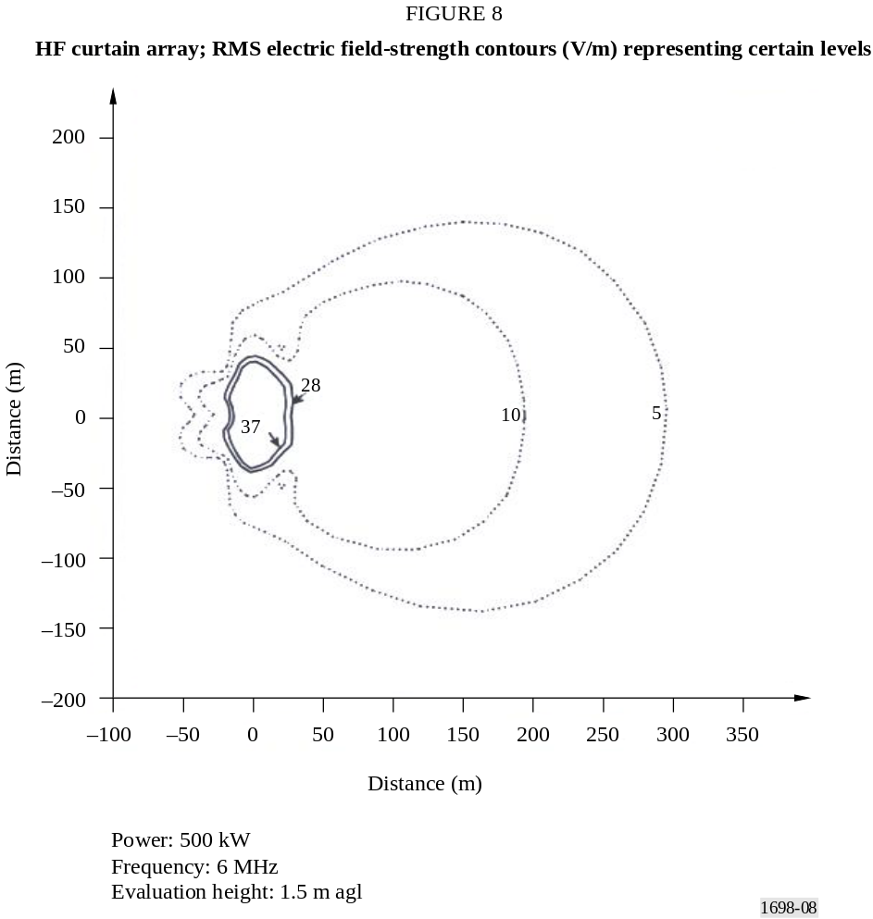
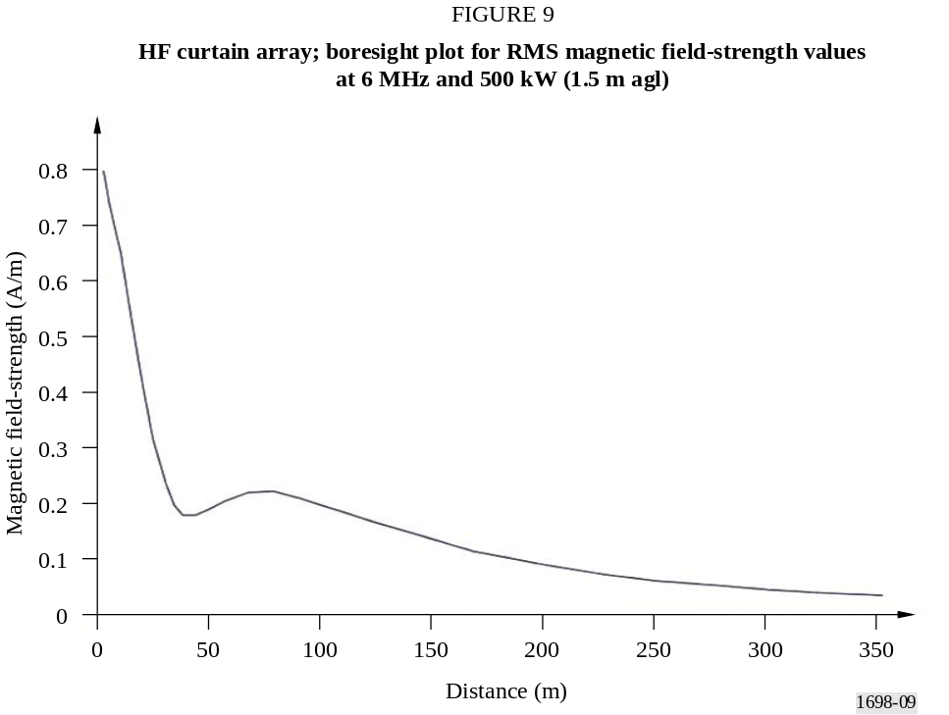
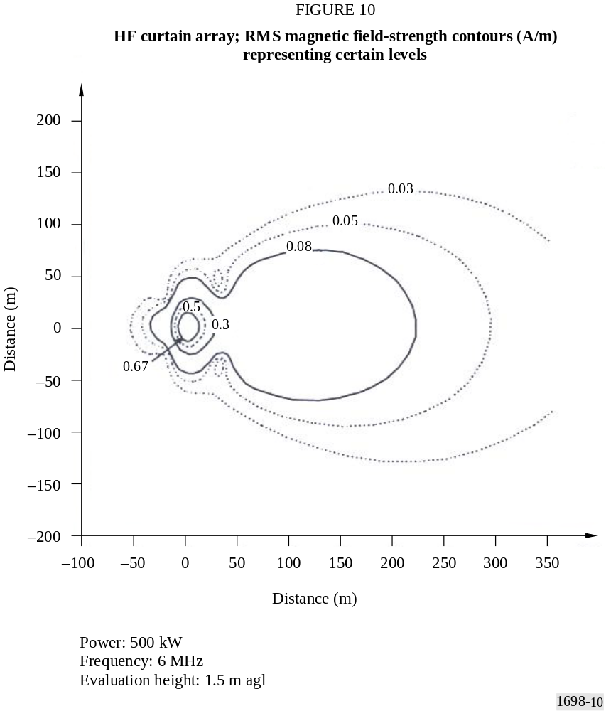

2 Example B – Determination of the magnetic field strength in the near field zone of high-power MF/LF antennas
This example has the aim to determine magnetic field strength in the near-field zone of MF and LF mast antennas (monopoles), solving Hallen’s integral equation.
In frequency bands below 10 MHz physical relations in the EMF are much more complex. In contrast to microwave frequencies, where the EMF has characteristics of the field in the far zone even at very short distances from the radiation source, and where the concept of the radiated power density (Poynting vector intensity) is very useful, in the MF/LF frequency band the field in the antenna vicinity is very complex. In fact, in the near field zone, the simple relationship between the electric and magnetic fields no longer exists: the two fields are not in phase and their ratio is not 377 Ω. That fact additionally complicates the relationships in the EMF below 10 MHz.
Clearly, the measured field strengths will depend on the type of transmitting antenna, transmitter power and distance from the transmitting antenna. For example, in the case of high-power transmitter E-component, field strengths on a typical LF/MF site may range from a few V/m to over 250 V/m. Very close to the transmitting antenna the field strength may be of the order of 1 000 V/m.

3 Example C – Near electromagnetic field of HF transmitting curtain antennas

3.1 Introduction
This example deals with significantly more complicated antenna structures, referred to as curtain antennas. These antennas are very important for short-wave (HF) high-power transmitting purposes. They are, actually, arrays of horizontal dipoles arranged in a vertical plane.
The general trend towards increasing power and gain of transmitting antennas is very pronounced in HF broadcasting. Transmitter power of 500 kW and antenna gain (in the direction of the maximum of radiation) of over 20 dB (with respect to a half-wave dipole) has become almost standard in large transmitting centres for global coverage. A 500 kW transmitter with an antenna of a 20 dB gain produces an effective radiated power (ERP) of 50 MW.
In § 3.2, the numerical technique is briefly described which was used to compute near electric and magnetic fields of high-power antennas. Finally, in § 3.3, results are given for the fields in the vicinity of the HF curtain antennas.

3.2 Numerical analysis of wire structures
Calculations of the near fields of curtain antennas were done using program AWAS (Analysis of Wire Antennas and Scatterers), which is one of several programs developed at the School of Electrical Engineering, University of Belgrade, for the analysis of wire antennas and scatterers. Briefly, the program is based on formulating the so-called two-potential equation for the current distribution along the wires. This equation is solved using the MOM with the polynomial approximation for the current.
An arbitrary structure, located in a vacuum, and assembled from perfectly conducting straight wire segments is considered. According to the boundary conditions, on the wire surfaces, the tangential component of the total electric field must be zero, i.e.:
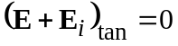 (13)
where:
E : electric field produced by the currents and charges of the wire structure
E_{i} : impressed electric field, which models the excitation to the system.
The impressed field can be, for example, the electric field of a plane wave incident on the structure (when analysing scatterers or receiving antennas), or a field located in a small region at the antenna terminals, which models the generator driving the antenna (when analysing transmitting antennas).
The electric field produced by the wire currents and charges can be expressed in terms of the magnetic vector-potential, A, and electric scalar-potential, V, as:
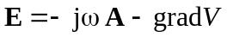 (14)
where:
ω : angular frequency (ω = 2π f).
The two potentials, in turn, can be expressed in terms of the densities of the surface currents (J_{s}) and charges (ρ_{s}), which are related by the continuity equation. Next, the surface currents and charges are approximated by line currents and charges (thin-wire approximation), and the wire structure is divided into N segments (each of them having a local axis, s_{m}). Finally, the two-potential equation (also called the vector-scalar-potential equation) for the current distribution is obtained in the form:
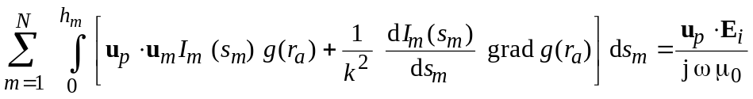 (15)
where:
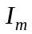: intensity of the current along a wire segment
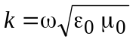: free-space phase coefficient
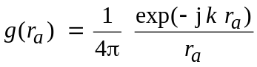: corresponding Green’s function
r_{a} : approximate average distance between the point on the surface of the wire element ds_{m} and the field point.
Equation (15) is an integro-differential equation for the current distribution, and it can be solved only numerically. To that purpose, the general guidelines of the MOM are followed, and approximate the unknown function I_{m} (s_{m}) by a series of known functions (basis functions), with unknown weighting coefficients. As the basis functions, the simple power functions are chosen, which amount to the polynomial approximation of the current distribution, i.e.:
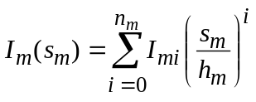 (16)
where:
h_{m} : segment length
I_{mi} : weighting coefficients.
Equation (15) cannot be satisfied exactly at all points along the wire segments, but only approximately. According to the MOM, a set of weighting functions is selected, and the inner
products of equation (15) and these functions are evaluated. The weighting functions are taken to be pulses. Each pulse is a unity constant, defined on a short sub-segment, and zero otherwise. A typical distribution of the pulses is shown in Fig. 11.
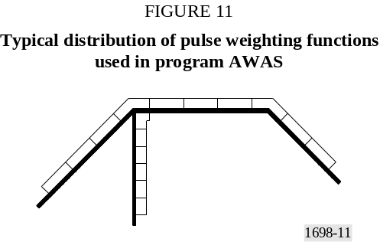
For a pulse defined on the sub-segment (s_{p1}, s_{p2}) along the axis of the wire segment p, the evaluation of the inner product results in the equation (17):
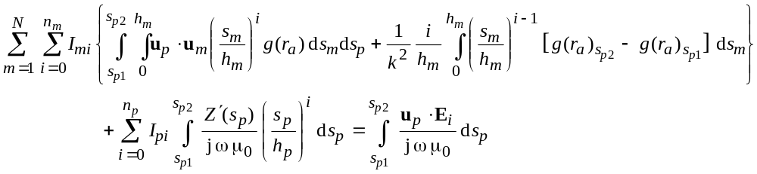 (17)
In this equation, u_{p} is the unit vector of the wire segment p, and Z′ is the impedance per unit length of a possible impedance loading distributed along the segment. When evaluated for all the pulses, equations of the form (17) comprise a system of linear equations in I_{mi}, which can be solved numerically.
Once the coefficients I_{mi} are known, the approximate current distribution along the wire segments is determined, and various characteristics of the wire structure can be evaluated. This part of the Recommendation, deals primarily with the near electric and magnetic fields. The electric field can be evaluated in terms of the two potentials, in a similar way as when deriving the two-potential equation, i.e.:
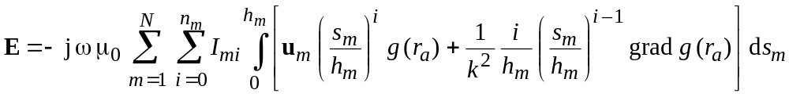 (18)
The magnetic field can be expressed in terms of the magnetic vector-potential as:
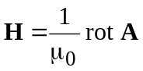 (19)
When this potential is expressed in terms of the wire currents, one finally obtains:
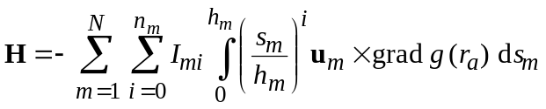 (20)

3.3 Near electric and magnetic fields of curtain antennas
There is a variety of high-power transmitting antennas used in the HF range (short waves), such as horizontal dipoles (usually forming a directive array), rhombic antennas, and vertical monopoles. The target of the investigation are arrays of horizontal dipoles, arranged in a vertical plane, known as curtain antennas, as this kind of arrays are planned to be used in the new short-way transmitting centre of Radio Yugoslavia, located at Stubline near Belgrade. The dipoles in a curtain array are usually half-wave dipoles, either simple, or folded, fed by currents of approximately equal amplitudes (but sometimes of different phases) to produce the desired radiation pattern. The array usually has a passive reflector, which in most practical cases consists of a wire mesh (aperiodic reflector), but can also be an array of tuned dipoles. Curtain arrays are labelled H(R)(S) m/n/h, where H denotes an array of horizontal dipoles arranged in a vertical plane; R denotes a reflector (if present); S denotes a phase shift (if present) between the currents feeding adjacent collinear dipoles in order to shift the azimuth of the main beam; m denotes the number of collinear dipoles in each row; n denotes the number of parallel dipoles stacked vertically (usually at a distance of one-half wavelength), i.e., the number of rows (bays); and h denotes the height of the lowest row above the ground (in wavelengths).
Curtain arrays have excellent properties, including a high gain (more than 20 dB), i.e., a highly directive radiation pattern, and high power-handling capabilities (up to 500 kW). Hence, they play a very important role in large HF transmitting centres. The central problem in this Recommendation is developing an accurate and efficient technique for the evaluation of these fields.
The antenna field of the new HF centre of Radio Yugoslavia has a total of 15 horizontally polarized antennas. Two of them are quadrant antennas, with an omnidirectional characteristic, and thirteen are dipole curtain antennas (Fig. 12). Seven curtain antennas contain 16 folded dipoles each, arranged in four bays of four elements (HRS 4/4/h), while six curtain antennas contain two folded dipoles each, arranged in one bay (HR 2/1/h). All curtains have an aperiodic reflector, made of thin horizontal wires. The centre has two transmitters. The power of each transmitter is 500 kW (unmodulated carrier), and it is possible to simultaneously transmit two programs towards different destinations. The transmitters are connected to corresponding antennas through an antenna switching field, which is located in a room next to the transmitter hall. The layout of the antenna field, with the building with transmitters, is shown in Fig. 13. Figure 14 shows details of one antenna (B12).
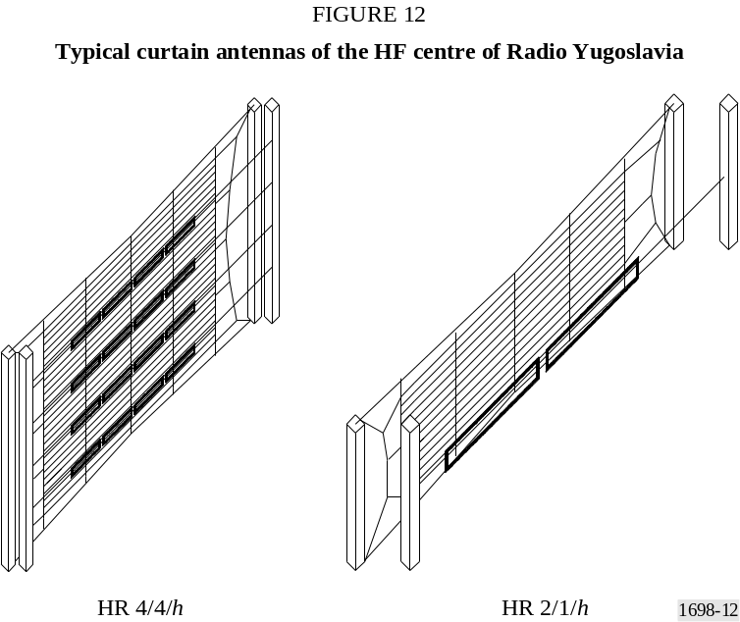

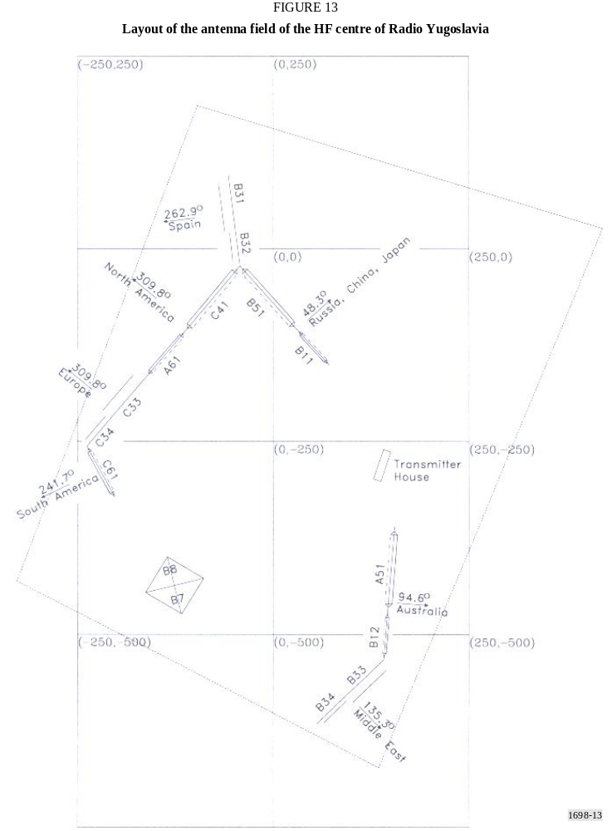

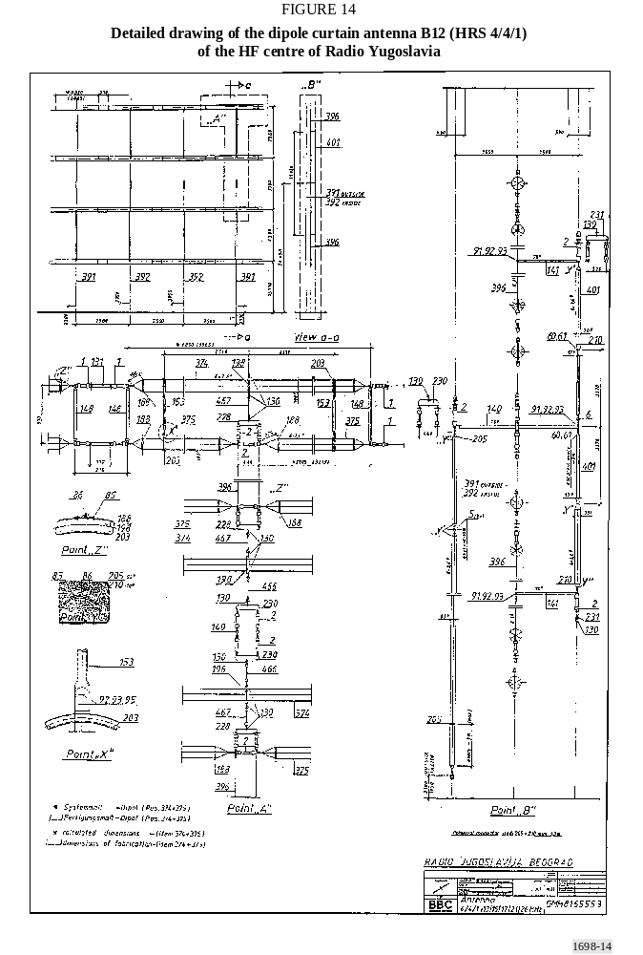

In the literature, there are few papers dealing with the calculation of the electric and magnetic fields of HF curtain antennas, but all of them are based on the sinusoidal approximation of the current distribution along dipoles, and on the assumption that the currents feeding dipoles have identical amplitudes. The goal is to provide a more rigorous analysis, using a more accurate approximation for the current distribution, and taking into account the coupling between the elements of the array, i.e., by feeding the elements by equal-amplitude voltages.
It has been shown experimentally (and confirmed theoretically using the sinusoidal approximation for the current distribution) that approximating the real soil by a perfectly conducting plane yields accurate results. This simplification is important, as it allows program AWAS to be used directly, without any modifications, as it can treat antennas only above a perfect ground. The present analysis was also expedited by taking simple dipoles instead of folded dipoles. This approximation was established to yield accurate results. The length of a simple dipole is taken to be somewhat shorter than half-wavelength at the design frequency, based on data taken from the dimensions of the actual curtains. The distance between feeding points of adjacent antennas is always half-wavelength, both horizontally and vertically. The distance between the dipoles and the reflector is exactly quarter-wavelength. The reflector was modelled by introducing negative images (in the vertical plane) of the original dipoles. The distance between the original dipoles and their respective images is thus half-wavelength. Figure 15 shows AWAS models of typical curtain antennas of the HF centre of Radio Yugoslavia.

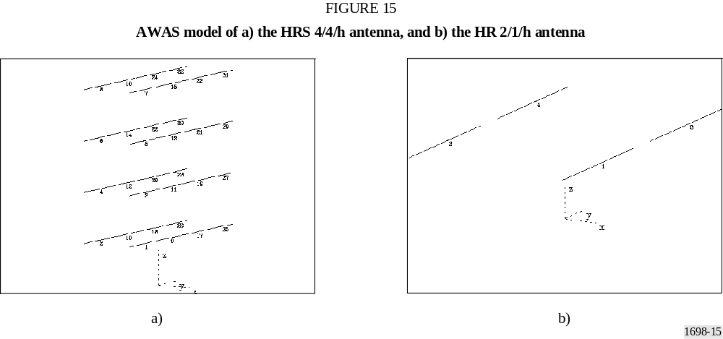

The near electric and magnetic fields were evaluated in the direction of the maximum of the radiation pattern (as the field in the direction of side lobes was found to be substantially weaker). The fields were evaluated at elevations of z = 2 m, for evaluation of radiation hazards for the staff of the centre, who may walk on the open field of the centre, and z = 5 m for the general population, taking into account possible dwelling in two-level houses.
Analysis results were first compared with the results for a HRS 4/4/1 antenna. The operating frequency of the antenna is 15.245 MHz, and the fed power is 500 kW. Figure 16a) shows the results for the “equivalent” Poynting vector, evaluated by AWAS, when the dipoles are assumed to be fed by identical currents. Figure 16b) shows the same results, but taking the dipoles to be fed by identical voltages, along with measured data at z = 2 m. The agreement between the theoretical and experimental data is fair. It is obvious that feeding the antenna with equal voltages results in a better prediction of the actual field, in particular near the dip at 70 m distance from the antenna.

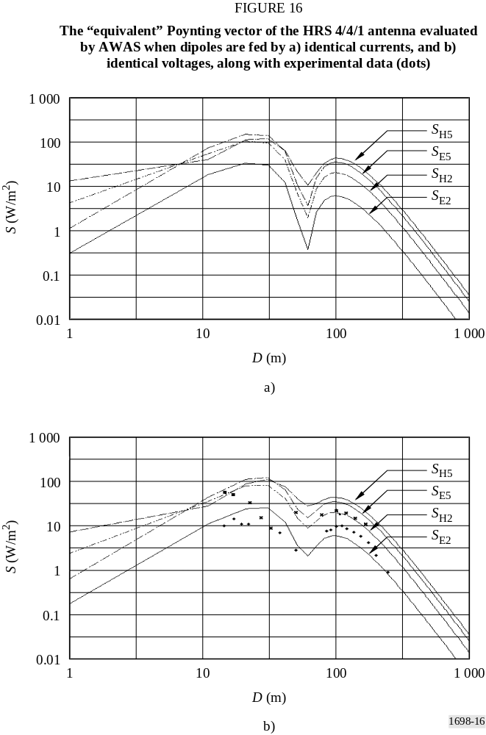

Gaining a confidence in the numerical technique used to calculate the near fields, the fields of all the curtain antennas of the new centre of Radio Yugoslavia have been evaluated. Two representative examples are shown in Figs. 17 and 18.
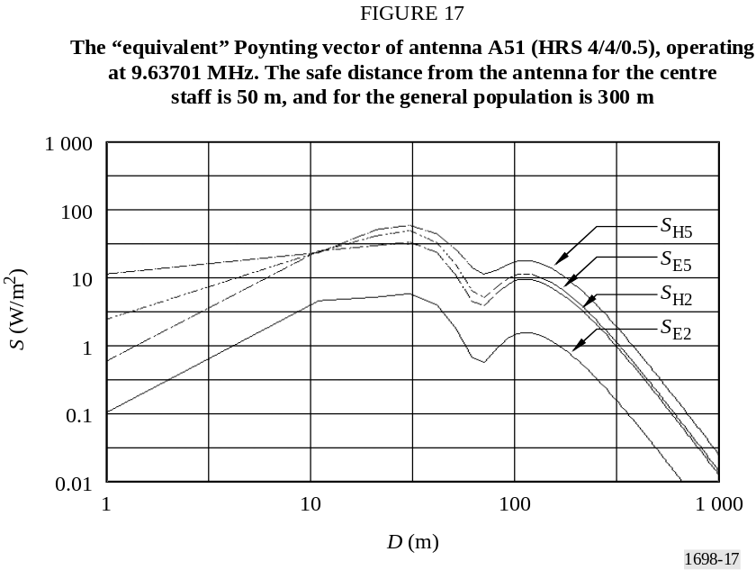
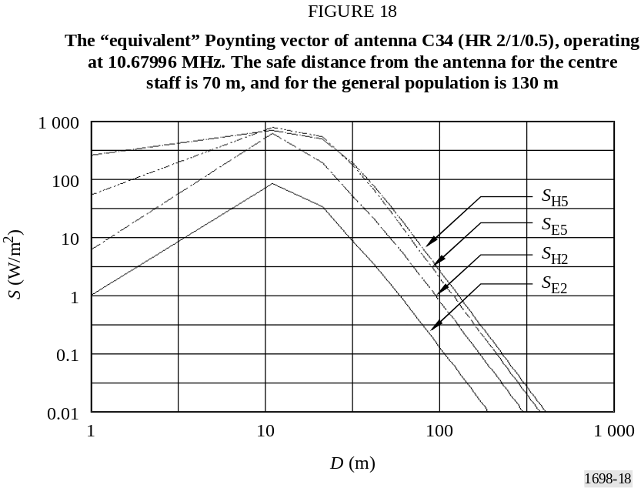

4 Conclusions
Near electric and magnetic fields in the vicinity of high-power transmitting HF curtain antennas have been investigated theoretically, using program AWAS. The theory was applied in particular to antennas of the new centre of Radio Yugoslavia. Safety zones for humans in the vicinity of these antennas were determined. The results for the near fields of curtain antennas are presented for the first time using a rigorous theory, and they are found to be in good agreement with experimental data published elsewhere.
Appendix 2
to Annex 1
Comparison between predictions and measurements

1 Foreword
Simulation and measurements have been separately performed by different personnel without mutual communications in order to avoid reciprocal influences in work and in results.
The antenna system has been only partially simulated as it is particularly complex (see § 1.1 for antenna model).
Measurements and predictions have been performed on an antenna system, represented in Figs. 19 and 20, capable of operation in the short wave band, comparisons were made at 13 MHz and 18 MHz.

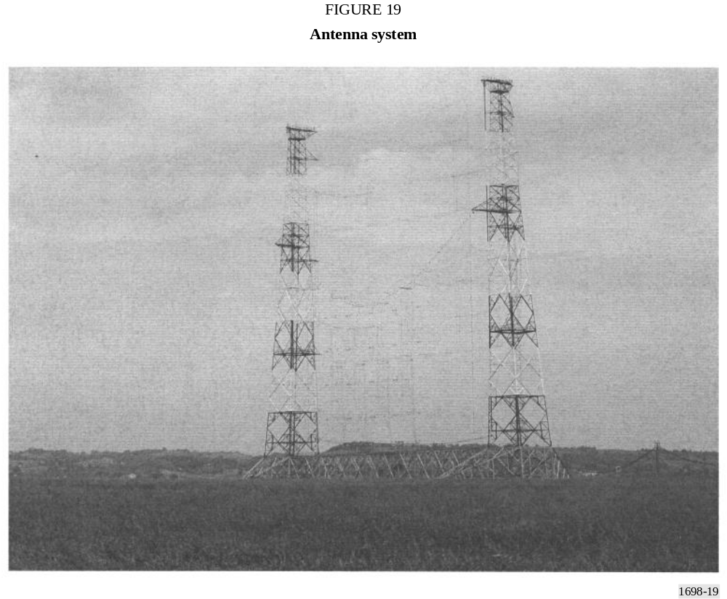

1.1 Model used for antenna system
The antenna system, shown in Fig. 19, is made of a horizontally polarized array of 16 folded dipoles disposed in front of a reflector realized by a wired network. Dipoles are fed by bifilar lines forming a complex impedance matching network; all bifilar lines of the impedance matching network, represented in Fig. 20, are mainly vertically disposed (orthogonally to dipoles); some horizontal lines are relatively short and are orthogonally disposed, both to dipoles and feeders, along the direction of propagation. At the antenna base are disposed other bifilar lines used to split the RF power among the four dipole “columns”.

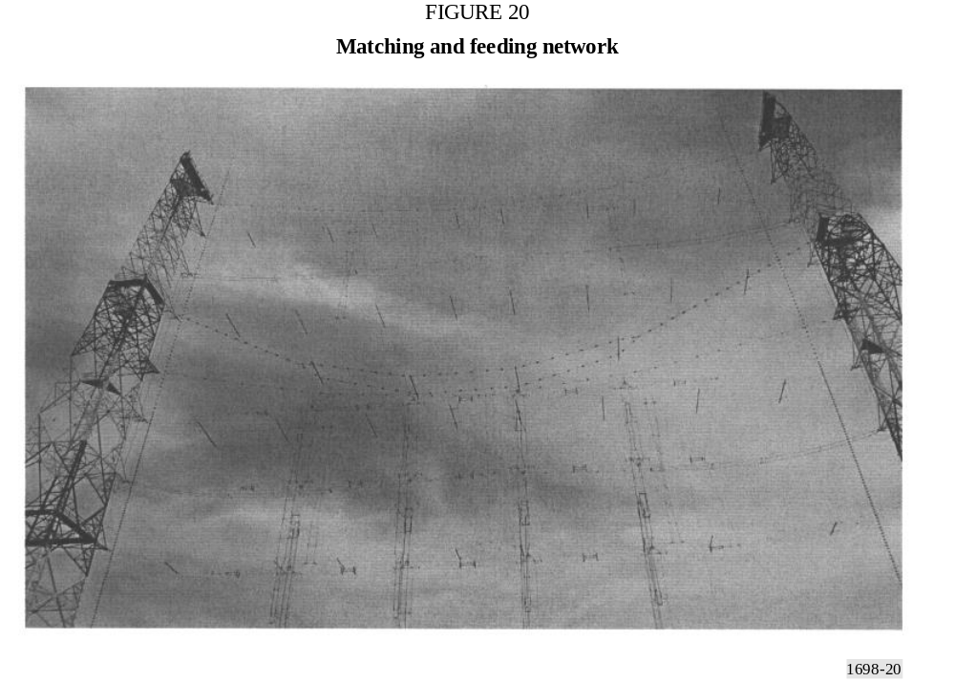

In order to simplify the model and avoid unnecessary details and consequent longer calculation time, the entire system has been modelled as a simple 16 dipole array as in Fig. 21, each fed by its own voltage generator correctly phased with all the others, with no need to model the matching/ feeding network. Furthermore, each folded dipole, physically realized by a couple of parallel wires folded at the edges, has been modelled as a single wire folded dipole, of an adequate cross section to obtain the identical value of impedance.
Finally, each dipole has been represented by 24 segments, each of a length not more than /20, as in Fig. 22.

1.2 Advantages and limitations of the implemented model of antenna system
The most important advantage is the extreme simplicity of the model realized versus the complexity of the real antenna system. With this model, it is possible to obtain a relatively low calculation time (about ten minutes in a 2 GHz Pentium 4).
Another advantage is the possibility of easily adjusting the model, if necessary, in order to better represent the real system. In fact, generally the result of a first comparison between simulations and measurements represents a good feedback to perform some adjustments on the first model. The most important limitation in the simple model adopted is the impossibility to correctly take into account the contribution of the complex matching/feeding network to the x, y, z components of the fields. In fact a certain amount of power is radiated by bi-filar matching lines that work in a standing wave regime. For this reason in the result of prediction, the vertical component of the E field does not appear (z component), as well as the horizontal component in the direction of propagation (y component), except in some cases where the values are quite low; a similar behaviour is visible for the x component of the H field. This is because the prediction was made without considering vertical radiators and radiators in the direction of propagation. In the measurement results, to the contrary, both the vertical (z) and the horizontal (y) components of the E field are present, as well as the horizontal (x) component of the H field, causing some problems in a direct comparison. The most reasonable solution is to consider these two components as generated by the amount of power that does not reach the dipole arrays; their contribution to the measured field should be considered inside the horizontal (x) one in the result of simulation. In other terms, the horizontal contribution (x) resulting from the simulation must be compared with the global result of the measurements, obtained as the square root of the sum of the square of contributions measured on x, y, z axis.

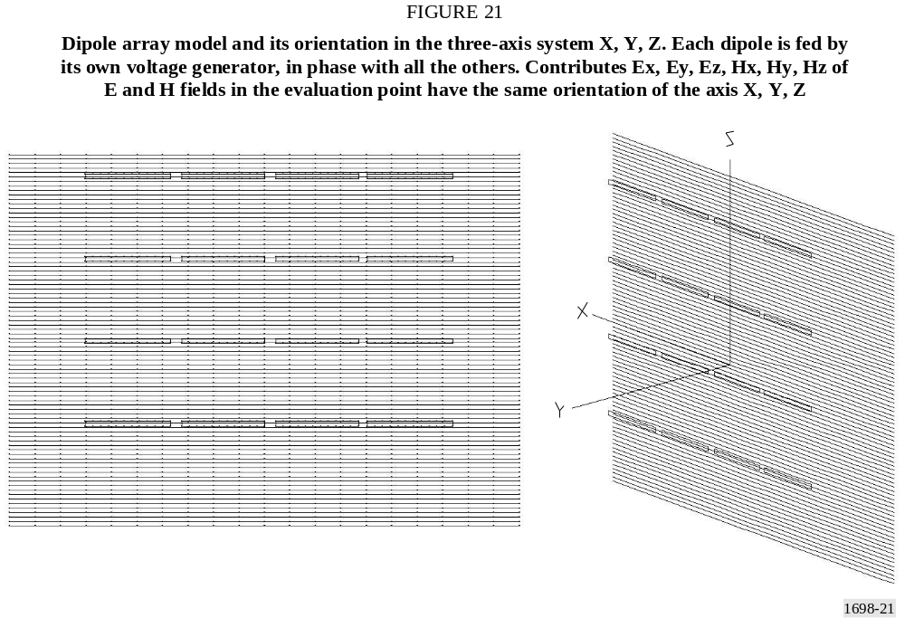

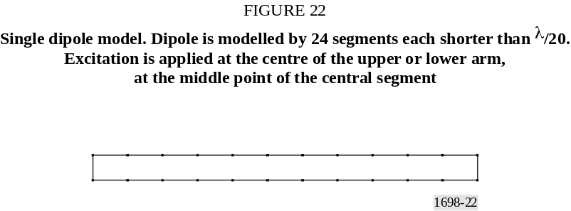

2 Comparison between prediction and measurements

2.1 13 MHz

2.1.1 Predictions

2.1.1.1 Notes about the model
In order to best fit the previously described model to the real antenna system, it is necessary to know the right amount of power at the input of each dipole, taking into account losses in transmission line.
In order to apply the appropriate voltage value at each dipole, in the simulation the input impedance of each dipole has been calculated. The values are represented in Fig. 23.
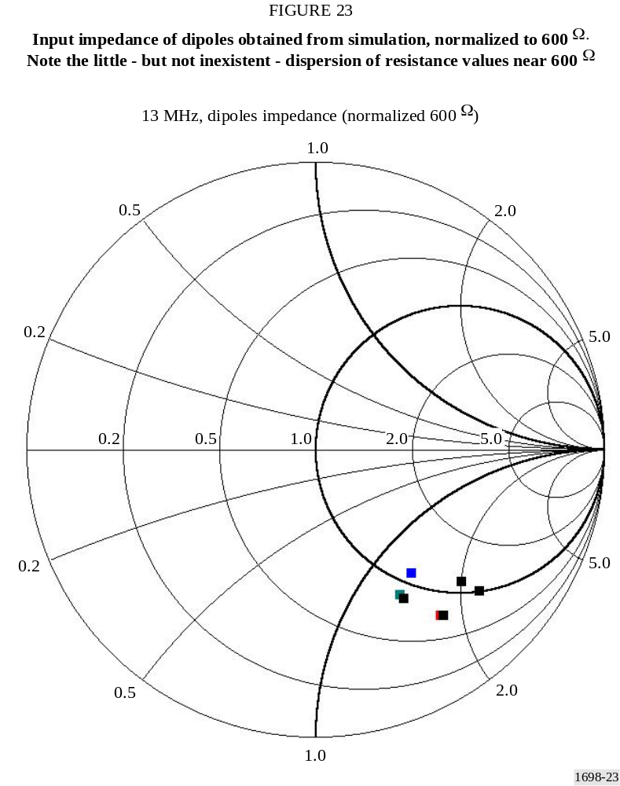
Then, for each dipole, a common value of resistance equal to 600 Ω has been adopted, this being the average value obtained from the simulation. Note that this decision may be the cause of inaccuracy in the prediction’s results.
In order to compensate the mismatch mainly due to the reactive component and the consequent reflection of power towards the transmitter, an adequate increase of power has been considered. Consequently, an adequate voltage has been applied at each dipole.

2.1.1.2 Far field evaluations
In order to best compare the behaviour of the model with real antennas, given in Figs. 19 and 20, the radiation diagrams were calculated. The results are shown in Fig. 24 (horizontal plane), Fig. 25 (vertical plane) and Fig. 26 (frontal view).

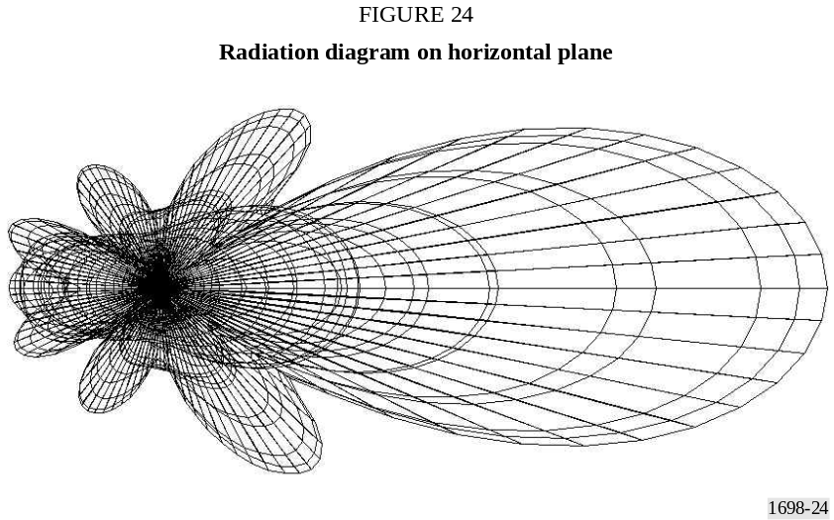

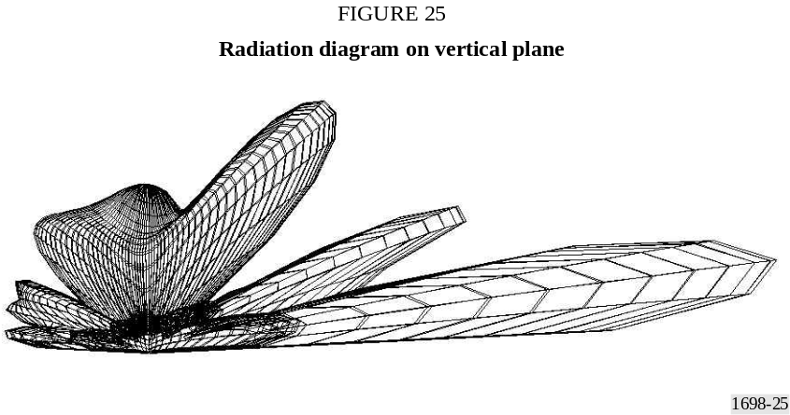

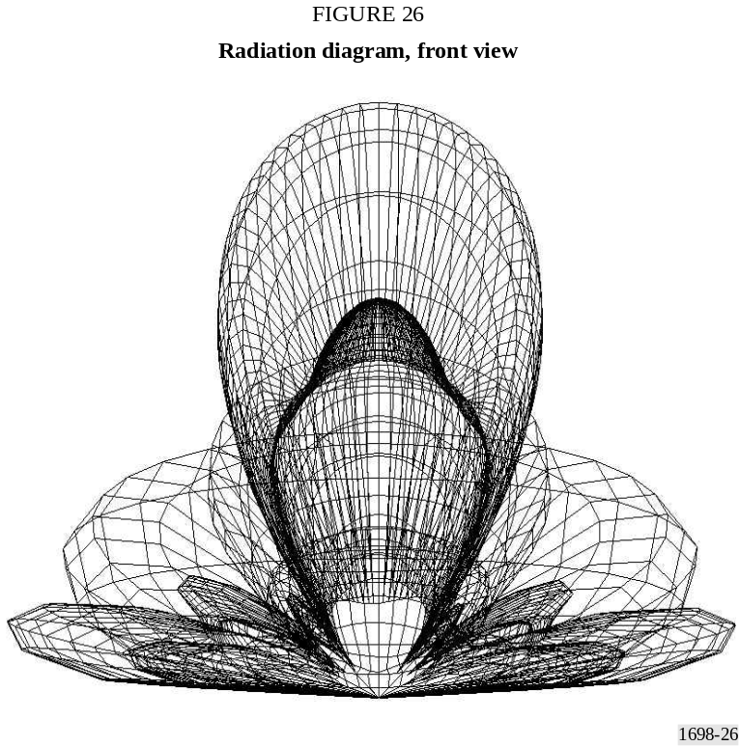

2.1.1.3 Results of prediction of the field strength in the near zone
Prediction was made calculating the x, y, z components of E and H fields in the direction of the antenna’s maximum gain (Y axis) at 2 m over terrain (Z axis = 2). The calculated values are represented in Fig. 27 (E field) and Fig. 28 (H field). The strong influence of the terrain both in the evaluations and in the measurements may introduce an additional difference between the two results. In order to show the strong influence of terrain, the E and H fields values have also been calculated varying the height of the evaluation point over the terrain (Z axis) from 0 up to 9 m at a fixed distance of 60 m (Y = 60). The behaviour is illustrated in Fig. 29 (E field) and Fig. 30 (H field).

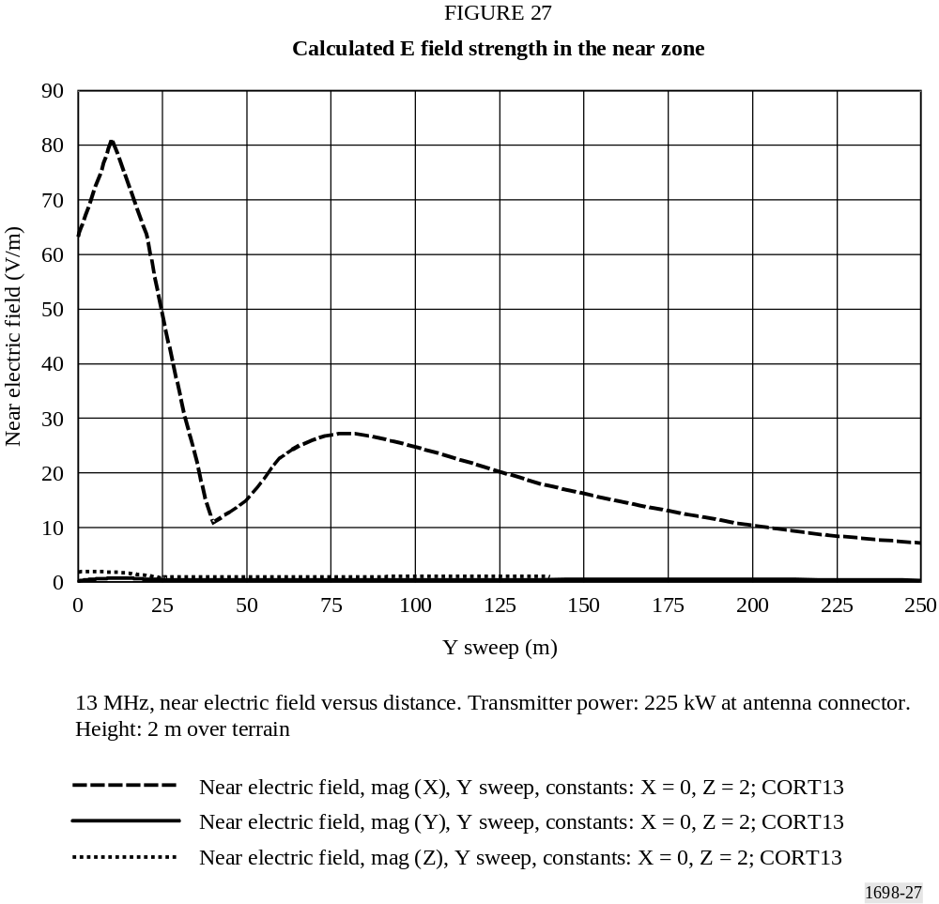

The most important contribution is the x component. The horizontal axis represents the distance in metres from antenna (Y sweep). Z is fixed at 2 m (height over terrain). The intensity of the E field’s components is represented in V/m on the vertical axis.

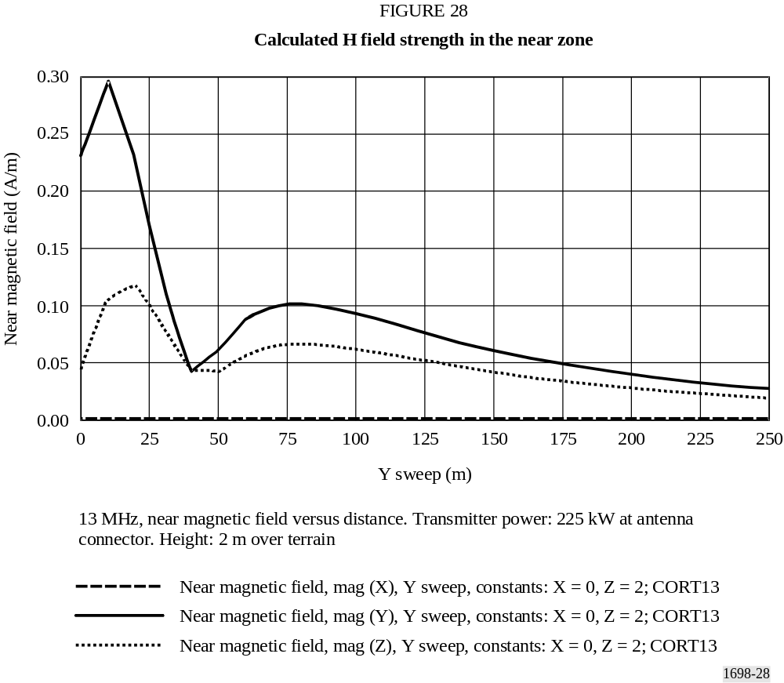

The main contribution is the y component. The z component is lower, while the x component is 0. The horizontal axis represents the distance in metres from antenna (Y sweep). Z is fixed at 2 m (height over terrain). The intensity of the H field’s components is represented in A/m on the vertical axis.

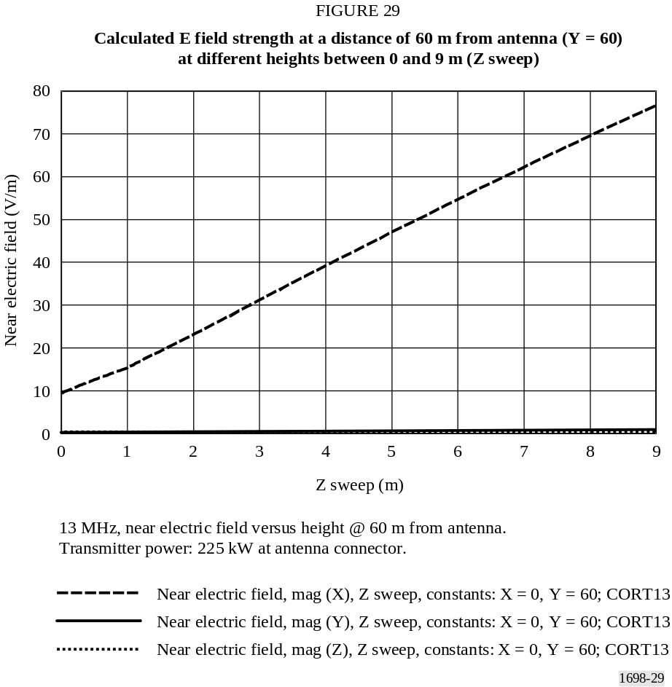

The strong relationship between E values and height (only x component of E field is present) is evident.

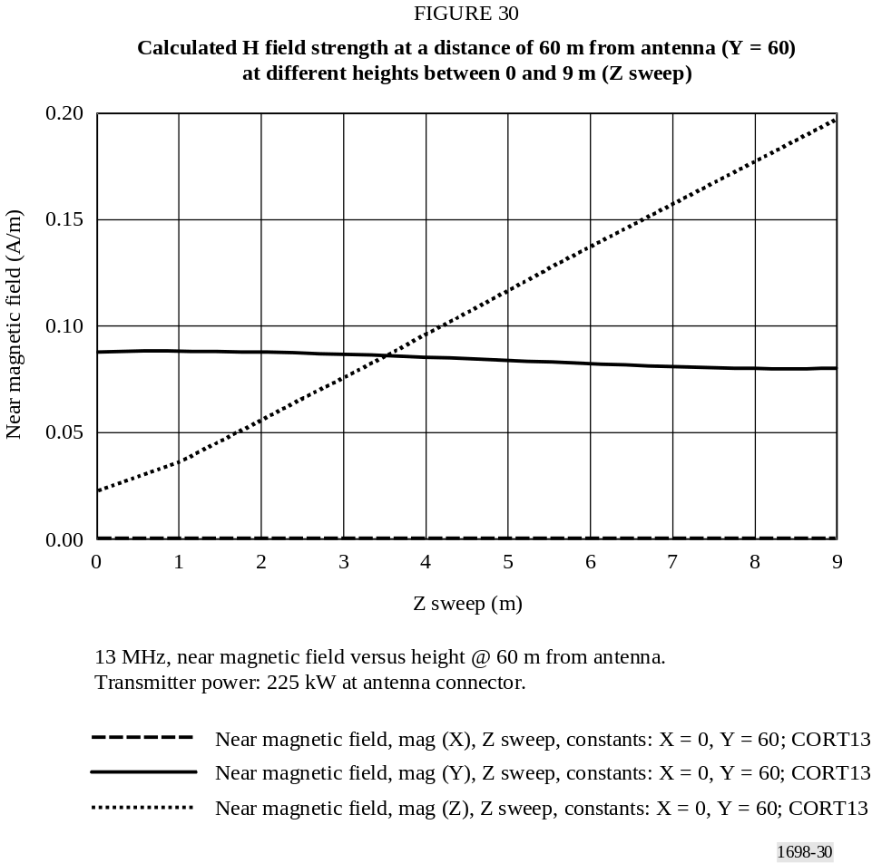

The strong relationship between H values and height (both z and y components of H field are present, y component’s value is quite constant) is also evident.

2.1.2 Measurements
Measurements have been performed using a broadband field strength meter installed over a dielectric trolley moved by an operator placed far away from the antenna site. By this means any perturbation of the E/H fields is avoided.

2.1.2.1 Results of measurements
Measured values are presented in Fig. 31 (E field) and Fig. 32 (H field). Fig. 31 and Fig. 32 are directly comparable with Fig. 27 and Fig. 28 respectively.
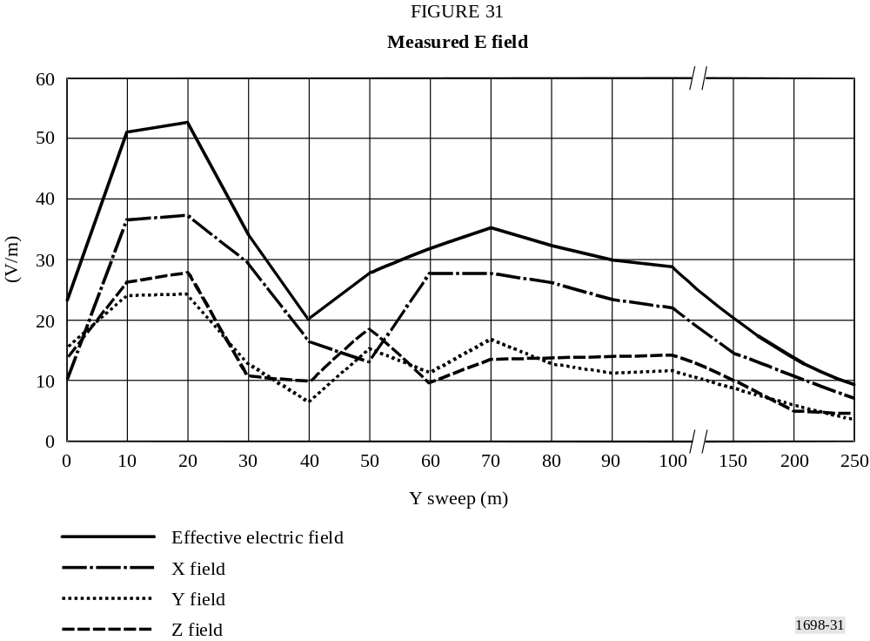

The horizontal axis represents the distance in metres from antenna (Y sweep). The intensity of the E field’s components is represented in V/m on the vertical axis. All the three components x, y, z of the E field are present, and the upper line represents the global value.

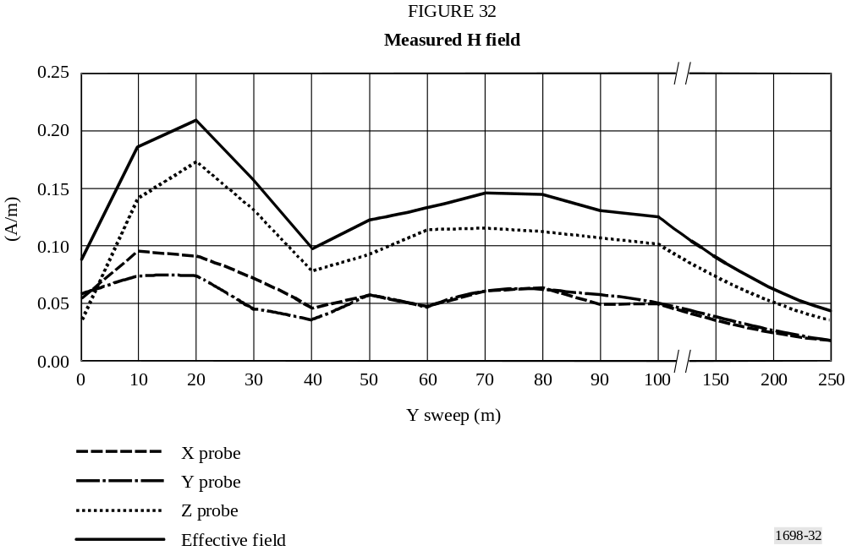
The horizontal axis represents the distance in metres from the antenna (Y sweep). The intensity of the H field’s components is represented in A/m on the vertical axis. All the three components x, y, z of the H field are present, and the upper line represents the global value.

2.2 18 MHz

2.2.1 Predictions

2.2.1.1 Notes about the model
In order to best fit the previously described model to the real antenna system, it is necessary to know the right amount of power at the input of each dipole, taking into account losses in transmission line and losses due to mismatch.
In order to apply the appropriate voltage value at each dipole, in the simulation the input impedance of each dipole has been calculated. The values are represented in Fig. 33.

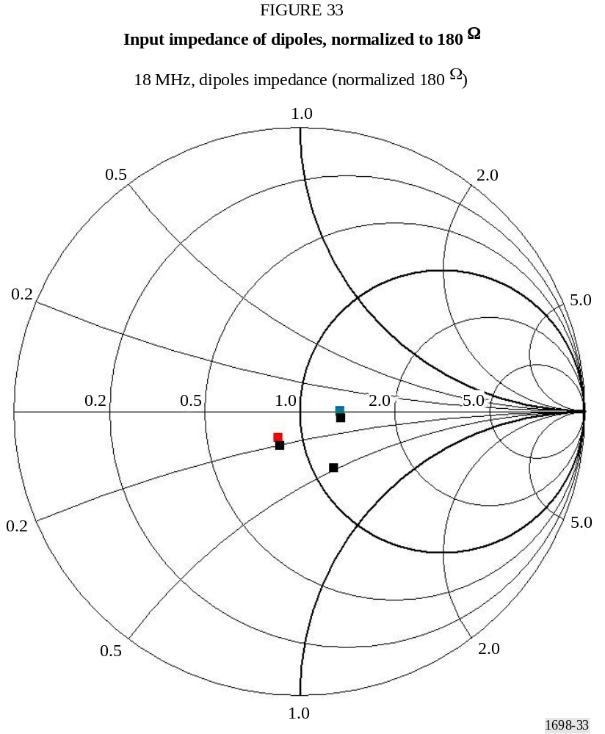

Then, for each dipole, a common value of resistance equal to 180 Ω has been adopted, this being the average value obtained from the simulation. Note that this decision may be the cause of the inaccuracy in the prediction results.
Due to the low reactive components of the complex input impedance, no adjustments to transmitter power are necessary in order to compensate for power losses due to the mismatch, and consequent reflection, between transmitter and antenna.
Note the little – but not inexistent – dispersion of resistance values near 180 Ω and the substantial absence of reactive components.

2.2.1.2 Far field evaluations
In order to best compare the behaviour of the model, with real antennas, given in Figs. 19 and 20 the radiation diagrams have been calculated. The results are shown in Fig. 34 (horizontal plane), Fig. 35 (vertical plane) and Fig. 36 (frontal view).

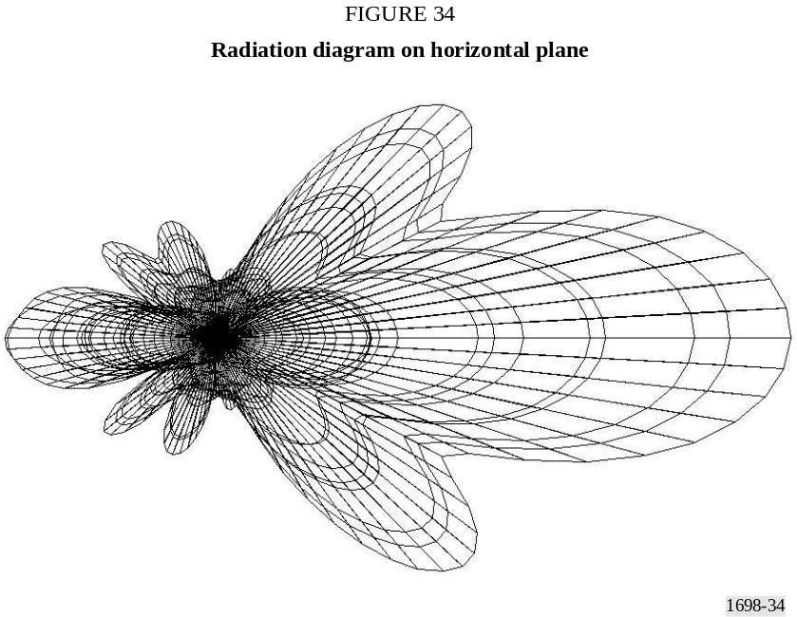

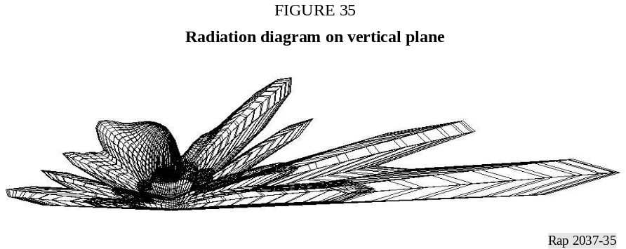

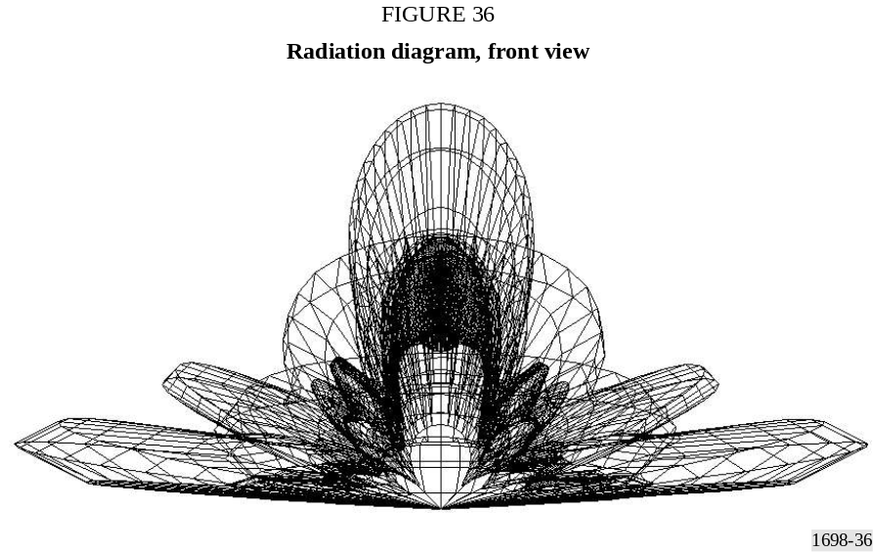

2.2.1.3 Results of prediction of the field strength in the near zone
Prediction was made calculating the x, y, z components of the E and H fields in the direction of the antenna’s maximum gain (Y axis) at 2 m over terrain (Z axis = 2). The calculated values are represented in Fig. 37 (E field) and Fig. 38 (H field). The strong influence of the terrain both in the evaluations and in the measurements may introduce an additional difference between the two results. In order to show the strong influence of terrain, the E and H field values have also been calculated varying the height of the evaluation point over the terrain (Z axis) from 0 up to 9 m at a fixed distance of 60 m (Y = 60). The behaviour is illustrated in Fig. 39 (E field) and Fig. 40 (H field).

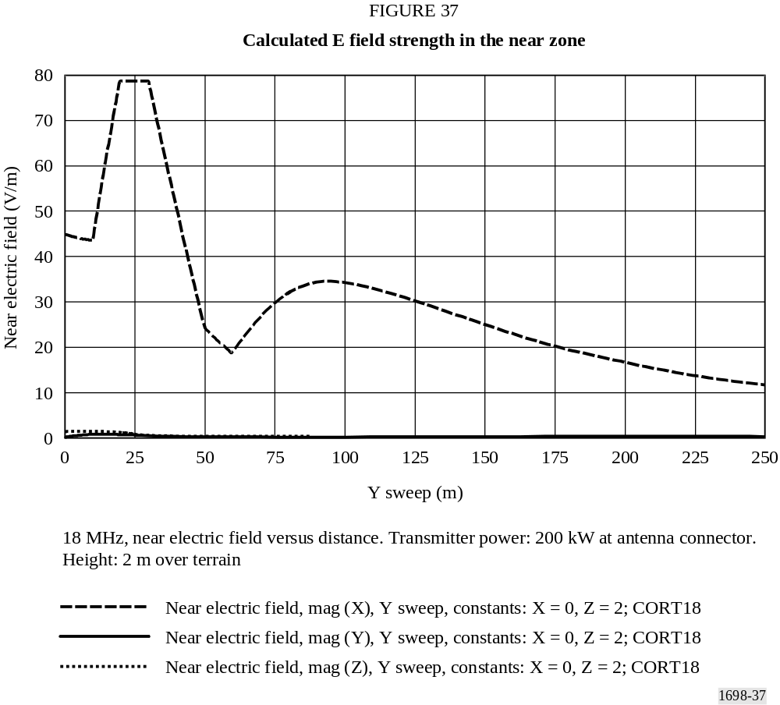

The most important contribution is the x component. The horizontal axis represents the distance in metres from the antenna (Y sweep). Z is fixed at 2 m (height over terrain). The intensity of the E field’s components is represented in V/m on the vertical axis.

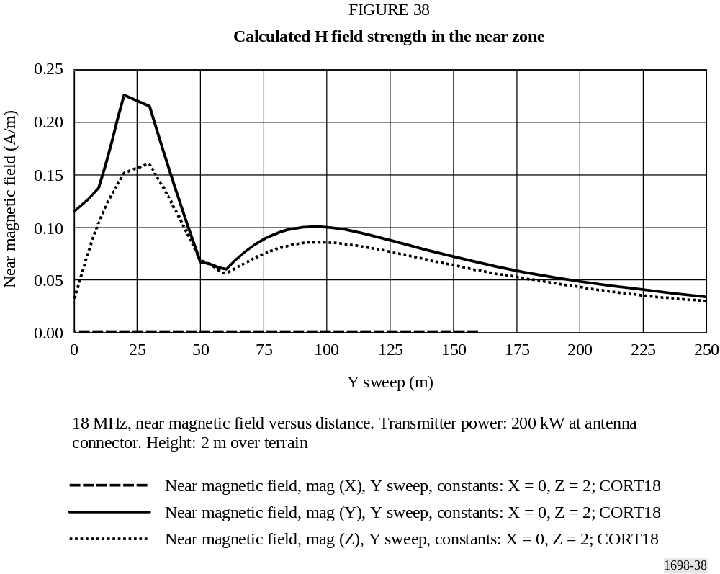

The main contribution is the y component. The z component is lower, while the x component is 0. The horizontal axis represents the distance in metres from antenna (Y sweep). Z is fixed at 2 m (height over terrain). The intensity of the H field’s components is represented in A/m on the vertical axis.

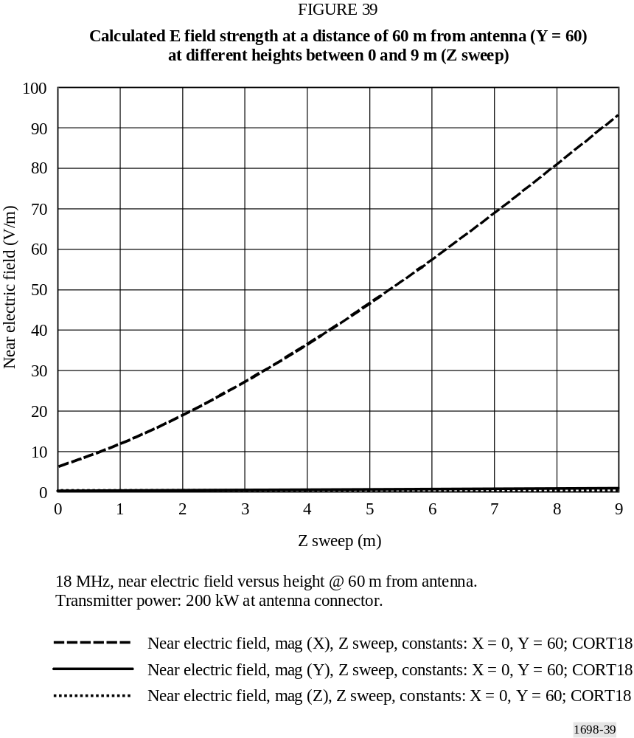

The strong relationship between E values and height (only x component of E field is present) is evident.

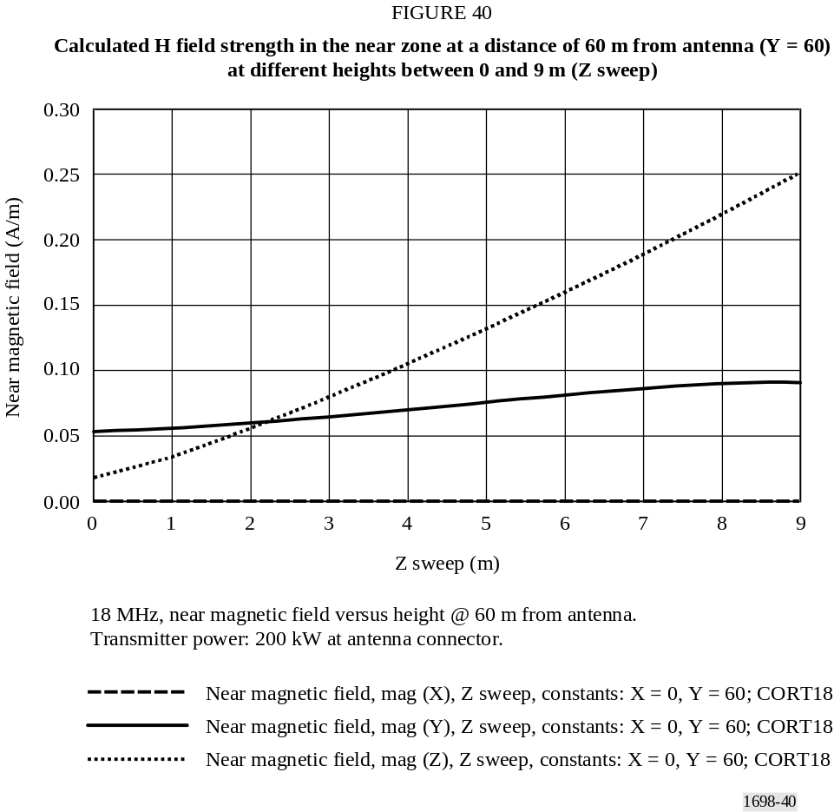

The strong relationship between H values and height (both z and y components of the H field are present, the y component’s value is quite constant) is evident.

2.2.2 Measurements
Measurements have been performed using a broadband field strength meter installed over a dielectric trolley moved by an operator placed far away from the antenna site. By this means any kind of perturbation on the E/H fields is avoided.

2.2.2.1 Results of measurements
Measured values are presented in Fig. 41 (E field) and Fig. 42 (H field). Figs. 41 and 42 are directly comparable with Figs. 37 and 38, respectively.

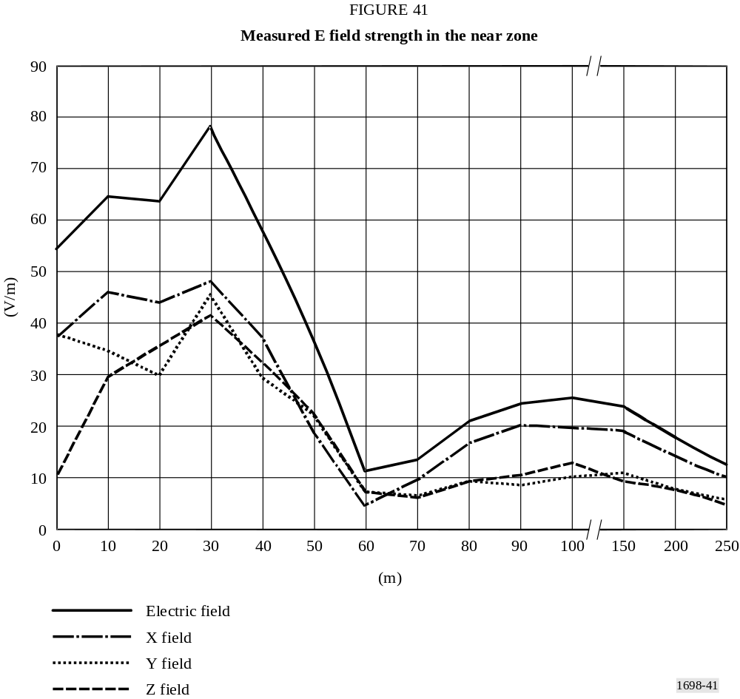

The horizontal axis represents the distance in metres from the antenna (Y sweep). The intensity of the E field’s components is represented in V/m on the vertical axis. All three components x, y, z of the E field are present, and the upper line represents the global value.

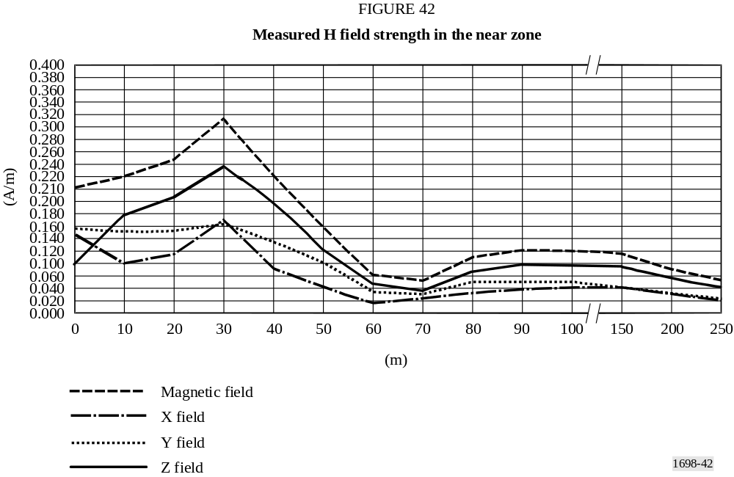
The horizontal axis represents the distance in metres from the antenna (Y sweep). The intensity of the H field’s components is represented in A/m on the vertical axis. All three components x, y, z of the H field are present, and the upper line represents the global value.

2.3 Comparison between measurements and predictions of the field strength in the near zone

2.3.1 13 MHz
At a distance less than 40 m the prediction has given values, of both E and H field, higher than the measured ones; the maximum values of E and H were found at a distance of 10-20 m from the antenna system, in both the simulation results and in the measurements.
Both in the predicted and in the measured values, there is an evident “minimum” at 40 m from the antenna, deeper in the prediction than in the measurement.
The second “maximum” reaches its peak, in both cases, at 75 m from the antenna; in this case the values obtained from simulations are lower than the measured ones.
At longer distances, 250 m from the antenna, all fields approach similar values between prediction and measurement.

2.3.2 18 MHz
At a distance less than 40 m the prediction has given values, of both E and H field, higher than measured ones; the maximum values of E and H were found at a distance of 10-20 m from the antenna system, in both the simulation results and in the measurements.
A second “maximum” is reached at 100 m, both in prediction and measurement, for E and H fields, with a lower value for the measured E field. At a distance higher than 60 m from the antenna the H field assumes the same value both in prediction and in measurement.

3 Conclusions
The comparison between measured and predicted values of the E and H fields, both at 13 MHz and 18 MHz, gives interesting results.
Values are, generally, not in full mutual agreement, as would seem to be expected; however there are no substantial differences among them, when compared with uncertainty of instrumentation, uncertainty in the planarity of the Earth’s surface near the antenna (not taken into account in simulations, even when is clear the field’s intensity has a strong dependence on height of the measurement point) and the imposed simplicity of the model. Differences are bigger near the antenna (i.e. the first maximum at about 10 m), up to 50%, and decrease with increasing distance; at 250 m the differences are quite small.
The reasons for these differences are to be found in the difficulties in near field measurements, the uncertainty inherent in the instrumentation, the simplicity of the model, the presence of some objects near the antenna (metallic structures, the two lattices supporting dipoles and matching network, a little house) that have not been taken into account in the model, as well as the matching network and its radiation. Finally, terrain has been modelled with its typical electrical values.
In order to best approach the activity of E and H field prediction using a model, we recommend the following:
Antenna model: physical dimensions of radiating and passive elements need to be carefully investigated as well as the complex input impedance of the system. In order to simplify a complex system, i.e. an array of radiators, it may be convenient to substitute the matching and feeding network with an equal number of voltage generators applied at the input of each radiator. If the matching network is not considered, then it is necessary to compensate for the:
– Eventual mismatch between generators and radiators by the introduction of artificial matching elements or simple networks, or adjusting the power assigned to the transmitter. The final result is quite insensitive to the presence of small mismatches that do not require modelling.
Segment subdivision: it is sufficient to represent filar antenna systems with segments not longer than /20.
Terrain model: it is necessary to give the exact values of permittivity and conductivity, especially in the case of a horizontally-polarized E field.
Transmitter power: it is important to take into account losses in transmission lines, matching network, resistance of junctions, mismatches to the load. In some cases it is opportune to artificially adjust the exact value of power in order to take into account various causes of losses without complicating the model of the antenna system.
Height of measurement points referred to ground: in many cases this parameter is very important if the scope is a comparison between measurements and predictions. In fact, the strong influence of height may be noted in the value of fields, and, if the terrain is modelled as a plane, large errors may be encountered, by comparison with measurement. In all these cases in which radiators are in the vicinity of terrain and terrain is not quite plane, the results of prediction must be taken with prudence.
Selection of code: the simulation based on MOM seems to be useful and easy to use in cases of filar antennas, of which physical and electrical characteristics are well known. It is possible and quite easy to simplify the model according to a minimum number of rules, without loss in precision of the results.
Appendix 3
to Annex 1
Limits and levels

1 Regulatory and advisory authorities on health aspects
A number of international and national authorities are concerned with the health aspects of EMFs. A non-exhaustive list is given at the end of this Appendix for information.

2 Comparison of basic limits and derived levels from widely used regulations
Present standard guidelines differ in the definition of groups of persons potentially at risk “exposure groups” (e.g. general public, occupationally exposed workers, age) and/or in the place of locations of interest (e.g. public places, houses, fenced enclosures and restricted buildings).
Differences also appear on the parts of the body considered.
Compared in this Appendix are:
− IEEE Standard for safety levels with respect to human exposure to radio frequency electromagnetic fields, 3 kHz to 300 GHz [3].
− ICNIRP guidelines for limiting of exposure to time-varying electric, magnetic and electromagnetic fields (up to 300 GHz) [4].
− UK NRPB board statement on restrictions on human exposure to static and time varying electromagnetic fields and radiation [5].
Table 5 gives an approximate comparison between groups and locations selected in the standards.

TABLE 5
 | IEEE/ANSI | ICNIRP | NRPB
Groups | No | General public  Occupationally exposed people | Adults and children  Adults
Locations | Controlled  (Awareness of exposed people)  Uncontrolled  (No awareness) | No | No

2.1 Comparison of basic biological limits
Standards and guidelines give “basic limits” for contact current, current density and SAR and are reported in Table 6, together with measuring conditions.
A common guideline for compared standards is that all of them do not allow SAR over the entire body to exceed the value of 4 W/kg.
By applying a safety factor of 10, the basic SAR limit (whole-body-averaged SAR) is reduced to 0.4 W/kg. The NRPB basic limit of 0.4 W/kg is proposed as the maximum level allowed for core temperature increase of 1 K.
It is to be noted that the basic whole body limit for SAR is averaged over a time of 6 min. There are also limits applicable to specific part of the body, referred as “local SARs”; since resonance effects may give rise to local “hot spots”, these limits are higher than the whole-body-averaged SAR.

2.2 Comparison of derived limit levels for E, H and power flux limits at various frequencies
The direct measurement of the current density and specific absorption rate is very difficult and not possible in practice. Therefore, derived levels are given in addition to the basic limits, in the standards and guidelines considered here.
On the other hand measurement of EM field quantities E and H are of more practical feasibility.
SAR is frequency dependent, while the basic limits as in Table 6 are assumed constant. By means of the relevant data the SAR limit may be transformed into free field corresponding quantities E, H and S.

TABLE 6
Comparison of basic biological restrictions (SAR limits) and
reference levels (current parameters)
Parameter | IEEE/ANSI |  | ICNIRP |  | NRPB
Parameter | Controlled | Uncontrolled | Occupational | General public | NRPB
RMS induced or contact current (mA) | 1 000 f  ^{(13a))} | 450 f  ^{(13a))} | 100  ⁽²⁾ | 45  ⁽²⁾
 | 100  ^{(1) , (13b))} | 45  ^{(1) , (13b))} | 40  ⁽³⁾ | 20  ⁽³⁾
Current density RMS (A/m²)  Averaging area (cm²)  Averaging times | 350 f  1  1  ⁽⁴⁾ | 15.7 f  1  1  ⁽⁴⁾ | 10 f  1  ⁽⁴⁾ | 2 f  1  ⁽⁴⁾ | 10 f
Whole-body-average (W/kg) SAR | 0.4  ^{(5a))} | 0.08  ^{(5b))} | 0.4  ^{(5a))} | 0.08  ^{(5a))} | 0.4  ^{(5c))}
Local SAR (W/kg)  Averaging mass (kg) | 8  ^{(13c))}  0.001  ⁽⁶⁾ | 1.6  ^{(13c))}  0.001  ⁽⁶⁾ | 10  ^{(13d))}  0.001  ^{(5a), (7)} | 2  ^{(13d))}  0.01  ^{(5a), (7)} | 10  0.01 and 0.1  ^{(5a)), (10)}
Local Sar⁽⁷⁾ (W/kg)  Averaging mass (kg) | 20  ^{(13c))}  0.010⁽⁸⁾ | 4  ^{(13c))}  0.010⁽⁸⁾ | 20  ^{(13d))}  0.01^{(5a)), (9)} | 4  ^{(13d))}  0.01^{(5a)), (9)} | 20  0.1^{(5a)), (9)}
Power density (W/m²)  Averaging time (min) |  |  | 50  68/f ^{1,05}  ^{(12), (13)} | 10  68/f ^{1,05}  ^{(12), (13)} | 100  68/f ^{1,05}  ⁽¹²⁾
f : frequency in MHz (unless otherwise stated).
⁽¹⁾ Current through each foot. f : frequency (MHz).
⁽²⁾ Current induced in any limb (10-110 MHz).
⁽³⁾ Contact current from conductive objects (100 kHz-110 MHz).
⁽⁴⁾ Current density over any 1 cm² area of tissue.
⁽⁵⁾ a) The SAR limits relate to an averaging time of 6 min.
b) The SAR limits relate to an averaging time as given in Table 7.
c) The SAR limits relate to an averaging time of 15 min.
⁽⁶⁾ Localized SAR except for the hands, wrists, feet and ankles (100 kHz-6 GHz).
⁽⁷⁾ Localized SAR for head and trunk (100 kHz-10 GHz).
⁽⁸⁾ Localized SAR for the hands, wrists, feet and ankles (100 kHz-6 GHz).
⁽⁹⁾ Localized SAR for limbs (100 kHz-10 GHz).
⁽¹⁰⁾ Localized SAR for head, neck, trunk and foetus (10 MHz-10 GHz).
⁽¹¹⁾ 10 g for the head and foetus; 100 g for the neck and trunk.
⁽¹²⁾ For frequencies between 10 and 300 GHz. f : frequency (GHz).
⁽¹³⁾ Averaged over any 20 cm² of exposed area:
a) 3 kHz < f < 100 kHz
b) 100 kHz < f < 100 MHz
c) 100 kHz < f < 6 GHz
d) 100 kHz < f < 10 GHz.

Tables 7, 8 and 9 show the maximum level respectively of E, H and power density in various bands in the frequency range 1 kHz-300 GHz. The limits are calculated under the conservative assumption of optimum electromagnetic coupling between the EMF and the body.

TABLE 7
Comparison of derived levels; E field (r.m.s. values V/m)*
Frequency range | IEEE/ANSI |  | ICNIRP |  | NRPB
Frequency range | Controlled | Uncontrolled | Occupational | General public | Adults only | Adults and children
0.6-3 kHz |  |  |  |  | 1 000
3-30 kHz | 614 |  | 610  ⁽¹⁾ | 87
30-38 kHz
38-65 kHz
65-100 kHz
100-410 kHz
410-600 kHz
600-610 kHz |  |  | 610  ⁽¹⁾ | 87 | 600/f
610-680 kHz
680-920 kHz
0.92-1 MHz
1-1.34 MHz |  |  | 610/f | 87/f ^{0.5}
1.34-3 MHz | 614 | 823.8/f | 610/f | 87/f ^{0.5}
3-10 MHz | 1 842/f | 823.8/f | 610/f | 87/f ^{0.5}
10-12 MHz | 1 842/f | 823.8/f | 61 | 28 | 60 | 600/f
12-30 MHz |  |  |  |  |  | 50  ⁽²⁾
30-60 MHz | 61.4 | 27.5
60-100 MHz |  |  |  |  | f  ⁽²⁾ | 50  ⁽²⁾
100-137 MHz
137-200 MHz |  |  |  |  | 137  ⁽²⁾ | 50  ⁽²⁾
200-300 MHz |  |  |  |  |  | 0.25 f  ⁽²⁾
300-400 MHz |  |  | 61 | 28 | 137  ⁽²⁾
400-800 MHz |  |  | 3 f ^{0.5} | 1.375 f ^{0.5} | 137  ⁽²⁾ | 100  ⁽²⁾
0.8-1.1 GHz |  |  |  |  |  | 0.125 f  ⁽²⁾
1.1-1.55 GHz |  |  |  |  | 0.125 f  ⁽²⁾ | 0.125 f  ⁽²⁾
1.55-2 GHz |  |  |  |  | 194  ⁽²⁾
2-3 GHz |  |  | 137 | 61
3-15 GHz
15-300 GHz
f : frequency (MHz, unless otherwise stated).
* Values should be averaged over 6 min, except as shown below:
a) f ²/0.3
b) 30 min.
⁽¹⁾ This value is in the range 0.82 kHz to 1 MHz.
⁽²⁾ Plane wave equivalent value of the E field.

TABLE 8
Comparison of derived levels; H field (RMS values A/m)^{(1), (2)}
Frequency range | IEEE/ANSI |  |  | ICNIRP |  | NRPB
Frequency range | Controlled | Uncontrolled |  | Occupational | General public | Adults only |  | Adults and children
1-3 kHz |  |  |  |  |  | 64
3-30 kHz | 163 |  |  |  | 5  ⁽³⁾
30-38 kHz
38-65 kHz
65-100 kHz |  |  |  | 1.6/f | 5  ⁽³⁾
100-140 kHz | 16.3/f |  |  | 1.6/f | 5  ⁽³⁾
140-150 kHz
150-535 kHz |  |  |  | 1.6/f | 0.73/f
535-610 kHz |  |  |  | 1.6/f | 0.73/f | 18/f ²
610-680 kHz
0.68-1 MHz
1-1.34 MHz
1.34-3 MHz
3-10 MHz
10-12 MHz |  |  |  | 0.16 | 0.073
12-30 MHz |  |  |  | 0.16 | 0.073 | 0.16  ⁽²⁾ | 0.13
30-60 MHz | 16.3/f |  | 158.3/f ^{1.668}  ^{(1a))}
60-100 MHz |  |  |  |  |  | f /377  ⁽²⁾
100-137 MHz | 0.163 |  | 0.0729  ^{(1b))}
137-200 MHz |  |  |  |  |  | 0.36  ⁽²⁾
200-300 MHz |  |  |  |  |  |  | 0.66 × 10^{–3} f
300-400 MHz
400-800 MHz |  |  |  | 0.008f ^{0.5} | 0.0037f ^{0.5} | 0.36  ⁽²⁾ | 0.26
0.8-1.1 GHz |  |  |  |  |  |  | 0.33 × 10^{–3} f
1.1-1.55 GHz |  |  |  |  |  | 0.33 × 10^{–3} f  ⁽²⁾
1.55-2 GHz |  |  |  |  |  | 0.52
2-3 GHz |  |  |  | 0.36 | 0.16
3-15 GHz
15-300 GHz
f : frequency (MHz, unless otherwise stated).
⁽¹⁾ Values should be averaged over 6 min, except as shown below:
a) 0.0636 f ^{1.337} min
b) 30 min.
⁽²⁾ Plane wave equivalent value of the H field, based on power density values given for adults. NOTE - These values are not given explicitly in the same way as the E field and power density values are specified.
⁽³⁾ This value is valid in the range 0.8 kHz to 150 kHz.

TABLE 9
Comparison of derived levels; power density (W/m²)⁽³⁾
 | IEEE/ANSI⁽¹⁾ |  |  |  |  | ICNIRP |  | NRPB
Frequency range | Controlled |  | Uncontrolled |  |  | Occupational | General public | Adults only | Adults and children
Frequency range | E field | H field | E field | H field
<100 Hz
0.1-1 kHz
1-3 kHz
3-30 kHz | 1 000 | 10 × 10⁶ | 1 000 |  | 10 × 10⁶
30-100 kHz
100-410 kHz | 1 000 | 10^{5/}f ² | 1 000 |  | 10^{5/}f ²
0.41-1 MHz
1-1.34 MHz
1.34-3 MHz | 1 000 | 10^{5/}f ² | 1 800/ f ²  ^{(2), (3a))} |  | 10^{5/}f ²  ⁽²⁾
3-10 MHz | 9 000/f ² | 10^{5/}f ² | 1 800/ f ²  ^{(2), (3b))} |  | 10^{5/}f ²  ⁽²⁾
10-12 MHz |  |  |  |  |  | 10 | 2 | 10
12-30 MHz |  |  |  |  |  |  |  |  | 6.6
30-60 MHz | 10 | 10^{5/}f ² | 2  ^{(2), (3b))} |  | (9.4 × 10⁶ )/f ^{8.336}  ^{(2), (3c))}
60-100 MHz |  |  |  |  |  |  |  | 2.7 × 10^{–3} f ² | 6.6
100-137 MHz | 10 |  | 2  ^{(3b))}
137-200 MHz |  |  |  |  |  |  |  | 50
200-300 MHz |  |  |  |  |  |  |  |  | 0.165 × 10^{–3}f ²
300-400 MHz | f /30 |  | f /150  ^{(3b))}
400-800 MHz |  |  |  |  |  | f /40 | f /200 | 50 | 26
0.8-1.1 GHz |  |  |  |  |  |  |  |  | 41 × 10^{–6} f ²
1.1-1.55 GHz |  |  |  |  |  |  |  | 41 × 10^{–6} f ² | 41 × 10^{–6} f ²
1.55-2 GHz |  |  |  |  |  |  |  | 100
2-3 GHz
3-15 GHz | 100 |  | f /150  ^{(3d))} |  |  | 50 | 10
15-300 GHz | 100^{(3e))} |  |  |  |  | 50 | 10
f : frequency (MHz, unless otherwise stated).
⁽¹⁾ Below 100 MHz, plane-wave equivalent values are given for the E and H fields.
⁽²⁾ As given by some commercially available meters.
⁽³⁾ Values should be averaged over 6 min, except as shown below:
a) f ²/0.3 min
b) 30 min
c) 0.0336 f ^{1.337} min
d) 90 000/f min
e) 616 000/f ^{1.2} min.

3 Field-strength values to be determined
Using data given in the tables in this Appendix, for § 2.2 the range of electrical and magnetic field strengths are shown in Figs. 43 and 44, respectively.
These curves/graphs should not be used as a basis for an administration’s regulatory requirements. They represent a composite view of the limits currently depicted and are certain to evolve over time. As such, they are merely illustrative of the methodology that could be applied to develop useful standards within an administration.
Also, it must be recognized that results of independent studies of the subject are not entirely consistent and, as a result the interpretation, of the results by responsible authorities has in the past, and will continue in the future, to result in differing requirements in different countries.

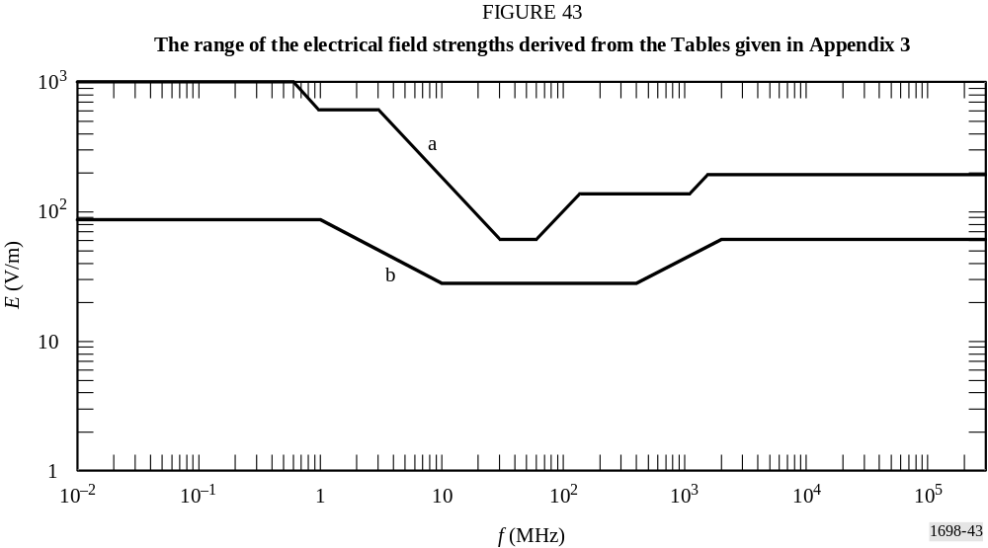

The curves “a” and “b” represent the upper and lower boundaries respectively of some known, existing recommendations for RF exposures levels (presented in this Appendix, as example). All curves from authorities making such recommendations lie between these boundaries, and any curve between curves “a” and “b” should allow adequate broadcasting services.
The curves “a” and “b” represent the upper and lower boundaries respectively of some known, existing recommendations for RF exposure levels (presented in this Appendix, as example). All curves from authorities making such recommendations lie between these boundaries, and any curve between curves “a” and “b” should allow adequate broadcasting services.
The differences between the suggested maximum levels at the same frequency (Figs. 43 and 44) depend on the different conditions considered by the various sources suggesting the limits.
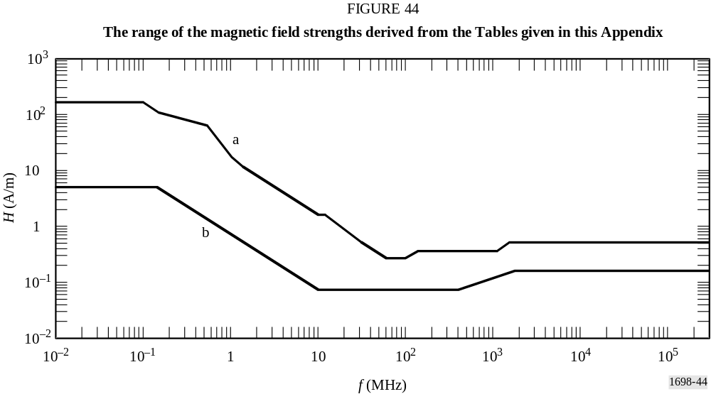

4 Numerical procedures and calculation of EMF quantities
In few relatively simple cases, electromagnetic radiation and scatter problems can be solved by using analytic procedures in a closed form. However, the solution of general problems, with random geometries, requires the application of numerical calculation procedures, running on powerful computers.
The numerical procedures, depending on the frequency range under consideration and the size of the geometrical structures used, are available for the calculation of EMF field quantities.
Among these different methods we have decided to use the MOM, used in the design of broadcast antenna systems and in calculating their resultant electromagnetic fields.
The MOM is used intensively for calculating the SAR distribution in so-called /block model/.
The electric field intensities within the body are calculated from the solution of the integral equation of the electric field by using Maxwell’s equations.
The software used is: NEC – WIN Professional V 1.1 (1997) by Nittany Scientific, inc. – http://www.nittany-scientific.com/.

5 List of some national regulations

5.1 Administrations

5.1.1 Australia
Australian Radiation Protection and Nuclear Safety Agency (ARPANSA) Radiation Protection Standard RPS-3, Radiation Protection Standard – Maximum exposure levels to radiofrequency fields – 3 kHz to 300 GHz.

5.1.2 Brazil
Resolution n. 303/202 – Regulamento sobre Limitacao da Exposicao a Campos Elétricos, Magnéticos e Elétromagnéticos na Faixa de Radiofrequencias entre 9 kHz e 300 GHz.
www.anatel.gov.br/bibliotheca/Templates/Resolucoes/resolucoes.asp.

5.1.3 France
Decree nb.2002-775 of 03.05.2002, relating to the limit values of public exposure to the electromagnetic fields radiated by the equipment used in the telecommunication networks or by the radioelectric installations.

5.1.4 Germany
Bundesministerium für Wirtschaft und Arbeit. www.bmwi.de.

5.1.5 Italy
DPCM 8 July 2003. www.parlamento.it/parlam/leggi/elelenum.htm.

5.1.6 New Zealand

5.1.7 United States of America
http://www.fcc.gov/oet/rfsafety/.

5.1.8 Vatican City State
Delibera del 16/12/1992 No: 225620.

5.1.9 Japan
Radio Law (Law No. 131 of May 2, 1950), Article 30.
The Regulations for Enforcement of the Radio Law (Radio Regulatory Commission Rules No. 14 of November 30, 1950), Article 21-3 and Annex, Table 2-3-2.
Website: http://www.tele.soumu.go.jp/e/ele/index.htm (in English)
http://www.tele.soumu.go.jp/j/ele/index.htm (in Japanese)
(The Articles of the Law and the Regulations are available only in Japanese. Some reports to the Ministry are available in English.)

6 List of some Regulatory and Advisory bodies

6.1 Electronic Components Commitee, Comité des composants électroniques, CENELEC [6]

6.2 German Commission for Electrical and Electronic Information technologies, DKE

6.3 European Union, EU –Recommendation from the Council of the European Union, L 199, 12 July 1999

6.4 Institute of Electrical and Electronics Engineer/ American National Standards Institute (IEEE/ANSI)

6.5 International Commission on non-ionizing radiation (ICNIRP)

6.6 International Electrotechnical Commission (IEC)

6.7 World Health Organization (WHO)

6.8 National Radiological Protection Board (NRPB)

6.9 European Telecommunications Standards Institute (ETSI)

Appendix 4
to Annex 1
Additional evaluation methods

1 Dosimetry
The application of dosimetric concepts enables the link to be established between external (i.e. outside the body) field strengths and internal quantities of electric field strength, induced current density and the energy absorption rate in tissues. The development of experimental and numerical dosimetry has been complementary. Both approaches necessitate approximations to the simulation of human exposure; however the development of tissue equivalent materials and minimally disturbing probes in the experimental domain and the use of anatomically realistic models for computational purposes have improved the understanding of the interaction of RF fields with the body.
Whereas current density is the quantity most clearly related to the biological effects at low frequencies, it is the SAR, which becomes the more significant quantity as frequencies increase towards wavelengths comparable to the human body dimensions.
In most exposure situations the SAR can only be inferred from measured field strengths in the environment using dosimetric models. At frequencies below 100 MHz non-invasive techniques have been used to measure induced current, and in extended uniform fields, external electric field strengths have been related to induced current as a function of frequency. In the body resonance
region, exposures of practical significance arise in the reactive near field where coupling of the incident field with the body is difficult to establish owing to non-uniformity of the field and changing alignment between field and body. In addition, localized increases in current density and SAR may arise in parts of the body as a consequence of the restricted geometrical cross-section of the more conductive tissues.
Dosimetric quantities can be calculated by use of suitable numeric procedures and calculational models of the human body. On the other hand such quantities can be measured using suitable physical models (phantoms).

2 SAR measurement
The SAR (W/kg), is the basic limit quantity of most RF exposure regulations and standards. SAR is a measure of the rate of electromagnetic energy dissipated per unit mass of tissue.
The SAR may be specified as the value normalized over the whole body mass (sometimes referred to as the “whole body averaged SAR”) or the localized value over a small volume of tissue (localized SAR).
SAR can be ascertained from the internal quantities in three ways, as indicated by the following equation:
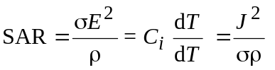
where:
E : value of the internal electric field strength in the body tissue (V/m^{–1})
: conductivity of body tissue (S/m^{–1})
: density of body tissue (kg/m^{–3})
C_{i} : heat capacity of body tissue (J/kg^{–1} °C^{–1})
dT/dt : time derivative of temperature in body tissue (°C/s^{–1})
J : value of the induced current density in the body tissue (A/m²).
The local SAR in an incremental mass (dm) is defined as the time derivative of the incremental absorbed energy (dW) divided by the mass:
SAR = d/dt dW/dm
This quantity value is important from two standpoints; the resulting non-uniform distribution of energy absorption when exposed to a uniform plane wave, and the localized energy absorption arising from non-uniform fields in close proximity to a source of exposure.
Exposure regulations or standards contain derived electric and magnetic field limits. The underlying dosimetric concept assures that compliance with the (external) derived levels will assure compliance with the basic SAR limits. However, external or internal SAR measurements can also be used to show compliance. For partial-body near-field exposure conditions, the external electromagnetic fields may be difficult to measure, or may exceed the derived limits although the local SAR is below the basic limits. In these cases internal SAR measurements in body models have to be conducted. The most important methods to measure SAR will be described below.

2.1 Electric field measurement
The SAR is also proportional to the squared RMS electric field strength E (V/m) inside the exposed tissue:
SAR = σ E²/ρ
where:
σ (S/m) : conductivity
ρ (kg/m³) : mass density of the tissue material at the position of interest.
Using an isotropic electric field probe, the local SAR inside an irradiated body model can be determined. By moving the probe and repeating the electric field measurements in the whole body or in a part of the body, the SAR distribution and the whole body or partial-body averaged SAR values can be determined. A single electric field measurement takes only a few seconds, which means that three-dimensional SAR distributions can be determined with high spatial resolution and with a reasonable measurement time (typically less than an hour).

2.2 Temperature measurement
The SAR is proportional to initial rate of temperature rise dT/dt (C/s) in the tissue of an exposed object:
SAR = c T/t
where c is the specific heat capacity of the tissue material (J/kgC). Using certain temperature probes, the local SAR inside an irradiated body model can be determined. One or more probes are used to determine the temperature rise ΔT during a short exposure time Δt (typically less than 30 s to prevent heat transfer). The initial rate of temperature rise is approximated by ΔT/ΔT, and the local SAR value is calculated for each measurement position. By repeating the temperature measurements in the whole body or in a part of the body, the SAR distribution and the whole-body or partial-body averaged SAR values can be determined.
Three-dimensional SAR-distribution measurements are very time consuming due to the large number of measurement points. To achieve a reasonable measurement time the number of points has to be limited. This means that it is very difficult to measure strongly non-uniform SAR distributions accurately. The accuracy of temperature measurements may also be affected by thermal conduction and convection during measurements, or between measurements.

2.3 Calorimetric measurement
The whole-body average SAR can be determined using calorimetric methods. In a normal calorimetric measurement, a full-size or scaled body model at thermal equilibrium is irradiated for a period of time. A calorimeter is then used to measure the heat flow from the body, until the model is at thermal equilibrium again. The obtained total absorbed energy is then divided by the exposure time and the mass of the body model, which gives the whole-body SAR. The calorimetric twin-well technique uses two calorimetres and two identical body models. One of the models is irradiated, and the other one is used as a thermal reference. This means that the measurement can be performed under less well-controlled thermal conditions than a normal calorimetric measurement.
Calorimetric measurements give rather accurate determinations of whole-body SAR, but do not give any information about the internal SAR distribution. To get accurate results a sufficient amount of energy deposition is required. The total time of a measurement, which is determined by the time to reach thermal equilibrium after exposure, may be up to several hours. Partial body SAR can be measured by using partial-body phantoms and small calorimetres.

3 Body current measurement
Measurement devices for body current may be carried out in two categories:
– measurement devices for body to ground current;
– measurement devices for contact current.

3.1 Induced body currents
Internal body currents that are induced in persons occur from partial or whole-body exposure of the body to RF fields in the absence of contact with objects other than the ground.
The two principal techniques used for measuring body currents include clamp-on type (solenoidal) current transformers for measuring current flowing in the limbs, and parallel plate systems that permit the measurement of currents flowing to ground through the feet.
Clamp-on current transformer instruments have been developed that can be worn.
The meter unit is mounted either directly on the transformer or connected through a fibre-optic link to provide a display of the current flowing in a limb around which the current transformer is clamped. Current sensing in these units may be accomplished using either narrow-band techniques, e.g., spectrum analysers or tuned receivers (which offer the advantage of being able to determine the frequency distribution of the induced current in multi-source environments, or broadband techniques using diode detection or thermal conversion).
Instruments have been designed to provide true r.m.s. indications in the presence of multiple frequencies and/or amplitude-modulated waveforms.
The upper frequency response of current transformers is usually limited to about 100 MHz however air cored transformers (as opposed to ferrite-cored), have been used to extend the upper frequency response of these instruments. Whilst air-cored transformers are lighter and therefore useful for longer term measurements, they are significantly less sensitive than ferrite cored devices.
An alternative to the clamp-on device is the parallel plate system. In this instrument, the body current flows through the feet to a conductive top plate, through some form of current sensor mounted between the plates, and thereby to ground. The current flowing between the top and bottom plates may be determined by measuring the RF voltage drop across a low impedance resistor. Alternatively, a small aperture RF current transformer or a vacuum thermocouple may be used to measure the current flowing through the conductor between the two plates.
Instruments with a flat frequency response between 3 kHz and 100 MHz are available.
There are several issues that should be considered when selecting an instrument for measuring induced current.
Firstly, stand-on meters are subject to the influence of electric-field induced displacement currents from fields terminating on the top plate. Investigations have shown that apparent errors arising in the absence of a person are not material to the operation of the metres when a person is present.
Secondly, the sum of both ankle currents measured with clamp-on type meters tends to be slightly greater than the corresponding value indicated with plate type meters. The magnitude of this effect, which is a function the RF frequency and meter geometry, is not likely to be material. Nonetheless, the more accurate method of assessing limb currents is the current transformer. The precise method of measurement may depend upon the requirements of protection guidelines against which compliance assessments are made.
Thirdly, the ability to measure induced currents in limbs under realistic grounding conditions such as found in practice need to be considered. In particular, the differing degree of electrical contact between the ground and bottom plate of the parallel plate system and the actual ground surface may affect the apparent current flowing to ground.
Measurements can be made using antennas designed to be equivalent to a person. This enables a standardized approach to be used and permit current measurements to be made without the need for people to be exposed to potentially hazardous currents and fields.

3.2 Contact current measurement
The current measurement device has to be inserted between the hand of the person and the conductive object. The measurement technique may consist of a metallic probe (definite contact area) to be held by hand at one end of the probe while the other end is touched to the conductive object. A clamp-on current sensor (current transformer) can be used to measure the contact current which is flowing into the hand in contact with the conductive object.
Alternative methods are:
– the measurement of the potential difference (voltage drop) across a non-inductive resistor (resistance range of 5-10) connected in series between the object and the metallic probe held in the hand;
– a thermocouple milliammeter placed directly in series.
The wiring connections and the current meter must be set up in such way that interference and errors due to pick-up are minimized.
In the case where excessively high currents are expected an electrical network of resistors and capacitors can simulate the body’s equivalent impedance.

3.3 Touch voltage measurement
The touch voltage (no-load-voltage) is measured by means of a suitable voltmeter or oscilloscope for the frequency range under consideration. The measurement devices are connected between the conductive object charged by field induced voltage and reference potential (ground). The input impedance of the voltmeter must not be smaller than 10 k Ω.

Appendix 5
to Annex 1
Electromedical devices

1 Electromedical devices
Electromagnetic compatibility (EMC) is a general concern for electronic equipment and particularly electronic medical devices. If electromedical devices are used in the presence of strong electromagnetic fields they may malfunction. The risk of such malfunction increases if the field strengths are great enough. The risk of malfunction depends upon several variables, such as the level of field strength, which is dependent on distance between the radiating antenna and the device, the transmitter power, the frequency of the waves, the type of modulation of the radiated signal, the effect of cable coupling as well as the electronic devices own RF immunity.
RF interference to electromedical devices can usually be reduced or eliminated by suitable RF screening or electronic filtering. Applied techniques derived from those commonly used for EMC are suitable. Special limits, that may be significantly lower than general limits for population, may apply to medical devices, implanted or not, and to medical instrumentation.

1.1 Implanted and portable devices
EMF can cause RF interference to active implanted or portable medical devices.
Insulin pumps and cardiac pacemakers belong to this class and, in the future, there may be an increasing number of these devices. Also the range and the number of different new devices appears to be increasing, e.g. portable monitors, prosthetic aids for sight and motion. Generally speaking, pacemakers and other medical devices could suffer interference from radiated EMF. However in the case of electromedical implanted devices, RF interference problems have not yet been completely solved due to the lack of full awareness of the problem by manufacturers and suppliers.

Appendix 6
to Annex 1
References
[1] IEC [6 October 2000] IEC Committee Draft (CD) 85/214/CD: Measurement and evaluation of high frequency (9 kHz to 300 GHz) electromagnetic fields with regard to human exposure.
[2] EBU [November 2001] BPN 023: Radio frequency radiation: Exposure limits and their implication for broadcasters. European Broadcasting Union.
[3] ANSI/IEEE [1992] Standard for safety levels with respect to human exposure to radiofrequency electromagnetic fields, 3 kHz to 300 GHz. IEEE Std C95.1/D1.4.
[4] ICNIRP [April 1998] Guidelines for limiting exposure to time-varying electric, magnetic and electromagnetic fields (up to 300 GHz). Health Physics, Vol. 74, 4, p. 494-522.
[5] NRPB [1993] Board Statement on restrictions on human exposure to state and time varying electromagnetic fields and radiation. Doc. NRPB, Vol. 4, 5.
[6] CENELEC [21 November 2003] Draft prEN 50413: Basic Standard on measurement and calculation procedures for human exposure to electric, magnetic and electromagnetic fields (0 Hz-300 GHz).
[7] IEEE. IEEE Std C95.3: IEEE recommended practice for measurements and computations of radio frequency electromagnetic fields with respect to human exposure to such fields, 100 kHz-300 GHz.

1 Generally, the characteristic impedance of a medium is given by 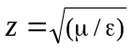where μ is the magnetic permeability (= 1.2566.. × 10^{–6} F/m in free space), and ε is the permittivity (= 8.85418 × 10^{–12} H/m in free space).

