Recommendation ITU-R BS.1615-2
(12/2020)
“Planning parameters” for digital sound broadcasting at frequencies below 30 MHz
BS Series
Broadcasting service
(sound)

Foreword
The role of the Radiocommunication Sector is to ensure the rational, equitable, efficient and economical use of the radio-frequency spectrum by all radiocommunication services, including satellite services, and carry out studies without limit of frequency range on the basis of which Recommendations are adopted.
The regulatory and policy functions of the Radiocommunication Sector are performed by World and Regional Radiocommunication Conferences and Radiocommunication Assemblies supported by Study Groups.

Policy on Intellectual Property Right (IPR)
ITU-R policy on IPR is described in the Common Patent Policy for ITU-T/ITU-R/ISO/IEC referenced in Resolution ITU-R 1. Forms to be used for the submission of patent statements and licensing declarations by patent holders are available from http://www.itu.int/ITU-R/go/patents/en where the Guidelines for Implementation of the Common Patent Policy for ITU-T/ITU-R/ISO/IEC and the ITU-R patent information database can also be found.

Series of ITU-R Recommendations
(Also available online at http://www.itu.int/publ/R-REC/en)
Series | Title
BO | Satellite delivery
BR | Recording for production, archival and play-out; film for television
BS | Broadcasting service (sound)
BT | Broadcasting service (television)
F | Fixed service
M | Mobile, radiodetermination, amateur and related satellite services
P | Radiowave propagation
RA | Radio astronomy
RS | Remote sensing systems
S | Fixed-satellite service
SA | Space applications and meteorology
SF | Frequency sharing and coordination between fixed-satellite and fixed service systems
SM | Spectrum management
SNG | Satellite news gathering
TF | Time signals and frequency standards emissions
V | Vocabulary and related subjects

Note: This ITU-R Recommendation was approved in English under the procedure detailed in Resolution ITU-R 1.

Electronic Publication
Geneva, 2020

© ITU 2020
All rights reserved. No part of this publication may be reproduced, by any means whatsoever, without written permission of ITU.

RECOMMENDATION ITU-R BS.1615-2
“Planning parameters” for digital sound broadcasting
at frequencies below 30 MHz
(2003-2011-2020)
Scope
This Recommendation describes the planning criteria, which could be used for planning of terrestrial digital sound broadcasting in the MF band, including DRM and IBOC (HD Radio) Digital Systems in Recommendation ITU-R BS.1514.
Keywords
Digital Sound Broadcasting, DRM, IBOC, HD Radio
The ITU Radiocommunication Assembly,
considering
a) that ITU-R is carrying out urgent studies on the development of digital broadcasting modulation emissions in the bands allocated to the broadcasting service below 30 MHz;
b) Recommendation ITU-R BS.1514 describing a digital system suitable for broadcasting in the bands below 30 MHz;
c) that values of RF protection ratios to be applied for all relevant combinations of wanted and unwanted analogue and digital emissions have not been included in the Recommendation mentioned in considering b);
d) that values of minimum usable field strength for wanted digital emissions have not been included in the Recommendation mentioned in considering b);
e) that the analogue emissions will remain in use in the LF, MF and HF bands for some time;
f) that the availability of consistent sets of “planning parameters” will facilitate the introduction of digital emissions in these bands,
recommends
1 that the relevant minimum usable field strength values given in Annex 1 and the values of RF protection ratios given in Annex 2 should be used as a guideline for the introduction of DRM digital broadcasting services in the bands below 30 MHz;
2 that the relevant minimum usable field strength values given in Annex 3 and the values of RF protection ratios given in Annex 4 should be used as a guideline for the introduction of IBOC (HD Radio) digital broadcasting services in the band between 525 kHz and 1 705 kHz,
invites ITU-R
to develop suitable computer software for the introduction of digital broadcasting emissions in the LF, MF and HF broadcasting bands, taking into account the “planning parameters” covered in the Annexes to this Recommendation, and to participate actively in this development.

Annex 1
Minimum usable field strengths for digital sound broadcasting (DSB)
(Digital Radio Mondiale (DRM) system) at frequencies below 30 MHz

1 Introduction
The information on minimum usable field strength contained in this Annex relies upon measurements made using the DRM system. The values are derived from results on S/N after applying the procedure given in Attachment 1 to this Annex. The influence of the variety of system parameters as well as of the propagation conditions in the different frequency bands has been considered during the evaluation of the S/N values.
NOTE 1 – Report ITU-R BS.2144 examines the reasons for the introduction of digital sound broadcasting in the bands below 30 MHz and looks at the technologies involved.

2 Relevant transmission parameters

2.1 DRM robustness modes
In the DRM specification, four robustness modes with different parameters (subcarrier number and spacing, useful symbol and guard interval length, etc.) for the orthogonal frequency division multiplex (OFDM) transmission scheme are defined for the various propagation conditions in the LF, MF and HF bands (see Table 1).
TABLE 1
DRM robustness modes
Robustness mode | Typical propagation conditions | Preferred frequency bands
A | Ground-wave channels, with minor fading | LF, MF
B | Time – and frequency-selective channels, with longer delay spread | MF, HF
C | As robustness mode B, but with higher Doppler spread | Only HF
D | As robustness mode B, but with severe delay and Doppler spread | Only HF

2.2 Spectrum occupancy types
For each robustness mode the occupied signal bandwidth can be varied dependent on the frequency band and on the desired application. The specified spectrum occupancy types are shown in Table 2.
TABLE 2
Bandwidths for DRM robustness mode combinations (kHz)
Robustness mode | Spectrum occupancy type
 | 0 | 1 | 2 | 3 | 4 | 5
A | 4.208 | 4.708 | 8.542 | 9.542 | 17.208 | 19.208
B | 4.266 | 4.828 | 8.578 | 9.703 | 17.203 | 19.266
C |  |  |  | 9.477 |  | 19.159
D |  |  |  | 9.536 |  | 19.179
Nominal bandwidth (kHz) | 4.5 | 5 | 9 | 10 | 18 | 20

The bandwidths in the last row of Table 2 are the nominal bandwidths for the respective spectrum occupancy types of the DRM signal and the values given in lines A to D are the exact signal bandwidths for the different robustness mode combinations.

2.3 Modulation and protection levels
Audio services are transmitted in the main service channel (MSC) of the DRM multiplex. For all robustness modes two different modulation schemes (16- or 64-QAM) are defined for the MSC, which can be used in combination with one of two (16-QAM) or four (64-QAM) protection levels, respectively.
Each protection level is characterized by a specific parameter set for the two (16-QAM) or three (64-QAM) convolutional encoders, resulting in a certain average code rate for the overall multilevel encoding process in the modulator. For 16-QAM protection level, No. 0 corresponds to an average code rate of 0.5; No. 1 to 0.62. For 64-QAM the protection levels, Nos 0 to 3 correspond to average code rates of 0.5, 0.6, 0.71 and 0.78.

3 Computation of minimum usable field strength
To achieve a sufficiently high quality of service for a DRM digital audio service, a BER of about 1 × 10^{–4} is needed. The S/N required at the receiver input to achieve this BER is dependent, apart from the system parameters, also on the wave propagation conditions in the different frequency bands. Corresponding details can be found in Attachments 2 and 3 to this Annex.
On the basis of these S/N values, the minimum usable field strength can be computed applying the procedure proposed in Attachment 1 to this Annex. The relevant resulting values can be found in Tables 3 to 6. For the LF and MF bands (Tables 3 to 5), only results for the DRM robustness mode A are included. If one of the other robustness modes is intended to be used in these bands, the corresponding field strength values can be computed with the help of S/N values for these modes given in Attachment 2 to this Annex.
TABLE 3
Minimum usable field strength (dB(µV/m)) to achieve BER of 1 × 10^{–4} for DRM robustness mode A with spectrum occupancy types 0 or 2 (4.5 or 9 kHz) dependent on modulation scheme and protection level for the LF frequency band (ground-wave propagation)
Modulation  scheme | Protection  level No. | Average code rate | Robustness mode/spectrum occupancy type
 |  |  | A/0 (4.5 kHz) | A/2 (9 kHz)
16-QAM | 0 | 0.5 | 39.3 | 39.1
 | 1 | 0.62 | 41.4 | 41.2
64-QAM | 0 | 0.5 | 44.8 | 44.6
 | 1 | 0.6 | 46.3 | 45.8
 | 2 | 0.71 | 48.0 | 47.6
 | 3 | 0.78 | 49.7 | 49.2

TABLE 4
Minimum usable field strength (dB(µV/m)) to achieve BER of 1 × 10^{–4} for DRM robustness mode A with different spectrum occupancy types dependent on protection level and modulation scheme for the MF frequency band (ground-wave propagation)
Modulation  scheme | Protection  level No. | Average code rate | Robustness mode/spectrum occupancy type
 |  |  | A/0 (4.5 kHz), A/1 (5 kHz) | A/2 (9 kHz), A/3 (10 kHz)
16-QAM | 0 | 0.5 | 33.3 | 33.1
 | 1 | 0.62 | 35.4 | 35.2
64-QAM | 0 | 0.5 | 38.8 | 38.6
 | 1 | 0.6 | 40.3 | 39.8
 | 2 | 0.71 | 42.0 | 41.6
 | 3 | 0.78 | 43.7 | 43.2

TABLE 5
Minimum usable field strength (dB(µV/m)) to achieve BER of 1 × 10^{–4} for DRM robustness mode A with different spectrum occupancy types dependent on protection level and modulation scheme for the MF frequency band (ground-wave plus sky-wave propagation)
Modulation  scheme | Protection  level No. | Average code rate | Robustness mode/spectrum occupancy type
 |  |  | A/0 (4.5 kHz), A/1 (5 kHz) | A/2 (9 kHz), A/3 (10 kHz)
16-QAM | 0 | 0.5 | 34.3 | 33.9
 | 1 | 0.62 | 37.2 | 37.0
64-QAM | 0 | 0.5 | 39.7 | 39.4
 | 1 | 0.6 | 41.1 | 40.8
 | 2 | 0.71 | 44.2 | 43.7
 | 3 | 0.78 | 47.4 | 46.5

TABLE 6
Range of minimum usable field strengths (dB(µV/m)) to achieve BER of 1 × 10^{–4} for DRM robustness mode B with spectrum occupancy types 1 or 3 (5 or 10 kHz) dependent on protection level and modulation scheme for the HF frequency band
Modulation  scheme | Protection  level No. | Average code rate | Robustness mode/spectrum occupancy type
 |  |  | B/1 (5 kHz) | B/3 (10 kHz)
16-QAM | 0 | 0.5 | 19.2-22.8 | 19.1-22.5
 | 1 | 0.62 | 22.5-25.6 | 22.2-25.3
64-QAM | 0 | 0.5 | 25.1-28.3 | 24.6-27.8
 | 1 | 0.6 | 27.7-30.4 | 27.2-29.9

NOTE 1 – The derivation of the values in Tables 3 to 6 is based on the intrinsic noise level of a digital receiver as given in the last row of the Table in Attachment 1 to this Annex. However, when the effect of the external noise is greater than that of the receiver intrinsic noise, then the external noise value should replace the corresponding value of the intrinsic noise in Attachment 1 to this Annex. The adaptation of the values for minimum usable field strength in Tables 3 to 6 can be done afterwards according to the procedure described in Attachment 1 to this Annex.
Not considered in the computation of the field strength up to now are any changes in antenna design and integration into modern receivers (see also Attachment 1 to this Annex).
Table 6 shows the range for minimum usable field strength needed to achieve the BER target on HF channels using robustness mode B. This range gives an impression on the spread of the results caused by varying propagation channel conditions (for details on the system performance evaluation see Attachment 2 to this Annex). As for LF and MF bands, field strength values for other robustness modes can be computed with the S/N values given in Attachment 2 to this Annex. Only mode A is not applicable to HF transmission due to the lack of robustness in the OFDM parameters (length of the guard interval and frequency spacing of the subcarriers).
In contrast to the entries in Tables 3 to 5, results for protection level Nos 2 and 3 in combination with 64-QAM are not included in Table 6 for HF bands, due to the occurrence of bit-error floors even at higher S/N, which are caused by the weak error protection. Therefore these protection levels are not recommended for HF transmission on channels with strong time – and/or frequency-selective behaviour (see Attachments 2 and 3 to this Annex).

4 Further remarks
In DRM field tests it was also recognized that the fading depth with the digital broadband OFDM signal was distinctly less than with the analogue AM transmission (mainly the carrier) under the same propagation conditions. This fact has to be considered either in the algorithms for prediction of median field strength (Recommendation ITU-R P.533) or for computation of transmission reliability (Recommendation ITU-R P.842) by modification of corresponding fading margins. Furthermore, Recommendation ITU-R P.842 – Computation of reliability and compatibility of HF radio systems, makes simplifying assumptions that are unlikely to apply to specific digital modulation.

Attachment 1
to Annex 1
Procedure for estimation of the minimum usable field strength
1 Receiving by receivers using built-in antenna, as defined in Recommendation ITU-R BS.703 – Characteristics of AM sound broadcasting reference receivers for planning purposes.

2 Receiver sensitivity

 |  | Double sideband  (DSB) (AM) |  | Digital
1 Required receiving quality |  | Audio frequency S/N: 26 dB  with 30% (−10.5 dB)  modulation (Rec. ITU-R BS.703) |  | BER = 1 × 10^{–4}
2 Required C/N for the above quality (dB) |  | 26 + 10.5 = 36.5 |  | x
3 Receiver IF bandwidth (kHz) |  | 8 |  | 10  (1 dB higher receiver intrinsic noise than DSB)
4 Receiver sensitivity for the above C/N (dB(μV/m)) | LF | 66 | Required in  Recommendation  ITU-R BS.703 | 30.5 + x | (x dB above the receiver intrinsic noise)
 | MF | 60 |  | 24.5 + x
 | HF | 40 |  | 4.5 + x
5 Receiver intrinsic noise related to field strength, for the above sensitivity (dB(μV/m)) | LF | 29.5 | (36.5 dB (C/N)  below the sensitivity) | 30.5 | (1 dB higher than DSB)
 | MF | 23.5 |  | 24.5
 | HF | 3.5⁽¹⁾ |  | 4.5
⁽¹⁾ This value, 3.5 dB(μV/m), is also indicated in Annex 4 to Recommendation ITU-R BS.560.
NOTE 1 – In the case of the digital receiver, the expression S/N should be used instead of C/N which is used for the analogue DSB receiver.
NOTE 2 – Intrinsic noise of the reference DSB receiver can be calculated as 36.5 dB below the sensitivity.
NOTE 3 – Intrinsic noise of the reference digital receiver is estimated about 1 dB higher than DSB due to IF bandwidth difference and the sensitivity of the reference digital receiver for x dB S/N is calculated as x dB above that. The value x is taken from Table 8.
NOTE 4 – The increase of antenna loss for any receiver that uses a small-sized built-in antenna directly increases the receiver intrinsic noise related to the field strength. This should be taken into account.

3 Other factors to be considered
The external noise level (increasing man-made noise) and the pulse nature of some of the external noise have to be considered. Recommendation ITU-R P.372 deals with radio noise, including some information on impulsive noise. This provides some indication of the noise levels encountered by a digital system. The integrated effects of distant thunderstorms are also included and the statistical characteristics of the amplitude probability density function are modelled. The method of applying the information is given in Recommendation ITU-R P.372.

Attachment 2
to Annex 1
Required S/N ratios for DRM reception

1 Introduction
In Recommendation ITU-R BS.1514, the use of the DRM system was recommended for DSB in the broadcasting frequency bands below 30 MHz. To achieve a sufficiently high quality of service for a digital audio programme transmitted via this system, a BER of about 1 × 10⁻⁴ is needed. In the following values on S/N ratios required to achieve this BER are given for typical propagation conditions on the relevant frequency bands. The values were derived by tests with receiver equipment recently developed on the basis of the current DRM specification published as TS 101 980 (V1.1.1) in September 2001 by the European Telecommunications Standards Institute (ETSI). With these S/N values the corresponding minimum usable field strengths can be computed applying the procedure proposed in Attachment 1 to Annex 1.

2 S/N values for LF/MF bands
In Attachment 3 to Annex 1 a detailed description of transmission channel models used to evaluate the system performance can be found. Channel model No. 1 represents the typical behaviour of a transmission channel with ground-wave propagation during daytime in LF and MF bands. In Table 7 the required S/N for the different robustness modes and their typical spectrum occupancy types (2 for mode A, i.e. nominal channel bandwidth of 9 kHz, and 3, i.e. 10 kHz, for the others) to achieve a BER of 1 × 10⁻⁴ on this channel is given.
For real transmissions based on ground-wave propagation only the use of robustness mode A is recommended because of the higher achievable service data rate. The values for the other modes are included in Table 7 only for reference. The degradation of their performance in S/N compared with mode A can be explained by the fact that the ratio between the numbers of data and pilot subcarriers is varying from mode to mode. With the robustness of the mode the number of pilot subcarriers, which are boosted in power in comparison with data subcarriers, also increases and therefore the average usable power of the remaining data subcarriers decreases.
TABLE 7
S/N (dB) to achieve BER of 1 × 10⁻⁴ for all DRM robustness modes with spectrum
occupancy types 2 or 3 (9 or 10 kHz) dependent on modulation scheme and
protection level for channel model No. 1
Modulation  scheme | Protection  level No. | Average code rate | Robustness mode/spectrum occupancy type
 |  |  | A/2  (9 kHz) | B/3 (10 kHz) | C/3 (10 kHz) | D/3 (10 kHz)
16-QAM | 0 | 0.5 | 8.6 | 9.3 | 9.6 | 10.2
 | 1 | 0.62 | 10.7 | 11.3 | 11.6 | 12.1
64-QAM | 0 | 0.5 | 14.1 | 14.7 | 15.1 | 15.9
 | 1 | 0.6 | 15.3 | 15.9 | 16.3 | 17.2
 | 2 | 0.71 | 17.1 | 17.7 | 18.1 | 19.1
 | 3 | 0.78 | 18.7 | 19.3 | 19.7 | 21.4

For simulcast applications in a nominal channel bandwidth of 9 or 10 kHz DRM spectrum occupancy types 0 and 1 are suitable. Only robustness modes A and B are providing this feature. The corresponding S/N values for channel model No. 1 can be found in Table 8.
TABLE 8
S/N (dB) to achieve BER of 1 × 10⁻⁴ for DRM robustness modes A and B with
spectrum occupancy type 0 or 1 (4.5 or 5 kHz) dependent on modulation
scheme and protection level for channel model No. 1
Modulation  scheme | Protection  level No. | Average code rate | Robustness mode/spectrum occupancy type
 |  |  | A/0  (4.5 kHz) | B/1  (5 kHz)
16-QAM | 0 | 0.5 | 8.8 | 9.5
 | 1 | 0.62 | 10.9 | 11.5
64-QAM | 0 | 0.5 | 14.3 | 14.9
 | 1 | 0.6 | 15.8 | 16.2
 | 2 | 0.71 | 17.5 | 17.9
 | 3 | 0.78 | 19.2 | 19.5

For the application of robustness mode A with spectrum occupancy types 1 or 3 or mode B with 0 or 2 the S/N values in Tables 7 and 8 are also recommended, because differences in performance are less than 0.1 dB.
In contrast to channel model No. 1 the channel model No. 2 represents a wave propagation model for MF bands at night-time including a delayed sky wave in addition to the ground wave. The required S/N for this channel model is shown in Table 9. Only results for the relevant robustness modes A and B are given (also for lower spectrum occupancy types).
TABLE 9
S/N (dB) to achieve BER of 1 × 10⁻⁴ for DRM robustness modes A and B with different
spectrum occupancy types dependent on modulation scheme and protection level
for channel model No. 2
Modulation  scheme | Protection  level No. | Average code rate | Robustness mode/spectrum occupancy type
 |  |  | A/0  (4.5 kHz) | A/2 (9 kHz) | B/1  (5 kHz) | B/3 (10 kHz)
16-QAM | 0 | 0.5 | 9.8 | 9.4 | 10.3 | 10.2
 | 1 | 0.62 | 12.7 | 12.5 | 13.2 | 13.1
64-QAM | 0 | 0.5 | 15.2 | 14.9 | 15.8 | 15.6
 | 1 | 0.6 | 16.6 | 16.3 | 17.3 | 16.9
 | 2 | 0.71 | 19.7 | 19.2 | 20.4 | 19.7
 | 3 | 0.78 | 22.9 | 22.0 | 22.8 | 22.3

Compared with pure ground-wave propagation the system performance degrades due to the increased frequency-selectivity and especially the slowly time-selective channel behaviour caused by the sky wave. The values indicate the correlation between the strength of the channel coding and the S/N impairment, i.e. with increasing coding rate the impairment increases, too. But for correct interpretation of the results it has to be considered that under the assumption of the same noise power as for pure ground-wave propagation the additional sky-wave power would lead to a gain in received signal power of approximately 1 dB, i.e. the resulting impairment in that case is only marginal, at least for a sufficient strength of the applied error protection scheme (protection levels Nos 0 and 1).

3 S/N values for HF bands
In Tables 10 to 13 the S/N values for the three robustness modes suited for HF transmission are given for channel models Nos 3 to 6. Mode A is not able to be applied for HF due to the lack of robustness in the OFDM parameters (length of the guard interval and frequency spacing of the subcarriers). In the case of mode B, results both for spectrum occupancy type 1 and 3 are included. Only robustness mode D is applicable also for channels with extremely long path delays and Doppler spreads as defined with channel model No. 6, which is a typical example for tropical-near-vertical incidence sky-wave propagation.
For 16-QAM modulation and also for 64-QAM with strong error protection (protection levels Nos 0 and 1) robustness mode B achieves the best performance, i.e. the lowest S/N values are required to achieve high quality audio transmission. On channel model No. 5, where the fast-fading on the two paths is dominating, the better robustness of mode C and D in view of synchronization and channel estimation plays a more and more important role in the case of reduced coding strength.
Nevertheless, the results for protection level Nos 2 and 3 in combination with 64-QAM show an increasing performance degradation due to the occurrence of a bit-error floor even at higher S/N. Therefore these protection levels are not recommended for HF transmission on channels with strong time- and/or frequency-selective behaviour like channel models Nos 3 to 6. It also has to be kept in mind that the results given in the different tables may represent typical bad cases for HF transmission, but not necessarily the worst ones. The S/N values for HF and also for MF with sky-wave propagation have to be seen as a useful index for the achievement of the required quality of service, but cannot guarantee it under all circumstances.
TABLE 10
S/N (dB) to achieve BER of 1 × 10^{–4} for DRM robustness mode B with spectrum occupancy type 1 dependent on modulation scheme and protection level for channel model Nos 3 to 6
Modulation  scheme | Protection  level No. | Average code rate | Channel model No.
 |  |  | 3 | 4 | 5 | 6
16-QAM | 0 | 0.5 | 18.3 | 16.2 | 14.7 | –
 | 1 | 0.62 | 21.1 | 19.3 | 18.0 | –
64-QAM | 0 | 0.5 | 23.8 | 21.5 | 20.6 | –
 | 1 | 0.6 | 25.9 | 23.7 | 23.2 | –
 | 2 | 0.71 | 29.0⁽¹⁾ | 27.0⁽¹⁾ | 29.4⁽¹⁾ | –
 | 3 | 0.78 | 31.2⁽¹⁾ | 30.0⁽¹⁾ | – | –
⁽¹⁾ Protection levels not recommended for use in HF propagation conditions with severe time- and frequency-selective fading.

TABLE 11
S/N (dB) to achieve BER of 1 × 10^{–4} for DRM robustness mode B with spectrum occupancy type 3 dependent on modulation scheme and protection level for channel model Nos 3 to 6
Modulation  scheme | Protection  level No. | Average code rate | Channel model No.
 |  |  | 3 | 4 | 5 | 6
16-QAM | 0 | 0.5 | 18.0 | 16.0 | 14.6 | –
 | 1 | 0.62 | 20.8 | 19.0 | 17.7 | –
64-QAM | 0 | 0.5 | 23.3 | 21.3 | 20.1 | –
 | 1 | 0.6 | 25.4 | 23.5 | 22.7 | –
 | 2 | 0.71 | 28.3⁽¹⁾ | 26.8⁽¹⁾ | 27.0⁽¹⁾ | –
 | 3 | 0.78 | 30.9⁽¹⁾ | 29.7⁽¹⁾ | – | –
⁽¹⁾ Protection levels not recommended for use in HF propagation conditions with severe time- and frequency-selective fading.

TABLE 12
S/N (dB) to achieve BER of 1 × 10^{–4} for DRM robustness mode C with spectrum occupancy type 3 dependent on modulation scheme and protection level for channel model Nos 3 to 6
Modulation  scheme | Protection  level No. | Average code rate | Channel model No.
 |  |  | 3 | 4 | 5 | 6
16-QAM | 0 | 0.5 | 18.0 | 16.5 | 14.6 | –
 | 1 | 0.62 | 20.9 | 19.1 | 17.6 | –
64-QAM | 0 | 0.5 | 23.6 | 21.3 | 20.2 | –
 | 1 | 0.6 | 25.6 | 23.7 | 22.3 | –
 | 2 | 0.71 | 29.0⁽¹⁾ | 26.8⁽¹⁾ | 26.4⁽¹⁾ | –
 | 3 | 0.78 | 32.3⁽¹⁾ | 29.6⁽¹⁾ | 33.3⁽¹⁾ | –
⁽¹⁾ Protection levels not recommended for use in HF propagation conditions with severe time- and frequency-selective fading.

TABLE 13
S/N (dB) to achieve BER of 1 × 10^{–4} for DRM robustness mode D with spectrum occupancy type 3 dependent on modulation scheme and protection level on channel model Nos 3 to 6
Modulation  scheme | Protection  level No. | Average code rate | Channel model No.
 |  |  | 3 | 4 | 5 | 6
16-QAM | 0 | 0.5 | 18.5 | 16.9 | 15.3 | 16.0
 | 1 | 0.62 | 21.2 | 19.9 | 18.3 | 19.2
64-QAM | 0 | 0.5 | 24.2 | 22.2 | 20.8 | 22.1
 | 1 | 0.6 | 26.3 | 24.5 | 22.9 | 25.2
 | 2 | 0.71 | 29.2⁽¹⁾ | 27.6⁽¹⁾ | 27.2⁽¹⁾ | 29.3⁽¹⁾
 | 3 | 0.78 | 32.1⁽¹⁾ | 31.7⁽¹⁾ | 35.5⁽¹⁾ | 32.5⁽¹⁾
⁽¹⁾ Protection levels not recommended for use in HF propagation conditions with severe time- and frequency-selective fading.

Attachment 3
to Annex 1
Prediction and modelling of radiowave propagation
for DSB at frequencies below 30 MHz

1 Introduction
For the introduction of DSB the effect of the radio channels on the reception quality in the LF, MF and HF bands has to be considered. In principle all three are multipath channels, because the surface of the Earth and the ionosphere are involved in the mechanism of electromagnetic wave propagation. In the following parts of this Attachment, methods to predict and to simulate the multipath profiles are described.

2 Prediction of HF sky-wave propagation
For sky-wave propagation, Recommendation ITU-R P.533 – Method for the prediction of the performance of HF circuits, provides within the method parameters for wave propagation mode and field strength. The time delay of an individual wave propagation mode, as predicted in this Recommendation for ranges up to 7 000 km, is given by:

where:
p′: virtual slant range (km)
c: velocity of light (km/s).
The values of time delay for each individual mode may be used in conjunction with the predicted field strength for each mode, as determined according to the procedure in § 5.1.3 of the Recommendation ITU-R P.533 to give the median time-delay profile, thereby estimating multipath time spread.
When a single propagation mode (e.g. one-hop F) is operational, the propagation may comprise up to four multipath components, as there can be both O and X (magneto-ionic polarization components), and both high- and low-angle rays at frequencies near the maximum usable frequency (MUF). When the ratio of working frequency/MUF exceeds 0.9, the magneto-ionic components are resolvable and there are two to four rays with equal relative powers and total time dispersion about 0.3 to 0.6 ms. As the ratio of working frequency/MUF decreases below 0.9 the O and X modes merge and the high-angle ray becomes defocused and disappears, limiting the total dispersion for the path. As guidance, typical values for the maximum multipath spread are shown in Fig. 1 for various ranges and ratios of the working frequency to the instantaneous path MUF.
Figure 1
Multipath delay time
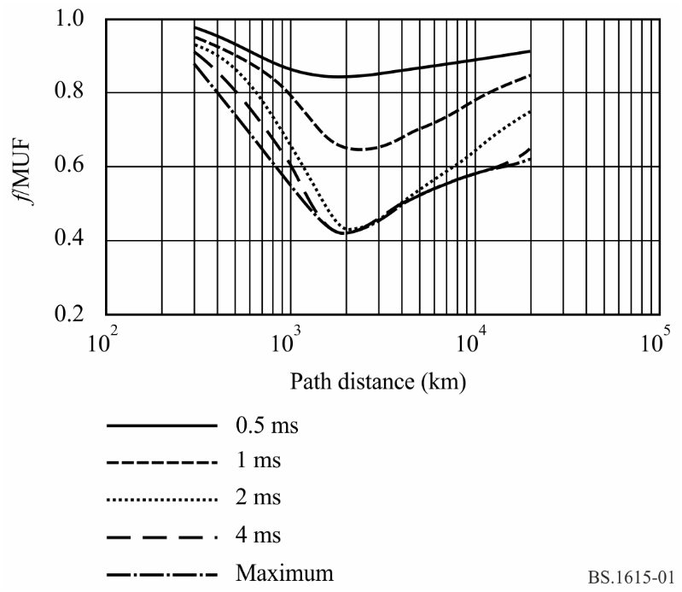
These values may not apply for paths which traverse the equatorial (low magnetic dip) region after sunset, or the auroral regions during times of ionospheric disturbance. In such cases, the time dispersion may increase up to a maximum of about 4 ms. This is likely to be most severe during the major periods of occurrence of equatorial ionospheric irregularities, i.e. March-April, June and September-October.
As assistance in gauging the mode structure and the multimode fading of HF sky-wave signals, each mode may be approximately described by a Rice-Nakagami distribution, where the k-factor will describe the ratio of the specular to diffuse reflection from the layer.

3 Prediction of MF ground- and sky-wave propagation
As regards MF, the simplistic approach of Recommendation ITU-R P.1321 – Propagation factors affecting systems using digital modulation techniques at LF and MF is recommended for both ground-wave and sky-wave predictions.

4 Modelling of propagation channels
The approach is to use stochastic time-varying models with stationary statistics and define models for good, moderate and bad conditions by taking appropriate parameter values of the general model. One of those models with adaptable parameters is the wide sense stationary uncorrelated scattering (WSSUS) model. The justification for the stationary approach with different parameter sets is that results on real channels lead to BER curves between best and worst cases found in the simulation.
The channel models have been generated from the following equations where e(t) and s(t) are the complex envelops of the input and output signals respectively:

(1)

This is a tapped delay-line where:
ρ_{k} : attenuation of the path number k (listed in Table 14)
Δ_{k} : relative delay of the path number k (listed in Table 14).
The time-variant tap weights {c_{k}(t)} are zero mean complex-valued stationary Gaussian random processes. The magnitudes |c_{k}(t)| are Rayleigh-distributed and the phases Φ(t) are uniformly distributed.
For each weight {c_{k}(t)} there is one stochastic process, characterized by its variance and its power density spectrum (PDS). The variance is a measure for the average signal power, which is received via this path and is defined by the relative attenuation ρ_{k}, and the PDS determines the average speed of variation in time. The width of the PDS is quantified by a number and is referred to as the Doppler spread, D_{sp}, of that path (listed in Table 14).
There might be also a non-zero centre frequency of the PDS, which can be interpreted as an average frequency shift or Doppler shift, D_{sh}, (listed in Table 14).
The PDS is modelled by filtering white noise (i.e. with constant PDS) and is equal to:

(2)

H( f ) is the transfer function of the filter. The stochastic processes belonging to every individual path then become Rayleigh processes. For the ionospheric path, a Gaussian shape has proven to be a good approach with respect to real observations.
The Doppler profile on each path k is then defined as:

(3)

The Doppler spread is specified as two-sided and contains 68% of the power:

(4)
TABLE 14
Set of transmission channel models
Channel model No. 1  (additive white Gaussian noise) |  | Good:  Typical/moderate:  Bad: | LF, MF, HF  LF with variable S/N
 | Path 1
Delay, Δ_{k} (ms) | 0
Path gain, r.m.s., ρ_{k} | 1
Doppler shift, D_{sh} (Hz) | 0
Doppler spread, D_{sp} (Hz) | 0

Channel model No. 2  (ground wave + sky wave) |  | Good:  Typical/moderate:  Bad: | MF, HF
 | Path 1 | Path 2
Delay, Δ_{k} (ms) | 0 | 1
Path gain, r.m.s., ρ_{k} | 1 | 0.5
Doppler shift, D_{sh} (Hz) | 0 | 0
Doppler spread, D_{sp} (Hz) | 0 | 0.1

Channel model No. 3 |  | Good:  Typical/moderate:  Bad: | HF  MF
 | Path 1 | Path 2 | Path 3 | Path 4
Delay, Δ_{k} (ms) | 0 | 0.7 | 1.5 | 2.2
Path gain, r.m.s., ρ_{k} | 1 | 0.7 | 0.5 | 0.25
Doppler shift, D_{sh} (Hz) | 0.1 | 0.2 | 0.5 | 1.0
Doppler spread, D_{sp} (Hz) | 0.1 | 0.5 | 1.0 | 2.0

Channel model No. 4 |  | Good:  Typical/moderate:  Bad | HF
 | Path 1 | Path 2
Delay, Δ_{k} (ms) | 0 | 2
Path gain, r.m.s., ρ_{k} | 1 | 1
Doppler shift, D_{sh} (Hz) | 0 | 0
Doppler spread, D_{sp} (Hz) | 1 | 1

TABLE 14 (end)
Channel model No. 5 |  | Good:  Typical/moderate:  Bad: | HF
 | Path 1 | Path 2
Delay, Δ_{k} (ms) | 0 | 4
Path gain, r.m.s., ρ_{k} | 1 | 1
Doppler shift, D_{sh} (Hz) | 0 | 0
Doppler spread, D_{sp} (Hz) | 2 | 2

Channel model No. 6  (near vertical incidence  in tropical zones) |  | Good:  Typical/moderate:  Bad: | HF
 | Path 1 | Path 2 | Path 3 | Path 4
Delay, Δ_{k} (ms) | 0 | 2 | 4 | 6
Path gain, r.m.s., ρ_{k} | 0.5 | 1 | 0.25 | 0.0625
Doppler shift, D_{sh} (Hz) | 0 | 1.2 | 2.4 | 3.6
Doppler spread, D_{sp} (Hz) | 0.1 | 2.4 | 4.8 | 7.2

Annex 2
RF protection ratios for DSB (DRM system) at frequencies below 30 MHz

1 Introduction
The DRM specification allows for several robustness modes (A to D) and spectrum occupancy types (0 to 5) of DRM signals. Only certain combinations of robustness modes (A to D) and spectrum occupancy types (0 to 5) are used in this Annex. The parameters for the used mode combinations, i.e. the respective number of subcarriers and the corresponding subcarrier spacing in the OFDM signal, lead to the bandwidths in rows A to D of Table 15.
TABLE 15
Bandwidths for DRM mode combinations (kHz)
Robustness mode | Spectrum occupancy type
 | 0 | 1 | 2 | 3 | 4 | 5
A | 4.208 | 4.708 | 8.542 | 9.542 | 17.208 | 19.208
B | 4.266 | 4.828 | 8.578 | 9.703 | 17.203 | 19.266
C |  |  |  | 9.477 |  | 19.159
D |  |  |  | 9.536 |  | 19.179
Nominal bandwidth (kHz) | 4.5 | 5 | 9 | 10 | 18 | 20

The bandwidths in the last row of Table 15 are the nominal bandwidths for the respective spectrum occupancies of the DRM signal, and the values given in lines A to D are the exact signal bandwidths for the different mode combinations.

2 RF protection ratios
The combinations of spectrum occupancy types and robustness modes lead to several transmitter RF spectra, which cause different interference and therefore require different RF protection ratios. The applied calculation method is described in detail in Attachment 2 to this Annex. The differences in protection ratios for the different DRM robustness modes are quite small. Therefore, the RF protection ratios presented in the following tables are restricted to the robustness mode B. More calculation results are presented in Attachment 1 to this Annex.
Table 16 shows calculation results for AM interfered with by digital and Table 17, digital interfered with by AM. These values are calculated for AM signals with high compression. The RF protection ratios for digital interfered with by digital are given in Table 18. Correction values for DRM reception using different modulation schemes and protection levels are given in Table 19.
The values in Tables 16 to 18 represent relative RF protection ratios, A_{RF_relative}. For the pure AM case, the relative protection ratio is the difference in dB between the protection ratio when the carriers of the wanted and unwanted transmitters have a frequency difference of Δf Hz and the protection ratio when the carriers of these transmitters have the same frequency (Recommendation ITU-R BS.560), i.e. the co-channel RF protection ratio, A_{RF}, which corresponds to the audio frequency (AF) protection ratio, A_{AF}. In the case of a digital signal its nominal frequency instead of the carrier frequency is the relevant value for the determination of the frequency difference. For spectrum occupancy types 2 and 3 the nominal frequency corresponds to the centre frequency of the OFDM block, for the types 0 and 1 the centre frequency is shifted about 2.2 and 2.4 kHz, respectively, above the nominal frequency. Due to the fact that the spectrum of the interference signal is different from the AF spectrum of analogue AM, the values for relative RF protection ratio in the case of co-channel interference are not equal to zero.
To adjust Table 16 to a given AM planning scenario, the relevant AF protection ratio has to be added to the values in the Table to get the required RF protection ratio (see Attachment 2 to this Annex). Relevant values may be determined taking into account:
– for HF, the AF protection ratio of 17 dB, which was adopted for HFBC planning by WARC HFBC-87 for AM interfered with by AM;
– for LF/MF, the AF protection of 30 dB, which was adopted by the Regional Administrative LF/MF Broadcasting Conference for Regions 1 and 3 (Geneva, 1975) for AM interfered with by AM.
With DRM as the wanted signal, the AF protection ratio as a parameter for the quality of service has to be replaced by the S/I required to achieve a certain BER. A BER threshold of 1 × 10^{–4} is supposed for the calculations (see Annex 1). The protection ratio values in Tables 17 and 18 are based on 64-QAM modulation and protection level No. 1. For other combinations the correction values in Table 19 have to be added to the S/I values given in the Tables.

TABLE 16
Relative RF protection ratios between broadcasting systems below 30 MHz (dB)
AM interfered with by digital
Wanted signal | Unwanted signal | Frequency separation  ƒ_{unwanted} – ƒ_{wanted} (kHz) |  |  |  |  |  |  |  |  |  |  |  |  | Parameters
 |  |  |  |  |  |  |  |  |  |  |  |  |  |  | B_{DRM}  (kHz) | A_{AF}^{(1),(2)}  (dB)
 |  | –20 | –18 | –15 | –10 | –9 | –5 | 0 | 5 | 9 | 10 | 15 | 18 | 20
AM | DRM_B0⁽³⁾ | –50.4 | –50.4 | –49 | –35.5 | –28.4 | 6.4 | 6.6 | –30.9 | –46.7 | –48.2 | –50.4 | –50.4 | –50.4 | 4.5 | –
AM | DRM_B1⁽⁴⁾ | –51 | –50.5 | –47.6 | –32 | –23.8 | 6 | 6 | –31.1 | 45.7 | 47.4 | –51 | –51 | –51 | 5 | –
AM | DRM_B2 | –48.8 | –46.9 | –43.5 | –34.4 | –29.7 | 3.4 | 6.5 | 3.4 | –29.7 | –34.4 | –43.5 | –46.9 | –48.8 | 9 | –
AM | DRM_B3 | –47.2 | –45.3 | –41.9 | –32 | –25.9 | 3 | 6 | 3 | –25.9 | –32 | –41.9 | –45.3 | –47.2 | 10 | –
AM | DRM_B4 | −35.3 | −27.4 | −1.3 | 3.4 | 3.4 | 3.4 | 3.4 | 0.3 | −27.4 | −32.9 | −39.2 | −41.9 | −43.3 | 18
AM | DRM_B5 | −29.3 | −14.6 | 0.1 | 3 | 3 | 3 | 3 | 0.1 | −22.5 | −28.8 | −38.2 | −40.9 | −42.2 | 20
B_{DRM}: nominal bandwidth of DRM signal.
DRM_B0: DRM signal, robustness mode B, spectrum occupancy type 0.
⁽¹⁾ The RF protection ratio for AM interfered with by digital can be calculated by adding a suitable value for the AF protection ratio according to a given planning scenario to the values in the Table.
⁽²⁾ The values presented in this table refer to the specific case of high AM compression. For consistency with Table 17, the same modulation depth, namely that associated with high compression, has been assumed for the AM signal. In order to offer adequate protection to AM signals with normal levels of compression (as defined in Attachment 1 to Annex 2), each value in the Table should be increased to accommodate the difference between normal and high compression.
⁽³⁾ The centre frequency of DRM_B0 transmission is shifted about 2.2 kHz above the nominal frequency.
⁽⁴⁾ The centre frequency of DRM_B1 transmission is shifted about 2.4 kHz above the nominal frequency.

TABLE 17
Relative RF protection ratios between broadcasting systems below 30 MHz (dB)
Digital (64-QAM, protection level No. 1) interfered with by AM
Wanted signal | Unwanted signal | Frequency separation  ƒ_{unwanted} – ƒ_{wanted} (kHz) |  |  |  |  |  |  |  |  |  |  |  |  | Parameters
 |  |  |  |  |  |  |  |  |  |  |  |  |  |  | B_{DRM}  (kHz) | S/I  (dB)
 |  | –20 | –18 | –15 | –10 | –9 | –5 | 0 | 5 | 9 | 10 | 15 | 18 | 20
DRM_B0⁽¹⁾ | AM | –57.7 | –55.5 | –52.2 | –46.1 | –45 | –36.2 | 0 | –3.5 | –30.9 | –41.1 | –46.9 | –50.6 | –53 | 4.5 | 4.6
DRM_B1⁽²⁾ | AM | –57.4 | –55.2 | –51.9 | –45.9 | –44.7 | –36 | 0 | –0.2 | –22 | –37.6 | –46 | –49.6 | –52 | 5 | 4.6
DRM_B2 | AM | –54.6 | –52.4 | –48.8 | –42.8 | –33.7 | –6.4 | 0 | –6.4 | –33.7 | –42.8 | –48.8 | –52.4 | –54.6 | 9 | 7.3
DRM_B3 | AM | –53.9 | –51.5 | –48 | –39.9 | –25 | –3.1 | 0 | –3.1 | –25 | –39.9 | –48 | –51.5 | –53.9 | 10 | 7.3
DRM_B4 | AM | −53.8 | −52.2 | −48.6 | −42.7 | −36.7 | −7.6 | 0 | 0 | 0 | 0 | −12.8 | −36.7 | −43.9 | 18 | 7.4
DRM_B5 | AM | −53.2 | −51.5 | −47.9 | −41.2 | −27.1 | −4.3 | 0 | 0 | 0 | 0 | −4.6 | −20 | −41.5 | 20 | 7.4
S/I: signal-to-interference ratio for a BER of 1 × 10^{–4}.
⁽¹⁾ The centre frequency of DRM_B0 transmission is shifted about 2.2 kHz above the nominal frequency.
⁽²⁾ The centre frequency of DRM_B1 transmission is shifted about 2.4 kHz above the nominal frequency.

TABLE 18
Relative RF protection ratios between broadcasting systems below 30 MHz (dB)
Digital (64-QAM, protection level No. 1) interfered with by digital
Wanted signal | Unwanted signal | Frequency separation  ƒ_{unwanted} – ƒ_{wanted} (kHz) |  |  |  |  |  |  |  |  |  |  |  |  | Parameters
 |  |  |  |  |  |  |  |  |  |  |  |  |  |  | B_{DRM}  (kHz) | S/I  (dB)
 |  | –20 | –18 | –15 | –10 | –9 | –5 | 0 | 5 | 9 | 10 | 15 | 18 | 20
DRM_B0 | DRM_B0 | –60 | –59.9 | –60 | –55.2 | –53.2 | –40.8 | 0 | –40.8 | –53.2 | –55.2 | –60 | –59.9 | –60 | 4.5 | 16.2
DRM_B0 | DRM_B1 | –60.1 | –60 | –59.5 | –52.5 | –50.4 | –37.4 | 0 | –40 | –51.6 | –53.6 | –59.8 | –60 | –60.1 | 5 | 15.7
DRM_B0 | DRM_B2 | –57.4 | –55.7 | –52.9 | –46.7 | –45.1 | –36.6 | 0 | –0.8 | –35.6 | –38.4 | –47.7 | –51.5 | –53.6 | 9 | 13.2
DRM_B0 | DRM_B3 | –55.2 | –53.6 | –50.7 | –44.5 | –42.9 | –33.1 | 0 | –0.1 | –13.6 | –36.2 | –45.5 | –49.3 | –51.4 | 10 | 12.6
DRM_B0 | DRM_B4 | −41.30 | −39.20 | −38.00 | −0.90 | 0.00 | 0.00 | 0.00 | −0.80 | −30.20 | −26.80 | −41.00 | −43.90 | −45.50 | 18.00 | 10.30
DRM_B0 | DRM_B5 | −38.80 | −36.20 | −30.80 | 0.00 | 0.00 | 0.00 | 0.00 | −0.20 | −13.00 | −27.50 | −39.40 | −42.30 | −43.80 | 20.00 | 9.80
DRM_B1 | DRM_B0 | –59.4 | –59.5 | –59.5 | –55 | –53 | –40.8 | 0 | –37.9 | –51.7 | –53.9 | –59.4 | –59.5 | –59.4 | 4.5 | 16.2
DRM_B1 | DRM_B1 | –60 | –60 | –59.5 | –52.8 | –50.8 | –37.8 | 0 | –37.8 | –50.8 | –52.8 | –59.5 | –60 | –60 | 5 | 16.2
DRM_B1 | DRM_B2 | –57.1 | –55.4 | –52.6 | –46.4 | –44.9 | –36.4 | 0 | –0.1 | –13.7 | –36.8 | –46.6 | –50.5 | –52.7 | 9 | 13.2
DRM_B1 | DRM_B3 | –55.5 | –53.8 | –51 | –44.8 | –43.3 | –33.5 | 0 | –0.1 | –8.1 | –35.2 | –45 | –48.9 | –51.1 | 10 | 13.2
DRM_B1 | DRM_B4 | −41.30 | −39.30 | −38.10 | −1.40 | −0.40 | 0.00 | 0.00 | −0.40 | −13.70 | −27.60 | −40.40 | −43.30 | −45.00 | 18.00 | 10.90
DRM_B1 | DRM_B5 | −39.00 | −36.60 | −31.30 | −0.10 | 0.00 | 0.00 | 0.00 | −0.10 | −7.90 | −31.30 | −39.10 | −41.90 | −43.60 | 20.00 | 10.40
DRM_B2 | DRM_B0 | –57 | –56.8 | –54.8 | –43.4 | –39.1 | –0.7 | 0 | –40.6 | –52.2 | –53.9 | –57 | –57 | –57 | 4.5 | 15.9
DRM_B2 | DRM_B1 | –56.9 | –56.1 | –52.7 | –40.2 | –14.1 | –0.1 | 0 | –39.7 | –50.8 | –52.5 | –56.9 | –57 | –57 | 5 | 15.4
DRM_B2 | DRM_B2 | –55.1 | –53.1 | –49.5 | –40.7 | –38.1 | –3.7 | 0 | –3.7 | –38.1 | –40.7 | –49.5 | –53.1 | –55.1 | 9 | 15.9
DRM_B2 | DRM_B3 | –52.9 | –51 | –47.4 | –38.6 | –16.6 | –3.2 | 0 | –3.2 | –16.6 | –38.6 | –47.4 | –51 | –52.9 | 10 | 15.4
DRM_B2 | DRM_B4 | −37.20 | −32.80 | −5.10 | −0.40 | 0.00 | 0.00 | 0.00 | −3.70 | −32.80 | −29.40 | −42.50 | −45.20 | −46.80 | 18.00 | 13.40
DRM_B2 | DRM_B5 | −32.60 | −32.60 | −3.60 | 0.00 | 0.00 | 0.00 | 0.00 | −3.60 | −37.50 | −32.10 | −43.10 | −45.80 | −47.30 | 20.00 | 12.90

TABLE 18 (end)
Wanted  signal | Unwanted  signal | Frequency separation  ƒ_{unwanted} – ƒ_{wanted} (kHz) |  |  |  |  |  |  |  |  |  |  |  |  | Parameters
 |  |  |  |  |  |  |  |  |  |  |  |  |  |  | B_{DRM}  (kHz) | S/I  (dB)
 |  | –20 | –18 | –15 | –10 | –9 | –5 | 0 | 5 | 9 | 10 | 15 | 18 | 20
DRM_B3 | DRM_B0 | –56.4 | –56.2 | –53.8 | –41.1 | –14.1 | –0.1 | 0 | –37.7 | –50.9 | –52.8 | –56.4 | –56.4 | –56.4 | 4.5 | 15.9
DRM_B3 | DRM_B1 | –56.8 | –55.7 | –52.1 | –38.2 | –8.2 | –0.1 | 0 | –37.6 | –50.1 | –51.9 | –56.7 | –57 | –57 | 5 | 15.9
DRM_B3 | DRM_B2 | –54.3 | –52.3 | –48.6 | –39.3 | –16.7 | –3.1 | 0 | –3.1 | –16.7 | –39.3 | –48.6 | –52.3 | –54.3 | 9 | 15.9
DRM_B3 | DRM_B3 | –52.7 | –50.7 | –47 | –37.7 | –11.1 | –3.1 | 0 | –3.1 | –11.1 | –37.7 | –47 | –50.7 | –52.7 | 10 | 15.9
DRM_B3 | DRM_B4 | −40.80 | −37.90 | −5.00 | −0.40 | 0.00 | 0.20 | 0.00 | −3.80 | −37.90 | −31.50 | −42.70 | −45.50 | −46.90 | 18.00 | 13.70
DRM_B3 | DRM_B5 | −34.40 | −8.00 | −3.10 | 0.00 | 0.00 | 0.00 | 0.00 | −3.10 | −10.90 | −33.80 | −40.70 | −43.50 | −44.90 | 20.00 | 13.40
DRM_B4 | DRM_B0 | −54.00 | −53.90 | −52.90 | −43.90 | −44.80 | −1.10 | 0.00 | 0.00 | −0.30 | −1.50 | −45.20 | −51.10 | −53.10 | 4.50 | 16.60
DRM_B4 | DRM_B1 | −54.60 | −54.20 | −52.00 | −41.60 | −19.60 | −0.90 | 0.00 | 0.00 | −0.80 | −2.00 | −45.50 | −50.70 | −52.80 | 5.00 | 16.60
DRM_B4 | DRM_B2 | −54.00 | −52.40 | −49.10 | −41.40 | −41.80 | −4.00 | 0.00 | 0.20 | 0.00 | −0.50 | −5.40 | −41.80 | −43.60 | 9.00 | 16.40
DRM_B4 | DRM_B3 | −52.40 | −50.70 | −47.30 | −41.90 | −19.70 | −3.60 | 0.00 | 0.40 | 0.00 | −0.50 | −4.80 | −19.70 | −49.40 | 10.00 | 16.20
DRM_B4 | DRM_B4 | −40.6 | −37.7 | −8.4 | −3.7 | −3.2 | −1.5 | 0 | −1.5 | −3.2 | −3.7 | −8.4 | −37.7 | −40.6 | 18 | 16.4
DRM_B4 | DRM_B5 | −35.20 | −14.70 | −6.30 | −2.90 | −2.50 | −1.00 | 0.00 | −1.30 | −2.90 | −3.40 | −7.40 | −20.80 | −42.90 | 20.00 | 15.90
DRM_B5 | DRM_B0 | −53.40 | −53.40 | −52.00 | −41.70 | −19.50 | −0.30 | 0.00 | 0.00 | 0.00 | 0.00 | −47.30 | −48.30 | −51.40 | 4.50 | 16.60
DRM_B5 | DRM_B1 | −54.00 | −53.40 | −51.10 | −44.60 | −9.40 | −0.40 | 0.00 | 0.00 | 0.00 | −0.30 | −46.40 | −47.90 | −51.00 | 5.00 | 16.60
DRM_B5 | DRM_B2 | −53.20 | −51.70 | −48.30 | −42.40 | −19.80 | −3.30 | 0.00 | 0.00 | 0.00 | 0.00 | −3.40 | −11.80 | −43.30 | 9.00 | 16.60
DRM_B5 | DRM_B3 | −52.00 | −50.30 | −46.80 | −41.10 | −12.10 | −3.30 | 0.00 | 0.20 | 0.20 | 0.00 | −3.40 | −8.60 | −42.10 | 10.00 | 16.40
DRM_B5 | DRM_B4 | −43.50 | −21.30 | −7.50 | −3.40 | −2.90 | −1.30 | 0.00 | −1.10 | −2.50 | −2.90 | −6.40 | −14.70 | −35.40 | 18.00 | 16.60
DRM_B5 | DRM_B5 | −39.1 | −11.5 | −6.3 | −3.2 | −2.7 | −1.4 | 0 | −1.4 | −2.7 | −3.2 | −6.3 | −11.5 | −39.1 | 20 | 16.4

TABLE 19
S/I correction values in Tables 17 and 18 to be used for other combinations
of modulation scheme and protection level No.
Modulation  scheme | Protection  level No. | Average code rate | Correction values (dB) for DRM  robustness mode/spectrum occupancy type
 |  |  | B/0 (4.5 kHz), B/1 (5 kHz) | B/2 (9 kHz), B/3 (10 kHz)
16-QAM | 0 | 0.5 | –6.7 | –6.6
 | 1 | 0.62 | –4.7 | –4.6
64-QAM | 0 | 0.5 | –1.3 | –1.2
 | 1 | 0.6 | 0.0 | 0.0
 | 2 | 0.71 | 1.7 | 1.8
 | 3 | 0.78 | 3.3 | 3.4

3 RF power reduction for DSB
For the introduction of a digitally modulated signal in an existing environment, it has to be ensured that this new signal will not cause more interference to other AM stations than the AM signal which is replaced by the digitally modulated signal. Values for the required power reduction to fulfil this requirement can easily be found when the RF protection ratios for AM interfered with by AM and AM interfered with by digital are known.
The RF protection ratio is the required power difference between the wanted and the unwanted signal which ascertains a stated quality (either analogue audio or digital S/N). When the wanted audio quality is comparable for AM interfered with by AM and AM interfered with by digital, the difference in RF protection ratio is the required power reduction.
Recommendation ITU-R BS.560 contains relative RF protection ratios for AM interfered with by AM (see Table 20).
TABLE 20
Relative RF protection ratios for AM interfered with by AM
Wanted  signal | Unwanted  signal | Frequency separation  ƒ_{unwanted} – ƒ_{wanted} (kHz)
 |  | –20 | –18 | –15 | –10 | –9 | –5 | 0 | 5 | 9 | 10 | 15 | 18 | 20
AM | AM | –55.4 | –53.3 | –49.5 | –35.5 | –29.0 | –2.5 | 0.0 | –2.5 | –29.0 | –35.5 | –49.5 | –53.3 | –55.4

With that knowledge, the required power reduction for the different DRM modes can be calculated as the difference of the values of Table 23 and of Table 20. The result is given in Table 21.
In Table 21, it can be seen that for some modes the required power reduction to restrict the interference to AM transmissions at certain frequency separations is somewhat higher than the co-channel value. In that case it has to be considered if the digitally modulated signal appears somewhere as interferer with one of these frequency separations and if it is the strongest interferer. If that is the case, the higher value has to be taken into account.
TABLE 21
Required power reduction
Replaced  signal | New  signal | Frequency separation  ƒ_{unwanted} – ƒ_{wanted} (kHz) |  |  |  |  |  |  |  |  |  |  |  |  | Parameter
 |  |  |  |  |  |  |  |  |  |  |  |  |  |  | B_{DRM}  (kHz) | A_{AF}  (dB)
 |  | –20 | –18 | –15 | –10 | –9 | –5 | 0 | 5 | 9 | 10 | 15 | 18 | 20
AM | DRM_A0 | 5 | 2.9 | 0.4 | –0.1 | 0.5 | 9 | 6.6 | –28.6 | –17.9 | –12.8 | –0.9 | 2.9 | 5 | 4.5 | –
AM | DRM_A1 | 4.5 | 2.7 | 1.6 | 3 | 4.5 | 8.6 | 6.1 | –28.8 | –17 | –12.2 | –1.4 | 2.4 | 4.5 | 5 | –
AM | DRM_A2 | 6.5 | 6.3 | 5.9 | 1 | –0.8 | 5.9 | 6.6 | 5.9 | –0.8 | 1 | 5.9 | 6.3 | 6.5 | 9 | –
AM | DRM_A3 | 8 | 7.8 | 7.4 | 3.1 | 2.5 | 5.6 | 6.1 | 5.6 | 2.5 | 3.1 | 7.4 | 7.8 | 8 | 10 | –
AM | DRM_B0 | 5 | 2.9 | 0.5 | 0 | 0.6 | 8.9 | 6.6 | –28.4 | –17.7 | –12.7 | –0.9 | 2.9 | 5 | 4.5 | –
AM | DRM_B1 | 4.4 | 2.8 | 1.9 | 3.5 | 5.2 | 8.5 | 6 | –28.6 | –16.7 | –11.9 | –1.5 | 2.3 | 4.4 | 5 | –
AM | DRM_B2 | 6.6 | 6.4 | 6 | 1.1 | –0.7 | 5.9 | 6.5 | 5.9 | –0.7 | 1.1 | 6 | 6.4 | 6.6 | 9 | –
AM | DRM_B3 | 8.2 | 8 | 7.6 | 3.5 | 3.1 | 5.5 | 6 | 5.5 | 3.1 | 3.5 | 7.6 | 8 | 8.2 | 10 | –
AM | DRM_C3 | 7.9 | 7.7 | 7.3 | 2.9 | 2.3 | 5.6 | 6.1 | 5.6 | 2.3 | 2.9 | 7.3 | 7.7 | 7.9 | 10 | –
AM | DRM_D3 | 8 | 7.8 | 7.3 | 3.1 | 2.5 | 5.6 | 6.1 | 5.6 | 2.5 | 3.1 | 7.3 | 7.8 | 8 | 10 | –

Attachment 1
to Annex 2
Calculated RF protection ratios for DSB (DRM system)
at frequencies below 30 MHz

1 Introduction
In this Attachment, more information on calculated RF protection ratios, which are required for AM and DRM reception, is given. The RF protection ratios are derived using the parameters given in § 1 of Attachment 2 to this Annex and applying the calculation method described in § 2 of the same Attachment.

2 Calculation parameters

2.1 Analogue signal

AM transmitter
– Cut-off frequency or bandwidth: Ftx = 4.5 kHz, i.e. B = 9 kHz
– Low-pass AF filter slope: −60 dB/octave, starting with 0 dB at Ftx
(See Fig. 6 of Attachment 2 to this Annex.)
– Harmonic distortion: k₂ = 0 k₃ = 0.7% (−43 dB)
– Intermodulation: d₃ = −40 dB
– Noise floor: −60.3 dBc/kHz
With the above parameters the calculated RF spectrum is compliant with the spectrum mask included in Recommendation ITU-R SM.328.

AM modulation
– Modulating signal for unwanted wave: coloured noise according to Recommendation ITU-R BS.559
– Modulation depth: m_{r.m.s.}= 25% (corresponds to a programme signal with normal compression)
– High compression: increases the sideband power by 6.5 dB with normal compression

AM receiver
– Selectivity curve: B_{af} = 2.2 kHz, slope = 35 dB/octave, see Figs 2 and 3
– Audio signal evaluation: r.m.s. used for signal evaluation
– AF protection ratio: desired value.

2.2 DRM signal
The DRM specification allows for several robustness modes (A to D) and spectrum occupancy types (0 to 5) of DRM signals. Only certain combinations of robustness modes (A to D) and spectrum occupancy types (0 to 3) are used in this Attachment. The parameters for the used mode combinations, i.e. the respective number of subcarriers and the corresponding subcarrier spacing in OFDM signal lead to the bandwidths in rows A to D of Table 22.
TABLE 22
Bandwidths for DRM mode combinations (kHz)
Robustness mode | Spectrum occupancy type
 | 0 | 1 | 2 | 3 | 4 | 5
A | 4.208 | 4.708 | 8.542 | 9.542 | 17.208 | 19.208
B | 4.266 | 4.828 | 8.578 | 9.703 | 17.203 | 19.266
C |  |  |  | 9.477 |  | 19.159
D |  |  |  | 9.536 |  | 19.179
Nominal bandwidth (kHz) | 4.5 | 5 | 9 | 10 | 18 | 20

The bandwidths in the last row of Table 22 are the nominal bandwidths for the respective spectrum occupancies of the DRM signal, and the values given in lines A to D are the exact signal bandwidths for the different mode combinations.

Transmitter for digital signals
– Bandwidths: see Table 22
– Spectrum masks: calculated according to Recommendation ITU-R SM.328, § 6.3.3 of Annex 1 using the exact bandwidths F of Table 22. This includes a 30 dB attenuation at ±0.53 F, beyond this point there is a slope of
–12 dB/octave to –60 dB. Examples of the masks for spectrum occupancy types 1 (5 kHz) and 3 (10 kHz) are given in Figs 2 and 3 (including also the filter curves for AM and digital receivers).

Receiver/demodulator for digital signals
– Bandwidths: see Table 22
– Shoulder distance: 52 dB
– Additional IF filter: BIF = nominal DRM bandwidth + 6 kHz, slope = 35 dB/octave4
– Selectivity curve: see Figs 2 and 3
– Required S/I for a BER = 1 × 10^{–4}: valid for 64-QAM, protection level No. 1

3 RF protection ratios
The combinations of spectrum occupancy types and robustness modes lead to several transmitter RF spectra, which cause different interference and therefore require different RF protection ratios. The applied calculation method is described in detail in Attachment 2 to this Annex.
Table 23 shows calculation results for AM interfered with by digital and Table 24, digital interfered with by AM. These values are calculated for AM signals with high compression. The RF protection ratios for digital interfered with by digital are given in Table 25 for all the digital mode combinations, but only for identical mode combination pairings, e.g. digital mode B3 (robustness mode B, spectrum occupancy 3) interfered with by digital B3. Table 26 shows RF protection ratios between identical and different spectrum occupancies, but only for the robustness mode B. Correction factors for the different modulation schemes are given in Tables 27 to 29.
FIGURE 2
Transmitter spectrum mask and receiver/demodulator selectivity curves for
DRM robustness mode B and spectrum occupancy type 1 (5 kHz)
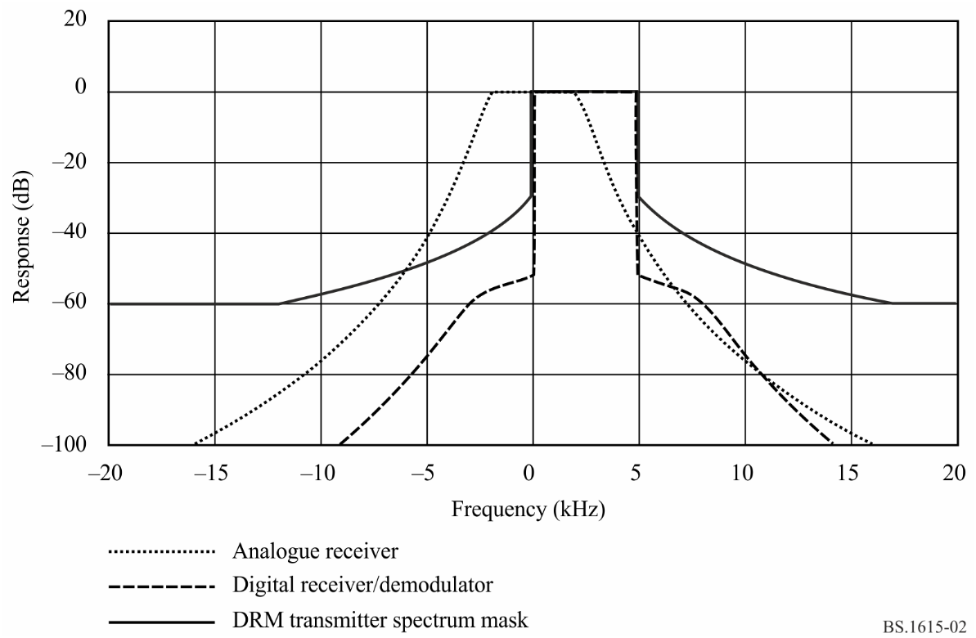
figure 3
Transmitter spectrum mask and receiver/demodulator selectivity curves for
DRM robustness mode B and spectrum occupancy type 3 (10 kHz)
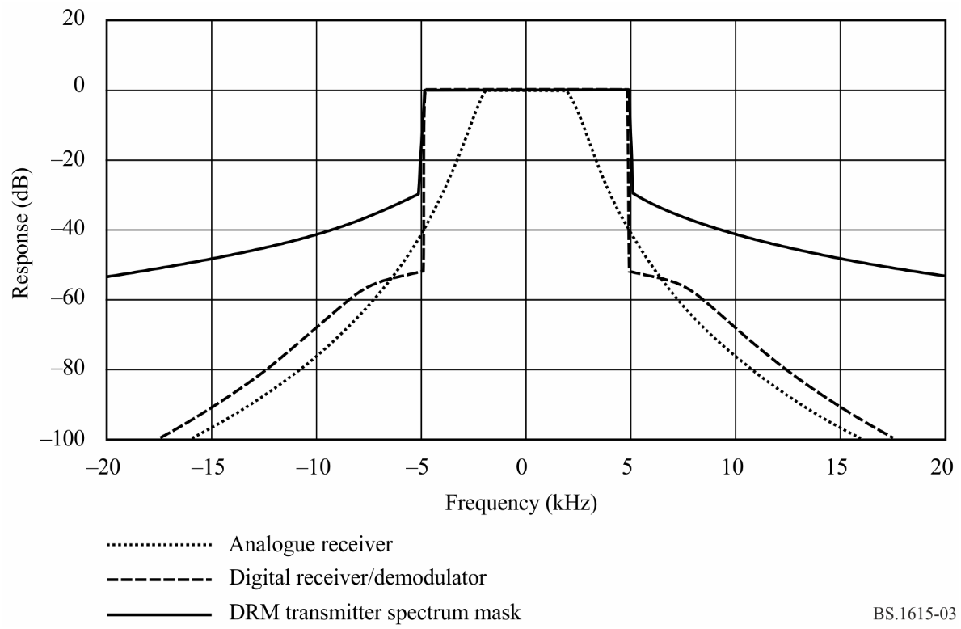

TABLE 23
Relative RF protection ratios between broadcasting systems below 30 MHz (dB) AM interfered with by digital
Wanted  signal | Unwanted  signal | Frequency separation  ƒ_{unwanted} – ƒ_{wanted} (kHz) |  |  |  |  |  |  |  |  |  |  |  |  | Parameters
 |  |  |  |  |  |  |  |  |  |  |  |  |  |  | B_{DRM} (kHz) | A_{AF}^{(1),(2)}  (dB)
 |  | –20 | –18 | –15 | –10 | –9 | –5 | 0 | 5 | 9 | 10 | 15 | 18 | 20
AM | DRM_A0 | –50.4 | –50.4 | –49.1 | –35.6 | –28.5 | 6.5 | 6.6 | –31.1 | –46.9 | –48.3 | –50.4 | –50.4 | –50.4 | 4.5 | –
AM | DRM_A1 | –50.9 | –50.6 | –47.9 | –32.5 | –24.5 | 6.1 | 6.1 | –31.3 | –46 | –47.7 | –50.9 | –50.9 | –50.9 | 5 | –
AM | DRM_A2 | –48.9 | –47 | –43.6 | –34.5 | –29.8 | 3.4 | 6.6 | 3.4 | –29.8 | –34.5 | –43.6 | –47 | –48.9 | 9 | –
AM | DRM_A3 | –47.4 | –45.5 | –42.1 | –32.4 | –26.5 | 3.1 | 6.1 | 3.1 | –26.5 | –32.4 | –42.1 | –45.5 | –47.4 | 10 | –
AM | DRM_A4 | −35.3 | −27.4 | −1.3 | 3.5 | 3.5 | 3.5 | 3.5 | 0.3 | −27.4 | −32.9 | −39.3 | −41.9 | −43.4 | 18 | –
AM | DRM_A5 | −29.3 | −14.5 | 0.1 | 3.1 | 3.1 | 3.1 | 3.1 | 0.1 | −22.8 | −29.3 | −38.4 | −40.8 | −42.3 | 20 | –
AM | DRM_B0 | –50.4 | –50.4 | –49 | –35.5 | –28.4 | 6.4 | 6.6 | –30.9 | –46.7 | –48.2 | –50.4 | –50.4 | –50.4 | 4.5 | –
AM | DRM_B1 | –51 | –50.5 | –47.6 | –32 | –23.8 | 6 | 6 | –31.1 | –45.7 | –47.4 | –51 | –51 | –51 | 5 | –
AM | DRM_B2 | –48.8 | –46.9 | –43.5 | –34.4 | –29.7 | 3.4 | 6.5 | 3.4 | –29.7 | –34.4 | –43.5 | –46.9 | –48.8 | 9 | –
AM | DRM_B3 | –47.2 | –45.3 | –41.9 | –32 | –25.9 | 3 | 6 | 3 | –25.9 | –32 | –41.9 | –45.3 | –47.2 | 10 | –
AM | DRM_B4 | −35.3 | −27.4 | −1.3 | 3.4 | 3.4 | 3.4 | 3.4 | 0.3 | −27.4 | −32.9 | −39.2 | −41.9 | −43.3 | 18 | –
AM | DRM_B5 | −29.3 | −14.6 | 0.1 | 3 | 3 | 3 | 3 | 0.1 | −22.5 | −28.8 | −38.2 | −40.9 | −42.2 | 20 | –
AM | DRM_C3 | –47.5 | –45.6 | –42.2 | –32.6 | –26.7 | 3.1 | 6.1 | 3.1 | –26.7 | –32.6 | –42.2 | –45.6 | –47.5 | 10 | –
AM | DRM_C5 | −29.7 | −14.6 | 0.1 | 3.1 | 3.1 | 3.1 | 3.1 | 0.1 | −22.7 | −29.4 | −38.3 | −40.9 | −42.3 | 20 | –
AM | DRM_D3 | –47.4 | –45.5 | –42.2 | –32.4 | –26.5 | 3.1 | 6.1 | 3.1 | –26.5 | –32.4 | –42.2 | –45.5 | –47.4 | 10 | –
AM | DRM_D5 | −29.9 | −15 | 0.1 | 3.1 | 3.1 | 3.1 | 3.1 | 0.2 | −22.3 | −28.8 | −38.3 | −40.7 | −42.2 | 20 | –
A_{AF}: audio frequency protection ratio.
DRM_A0: DRM signal, robustness mode A, spectrum occupancy type 0.
⁽¹⁾ The RF protection ratio for AM interfered with by digital can be calculated by adding a suitable value for the AF protection ratio according to a given planning scenario to the values in this Table.
⁽²⁾ The values presented in this Table refer to the specific case of high AM compression. For consistency with Table 25, the same modulation depth, namely that associated with high compression, has been assumed for the AM signal. In order to offer adequate protection to AM signals with normal levels of compression (as defined in Attachment 1 to Annex 2), each value in the Table should be increased to accommodate the difference between normal and high compression.

TABLE 24
Relative RF protection ratios between broadcasting systems below 30 MHz (dB)
Digital (64-QAM, protection level No. 1) interfered with by AM
Wanted signal | Unwanted signal | Frequency separation  ƒ_{unwanted} – ƒ_{wanted} (kHz) |  |  |  |  |  |  |  |  |  |  |  |  | Parameters
 |  |  |  |  |  |  |  |  |  |  |  |  |  |  | B_{DRM}  (kHz) | S/I  (dB)
 |  | –20 | –18 | –15 | –10 | –9 | –5 | 0 | 5 | 9 | 10 | 15 | 18 | 20
DRM_A0 | AM | –57.7 | –55.5 | –52.2 | –46.2 | –45 | –36.7 | 0 | –3.5 | –31.2 | –41.1 | –47 | –50.7 | –53 | 4.5 | 4.2
DRM_A1 | AM | –57.5 | –55.2 | –52 | –45.9 | –44.8 | –36.6 | 0 | –0.6 | –22.8 | –38.4 | –46.1 | –49.8 | –52.2 | 5 | 4.2
DRM_A2 | AM | –54.7 | –52.4 | –48.8 | –42.9 | –34 | –6.5 | 0 | –6.5 | –34 | –42.9 | –48.8 | –52.4 | –54.7 | 9 | 6.7
DRM_A3 | AM | –54 | –51.7 | –48.1 | –40.6 | –25.8 | –3.6 | 0 | –3.6 | –25.8 | –40.6 | –48.1 | –51.7 | –54 | 10 | 6.7
DRM_A4 | AM | −54.4 | −52.2 | −48.6 | −42.7 | −36.7 | −7.5 | 0 | 0 | 0 | 0 | −12.8 | −36.7 | −43.9 | 18 | 7.4
DRM_A5 | AM | −53.8 | −51.5 | −48 | −41.5 | −27.9 | −4.6 | 0 | 0 | 0 | 0 | −4.6 | −20 | −41.5 | 20 | 7.4
DRM_B0 | AM | –57.7 | –55.5 | –52.2 | –46.1 | –45 | –36.2 | 0 | –3.5 | –30.9 | –41.1 | –46.9 | –50.6 | –53 | 4.5 | 4.6
DRM_B1 | AM | –57.4 | –55.2 | –51.9 | –45.9 | –44.7 | –36 | 0 | –0.2 | –22 | –37.6 | –46 | –49.6 | –52 | 5 | 4.6
DRM_B2 | AM | –54.6 | –52.4 | –48.8 | –42.8 | –33.7 | –6.4 | 0 | –6.4 | –33.7 | –42.8 | –48.8 | –52.4 | –54.6 | 9 | 7.3
DRM_B3 | AM | –53.9 | –51.5 | –48 | –39.9 | –25 | –3.1 | 0 | –3.1 | –25 | –39.9 | –48 | –51.5 | –53.9 | 10 | 7.3
DRM_B4 | AM | −53.8 | −52.2 | −48.6 | −42.7 | −36.7 | −7.6 | 0 | 0 | 0 | 0 | −12.8 | −36.7 | −43.9 | 18 | 7.4
DRM_B5 | AM | −53.2 | −51.5 | −47.9 | −41.2 | −27.1 | −4.3 | 0 | 0 | 0 | 0 | −4.6 | −20 | −41.5 | 20 | 7.4
DRM_C3 | AM | –54 | –51.7 | –48.1 | –40.9 | –26.1 | –3.8 | 0 | –3.8 | –26.1 | –40.9 | –48.1 | –51.7 | –54 | 10 | 7.7
DRM_C5 | AM | −53.2 | −51.5 | −48 | −41.5 | −27.9 | −4.6 | 0 | 0 | 0 | 0 | −4.9 | −20.3 | −41.7 | 20 | 7.4
DRM_D3 | AM | –54 | –51.7 | –48.1 | –40.7 | –25.8 | –3.6 | 0 | –3.6 | –25.8 | –40.7 | –48.1 | –51.7 | –54 | 10 | 8.6
DRM_D5 | AM | −53.2 | −51.5 | −47.9 | −41.2 | −27.1 | −4.3 | 0 | 0 | 0 | 0 | −5.1 | −20.5 | −41.8 | 20 | 7.4

TABLE 25
Relative RF protection ratios between broadcasting systems below 30 MHz (dB) Digital (64-QAM, protection level No. 1)
interfered with by digital (identical robustness modes and spectrum occupancy types)
Wanted signal | Unwanted signal | Frequency separation  ƒ_{unwanted} – ƒ_{wanted} (kHz) |  |  |  |  |  |  |  |  |  |  |  |  | Parameters
 |  |  |  |  |  |  |  |  |  |  |  |  |  |  | B_{DRM}  (kHz) | S/I  (dB)
 |  | –20 | –18 | –15 | –10 | –9 | –5 | 0 | 5 | 9 | 10 | 15 | 18 | 20
DRM_A0 | DRM_A0 | –60.1 | –60 | –60 | –55.4 | –53.4 | –41.2 | 0 | –41.2 | –53.4 | –55.4 | –60 | –60 | –60.1 | 4.5 | 15.8
DRM_A1 | DRM_A1 | –60 | –60 | –59.7 | –53.3 | –51.3 | –38.4 | 0 | –38.4 | –51.3 | –53.3 | –59.7 | –60 | –60 | 5 | 15.8
DRM_A2 | DRM_A2 | –55.1 | –53.1 | –49.6 | –40.8 | –38.3 | –3.8 | 0 | –3.8 | –38.3 | –40.8 | –49.6 | –53.1 | –55.1 | 9 | 15.3
DRM_A3 | DRM_A3 | –53 | –51 | –47.3 | –38.1 | –12.1 | –3.2 | 0 | –3.2 | –12.1 | –38.1 | –47.3 | –51 | –53 | 10 | 15.3
DRM_A4 | DRM_A4 | −40.3 | −37 | −8.4 | −3.7 | −3.2 | −1.5 | 0 | −1.5 | −3.2 | −3.7 | −8.4 | −37 | −40.3 | 18 | 16.4
DRM_A5 | DRM_A5 | −37 | −11.8 | −6.3 | −3.2 | −2.7 | −1.4 | 0 | −1.4 | −2.7 | −3.2 | −6.3 | −11.8 | −37 | 20 | 16.4
DRM_B0 | DRM_B0 | –60 | –59.9 | –60 | –55.2 | –53.2 | –40.8 | 0 | –40.8 | –53.2 | –55.2 | –60 | –59.9 | –60 | 4.5 | 16.2
DRM_B1 | DRM_B1 | –60 | –60 | –59.5 | –52.8 | –50.8 | –37.8 | 0 | –37.8 | –50.8 | –52.8 | –59.5 | –60 | –60 | 5 | 16.2
DRM_B2 | DRM_B2 | –55.1 | –53.1 | –49.5 | –40.7 | –38.1 | –3.7 | 0 | –3.7 | –38.1 | –40.7 | –49.5 | –53.1 | –55.1 | 9 | 15.9
DRM_B3 | DRM_B3 | –52.7 | –50.7 | –47 | –37.7 | –11.1 | –3.1 | 0 | –3.1 | –11.1 | –37.7 | –47 | –50.7 | –52.7 | 10 | 15.9
DRM_B4 | DRM_B4 | −40.6 | −37.7 | −8.4 | −3.7 | −3.2 | −1.5 | 0 | −1.5 | −3.2 | −3.7 | −8.4 | −37.7 | −40.6 | 18 | 16.4
DRM_B5 | DRM_B5 | −39.1 | −11.5 | −6.3 | −3.2 | −2.7 | −1.4 | 0 | −1.4 | −2.7 | −3.2 | −6.3 | −11.5 | −39.1 | 20 | 16.4
DRM_C3 | DRM_C3 | –53.2 | –51.1 | –47.5 | –38.3 | –12.6 | –3.2 | 0 | –3.2 | –12.6 | –38.3 | –47.5 | –51.1 | –53.2 | 10 | 16.3
DRM_C5 | DRM_C5 | −36.5 | −12.1 | −6.4 | −3.2 | −2.8 | −1.4 | 0 | −1.4 | −2.8 | −3.2 | −6.4 | −12.1 | −36.5 | 20 | 16.4
DRM_D3 | DRM_D3 | –53 | –51 | –47.4 | –38.1 | –12.2 | –3.2 | 0 | –3.2 | –12.2 | –38.1 | –47.4 | –51 | –53 | 10 | 17.2
DRM_D5 | DRM_D5 | −37.2 | −12 | −6.4 | −3.2 | −2.8 | −1.4 | 0 | −1.4 | −2.8 | −3.2 | −6.4 | −12 | −37.2 | 20 | 16.4

TABLE 26
Relative RF protection ratios between broadcasting systems below 30 MHz (dB)
Digital (64-QAM, protection level No. 1) interfered with by digital
Wanted signal | Unwanted signal | Frequency separation  ƒ_{unwanted} – ƒ_{wanted} (kHz) |  |  |  |  |  |  |  |  |  |  |  |  | Parameters
 |  |  |  |  |  |  |  |  |  |  |  |  |  |  | B_{DRM}  (kHz) | S/I  (dB)
 |  | –20 | –18 | –15 | –10 | –9 | –5 | 0 | 5 | 9 | 10 | 15 | 18 | 20
DRM_B0 | DRM_B0 | –60 | –59.9 | –60 | –55.2 | –53.2 | –40.8 | 0 | –40.8 | –53.2 | –55.2 | –60 | –59.9 | –60 | 4.5 | 16.2
DRM_B0 | DRM_B1 | –60.1 | –60 | –59.5 | –52.5 | –50.4 | –37.4 | 0 | –40 | –51.6 | –53.6 | –59.8 | –60 | –60.1 | 5 | 15.7
DRM_B0 | DRM_B2 | –57.4 | –55.7 | –52.9 | –46.7 | –45.1 | –36.6 | 0 | –0.8 | –35.6 | –38.4 | –47.7 | –51.5 | –53.6 | 9 | 13.2
DRM_B0 | DRM_B3 | –55.2 | –53.6 | –50.7 | –44.5 | –42.9 | –33.1 | 0 | –0.1 | –13.6 | –36.2 | –45.5 | –49.3 | –51.4 | 10 | 12.6
DRM_B0 | DRM_B4 | −41.30 | −39.20 | −38.00 | −0.90 | 0.00 | 0.00 | 0.00 | −0.80 | −30.20 | −26.80 | −41.00 | −43.90 | −45.50 | 18.00 | 10.30
DRM_B0 | DRM_B5 | −38.80 | −36.20 | −30.80 | 0.00 | 0.00 | 0.00 | 0.00 | −0.20 | −13.00 | −27.50 | −39.40 | −42.30 | −43.80 | 20.00 | 9.80
DRM_B1 | DRM_B0 | –59.4 | –59.5 | –59.5 | –55 | –53 | –40.8 | 0 | –37.9 | –51.7 | –53.9 | –59.4 | –59.5 | –59.4 | 4.5 | 16.2
DRM_B1 | DRM_B1 | –60 | –60 | –59.5 | –52.8 | –50.8 | –37.8 | 0 | –37.8 | –50.8 | –52.8 | –59.5 | –60 | –60 | 5 | 16.2
DRM_B1 | DRM_B2 | –57.1 | –55.4 | –52.6 | –46.4 | –44.9 | –36.4 | 0 | –0.1 | –13.7 | –36.8 | –46.6 | –50.5 | –52.7 | 9 | 13.2
DRM_B1 | DRM_B3 | –55.5 | –53.8 | –51 | –44.8 | –43.3 | –33.5 | 0 | –0.1 | –8.1 | –35.2 | –45 | –48.9 | –51.1 | 10 | 13.2
DRM_B1 | DRM_B4 | −41.30 | −39.30 | −38.10 | −1.40 | −0.40 | 0.00 | 0.00 | −0.40 | −13.70 | −27.60 | −40.40 | −43.30 | −45.00 | 18.00 | 10.90
DRM_B1 | DRM_B5 | −39.00 | −36.60 | −31.30 | −0.10 | 0.00 | 0.00 | 0.00 | −0.10 | −7.90 | −31.30 | −39.10 | −41.90 | −43.60 | 20.00 | 10.40
DRM_B2 | DRM_B0 | –57 | –56.8 | –54.8 | –43.4 | –39.1 | –0.7 | 0 | –40.6 | –52.2 | –53.9 | –57 | –57 | –57 | 4.5 | 15.9
DRM_B2 | DRM_B1 | –56.9 | –56.1 | –52.7 | –40.2 | –14.1 | –0.1 | 0 | –39.7 | –50.8 | –52.5 | –56.9 | –57 | –57 | 5 | 15.4
DRM_B2 | DRM_B2 | –55.1 | –53.1 | –49.5 | –40.7 | –38.1 | –3.7 | 0 | –3.7 | –38.1 | –40.7 | –49.5 | –53.1 | –55.1 | 9 | 15.9
DRM_B2 | DRM_B3 | –52.9 | –51 | –47.4 | –38.6 | –16.6 | –3.2 | 0 | –3.2 | –16.6 | –38.6 | –47.4 | –51 | –52.9 | 10 | 15.4
DRM_B2 | DRM_B4 | −37.20 | −32.80 | −5.10 | −0.40 | 0.00 | 0.00 | 0.00 | −3.70 | −32.80 | −29.40 | −42.50 | −45.20 | −46.80 | 18.00 | 13.40
DRM_B2 | DRM_B5 | −32.60 | −32.60 | −3.60 | 0.00 | 0.00 | 0.00 | 0.00 | −3.60 | −37.50 | −32.10 | −43.10 | −45.80 | −47.30 | 20.00 | 12.90

TABLE 26 (end)
Wanted  signal | Unwanted  signal | Frequency separation  ƒ_{unwanted} – ƒ_{wanted} (kHz) |  |  |  |  |  |  |  |  |  |  |  |  | Parameters
 |  |  |  |  |  |  |  |  |  |  |  |  |  |  | B_{DRM}  (kHz) | S/I  (dB)
 |  | –20 | –18 | –15 | –10 | –9 | –5 | 0 | 5 | 9 | 10 | 15 | 18 | 20
DRM_B3 | DRM_B0 | –56.4 | –56.2 | –53.8 | –41.1 | –14.1 | –0.1 | 0 | –37.7 | –50.9 | –52.8 | –56.4 | –56.4 | –56.4 | 4.5 | 15.9
DRM_B3 | DRM_B1 | –56.8 | –55.7 | –52.1 | –38.2 | –8.2 | –0.1 | 0 | –37.6 | –50.1 | –51.9 | –56.7 | –57 | –57 | 5 | 15.9
DRM_B3 | DRM_B2 | –54.3 | –52.3 | –48.6 | –39.3 | –16.7 | –3.1 | 0 | –3.1 | –16.7 | –39.3 | –48.6 | –52.3 | –54.3 | 9 | 15.9
DRM_B3 | DRM_B3 | –52.7 | –50.7 | –47 | –37.7 | –11.1 | –3.1 | 0 | –3.1 | –11.1 | –37.7 | –47 | –50.7 | –52.7 | 10 | 15.9
DRM_B3 | DRM_B4 | −40.80 | −37.90 | −5.00 | −0.40 | 0.00 | 0.20 | 0.00 | −3.80 | −37.90 | −31.50 | −42.70 | −45.50 | −46.90 | 18.00 | 13.70
DRM_B3 | DRM_B5 | −34.40 | −8.00 | −3.10 | 0.00 | 0.00 | 0.00 | 0.00 | −3.10 | −10.90 | −33.80 | −40.70 | −43.50 | −44.90 | 20.00 | 13.40
DRM_B4 | DRM_B0 | −54.00 | −53.90 | −52.90 | −43.90 | −44.80 | −1.10 | 0.00 | 0.00 | −0.30 | −1.50 | −45.20 | −51.10 | −53.10 | 4.50 | 16.60
DRM_B4 | DRM_B1 | −54.60 | −54.20 | −52.00 | −41.60 | −19.60 | −0.90 | 0.00 | 0.00 | −0.80 | −2.00 | −45.50 | −50.70 | −52.80 | 5.00 | 16.60
DRM_B4 | DRM_B2 | −54.00 | −52.40 | −49.10 | −41.40 | −41.80 | −4.00 | 0.00 | 0.20 | 0.00 | −0.50 | −5.40 | −41.80 | −43.60 | 9.00 | 16.40
DRM_B4 | DRM_B3 | −52.40 | −50.70 | −47.30 | −41.90 | −19.70 | −3.60 | 0.00 | 0.40 | 0.00 | −0.50 | −4.80 | −19.70 | −49.40 | 10.00 | 16.20
DRM_B4 | DRM_B4 | −40.6 | −37.7 | −8.4 | −3.7 | −3.2 | −1.5 | 0 | −1.5 | −3.2 | −3.7 | −8.4 | −37.7 | −40.6 | 18 | 16.4
DRM_B4 | DRM_B5 | −35.20 | −14.70 | −6.30 | −2.90 | −2.50 | −1.00 | 0.00 | −1.30 | −2.90 | −3.40 | −7.40 | −20.80 | −42.90 | 20.00 | 15.90
DRM_B5 | DRM_B0 | −53.40 | −53.40 | −52.00 | −41.70 | −19.50 | −0.30 | 0.00 | 0.00 | 0.00 | 0.00 | −47.30 | −48.30 | −51.40 | 4.50 | 16.60
DRM_B5 | DRM_B1 | −54.00 | −53.40 | −51.10 | −44.60 | −9.40 | −0.40 | 0.00 | 0.00 | 0.00 | −0.30 | −46.40 | −47.90 | −51.00 | 5.00 | 16.60
DRM_B5 | DRM_B2 | −53.20 | −51.70 | −48.30 | −42.40 | −19.80 | −3.30 | 0.00 | 0.00 | 0.00 | 0.00 | −3.40 | −11.80 | −43.30 | 9.00 | 16.60
DRM_B5 | DRM_B3 | −52.00 | −50.30 | −46.80 | −41.10 | −12.10 | −3.30 | 0.00 | 0.20 | 0.20 | 0.00 | −3.40 | −8.60 | −42.10 | 10.00 | 16.40
DRM_B5 | DRM_B4 | −43.50 | −21.30 | −7.50 | −3.40 | −2.90 | −1.30 | 0.00 | −1.10 | −2.50 | −2.90 | −6.40 | −14.70 | −35.40 | 18.00 | 16.60
DRM_B5 | DRM_B5 | −39.1 | −11.5 | −6.3 | −3.2 | −2.7 | −1.4 | 0 | −1.4 | −2.7 | −3.2 | −6.3 | −11.5 | −39.1 | 20 | 16.4

TABLE 27
S/I correction values to be used in Tables 24 and 25 for other
combinations of modulation scheme and protection level No.
Modulation  scheme | Protection  level No. | Average code rate | Correction values (dB) for DRM  robustness mode/spectrum occupancy type
 |  |  | A/0 (4.5 kHz), A/1 (5 kHz) | A/2 (9 kHz), A/3 (10 kHz)
16-QAM | 0 | 0.5 | –7.0 | –6.7
 | 1 | 0.62 | –4.9 | –4.6
64-QAM | 0 | 0.5 | –1.5 | –1.2
 | 1 | 0.6 | 0.0 | 0.0
 | 2 | 0.71 | 1.7 | 1.8
 | 3 | 0.78 | 3.4 | 3.4

TABLE 28
S/I correction values to be used in Tables 24, 25 and 26 for other
combinations of modulation scheme and protection level No.
Modulation  scheme | Protection  level No. | Average code rate | Correction values (dB) for DRM  robustness mode/spectrum occupancy type
 |  |  | B/0 (4.5 kHz), B/1 (5 kHz) | B/2 (9 kHz), B/3 (10 kHz)
16-QAM | 0 | 0.5 | –6.7 | –6.6
 | 1 | 0.62 | –4.7 | –4.6
64-QAM | 0 | 0.5 | –1.3 | –1.2
 | 1 | 0.6 | 0.0 | 0.0
 | 2 | 0.71 | 1.7 | 1.8
 | 3 | 0.78 | 3.3 | 3.4

TABLE 29
S/I correction values to be used in Tables 24 and 25 for other
combinations of modulation scheme and protection level No.
Modulation  scheme | Protection  level No. | Average code rate | Correction values (dB) for DRM  robustness mode/spectrum occupancy type
 |  |  | C/3 (10 kHz) | D/3 (10 kHz)
16-QAM | 0 | 0.5 | –6.7 | –7.0
 | 1 | 0.62 | –4.7 | –5.1
64-QAM | 0 | 0.5 | –1.2 | –1.3
 | 1 | 0.6 | 0.0 | 0.0
 | 2 | 0.71 | 1.8 | 1.9
 | 3 | 0.78 | 3.4 | 4.2

The values in Tables 23 to 26 represent relative RF protection ratios, A_{RF_relative}. For the pure AM case, the relative protection ratio is the difference (dB) between the protection ratio when the carriers of the wanted and unwanted transmitters have a frequency difference of Δf Hz, and the protection ratio when the carriers of these transmitters have the same frequency (Recommendation ITU-R BS.560), i.e. the co-channel RF protection ratio, A_{RF}, which corresponds to the AF protection ratio, A_{AF}. In the case of a digital signal, its nominal frequency instead of the carrier frequency is the relevant value for the determination of the frequency difference. For spectrum occupancy types 2 and 3, the nominal frequency corresponds to the centre frequency of the OFDM block; for the types 0 and 1, the centre frequency is shifted about 2.2 and 2.4 kHz, respectively, above the nominal frequency. Due to the fact that the spectrum of the interference signal is different from the AF spectrum of analogue AM, the values for relative AF protection ratio in the case of co-channel interference are not equal to zero.
To adjust Table 23 to a given AM planning scenario, the relevant AF protection ratio has to be added to the values in the Table to get the required RF protection ratio (see Attachment 2 to this Annex). Relevant values may be determined taking into account:
– for HF, the AF protection ratio of 17 dB, which was adopted for HFBC planning by WARC HFBC-87 for AM interfered with by AM;
– for LF/MF, the AF protection ratio of 30 dB, which was adopted by the Regional Administrative LF/MF Broadcasting Conference for Regions 1 and 3 (Geneva, 1975) for AM interfered with by AM.
With DRM as the wanted signal the AF protection ratio as a parameter for the quality of service has to be replaced by the S/I required to achieve a certain BER. A BER threshold of 1 × 10^{–4} is supposed for the calculations (see Annex 1). The protection ratio values in Tables 24 and 25 are based on 64-QAM modulation and protection level No. 1. For other combinations, the correction values in Table 26 have to be added to the S/I values given in the Tables.

Attachment 2
to Annex 2
Method of measurements and determination of RF protection ratios

1 Method of measurements in accordance with Recommendation ITU-R BS.559

1.1 Calculation method
It has been decided that RF protection ratios should be determined using the calculation method outlined in § 2 of this Attachment.

1.2 RF power relationship AM/digital
The RF power of an AM signal is the power of the AM carrier, whereas the RF power of a digital signal is the total power within the bandwidth of the wanted signal.

1.3 Receiver characteristics

1.3.1 AM receiver selectivity curve
It was decided to take for calculations of RF protection ratios the selectivity curve of a modern AM receiver (audio frequency bandwidth = 2.2 kHz; slope = 35 dB/octave). Further reasons for this decision were that the influence on protection ratios is expected to be low and the latter selectivity curve is not too optimistic.

1.3.2 Digital receiver: required S/I
For the calculation of RF protection ratios, measured S/I for the digital system shall be used and stated together with the respective protection ratios. Thus the provided values could later be reviewed, taking into account future developments.

1.4 Use of the DRM spectrum mask
Because digital signals must not cause higher interference to existing transmissions than AM transmissions, it was decided that it is appropriate to apply the measured DRM spectrum mask for the calculation of RF protection ratios.

1.5 Frequency separations

RF protection ratios should be given for the following frequency separations:
– 9 kHz channel spacing: 0 kHz, 9 kHz, 18 kHz
– 10 kHz channel spacing: 0 kHz, 5 kHz, 10 kHz, 15 kHz, 20 kHz.

2 Determination of RF protection ratios for DSB in the broadcasting bands below 30 MHz

2.1 Introduction
For the introduction of DRM in an existing environment, it has to be ensured that the digitally modulated signal causes no more interference to other AM stations than the AM signal which is replaced by DRM. On the other hand, the interference from existing AM stations has to be low enough to allow for a reliable reception of the digital signal. Therefore, protection ratios are needed for the following four cases:
– AM reception interfered with by AM transmissions (AM-AM).
– AM reception interfered with by digitally modulated signals (AM-DIG).
– Reception of digitally modulated signals interfered with by AM transmissions (DIG-AM).
– Reception of digitally modulated signals interfered with by digitally modulated signals (DIG-DIG).
The RF protection ratios may either be measured using directly the method described in Recommendation ITU-R BS.559 or using an adapted method, taking into account the different modulation characteristics or they may be calculated. The first case above (AM-AM) is covered by the existing protection ratio curves in Recommendation ITU-R BS.560. In order to restrict the number of complicated measurements, and as long as only a few receivers for digitally modulated signals exist, it may be helpful to calculate the RF protection ratios for the other cases. The calculation of protection ratios has the additional advantage that the applied system parameters may easily be changed.
For the determination of protection ratios, a calculation model was developed based on a numerical method for the calculation of RF protection ratios for AM transmission systems and on Recommendation ITU-R BS.559. Using this model leads, under certain assumptions, to protection ratios quite similar to those given in Recommendation ITU-R BS.560. The differences between calculated values for AM-AM and the ITU protection ratio curves are negligible (Table 30, last two columns ΔA_{RI}/dB). Therefore, this model can also be used to calculate RF protection ratios with sufficient accuracy for AM interfered with by DRM.
RF protection ratios for the cases DRM interfered with by AM or DRM may also be calculated using this model, but there are larger uncertainties because the performance of DRM receivers and the influence of the AM carrier to DRM reception are not known well enough.

2.2 Calculation model

2.2.1 Calculation method
The RF protection ratios are calculated by simulating the transmitters for desired and undesired signals and feeding their signals at different channel separations into a model receiver (see Fig. 4). The required RF protection ratio is then the difference between the response to the undesired and the desired signal.
The total interference to the desired signal is calculated by taking the power sum of the interference caused by the sidebands of the undesired signal and the interference caused by the RF carrier (in case of AM signals).
This calculation leads to relative RF protection ratios. The required absolute RF protection ratio to protect the existing AM service is derived by adding the wanted AF protection ratio (see § 3.4) using the following equation:

(5)

The RF protection for DRM is derived by a similar calculation. Instead of the AF protection ratio the required S/I ratio (see § 3.7) for a specified BER is taken into account:

(6)

2.3 Transmitter model
The complete set of transmitter parameters used for the calculation are given in § 3.
In case of AM transmissions, a modulation with coloured noise according to Recommendation ITU-R BS.559 is assumed (see § 3.3), as it is recommended for the measurement of AM protection ratios. The spectral distribution of the radiated signal is composed of the modulating signal, harmonic distortion, intermodulation, transmitter filter and noise floor (see §§ 3.1 and 3.2).
For digitally modulated transmitters, the measured spectra of DRM transmitters or an assumed theoretical spectrum that fulfils the requirement for out-of-band emissions are used (see §§ 3.1, 3.5 and 3.6).
figure 4
Calculation and/or measurement of RF protection ratios test set-up
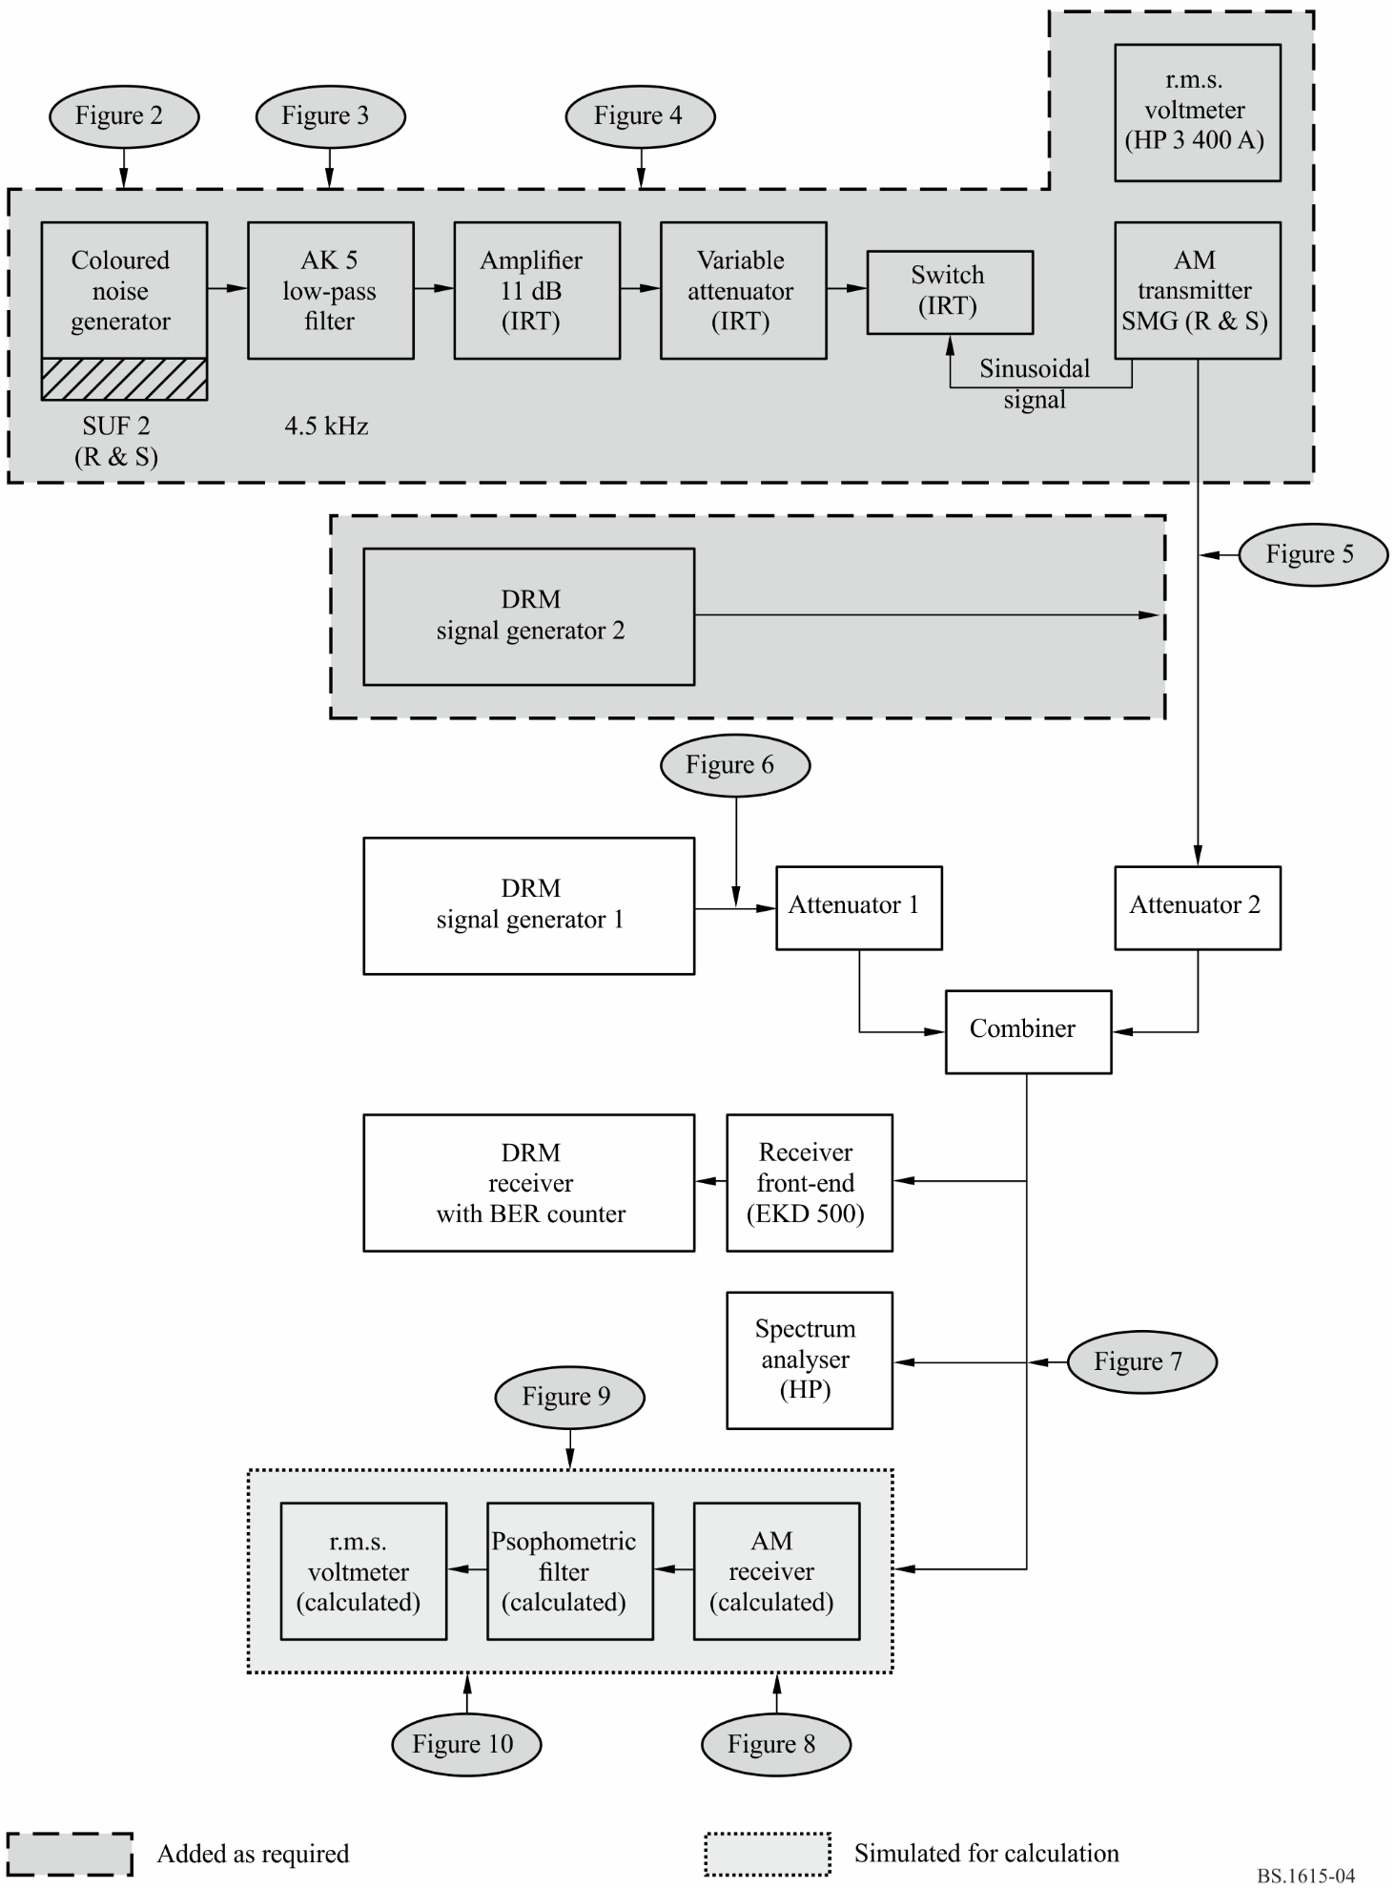

2.4 Receiver model
The complete set of receiver parameters used for the calculation are given in § 3.
For the verification of the calculation method for AM reception the characteristics of the measurement receiver with band-pass filter (MBF) is used (see § 3.4 and Fig. 11a). The spectral components falling in its pass-band are weighted according to Recommendation ITU-R BS.468 (see Fig. 12) and their power is summed up, either as desired or undesired signal.
The characteristics of a receiver for digitally modulated signals is described by its selectivity (see §§ 3.1 and 3.7). The power of all spectral components falling in its pass-band is summed up, either as desired or undesired signal.

2.5 Future extension of the calculation model
It may be necessary to expand the calculation model in order to allow for the calculation of RF protection ratios for simulcast transmissions, which leads to five additional interference cases:
– AM reception interfered with by simulcast transmissions (AM-SIM).
– Reception of digitally modulated signals interfered with by simulcast transmissions (DIG-SIM).
– Simulcast reception interfered with by AM transmissions (SIM-AM).
– Simulcast reception interfered with by digitally modulated signals (SIM-DIG).
– Simulcast reception interfered with by simulcast transmissions (SIM-SIM).

3 Assumed system parameters

3.1 Spectrum masks
The spectrum masks for AM transmissions are based on a model taking into account the non-linear distortion of the transmitter and/or the modulating signal as well as a certain noise floor. For amplitude modulated transmitters second- and third-order harmonic distortion as well as third-order intermodulation are incorporated in the calculation model. For digitally modulated transmitters, measured or assumed spectra are used.
The spectrum shaping for the AM transmitter is performed by using a low-pass filter with the parameters given in § 3.2 (see Figs 5, 6 and 7). The selectivity curve of the AM receiver is given under § 3.4.
The parameters given in §§ 3.2, 3.3 and 3.4 were chosen for the AM transmitter and receiver models because they are usual for AM transmissions and, moreover, they lead in the case AM interfered with by AM to the RF protection ratios of Recommendation ITU-R BS.560.
The receiver selectivity curves and the spectrum masks resulting from the parameters specified in the following clauses are presented graphically in Figs 8, 9, 10 and 11.

3.2 AM transmitter (Figs 5 to 8)
– sideband power: N_{sb} = N_{c} * m²/2
– total power: N_{total} = N_{c} * (1 + m²/2)
– cut-off frequency or bandwidth: F_{tx} = 4.5 kHz, i.e. B = 9 kHz
– low-pass AF filter slope: 60 dB/octave, starting with 0 dB at F_{tx}
(see Fig. 6)
– harmonic distortion: k₂ = 0 k₃ = 0.7% (−43 dB)
– intermodulation: d₃ = −40 dB
– noise floor: −60.3 dBc/kHz.
With the above parameters, the calculated RF spectrum of the AM signal is compliant with the spectrum mask included in Recommendation ITU-R SM.328.

3.3 AM modulation (Figs 5 to 7)
– modulating signal: coloured noise according to Recommendation ITU-R BS.559
– modulation depth: m_{r.m.s.} = 25% (corresponding to a programme signal with normal compression)
– high compression: increase of the modulating signal power by 6.5 dB (this may be achieved by a compressor with a compression gain of 15 dB and a compression ratio of 2:1).

3.4 AM receiver (Figs 11a and 11b)
– selectivity curve: as MBF, or a modern AM receiver with B = 4.4 kHz, slope = 35 dB/octave
– audio signal measurement: r.m.s.
– AF protection ratio: desired value.

3.5 Transmitter for digital signals
– sideband power: N_{sb} = N_{total}
– carrier power: N_{c} = 0
– bandwidth: B = 9 kHz or 10 kHz.

3.6 Digital modulation (Figs 9a and 9b)
– spectrum: defined by measured transmitter signal or required spectrum mask.

3.7 Receiver for digital signals (Fig. 9a)
– bandwidth: B = 9 kHz or 10 kHz
– selectivity curve: receiver spectrum (Figs 2 and 3)
– required S/I: S/I required to achieve BER of 1 × 10^{–4} dependent on robustness mode, spectrum occupancy type, modulation scheme and protection level.
figure 5
Characteristic of noise shaping filter
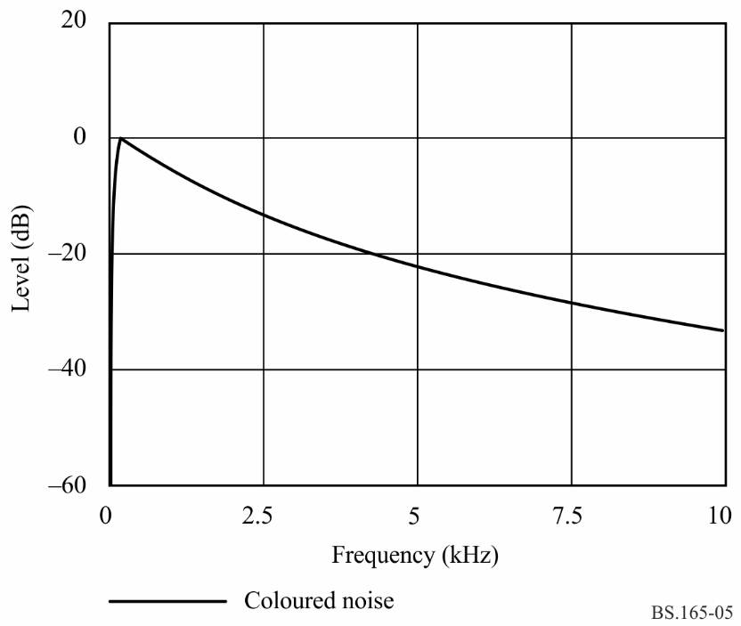
figure 6
Low-pass filter used in AM transmission
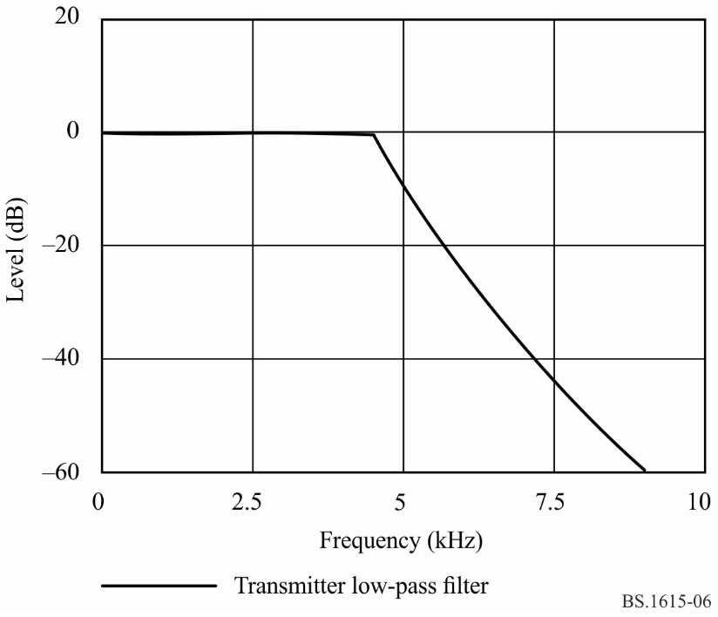
figure 7
Modulating signal for AM
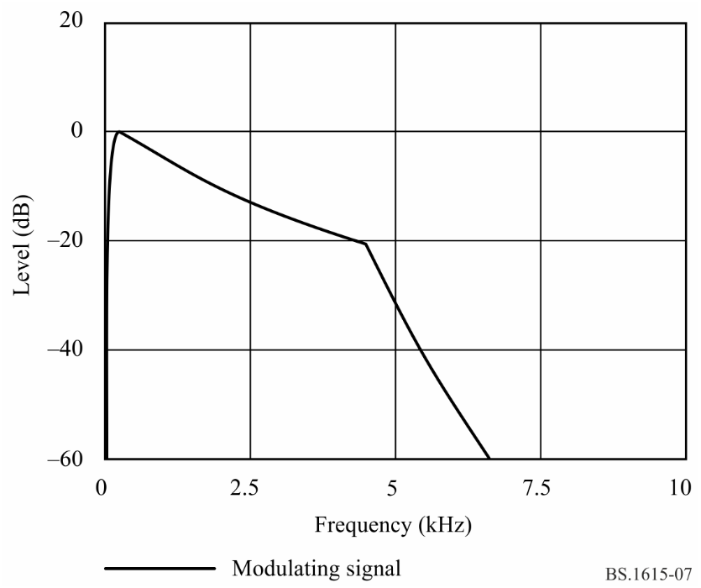
FIGURE 8
AM signal modulated with coloured noise
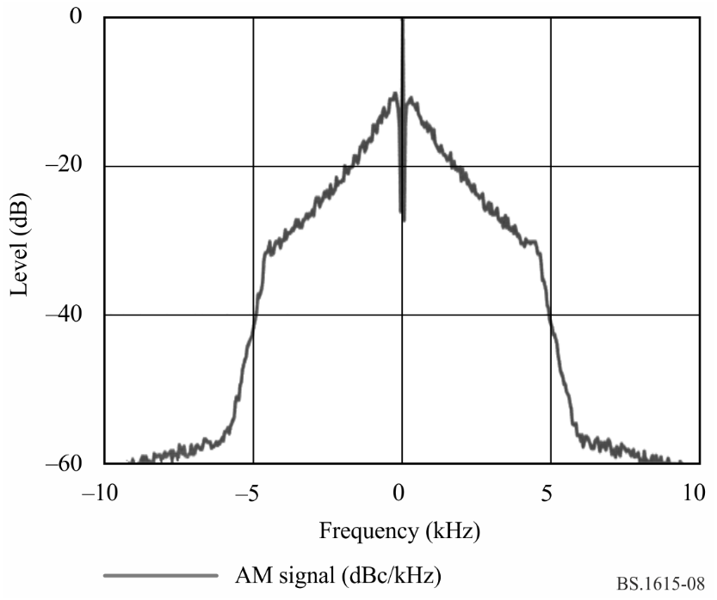
FIGURE 9a
DRM synthesizer signal (64-QAM, 9 kHz)
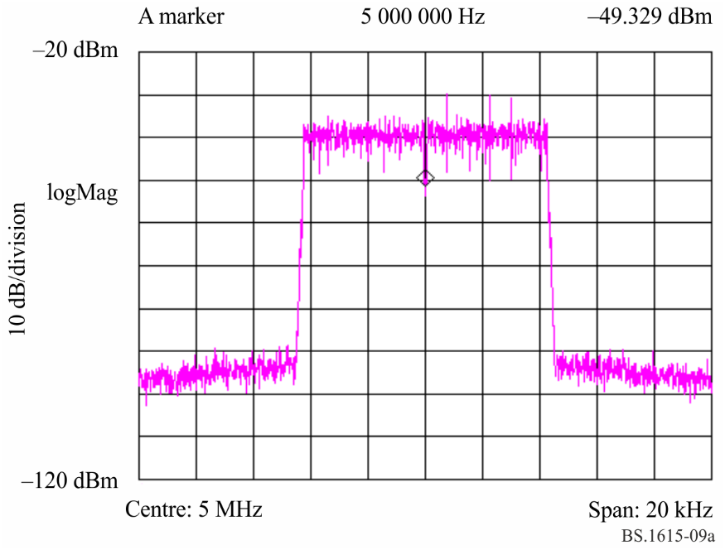
FIGURE 9b
DRM synthesizer signal (64-QAM, 9 kHz) and ITU spectrum mask
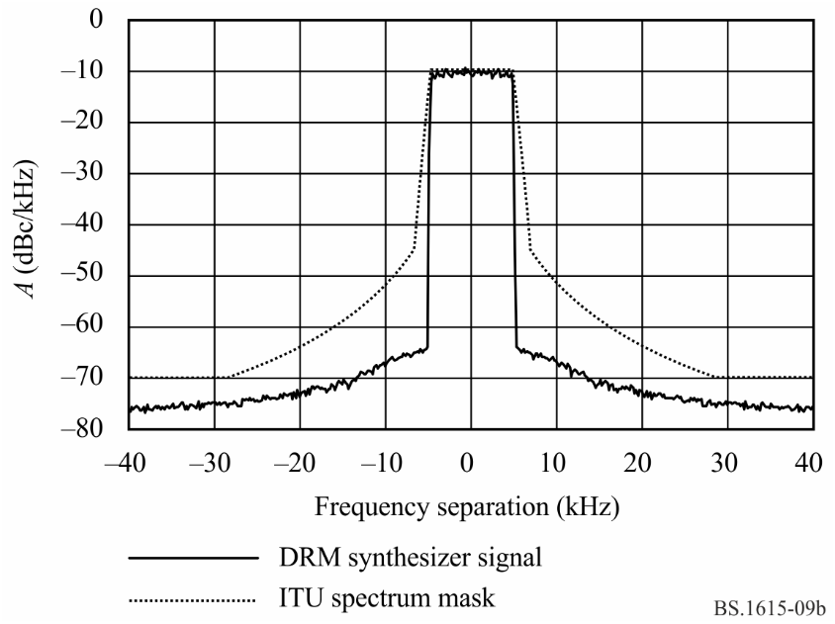
FIGURE 10a
AM signal interfered with by AM signal
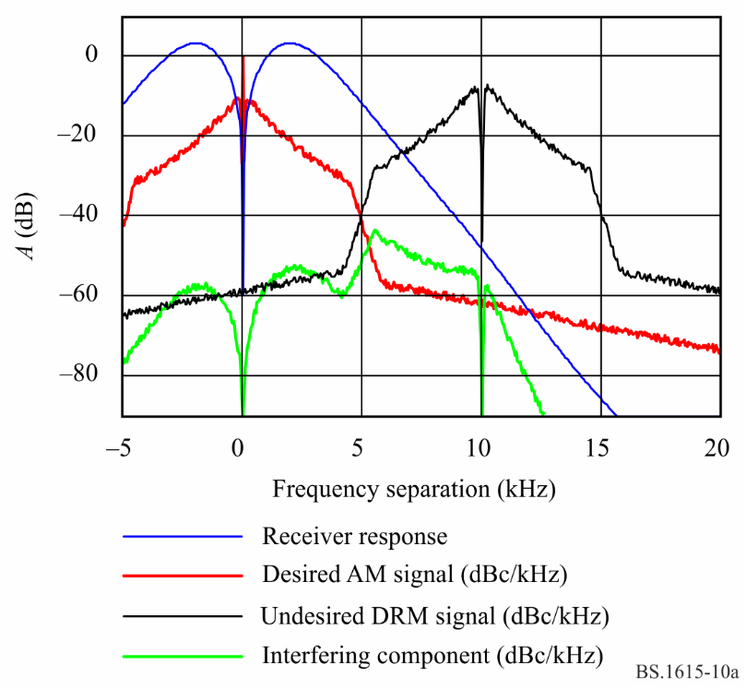
FIGURE 10b
AM signal interfered with by DRM signal
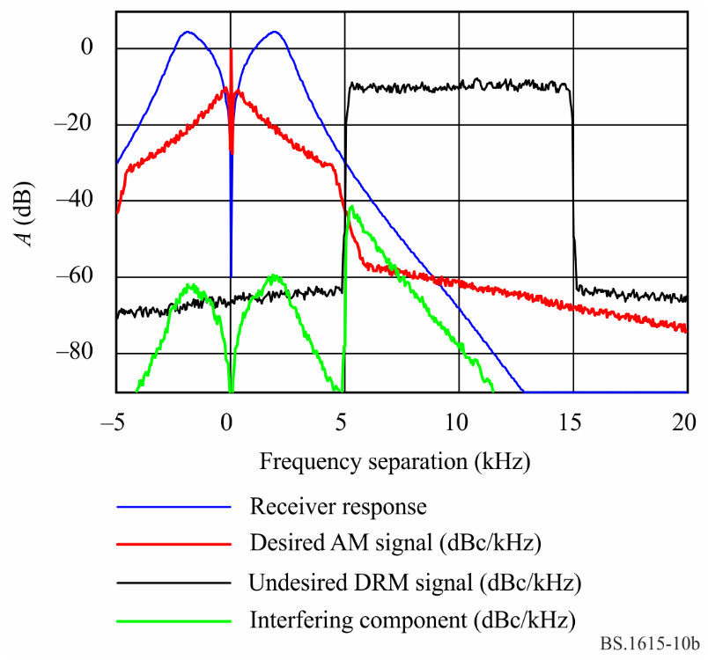
FIGURE 11a
Selectivity curve of MBF receiver
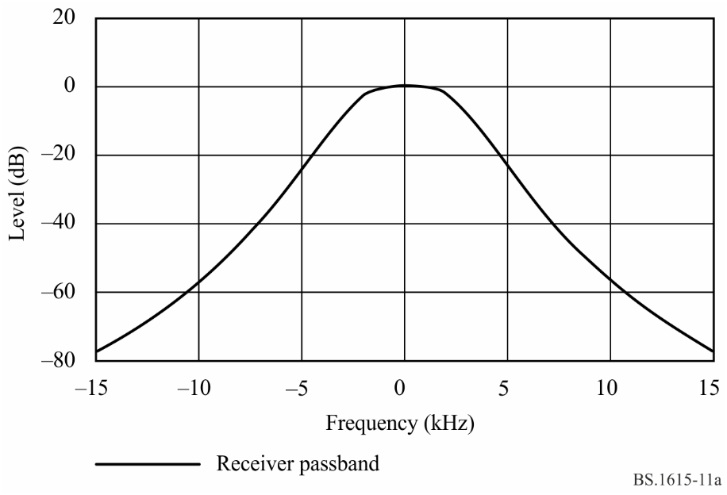
FIGURE 11b
Selectivity curve of a modern AM receiver
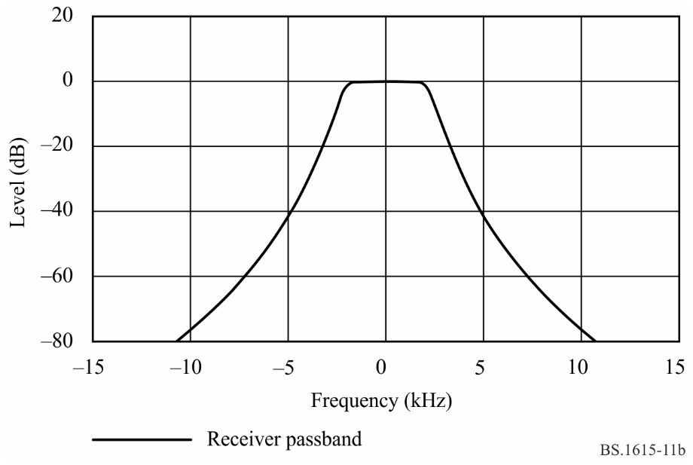
FIGURE 12
Signal shaping of psophometric filter
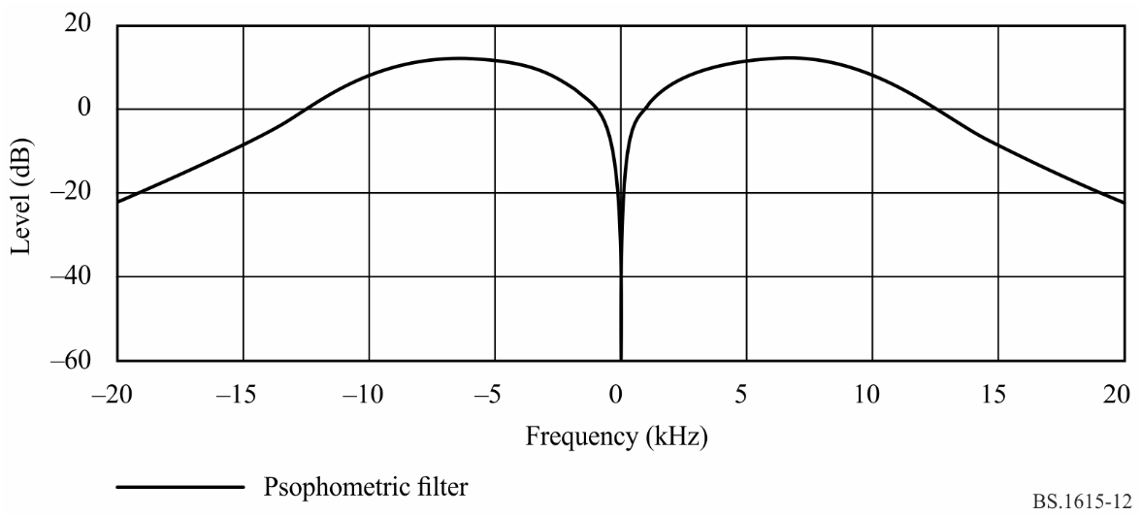
FIGURE 13
Receiver response including selectivity curve and psophometric filter
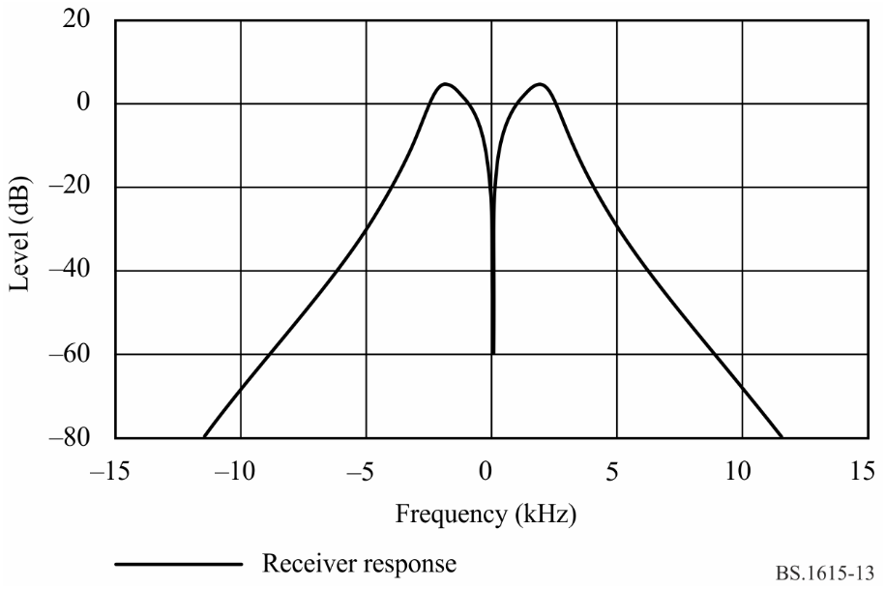

4 Verification of calculation method
Using the developed calculation model and the system parameters of § 3 and an AF protection ratio of 30 dB led in the case AM interfered with by AM (AM-AM) to the results presented in Table 30 and Figs 14 and 15. The calculated RF protection ratios are given for frequency separations up to 20 kHz for normal and high compression of the transmitted AM signals. In Fig. 14, only the relative RF protection ratio values are drawn in the diagram.
TABLE 30
Calculated RF protection ratios A_{RF} for AM, ITU values A_{ITU} and
calculation error ∆A_{RI} for AM transmissions
Desired: AM |  | Undesired: AM |  |  | A_{AF}: 30 dB
Δf/kHz | A_{RF}/dB |  | A_{ITU}/dB |  |  | ΔA_{RI}/dB
0 | 30 | 30 | 30 | 30 |  | 0 | 0
5 | 32.4 | 27 | 33 | 27.5 |  | –0.6 | –0.5
9 | 4.7 | 1.4 | 5 | 1 |  | –0.3 | 0.4
10 | –2.4 | –5.4 | –2 | –5.5 |  | –0.4 | 0.1
15 | –19.6 | –19.7 | –19 | –19.5 |  | –0.6 | –0.2
18 | –23.3 | –23.3 | –23.3 | –23.3 |  | 0 | 0
20 | –25.6 | –25.7 | –25.4 | –25.4 |  | –0.2 | –0.3
 | Normal  compression | High  compression | Normal  compression | High  compression |  | Normal  compression | High  compression

The comparison of calculated values with the RF protection ratios of Recommendation ITU-R BS.560 shows that the calculation error is less than 0.6 dB.
FIGURE 14
Relative RF protection ratios AM interfered with by AM
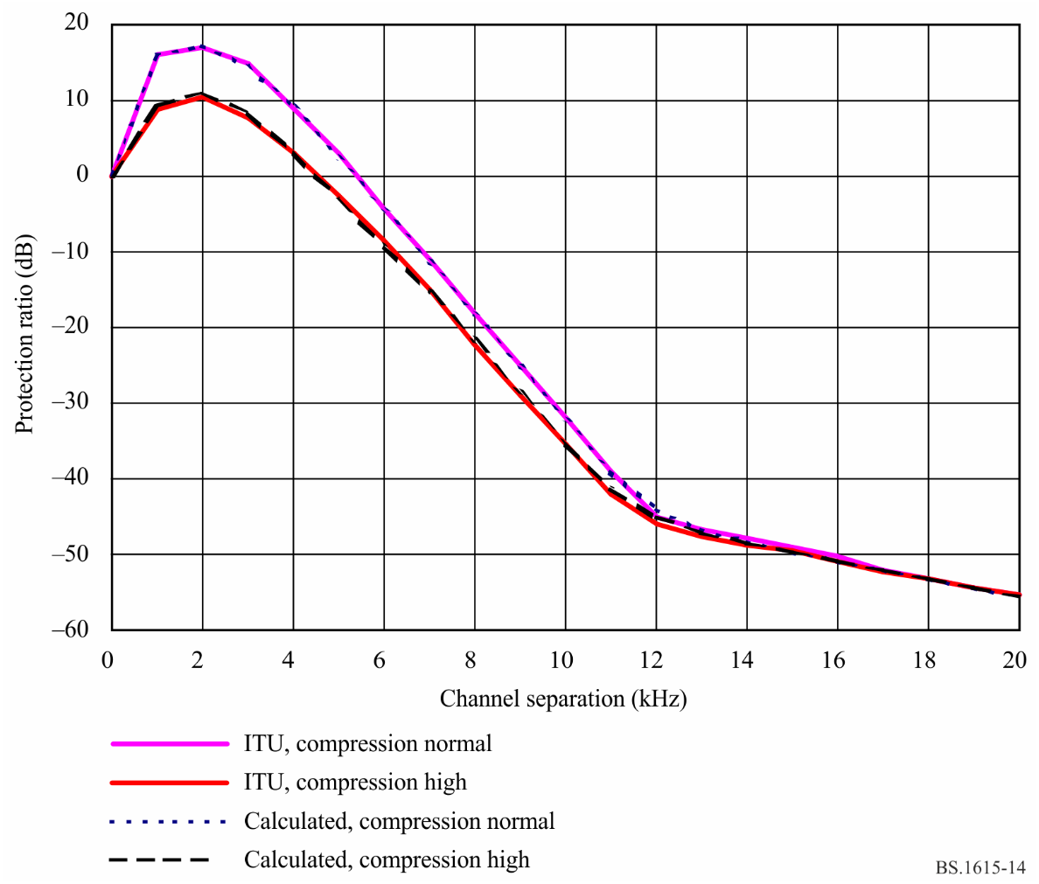

5 Application for digitally modulated signals
The small calculation error for the determination of RF protection ratios in the case AM interfered with by AM shows that this method can also be used with sufficient accuracy to calculate RF protection ratios for AM interfered with by digitally modulated signals, under the condition that the spectrum of the interfering digital signal is known.
For digitally modulated signals interfered with by AM or digitally modulated signals, the selectivity curve and the demodulation characteristics of the receiver have to be known. Therefore, this method can only be applied with some restrictions, e.g. to investigate the influence of different spectra based on known measurement results.

6 Summary
The described calculation model has been used for the determination of RF protection ratios for DSB in the broadcasting bands below 30 MHz. The achieved accuracy is sufficient for planning purposes. The calculations should be based on measured transmitter spectra or on a spectrum mask which is needed to fulfil the requirements for out-of-band emissions. Only if it is necessary should the calculation results be checked and completed by measurement results.
FIGURE 15
Calculation error for RF protection ratios AM interfered with by AM
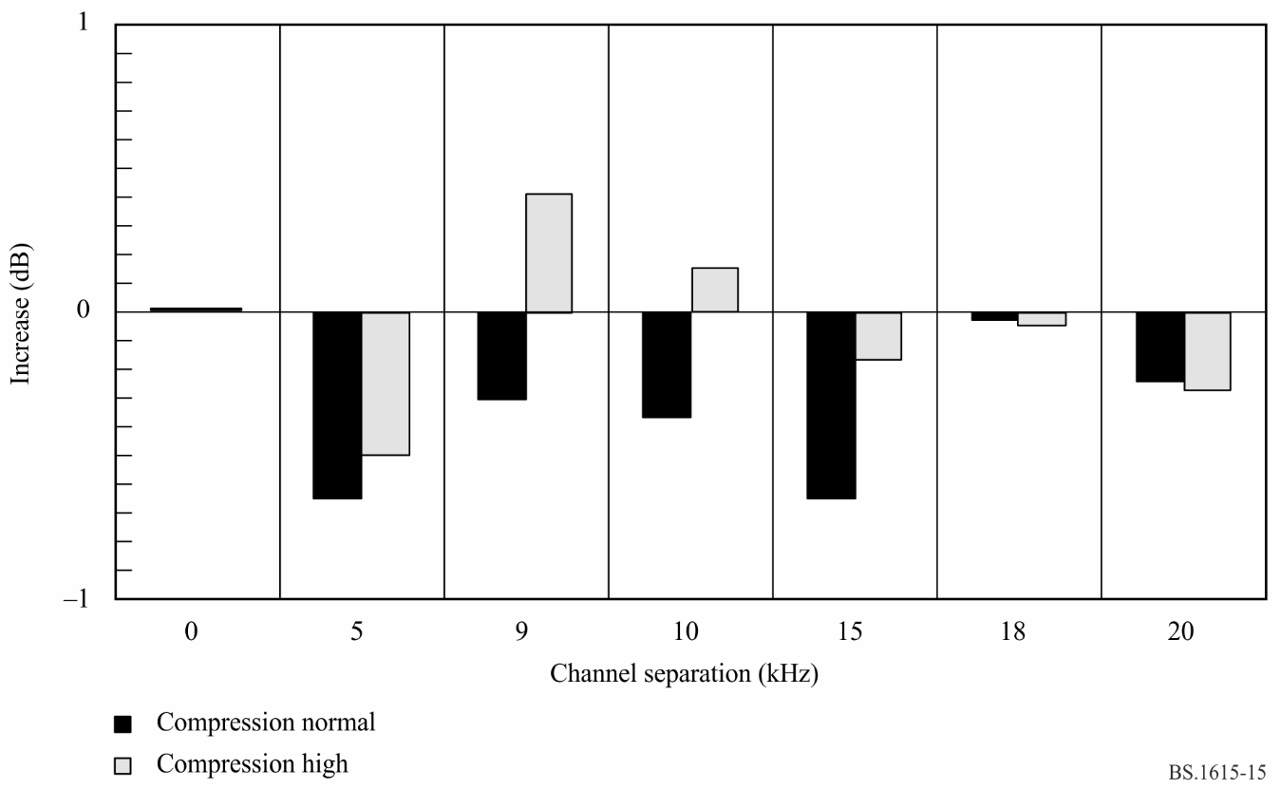

Attachment 3
to Annex 2
Calculated RF protection ratios for DSB (DRM system) using 18 and 20 kHz bandwidths at frequencies below 30 MHz

1 Background
Initially, Recommendation ITU-R BS.1615 was approved by RA-03 and provided information about RF protection ratios for DRM signals with bandwidths of 4.5 kHz, 5 kHz, 9 kHz and 10 kHz.
However, in 2001 and up until the beginning of 2002, the PDNR produced by Task Group 6/7 of ITU-R (PDNR-2001) provided information on RF PR for DRM signals with bandwidths of 4.5 kHz, 9 kHz, 10 kHz, 18 kHz and 20 kHz. During the works by TG 6/7 in 2002, bandwidths of 18 kHz and 20 kHz were suppressed.
This Attachment describes the method used to include in Recommendation ITU-R BS.1615 protection ratio values for DRM signals with bandwidths of 18 and 20 kHz.

2 Basic parameters - Reminders

2.1 DRM bandwidths
TABLE 31
Bandwidths (F) for specified DRM mode combinations (Hz)
Mode | 0 | 1 | 2 | 3 | 4 | 5
A | 4 208 | 4 708 | 8 542 | 9 542 | 17 208 | 19 208
B | 4 266 | 4 828 | 8 578 | 9 703 | 17 203 | 19 266
C |  |  |  | 9 477 |  | 19 159
D |  |  |  | 9 536 |  | 19 179
B_{DRM}  (kHz) | 4.5 | 5 | 9 | 10 | 18 | 20

Remark: It should be noted that the exact bandwidths of cases A4, A5, B4, B5, C5, D5 are not the double of bandwidths in cases A2, A3, B2, B3, C3, D3. Examples:
A2 = 8 542 Hz 2 × A2 = 17 084 Hz A4 = 17 208 Hz
A3 = 9 542 Hz 2 × A3 = 19 084 Hz A5 = 19 208 Hz
B3 = 9 703 Hz 2 × B3 = 19 406 Hz B5 = 19 266 Hz
C3 = 9 477 Hz 2 × C3 = 18 954 Hz C5 = 19 159 Hz
D3 = 9 536 Hz 2 × D3 = 19 072 Hz D5 = 19 179 Hz

2.2 Spectrum mask
In 2001, the characteristics of the spectrum mask of the transmitter were calculated according to Recommendation ITU-R SM.328-11, § 6.3.3 using the exact bandwidths F of Table 31. This includes a 35 dB attenuation at ±0.57 F, beyond this point there is a slope of –12 dB/octave to
–60 dB.
An example of the mask for spectrum occupancy type 2 (9 kHz) is given in Fig. 16 (including also the filter curves for AM and digital receivers).
In 2002, the characteristics of the spectrum mask were changed. The attenuation of DRM signals between:
± 0.50 and ± 0.53 of the bandwidth (F) is 30 dB and not 35 dB at ±0.57 F. Above and below ± 0.53F down to –60 dB a slope of –12 dB/octave can be assumed.
An example of the mask for spectrum occupancy type 3 (10 kHz) is given in Fig. 17 (including also the filter curves for AM and digital receivers).
The steeper slope between ± 0.5 and ± 0.53 F of the DRM spectrum has a large influence on the RF protection ratio for a DRM reception in the adjacent channel.
Figure 16
Spectrum mask in 2001
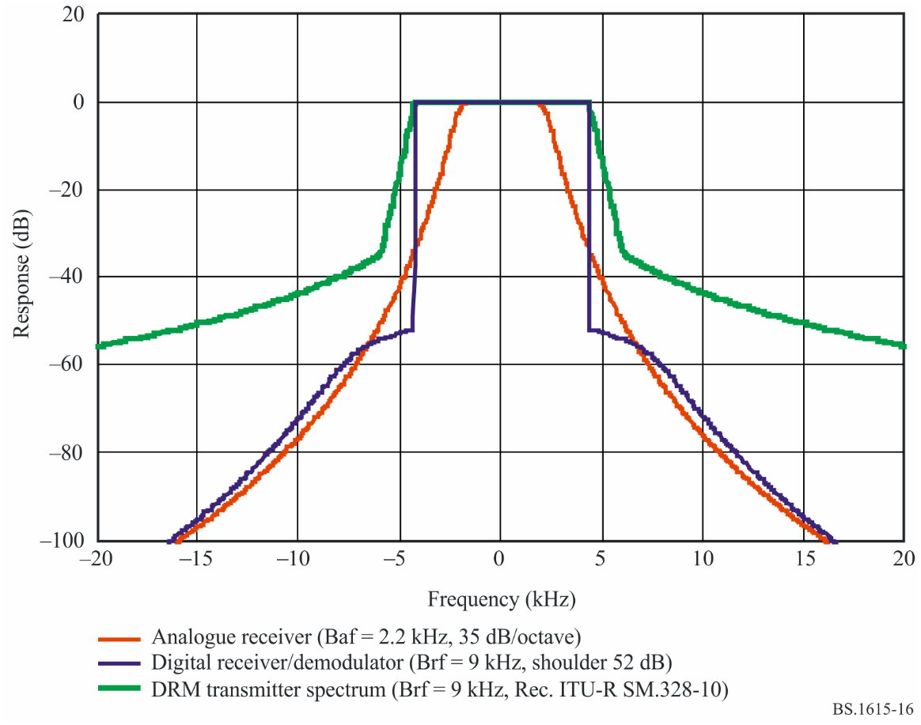
Figure 17
Spectrum mask in Recommendation ITU-R BS.1615
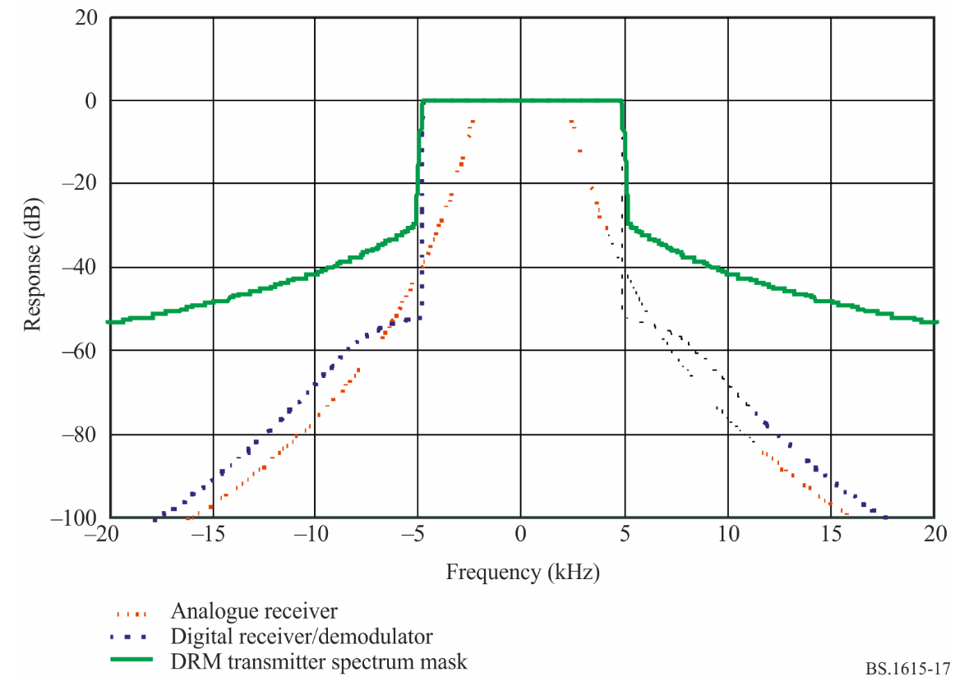

2.3 DRM Signal

BW = 9 kHz
F_{c}
4.5 | 4.5
BW = 10 kHz
F_{c}
5 | 5
BW = 18 kHz
F_{c}
4.5 | 4.5 | 4.5 | 4.5
BW = 20 kHz
F_{c}
5 | 5 | 5 | 5
Remark: The so-called “central or reference frequency F_{c}” does not exist physically. However, it is used to specify the central frequency of a DRM channel of 9 kHz and 10 kHz bandwidths.
For 18 kHz and 20 kHz bandwidths, the “reference frequency F_{c}” has the same position as for 9 and 10 kHz. In other words, the “reference” frequency of a 18 kHz or 20 kHz DRM signal is not located in the middle of the bandwidth.

2.4 True values and relative values of protection ratios
In the next paragraph, it will be referred to Tables providing either “true values” of protection ratios (in PDNR_2001) or “relative values” of protection ratios (in Recommendation ITU-R BS.1615).
For AM interfered with by DRM, the absolute RF protection ratio to protect the existing AM service is derived by adding the wanted AF protection ratio (A_{AF}) using the following equation:

Inversely, A_{RF_ relative} = A_{RF} – A_{AF}

For DRM interfered with by AM, the RF protection for DRM is derived by a similar calculation. Instead of the AF protection ratio the required S/I ratio for a specified BER is taken into account:

Inversely, A_{RF_ relative} = A_{RF} – S/I

The protection ratios are given for various frequency separations between the unwanted signal and the wanted frequency, extending from −20 kHz to +20 kHz.
In the Tables “AM interfered with by DRM” f_{unwanted} – f_{wanted} = Δ has the following meaning:
If the frequency separation is Δ = −10 kHz, f_{DRM} is lower than f_{wanted} by 10 kHz
If the frequency separation is Δ = +15 kHz, f_{DRM} is higher than f_{wanted} by 15 kHz

3 Method to derive protection ratios for 18 and 20 kHz DRM signals
− Use the last tables produced in 2001 by TG 6/7 for 18 and 20 kHz bandwidths and for a spectrum mask offering an attenuation of 35 dB at ±0.57 F.
− Derive the relative PR from these tables (with A_{AF} = 17 dB).
− Use the final tables existing in Recommendation ITU-R BS.1615 established for a spectrum mask offering an attenuation of 30 dB at ±0.53 F.
− Calculate the differences d between relative PR between values calculated in 2001 and values in Recommendation ITU-R BS.1615 for DRM signals up to 10 kHz bandwidths.
− Apply these differences d to the PR values established in 2001 taking into account the positions of the unwanted and wanted signals and the similarities.

Positions of the unwanted (DRM) and wanted (AM) signals – Similarities
Δ = f_{unwanted} – f_{wanted}

 |  |  |  |  |  |  |  |  | similarities
 |  |  |  |  |  |  |  |  | DRM_A5 | DRM_A3
 |  |  |  |  | Fam
F_{DRM} |  |  |  |  |  |  |  |  | Δ = −20 | Δ = −10
 |  |  |  | Fam |  |  |  |  | Δ = −18 | Δ = −9
F_{DRM} |  |  |  |  |  |  |  |  | Δ = −15 | Δ = −5
 |  |  | Fam
F_{DRM} |  |  |  |  |  |  |  |  | Δ = −10 | Δ = 0
 |  |  |  |  |  |  |  |  | Δ = −9 | Δ = 0
F_{DRM} |  | Fam |  |  |  |  |  |  | Δ = −5 | Δ = 0
 | similarities
 | DRM_A3 | DRM_A5
 | Δ = +5 | Δ = +5 |  |  |  |  |  | Fam | F_{DRM}
 | Δ = +9 | Δ = +9
 | Δ = +10 | Δ = +10 |  |  |  |  | Fam |  | F_{DRM}
 | Δ = +15 | Δ = +15 |  |  |  | Fam |  |  | F_{DRM}
 | Δ = +18 | Δ = +18
 | Δ = +20 | Δ = +20 |  |  | Fam |  |  |  | F_{DRM}

Similarities: Taking into account the positions of the DRM signals, there are similarities between DRM_A3 and DRM_A5.
Let us take Δ = f_{unwanted} – f_{wanted}
DRM_A5 at Δ = −20 kHz/18 kHz equivalent to DRM_A3 at Δ = −10 kHz/9 kHz
DRM_A5 at Δ = −15 kHz equivalent to DRM A3 at Δ = −5 kHz
DRM_A5 at Δ = −10 kHz/9 kHz equivalent to DRM_A3 at Δ = 0 kHz
DRM_A5 at Δ = −5 kHz equivalent to DRM_A3 at Δ = 0 kHz
DRM_A5 at Δ = 0 kHz equivalent to DRM_A3 at Δ = 0 kHz
DRM_A5 at Δ = +5 kHz equivalent to DRM_A3 at Δ = +5 kHz
DRM_A5 at Δ = +10 kHz/9 kHz equivalent to DRM_A3 at Δ = +10 kHz/9 kHz
DRM_A5 at Δ = +15 kHz equivalent to DRM_A3 at Δ = +15 kHz
DRM_A5 at Δ = +20 kHz/18 kHz equivalent to DRM_A3 at Δ = +20 kHz/18 kHz

3.1 AM interfered with by DRM
DRM_A2, A3, B2, B3, C3 and D3 will be taken into account in the tables issued by TG 6/7 in 2001 and by Recommendation ITU-R BS.1615.
Method:
Step 1: original table by PDNR_01 in 2001
Step 2: final table in Recommendation ITU-R BS.1615
Step 3: transformation of true PR values of PDNR_01 in relative values for AM interfered with by DRM,
taking into account the formula: A_{RF_ relative} = A_{RF} – A_{AF}
Step 4: calculation of differences “d” between relative PR given by Recommendation ITU-R BS.1615 and PR given by PDNR_01
3.1.1 Case: Mode A_9 kHz and Mode A_18 kHz.
apply “d” to relative PR of PDNR_01 for 18 kHz bandwidths, taking into account the similarities.
3.1.2 Case: Mode A_10 kHz and Mode A_20 kHz.
apply “d” to relative PR of PDNR_01 for 20 kHz bandwidths, taking into account the similarities.
3.1.3 Case: Mode B_9 kHz and Mode B_18 kHz.
apply “d” to relative PR of PDNR_01 for 18 kHz bandwidths, taking into account the similarities.
3.1.4 Case: Mode B_10 kHz and Mode B_20 kHz.
apply “d” to relative PR of PDNR_01 for 20 kHz bandwidths, taking into account the similarities.
3.1.5 Case: Mode C_10 kHz and Mode C_20 kHz.
apply “d” to relative PR of PDNR_01 for 20 kHz bandwidths, taking into account the similarities.
3.1.6 Case: Mode D_10 kHz and Mode D_20 kHz.
apply “d” to relative PR of PDNR_01 for 20 kHz bandwidths, taking into account the similarities.

    - Step 1
TABLE 1 (PDNR_2001)
RF protection ratios between broadcasting systems below 30 MHz (dB) 64-QAM, protection level No. 1
AM interfered with by DRM
Case | Wanted  signal | Unwanted  signal | Frequency separation  f_{unwanted} – f_{wanted} (kHz) |  |  |  |  |  |  |  |  |  |  |  |  | Parameters
 |  |  |  |  |  |  |  |  |  |  |  |  |  |  |  | B_{DRM}  (kHz) | S/N  (dB) | A_{AF}  (dB)
 |  |  | −20 | −18 | −15 | −10 | −9 | −5 | 0 | 5 | 9 | 10 | 15 | 18 | 20
0 | AM | AM | −38.4 | −36.3 | −32.5 | −18.5 | −12.0 | 14.5 | 17.0 | 14.5 | −12.0 | −18.5 | −32.5 | −36.3 | −38.4 | 9 |  | 17
1 | AM | DRM_A0 | −33.5 | −33.5 | −32.3 | −18.4 | −10.9 | 23.3 | 23.4 | −13.6 | −30.2 | −31.6 | −33.5 | −33.5 | −33.5 | 4.5 |  | 17
2 | AM | DRM_A1 | −34.0 | −33.8 | −31.2 | −15.0 | −6.7 | 23.0 | 23.0 | −13.8 | −29.3 | −31.0 | −34.0 | −34.0 | −34.0 | 5 |  | 17
3 | AM | DRM_A2 | −32.2 | −30.3 | −26.9 | −17.3 | −11.5 | 20.3 | 23.4 | 20.3 | −11.5 | −17.3 | −26.9 | −30.3 | −32.2 | 9 |  | 17
4 | AM | DRM_A3 | −30.8 | −28.9 | −25.5 | −14.6 | −7.1 | 19.9 | 22.9 | 19.9 | −7.1 | −14.6 | −25.5 | −28.9 | −30.8 | 10 |  | 17
5 | AM | DRM_A4 | −18.1 | −9.1 | 15.6 | 20.3 | 20.3 | 20.3 | 20.3 | 17.2 | −9.1 | −15.7 | −22.6 | −25.2 | −26.7 | 18 |  | 17
6 | AM | DRM_A5 | −11.5 | 5.1 | 16.9 | 19.9 | 19.9 | 19.9 | 19.9 | 16.9 | −3.4 | −11.5 | −21.7 | −24.2 | −25.7 | 20 |  | 17
7 | AM | DRM_B0 | −33.6 | −33.6 | −32.3 | −18.3 | −10.8 | 23.3 | 23.4 | −13.4 | −29.9 | −31.5 | −33.6 | −33.6 | −33.6 | 4.5 |  | 17
8 | AM | DRM_B1 | −34.1 | −33.8 | −30.9 | −14.5 | −5.9 | 22.9 | 22.9 | −13.5 | −29.1 | −30.7 | −34.1 | −34.1 | −34.1 | 5 |  | 17
9 | AM | DRM_B2 | −32.2 | −30.2 | −26.9 | −17.2 | −11.4 | 20.3 | 23.4 | 20.3 | −11.4 | −17.2 | −26.9 | −30.2 | −32.2 | 9 |  | 17
10 | AM | DRM_B3 | −30.6 | −28.6 | −25.3 | −14.2 | −6.2 | 19.8 | 22.8 | 19.8 | −6.2 | −14.2 | −25.3 | −28.6 | −30.6 | 10 |  | 17
11 | AM | DRM_B4 | −18.1 | −9.1 | 15.6 | 20.3 | 20.3 | 20.3 | 20.3 | 17.2 | −9.1 | −15.7 | −22.6 | −25.2 | −26.7 | 18 |  | 17
12 | AM | DRM_B5 | −11.5 | 5.1 | 16.9 | 19.8 | 19.8 | 19.8 | 19.8 | 16.9 | −2.8 | −11.0 | −21.6 | −24.1 | −25.6 | 20 |  | 17
13 | AM | DRM_C3 | −30.9 | −28.9 | −25.6 | −14.8 | −7.4 | 19.9 | 22.9 | 19.9 | −7.4 | −14.8 | −25.6 | −28.9 | −30.9 | 10 |  | 17
14 | AM | DRM_C5 | −11.9 | 4.7 | 16.9 | 19.9 | 19.9 | 19.9 | 19.9 | 16.9 | −3.4 | −11.6 | −21.7 | −24.2 | −25.7 | 20 |  | 17
15 | AM | DRM_D3 | −30.8 | −28.9 | −25.5 | −14.7 | −7.1 | 19.9 | 22.9 | 19.9 | −7.1 | −14.7 | −25.5 | −28.9 | −30.8 | 10 |  | 17
16 | AM | DRM_D5 | −12.2 | 4.4 | 16.9 | 19.9 | 19.9 | 19.9 | 19.9 | 17.0 | −2.9 | −11.1 | −21.6 | −24.1 | −25.6 | 20 |  | 17
AM: AM signal
DRM_A0: DRM signal, robustness mode A, spectrum occupancy 0

    - Step 2
TABLE 2 (Recommendation ITU-R BS.1615)
Relative RF protection ratios between broadcasting systems below 30 MHz (dB)
AM interfered with by digital
Wanted  signal | Unwanted  signal | Frequency separation  f_{unwanted} – f_{wanted} (kHz) |  |  |  |  |  |  |  |  |  |  |  |  | Parameters
 |  |  |  |  |  |  |  |  |  |  |  |  |  |  | B_{DRM}  (kHz) | A_{AF}^{(1), (2)}  (dB)
 |  | –20 | –18 | –15 | –10 | –9 | –5 | 0 | 5 | 9 | 10 | 15 | 18 | 20
AM | DRM_A0 | –50.4 | –50.4 | –49.1 | –35.6 | –28.5 | 6.5 | 6.6 | –31.1 | –46.9 | –48.3 | –50.4 | –50.4 | –50.4 | 4.5 | –
AM | DRM_A1 | –50.9 | –50.6 | –47.9 | –32.5 | –24.5 | 6.1 | 6.1 | –31.3 | –46 | –47.7 | –50.9 | –50.9 | –50.9 | 5 | –
AM | DRM_A2 | –48.9 | –47 | –43.6 | –34.5 | –29.8 | 3.4 | 6.6 | 3.4 | –29.8 | –34.5 | –43.6 | –47 | –48.9 | 9 | –
AM | DRM_A3 | –47.4 | –45.5 | –42.1 | –32.4 | –26.5 | 3.1 | 6.1 | 3.1 | –26.5 | –32.4 | –42.1 | –45.5 | –47.4 | 10 | –
AM | DRM_B0 | –50.4 | –50.4 | –49 | –35.5 | –28.4 | 6.4 | 6.6 | –30.9 | –46.7 | –48.2 | –50.4 | –50.4 | –50.4 | 4.5 | –
AM | DRM_B1 | –51 | –50.5 | –47.6 | –32 | –23.8 | 6 | 6 | –31.1 | –45.7 | –47.4 | –51 | –51 | –51 | 5 | –
AM | DRM_B2 | –48.8 | –46.9 | –43.5 | –34.4 | –29.7 | 3.4 | 6.5 | 3.4 | –29.7 | –34.4 | –43.5 | –46.9 | –48.8 | 9 | –
AM | DRM_B3 | –47.2 | –45.3 | –41.9 | –32 | –25.9 | 3 | 6 | 3 | –25.9 | –32 | –41.9 | –45.3 | –47.2 | 10 | –
AM | DRM_C3 | –47.5 | –45.6 | –42.2 | –32.6 | –26.7 | 3.1 | 6.1 | 3.1 | –26.7 | –32.6 | –42.2 | –45.6 | –47.5 | 10 | –
AM | DRM_D3 | –47.4 | –45.5 | –42.2 | –32.4 | –26.5 | 3.1 | 6.1 | 3.1 | –26.5 | –32.4 | –42.2 | –45.5 | –47.4 | 10 | –
A_{AF}: audio frequency protection ratio
DRM_A0: DRM signal, robustness mode A, spectrum occupancy type 0
⁽¹⁾ The RF protection ratio for AM interfered with by digital can be calculated by adding a suitable value for the AF protection ratio according to a given planning scenario to the values in this Table.
⁽²⁾ The values presented in this Table refer to the specific case of high AM compression. For consistency with Table 25, the same modulation depth, namely that associated with high compression, has been assumed for the AM signal. In order to offer adequate protection to AM signals with normal levels of compression (as defined in Attachment 1 to Annex 2), each value in the Table should be increased to accommodate the difference between normal and high compression.

    - Steps 3 + 4 (see following tables)
AM interfered with by DRM
RF protection ratios between broadcasting systems below 30 MHz (dB) 64-QAM, protection level No. 1

3.1.1 Mode DRM_A2_9 kHz

Case | Wanted  signal | Unwanted  signal | Frequency separation  f_{unwanted} – f_{wanted} (kHz) |  |  |  |  |  |  |  |  |  |  |  |  | Parameters
 |  |  | −20 | −18 | −15 | −10 | −9 | −5 | 0 | 5 | 9 | 10 | 15 | 18 | 20 | B_{DRM}  (kHz) | S/N  (dB) | A_{AF}  (dB)
3 | AM | DRM_A2 | −32.2 | −30.3 | −26.9 | −17.3 | −11.5 | 20.3 | 23.4 | 20.3 | −11.5 | −17.3 | −26.9 | −30.3 | −32.2 | 9 |  | 17
3a | AM | A2/AREL | −49.2 | −47.3 | −43.9 | −34.3 | −28.5 | 3.3 | 6.4 | 3.3 | −28.5 | −34.3 | −43.9 | −47.3 | −49.2 | 9 |  | 17
3b | AM | DRM_A2  Rec. ITU-R  BS.1615 | −48.9 | −47 | −43.6 | −34.5 | −29.8 | 3.4 | 6.6 | 3.4 | −29.8 | −34.5 | −43.6 | −47 | −48.9 | 9 |  | 17
diff | AM | d | 0.3 | 0.3 | 0.3 | −0.2 | −1.3 | 0.1 | 0.2 | 0.1 | −1.3 | −0.2 | 0.3 | 0.3 | 0.3 | 9 |  | 17

To obtain the A_{RF_REL} in Recommendation ITU-R BS.1615 (DRM_A2), add to A_{RF_REL} in Document 6-7/21 the difference [3b-3a].
    - Mode DRM_A4_18 kHz

Case | Wanted  signal | Unwanted  signal | Frequency separation  f_{unwanted} – f_{wanted} (kHz) |  |  |  |  |  |  |  |  |  |  |  |  | Parameters
 |  |  | −20 | −18 | −15 | −10 | −9 | −5 | 0 | 5 | 9 | 10 | 15 | 18 | 20 | B_{DRM}  (kHz) | S/N  (dB) | A_{AF}  (dB)
5 | AM | DRM_A4 | −18.1 | −9.1 | 15.6 | 20.3 | 20.3 | 20.3 | 20.3 | 17.2 | −9.1 | −15.7 | −22.6 | −25.2 | −26.7 | 18 |  | 17
5 | AM | A4/AREL | −35.1 | −26.1 | −1.4 | 3.3 | 3.3 | 3.3 | 3.3 | 0.2 | −26.1 | −32.7 | −39.6 | −42.2 | −43.7 | 18 |  | 17
 |  | d similar | −0.2 | −1.3 | 0.1 | 0.2 | 0.2 | 0.2 | 0.2 | 0.1 | −1.3 | −0.2 | 0.3 | 0.3 | 0.3
New 5 | AM | A4/AREL | −35.3 | −27.4 | −1.3 | 3.5 | 3.5 | 3.5 | 3.5 | 0.3 | −27.4 | −32.9 | −39.3 | −41.9 | −43.4 | 18 |  | 17

3.1.2 Mode DRM_A3_10 kHz

Case | Wanted  signal | Unwanted  signal | Frequency separation  f_{unwanted} – f_{wanted} (kHz) |  |  |  |  |  |  |  |  |  |  |  |  | Parameters
 |  |  | −20 | −18 | −15 | −10 | −9 | −5 | 0 | 5 | 9 | 10 | 15 | 18 | 20 | B_{DRM}  (kHz) | S/N  (dB) | A_{AF}  (dB)
4 | AM | DRM_A3 | −30.8 | −28.9 | −25.5 | −14.6 | −7.1 | 19.9 | 22.9 | 19.9 | −7.1 | −14.6 | −25.5 | −28.9 | −30.8 | 10 |  | 17
4a | AM | A3/A_{REL} | −47.8 | −45.9 | −42.5 | −31.6 | −24.1 | 2.9 | 5.9 | 2.9 | −24.1 | −31.6 | −42.5 | −45.9 | −47.8 | 10 |  | 17
4b | AM | DRM_A3  Rec. ITU-R  BS.1615 | −47.4 | −45.5 | −42.1 | −32.4 | −26.5 | 3.1 | 6.1 | 3.1 | −26.5 | −32.4 | −42.1 | −45.5 | −47.4 | 10 |  | 17
diff | AM | d | 0.4 | 0.4 | 0.4 | −0.8 | −2.4 | 0.2 | 0.2 | 0.2 | −2.4 | −0.8 | 0.3 | 0.4 | 0.4

To obtain the A_{RF_rel} in Recommendation ITU-R BS.1615 (DRM_A3), add to A_{RF_rel} in Document 6-7/21 the difference [4b-4a].
    - Mode DRM_A5_20 kHz

Case | Wanted  signal | Unwanted  signal | Frequency separation  f_{unwanted} – f_{wanted} (kHz) |  |  |  |  |  |  |  |  |  |  |  |  | Parameters
 |  |  | −20 | −18 | −15 | −10 | −9 | −5 | 0 | 5 | 9 | 10 | 15 | 18 | 20 | B_{DRM}  (kHz) | S/N  (dB) | A_{AF}  (dB)
6 | AM | DRM_A5 | −11.5 | 5.1 | 16.9 | 19.9 | 19.9 | 19.9 | 19.9 | 16.9 | −3.4 | −11.5 | −21.7 | −24.2 | −25.7 | 20 |  | 17
6 | AM | A5/A_{REL} | −28.5 | −12.1 | −0.1 | 2.9 | 2.9 | 2.9 | 2.9 | −0.1 | −20.4 | −28.5 | −38.7 | −41.2 | −42.7 | 20 |  | 17
 |  | d similar | −0.8 | −2.4 | 0.2 | 0.2 | 0.2 | 0.2 | 0.2 | 0.2 | −2.4 | −0.8 | 0.3 | 0.4 | 0.4
New 6 | AM | A5/A_{REL} | −29.3 | −14.5 | 0.1 | 3.1 | 3.1 | 3.1 | 3.1 | 0.1 | −22.8 | −29.3 | −38.4 | −40.8 | −42.3 | 20 |  | 17

3.1.3 Mode B2_9 kHz

Case | Wanted  signal | Unwanted  signal | Frequency separation  f_{unwanted} – f_{wanted} (kHz) |  |  |  |  |  |  |  |  |  |  |  |  | Parameters
 |  |  | −20 | −18 | −15 | −10 | −9 | −5 | 0 | 5 | 9 | 10 | 15 | 18 | 20 | B_{DRM}  (kHz) | S/N  (dB) | A_{AF}  (dB)
9 | AM | DRM_B2 | −32.2 | −30.2 | −26.9 | −17.2 | −11.4 | 20.3 | 23.4 | 20.3 | −11.4 | 17.2 | −26.9 | −30.2 | −32.2 | 9 |  | 17
9a | AM | B2/A_{REL} | −49.2 | −47.2 | −43.9 | −34.2 | −28.4 | 3.3 | 6.4 | 3.3 | −28.4 | −34.2 | −43.9 | −47 | −49.2 | 9 |  | 17
9b | AM | DRM_B2  Rec. ITU-R  BS.1615 | −48.8 | −46.9 | −43.5 | −34.4 | −29.7 | 3.4 | 6.5 | 3.4 | −29.7 | −34.4 | −43.5 | −46.9 | −48.8 | 9 |  | 17
diff | 9a-9b | d | 0.4 | 0.3 | 0.4 | −0.2 | −1.3 | 0.1 | 0.1 | 0.1 | −1.3 | −0.2 | 0.4 | 0.3 | 0.4

To obtain the A_{RF_rel} in Recommendation ITU-R BS.1615 (DRM_B2), add to A_{RF_rel} in Document 6-7/21 the difference [9b-9a].
    - Mode B4_18 kHz

Case | Wanted  signal | Unwanted  signal | Frequency separation  f_{unwanted} – f_{wanted} (kHz) |  |  |  |  |  |  |  |  |  |  |  |  | Parameters
 |  |  | −20 | −18 | −15 | −10 | −9 | −5 | 0 | 5 | 9 | 10 | 15 | 18 | 20 | B_{DRM}  (kHz) | S/N  (dB) | A_{AF}  (dB)
11 | AM | DRM_B4 | −18.1 | −9.1 | 15.6 | 20.3 | 20.3 | 20.3 | 20.3 | 17.2 | −9.1 | −15.7 | −22.6 | −25.2 | −26.7 | 18 |  | 17
11 | AM | B4/A_{REL} | −35.1 | −26.1 | −1.4 | 3.3 | 3.3 | 3.3 | 3.3 | 0.2 | −26.1 | −32.7 | −39.6 | −42.2 | −43.7 | 18 |  | 17
 |  | d similar | −0.2 | −1.3 | 0.1 | 0.1 | 0.1 | 0.1 | 0.1 | 0.1 | −1.3 | −0.2 | 0.4 | 0.3 | 0.4
New 11 | AM | B4/A_{REL} | −35.3 | −27.4 | −1.3 | 3.4 | 3.4 | 3.4 | 3.4 | 0.3 | −27.4 | −32.9 | −39.2 | −41.9 | −43.3 | 18 |  | 17

3.1.4 Mode B3_10 kHz

Case | Wanted  signal | Unwanted  signal | Frequency separation  f_{unwanted} – f_{wanted} (kHz) |  |  |  |  |  |  |  |  |  |  |  |  | Parameters
 |  |  | −20 | −18 | −15 | −10 | −9 | −5 | 0 | 5 | 9 | 10 | 15 | 18 | 20 | B_{DRM}  (kHz) | S/N  (dB) | A_{AF}  (dB)
10 | AM | DRM_B3 | −30.6 | −28.6 | −25.3 | −14.2 | −6.2 | 19.8 | 22.8 | 19.8 | −6.2 | −14.2 | −25.3 | −28.6 | −30.6 | 10 |  | 17
10a |  | B3/A_{REL} | −47.6 | −45.6 | −42.3 | −31.2 | −23.2 | 2.8 | 5.8 | 2.8 | −23.2 | −31.2 | −42.3 | −45.6 | −47.6 | 10 |  | 17
10b | AM | DRM_B3  Rec. ITU-R  BS.1615 | −47.2 | −45.3 | −41.9 | −32 | −25.9 | 3 | 6 | 3 | −25.9 | −32 | −41.9 | −45.3 | −47.2 | 10 |  | 17
diff | 10a-10b | d | 0.4 | 0.3 | 0.4 | −0.8 | −2.7 | 0.2 | 0.2 | 0.2 | −2.7 | −0.8 | 0.4 | 0.3 | 0.4

To obtain the A_{RF_rel} in Recommendation ITU-R BS.1615 (DRM_B3), add to A_{RF_rel} in Document 6-7/21 the difference [10b-10a].
    - Mode B5_20 kHz

Case | Wanted  signal | Unwanted  signal | Frequency separation  f_{unwanted} – f_{wanted} (kHz) |  |  |  |  |  |  |  |  |  |  |  |  | Parameters
 |  |  | −20 | −18 | −15 | −10 | −9 | −5 | 0 | 5 | 9 | 10 | 15 | 18 | 20 | B_{DRM}  (kHz) | S/N  (dB) | A_{AF}  (dB)
12 | AM | DRM_B5 | −11.5 | 5.1 | 16.9 | 19.8 | 19.8 | 19.8 | 19.8 | 16.9 | −2.8 | −11.0 | −21.6 | −24.1 | −25.6 | 20 |  | 17
12 | AM | B5/A_{REL} | −28.5 | −11.9 | −0.1 | 2.8 | 2.8 | 2.8 | 2.8 | −0.1 | −19.8 | −28 | −38.6 | −41.1 | −42.6 | 20 |  | 17
 |  | d similar | −0.8 | −2.7 | 0.2 | 0.2 | 0.2 | 0.2 | 0.2 | 0.2 | −2.7 | −0.8 | 0.4 | 0.2 | 0.4
New 12 | AM | B5/A_{REL} | −29.3 | −14.6 | 0.1 | 3 | 3 | 3 | 3 | 0.1 | −22.5 | −28.8 | −38.2 | −40.9 | −42.2 | 20 |  | 17

3.1.5 Mode DRM_C3_10 kHz

Case | Wanted  signal | Unwanted  signal | Frequency separation  f_{unwanted} – f_{wanted} (kHz) |  |  |  |  |  |  |  |  |  |  |  |  | Parameters
 |  |  | −20 | −18 | −15 | −10 | −9 | −5 | 0 | 5 | 9 | 10 | 15 | 18 | 20 | B_{DRM}  (kHz) | S/N  (dB) | A_{AF}  (dB)
13 | AM | DRM_C3 | −30.9 | −28.9 | −25.6 | −14.8 | −7.4 | 19.9 | 22.9 | 19.9 | −7.4 | −14.8 | −25.6 | −28.9 | −30.9 | 10 |  | 17
13a | AM | C3/A_{REL} | −47.9 | −45.9 | −42.6 | −31.8 | −24.4 | 2.9 | 5.9 | 2.9 | −24.4 | −31.8 | -42.6 | −45.9 | −47.9 | 10 |  | 17
13b | AM | DRM_C3  Rec. ITU-R  BS.1615 | −47.5 | −45.6 | −42.2 | −32.6 | −26.7 | 3.1 | 6.1 | 3.1 | −26.7 | −32.6 | -42.2 | −45.6 | −47.5 | 10 |  | 17
diff | AM | d | 0.40 | 0.30 | 0.40 | −0.80 | −2.30 | 0.20 | 0.20 | 0.20 | −2.30 | −0.80 | 0.40 | 0.30 | 0.40 | 10 |  | 17

To obtain the A_{RF_REL} in Recommendation ITU-R BS.1615 (DRM_C3), add to A_{RF_REL} in Document 6-7/21 the difference [13b-13a].
    - Mode DRM_C5_20 kHz

Case | Wanted  signal | Unwanted  signal | Frequency separation  f_{unwanted} – f_{wanted} (kHz) |  |  |  |  |  |  |  |  |  |  |  |  | Parameters
 |  |  | −20 | −18 | −15 | −10 | −9 | −5 | 0 | 5 | 9 | 10 | 15 | 18 | 20 | B_{DRM}  (kHz) | S/N  (dB) | A_{AF}  (dB)
14 | AM | DRM_C5 | −11.9 | 4.7 | 16.9 | 19.9 | 19.9 | 19.9 | 19.9 | 16.9 | −3.4 | −11.6 | −21.7 | −24.2 | −25.7 | 20 |  | 17
14 | AM | C5/A_{REL} | −28.9 | −12.3 | −0.1 | 2.9 | 2.9 | 2.9 | 2.9 | −0.1 | −20.4 | −28.6 | −38.7 | −41.2 | −42.7 | 20 |  | 17
 |  | d similar | −0.8 | −2.3 | 0.2 | 0.2 | 0.2 | 0.2 | 0.2 | 0.20 | −2.30 | −0.80 | 0.40 | 0.30 | 0.40
New 14 | AM | C5/A_{REL} | −29.7 | −14.6 | 0.1 | 3.1 | 3.1 | 3.1 | 3.1 | 0.1 | −22.7 | −29.4 | −38.3 | −40.9 | −42.3 | 20 |  | 17

3.1.6 Mode DRM_D3_10 kHz

Case | Wanted  signal | Unwanted  signal | Frequency separation  f_{unwanted} – f_{wanted} (kHz) |  |  |  |  |  |  |  |  |  |  |  |  | Parameters
 |  |  | −20 | −18 | −15 | −10 | −9 | −5 | 0 | 5 | 9 | 10 | 15 | 18 | 20 | B_{DRM}  (kHz) | S/N  (dB) | A_{AF}  (dB)
15 | AM | DRM_D3 | −30.8 | −28.9 | −25.5 | −14.7 | −7.1 | 19.9 | 22.9 | 19.9 | −7.1 | −14.7 | −25.5 | −28.9 | −30.8 | 10 |  | 17
15a | AM | D3/A_{REL} | −47.8 | −45.9 | −42.5 | −31.7 | −24.1 | 2.9 | 5.9 | 2.9 | −24.1 | −31.7 | −42.5 | −45.9 | −47.8 | 10 |  | 17
15b | AM | DRM_D3  Rec. ITU-R  BS.1615 | −47.4 | −45.5 | −42.2 | −32.4 | −26.5 | 3.1 | 6.1 | 3.1 | −26.5 | −32.4 | −42.2 | −45.5 | −47.4 | 10 |  | 17
diff | AM | d | 0.40 | 0.40 | 0.30 | −0.70 | −2.40 | 0.20 | 0.20 | 0.20 | −2.40 | −0.70 | 0.30 | 0.40 | 0.40 | 10 |  | 17

To obtain the A_{RF_REL} in Recommendation ITU-R BS.1615 (DRM_D3), add to A_{RF_REL} in Document 6-7/21 the difference [15b-15a].
    - Mode DRM_D5_20 kHz

Case | Wanted  signal | Unwanted  signal | Frequency separation  f_{unwanted} – f_{wanted} (kHz) |  |  |  |  |  |  |  |  |  |  |  |  | Parameters
 |  |  | −20 | −18 | −15 | −10 | −9 | −5 | 0 | 5 | 9 | 10 | 15 | 18 | 20 | B_{DRM}  (kHz) | S/N  (dB) | A_{AF}  (dB)
16 | AM | DRM_D5 | −12.2 | 4.4 | 16.9 | 19.9 | 19.9 | 19.9 | 19.9 | 17.0 | −2.9 | −11.1 | −21.6 | −24.1 | −25.6 | 20 |  | 17
16 | AM | D5/A_{REL} | −29.2 | −12.6 | −0.1 | 2.9 | 2.9 | 2.9 | 2.9 | 0 | −19.9 | −28.1 | −38.6 | −41.1 | −42.6 | 20 |  | 17
 |  | d similar | −0.70 | −2.40 | 0.20 | 0.20 | 0.20 | 0.20 | 0.20 | 0.20 | −2.40 | −0.70 | 0.30 | 0.40 | 0.40
New 16 | AM | D5/A_{REL} | −29.9 | −15 | 0.1 | 3.1 | 3.1 | 3.1 | 3.1 | 0.2 | −22.3 | −28.8 | −38.3 | −40.7 | −42.2 | 20 |  | 17

3.2 DRM interfered with by DRM, identical modes
In this section we apply the same method described in § 3, taking into account that the similarities should be adjusted adequately.
The source figures are taken from the original table by PDNR_01 in 2001 (see Table 3) and from the final table in Recommendation ITU-R BS.1615 (see Table 4).
The calculation is described in the following sections:
3.2.1 New figures for DRM_A4_18 kHz are derived from analysis made on DRM_A2_9 kHz
3.2.2 New figures for DRM_A5_20 kHz are derived from analysis made on DRM_A3_10 kHz
3.2.3 New figures for DRM_B4_18 kHz are derived from analysis made on DRM_B2_9 kHz
3.2.4 New figures for DRM_B5_20 kHz are derived from analysis made on DRM_B3_10 kHz
3.2.5 New figures for DRM_C5_20 kHz are derived from analysis made on DRM_C3_10 kHz
3.2.6 New figures for DRM_D5_20 kHz are derived from analysis made on DRM_D3_10 kHz

TABLE 3 (PDNR_2001)
RF protection ratios between broadcasting systems below 30 MHz (dB)
64-QAM, protection level No. 1
DRM interfered with by DRM (identical modes)
Case | Wanted  signal | Unwanted  signal | Frequency separation  f_{unwanted} – f_{wanted} (kHz) |  |  |  |  |  |  |  |  |  |  |  |  | Parameters
 |  |  |  |  |  |  |  |  |  |  |  |  |  |  |  | B_{DRM}  (kHz) | S/N  (dB) | A_{AF}  (dB)
 |  |  | −20 | −18 | −15 | −10 | −9 | −5 | 0 | 5 | 9 | 10 | 15 | 18 | 20
0 | AM | AM | −38.4 | −36.3 | −32.5 | −18.5 | −12.0 | 14.5 | 17.0 | 14.5 | −12.0 | −18.5 | −32.5 | −36.3 | −38.4 | 9 |  | 17
33 | DRM_A0 | DRM_A0 | −43.6 | −43.5 | −43.6 | −39.2 | −37.2 | −24.8 | 16.4 | −24.8 | −37.2 | −39.2 | −43.6 | −43.5 | −43.6 | 4.5 | 16.4
34 | DRM_A1 | DRM_A1 | −43.6 | −43.6 | −43.4 | −37.0 | −35.0 | −10.2 | 16.4 | −10.2 | −35.0 | −37.0 | −43.4 | −43.6 | −43.6 | 5 | 16.4
35 | DRM_A2 | DRM_A2 | −38.9 | −36.9 | −33.4 | −24.2 | −8.9 | 12.8 | 16.4 | 12.8 | −8.9 | −24.2 | −33.4 | −36.9 | −38.9 | 9 | 16.4
36 | DRM_A3 | DRM_A3 | −36.8 | −34.8 | −31.1 | −7.9 | 5.5 | 13.4 | 16.4 | 13.4 | 5.5 | −7.9 | −31.1 | −34.8 | −36.8 | 10 | 16.4
37 | DRM_A4 | DRM_A4 | −23.7 | −7.6 | 8.2 | 12.9 | 13.4 | 15.1 | 16.4 | 15.1 | 13.4 | 12.9 | 8.2 | −7.6 | −23.7 | 18 | 16.4
38 | DRM_A5 | DRM_A5 | −6.8 | 5.8 | 10.3 | 13.4 | 13.9 | 15.2 | 16.4 | 15.2 | 13.9 | 13.4 | 10.3 | 5.8 | −6.8 | 20 | 16.4
39 | DRM_B0 | DRM_B0 | −43.6 | −43.6 | −43.6 | −38.9 | −36.9 | −24.2 | 16.4 | −24.2 | −36.9 | −38.9 | −43.6 | −43.6 | −43.6 | 4.5 | 16.4
40 | DRM_B1 | DRM_B1 | −43.6 | −43.6 | −43.2 | −36.6 | −34.5 | −5.7 | 16.4 | −5.7 | −34.5 | −36.6 | −43.2 | −43.6 | −43.6 | 5 | 16.4
41 | DRM_B2 | DRM_B2 | −38.8 | −36.8 | −33.3 | −23.9 | −8.1 | 12.9 | 16.4 | 12.9 | −8.1 | −23.9 | −33.3 | −36.8 | −38.8 | 9 | 16.4
42 | DRM_B3 | DRM_B3 | −36.5 | −34.4 | −30.8 | −4.9 | 6.3 | 13.5 | 16.4 | 13.5 | 6.3 | −4.9 | −30.8 | −34.4 | −36.5 | 10 | 16.4
43 | DRM_B4 | DRM_B4 | −23.8 | −7.7 | 8.2 | 12.9 | 13.4 | 15.1 | 16.4 | 15.1 | 13.4 | 12.9 | 8.2 | −7.7 | −23.8 | 18 | 16.4
44 | DRM_B5 | DRM_B5 | −6.3 | 5.9 | 10.3 | 13.4 | 13.9 | 15.2 | 16.4 | 15.2 | 13.9 | 13.4 | 10.3 | 5.9 | −6.3 | 20 | 16.4
45 | DRM_C3 | DRM_C3 | −36.9 | −34.9 | −31.3 | −9.1 | 5.2 | 13.4 | 16.4 | 13.4 | 5.2 | −9.1 | −31.3 | −34.9 | −36.9 | 10 | 16.4
46 | DRM_C5 | DRM_C5 | −7.3 | 5.7 | 10.2 | 13.4 | 13.8 | 15.2 | 16.4 | 15.2 | 13.8 | 13.4 | 10.2 | 5.7 | −7.3 | 20 | 16.4
47 | DRM_D3 | DRM_D3 | −36.8 | −34.8 | −31.1 | −8.0 | 5.5 | 13.4 | 16.4 | 13.4 | 5.5 | −8.0 | −31.1 | −34.8 | −36.8 | 10 | 16.4
48 | DRM_D5 | DRM_D5 | −7.1 | 5.7 | 10.2 | 13.4 | 13.8 | 15.2 | 16.4 | 15.2 | 13.8 | 13.4 | 10.2 | 5.7 | −7.1 | 20 | 16.4
AM: AM signal
DRM_A0: DRM signal, robustness mode A, spectrum occupancy 0

TABLE 4 (Recommendation ITU-R BS.1615)
Relative RF protection ratios between broadcasting systems below 30 MHz (dB) Digital (64-QAM, protection level No. 1)
interfered with by digital (identical robustness modes and spectrum occupancy types)
Wanted  signal | Unwanted  signal | Frequency separation  f_{unwanted} – f_{wanted} (kHz) |  |  |  |  |  |  |  |  |  |  |  |  | Parameters
 |  |  |  |  |  |  |  |  |  |  |  |  |  |  | B_{DRM}  (kHz) | S/N (dB)
 |  | –20 | –18 | –15 | –10 | –9 | –5 | 0 | 5 | 9 | 10 | 15 | 18 | 20
DRM_A0 | DRM_A0 | –60.1 | –60 | –60 | –55.4 | –53.4 | –41.2 | 0 | –41.2 | –53.4 | –55.4 | –60 | –60 | –60.1 | 4.5 | 15.8
DRM_A1 | DRM_A1 | –60 | –60 | –59.7 | –53.3 | –51.3 | –38.4 | 0 | –38.4 | –51.3 | –53.3 | –59.7 | –60 | –60 | 5 | 15.8
DRM_A2 | DRM_A2 | –55.1 | –53.1 | –49.6 | –40.8 | –38.3 | –3.8 | 0 | –3.8 | –38.3 | –40.8 | –49.6 | –53.1 | –55.1 | 9 | 15.3
DRM_A3 | DRM_A3 | –53 | –51 | –47.3 | –38.1 | –12.1 | –3.2 | 0 | –3.2 | –12.1 | –38.1 | –47.3 | –51 | –53 | 10 | 15.3
DRM_B0 | DRM_B0 | –60 | –59.9 | –60 | –55.2 | –53.2 | –40.8 | 0 | –40.8 | –53.2 | –55.2 | –60 | –59.9 | –60 | 4.5 | 16.2
DRM_B1 | DRM_B1 | –60 | –60 | –59.5 | –52.8 | –50.8 | –37.8 | 0 | –37.8 | –50.8 | –52.8 | –59.5 | –60 | –60 | 5 | 16.2
DRM_B2 | DRM_B2 | –55.1 | –53.1 | –49.5 | –40.7 | –38.1 | –3.7 | 0 | –3.7 | –38.1 | –40.7 | –49.5 | –53.1 | –55.1 | 9 | 15.9
DRM_B3 | DRM_B3 | –52.7 | –50.7 | –47 | –37.7 | –11.1 | –3.1 | 0 | –3.1 | –11.1 | –37.7 | –47 | –50.7 | –52.7 | 10 | 15.9
DRM_C3 | DRM_C3 | –53.2 | –51.1 | –47.5 | –38.3 | –12.6 | –3.2 | 0 | –3.2 | –12.6 | –38.3 | –47.5 | –51.1 | –53.2 | 10 | 16.3
DRM_D3 | DRM_D3 | –53 | –51 | –47.4 | –38.1 | –12.2 | –3.2 | 0 | –3.2 | –12.2 | –38.1 | –47.4 | –51 | –53 | 10 | 17.2

3.2.1 Mode DRM_A2_9 kHz

Case | Wanted  signal | Unwanted  signal | Frequency separation  f_{unwanted} – f_{wanted} (kHz) |  |  |  |  |  |  |  |  |  |  |  |  | Parameters
 |  |  | −20 | −18 | −15 | −10 | −9 | −5 | 0 | 5 | 9 | 10 | 15 | 18 | 20 | B_{DRM}  (kHz) | S/N  (dB) | A_{AF}  (dB)
35 | DRM_A2 | DRM_A2 | −38.9 | −36.9 | −33.4 | −24.2 | −8.9 | 12.8 | 16.4 | 12.8 | −8.9 | −24.2 | −33.4 | −36.9 | −38.9
35a | A2 | A2/A_{REL} | −55.3 | −53.3 | −49.8 | −40.6 | −25.3 | −3.6 | 0 | −3.6 | −25.3 | −40.6 | −49.8 | −53.3 | −55.3 | 9
35b | DRM_A2  Rec. ITU-R  BS.1615 | DRM_A2  Rec. ITU-R  BS.1615 | −55.1 | −53.1 | −49.6 | −40.8 | −38.3 | −3.8 | 0 | −3.8 | −38.3 | −40.8 | −49.6 | −53.1 | −55.1 | 9 | 15.3
diff | d | d | 0.2 | 0.2 | 0.2 | −0.2 | −13 | −0.2 | 0 | −0.2 | −13 | −0.2 | 0.2 | 0.2 | 0.2 | 9

To obtain the A_{RF_REL} in Recommendation ITU-R BS.1615 (DRM_A4), add to A_{RF_REL} in Document 6-7/21 the difference [35b-35a].
    - Mode DRM_A4_18 kHz

Case | Wanted  signal | Unwanted  signal | Frequency separation  f_{unwanted} – f_{wanted} (kHz) |  |  |  |  |  |  |  |  |  |  |  |  | Parameters
 |  |  | −20 | −18 | −15 | −10 | −9 | −5 | 0 | 5 | 9 | 10 | 15 | 18 | 20 | B_{DRM}  (kHz) | S/N  (dB) | A_{AF}  (dB)
37 | DRM_A4 | DRM_A4 | −23.7 | −7.6 | 8.2 | 12.9 | 13.4 | 15.1 | 16.4 | 15.1 | 13.4 | 12.9 | 8.2 | −7.6 | −23.7 | 18 | 16.4
37 | A4 | A4/A_{REL} | −40.1 | −24 | −8.2 | −3.5 | −3 | −1.3 | 0 | −1.3 | −3 | −3.5 | −8.2 | −24 | −40.1 | 18 | 16.4
 |  | d similar | −0.2 | −13 | −0.2 | −0.2 | −0.2 | −0.2 | 0 | −0.2 | −0.2 | −0.2 | −0.2 | −13 | −0.2
New 37 | A4 | A4/A_{REL} | −40.3 | −37 | −8.4 | −3.7 | −3.2 | −1.5 | 0 | −1.5 | −3.2 | −3.7 | −8.4 | −37 | −40.3 | 18 | 16.4

3.2.2 Mode DRM_A3_10 kHz

Case | Wanted  signal | Unwanted  signal | Frequency separation  f_{unwanted} – f_{wanted} (kHz) |  |  |  |  |  |  |  |  |  |  |  |  | Parameters
 |  |  | −20 | −18 | −15 | −10 | −9 | −5 | 0 | 5 | 9 | 10 | 15 | 18 | 20 | B_{DRM}  (kHz) | S/N  (dB) | A_{AF}  (dB)
36 | DRM_A3 | DRM_A3 | −36.8 | −34.8 | −31.1 | −7.9 | 5.5 | 13.4 | 16.4 | 13.4 | 5.5 | −7.9 | −31.1 | −34.8 | −36.8 | 10 | 16.4
36a | A3 | A3/A_{REL} | −53.2 | −51.2 | −47.5 | −24.3 | −10.9 | −3 | 0 | −3 | −10.9 | −24.3 | −47.5 | −51.2 | −53.2 | 10 | 16.4
36b | DRM_A3  Rec. ITU-R  BS.1615 | DRM_A3  Rec. ITU-R  BS.1615 | −53 | −51 | −47.3 | −38.1 | −12.1 | −3.2 | 0 | −3.2 | −12.1 | −38.1 | −47.3 | −51 | −53 | 10 | 15.3
diff | d | d | 0.2 | 0.2 | 0.2 | −13.8 | −1.2 | −0.2 | 0 | −0.2 | −1.2 | −13.8 | 0.2 | 0.2 | 0.2 | 10

To obtain the A_{RF_REL} in Recommendation ITU-R BS.1615 (DRM_A5), add to A_{RF_REL} in Document 6-7/21 the difference [36b-36a].
    - Mode DRM_A5_20 kHz

Case | Wanted  signal | Unwanted  signal | Frequency separation  f_{unwanted} – f_{wanted} (kHz) |  |  |  |  |  |  |  |  |  |  |  |  | Parameters
 |  |  | −20 | −18 | −15 | −10 | −9 | −5 | 0 | 5 | 9 | 10 | 15 | 18 | 20 | B_{DRM}  (kHz) | S/N  (dB) | A_{AF}  (dB)
38 | DRM_A5 | DRM_A5 | −6.8 | 5.8 | 10.3 | 13.4 | 13.9 | 15.2 | 16.4 | 15.2 | 13.9 | 13.4 | 10.3 | 5.8 | −6.8
38 | A5 | A5/A_{REL} | −23.2 | −10.6 | −6.1 | −3 | −2.5 | −1.2 | 0 | −1.2 | −2.5 | −3 | −6.1 | −10.6 | −23.2 | 20 | 16.4
 |  | d similar | −13.8 | −1.2 | −0.2 | −0.2 | −0.2 | −0.2 | 0 | −0.2 | −0.2 | −0.2 | −0.2 | −1.2 | −13.8 | 10
New 38 | A5 | A5/A_{REL} | −37 | −11.8 | −6.3 | −3.2 | −2.7 | −1.4 | 0 | −1.4 | −2.7 | −3.2 | −6.3 | −11.8 | −37 | 20 | 16.4

3.2.3 Mode DRM_B2_9 kHz

Case | Wanted  signal | Unwanted  signal | Frequency separation  f_{unwanted} – f_{wanted} (kHz) |  |  |  |  |  |  |  |  |  |  |  |  | Parameters
 |  |  | −20 | −18 | −15 | −10 | −9 | −5 | 0 | 5 | 9 | 10 | 15 | 18 | 20 | B_{DRM}  (kHz) | S/N  (dB) | A_{AF}  (dB)
41 | DRM_B2 | DRM_B2 | −38.8 | −36.8 | −33.3 | −23.9 | −8.1 | 12.9 | 16.4 | 12.9 | −8.1 | −23.9 | −33.3 | −36.8 | −38.8
41a | B2 | B2/A_{REL} | −55.2 | −53.2 | −49.7 | −40.3 | −24.5 | −3.5 | 0 | −3.5 | −24.5 | −40.3 | −49.7 | −53.2 | −55.2 | 9 | 16.4
41b | DRM_B2  Rec. ITU-R  BS.1615 | DRM_B2  Rec. ITU-R  BS.1615 | −55.1 | −53.1 | −49.5 | −40.7 | −38.1 | −3.7 | 0 | −3.7 | −38.1 | −40.7 | −49.5 | −53.1 | −55.1 | 9 | 15.9
diff | d | d | 0.1 | 0.1 | 0.2 | −0.4 | −13.6 | −0.2 | 0 | −0.2 | −13.6 | −0.4 | 0.2 | 0.1 | 0.1 | 9

To obtain the A_{RF_REL} in Recommendation ITU-R BS.1615 (DRM_B4), add to A_{RF_REL} in Document 6-7/21 the difference [41b-41a].
    - Mode DRM_B4_18 kHz

Case | Wanted  signal | Unwanted  signal | Frequency separation  f_{unwanted} – f_{wanted} (kHz) |  |  |  |  |  |  |  |  |  |  |  |  | Parameters
 |  |  | −20 | −18 | −15 | −10 | −9 | −5 | 0 | 5 | 9 | 10 | 15 | 18 | 20 | B_{DRM}  (kHz) | S/N  (dB) | A_{AF}  (dB)
43 | DRM_B4 | DRM_B4 | −23.8 | −7.7 | 8.2 | 12.9 | 13.4 | 15.1 | 16.4 | 15.1 | 13.4 | 12.9 | 8.2 | −7.7 | −23.8
43 | B4 | B4/A_{REL} | −40.2 | −24.1 | −8.2 | −3.5 | −3 | −1.3 | 0 | −1.3 | −3 | −3.5 | −8.2 | −24.1 | −40.2 | 18 | 16.4
 |  | d similar | −0.4 | −13.6 | −0.2 | −0.2 | −0.2 | −0.2 | 0 | −0.2 | −0.2 | −0.2 | −0.2 | −13.6 | −0.4 | 9
New 43 | B4 | B4/A_{REL} | −40.6 | −37.7 | −8.4 | −3.7 | −3.2 | −1.5 | 0 | −1.5 | −3.2 | −3.7 | −8.4 | −37.7 | −40.6 | 18 | 16.4

3.2.4 Mode DRM_B3_10 kHz

Case | Wanted  signal | Unwanted  signal | Frequency separation  f_{unwanted} – f_{wanted} (kHz) |  |  |  |  |  |  |  |  |  |  |  |  | Parameters
 |  |  | −20 | −18 | −15 | −10 | −9 | −5 | 0 | 5 | 9 | 10 | 15 | 18 | 20 | B_{DRM}  (kHz) | S/N  (dB) | A_{AF}  (dB)
42 | DRM_B3 | DRM_B3 | −36.5 | −34.4 | −30.8 | −4.9 | 6.3 | 13.5 | 16.4 | 13.5 | 6.3 | −4.9 | −30.8 | −34.4 | −36.5
42a | B3 | B3/A_{REL} | −52.9 | −50.8 | −47.2 | −21.3 | −10.1 | −2.9 | 0 | −2.9 | −10.1 | −21.3 | −47.2 | −50.8 | −52.9 | 10 | 16.4
42b | DRM_B3  Rec. ITU-R  BS.1615 | DRM_B3  Rec. ITU-R  BS.1615 | −52.7 | −50.7 | −47 | −37.7 | −11.1 | −3.1 | 0 | −3.1 | −11.1 | −37.7 | −47 | −50.7 | −52.7 | 10 | 15.9
diff | d | d | 0.2 | 0.1 | 0.2 | −16.4 | −1 | −0.2 | 0 | −0.2 | −1 | −16.4 | 0.2 | 0.1 | 0.2 | 10

To obtain the A_{RF_REL} in Recommendation ITU-R BS.1615 (DRM_B5), add to A_{RF_REL} in Document 6-7/21 the difference [42b-42a].
    - Mode DRM_B5_20 kHz

Case | Wanted  signal | Unwanted  signal | Frequency separation  f_{unwanted} – f_{wanted} (kHz) |  |  |  |  |  |  |  |  |  |  |  |  | Parameters
 |  |  | −20 | −18 | −15 | −10 | −9 | −5 | 0 | 5 | 9 | 10 | 15 | 18 | 20 | B_{DRM}  (kHz) | S/N  (dB) | A_{AF}  (dB)
44 | DRM_B5 | DRM_B5 | −6.3 | 5.9 | 10.3 | 13.4 | 13.9 | 15.2 | 16.4 | 15.2 | 13.9 | 13.4 | 10.3 | 5.9 | −6.3
44 | B5 | B5/A_{REL} | −22.7 | −10.5 | −6.1 | −3 | −2.5 | −1.2 | 0 | −1.2 | −2.5 | −3 | −6.1 | −10.5 | −22.7 | 20 | 16.4
 |  | d similar | −16.4 | −1 | −0.2 | −0.2 | −0.2 | −0.2 | 0 | −0.2 | −0.2 | −0.2 | −0.2 | −1 | −16.4 | 10
New 44 | B5 | B5/A_{REL} | −39.1 | −11.5 | −6.3 | −3.2 | −2.7 | −1.4 | 0 | −1.4 | −2.7 | −3.2 | −6.3 | −11.5 | −39.1 | 20 | 16.4

3.2.5 Mode DRM_C3_10 kHz

Case | Wanted  signal | Unwanted  signal | Frequency separation  f_{unwanted} – f_{wanted} (kHz) |  |  |  |  |  |  |  |  |  |  |  |  | Parameters
 |  |  | −20 | −18 | −15 | −10 | −9 | −5 | 0 | 5 | 9 | 10 | 15 | 18 | 20 | B_{DRM}  (kHz) | S/N  (dB) | A_{AF}  (dB)
45 | DRM_C3 | DRM_C3 | −36.9 | −34.9 | −31.3 | −9.1 | 5.2 | 13.4 | 16.4 | 13.4 | 5.2 | −9.1 | −31.3 | −34.9 | −36.9
45a | C3 | C3/A_{REL} | −53.3 | −51.3 | −47.7 | −25.5 | −11.2 | −3 | 0 | −3 | −11.2 | −25.5 | −47.7 | −51.3 | −53.3 | 10 | 16.4
45b | DRM_C3  Rec. ITU-R  BS.1615 | DRM_C3  Rec. ITU-R  BS.1615 | −53.2 | −51.1 | −47.5 | −38.3 | −12.6 | −3.2 | 0 | −3.2 | −12.6 | −38.3 | −47.5 | −51.1 | −53.2 | 10 | 16.3
diff | d | d | 0.1 | 0.2 | 0.2 | −12.8 | −1.4 | −0.2 | 0 | −0.2 | −1.4 | −12.8 | 0.2 | 0.2 | 0.1 | 10

To obtain the A_{RF_REL} in Recommendation ITU-R BS.1615 (DRM_C5), add to A_{RF_REL} in Document 6-7/21 the difference [45b-45a].
    - Mode DRM_C5_20 kHz

Case | Wanted  signal | Unwanted  signal | Frequency separation  f_{unwanted} – f_{wanted} (kHz) |  |  |  |  |  |  |  |  |  |  |  |  | Parameters
 |  |  | −20 | −18 | −15 | −10 | −9 | −5 | 0 | 5 | 9 | 10 | 15 | 18 | 20 | B_{DRM}  (kHz) | S/N  (dB) | A_{AF}  (dB)
46 | DRM_C5 | DRM_C5 | −7.3 | 5.7 | 10.2 | 13.4 | 13.8 | 15.2 | 16.4 | 15.2 | 13.8 | 13.4 | 10.2 | 5.7 | −7.3
46 | C5 | C5/A_{REL} | −23.7 | −10.7 | −6.2 | −3 | −2.6 | −1.2 | 0 | −1.2 | −2.6 | −3 | −6.2 | −10.7 | −23.7 | 20 | 16.4
 |  | d similar | −12.8 | −1.4 | −0.2 | −0.2 | −0.2 | −0.2 | 0 | −0.2 | −0.2 | −0.2 | −0.2 | −1.4 | −12.8 | 10
New 46 | C5 | C5/A_{REL} | −36.5 | −12.1 | −6.4 | −3.2 | −2.8 | −1.4 | 0 | −1.4 | −2.8 | −3.2 | −6.4 | −12.1 | −36.5 | 20 | 16.4

3.2.6 Mode DRM_D3_10 kHz

Case | Wanted  signal | Unwanted  signal | Frequency separation  f_{unwanted} – f_{wanted} (kHz) |  |  |  |  |  |  |  |  |  |  |  |  | Parameters
 |  |  | −20 | −18 | −15 | −10 | −9 | −5 | 0 | 5 | 9 | 10 | 15 | 18 | 20 | B_{DRM}  (kHz) | S/N  (dB) | A_{AF}  (dB)
47 | DRM_D3 | DRM_D3 | −36.8 | −34.8 | −31.1 | −8 | 5.5 | 13.4 | 16.4 | 13.4 | 5.5 | −8 | −31.1 | −34.8 | −36.8
47a | D3 | D3/A_{REL} | −53.2 | −51.2 | −47.5 | −24.4 | −10.9 | −3 | 0 | −3 | −10.9 | −24.4 | −47.5 | −51.2 | −53.2 | 10 | 16.4
47b | DRM_D3  Rec. ITU-R  BS.1615 | DRM_D3  Rec. ITU-R  BS.1615 | −53 | −51 | −47.4 | −38.1 | −12.2 | −3.2 | 0 | −3.2 | −12.2 | −38.1 | −47.4 | −51 | −53 | 10 | 17.2
diff | d | d | 0.2 | 0.2 | 0.1 | −13.7 | −1.3 | −0.2 | 0 | −0.2 | −1.3 | −13.7 | 0.1 | 0.2 | 0.2 | 10

To obtain the A_{RF_REL} in Recommendation ITU-R BS.1615 (DRM_D5), add to A_{RF_REL} in Document 6-7/21 the difference [47b-47a].
    - Mode DRM_D5_20 kHz

Case | Wanted  signal | Unwanted  signal | Frequency separation  f_{unwanted} – f_{wanted} (kHz) |  |  |  |  |  |  |  |  |  |  |  |  | Parameters
 |  |  | −20 | −18 | −15 | −10 | −9 | −5 | 0 | 5 | 9 | 10 | 15 | 18 | 20 | B_{DRM}  (kHz) | S/N  (dB) | A_{AF}  (dB)
48 | DRM_D5 | DRM_D5 | −7.1 | 5.7 | 10.2 | 13.4 | 13.8 | 15.2 | 16.4 | 15.2 | 13.8 | 13.4 | 10.2 | 5.7 | −7.1
48 | D5 | D5/A_{REL} | −23.5 | −10.7 | −6.2 | −3 | −2.6 | −1.2 | 0 | −1.2 | −2.6 | −3 | −6.2 | −10.7 | −23.5 | 20 | 16.4
 |  | d similar | −13.7 | −1.3 | −0.2 | −0.2 | −0.2 | −0.2 | 0 | −0.2 | −0.2 | −0.2 | −0.2 | −1.3 | −13.7 | 10
New 48 | D5 | D5/A_{REL} | −37.2 | −12 | −6.4 | −3.2 | −2.8 | −1.4 | 0 | −1.4 | −2.8 | −3.2 | −6.4 | −12 | −37.2 | 20 | 16.4

3.3 DRM interfered with by AM

3.3.1 Proposed method
For DRM interfered with by AM, it is expected that the modification of the DRM transmitter spectrum mask should not have an impact on the protection ratio for the digital system as this protection ratio depends on the characteristics of the digital receiver, not the transmitter. This is checked by comparing the PDNR values (old DRM transmitter spectrum mask, see Table 5, case 17 for example ) and Recommendation ITU-R BS.1615 (new spectrum mask, see Table 6, first line, after conversion from relative to absolute values) for the same DRM mode interfered with by AM. This comparison is shown below.
    - a) PDNR (absolute protection ratios, Table 5)

Case | Wanted | Unwanted | Frequency separation  f_{unwanted} – f_{wanted} (kHz) |  |  |  |  |  |  |  |  |  |  |  |  | Parameters
 |  |  | −20 | −18 | −15 | −10 | −9 | −5 | 0 | 5 | 9 | 10 | 15 | 18 | 20 | B_{DRM}  (kHz) | S/N  (dB) | A_{AF}  (dB)
17 | DRM_A0 | AM | −52.8 | −50.6 | −47.3 | −41.2 | −40.1 | −31.7 | 5.0 | 1.4 | −26.2 | −36.1 | −42.0 | −45.7 | −48.1 | 4.5 | 16.4

    - b) Recommendation ITU-R BS.1615 (relative protection ratios, Table 6 below)

Wanted | Unwanted | −20 | −18 | −15 | −10 | −9 | −5 | 0 | 5 | 9 | 10 | 15 | 18 | 20 | BDRM  (kHz) | S/I  (dB)
DRM_A0 | AM | −57.7 | −55.5 | −52.2 | −46.2 | −45 | −36.7 | 0 | −3.5 | −31.2 | −41.1 | −47 | −50.7 | −53 | 4.5 | 4.2

    - c) Recommendation ITU-R BS.1615 (absolute protection ratios)

DRM_A0 | AM | −53.5 | −51.3 | −48 | −42 | −41.8 | −32.5 | 4.2 | 0.7 | −27 | −36.9 | −42.8 | −46.5 | −48.8

Difference between the PDNR figures and the Recommendation ITU-R BS.1615 figures
DRM_A1 | AM | 0.8 | 0.7 | 0.8 | 0.7 | 0.8 | 0.8 | 0.8 | 0.8 | 0.7 | 0.8 | 0.7 | 0.8 | 0.8

We note from this comparison that the difference between the absolute values of protection ratios in the PDNR [row a] and in Recommendation ITU-R BS.1615 [row c] is around 0.8 dB or 0.7 dB. This difference may come from the fact that the carriers have not exactly the same positions in the two masks (±0.57 F and ±0.53 F) nor the same levels. Therefore, the signal with the narrower spectrum mask (as in Recommendation ITU-R BS.1615) is more robust, and this gives ∆_{F} = 0 a better protection ratio.

3.3.2 Calculation
This method is applied using the source figures given in Tables 5 and 6.

TABLE 5 (PDNR_2001)
RF protection ratios between broadcasting systems below 30 MHz (dB) 64-QAM, protection level No. 1
DRM interfered with by AM
Case | Wanted  signal | Unwanted  signal | Frequency separation  f_{unwanted} – f_{wanted} (kHz) |  |  |  |  |  |  |  |  |  |  |  |  | Parameters
 |  |  |  |  |  |  |  |  |  |  |  |  |  |  |  | B_{DRM}  (kHz) | S/N  (dB) | A_{AF}  (dB)
 |  |  | −20 | −18 | −15 | −10 | −9 | −5 | 0 | 5 | 9 | 10 | 15 | 18 | 20
0 | AM | AM | −38.4 | −36.3 | −32.5 | −18.5 | −12.0 | 14.5 | 17.0 | 14.5 | −12.0 | −18.5 | −32.5 | −36.3 | −38.4 | 9 |  | 17
17 | DRM_A0 | AM | −52.8 | −50.6 | −47.3 | −41.2 | −40.1 | −31.7 | 5.0 | 1.4 | −26.2 | −36.1 | −42.0 | −45.7 | −48.1 | 4.5 | 16.4
18 | DRM_A1 | AM | −52.5 | −50.3 | −47.0 | −41.0 | −39.8 | −31.6 | 5.0 | 4.4 | −17.9 | −33.4 | −41.2 | −44.8 | −47.2 | 5 | 16.4
19 | DRM_A2 | AM | −46.7 | −44.4 | −40.8 | −34.9 | −26.0 | 1.4 | 8.0 | 1.4 | −26.0 | −34.9 | −40.8 | −44.4 | −46.7 | 9 | 16.4
20 | DRM_A3 | AM | −46.0 | −43.7 | −40.1 | −32.7 | −17.8 | 4.4 | 8.0 | 4.4 | −17.8 | −32.7 | −40.1 | −43.7 | −46.0 | 10 | 16.4
21 | DRM_A4 | AM | −46.4 | −44.2 | −40.6 | −34.7 | −28.7 | 0.5 | 8.0 | 8.0 | 8.0 | 8.0 | −4.8 | −28.7 | −35.9 | 18 | 16.4
22 | DRM_A5 | AM | −45.8 | −43.5 | −40.0 | −33.5 | −19.9 | 3.4 | 8.0 | 8.0 | 8.0 | 8.0 | 3.4 | −12.0 | −33.5 | 20 | 16.4
23 | DRM_B0 | AM | −52.7 | −50.5 | −47.2 | −41.2 | −40.0 | −31.2 | 5.0 | 1.5 | −26.0 | −36.1 | −42.0 | −45.7 | −48.0 | 4.5 | 16.4
24 | DRM_B1 | AM | −52.4 | −50.2 | −46.9 | −40.9 | −39.7 | −31.1 | 5.0 | 4.8 | −17.1 | −32.6 | −41.0 | −44.7 | −47.1 | 5 | 16.4
25 | DRM_B2 | AM | −46.7 | −44.4 | −40.8 | −34.9 | −25.7 | 1.5 | 8.0 | 1.5 | −25.7 | −34.9 | −40.8 | −44.4 | −46.7 | 9 | 16.4
26 | DRM_B3 | AM | −45.9 | −43.6 | −40.0 | −31.9 | −17.0 | 4.8 | 8.0 | 4.8 | −17.0 | −31.9 | −40.0 | −43.6 | −45.9 | 10 | 16.4
27 | DRM_B4 | AM | −46.4 | −44.2 | −40.6 | −34.7 | −28.7 | 0.4 | 8.0 | 8.0 | 8.0 | 8.0 | −4.8 | −28.7 | −35.9 | 18 | 16.4
28 | DRM_B5 | AM | −45.8 | −43.5 | −39.9 | −33.2 | −19.1 | 3.7 | 8.0 | 8.0 | 8.0 | 8.0 | 3.4 | −12.0 | −33.5 | 20 | 16.4
29 | DRM_C3 | AM | −46.1 | −43.7 | −40.2 | −32.9 | −18.2 | 4.2 | 8.0 | 4.2 | −18.2 | −32.9 | −40.2 | −43.7 | −46.1 | 10 | 16.4
30 | DRM_C5 | AM | −45.8 | −43.5 | −40.0 | −33.5 | −19.9 | 3.4 | 8.0 | 8.0 | 8.0 | 8.0 | 3.1 | −12.3 | −33.7 | 20 | 16.4
31 | DRM_D3 | AM | −46.0 | −43.7 | −40.1 | −32.7 | −17.9 | 4.4 | 8.0 | 4.4 | −17.9 | −32.7 | −40.1 | −43.7 | −46.0 | 10 | 16.4
32 | DRM_D5 | AM | −45.8 | −43.5 | −39.9 | −33.2 | −19.1 | 3.7 | 8.0 | 8.0 | 8.0 | 8.0 | 2.9 | −12.5 | −33.8 | 20 | 16.4
AM: AM signal
DRM_A0: DRM signal, robustness mode A, spectrum occupancy 0

TABLE 6 (Recommendation ITU-R BS.1615)
Relative RF protection ratios between broadcasting systems below 30 MHz (dB)
Digital (64-QAM, protection level No. 1) interfered with by AM
Wanted  signal | Unwanted  signal | Frequency separation  f_{unwanted} – f_{wanted} (kHz) |  |  |  |  |  |  |  |  |  |  |  |  | Parameters
 |  |  |  |  |  |  |  |  |  |  |  |  |  |  | B_{DRM}  (kHz) | S/I  (dB)
 |  | –20 | –18 | –15 | –10 | –9 | –5 | 0 | 5 | 9 | 10 | 15 | 18 | 20
DRM_A0 | AM | –57.7 | –55.5 | –52.2 | –46.2 | –45 | –36.7 | 0 | –3.5 | –31.2 | –41.1 | –47 | –50.7 | –53 | 4.5 | 4.2
DRM_A1 | AM | –57.5 | –55.2 | –52 | –45.9 | –44.8 | –36.6 | 0 | –0.6 | –22.8 | –38.4 | –46.1 | –49.8 | –52.2 | 5 | 4.2
DRM_A2 | AM | –54.7 | –52.4 | –48.8 | –42.9 | –34 | –6.5 | 0 | –6.5 | –34 | –42.9 | –48.8 | –52.4 | –54.7 | 9 | 6.7
DRM_A3 | AM | –54 | –51.7 | –48.1 | –40.6 | –25.8 | –3.6 | 0 | –3.6 | –25.8 | –40.6 | –48.1 | –51.7 | –54 | 10 | 6.7
DRM_B0 | AM | –57.7 | –55.5 | –52.2 | –46.1 | –45 | –36.2 | 0 | –3.5 | –30.9 | –41.1 | –46.9 | –50.6 | –53 | 4.5 | 4.6
DRM_B1 | AM | –57.4 | –55.2 | –51.9 | –45.9 | –44.7 | –36 | 0 | –0.2 | –22 | –37.6 | –46 | –49.6 | –52 | 5 | 4.6
DRM_B2 | AM | –54.6 | –52.4 | –48.8 | –42.8 | –33.7 | –6.4 | 0 | –6.4 | –33.7 | –42.8 | –48.8 | –52.4 | –54.6 | 9 | 7.3
DRM_B3 | AM | –53.9 | –51.5 | –48 | –39.9 | –25 | –3.1 | 0 | –3.1 | –25 | –39.9 | –48 | –51.5 | –53.9 | 10 | 7.3
DRM_C3 | AM | –54 | –51.7 | –48.1 | –40.9 | –26.1 | –3.8 | 0 | –3.8 | –26.1 | –40.9 | –48.1 | –51.7 | –54 | 10 | 7.7
DRM_D3 | AM | –54 | –51.7 | –48.1 | –40.7 | –25.8 | –3.6 | 0 | –3.6 | –25.8 | –40.7 | –48.1 | –51.7 | –54 | 10 | 8.6

Calculating the difference for all DRM modes, using the same method as above gives the following:
Difference (PDNR_001) – (Recommendation ITU-R BS.1615)

Wanted  signal | Unwanted  signal | Frequency separation  f_{unwanted} – f_{wanted} (kHz)
 |  | −20 | −18 | −15 | −10 | −9 | −5 | 0 | 5 | 9 | 10 | 15 | 18 | 20
DRM_A0 | AM | 0.7 | 0.7 | 0.7 | 0.8 | 0.7 | 0.8 | 0.8 | 0.7 | 0.8 | 0.8 | 0.8 | 0.8 | 0.7
DRM_A1 | AM | 0.8 | 0.7 | 0.8 | 0.7 | 0.8 | 0.8 | 0.8 | 0.8 | 0.7 | 0.8 | 0.7 | 0.8 | 0.8
DRM_A2 | AM | 1.3 | 1.3 | 1.3 | 1.3 | 1.3 | 1.2 | 1.3 | 1.2 | 1.3 | 1.3 | 1.3 | 1.3 | 1.3
DRM_A3 | AM | 1.3 | 1.3 | 1.3 | 1.2 | 1.3 | 1.3 | 1.3 | 1.3 | 1.3 | 1.2 | 1.3 | 1.3 | 1.3
DRM_B0 | AM | 0.4 | 0.4 | 0.4 | 0.3 | 0.4 | 0.4 | 0.4 | 0.4 | 0.3 | 0.4 | 0.3 | 0.3 | 0.4
DRM_B1 | AM | 0.4 | 0.4 | 0.4 | 0.4 | 0.4 | 0.3 | 0.4 | 0.4 | 0.3 | 0.4 | 0.4 | 0.3 | 0.3
DRM_B2 | AM | 0.6 | 0.7 | 0.7 | 0.6 | 0.7 | 0.6 | 0.7 | 0.6 | 0.7 | 0.6 | 0.7 | 0.7 | 0.6
DRM_B3 | AM | 0.7 | 0.6 | 0.7 | 0.7 | 0.7 | 0.6 | 0.7 | 0.6 | 0.7 | 0.7 | 0.7 | 0.6 | 0.7
DRM_C3 | AM | 0.2 | 0.3 | 0.2 | 0.3 | 0.2 | 0.3 | 0.3 | 0.3 | 0.2 | 0.3 | 0.2 | 0.3 | 0.2
DRM_D3 | AM | −0.6 | −0.6 | −0.6 | −0.6 | −0.7 | −0.6 | −0.6 | −0.6 | −0.7 | −0.6 | −0.6 | −0.6 | −0.6
 | Average difference | 0.6 | 0.6 | 0.6 | 0.6 | 0.6 | 0.6 | 0.6 | 0.6 | 0.6 | 0.6 | 0.6 | 0.6 | 0.6

The average of the differences calculated for all common modes between the PDNR and Recommendation ITU-R BS.1615 is 0.6 dB. We choose to use this value to calculate the protection ratios in Recommendation ITU-R BS.1615 for the large bandwidths (18 and 20 kHz) from the corresponding figures in the PDNR by applying:
    - PR (BS.1615-absolute) = PR (PDNR-absolute) – 0.6
Based on this. the final calculated figures for 18 and 20 kHz DRM signal bandwidths in Recommendation ITU-R BS.1615 are given in the table below:

    - New figures for Recommendation ITU-R BS.1615 absolute protection ratios

Wanted  signal | Unwanted  signal | Frequency separation  f_{unwanted} – f_{wanted} (kHz) |  |  |  |  |  |  |  |  |  |  |  |  | Parameters
 |  | −20 | −18 | −15 | −10 | −9 | −5 | 0 | 5 | 9 | 10 | 15 | 18 | 20 | B_{DRM}  (kHz) | S/I  (dB)
DRM_A4 | AM | −47 | −44.8 | −41.2 | −35.3 | −29.3 | −0.1 | 7.4 | 7.4 | 7.4 | 7.4 | −5.4 | −29.3 | −36.5 | 18
DRM_A5 | AM | −46.4 | −44.1 | −40.6 | −34.1 | −20.5 | 2.8 | 7.4 | 7.4 | 7.4 | 7.4 | 2.8 | −12.6 | −34.1 | 20
DRM_B4 | AM | −46.4 | −44.8 | −41.2 | −35.3 | −29.3 | −0.2 | 7.4 | 7.4 | 7.4 | 7.4 | −5.4 | −29.3 | −36.5 | 18
DRM_B5 | AM | −45.8 | −44.1 | −40.5 | −33.8 | −19.7 | 3.1 | 7.4 | 7.4 | 7.4 | 7.4 | 2.8 | −12.6 | −34.1 | 20
DRM_C5 | AM | −45.8 | −44.1 | −40.6 | −34.1 | −20.5 | 2.8 | 7.4 | 7.4 | 7.4 | 7.4 | 2.5 | −12.9 | −34.3 | 20
DRM_D5 | AM | −45.8 | −44.1 | −40.5 | −33.8 | −19.7 | 3.1 | 7.4 | 7.4 | 7.4 | 7.4 | 2.3 | −13.1 | −34.4 | 20

From the previous table, it can be deduced that the S/I for all the modes considered in the table is 7.4 dB which corresponds to the absolute protection ratio. From this the relative protection ratios can be calculated by applying:
    - PR (BS.1615-relative) = PR (BS.1615-absolute) – 7.4
The results are given in the table below. These figures can be added as new rows to Table 24 of Recommendation ITU-R BS.1615.
    - New figures for Recommendation ITU-R BS.1615 relative protection ratios

 | Wanted  signal | Unwanted  signal | Frequency separation  f_{unwanted} – f_{wanted} (kHz) |  |  |  |  |  |  |  |  |  |  |  |  | Parameters
 |  |  | −20 | −18 | −15 | −10 | −9 | −5 | 0 | 5 | 9 | 10 | 15 | 18 | 20 | B_{DRM} (kHz) | S/I (dB)
New 21 | DRM_A4 | AM | −54.4 | −52.2 | −48.6 | −42.7 | −36.7 | −7.5 | 0 | 0 | 0 | 0 | −12.8 | −36.7 | −43.9 | 18 | 7.4
New 22 | DRM_A5 | AM | −53.8 | −51.5 | −48 | −41.5 | −27.9 | −4.6 | 0 | 0 | 0 | 0 | −4.6 | −20 | −41.5 | 20 | 7.4
New 27 | DRM_B4 | AM | −53.8 | −52.2 | −48.6 | −42.7 | −36.7 | −7.6 | 0 | 0 | 0 | 0 | −12.8 | −36.7 | −43.9 | 18 | 7.4
New 28 | DRM_B5 | AM | −53.2 | −51.5 | −47.9 | −41.2 | −27.1 | −4.3 | 0 | 0 | 0 | 0 | −4.6 | −20 | −41.5 | 20 | 7.4
New 30 | DRM_C5 | AM | −53.2 | −51.5 | −48 | −41.5 | −27.9 | −4.6 | 0 | 0 | 0 | 0 | −4.9 | −20.3 | −41.7 | 20 | 7.4
New 32 | DRM_D5 | AM | −53.2 | −51.5 | −47.9 | −41.2 | −27.1 | −4.3 | 0 | 0 | 0 | 0 | −5.1 | −20.5 | −41.8 | 20 | 7.4

3.3 Digital (64-QAM, protection level No. 1) interfered with by digital
In this section we apply the method described in § 3, taking into account that the similarities should be adjusted adequately.
The source figures are taken from the original PDNR_01 in 2001 (Tables 7A and 7B) and from the last Recommendation ITU-R BS.1615 (Table 8).

 | Target configuration |  |  |  | Reference configuration
 | Case | Wanted  signal | Unwanted  signal |  |  | Wanted  signal | Unwanted  signal
Section
3.3.1 | New 53 | DRM_B0 | DRM_B4 |  | 51 | DRM_B0 | DRM_B2
3.3.2 | New 54 | DRM_B0 | DRM_B5 |  | 52 | DRM_B0 | DRM_B3
3.3.3 | New 59 | DRM_B1 | DRM_B4 |  | 57 | DRM_B1 | DRM_B2
3.3.4 | New 60 | DRM_B1 | DRM_B5 |  | 58 | DRM_B1 | DRM_B3
3.3.5 | New 65 | DRM_B2 | DRM_B4 |  | 63 | DRM_B2 | DRM_B2
3.3.6 | New 66 | DRM_B2 | DRM_B5 |  | 64 | DRM_B2 | DRM_B3
3.3.7 | New 71 | DRM_B3 | DRM_B4 |  | 69 | DRM_B3 | DRM_B2
3.3.8 | New 72 | DRM_B3 | DRM_B5 |  | 70 | DRM_B3 | DRM_B3
3.3.9 | New 73 | DRM_B4 | DRM_B0 |  | 61 | DRM_B2 | DRM_B0
3.3.10 | New 74 | DRM_B4 | DRM_B1 |  | 62 | DRM_B2 | DRM_B1
3.3.11 | New 75 | DRM_B4 | DRM_B2 |  | 63 | DRM_B2 | DRM_B2
3.3.12 | New 76 | DRM_B4 | DRM_B3 |  | 64 | DRM_B2 | DRM_B3
3.3.13 | New 78 | DRM_B4 | DRM_B5 |  | 64 | DRM_B2 | DRM_B3
3.3.14 | 79 | DRM_B5 | DRM_B0 |  | 67 | DRM_B3 | DRM_B0
3.3.15 | 80 | DRM_B5 | DRM_B1 |  | 68 | DRM_B3 | DRM_B1
3.3.16 | 81 | DRM_B5 | DRM_B2 |  | 69 | DRM_B3 | DRM_B2
3.3.17 | 82 | DRM_B5 | DRM_B3 |  | 70 | DRM_B3 | DRM_B3
3.3.18 | 83 | DRM_B5 | DRM_B4 |  | 69 | DRM_B3 | DRM_B2

The calculation is described in the following sections.

TABLE 7A (PDNR_2001)
RF protection ratios between broadcasting systems below 30 MHz (dB) 64-QAM, protection level No. 1
DRM interfered with by DRM (identical and different spectrum occupancy modes)
Case | Wanted  signal | Unwanted  signal | Frequency separation  f_{unwanted} – f_{wanted} (kHz) |  |  |  |  |  |  |  |  |  |  |  |  | Parameters
 |  |  |  |  |  |  |  |  |  |  |  |  |  |  |  | B_{DRM}  (kHz) | S/N  (dB) | A_{AF}  (dB)
 |  |  | –20 | –18 | –15 | –10 | –9 | –5 | 0 | 5 | 9 | 10 | 15 | 18 | 20
0 | AM | AM | –38.4 | –36.3 | –32.5 | –18.5 | –12.0 | 14.5 | 17.0 | 14.5 | –12.0 | –18.5 | –32.5 | –36.3 | –38.4 | 9 | – | 17
49 | DRM_B0 | DRM_B0 | –43.6 | –43.6 | –43.6 | –38.9 | –36.9 | –24.2 | 16.4 | –24.2 | –36.9 | –38.9 | –43.6 | –43.6 | –43.6 | 4.5 | 16.4 | –
50 | DRM_B0 | DRM_B1 | –44.1 | –44.1 | –43.7 | –36.8 | –34.7 | –5.9 | 15.8 | –23.0 | –35.9 | –37.8 | –44.0 | –44.1 | –44.1 | 5 | 16.4 | –
51 | DRM_B0 | DRM_B2 | –44.2 | –42.5 | –39.7 | –33.5 | –31.9 | –14.4 | 13.3 | 12.8 | –8.2 | –24.5 | –34.5 | –38.2 | –40.4 | 9 | 16.4 | –
52 | DRM_B0 | DRM_B3 | –42.6 | –40.9 | –38.1 | –31.9 | –30.3 | –2.8 | 12.8 | 12.8 | 2.3 | –14.9 | –32.9 | –36.6 | –38.8 | 10 | 16.4 | –
53 | DRM_B0 | DRM_B4 | –31.1 | –29.0 | –18.8 | 9.4 | 10.3 | 10.3 | 10.3 | 9.8 | –5.8 | –15.9 | –30.8 | –33.6 | –35.3 | 18 | 16.4 | –
54 | DRM_B0 | DRM_B5 | –29.2 | –26.6 | –3.5 | 9.8 | 9.8 | 9.8 | 9.8 | 9.7 | –0.1 | –9.2 | –29.8 | –32.6 | –34.2 | 20 | 16.4 | –
55 | DRM_B1 | DRM_B0 | –43.1 | –43.1 | –43.1 | –38.7 | –36.8 | –24.2 | 16.5 | –6.5 | –35.5 | –37.6 | –43.1 | –43.1 | –43.1 | 4.5 | 16.4 | –
56 | DRM_B1 | DRM_B1 | –43.6 | –43.6 | –43.2 | –36.6 | –34.5 | –5.7 | 16.4 | –5.7 | –34.5 | –36.6 | –43.2 | –43.6 | –43.6 | 5 | 16.4 | –
57 | DRM_B1 | DRM_B2 | –43.8 | –42.2 | –39.3 | –33.2 | –31.6 | –14.4 | 13.6 | 13.4 | 2.6 | –16.7 | –33.4 | –37.3 | –39.5 | 9 | 16.4 | –
58 | DRM_B1 | DRM_B3 | –42.2 | –40.6 | –37.7 | –31.6 | –30.0 | –2.7 | 13.4 | 13.3 | 6.3 | –4.9 | –31.8 | –35.7 | –37.9 | 10 | 16.4 | –
59 | DRM_B1 | DRM_B4 | –30.8 | –28.7 | –18.8 | 9.5 | 10.5 | 10.9 | 10.9 | 10.4 | –0.1 | –10.2 | –29.9 | –32.8 | –34.5 | 18 | 16.4 | –
60 | DRM_B1 | DRM_B5 | –28.8 | –26.3 | –3.5 | 10.3 | 10.4 | 10.4 | 10.4 | 10.3 | 3.5 | –4.0 | –28.9 | –31.7 | –33.4 | 20 | 16.4 | –
61 | DRM_B2 | DRM_B0 | –40.6 | –40.5 | –38.5 | –27.1 | –16.2 | 15.8 | 16.5 | –24.0 | –36.0 | –37.6 | –40.6 | –40.6 | –40.6 | 4.5 | 16.4 | –
62 | DRM_B2 | DRM_B1 | –41.0 | –40.2 | –37.0 | –24.3 | 3.8 | 15.9 | 16.0 | –22.7 | –35.0 | –36.8 | –41.0 | –41.1 | –41.1 | 5 | 16.4 | –
63 | DRM_B2 | DRM_B2 | –38.8 | –36.8 | –33.3 | –23.9 | –8.1 | 12.9 | 16.4 | 12.9 | –8.1 | –23.9 | –33.3 | –36.8 | –38.8 | 9 | 16.4 | –
64 | DRM_B2 | DRM_B3 | –37.2 | –35.2 | –31.7 | –14.7 | 2.4 | 12.9 | 15.9 | 12.9 | 2.4 | –14.7 | –31.7 | –35.2 | –37.2 | 10 | 16.4 | –
65 | DRM_B2 | DRM_B4 | –23.4 | –5.8 | 8.5 | 13.0 | 13.4 | 13.4 | 13.4 | 9.9 | –5.8 | –15.6 | –29.3 | –31.9 | –33.5 | 18 | 16.4 | –
66 | DRM_B2 | DRM_B5 | –9.6 | 4.9 | 10.0 | 12.9 | 12.9 | 12.9 | 12.9 | 10.0 | 0.0 | –9.1 | –28.3 | –30.9 | –32.4 | 20 | 16.4 | –
AM: AM signal
DRM_B0: DRM signal, robustness mode B, spectrum occupancy 0

TABLE 7B (PDNR_2001)
RF protection ratios between broadcasting systems below 30 MHz (dB) 64-QAM, protection level No. 1
DRM interfered with by DRM (identical and different spectrum occupancy modes)
Case | Wanted  signal | Unwanted  signal | Frequency separation  f_{unwanted} – f_{wanted} (kHz) |  |  |  |  |  |  |  |  |  |  |  |  | Parameters
 |  |  |  |  |  |  |  |  |  |  |  |  |  |  |  | B_{DRM}  (kHz) | S/N  (dB) | A_{AF}  (dB)
 |  |  | –20 | –18 | –15 | –10 | –9 | –5 | 0 | 5 | 9 | 10 | 15 | 18 | 20
0 | AM | AM | –38.4 | –36.3 | –32.5 | –18.5 | –12.0 | 14.5 | 17.0 | 14.5 | –12.0 | –18.5 | –32.5 | –36.3 | –38.4 | 9 | – | 17
67 | DRM_B3 | DRM_B0 | –40.0 | –39.8 | –37.5 | –24.9 | 4.1 | 16.4 | 16.6 | –6.5 | –34.7 | –36.5 | –40.0 | –40.0 | –40.0 | 4.5 | 16.4 | –
68 | DRM_B3 | DRM_B1 | –40.4 | –39.4 | –35.9 | –10.1 | 8.7 | 16.4 | 16.5 | –5.7 | –33.8 | –35.7 | –40.4 | –40.6 | –40.6 | 5 | 16.4 | –
69 | DRM_B3 | DRM_B2 | –38.1 | –36.0 | –32.4 | –16.5 | 2.6 | 13.5 | 16.6 | 13.5 | 2.6 | –16.5 | –32.4 | –36.0 | –38.1 | 9 | 16.4 | –
70 | DRM_B3 | DRM_B3 | –36.5 | –34.4 | –30.8 | –4.9 | 6.3 | 13.5 | 16.4 | 13.5 | 6.3 | –4.9 | –30.8 | –34.4 | –36.5 | 10 | 16.4 | –
71 | DRM_B3 | DRM_B4 | –19.5 | –0.1 | 9.3 | 13.3 | 13.7 | 13.9 | 13.7 | 10.5 | –0.1 | –10.2 | –28.5 | –31.3 | –32.8 | 18 | 16.4 | –
72 | DRM_B3 | DRM_B5 | –4.6 | 6.4 | 10.5 | 13.4 | 13.4 | 13.4 | 13.4 | 10.5 | 3.5 | –4.0 | –27.5 | –30.2 | –31.7 | 20 | 16.4 | –
73 | DRM_B4 | DRM_B0 | –37.5 | –37.5 | –36.5 | –27.5 | –21.8 | 15.5 | 16.6 | 16.6 | 16.3 | 15.1 | –28.5 | –34.8 | –36.7 | 4.5 | 16.4 | –
74 | DRM_B4 | DRM_B1 | –38.1 | –37.7 | –35.7 | –25.1 | –1.1 | 15.7 | 16.6 | 16.6 | 15.8 | 14.6 | –27.9 | –34.3 | –36.5 | 5 | 16.4 | –
75 | DRM_B4 | DRM_B2 | –37.7 | –36.1 | –32.9 | –24.6 | –11.8 | 12.6 | 16.4 | 16.6 | 16.4 | 15.9 | 11.2 | –11.8 | –26.8 | 9 | 16.4 | –
76 | DRM_B4 | DRM_B3 | –36.4 | –34.6 | –31.3 | –17.7 | –0.4 | 12.8 | 16.2 | 16.6 | 16.2 | 15.7 | 11.6 | –0.4 | –25.2 | 10 | 16.4 | –
77 | DRM_B4 | DRM_B4 | –23.8 | –7.7 | 8.2 | 12.9 | 13.4 | 15.1 | 16.4 | 15.1 | 13.4 | 12.9 | 8.2 | –7.7 | –23.8 | 18 | 16.4 | –
78 | DRM_B4 | DRM_B5 | –11.3 | 4.3 | 9.8 | 13.2 | 13.6 | 15.1 | 15.9 | 14.8 | 13.2 | 12.7 | 8.7 | –1.8 | –19.0 | 20 | 16.4 | –
79 | DRM_B5 | DRM_B0 | –37.0 | –37.0 | –35.7 | –25.5 | –1.3 | 16.2 | 16.6 | 16.6 | 16.6 | 16.6 | –16.1 | –32.1 | –35.1 | 4.5 | 16.4 | –
80 | DRM_B5 | DRM_B1 | –37.5 | –37.0 | –34.8 | –16.4 | 7.6 | 16.2 | 16.6 | 16.6 | 16.6 | 16.3 | –14.4 | –31.5 | –34.7 | 5 | 16.4 | –
81 | DRM_B5 | DRM_B2 | –37.0 | –35.4 | –32.1 | –19.6 | –0.5 | 13.3 | 16.6 | 16.6 | 16.6 | 16.6 | 13.2 | 7.5 | –20.5 | 9 | 16.4 | –
82 | DRM_B5 | DRM_B3 | –35.8 | –34.0 | –30.6 | –8.3 | 5.3 | 13.3 | 16.4 | 16.6 | 16.6 | 16.4 | 13.2 | 8.8 | –9.3 | 10 | 16.4 | –
83 | DRM_B5 | DRM_B4 | –20.7 | –2.0 | 9.1 | 13.2 | 13.7 | 15.3 | 16.6 | 15.5 | 14.1 | 13.7 | 10.2 | 4.6 | –12.6 | 18 | 16.4 | –
84 | DRM_B5 | DRM_B5 | –6.3 | 5.9 | 10.3 | 13.4 | 13.9 | 15.2 | 16.4 | 15.2 | 13.9 | 13.4 | 10.3 | 5.9 | –6.3 | 20 | 16.4 | –
AM: AM signal
DRM_B3: DRM signal, robustness mode B, spectrum occupancy 3

TABLE 8 (Recommendation ITU-R BS.1615)
Relative RF protection ratios between broadcasting systems below 30 MHz (dB)
Digital (64-QAM, protection level No. 1) interfered with by digital
Wanted  signal | Unwanted  signal | Frequency separation  f_{unwanted} – f_{wanted} (kHz) |  |  |  |  |  |  |  |  |  |  |  |  | Parameters
 |  |  |  |  |  |  |  |  |  |  |  |  |  |  | B_{DRM}  (kHz) | S/I  (dB)
 |  | –20 | –18 | –15 | –10 | –9 | –5 | 0 | 5 | 9 | 10 | 15 | 18 | 20
DRM_B0 | DRM_B0 | –60 | –59.9 | –60 | –55.2 | –53.2 | –40.8 | 0 | –40.8 | –53.2 | –55.2 | –60 | –59.9 | –60 | 4.5 | 16.2
DRM_B0 | DRM_B1 | –60.1 | –60 | –59.5 | –52.5 | –50.4 | –37.4 | 0 | –40 | –51.6 | –53.6 | –59.8 | –60 | –60.1 | 5 | 15.7
DRM_B0 | DRM_B2 | –57.4 | –55.7 | –52.9 | –46.7 | –45.1 | –36.6 | 0 | –0.8 | –35.6 | –38.4 | –47.7 | –51.5 | –53.6 | 9 | 13.2
DRM_B0 | DRM_B3 | –55.2 | –53.6 | –50.7 | –44.5 | –42.9 | –33.1 | 0 | –0.1 | –13.6 | –36.2 | –45.5 | –49.3 | –51.4 | 10 | 12.6
DRM_B1 | DRM_B0 | –59.4 | –59.5 | –59.5 | –55 | –53 | –40.8 | 0 | –37.9 | –51.7 | –53.9 | –59.4 | –59.5 | –59.4 | 4.5 | 16.2
DRM_B1 | DRM_B1 | –60 | –60 | –59.5 | –52.8 | –50.8 | –37.8 | 0 | –37.8 | –50.8 | –52.8 | –59.5 | –60 | –60 | 5 | 16.2
DRM_B1 | DRM_B2 | –57.1 | –55.4 | –52.6 | –46.4 | –44.9 | –36.4 | 0 | –0.1 | –13.7 | –36.8 | –46.6 | –50.5 | –52.7 | 9 | 13.2
DRM_B1 | DRM_B3 | –55.5 | –53.8 | –51 | –44.8 | –43.3 | –33.5 | 0 | –0.1 | –8.1 | –35.2 | –45 | –48.9 | –51.1 | 10 | 13.2
DRM_B2 | DRM_B0 | –57 | –56.8 | –54.8 | –43.4 | –39.1 | –0.7 | 0 | –40.6 | –52.2 | –53.9 | –57 | –57 | –57 | 4.5 | 15.9
DRM_B2 | DRM_B1 | –56.9 | –56.1 | –52.7 | –40.2 | –14.1 | –0.1 | 0 | –39.7 | –50.8 | –52.5 | –56.9 | –57 | –57 | 5 | 15.4
DRM_B2 | DRM_B2 | –55.1 | –53.1 | –49.5 | –40.7 | –38.1 | –3.7 | 0 | –3.7 | –38.1 | –40.7 | –49.5 | –53.1 | –55.1 | 9 | 15.9
DRM_B2 | DRM_B3 | –52.9 | –51 | –47.4 | –38.6 | –16.6 | –3.2 | 0 | –3.2 | –16.6 | –38.6 | –47.4 | –51 | –52.9 | 10 | 15.4
DRM_B3 | DRM_B0 | –56.4 | –56.2 | –53.8 | –41.1 | –14.1 | –0.1 | 0 | –37.7 | –50.9 | –52.8 | –56.4 | –56.4 | –56.4 | 4.5 | 15.9
DRM_B3 | DRM_B1 | –56.8 | –55.7 | –52.1 | –38.2 | –8.2 | –0.1 | 0 | –37.6 | –50.1 | –51.9 | –56.7 | –57 | –57 | 5 | 15.9
DRM_B3 | DRM_B2 | –54.3 | –52.3 | –48.6 | –39.3 | –16.7 | –3.1 | 0 | –3.1 | –16.7 | –39.3 | –48.6 | –52.3 | –54.3 | 9 | 15.9
DRM_B3 | DRM_B3 | –52.7 | –50.7 | –47 | –37.7 | –11.1 | –3.1 | 0 | –3.1 | –11.1 | –37.7 | –47 | –50.7 | –52.7 | 10 | 15.9

3.3.1 Mode DRM_B0_4.5 kHz interfered with by B4_18 kHz

Case | Wanted  signal | Unwanted  signal | Frequency separation  f_{unwanted} – f_{wanted} (kHz) |  |  |  |  |  |  |  |  |  |  |  |  | Parameters
 |  |  | −20 | −18 | −15 | −10 | −9 | −5 | 0 | 5 | 9 | 10 | 15 | 18 | 20 | B_{DRM}  (kHz) | S/I  (dB)
51 | DRM_B0 | DRM_B2 | –44.20 | –42.50 | –39.70 | –33.50 | –31.90 | –14.40 | 13.30 | 12.80 | –8.20 | –24.50 | –34.50 | –38.20 | –40.40
51a | DRM_B0  /REL | DRM_B2  /REL | –57.50 | –55.80 | –53.00 | –46.80 | –45.20 | –27.70 | 0.00 | –0.50 | –21.50 | –37.80 | –47.80 | –51.50 | –53.70 | 9.00 | 13.30
51b | DRM_B0  Rec. ITU-R  BS.1615 | DRM_B2  Rec. ITU-R  BS.1615 | –57.40 | –55.70 | –52.90 | –46.70 | –45.10 | –36.60 | 0.00 | –0.80 | –35.60 | –38.40 | –47.70 | –51.50 | –53.60 | 9.00 | 13.20
diff |  | d = 51a-51b | –0.10 | –0.10 | –0.10 | –0.10 | –0.10 | 8.90 | 0.00 | 0.30 | 14.10 | 0.60 | –0.10 | 0.00 | –0.10

To obtain the new figure in Recommendation ITU-R BS.1615 for the concerned configuration, subtract from the corresponding figure in Document 6-7/21 the difference “d” after adjustment for the similarities, as shown below:

Case | Wanted  signal | Unwanted  signal | Frequency separation  f_{unwanted} – f_{wanted} (kHz) |  |  |  |  |  |  |  |  |  |  |  |  | Parameters
 |  |  | −20 | −18 | −15 | −10 | −9 | −5 | 0 | 5 | 9 | 10 | 15 | 18 | 20 | B_{DRM}  (kHz) | S/I  (dB)
53 | DRM_B0 | DRM_B4 | –31.10 | –29.00 | –18.80 | 9.40 | 10.30 | 10.30 | 10.30 | 9.80 | –5.80 | –15.90 | –30.80 | –33.60 | –35.30 | 18.00
53 | DRM_B0  /REL | DRM_B4  /REL | –41.40 | –39.30 | –29.10 | –0.90 | 0.00 | 0.00 | 0.00 | –0.50 | –16.10 | –26.20 | –41.10 | –43.90 | –45.60 | 18.00 | 10.30
 |  | d similar | –0.10 | –0.10 | 8.90 | 0.00 | 0.00 | 0.00 | 0.00 | 0.30 | 14.10 | 0.60 | –0.10 | 0.00 | –0.10
New 53 | DRM_B0  Rec. ITU-R  BS.1615 | DRM_B4  Rec. ITU-R  BS.1615 | –41.30 | –39.20 | –38.00 | –0.90 | 0.00 | 0.00 | 0.00 | –0.80 | –30.20 | –26.80 | –41.00 | –43.90 | –45.50 | 18.00 | 10.30

3.3.2 Mode DRM_B0_4.5 kHz interfered with by B5_20 kHz

Case | Wanted  signal | Unwanted  signal | Frequency separation  f_{unwanted} – f_{wanted} (kHz) |  |  |  |  |  |  |  |  |  |  |  |  | Parameters
 |  |  | −20 | −18 | −15 | −10 | −9 | −5 | 0 | 5 | 9 | 10 | 15 | 18 | 20 | B_{DRM}  (kHz) | S/I  (dB)
52 | DRM_B0 | DRM_B3 | –42.60 | –40.90 | –38.10 | –31.90 | –30.30 | –2.80 | 12.80 | 12.80 | 2.30 | –14.90 | –32.90 | –36.60 | –38.80 | 10.00
52a | DRM_B0  /REL | DRM_B3 /REL | –55.40 | –53.70 | –50.90 | –44.70 | –43.10 | –15.60 | 0.00 | 0.00 | –10.50 | –27.70 | –45.70 | –49.40 | –51.60 | 10.00 | 12.80
52b | DRM_B0  Rec. ITU-R  BS.1615 | DRM_B3 Rec. ITU-R  BS.1615 | –55.20 | –53.60 | –50.70 | –44.50 | –42.90 | –33.10 | 0.00 | –0.10 | –13.60 | –36.20 | –45.50 | –49.30 | –51.40 | 10.00 | 12.60
diff |  | d = 52a-52b | –0.20 | –0.10 | –0.20 | –0.20 | –0.20 | 17.50 | 0.00 | 0.10 | 3.10 | 8.50 | –0.20 | –0.10 | –0.20

To obtain the new figure in Recommendation ITU-R BS.1615 for the concerned configuration, subtract from the corresponding figure in Document 6-7/21 the difference “d” after adjustment for the similarities, as shown below:

Case | Wanted  signal | Unwanted  signal | Frequency separation  f_{unwanted} – f_{wanted} (kHz) |  |  |  |  |  |  |  |  |  |  |  |  | Parameters
 |  |  | −20 | −18 | −15 | −10 | −9 | −5 | 0 | 5 | 9 | 10 | 15 | 18 | 20 | B_{DRM}  (kHz) | S/I  (dB)
54 | DRM_B0 | DRM_B5 | –29.20 | –26.60 | –3.50 | 9.80 | 9.80 | 9.80 | 9.80 | 9.70 | –0.10 | –9.20 | –29.80 | –32.60 | –34.20 | 20.00
54 | DRM_B0  /REL | DRM_B5  /REL | –39.00 | –36.40 | –13.30 | 0.00 | 0.00 | 0.00 | 0.00 | –0.10 | –9.90 | –19.00 | –39.60 | –42.40 | –44.00 | 20.00 | 9.80
 |  | d similar | –0.20 | –0.20 | 17.50 | 0.00 | 0.00 | 0.00 | 0.00 | 0.10 | 3.10 | 8.50 | –0.20 | –0.10 | –0.20
New 54 | DRM_B0  Rec. ITU-R  BS.1615 | DRM_B5  Rec. ITU-R  BS.1615 | –38.80 | –36.20 | –30.80 | 0.00 | 0.00 | 0.00 | 0.00 | –0.20 | –13.00 | –27.50 | –39.40 | –42.30 | –43.80 | 20.00 | 9.80

3.3.3 Mode DRM_B1_5 kHz interfered with by B4_18 kHz

Case | Wanted  signal | Unwanted  signal | Frequency separation  f_{unwanted} – f_{wanted} (kHz) |  |  |  |  |  |  |  |  |  |  |  |  | Parameters
 |  |  | −20 | −18 | −15 | −10 | −9 | −5 | 0 | 5 | 9 | 10 | 15 | 18 | 20 | B_{DRM}  (kHz) | S/I  (dB)
57 | DRM_B1 | DRM_B2 | –43.80 | –42.20 | –39.30 | –33.20 | –31.60 | –14.40 | –3.60 | 13.40 | 2.60 | -16.70 | –33.40 | –37.30 | –39.50 | 9.00
57a | DRM_B1  /REL | DRM_B2  /REL | –57.40 | –55.80 | –52.90 | –46.80 | –45.20 | –28.00 | 0.00 | –0.20 | –11.00 | –30.30 | –47.00 | –50.90 | –53.10 | 9.00 | 13.60
57b | DRM_B1  Rec. ITU-R  BS.1615 | DRM_B2  Rec. ITU-R  BS.1615 | –57.10 | –55.40 | –52.60 | –46.40 | –44.90 | –36.40 | 0.00 | –0.10 | –13.70 | –36.80 | –46.60 | –50.50 | –52.70 | 9.00 | 13.20
diff |  | d = 57a-57b | –0.30 | –0.40 | –0.30 | –0.40 | –0.30 | 8.40 | 0.00 | –0.10 | 2.70 | 6.50 | –0.40 | –0.40 | –0.40

To obtain the new figure in Recommendation ITU–R BS.1615 for the concerned configuration, subtract from the corresponding figure in Document 6-7/21 the difference “d” after adjustment for the similarities, as shown below:

Case | Wanted  signal | Unwanted  signal | Frequency separation  f_{unwanted} – f_{wanted} (kHz) |  |  |  |  |  |  |  |  |  |  |  |  | Parameters
 |  |  | −20 | −18 | −15 | −10 | −9 | −5 | 0 | 5 | 9 | 10 | 15 | 18 | 20 | B_{DRM}  (kHz) | S/I  (dB)
59 | DRM_B1 | DRM_B4 | –30.80 | –28.70 | –18.80 | 9.50 | 10.50 | 10.90 | 10.90 | 10.40 | –0.10 | –10.20 | –29.90 | –32.80 | –34.50 | 18.00
59 | DRM_B1  /REL | DRM_B4  /REL | –41.70 | –39.60 | –29.70 | –1.40 | –0.40 | 0.00 | 0.00 | –0.50 | –11.00 | –21.10 | –40.80 | –43.70 | –45.40 | 18.00 | 10.90
 |  | d similar | –0.40 | –0.30 | 8.40 | 0.00 | 0.00 | 0.00 | 0.00 | –0.10 | 2.70 | 6.50 | –0.40 | –0.40 | –0.40
New 59 | DRM_B1  Rec. ITU-R  BS.1615 | DRM_B4  Rec. ITU-R  BS.1615 | –41.30 | –39.30 | –38.10 | –1.40 | –0.40 | 0.00 | 0.00 | –0.40 | –13.70 | –27.60 | –40.40 | –43.30 | –45.00 | 18.00 | 10.90

3.3.4 Mode DRM_B1_5 kHz interfered with by B5_20 kHz

Case | Wanted  signal | Unwanted  signal | Frequency separation  f_{unwanted} – f_{wanted} (kHz) |  |  |  |  |  |  |  |  |  |  |  |  | Parameters
 |  |  | −20 | −18 | −15 | −10 | −9 | −5 | 0 | 5 | 9 | 10 | 15 | 18 | 20 | B_{DRM}  (kHz) | S/I  (dB)
58 | DRM_B1 | DRM_B3 | –42.20 | –40.60 | –37.70 | –31.60 | –30.00 | –2.70 | 13.40 | 13.30 | 6.30 | –4.90 | –31.80 | –35.70 | –37.90 | 10.00
58a | DRM_B1  /REL | DRM_B3  /REL | –55.60 | –54.00 | –51.10 | –45.00 | –43.40 | –16.10 | 0.00 | –0.10 | –7.10 | –18.30 | –45.20 | –49.10 | –51.30 | 10.00 | 13.30
58b | DRM_B1  Rec. ITU-R  BS.1615 | DRM_B3  Rec. ITU-R  BS.1615 | –55.50 | –53.80 | –51.00 | –44.80 | –43.30 | –33.50 | 0.00 | –0.10 | –8.10 | –35.20 | –45.00 | –48.90 | –51.10 | 10.00 | 13.20
diff |  | d = 58a-58b | –0.10 | –0.20 | –0.10 | –0.20 | –0.10 | 17.40 | 0.00 | 0.00 | 1.00 | 16.90 | –0.20 | –0.20 | –0.20

To obtain the new figure in Recommendation ITU-R BS.1615 for the concerned configuration, subtract from the corresponding figure in Document 6-7/21 the difference “d” after adjustment for the similarities, as shown below:

Case | Wanted  signal | Unwanted  signal | Frequency separation  f_{unwanted} – f_{wanted} (kHz) |  |  |  |  |  |  |  |  |  |  |  |  | Parameters
 |  |  | −20 | −18 | −15 | −10 | −9 | −5 | 0 | 5 | 9 | 10 | 15 | 18 | 20 | B_{DRM}  (kHz) | S/I  (dB)
60 | DRM_B1 | DRM_B5 | –28.80 | –26.30 | –3.50 | 10.30 | 10.40 | 10.40 | 10.40 | 10.30 | 3.50 | –4.00 | –28.90 | –31.70 | –33.40 | 20.00
60 | DRM_B1  /REL | DRM_B5  /REL | –39.20 | –36.70 | –13.90 | –0.10 | 0.00 | 0.00 | 0.00 | –0.10 | –6.90 | –14.40 | –39.30 | –42.10 | –43.80 | 20.00 | 10.40
 |  | d similar | –0.20 | –0.10 | 17.40 | 0.00 | 0.00 | 0.00 | 0.00 | 0.00 | 1.00 | 16.90 | –0.20 | –0.20 | –0.20
New 60 | DRM_B1  Rec. ITU-R  BS.1615 | DRM_B5  Rec. ITU-R  BS.1615 | –39.00 | –36.60 | –31.30 | –0.10 | 0.00 | 0.00 | 0.00 | –0.10 | –7.90 | –31.30 | –39.10 | –41.90 | –43.60 | 20.00 | 10.40

3.3.5 Mode DRM_B2_9 kHz interfered with by B4_18 kHz

Case | Wanted  signal | Unwanted  signal | Frequency separation  f_{unwanted} – f_{wanted} (kHz) |  |  |  |  |  |  |  |  |  |  |  |  | Parameters
 |  |  | −20 | −18 | −15 | −10 | −9 | −5 | 0 | 5 | 9 | 10 | 15 | 18 | 20 | B_{DRM}  (kHz) | S/I  (dB)
63 | DRM_B2 | DRM_B2 | –38.80 | –36.80 | –33.30 | –23.90 | –8.10 | 12.90 | 16.40 | 12.90 | –8.10 | –23.90 | –33.30 | –36.80 | –38.80 | 9.00
63a | DRM_B2  /REL | DRM_B2  /REL | –55.20 | –53.20 | –49.70 | –40.30 | –24.50 | –3.50 | 0.00 | –3.50 | –24.50 | –40.30 | –49.70 | –53.20 | –55.20 | 9.00 | 16.40
63b | DRM_B2  Rec. ITU-R  BS.1615 | DRM_B2  Rec. ITU-R  BS.1615 | –55.10 | –53.10 | –49.50 | –40.70 | –38.10 | –3.70 | 0.00 | –3.70 | –38.10 | –40.70 | –49.50 | –53.10 | –55.10 | 9.00 | 15.90
diff |  | d = 63a-63b | –0.10 | –0.10 | –0.20 | 0.40 | 13.60 | 0.20 | 0.00 | 0.20 | 13.60 | 0.40 | –0.20 | –0.10 | –0.10

To obtain the new figure in Recommendation ITU-R BS.1615 for the concerned configuration, subtract from the corresponding figure in Document 6-7/21 the difference “d” after adjustment for the similarities, as shown below:

Case | Wanted  signal | Unwanted  signal | Frequency separation  f_{unwanted} – f_{wanted} (kHz) |  |  |  |  |  |  |  |  |  |  |  |  | Parameters
 |  |  | −20 | −18 | −15 | −10 | −9 | −5 | 0 | 5 | 9 | 10 | 15 | 18 | 20 | B_{DRM}  (kHz) | S/I  (dB)
65 | DRM_B2 | DRM_B4 | –23.40 | –5.80 | 8.50 | 13.00 | 13.40 | 13.40 | 13.40 | 9.90 | –5.80 | –15.60 | –29.30 | –31.90 | –33.50 | 18.00
65 | DRM_B2  /REL | DRM_B4  /REL | –36.80 | –19.20 | –4.90 | –0.40 | 0.00 | 0.00 | 0.00 | –3.50 | –19.20 | –29.00 | –42.70 | –45.30 | –46.90 | 18.00 | 13.40
 |  | d similar | 0.40 | 13.60 | 0.20 | 0.00 | 0.00 | 0.00 | 0.00 | 0.20 | 13.60 | 0.40 | –0.20 | –0.10 | –0.10
New 65 | DRM_B2  Rec. ITU-R  BS.1615 | DRM_B4  Rec. ITU-R  BS.1615 | –37.20 | –32.80 | –5.10 | –0.40 | 0.00 | 0.00 | 0.00 | –3.70 | –32.80 | –29.40 | –42.50 | –45.20 | –46.80 | 18.00 | 13.40

3.3.6 Mode DRM_B2_9 kHz interfered with by B5_20 kHz

Case | Wanted  signal | Unwanted  signal | Frequency separation  f_{unwanted} – f_{wanted} (kHz) |  |  |  |  |  |  |  |  |  |  |  |  | Parameters
 |  |  | −20 | −18 | −15 | −10 | −9 | −5 | 0 | 5 | 9 | 10 | 15 | 18 | 20 | B_{DRM}  (kHz) | S/I  (dB)
64 | DRM_B2 | DRM_B3 | –37.20 | –35.20 | –31.70 | –14.70 | 2.40 | 12.90 | 15.90 | 12.90 | 2.40 | –14.70 | –31.70 | –35.20 | –37.20 | 10.00
64a | DRM_B2  /REL | DRM_B3  /REL | –53.10 | –51.10 | –47.60 | –30.60 | –13.50 | –3.00 | 0.00 | –3.00 | –13.50 | –30.60 | –47.60 | –51.10 | –53.10 | 10.00 | 15.90
64b | DRM_B2  Rec. ITU-R  BS.1615 | DRM_B3  Rec. ITU-R  BS.1615 | –55.10 | –53.10 | –49.50 | –40.70 | –38.10 | –3.70 | 0.00 | –3.70 | –38.10 | –40.70 | –49.50 | –53.10 | –55.10 | 10.00 | 15.90
diff |  | d = 64a-64b | 2.00 | 2.00 | 1.90 | 10.10 | 24.60 | 0.70 | 0.00 | 0.70 | 24.60 | 10.10 | 1.90 | 2.00 | 2.00

To obtain the new figure in Recommendation ITU-R BS.1615 for the concerned configuration, subtract from the corresponding figure in Document 6-7/21 the difference “d” after adjustment for the similarities, as shown below:

Case | Wanted  signal | Unwanted  signal | Frequency separation  f_{unwanted} – f_{wanted} (kHz) |  |  |  |  |  |  |  |  |  |  |  |  | Parameters
 |  |  | −20 | −18 | −15 | −10 | −9 | −5 | 0 | 5 | 9 | 10 | 15 | 18 | 20 | B_{DRM}  (kHz) | S/I  (dB)
66 | DRM_B2 | DRM_B5 | –9.60 | 4.90 | 10.00 | 12.90 | 12.90 | 12.90 | 12.90 | 10.00 | 0.00 | –9.10 | –28.30 | –30.90 | –32.40 | 20.00
66 | DRM_B2  /REL | DRM_B5  /REL | –22.50 | –8.00 | –2.90 | 0.00 | 0.00 | 0.00 | 0.00 | –2.90 | –12.90 | –22.00 | –41.20 | –43.80 | –45.30 | 20.00 | 12.90
 |  | d similar | 10.10 | 24.60 | 0.70 | 0.00 | 0.00 | 0.00 | 0.00 | 0.70 | 24.60 | 10.10 | 1.90 | 2.00 | 2.00
New 66 | DRM_B2  Rec. ITU-R  BS.1615 | DRM_B5  Rec. ITU-R  BS.1615 | –32.60 | –32.60 | –3.60 | 0.00 | 0.00 | 0.00 | 0.00 | –3.60 | –37.50 | –32.10 | –43.10 | –45.80 | –47.30 | 20.00 | 12.90

3.3.7 Mode DRM_B3_10 kHz interfered with by B4_18 kHz

Case | Wanted  signal | Unwanted  signal | Frequency separation  f_{unwanted} – f_{wanted} (kHz) |  |  |  |  |  |  |  |  |  |  |  |  | Parameters
 |  |  | −20 | −18 | −15 | −10 | −9 | −5 | 0 | 5 | 9 | 10 | 15 | 18 | 20 | B_{DRM}  (kHz) | S/I  (dB)
69 | DRM_B3 | DRM_B2 | –38.10 | –36.00 | –32.40 | –16.50 | 2.60 | 13.50 | 16.60 | 13.50 | 2.60 | –16.50 | –32.40 | –36.00 | –38.10 | 9.00
69a | DRM_B3  /REL | DRM_B2  /REL | –54.70 | –52.60 | –49.00 | –33.10 | –14.00 | –3.10 | 0.00 | –3.10 | –14.00 | –33.10 | –49.00 | –52.60 | –54.70 | 9.00 | 16.60
69b | DRM_B3  Rec. ITU-R  BS.1615 | DRM_B2  Rec. ITU-R  BS.1615 | –55.10 | –53.10 | –49.50 | –40.70 | –38.10 | –3.70 | 0.00 | –3.70 | –38.10 | –40.70 | –49.50 | –53.10 | –55.10 | 9.00 | 15.90
diff |  | d = 69a-69b | 0.40 | 0.50 | 0.50 | 7.60 | 24.10 | 0.60 | 0.00 | 0.60 | 24.10 | 7.60 | 0.50 | 0.50 | 0.40

To obtain the new figure in Recommendation ITU-R BS.1615 for the concerned configuration, subtract from the corresponding figure in Document 6-7/21 the difference “d” after adjustment for the similarities, as shown below:

Case | Wanted  signal | Unwanted  signal | Frequency separation  f_{unwanted} – f_{wanted} (kHz) |  |  |  |  |  |  |  |  |  |  |  |  | Parameters
 |  |  | −20 | −18 | −15 | −10 | −9 | −5 | 0 | 5 | 9 | 10 | 15 | 18 | 20 | B_{DRM}  (kHz) | S/I  (dB)
71 | DRM_B3 | DRM_B4 | –19.50 | –0.10 | 9.30 | 13.30 | 13.70 | 13.90 | 13.70 | 10.50 | –0.10 | –10.20 | –28.50 | –31.30 | –32.80 | 18.00
71 | DRM_B3  /REL | DRM_B4  /REL | –33.20 | –13.80 | –4.40 | –0.40 | 0.00 | 0.20 | 0.00 | –3.20 | –13.80 | –23.90 | –42.20 | –45.00 | –46.50 | 18.00 | 13.70
 |  | d similar | 7.60 | 24.10 | 0.60 | 0.00 | 0.00 | 0.00 | 0.00 | 0.60 | 24.10 | 7.60 | 0.50 | 0.50 | 0.40
New 71 | DRM_B3  Rec. ITU-R  BS.1615 | DRM_B4  Rec. ITU-R  BS.1615 | –40.80 | –37.90 | –5.00 | –0.40 | 0.00 | 0.20 | 0.00 | –3.80 | –37.90 | –31.50 | –42.70 | –45.50 | –46.90 | 18.00 | 13.70

3.3.8 Mode DRM_B3_10 kHz interfered with by B5_20 kHz

Case | Wanted  signal | Unwanted  signal | Frequency separation  f_{unwanted} – f_{wanted} (kHz) |  |  |  |  |  |  |  |  |  |  |  |  | Parameters
 |  |  | −20 | −18 | −15 | −10 | −9 | −5 | 0 | 5 | 9 | 10 | 15 | 18 | 20 | B_{DRM}  (kHz) | S/I  (dB)
70 | DRM_B3 | DRM_B3 | –36.50 | –34.40 | –30.80 | –4.90 | 6.30 | 13.50 | 16.40 | 13.50 | 6.30 | –4.90 | –30.80 | –34.40 | –36.50 | 10.00
70a | DRM_B3  /REL | DRM_B3  /REL | –52.90 | –50.80 | –47.20 | –21.30 | –10.10 | –2.90 | 0.00 | –2.90 | –10.10 | –21.30 | –47.20 | –50.80 | –52.90 | 10.00 | 16.40
70b | DRM_B3  Rec. ITU-R  BS.1615 | DRM_B3  Rec. ITU-R  BS.1615 | –52.70 | –50.70 | –47.00 | –37.70 | –11.10 | –3.10 | 0.00 | –3.10 | –11.10 | –37.70 | –47.00 | –50.70 | –52.70 | 10.00 | 15.90
diff |  | d = 70a-70b | –0.20 | –0.10 | –0.20 | 16.40 | 1.00 | 0.20 | 0.00 | 0.20 | 1.00 | 16.40 | –0.20 | –0.10 | –0.20

To obtain the new figure in Recommendation ITU-R BS.1615 for the concerned configuration, subtract from the corresponding figure of Document 6-7/21 the difference “d” after adjustment for the similarities, as shown below:

Case | Wanted  signal | Unwanted  signal | Frequency separation  f_{unwanted} – f_{wanted} (kHz) |  |  |  |  |  |  |  |  |  |  |  |  | Parameters
 |  |  | −20 | −18 | −15 | −10 | −9 | −5 | 0 | 5 | 9 | 10 | 15 | 18 | 20 | B_{DRM}  (kHz) | S/I  (dB)
72 | DRM_B3 | DRM_B5 | –4.60 | 6.40 | 10.50 | 13.40 | 13.40 | 13.40 | 13.40 | 10.50 | 3.50 | –4.00 | –27.50 | –30.20 | –31.70 | 20.00
72 | DRM_B3  /REL | DRM_B5  /REL | –18.00 | –7.00 | –2.90 | 0.00 | 0.00 | 0.00 | 0.00 | –2.90 | –9.90 | –17.40 | –40.90 | –43.60 | –45.10 | 20.00 | 13.40
 |  | d similar | 16.40 | 1.00 | 0.20 | 0.00 | 0.00 | 0.00 | 0.00 | 0.20 | 1.00 | 16.40 | –0.20 | –0.10 | –0.20
New 72 | DRM_B3  Rec. ITU-R  BS.1615 | DRM_B5  Rec. ITU-R  BS.1615 | –34.40 | –8.00 | –3.10 | 0.00 | 0.00 | 0.00 | 0.00 | –3.10 | –10.90 | –33.80 | –40.70 | –43.50 | –44.90 | 20.00 | 13.40

3.3.9 Mode DRM_B4_18 kHz interfered with by B0_4.5 kHz

Case | Wanted  signal | Unwanted  signal | Frequency separation  f_{unwanted} – f_{wanted} (kHz) |  |  |  |  |  |  |  |  |  |  |  |  | Parameters
 |  |  | −20 | −18 | −15 | −10 | −9 | −5 | 0 | 5 | 9 | 10 | 15 | 18 | 20 | B_{DRM}  (kHz) | S/I  (dB)
61 | DRM_B2 | DRM_B0 | –40.60 | –40.50 | –38.50 | –27.10 | –16.20 | 15.80 | 16.50 | –24.00 | –36.00 | –37.60 | –40.60 | –40.60 | –40.60 | 4.50
61a | DRM_B2  /REL | DRM_B0  /REL | –57.10 | –57.00 | –55.00 | –43.60 | –32.70 | –0.70 | 0.00 | –40.50 | –52.50 | –54.10 | –57.10 | –57.10 | –57.10 | 4.50 | 16.50
61b | DRM_B2  Rec. ITU-R  BS.1615 | DRM_B0  Rec. ITU-R  BS.1615 | –57.00 | –56.80 | –54.80 | –43.40 | –39.10 | –0.70 | 0.00 | –40.60 | –52.20 | –53.90 | –57.00 | –57.00 | –57.00 | 4.50 | 15.90
diff |  | d = 61a-61b | –0.10 | –0.20 | –0.20 | –0.20 | 6.40 | 0.00 | 0.00 | 0.10 | –0.30 | –0.20 | –0.10 | –0.10 | –0.10

To obtain the new figure in Recommendation ITU-R BS.1615 for the concerned configuration, subtract from the corresponding figure of Document 6-7/21 the difference “d” after adjustment for the similarities, as shown below:

Case | Wanted  signal | Unwanted  signal | Frequency separation  f_{unwanted} – f_{wanted} (kHz) |  |  |  |  |  |  |  |  |  |  |  |  | Parameters
 |  |  | −20 | −18 | −15 | −10 | −9 | −5 | 0 | 5 | 9 | 10 | 15 | 18 | 20 | B_{DRM}  (kHz) | S/I  (dB)
73 | DRM_B4 | DRM_B0 | –37.50 | –37.50 | –36.50 | –27.50 | –21.80 | 15.50 | 16.60 | 16.60 | 16.30 | 15.10 | –28.50 | –34.80 | –36.70 | 4.50
73 | DRM_B4  /REL | DRM_B0  /REL | –54.10 | –54.10 | –53.10 | –44.10 | –38.40 | –1.10 | 0.00 | 0.00 | –0.30 | –1.50 | –45.10 | –51.40 | –53.30 | 4.50 | 16.60
 |  | d similar | –0.10 | –0.20 | –0.20 | –0.20 | 6.40 | 0.00 | 0.00 | 0.00 | 0.00 | 0.00 | 0.10 | –0.30 | –0.20
New 73 | DRM_B4  Rec. ITU-R  BS.1615 | DRM_B0  Rec. ITU-R  BS.1615 | –54.00 | –53.90 | –52.90 | –43.90 | –44.80 | –1.10 | 0.00 | 0.00 | –0.30 | –1.50 | –45.20 | –51.10 | –53.10 | 4.50 | 16.60

3.3.10 Mode DRM_B4_18 kHz interfered with by B1_5 kHz

Case | Wanted  signal | Unwanted  signal | Frequency separation  f_{unwanted} – f_{wanted} (kHz) |  |  |  |  |  |  |  |  |  |  |  |  | Parameters
 |  |  | −20 | −18 | −15 | −10 | −9 | −5 | 0 | 5 | 9 | 10 | 15 | 18 | 20 | B_{DRM}  (kHz) | S/I  (dB)
62 | DRM_B2 | DRM_B1 | –41.00 | –40.20 | –37.00 | –24.30 | 3.80 | 15.90 | 16.00 | –22.70 | –35.00 | –36.80 | –41.00 | –41.10 | –41.10 | 5.00
62a | DRM_B2  /REL | DRM_B1  /REL | –57.00 | –56.20 | –53.00 | –40.30 | –12.20 | –0.10 | 0.00 | –38.70 | –51.00 | –52.80 | –57.00 | –57.10 | –57.10 | 5.00 | 16.00
62b | DRM_B2  Rec. ITU-R  BS.1615 | DRM_B1  Rec. ITU-R  BS.1615 | –56.90 | –56.10 | –52.70 | –40.20 | –14.10 | –0.10 | 0.00 | –39.70 | –50.80 | –52.50 | –56.90 | –57.00 | –57.00 | 5.00 | 15.40
diff |  | d = 62a-62b | –0.10 | –0.10 | –0.30 | –0.10 | 1.90 | 0.00 | 0.00 | 1.00 | –0.20 | –0.30 | –0.10 | –0.10 | –0.10

To obtain the new figure in Recommendation ITU-R BS.1615 for the concerned configuration, subtract from the corresponding figure of Document 6-7/21 the difference “d” after adjustment for the similarities, as shown below:

Case | Wanted  signal | Unwanted  signal | Frequency separation  f_{unwanted} – f_{wanted} (kHz) |  |  |  |  |  |  |  |  |  |  |  |  | Parameters
 |  |  | −20 | −18 | −15 | −10 | −9 | −5 | 0 | 5 | 9 | 10 | 15 | 18 | 20 | B_{DRM}  (kHz) | S/I  (dB)
74 | DRM_B4 | DRM_B1 | –38.10 | –37.70 | –35.70 | –25.10 | –1.10 | 15.70 | 16.60 | 16.60 | 15.80 | 14.60 | –27.90 | –34.30 | –36.50 | 5.00
74 | DRM_B4  /REL | DRM_B1  /REL | –54.70 | –54.30 | –52.30 | –41.70 | –17.70 | –0.90 | 0.00 | 0.00 | –0.80 | –2.00 | –44.50 | –50.90 | –53.10 | 5.00 | 16.60
 |  | d similar | –0.10 | –0.10 | –0.30 | –0.10 | 1.90 | 0.00 | 0.00 | 0.00 | 0.00 | 0.00 | 1.00 | –0.20 | –0.30
New 74 | DRM_B4  Rec. ITU-R  BS.1615 | DRM_B1  Rec. ITU-R  BS.1615 | –54.60 | –54.20 | –52.00 | –41.60 | –19.60 | –0.90 | 0.00 | 0.00 | –0.80 | –2.00 | –45.50 | –50.70 | –52.80 | 5.00 | 16.60

3.3.11 Mode DRM_B4_18 kHz interfered with by B2_9 kHz

Case | Wanted  signal | Unwanted  signal | Frequency separation  f_{unwanted} – f_{wanted} (kHz) |  |  |  |  |  |  |  |  |  |  |  |  | Parameters
 |  |  | −20 | −18 | −15 | −10 | −9 | −5 | 0 | 5 | 9 | 10 | 15 | 18 | 20 | B_{DRM}  (kHz) | S/I  (dB)
63 | DRM_B2 | DRM_B2 | –38.80 | –36.80 | –33.30 | –23.90 | –8.10 | 12.90 | 16.40 | 12.90 | –8.10 | –23.90 | –33.30 | –36.80 | –38.80 | 9.00
63a | DRM_B2  /REL | DRM_B2  /REL | –55.20 | –53.20 | –49.70 | –40.30 | –24.50 | –3.50 | 0.00 | –3.50 | –24.50 | –40.30 | –49.70 | –53.20 | –55.20 | 9.00 | 12.90
63b | DRM_B2  Rec. ITU-R  BS.1615 | DRM_B2  Rec. ITU-R  BS.1615 | –55.10 | –53.10 | –49.50 | –40.70 | –38.10 | –3.70 | 0.00 | –3.70 | –38.10 | –40.70 | –49.50 | –53.10 | –55.10 | 9.00 | 15.90
diff |  | d = 63a-63b | –0.10 | –0.10 | –0.20 | 0.40 | 13.60 | 0.20 | 0.00 | 0.20 | 13.60 | 0.40 | –0.20 | –0.10 | –0.10

To obtain the new figure in Recommendation ITU-R BS.1615 for the concerned configuration, subtract from the corresponding figure of Document 6-7/21 the difference “d” after adjustment for the similarities, as shown below:

Case | Wanted  signal | Unwanted  signal | Frequency separation  f_{unwanted} – f_{wanted} (kHz) |  |  |  |  |  |  |  |  |  |  |  |  | Parameters
 |  |  | −20 | −18 | −15 | −10 | −9 | −5 | 0 | 5 | 9 | 10 | 15 | 18 | 20 | B_{DRM}  (kHz) | S/I  (dB)
75 | DRM_B4 | DRM_B2 | –37.70 | –36.10 | –32.90 | –24.60 | –11.80 | 12.60 | 16.40 | 16.60 | 16.40 | 15.90 | 11.20 | –11.80 | –26.80 | 9.00
75 | DRM_B4  /REL | DRM_B2  /REL | –54.10 | –52.50 | –49.30 | –41.00 | –28.20 | –3.80 | 0.00 | 0.20 | 0.00 | –0.50 | –5.20 | –28.20 | –43.20 | 9.00 | 16.40
 |  | d similar | –0.10 | –0.10 | –0.20 | 0.40 | 13.60 | 0.20 | 0.00 | 0.00 | 0.00 | 0.00 | 0.20 | 13.60 | 0.40
New 75 | DRM_B4  Rec. ITU-R  BS.1615 | DRM_B2  Rec. ITU-R  BS.1615 | –54.00 | –52.40 | –49.10 | –41.40 | –41.80 | –4.00 | 0.00 | 0.20 | 0.00 | –0.50 | –5.40 | –41.80 | –43.60 | 9.00 | 16.40

3.3.12 Mode DRM_B4_18 kHz interfered with by B3_10 kHz

Case | Wanted  signal | Unwanted  signal | Frequency separation  f_{unwanted} – f_{wanted} (kHz) |  |  |  |  |  |  |  |  |  |  |  |  | Parameters
 |  |  | −20 | −18 | −15 | −10 | −9 | −5 | 0 | 5 | 9 | 10 | 15 | 18 | 20 | B_{DRM}  (kHz) | S/I  (dB)
64 | DRM_B2 | DRM_B3 | –37.20 | –35.20 | –31.70 | –14.70 | 2.40 | 12.90 | 15.90 | 12.90 | 2.40 | –14.70 | –31.70 | –35.20 | –37.20 | 10.00
64a | DRM_B2  /REL | DRM_B3  /REL | –53.10 | –51.10 | –47.60 | –30.60 | –13.50 | –3.00 | 0.00 | –3.00 | –13.50 | –30.60 | –47.60 | –51.10 | –53.10 | 10.00 | 15.90
64b | DRM_B2  Rec. ITU-R  BS.1615 | DRM_B3  Rec. ITU-R  BS.1615 | –52.90 | –51.00 | –47.40 | –38.60 | –16.60 | –3.20 | 0.00 | –3.20 | –16.60 | –38.60 | –47.40 | –51.00 | –52.90 | 10.00 | 15.40
diff |  | d = 64a-64b | –0.20 | –0.10 | –0.20 | 8.00 | 3.10 | 0.20 | 0.00 | 0.20 | 3.10 | 8.00 | –0.20 | –0.10 | –0.20

To obtain the new figure in Recommendation ITU-R BS.1615 for the concerned configuration, subtract from the corresponding figure of Document 6-7/21 the difference “d” after adjustment for the similarities, as shown below:

Case | Wanted  signal | Unwanted  signal | Frequency separation  f_{unwanted} – f_{wanted} (kHz) |  |  |  |  |  |  |  |  |  |  |  |  | Parameters
 |  |  | −20 | −18 | −15 | −10 | −9 | −5 | 0 | 5 | 9 | 10 | 15 | 18 | 20 | B_{DRM}  (kHz) | S/I  (dB)
76 | DRM_B4 | DRM_B3 | –36.40 | –34.60 | –31.30 | –17.70 | –0.40 | 12.80 | 16.20 | 16.60 | 16.20 | 15.70 | 11.60 | –0.40 | –25.20 | 10.00
76 | DRM_B4  /REL | DRM_B3  /REL | –52.60 | –50.80 | –47.50 | –33.90 | –16.60 | –3.40 | 0.00 | 0.40 | 0.00 | –0.50 | –4.60 | –16.60 | –41.40 | 10.00 | 16.20
 |  | d similar | –0.20 | –0.10 | –0.20 | 8.00 | 3.10 | 0.20 | 0.00 | 0.00 | 0.00 | 0.00 | 0.20 | 3.10 | 8.00
New 76 | DRM_B4  Rec. ITU-R  BS.1615 | DRM_B3  Rec. ITU-R  BS.1615 | –52.40 | –50.70 | –47.30 | –41.90 | –19.70 | –3.60 | 0.00 | 0.40 | 0.00 | –0.50 | –4.80 | –19.70 | –49.40 | 10.00 | 16.20

3.3.13 Mode DRM_B4_18 kHz interfered with by B5_20 kHz

Case | Wanted  signal | Unwanted  signal | Frequency separation  f_{unwanted} – f_{wanted} (kHz) |  |  |  |  |  |  |  |  |  |  |  |  | Parameters
 |  |  | −20 | −18 | −15 | −10 | −9 | −5 | 0 | 5 | 9 | 10 | 15 | 18 | 20 | B_{DRM}  (kHz) | S/I  (dB)
64 | DRM_B2 | DRM_B3 | –37.20 | –35.20 | –31.70 | –14.70 | 2.40 | 12.90 | 15.90 | 12.90 | 2.40 | –14.70 | –31.70 | –35.20 | –37.20 | 10.00
64a | DRM_B2  /REL | DRM_B3  /REL | –53.10 | –51.10 | –47.60 | –30.60 | –13.50 | –3.00 | 0.00 | –3.00 | –13.50 | –30.60 | –47.60 | –51.10 | –53.10 | 10.00 | 15.90
64b | DRM_B2  Rec. ITU-R  BS.1615 | DRM_B3  Rec. ITU-R  BS.1615 | –52.90 | –51.00 | –47.40 | –38.60 | –16.60 | –3.20 | 0.00 | –3.20 | –16.60 | –38.60 | –47.40 | –51.00 | –52.90 | 10.00 | 15.40
diff |  | d = 64a-64b | –0.20 | –0.10 | –0.20 | 8.00 | 3.10 | 0.20 | 0.00 | 0.20 | 3.10 | 8.00 | –0.20 | –0.10 | –0.20

To obtain the new figure in Recommendation ITU-R BS.1615 for the concerned configuration, subtract from the corresponding figure of Document 6-7/21 the difference “d” after adjustment for the similarities, as shown below:

Case | Wanted  signal | Unwanted  signal | Frequency separation  f_{unwanted} – f_{wanted} (kHz) |  |  |  |  |  |  |  |  |  |  |  |  | Parameters
 |  |  | −20 | −18 | −15 | −10 | −9 | −5 | 0 | 5 | 9 | 10 | 15 | 18 | 20 | B_{DRM}  (kHz) | S/I  (dB)
78 | DRM_B4 | DRM_B5 | –11.30 | 4.30 | 9.80 | 13.20 | 13.60 | 15.10 | 15.90 | 14.80 | 13.20 | 12.70 | 8.70 | –1.80 | –19.00 | 20.00
78 | DRM_B4  /REL | DRM_B5  /REL | –27.20 | –11.60 | –6.10 | –2.70 | –2.30 | –0.80 | 0.00 | –1.10 | –2.70 | –3.20 | –7.20 | –17.70 | –34.90 | 20.00 | 15.90
 |  | d similar | 8.00 | 3.10 | 0.20 | 0.20 | 0.20 | 0.20 | 0.00 | 0.20 | 0.20 | 0.20 | 0.20 | 3.10 | 8.00
New 78 | DRM_B4  Rec. ITU-R  BS.1615 | DRM_B5  Rec. ITU-R  BS.1615 | –35.20 | –14.70 | –6.30 | –2.90 | –2.50 | –1.00 | 0.00 | –1.30 | –2.90 | –3.40 | –7.40 | –20.80 | –42.90 | 20.00 | 15.90

3.3.14 Mode DRM_B5_20 kHz interfered with by B0_4.5 kHz

Case | Wanted  signal | Unwanted  signal | Frequency separation  f_{unwanted} – f_{wanted} (kHz) |  |  |  |  |  |  |  |  |  |  |  |  | Parameters
 |  |  | −20 | −18 | −15 | −10 | −9 | −5 | 0 | 5 | 9 | 10 | 15 | 18 | 20 | B_{DRM}  (kHz) | S/I  (dB)
67 | DRM_B3 | DRM_B0 | –40.00 | –39.80 | –37.50 | –24.90 | 4.10 | 16.40 | 16.60 | –6.50 | –34.70 | –36.50 | –40.00 | –40.00 | –40.00 | 4.50
67a | DRM_B3  /REL | DRM_B0  /REL | –56.60 | –56.40 | –54.10 | –41.50 | –12.50 | –0.20 | 0.00 | –23.10 | –51.30 | –53.10 | –56.60 | –56.60 | –56.60 | 4.50 | 16.60
67b | DRM_B3  Rec. ITU-R  BS.1615 | DRM_B0  Rec. ITU-R  BS.1615 | –56.40 | –56.20 | –53.80 | –41.10 | –14.10 | –0.10 | 0.00 | –37.70 | –50.90 | –52.80 | –56.40 | –56.40 | –56.40 | 4.50 | 15.90
diff |  | d = 67a-67b | –0.20 | –0.20 | –0.30 | –0.40 | 1.60 | –0.10 | 0.00 | 14.60 | –0.40 | –0.30 | –0.20 | –0.20 | –0.20

To obtain the new figure in Recommendation ITU-R BS.1615 for the concerned configuration, subtract from the corresponding figure of Document 6-7/21 the difference “d” after adjustment for the similarities, as shown below:

Case | Wanted  signal | Unwanted  signal | Frequency separation  f_{unwanted} – f_{wanted} (kHz) |  |  |  |  |  |  |  |  |  |  |  |  | Parameters
 |  |  | −20 | −18 | −15 | −10 | −9 | −5 | 0 | 5 | 9 | 10 | 15 | 18 | 20 | B_{DRM}  (kHz) | S/I  (dB)
79 | DRM_B5 | DRM_B0 | –37.00 | –37.00 | –35.70 | –25.50 | –1.30 | 16.20 | 16.60 | 16.60 | 16.60 | 16.60 | –16.10 | –32.10 | –35.10 | 4.50
79 | DRM_B5  /REL | DRM_B0  /REL | –53.60 | –53.60 | –52.30 | –42.10 | –17.90 | –0.40 | 0.00 | 0.00 | 0.00 | 0.00 | –32.70 | –48.70 | –51.70 | 4.50 | 16.60
 |  | d similar | –0.20 | –0.20 | –0.30 | –0.40 | 1.60 | –0.10 | 0.00 | 0.00 | 0.00 | 0.00 | 14.60 | –0.40 | –0.30
New 79 | DRM_B5  Rec. ITU-R  BS.1615 | DRM_B0  Rec. ITU-R  BS.1615 | –53.40 | –53.40 | –52.00 | –41.70 | –19.50 | –0.30 | 0.00 | 0.00 | 0.00 | 0.00 | –47.30 | –48.30 | –51.40 | 4.50 | 16.60

3.3.15 Mode DRM_B5_20 kHz interfered with by B1_5 kHz

Case | Wanted  signal | Unwanted  signal | Frequency separation  f_{unwanted} – f_{wanted} (kHz) |  |  |  |  |  |  |  |  |  |  |  |  | Parameters
 |  |  | −20 | −18 | −15 | −10 | −9 | −5 | 0 | 5 | 9 | 10 | 15 | 18 | 20 | B_{DRM}  (kHz) | S/I  (dB)
68 | DRM_B3 | DRM_B1 | –40.40 | –39.40 | –35.90 | –10.10 | 8.70 | 16.40 | 16.50 | –5.70 | –33.80 | –35.70 | –40.40 | –40.60 | –40.60 | 5.00
68a | DRM_B3  /REL | DRM_B1  /REL | –56.90 | –55.90 | –52.40 | –26.60 | –7.80 | –0.10 | 0.00 | –22.20 | –50.30 | –52.20 | –56.90 | –57.10 | –57.10 | 5.00 | 16.50
68b | DRM_B3  Rec. ITU-R  BS.1615 | DRM_B1  Rec. ITU-R  BS.1615 | –56.80 | –55.70 | –52.10 | –38.20 | –8.20 | –0.10 | 0.00 | –37.60 | –50.10 | –51.90 | –56.70 | –57.00 | –57.00 | 5.00 | 15.90
diff |  | d = 68a-68b | –0.10 | –0.20 | –0.30 | 11.60 | 0.40 | 0.00 | 0.00 | 15.40 | –0.20 | –0.30 | –0.20 | –0.10 | –0.10

To obtain the new figure in Recommendation ITU-R BS.1615 for the concerned configuration, subtract from the corresponding figure of Document 6-7/21 the difference “d” after adjustment for the similarities, as shown below:

Case | Wanted  signal | Unwanted  signal | Frequency separation  f_{unwanted} – f_{wanted} (kHz) |  |  |  |  |  |  |  |  |  |  |  |  | Parameters
 |  |  | −20 | −18 | −15 | −10 | −9 | −5 | 0 | 5 | 9 | 10 | 15 | 18 | 20 | B_{DRM}  (kHz) | S/I  (dB)
80 | DRM_B5 | DRM_B1 | –37.50 | –37.00 | –34.80 | –16.40 | 7.60 | 16.20 | 16.60 | 16.60 | 16.60 | 16.30 | –14.40 | –31.50 | –34.70 | 5.00
80 | DRM_B5  /REL | DRM_B1  /REL | –54.10 | –53.60 | –51.40 | –33.00 | –9.00 | –0.40 | 0.00 | 0.00 | 0.00 | –0.30 | –31.00 | –48.10 | –51.30 | 5.00 | 16.60
 |  | d similar | –0.10 | –0.20 | –0.30 | 11.60 | 0.40 | 0.00 | 0.00 | 0.00 | 0.00 | 0.00 | 15.40 | –0.20 | –0.30
New 80 | DRM_B5  Rec. ITU-R  BS.1615 | DRM_B1  Rec. ITU-R  BS.1615 | –54.00 | –53.40 | –51.10 | –44.60 | –9.40 | –0.40 | 0.00 | 0.00 | 0.00 | –0.30 | –46.40 | –47.90 | –51.00 | 5.00 | 16.60

3.3.16 Mode DRM_B5_20 kHz interfered with by B2_9 kHz

Case | Wanted  signal | Unwanted  signal | Frequency separation  f_{unwanted} – f_{wanted} (kHz) |  |  |  |  |  |  |  |  |  |  |  |  | Parameters
 |  |  | −20 | −18 | −15 | −10 | −9 | −5 | 0 | 5 | 9 | 10 | 15 | 18 | 20 | B_{DRM}  (kHz) | S/I  (dB)
69 | DRM_B3 | DRM_B2 | –38.10 | –36.00 | –32.40 | –16.50 | 2.60 | 13.50 | 16.60 | 13.50 | 2.60 | –16.50 | –32.40 | –36.00 | –38.10 | 9.00
69a | DRM_B3  /REL | DRM_B2  /REL | –54.70 | –52.60 | –49.00 | –33.10 | –14.00 | –3.10 | 0.00 | –3.10 | –14.00 | –33.10 | –49.00 | –52.60 | –54.70 | 9.00 | 16.60
69b | DRM_B3  Rec. ITU-R  BS.1615 | DRM_B2  Rec. ITU-R  BS.1615 | –54.30 | –52.30 | –48.60 | –39.30 | –16.70 | –3.10 | 0.00 | –3.10 | –16.70 | –39.30 | –48.60 | –52.30 | –54.30 | 9.00 | 15.90
diff |  | d = 69a-69b | –0.40 | –0.30 | –0.40 | 6.20 | 2.70 | 0.00 | 0.00 | 0.00 | 2.70 | 6.20 | –0.40 | –0.30 | –0.40

To obtain the new figure in Recommendation ITU-R BS.1615 for the concerned configuration, subtract from the corresponding figure of Document 6-7/21 the difference “d” after adjustment for the similarities, as shown below:

Case | Wanted  signal | Unwanted  signal | Frequency separation  f_{unwanted} – f_{wanted} (kHz) |  |  |  |  |  |  |  |  |  |  |  |  | Parameters
 |  |  | −20 | −18 | −15 | −10 | −9 | −5 | 0 | 5 | 9 | 10 | 15 | 18 | 20 | B_{DRM}  (kHz) | S/I  (dB)
81 | DRM_B5 | DRM_B2 | –37.00 | –35.40 | –32.10 | –19.60 | –0.50 | 13.30 | 16.60 | 16.60 | 16.60 | 16.60 | 13.20 | 7.50 | –20.50 | 9.00
81 | DRM_B5  /REL | DRM_B2  /REL | –53.60 | –52.00 | –48.70 | –36.20 | –17.10 | –3.30 | 0.00 | 0.00 | 0.00 | 0.00 | –3.40 | –9.10 | –37.10 | 9.00 | 16.60
 |  | d similar | –0.40 | –0.30 | –0.40 | 6.20 | 2.70 | 0.00 | 0.00 | 0.00 | 0.00 | 0.00 | 0.00 | 2.70 | 6.20
New 81 | DRM_B5  Rec. ITU-R  BS.1615 | DRM_B2  Rec. ITU-R  BS.1615 | –53.20 | –51.70 | –48.30 | –42.40 | –19.80 | –3.30 | 0.00 | 0.00 | 0.00 | 0.00 | –3.40 | –11.80 | –43.30 | 9.00 | 16.60

3.3.17 Mode DRM_B5_20 kHz interfered with by B3_10 kHz

Case | Wanted  signal | Unwanted  signal | Frequency separation  f_{unwanted} – f_{wanted} (kHz) |  |  |  |  |  |  |  |  |  |  |  |  | Parameters
 |  |  | −20 | −18 | −15 | −10 | −9 | −5 | 0 | 5 | 9 | 10 | 15 | 18 | 20 | B_{DRM}  (kHz) | S/I  (dB)
70 | DRM_B3 | DRM_B3 | –36.50 | –34.40 | –30.80 | –4.90 | 6.30 | 13.50 | 16.40 | 13.50 | 6.30 | –4.90 | –30.80 | –34.40 | –36.50 | 10.00
70a | DRM_B3  /REL | DRM_B3  /REL | –52.90 | –50.80 | –47.20 | –21.30 | –10.10 | –2.90 | 0.00 | –2.90 | –10.10 | –21.30 | –47.20 | –50.80 | –52.90 | 10.00 | 16.40
70b | DRM_B3  Rec. ITU-R  BS.1615 | DRM_B3  Rec. ITU-R  BS.1615 | –52.70 | –50.70 | –47.00 | –37.70 | –11.10 | –3.10 | 0.00 | –3.10 | –11.10 | –37.70 | –47.00 | –50.70 | –52.70 | 10.00 | 15.90
diff |  | d = 70a-70b | –0.20 | –0.10 | –0.20 | 16.40 | 1.00 | 0.20 | 0.00 | 0.20 | 1.00 | 16.40 | –0.20 | –0.10 | –0.20

To obtain the new figure in Recommendation ITU-R BS.1615 for the concerned configuration, subtract from the corresponding figure in Document 6-7/21 the difference “d” after adjustment for the similarities, as shown below:

Case | Wanted  signal | Unwanted  signal | Frequency separation  f_{unwanted} – f_{wanted} (kHz) |  |  |  |  |  |  |  |  |  |  |  |  | Parameters
 |  |  | −20 | −18 | −15 | −10 | −9 | −5 | 0 | 5 | 9 | 10 | 15 | 18 | 20 | BDRM  (kHz) | S/I  (dB)
82 | DRM_B5 | DRM_B3 | –35.80 | –34.00 | –30.60 | –8.30 | 5.30 | 13.30 | 16.40 | 16.60 | 16.60 | 16.40 | 13.20 | 8.80 | –9.30 | 10.00
82 | DRM_B5  /REL | DRM_B3  /REL | –52.20 | –50.40 | –47.00 | –24.70 | –11.10 | –3.10 | 0.00 | 0.20 | 0.20 | 0.00 | –3.20 | –7.60 | –25.70 | 10.00 | 16.40
 |  | d similar | –0.20 | –0.10 | –0.20 | 16.40 | 1.00 | 0.20 | 0.00 | 0.00 | 0.00 | 0.00 | 0.20 | 1.00 | 16.40
New 82 | DRM_B5  Rec. ITU-R  BS.1615 | DRM_B3  Rec. ITU-R  BS.1615 | –52.00 | –50.30 | –46.80 | –41.10 | –12.10 | –3.30 | 0.00 | 0.20 | 0.20 | 0.00 | –3.40 | –8.60 | –42.10 | 10.00 | 16.40

3.3.18 Mode DRM_B5_20 kHz interfered with by B4_18 kHz

Case | Wanted  signal | Unwanted  signal | Frequency separation  f_{unwanted} – f_{wanted} (kHz) |  |  |  |  |  |  |  |  |  |  |  |  | Parameters
 |  |  | −20 | −18 | −15 | −10 | −9 | −5 | 0 | 5 | 9 | 10 | 15 | 18 | 20 | B_{DRM}  (kHz) | S/I  (dB)
69 | DRM_B3 | DRM_B2 | –38.10 | –36.00 | –32.40 | –16.50 | 2.60 | 13.50 | 16.60 | 13.50 | 2.60 | –16.50 | –32.40 | –36.00 | –38.10 | 9.00
69a | DRM_B3  /REL | DRM_B2  /REL | –54.70 | –52.60 | –49.00 | –33.10 | –14.00 | –3.10 | 0.00 | –3.10 | –14.00 | –33.10 | –49.00 | –52.60 | –54.70 | 9.00 | 16.60
69b | DRM_B3  Rec. ITU-R  BS.1615 | DRM_B2  Rec. ITU-R  BS.1615 | –54.30 | –52.30 | –48.60 | –39.30 | –16.70 | –3.10 | 0.00 | –3.10 | –16.70 | –39.30 | –48.60 | –52.30 | –54.30 | 9.00 | 15.90
diff |  | d = 69a-69b | –0.40 | –0.30 | –0.40 | 6.20 | 2.70 | 0.00 | 0.00 | 0.00 | 2.70 | 6.20 | –0.40 | –0.30 | –0.40

To obtain the new figure in Recommendation ITU-R BS.1615 for the concerned configuration, subtract from the corresponding figure of Document 6-7/21 the difference “d” after adjustment for the similarities, as shown below:

Case | Wanted  signal | Unwanted  signal | Frequency separation  f_{unwanted} – f_{wanted} (kHz) |  |  |  |  |  |  |  |  |  |  |  |  | Parameters
 |  |  | −20 | −18 | −15 | −10 | −9 | −5 | 0 | 5 | 9 | 10 | 15 | 18 | 20 | B_{DRM}  (kHz) | S/I  (dB)
83 | DRM_B5 | DRM_B4 | –20.70 | –2.00 | 9.10 | 13.20 | 13.70 | 15.30 | 16.60 | 15.50 | 14.10 | 13.70 | 10.20 | 4.60 | –12.60 | 18.00
83 | DRM_B5  /REL | DRM_B4  /REL | –37.30 | –18.60 | –7.50 | –3.40 | –2.90 | –1.30 | 0.00 | –1.10 | –2.50 | –2.90 | –6.40 | –12.00 | –29.20 | 18.00 | 16.60
 |  | d similar | 6.20 | 2.70 | 0.00 | 0.00 | 0.00 | 0.00 | 0.00 | 0.00 | 0.00 | 0.00 | 0.00 | 2.70 | 6.20
New 83 | DRM_B5  Rec. ITU-R  BS.1615 | DRM_B4  Rec. ITU-R  BS.1615 | –43.50 | –21.30 | –7.50 | –3.40 | –2.90 | –1.30 | 0.00 | –1.10 | –2.50 | –2.90 | –6.40 | –14.70 | –35.40 | 18.00 | 16.60

4 Summary

4.1 AM interfered with by DRM
These tables summarize the new relative protection ratios (A_{REL}) for DRM_A4, DRM_A5, DRM_B4, DRM_B5, DRM_C5 and DRM_D5.

Case | Wanted  signal | Unwanted  signal | Frequency separation  f_{unwanted} – f_{wanted} (kHz) |  |  |  |  |  |  |  |  |  |  |  |  | Parameters
 |  |  |  |  |  |  |  |  |  |  |  |  |  |  |  | B_{DRM}  (kHz) | S/N  (dB) | A_{AF}  (dB)
 |  |  | −20 | −18 | −15 | −10 | −9 | −5 | 0 | 5 | 9 | 10 | 15 | 18 | 20

DRM_A4

5 | AM | A4/A_{REL} | −35.1 | −26.1 | −1.4 | 3.3 | 3.3 | 3.3 | 3.3 | 0.2 | −26.1 | −32.7 | −39.6 | −42.2 | −43.7 | 18 |  | 17
New 5 | AM | A4/A_{REL} | −35.3 | −27.4 | −1.3 | 3.5 | 3.5 | 3.5 | 3.5 | 0.3 | −27.4 | −32.9 | −39.3 | −41.9 | −43.4 | 18 |  | 17

DRM_A5

6 | AM | A5/A_{REL} | −28.5 | −12.1 | −0.1 | 2.9 | 2.9 | 2.9 | 2.9 | −0.10 | −20.4 | −28.5 | −38.7 | −41.2 | −42.7 | 20 |  | 17
New 6 | AM | A5/A_{REL} | −29.3 | −14.5 | 0.1 | 3.1 | 3.1 | 3.1 | 3.1 | 0.1 | −22.8 | −29.3 | −38.4 | −40.8 | −42.3. | 20 |  | 17

DRM_B4

11 | AM | B4/A_{REL} | −35.1 | −26.1 | −1.4 | 3.3 | 3.3 | 3.3 | 3.3 | 0.2 | −26.1 | −32.7 | −39.6 | −42.2 | −43.7 | 18 |  | 17
New 11 | AM | B4/A_{REL} | −35.3 | −27.4 | −1.3 | 3.4 | 3.4 | 3.4 | 3.4 | 0.3 | −27.4 | −32.9 | −39.2 | −41.9 | −43.3 | 18 |  | 17

DRM_B5

12 | AM | B5/A_{REL} | −28.5 | −11.9 | −0.1 | 2.8 | 2.8 | 2.8 | 2.8 | −0.1 | −19.8 | −28 | −38.6 | −41.1 | −42.6 | 20 | 17
New 12 | AM | B5/A_{REL} | −29.3 | −14.6 | 0.1 | 3 | 3 | 3 | 3 | 0.1 | −22.5 | −28.8 | −38.2 | −40.9 | −42.2 | 20 | 17

DRM_C5

14 | AM | C5/A_{REL} | −28.9 | −12.3 | −0.1 | 2.9 | 2.9 | 2.9 | 2.9 | −0.1 | −20.4 | −28.6 | −38.7 | −41.2 | −42.7 | 20 | 17
New 14 | AM | C5/A_{REL} | −29.7 | −14.6 | 0.1 | 3.1 | 3.1 | 3.1 | 3.1 | 0.1 | −22.7 | −29.4 | −38.3 | −40.9 | −42.3 | 20 | 17

DRM_D5

16 | AM | D5/A_{REL} | −29.2 | −12.6 | −0.1 | 2.9 | 2.9 | 2.9 | 2.9 | 0 | −19.9 | −28.1 | −38.6 | −41.1 | −42.6 | 20 | 17
New 16 | AM | D5/A_{REL} | −29.9 | −15 | 0.1 | 3.1 | 3.1 | 3.1 | 3.1 | 0.2 | −22.3 | −28.8 | −38.3 | −40.7 | −42.2 | 20 | 17

4.2 DRM interfered with by DRM, identical modes
These tables summarize the new relative protection ratios (A_{REL}) for DRM_A4, DRM_A5, DRM_B4, DRM_B5, DRM_C5 and DRM_D5.
DRM_A4

37 | A4 | A4/A_{REL} | −40.1 | −24 | −8.2 | −3.5 | −3 | −1.3 | 0 | −1.3 | −3 | −3.5 | −8.2 | −24 | −40.1 | 18 | 16.4
New 37 | A4 | A4/A_{REL} | −40.3 | −37 | −8.4 | −3.7 | −3.2 | −1.5 | 0 | −1.5 | −3.2 | −3.7 | −8.4 | −37 | −40.3 | 18 | 16.4

DRM_A5

38 | A5 | A5/A_{REL} | −23.2 | −10.6 | −6.1 | −3 | −2.5 | −1.2 | 0 | −1.2 | −2.5 | −3 | −6.1 | −10.6 | −23.2 | 20 | 16.4
New 38 | A5 | A5/A_{REL} | −37 | −11.8 | −6.3 | −3.2 | −2.7 | −1.4 | 0 | −1.4 | −2.7 | −3.2 | −6.3 | −11.8 | −37 | 20 | 16.4

DRM_B4

43 | B4 | B4/A_{REL} | −40.2 | −24.1 | −8.2 | −3.5 | −3 | −1.3 | 0 | −1.3 | −3 | −3.5 | −8.2 | −24.1 | −40.2 | 18 | 16.4
New 43 | B4 | B4/A_{REL} | −40.6 | −37.7 | −8.4 | −3.7 | −3.2 | −1.5 | 0 | −1.5 | −3.2 | −3.7 | −8.4 | −37.7 | −40.6 | 18 | 16.4

DRM_B5

44 | B5 | B5/A_{REL} | −22.7 | −10.5 | −6.1 | −3 | −2.5 | −1.2 | 0 | −1.2 | −2.5 | −3 | −6.1 | −10.5 | −22.7 | 20 | 16.4
New 44 | B5 | B5/A_{REL} | −39.1 | −11.5 | −6.3 | −3.2 | −2.7 | −1.4 | 0 | −1.4 | −2.7 | −3.2 | −6.3 | −11.5 | −39.1 | 20 | 16.4

DRM_C5

46 | C5 | C5/A_{REL} | −23.7 | −10.7 | −6.2 | −3 | −2.6 | −1.2 | 0 | −1.2 | −2.6 | −3 | −6.2 | −10.7 | −23.7 | 20 | 16.4
New 46 | C5 | C5/A_{REL} | −36.5 | −12.1 | −6.4 | −3.2 | −2.8 | −1.4 | 0 | −1.4 | −2.8 | −3.2 | −6.4 | −12.1 | −36.5 | 20 | 16.4

DRM_D5

48 | D5 | D5/A_{REL} | −23.5 | −10.7 | −6.2 | −3 | −2.6 | −1.2 | 0 | −1.2 | −2.6 | −3 | −6.2 | −10.7 | −23.5 | 20 | 16.4
New 48 | D5 | D5/A_{REL} | −37.2 | −12 | −6.4 | −3.2 | −2.8 | −1.4 | 0 | −1.4 | −2.8 | −3.2 | −6.4 | −12 | −37.2 | 20 | 16.4

4.3 DRM interfered with by AM
These Tables summarize the new relative protection ratios for DRM_A4, DRM_A5, DRM_B4, DRM_B5, DRM_C5 and DRM_D5.

 | Wanted  signal | Unwanted  signal | Frequency separation  f_{unwanted} – f_{wanted} (kHz) |  |  |  |  |  |  |  |  |  |  |  |  | Parameters
 |  |  | −20 | −18 | −15 | −10 | −9 | −5 | 0 | 5 | 9 | 10 | 15 | 18 | 20 | B_{DRM} (kHz) | S/I (dB)
New 21 | DRM_A4 | AM | −54.4 | −52.2 | −48.6 | −42.7 | −36.7 | −7.5 | 0 | 0 | 0 | 0 | −12.8 | −36.7 | −43.9 | 18 | 7.4
New 22 | DRM_A5 | AM | −53.8 | −51.5 | −48 | −41.5 | −27.9 | −4.6 | 0 | 0 | 0 | 0 | −4.6 | −20 | −41.5 | 20 | 7.4
New 27 | DRM_B4 | AM | −53.8 | −52.2 | −48.6 | −42.7 | −36.7 | −7.6 | 0 | 0 | 0 | 0 | −12.8 | −36.7 | −43.9 | 18 | 7.4
New 28 | DRM_B5 | AM | −53.2 | −51.5 | −47.9 | −41.2 | −27.1 | −4.3 | 0 | 0 | 0 | 0 | −4.6 | −20 | −41.5 | 20 | 7.4
New 30 | DRM_C5 | AM | −53.2 | −51.5 | −48 | −41.5 | −27.9 | −4.6 | 0 | 0 | 0 | 0 | −4.9 | −20.3 | −41.7 | 20 | 7.4
New 32 | DRM_D5 | AM | −53.2 | −51.5 | −47.9 | −41.2 | −27.1 | −4.3 | 0 | 0 | 0 | 0 | −5.1 | −20.5 | −41.8 | 20 | 7.4

4.4 DRM interfered with by DRM, different modes
The following Table summarizes the new relative protection ratios for DRM interfered with by DRM for different modes to be included in Table 26 of Recommendation ITU-R BS.1615.

Wanted  signal | Unwanted  signal | Frequency separation  f_{unwanted} – f_{wanted} (kHz) |  |  |  |  |  |  |  |  |  |  |  |  | Parameters
 |  |  |  |  |  |  |  |  |  |  |  |  |  |  | B_{DRM}  (kHz) | S/I  (dB)
 |  | –20 | –18 | –15 | –10 | –9 | –5 | 0 | 5 | 9 | 10 | 15 | 18 | 20
DRM_B0 | DRM_B4 | –41.30 | –39.20 | –38.00 | –0.90 | 0.00 | 0.00 | 0.00 | –0.80 | –30.20 | –26.80 | –41.00 | –43.90 | –45.50 | 18.00 | 10.30
DRM_B0 | DRM_B5 | –38.80 | –36.20 | –30.80 | 0.00 | 0.00 | 0.00 | 0.00 | –0.20 | –13.00 | –27.50 | –39.40 | –42.30 | –43.80 | 20.00 | 9.80
DRM_B1 | DRM_B4 | –41.30 | –39.30 | –38.10 | –1.40 | –0.40 | 0.00 | 0.00 | –0.40 | –13.70 | –27.60 | –40.40 | –43.30 | –45.00 | 18.00 | 10.90
DRM_B1 | DRM_B5 | –39.00 | –36.60 | –31.30 | –0.10 | 0.00 | 0.00 | 0.00 | –0.10 | –7.90 | –31.30 | –39.10 | –41.90 | –43.60 | 20.00 | 10.40
DRM_B2 | DRM_B4 | –37.20 | –32.80 | –5.10 | –0.40 | 0.00 | 0.00 | 0.00 | –3.70 | –32.80 | –29.40 | –42.50 | –45.20 | –46.80 | 18.00 | 13.40
DRM_B2 | DRM_B5 | –32.60 | –32.60 | –3.60 | 0.00 | 0.00 | 0.00 | 0.00 | –3.60 | –37.50 | –32.10 | –43.10 | –45.80 | –47.30 | 20.00 | 12.90
DRM_B3 | DRM_B4 | –40.80 | –37.90 | –5.00 | –0.40 | 0.00 | 0.20 | 0.00 | –3.80 | –37.90 | –31.50 | –42.70 | –45.50 | –46.90 | 18.00 | 13.70
DRM_B3 | DRM_B5 | –34.40 | –8.00 | –3.10 | 0.00 | 0.00 | 0.00 | 0.00 | –3.10 | –10.90 | –33.80 | –40.70 | –43.50 | –44.90 | 20.00 | 13.40
DRM_B4 | DRM_B0 | –54.00 | –53.90 | –52.90 | –43.90 | –44.80 | –1.10 | 0.00 | 0.00 | –0.30 | –1.50 | –45.20 | –51.10 | –53.10 | 4.50 | 16.60
DRM_B4 | DRM_B1 | –54.60 | –54.20 | –52.00 | –41.60 | –19.60 | –0.90 | 0.00 | 0.00 | –0.80 | –2.00 | –45.50 | –50.70 | –52.80 | 5.00 | 16.60
DRM_B4 | DRM_B2 | –54.00 | –52.40 | –49.10 | –41.40 | –41.80 | –4.00 | 0.00 | 0.20 | 0.00 | –0.50 | –5.40 | –41.80 | –43.60 | 9.00 | 16.40
DRM_B4 | DRM_B3 | –52.40 | –50.70 | –47.30 | –41.90 | –19.70 | –3.60 | 0.00 | 0.40 | 0.00 | –0.50 | –4.80 | –19.70 | –49.40 | 10.00 | 16.20
DRM_B4 | DRM_B5 | –35.20 | –14.70 | –6.30 | –2.90 | –2.50 | –1.00 | 0.00 | –1.30 | –2.90 | –3.40 | –7.40 | –20.80 | –42.90 | 20.00 | 15.90
DRM_B5 | DRM_B0 | –53.40 | –53.40 | –52.00 | –41.70 | –19.50 | –0.30 | 0.00 | 0.00 | 0.00 | 0.00 | –47.30 | –48.30 | –51.40 | 4.50 | 16.60
DRM_B5 | DRM_B1 | –54.00 | –53.40 | –51.10 | –44.60 | –9.40 | –0.40 | 0.00 | 0.00 | 0.00 | –0.30 | –46.40 | –47.90 | –51.00 | 5.00 | 16.60
DRM_B5 | DRM_B2 | –53.20 | –51.70 | –48.30 | –42.40 | –19.80 | –3.30 | 0.00 | 0.00 | 0.00 | 0.00 | –3.40 | –11.80 | –43.30 | 9.00 | 16.60
DRM_B5 | DRM_B3 | –52.00 | –50.30 | –46.80 | –41.10 | –12.10 | –3.30 | 0.00 | 0.20 | 0.20 | 0.00 | –3.40 | –8.60 | –42.10 | 10.00 | 16.40
DRM_B5 | DRM_B4 | –43.50 | –21.30 | –7.50 | –3.40 | –2.90 | –1.30 | 0.00 | –1.10 | –2.50 | –2.90 | –6.40 | –14.70 | –35.40 | 18.00 | 16.60

Annex 3
Minimum usable field strengths for digital sound broadcasting (DSB)
IBOC system at frequencies 525 kHz – 1 705 kHz

1 Introduction
The information on minimum field strength contained in this Annex relies upon measurements made using the IBOC system. The values are derived from results on C/N after applying the procedure given in Attachment 1 to this Annex. The influence of the variety of system parameters as well as of the propagation conditions in the different frequency bands has been considered during the evaluation of the C/N values.

2 IBOC system configurations
The MF IBOC system operates in two modes: hybrid and all-digital. In hybrid mode, this IBOC implementation preserves the analogue broadcast located on the main frequency assignment and adds low-level digitally-modulated signals immediately adjacent to either side (or both sides) of the analogue signal. In all-digital mode, the system takes advantage of a previously vacated analogue broadcast and employs digitally-modulated signals immediately adjacent to either side (or both sides) of the analogue carrier.
The IBOC hybrid configuration makes use of the existing MF Band allocations and embeds new audio and data services with the existing analogue frequency raster. The system characteristics for the IBOC system can be found in Recommendation ITU-R BS.1514.
A detailed report of IBOC planning analysis for MF band Report ITU-R BS.2482 provides the details and modelling for deriving the planning requirements.

2.1 Operating modes and parameters
The system can be configured to use multiple frequency blocks that employ up to 30-kHz digital signal bandwidth. Such spectral configurations are shown for hybrid signal composition in Fig. 18, and for all-digital signal composition in Fig. 19.
FIGURE 18
IBOC AM system analogue signal and digital block positioning examples
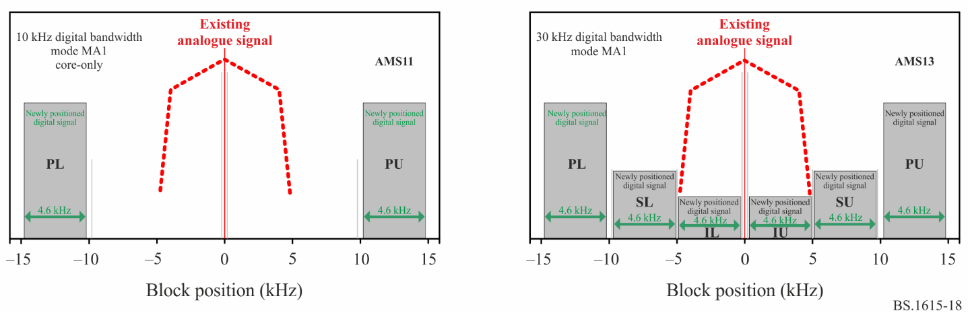
NOTE ̶ PL/SL/TL and PU/SU/TU are used for indicating lower positioning and upper positioning (respectively) of the digital block. The indication is for convenience only, and does not suggest an actual difference in the signal.
The configuration is defined by system modes and power settings, and provides various combinations of logical channels, bit rates, and protection levels.
Three different digital block-pairs or blocks may be employed. The Primary block-pair, indicated by PL (Primary Lower) and PU (Primary Upper), occupies 10-kHz, is present in all the configurations and carries logical channel P1. The Secondary block-pair, indicated by SL (Secondary Lower) and SU (Secondary Upper), may be present in the 20-kHz configuration MA3 and in the 30-kHz configuration MA1. The Tertiary block-pair, indicated by TL (Tertiary Lower) and TU (Tertiary Upper), may be present in the 30-kHz configuration MA1. Logical channel P3 is carried solely by the Secondary block-pair in the 20-kHz configuration MA3, and jointly by the Secondary block-pair and Tertiary block-pair in the 30-kHz configuration MA1.
FIGURE 19
IBOC AM system digital-only block positioning examples
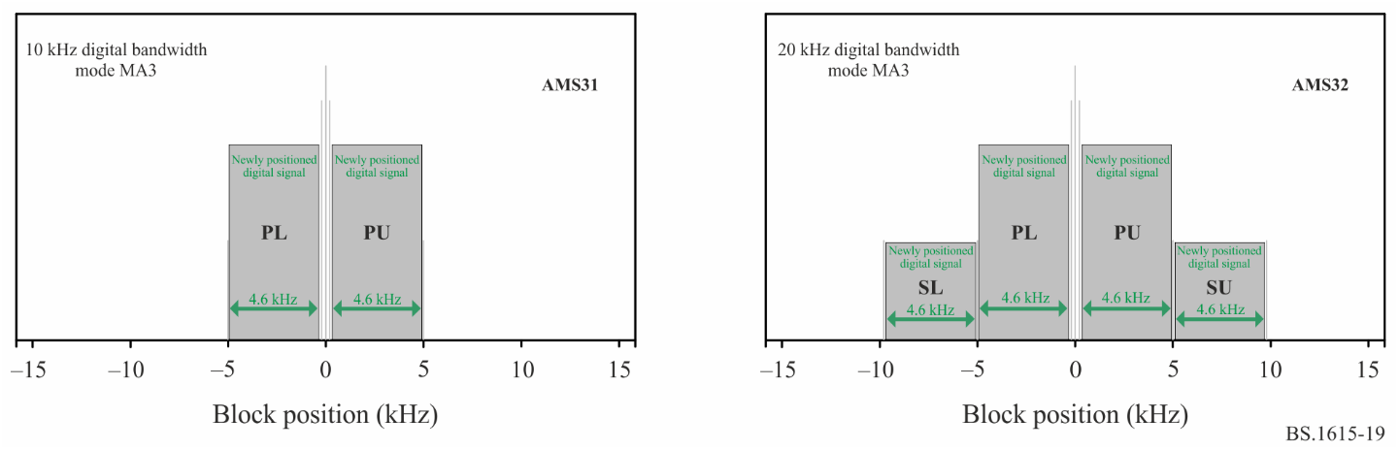
NOTE ̶ PL/SL and PU/SU are used for indicating lower positioning and upper positioning (respectively) of the digital block. The indication is for convenience only, and does not suggest an actual difference in the signal.
The essential characteristics of the IBOC system configurations (operating modes) are summarized in Table 32. Additional time-frequency information may be found in Table 33.
TABLE 32
Characteristics of various IBOC AM system operating modes
System  mode | Used  BW  (kHz) | Total⁽¹⁾  bit  rate | Channel P1 |  |  | Channel P3 |  |  | Analogue  host  signal  support | Comments
 |  |  | Code  rate | Bit⁽¹⁾  rate | Modula-  tion | Code  rate | Bit⁽¹⁾  rate | Modula-  tion |  | Interleaver  span
MA1 | 10 | 20.4 | 5/12 | 20.4 | 64 QAM | - | - | - | Yes | P1: ~4.5s
MA1⁽²⁾ | 30⁽³⁾ | 36.4 | 5/12 | 20.4 | 64 QAM | 2/3 | 16 | 16 QAM / QPSK | Yes | P1: ~4.5s  P3: ~4.5s
MA3 | 10 | 20.4 | 5/12 | 20.4 | 64 QAM | - | - | - | No | P1: ~4.5s
MA3⁽²⁾ | 20 | 40.4 | 5/12 | 20.4 | 64 QAM | 5/12 | 20 | 64 QAM | No | P1: ~4.5s  P3: ~4.5s
⁽¹⁾ The bit rates reflect the throughput (‘net’ bit rate) by the application layer, and do not include the overhead used by the physical layer.
⁽²⁾ Joint configuration of two or more digital signal block-pairs for enhanced services or features. Each digital block-pair may be adjusted independently for power level.
⁽³⁾ This value includes shared (overlapped) bandwidth with the analogue host signal.
TABLE 33
IBOC system time-frequency parameters for MF band
Parameter name | Computed value (rounded)
Symbol duration (with prefix), T_{s} | 5.805 ms
Frame duration, T_{f} | 1.486 s
OFDM subcarrier spacing, Δf | 181.7 Hz
Number of carriers | 10 kHz band: 54  20 kHz band: 104  30 kHz band: 156
Used bandwidth | 10 kHz band: 9.8 kHz  20 kHz band: 18.9 kHz  30 kHz band: 28.4 kHz

3 Minimum usable field strength

3.1 Noise level related audio protection minimum usable field strength (Legacy method)
The minimum usable field strength E_{min} for the IBOC system, using legacy audio protection noise-level-based approach, is indicated in Tables 34 to 37. All the values are rounded towards the nearest 0.5 dBµV/m.
It is noted that the minimum usable field strength is indicated for the carrier frequency (as a measurable reference). It employs the relevant carrier to digital block-pair power ratio (L_{p}, L_{st} and L_{s}, respectively).
NOTE – The value of L_{p}, L_{st} and L_{s} may vary from one configuration to another.
The reception environment and related antenna and noise considerations are further described in § 3 of Report ITU-R BS.2482.
TABLE 34
IBOC receiver minimum usable carrier field strength for hybrid configuration primary bands reception based on noise level (adjustable settings)
Reception mode |  | FX | MO | PO
Channel model symbol |  | FXWGN | UFGCS/RFGCS | FXWGN
Environment |  | Suburban/Urban | Suburban/Urban | Suburban/Urban
Speed (km/h) |  | 0 (static) | 55, 100 (driving) | 0 (quasi static)
Indicated antenna noise @10 kHz BW (dBµV/m) |  | 23.5 | 23.5 | 23.5
MA1 – 10 kHz | Minimum carrier field strength E_{min} (dBµV/m)  For receiving PL+PU | 36.5 + L_{p} | 36.5 + L_{p} | 36.5 + L_{p}
MA1 – 30 kHz | Minimum carrier field strength E_{min} (dBµV/m)  For receiving PL+PU | 36.5 + L_{p} | 36.5 + L_{p} | 36.5 + L_{p}
TABLE 35
IBOC receiver minimum usable carrier field strength for hybrid configuration secondary
and tertiary bands reception based on noise level (adjustable settings)
Reception mode |  | FX | MO | PO
Channel model symbol |  | FXWGN | UFGCS/RFGCS | FXWGN
Environment |  | Suburban/Urban | Suburban/Urban | Suburban/Urban
Speed (km/h) |  | 0 (static) | 55, 100 (driving) | 0 (quasi static)
Indicated antenna noise @10 kHz BW (dBµV/m) |  | 23.5 | 23.5 | 23.5
MA1 – 30 kHz | Minimum carrier field strength E_{min} (dBµV/m)  For receiving SL+SU and TL+TU | 34 + L_{st} | 34 + L_{st} | 34 + L_{st}
TABLE 36
IBOC receiver minimum usable carrier field strength for all digital configuration primary bands reception based on noise level (adjustable settings)
Reception mode |  | FX | MO | PO
Channel model symbol |  | FXWGN | UFGCS/RFGCS | FXWGN
Environment |  | Suburban/Urban | Suburban/Urban | Suburban/Urban
Speed (km/h) |  | 0 (static) | 55, 100 (driving) | 0 (quasi static)
Indicated antenna noise @10 kHz BW (dBµV/m) |  | 23.5 | 23.5 | 23.5
MA3 – 10 kHz | Minimum carrier field strength E_{min} (dBµV/m)  For receiving PL+PU | 36.5 + L_{p} | 36.5 + L_{p} | 36.5 + L_{p}
MA3 – 20 kHz | Minimum carrier field strength E_{min} (dBµV/m)  For receiving PL+PU | 36.5 + L_{p} | 36.5 + L_{p} | 36.5 + L_{p}
TABLE 37
IBOC receiver minimum usable carrier field strength for all digital configuration secondary bands reception based on noise level (adjustable settings)
Reception mode |  | FX | MO | PO
Channel model symbol |  | FXWGN | UFGCS/RFGCS | FXWGN
Environment |  | Suburban/Urban | Suburban/Urban | Suburban/Urban
Speed (km/h) |  | 0 (static) | 55, 100 (driving) | 0 (quasi static)
Indicated antenna noise @10 kHz BW (dBµV/m) |  | 23.5 | 23.5 | 23.5
MA3 – 20 kHz | Minimum carrier field strength E_{min} (dBµV/m)  For receiving SL+SU | 36.5 + L_{s} | 36.5 + L_{s} | 36.5 + L_{s}

3.2 Integrated receiver practice related minimum usable field strength
The minimum usable field strength E_{min} for the IBOC system, using an integrated receiver practice-based approach, is indicated in Tables 38 to 41. All the values are rounded towards the nearest 0.5 dBµV/m.
It is noted that the minimum usable field strength is indicated for the carrier frequency (as a measurable reference). It employs the relevant carrier to digital block-pair power ratio (L_{p}, L_{st} and L_{s}, respectively).
NOTE – The value of L_{p}, L_{st} and L_{s} may vary from one configuration to another.
TABLE 38
IBOC receiver minimum usable carrier field strength for hybrid configuration primary bands reception based on integrated receiver practice (adjustable settings)
Reception mode |  | FX | MO | PO
Channel model symbol |  | FXWGN | UFGCS/RFGCS | FXWGN
Environment |  | Suburban/Urban | Suburban/Urban | Suburban/Urban
Speed (km/h) |  | 0 (static) | 55, 100 (driving) | 0 (quasi static)
Antenna type |  | Air loop | Whip | Ferrite loop
Calculated receiver noise factor (dB) |  | 85 | 64.5 | 91.5
Calculated antenna noise @10 kHz BW (dBµV/m) |  | 29.5 | 9 | 36
Fading margin (dB) |  | 0 | 3 | 0
Implementation loss (dB) |  | 3 | 3 | 4
MA1 – 10 kHz | Minimum carrier field strength E_{min} (dBµV/m)  For receiving PL+PU | 45.5 + L_{p} | 28 + L_{p} | 53 + L_{p}
MA1 – 30 kHz | Minimum carrier field strength E_{min} (dBµV/m)  For receiving PL+PU | 45.5 + L_{p} | 28 + L_{p} | 53 + L_{p}
TABLE 39
IBOC receiver minimum usable carrier field strength for hybrid configuration secondary bands reception based on integrated receiver practice (adjustable settings)
Reception mode |  | FX | MO | PO
Channel model symbol |  | FXWGN | UFGCS/RFGCS | FXWGN
Environment |  | Suburban/Urban | Suburban/Urban | Suburban/Urban
Speed (km/h) |  | 0 (static) | 55, 100 (driving) | 0 (quasi static)
Antenna type |  | Air loop | Whip | Ferrite loop
Calculated receiver noise factor (dB) |  | 85 | 64.5 | 91.5
Calculated antenna noise @10 kHz BW (dBµV/m) |  | 29.5 | 9 | 36
Fading margin (dB) |  | 0 | 3 | 0
Implementation loss (dB) |  | 3 | 3 | 4
MA1 – 30 kHz | Minimum carrier field strength E_{min} (dBµV/m)  For receiving SL+SU and TL+TU | 43 + L_{st} | 25.5 + L_{st} | 50.5 + L_{st}
TABLE 40
IBOC receiver minimum usable carrier field strength for all digital configuration primary bands reception based on integrated receiver practice (adjustable settings)
Reception mode |  | FX | MO | PO
Channel model symbol |  | FXWGN | UFGCS/RFGCS | FXWGN
Environment |  | Suburban/Urban | Suburban/Urban | Suburban/Urban
Speed (km/h) |  | 0 (static) | 55, 100 (driving) | 0 (quasi static)
Antenna type |  | Air loop | Whip | Ferrite loop
Calculated receiver noise factor (dB) |  | 85 | 64.5 | 91.5
Calculated antenna noise @10 kHz BW (dBµV/m) |  | 29.5 | 9 | 36
Fading margin (dB) |  | 0 | 3 | 0
Implementation loss (dB) |  | 3 | 3 | 4
MA3 – 10 kHz | Minimum carrier field strength E_{min} (dBµV/m)  For receiving PL+PU | 45.5 + L_{p} | 28 + L_{p} | 49 + L_{p}
MA3 – 20 kHz | Minimum carrier field strength E_{min} (dBµV/m)  For receiving PL+PU | 45.5 + L_{p} | 28 + L_{p} | 49 + L_{p}
TABLE 41
IBOC receiver minimum usable carrier field strength for all digital configuration secondary bands reception based on integrated receiver practice (adjustable settings)
Reception mode |  | FX | MO | PO
Channel model symbol |  | FXWGN | UFGCS/RFGCS | FXWGN
Environment |  | Suburban/Urban | Suburban/Urban | Suburban/Urban
Speed (km/h) |  | 0 (static) | 55, 100 (driving) | 0 (quasi static)
Antenna type |  | Air loop | Whip | Ferrite loop
Calculated receiver noise factor (dB) |  | 85 | 64.5 | 91.5
Calculated antenna noise @10 kHz BW (dBµV/m) |  | 29.5 | 9 | 36
Fading margin (dB) |  | 0 | 3 | 0
Implementation loss (dB) |  | 3 | 3 | 4
MA3 – 20 kHz | Minimum carrier field strength E_{min} (dBµV/m)  For receiving SL+SU | 45.5 + L_{s} | 28 + L_{s} | 49 + L_{s}

Attachment 1
to Annex 3
Procedure for estimation of the minimum usable field strength

1 Spectrum management considerations and control
The IBOC system promotes spectrum management by allowing the introduction of digital broadcasts without the need for additional spectrum allocations. Special attention is given to allowing for adequate operation of the legacy analogue services while adding the digital signals. That includes also the prevalence of older receivers alongside with better performing newer receivers that can benefit from the digital services. Therefore, the system is often introduced with nominal power setting, but it allows for individually adjusting the power level of each digital block-pair (‘sub-bands’).
The power settings of each digital signal block-pair are provided in terms of dBc. The values indicate the ratio of the total power of the digital block-pair to the analogue (or otherwise measurable reference) carrier frequency power. Such an approach allows for hybrid signal composition to easily relate the signal components to each other in terms of power, as well as in terms of relating performance to the carrier power (being a single power parameter).
FIGURE 20
IBOC digital signal power settings for AM system mode MA1
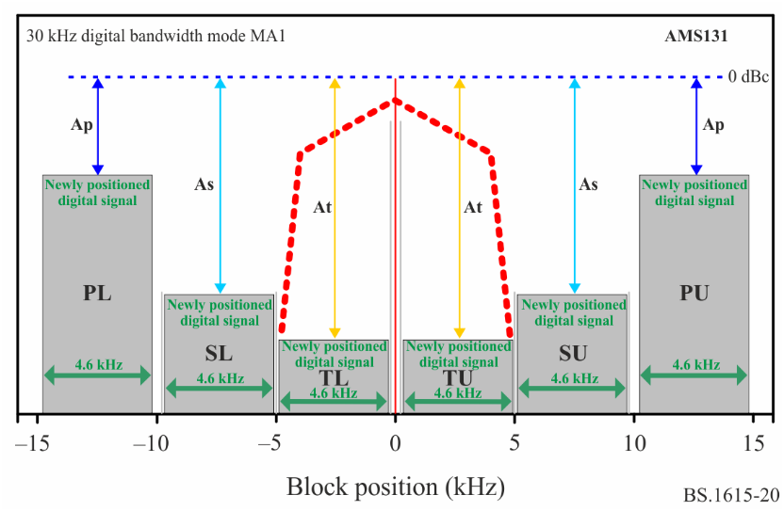
In system mode MA1, the transmitted digital power is separately defined for each block-pair. The definition is in dBc, relative to the existing analogue host carrier frequency power (which is the reference at 0 dBc). The values apply to the digital signal power density over a specified bandwidth. The specified bandwidth is typically one subcarrier bandwidth of 181.7 Hz. That bandwidth is often converted to 300 Hz in order to simplify practical settings and field measurements.
The parameters in Fig. 20 apply to the AM mode MA1 configuration as follows:
• 0 dBc indicates the analogue host carrier frequency power level
• A_{p} indicates the power density setting of the primary block-pair in dBc/181.7 Hz
• A_{s} indicates the power density setting of the secondary block-pair in dBc/181.7 Hz
• A_{t} indicates the power density setting of the tertiary block-pair in dBc/181.7 Hz
The term L_{p} indicates the ratio of the analogue frequency power to the total power of the primary digital block-pair may be calculated from the power density as follows:
$${L_{p}}_{}=-\left(A_{p}+10⋅\log\left(9200/181.7\right)\right)$$
Similarly, the ratio of the analogue carrier power to the secondary block-pair L_{s}, and tertiary block-pair L_{t} can be calculated from the power density. However, in system mode MA1, the secondary and tertiary block-pairs are only used jointly. Therefore, only the ratio L_{st} of the analogue carrier power to the joint power of these block-pairs is of interest.
FIGURE 21
IBOC digital signal power settings for AM system mode MA3
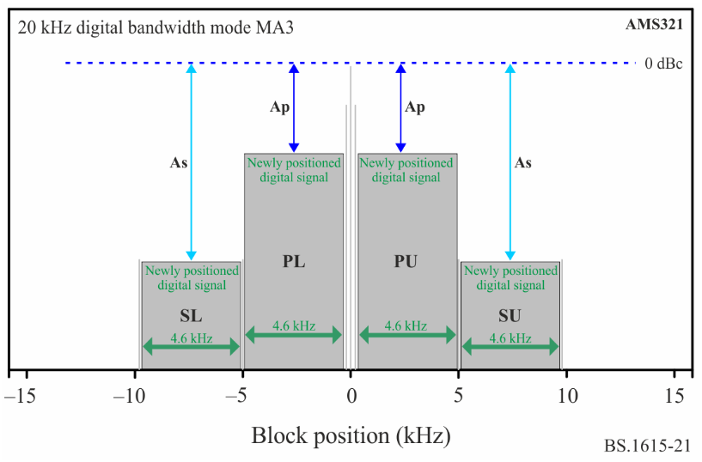
The parameters in Fig. 21 apply to the AM mode MA3 configuration as follows:
• 0 dBc indicates the power level of the included carrier frequency (at 0 Hz)
• Ap indicates the power density setting of the primary block-pair in dBc/181.7 Hz
• As indicates the power density setting of the secondary block-pair in dBc/181.7 Hz
Then for MA1,
• For the nominal settings of A_{p} = −30 dBc, L_{p} ~ 13 dB
• For the nominal settings of A_{s} = −43 dBc and A_{t} = −44 dBc ÷ −50 dBc, L_{st} ~ 24.5 dB
Then for MA3,
• For the nominal settings of A_{p} = −15 dBc, L_{p} ~ −2.5 dB
• For the nominal settings of A_{s} = −30 dBc, L_{s} ~ 12.5 dB
• For these nominal settings, the total power of the digital subcarriers (including the reference subcarriers and the PIDS subcarriers), exceeds the power of the included frequency carrier at 0 Hz by approximately 2.3 dB.
These power ratios (L_{p}, L_{s}, L_{st}) are further used for planning, thus allowing for flexibility and adjustment if and when such need arises.

2 Field strength considerations
The calculations of minimum field strength are provided twice, where each time a different approach is considered.
The first is a legacy audio protection noise-level-based approach which follows ITU-based information.
The later approach is the receiver practice approach, which applies to the highly integrated receivers and follows practical considerations as often apply to more recent receiver implementations.
Specifically, the following is noted:
• The noise driven approach solely considers the information provided by ITU documents such as Recommendation ITU-R P.368, Recommendation ITU-R P.1321, Recommendation ITU-R P.1147, Recommendation ITU-R P.372, Recommendation ITU-R BS.703, Report ITU-R SM.2055 and Recommendation ITU-R BS.415, regarding both noise sources and wave propagation.
The referenced ITU documents that provided data regarding noise were established in the 1970s and updated only to a limited degree. Technological advances in recent decades have resulted in increased man-made noise, as has been observed and indicated in certain independent (non ITU) published documents.
While certain other systems’ approaches may consider only the noise data from referenced documents for deriving the minimum usable field strength, the IBOC system’s analysis applies also a supplementary approach, where receiver design practices are considered in order to determine the reception limiting factors for a given field strength. This may be considered informative but has the potential for assisting with realistic planning regarding minimum usable field strength, rather than only referring to potentially increased noise as the sole cause for reception performance.
• Large signal variability is indicated in the referenced documents, due to the limited accuracy of the propagation analysis and due to dispersion and GCS impacts. In attempting to predict reception in mobile mode, the signal strength over a large reception area is often measured in limited size squares and/or over several static location points. While certain other systems’ approaches may consider such quasi-static information sufficient for mobile reception analysis, the IBOC system’s approach to signal reception considers ‘good’ mobile reception as the reception in motion. As a result, the IBOC system applies an additional (on top of already considered propagation and noise information) GCS-related fading margin of 3 dB to mobile reception mode for adequate reception in true motion.
• Broad industry experience with advanced and highly integrated and/or small receivers indicates that such receivers may be optimized for a wide range of functionalities other than medium wave reception. Therefore, considering implementation losses may be required. Such losses are included in the receiver practices approach for deriving the minimum usable field strength.
The IBOC system analysis for deriving field strength requirements considers the most probable usage scenarios along with conservative assumptions regarding adverse channel conditions, environmental noise (man-made), and deployment margins. Considering less conservative parameters or partial data may lead to potential reduction of more than 10 dB in minimum usable field strength requirements, which may potentially lead to inadequate planning and then inadequate reception in realistic conditions.
The various channel models, reception modes and details related to the analysis and calculations for deriving the minimum required field strength, for allowing an adequate operation of IBOC receivers, are provided in Report ITU-R BS.2482.
In certain IBOC system configurations (i.e. system modes) where both channels P1 (included in PL+PU digital block-pair) and P3 (included in SL+SU and TL+TU) are active, and where power level settings for each block-pair are different, separate requirements (CNR) are used for planning and are specifically indicated in the tables in this section.

3 Background for calculating the actual noise factor at the receiver input
Receiver sensitivity, being the minimum required signal field strength at the receiver antenna (E) is expressed as a function of the required pre-detection SNR (or C/N₀). For a given signal field strength E (µV/m) impinging upon the antenna, the C/N₀ exhibited at the receiver input is expressed as a function of the field strength, the antenna effective length h_{e}(f), the transfer function of the antenna circuit (matched) filter H_{a}(f), and the sum of noise sources comprising N₀.
For a short (length, l << λ) monopole antenna (over a ‘sufficient’ ground plane), the indicated relationship (Recommendation ITU-R P.372) between the noise field strength and the antenna noise factor is given by:
dBµV/m (1)
And for a reference point of f = 1 MHz; b = 10 kHz:
dBµV/m (2)
However, the indicated noise field is at the antenna. It is then transformed to noise voltage at the receiver input. The transformation is done by the receiver antenna circuit that is represented by the antenna factor (AF) (as resulting from the antenna effective length h_{e}(f), and the transfer function H_{a}(f)). The transformation can then be expressed by the antenna factor (AF) and by the actual noise factor at the receiver input.
dBµV/m (3)
The actual noise factor at the receiver input:
dB (4)
The actual noise factor can be calculated for specific cases where the receiver antenna circuit is defined.
For reference only, three typical receiver antennas were chosen as indicated in § 3. Then, the IBOC broadcasting-specific integrated method has been used for calculating the actual receiver noise factor. The results are indicated in Table 5.

3.1 Determining the minimum usable field strength using ITU noise related data
For each system configuration and for each reception mode, the applicable C/N₀ is defined.
The minimum usable field strength based on SNR and ITU related noise field E_{n}:
(5)
Using the conversion definitions as provided in Annex 1 (related to analogue signal bandwidth of 10 kHz), the minimum usable field strength is:
(6)
where L_{x} is the relevant power setting ratio as indicated in Attachment 1.

3.2 Determining the minimum usable field strength using receiver practice integrated method
The integrated method considers the actual receiver input noise factor (and noise field strength), specific margins related to the reception modes, and implementation losses.
Using the general format in equation (5), in addition to the factors indicated for this specific method, the expression for calculating minimum usable field strength is:
(7)
where:
L_{x} : relevant power setting ratio as indicated in Annex 3
L_{f} : fading margin as applicable to the specific reception mode
L_{im} : implementation loss as applicable to the specific receiver for the reception mode.
The reception environment and related antenna and noise considerations, are further described in Report ITU-R BS.2482.

Attachment 2
to Annex 3
Carrier to noise ratio for digital sound broadcast (DSB) IBOC System

1 Reception level
It is expected that AM IBOC digital audio streams broadcast using this standard will provide stereophonic audio free of undesirable artifacts if both the core stream and the enhanced stream have a received bit error rate (BER) of 1×10⁻⁴.
The minimum carrier-to-noise ratio (C/N₀) levels at which the expected BER of the audio stream of an AM signal will not exceed 1×10⁻⁴ are provided in Table 42. Carrier-to-noise ratio (C/N₀) is defined as the total AM unmodulated carrier power to the AWGN power spectral density.

1.1 Minimum C/N
CNR values (at f = 1 MHz) are provided for an average decoded BER of 1×10⁻⁴ as a reference operating point for providing services. These values are provided in terms of C/N₀ [dB-Hz], reflecting the ratio of the analogue (or otherwise measurable reference) carrier frequency power to the noise density (in 1 Hz).
In considering the propagation factors and noise-related information, as provided in Recommendation ITU-R P.1321, and particularly their large variability or their level of uncertainty, and based on potential (and actual) usage scenarios of various IBOC receiver types, the following approach is applied for planning:
1 A single coding rate and an interleaver span that far exceeds the indicated composite wave time span are employed (see). Therefore, no significant dependency on the wave composition variants is considered.
2 For fixed reception, only noise (ambient, man-made) is considered.
3 For mobile receivers, typical usage is more likely to be experienced in urban areas. In addition, analysis and actual tests have not shown significant differences of impact on reception, between urban conditions (55 km/h) and suburban conditions (100 km/h), with often urban environment causing more signal disruption. Therefore, urban reception conditions analysis, which employs more aggressive GCS dispersive profiles, are used for planning purposes.
4 For portable receivers, it is assumed that they are likely to be used for quasi-static reception, thus quasi-static (0 km/h) outdoor conditions. Therefore, such reception is used in conjunction with portable receivers for planning purposes. Only noise (ambient, man-made) is considered.
The signal-to-noise requirements for the IBOC system are provided in terms of C/N₀ (carrier power to noise spectral density ratio). The carrier frequency power is an easily measurable reference. These values consider the ratio of the analogue host carrier frequency power to the total power of the digital block-pair, for the hybrid configurations. Similarly, these values consider already the ratio of the transmitted carrier frequency power to the total power of the digital block-pair, for the all-digital configurations.
The ratio of the carrier frequency power to the total power of the digital block-pair may be adjusted. using the power adjustment parameters L_{p}, L_{st} and L_{s} (as defined in § 3)
The cases (and models) and their related required C/N₀ (carrier power to noise spectral density ratio) as analysed for planning purposes are provided in Table 42 for the parameter-dependent adjustable settings. All the values are rounded towards the nearest 0.5 dB-Hz.
TABLE 42
IBOC receiver required C/N₀ for various reception modes (adjustable settings)
Reception mode |  | FX | MO | PO
Channel model symbol |  | FXWGN | UFGCS/RFGCS | FXWGN
Environment |  | Suburban/Urban | Suburban/Urban | Suburban/Urban
Speed (km/h) |  | 0 (static) | 55, 100 (driving) | 0 (quasi static)
MA1 – 10 kHz | Required C/N₀  (dB–Hz)  For receiving P1 | 53 + L_{p} * | 53 + L_{p} * | 53 + L_{p} *
MA1 – 30 kHz | Required C/N₀  (dB–Hz)  For receiving P1 | 53 + L_{p} * | 53 + L_{p} * | 53 + L_{p} *
MA1 – 30 kHz | Required C/N₀  (dB–Hz)  For receiving P1 and P3 | 50.5 + L_{st} * | 50.5 + L_{st} | 50.5 + L_{st}
MA3 – 10 kHz | Required C/N₀  (dB–Hz)  For receiving P1 | 53.5 + L_{p} * | 53.5 + L_{p} * | 53.5 + L_{p} *
MA3 – 20 kHz | Required C/N₀  (dB–Hz)  For receiving P1 | 53.5 + L_{p} * | 53.5 + L_{p} * | 53.5 + L_{p} *
MA3 – 20 kHz | Required C/N₀  (dB–Hz)  For receiving P1 and P3 | 53.5 + L_{s} * | 53.5 + L_{s} * | 53.5 + L_{s} *
* Power adjustment parameter.

Attachment 3
to Annex 3
Conversion of C/N₀ to SNR for IBOC signals
The carrier-to-noise ratio, often written CNR or C/N, is the signal-to-noise ratio (SNR) of a modulated signal. The noise power N is typically defined in the signal’s processing (reception) bandwidth.
The carrier-to-noise-spectral-density ratio (C/N₀) is similar to carrier-to-noise ratio, except that the noise N₀ is defined per unit Hz bandwidth.
For AM system analysis, the carrier-to-noise-spectral-density ratio C/N₀ is being used. The analogue carrier power C is an easily measurable reference, both in analysis and in field evaluation.
    - IBOC AM conversion of C/N₀ to digital CNR or SNR example
In order to convert C/N₀ to SNR, the ratio of carrier power to digital band power C/C_{d} is used.
For example, in system configuration mode MA1-10kHz that has a single block-pair and employs 10 kHz bandwidth, with power ratio L_{p} = (C/C_{d})_{dB}
Then

Annex 4
RF protection ratios for DSB (IBOC system) at frequencies between 525 kHz and 1 705 kHz

1 Introduction
The IBOC system protection requirements for ITU Region 1 and Region 3 (9kHz spacing) and ITU Region 2 (10kHz spacing) are analysed and defined.

2 IBOC system spectral mask
The system can be configured to use multiple frequency blocks. Each frequency block occupies a nominal bandwidth of 5 kHz (actual bandwidth of approximately 4.8 kHz). Such spectral configurations are shown for hybrid signal composition in Fig. 18, and for all-digital signal composition in Fig. 19.
Ideally, it is desired to configure each matching block-pair at the same power level. However, the system supports setting the power level of each individual block. Therefore, for the purpose of defining the protection ratios, each such configuration can be analysed by each block at a time.
FIGURE 22
IBOC hybrid signal spectra – MA1 at 10 kHz used bandwidth digital signal spectra and emissions mask
and normalized analogue PSD
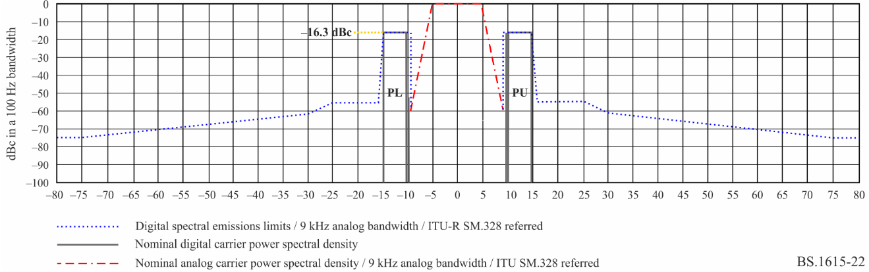
TABLE 43
IBOC digital waveform spectral emissions limits for hybrid configuration – Mode MA1
Frequency offset relative to carrier | Level relative to uniform distribution of unmodulated carrier  Recommendation ITU-R SM.328-11, § 6.3.3  (dBc per 100 Hz)
9.4 to 15 kHz offset | −16.3
15 to 15.2 kHz offset | −17.5
15.2 to 15.8 kHz offset | −28.5 − (|frequency offset in kHz| − 15.2) · 43.3
15.8 to 25 kHz offset | −54.5
25 kHz to 30.5 kHz offset | −54.5 − (|frequency offset in kHz| − 25) · 1.273
30.5 kHz to 75 kHz offset | −61.5 − (|frequency offset in kHz| − 30.5) · 0.292
> 75 kHz offset | −74.5

The spectra of one supported hybrid signal configuration, using 10 kHz bandwidth, is shown in Fig. 22. In that case, the secondary and tertiary bands are not present. Referring to Recommendation ITU-R SM.328, the emissions mask is shown for each block, and details are provided in Table 43. For protection and interference analysis, the contribution of each block may be calculated individually and then combined (if combination is still relevant, given the frequency-separated positioning). Additionally, the power level of the blocks may be set independently of each other, if considered necessary for mitigating potential interference in a specific case.
FIGURE 23
IBOC hybrid signal spectra and digital signal emissions mask – Mode MA3 at 10 kHz used bandwidth
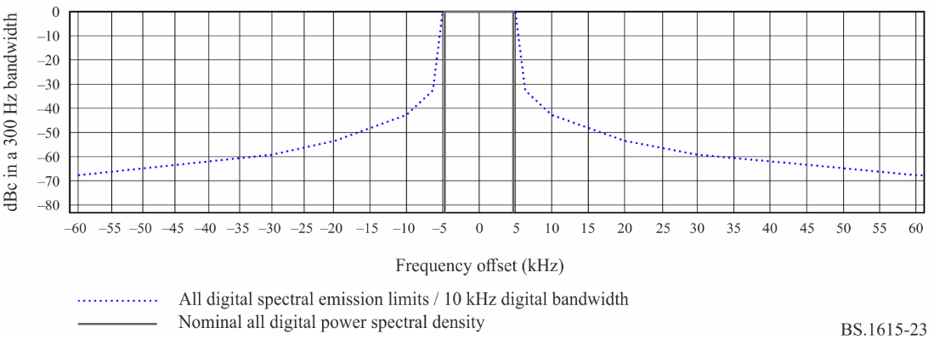
TABLE 44
IBOC digital waveform spectral emissions limits for all-digital configuration –
Mode MA3 10 kHz bandwidth
Frequency offset relative to carrier | Level relative to uniform distribution  Recommendation ITU-R SM.328-11, § 6.3.3  (dBc per 100 Hz)
0.3 kHz to 5.0 Hz offset | 0
5.0 kHz to 7.0 kHz offset | − (|frequency offset in kHz| − 5.0) · 17.35
7.0 to 10.4 kHz offset | −34.7 − (|frequency offset in kHz| − 7.0) · 2.06
10.4 to 20.0 kHz offset | −41.7 − (|frequency offset in kHz| − 10.4) · 1.25
20.0 to 30.0 kHz offset | −53.7 − (|frequency offset in kHz| − 20.0) · 0.60
30.0 to 60.0 kHz offset | −59.7 − (|frequency offset in kHz| − 30.0) · 0.27
> 60 kHz offset | −67.8

The spectra of one supported all-digital signal configuration, using 10 kHz bandwidth, is shown in Fig. 23. In that case, the secondary bands are not present. Referring to Recommendation ITU-R SM.328, the emissions mask is shown for the block-pair, and details are provided in Table 44. For protection and interference analysis, the contribution of the block-pair should be used, following by setting the power level of the block-pair accordingly. However, it is possible to calculate the contribution of each block individually and then combine the results. Then, the power level of the blocks may be set independently of each other, if considered necessary for mitigating potential interference in unique cases.
FIGURE 24
IBOC hybrid signal spectra and digital signal emissions mask – Mode MA3 at 20 kHz used bandwidth
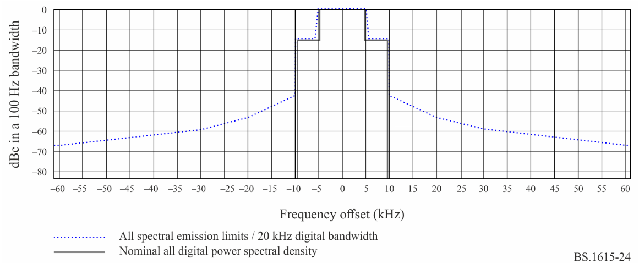
TABLE 45
IBOC digital waveform spectral emissions limits for all-digital configuration –
Mode MA3 20 kHz bandwidth
Frequency offset relative to carrier | Level relative to uniform distribution  Recommendation ITU-R SM.328-11, § 6.3.3  (dBc per 100 Hz)
0.3 kHz to 5.0 kHz offset | 0
5.0 kHz to 5.9 kHz offset | − (|frequency offset in kHz| − 5.0) · 16.67
5.9 kHz to 10.0 kHz offset | −15
10.0 to 11.2 kHz offset | −15 − (|frequency offset in kHz| − 10.0) · 23.08
11.2 to 20.0 kHz offset | −42.7 − (|frequency offset in kHz| − 11.2) · 1.25
20.0 to 30.0 kHz offset | −53.7 − (|frequency offset in kHz| − 20.0) · 0.6
30.0 to 60.0 kHz offset | −59.7 − (|frequency offset in kHz| − 30) · 0.27
> 60 kHz offset | −67.8

The spectra of higher bitrate supported all-digital signal configuration, using 20 kHz bandwidth, is shown in Fig. 24. In that case, the secondary bands are not present. Referring to Recommendation ITU-R SM.328, the emissions mask is shown for the block-pair, and details are provided in Table 45. For protection and interference analysis, the contribution of each block-pair (PL+PU and SL+SU respectively) should be used, following by setting the power level of each block-pair accordingly. However, it is possible to calculate the contribution of each block individually and then combine the results. Then, the power level of the blocks may be set independently of each other, if considered necessary for mitigating potential interference in unique cases

3 RF protection levels
For calculating the protection ratio required for the analogue AM signal, preserving the performance of the audio frequency (thus the audio protection ratio) may be considered. Recommendation ITU-R BS.560 provides the required RF signal protection ratio, which is required for ensuring the audio signal protection ratio. For Region 2, the AF protection ratio and the employed related (un-corrected) RF protection ratio is 26 dB. For Regions 1 and 3, an AF protection ratio of 30 dB, was adopted by the Regional Administrative LF/MF Broadcasting Conference for ITU Regions 1 and 3 (Geneva, 1975). The same value is used for calculating the RF protection ratio, as the AF correction is less than 1 dB.
While the IBOC system is initially associated with ITU Region 2 and its practiced protection ratios, the protection ratios have been also calculated and provided in the following Tables in respect to ITU Regions 1 and 3.
The relative RF protection ratio for AM interfered by AM follows Recommendation ITU-R BS.560 § 2, Fig. 1. The higher protection ratio demanding case of low audio compression (curve C) is used, thus ensuring sufficient protection for the highly compressed audio (curve D). The relative ratio is provided in Table 46.
TABLE 46
Relative Protection Ratio for AM interfered by AM
Desired | Undesired | F_{undesired} – F_{desired} (kHz)
 |  | −20 | −18 | −10 | −9 | 0 | +9 | +10 | +18 | +20
AM | AM | −55.4 | −53.3 | −32 | −25 | 0 | −25 | −32 | −53.3 | −55.4

3.1 Calculation methodology for interference involving analogue AM
Calculating the interference to analogue AM signals may require certain assumptions. A possible approach to calculating the interference to analogue AM signals may involve assumption regarding the parameters of a receiver filter. However, such assumption may be valid only for a given time and may not represent receiver improvements. IBOC receivers, which handles simultaneously both analogue AM and digital signals, have employed various filters, thus suggesting that assuming a specific filter (for modelling receiver performance) may be inadequate.
An alternative approach is adopted by IBOC system. It is based on a firmly defined reference broadcast waveforms for analogue AM and a long time established and field employed AM to AM interference paradigm. The approach examines the relatively added interference by the digital signal in comparison to a potentially existing (or hypothetically placed or previously existing but now removed) analogue AM signal. Employing the defined signals and familiar paradigm is assumed more reliable and sustainable for deriving the adjusted RF protection ratios.
Detailed and refined calculations of protection ratio and coloured noise modulated analogue AM spectra are already defined. For practical reason, including channel raster resolution, flow up Figures and analysis in Recommendation ITU-R BS.560 (Fig. 1) for protection requirements, Recommendation ITU-R SM.328 (Fig. 11) for spectra modelling, and Recommendation ITU-R BS.559 (Fig. 8) for objective analysis, are provided for frequency shifts (Δf) resolution of 1 kHz.
FIGURE 25
IBOC hybrid signal spectra – MA1 10kHz used bandwidth digital signal spectra and emissions mask
and coloured noise modulated analogue AM spectra
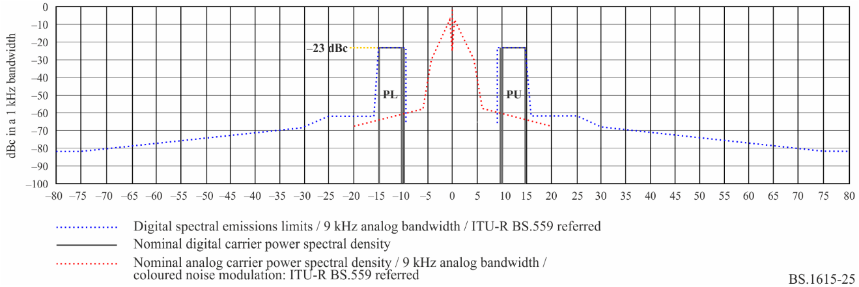
The IBOC hybrid signal in mode MA1 consists of the original analogue signal (‘host’) and a digital signal block (or block-pair). The analogue signal spectra, generated by using coloured noise for modulation, as recommended (Recommendation ITU-R BS.559), and including both digital blocks (PL and PU) and their spectral mask are shown in Fig. 25, using resolution of 1 kHz. Since the original analogue AM signal is present, the level of the digital signal PSD does not exceed -23 dBc. The level of each block can be individually reduced or set such that only one block is present.

3.2 Protection tables
The IBOC protection ratios provided in Tables 47 and 48 are based on the system and field strength definitions provided above and detailed analysis in Report ITU-R BS.2482-0.
The protection ratios in this Recommendation are representative of steady state conditions and should serve well for daytime planning. Administrations may wish to take into consideration an additional factor to compensate for sky-wave fading conditions.
TABLE 47
Relative protection ratio⁽¹⁾ for AM interfered by with IBOC waveform
Desired | Undesired | F_{undesired} – F_{desired} (kHz)
 |  | −20 | −18 | −10 | −9 | 0 | +9 | +10 | +18 | +20
AM | AM | −55.4 | −53.3 | −32 | −25 | 0 | −25 | −32 | −53.3 | −55.4
AM | MA1: PU | −37 | −30 | −4 | −4 | 0 | −25 | −32 | −53.3 | −55.4
AM | MA1: PL | −55.4 | −53.3 | −32 | −25 | 0 | −4 | −4 | −30 | −37
AM | MA3: 10 kHz | −49 | −47 | −23 | −16 | 6 | −16 | −23 | −47 | −49
AM | MA3: 20 kHz | −41 | −36 | −12 | −11 | 6 | −11 | −12 | −36 | −41
⁽¹⁾ Relative protection values are calculated based on signals spectral characteristics, before considering additional filtering by any chosen receiver filter.

TABLE 48
Relative protection ratio⁽¹⁾ for IBOC digital components of hybrid waveform
interfered with by digital components of hybrid waveform
Desired | Un-desired | F_{undesired} – F_{desired} (kHz)
 |  | −20 | −10 | 0 | +10 | +20
AM | AM | −55.4 | −32 | 0 | −32 | −55.4
Hybrid Mode MA1: PL+PU | Hybrid Mode MA1: TL+SL+PL+PU+SU+TU | <−75⁽²⁾ | −44.5 | −22.8 | −44.5 | <−75⁽²⁾
Hybrid Mode MA1: TL+SL+ SU+TU | Hybrid Mode MA1: TL+SL+PL+PU+SU+TU | −74 | −23.2 | −19 | −23.2 | −74
Hybrid Mode MA1: PL+PU | All-Digital Mode MA3: SL+PL+PU+SU | <−75⁽²⁾ | −44.2 | −28.2 | −44.2 | <−75⁽²⁾
Hybrid Mode MA1: TL+SL+ SU+TU | All-Digital Mode MA3: SL+PL+PU+SU | −74 | −23 | −28.5 | −23 | −74
All-Digital Mode MA3: PL+PU | All-Digital Mode MA3: SL+PL+PU+SU | <−75⁽²⁾ | −59 | −18 | −59 | <−75⁽²⁾
All-Digital Mode MA3: SL +SU | All-Digital Mode MA3: SL+PL+PU+SU | <−75⁽²⁾ | −59 | −18 | −59 | <−75⁽²⁾
⁽¹⁾ Relative protection values are calculated based on signals spectral characteristics, before considering additional filtering by any chosen receiver filter. Calculations are in reference to the protection requirements for analogue AM.
⁽²⁾ Results are calculated but are unlikely to be experienced in actuality due to the high range.

Attachment 1
to Annex 4
Calculation methodology for interference

1 Calculation methodology for interference involving analogue AM
Calculating the interference to analogue AM signals may require certain assumptions. A possible approach to calculating the interference to analogue AM signals may involve assumption regarding the parameters of a receiver filter. However, such assumption may be valid only for a given time and may not represent receiver improvements. IBOC receivers, which handle simultaneously both analogue AM and digital signals, have employed various filters, thus suggesting that assuming a specific filter (for modelling receiver performance) may be inadequate.
An alternative approach is adopted by IBOC system. It is based on a firmly defined reference broadcast waveforms for analogue AM and a long time established and field employed AM to AM interference paradigm. The approach examines the relatively added interference by the digital signal in comparison to a potentially existing (or hypothetically placed or previously existing but now removed) analogue AM signal. Employing the defined signals and familiar paradigm is assumed more reliable and sustainable for deriving the adjusted RF protection ratios.
Detailed and refined calculations of protection ratio and coloured noise modulated analogue AM spectra are already defined. For practical reason, including channel raster resolution, flow up Figures and analysis in Recommendation ITU-R BS.560 (Fig. 1) for protection requirements, Recommendation ITU-R SM.328 (Fig. 11) for spectra modelling, and Recommendation ITU-R BS.559 (Fig. 8) for objective analysis, are provided for frequency shifts (Δf) resolution of 1kHz.
FIGURE 26
IBOC hybrid signal spectra – MA1 10 kHz used bandwidth digital signal spectra and emissions mask and coloured noise modulated analogue AM spectra
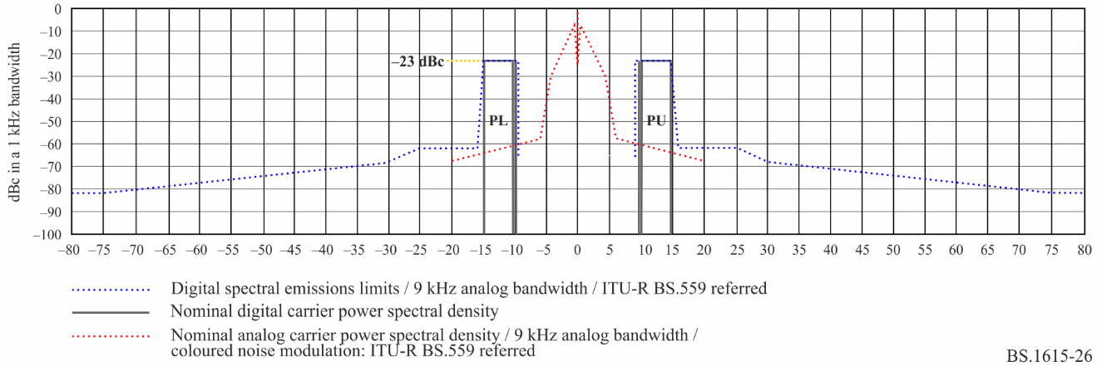

2 IBOC Interference into analogue and protection

2.1 Desired AM signal interfered by IBOC hybrid
The IBOC hybrid signal in modified mode MA1 consists of the original analogue signal (‘host’) and a digital signal block (or block-pair). The analogue signal spectra, generated by using coloured noise for modulation, as recommended (Recommendation ITU-R BS.559), and including both digital blocks (PL and PU) and their spectral mask are shown in Fig. 26, using resolution of 1 kHz. Since the original analogue AM signal is present, the level of the digital signal PSD does not exceed
−23 dBc. The level of each block can be individually reduced or set such that only one block is present.
FIGURE 27
Desired AM Signal interfered by IBOC Hybrid Signal Analogue + PU (0 Hz)
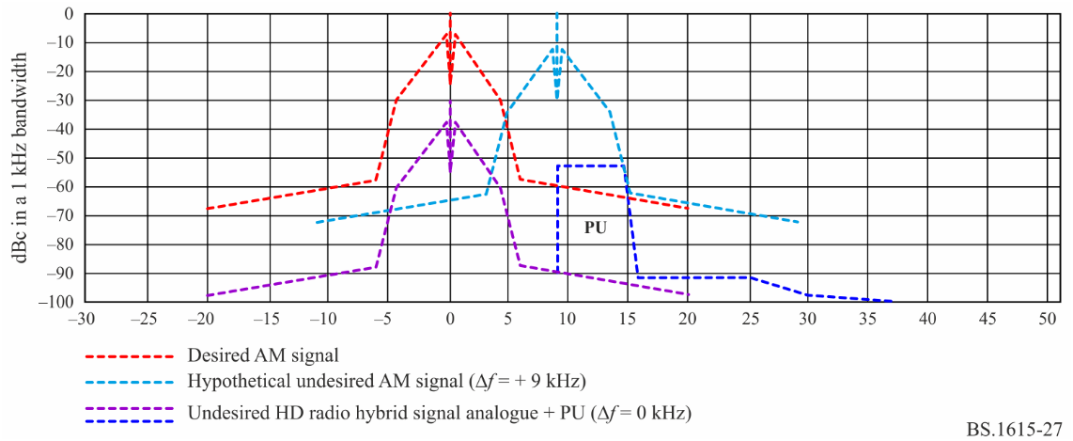
The desired analogue AM signal along with interfering IBOC hybrid signal consisting of AM and PU is shown in Fig. 27. The co-channel (shift of 0 kHz) hybrid signal is required to adhere to the AM protection ratio of 30 dB, referenced to hypothetical interfering analogue AM signal.
The digital block PU (of that interfering hybrid signal) is inherently located in the frequency band that otherwise would be interfered by a shifted analogue AM signal. Therefore, a hypothetical AM signal shifted by +9 kHz and set at the maximum allowed AM to AM protection level of 5 dB, is shown for reference. The added interference by PU is the calculated contribution of PU spectra that exceeds the spectra of hypothetical (allowed) AM interference in that band. In the specific example in Fig. 27, it can be seen that PU interference does not exceed that interference of the hypothetical AM.
FIGURE 28
Desired AM signal interfered by IBOC hybrid signal analogue + PU (10 kHz)
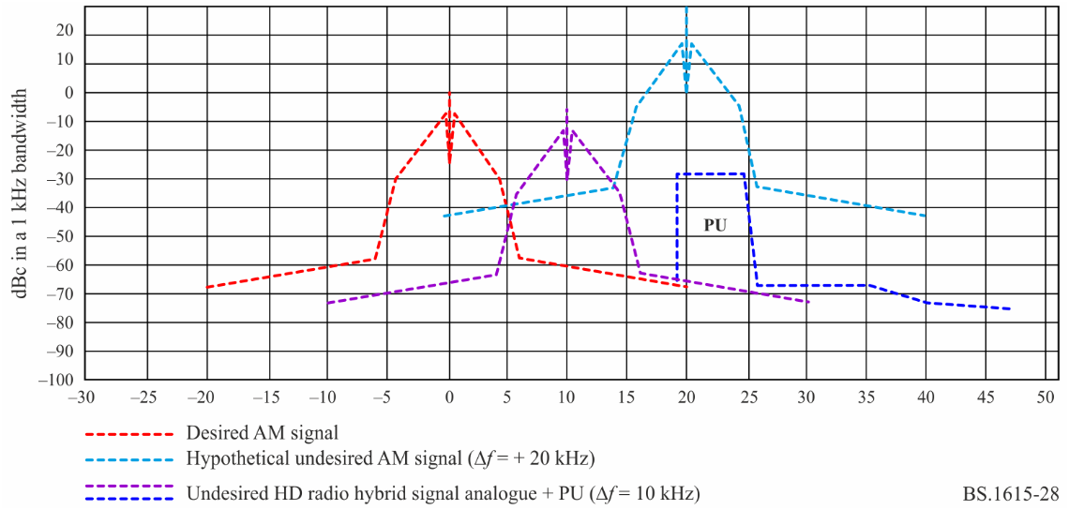
Similarly, when the undesired above IBOC hybrid signal configuration is shifted by +10 kHz, the incremental interference (if exists) overlaps with a hypothetical analogue shifted further. Therefore, the added interference (if exists) is calculated for hypothetical AM signal at any applicable shift. As can be seen (or interpreted) from Figs 27 and 28, there seems to be no added interference from PU at any frequency shift > 0 Hz, for channel spacing in multiples of 9 kHz and 10 kHz.
FIGURE 29
Desired AM signal interfered by IBOC hybrid signal analogue + PU (−9 kHz)
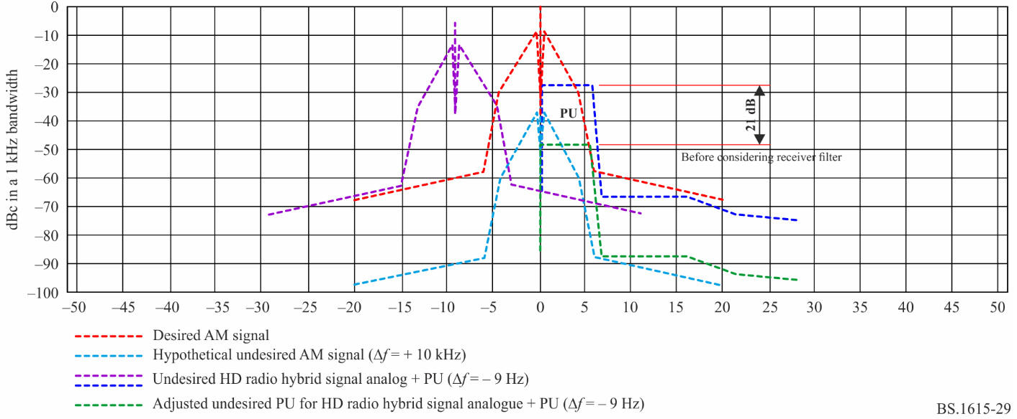
In the situation is shown in Fig. 29, the undesired IBOC hybrid signal configuration is shifted by
−9 kHz, and the analogue component is set at the allowed level of −5 dBc. The incremental interference (caused by PU) overlaps with a hypothetical interfering analogue shifted by 0 Hz. The hypothetical interfering analogue signal is adjusted by 30 dB as required for protecting the desired signal. Yet, the digital block PU (or the entire hybrid signal) must be further reduced by approximately 21 dB (to approximately 12 dB below the level of the hypothetical interfering analogue) in order for the entire integrated PU power to not exceed the interference allowed for the hypothetical signal.
It is noted that the interference is calculated without assuming the additional filtering of a receiver filter. Any given receiver filter may further reduce the interference by 1 dB to 7 dB, thus allowing to adjust (relief) the protection requirements accordingly. For example, a narrow receiver filter with a bandwidth of 2.4 kHz at −3 dB and a slope of 36 dB/Octave may further filter the interference from PU by an amount of approximately 5 dB, thus requiring the reduction of PU level by approximately 7 dB (instead of the no-filter case), and setting it at a power level similar to that of the hypothetical interfering analogue shifted by 0 Hz (i.e. −30 dBc).
FIGURE 30
Desired AM signal interfered by IBOC hybrid signal analogue + PU (−20 kHz)
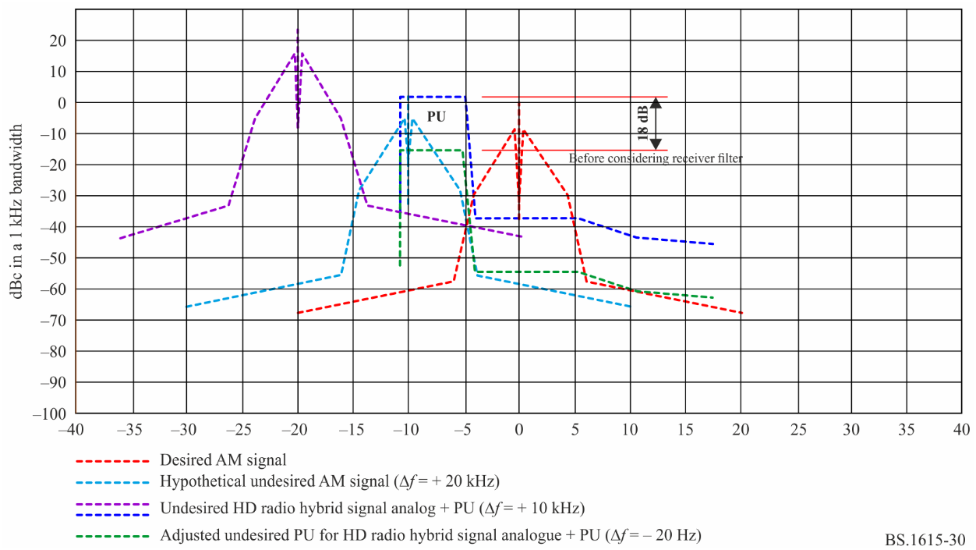
In the situation is shown in Fig. 30, the undesired IBOC hybrid signal configuration is shifted by
−20 kHz, and the analogue component is set at the allowed level of +25.4 dBc. The incremental interference (caused by PU) overlaps with a hypothetical interfering analogue shifted by −10 Hz. The hypothetical interfering analogue signal is adjusted by 30 dB as required for protecting the desired signal. Yet, the digital block PU (or the entire hybrid signal) must be further reduced by approximately 18 dB in order for the entire integrated PU power to not exceed the interference allowed for the hypothetical signal.
It is noted that the interference is calculated without assuming the additional filtering of a receiver filter. Any given receiver filter may further reduce the interference by 3 dB to 15 dB, thus allowing to adjust (relief) the protection requirements accordingly. For example, a narrow receiver filter with a bandwidth of 2.4 kHz at −3 dB and a slope of 36 dB/Octave may further filter the interference from PU by an amount of approximately 11 dB, thus requiring the reduction of PU level by approximately 7 dB (instead of the no-filter case), and setting it at a power level similar to that of the hypothetical interfering analogue shifted by −10 Hz (i.e. +2 dBc).

2.2 AM signal interfered by IBOC Digital
The desired analogue AM signal along with co-channel interfering IBOC digital signal consisting of PL and PU is shown in Fig. 31. The digital signal is configured to mode MA3 at 10 kHz bandwidth. In that specific configuration, the total power of the modulated subcarriers is approximately 2.3 dB above the power of the included un-modulated carrier (at 0 Hz). Therefore, the actual resulting spectrum of the modulated subcarrier is equivalently lowered (in reference to 0 dBc) by 2 dB.
The co-channel (shift of 0 kHz) digital signal is required to adhere to the AM protection ratio of 30 dB, referenced to hypothetical interfering analogue AM signal.
The hypothetical interfering analogue signal is adjusted by 30 dB as required for protecting the desired signal. Yet, the digital signal has to be further reduced by approximately 6 dB (Having the modulated subcarriers at approximately 8 dB below the level of the hypothetical interfering analogue) in order for the entire integrated digital signal power to not exceed the interference allowed for the hypothetical signal.
It is noted that the interference is calculated without assuming the additional filtering of a receiver filter. Any given receiver filter may further reduce the interference by 1 dB to 7 dB, thus allowing to adjust (relief) the protection requirements accordingly. For example, a narrow receiver filter with a bandwidth of 2.4 kHz at -3 dB and a slope of 36 dB/Octave may further filter the interference from PL + PU by an amount of approximately 2dB, thus requiring the reduction of digital signal by only 4 dB (instead of the no-filter case), resulting in setting the modulated subcarriers at approximately 6 dB below the level of the hypothetical interfering analogue.
FIGURE 31
Desired AM signal interfered by IBOC digital signal with 10 kHz BW (0 kHz)
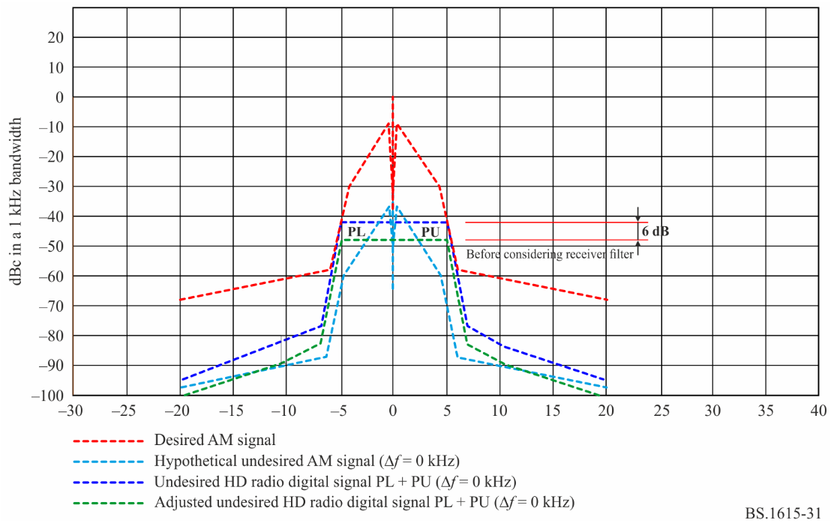
FIGURE 32
Desired AM signal interfered by IBOC digital signal with 10 kHz BW (+9 kHz)
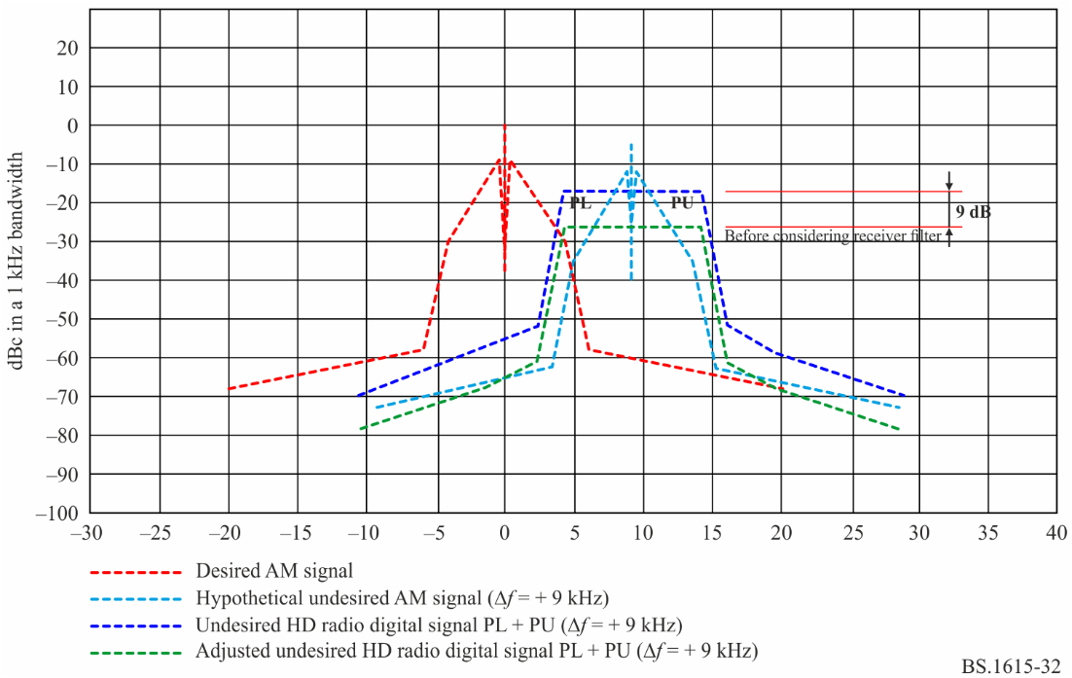
The desired analogue AM signal along with interfering IBOC digital signal consisting of PL and PU, shifted by +9 kHz, is shown in Fig. 32. The digital signal resulting spectrum of the modulated subcarrier is equivalently lowered (in reference to 0 dBc) by 2 dB.
The hypothetical interfering analogue signal, shifted by +9 kHz, and set at the allowed level of −5 dBc as required for protecting the desired signal from such analogue AM. Yet, the digital signal has to be further reduced by approximately 9 dB (having the modulated subcarriers at approximately 11 dB below the level of the hypothetical interfering analogue) in order for the entire integrated digital signal power to not exceed the interference allowed for the hypothetical signal. The adjustment consists approximately 6 dB in band excess power and approximately additional 3 dB difference between the hypothetical AM spectrum and the digital signal mask in the out-of-band range of −5 kHz to −7 kHz removed from the enter frequency of the digital interference.
It is noted that the interference is calculated without assuming the additional filtering of a receiver filter. Any given receiver filter may further reduce the interference by 2 dB to 12 dB, thus allowing to adjust (relief) the protection requirements accordingly. For example, a narrow receiver filter with a bandwidth of 2.4 kHz at −3 dB and a slope of 36 dB/Octave may further filter the interference from PL by an amount of approximately 8 dB, thus requiring the reduction of digital signal by only 1 dB (instead of the no-filter case), resulting in setting the modulated subcarriers at approximately 3 dB below the level of the hypothetical interfering analogue.
When the digital interfering signal and the hypothetical AM interference are shifted by +10 kHz and compared to the maximum allowed AM to AM interference at +10 kHz, similar relative results as for the shift by +9 kHz, may be obtained for the cases without and with assuming additional receiver filtering.
FIGURE 33
Desired AM Signal interfered by IBOC Digital Signal with 10 kHz BW (+20 kHz)
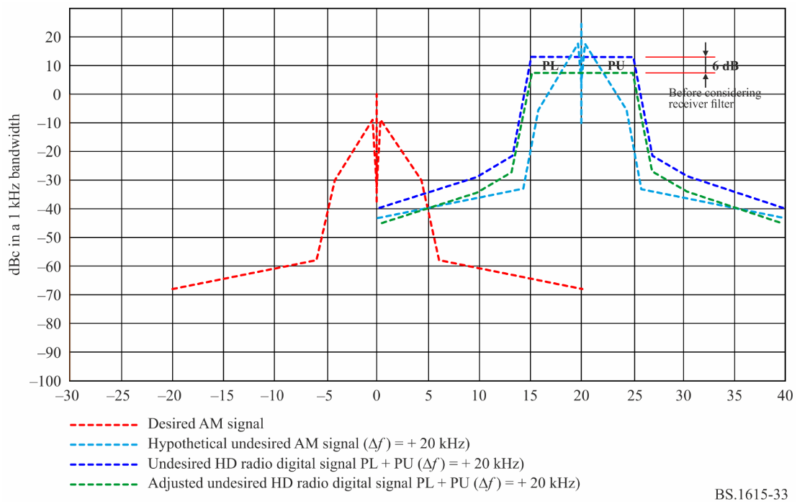
The desired analogue AM signal along with interfering IBOC digital signal consisting of PL and PU, shifted by +20 kHz, is shown in Fig. 33.
The hypothetical interfering analogue signal, shifted by +20 kHz, is set at the allowed level of +25.4 dBc as required for protecting the desired signal from such analogue AM (having the modulated subcarriers at approximately 8 dB below the level of the hypothetical interfering analogue) in order for the entire integrated digital signal power to not exceed the interference allowed for the hypothetical signal.
It is noted that the interference is calculated without assuming the additional filtering of a receiver filter. Any given receiver filter may further reduce the interference by very little, as the excess interference is caused by the slow drop of the far out-of-band signal. For example, a narrow receiver filter with a bandwidth of 2.4 kHz at −3 dB and a slope of 36 dB/Octave may further filter the interference by an amount of approximately 1 dB, resulting in setting the modulated subcarriers at approximately 7dB below the level of the hypothetical interfering analogue.
When the digital interfering signal and the hypothetical AM interference are shifted by +18 kHz and compared to the maximum allowed AM to AM interference at +18 kHz, similar relative results as for the shift by +20 kHz, may be obtained for the cases without and with assuming additional receiver filtering.
FIGURE 34
Desired AM signal interfered by IBOC digital signal with 20 kHz BW (0 kHz)
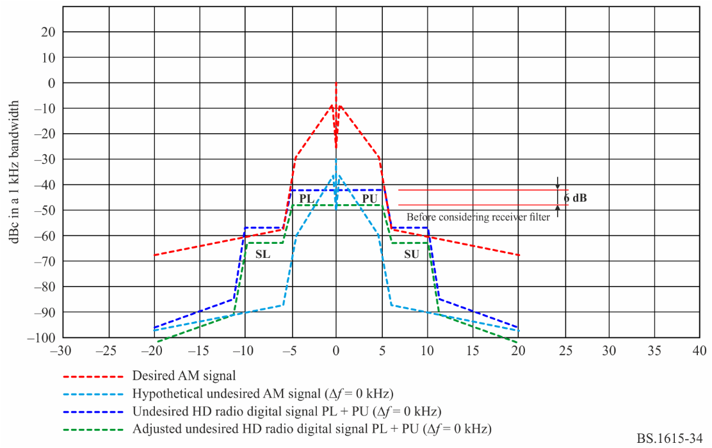
The desired analogue AM signal along with co-channel interfering IBOC digital signal consisting of SL, PL, PU and SU, is shown in Fig. 34. The digital signal is configured to mode MA3 at 20 kHz bandwidth. In that specific configuration, the total power of the modulated subcarriers is approximately 2.4 dB above the power of the included un-modulated carrier (at 0 Hz). Therefore, the actual resulting spectrum of the modulated subcarrier is equivalently lowered (in reference to 0 dBc) by approximately 2 dB.
The co-channel (shift of 0 kHz) digital signal is required to adhere to the AM protection ratio of 30 dB, referenced to hypothetical interfering analogue AM signal.
The hypothetical interfering analogue signal is adjusted by 30 dB as required for protecting the desired signal. Yet, the digital signal has to be further reduced by approximately 6 dB (Having the modulated subcarriers PL + PU at approximately 8 dB below the level of the hypothetical interfering analogue) in order for the entire integrated digital signal power to not exceed the interference allowed for the hypothetical signal.
It is noted that the interference is calculated without assuming the additional filtering of a receiver filter. Any given receiver filter may further reduce the interference by 1 dB to 7 dB, thus allowing to adjust (relief) the protection requirements accordingly. For example, a narrow receiver filter with a bandwidth of 2.4 kHz at −3 dB and a slope of 36 dB/Octave may further filter the interference from the digital signal (caused nearly solely by PL + PU) by an amount of approximately 2 dB, thus requiring the reduction of digital signal by only 4 dB (instead of the no-filter case), resulting in setting the modulated PL + PU subcarriers at approximately 6 dB below the level of the hypothetical interfering analogue.
FIGURE 35
Desired AM signal interfered by IBOC digital signal with 20 kHz BW (+9 kHz)
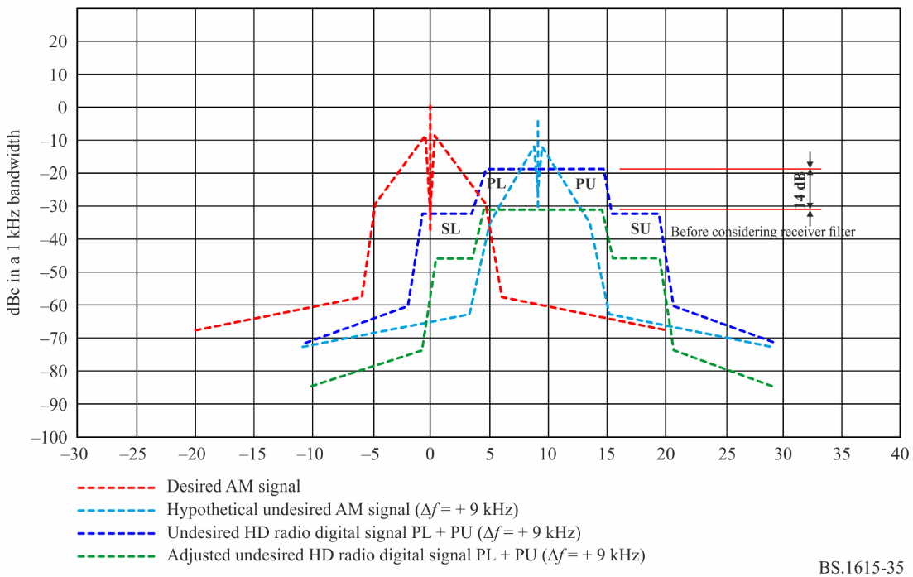
The desired analogue AM signal along with interfering IBOC digital signal consisting of PL and PU, shifted by +9 kHz, is shown in Fig. 35. The digital signal resulting spectrum of the modulated subcarrier is equivalently lowered (in reference to 0 dBc) by 2 dB.
The hypothetical interfering analogue signal, shifted by +9 kHz, and set at the allowed level of -5 dBc as required for protecting the desired signal from such analogue AM. Yet, the digital signal has to be further reduced by approximately 14 dB (Having the modulated subcarriers PL + PU at approximately 16 dB below the level of the hypothetical interfering analogue) in order for the entire integrated digital signal power to not exceed the interference allowed for the hypothetical signal. The adjustment is required mostly due to the level of SL, which is perceived as co-channel. Residual interference is caused by the digital signal mask in the out-of-band range of −5 kHz to −5.9 kHz removed from the enter frequency of the digital interference.
It is noted that the interference is calculated without assuming the additional filtering of a receiver filter. Any given receiver filter may further reduce the interference very little, thus barely allowing to adjust (relief) the protection requirements. For example, a narrow receiver filter with a bandwidth of 2.4 kHz at −3 dB and a slope of 36 dB/Octave may further filter the interference from PL by an amount of approximately 8 dB, thus requiring the reduction of digital signal by only 1 dB (instead of the no-filter case), resulting in setting the modulated subcarriers at approximately 3 dB below the level of the hypothetical interfering analogue.
When the digital interfering signal and the hypothetical AM interference are shifted by +10 kHz and compared to the maximum allowed AM to AM interference at +10 kHz, the interference from SL may be reduced by up to 1 dB comparing to that for the shift by +9 kHz. Receiver filtering may not help with reducing the interference noticeably.
FIGURE 36
Desired AM signal interfered by IBOC digital signal with 20 kHz BW (+20 kHz)
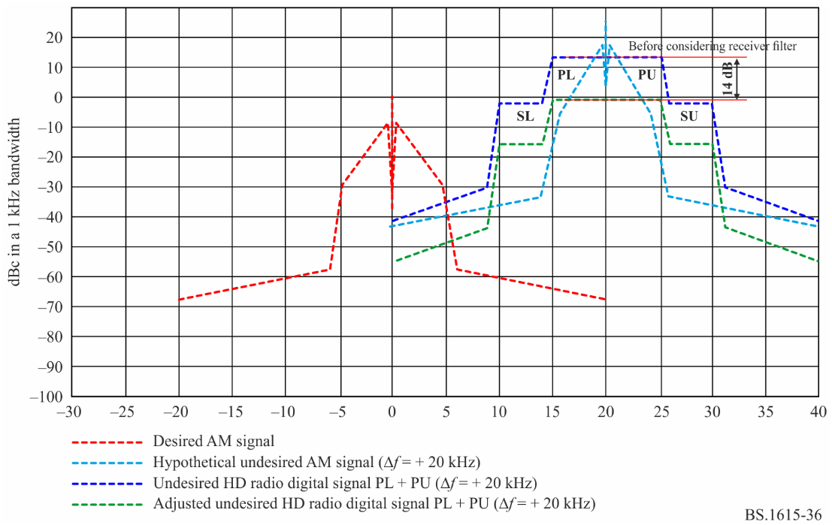

As far as the minimum usable field strength values given in Annex 1 related to the tropical broadcasting bands are concerned, these values are a first approximation and field tests will be needed to verify these values.
Psophometric weighting according to Recommendation ITU-R BS.468.
These parameters were chosen to approximate the calculated RF protection ratios to the measured values.
As modern AM receiver, a receiver with an AF bandwidth of 2.2 kHz and a selectivity curve having a slope of 35 dB/octave is used. This leads to an attenuation of about 41.5 dB at 5 kHz frequency separation (see Fig. 11b). The choice of such a receiver is based on measurements of 27 AM receivers performed by “Deutsche Welle” during the time period between 1989 and 1997.
Psophometric weighting according to Recommendation ITU-R BS.468.
The IBOC system is implemented and referenced in ITU Region 2 as HD Radio™ System.
The IBOC system is implemented and referenced in ITU Region 2 as HD Radio™ System.

