International Telecommunication Union
Telecommunication Standardization Bureau

Geneva, 1 May 2013

Ref:  Tel:  Fax:  E-mail: | TSB AAP-10  AAP/MJ  +41 22 730 5860  +41 22 730 5853  tsbdir@itu.int | – To Administrations of Member States of the Union;  – To ITU-T Sector Members;  – To ITU-T Associates  Copy:  – To the ITU-T Study Group Chairmen and Vice-Chairmen;  – To the Director of the Telecommunication Development Bureau;  – To the Director of the Radiocommunication Bureau

Subject: | Situation concerning Recommendations under the Alternative Approval Process (AAP)

Dear Sir/Madam,
The Alternative Approval Process (AAP) defined in Rec. ITU-T A.8 applies to Recommendations which do not have policy or regulatory implications and which, therefore, do not require formal consultation of Member States (see ITU Convention 246B).
Annex 1 lists those texts whose status has changed compared with previous TSB AAP Announcements.
If you wish to submit a comment relative to a Recommendation under AAP, you are encouraged to use the on-line AAP comment submission form available on the page of the Recommendation in the AAP area of the ITU-T website at http://www.itu.int/ITU-T/aap (see Annex 2). Alternatively, comments can be submitted by completing the form in Annex 3 and sending it to the secretariat of the concerned study group.
Please note that comments that simply support adoption of the text in question are not encouraged.
Yours faithfully,
Malcolm Johnson
Director of the Telecommunication Standardization Bureau
Annexes: 3

Annex 1
(to TSB AAP-10)

Status codes used in the AAP announcements:
LC = Last Call
LJ = Last Call Judgment (includes comment resolution)
AR = Additional Review
AJ = Additional Review Judgment (includes comment resolution)
SG = For Study Group approval
A = Approved
AT = Approved with typographic corrections
AC = Approved after Additional Review of Comments
NA = Not approved
TAP = Moved to TAP (ITU-T A.8 / § 5.2)
ITU-T website entry page:
http://www.itu.int/ITU-T
Alternative approval process (AAP) welcome page:
http://www.itu.int/ITU-T/aapinfo
Note – A tutorial on the ITU-T AAP application is available under the AAP welcome page
ITU-T website AAP Recommendation search page:
http://www.itu.int/ITU-T/aap/
Study Group web pages and contacts:
SG 2 | http://www.itu.int/ITU-T/studygroups/com02 | tsbsg2@itu.int
SG 3 | http://www.itu.int/ITU-T/studygroups/com03 | tsbsg3@itu.int
SG 5 | http://www.itu.int/ITU-T/studygroups/com05 | tsbsg5@itu.int
SG 9 | http://www.itu.int/ITU-T/studygroups/com09 | tsbsg9@itu.int
SG 11 | http://www.itu.int/ITU-T/studygroups/com11 | tsbsg11@itu.int
SG 12 | http://www.itu.int/ITU-T/studygroups/com12 | tsbsg12@itu.int
SG 13 | http://www.itu.int/ITU-T/studygroups/com13 | tsbsg13@itu.int
SG 15 | http://www.itu.int/ITU-T/studygroups/com15 | tsbsg15@itu.int
SG 16 | http://www.itu.int/ITU-T/studygroups/com16 | tsbsg16@itu.int
SG 17 | http://www.itu.int/ITU-T/studygroups/com17 | tsbsg17@itu.int

Situation concerning Study Group 11 Recommendations under AAP
Rec # | Title | Last Call (LC) Period |  |  |  | Additional Review (AR) Period |  |  |  | Status
 |  | LC Start | LC End | LC  Result | LJ  Result | AR Start | AR End | AR  Result | AJ  Result
Q.3942.1 (Q. IMS Net. Conf-TIP-TIR PICS Rel 10) | Terminating Identification Restriction (TIR) using IP Multimedia (IM) Core Network (CN) subsystem; Conformance Test Specification;" Part 1: Protocol Implementation Conformance Statement (PICS)" | 2013-04-01 | 2013-04-28 | A |  |  |  |  |  | A
Q.3943.1 (Q. IMS Net. Conf-OIP-OIR PICS Rel.10) | Originating Identification Presentation (OIP) and Originating Identification Restriction (OIR) using IP Multimedia (IM) Core Network (CN) subsystem; Conformance Tests Specification; Part 1: Protocol Implementation Conformance Statement (PICS) | 2013-04-01 | 2013-04-28 | A |  |  |  |  |  | A
Q.3943.2 (Q. IMS Net. Conf-OIP-OIR TSS-TP Rel. 10) | Originating Identification Presentation (OIP) and Originating Identification Restriction (OIR) using IP Multimedia (IM) Core Network (CN) subsystem; Conformance Tests Specification, Network side; Part 2: Test Suite Structure and Test Purposes (TSS&TP) | 2013-04-01 | 2013-04-28 | A |  |  |  |  |  | A
Q.3943.3 (Q. IMS User Conf-OIP-OIR PICS Rel.10) | Originating Identification Presentation (OIP) and Originating Identification Restriction (OIR) using IP Multimedia (IM) Core Network (CN) subsystem; Conformance Tests Specification; User side; Part 3: Test Suite Structure and Test Purposes (TSS&TP) | 2013-04-01 | 2013-04-28 | A |  |  |  |  |  | A
Q.3946.2 (Q.39xx-2) | IETF SIP RFC3261 Conformance Tests Specification; Part 2: Test Suite Structure and Test Purposes (TSS&TP) | 2013-04-01 | 2013-04-28 | A |  |  |  |  |  | A
Situation concerning Study Group 13 Recommendations under AAP
Rec # | Title | Last Call (LC) Period |  |  |  | Additional Review (AR) Period |  |  |  | Status
 |  | LC Start | LC End | LC  Result | LJ  Result | AR Start | AR End | AR  Result | AJ  Result
Y.3501 (Y.ccf) | Cloud computing framework and high-level requirements | 2013-03-16 | 2013-04-12 | LJ | AR | 2013-05-01 | 2013-05-21 |  |  | AR
Y.3510 (Y.ccinfra) | Cloud computing infrastructure requirements | 2013-03-16 | 2013-04-12 | LJ | AR | 2013-05-01 | 2013-05-21 |  |  | AR
Situation concerning Study Group 15 Recommendations under AAP
Rec # | Title | Last Call (LC) Period |  |  |  | Additional Review (AR) Period |  |  |  | Status
 |  | LC Start | LC End | LC  Result | LJ  Result | AR Start | AR End | AR  Result | AJ  Result
G.993.2 (2011) Amd.3 | Very high speed digital subscriber line transceivers 2 (VDSL2): Amendment 3 | 2013-02-16 | 2013-03-15 | AR |  | 2013-04-01 | 2013-04-21 | AC |  | AC
G.993.5 (2010) Amd.3 | Self-FEXT cancellation (vectoring) for use with VDSL2 transceivers: Amendment 3 | 2013-02-16 | 2013-03-15 | AR |  | 2013-04-01 | 2013-04-21 | AC |  | AC
G.997.1 (2012) Amd.2 | Physical layer management for digital subscriber line transceivers: Amendment 2 | 2013-02-16 | 2013-03-15 | AR |  | 2013-04-01 | 2013-04-21 | AC |  | AC

Annex 2
(to TSB AAP-10)
Using the on-line comment submission form
Comment submission
1) Go to AAP search Web page at http://www.itu.int/ITU-T/aap/
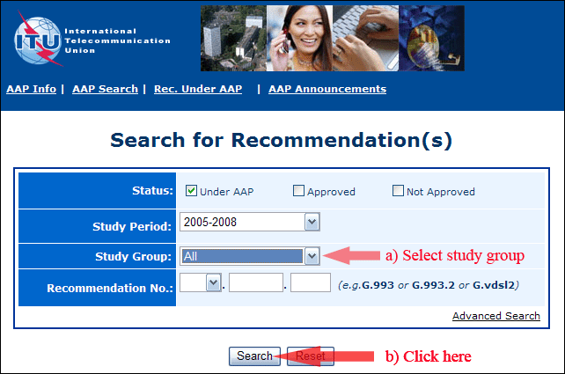
2) Select your Recommendation
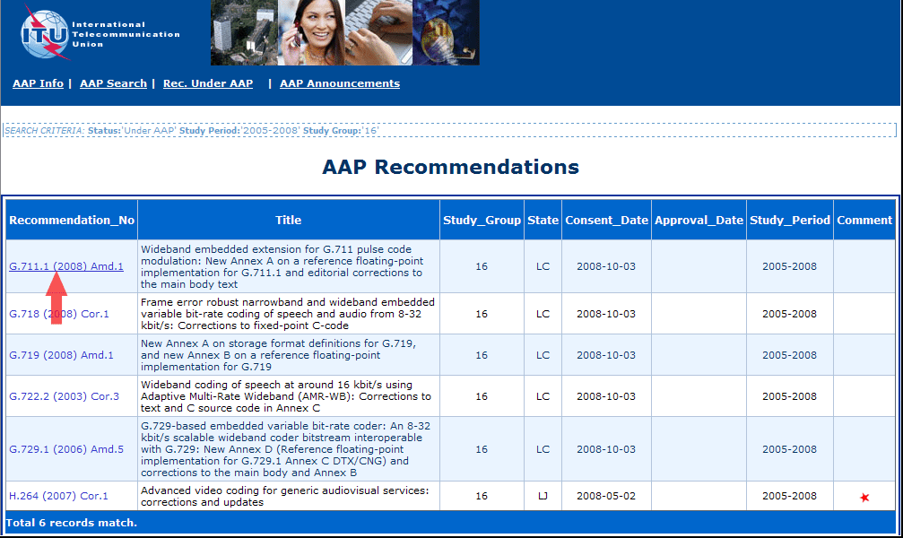
3) Click the "Submit Comment" button
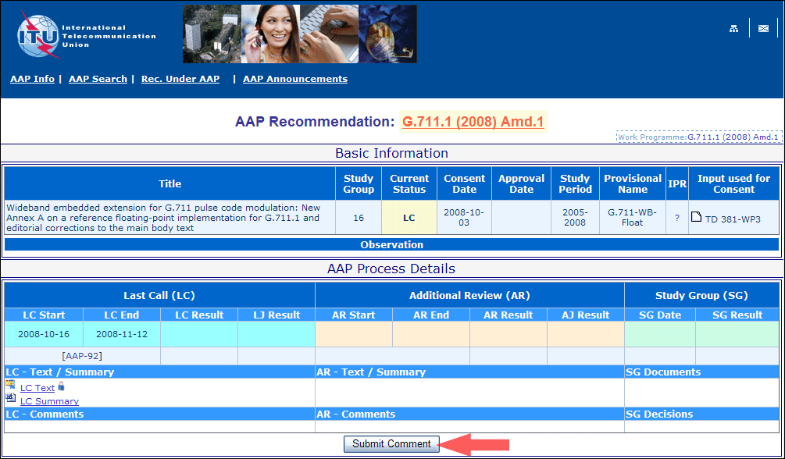
4) Complete the on-line form and click on "Submit"
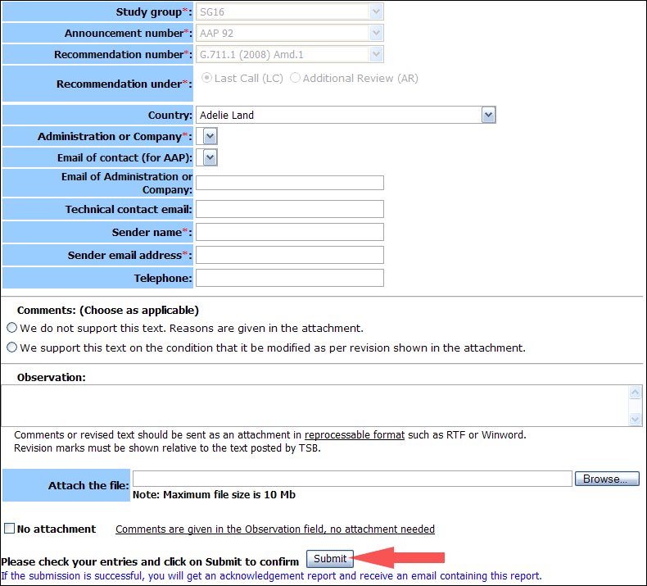
For more information, read the AAP tutorial on:
http://www.itu.int/ITU-T/aapinfo/files/AAPTutorial.pdf
Annex 3
(to TSB AAP-10)
Recommendations under LC/AR – Comment submission form
(Separate form for each Recommendation being commented upon)
ITU-T AAP comment submission form for the period 2009-2012
Study Group:
Announcement number:
Recommendation number:
Recommendation under: | Last call (LC)  Additional Review (AR)
Country:
Administration/Company:
Name of AAP Contact Person:
Email of AAP Contact Person:
Sender name:
(if different from AAP Contact Person)
Sender email address:
Telephone:
Comments:  (Choose as applicable) | We do not support this text. Reasons are given in the attachment.  We support this text on the condition that it be modified as per revision shown in the attachment.
Observations:
No attachment: Comments are given in the Observation field, no attachment needed
To be returned to: email: tsbsg....@itu.int
[or fax +41 22 730 5853]
Comments or revised text should be sent as an attachment in RTF or WinWord format.
Revision marks must be shown relative to the text posted by TSB.

