International Telecommunication Union
Telecommunication Standardization Bureau

Geneva, 1 April 2013

Ref:  Tel:  Fax:  E-mail: | TSB AAP-8  AAP/MJ  +41 22 730 5860  +41 22 730 5853  tsbdir@itu.int | – To Administrations of Member States of the Union;  – To ITU-T Sector Members;  – To ITU-T Associates  Copy:  – To the ITU-T Study Group Chairmen and Vice-Chairmen;  – To the Director of the Telecommunication Development Bureau;  – To the Director of the Radiocommunication Bureau

Subject: | Situation concerning Recommendations under the Alternative Approval Process (AAP)

Dear Sir/Madam,
The Alternative Approval Process (AAP) defined in Rec. ITU-T A.8 applies to Recommendations which do not have policy or regulatory implications and which, therefore, do not require formal consultation of Member States (see ITU Convention 246B).
Annex 1 lists those texts whose status has changed compared with previous TSB AAP Announcements.
If you wish to submit a comment relative to a Recommendation under AAP, you are encouraged to use the on-line AAP comment submission form available on the page of the Recommendation in the AAP area of the ITU-T website at http://www.itu.int/ITU-T/aap (see Annex 2). Alternatively, comments can be submitted by completing the form in Annex 3 and sending it to the secretariat of the concerned study group.
Please note that comments that simply support adoption of the text in question are not encouraged.
Yours faithfully,
Malcolm Johnson
Director of the Telecommunication Standardization Bureau
Annexes: 3

Annex 1
(to TSB AAP-8)

Status codes used in the AAP announcements:
LC = Last Call
LJ = Last Call Judgment (includes comment resolution)
AR = Additional Review
AJ = Additional Review Judgment (includes comment resolution)
SG = For Study Group approval
A = Approved
AT = Approved with typographic corrections
AC = Approved after Additional Review of Comments
NA = Not approved
TAP = Moved to TAP (ITU-T A.8 / § 5.2)
ITU-T website entry page:
http://www.itu.int/ITU-T
Alternative approval process (AAP) welcome page:
http://www.itu.int/ITU-T/aapinfo
Note – A tutorial on the ITU-T AAP application is available under the AAP welcome page
ITU-T website AAP Recommendation search page:
http://www.itu.int/ITU-T/aap/
Study Group web pages and contacts:
SG 2 | http://www.itu.int/ITU-T/studygroups/com02 | tsbsg2@itu.int
SG 3 | http://www.itu.int/ITU-T/studygroups/com03 | tsbsg3@itu.int
SG 5 | http://www.itu.int/ITU-T/studygroups/com05 | tsbsg5@itu.int
SG 9 | http://www.itu.int/ITU-T/studygroups/com09 | tsbsg9@itu.int
SG 11 | http://www.itu.int/ITU-T/studygroups/com11 | tsbsg11@itu.int
SG 12 | http://www.itu.int/ITU-T/studygroups/com12 | tsbsg12@itu.int
SG 13 | http://www.itu.int/ITU-T/studygroups/com13 | tsbsg13@itu.int
SG 15 | http://www.itu.int/ITU-T/studygroups/com15 | tsbsg15@itu.int
SG 16 | http://www.itu.int/ITU-T/studygroups/com16 | tsbsg16@itu.int
SG 17 | http://www.itu.int/ITU-T/studygroups/com17 | tsbsg17@itu.int

Situation concerning Study Group 2 Recommendations under AAP
Rec # | Title | Last Call (LC) Period |  |  |  | Additional Review (AR) Period |  |  |  | Status
 |  | LC Start | LC End | LC  Result | LJ  Result | AR Start | AR End | AR  Result | AJ  Result
M.1400 | Designations for interconnections among operators networks | 2013-02-16 | 2013-03-15 | A |  |  |  |  |  | A
M.3349 (M.sp-life-req) | Requirements for service and product lifecycle management across the business to business interfaces | 2013-02-16 | 2013-03-15 | A |  |  |  |  |  | A
M.3705 (M.log-neutral) | Common management services - Log Management - Requirements and Analysis - Protocol Neutral Requirements and Analysis | 2013-02-16 | 2013-03-15 | A |  |  |  |  |  | A
Q.818 Corrigendum 1 | Web-Services based Management Services - Corrigendum 1 | 2013-02-16 | 2013-03-15 | AT |  |  |  |  |  | AT
X.782 Corrigendum 1 | Guidelines for defining web services for managed objects and management interfaces - Corrigendum 1 | 2013-02-16 | 2013-03-15 | AT |  |  |  |  |  | AT
Situation concerning Study Group 5 Recommendations under AAP
Rec # | Title | Last Call (LC) Period |  |  |  | Additional Review (AR) Period |  |  |  | Status
 |  | LC Start | LC End | LC  Result | LJ  Result | AR Start | AR End | AR  Result | AJ  Result
K.44 (2012) Cor.1 (2013-02) (K.44 Corrigendum) | Resistibility tests for telecommunication equipment exposed to overvoltages and overcurrents – Basic Recommendation - Corrigendum 1 | 2013-02-16 | 2013-03-15 | A |  |  |  |  |  | A
Situation concerning Study Group 11 Recommendations under AAP
Rec # | Title | Last Call (LC) Period |  |  |  | Additional Review (AR) Period |  |  |  | Status
 |  | LC Start | LC End | LC  Result | LJ  Result | AR Start | AR End | AR  Result | AJ  Result
Q.3942.1 (Q. IMS Net. Conf-TIP-TIR PICS Rel 10) | Terminating Identification Restriction (TIR) using IP Multimedia (IM) Core Network (CN) subsystem; Conformance Test Specification;" Part 1: Protocol Implementation Conformance Statement (PICS)" | 2013-04-01 | 2013-04-28 |  |  |  |  |  |  | LC
Q.3943.1 (Q. IMS Net. Conf-OIP-OIR PICS Rel.10) | Originating Identification Presentation (OIP) and Originating Identification Restriction (OIR) using IP Multimedia (IM) Core Network (CN) subsystem; Conformance Tests Specification; Part 1: Protocol Implementation Conformance Statement (PICS) | 2013-04-01 | 2013-04-28 |  |  |  |  |  |  | LC
Q.3943.2 (Q. IMS Net. Conf-OIP-OIR TSS-TP Rel. 10) | Originating Identification Presentation (OIP) and Originating Identification Restriction (OIR) using IP Multimedia (IM) Core Network (CN) subsystem; Conformance Tests Specification, Network side; Part 2: Test Suite Structure and Test Purposes (TSS&TP) | 2013-04-01 | 2013-04-28 |  |  |  |  |  |  | LC
Q.3943.3 (Q. IMS User Conf-OIP-OIR PICS Rel.10) | Originating Identification Presentation (OIP) and Originating Identification Restriction (OIR) using IP Multimedia (IM) Core Network (CN) subsystem; Conformance Tests Specification; User side; Part 3: Test Suite Structure and Test Purposes (TSS&TP) | 2013-04-01 | 2013-04-28 |  |  |  |  |  |  | LC
Q.3946.2 (Q.39xx-2) | IETF SIP RFC3261 Conformance Tests Specification; Part 2: Test Suite Structure and Test Purposes (TSS&TP) | 2013-04-01 | 2013-04-28 |  |  |  |  |  |  | LC
Situation concerning Study Group 15 Recommendations under AAP
Rec # | Title | Last Call (LC) Period |  |  |  | Additional Review (AR) Period |  |  |  | Status
 |  | LC Start | LC End | LC  Result | LJ  Result | AR Start | AR End | AR  Result | AJ  Result
G.993.2 (2011) Amd.3 | Very high speed digital subscriber line transceivers 2 (VDSL2): Amendment 3 | 2013-02-16 | 2013-03-15 | AR |  | 2013-04-01 | 2013-04-21 |  |  | AR
G.993.5 (2010) Amd.3 | Self-FEXT cancellation (vectoring) for use with VDSL2 transceivers: Amendment 3 | 2013-02-16 | 2013-03-15 | AR |  | 2013-04-01 | 2013-04-21 |  |  | AR
G.996.2 (2009) Amd.3 | Line testing for digital subscriber lines (DSL): Amendment 3 | 2013-02-16 | 2013-03-15 | A |  |  |  |  |  | A
G.997.1 (2012) Amd.2 | Physical layer management for digital subscriber line transceivers: Amendment 2 | 2013-02-16 | 2013-03-15 | AR |  | 2013-04-01 | 2013-04-21 |  |  | AR
G.998.4 (2010) Cor.5 | Improved impulse noise protection for DSL transceivers: Corrigendum 5 | 2013-02-16 | 2013-03-15 | A |  |  |  |  |  | A
G.9902 (2012) Amd.1 | Narrow-band orthogonal frequency division multiplexing power line communication ransceivers for ITU-T G.hnem networks: Amendment 1 | 2013-02-16 | 2013-03-15 | A |  |  |  |  |  | A
G.9903 (2012) Amd.1 | Narrow-band orthogonal frequency division multiplexing power line communication transceivers for G3-PLC networks: Amendment 1 | 2013-02-16 | 2013-03-15 | LJ |  |  |  |  |  | LJ
G.9961 (2010) Cor.2 (G.hn) | Unified high-speed wire-line based home networking transceivers - Data link layer specification: Corrigendum 2 | 2013-02-16 | 2013-03-15 | LJ |  |  |  |  |  | LJ
G.9962 (G.hn) | Unified high-speed wire-line based home networking transceivers - Management specification | 2013-02-16 | 2013-03-15 | LJ |  |  |  |  |  | LJ
Situation concerning Study Group 16 Recommendations under AAP
Rec # | Title | Last Call (LC) Period |  |  |  | Additional Review (AR) Period |  |  |  | Status
 |  | LC Start | LC End | LC  Result | LJ  Result | AR Start | AR End | AR  Result | AJ  Result
F.747.3 (F.USN-NRP) | Requirements and functional model for ubiquitous network robot platform to support USN applications and services | 2013-02-16 | 2013-03-15 | A |  |  |  |  |  | A
G.718 (2008) Amd.3 (G.718-SWB-Float) | Variable bit rate embedded coding of speech signals: New Annex C with an alternative floating-point implementation of the superwideband monaural extension | 2013-02-16 | 2013-03-15 | A |  |  |  |  |  | A
G.729.1 (2006) Amd.8 (G.729.1-SWB-Float) | G.729-based embedded variable bit-rate coder: An 8-32 kbit/s scalable wideband coder bitstream interoperable with G.729: New Annex G with an alternative floating-point implementation of the superwideband monaural extension | 2013-02-16 | 2013-03-15 | A |  |  |  |  |  | A
H.225.0 (2009) Amd.1 | Call signalling protocols and media stream packetization for packet-based multimedia communication systems: Use of FACILITY message to enable call transfer | 2013-02-16 | 2013-03-15 | A |  |  |  |  |  | A
H.248.1 (V3) | Gateway control protocol: Version 3 | 2013-02-16 | 2013-03-15 | A |  |  |  |  |  | A
H.248.11 | Gateway control protocol: Media gateway overload control package | 2013-02-16 | 2013-03-15 | A |  |  |  |  |  | A
H.248.15 | Gateway control protocol: SDP H.248 package attribute | 2013-02-16 | 2013-03-15 | A |  |  |  |  |  | A
H.248.16 | Gateway control protocol: Enhanced digit collection packages and procedures | 2013-02-16 | 2013-03-15 | A |  |  |  |  |  | A
H.248.17 | Gateway control protocol: Line test packages | 2013-02-16 | 2013-03-15 | A |  |  |  |  |  | A
H.248.18 | Gateway control protocol: Package for support of multiple profiles | 2013-02-16 | 2013-03-15 | A |  |  |  |  |  | A
H.248.19 | Gateway control protocol: Decomposed multipoint control unit, audio, video and data conferencing packages | 2013-02-16 | 2013-03-15 | A |  |  |  |  |  | A
H.248.2 | Gateway control protocol: Facsimile, text conversation and call discrimination packages | 2013-02-16 | 2013-03-15 | A |  |  |  |  |  | A
H.248.20 | Gateway control protocol: The use of local and remote descriptors with H.221 and H.223 multiplexing | 2013-02-16 | 2013-03-15 | A |  |  |  |  |  | A
H.248.22 | Gateway control protocol: Shared Risk Group package | 2013-02-16 | 2013-03-15 | A |  |  |  |  |  | A
H.248.23 | Gateway control protocol: Enhanced Alerting packages | 2013-02-16 | 2013-03-15 | A |  |  |  |  |  | A
H.248.25 | Gateway control protocol: Basic CAS packages | 2013-02-16 | 2013-03-15 | A |  |  |  |  |  | A
H.248.26 | Gateway control protocol: Enhanced analogue lines packages | 2013-02-16 | 2013-03-15 | A |  |  |  |  |  | A
H.248.29 | Gateway control protocol: International CAS compelled register signalling packages | 2013-02-16 | 2013-03-15 | A |  |  |  |  |  | A
H.248.3 | Gateway control protocol: User interface elements and actions packages | 2013-02-16 | 2013-03-15 | A |  |  |  |  |  | A
H.248.32 | Gateway control protocol: Detailed congestion reporting package | 2013-02-16 | 2013-03-15 | A |  |  |  |  |  | A
H.248.36 | Gateway control protocol: Hanging Termination Detection package | 2013-02-16 | 2013-03-15 | A |  |  |  |  |  | A
H.248.40 | Gateway control protocol: Application data inactivity detection package | 2013-02-16 | 2013-03-15 | A |  |  |  |  |  | A
H.248.41 | Gateway control protocol: IP domain connection package | 2013-02-16 | 2013-03-15 | A |  |  |  |  |  | A
H.248.57 | Gateway control protocol: RTP control protocol package | 2013-02-16 | 2013-03-15 | A |  |  |  |  |  | A
H.248.61 | Gateway control protocol: Packages for network level H.248 statistics | 2013-02-16 | 2013-03-15 | A |  |  |  |  |  | A
H.248.64 | Gateway control protocol: IP router packages | 2013-02-16 | 2013-03-15 | A |  |  |  |  |  | A
H.248.78 | Gateway control protocol: Bearer-level application level gateway | 2013-02-16 | 2013-03-15 | A |  |  |  |  |  | A
H.248.8 | Gateway control protocol: Error code and service change reason description | 2013-02-16 | 2013-03-15 | A |  |  |  |  |  | A
H.248.81 (2011) Amd.1 | Gateway control protocol: Guidelines on the use of the international emergency preference scheme (IEPS) call indicator and priority indicator in ITU-T H.248 profiles: New Appendix II, plus additions and corrections | 2013-02-16 | 2013-03-15 | A |  |  |  |  |  | A
H.248.82 (H.248.ECN) | Gateway control protocol: Explicit congestion notification support | 2013-02-16 | 2013-03-15 | A |  |  |  |  |  | A
H.248.85 (H.248.LOOPB) | Gateway control protocol: Usage of loopback in H.248 | 2013-02-16 | 2013-03-15 | A |  |  |  |  |  | A
H.262 (2012) Amd.1 | Information technology - Generic coding of moving pictures and associated audio information: Video: Frame packing arrangement signalling for quincunx pattern | 2013-02-16 | 2013-03-15 | A |  |  |  |  |  | A
H.323 (2009) Amd.1 | Packet-based multimedia communications systems: Use of FACILITY message to enable call transfer | 2013-02-16 | 2013-03-15 | A |  |  |  |  |  | A
H.450.4 | Call hold supplementary service for H.323 | 2013-02-16 | 2013-03-15 | A |  |  |  |  |  | A
H.450.5 | Call park and call pickup supplementary services for H.323 | 2013-02-16 | 2013-03-15 | A |  |  |  |  |  | A
H.450.7 | Message waiting indication supplementary service for H.323 | 2013-02-16 | 2013-03-15 | A |  |  |  |  |  | A
H.450.8 | Name identification supplementary service for H.323 | 2013-02-16 | 2013-03-15 | A |  |  |  |  |  | A
H.460.1 | Guidelines for the use of the generic extensible framework | 2013-02-16 | 2013-03-15 | A |  |  |  |  |  | A
H.460.18 | Traversal of H.323 signalling across network address translators and firewalls | 2013-02-16 | 2013-03-15 | A |  |  |  |  |  | A
H.460.19 | Traversal of H.323 media across network address translators and firewalls | 2013-02-16 | 2013-03-15 | A |  |  |  |  |  | A
H.460.2 | Number portability interworking between H.323 and SCN network | 2013-02-16 | 2013-03-15 | A |  |  |  |  |  | A
H.460.24 (2009) Amd.2 | Point-to-point media through network address translators and firewalls within ITU-T H.323 systems: Support for ITU-T H.460.19 multiplex media mode for point-to-point media | 2013-02-16 | 2013-03-15 | A |  |  |  |  |  | A
H.460.6 | Extended fast connect feature | 2013-02-16 | 2013-03-15 | A |  |  |  |  |  | A
H.460.7 | Digit maps within H.323 systems | 2013-02-16 | 2013-03-15 | A |  |  |  |  |  | A
H.626.1 (H.VSMarch) | Architecture for mobile visual surveillance | 2013-02-16 | 2013-03-15 | A |  |  |  |  |  | A
H.751 (H.IPTV-RIM, ex HSTP.IPTV-RIM) | Metadata for rights information interoperability in IPTV services | 2013-02-16 | 2013-03-15 | A |  |  |  |  |  | A
T.800 (2002) Amd.6 | Information technology - JPEG 2000 image coding system: Core coding system: Updated ICC profile support, bit depth and resolution clarifications | 2013-02-16 | 2013-03-15 | A |  |  |  |  |  | A
T.801 (2002) Amd.3 | Information technology - JPEG 2000 image coding system: Extensions: Box-based file format for JPEG XR, extended ROI boxes, XML boxing, compressed channel definition boxes, and representation of floating point | 2013-02-16 | 2013-03-15 | A |  |  |  |  |  | A
T.808 (2005) Amd.5 | Information technology - JPEG 2000 image coding system: Interactivity tools, APIs and protocols: UDP transport and additional enhancements to JPIP | 2013-02-16 | 2013-03-15 | A |  |  |  |  |  | A

Annex 2
(to TSB AAP-8)
Using the on-line comment submission form
Comment submission
1) Go to AAP search Web page at http://www.itu.int/ITU-T/aap/
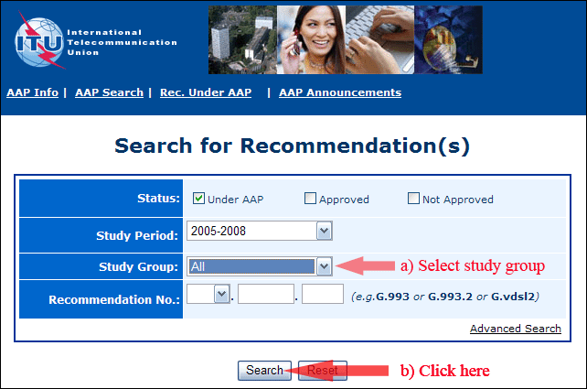
2) Select your Recommendation
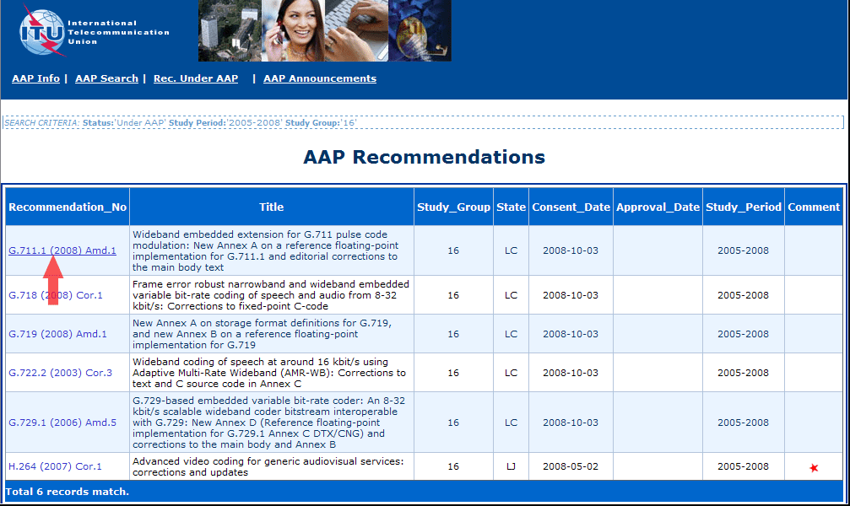
3) Click the "Submit Comment" button
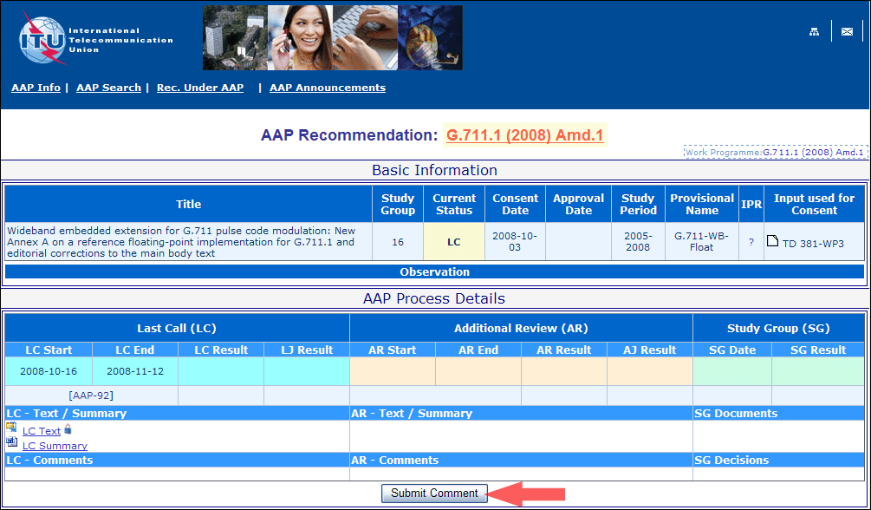
4) Complete the on-line form and click on "Submit"
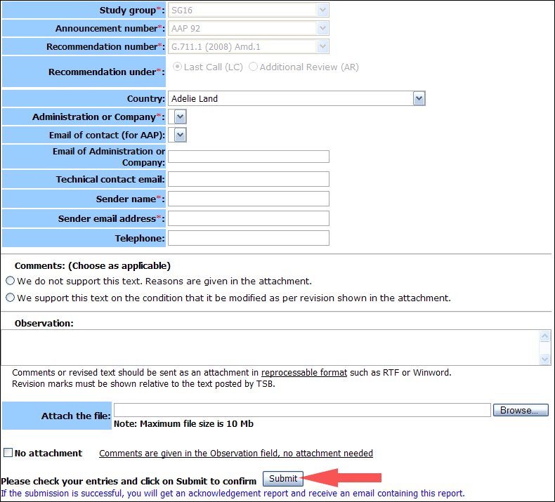
For more information, read the AAP tutorial on:
http://www.itu.int/ITU-T/aapinfo/files/AAPTutorial.pdf
Annex 3
(to TSB AAP-8)
Recommendations under LC/AR – Comment submission form
(Separate form for each Recommendation being commented upon)
ITU-T AAP comment submission form for the period 2009-2012
Study Group:
Announcement number:
Recommendation number:
Recommendation under: | Last call (LC)  Additional Review (AR)
Country:
Administration/Company:
Name of AAP Contact Person:
Email of AAP Contact Person:
Sender name:
(if different from AAP Contact Person)
Sender email address:
Telephone:
Comments:  (Choose as applicable) | We do not support this text. Reasons are given in the attachment.  We support this text on the condition that it be modified as per revision shown in the attachment.
Observations:
No attachment: Comments are given in the Observation field, no attachment needed
To be returned to: email: tsbsg....@itu.int
[or fax +41 22 730 5853]
Comments or revised text should be sent as an attachment in RTF or WinWord format.
Revision marks must be shown relative to the text posted by TSB.

