|  |  |
| --- | --- |
| Международный союз электросвязи  *Бюро стандартизации электросвязи* | ITU-COLOR |

Женева, 16 февраля 2013

|  |  |  |
| --- | --- | --- |
| Осн.:  Тел.:  Факс:  Эл. почта: | **TSB AAP-5**  AAP/MJ  +41 22 730 5860  +41 22 730 5853  [tsbdir@itu.int](mailto:tsbdir@itu.int) | – Администрациям Государств – Членов Союза;  – Членам Сектора МСЭ-Т;  – Ассоциированным членам МСЭ-Т  **Копии:**  – Председателям и заместителям председателей Исследовательских комиссий МСЭ-Т;  – Директору Бюро Развития Электросвязи;  – Директору Бюро Радиосвязи |

|  |  |
| --- | --- |
| Предмет: | **Положение относительно Рекомендаций, рассматриваемых в соответствии с альтернативным процессом утверждения (АПУ)** |

Уважаемая госпожа,  
уважаемый господин,

Альтернативный процесс утверждения (АПУ), определенный в Рекомендации МСЭ-Т А.8, распространяется на Рекомендации, которые не имеют политических или регламентарных последствий и которые поэтому не требуют официальных консультаций с Государствами-Членами (см. п. 246B Конвенции МСЭ).

В **Приложении 1** содержится перечень текстов, статус которых изменился по сравнению с предыдущими объявлениями об АПУ БСЭ.

Если вы желаете представить замечания относительно какой-либо Рекомендации, рассматриваемой в соответствии с АПУ, рекомендуем Вам использовать онлайновую форму для представления замечаний по АПУ, которая размещена на странице этой Рекомендации в разделе веб-сайта МСЭ-Т, посвященном АПУ, по адресу: <http://www.itu.int/ITU-T/aap/> (см. **Приложение 2**). Замечания можно представить иным способом, заполнив приведенную в **Приложении 3** форму и направив ее в секретариат заинтересованной исследовательской комиссии.

Просим принять к сведению, что не рекомендуется представлять замечания, являющиеся не чем иным, как поддержкой рассматриваемого текста.

С уважением,

Малколм Джонсон  
Директор Бюро   
стандартизации электросвязи

**Приложения**: 3

Annex 1

(to TSB AAP-5)

Status codes used in the AAP announcements:

LC = Last Call

LJ = Last Call Judgment (includes comment resolution)

AR = Additional Review

AJ = Additional Review Judgment (includes comment resolution)

SG = For Study Group approval

A = Approved

AT = Approved with typographic corrections

AC = Approved after Additional Review of Comments

NA = Not approved

TAP = Moved to TAP (ITU-T A.8 / § 5.2)

ITU-T website entry page:

[http://www.itu.int/ITU-T](http://www.itu.int/ITU-T/)

Alternative approval process (AAP) welcome page:

[http://www.itu.int/ITU-T/aapinfo](http://www.itu.int/ITU-T/aapinfo/)

Note – A tutorial on the ITU-T AAP application is available under the AAP welcome page

ITU-T website AAP Recommendation search page:

<http://www.itu.int/ITU-T/aap/>

Study Group web pages and contacts:

|  |  |  |
| --- | --- | --- |
| SG 2 | <http://www.itu.int/ITU-T/studygroups/com02> | [tsbsg2@itu.int](mailto:tsbsg2@itu.int) |
| SG 3 | <http://www.itu.int/ITU-T/studygroups/com03> | [tsbsg3@itu.int](mailto:tsbsg3@itu.int) |
| SG 5 | <http://www.itu.int/ITU-T/studygroups/com05> | [tsbsg5@itu.int](mailto:tsbsg5@itu.int) |
| SG 9 | <http://www.itu.int/ITU-T/studygroups/com09> | [tsbsg9@itu.int](mailto:tsbsg9@itu.int) |
| SG 11 | <http://www.itu.int/ITU-T/studygroups/com11> | [tsbsg11@itu.int](mailto:tsbsg11@itu.int) |
| SG 12 | <http://www.itu.int/ITU-T/studygroups/com12> | [tsbsg12@itu.int](mailto:tsbsg12@itu.int) |
| SG 13 | <http://www.itu.int/ITU-T/studygroups/com13> | [tsbsg13@itu.int](mailto:tsbsg13@itu.int) |
| SG 15 | <http://www.itu.int/ITU-T/studygroups/com15> | [tsbsg15@itu.int](mailto:tsbsg15@itu.int) |
| SG 16 | <http://www.itu.int/ITU-T/studygroups/com16> | [tsbsg16@itu.int](mailto:tsbsg16@itu.int) |
| SG 17 | <http://www.itu.int/ITU-T/studygroups/com17> | [tsbsg17@itu.int](mailto:tsbsg17@itu.int) |

Situation concerning Study Group 2 Recommendations under AAP

| **Rec #** | **Title** | **Last Call (LC) Period** | | | | **Additional Review (AR) Period** | | | | Status |
| --- | --- | --- | --- | --- | --- | --- | --- | --- | --- | --- |
| **LC Start** | **LC End** | **LC Result** | **LJ Result** | **AR Start** | **AR End** | **AR Result** | **AJ Result** |
| [M.1400](http://www.itu.int/itu-t/aap/AAPRecDetails.aspx?AAPSeqNo=2774) | Designations for interconnections among operators networks | 2013-02-16 | 2013-03-15 |  |  |  |  |  |  | LC |
| [M.3349 (M.sp-life-req)](http://www.itu.int/itu-t/aap/AAPRecDetails.aspx?AAPSeqNo=2775) | Requirements for service and product lifecycle management across the business to business interfaces | 2013-02-16 | 2013-03-15 |  |  |  |  |  |  | LC |
| [M.3705 (M.log-neutral)](http://www.itu.int/itu-t/aap/AAPRecDetails.aspx?AAPSeqNo=2776) | Common management services - Log Management - Requirements and Analysis - Protocol Neutral Requirements and Analysis | 2013-02-16 | 2013-03-15 |  |  |  |  |  |  | LC |
| [Q.818 Corrigendum 1](http://www.itu.int/itu-t/aap/AAPRecDetails.aspx?AAPSeqNo=2777) | Web-Services based Management Services - Corrigendum 1 | 2013-02-16 | 2013-03-15 |  |  |  |  |  |  | LC |
| [X.782 Corrigendum 1](http://www.itu.int/itu-t/aap/AAPRecDetails.aspx?AAPSeqNo=2778) | Guidelines for defining web services for managed objects and management interfaces - Corrigendum 1 | 2013-02-16 | 2013-03-15 |  |  |  |  |  |  | LC |

Situation concerning Study Group 5 Recommendations under AAP

| **Rec #** | **Title** | **Last Call (LC) Period** | | | | **Additional Review (AR) Period** | | | | Status |
| --- | --- | --- | --- | --- | --- | --- | --- | --- | --- | --- |
| **LC Start** | **LC End** | **LC Result** | **LJ Result** | **AR Start** | **AR End** | **AR Result** | **AJ Result** |
| [K.44 (2012) Cor.1 (2013-02) (K.44 Corrigendum)](http://www.itu.int/itu-t/aap/AAPRecDetails.aspx?AAPSeqNo=2780) | Resistibility tests for telecommunication equipment exposed to overvoltages and overcurrents – Basic Recommendation - Corrigendum 1 | 2013-02-16 | 2013-03-15 |  |  |  |  |  |  | LC |

Situation concerning Study Group 15 Recommendations under AAP

| **Rec #** | **Title** | **Last Call (LC) Period** | | | | **Additional Review (AR) Period** | | | | Status |
| --- | --- | --- | --- | --- | --- | --- | --- | --- | --- | --- |
| **LC Start** | **LC End** | **LC Result** | **LJ Result** | **AR Start** | **AR End** | **AR Result** | **AJ Result** |
| [G.989.1 (G.ngpon2)](http://www.itu.int/itu-t/aap/AAPRecDetails.aspx?AAPSeqNo=2663) | 40-Gigabit-capable passive optical networks (NG-PON2): General requirements | 2012-10-01 | 2012-10-28 | LJ | AR | 2013-02-16 | 2013-03-08 |  |  | AR |
| [G.993.2 (2011) Amd.3](http://www.itu.int/itu-t/aap/AAPRecDetails.aspx?AAPSeqNo=2765) | Very high speed digital subscriber line transceivers 2 (VDSL2): Amendment 3 | 2013-02-16 | 2013-03-15 |  |  |  |  |  |  | LC |
| [G.993.5 (2010) Amd.3](http://www.itu.int/itu-t/aap/AAPRecDetails.aspx?AAPSeqNo=2766) | Self-FEXT cancellation (vectoring) for use with VDSL2 transceivers: Amendment 3 | 2013-02-16 | 2013-03-15 |  |  |  |  |  |  | LC |
| [G.996.2 (2009) Amd.3](http://www.itu.int/itu-t/aap/AAPRecDetails.aspx?AAPSeqNo=2767) | Line testing for digital subscriber lines (DSL): Amendment 3 | 2013-02-16 | 2013-03-15 |  |  |  |  |  |  | LC |
| [G.997.1 (2012) Amd.2](http://www.itu.int/itu-t/aap/AAPRecDetails.aspx?AAPSeqNo=2768) | Physical layer management for digital subscriber line transceivers: Amendment 2 | 2013-02-16 | 2013-03-15 |  |  |  |  |  |  | LC |
| [G.998.4 (2010) Cor.5](http://www.itu.int/itu-t/aap/AAPRecDetails.aspx?AAPSeqNo=2769) | Improved impulse noise protection for DSL transceivers: Corrigendum 5 | 2013-02-16 | 2013-03-15 |  |  |  |  |  |  | LC |
| [G.9902 (2012) Amd.1](http://www.itu.int/itu-t/aap/AAPRecDetails.aspx?AAPSeqNo=2770) | Narrow-band orthogonal frequency division multiplexing power line communication ransceivers for ITU-T G.hnem networks: Amendment 1 | 2013-02-16 | 2013-03-15 |  |  |  |  |  |  | LC |
| [G.9903 (2012) Amd.1](http://www.itu.int/itu-t/aap/AAPRecDetails.aspx?AAPSeqNo=2771) | Narrow-band orthogonal frequency division multiplexing power line communication transceivers for G3-PLC networks: Amendment 1 | 2013-02-16 | 2013-03-15 |  |  |  |  |  |  | LC |
| [G.9961 (2010) Cor.2 (G.hn)](http://www.itu.int/itu-t/aap/AAPRecDetails.aspx?AAPSeqNo=2772) | Unified high-speed wire-line based home networking transceivers - Data link layer specification: Corrigendum 2 | 2013-02-16 | 2013-03-15 |  |  |  |  |  |  | LC |
| [G.9962 (G.hn)](http://www.itu.int/itu-t/aap/AAPRecDetails.aspx?AAPSeqNo=2773) | Unified high-speed wire-line based home networking transceivers - Management specification | 2013-02-16 | 2013-03-15 |  |  |  |  |  |  | LC |

Situation concerning Study Group 16 Recommendations under AAP

| **Rec #** | **Title** | **Last Call (LC) Period** | | | | **Additional Review (AR) Period** | | | | Status |
| --- | --- | --- | --- | --- | --- | --- | --- | --- | --- | --- |
| **LC Start** | **LC End** | **LC Result** | **LJ Result** | **AR Start** | **AR End** | **AR Result** | **AJ Result** |
| [F.747.3 (F.USN-NRP)](http://www.itu.int/itu-t/aap/AAPRecDetails.aspx?AAPSeqNo=2710) | Requirements and functional model for ubiquitous network robot platform to support USN applications and services | 2013-02-16 | 2013-03-15 |  |  |  |  |  |  | LC |
| [G.718 (2008) Amd.3 (G.718-SWB-Float)](http://www.itu.int/itu-t/aap/AAPRecDetails.aspx?AAPSeqNo=2711) | Variable bit rate embedded coding of speech signals: New Annex C with an alternative floating-point implementation of the superwideband monaural extension | 2013-02-16 | 2013-03-15 |  |  |  |  |  |  | LC |
| [G.729.1 (2006) Amd.8 (G.729.1-SWB-Float)](http://www.itu.int/itu-t/aap/AAPRecDetails.aspx?AAPSeqNo=2712) | G.729-based embedded variable bit-rate coder: An 8-32 kbit/s scalable wideband coder bitstream interoperable with G.729: New Annex G with an alternative floating-point implementation of the superwideband monaural extension | 2013-02-16 | 2013-03-15 |  |  |  |  |  |  | LC |
| [H.225.0 (2009) Amd.1](http://www.itu.int/itu-t/aap/AAPRecDetails.aspx?AAPSeqNo=2713) | Call signalling protocols and media stream packetization for packet-based multimedia communication systems: Use of FACILITY message to enable call transfer | 2013-02-16 | 2013-03-15 |  |  |  |  |  |  | LC |
| [H.248.1 (V3)](http://www.itu.int/itu-t/aap/AAPRecDetails.aspx?AAPSeqNo=2714) | Gateway control protocol: Version 3 | 2013-02-16 | 2013-03-15 |  |  |  |  |  |  | LC |
| [H.248.11](http://www.itu.int/itu-t/aap/AAPRecDetails.aspx?AAPSeqNo=2727) | Gateway control protocol: Media gateway overload control package | 2013-02-16 | 2013-03-15 |  |  |  |  |  |  | LC |
| [H.248.15](http://www.itu.int/itu-t/aap/AAPRecDetails.aspx?AAPSeqNo=2719) | Gateway control protocol: SDP H.248 package attribute | 2013-02-16 | 2013-03-15 |  |  |  |  |  |  | LC |
| [H.248.16](http://www.itu.int/itu-t/aap/AAPRecDetails.aspx?AAPSeqNo=2720) | Gateway control protocol: Enhanced digit collection packages and procedures | 2013-02-16 | 2013-03-15 |  |  |  |  |  |  | LC |
| [H.248.17](http://www.itu.int/itu-t/aap/AAPRecDetails.aspx?AAPSeqNo=2721) | Gateway control protocol: Line test packages | 2013-02-16 | 2013-03-15 |  |  |  |  |  |  | LC |
| [H.248.18](http://www.itu.int/itu-t/aap/AAPRecDetails.aspx?AAPSeqNo=2722) | Gateway control protocol: Package for support of multiple profiles | 2013-02-16 | 2013-03-15 |  |  |  |  |  |  | LC |
| [H.248.19](http://www.itu.int/itu-t/aap/AAPRecDetails.aspx?AAPSeqNo=2723) | Gateway control protocol: Decomposed multipoint control unit, audio, video and data conferencing packages | 2013-02-16 | 2013-03-15 |  |  |  |  |  |  | LC |
| [H.248.2](http://www.itu.int/itu-t/aap/AAPRecDetails.aspx?AAPSeqNo=2715) | Gateway control protocol: Facsimile, text conversation and call discrimination packages | 2013-02-16 | 2013-03-15 |  |  |  |  |  |  | LC |
| [H.248.20](http://www.itu.int/itu-t/aap/AAPRecDetails.aspx?AAPSeqNo=2724) | Gateway control protocol: The use of local and remote descriptors with H.221 and H.223 multiplexing | 2013-02-16 | 2013-03-15 |  |  |  |  |  |  | LC |
| [H.248.22](http://www.itu.int/itu-t/aap/AAPRecDetails.aspx?AAPSeqNo=2728) | Gateway control protocol: Shared Risk Group package | 2013-02-16 | 2013-03-15 |  |  |  |  |  |  | LC |
| [H.248.23](http://www.itu.int/itu-t/aap/AAPRecDetails.aspx?AAPSeqNo=2725) | Gateway control protocol: Enhanced Alerting packages | 2013-02-16 | 2013-03-15 |  |  |  |  |  |  | LC |
| [H.248.25](http://www.itu.int/itu-t/aap/AAPRecDetails.aspx?AAPSeqNo=2759) | Gateway control protocol: Basic CAS packages | 2013-02-16 | 2013-03-15 |  |  |  |  |  |  | LC |
| [H.248.26](http://www.itu.int/itu-t/aap/AAPRecDetails.aspx?AAPSeqNo=2729) | Gateway control protocol: Enhanced analogue lines packages | 2013-02-16 | 2013-03-15 |  |  |  |  |  |  | LC |
| [H.248.29](http://www.itu.int/itu-t/aap/AAPRecDetails.aspx?AAPSeqNo=2726) | Gateway control protocol: International CAS compelled register signalling packages | 2013-02-16 | 2013-03-15 |  |  |  |  |  |  | LC |
| [H.248.3](http://www.itu.int/itu-t/aap/AAPRecDetails.aspx?AAPSeqNo=2716) | Gateway control protocol: User interface elements and actions packages | 2013-02-16 | 2013-03-15 |  |  |  |  |  |  | LC |
| [H.248.32](http://www.itu.int/itu-t/aap/AAPRecDetails.aspx?AAPSeqNo=2730) | Gateway control protocol: Detailed congestion reporting package | 2013-02-16 | 2013-03-15 |  |  |  |  |  |  | LC |
| [H.248.36](http://www.itu.int/itu-t/aap/AAPRecDetails.aspx?AAPSeqNo=2731) | Gateway control protocol: Hanging Termination Detection package | 2013-02-16 | 2013-03-15 |  |  |  |  |  |  | LC |
| [H.248.40](http://www.itu.int/itu-t/aap/AAPRecDetails.aspx?AAPSeqNo=2760) | Gateway control protocol: Application data inactivity detection package | 2013-02-16 | 2013-03-15 |  |  |  |  |  |  | LC |
| [H.248.41](http://www.itu.int/itu-t/aap/AAPRecDetails.aspx?AAPSeqNo=2732) | Gateway control protocol: IP domain connection package | 2013-02-16 | 2013-03-15 |  |  |  |  |  |  | LC |
| [H.248.57](http://www.itu.int/itu-t/aap/AAPRecDetails.aspx?AAPSeqNo=2733) | Gateway control protocol: RTP control protocol package | 2013-02-16 | 2013-03-15 |  |  |  |  |  |  | LC |
| [H.248.61](http://www.itu.int/itu-t/aap/AAPRecDetails.aspx?AAPSeqNo=2734) | Gateway control protocol: Packages for network level H.248 statistics | 2013-02-16 | 2013-03-15 |  |  |  |  |  |  | LC |
| [H.248.64](http://www.itu.int/itu-t/aap/AAPRecDetails.aspx?AAPSeqNo=2735) | Gateway control protocol: IP router packages | 2013-02-16 | 2013-03-15 |  |  |  |  |  |  | LC |
| [H.248.78](http://www.itu.int/itu-t/aap/AAPRecDetails.aspx?AAPSeqNo=2761) | Gateway control protocol: Bearer-level application level gateway | 2013-02-16 | 2013-03-15 |  |  |  |  |  |  | LC |
| [H.248.8](http://www.itu.int/itu-t/aap/AAPRecDetails.aspx?AAPSeqNo=2718) | Gateway control protocol: Error code and service change reason description | 2013-02-16 | 2013-03-15 |  |  |  |  |  |  | LC |
| [H.248.81 (2011) Amd.1](http://www.itu.int/itu-t/aap/AAPRecDetails.aspx?AAPSeqNo=2736) | Gateway control protocol: Guidelines on the use of the international emergency preference scheme (IEPS) call indicator and priority indicator in ITU-T H.248 profiles: New Appendix II, plus additions and corrections | 2013-02-16 | 2013-03-15 |  |  |  |  |  |  | LC |
| [H.248.82 (H.248.ECN)](http://www.itu.int/itu-t/aap/AAPRecDetails.aspx?AAPSeqNo=2737) | Gateway control protocol: Explicit congestion notification support | 2013-02-16 | 2013-03-15 |  |  |  |  |  |  | LC |
| [H.248.85 (H.248.LOOPB)](http://www.itu.int/itu-t/aap/AAPRecDetails.aspx?AAPSeqNo=2738) | Gateway control protocol: Usage of loopback in H.248 | 2013-02-16 | 2013-03-15 |  |  |  |  |  |  | LC |
| [H.262 (2012) Amd.1](http://www.itu.int/itu-t/aap/AAPRecDetails.aspx?AAPSeqNo=2739) | Information technology - Generic coding of moving pictures and associated audio information: Video: Frame packing arrangement signalling for quincunx pattern | 2013-02-16 | 2013-03-15 |  |  |  |  |  |  | LC |
| [H.323 (2009) Amd.1](http://www.itu.int/itu-t/aap/AAPRecDetails.aspx?AAPSeqNo=2742) | Packet-based multimedia communications systems: Use of FACILITY message to enable call transfer | 2013-02-16 | 2013-03-15 |  |  |  |  |  |  | LC |
| [H.450.4](http://www.itu.int/itu-t/aap/AAPRecDetails.aspx?AAPSeqNo=2743) | Call hold supplementary service for H.323 | 2013-02-16 | 2013-03-15 |  |  |  |  |  |  | LC |
| [H.450.5](http://www.itu.int/itu-t/aap/AAPRecDetails.aspx?AAPSeqNo=2762) | Call park and call pickup supplementary services for H.323 | 2013-02-16 | 2013-03-15 |  |  |  |  |  |  | LC |
| [H.450.7](http://www.itu.int/itu-t/aap/AAPRecDetails.aspx?AAPSeqNo=2744) | Message waiting indication supplementary service for H.323 | 2013-02-16 | 2013-03-15 |  |  |  |  |  |  | LC |
| [H.450.8](http://www.itu.int/itu-t/aap/AAPRecDetails.aspx?AAPSeqNo=2745) | Name identification supplementary service for H.323 | 2013-02-16 | 2013-03-15 |  |  |  |  |  |  | LC |
| [H.460.1](http://www.itu.int/itu-t/aap/AAPRecDetails.aspx?AAPSeqNo=2746) | Guidelines for the use of the generic extensible framework | 2013-02-16 | 2013-03-15 |  |  |  |  |  |  | LC |
| [H.460.18](http://www.itu.int/itu-t/aap/AAPRecDetails.aspx?AAPSeqNo=2750) | Traversal of H.323 signalling across network address translators and firewalls | 2013-02-16 | 2013-03-15 |  |  |  |  |  |  | LC |
| [H.460.19](http://www.itu.int/itu-t/aap/AAPRecDetails.aspx?AAPSeqNo=2751) | Traversal of H.323 media across network address translators and firewalls | 2013-02-16 | 2013-03-15 |  |  |  |  |  |  | LC |
| [H.460.2](http://www.itu.int/itu-t/aap/AAPRecDetails.aspx?AAPSeqNo=2747) | Number portability interworking between H.323 and SCN network | 2013-02-16 | 2013-03-15 |  |  |  |  |  |  | LC |
| [H.460.24 (2009) Amd.2](http://www.itu.int/itu-t/aap/AAPRecDetails.aspx?AAPSeqNo=2752) | Point-to-point media through network address translators and firewalls within ITU-T H.323 systems: Support for ITU-T H.460.19 multiplex media mode for point-to-point media | 2013-02-16 | 2013-03-15 |  |  |  |  |  |  | LC |
| [H.460.6](http://www.itu.int/itu-t/aap/AAPRecDetails.aspx?AAPSeqNo=2748) | Extended fast connect feature | 2013-02-16 | 2013-03-15 |  |  |  |  |  |  | LC |
| [H.460.7](http://www.itu.int/itu-t/aap/AAPRecDetails.aspx?AAPSeqNo=2749) | Digit maps within H.323 systems | 2013-02-16 | 2013-03-15 |  |  |  |  |  |  | LC |
| [H.626.1 (H.VSMarch)](http://www.itu.int/itu-t/aap/AAPRecDetails.aspx?AAPSeqNo=2753) | Architecture for mobile visual surveillance | 2013-02-16 | 2013-03-15 |  |  |  |  |  |  | LC |
| [H.751 (H.IPTV-RIM, ex HSTP.IPTV-RIM)](http://www.itu.int/itu-t/aap/AAPRecDetails.aspx?AAPSeqNo=2764) | Metadata for rights information interoperability in IPTV services | 2013-02-16 | 2013-03-15 |  |  |  |  |  |  | LC |
| [T.800 (2002) Amd.6](http://www.itu.int/itu-t/aap/AAPRecDetails.aspx?AAPSeqNo=2755) | Information technology - JPEG 2000 image coding system: Core coding system: Updated ICC profile support, bit depth and resolution clarifications | 2013-02-16 | 2013-03-15 |  |  |  |  |  |  | LC |
| [T.801 (2002) Amd.3](http://www.itu.int/itu-t/aap/AAPRecDetails.aspx?AAPSeqNo=2757) | Information technology - JPEG 2000 image coding system: Extensions: Box-based file format for JPEG XR, extended ROI boxes, XML boxing, compressed channel definition boxes, and representation of floating point | 2013-02-16 | 2013-03-15 |  |  |  |  |  |  | LC |
| [T.808 (2005) Amd.5](http://www.itu.int/itu-t/aap/AAPRecDetails.aspx?AAPSeqNo=2758) | Information technology - JPEG 2000 image coding system: Interactivity tools, APIs and protocols: UDP transport and additional enhancements to JPIP | 2013-02-16 | 2013-03-15 |  |  |  |  |  |  | LC |

Annex 2

(to TSB AAP-5)

Using the on-line comment submission form

Comment submission

1) Go to AAP search Web page at <http://www.itu.int/ITU-T/aap/>

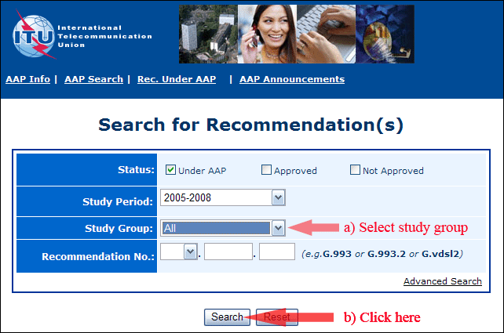

2) Select your Recommendation

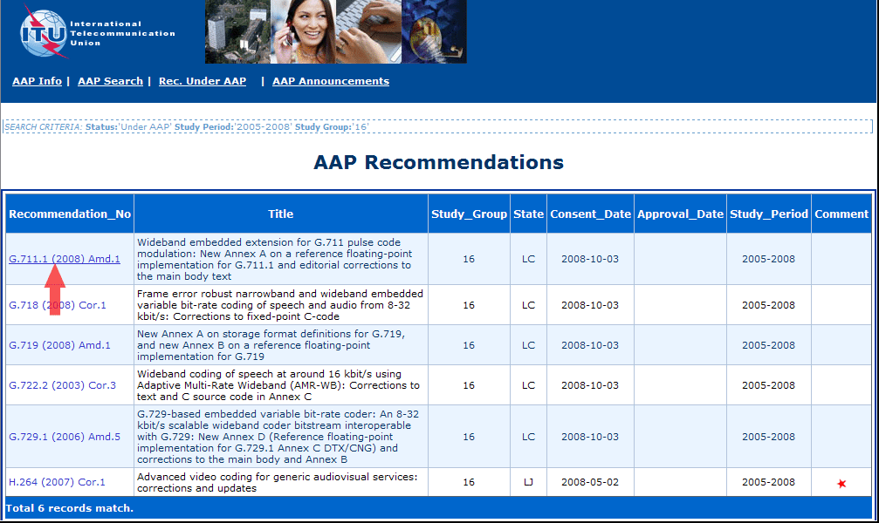

3) Click the "Submit Comment" button

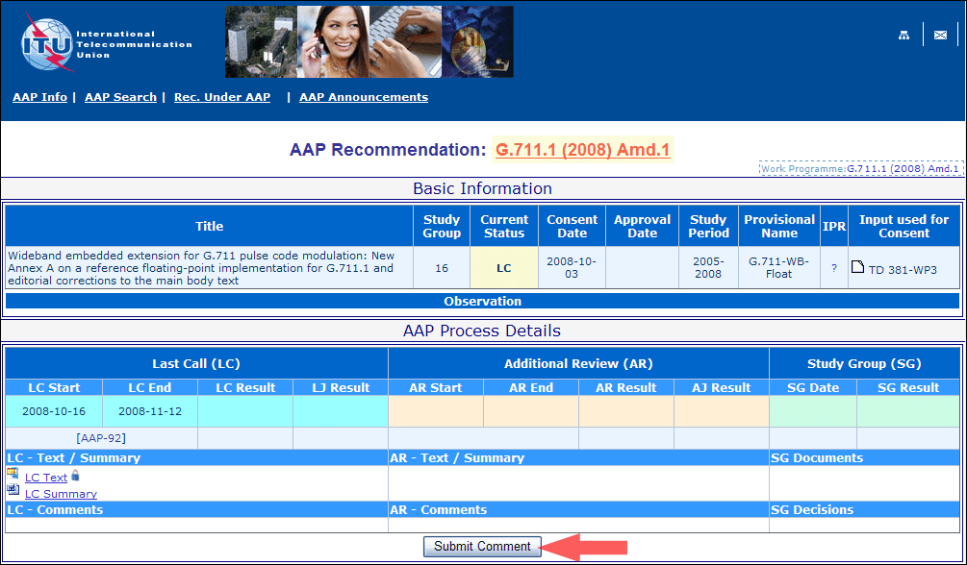

4) Complete the on-line form and click on "Submit"

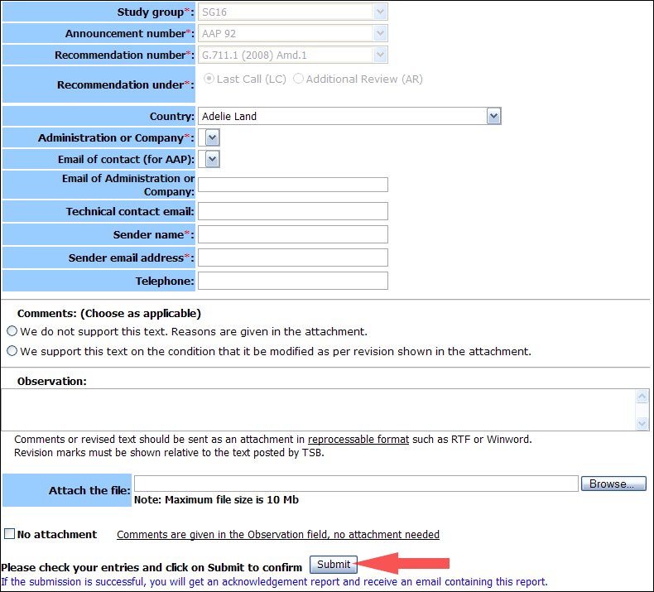

For more information, read the AAP tutorial on:   
<http://www.itu.int/ITU-T/aapinfo/files/AAPTutorial.pdf>

Annex 3

(to TSB AAP-5)

Recommendations under LC/AR – Comment submission form

*(Separate form for each Recommendation being commented upon)*

|  |  |
| --- | --- |
| ITU-T AAP comment submission form for the period 2009-2012 | |
| **Study Group:** |  |
| **Announcement number:** |  |
| **Recommendation number:** |  |
| **Recommendation under:** | Last call (LC)   Additional Review (AR) |
| **Country:** |  |
| **Administration/Company:** |  |
| **Name of AAP Contact Person:** |  |
| **Email of AAP Contact Person:** |  |
| **Sender name: (if different from AAP Contact Person)** |  |
| **Sender email address:** |  |
| **Telephone:** |  |
| **Comments: (Choose as applicable)** | We do not support this text. Reasons are given in the attachment.   We support this text on the condition that it be modified as per revision shown in the attachment. |
| **Observations:** |  |

**No attachment:** Comments are given in the Observation field, no attachment needed

*To be returned to: email:* [*tsbsg....@itu.int*](mailto:tsbsg....@itu.int) *[or fax +41 22 730 5853]  
Comments or revised text should be sent as an attachment in RTF or WinWord format.  
Revision marks must be shown relative to the text posted by TSB.*