国 际 电 信 联 盟
电信标准化局
2013年2月16日 ，日内瓦

参考号:  电话:  传真:  电子邮件: | 电信标准化局AAP-5  AAP/MJ  +41 22 730 5860  +41 22 730 5853  tsbdir@itu.int | – 致国际电联成员国各主管部门；  – 致ITU-T各部门成员；  – 致ITU-T 部门准成员  抄送：  – 电信标准化局研究组主席和副主席  – 电信发展局主任  – 无线电通信局主任

事由: | 有关采用替换批准程序（AAP）处理的建议书的情况

先生/女士，
ITU-T A.8 建议书中规定的建议书替换批准程序 (AAP) 适用于那些不会产生政策或 监管影响、因而不需与成员国正式协商的建议书（见国际电联《公约》第246B款）。
附件1列出了那些在以往电信标准化局AAP预告后地位发生变化的案文。
如您希望针对某个适用AAP的建议书提出意见，请使用可在ITU-T网站AAP区域 （http://www.itu.int/ITU-T/aap）的“建议书”网页上获取的《AAP意见在线提交表格》 （见附件2）。或者，可填妥附件3 中的表格并将意见发送给相关研究组的秘书处。
敬请留意，我们不鼓励提交仅支持通过所涉案文而没有实质内容的意见。

顺致敬意！

马尔科姆•琼森
电信标准化局主任

附件：3件

Annex 1
(to TSB AAP-5)

Status codes used in the AAP announcements:
LC = Last Call
LJ = Last Call Judgment (includes comment resolution)
AR = Additional Review
AJ = Additional Review Judgment (includes comment resolution)
SG = For Study Group approval
A = Approved
AT = Approved with typographic corrections
AC = Approved after Additional Review of Comments
NA = Not approved
TAP = Moved to TAP (ITU-T A.8 / § 5.2)
ITU-T website entry page:
http://www.itu.int/ITU-T
Alternative approval process (AAP) welcome page:
http://www.itu.int/ITU-T/aapinfo
Note – A tutorial on the ITU-T AAP application is available under the AAP welcome page
ITU-T website AAP Recommendation search page:
http://www.itu.int/ITU-T/aap/
Study Group web pages and contacts:
SG 2 | http://www.itu.int/ITU-T/studygroups/com02 | tsbsg2@itu.int
SG 3 | http://www.itu.int/ITU-T/studygroups/com03 | tsbsg3@itu.int
SG 5 | http://www.itu.int/ITU-T/studygroups/com05 | tsbsg5@itu.int
SG 9 | http://www.itu.int/ITU-T/studygroups/com09 | tsbsg9@itu.int
SG 11 | http://www.itu.int/ITU-T/studygroups/com11 | tsbsg11@itu.int
SG 12 | http://www.itu.int/ITU-T/studygroups/com12 | tsbsg12@itu.int
SG 13 | http://www.itu.int/ITU-T/studygroups/com13 | tsbsg13@itu.int
SG 15 | http://www.itu.int/ITU-T/studygroups/com15 | tsbsg15@itu.int
SG 16 | http://www.itu.int/ITU-T/studygroups/com16 | tsbsg16@itu.int
SG 17 | http://www.itu.int/ITU-T/studygroups/com17 | tsbsg17@itu.int

Situation concerning Study Group 2 Recommendations under AAP
Rec # | Title | Last Call (LC) Period |  |  |  | Additional Review (AR) Period |  |  |  | Status
 |  | LC Start | LC End | LC  Result | LJ  Result | AR Start | AR End | AR  Result | AJ  Result
M.1400 | Designations for interconnections among operators networks | 2013-02-16 | 2013-03-15 |  |  |  |  |  |  | LC
M.3349 (M.sp-life-req) | Requirements for service and product lifecycle management across the business to business interfaces | 2013-02-16 | 2013-03-15 |  |  |  |  |  |  | LC
M.3705 (M.log-neutral) | Common management services - Log Management - Requirements and Analysis - Protocol Neutral Requirements and Analysis | 2013-02-16 | 2013-03-15 |  |  |  |  |  |  | LC
Q.818 Corrigendum 1 | Web-Services based Management Services - Corrigendum 1 | 2013-02-16 | 2013-03-15 |  |  |  |  |  |  | LC
X.782 Corrigendum 1 | Guidelines for defining web services for managed objects and management interfaces - Corrigendum 1 | 2013-02-16 | 2013-03-15 |  |  |  |  |  |  | LC
Situation concerning Study Group 5 Recommendations under AAP
Rec # | Title | Last Call (LC) Period |  |  |  | Additional Review (AR) Period |  |  |  | Status
 |  | LC Start | LC End | LC  Result | LJ  Result | AR Start | AR End | AR  Result | AJ  Result
K.44 (2012) Cor.1 (2013-02) (K.44 Corrigendum) | Resistibility tests for telecommunication equipment exposed to overvoltages and overcurrents – Basic Recommendation - Corrigendum 1 | 2013-02-16 | 2013-03-15 |  |  |  |  |  |  | LC
Situation concerning Study Group 15 Recommendations under AAP
Rec # | Title | Last Call (LC) Period |  |  |  | Additional Review (AR) Period |  |  |  | Status
 |  | LC Start | LC End | LC  Result | LJ  Result | AR Start | AR End | AR  Result | AJ  Result
G.989.1 (G.ngpon2) | 40-Gigabit-capable passive optical networks (NG-PON2): General requirements | 2012-10-01 | 2012-10-28 | LJ | AR | 2013-02-16 | 2013-03-08 |  |  | AR
G.993.2 (2011) Amd.3 | Very high speed digital subscriber line transceivers 2 (VDSL2): Amendment 3 | 2013-02-16 | 2013-03-15 |  |  |  |  |  |  | LC
G.993.5 (2010) Amd.3 | Self-FEXT cancellation (vectoring) for use with VDSL2 transceivers: Amendment 3 | 2013-02-16 | 2013-03-15 |  |  |  |  |  |  | LC
G.996.2 (2009) Amd.3 | Line testing for digital subscriber lines (DSL): Amendment 3 | 2013-02-16 | 2013-03-15 |  |  |  |  |  |  | LC
G.997.1 (2012) Amd.2 | Physical layer management for digital subscriber line transceivers: Amendment 2 | 2013-02-16 | 2013-03-15 |  |  |  |  |  |  | LC
G.998.4 (2010) Cor.5 | Improved impulse noise protection for DSL transceivers: Corrigendum 5 | 2013-02-16 | 2013-03-15 |  |  |  |  |  |  | LC
G.9902 (2012) Amd.1 | Narrow-band orthogonal frequency division multiplexing power line communication ransceivers for ITU-T G.hnem networks: Amendment 1 | 2013-02-16 | 2013-03-15 |  |  |  |  |  |  | LC
G.9903 (2012) Amd.1 | Narrow-band orthogonal frequency division multiplexing power line communication transceivers for G3-PLC networks: Amendment 1 | 2013-02-16 | 2013-03-15 |  |  |  |  |  |  | LC
G.9961 (2010) Cor.2 (G.hn) | Unified high-speed wire-line based home networking transceivers - Data link layer specification: Corrigendum 2 | 2013-02-16 | 2013-03-15 |  |  |  |  |  |  | LC
G.9962 (G.hn) | Unified high-speed wire-line based home networking transceivers - Management specification | 2013-02-16 | 2013-03-15 |  |  |  |  |  |  | LC
Situation concerning Study Group 16 Recommendations under AAP
Rec # | Title | Last Call (LC) Period |  |  |  | Additional Review (AR) Period |  |  |  | Status
 |  | LC Start | LC End | LC  Result | LJ  Result | AR Start | AR End | AR  Result | AJ  Result
F.747.3 (F.USN-NRP) | Requirements and functional model for ubiquitous network robot platform to support USN applications and services | 2013-02-16 | 2013-03-15 |  |  |  |  |  |  | LC
G.718 (2008) Amd.3 (G.718-SWB-Float) | Variable bit rate embedded coding of speech signals: New Annex C with an alternative floating-point implementation of the superwideband monaural extension | 2013-02-16 | 2013-03-15 |  |  |  |  |  |  | LC
G.729.1 (2006) Amd.8 (G.729.1-SWB-Float) | G.729-based embedded variable bit-rate coder: An 8-32 kbit/s scalable wideband coder bitstream interoperable with G.729: New Annex G with an alternative floating-point implementation of the superwideband monaural extension | 2013-02-16 | 2013-03-15 |  |  |  |  |  |  | LC
H.225.0 (2009) Amd.1 | Call signalling protocols and media stream packetization for packet-based multimedia communication systems: Use of FACILITY message to enable call transfer | 2013-02-16 | 2013-03-15 |  |  |  |  |  |  | LC
H.248.1 (V3) | Gateway control protocol: Version 3 | 2013-02-16 | 2013-03-15 |  |  |  |  |  |  | LC
H.248.11 | Gateway control protocol: Media gateway overload control package | 2013-02-16 | 2013-03-15 |  |  |  |  |  |  | LC
H.248.15 | Gateway control protocol: SDP H.248 package attribute | 2013-02-16 | 2013-03-15 |  |  |  |  |  |  | LC
H.248.16 | Gateway control protocol: Enhanced digit collection packages and procedures | 2013-02-16 | 2013-03-15 |  |  |  |  |  |  | LC
H.248.17 | Gateway control protocol: Line test packages | 2013-02-16 | 2013-03-15 |  |  |  |  |  |  | LC
H.248.18 | Gateway control protocol: Package for support of multiple profiles | 2013-02-16 | 2013-03-15 |  |  |  |  |  |  | LC
H.248.19 | Gateway control protocol: Decomposed multipoint control unit, audio, video and data conferencing packages | 2013-02-16 | 2013-03-15 |  |  |  |  |  |  | LC
H.248.2 | Gateway control protocol: Facsimile, text conversation and call discrimination packages | 2013-02-16 | 2013-03-15 |  |  |  |  |  |  | LC
H.248.20 | Gateway control protocol: The use of local and remote descriptors with H.221 and H.223 multiplexing | 2013-02-16 | 2013-03-15 |  |  |  |  |  |  | LC
H.248.22 | Gateway control protocol: Shared Risk Group package | 2013-02-16 | 2013-03-15 |  |  |  |  |  |  | LC
H.248.23 | Gateway control protocol: Enhanced Alerting packages | 2013-02-16 | 2013-03-15 |  |  |  |  |  |  | LC
H.248.25 | Gateway control protocol: Basic CAS packages | 2013-02-16 | 2013-03-15 |  |  |  |  |  |  | LC
H.248.26 | Gateway control protocol: Enhanced analogue lines packages | 2013-02-16 | 2013-03-15 |  |  |  |  |  |  | LC
H.248.29 | Gateway control protocol: International CAS compelled register signalling packages | 2013-02-16 | 2013-03-15 |  |  |  |  |  |  | LC
H.248.3 | Gateway control protocol: User interface elements and actions packages | 2013-02-16 | 2013-03-15 |  |  |  |  |  |  | LC
H.248.32 | Gateway control protocol: Detailed congestion reporting package | 2013-02-16 | 2013-03-15 |  |  |  |  |  |  | LC
H.248.36 | Gateway control protocol: Hanging Termination Detection package | 2013-02-16 | 2013-03-15 |  |  |  |  |  |  | LC
H.248.40 | Gateway control protocol: Application data inactivity detection package | 2013-02-16 | 2013-03-15 |  |  |  |  |  |  | LC
H.248.41 | Gateway control protocol: IP domain connection package | 2013-02-16 | 2013-03-15 |  |  |  |  |  |  | LC
H.248.57 | Gateway control protocol: RTP control protocol package | 2013-02-16 | 2013-03-15 |  |  |  |  |  |  | LC
H.248.61 | Gateway control protocol: Packages for network level H.248 statistics | 2013-02-16 | 2013-03-15 |  |  |  |  |  |  | LC
H.248.64 | Gateway control protocol: IP router packages | 2013-02-16 | 2013-03-15 |  |  |  |  |  |  | LC
H.248.78 | Gateway control protocol: Bearer-level application level gateway | 2013-02-16 | 2013-03-15 |  |  |  |  |  |  | LC
H.248.8 | Gateway control protocol: Error code and service change reason description | 2013-02-16 | 2013-03-15 |  |  |  |  |  |  | LC
H.248.81 (2011) Amd.1 | Gateway control protocol: Guidelines on the use of the international emergency preference scheme (IEPS) call indicator and priority indicator in ITU-T H.248 profiles: New Appendix II, plus additions and corrections | 2013-02-16 | 2013-03-15 |  |  |  |  |  |  | LC
H.248.82 (H.248.ECN) | Gateway control protocol: Explicit congestion notification support | 2013-02-16 | 2013-03-15 |  |  |  |  |  |  | LC
H.248.85 (H.248.LOOPB) | Gateway control protocol: Usage of loopback in H.248 | 2013-02-16 | 2013-03-15 |  |  |  |  |  |  | LC
H.262 (2012) Amd.1 | Information technology - Generic coding of moving pictures and associated audio information: Video: Frame packing arrangement signalling for quincunx pattern | 2013-02-16 | 2013-03-15 |  |  |  |  |  |  | LC
H.323 (2009) Amd.1 | Packet-based multimedia communications systems: Use of FACILITY message to enable call transfer | 2013-02-16 | 2013-03-15 |  |  |  |  |  |  | LC
H.450.4 | Call hold supplementary service for H.323 | 2013-02-16 | 2013-03-15 |  |  |  |  |  |  | LC
H.450.5 | Call park and call pickup supplementary services for H.323 | 2013-02-16 | 2013-03-15 |  |  |  |  |  |  | LC
H.450.7 | Message waiting indication supplementary service for H.323 | 2013-02-16 | 2013-03-15 |  |  |  |  |  |  | LC
H.450.8 | Name identification supplementary service for H.323 | 2013-02-16 | 2013-03-15 |  |  |  |  |  |  | LC
H.460.1 | Guidelines for the use of the generic extensible framework | 2013-02-16 | 2013-03-15 |  |  |  |  |  |  | LC
H.460.18 | Traversal of H.323 signalling across network address translators and firewalls | 2013-02-16 | 2013-03-15 |  |  |  |  |  |  | LC
H.460.19 | Traversal of H.323 media across network address translators and firewalls | 2013-02-16 | 2013-03-15 |  |  |  |  |  |  | LC
H.460.2 | Number portability interworking between H.323 and SCN network | 2013-02-16 | 2013-03-15 |  |  |  |  |  |  | LC
H.460.24 (2009) Amd.2 | Point-to-point media through network address translators and firewalls within ITU-T H.323 systems: Support for ITU-T H.460.19 multiplex media mode for point-to-point media | 2013-02-16 | 2013-03-15 |  |  |  |  |  |  | LC
H.460.6 | Extended fast connect feature | 2013-02-16 | 2013-03-15 |  |  |  |  |  |  | LC
H.460.7 | Digit maps within H.323 systems | 2013-02-16 | 2013-03-15 |  |  |  |  |  |  | LC
H.626.1 (H.VSMarch) | Architecture for mobile visual surveillance | 2013-02-16 | 2013-03-15 |  |  |  |  |  |  | LC
H.751 (H.IPTV-RIM, ex HSTP.IPTV-RIM) | Metadata for rights information interoperability in IPTV services | 2013-02-16 | 2013-03-15 |  |  |  |  |  |  | LC
T.800 (2002) Amd.6 | Information technology - JPEG 2000 image coding system: Core coding system: Updated ICC profile support, bit depth and resolution clarifications | 2013-02-16 | 2013-03-15 |  |  |  |  |  |  | LC
T.801 (2002) Amd.3 | Information technology - JPEG 2000 image coding system: Extensions: Box-based file format for JPEG XR, extended ROI boxes, XML boxing, compressed channel definition boxes, and representation of floating point | 2013-02-16 | 2013-03-15 |  |  |  |  |  |  | LC
T.808 (2005) Amd.5 | Information technology - JPEG 2000 image coding system: Interactivity tools, APIs and protocols: UDP transport and additional enhancements to JPIP | 2013-02-16 | 2013-03-15 |  |  |  |  |  |  | LC

Annex 2
(to TSB AAP-5)
Using the on-line comment submission form
Comment submission
1) Go to AAP search Web page at http://www.itu.int/ITU-T/aap/
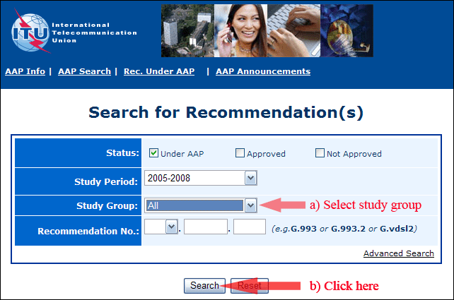
2) Select your Recommendation
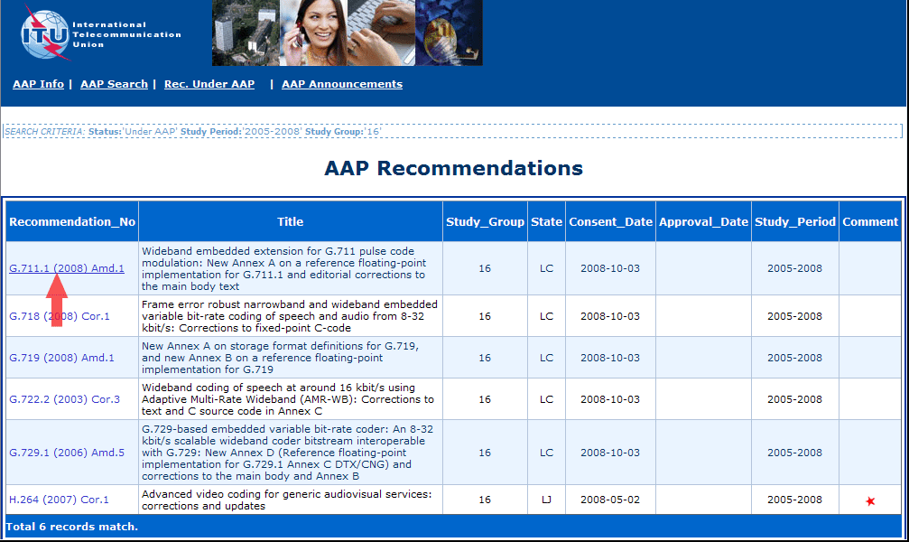
3) Click the "Submit Comment" button
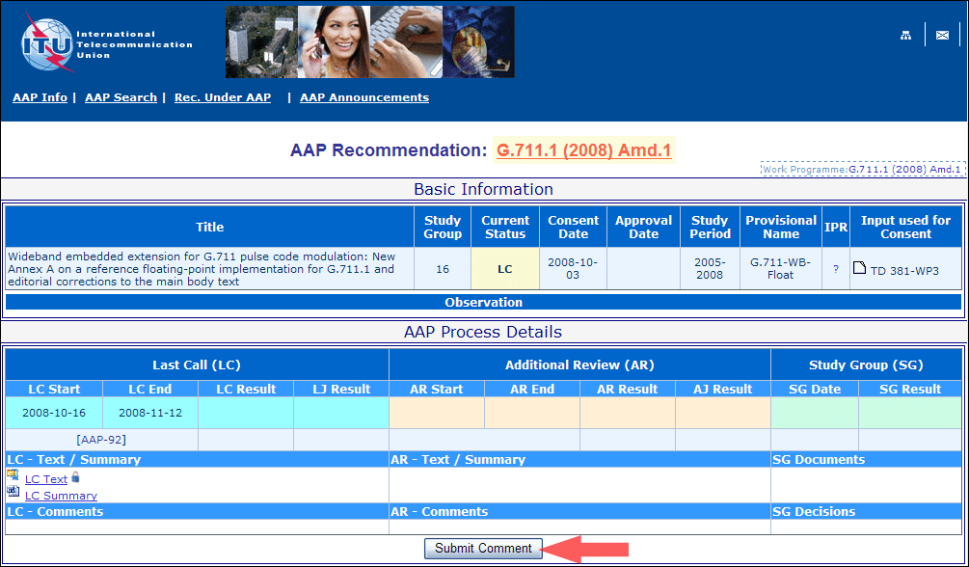
4) Complete the on-line form and click on "Submit"
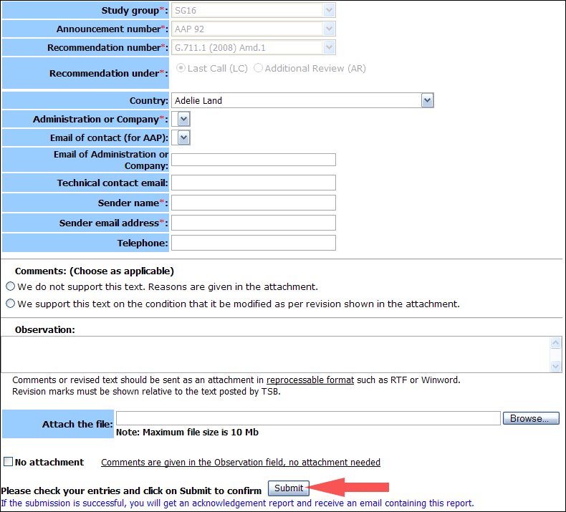
For more information, read the AAP tutorial on:
http://www.itu.int/ITU-T/aapinfo/files/AAPTutorial.pdf
Annex 3
(to TSB AAP-5)
Recommendations under LC/AR – Comment submission form
(Separate form for each Recommendation being commented upon)
ITU-T AAP comment submission form for the period 2009-2012
Study Group:
Announcement number:
Recommendation number:
Recommendation under: | Last call (LC)  Additional Review (AR)
Country:
Administration/Company:
Name of AAP Contact Person:
Email of AAP Contact Person:
Sender name:
(if different from AAP Contact Person)
Sender email address:
Telephone:
Comments:  (Choose as applicable) | We do not support this text. Reasons are given in the attachment.  We support this text on the condition that it be modified as per revision shown in the attachment.
Observations:
No attachment: Comments are given in the Observation field, no attachment needed
To be returned to: email: tsbsg....@itu.int
[or fax +41 22 730 5853]
Comments or revised text should be sent as an attachment in RTF or WinWord format.
Revision marks must be shown relative to the text posted by TSB.

