Международный союз электросвязи
Бюро стандартизации электросвязи

Женева, 1 октября 2012

Осн.:  Тел.:  Факс:  Эл. почта: | TSB AAP-91  AAP/MJ  +41 22 730 5860  +41 22 730 5853  tsbdir@itu.int | – Администрациям Государств – Членов Союза;  – Членам Сектора МСЭ-Т;  – Ассоциированным членам МСЭ-Т  Копии:  – Председателям и заместителям председателей Исследовательских комиссий МСЭ-Т;  – Директору Бюро Развития Электросвязи;  – Директору Бюро Радиосвязи

Предмет: | Положение относительно Рекомендаций, рассматриваемых в соответствии с альтернативным процессом утверждения (АПУ)

Уважаемая госпожа,
уважаемый господин,

Альтернативный процесс утверждения (АПУ), определенный в Рекомендации МСЭ-Т А.8, распространяется на Рекомендации, которые не имеют политических или регламентарных последствий и которые поэтому не требуют официальных консультаций с Государствами-Членами (см. п. 246B Конвенции МСЭ).
В Приложении 1 содержится перечень текстов, статус которых изменился по сравнению с предыдущими объявлениями об АПУ БСЭ.
Если вы желаете представить замечания относительно какой-либо Рекомендации, рассматриваемой в соответствии с АПУ, рекомендуем Вам использовать онлайновую форму для представления замечаний по АПУ, которая размещена на странице этой Рекомендации в разделе веб-сайта МСЭ-Т, посвященном АПУ, по адресу: http://www.itu.int/ITU-T/aap/ (см. Приложение 2). Замечания можно представить иным способом, заполнив приведенную в Приложении 3 форму и направив ее в секретариат заинтересованной исследовательской комиссии.
Просим принять к сведению, что не рекомендуется представлять замечания, являющиеся не чем иным, как поддержкой рассматриваемого текста.
С уважением,
Малколм Джонсон
Директор Бюро
стандартизации электросвязи
Приложения: 3

Annex 1
(to TSB AAP-91)

Status codes used in the AAP announcements:
LC = Last Call
LJ = Last Call Judgment (includes comment resolution)
AR = Additional Review
AJ = Additional Review Judgment (includes comment resolution)
SG = For Study Group approval
A = Approved
AT = Approved with typographic corrections
AC = Approved after Additional Review of Comments
NA = Not approved
TAP = Moved to TAP (ITU-T A.8 / § 5.2)
ITU-T website entry page:
http://www.itu.int/ITU-T
Alternative approval process (AAP) welcome page:
http://www.itu.int/ITU-T/aapinfo
Note – A tutorial on the ITU-T AAP application is available under the AAP welcome page
ITU-T website AAP Recommendation search page:
http://www.itu.int/ITU-T/aap/
Study Group web pages and contacts:
SG 2 | http://www.itu.int/ITU-T/studygroups/com02 | tsbsg2@itu.int
SG 3 | http://www.itu.int/ITU-T/studygroups/com03 | tsbsg3@itu.int
SG 5 | http://www.itu.int/ITU-T/studygroups/com05 | tsbsg5@itu.int
SG 9 | http://www.itu.int/ITU-T/studygroups/com09 | tsbsg9@itu.int
SG 11 | http://www.itu.int/ITU-T/studygroups/com11 | tsbsg11@itu.int
SG 12 | http://www.itu.int/ITU-T/studygroups/com12 | tsbsg12@itu.int
SG 13 | http://www.itu.int/ITU-T/studygroups/com13 | tsbsg13@itu.int
SG 15 | http://www.itu.int/ITU-T/studygroups/com15 | tsbsg15@itu.int
SG 16 | http://www.itu.int/ITU-T/studygroups/com16 | tsbsg16@itu.int
SG 17 | http://www.itu.int/ITU-T/studygroups/com17 | tsbsg17@itu.int

Situation concerning Study Group 9 Recommendations under AAP
Rec # | Title | Last Call (LC) Period |  |  |  | Additional Review (AR) Period |  |  |  | Status
Rec # | Title | LC Start | LC End | LC  Result | LJ  Result | AR Start | AR End | AR  Result | AJ  Result | Status
J.381 (J.atrans-req) | Requirements for advanced digital cable transmission technologies | 2012-05-16 | 2012-06-12 | LJ | AR | 2012-09-01 | 2012-09-21 | AC |  | AC
Situation concerning Study Group 12 Recommendations under AAP
Rec # | Title | Last Call (LC) Period |  |  |  | Additional Review (AR) Period |  |  |  | Status
Rec # | Title | LC Start | LC End | LC  Result | LJ  Result | AR Start | AR End | AR  Result | AJ  Result | Status
P.381 (P.UHIP) | Technical requirements and test methods for universal wired headset or headphone interface of digital wireless terminals | 2012-06-16 | 2012-07-13 | AR |  | 2012-08-01 | 2012-08-21 | AJ | AC | AC
Situation concerning Study Group 15 Recommendations under AAP
Rec # | Title | Last Call (LC) Period |  |  |  | Additional Review (AR) Period |  |  |  | Status
Rec # | Title | LC Start | LC End | LC  Result | LJ  Result | AR Start | AR End | AR  Result | AJ  Result | Status
G.650.1 (2010) Amd.1 | Definitions and test methods for linear, deterministic attributes of single-mode fibre and cable: Amendment 1 | 2012-10-01 | 2012-10-28 |  |  |  |  |  |  | LC
G.654 | Characteristics of a cut-off shifted single-mode optical fibre and cable | 2012-10-01 | 2012-10-28 |  |  |  |  |  |  | LC
G.657 | Characteristics of a bending-loss insensitive single-mode optical fibre and cable for the access network | 2012-10-01 | 2012-10-28 |  |  |  |  |  |  | LC
G.664 | Optical safety procedures and requirements for optical transmission systems | 2012-10-01 | 2012-10-28 |  |  |  |  |  |  | LC
G.672 (G.rmon) | Characteristics of multi-degree reconfigurable optical add/drop multiplexers | 2012-10-01 | 2012-10-28 |  |  |  |  |  |  | LC
G.709/Y.1331 (2012) Amd.1 | Interfaces for the Optical Transport Network (OTN): Amendment 1 | 2012-10-01 | 2012-10-28 |  |  |  |  |  |  | LC
G.709/Y.1331 (2012) Cor.1 | Interfaces for the Optical Transport Network (OTN): Corrigendum 1 | 2012-10-01 | 2012-10-28 |  |  |  |  |  |  | LC
G.798 | Characteristics of optical transport network hierarchy equipment functional blocks | 2012-10-01 | 2012-10-28 |  |  |  |  |  |  | LC
G.798.1 | Types and characteristics of optical transport network equipment | 2012-10-01 | 2012-10-28 |  |  |  |  |  |  | LC
G.806 (2012) Cor.1 | Characteristics of transport equipment - Description methodology and generic functionality: Corrigendum 1 | 2012-10-01 | 2012-10-28 |  |  |  |  |  |  | LC
G.808.3 (G.smp) | Generic protection switching - Shared Mesh Protection | 2012-10-01 | 2012-10-28 |  |  |  |  |  |  | LC
G.870/Y.1352 | Terms and definitions for Optical Transport Networks (OTN) | 2012-10-01 | 2012-10-28 |  |  |  |  |  |  | LC
G.872 | Architecture of optical transport networks | 2012-10-01 | 2012-10-28 |  |  |  |  |  |  | LC
G.873.1 (2011) Amd.1 | Optical Transport Network (OTN): Linear protection: Amendment 1 | 2012-10-01 | 2012-10-28 |  |  |  |  |  |  | LC
G.873.2 (2012) Amd.1 | Optical Transport Network (OTN) - Ring Protection: Amendment 1 | 2012-10-01 | 2012-10-28 |  |  |  |  |  |  | LC
G.874 (2010) Amd.2 | Management aspects of optical transport network elements: Amendment 2 | 2012-10-01 | 2012-10-28 |  |  |  |  |  |  | LC
G.874.1 | Optical transport network (OTN): Protocol-neutral management information model for the network element view | 2012-10-01 | 2012-10-28 |  |  |  |  |  |  | LC
G.979 (G.msub) | Characteristics of monitoring systems for optical submarine cable systems | 2012-10-01 | 2012-10-28 |  |  |  |  |  |  | LC
G.988 (G.omci) | ONU management and control interface (OMCI) specification | 2012-10-01 | 2012-10-28 |  |  |  |  |  |  | LC
G.989.1 (G.ngpon2) | 40-Gigabit-capable passive optical networks (NG-PON2): General requirements | 2012-10-01 | 2012-10-28 |  |  |  |  |  |  | LC
G.992.3 (2009) Amd.5 | Asymmetric digital subscriber line transceivers 2 (ADSL2): Amendment 5 - Accuracy of test parameters | 2012-10-01 | 2012-10-28 |  |  |  |  |  |  | LC
G.993.2 (2011) Amd.2 | Very high speed digital subscriber line transceivers 2 (VDSL2): Amendment 2 | 2012-10-01 | 2012-10-28 |  |  |  |  |  |  | LC
G.993.5 (2010) Amd.2 | Self-FEXT cancellation (vectoring) for use with VDSL2 transceivers: Amendment 2 | 2012-10-01 | 2012-10-28 |  |  |  |  |  |  | LC
G.994.1 (2012) Amd.1 | Handshake procedures for digital subscriber line (DSL) transceivers: Amendment 1 | 2012-10-01 | 2012-10-28 |  |  |  |  |  |  | LC
G.997.1 (2012) Amd.1 | Physical layer management for digital subscriber line (DSL) transceivers: Amendment 1 | 2012-10-01 | 2012-10-28 |  |  |  |  |  |  | LC
G.7041/Y.1303 (2011) Amd.2 | Generic Framing Procedure (GFP): Amendment 2 | 2012-10-01 | 2012-10-28 |  |  |  |  |  |  | LC
G.8001/Y.1354 | Terms and definitions for Ethernet frames over Transport | 2012-10-01 | 2012-10-28 |  |  |  |  |  |  | LC
G.8011/Y.1307 | Ethernet over Transport – Ethernet service characteristics | 2012-10-01 | 2012-10-28 |  |  |  |  |  |  | LC
G.8012.1/Y.1308.1 | Interfaces for the Ethernet Transport network | 2012-10-01 | 2012-10-28 |  |  |  |  |  |  | LC
G.8021.1/Y.1341.1 | Types and characteristics of Ethernet transport network equipment | 2012-10-01 | 2012-10-28 |  |  |  |  |  |  | LC
G.8021/Y.1341 (2012) Amd.1 | Characteristics of Ethernet transport network equipment functional blocks: Amendment 1 | 2012-10-01 | 2012-10-28 |  |  |  |  |  |  | LC
G.8101/Y.1355 | Terms and definitions for MPLS Transport Profile (MPLS-TP) | 2012-10-01 | 2012-10-28 |  |  |  |  |  |  | LC
G.8112/Y.1371 | Interfaces for the MPLS Transport Profile (MPLS-TP) layer network | 2012-10-01 | 2012-10-28 |  |  |  |  |  |  | LC
G.8121/Y.1381 | Characteristics of MPLS-TP Network Equipment Functional Blocks | 2012-01-16 | 2012-02-12 | LJ | AR | 2012-07-01 | 2012-07-21 | AJ | SG | AC
G.8121/Y.1381 (2012) Amd.1 | Characteristics of MPLS-TP Network equipment functional blocks: Amendment 1 | 2012-10-01 | 2012-10-28 |  |  |  |  |  |  | LC
G.8151/Y.1374 (2012) Amd.1 | Management aspects of the MPLS-TP network element: Amendment 1 | 2012-10-01 | 2012-10-28 |  |  |  |  |  |  | LC
G.8251 (2010) Amd.3 | The control of jitter and wander within the optical transport network (OTN): Amendment 3 | 2012-10-01 | 2012-10-28 |  |  |  |  |  |  | LC
G.8262/Y.1362 (2010) Amd.2 | Timing characteristics of a synchronous Ethernet equipment slave clock (EEC): Amendment 2 | 2012-10-01 | 2012-10-28 |  |  |  |  |  |  | LC
G.8265.1/Y.1365.1 (2010) Amd.2 | Precision time protocol telecom profile for frequency synchronization: Amendment 2 | 2012-10-01 | 2012-10-28 |  |  |  |  |  |  | LC
G.8272/Y.1367 | Timing characteristics of primary reference time clock | 2012-10-01 | 2012-10-28 |  |  |  |  |  |  | LC
G.9902 (G.9956, G.hnem) | Narrow-band OFDM power line communication transceivers - G.hnem | 2012-10-01 | 2012-10-28 |  |  |  |  |  |  | LC
G.9903 (G.9956 Annex A, G.9957, G) | Narrow-band OFDM power line communication transceivers - G3-PLC | 2012-10-01 | 2012-10-28 |  |  |  |  |  |  | LC
G.9904 (G.9956 Annex B, G.9958, P) | Narrow-band OFDM power line communication transceivers - PRIME | 2012-10-01 | 2012-10-28 |  |  |  |  |  |  | LC
G.9956 (2011) Amd.1 (G.hnem) | Narrow-band OFDM power line communication transceivers - Data link layer specification: Amendment 1 | 2012-10-01 | 2012-10-28 |  |  |  |  |  |  | LC
G.9956 (2011) Cor.1 (G.hnem) | Narrow-band OFDM power line communication transceivers - Data link layer specification: Corrigendum 1 | 2012-01-16 | 2012-02-12 | LJ | AR | 2012-06-16 | 2012-07-06 | AJ | SG | AC
G.9961 (2010) Amd.1 | Data link layer (DLL) for unified high-speed wire-line based home networking transceivers: Amendment 1 | 2012-02-01 | 2012-02-28 | LJ | AR | 2012-06-16 | 2012-07-06 | AJ | SG | AC
L.64 | ID tag requirements for infrastructure and network elements management | 2012-10-01 | 2012-10-28 |  |  |  |  |  |  | LC
L.92 (L.dmosp) | Disaster management for outside plant facilities | 2012-10-01 | 2012-10-28 |  |  |  |  |  |  | LC
O.175 (O.xgponjitter) | Jitter measuring equipment for digital systems based on XG-PON | 2012-10-01 | 2012-10-28 |  |  |  |  |  |  | LC

Annex 2
(to TSB AAP-91)
Using the on-line comment submission form
Comment submission
1) Go to AAP search Web page at http://www.itu.int/ITU-T/aap/
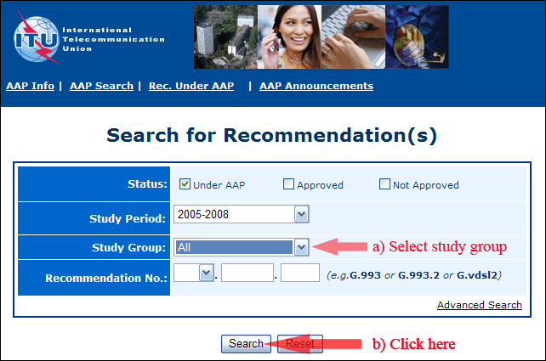
2) Select your Recommendation
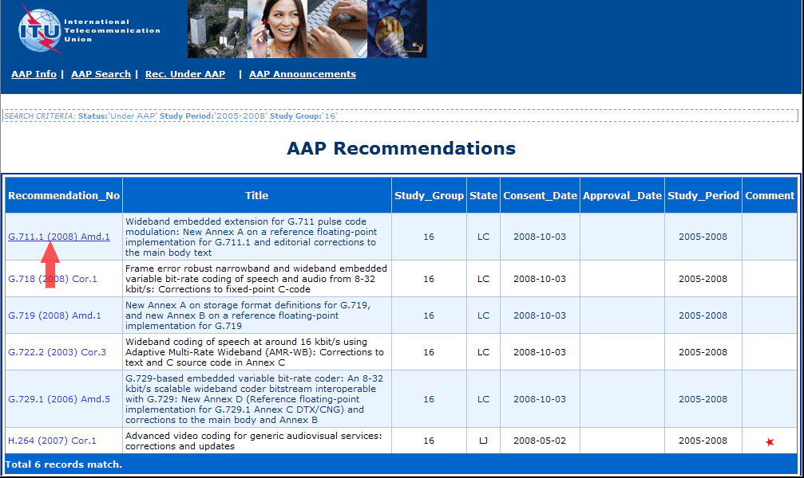
3) Click the "Submit Comment" button
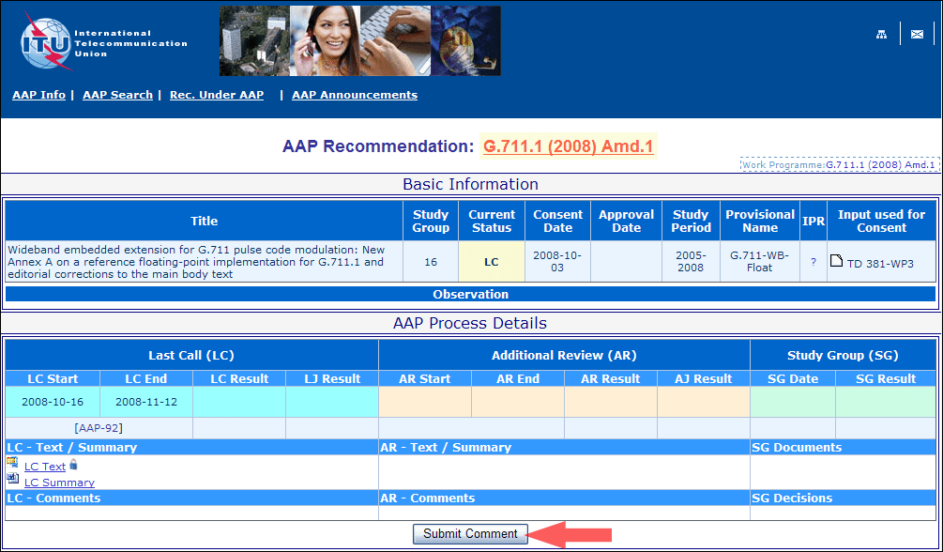
4) Complete the on-line form and click on "Submit"
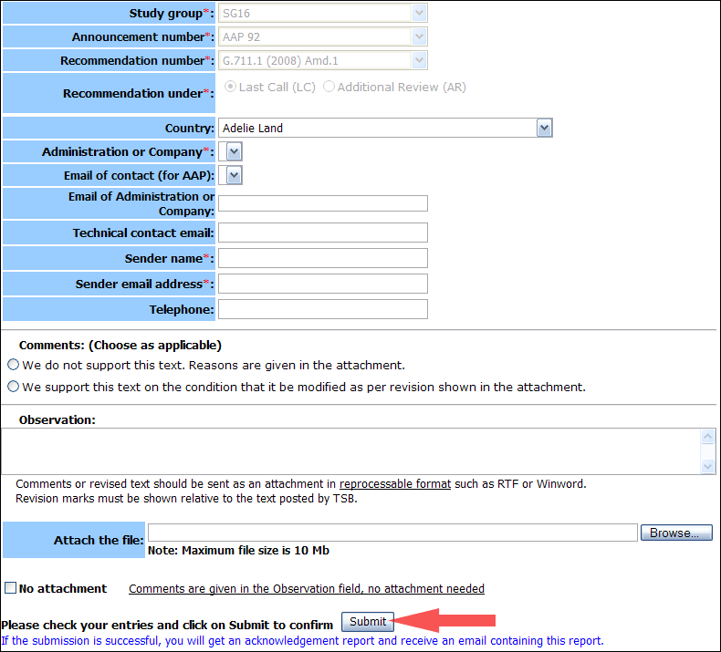
For more information, read the AAP tutorial on:
http://www.itu.int/ITU-T/aapinfo/files/AAPTutorial.pdf
Annex 3
(to TSB AAP-91)
Recommendations under LC/AR – Comment submission form
(Separate form for each Recommendation being commented upon)
ITU-T AAP comment submission form for the period 2009-2012
Study Group:
Announcement number:
Recommendation number:
Recommendation under: | Last call (LC)  Additional Review (AR)
Country:
Administration/Company:
Name of AAP Contact Person:
Email of AAP Contact Person:
Sender name:
(if different from AAP Contact Person)
Sender email address:
Telephone:
Comments:  (Choose as applicable) | We do not support this text. Reasons are given in the attachment.  We support this text on the condition that it be modified as per revision shown in the attachment.
Observations:
No attachment: Comments are given in the Observation field, no attachment needed
To be returned to: email: tsbsg....@itu.int
[or fax +41 22 730 5853]
Comments or revised text should be sent as an attachment in RTF or WinWord format.
Revision marks must be shown relative to the text posted by TSB.

