Union Internationale des Telecommunications
Bureau de la normalisation des télécommunications

Genève, le 1 octobre 2012

Réf:  Tél:  Fax:  E-mail: | TSB AAP-91  AAP/MJ  +41 22 730 5860  +41 22 730 5853  tsbdir@itu.int | – Aux administrations des Etats Membres de l'Union;  – Aux Membres du Secteur UIT-T;  – Aux Associés de l'UIT-T  Copie:  – Aux Présidents et Vice-Présidents des Commissions d'études de l'UIT-T;  – Au Directeur du Bureau de développement des télécommunications;  – Au Directeur du Bureau des radiocommunications

Objet: | Etat des Recommandations auxquelles s'applique la variante de la procédure d'approbation (AAP)

Madame, Monsieur,

La variante de la procédure d'approbation (AAP), définie dans la Recommandation UIT-T A.8, s'applique aux Recommandations qui n'ont pas d'incidence politique ou réglementaire et ne nécessitent donc pas une consultation formelle des Etats Membres (voir le numéro 246B de la Convention de l'UIT).
L'Annexe 1 énumère les textes dont le statut a changé par rapport aux annonces TSB AAP antérieures.
Si vous souhaitez soumettre des observations sur une Recommandation ayant fait l'objet de la procédure AAP, vous êtes encouragés à utiliser le formulaire en ligne de soumission des observations AAP, disponible dans l'espace AAP du site web de l'UIT-T à l'adresse http://www.itu.int/ITU-T/aap/, à la page de la Recommandation concernée (voir l'Annexe 2). Vous pouvez aussi soumettre vos observations en remplissant le formulaire figurant à l'Annexe 3 et en l'envoyant au secrétariat de la Commission d'études concernée.
Veuillez noter que les observations ayant simplement pour objet d'appuyer l'adoption du texte en question ne sont pas encouragées.
Veuillez agréer, Madame, Monsieur, l'assurance de ma considération distinguée.
Malcolm Johnson
Directeur du Bureau de la normalisation des télécommunications

Annexes: 3

Annex 1
(to TSB AAP-91)

Status codes used in the AAP announcements:
LC = Last Call
LJ = Last Call Judgment (includes comment resolution)
AR = Additional Review
AJ = Additional Review Judgment (includes comment resolution)
SG = For Study Group approval
A = Approved
AT = Approved with typographic corrections
AC = Approved after Additional Review of Comments
NA = Not approved
TAP = Moved to TAP (ITU-T A.8 / § 5.2)
ITU-T website entry page:
http://www.itu.int/ITU-T
Alternative approval process (AAP) welcome page:
http://www.itu.int/ITU-T/aapinfo
Note – A tutorial on the ITU-T AAP application is available under the AAP welcome page
ITU-T website AAP Recommendation search page:
http://www.itu.int/ITU-T/aap/
Study Group web pages and contacts:
SG 2 | http://www.itu.int/ITU-T/studygroups/com02 | tsbsg2@itu.int
SG 3 | http://www.itu.int/ITU-T/studygroups/com03 | tsbsg3@itu.int
SG 5 | http://www.itu.int/ITU-T/studygroups/com05 | tsbsg5@itu.int
SG 9 | http://www.itu.int/ITU-T/studygroups/com09 | tsbsg9@itu.int
SG 11 | http://www.itu.int/ITU-T/studygroups/com11 | tsbsg11@itu.int
SG 12 | http://www.itu.int/ITU-T/studygroups/com12 | tsbsg12@itu.int
SG 13 | http://www.itu.int/ITU-T/studygroups/com13 | tsbsg13@itu.int
SG 15 | http://www.itu.int/ITU-T/studygroups/com15 | tsbsg15@itu.int
SG 16 | http://www.itu.int/ITU-T/studygroups/com16 | tsbsg16@itu.int
SG 17 | http://www.itu.int/ITU-T/studygroups/com17 | tsbsg17@itu.int

Situation concerning Study Group 9 Recommendations under AAP
Rec # | Title | Last Call (LC) Period |  |  |  | Additional Review (AR) Period |  |  |  | Status
 |  | LC Start | LC End | LC  Result | LJ  Result | AR Start | AR End | AR  Result | AJ  Result
J.381 (J.atrans-req) | Requirements for advanced digital cable transmission technologies | 2012-05-16 | 2012-06-12 | LJ | AR | 2012-09-01 | 2012-09-21 | AC |  | AC
Situation concerning Study Group 12 Recommendations under AAP
Rec # | Title | Last Call (LC) Period |  |  |  | Additional Review (AR) Period |  |  |  | Status
 |  | LC Start | LC End | LC  Result | LJ  Result | AR Start | AR End | AR  Result | AJ  Result
P.381 (P.UHIP) | Technical requirements and test methods for universal wired headset or headphone interface of digital wireless terminals | 2012-06-16 | 2012-07-13 | AR |  | 2012-08-01 | 2012-08-21 | AJ | AC | AC
Situation concerning Study Group 15 Recommendations under AAP
Rec # | Title | Last Call (LC) Period |  |  |  | Additional Review (AR) Period |  |  |  | Status
 |  | LC Start | LC End | LC  Result | LJ  Result | AR Start | AR End | AR  Result | AJ  Result
G.650.1 (2010) Amd.1 | Definitions and test methods for linear, deterministic attributes of single-mode fibre and cable: Amendment 1 | 2012-10-01 | 2012-10-28 |  |  |  |  |  |  | LC
G.654 | Characteristics of a cut-off shifted single-mode optical fibre and cable | 2012-10-01 | 2012-10-28 |  |  |  |  |  |  | LC
G.657 | Characteristics of a bending-loss insensitive single-mode optical fibre and cable for the access network | 2012-10-01 | 2012-10-28 |  |  |  |  |  |  | LC
G.664 | Optical safety procedures and requirements for optical transmission systems | 2012-10-01 | 2012-10-28 |  |  |  |  |  |  | LC
G.672 (G.rmon) | Characteristics of multi-degree reconfigurable optical add/drop multiplexers | 2012-10-01 | 2012-10-28 |  |  |  |  |  |  | LC
G.709/Y.1331 (2012) Amd.1 | Interfaces for the Optical Transport Network (OTN): Amendment 1 | 2012-10-01 | 2012-10-28 |  |  |  |  |  |  | LC
G.709/Y.1331 (2012) Cor.1 | Interfaces for the Optical Transport Network (OTN): Corrigendum 1 | 2012-10-01 | 2012-10-28 |  |  |  |  |  |  | LC
G.798 | Characteristics of optical transport network hierarchy equipment functional blocks | 2012-10-01 | 2012-10-28 |  |  |  |  |  |  | LC
G.798.1 | Types and characteristics of optical transport network equipment | 2012-10-01 | 2012-10-28 |  |  |  |  |  |  | LC
G.806 (2012) Cor.1 | Characteristics of transport equipment - Description methodology and generic functionality: Corrigendum 1 | 2012-10-01 | 2012-10-28 |  |  |  |  |  |  | LC
G.808.3 (G.smp) | Generic protection switching - Shared Mesh Protection | 2012-10-01 | 2012-10-28 |  |  |  |  |  |  | LC
G.870/Y.1352 | Terms and definitions for Optical Transport Networks (OTN) | 2012-10-01 | 2012-10-28 |  |  |  |  |  |  | LC
G.872 | Architecture of optical transport networks | 2012-10-01 | 2012-10-28 |  |  |  |  |  |  | LC
G.873.1 (2011) Amd.1 | Optical Transport Network (OTN): Linear protection: Amendment 1 | 2012-10-01 | 2012-10-28 |  |  |  |  |  |  | LC
G.873.2 (2012) Amd.1 | Optical Transport Network (OTN) - Ring Protection: Amendment 1 | 2012-10-01 | 2012-10-28 |  |  |  |  |  |  | LC
G.874 (2010) Amd.2 | Management aspects of optical transport network elements: Amendment 2 | 2012-10-01 | 2012-10-28 |  |  |  |  |  |  | LC
G.874.1 | Optical transport network (OTN): Protocol-neutral management information model for the network element view | 2012-10-01 | 2012-10-28 |  |  |  |  |  |  | LC
G.979 (G.msub) | Characteristics of monitoring systems for optical submarine cable systems | 2012-10-01 | 2012-10-28 |  |  |  |  |  |  | LC
G.988 (G.omci) | ONU management and control interface (OMCI) specification | 2012-10-01 | 2012-10-28 |  |  |  |  |  |  | LC
G.989.1 (G.ngpon2) | 40-Gigabit-capable passive optical networks (NG-PON2): General requirements | 2012-10-01 | 2012-10-28 |  |  |  |  |  |  | LC
G.992.3 (2009) Amd.5 | Asymmetric digital subscriber line transceivers 2 (ADSL2): Amendment 5 - Accuracy of test parameters | 2012-10-01 | 2012-10-28 |  |  |  |  |  |  | LC
G.993.2 (2011) Amd.2 | Very high speed digital subscriber line transceivers 2 (VDSL2): Amendment 2 | 2012-10-01 | 2012-10-28 |  |  |  |  |  |  | LC
G.993.5 (2010) Amd.2 | Self-FEXT cancellation (vectoring) for use with VDSL2 transceivers: Amendment 2 | 2012-10-01 | 2012-10-28 |  |  |  |  |  |  | LC
G.994.1 (2012) Amd.1 | Handshake procedures for digital subscriber line (DSL) transceivers: Amendment 1 | 2012-10-01 | 2012-10-28 |  |  |  |  |  |  | LC
G.997.1 (2012) Amd.1 | Physical layer management for digital subscriber line (DSL) transceivers: Amendment 1 | 2012-10-01 | 2012-10-28 |  |  |  |  |  |  | LC
G.7041/Y.1303 (2011) Amd.2 | Generic Framing Procedure (GFP): Amendment 2 | 2012-10-01 | 2012-10-28 |  |  |  |  |  |  | LC
G.8001/Y.1354 | Terms and definitions for Ethernet frames over Transport | 2012-10-01 | 2012-10-28 |  |  |  |  |  |  | LC
G.8011/Y.1307 | Ethernet over Transport – Ethernet service characteristics | 2012-10-01 | 2012-10-28 |  |  |  |  |  |  | LC
G.8012.1/Y.1308.1 | Interfaces for the Ethernet Transport network | 2012-10-01 | 2012-10-28 |  |  |  |  |  |  | LC
G.8021.1/Y.1341.1 | Types and characteristics of Ethernet transport network equipment | 2012-10-01 | 2012-10-28 |  |  |  |  |  |  | LC
G.8021/Y.1341 (2012) Amd.1 | Characteristics of Ethernet transport network equipment functional blocks: Amendment 1 | 2012-10-01 | 2012-10-28 |  |  |  |  |  |  | LC
G.8101/Y.1355 | Terms and definitions for MPLS Transport Profile (MPLS-TP) | 2012-10-01 | 2012-10-28 |  |  |  |  |  |  | LC
G.8112/Y.1371 | Interfaces for the MPLS Transport Profile (MPLS-TP) layer network | 2012-10-01 | 2012-10-28 |  |  |  |  |  |  | LC
G.8121/Y.1381 | Characteristics of MPLS-TP Network Equipment Functional Blocks | 2012-01-16 | 2012-02-12 | LJ | AR | 2012-07-01 | 2012-07-21 | AJ | SG | AC
G.8121/Y.1381 (2012) Amd.1 | Characteristics of MPLS-TP Network equipment functional blocks: Amendment 1 | 2012-10-01 | 2012-10-28 |  |  |  |  |  |  | LC
G.8151/Y.1374 (2012) Amd.1 | Management aspects of the MPLS-TP network element: Amendment 1 | 2012-10-01 | 2012-10-28 |  |  |  |  |  |  | LC
G.8251 (2010) Amd.3 | The control of jitter and wander within the optical transport network (OTN): Amendment 3 | 2012-10-01 | 2012-10-28 |  |  |  |  |  |  | LC
G.8262/Y.1362 (2010) Amd.2 | Timing characteristics of a synchronous Ethernet equipment slave clock (EEC): Amendment 2 | 2012-10-01 | 2012-10-28 |  |  |  |  |  |  | LC
G.8265.1/Y.1365.1 (2010) Amd.2 | Precision time protocol telecom profile for frequency synchronization: Amendment 2 | 2012-10-01 | 2012-10-28 |  |  |  |  |  |  | LC
G.8272/Y.1367 | Timing characteristics of primary reference time clock | 2012-10-01 | 2012-10-28 |  |  |  |  |  |  | LC
G.9902 (G.9956, G.hnem) | Narrow-band OFDM power line communication transceivers - G.hnem | 2012-10-01 | 2012-10-28 |  |  |  |  |  |  | LC
G.9903 (G.9956 Annex A, G.9957, G) | Narrow-band OFDM power line communication transceivers - G3-PLC | 2012-10-01 | 2012-10-28 |  |  |  |  |  |  | LC
G.9904 (G.9956 Annex B, G.9958, P) | Narrow-band OFDM power line communication transceivers - PRIME | 2012-10-01 | 2012-10-28 |  |  |  |  |  |  | LC
G.9956 (2011) Amd.1 (G.hnem) | Narrow-band OFDM power line communication transceivers - Data link layer specification: Amendment 1 | 2012-10-01 | 2012-10-28 |  |  |  |  |  |  | LC
G.9956 (2011) Cor.1 (G.hnem) | Narrow-band OFDM power line communication transceivers - Data link layer specification: Corrigendum 1 | 2012-01-16 | 2012-02-12 | LJ | AR | 2012-06-16 | 2012-07-06 | AJ | SG | AC
G.9961 (2010) Amd.1 | Data link layer (DLL) for unified high-speed wire-line based home networking transceivers: Amendment 1 | 2012-02-01 | 2012-02-28 | LJ | AR | 2012-06-16 | 2012-07-06 | AJ | SG | AC
L.64 | ID tag requirements for infrastructure and network elements management | 2012-10-01 | 2012-10-28 |  |  |  |  |  |  | LC
L.92 (L.dmosp) | Disaster management for outside plant facilities | 2012-10-01 | 2012-10-28 |  |  |  |  |  |  | LC
O.175 (O.xgponjitter) | Jitter measuring equipment for digital systems based on XG-PON | 2012-10-01 | 2012-10-28 |  |  |  |  |  |  | LC

Annex 2
(to TSB AAP-91)
Using the on-line comment submission form
Comment submission
1) Go to AAP search Web page at http://www.itu.int/ITU-T/aap/
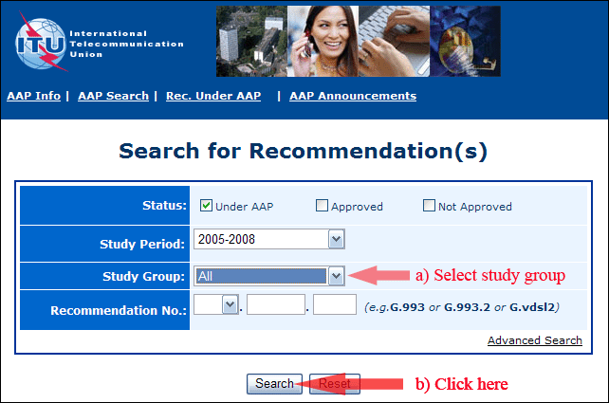
2) Select your Recommendation
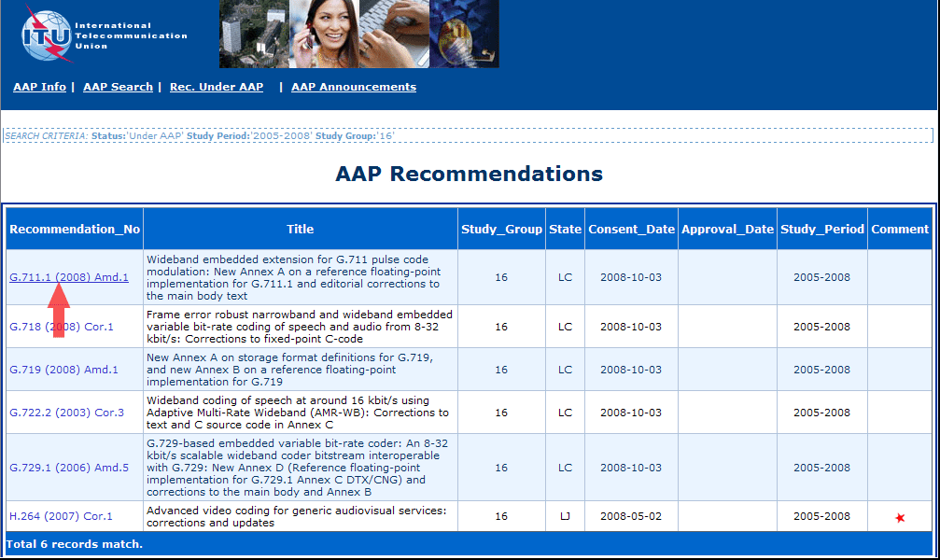
3) Click the "Submit Comment" button
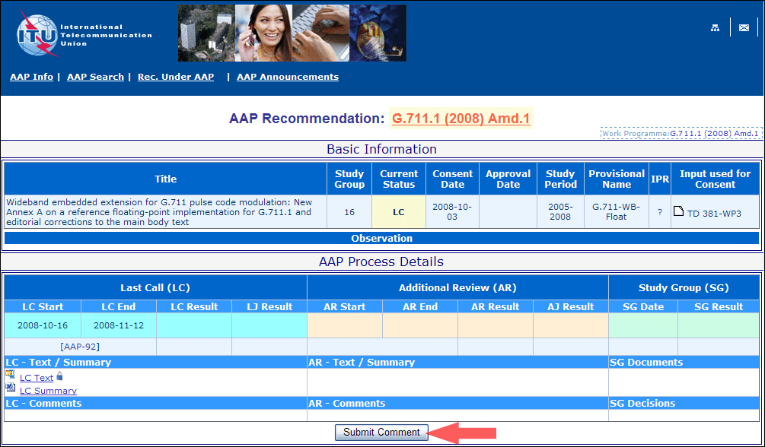
4) Complete the on-line form and click on "Submit"
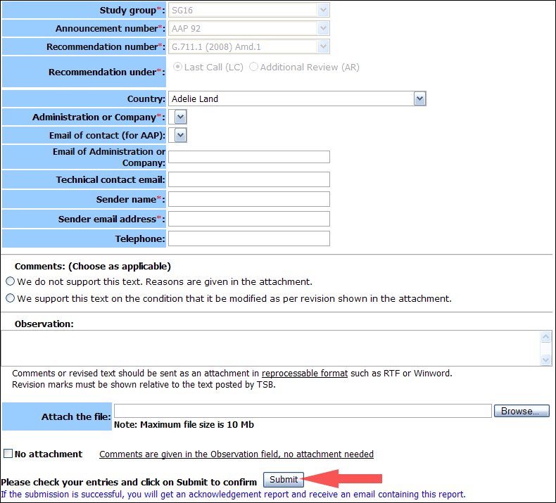
For more information, read the AAP tutorial on:
http://www.itu.int/ITU-T/aapinfo/files/AAPTutorial.pdf
Annex 3
(to TSB AAP-91)
Recommendations under LC/AR – Comment submission form
(Separate form for each Recommendation being commented upon)
ITU-T AAP comment submission form for the period 2009-2012
Study Group:
Announcement number:
Recommendation number:
Recommendation under: | Last call (LC)  Additional Review (AR)
Country:
Administration/Company:
Name of AAP Contact Person:
Email of AAP Contact Person:
Sender name:
(if different from AAP Contact Person)
Sender email address:
Telephone:
Comments:  (Choose as applicable) | We do not support this text. Reasons are given in the attachment.  We support this text on the condition that it be modified as per revision shown in the attachment.
Observations:
No attachment: Comments are given in the Observation field, no attachment needed
To be returned to: email: tsbsg....@itu.int
[or fax +41 22 730 5853]
Comments or revised text should be sent as an attachment in RTF or WinWord format.
Revision marks must be shown relative to the text posted by TSB.

