Unión Internacional de Telecomunicaciones
Oficina de Normalización de las Telecomunicaciones

Ginebra, 16 de septiembre de 2012

Ref:  Tel:  Fax:  Correo-e: | TSB AAP-90  AAP/MJ  +41 22 730 5860  +41 22 730 5853  tsbdir@itu.int | – A las Administraciones de los Estados Miembros de la Unión;  – A los Miembros del Sector UIT-T;  – A los Asociados del UIT-T  Copia:  – A los Presidentes y a los Vicepresidentes de las Comisiones de Estudio del UIT-T;  – Al Director de la Oficina de Desarrollo de las Telecomunicaciones;  – Al Director de la Oficina de Radiocomunicaciones

Asunto: | Situación de las Recomendaciones sometidas al proceso de aprobación alternativo (AAP)

Muy señora mía/Muy señor mío:

El proceso de aprobación alternativo (AAP) definido en la Recomendación A.8 del UIT-T se aplica a las Recomendaciones que no tienen consecuencias en materia de política o reglamentación y que no requieren, por lo tanto, la consulta formal de los Estados Miembros (véase el número 246B del Convenio de la UIT).
En el anexo 1 se enumera la lista de los textos cuyo estado ha cambiado con respecto a los anuncios TSB AAP precedentes.
Si desea formular un comentario en relación con una Recomendación sometida al AAP, le alentamos a utilizar el formulario de presentación de comentarios disponible en la página de la Recomendación que figura en el área AAP del sitio web del UIT-T, en la dirección http://www.itu.int/ITU-T/aap/ (véase también el anexo 2). Alternativamente, pueden presentarse comentarios completando el formulario del anexo 3 y remitiéndolo a la secretaría de la Comisión de Estudio correspondiente.
Le rogamos tenga en cuenta que no se alientan comentarios que se limiten a apoyar la adopción del texto en cuestión.
Le saluda atentamente,

Malcolm Johnson
Director de la Oficina de
Normalización de las Telecomunicaciones
Anexos: 3

Annex 1
(to TSB AAP-90)

Status codes used in the AAP announcements:
LC = Last Call
LJ = Last Call Judgment (includes comment resolution)
AR = Additional Review
AJ = Additional Review Judgment (includes comment resolution)
SG = For Study Group approval
A = Approved
AT = Approved with typographic corrections
AC = Approved after Additional Review of Comments
NA = Not approved
TAP = Moved to TAP (ITU-T A.8 / § 5.2)
ITU-T website entry page:
http://www.itu.int/ITU-T
Alternative approval process (AAP) welcome page:
http://www.itu.int/ITU-T/aapinfo
Note – A tutorial on the ITU-T AAP application is available under the AAP welcome page
ITU-T website AAP Recommendation search page:
http://www.itu.int/ITU-T/aap/
Study Group web pages and contacts:
SG 2 | http://www.itu.int/ITU-T/studygroups/com02 | tsbsg2@itu.int
SG 3 | http://www.itu.int/ITU-T/studygroups/com03 | tsbsg3@itu.int
SG 5 | http://www.itu.int/ITU-T/studygroups/com05 | tsbsg5@itu.int
SG 9 | http://www.itu.int/ITU-T/studygroups/com09 | tsbsg9@itu.int
SG 11 | http://www.itu.int/ITU-T/studygroups/com11 | tsbsg11@itu.int
SG 12 | http://www.itu.int/ITU-T/studygroups/com12 | tsbsg12@itu.int
SG 13 | http://www.itu.int/ITU-T/studygroups/com13 | tsbsg13@itu.int
SG 15 | http://www.itu.int/ITU-T/studygroups/com15 | tsbsg15@itu.int
SG 16 | http://www.itu.int/ITU-T/studygroups/com16 | tsbsg16@itu.int
SG 17 | http://www.itu.int/ITU-T/studygroups/com17 | tsbsg17@itu.int

Situation concerning Study Group 12 Recommendations under AAP
Rec # | Title | Last Call (LC) Period |  |  |  | Additional Review (AR) Period |  |  |  | Status
 |  | LC Start | LC End | LC  Result | LJ  Result | AR Start | AR End | AR  Result | AJ  Result
P.1201 (P.NAMS) | Parametric non-intrusive assessment of audiovisual media streaming quality | 2012-09-16 | 2012-10-13 |  |  |  |  |  |  | LC
P.1201.1 (P.NAMS-LR) | Parametric non-intrusive assessment of audiovisual media streaming quality - lower resolution application area | 2012-09-16 | 2012-10-13 |  |  |  |  |  |  | LC
P.1201.2 (P.NAMS-HR) | Parametric non-intrusive assessment of audiovisual media streaming quality - higher resolution application area | 2012-09-16 | 2012-10-13 |  |  |  |  |  |  | LC
P.1202 (P.NBAMS) | Parametric non-intrusive bitstream assessment of video media streaming quality | 2012-09-16 | 2012-10-13 |  |  |  |  |  |  | LC
P.1202.1 (P.NBAMS-LR) | Parametric non-intrusive bitstream assessment of video media streaming quality - lower resolution application area | 2012-09-16 | 2012-10-13 |  |  |  |  |  |  | LC
Situation concerning Study Group 16 Recommendations under AAP
Rec # | Title | Last Call (LC) Period |  |  |  | Additional Review (AR) Period |  |  |  | Status
 |  | LC Start | LC End | LC  Result | LJ  Result | AR Start | AR End | AR  Result | AJ  Result
G.711.1 (G.711.1) | Wideband embedded extension for G.711 pulse code modulation | 2012-08-16 | 2012-09-12 | A |  |  |  |  |  | A
G.722 (G.722) | 7 kHz audio-coding within 64 kbit/s | 2012-08-16 | 2012-09-12 | A |  |  |  |  |  | A
Situation concerning Study Group 17 Recommendations under AAP
Rec # | Title | Last Call (LC) Period |  |  |  | Additional Review (AR) Period |  |  |  | Status
 |  | LC Start | LC End | LC  Result | LJ  Result | AR Start | AR End | AR  Result | AJ  Result
E.115 (2010) Cor.1 | Corrigendum 1 to ITU-T E.115 (2010) | 2012-09-16 | 2012-10-13 |  |  |  |  |  |  | LC
X.500 | Information technology - Open Systems Interconnection - The Directory: Overview of concepts, models and services | 2012-09-16 | 2012-10-13 |  |  |  |  |  |  | LC
X.501 | Information technology - Open Systems Interconnection - The Directory: Models | 2012-09-16 | 2012-10-13 |  |  |  |  |  |  | LC
X.501 (2008) Cor.3 | Information technology - Open Systems Interconnection -The Directory - Models - Technical Corrigendum 3 | 2012-09-16 | 2012-10-13 |  |  |  |  |  |  | LC
X.509 | Information technology - Open Systems Interconnection - The Directory: Public-key and attribute certificate frameworks | 2012-09-16 | 2012-10-13 |  |  |  |  |  |  | LC
X.509 (2008) Cor.3 | Information technology - Open Systems Interconnection -The Directory - Public-key and attribute certificate frameworks - Technical Corrigendum 3 | 2012-09-16 | 2012-10-13 |  |  |  |  |  |  | LC
X.511 | Information technology - Open Systems Interconnection - The Directory: Abstract service definition | 2012-09-16 | 2012-10-13 |  |  |  |  |  |  | LC
X.511 (2008) Cor.3 | Information technology - Open Systems Interconnection -The Directory - Abstract service definition- Technical Corrigendum 3 | 2012-09-16 | 2012-10-13 |  |  |  |  |  |  | LC
X.518 | Information technology - Open Systems Interconnection - The Directory: Procedures for distributed operations | 2012-09-16 | 2012-10-13 |  |  |  |  |  |  | LC
X.518 (2008) Cor.2 | Information technology - Open Systems Interconnection -The Directory - Procedures for distributed operations- Technical Corrigendum 2 | 2012-09-16 | 2012-10-13 |  |  |  |  |  |  | LC
X.519 | Information technology - Open Systems Interconnection - The Directory: Protocols | 2012-09-16 | 2012-10-13 |  |  |  |  |  |  | LC
X.520 | Information technology - Open Systems Interconnection - The Directory - Selected attribute types | 2012-09-16 | 2012-10-13 |  |  |  |  |  |  | LC
X.520 (2008) Cor.3 | Information technology - Open Systems Interconnection -The Directory - Selected attribute types- Technical Corrigendum 3 | 2012-09-16 | 2012-10-13 |  |  |  |  |  |  | LC
X.521 | Information technology - Open Systems Interconnection - The Directory: Selected object classes | 2012-09-16 | 2012-10-13 |  |  |  |  |  |  | LC
X.525 | Information technology - Open Systems Interconnection - The Directory: Replication | 2012-09-16 | 2012-10-13 |  |  |  |  |  |  | LC
X.667 | Information technology - Procedures for the operation of Object Identifier Registration Authorities: Generation of Universally Unique identifier (UUIDS) and their use in object identifiers | 2012-09-16 | 2012-10-13 |  |  |  |  |  |  | LC
X.1164 (X.p2p-4) | Use of service providers' user authentication infrastructure to implement public key infrastructure for peer-to-peer networks | 2012-09-16 | 2012-10-13 |  |  |  |  |  |  | LC
X.1196 (X.iptvsec-6) | Framework for the downloadable service and content protection system in the mobile Internet Protocol Television (IPTV) environment | 2012-09-16 | 2012-10-13 |  |  |  |  |  |  | LC
X.1313 (X.usnsec-3) | Security requirements for wireless sensor network routing | 2012-09-16 | 2012-10-13 |  |  |  |  |  |  | LC
Z.104 Amd.1 | Data and action language in SDL-2010 Annex C - Language binding | 2012-09-16 | 2012-10-13 |  |  |  |  |  |  | LC
Z.151 | User Requirements Notation (URN) – Language definition | 2012-09-16 | 2012-10-13 |  |  |  |  |  |  | LC

Annex 2
(to TSB AAP-90)
Using the on-line comment submission form
Comment submission
1) Go to AAP search Web page at http://www.itu.int/ITU-T/aap/
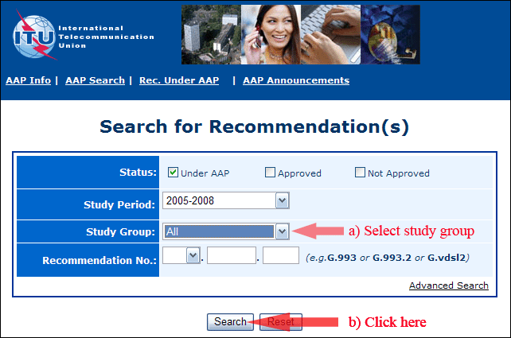
2) Select your Recommendation
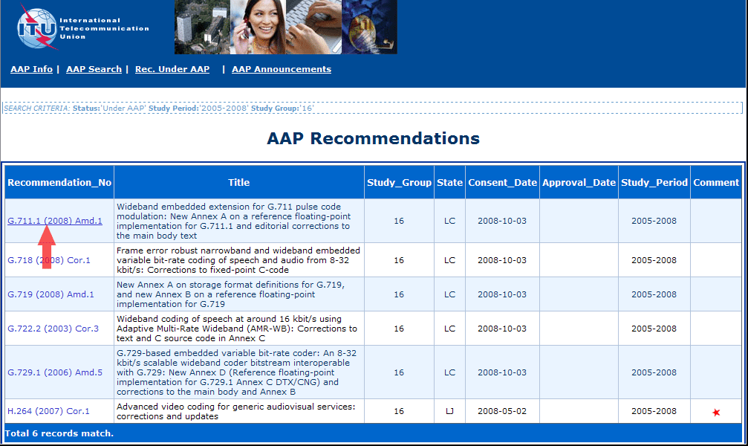
3) Click the "Submit Comment" button
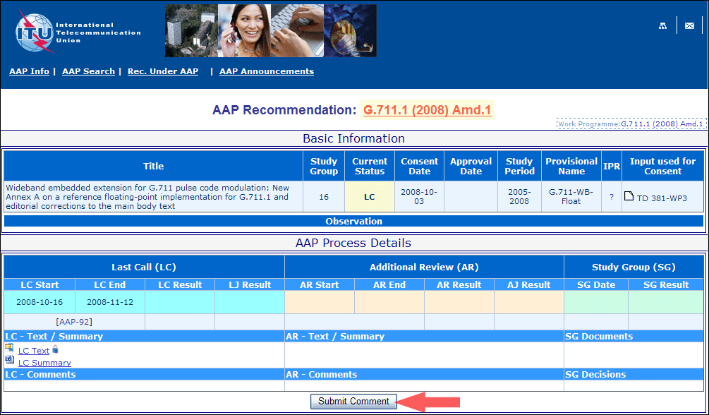
4) Complete the on-line form and click on "Submit"
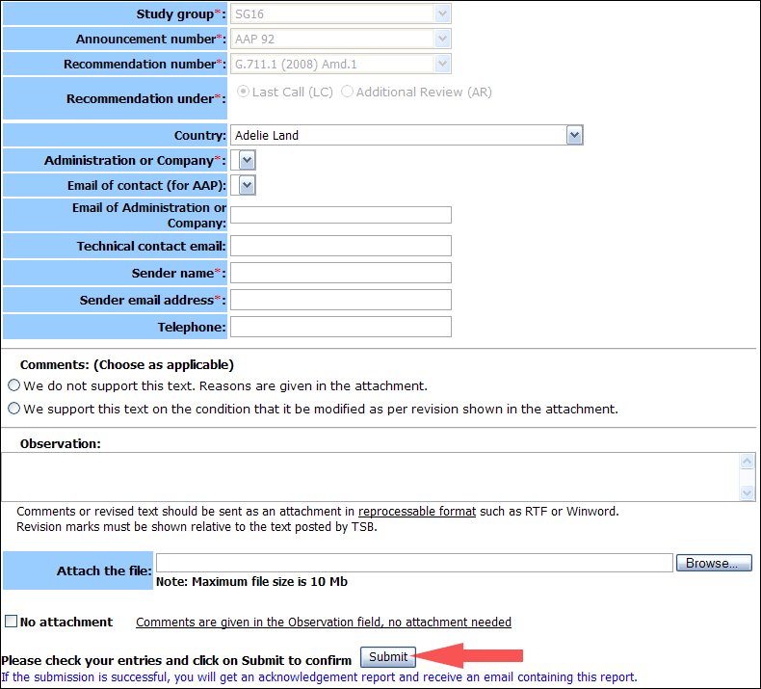
For more information, read the AAP tutorial on:
http://www.itu.int/ITU-T/aapinfo/files/AAPTutorial.pdf
Annex 3
(to TSB AAP-90)
Recommendations under LC/AR – Comment submission form
(Separate form for each Recommendation being commented upon)
ITU-T AAP comment submission form for the period 2009-2012
Study Group:
Announcement number:
Recommendation number:
Recommendation under: | Last call (LC)  Additional Review (AR)
Country:
Administration/Company:
Name of AAP Contact Person:
Email of AAP Contact Person:
Sender name:
(if different from AAP Contact Person)
Sender email address:
Telephone:
Comments:  (Choose as applicable) | We do not support this text. Reasons are given in the attachment.  We support this text on the condition that it be modified as per revision shown in the attachment.
Observations:
No attachment: Comments are given in the Observation field, no attachment needed
To be returned to: email: tsbsg....@itu.int
[or fax +41 22 730 5853]
Comments or revised text should be sent as an attachment in RTF or WinWord format.
Revision marks must be shown relative to the text posted by TSB.

