|  |  |
| --- | --- |
| Международный союз электросвязи  *Бюро стандартизации электросвязи* | ITU-COLOR |

Женева, 16 августа 2012

|  |  |  |
| --- | --- | --- |
| Осн.:  Тел.:  Факс:  Эл. почта: | **TSB AAP-88**  AAP/MJ  +41 22 730 5860  +41 22 730 5853  [tsbdir@itu.int](mailto:tsbdir@itu.int) | – Администрациям Государств – Членов Союза;  – Членам Сектора МСЭ-Т;  – Ассоциированным членам МСЭ-Т  **Копии:**  – Председателям и заместителям председателей Исследовательских комиссий МСЭ-Т;  – Директору Бюро Развития Электросвязи;  – Директору Бюро Радиосвязи |

|  |  |
| --- | --- |
| Предмет: | **Положение относительно Рекомендаций, рассматриваемых в соответствии с альтернативным процессом утверждения (АПУ)** |

Уважаемая госпожа,  
уважаемый господин,

Альтернативный процесс утверждения (АПУ), определенный в Рекомендации МСЭ-Т А.8, распространяется на Рекомендации, которые не имеют политических или регламентарных последствий и которые поэтому не требуют официальных консультаций с Государствами-Членами (см. п. 246B Конвенции МСЭ).

В **Приложении 1** содержится перечень текстов, статус которых изменился по сравнению с предыдущими объявлениями об АПУ БСЭ.

Если вы желаете представить замечания относительно какой-либо Рекомендации, рассматриваемой в соответствии с АПУ, рекомендуем Вам использовать онлайновую форму для представления замечаний по АПУ, которая размещена на странице этой Рекомендации в разделе веб-сайта МСЭ-Т, посвященном АПУ, по адресу: <http://www.itu.int/ITU-T/aap/> (см. **Приложение 2**). Замечания можно представить иным способом, заполнив приведенную в **Приложении 3** форму и направив ее в секретариат заинтересованной исследовательской комиссии.

Просим принять к сведению, что не рекомендуется представлять замечания, являющиеся не чем иным, как поддержкой рассматриваемого текста.

С уважением,

Малколм Джонсон  
Директор Бюро   
стандартизации электросвязи

**Приложения**: 3

Annex 1

(to TSB AAP-88)

Status codes used in the AAP announcements:

LC = Last Call

LJ = Last Call Judgment (includes comment resolution)

AR = Additional Review

AJ = Additional Review Judgment (includes comment resolution)

SG = For Study Group approval

A = Approved

AT = Approved with typographic corrections

AC = Approved after Additional Review of Comments

NA = Not approved

TAP = Moved to TAP (ITU-T A.8 / § 5.2)

ITU-T website entry page:

[http://www.itu.int/ITU-T](http://www.itu.int/ITU-T/)

Alternative approval process (AAP) welcome page:

[http://www.itu.int/ITU-T/aapinfo](http://www.itu.int/ITU-T/aapinfo/)

Note – A tutorial on the ITU-T AAP application is available under the AAP welcome page

ITU-T website AAP Recommendation search page:

<http://www.itu.int/ITU-T/aap/>

Study Group web pages and contacts:

|  |  |  |
| --- | --- | --- |
| SG 2 | <http://www.itu.int/ITU-T/studygroups/com02> | [tsbsg2@itu.int](mailto:tsbsg2@itu.int) |
| SG 3 | <http://www.itu.int/ITU-T/studygroups/com03> | [tsbsg3@itu.int](mailto:tsbsg3@itu.int) |
| SG 5 | <http://www.itu.int/ITU-T/studygroups/com05> | [tsbsg5@itu.int](mailto:tsbsg5@itu.int) |
| SG 9 | <http://www.itu.int/ITU-T/studygroups/com09> | [tsbsg9@itu.int](mailto:tsbsg9@itu.int) |
| SG 11 | <http://www.itu.int/ITU-T/studygroups/com11> | [tsbsg11@itu.int](mailto:tsbsg11@itu.int) |
| SG 12 | <http://www.itu.int/ITU-T/studygroups/com12> | [tsbsg12@itu.int](mailto:tsbsg12@itu.int) |
| SG 13 | <http://www.itu.int/ITU-T/studygroups/com13> | [tsbsg13@itu.int](mailto:tsbsg13@itu.int) |
| SG 15 | <http://www.itu.int/ITU-T/studygroups/com15> | [tsbsg15@itu.int](mailto:tsbsg15@itu.int) |
| SG 16 | <http://www.itu.int/ITU-T/studygroups/com16> | [tsbsg16@itu.int](mailto:tsbsg16@itu.int) |
| SG 17 | <http://www.itu.int/ITU-T/studygroups/com17> | [tsbsg17@itu.int](mailto:tsbsg17@itu.int) |

Situation concerning Study Group 11 Recommendations under AAP

| **Rec #** | **Title** | **Last Call (LC) Period** | | | | **Additional Review (AR) Period** | | | | Status |
| --- | --- | --- | --- | --- | --- | --- | --- | --- | --- | --- |
| **LC Start** | **LC End** | **LC Result** | **LJ Result** | **AR Start** | **AR End** | **AR Result** | **AJ Result** |
| [Q.3050 (Q.NGN-SigProt)](http://www.itu.int/itu-t/aap/AAPRecDetails.aspx?AAPSeqNo=2627) | Description of signaling protocols supporting NGN capability sets | 2012-07-16 | 2012-08-12 | A |  |  |  |  |  | A |
| [Q.3230 (Q.nacp.M13)](http://www.itu.int/itu-t/aap/AAPRecDetails.aspx?AAPSeqNo=2630) | Signalling Requirements and Protocol at the M13 interface between TLM-PE and NID-PE | 2012-07-16 | 2012-08-12 | A |  |  |  |  |  | A |
| [Q.3303.1 v2 (Q.3323.1 (Q.RwCOPS v2))](http://www.itu.int/itu-t/aap/AAPRecDetails.aspx?AAPSeqNo=2628) | Resource control protocol no.3 - Protocol at the interface between a Policy Decision Physical Entity (PD-PE) and a Policy Enforcement Physical Entity (PE-PE): COPS Profile version 2 | 2012-07-16 | 2012-08-12 | A |  |  |  |  |  | A |
| [Q.3304.2 v2 (Q.3324.2 (Q.RcSNMP))](http://www.itu.int/itu-t/aap/AAPRecDetails.aspx?AAPSeqNo=2629) | Resource control protocol No.4 (rcp4) - Protocols at the Rc interface between a transport resource control physical entity (TRC-PE) and a transport physical entity (T-PE): SNMP alternative | 2012-07-16 | 2012-08-12 | A |  |  |  |  |  | A |
| [Q.3912 (Q.monitor_ss)](http://www.itu.int/itu-t/aap/AAPRecDetails.aspx?AAPSeqNo=2633) | Set of parameters of NGN streaming services for monitoring | 2012-07-16 | 2012-08-12 | A |  |  |  |  |  | A |
| [Q.3930](http://www.itu.int/itu-t/aap/AAPRecDetails.aspx?AAPSeqNo=2635) | Performance Testing of distributed systems; Concepts and Terminology | 2012-07-16 | 2012-08-12 | A |  |  |  |  |  | A |
| [Q.3940 (Q.SIP-ISDN-IT B (integration tests))](http://www.itu.int/itu-t/aap/AAPRecDetails.aspx?AAPSeqNo=2632) | NGN/IMS interconnection tests between network operators at the IMS 'Ic' Interface and NGN NNI / SIP-I | 2012-07-16 | 2012-08-12 | A |  |  |  |  |  | A |
| [Q.3949 (Q.MMtesting)](http://www.itu.int/itu-t/aap/AAPRecDetails.aspx?AAPSeqNo=2634) | Real-time multimedia service testing framework at the user-to-user network interface of next generation networks | 2012-07-16 | 2012-08-12 | A |  |  |  |  |  | A |
| [X.603.1 Revised](http://www.itu.int/itu-t/aap/AAPRecDetails.aspx?AAPSeqNo=2631) | Information technology - Relayed multicast protocol: Specification for simplex group applications | 2012-07-16 | 2012-08-12 | A |  |  |  |  |  | A |

Situation concerning Study Group 15 Recommendations under AAP

| **Rec #** | **Title** | **Last Call (LC) Period** | | | | **Additional Review (AR) Period** | | | | Status |
| --- | --- | --- | --- | --- | --- | --- | --- | --- | --- | --- |
| **LC Start** | **LC End** | **LC Result** | **LJ Result** | **AR Start** | **AR End** | **AR Result** | **AJ Result** |
| [G.808.1 (2010) Amd.1](http://www.itu.int/itu-t/aap/AAPRecDetails.aspx?AAPSeqNo=2465) | Generic Protection Switching - Linear Trail and Subnetwork Protection: Amendment 1 | 2012-01-16 | 2012-02-12 | LJ | AR | 2012-07-16 | 2012-08-05 | AC |  | AC |
| [G.8121/Y.1381](http://www.itu.int/itu-t/aap/AAPRecDetails.aspx?AAPSeqNo=2470) | Characteristics of MPLS-TP Network Equipment Functional Blocks | 2012-01-16 | 2012-02-12 | LJ | AR | 2012-07-01 | 2012-07-21 | AJ | SG | SG |
| [G.9956 (2011) Cor.1 (G.hnem)](http://www.itu.int/itu-t/aap/AAPRecDetails.aspx?AAPSeqNo=2448) | Narrow-band OFDM power line communication transceivers - Data link layer specification: Corrigendum 1 | 2012-01-16 | 2012-02-12 | LJ | AR | 2012-06-16 | 2012-07-06 | AJ | SG | SG |
| [G.9961 (2010) Amd.1](http://www.itu.int/itu-t/aap/AAPRecDetails.aspx?AAPSeqNo=2262) | Data link layer (DLL) for unified high-speed wire-line based home networking transceivers: Amendment 1 | 2012-02-01 | 2012-02-28 | LJ | AR | 2012-06-16 | 2012-07-06 | AJ | SG | SG |

Situation concerning Study Group 16 Recommendations under AAP

| **Rec #** | **Title** | **Last Call (LC) Period** | | | | **Additional Review (AR) Period** | | | | Status |
| --- | --- | --- | --- | --- | --- | --- | --- | --- | --- | --- |
| **LC Start** | **LC End** | **LC Result** | **LJ Result** | **AR Start** | **AR End** | **AR Result** | **AJ Result** |
| [G.711.1 (G.711.1)](http://www.itu.int/itu-t/aap/AAPRecDetails.aspx?AAPSeqNo=2599) | Wideband embedded extension for G.711 pulse code modulation | 2012-08-16 | 2012-09-12 |  |  |  |  |  |  | LC |
| [G.722 (G.722)](http://www.itu.int/itu-t/aap/AAPRecDetails.aspx?AAPSeqNo=2600) | 7 kHz audio-coding within 64 kbit/s | 2012-08-16 | 2012-09-12 |  |  |  |  |  |  | LC |

Annex 2

(to TSB AAP-88)

Using the on-line comment submission form

Comment submission

1) Go to AAP search Web page at <http://www.itu.int/ITU-T/aap/>

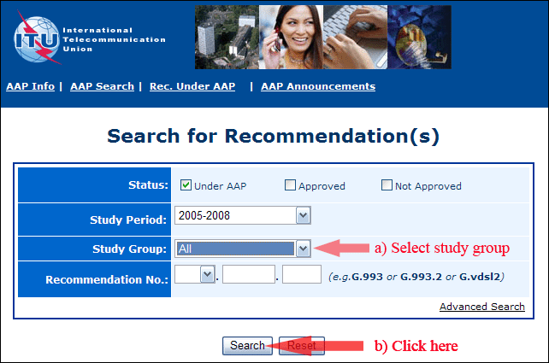

2) Select your Recommendation

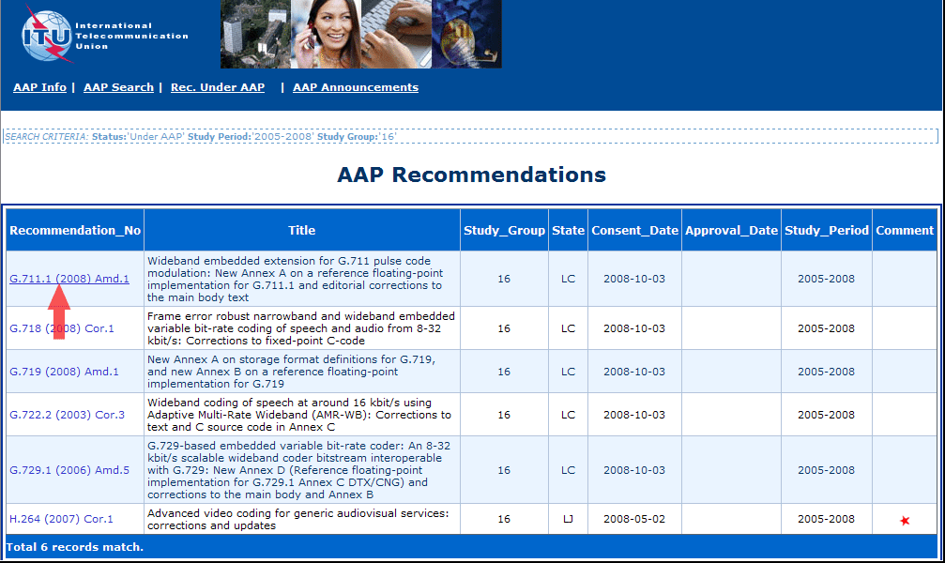

3) Click the "Submit Comment" button

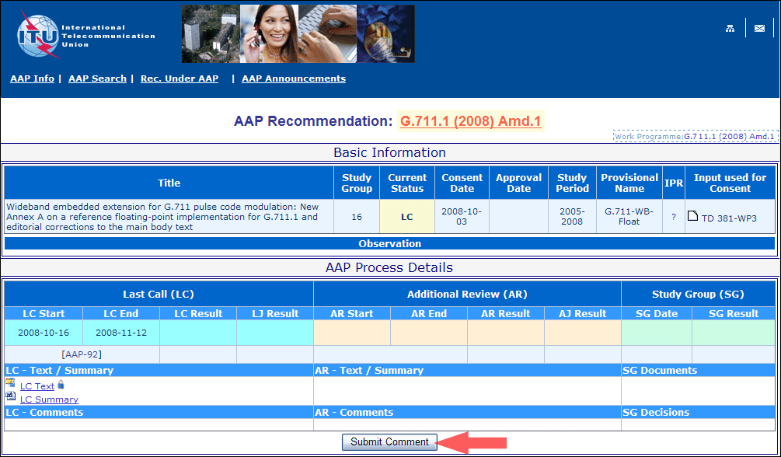

4) Complete the on-line form and click on "Submit"

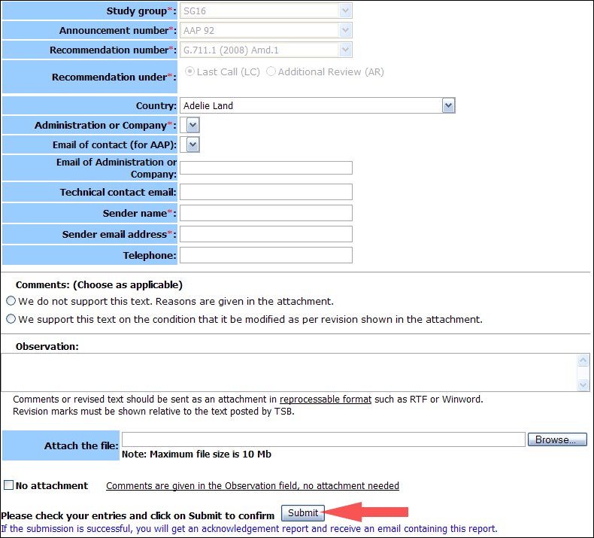

For more information, read the AAP tutorial on:   
<http://www.itu.int/ITU-T/aapinfo/files/AAPTutorial.pdf>

Annex 3

(to TSB AAP-88)

Recommendations under LC/AR – Comment submission form

*(Separate form for each Recommendation being commented upon)*

|  |  |
| --- | --- |
| ITU-T AAP comment submission form for the period 2009-2012 | |
| **Study Group:** |  |
| **Announcement number:** |  |
| **Recommendation number:** |  |
| **Recommendation under:** | Last call (LC)   Additional Review (AR) |
| **Country:** |  |
| **Administration/Company:** |  |
| **Name of AAP Contact Person:** |  |
| **Email of AAP Contact Person:** |  |
| **Sender name: (if different from AAP Contact Person)** |  |
| **Sender email address:** |  |
| **Telephone:** |  |
| **Comments: (Choose as applicable)** | We do not support this text. Reasons are given in the attachment.   We support this text on the condition that it be modified as per revision shown in the attachment. |
| **Observations:** |  |

**No attachment:** Comments are given in the Observation field, no attachment needed

*To be returned to: email:* [*tsbsg....@itu.int*](mailto:tsbsg....@itu.int) *[or fax +41 22 730 5853]  
Comments or revised text should be sent as an attachment in RTF or WinWord format.  
Revision marks must be shown relative to the text posted by TSB.*