International Telecommunication Union  Telecommunication Standardization Bureau | 

Geneva, 16 August 2012

Ref:  Tel:  Fax:  E-mail: | TSB AAP-88  AAP/MJ  +41 22 730 5860  +41 22 730 5853  tsbdir@itu.int | – To Administrations of Member States of the Union;  – To ITU-T Sector Members;  – To ITU-T Associates  Copy:  – To the ITU-T Study Group Chairmen and Vice-Chairmen;  – To the Director of the Telecommunication Development Bureau;  – To the Director of the Radiocommunication Bureau

Subject: | Situation concerning Recommendations under the Alternative Approval Process (AAP)

Dear Sir/Madam,
The Alternative Approval Process (AAP) defined in Rec. ITU-T A.8 applies to Recommendations which do not have policy or regulatory implications and which, therefore, do not require formal consultation of Member States (see ITU Convention 246B).
Annex 1 lists those texts whose status has changed compared with previous TSB AAP Announcements.
If you wish to submit a comment relative to a Recommendation under AAP, you are encouraged to use the on-line AAP comment submission form available on the page of the Recommendation in the AAP area of the ITU-T website at http://www.itu.int/ITU-T/aap (see Annex 2). Alternatively, comments can be submitted by completing the form in Annex 3 and sending it to the secretariat of the concerned study group.
Please note that comments that simply support adoption of the text in question are not encouraged.
Yours faithfully,
Malcolm Johnson
Director of the Telecommunication Standardization Bureau
Annexes: 3

Annex 1
(to TSB AAP-88)

Status codes used in the AAP announcements:
LC = Last Call
LJ = Last Call Judgment (includes comment resolution)
AR = Additional Review
AJ = Additional Review Judgment (includes comment resolution)
SG = For Study Group approval
A = Approved
AT = Approved with typographic corrections
AC = Approved after Additional Review of Comments
NA = Not approved
TAP = Moved to TAP (ITU-T A.8 / § 5.2)
ITU-T website entry page:
http://www.itu.int/ITU-T
Alternative approval process (AAP) welcome page:
http://www.itu.int/ITU-T/aapinfo
Note – A tutorial on the ITU-T AAP application is available under the AAP welcome page
ITU-T website AAP Recommendation search page:
http://www.itu.int/ITU-T/aap/
Study Group web pages and contacts:
SG 2 | http://www.itu.int/ITU-T/studygroups/com02 | tsbsg2@itu.int
SG 3 | http://www.itu.int/ITU-T/studygroups/com03 | tsbsg3@itu.int
SG 5 | http://www.itu.int/ITU-T/studygroups/com05 | tsbsg5@itu.int
SG 9 | http://www.itu.int/ITU-T/studygroups/com09 | tsbsg9@itu.int
SG 11 | http://www.itu.int/ITU-T/studygroups/com11 | tsbsg11@itu.int
SG 12 | http://www.itu.int/ITU-T/studygroups/com12 | tsbsg12@itu.int
SG 13 | http://www.itu.int/ITU-T/studygroups/com13 | tsbsg13@itu.int
SG 15 | http://www.itu.int/ITU-T/studygroups/com15 | tsbsg15@itu.int
SG 16 | http://www.itu.int/ITU-T/studygroups/com16 | tsbsg16@itu.int
SG 17 | http://www.itu.int/ITU-T/studygroups/com17 | tsbsg17@itu.int

Situation concerning Study Group 11 Recommendations under AAP
Rec # | Title | Last Call (LC) Period |  |  |  | Additional Review (AR) Period |  |  |  | Status
Rec # | Title | LC Start | LC End | LC  Result | LJ  Result | AR Start | AR End | AR  Result | AJ  Result | Status
Q.3050 (Q.NGN-SigProt) | Description of signaling protocols supporting NGN capability sets | 2012-07-16 | 2012-08-12 | A |  |  |  |  |  | A
Q.3230 (Q.nacp.M13) | Signalling Requirements and Protocol at the M13 interface between TLM-PE and NID-PE | 2012-07-16 | 2012-08-12 | A |  |  |  |  |  | A
Q.3303.1 v2 (Q.3323.1 (Q.RwCOPS v2)) | Resource control protocol no.3 - Protocol at the interface between a Policy Decision Physical Entity (PD-PE) and a Policy Enforcement Physical Entity (PE-PE): COPS Profile version 2 | 2012-07-16 | 2012-08-12 | A |  |  |  |  |  | A
Q.3304.2 v2 (Q.3324.2 (Q.RcSNMP)) | Resource control protocol No.4 (rcp4) - Protocols at the Rc interface between a transport resource control physical entity (TRC-PE) and a transport physical entity (T-PE): SNMP alternative | 2012-07-16 | 2012-08-12 | A |  |  |  |  |  | A
Q.3912 (Q.monitor_ss) | Set of parameters of NGN streaming services for monitoring | 2012-07-16 | 2012-08-12 | A |  |  |  |  |  | A
Q.3930 | Performance Testing of distributed systems; Concepts and Terminology | 2012-07-16 | 2012-08-12 | A |  |  |  |  |  | A
Q.3940 (Q.SIP-ISDN-IT B (integration tests)) | NGN/IMS interconnection tests between network operators at the IMS 'Ic' Interface and NGN NNI / SIP-I | 2012-07-16 | 2012-08-12 | A |  |  |  |  |  | A
Q.3949 (Q.MMtesting) | Real-time multimedia service testing framework at the user-to-user network interface of next generation networks | 2012-07-16 | 2012-08-12 | A |  |  |  |  |  | A
X.603.1 Revised | Information technology - Relayed multicast protocol: Specification for simplex group applications | 2012-07-16 | 2012-08-12 | A |  |  |  |  |  | A
Situation concerning Study Group 15 Recommendations under AAP
Rec # | Title | Last Call (LC) Period |  |  |  | Additional Review (AR) Period |  |  |  | Status
Rec # | Title | LC Start | LC End | LC  Result | LJ  Result | AR Start | AR End | AR  Result | AJ  Result | Status
G.808.1 (2010) Amd.1 | Generic Protection Switching - Linear Trail and Subnetwork Protection: Amendment 1 | 2012-01-16 | 2012-02-12 | LJ | AR | 2012-07-16 | 2012-08-05 | AC |  | AC
G.8121/Y.1381 | Characteristics of MPLS-TP Network Equipment Functional Blocks | 2012-01-16 | 2012-02-12 | LJ | AR | 2012-07-01 | 2012-07-21 | AJ | SG | SG
G.9956 (2011) Cor.1 (G.hnem) | Narrow-band OFDM power line communication transceivers - Data link layer specification: Corrigendum 1 | 2012-01-16 | 2012-02-12 | LJ | AR | 2012-06-16 | 2012-07-06 | AJ | SG | SG
G.9961 (2010) Amd.1 | Data link layer (DLL) for unified high-speed wire-line based home networking transceivers: Amendment 1 | 2012-02-01 | 2012-02-28 | LJ | AR | 2012-06-16 | 2012-07-06 | AJ | SG | SG
Situation concerning Study Group 16 Recommendations under AAP
Rec # | Title | Last Call (LC) Period |  |  |  | Additional Review (AR) Period |  |  |  | Status
Rec # | Title | LC Start | LC End | LC  Result | LJ  Result | AR Start | AR End | AR  Result | AJ  Result | Status
G.711.1 (G.711.1) | Wideband embedded extension for G.711 pulse code modulation | 2012-08-16 | 2012-09-12 |  |  |  |  |  |  | LC
G.722 (G.722) | 7 kHz audio-coding within 64 kbit/s | 2012-08-16 | 2012-09-12 |  |  |  |  |  |  | LC

Annex 2
(to TSB AAP-88)
Using the on-line comment submission form
Comment submission
1) Go to AAP search Web page at http://www.itu.int/ITU-T/aap/
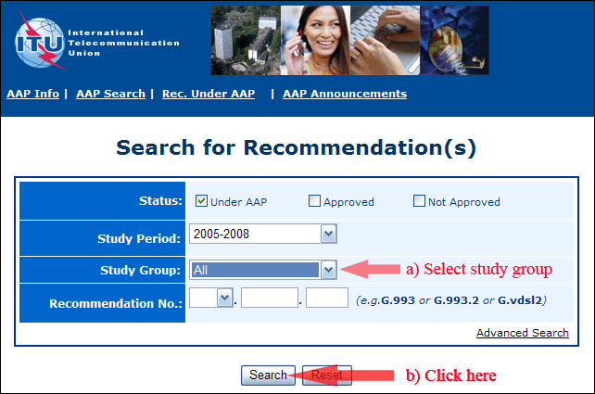
2) Select your Recommendation
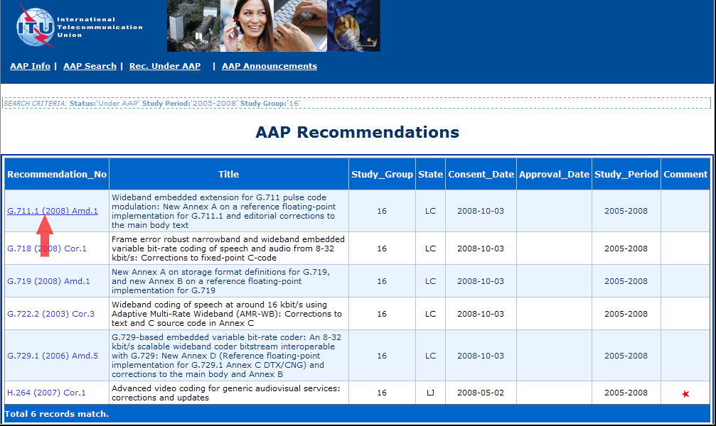
3) Click the "Submit Comment" button
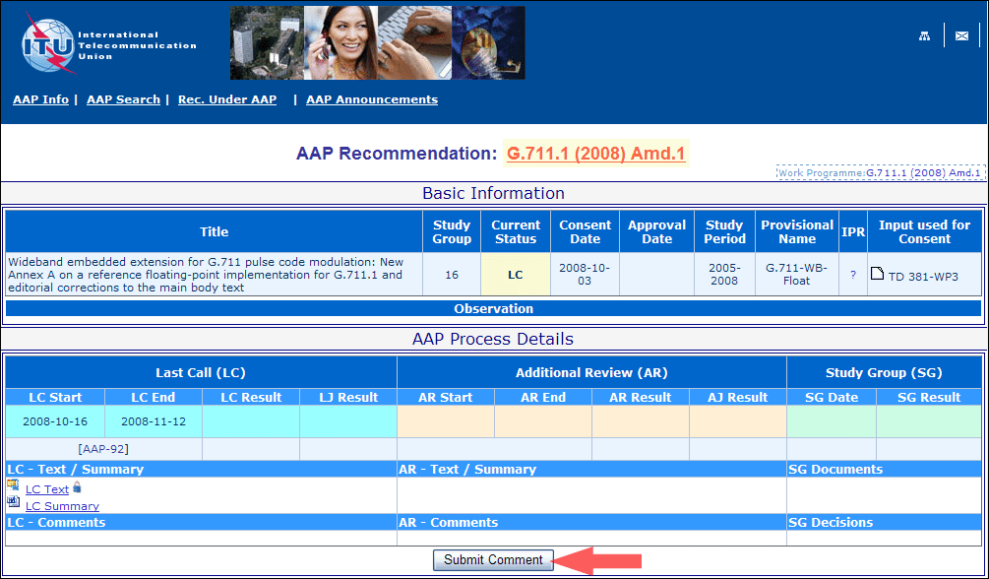
4) Complete the on-line form and click on "Submit"
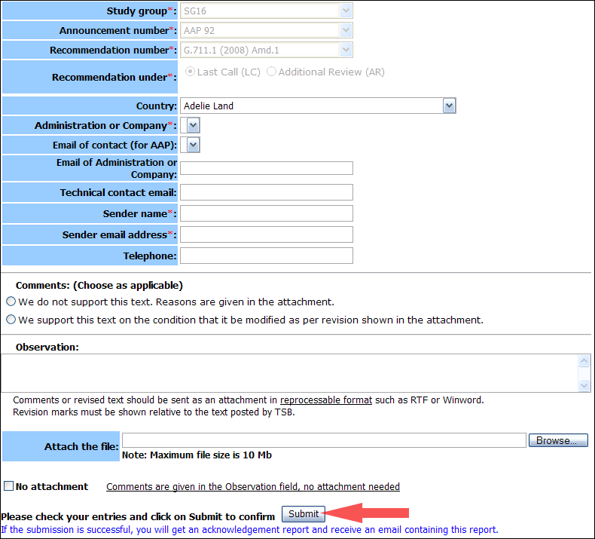
For more information, read the AAP tutorial on:
http://www.itu.int/ITU-T/aapinfo/files/AAPTutorial.pdf
Annex 3
(to TSB AAP-88)
Recommendations under LC/AR – Comment submission form
(Separate form for each Recommendation being commented upon)
ITU-T AAP comment submission form for the period 2009-2012
Study Group:
Announcement number:
Recommendation number:
Recommendation under: | Last call (LC)  Additional Review (AR)
Country:
Administration/Company:
Name of AAP Contact Person:
Email of AAP Contact Person:
Sender name:
(if different from AAP Contact Person)
Sender email address:
Telephone:
Comments:  (Choose as applicable) | We do not support this text. Reasons are given in the attachment.  We support this text on the condition that it be modified as per revision shown in the attachment.
Observations:
No attachment: Comments are given in the Observation field, no attachment needed
To be returned to: email: tsbsg....@itu.int
[or fax +41 22 730 5853]
Comments or revised text should be sent as an attachment in RTF or WinWord format.
Revision marks must be shown relative to the text posted by TSB.

