International Telecommunication Union
Telecommunication Standardization Bureau

Geneva, 16 June 2012

Ref:  Tel:  Fax:  E-mail: | TSB AAP-84  AAP/MJ  +41 22 730 5860  +41 22 730 5853  tsbdir@itu.int | – To Administrations of Member States of the Union;  – To ITU-T Sector Members;  – To ITU-T Associates  Copy:  – To the ITU-T Study Group Chairmen and Vice-Chairmen;  – To the Director of the Telecommunication Development Bureau;  – To the Director of the Radiocommunication Bureau

Subject: | Situation concerning Recommendations under the Alternative Approval Process (AAP)

Dear Sir/Madam,
The Alternative Approval Process (AAP) defined in Rec. ITU-T A.8 applies to Recommendations which do not have policy or regulatory implications and which, therefore, do not require formal consultation of Member States (see ITU Convention 246B).
Annex 1 lists those texts whose status has changed compared with previous TSB AAP Announcements.
If you wish to submit a comment relative to a Recommendation under AAP, you are encouraged to use the on-line AAP comment submission form available on the page of the Recommendation in the AAP area of the ITU-T website at http://www.itu.int/ITU-T/aap (see Annex 2). Alternatively, comments can be submitted by completing the form in Annex 3 and sending it to the secretariat of the concerned study group.
Please note that comments that simply support adoption of the text in question are not encouraged.
Yours faithfully,
Malcolm Johnson
Director of the Telecommunication Standardization Bureau
Annexes: 3

Annex 1
(to TSB AAP-84)

Status codes used in the AAP announcements:
LC = Last Call
LJ = Last Call Judgment (includes comment resolution)
AR = Additional Review
AJ = Additional Review Judgment (includes comment resolution)
SG = For Study Group approval
A = Approved
AT = Approved with typographic corrections
AC = Approved after Additional Review of Comments
NA = Not approved
TAP = Moved to TAP (ITU-T A.8 / § 5.2)
ITU-T website entry page:
http://www.itu.int/ITU-T
Alternative approval process (AAP) welcome page:
http://www.itu.int/ITU-T/aapinfo
Note – A tutorial on the ITU-T AAP application is available under the AAP welcome page
ITU-T website AAP Recommendation search page:
http://www.itu.int/ITU-T/aap/
Study Group web pages and contacts:
SG 2 | http://www.itu.int/ITU-T/studygroups/com02 | tsbsg2@itu.int
SG 3 | http://www.itu.int/ITU-T/studygroups/com03 | tsbsg3@itu.int
SG 5 | http://www.itu.int/ITU-T/studygroups/com05 | tsbsg5@itu.int
SG 9 | http://www.itu.int/ITU-T/studygroups/com09 | tsbsg9@itu.int
SG 11 | http://www.itu.int/ITU-T/studygroups/com11 | tsbsg11@itu.int
SG 12 | http://www.itu.int/ITU-T/studygroups/com12 | tsbsg12@itu.int
SG 13 | http://www.itu.int/ITU-T/studygroups/com13 | tsbsg13@itu.int
SG 15 | http://www.itu.int/ITU-T/studygroups/com15 | tsbsg15@itu.int
SG 16 | http://www.itu.int/ITU-T/studygroups/com16 | tsbsg16@itu.int
SG 17 | http://www.itu.int/ITU-T/studygroups/com17 | tsbsg17@itu.int

Situation concerning Study Group 9 Recommendations under AAP
Rec # | Title | Last Call (LC) Period |  |  |  | Additional Review (AR) Period |  |  |  | Status
 |  | LC Start | LC End | LC  Result | LJ  Result | AR Start | AR End | AR  Result | AJ  Result
J.185 (J.fmc-rev) | Transmission equipment for transferring multi-channel television signals over optical access networks by frequency modulation conversion | 2012-05-16 | 2012-06-12 | A |  |  |  |  |  | A
J.381 (J.atrans-req) | Requirements for advanced digital cable transmission technologies | 2012-05-16 | 2012-06-12 | LJ |  |  |  |  |  | LJ
J.1101 (J.vodoc-req) | Functional requirements for IP-based switched digital video using Data Over Cable Service Interface Specifications | 2012-05-16 | 2012-06-12 | A |  |  |  |  |  | A
Situation concerning Study Group 11 Recommendations under AAP
Rec # | Title | Last Call (LC) Period |  |  |  | Additional Review (AR) Period |  |  |  | Status
 |  | LC Start | LC End | LC  Result | LJ  Result | AR Start | AR End | AR  Result | AJ  Result
Q.3304.1 v2 (Q.RcCOPSv2, Q.3324.1) | Resource Control Protocol no. 4 (rcp4) Protocol at the interface between a Transport Resource Control Physical Entity (TRC-PE) and a Transport Physical Entity (T-PE) (Rc interface): COPS alternative | 2012-03-01 | 2012-03-28 | LJ | SG |  |  |  |  | AC
Situation concerning Study Group 12 Recommendations under AAP
Rec # | Title | Last Call (LC) Period |  |  |  | Additional Review (AR) Period |  |  |  | Status
 |  | LC Start | LC End | LC  Result | LJ  Result | AR Start | AR End | AR  Result | AJ  Result
G.1021 (G.102buff) | Buffer models for development of client performance metrics | 2012-06-16 | 2012-07-13 |  |  |  |  |  |  | LC
G.1070 | Opinion model for video-telephony applications | 2012-06-16 | 2012-07-13 |  |  |  |  |  |  | LC
P.381 (P.UHIP) | Technical requirements and test methods for universal wired headset or headphone interface of digital wireless terminals | 2012-06-16 | 2012-07-13 |  |  |  |  |  |  | LC
P.501 (2012) Amd.1 (P.501) | Amendment 1 to P.501 (2012): Test signals for use in telephonometry | 2012-06-16 | 2012-07-13 |  |  |  |  |  |  | LC
P.1301 (P.AMT) | Subjective quality evaluation of audio and audiovisual multiparty telemeetings | 2012-06-16 | 2012-07-13 |  |  |  |  |  |  | LC
P.1401 (P.STAT) | Methods, metrics and procedures for statistical evaluation, qualification and comparison of objective quality prediction models | 2012-06-16 | 2012-07-13 |  |  |  |  |  |  | LC
Y.1566 (Y.QoSmap) | QoS mapping and interconnection between Ethernet, IP and MPLS networks | 2012-06-16 | 2012-07-13 |  |  |  |  |  |  | LC
Situation concerning Study Group 15 Recommendations under AAP
Rec # | Title | Last Call (LC) Period |  |  |  | Additional Review (AR) Period |  |  |  | Status
 |  | LC Start | LC End | LC  Result | LJ  Result | AR Start | AR End | AR  Result | AJ  Result
G.987 | 10-Gigabit-capable passive optical network (XG-PON) systems: Definitions, abbreviations and acronyms | 2012-05-16 | 2012-06-12 | A |  |  |  |  |  | A
G.987.4 (G.xgpon.re) | 10-Gigabit-capable Passive Optical Networks (XG-PON): Reach extension | 2012-01-16 | 2012-02-12 | LJ | AR | 2012-05-16 | 2012-06-05 | AC |  | AC
G.988 (2010) Cor.1 | ONU management and control interface (OMCI) specification: Corrigendum 1 | 2012-05-16 | 2012-06-12 | A |  |  |  |  |  | A
G.993.2 (2011) Cor.1 | Very high speed digital subscriber line transceivers 2 (VDSL2): Corrigendum 1 | 2012-05-16 | 2012-06-12 | LJ |  |  |  |  |  | LJ
G.993.5 (2010) Cor.2 | Self-FEXT cancellation (vectoring) for use with VDSL2 transceivers: Corrigendum 2 | 2012-05-16 | 2012-06-12 | A |  |  |  |  |  | A
G.994.1 | Handshake procedures for digital subscriber line (DSL) transceivers | 2012-05-16 | 2012-06-12 | A |  |  |  |  |  | A
G.997.1 | Physical layer management for digital subscriber line (DSL) transceivers | 2012-05-16 | 2012-06-12 | LJ |  |  |  |  |  | LJ
G.998.4 (2010) Cor.4 | Improved impulse noise protection for DSL transceivers: Corrigendum 4 | 2012-05-16 | 2012-06-12 | A |  |  |  |  |  | A
G.9956 (2011) Cor.1 (G.hnem) | Narrow-band OFDM power line communication transceivers - Data link layer specification: Corrigendum 1 | 2012-01-16 | 2012-02-12 | LJ | AR | 2012-06-16 | 2012-07-06 |  |  | AR
G.9961 (2010) Amd.1 | Data link layer (DLL) for unified high-speed wire-line based home networking transceivers: Amendment 1 | 2012-02-01 | 2012-02-28 | LJ | AR | 2012-06-16 | 2012-07-06 |  |  | AR
Situation concerning Study Group 17 Recommendations under AAP
Rec # | Title | Last Call (LC) Period |  |  |  | Additional Review (AR) Period |  |  |  | Status
 |  | LC Start | LC End | LC  Result | LJ  Result | AR Start | AR End | AR  Result | AJ  Result
Z.161 | Testing and test control notation version 3: TTCN-3 core language | 2012-05-01 | 2012-05-28 | LJ | A |  |  |  |  | A
Z.161.1 | The testing and test control notation version 3: TTCN-3 language extensions: Support of interfaces with continuous signals | 2012-05-01 | 2012-05-28 | LJ | A |  |  |  |  | A
Z.164 | Testing and Test control notation version 3: TTCN-3 operational semantics | 2012-05-01 | 2012-05-28 | LJ | A |  |  |  |  | A
Z.165 | Testing and test control notation version 3: TTCN-3 runtime interface (TRI) | 2012-05-01 | 2012-05-28 | LJ | A |  |  |  |  | A
Z.165.1 | Testing and Test control notation version 3: TTCN-3 extension package, Extended TRI | 2012-05-01 | 2012-05-28 | LJ | A |  |  |  |  | A
Z.166 | Testing and test control notation version 3: TTCN-3 control interface (TCI) | 2012-05-01 | 2012-05-28 | LJ | A |  |  |  |  | A
Z.167 | Testing and test control notation version 3: TTCN-3 mapping from ASN.1 | 2012-05-01 | 2012-05-28 | LJ | A |  |  |  |  | A
Z.168 | Testing and test control notation version 3: TTCN-3 mapping from CORBA IDL | 2012-05-01 | 2012-05-28 | LJ | A |  |  |  |  | A
Z.169 | Testing and test control notation version 3: TTCN-3 mapping from XMLdata definition | 2012-05-01 | 2012-05-28 | LJ | A |  |  |  |  | A
Z.170 | Testing and test control notation version 3: TTCN-3 documentation comment specification | 2012-05-01 | 2012-05-28 | LJ | A |  |  |  |  | A

Annex 2
(to TSB AAP-84)
Using the on-line comment submission form
Comment submission
1) Go to AAP search Web page at http://www.itu.int/ITU-T/aap/
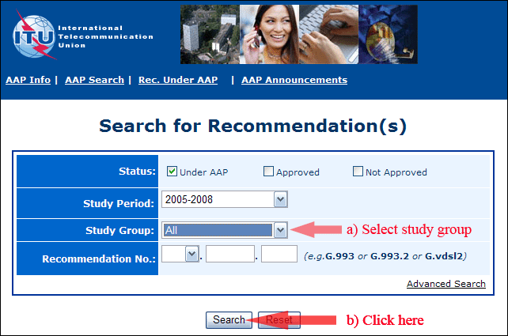
2) Select your Recommendation
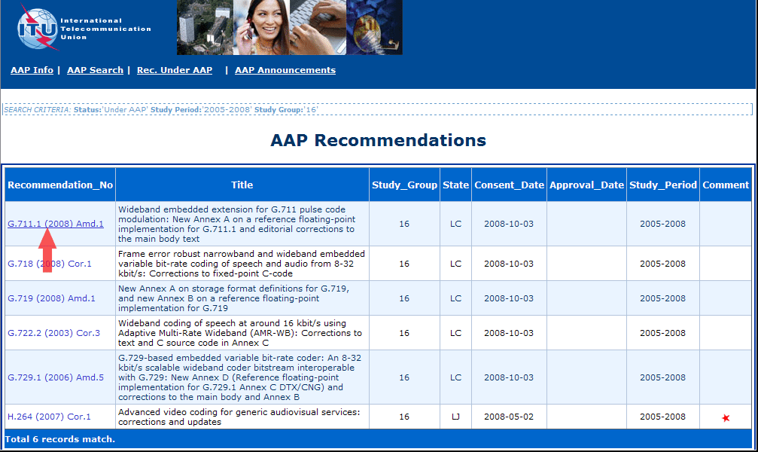
3) Click the "Submit Comment" button
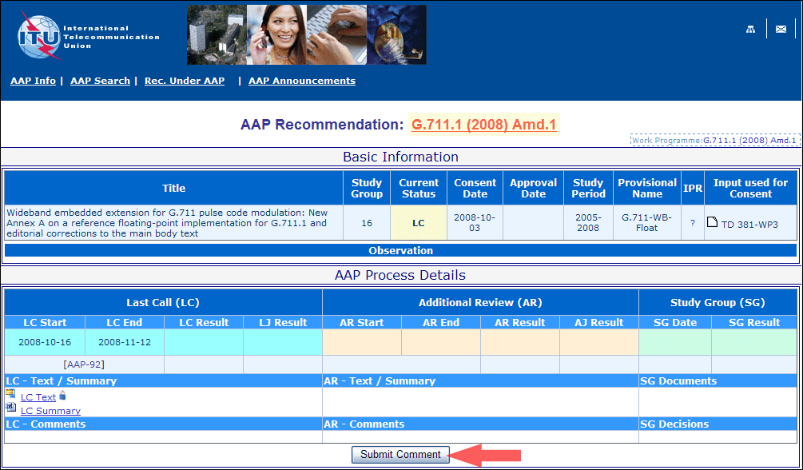
4) Complete the on-line form and click on "Submit"
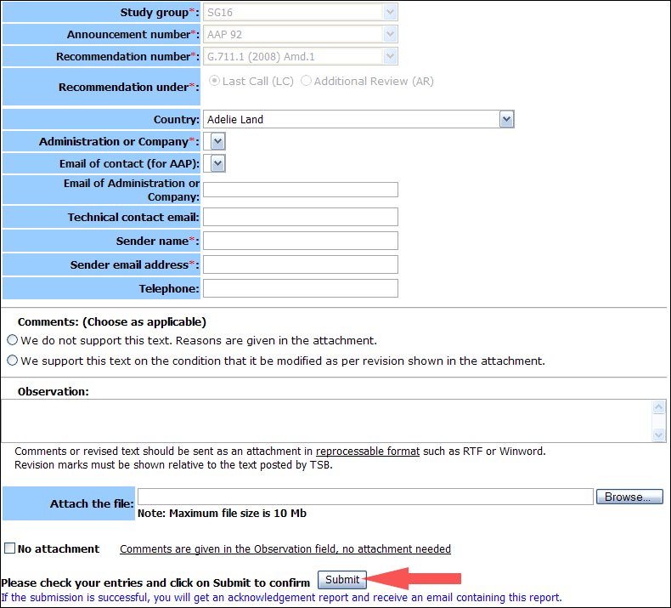
For more information, read the AAP tutorial on:
http://www.itu.int/ITU-T/aapinfo/files/AAPTutorial.pdf
Annex 3
(to TSB AAP-84)
Recommendations under LC/AR – Comment submission form
(Separate form for each Recommendation being commented upon)
ITU-T AAP comment submission form for the period 2009-2012
Study Group:
Announcement number:
Recommendation number:
Recommendation under: | Last call (LC)  Additional Review (AR)
Country:
Administration/Company:
Name of AAP Contact Person:
Email of AAP Contact Person:
Sender name:
(if different from AAP Contact Person)
Sender email address:
Telephone:
Comments:  (Choose as applicable) | We do not support this text. Reasons are given in the attachment.  We support this text on the condition that it be modified as per revision shown in the attachment.
Observations:
No attachment: Comments are given in the Observation field, no attachment needed
To be returned to: email: tsbsg....@itu.int
[or fax +41 22 730 5853]
Comments or revised text should be sent as an attachment in RTF or WinWord format.
Revision marks must be shown relative to the text posted by TSB.

