|  |  |
| --- | --- |
|  | الا تحــاد الــدولي للاتصــالات  *مكتب تقييس الاتصالات* |

|  |  |  |
| --- | --- | --- |
|  |  | جنيف، 16 يونيو 2012 |
| المرجع:    الهاتف:  الفاكس:  البريد الإلكتروني: | **TSB AAP-84**  AAP/MJ  +41 22 730 5860  +41 22 730 5853  tsbdir@itu.int | - إلى إدارات الدول الأعضاء في الاتحاد؛  - إلى أعضاء قطاع تقييس الاتصالات؛  - إلى المنتسبين إلى قطاع تقييس الاتصالات  **نسخة إلى:**  - رؤساء لجان الدراسات في قطاع تقييس الاتصالات ونوابهم؛  - مدير مكتب تنمية الاتصالات؛  - مدير مكتب الاتصالات الراديوية |

الموضوع: **حالة التوصيات الخاضعة لعملية الموافقة البديلة (AAP)**

حضرات السادة والسيدات،

تحية طيبة وبعد،

تنطبق عملية الموافقة البديلة (AAP) المعرفة في التوصية ITU‑T A.8 على التوصيات التي لا تنطوي على بعد سياسي أوتنظيمي ولا تتطلب بالتالي استشارة الدول الأعضاء رسمياً (انظر الرقم 246B من اتفاقية الاتحاد).

ويتضمن **الملحق 1** لائحة بالنصوص التي تغيرت حالتها مقارنة بما جاء في إعلانات عملية الموافقة البديلة السابقة.

إذا رغبتم في تقديم تعليق بشأن توصية ما خاضعة لعملية الموافقة البديلة، فنرجو منكم استعمال استمارة التعليق على الخط المتوفّرة على موقع قطاع تقييس الاتصالات على صفحة عملية الموافقة البديلة [http://www.itu.int/ITU-T/aap](http://www.itu.int/ITU-T/aap/) على المدخل الخاص بالتوصية المعنية (انظر **الملحق** (**2**. وبديلاً من ذلك، يمكنكم تقديم التعليقات باستكمال الاستمارة الواردة في **الملحق 3** وإرسالها إلى أمانة لجنة الدراسات المعنية بالأمر.

وتجدر الإشارة إلى أنه يفضّل عدم إرسال تعليقات تقتصر على تأييد اعتماد النص قيد النظر.

وتفضلوا بقبول فائق الاحترام والتقدير.

مالكولم جونسون  
مدير مكتب تقييس الاتصالات

**الملحقات:** 3

Annex 1

(to TSB AAP-84)

Status codes used in the AAP announcements:

LC = Last Call

LJ = Last Call Judgment (includes comment resolution)

AR = Additional Review

AJ = Additional Review Judgment (includes comment resolution)

SG = For Study Group approval

A = Approved

AT = Approved with typographic corrections

AC = Approved after Additional Review of Comments

NA = Not approved

TAP = Moved to TAP (ITU-T A.8 / § 5.2)

ITU-T website entry page:

[http://www.itu.int/ITU-T](http://www.itu.int/ITU-T/)

Alternative approval process (AAP) welcome page:

[http://www.itu.int/ITU-T/aapinfo](http://www.itu.int/ITU-T/aapinfo/)

Note – A tutorial on the ITU-T AAP application is available under the AAP welcome page

ITU-T website AAP Recommendation search page:

<http://www.itu.int/ITU-T/aap/>

Study Group web pages and contacts:

|  |  |  |
| --- | --- | --- |
| SG 2 | <http://www.itu.int/ITU-T/studygroups/com02> | [tsbsg2@itu.int](mailto:tsbsg2@itu.int) |
| SG 3 | <http://www.itu.int/ITU-T/studygroups/com03> | [tsbsg3@itu.int](mailto:tsbsg3@itu.int) |
| SG 5 | <http://www.itu.int/ITU-T/studygroups/com05> | [tsbsg5@itu.int](mailto:tsbsg5@itu.int) |
| SG 9 | <http://www.itu.int/ITU-T/studygroups/com09> | [tsbsg9@itu.int](mailto:tsbsg9@itu.int) |
| SG 11 | <http://www.itu.int/ITU-T/studygroups/com11> | [tsbsg11@itu.int](mailto:tsbsg11@itu.int) |
| SG 12 | <http://www.itu.int/ITU-T/studygroups/com12> | [tsbsg12@itu.int](mailto:tsbsg12@itu.int) |
| SG 13 | <http://www.itu.int/ITU-T/studygroups/com13> | [tsbsg13@itu.int](mailto:tsbsg13@itu.int) |
| SG 15 | <http://www.itu.int/ITU-T/studygroups/com15> | [tsbsg15@itu.int](mailto:tsbsg15@itu.int) |
| SG 16 | <http://www.itu.int/ITU-T/studygroups/com16> | [tsbsg16@itu.int](mailto:tsbsg16@itu.int) |
| SG 17 | <http://www.itu.int/ITU-T/studygroups/com17> | [tsbsg17@itu.int](mailto:tsbsg17@itu.int) |

Situation concerning Study Group 9 Recommendations under AAP

| **Rec #** | **Title** | **Last Call (LC) Period** | | | | **Additional Review (AR) Period** | | | | Status |
| --- | --- | --- | --- | --- | --- | --- | --- | --- | --- | --- |
| **LC Start** | **LC End** | **LC Result** | **LJ Result** | **AR Start** | **AR End** | **AR Result** | **AJ Result** |
| [J.185 (J.fmc-rev)](http://www.itu.int/itu-t/aap/AAPRecDetails.aspx?AAPSeqNo=2577) | Transmission equipment for transferring multi-channel television signals over optical access networks by frequency modulation conversion | 2012-05-16 | 2012-06-12 | A |  |  |  |  |  | A |
| [J.381 (J.atrans-req)](http://www.itu.int/itu-t/aap/AAPRecDetails.aspx?AAPSeqNo=2573) | Requirements for advanced digital cable transmission technologies | 2012-05-16 | 2012-06-12 | LJ |  |  |  |  |  | LJ |
| [J.1101 (J.vodoc-req)](http://www.itu.int/itu-t/aap/AAPRecDetails.aspx?AAPSeqNo=2575) | Functional requirements for IP-based switched digital video using Data Over Cable Service Interface Specifications | 2012-05-16 | 2012-06-12 | A |  |  |  |  |  | A |

Situation concerning Study Group 11 Recommendations under AAP

| **Rec #** | **Title** | **Last Call (LC) Period** | | | | **Additional Review (AR) Period** | | | | Status |
| --- | --- | --- | --- | --- | --- | --- | --- | --- | --- | --- |
| **LC Start** | **LC End** | **LC Result** | **LJ Result** | **AR Start** | **AR End** | **AR Result** | **AJ Result** |
| [Q.3304.1 v2 (Q.RcCOPSv2, Q.3324.1)](http://www.itu.int/itu-t/aap/AAPRecDetails.aspx?AAPSeqNo=2513) | Resource Control Protocol no. 4 (rcp4) Protocol at the interface between a Transport Resource Control Physical Entity (TRC-PE) and a Transport Physical Entity (T-PE) (Rc interface): COPS alternative | 2012-03-01 | 2012-03-28 | LJ | SG |  |  |  |  | AC |

Situation concerning Study Group 12 Recommendations under AAP

| **Rec #** | **Title** | **Last Call (LC) Period** | | | | **Additional Review (AR) Period** | | | | Status |
| --- | --- | --- | --- | --- | --- | --- | --- | --- | --- | --- |
| **LC Start** | **LC End** | **LC Result** | **LJ Result** | **AR Start** | **AR End** | **AR Result** | **AJ Result** |
| [G.1021 (G.102buff)](http://www.itu.int/itu-t/aap/AAPRecDetails.aspx?AAPSeqNo=2609) | Buffer models for development of client performance metrics | 2012-06-16 | 2012-07-13 |  |  |  |  |  |  | LC |
| [G.1070](http://www.itu.int/itu-t/aap/AAPRecDetails.aspx?AAPSeqNo=2611) | Opinion model for video-telephony applications | 2012-06-16 | 2012-07-13 |  |  |  |  |  |  | LC |
| [P.381 (P.UHIP)](http://www.itu.int/itu-t/aap/AAPRecDetails.aspx?AAPSeqNo=2606) | Technical requirements and test methods for universal wired headset or headphone interface of digital wireless terminals | 2012-06-16 | 2012-07-13 |  |  |  |  |  |  | LC |
| [P.501 (2012) Amd.1 (P.501)](http://www.itu.int/itu-t/aap/AAPRecDetails.aspx?AAPSeqNo=2612) | Amendment 1 to P.501 (2012): Test signals for use in telephonometry | 2012-06-16 | 2012-07-13 |  |  |  |  |  |  | LC |
| [P.1301 (P.AMT)](http://www.itu.int/itu-t/aap/AAPRecDetails.aspx?AAPSeqNo=2610) | Subjective quality evaluation of audio and audiovisual multiparty telemeetings | 2012-06-16 | 2012-07-13 |  |  |  |  |  |  | LC |
| [P.1401 (P.STAT)](http://www.itu.int/itu-t/aap/AAPRecDetails.aspx?AAPSeqNo=2607) | Methods, metrics and procedures for statistical evaluation, qualification and comparison of objective quality prediction models | 2012-06-16 | 2012-07-13 |  |  |  |  |  |  | LC |
| [Y.1566 (Y.QoSmap)](http://www.itu.int/itu-t/aap/AAPRecDetails.aspx?AAPSeqNo=2608) | QoS mapping and interconnection between Ethernet, IP and MPLS networks | 2012-06-16 | 2012-07-13 |  |  |  |  |  |  | LC |

Situation concerning Study Group 15 Recommendations under AAP

| **Rec #** | **Title** | **Last Call (LC) Period** | | | | **Additional Review (AR) Period** | | | | Status |
| --- | --- | --- | --- | --- | --- | --- | --- | --- | --- | --- |
| **LC Start** | **LC End** | **LC Result** | **LJ Result** | **AR Start** | **AR End** | **AR Result** | **AJ Result** |
| [G.987](http://www.itu.int/itu-t/aap/AAPRecDetails.aspx?AAPSeqNo=2566) | 10-Gigabit-capable passive optical network (XG-PON) systems: Definitions, abbreviations and acronyms | 2012-05-16 | 2012-06-12 | A |  |  |  |  |  | A |
| [G.987.4 (G.xgpon.re)](http://www.itu.int/itu-t/aap/AAPRecDetails.aspx?AAPSeqNo=2442) | 10-Gigabit-capable Passive Optical Networks (XG-PON): Reach extension | 2012-01-16 | 2012-02-12 | LJ | AR | 2012-05-16 | 2012-06-05 | AC |  | AC |
| [G.988 (2010) Cor.1](http://www.itu.int/itu-t/aap/AAPRecDetails.aspx?AAPSeqNo=2567) | ONU management and control interface (OMCI) specification: Corrigendum 1 | 2012-05-16 | 2012-06-12 | A |  |  |  |  |  | A |
| [G.993.2 (2011) Cor.1](http://www.itu.int/itu-t/aap/AAPRecDetails.aspx?AAPSeqNo=2568) | Very high speed digital subscriber line transceivers 2 (VDSL2): Corrigendum 1 | 2012-05-16 | 2012-06-12 | LJ |  |  |  |  |  | LJ |
| [G.993.5 (2010) Cor.2](http://www.itu.int/itu-t/aap/AAPRecDetails.aspx?AAPSeqNo=2569) | Self-FEXT cancellation (vectoring) for use with VDSL2 transceivers: Corrigendum 2 | 2012-05-16 | 2012-06-12 | A |  |  |  |  |  | A |
| [G.994.1](http://www.itu.int/itu-t/aap/AAPRecDetails.aspx?AAPSeqNo=2570) | Handshake procedures for digital subscriber line (DSL) transceivers | 2012-05-16 | 2012-06-12 | A |  |  |  |  |  | A |
| [G.997.1](http://www.itu.int/itu-t/aap/AAPRecDetails.aspx?AAPSeqNo=2571) | Physical layer management for digital subscriber line (DSL) transceivers | 2012-05-16 | 2012-06-12 | LJ |  |  |  |  |  | LJ |
| [G.998.4 (2010) Cor.4](http://www.itu.int/itu-t/aap/AAPRecDetails.aspx?AAPSeqNo=2572) | Improved impulse noise protection for DSL transceivers: Corrigendum 4 | 2012-05-16 | 2012-06-12 | A |  |  |  |  |  | A |
| [G.9956 (2011) Cor.1 (G.hnem)](http://www.itu.int/itu-t/aap/AAPRecDetails.aspx?AAPSeqNo=2448) | Narrow-band OFDM power line communication transceivers - Data link layer specification: Corrigendum 1 | 2012-01-16 | 2012-02-12 | LJ | AR | 2012-06-16 | 2012-07-06 |  |  | AR |
| [G.9961 (2010) Amd.1](http://www.itu.int/itu-t/aap/AAPRecDetails.aspx?AAPSeqNo=2262) | Data link layer (DLL) for unified high-speed wire-line based home networking transceivers: Amendment 1 | 2012-02-01 | 2012-02-28 | LJ | AR | 2012-06-16 | 2012-07-06 |  |  | AR |

Situation concerning Study Group 17 Recommendations under AAP

| **Rec #** | **Title** | **Last Call (LC) Period** | | | | **Additional Review (AR) Period** | | | | Status |
| --- | --- | --- | --- | --- | --- | --- | --- | --- | --- | --- |
| **LC Start** | **LC End** | **LC Result** | **LJ Result** | **AR Start** | **AR End** | **AR Result** | **AJ Result** |
| [Z.161](http://www.itu.int/itu-t/aap/AAPRecDetails.aspx?AAPSeqNo=2538) | Testing and test control notation version 3: TTCN-3 core language | 2012-05-01 | 2012-05-28 | LJ | A |  |  |  |  | A |
| [Z.161.1](http://www.itu.int/itu-t/aap/AAPRecDetails.aspx?AAPSeqNo=2539) | The testing and test control notation version 3: TTCN-3 language extensions: Support of interfaces with continuous signals | 2012-05-01 | 2012-05-28 | LJ | A |  |  |  |  | A |
| [Z.164](http://www.itu.int/itu-t/aap/AAPRecDetails.aspx?AAPSeqNo=2540) | Testing and Test control notation version 3: TTCN-3 operational semantics | 2012-05-01 | 2012-05-28 | LJ | A |  |  |  |  | A |
| [Z.165](http://www.itu.int/itu-t/aap/AAPRecDetails.aspx?AAPSeqNo=2541) | Testing and test control notation version 3: TTCN-3 runtime interface (TRI) | 2012-05-01 | 2012-05-28 | LJ | A |  |  |  |  | A |
| [Z.165.1](http://www.itu.int/itu-t/aap/AAPRecDetails.aspx?AAPSeqNo=2542) | Testing and Test control notation version 3: TTCN-3 extension package, Extended TRI | 2012-05-01 | 2012-05-28 | LJ | A |  |  |  |  | A |
| [Z.166](http://www.itu.int/itu-t/aap/AAPRecDetails.aspx?AAPSeqNo=2543) | Testing and test control notation version 3: TTCN-3 control interface (TCI) | 2012-05-01 | 2012-05-28 | LJ | A |  |  |  |  | A |
| [Z.167](http://www.itu.int/itu-t/aap/AAPRecDetails.aspx?AAPSeqNo=2544) | Testing and test control notation version 3: TTCN-3 mapping from ASN.1 | 2012-05-01 | 2012-05-28 | LJ | A |  |  |  |  | A |
| [Z.168](http://www.itu.int/itu-t/aap/AAPRecDetails.aspx?AAPSeqNo=2545) | Testing and test control notation version 3: TTCN-3 mapping from CORBA IDL | 2012-05-01 | 2012-05-28 | LJ | A |  |  |  |  | A |
| [Z.169](http://www.itu.int/itu-t/aap/AAPRecDetails.aspx?AAPSeqNo=2546) | Testing and test control notation version 3: TTCN-3 mapping from XMLdata definition | 2012-05-01 | 2012-05-28 | LJ | A |  |  |  |  | A |
| [Z.170](http://www.itu.int/itu-t/aap/AAPRecDetails.aspx?AAPSeqNo=2547) | Testing and test control notation version 3: TTCN-3 documentation comment specification | 2012-05-01 | 2012-05-28 | LJ | A |  |  |  |  | A |

Annex 2

(to TSB AAP-84)

Using the on-line comment submission form

Comment submission

1) Go to AAP search Web page at <http://www.itu.int/ITU-T/aap/>

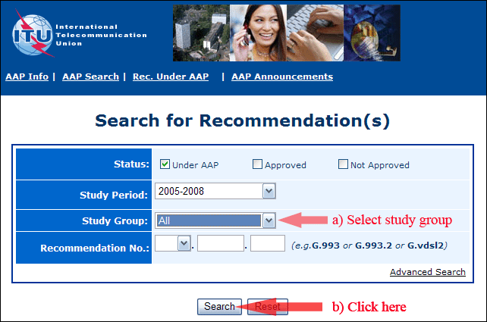

2) Select your Recommendation

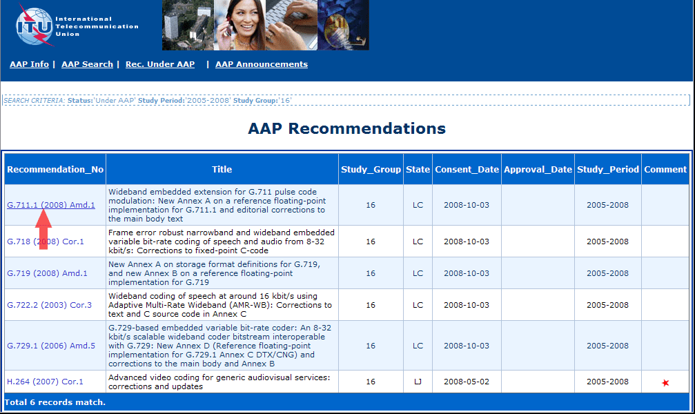

3) Click the "Submit Comment" button

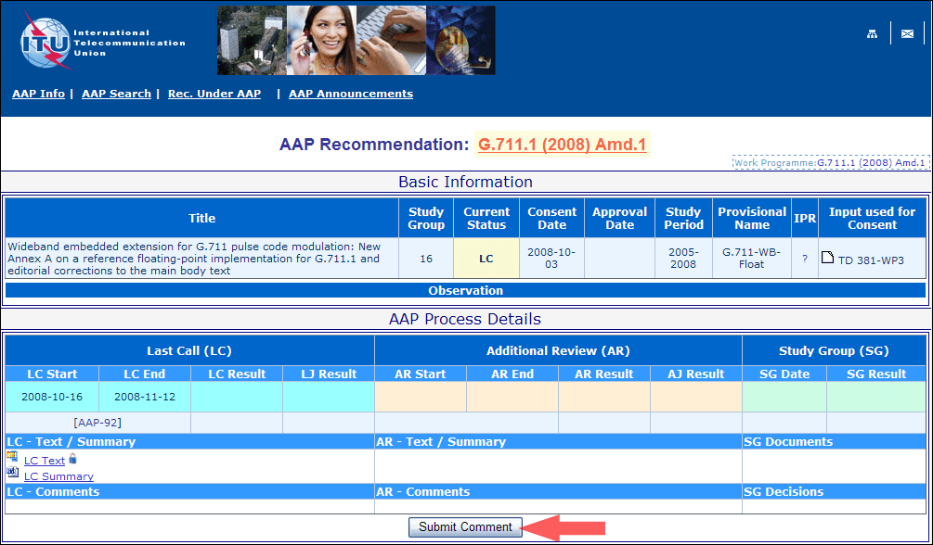

4) Complete the on-line form and click on "Submit"

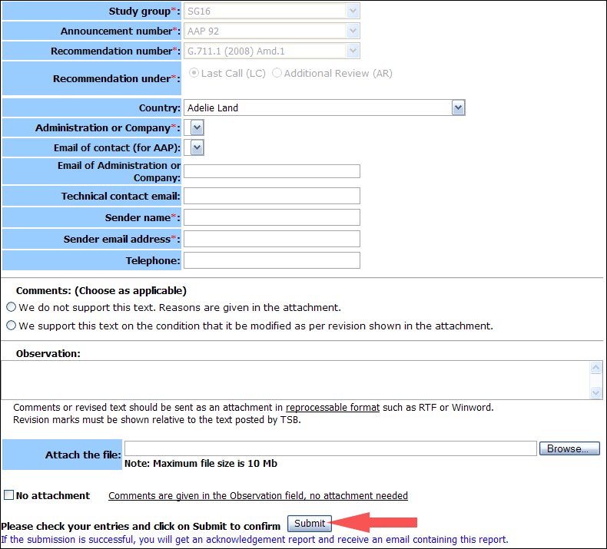

For more information, read the AAP tutorial on:   
<http://www.itu.int/ITU-T/aapinfo/files/AAPTutorial.pdf>

Annex 3

(to TSB AAP-84)

Recommendations under LC/AR – Comment submission form

*(Separate form for each Recommendation being commented upon)*

|  |  |
| --- | --- |
| ITU-T AAP comment submission form for the period 2009-2012 | |
| **Study Group:** |  |
| **Announcement number:** |  |
| **Recommendation number:** |  |
| **Recommendation under:** | Last call (LC)   Additional Review (AR) |
| **Country:** |  |
| **Administration/Company:** |  |
| **Name of AAP Contact Person:** |  |
| **Email of AAP Contact Person:** |  |
| **Sender name: (if different from AAP Contact Person)** |  |
| **Sender email address:** |  |
| **Telephone:** |  |
| **Comments: (Choose as applicable)** | We do not support this text. Reasons are given in the attachment.   We support this text on the condition that it be modified as per revision shown in the attachment. |
| **Observations:** |  |

**No attachment:** Comments are given in the Observation field, no attachment needed

*To be returned to: email:* [*tsbsg....@itu.int*](mailto:tsbsg....@itu.int) *[or fax +41 22 730 5853]  
Comments or revised text should be sent as an attachment in RTF or WinWord format.  
Revision marks must be shown relative to the text posted by TSB.*