|  |  |
| --- | --- |
| Международный союз электросвязи  *Бюро стандартизации электросвязи* |  |

Женева, 1 мая 2012

|  |  |  |
| --- | --- | --- |
| Осн.:  Тел.:  Факс:  Эл. почта: | **TSB AAP-81**  AAP/MJ  +41 22 730 5860  +41 22 730 5853  [tsbdir@itu.int](mailto:tsbdir@itu.int) | – Администрациям Государств – Членов Союза;  – Членам Сектора МСЭ-Т;  – Ассоциированным членам МСЭ-Т  **Копии:**  – Председателям и заместителям председателей Исследовательских комиссий МСЭ-Т;  – Директору Бюро Развития Электросвязи;  – Директору Бюро Радиосвязи |

|  |  |
| --- | --- |
| Предмет: | **Положение относительно Рекомендаций, рассматриваемых в соответствии с альтернативным процессом утверждения (АПУ)** |

Уважаемая госпожа,  
уважаемый господин,

Альтернативный процесс утверждения (АПУ), определенный в Рекомендации МСЭ-Т А.8, распространяется на Рекомендации, которые не имеют политических или регламентарных последствий и которые поэтому не требуют официальных консультаций с Государствами-Членами (см. п. 246B Конвенции МСЭ).

В **Приложении 1** содержится перечень текстов, статус которых изменился по сравнению с предыдущими объявлениями об АПУ БСЭ.

Если вы желаете представить замечания относительно какой-либо Рекомендации, рассматриваемой в соответствии с АПУ, рекомендуем Вам использовать онлайновую форму для представления замечаний по АПУ, которая размещена на странице этой Рекомендации в разделе веб-сайта МСЭ-Т, посвященном АПУ, по адресу: <http://www.itu.int/ITU-T/aap/> (см. **Приложение 2**). Замечания можно представить иным способом, заполнив приведенную в **Приложении 3** форму и направив ее в секретариат заинтересованной исследовательской комиссии.

Просим принять к сведению, что не рекомендуется представлять замечания, являющиеся не чем иным, как поддержкой рассматриваемого текста.

С уважением,

Малколм Джонсон  
Директор Бюро   
стандартизации электросвязи

**Приложения**: 3

Annex 1

(to TSB AAP-81)

Status codes used in the AAP announcements:

LC = Last Call

LJ = Last Call Judgment (includes comment resolution)

AR = Additional Review

AJ = Additional Review Judgment (includes comment resolution)

SG = For Study Group approval

A = Approved

AT = Approved with typographic corrections

AC = Approved after Additional Review of Comments

NA = Not approved

TAP = Moved to TAP (ITU-T A.8 / § 5.2)

ITU-T website entry page:

[http://www.itu.int/ITU-T](http://www.itu.int/ITU-T/)

Alternative approval process (AAP) welcome page:

[http://www.itu.int/ITU-T/aapinfo](http://www.itu.int/ITU-T/aapinfo/)

Note – A tutorial on the ITU-T AAP application is available under the AAP welcome page

ITU-T website AAP Recommendation search page:

<http://www.itu.int/ITU-T/aap/>

Study Group web pages and contacts:

|  |  |  |
| --- | --- | --- |
| SG 2 | <http://www.itu.int/ITU-T/studygroups/com02> | [tsbsg2@itu.int](mailto:tsbsg2@itu.int) |
| SG 3 | <http://www.itu.int/ITU-T/studygroups/com03> | [tsbsg3@itu.int](mailto:tsbsg3@itu.int) |
| SG 5 | <http://www.itu.int/ITU-T/studygroups/com05> | [tsbsg5@itu.int](mailto:tsbsg5@itu.int) |
| SG 9 | <http://www.itu.int/ITU-T/studygroups/com09> | [tsbsg9@itu.int](mailto:tsbsg9@itu.int) |
| SG 11 | <http://www.itu.int/ITU-T/studygroups/com11> | [tsbsg11@itu.int](mailto:tsbsg11@itu.int) |
| SG 12 | <http://www.itu.int/ITU-T/studygroups/com12> | [tsbsg12@itu.int](mailto:tsbsg12@itu.int) |
| SG 13 | <http://www.itu.int/ITU-T/studygroups/com13> | [tsbsg13@itu.int](mailto:tsbsg13@itu.int) |
| SG 15 | <http://www.itu.int/ITU-T/studygroups/com15> | [tsbsg15@itu.int](mailto:tsbsg15@itu.int) |
| SG 16 | <http://www.itu.int/ITU-T/studygroups/com16> | [tsbsg16@itu.int](mailto:tsbsg16@itu.int) |
| SG 17 | <http://www.itu.int/ITU-T/studygroups/com17> | [tsbsg17@itu.int](mailto:tsbsg17@itu.int) |

Situation concerning Study Group 5 Recommendations under AAP

| **Rec #** | **Title** | **Last Call (LC) Period** | | | | **Additional Review (AR) Period** | | | | Status |
| --- | --- | --- | --- | --- | --- | --- | --- | --- | --- | --- |
| **LC Start** | **LC End** | **LC Result** | **LJ Result** | **AR Start** | **AR End** | **AR Result** | **AJ Result** |
| [K.28](http://www.itu.int/itu-t/aap/AAPRecDetails.aspx?AAPSeqNo=2554) | Parameters of thyristor-based surge protective devices for the protection of telecommunication installations | 2012-05-01 | 2012-05-28 |  |  |  |  |  |  | LC |
| [K.44](http://www.itu.int/itu-t/aap/AAPRecDetails.aspx?AAPSeqNo=2555) | Resistibility tests for telecommunication equipment exposed to overvoltages and overcurrents – Basic Recommendation | 2012-05-01 | 2012-05-28 |  |  |  |  |  |  | LC |
| [K.46](http://www.itu.int/itu-t/aap/AAPRecDetails.aspx?AAPSeqNo=2556) | Protection of telecommunication lines using metallic symmetric conductors against lightning-induced surges | 2012-05-01 | 2012-05-28 |  |  |  |  |  |  | LC |
| [K.47](http://www.itu.int/itu-t/aap/AAPRecDetails.aspx?AAPSeqNo=2557) | Protection of telecommunication lines using metallic conductors against direct lightning discharges | 2012-05-01 | 2012-05-28 |  |  |  |  |  |  | LC |
| [K.89 (K.injury)](http://www.itu.int/itu-t/aap/AAPRecDetails.aspx?AAPSeqNo=2558) | Protection of persons inside a structure using telecommunication services provided by metallic conductors against lightning - Risk management | 2012-05-01 | 2012-05-28 |  |  |  |  |  |  | LC |
| [K.90 (K.mag)](http://www.itu.int/itu-t/aap/AAPRecDetails.aspx?AAPSeqNo=2561) | Evaluation techniques and working procedures for compliance with limits to power-frequency (DC, 50 Hz and 60 Hz) electromagnetic field exposure of network operator personnel | 2012-05-01 | 2012-05-28 |  |  |  |  |  |  | LC |
| [K.91 (K.guide)](http://www.itu.int/itu-t/aap/AAPRecDetails.aspx?AAPSeqNo=2562) | Guidance for assessment, evaluation and monitoring of human exposure to radio frequency electromagnetic fields | 2012-05-01 | 2012-05-28 |  |  |  |  |  |  | LC |
| [K.92 (K.henv)](http://www.itu.int/itu-t/aap/AAPRecDetails.aspx?AAPSeqNo=2559) | Conducted and radiated electromagnetic environment in home networking | 2012-05-01 | 2012-05-28 |  |  |  |  |  |  | LC |
| [K.93 (K.im_bb)](http://www.itu.int/itu-t/aap/AAPRecDetails.aspx?AAPSeqNo=2564) | Immunity of home network devices to electromagnetic disturbances | 2012-05-01 | 2012-05-28 |  |  |  |  |  |  | LC |
| [K.94 (K.deg)](http://www.itu.int/itu-t/aap/AAPRecDetails.aspx?AAPSeqNo=2560) | Mutual-disturbance test method for performance degradation evaluation of converged terminal devices | 2012-05-01 | 2012-05-28 |  |  |  |  |  |  | LC |
| [L.1200 (L.specDC)](http://www.itu.int/itu-t/aap/AAPRecDetails.aspx?AAPSeqNo=2565) | Specification of DC power feeding system interface | 2012-05-01 | 2012-05-28 |  |  |  |  |  |  | LC |
| [L.1310 (L.M&M)](http://www.itu.int/itu-t/aap/AAPRecDetails.aspx?AAPSeqNo=2563) | Energy efficiency metrics and measurement for telecommunication equipment | 2012-05-01 | 2012-05-28 |  |  |  |  |  |  | LC |

Situation concerning Study Group 11 Recommendations under AAP

| **Rec #** | **Title** | **Last Call (LC) Period** | | | | **Additional Review (AR) Period** | | | | Status |
| --- | --- | --- | --- | --- | --- | --- | --- | --- | --- | --- |
| **LC Start** | **LC End** | **LC Result** | **LJ Result** | **AR Start** | **AR End** | **AR Result** | **AJ Result** |
| [Q.3308.1 (Q.Rhv1)](http://www.itu.int/itu-t/aap/AAPRecDetails.aspx?AAPSeqNo=2515) | Resource control protocol 8 (rcp8) Protocol at the interface between Resource Admission Control Physical Entity (RAC-PE) and CPN Gateway Policy Enforcement Physical Entities (CGPE-PE ) (Rh interface): COPS alternative | 2012-03-01 | 2012-03-28 | LJ | AT |  |  |  |  | AT |
| [Q.3314 (Q.M9)](http://www.itu.int/itu-t/aap/AAPRecDetails.aspx?AAPSeqNo=2516) | Requirements and protocol at the interface between mobile location management physical entity used as a proxy and the central instance of the mobile location management physical entity (M9 interface) | 2012-03-01 | 2012-03-28 | LJ | AR | 2012-05-01 | 2012-05-21 |  |  | AR |
| [Q.3613 (Q.TS-IVR)](http://www.itu.int/itu-t/aap/AAPRecDetails.aspx?AAPSeqNo=2512) | Signalling requirements for touch screen terminal-based IVR services | 2012-03-01 | 2012-03-28 | LJ | AR | 2012-05-01 | 2012-05-21 |  |  | AR |
| [Q.3925](http://www.itu.int/itu-t/aap/AAPRecDetails.aspx?AAPSeqNo=2518) | The types of traffic flows which should be generated for voice, data and video on the Model network for testing QoS parameters | 2012-03-01 | 2012-03-28 | LJ | AT |  |  |  |  | AT |
| [X.603](http://www.itu.int/itu-t/aap/AAPRecDetails.aspx?AAPSeqNo=2517) | Information technology - Relayed multicast protocol: Framework | 2012-03-01 | 2012-03-28 | LJ | AT |  |  |  |  | AT |

Situation concerning Study Group 13 Recommendations under AAP

| **Rec #** | **Title** | **Last Call (LC) Period** | | | | **Additional Review (AR) Period** | | | | Status |
| --- | --- | --- | --- | --- | --- | --- | --- | --- | --- | --- |
| **LC Start** | **LC End** | **LC Result** | **LJ Result** | **AR Start** | **AR End** | **AR Result** | **AJ Result** |
| [Y.2023 (Y.MCC-arch)](http://www.itu.int/itu-t/aap/AAPRecDetails.aspx?AAPSeqNo=2508) | Functional requirements and architecture of the Next Generation Network for Multimedia Communication Centre service | 2012-03-01 | 2012-03-28 | AR |  | 2012-04-01 | 2012-04-21 | AC |  | AC |
| [Y.2060  (Y.IoT-overview)](http://www.itu.int/itu-t/aap/AAPRecDetails.aspx?AAPSeqNo=2510) | Overview of Internet of Things | 2012-03-01 | 2012-03-28 | LJ | SG |  |  |  |  | SG |
| [Y.2061  (Y.MOC-Reqts)](http://www.itu.int/itu-t/aap/AAPRecDetails.aspx?AAPSeqNo=2511) | Requirements for support of machine-oriented communication applications in the NGN environment | 2012-03-01 | 2012-03-28 | LJ | SG |  |  |  |  | SG |
| [Y.2080 (Y.dsnarch)](http://www.itu.int/itu-t/aap/AAPRecDetails.aspx?AAPSeqNo=2506) | Architecture of Distributed Service Networking | 2012-03-01 | 2012-03-28 | LJ | SG |  |  |  |  | SG |

Situation concerning Study Group 15 Recommendations under AAP

| **Rec #** | **Title** | **Last Call (LC) Period** | | | | **Additional Review (AR) Period** | | | | Status |
| --- | --- | --- | --- | --- | --- | --- | --- | --- | --- | --- |
| **LC Start** | **LC End** | **LC Result** | **LJ Result** | **AR Start** | **AR End** | **AR Result** | **AJ Result** |
| [G.873.2](http://www.itu.int/itu-t/aap/AAPRecDetails.aspx?AAPSeqNo=2466) | Optical Transport Network (OTN) - Ring Protection | 2012-01-16 | 2012-02-12 | LJ | AR | 2012-04-01 | 2012-04-21 | AC |  | AC |
| [G.984.1 (2008) Amd.2](http://www.itu.int/itu-t/aap/AAPRecDetails.aspx?AAPSeqNo=2437) | Gigabit-capable Passive Optical Networks (GPON): General characteristics: Amendment 2 | 2012-01-16 | 2012-02-12 | LJ | AR | 2012-04-01 | 2012-04-21 | AC |  | AC |
| [G.984.3 (2008) Amd.3](http://www.itu.int/itu-t/aap/AAPRecDetails.aspx?AAPSeqNo=2438) | Gigabit-capable Passive Optical Networks (GPON): Transmission convergence layer specification - Amendment 3 | 2012-01-16 | 2012-02-12 | LJ | AR | 2012-04-01 | 2012-04-21 | AC |  | AC |
| [G.987.1 (2010) Amd.1](http://www.itu.int/itu-t/aap/AAPRecDetails.aspx?AAPSeqNo=2440) | 10Gigabit-capable Passive Optical Networks (XG-PON): General Requirements: Amendment 1 | 2012-01-16 | 2012-02-12 | LJ | AR | 2012-04-01 | 2012-04-21 | AC |  | AC |
| [G.988 (2010) Amd.2](http://www.itu.int/itu-t/aap/AAPRecDetails.aspx?AAPSeqNo=2443) | ONU management and control interface (OMCI): Amendment 2 | 2012-01-16 | 2012-02-12 | LJ | AR | 2012-04-01 | 2012-04-21 | AC |  | AC |

Situation concerning Study Group 17 Recommendations under AAP

| **Rec #** | **Title** | **Last Call (LC) Period** | | | | **Additional Review (AR) Period** | | | | Status |
| --- | --- | --- | --- | --- | --- | --- | --- | --- | --- | --- |
| **LC Start** | **LC End** | **LC Result** | **LJ Result** | **AR Start** | **AR End** | **AR Result** | **AJ Result** |
| [Z.107](http://www.itu.int/itu-t/aap/AAPRecDetails.aspx?AAPSeqNo=2523) | Specification and Description language: Object-oriented data in SDL-2010 | 2012-04-01 | 2012-04-28 | AT |  |  |  |  |  | AT |
| [Z.109](http://www.itu.int/itu-t/aap/AAPRecDetails.aspx?AAPSeqNo=2548) | Specification and description language: Unified modeling language (UML) profile for SDL-2010 | 2012-04-01 | 2012-04-28 | AT |  |  |  |  |  | AT |
| [Z.151 (2008) Cor.1](http://www.itu.int/itu-t/aap/AAPRecDetails.aspx?AAPSeqNo=2528) | User Requirements Notation (URN) – Language definition | 2012-04-01 | 2012-04-28 | A |  |  |  |  |  | A |
| [Z.161](http://www.itu.int/itu-t/aap/AAPRecDetails.aspx?AAPSeqNo=2538) | Testing and test control notation version 3: TTCN-3 core language | 2012-05-01 | 2012-05-28 |  |  |  |  |  |  | LC |
| [Z.161.1](http://www.itu.int/itu-t/aap/AAPRecDetails.aspx?AAPSeqNo=2539) | The testing and test control notation version 3: TTCN-3 language extensions: Support of interfaces with continuous signals | 2012-05-01 | 2012-05-28 |  |  |  |  |  |  | LC |
| [Z.164](http://www.itu.int/itu-t/aap/AAPRecDetails.aspx?AAPSeqNo=2540) | Testing and Test control notation version 3: TTCN-3 operational semantics | 2012-05-01 | 2012-05-28 |  |  |  |  |  |  | LC |
| [Z.165](http://www.itu.int/itu-t/aap/AAPRecDetails.aspx?AAPSeqNo=2541) | Testing and test control notation version 3: TTCN-3 runtime interface (TRI) | 2012-05-01 | 2012-05-28 |  |  |  |  |  |  | LC |
| [Z.165.1](http://www.itu.int/itu-t/aap/AAPRecDetails.aspx?AAPSeqNo=2542) | Testing and Test control notation version 3: TTCN-3 extension package, Extended TRI | 2012-05-01 | 2012-05-28 |  |  |  |  |  |  | LC |
| [Z.166](http://www.itu.int/itu-t/aap/AAPRecDetails.aspx?AAPSeqNo=2543) | Testing and test control notation version 3: TTCN-3 control interface (TCI) | 2012-05-01 | 2012-05-28 |  |  |  |  |  |  | LC |
| [Z.167](http://www.itu.int/itu-t/aap/AAPRecDetails.aspx?AAPSeqNo=2544) | Testing and test control notation version 3: TTCN-3 mapping from ASN.1 | 2012-05-01 | 2012-05-28 |  |  |  |  |  |  | LC |
| [Z.168](http://www.itu.int/itu-t/aap/AAPRecDetails.aspx?AAPSeqNo=2545) | Testing and test control notation version 3: TTCN-3 mapping from CORBA IDL | 2012-05-01 | 2012-05-28 |  |  |  |  |  |  | LC |
| [Z.169](http://www.itu.int/itu-t/aap/AAPRecDetails.aspx?AAPSeqNo=2546) | Testing and test control notation version 3: TTCN-3 mapping from XMLdata definition | 2012-05-01 | 2012-05-28 |  |  |  |  |  |  | LC |
| [Z.170](http://www.itu.int/itu-t/aap/AAPRecDetails.aspx?AAPSeqNo=2547) | Testing and test control notation version 3: TTCN-3 documentation comment specification | 2012-05-01 | 2012-05-28 |  |  |  |  |  |  | LC |

Annex 2

(to TSB AAP-81)

Using the on-line comment submission form

Comment submission

1) Go to AAP search Web page at <http://www.itu.int/ITU-T/aap/>

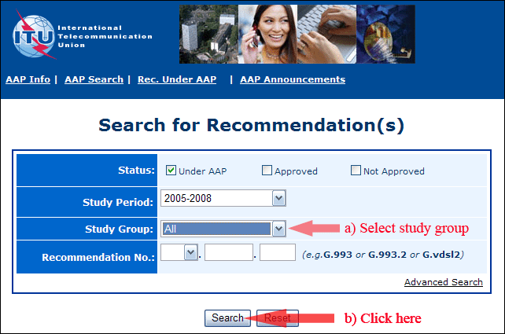

2) Select your Recommendation

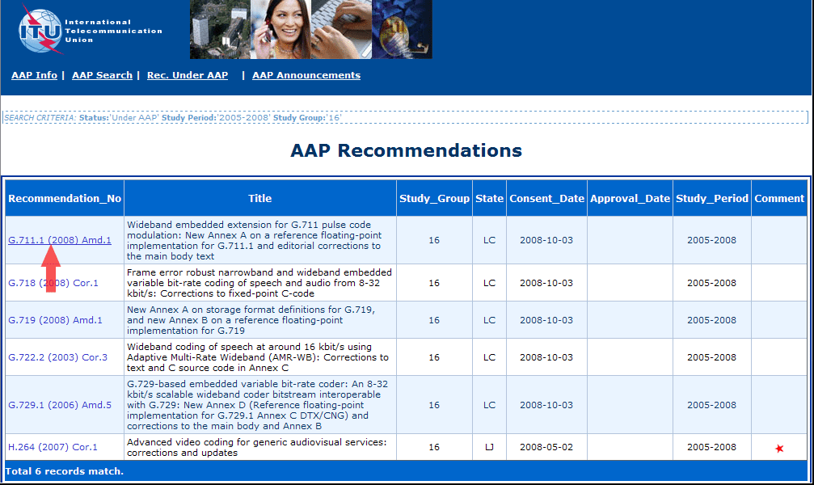

3) Click the "Submit Comment" button

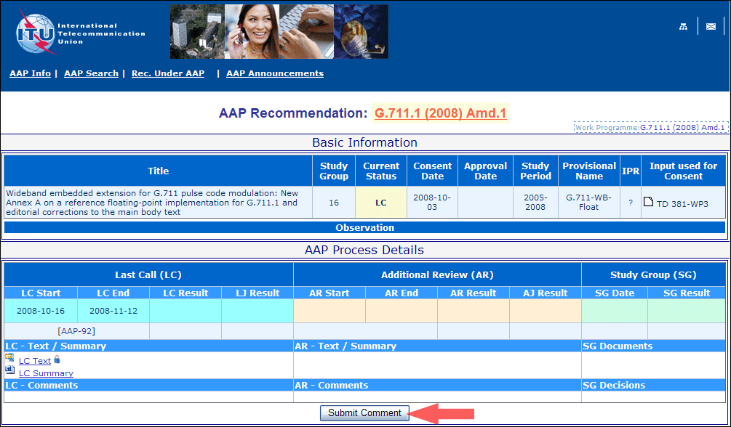

4) Complete the on-line form and click on "Submit"

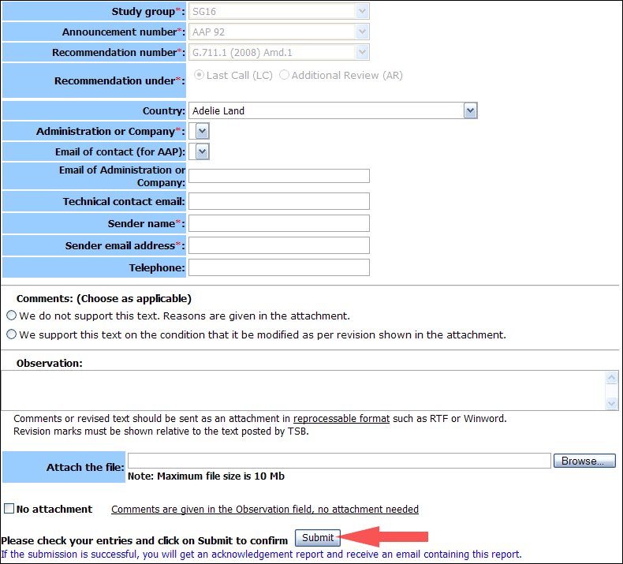

For more information, read the AAP tutorial on:   
<http://www.itu.int/ITU-T/aapinfo/files/AAPTutorial.pdf>

Annex 3

(to TSB AAP-81)

Recommendations under LC/AR – Comment submission form

*(Separate form for each Recommendation being commented upon)*

|  |  |
| --- | --- |
| ITU-T AAP comment submission form for the period 2009-2012 | |
| **Study Group:** |  |
| **Announcement number:** |  |
| **Recommendation number:** |  |
| **Recommendation under:** | Last call (LC)   Additional Review (AR) |
| **Country:** |  |
| **Administration/Company:** |  |
| **Name of AAP Contact Person:** |  |
| **Email of AAP Contact Person:** |  |
| **Sender name: (if different from AAP Contact Person)** |  |
| **Sender email address:** |  |
| **Telephone:** |  |
| **Comments: (Choose as applicable)** | We do not support this text. Reasons are given in the attachment.   We support this text on the condition that it be modified as per revision shown in the attachment. |
| **Observations:** |  |

**No attachment:** Comments are given in the Observation field, no attachment needed

*To be returned to: email:* [*tsbsg....@itu.int*](mailto:tsbsg....@itu.int) *[or fax +41 22 730 5853]  
Comments or revised text should be sent as an attachment in RTF or WinWord format.  
Revision marks must be shown relative to the text posted by TSB.*