International Telecommunication Union
Telecommunication Standardization Bureau

Geneva, 1 May 2012

Ref:  Tel:  Fax:  E-mail: | TSB AAP-81  AAP/MJ  +41 22 730 5860  +41 22 730 5853  tsbdir@itu.int | – To Administrations of Member States of the Union;  – To ITU-T Sector Members;  – To ITU-T Associates  Copy:  – To the ITU-T Study Group Chairmen and Vice-Chairmen;  – To the Director of the Telecommunication Development Bureau;  – To the Director of the Radiocommunication Bureau

Subject: | Situation concerning Recommendations under the Alternative Approval Process (AAP)

Dear Sir/Madam,
The Alternative Approval Process (AAP) defined in Rec. ITU-T A.8 applies to Recommendations which do not have policy or regulatory implications and which, therefore, do not require formal consultation of Member States (see ITU Convention 246B).
Annex 1 lists those texts whose status has changed compared with previous TSB AAP Announcements.
If you wish to submit a comment relative to a Recommendation under AAP, you are encouraged to use the on-line AAP comment submission form available on the page of the Recommendation in the AAP area of the ITU-T website at http://www.itu.int/ITU-T/aap (see Annex 2). Alternatively, comments can be submitted by completing the form in Annex 3 and sending it to the secretariat of the concerned study group.
Please note that comments that simply support adoption of the text in question are not encouraged.
Yours faithfully,
Malcolm Johnson
Director of the Telecommunication Standardization Bureau
Annexes: 3

Annex 1
(to TSB AAP-81)

Status codes used in the AAP announcements:
LC = Last Call
LJ = Last Call Judgment (includes comment resolution)
AR = Additional Review
AJ = Additional Review Judgment (includes comment resolution)
SG = For Study Group approval
A = Approved
AT = Approved with typographic corrections
AC = Approved after Additional Review of Comments
NA = Not approved
TAP = Moved to TAP (ITU-T A.8 / § 5.2)
ITU-T website entry page:
http://www.itu.int/ITU-T
Alternative approval process (AAP) welcome page:
http://www.itu.int/ITU-T/aapinfo
Note – A tutorial on the ITU-T AAP application is available under the AAP welcome page
ITU-T website AAP Recommendation search page:
http://www.itu.int/ITU-T/aap/
Study Group web pages and contacts:
SG 2 | http://www.itu.int/ITU-T/studygroups/com02 | tsbsg2@itu.int
SG 3 | http://www.itu.int/ITU-T/studygroups/com03 | tsbsg3@itu.int
SG 5 | http://www.itu.int/ITU-T/studygroups/com05 | tsbsg5@itu.int
SG 9 | http://www.itu.int/ITU-T/studygroups/com09 | tsbsg9@itu.int
SG 11 | http://www.itu.int/ITU-T/studygroups/com11 | tsbsg11@itu.int
SG 12 | http://www.itu.int/ITU-T/studygroups/com12 | tsbsg12@itu.int
SG 13 | http://www.itu.int/ITU-T/studygroups/com13 | tsbsg13@itu.int
SG 15 | http://www.itu.int/ITU-T/studygroups/com15 | tsbsg15@itu.int
SG 16 | http://www.itu.int/ITU-T/studygroups/com16 | tsbsg16@itu.int
SG 17 | http://www.itu.int/ITU-T/studygroups/com17 | tsbsg17@itu.int

Situation concerning Study Group 5 Recommendations under AAP
Rec # | Title | Last Call (LC) Period |  |  |  | Additional Review (AR) Period |  |  |  | Status
 |  | LC Start | LC End | LC  Result | LJ  Result | AR Start | AR End | AR  Result | AJ  Result
K.28 | Parameters of thyristor-based surge protective devices for the protection of telecommunication installations | 2012-05-01 | 2012-05-28 |  |  |  |  |  |  | LC
K.44 | Resistibility tests for telecommunication equipment exposed to overvoltages and overcurrents – Basic Recommendation | 2012-05-01 | 2012-05-28 |  |  |  |  |  |  | LC
K.46 | Protection of telecommunication lines using metallic symmetric conductors against lightning-induced surges | 2012-05-01 | 2012-05-28 |  |  |  |  |  |  | LC
K.47 | Protection of telecommunication lines using metallic conductors against direct lightning discharges | 2012-05-01 | 2012-05-28 |  |  |  |  |  |  | LC
K.89 (K.injury) | Protection of persons inside a structure using telecommunication services provided by metallic conductors against lightning - Risk management | 2012-05-01 | 2012-05-28 |  |  |  |  |  |  | LC
K.90 (K.mag) | Evaluation techniques and working procedures for compliance with limits to power-frequency (DC, 50 Hz and 60 Hz) electromagnetic field exposure of network operator personnel | 2012-05-01 | 2012-05-28 |  |  |  |  |  |  | LC
K.91 (K.guide) | Guidance for assessment, evaluation and monitoring of human exposure to radio frequency electromagnetic fields | 2012-05-01 | 2012-05-28 |  |  |  |  |  |  | LC
K.92 (K.henv) | Conducted and radiated electromagnetic environment in home networking | 2012-05-01 | 2012-05-28 |  |  |  |  |  |  | LC
K.93 (K.im_bb) | Immunity of home network devices to electromagnetic disturbances | 2012-05-01 | 2012-05-28 |  |  |  |  |  |  | LC
K.94 (K.deg) | Mutual-disturbance test method for performance degradation evaluation of converged terminal devices | 2012-05-01 | 2012-05-28 |  |  |  |  |  |  | LC
L.1200 (L.specDC) | Specification of DC power feeding system interface | 2012-05-01 | 2012-05-28 |  |  |  |  |  |  | LC
L.1310 (L.M&M) | Energy efficiency metrics and measurement for telecommunication equipment | 2012-05-01 | 2012-05-28 |  |  |  |  |  |  | LC
Situation concerning Study Group 11 Recommendations under AAP
Rec # | Title | Last Call (LC) Period |  |  |  | Additional Review (AR) Period |  |  |  | Status
 |  | LC Start | LC End | LC  Result | LJ  Result | AR Start | AR End | AR  Result | AJ  Result
Q.3308.1 (Q.Rhv1) | Resource control protocol 8 (rcp8) Protocol at the interface between Resource Admission Control Physical Entity (RAC-PE) and CPN Gateway Policy Enforcement Physical Entities (CGPE-PE ) (Rh interface): COPS alternative | 2012-03-01 | 2012-03-28 | LJ | AT |  |  |  |  | AT
Q.3314 (Q.M9) | Requirements and protocol at the interface between mobile location management physical entity used as a proxy and the central instance of the mobile location management physical entity (M9 interface) | 2012-03-01 | 2012-03-28 | LJ | AR | 2012-05-01 | 2012-05-21 |  |  | AR
Q.3613 (Q.TS-IVR) | Signalling requirements for touch screen terminal-based IVR services | 2012-03-01 | 2012-03-28 | LJ | AR | 2012-05-01 | 2012-05-21 |  |  | AR
Q.3925 | The types of traffic flows which should be generated for voice, data and video on the Model network for testing QoS parameters | 2012-03-01 | 2012-03-28 | LJ | AT |  |  |  |  | AT
X.603 | Information technology - Relayed multicast protocol: Framework | 2012-03-01 | 2012-03-28 | LJ | AT |  |  |  |  | AT
Situation concerning Study Group 13 Recommendations under AAP
Rec # | Title | Last Call (LC) Period |  |  |  | Additional Review (AR) Period |  |  |  | Status
 |  | LC Start | LC End | LC  Result | LJ  Result | AR Start | AR End | AR  Result | AJ  Result
Y.2023 (Y.MCC-arch) | Functional requirements and architecture of the Next Generation Network for Multimedia Communication Centre service | 2012-03-01 | 2012-03-28 | AR |  | 2012-04-01 | 2012-04-21 | AC |  | AC
Y.2060  (Y.IoT-overview) | Overview of Internet of Things | 2012-03-01 | 2012-03-28 | LJ | SG |  |  |  |  | SG
Y.2061  (Y.MOC-Reqts) | Requirements for support of machine-oriented communication applications in the NGN environment | 2012-03-01 | 2012-03-28 | LJ | SG |  |  |  |  | SG
Y.2080 (Y.dsnarch) | Architecture of Distributed Service Networking | 2012-03-01 | 2012-03-28 | LJ | SG |  |  |  |  | SG
Situation concerning Study Group 15 Recommendations under AAP
Rec # | Title | Last Call (LC) Period |  |  |  | Additional Review (AR) Period |  |  |  | Status
 |  | LC Start | LC End | LC  Result | LJ  Result | AR Start | AR End | AR  Result | AJ  Result
G.873.2 | Optical Transport Network (OTN) - Ring Protection | 2012-01-16 | 2012-02-12 | LJ | AR | 2012-04-01 | 2012-04-21 | AC |  | AC
G.984.1 (2008) Amd.2 | Gigabit-capable Passive Optical Networks (GPON): General characteristics: Amendment 2 | 2012-01-16 | 2012-02-12 | LJ | AR | 2012-04-01 | 2012-04-21 | AC |  | AC
G.984.3 (2008) Amd.3 | Gigabit-capable Passive Optical Networks (GPON): Transmission convergence layer specification - Amendment 3 | 2012-01-16 | 2012-02-12 | LJ | AR | 2012-04-01 | 2012-04-21 | AC |  | AC
G.987.1 (2010) Amd.1 | 10Gigabit-capable Passive Optical Networks (XG-PON): General Requirements: Amendment 1 | 2012-01-16 | 2012-02-12 | LJ | AR | 2012-04-01 | 2012-04-21 | AC |  | AC
G.988 (2010) Amd.2 | ONU management and control interface (OMCI): Amendment 2 | 2012-01-16 | 2012-02-12 | LJ | AR | 2012-04-01 | 2012-04-21 | AC |  | AC
Situation concerning Study Group 17 Recommendations under AAP
Rec # | Title | Last Call (LC) Period |  |  |  | Additional Review (AR) Period |  |  |  | Status
 |  | LC Start | LC End | LC  Result | LJ  Result | AR Start | AR End | AR  Result | AJ  Result
Z.107 | Specification and Description language: Object-oriented data in SDL-2010 | 2012-04-01 | 2012-04-28 | AT |  |  |  |  |  | AT
Z.109 | Specification and description language: Unified modeling language (UML) profile for SDL-2010 | 2012-04-01 | 2012-04-28 | AT |  |  |  |  |  | AT
Z.151 (2008) Cor.1 | User Requirements Notation (URN) – Language definition | 2012-04-01 | 2012-04-28 | A |  |  |  |  |  | A
Z.161 | Testing and test control notation version 3: TTCN-3 core language | 2012-05-01 | 2012-05-28 |  |  |  |  |  |  | LC
Z.161.1 | The testing and test control notation version 3: TTCN-3 language extensions: Support of interfaces with continuous signals | 2012-05-01 | 2012-05-28 |  |  |  |  |  |  | LC
Z.164 | Testing and Test control notation version 3: TTCN-3 operational semantics | 2012-05-01 | 2012-05-28 |  |  |  |  |  |  | LC
Z.165 | Testing and test control notation version 3: TTCN-3 runtime interface (TRI) | 2012-05-01 | 2012-05-28 |  |  |  |  |  |  | LC
Z.165.1 | Testing and Test control notation version 3: TTCN-3 extension package, Extended TRI | 2012-05-01 | 2012-05-28 |  |  |  |  |  |  | LC
Z.166 | Testing and test control notation version 3: TTCN-3 control interface (TCI) | 2012-05-01 | 2012-05-28 |  |  |  |  |  |  | LC
Z.167 | Testing and test control notation version 3: TTCN-3 mapping from ASN.1 | 2012-05-01 | 2012-05-28 |  |  |  |  |  |  | LC
Z.168 | Testing and test control notation version 3: TTCN-3 mapping from CORBA IDL | 2012-05-01 | 2012-05-28 |  |  |  |  |  |  | LC
Z.169 | Testing and test control notation version 3: TTCN-3 mapping from XMLdata definition | 2012-05-01 | 2012-05-28 |  |  |  |  |  |  | LC
Z.170 | Testing and test control notation version 3: TTCN-3 documentation comment specification | 2012-05-01 | 2012-05-28 |  |  |  |  |  |  | LC

Annex 2
(to TSB AAP-81)
Using the on-line comment submission form
Comment submission
1) Go to AAP search Web page at http://www.itu.int/ITU-T/aap/
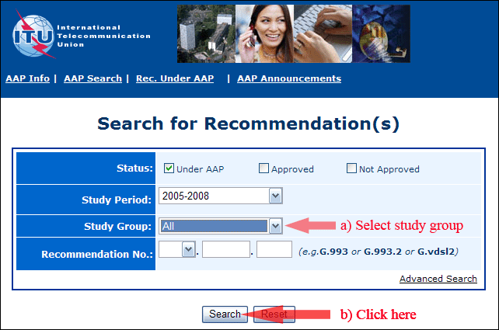
2) Select your Recommendation
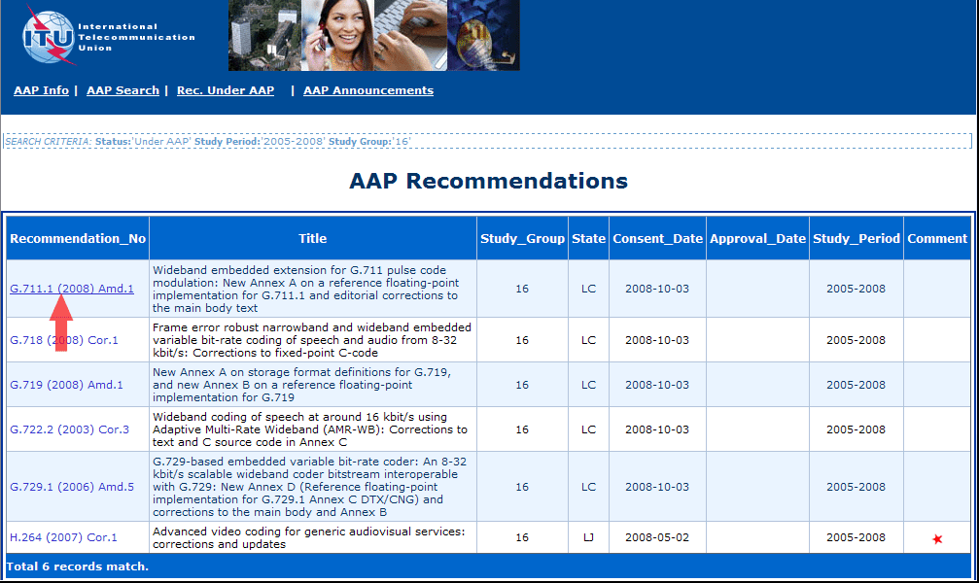
3) Click the "Submit Comment" button
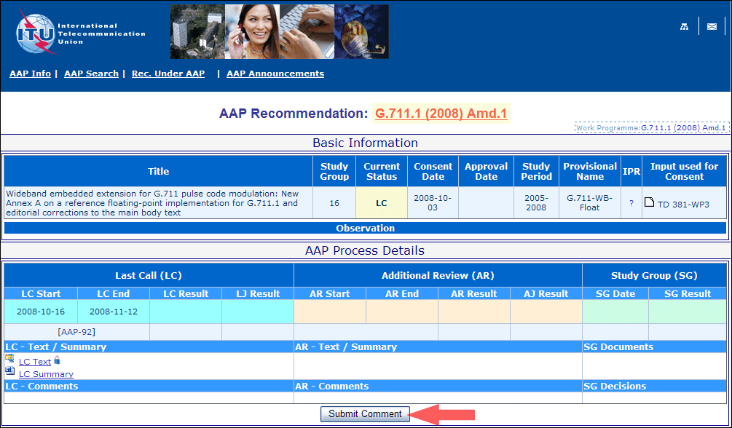
4) Complete the on-line form and click on "Submit"
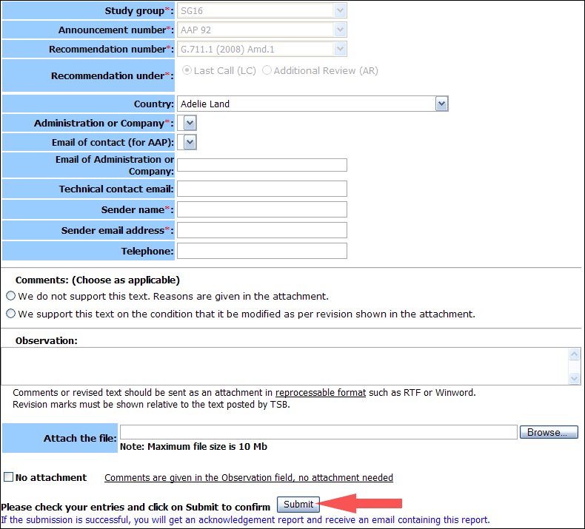
For more information, read the AAP tutorial on:
http://www.itu.int/ITU-T/aapinfo/files/AAPTutorial.pdf
Annex 3
(to TSB AAP-81)
Recommendations under LC/AR – Comment submission form
(Separate form for each Recommendation being commented upon)
ITU-T AAP comment submission form for the period 2009-2012
Study Group:
Announcement number:
Recommendation number:
Recommendation under: | Last call (LC)  Additional Review (AR)
Country:
Administration/Company:
Name of AAP Contact Person:
Email of AAP Contact Person:
Sender name:
(if different from AAP Contact Person)
Sender email address:
Telephone:
Comments:  (Choose as applicable) | We do not support this text. Reasons are given in the attachment.  We support this text on the condition that it be modified as per revision shown in the attachment.
Observations:
No attachment: Comments are given in the Observation field, no attachment needed
To be returned to: email: tsbsg....@itu.int
[or fax +41 22 730 5853]
Comments or revised text should be sent as an attachment in RTF or WinWord format.
Revision marks must be shown relative to the text posted by TSB.

