国 际 电 信 联 盟
电信标准化局
2012年4月1日 ，日内瓦

参考号:  电话:  传真:  电子邮件: | 电信标准化局AAP-79  AAP/MJ  +41 22 730 5860  +41 22 730 5853  tsbdir@itu.int | – 致国际电联成员国各主管部门；  – 致ITU-T各部门成员；  – 致ITU-T 部门准成员  抄送：  – 电信标准化局研究组主席和副主席  – 电信发展局主任  – 无线电通信局主任

事由: | 有关采用替换批准程序（AAP）处理的建议书的情况

先生/女士，
ITU-T A.8 建议书中规定的建议书替换批准程序 (AAP) 适用于那些不会产生政策或 监管影响、因而不需与成员国正式协商的建议书（见国际电联《公约》第246B款）。
附件1列出了那些在以往电信标准化局AAP预告后地位发生变化的案文。
如您希望针对某个适用AAP的建议书提出意见，请使用可在ITU-T网站AAP区域 （http://www.itu.int/ITU-T/aap）的“建议书”网页上获取的《AAP意见在线提交表格》 （见附件2）。或者，可填妥附件3 中的表格并将意见发送给相关研究组的秘书处。
敬请留意，我们不鼓励提交仅支持通过所涉案文而没有实质内容的意见。

顺致敬意！

马尔科姆•琼森
电信标准化局主任

附件：3件

Annex 1
(to TSB AAP-79)

Status codes used in the AAP announcements:
LC = Last Call
LJ = Last Call Judgment (includes comment resolution)
AR = Additional Review
AJ = Additional Review Judgment (includes comment resolution)
SG = For Study Group approval
A = Approved
AT = Approved with typographic corrections
AC = Approved after Additional Review of Comments
NA = Not approved
TAP = Moved to TAP (ITU-T A.8 / § 5.2)
ITU-T website entry page:
http://www.itu.int/ITU-T
Alternative approval process (AAP) welcome page:
http://www.itu.int/ITU-T/aapinfo
Note – A tutorial on the ITU-T AAP application is available under the AAP welcome page
ITU-T website AAP Recommendation search page:
http://www.itu.int/ITU-T/aap/
Study Group web pages and contacts:
SG 2 | http://www.itu.int/ITU-T/studygroups/com02 | tsbsg2@itu.int
SG 3 | http://www.itu.int/ITU-T/studygroups/com03 | tsbsg3@itu.int
SG 5 | http://www.itu.int/ITU-T/studygroups/com05 | tsbsg5@itu.int
SG 9 | http://www.itu.int/ITU-T/studygroups/com09 | tsbsg9@itu.int
SG 11 | http://www.itu.int/ITU-T/studygroups/com11 | tsbsg11@itu.int
SG 12 | http://www.itu.int/ITU-T/studygroups/com12 | tsbsg12@itu.int
SG 13 | http://www.itu.int/ITU-T/studygroups/com13 | tsbsg13@itu.int
SG 15 | http://www.itu.int/ITU-T/studygroups/com15 | tsbsg15@itu.int
SG 16 | http://www.itu.int/ITU-T/studygroups/com16 | tsbsg16@itu.int
SG 17 | http://www.itu.int/ITU-T/studygroups/com17 | tsbsg17@itu.int

Situation concerning Study Group 11 Recommendations under AAP
Rec # | Title | Last Call (LC) Period |  |  |  | Additional Review (AR) Period |  |  |  | Status
 |  | LC Start | LC End | LC  Result | LJ  Result | AR Start | AR End | AR  Result | AJ  Result
Q.3304.1 v2 (Q.RcCOPSv2, Q.3324.1) | Resource Control Protocol no. 4 (rcp4) Protocol at the interface between a Transport Resource Control Physical Entity (TRC-PE) and a Transport Physical Entity (T-PE) (Rc interface): COPS alternative | 2012-03-01 | 2012-03-28 | LJ |  |  |  |  |  | LJ
Q.3307.1 (2009) Amd.1 (Q.RiDiameter) | Amendment to Q.3307.1 | 2012-03-01 | 2012-03-28 | A |  |  |  |  |  | A
Q.3308.1 (Q.Rhv1) | Resource control protocol 8 (rcp8) Protocol at the interface between Resource Admission Control Physical Entity (RAC-PE) and CPN Gateway Policy Enforcement Physical Entities (CGPE-PE ) (Rh interface): COPS alternative | 2012-03-01 | 2012-03-28 | LJ |  |  |  |  |  | LJ
Q.3314 (Q.M9) | Requirements and protocol at the interface between mobile location management physical entity used as a proxy and the central instance of the mobile location management physical entity (M9 interface) | 2012-03-01 | 2012-03-28 | LJ |  |  |  |  |  | LJ
Q.3613 (Q.TS-IVR) | Signalling requirements for touch screen terminal-based IVR services | 2012-03-01 | 2012-03-28 | LJ |  |  |  |  |  | LJ
Q.3925 | The types of traffic flows which should be generated for voice, data and video on the Model network for testing QoS parameters | 2012-03-01 | 2012-03-28 | LJ |  |  |  |  |  | LJ
X.603 (Revised X.603) | Information technology - Relayed multicast protocol: Framework | 2012-03-01 | 2012-03-28 | LJ |  |  |  |  |  | LJ
Situation concerning Study Group 13 Recommendations under AAP
Rec # | Title | Last Call (LC) Period |  |  |  | Additional Review (AR) Period |  |  |  | Status
 |  | LC Start | LC End | LC  Result | LJ  Result | AR Start | AR End | AR  Result | AJ  Result
Y.2023 (Y.MCC-arch) | Functional requirements and architecture of the Next Generation Network for Multimedia Communication Centre service | 2012-03-01 | 2012-03-28 | AR |  | 2012-04-01 | 2012-04-21 |  |  | AR
Y.2060 (Y.IoT-overview) | Overview of Internet of Things | 2012-03-01 | 2012-03-28 | LJ |  |  |  |  |  | LJ
Y.2061 (Y.MOC-Reqts) | Requirements for support of machine-oriented communication applications in the NGN environment | 2012-03-01 | 2012-03-28 | LJ |  |  |  |  |  | LJ
Y.2062 (Y.UbiNet-hn) | Framework of object-to-object communication for ubiquitous networking in NGN | 2012-03-01 | 2012-03-28 | AT |  |  |  |  |  | AT
Y.2080 (Y.dsnarch) | Architecture of Distributed Service Networking | 2012-03-01 | 2012-03-28 | LJ |  |  |  |  |  | LJ
Y.2810 (Y.MMC) | Mobility Management Framework for IP Multicast Communications in Next Generation Networks | 2012-03-01 | 2012-03-28 | AT |  |  |  |  |  | AT
Y.3031 (Y.FNid) | Identification framework in future networks | 2012-03-01 | 2012-03-28 | LJ |  |  |  |  |  | LJ
Situation concerning Study Group 15 Recommendations under AAP
Rec # | Title | Last Call (LC) Period |  |  |  | Additional Review (AR) Period |  |  |  | Status
 |  | LC Start | LC End | LC  Result | LJ  Result | AR Start | AR End | AR  Result | AJ  Result
G.709/Y.1331 | Interfaces for the Optical Transport Network (OTN) | 2012-01-16 | 2012-02-12 | LJ | AT |  |  |  |  | AT
G.873.2 | Optical Transport Network (OTN) - Ring Protection | 2012-01-16 | 2012-02-12 | LJ | AR | 2012-04-01 | 2012-04-21 |  |  | AR
G.984.1 (2008) Amd.2 | Gigabit-capable Passive Optical Networks (GPON): General characteristics: Amendment 2 | 2012-01-16 | 2012-02-12 | LJ | AR | 2012-04-01 | 2012-04-21 |  |  | AR
G.984.3 (2008) Amd.3 | Gigabit-capable Passive Optical Networks (GPON): Transmission convergence layer specification - Amendment 3 | 2012-01-16 | 2012-02-12 | LJ | AR | 2012-04-01 | 2012-04-21 |  |  | AR
G.987.1 (2010) Amd.1 | 10Gigabit-capable Passive Optical Networks (XG-PON): General Requirements: Amendment 1 | 2012-01-16 | 2012-02-12 | LJ | AR | 2012-04-01 | 2012-04-21 |  |  | AR
G.988 (2010) Amd.2 | ONU management and control interface (OMCI): Amendment 2 | 2012-01-16 | 2012-02-12 | LJ | AR | 2012-04-01 | 2012-04-21 |  |  | AR
G.8261.1/Y.1361.1 | Packet Delay Variation Network Limits applicable to Packet Based Methods (Frequency Synchronization) | 2012-01-16 | 2012-02-12 | LJ | AT |  |  |  |  | AT
Situation concerning Study Group 16 Recommendations under AAP
Rec # | Title | Last Call (LC) Period |  |  |  | Additional Review (AR) Period |  |  |  | Status
 |  | LC Start | LC End | LC  Result | LJ  Result | AR Start | AR End | AR  Result | AJ  Result
H.741.0 (H.IPTV-AM, H.IPTV-AM.0, H.IPTV-AM.0-0) | IPTV application event handling: Overall aspects of audience measurement for IPTV services | 2012-02-01 | 2012-02-28 | AR |  | 2012-03-01 | 2012-03-21 | AC |  | AC
Situation concerning Study Group 17 Recommendations under AAP
Rec # | Title | Last Call (LC) Period |  |  |  | Additional Review (AR) Period |  |  |  | Status
 |  | LC Start | LC End | LC  Result | LJ  Result | AR Start | AR End | AR  Result | AJ  Result
Z.107 | Specification and Description language: Object-oriented data in SDL-2010 | 2012-04-01 | 2012-04-28 |  |  |  |  |  |  | LC
Z.109 | Specification and description language: Unified modeling language (UML) profile for SDL-2010 | 2012-04-01 | 2012-04-28 |  |  |  |  |  |  | LC
Z.151 Cor.1 | User Requirements Notation (URN) – Language definition | 2012-04-01 | 2012-04-28 |  |  |  |  |  |  | LC

Annex 2
(to TSB AAP-79)
Using the on-line comment submission form
Comment submission
1) Go to AAP search Web page at http://www.itu.int/ITU-T/aap/
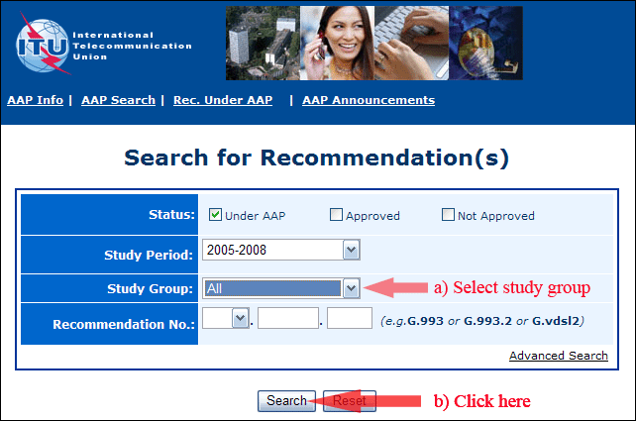
2) Select your Recommendation
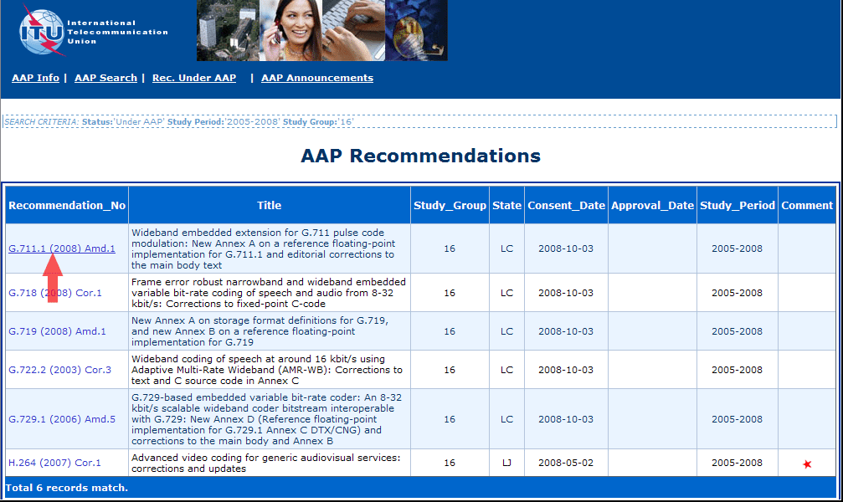
3) Click the "Submit Comment" button
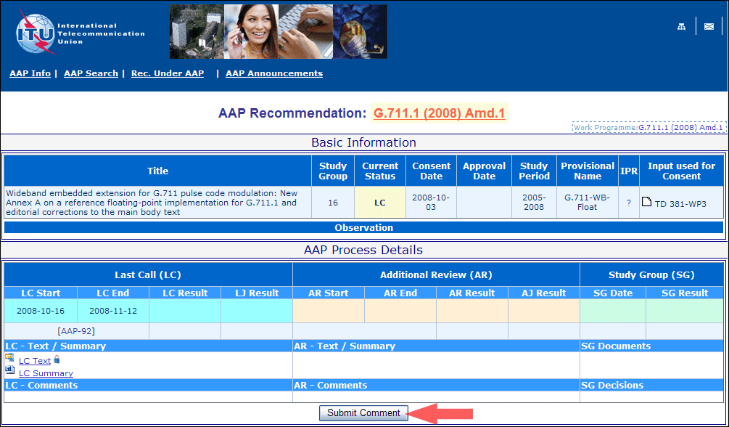
4) Complete the on-line form and click on "Submit"
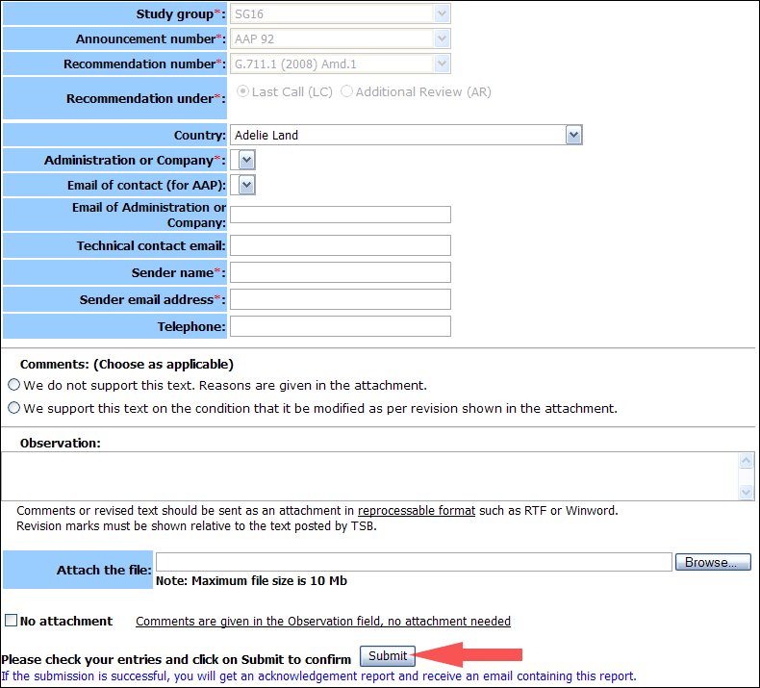
For more information, read the AAP tutorial on:
http://www.itu.int/ITU-T/aapinfo/files/AAPTutorial.pdf
Annex 3
(to TSB AAP-79)
Recommendations under LC/AR – Comment submission form
(Separate form for each Recommendation being commented upon)
ITU-T AAP comment submission form for the period 2009-2012
Study Group:
Announcement number:
Recommendation number:
Recommendation under: | Last call (LC)  Additional Review (AR)
Country:
Administration/Company:
Name of AAP Contact Person:
Email of AAP Contact Person:
Sender name:
(if different from AAP Contact Person)
Sender email address:
Telephone:
Comments:  (Choose as applicable) | We do not support this text. Reasons are given in the attachment.  We support this text on the condition that it be modified as per revision shown in the attachment.
Observations:
No attachment: Comments are given in the Observation field, no attachment needed
To be returned to: email: tsbsg....@itu.int
[or fax +41 22 730 5853]
Comments or revised text should be sent as an attachment in RTF or WinWord format.
Revision marks must be shown relative to the text posted by TSB.

