国 际 电 信 联 盟
电信标准化局
2012年2月16日 ，日内瓦

参考号:  电话:  传真:  电子邮件: | 电信标准化局AAP-76  AAP/MJ  +41 22 730 5860  +41 22 730 5853  tsbdir@itu.int | – 致国际电联成员国各主管部门；  – 致ITU-T各部门成员；  – 致ITU-T 部门准成员  抄送：  – 电信标准化局研究组主席和副主席  – 电信发展局主任  – 无线电通信局主任

事由: | 有关采用替换批准程序（AAP）处理的建议书的情况

先生/女士，
ITU-T A.8 建议书中规定的建议书替换批准程序 (AAP) 适用于那些不会产生政策或 监管影响、因而不需与成员国正式协商的建议书（见国际电联《公约》第246B款）。
附件1列出了那些在以往电信标准化局AAP预告后地位发生变化的案文。
如您希望针对某个适用AAP的建议书提出意见，请使用可在ITU-T网站AAP区域 （http://www.itu.int/ITU-T/aap）的“建议书”网页上获取的《AAP意见在线提交表格》 （见附件2）。或者，可填妥附件3 中的表格并将意见发送给相关研究组的秘书处。
敬请留意，我们不鼓励提交仅支持通过所涉案文而没有实质内容的意见。

顺致敬意！

马尔科姆•琼森
电信标准化局主任

附件：3件

Annex 1
(to TSB AAP-76)

Status codes used in the AAP announcements:
LC = Last Call
LJ = Last Call Judgment (includes comment resolution)
AR = Additional Review
AJ = Additional Review Judgment (includes comment resolution)
SG = For Study Group approval
A = Approved
AT = Approved with typographic corrections
AC = Approved after Additional Review of Comments
NA = Not approved
TAP = Moved to TAP (ITU-T A.8 / § 5.2)
ITU-T website entry page:
http://www.itu.int/ITU-T
Alternative approval process (AAP) welcome page:
http://www.itu.int/ITU-T/aapinfo
Note – A tutorial on the ITU-T AAP application is available under the AAP welcome page
ITU-T website AAP Recommendation search page:
http://www.itu.int/ITU-T/aap/
Study Group web pages and contacts:
SG 2 | http://www.itu.int/ITU-T/studygroups/com02 | tsbsg2@itu.int
SG 3 | http://www.itu.int/ITU-T/studygroups/com03 | tsbsg3@itu.int
SG 5 | http://www.itu.int/ITU-T/studygroups/com05 | tsbsg5@itu.int
SG 9 | http://www.itu.int/ITU-T/studygroups/com09 | tsbsg9@itu.int
SG 11 | http://www.itu.int/ITU-T/studygroups/com11 | tsbsg11@itu.int
SG 12 | http://www.itu.int/ITU-T/studygroups/com12 | tsbsg12@itu.int
SG 13 | http://www.itu.int/ITU-T/studygroups/com13 | tsbsg13@itu.int
SG 15 | http://www.itu.int/ITU-T/studygroups/com15 | tsbsg15@itu.int
SG 16 | http://www.itu.int/ITU-T/studygroups/com16 | tsbsg16@itu.int
SG 17 | http://www.itu.int/ITU-T/studygroups/com17 | tsbsg17@itu.int

Situation concerning Study Group 5 Recommendations under AAP
Rec # | Title | Last Call (LC) Period |  |  |  | Additional Review (AR) Period |  |  |  | Status
 |  | LC Start | LC End | LC  Result | LJ  Result | AR Start | AR End | AR  Result | AJ  Result
L.1410 (L.GNS) | Methodology for environmental impact assessment of information and communication technologies goods, networks and services | 2011-10-16 | 2011-11-12 | LJ | AR | 2012-02-16 | 2012-03-07 |  |  | AR
L.1420 (L.ORG) | Methodology for energy consumption and greenhouse gas emissions impact assessment of Information and Communication Technologies in organizations | 2011-10-16 | 2011-11-12 | LJ | AR | 2012-01-16 | 2012-02-05 | AC |  | AC
Situation concerning Study Group 11 Recommendations under AAP
Rec # | Title | Last Call (LC) Period |  |  |  | Additional Review (AR) Period |  |  |  | Status
 |  | LC Start | LC End | LC  Result | LJ  Result | AR Start | AR End | AR  Result | AJ  Result
Q.3303.3 v2 (Q.RwDiameterv2) | Resource control protocol no.3 (rcp3) Protocol at the interface between Policy Decision Physical Entity (PD-PE) and Policy Enforcement Physical Entity (PE-PE) (Rw interface): Diameter Profile version 2 | 2011-11-01 | 2011-11-28 | LJ | AR | 2012-01-16 | 2012-02-05 | AC |  | AC
Situation concerning Study Group 15 Recommendations under AAP
Rec # | Title | Last Call (LC) Period |  |  |  | Additional Review (AR) Period |  |  |  | Status
 |  | LC Start | LC End | LC  Result | LJ  Result | AR Start | AR End | AR  Result | AJ  Result
G.664 | Optical safety procedures and requirements for optical transport systems | 2012-01-16 | 2012-02-12 | A |  |  |  |  |  | A
G.671 | Transmission characteristics of optical components and subsystems | 2012-01-16 | 2012-02-12 | A |  |  |  |  |  | A
G.694.1 | Spectral Grids for WDM Applications: DWDM Frequency Grid | 2012-01-16 | 2012-02-12 | A |  |  |  |  |  | A
G.697 | Optical monitoring for dense wavelength division multiplexing systems | 2012-01-16 | 2012-02-12 | A |  |  |  |  |  | A
G.698.3 (G.sdapp) | Multichannel seeded DWDM applications with single-channel optical interfaces | 2012-01-16 | 2012-02-12 | A |  |  |  |  |  | A
G.709/Y.1331 | Interfaces for the Optical Transport Network (OTN) | 2012-01-16 | 2012-02-12 | LJ |  |  |  |  |  | LJ
G.783 (2006) Amd.3 | Characteristics of Synchronous Digital Hierarchy (SDH) Equipment Functional Blocks: Amendment 3 | 2012-01-16 | 2012-02-12 | LJ |  |  |  |  |  | LJ
G.798 (2010) Amd.2 | Characteristics of optical transport network hierarchy equipment functional blocks: Amendment 2 | 2012-01-16 | 2012-02-12 | LJ |  |  |  |  |  | LJ
G.798 (2010) Cor.2 | Characteristics of optical transport network hierarchy equipment functional blocks: Corrigendum 2 | 2012-01-16 | 2012-02-12 | A |  |  |  |  |  | A
G.800 | Unified functional architecture of transport networks | 2012-01-16 | 2012-02-12 | A |  |  |  |  |  | A
G.806 | Characteristics of Transport Equipment - Description Methodology and Generic Functionality | 2012-01-16 | 2012-02-12 | A |  |  |  |  |  | A
G.808.1 (2010) Amd.1 | Generic Protection Switching - Linear Trail and Subnetwork Protection: Amendment 1 | 2012-01-16 | 2012-02-12 | LJ |  |  |  |  |  | LJ
G.870/Y.1352 | Terms and definitions for Optical Transport Networks (OTN) | 2012-01-16 | 2012-02-12 | A |  |  |  |  |  | A
G.873.2 | Optical Transport Network (OTN) - Ring Protection | 2012-01-16 | 2012-02-12 | LJ |  |  |  |  |  | LJ
G.874 (2010) Amd.1 | Management aspects of optical transport network elements: Amendment 1 | 2012-01-16 | 2012-02-12 | LJ |  |  |  |  |  | LJ
G.959.1 | Optical transport networks physical layer interfaces | 2012-01-16 | 2012-02-12 | A |  |  |  |  |  | A
G.984.1 (2008) Amd.2 | Gigabit-capable Passive Optical Networks (GPON): General characteristics: Amendment 2 | 2012-01-16 | 2012-02-12 | LJ |  |  |  |  |  | LJ
G.984.3 (2008) Amd.3 | Gigabit-capable Passive Optical Networks (GPON): Transmission convergence layer specification - Amendment 3 | 2012-01-16 | 2012-02-12 | LJ |  |  |  |  |  | LJ
G.984.6 (2008) Amd. 2 | Gigabit-capable Passive Optical Networks (GPON): Reach extender (RE) units - Amendment 2 | 2012-01-16 | 2012-02-12 | LJ |  |  |  |  |  | LJ
G.987.1 (2010) Amd.1 | 10Gigabit-capable Passive Optical Networks (XG-PON): General Requirements: Amendment 1 | 2012-01-16 | 2012-02-12 | LJ |  |  |  |  |  | LJ
G.987.2 (2010) Amd.1 | 10-Gigabit-capable passive optical networks (XG-PON): Physical media dependent (PMD) layer specification: Amendment 1 | 2012-01-16 | 2012-02-12 | A |  |  |  |  |  | A
G.987.3 (2010) Amd.1 (G.xgpon.3) | 10-Gigabit-capable passive optical networks (XG-PON): Transmission convergence (TC) specifications: Amendment 1 | 2012-01-16 | 2012-02-12 | LJ |  |  |  |  |  | LJ
G.987.4 (G.xgpon.re) | 10-Gigabit-capable Passive Optical Networks (XG-PON): Reach extension | 2012-01-16 | 2012-02-12 | LJ |  |  |  |  |  | LJ
G.988 (2010) Amd.2 | ONU management and control interface (OMCI): Amendment 2 | 2012-01-16 | 2012-02-12 | LJ |  |  |  |  |  | LJ
G.993.2 (2011) Amd.1 | Very high speed digital subscriber line transceivers 2 (VDSL2): Amendment 1 | 2012-01-16 | 2012-02-12 | LJ |  |  |  |  |  | LJ
G.996.2 (2009) Amd.2 (G.lt Amd.1) | Line Testing for Digital Subscriber Lines (DSL): Amendment 2 | 2012-01-16 | 2012-02-12 | LJ |  |  |  |  |  | LJ
G.997.1 (2009) Amd.5 | Physical layer management for digital subscriber line (DSL) transceivers: Amendment 5 | 2012-01-16 | 2012-02-12 | LJ |  |  |  |  |  | LJ
G.998.4 (2010) Amd.2 | Improved impulse noise protection for DSL transceivers: Amendment 2 | 2012-01-16 | 2012-02-12 | LJ |  |  |  |  |  | LJ
G.7041/Y.1303 (2011) Amd.1 | Generic Framing Procedure (GFP): Amendment 1 | 2012-01-16 | 2012-02-12 | A |  |  |  |  |  | A
G.7044/Y.1347 (2011) Amd.1 (G.hao) | Hitless Adjustment of ODUflex(GFP) (HAO): Amendment 1 | 2012-01-16 | 2012-02-12 | A |  |  |  |  |  | A
G.7710/Y.1701 | Common equipment management function requirements | 2012-01-16 | 2012-02-12 | A |  |  |  |  |  | A
G.7714/Y.1705 (2005) Amd.1 | Generalized Automatic Discovery Techniques: Amendment 1 | 2012-01-16 | 2012-02-12 | A |  |  |  |  |  | A
G.8001/Y.1354 | Terms and definitions for Ethernet frames over Transport | 2012-01-16 | 2012-02-12 | LJ |  |  |  |  |  | LJ
G.8013/Y.1731 (2011) Amd.1 | OAM functions and mechanisms for Ethernet based networks: Amendment 1 | 2012-01-16 | 2012-02-12 | LJ |  |  |  |  |  | LJ
G.8021/Y.1341 | Characteristics of Ethernet transport network equipment functional blocks | 2012-01-16 | 2012-02-12 | LJ |  |  |  |  |  | LJ
G.8031/Y.1342 (2011) Cor.1 | Ethernet linear protection switching: Corrigendum 1 | 2012-01-16 | 2012-02-12 | A |  |  |  |  |  | A
G.8032/Y.1344 | Ethernet Ring Protection Switching | 2012-01-16 | 2012-02-12 | A |  |  |  |  |  | A
G.8080/Y.1304 (G.ason) | Architecture for the automatically switched optical network (ASON) | 2012-01-16 | 2012-02-12 | LJ |  |  |  |  |  | LJ
G.8081/Y.1353 | Terms and definitions for Automatically Switched Optical Networks (ASON) | 2012-01-16 | 2012-02-12 | LJ |  |  |  |  |  | LJ
G.8121/Y.1381 | Characteristics of MPLS-TP Network Equipment Functional Blocks | 2012-01-16 | 2012-02-12 | LJ |  |  |  |  |  | LJ
G.8151/Y.1374 | Management aspects of the MPLS-TP network element | 2012-01-16 | 2012-02-12 | LJ |  |  |  |  |  | LJ
G.8251 (2010) Amd.2 | The control of jitter and wander within the optical transport network (OTN): Amendment 2 | 2012-01-16 | 2012-02-12 | LJ |  |  |  |  |  | LJ
G.8251 (2010) Cor.1 | The control of jitter and wander within the optical transport network (OTN): Corrigendum 1 | 2012-01-16 | 2012-02-12 | A |  |  |  |  |  | A
G.8260 | Definitions and terminology for synchronization in packet networks | 2012-01-16 | 2012-02-12 | A |  |  |  |  |  | A
G.8261.1/Y.1361.1 | Packet Delay Variation Network Limits applicable to Packet Based Methods (Frequency Synchronization) | 2012-01-16 | 2012-02-12 | LJ |  |  |  |  |  | LJ
G.8262/Y.1362 (2010) Amd.1 | Timing characteristics of a synchronous Ethernet equipment slave clock (EEC): Amendment 1 | 2012-01-16 | 2012-02-12 | A |  |  |  |  |  | A
G.8263/Y.1363 (G.paclock-bis) | Timing characteristics of packet based equipment clocks (PEC) and packet based service clocks (PSC) | 2012-01-16 | 2012-02-12 | LJ |  |  |  |  |  | LJ
G.8264/Y.1364 (2008) Amd.2 (G.pacmod) | Distribution of timing information through packet networks: Amendment 2 | 2012-01-16 | 2012-02-12 | A |  |  |  |  |  | A
G.8264/Y.1364 (2008) Cor.2 (G.pacmod) | Distribution of timing information through packet networks: Corrigendum 2 | 2012-01-16 | 2012-02-12 | A |  |  |  |  |  | A
G.8271/Y.1366 (G.pactiming-bis) | Time and phase synchronization aspects of packet networks | 2012-01-16 | 2012-02-12 | LJ |  |  |  |  |  | LJ
G.9956 (2011) Cor.1 (G.hnem) | Narrow-band OFDM power line communication transceivers - Data link layer specification: Corrigendum 1 | 2012-01-16 | 2012-02-12 | LJ |  |  |  |  |  | LJ
G.9959 (ex. G.wnb) | Wireless narrow-band networks | 2012-01-16 | 2012-02-12 | A |  |  |  |  |  | A
L.89 (L.aid, L.dwpg) | Design of suspension wires, telecommunication poles and guy-lines for optical access networks | 2012-01-16 | 2012-02-12 | LJ |  |  |  |  |  | LJ
L.90 (L.oanbs) | Optical Access Networks topologies for Broadband Services | 2012-01-16 | 2012-02-12 | A |  |  |  |  |  | A
O.173 | Jitter measuring equipment for digital systems which are based on the Optical Transport Network (OTN) | 2012-01-16 | 2012-02-12 | A |  |  |  |  |  | A
O.174 (2009) Cor.2 | Jitter and wander measuring equipment for digital systems which are based on synchronous Ethernet technology: Corrigendum 2 | 2012-01-16 | 2012-02-12 | A |  |  |  |  |  | A
Situation concerning Study Group 16 Recommendations under AAP
Rec # | Title | Last Call (LC) Period |  |  |  | Additional Review (AR) Period |  |  |  | Status
 |  | LC Start | LC End | LC  Result | LJ  Result | AR Start | AR End | AR  Result | AJ  Result
H.248.12 | Gateway control protocol: H.248.1 packages for H.323 and H.324 interworking | 2012-01-16 | 2012-02-12 | A |  |  |  |  |  | A
H.248.34 | Gateway control protocol: Stimulus analogue line package | 2012-01-16 | 2012-02-12 | A |  |  |  |  |  | A
H.248.48 (H.248.QHR) | Gateway control protocol: RTCP XR block reporting package | 2012-01-16 | 2012-02-12 | A |  |  |  |  |  | A
H.248.50 Cor.1 | Gateway control protocol: NAT traversal toolkit packages: Corrections and clarification | 2012-01-16 | 2012-02-12 | A |  |  |  |  |  | A
H.248.79 (H.248.PACKETS) | Gateway control protocol: Guidelines for packet-based streams | 2012-01-16 | 2012-02-12 | A |  |  |  |  |  | A
H.248.83 (H.248.MGINST) | Gateway control protocol: Media gateway Instance Package | 2012-01-16 | 2012-02-12 | A |  |  |  |  |  | A
H.641 (H.SNMF) | SNMP-based sensor network management framework | 2012-01-16 | 2012-02-12 | A |  |  |  |  |  | A

Annex 2
(to TSB AAP-76)
Using the on-line comment submission form
Comment submission
1) Go to AAP search Web page at http://www.itu.int/ITU-T/aap/
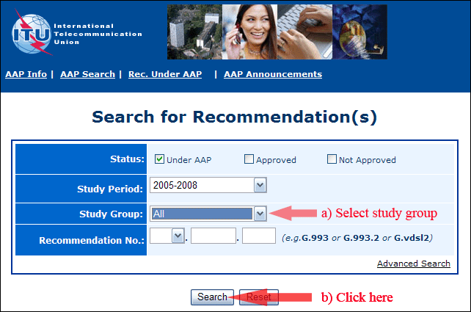
2) Select your Recommendation
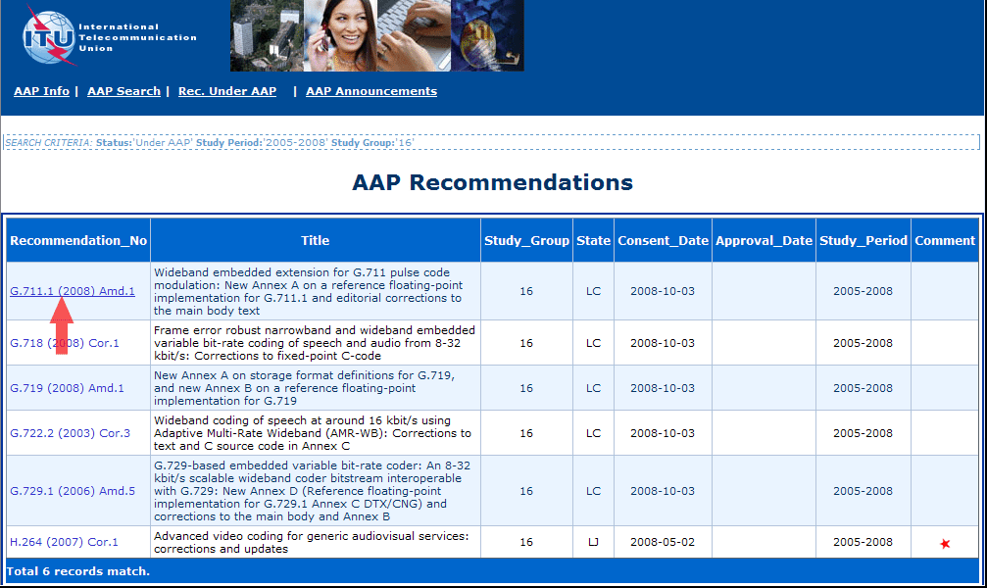
3) Click the "Submit Comment" button
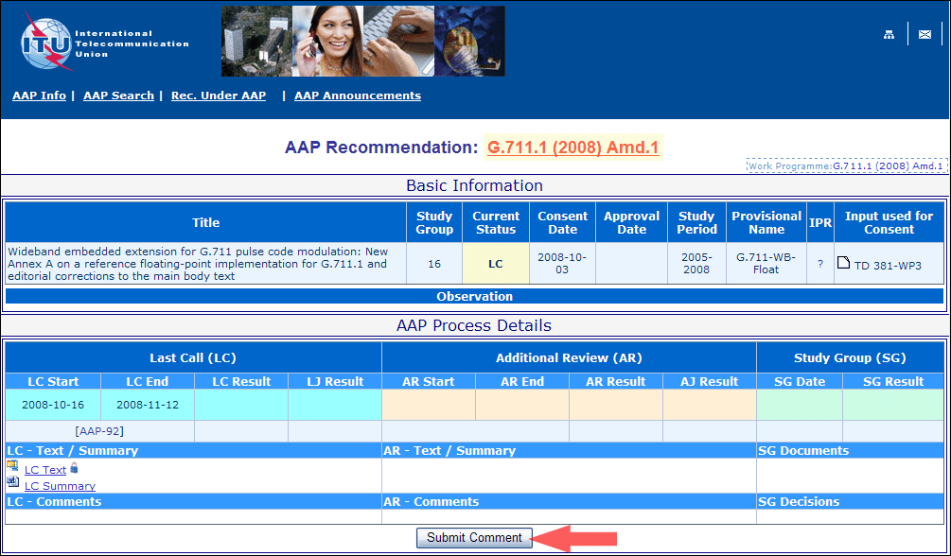
4) Complete the on-line form and click on "Submit"
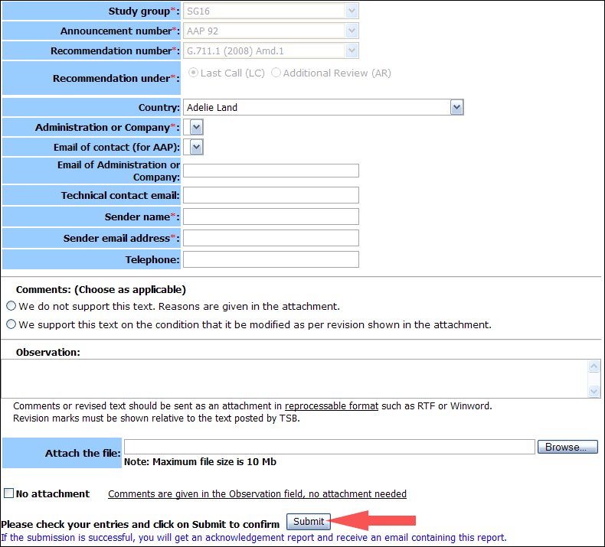
For more information, read the AAP tutorial on:
http://www.itu.int/ITU-T/aapinfo/files/AAPTutorial.pdf
Annex 3
(to TSB AAP-76)
Recommendations under LC/AR – Comment submission form
(Separate form for each Recommendation being commented upon)
ITU-T AAP comment submission form for the period 2009-2012
Study Group:
Announcement number:
Recommendation number:
Recommendation under: | Last call (LC)  Additional Review (AR)
Country:
Administration/Company:
Name of AAP Contact Person:
Email of AAP Contact Person:
Sender name:
(if different from AAP Contact Person)
Sender email address:
Telephone:
Comments:  (Choose as applicable) | We do not support this text. Reasons are given in the attachment.  We support this text on the condition that it be modified as per revision shown in the attachment.
Observations:
No attachment: Comments are given in the Observation field, no attachment needed
To be returned to: email: tsbsg....@itu.int
[or fax +41 22 730 5853]
Comments or revised text should be sent as an attachment in RTF or WinWord format.
Revision marks must be shown relative to the text posted by TSB.

