国 际 电 信 联 盟
电信标准化局
2012年2月1日 ，日内瓦

参考号:  电话:  传真:  电子邮件: | 电信标准化局AAP-75  AAP/MJ  +41 22 730 5860  +41 22 730 5853  tsbdir@itu.int | – 致国际电联成员国各主管部门；  – 致ITU-T各部门成员；  – 致ITU-T 部门准成员  抄送：  – 电信标准化局研究组主席和副主席  – 电信发展局主任  – 无线电通信局主任

事由: | 有关采用替换批准程序（AAP）处理的建议书的情况

先生/女士，
ITU-T A.8 建议书中规定的建议书替换批准程序 (AAP) 适用于那些不会产生政策或 监管影响、因而不需与成员国正式协商的建议书（见国际电联《公约》第246B款）。
附件1列出了那些在以往电信标准化局AAP预告后地位发生变化的案文。
如您希望针对某个适用AAP的建议书提出意见，请使用可在ITU-T网站AAP区域 （http://www.itu.int/ITU-T/aap）的“建议书”网页上获取的《AAP意见在线提交表格》 （见附件2）。或者，可填妥附件3 中的表格并将意见发送给相关研究组的秘书处。
敬请留意，我们不鼓励提交仅支持通过所涉案文而没有实质内容的意见。

顺致敬意！

马尔科姆•琼森
电信标准化局主任

附件：3件

Annex 1
(to TSB AAP-75)

Status codes used in the AAP announcements:
LC = Last Call
LJ = Last Call Judgment (includes comment resolution)
AR = Additional Review
AJ = Additional Review Judgment (includes comment resolution)
SG = For Study Group approval
A = Approved
AT = Approved with typographic corrections
AC = Approved after Additional Review of Comments
NA = Not approved
TAP = Moved to TAP (ITU-T A.8 / § 5.2)
ITU-T website entry page:
http://www.itu.int/ITU-T
Alternative approval process (AAP) welcome page:
http://www.itu.int/ITU-T/aapinfo
Note – A tutorial on the ITU-T AAP application is available under the AAP welcome page
ITU-T website AAP Recommendation search page:
http://www.itu.int/ITU-T/aap/
Study Group web pages and contacts:
SG 2 | http://www.itu.int/ITU-T/studygroups/com02 | tsbsg2@itu.int
SG 3 | http://www.itu.int/ITU-T/studygroups/com03 | tsbsg3@itu.int
SG 5 | http://www.itu.int/ITU-T/studygroups/com05 | tsbsg5@itu.int
SG 9 | http://www.itu.int/ITU-T/studygroups/com09 | tsbsg9@itu.int
SG 11 | http://www.itu.int/ITU-T/studygroups/com11 | tsbsg11@itu.int
SG 12 | http://www.itu.int/ITU-T/studygroups/com12 | tsbsg12@itu.int
SG 13 | http://www.itu.int/ITU-T/studygroups/com13 | tsbsg13@itu.int
SG 15 | http://www.itu.int/ITU-T/studygroups/com15 | tsbsg15@itu.int
SG 16 | http://www.itu.int/ITU-T/studygroups/com16 | tsbsg16@itu.int
SG 17 | http://www.itu.int/ITU-T/studygroups/com17 | tsbsg17@itu.int

Situation concerning Study Group 5 Recommendations under AAP
Rec # | Title | Last Call (LC) Period |  |  |  | Additional Review (AR) Period |  |  |  | Status
 |  | LC Start | LC End | LC  Result | LJ  Result | AR Start | AR End | AR  Result | AJ  Result
L.1100 (L.raremetals) | A method to provide recycling information of rare metals in ICT products | 2011-10-16 | 2011-11-12 | LJ | AR | 2012-02-01 | 2012-02-21 |  |  | AR
Situation concerning Study Group 11 Recommendations under AAP
Rec # | Title | Last Call (LC) Period |  |  |  | Additional Review (AR) Period |  |  |  | Status
 |  | LC Start | LC End | LC  Result | LJ  Result | AR Start | AR End | AR  Result | AJ  Result
Q.3313 (Q.Flowstatesig) | Signalling protocols and procedures relating to Flow State Aware QoS control in a bounded sub-network of a NGN | 2011-11-01 | 2011-11-28 | LJ | AR | 2012-02-01 | 2012-02-21 |  |  | AR
Q.3945 | The types and list of NGN services testing on the model networks. Test set I | 2011-11-01 | 2011-11-28 | LJ | AT |  |  |  |  | AT
Situation concerning Study Group 15 Recommendations under AAP
Rec # | Title | Last Call (LC) Period |  |  |  | Additional Review (AR) Period |  |  |  | Status
 |  | LC Start | LC End | LC  Result | LJ  Result | AR Start | AR End | AR  Result | AJ  Result
G.9961 (2010) Amd.1 * | Data link layer (DLL) for unified high-speed wire-line based home networking transceivers: Amendment 1 | 2012-02-01 | 2012-02-28 |  |  |  |  |  |  | LC
Situation concerning Study Group 16 Recommendations under AAP
Rec # | Title | Last Call (LC) Period |  |  |  | Additional Review (AR) Period |  |  |  | Status
 |  | LC Start | LC End | LC  Result | LJ  Result | AR Start | AR End | AR  Result | AJ  Result
G.168 (V7) | Digital network echo cancellers | 2012-02-01 | 2012-02-28 |  |  |  |  |  |  | LC
G.729.1 (2006) Amd.7 (G.729.1-VAD-Layer) | G.729-based embedded variable bit-rate coder: An 8-32 kbit/s scalable wideband coder bitstream interoperable with G.729: Voice activity detector using G.720.1 Annex A | 2012-02-01 | 2012-02-28 |  |  |  |  |  |  | LC
H.241 | Extended video procedures and control signals for H.300-series terminals | 2012-02-01 | 2012-02-28 |  |  |  |  |  |  | LC
H.262 (2000) Amd.4 | Information technology - Generic coding of moving pictures and associated audio information: Video: Frame packing arrangement signalling for 3D content | 2012-02-01 | 2012-02-28 |  |  |  |  |  |  | LC
H.741.0 (H.IPTV-AM, H.IPTV-AM.0, H.IPTV-AM.0-0) | IPTV application event handling: Overall aspects of audience measurement for IPTV services | 2012-02-01 | 2012-02-28 |  |  |  |  |  |  | LC

Annex 2
(to TSB AAP-75)
Using the on-line comment submission form
Comment submission
1) Go to AAP search Web page at http://www.itu.int/ITU-T/aap/
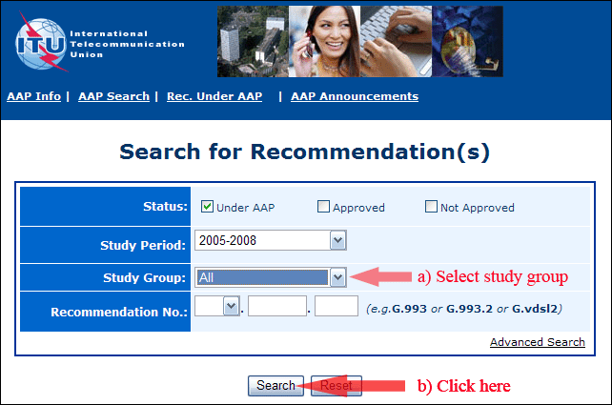
2) Select your Recommendation
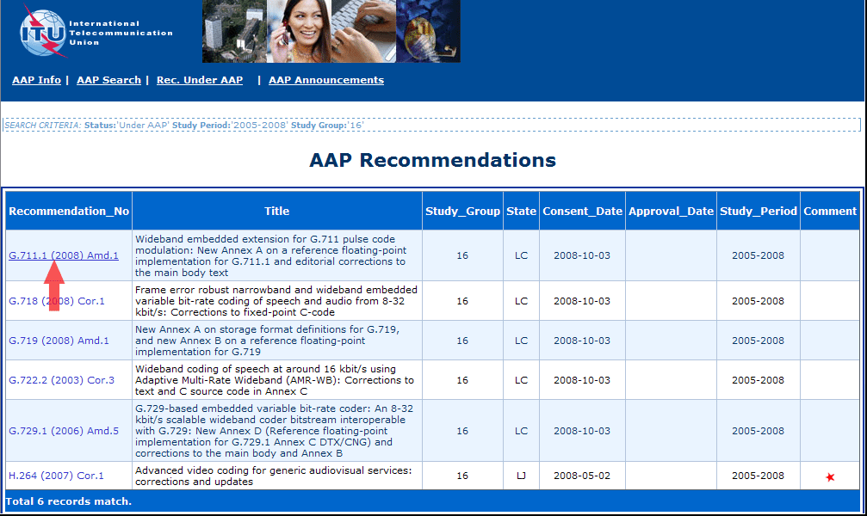
3) Click the "Submit Comment" button
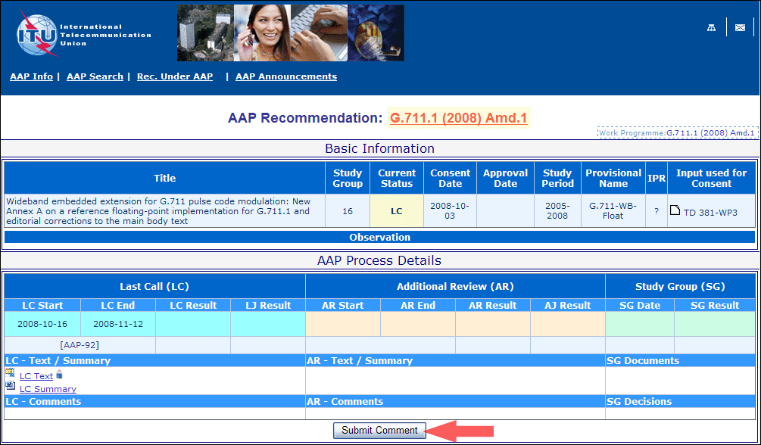
4) Complete the on-line form and click on "Submit"
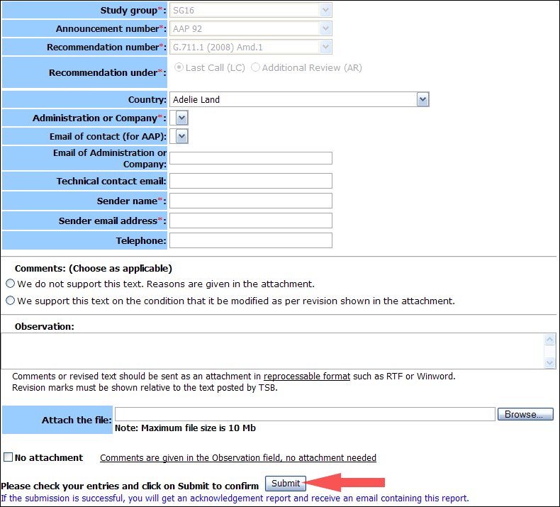
For more information, read the AAP tutorial on:
http://www.itu.int/ITU-T/aapinfo/files/AAPTutorial.pdf
Annex 3
(to TSB AAP-75)
Recommendations under LC/AR – Comment submission form
(Separate form for each Recommendation being commented upon)
ITU-T AAP comment submission form for the period 2009-2012
Study Group:
Announcement number:
Recommendation number:
Recommendation under: | Last call (LC)  Additional Review (AR)
Country:
Administration/Company:
Name of AAP Contact Person:
Email of AAP Contact Person:
Sender name:
(if different from AAP Contact Person)
Sender email address:
Telephone:
Comments:  (Choose as applicable) | We do not support this text. Reasons are given in the attachment.  We support this text on the condition that it be modified as per revision shown in the attachment.
Observations:
No attachment: Comments are given in the Observation field, no attachment needed
To be returned to: email: tsbsg....@itu.int
[or fax +41 22 730 5853]
Comments or revised text should be sent as an attachment in RTF or WinWord format.
Revision marks must be shown relative to the text posted by TSB.

* G.9961 (2010) Amd.1 was consented on 25 February 2011 and submitted to Last Call on 16 March 2011, and was then forwarded to Study Group, which decided on 16 December 2011 to reinitiate the Last Call process.

