Union Internationale des Telecommunications
Bureau de la normalisation des télécommunications

Genève, le 16 janvier 2012

Réf:  Tél:  Fax:  E-mail: | TSB AAP-74  AAP/MJ  +41 22 730 5860  +41 22 730 5853  tsbdir@itu.int | – Aux administrations des Etats Membres de l'Union;  – Aux Membres du Secteur UIT-T;  – Aux Associés de l'UIT-T  Copie:  – Aux Présidents et Vice-Présidents des Commissions d'études de l'UIT-T;  – Au Directeur du Bureau de développement des télécommunications;  – Au Directeur du Bureau des radiocommunications

Objet: | Etat des Recommandations auxquelles s'applique la variante de la procédure d'approbation (AAP)

Madame, Monsieur,

La variante de la procédure d'approbation (AAP), définie dans la Recommandation UIT-T A.8, s'applique aux Recommandations qui n'ont pas d'incidence politique ou réglementaire et ne nécessitent donc pas une consultation formelle des Etats Membres (voir le numéro 246B de la Convention de l'UIT).
L'Annexe 1 énumère les textes dont le statut a changé par rapport aux annonces TSB AAP antérieures.
Si vous souhaitez soumettre des observations sur une Recommandation ayant fait l'objet de la procédure AAP, vous êtes encouragés à utiliser le formulaire en ligne de soumission des observations AAP, disponible dans l'espace AAP du site web de l'UIT-T à l'adresse http://www.itu.int/ITU-T/aap/, à la page de la Recommandation concernée (voir l'Annexe 2). Vous pouvez aussi soumettre vos observations en remplissant le formulaire figurant à l'Annexe 3 et en l'envoyant au secrétariat de la Commission d'études concernée.
Veuillez noter que les observations ayant simplement pour objet d'appuyer l'adoption du texte en question ne sont pas encouragées.
Veuillez agréer, Madame, Monsieur, l'assurance de ma considération distinguée.
Malcolm Johnson
Directeur du Bureau de la normalisation des télécommunications

Annexes: 3

Annex 1
(to TSB AAP-74)

Status codes used in the AAP announcements:
LC = Last Call
LJ = Last Call Judgment (includes comment resolution)
AR = Additional Review
AJ = Additional Review Judgment (includes comment resolution)
SG = For Study Group approval
A = Approved
AT = Approved with typographic corrections
AC = Approved after Additional Review of Comments
NA = Not approved
TAP = Moved to TAP (ITU-T A.8 / § 5.2)
ITU-T website entry page:
http://www.itu.int/ITU-T
Alternative approval process (AAP) welcome page:
http://www.itu.int/ITU-T/aapinfo
Note – A tutorial on the ITU-T AAP application is available under the AAP welcome page
ITU-T website AAP Recommendation search page:
http://www.itu.int/ITU-T/aap/
Study Group web pages and contacts:
SG 2 | http://www.itu.int/ITU-T/studygroups/com02 | tsbsg2@itu.int
SG 3 | http://www.itu.int/ITU-T/studygroups/com03 | tsbsg3@itu.int
SG 5 | http://www.itu.int/ITU-T/studygroups/com05 | tsbsg5@itu.int
SG 9 | http://www.itu.int/ITU-T/studygroups/com09 | tsbsg9@itu.int
SG 11 | http://www.itu.int/ITU-T/studygroups/com11 | tsbsg11@itu.int
SG 12 | http://www.itu.int/ITU-T/studygroups/com12 | tsbsg12@itu.int
SG 13 | http://www.itu.int/ITU-T/studygroups/com13 | tsbsg13@itu.int
SG 15 | http://www.itu.int/ITU-T/studygroups/com15 | tsbsg15@itu.int
SG 16 | http://www.itu.int/ITU-T/studygroups/com16 | tsbsg16@itu.int
SG 17 | http://www.itu.int/ITU-T/studygroups/com17 | tsbsg17@itu.int

Situation concerning Study Group 5 Recommendations under AAP
Rec # | Title | Last Call (LC) Period |  |  |  | Additional Review (AR) Period |  |  |  | Status
 |  | LC Start | LC End | LC  Result | LJ  Result | AR Start | AR End | AR  Result | AJ  Result
L.1420 (L.ORG) | Methodology for energy consumption and greenhouse gas emissions impact assessment of Information and Communication Technologies in organizations | 2011-10-16 | 2011-11-12 | LJ | AR | 2012-01-16 | 2012-02-05 |  |  | AR
Situation concerning Study Group 9 Recommendations under AAP
Rec # | Title | Last Call (LC) Period |  |  |  | Additional Review (AR) Period |  |  |  | Status
 |  | LC Start | LC End | LC  Result | LJ  Result | AR Start | AR End | AR  Result | AJ  Result
J.205 (J.acf-req) | Requirements for harmonized Application Control Framework supporting hybrid broadcast & broadband applications | 2011-12-16 | 2012-01-12 | A |  |  |  |  |  | A
J.295 (J.adcstb-req) | Advanced cable set-top box requirement | 2011-12-16 | 2012-01-12 | A |  |  |  |  |  | A
J.706  (J.tgtdst-overview) | The overview of target content distribution | 2011-12-16 | 2012-01-12 | A |  |  |  |  |  | A
J.707 (J.target-dist) | Messages and protocols enabling target content distribution for integrated broadband cable networks | 2011-12-16 | 2012-01-12 | A |  |  |  |  |  | A
J.902 (J.ftvdf) | Multi-layer data structure for scalable view-range representation | 2011-12-16 | 2012-01-12 | A |  |  |  |  |  | A
J.1001 (J.rcas-req) | Requirements for conditional access client software remote renewable security system | 2011-12-16 | 2012-01-12 | A |  |  |  |  |  | A
Situation concerning Study Group 11 Recommendations under AAP
Rec # | Title | Last Call (LC) Period |  |  |  | Additional Review (AR) Period |  |  |  | Status
 |  | LC Start | LC End | LC  Result | LJ  Result | AR Start | AR End | AR  Result | AJ  Result
Q.3303.3 v2 (Q.RwDiameterv2) | Resource control protocol no.3 (rcp3) Protocol at the interface between Policy Decision Physical Entity (PD-PE) and Policy Enforcement Physical Entity (PE-PE) (Rw interface): Diameter Profile version 2 | 2011-11-01 | 2011-11-28 | LJ | AR | 2012-01-16 | 2012-02-05 |  |  | AR
Q.3909  (Q.NGN interoperability) | The framework and overview of NGN conformance and interoperability testing | 2011-11-01 | 2011-11-28 | LJ | AT |  |  |  |  | AT
Q.3950  (Q.nid-test-arch) | Testing and model network architecture for tag-based identification systems and functions | 2011-11-01 | 2011-11-28 | LJ | AT |  |  |  |  | AT
Situation concerning Study Group 12 Recommendations under AAP
Rec # | Title | Last Call (LC) Period |  |  |  | Additional Review (AR) Period |  |  |  | Status
 |  | LC Start | LC End | LC  Result | LJ  Result | AR Start | AR End | AR  Result | AJ  Result
P.501 | Test signals for use in telephonometry | 2011-12-01 | 2012-01-12 | A |  |  |  |  |  | A
Situation concerning Study Group 13 Recommendations under AAP
Rec # | Title | Last Call (LC) Period |  |  |  | Additional Review (AR) Period |  |  |  | Status
 |  | LC Start | LC End | LC  Result | LJ  Result | AR Start | AR End | AR  Result | AJ  Result
Y.2057 (Y.ipv6split) | Framework of Identifiers and Locators Separation in IPv6-based Next Generation Networks | 2011-11-01 | 2011-11-28 | LJ | AT |  |  |  |  | AT
Y.3011 (Y.FNvirt) | Framework of network virtualization for Future Networks | 2011-11-16 | 2011-12-13 | AR |  | 2011-12-16 | 2012-01-12 | AC |  | AC
Y.3021 (Y.FNenergy) | Framework of energy saving for Future Networks | 2011-11-01 | 2011-11-28 | LJ | AR | 2011-12-16 | 2012-01-12 | AC |  | AC
Situation concerning Study Group 15 Recommendations under AAP
Rec # | Title | Last Call (LC) Period |  |  |  | Additional Review (AR) Period |  |  |  | Status
 |  | LC Start | LC End | LC  Result | LJ  Result | AR Start | AR End | AR  Result | AJ  Result
G.664 | Optical safety procedures and requirements for optical transport systems | 2012-01-16 | 2012-02-12 |  |  |  |  |  |  | LC
G.671 | Transmission characteristics of optical components and subsystems | 2012-01-16 | 2012-02-12 |  |  |  |  |  |  | LC
G.694.1 | Spectral Grids for WDM Applications: DWDM Frequency Grid | 2012-01-16 | 2012-02-12 |  |  |  |  |  |  | LC
G.697 | Optical monitoring for dense wavelength division multiplexing systems | 2012-01-16 | 2012-02-12 |  |  |  |  |  |  | LC
G.698.3 (G.sdapp) | Multichannel seeded DWDM applications with single-channel optical interfaces | 2012-01-16 | 2012-02-12 |  |  |  |  |  |  | LC
G.709/Y.1331 | Interfaces for the Optical Transport Network (OTN) | 2012-01-16 | 2012-02-12 |  |  |  |  |  |  | LC
G.783 (2006) Amd.3 | Characteristics of Synchronous Digital Hierarchy (SDH) Equipment Functional Blocks: Amendment 3 | 2012-01-16 | 2012-02-12 |  |  |  |  |  |  | LC
G.798 (2010) Amd.2 | Characteristics of optical transport network hierarchy equipment functional blocks: Amendment 2 | 2012-01-16 | 2012-02-12 |  |  |  |  |  |  | LC
G.798 (2010) Cor.2 | Characteristics of optical transport network hierarchy equipment functional blocks: Corrigendum 2 | 2012-01-16 | 2012-02-12 |  |  |  |  |  |  | LC
G.800 | Unified functional architecture of transport networks | 2012-01-16 | 2012-02-12 |  |  |  |  |  |  | LC
G.806 | Characteristics of Transport Equipment - Description Methodology and Generic Functionality | 2012-01-16 | 2012-02-12 |  |  |  |  |  |  | LC
G.808.1 (2010) Amd.1 | Generic Protection Switching - Linear Trail and Subnetwork Protection: Amendment 1 | 2012-01-16 | 2012-02-12 |  |  |  |  |  |  | LC
G.870/Y.1352 | Terms and definitions for Optical Transport Networks (OTN) | 2012-01-16 | 2012-02-12 |  |  |  |  |  |  | LC
G.873.2 | Optical Transport Network (OTN) - Ring Protection | 2012-01-16 | 2012-02-12 |  |  |  |  |  |  | LC
G.874 (2010) Amd.1 | Management aspects of optical transport network elements: Amendment 1 | 2012-01-16 | 2012-02-12 |  |  |  |  |  |  | LC
G.959.1 | Optical transport networks physical layer interfaces | 2012-01-16 | 2012-02-12 |  |  |  |  |  |  | LC
G.984.1 (2008) Amd.2 | Gigabit-capable Passive Optical Networks (GPON): General charateristics: Amendment 2 | 2012-01-16 | 2012-02-12 |  |  |  |  |  |  | LC
G.984.3 (2008) Amd.3 | Gigabit-capable Passive Optical Networks (GPON): Transmission convergence layer specification - Amendment 3 | 2012-01-16 | 2012-02-12 |  |  |  |  |  |  | LC
G.984.6 (2008) Amd. 2 | Gigabit-capable Passive Optical Networks (GPON): Reach extender (RE) units - Amendment 2 | 2012-01-16 | 2012-02-12 |  |  |  |  |  |  | LC
G.987.1 (2010) Amd.1 | 10Gigabit-capable Passive Optical Networks (XG-PON): General Requirements: Amendment 1 | 2012-01-16 | 2012-02-12 |  |  |  |  |  |  | LC
G.987.2 (2010) Amd.1 | 10-Gigabit-capable passive optical networks (XG-PON): Physical media dependent (PMD) layer specification: Amendment 1 | 2012-01-16 | 2012-02-12 |  |  |  |  |  |  | LC
G.987.3 (2010) Amd.1 (G.xgpon.3) | 10-Gigabit-capable passive optical networks (XG-PON): Transmission convergence (TC) specifications: Amendment 1 | 2012-01-16 | 2012-02-12 |  |  |  |  |  |  | LC
G.987.4 (G.xgpon.re) | 10-Gigabit-capable Passive Optical Networks (XG-PON): Reach extension | 2012-01-16 | 2012-02-12 |  |  |  |  |  |  | LC
G.988 (2010) Amd.2 | ONU management and control interface (OMCI): Amendment 2 | 2012-01-16 | 2012-02-12 |  |  |  |  |  |  | LC
G.993.2 | Very high speed digital subscriber line transceivers 2 (VDSL2) | 2011-10-01 | 2011-10-28 | LJ | SG |  |  |  |  | AC
G.993.2 (2011) Amd.1 | Very high speed digital subscriber line transceivers 2 (VDSL2): Amendment 1 | 2012-01-16 | 2012-02-12 |  |  |  |  |  |  | LC
G.993.5 (2010) Amd.1 (G.vector) | Self-FEXT cancellation (vectoring) for use with VDSL2 transceivers: Amendment 1 | 2011-10-01 | 2011-10-28 | LJ | SG |  |  |  |  | AC
G.994.1 (2007) Amd.8 (G.hs) | Handshake procedures for digital subscriber line (DSL) transceivers - Amendment 8 | 2011-10-01 | 2011-10-28 | LJ | SG |  |  |  |  | AC
G.996.2 (2009) Amd.2 (G.lt Amd.1) | Line Testing for Digital Subscriber Lines (DSL): Amendment 2 | 2012-01-16 | 2012-02-12 |  |  |  |  |  |  | LC
G.997.1 (2009) Amd.4 | Physical layer management for digital subscriber line (DSL) transceivers: Amendment 4 | 2011-10-01 | 2011-10-28 | LJ | SG |  |  |  |  | AC
G.997.1 (2009) Amd.5 | Physical layer management for digital subscriber line (DSL) transceivers: Amendment 5 | 2012-01-16 | 2012-02-12 |  |  |  |  |  |  | LC
G.998.4 (2010) Amd.2 | Improved impulse noise protection for DSL transceivers: Amendment 2 | 2012-01-16 | 2012-02-12 |  |  |  |  |  |  | LC
G.998.4 (2010) Cor.3 | Improved impulse noise protection for DSL transceivers: Corrigendum 3 | 2011-10-01 | 2011-10-28 | LJ | SG |  |  |  |  | AC
G.7041/Y.1303 (2011) Amd.1 | Generic Framing Procedure (GFP): Amendment 1 | 2012-01-16 | 2012-02-12 |  |  |  |  |  |  | LC
G.7044/Y.1347 (2011) Amd.1 (G.hao) | Hitless Adjustment of ODUflex(GFP) (HAO): Amendment 1 | 2012-01-16 | 2012-02-12 |  |  |  |  |  |  | LC
G.7710/Y.1701 | Common equipment management function requirements | 2012-01-16 | 2012-02-12 |  |  |  |  |  |  | LC
G.7714/Y.1705 (2010) Amd.1 | Generalized Automatic Discovery Techniques: Amemdment 1 | 2012-01-16 | 2012-02-12 |  |  |  |  |  |  | LC
G.8001/Y.1354 | Terms and definitions for Ethernet frames over Transport | 2012-01-16 | 2012-02-12 |  |  |  |  |  |  | LC
G.8013/Y.1731 (2011) Amd.1 | OAM functions and mechanisms for Ethernet based networks: Amendment 1 | 2012-01-16 | 2012-02-12 |  |  |  |  |  |  | LC
G.8021/Y.1341 | Characteristics of Ethernet transport network equipment functional blocks | 2012-01-16 | 2012-02-12 |  |  |  |  |  |  | LC
G.8031/Y.1342 (2011) Cor.1 | Ethernet linear protection switching: Corrigendum 1 | 2012-01-16 | 2012-02-12 |  |  |  |  |  |  | LC
G.8032/Y.1344 | Ethernet Ring Protection Switching | 2012-01-16 | 2012-02-12 |  |  |  |  |  |  | LC
G.8080/Y.1304 (G.ason) | Architecture for the automatically switched optical network (ASON) | 2012-01-16 | 2012-02-12 |  |  |  |  |  |  | LC
G.8081/Y.1353 | Terms and definitions for Automatically Switched Optical Networks (ASON) | 2012-01-16 | 2012-02-12 |  |  |  |  |  |  | LC
G.8110.1/Y.1370.1 | Architecture of MPLS Transport Profile (MPLS-TP) layer network | 2011-09-01 | 2011-09-28 | LJ | SG |  |  |  |  | AC
G.8113.2/Y.1372.2 (G.tpoam G.mplstpoam) | Operations, administration and maintenance mechanisms for MPLS-TP networks using the tools defined for MPLS | 2011-10-16 | 2011-11-12 | SG |  |  |  |  |  | NA
G.8121/Y.1381 | Characteristics of MPLS-TP Network Equipment Functional Blocks | 2012-01-16 | 2012-02-12 |  |  |  |  |  |  | LC
G.8151/Y.1374 (G.tmpls-mgmt) | Management aspects of the MPLS-TP network element | 2012-01-16 | 2012-02-12 |  |  |  |  |  |  | LC
G.8251 (2010) Amd.2 | The control of jitter and wander within the optical transport network (OTN): Amendment 2 | 2012-01-16 | 2012-02-12 |  |  |  |  |  |  | LC
G.8251 (2010) Cor.1 | The control of jitter and wander within the optical transport network (OTN): Corrigendum 1 | 2012-01-16 | 2012-02-12 |  |  |  |  |  |  | LC
G.8260 | Definitions and terminology for synchronization in packet networks | 2012-01-16 | 2012-02-12 |  |  |  |  |  |  | LC
G.8261.1/Y.1361.1 | Packet Delay Variation Network Limits applicable to Packet Based Methods (Frequency Synchronization) | 2012-01-16 | 2012-02-12 |  |  |  |  |  |  | LC
G.8262/Y.1362 (2010) Amd.1 | Timing characteristics of a synchronous Ethernet equipment slave clock (EEC): Amendment 1 | 2012-01-16 | 2012-02-12 |  |  |  |  |  |  | LC
G.8263/Y.1363 (G.paclock-bis) | Timing characteristics of packet based equipment clocks (PEC) and packet based service clocks (PSC) | 2012-01-16 | 2012-02-12 |  |  |  |  |  |  | LC
G.8264/Y.1364 (2008) Amd.2 (G.pacmod) | Distribution of timing information through packet networks: Amendment 2 | 2012-01-16 | 2012-02-12 |  |  |  |  |  |  | LC
G.8264/Y.1364 (2008) Cor.2 (G.pacmod) | Distribution of timing information through packet networks: Corrigendum 2 | 2012-01-16 | 2012-02-12 |  |  |  |  |  |  | LC
G.8271/Y.1366 (G.pactiming-bis) | Time and phase synchronization aspects of packet networks | 2012-01-16 | 2012-02-12 |  |  |  |  |  |  | LC
G.9956 (2011) Cor.1 (G.hnem) | Narrow-band OFDM power line communication transceivers - Data link layer specification: Corrigendum 1 | 2012-01-16 | 2012-02-12 |  |  |  |  |  |  | LC
G.9959 (ex. G.wnb) | Wireless narrow-band networks | 2012-01-16 | 2012-02-12 |  |  |  |  |  |  | LC
G.9960 | Unified high-speed wire-line based home networking transceivers - System architecture and physical layer specification | 2011-10-01 | 2011-10-28 | LJ | SG |  |  |  |  | AC
G.9961 (2010) Amd.1 | Data link layer (DLL) for unified high-speed wire-line based home networking transceivers: Amendment 1 | 2011-03-16 | 2011-04-12 | LJ | SG |  |  |  |  | RI
G.9961 (2010) Cor.1 | Data link layer (DLL) for unified high-speed wire-line based home networking transceivers: Corrigendum 1 | 2011-03-16 | 2011-04-12 | LJ | SG |  |  |  |  | AC
G.9963 (G.hn-MIMO) | Unified high-speed wire-line based home networking transceivers - Multiple Input/Multiple Output (MIMO) | 2011-10-01 | 2011-10-28 | LJ | SG |  |  |  |  | AC
L.89 (L.aid, L.dwpg) | Design of suspension wires, telecommunication poles and guys for optical access networks | 2012-01-16 | 2012-02-12 |  |  |  |  |  |  | LC
L.90 (L.oanbs) | Optical Access Networks topologies for Broadband Services | 2012-01-16 | 2012-02-12 |  |  |  |  |  |  | LC
O.173 | Jitter measuring equipment for digital systems which are based on the Optical Transport Network (OTN) | 2012-01-16 | 2012-02-12 |  |  |  |  |  |  | LC
O.174 (2009) Cor.2 | Jitter and wander measuring equipment for digital systems which are based on synchronous Ethernet technology: Corrigendum 2 | 2012-01-16 | 2012-02-12 |  |  |  |  |  |  | LC
Situation concerning Study Group 16 Recommendations under AAP
Rec # | Title | Last Call (LC) Period |  |  |  | Additional Review (AR) Period |  |  |  | Status
 |  | LC Start | LC End | LC  Result | LJ  Result | AR Start | AR End | AR  Result | AJ  Result
H.248.12 | Gateway control protocol: H.248.1 packages for H.323 and H.324 interworking | 2012-01-16 | 2012-02-12 |  |  |  |  |  |  | LC
H.248.34 | Gateway control protocol: Stimulus analogue line package | 2012-01-16 | 2012-02-12 |  |  |  |  |  |  | LC
H.248.48 (H.248.QHR) | Gateway control protocol: RTCP XR block reporting package | 2012-01-16 | 2012-02-12 |  |  |  |  |  |  | LC
H.248.50 Cor.1 | Gateway control protocol: NAT traversal toolkit packages: Corrections and clarification | 2012-01-16 | 2012-02-12 |  |  |  |  |  |  | LC
H.248.79 (H.248.PACKETS) | Gateway control protocol: Guidelines for packet-based streams | 2012-01-16 | 2012-02-12 |  |  |  |  |  |  | LC
H.248.83 (H.248.MGINST) | Gateway control protocol: Media gateway Instance Package | 2012-01-16 | 2012-02-12 |  |  |  |  |  |  | LC
H.264 (V7) | Advanced video coding for generic audiovisual services | 2011-12-16 | 2012-01-12 | A |  |  |  |  |  | A
H.264.1 (V4) | Conformance specification for H.264 advanced video coding | 2011-12-16 | 2012-01-12 | A |  |  |  |  |  | A
H.264.2 (V4) | Reference software for H.264 advanced video coding | 2011-12-16 | 2012-01-12 | A |  |  |  |  |  | A
H.641 (H.SNMF) | SNMP-based sensor network management framework | 2012-01-16 | 2012-02-12 |  |  |  |  |  |  | LC
T.800 (2002) Amd.5 | Information technology - JPEG 2000 image coding system: Core coding system: Enhancements for digital cinema and archive profiles (additional frame rates) | 2011-12-16 | 2012-01-12 | A |  |  |  |  |  | A
T.805 | Information technology – JPEG 2000 image coding system: Compound image file format | 2011-12-16 | 2012-01-12 | A |  |  |  |  |  | A
T.810 (2006) Amd.1 | Information technology - JPEG 2000 image coding system: Wireless: IP based wireless networks | 2011-12-16 | 2012-01-12 | A |  |  |  |  |  | A
T.832 (T.JXR-2) | Information technology - JPEG XR image coding system - Image coding specification | 2011-12-16 | 2012-01-12 | A |  |  |  |  |  | A
T.835 (V2) | Information technology - JPEG XR image coding system - Reference software | 2011-12-16 | 2012-01-12 | A |  |  |  |  |  | A
Situation concerning Study Group 17 Recommendations under AAP
Rec # | Title | Last Call (LC) Period |  |  |  | Additional Review (AR) Period |  |  |  | Status
 |  | LC Start | LC End | LC  Result | LJ  Result | AR Start | AR End | AR  Result | AJ  Result
Z.100 | Specification and description language: Overview of SDL-2010 | 2011-09-16 | 2011-10-13 | LJ | AR | 2011-12-01 | 2011-12-21 | AC |  | AC
Z.101 | Specification and description language: Basic SDL-2010 | 2011-09-16 | 2011-10-13 | LJ | AR | 2011-12-01 | 2011-12-21 | AC |  | AC
Z.102 | Specification and description language: Comprehensive SDL-2010 | 2011-09-16 | 2011-10-13 | LJ | AR | 2011-12-01 | 2011-12-21 | AC |  | AC
Z.103 | Specification and description language: Shorthand notation and annotation in SDL-2010 | 2011-09-16 | 2011-10-13 | LJ | AR | 2011-12-01 | 2011-12-21 | AC |  | AC
Z.104 | Specification and description language: Data and action language in SDL-2010 | 2011-09-16 | 2011-10-13 | LJ | AR | 2011-12-01 | 2011-12-21 | AC |  | AC
Z.105 | Specification and description language: SDL-2010 combined with ASN.1 modules | 2011-09-16 | 2011-10-13 | LJ | AR | 2011-12-01 | 2011-12-21 | AC |  | AC
Z.106 | Specification and description language: Common interchange format for SDL-2010 | 2011-09-16 | 2011-10-13 | LJ | AR | 2011-12-01 | 2011-12-21 | AC |  | AC

Annex 2
(to TSB AAP-74)
Using the on-line comment submission form
Comment submission
1) Go to AAP search Web page at http://www.itu.int/ITU-T/aap/
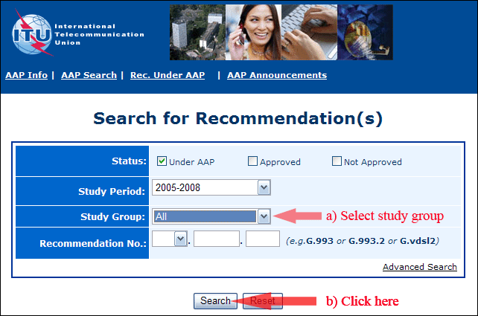
2) Select your Recommendation
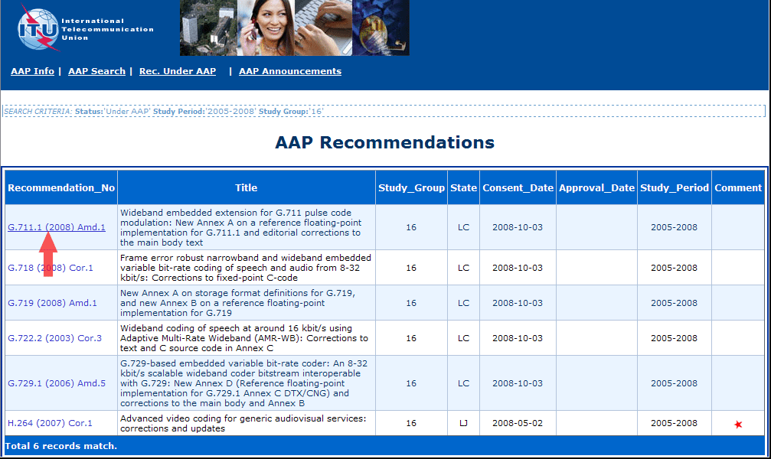
3) Click the "Submit Comment" button
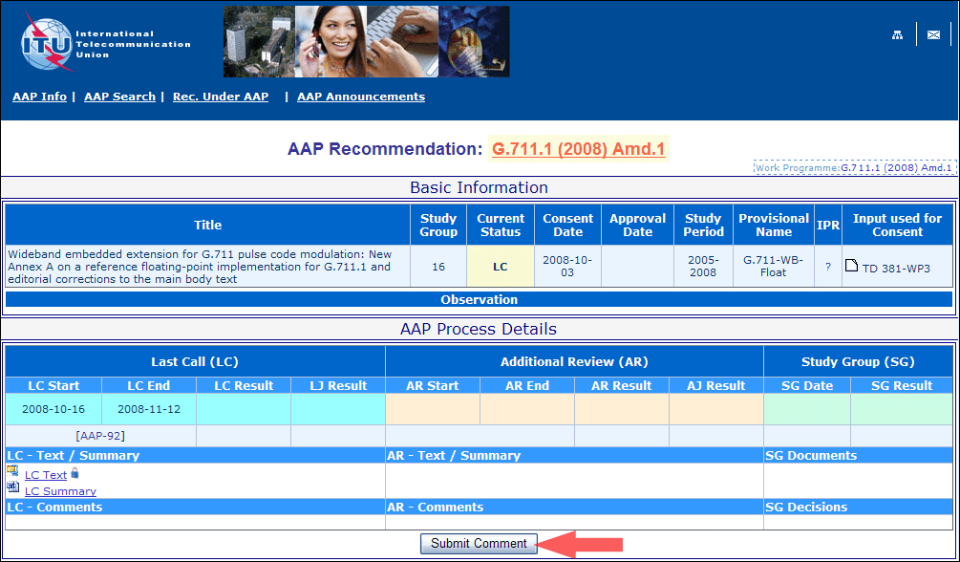
4) Complete the on-line form and click on "Submit"
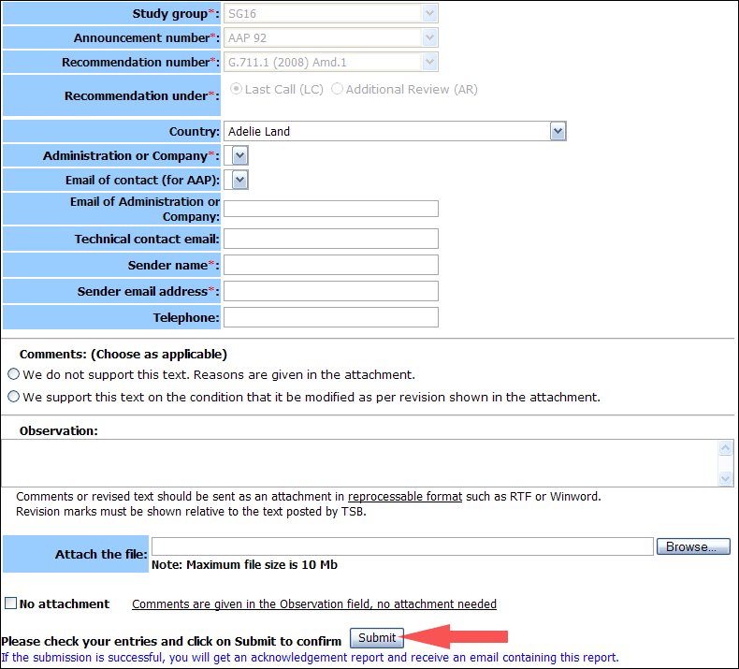
For more information, read the AAP tutorial on:
http://www.itu.int/ITU-T/aapinfo/files/AAPTutorial.pdf
Annex 3
(to TSB AAP-74)
Recommendations under LC/AR – Comment submission form
(Separate form for each Recommendation being commented upon)
ITU-T AAP comment submission form for the period 2009-2012
Study Group:
Announcement number:
Recommendation number:
Recommendation under: | Last call (LC)  Additional Review (AR)
Country:
Administration/Company:
Name of AAP Contact Person:
Email of AAP Contact Person:
Sender name:
(if different from AAP Contact Person)
Sender email address:
Telephone:
Comments:  (Choose as applicable) | We do not support this text. Reasons are given in the attachment.  We support this text on the condition that it be modified as per revision shown in the attachment.
Observations:
No attachment: Comments are given in the Observation field, no attachment needed
To be returned to: email: tsbsg....@itu.int
[or fax +41 22 730 5853]
Comments or revised text should be sent as an attachment in RTF or WinWord format.
Revision marks must be shown relative to the text posted by TSB.

