Unión Internacional de Telecomunicaciones
Oficina de Normalización de las Telecomunicaciones

Ginebra, 01 de diciembre de 2011

Ref:  Tel:  Fax:  Correo-e: | TSB AAP-72  AAP/MJ  +41 22 730 5860  +41 22 730 5853  tsbdir@itu.int | – A las Administraciones de los Estados Miembros de la Unión;  – A los Miembros del Sector UIT-T;  – A los Asociados del UIT-T  Copia:  – A los Presidentes y a los Vicepresidentes de las Comisiones de Estudio del UIT-T;  – Al Director de la Oficina de Desarrollo de las Telecomunicaciones;  – Al Director de la Oficina de Radiocomunicaciones

Asunto: | Situación de las Recomendaciones sometidas al proceso de aprobación alternativo (AAP)

Muy señora mía/Muy señor mío:

El proceso de aprobación alternativo (AAP) definido en la Recomendación A.8 del UIT-T se aplica a las Recomendaciones que no tienen consecuencias en materia de política o reglamentación y que no requieren, por lo tanto, la consulta formal de los Estados Miembros (véase el número 246B del Convenio de la UIT).
En el anexo 1 se enumera la lista de los textos cuyo estado ha cambiado con respecto a los anuncios TSB AAP precedentes.
Si desea formular un comentario en relación con una Recomendación sometida al AAP, le alentamos a utilizar el formulario de presentación de comentarios disponible en la página de la Recomendación que figura en el área AAP del sitio web del UIT-T, en la dirección http://www.itu.int/ITU-T/aap/ (véase también el anexo 2). Alternativamente, pueden presentarse comentarios completando el formulario del anexo 3 y remitiéndolo a la secretaría de la Comisión de Estudio correspondiente.
Le rogamos tenga en cuenta que no se alientan comentarios que se limiten a apoyar la adopción del texto en cuestión.
Le rogamos tomar nota que en vista del cierre anual de la UIT, no se publicará ningún anuncio AAP el 1 de enero de 2012. En consecuencia, la fecha límite de algunos textos ha sido prolongada ya que esta fecha límite cae alrededor de este período.
Le saluda atentamente,

Malcolm Johnson
Director de la Oficina de
Normalización de las Telecomunicaciones
Anexos: 3

Annex 1
(to TSB AAP-72)

Status codes used in the AAP announcements:
LC = Last Call
LJ = Last Call Judgment (includes comment resolution)
AR = Additional Review
AJ = Additional Review Judgment (includes comment resolution)
SG = For Study Group approval
A = Approved
AT = Approved with typographic corrections
AC = Approved after Additional Review of Comments
NA = Not approved
TAP = Moved to TAP (ITU-T A.8 / § 5.2)
ITU-T website entry page:
http://www.itu.int/ITU-T
Alternative approval process (AAP) welcome page:
http://www.itu.int/ITU-T/aapinfo
Note – A tutorial on the ITU-T AAP application is available under the AAP welcome page
ITU-T website AAP Recommendation search page:
http://www.itu.int/ITU-T/aap/
Study Group web pages and contacts:
SG 2 | http://www.itu.int/ITU-T/studygroups/com02 | tsbsg2@itu.int
SG 3 | http://www.itu.int/ITU-T/studygroups/com03 | tsbsg3@itu.int
SG 5 | http://www.itu.int/ITU-T/studygroups/com05 | tsbsg5@itu.int
SG 9 | http://www.itu.int/ITU-T/studygroups/com09 | tsbsg9@itu.int
SG 11 | http://www.itu.int/ITU-T/studygroups/com11 | tsbsg11@itu.int
SG 12 | http://www.itu.int/ITU-T/studygroups/com12 | tsbsg12@itu.int
SG 13 | http://www.itu.int/ITU-T/studygroups/com13 | tsbsg13@itu.int
SG 15 | http://www.itu.int/ITU-T/studygroups/com15 | tsbsg15@itu.int
SG 16 | http://www.itu.int/ITU-T/studygroups/com16 | tsbsg16@itu.int
SG 17 | http://www.itu.int/ITU-T/studygroups/com17 | tsbsg17@itu.int

Situation concerning Study Group 5 Recommendations under AAP
Rec # | Title | Last Call (LC) Period |  |  |  | Additional Review (AR) Period |  |  |  | Status
 |  | LC Start | LC End | LC  Result | LJ  Result | AR Start | AR End | AR  Result | AJ  Result
L.1300 (L.DC) | Best practices for green data centers | 2011-11-01 | 2011-11-28 | A |  |  |  |  |  | A
Situation concerning Study Group 11 Recommendations under AAP
Rec # | Title | Last Call (LC) Period |  |  |  | Additional Review (AR) Period |  |  |  | Status
 |  | LC Start | LC End | LC  Result | LJ  Result | AR Start | AR End | AR  Result | AJ  Result
Q.3303.3 v2 (Q.RwDiameterv2) | Resource control protocol no.3 (rcp3) Protocol at the interface between Policy Decision Physical Entity (PD-PE) and Policy Enforcement Physical Entity (PE-PE) (Rw interface): Diameter Profile version 2 | 2011-11-01 | 2011-11-28 | LJ |  |  |  |  |  | LJ
Q.3313 (Q.Flowstatesig) | Signalling protocols and procedures relating to Flow State Aware QoS control in a bounded sub-network of a NGN | 2011-11-01 | 2011-11-28 | LJ |  |  |  |  |  | LJ
Q.3909 (Q.NGN interoperability) | The framework and overview of NGN conformance and interoperability testing | 2011-11-01 | 2011-11-28 | LJ |  |  |  |  |  | LJ
Q.3945 | The types and list of NGN services testing on the model networks. Test set I | 2011-11-01 | 2011-11-28 | LJ |  |  |  |  |  | LJ
Q.3950  (Q.nid-test-arch) | Testing and model network architecture for tag-based identification systems and functions | 2011-11-01 | 2011-11-28 | LJ |  |  |  |  |  | LJ
Situation concerning Study Group 12 Recommendations under AAP
Rec # | Title | Last Call (LC) Period |  |  |  | Additional Review (AR) Period |  |  |  | Status
 |  | LC Start | LC End | LC  Result | LJ  Result | AR Start | AR End | AR  Result | AJ  Result
P.501 | Test signals for use in telephonometry | 2011-12-01 | 2012-01-12 |  |  |  |  |  |  | LC
Situation concerning Study Group 13 Recommendations under AAP
Rec # | Title | Last Call (LC) Period |  |  |  | Additional Review (AR) Period |  |  |  | Status
 |  | LC Start | LC End | LC  Result | LJ  Result | AR Start | AR End | AR  Result | AJ  Result
Q.1741.7 | IMT 2000 references to Release 9 of GSM-evolved UMTS core network | 2011-11-01 | 2011-11-28 | A |  |  |  |  |  | A
Q.1742.9 | IMT 2000 References (approved as of 31 December 2010) to ANSI-41 evolved Core Network with cdma2000 Access Network | 2011-11-01 | 2011-11-28 | A |  |  |  |  |  | A
Y.2057 (Y.ipv6split) | Framework of Identifiers and Locators Separation in IPv6-based Next Generation Networks | 2011-11-01 | 2011-11-28 | LJ |  |  |  |  |  | LJ
Y.2058 (Y.ipv6migration) | Roadmap for IPv6 Migration from Next Generation Networks Operators' Perspectives | 2011-11-01 | 2011-11-28 | A |  |  |  |  |  | A
Y.2111 | Resource and admission control functions in Next Generation Networks | 2011-11-01 | 2011-11-28 | AT |  |  |  |  |  | AT
Y.2122 (2009) Amd. 1 | Flow Aggregate Information Exchange Functions in Next Generation Networks - Amendment 1 - Information model | 2011-11-01 | 2011-11-28 | AT |  |  |  |  |  | AT
Y.2809 (Y.SMF) | Framework of Mobility Management in Service Stratum for Next Generation Networks | 2011-11-01 | 2011-11-28 | AT |  |  |  |  |  | AT
Y.3021 (Y.FNenergy) | Framework of energy saving for Future Networks | 2011-11-01 | 2011-11-28 | LJ |  |  |  |  |  | LJ
Situation concerning Study Group 17 Recommendations under AAP
Rec # | Title | Last Call (LC) Period |  |  |  | Additional Review (AR) Period |  |  |  | Status
 |  | LC Start | LC End | LC  Result | LJ  Result | AR Start | AR End | AR  Result | AJ  Result
Z.100 | Specification and description language: Overview of SDL-2010 | 2011-09-16 | 2011-10-13 | LJ | AR | 2011-12-01 | 2011-12-21 |  |  | AR
Z.101 | Specification and description language: Basic SDL-2010 | 2011-09-16 | 2011-10-13 | LJ | AR | 2011-12-01 | 2011-12-21 |  |  | AR
Z.102 | Specification and description language: Comprehensive SDL-2010 | 2011-09-16 | 2011-10-13 | LJ | AR | 2011-12-01 | 2011-12-21 |  |  | AR
Z.103 | Specification and description language: Shorthand notation and annotation in SDL-2010 | 2011-09-16 | 2011-10-13 | LJ | AR | 2011-12-01 | 2011-12-21 |  |  | AR
Z.104 | Specification and description language: Data and action language in SDL-2010 | 2011-09-16 | 2011-10-13 | LJ | AR | 2011-12-01 | 2011-12-21 |  |  | AR
Z.105 | Specification and description language: SDL-2010 combined with ASN.1 modules | 2011-09-16 | 2011-10-13 | LJ | AR | 2011-12-01 | 2011-12-21 |  |  | AR
Z.106 | Specification and description language: Common interchange format for SDL-2010 | 2011-09-16 | 2011-10-13 | LJ | AR | 2011-12-01 | 2011-12-21 |  |  | AR

Annex 2
(to TSB AAP-72)
Using the on-line comment submission form
Comment submission
1) Go to AAP search Web page at http://www.itu.int/ITU-T/aap/
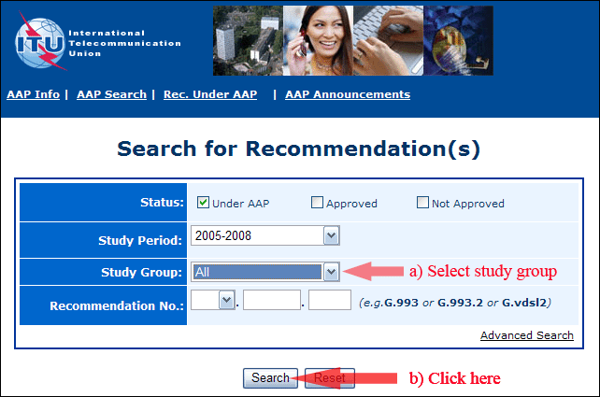
2) Select your Recommendation
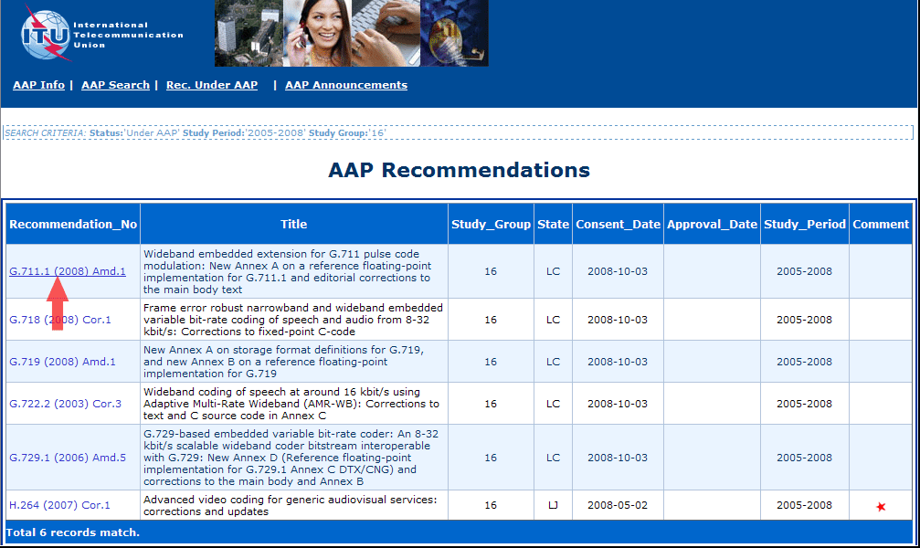
3) Click the "Submit Comment" button
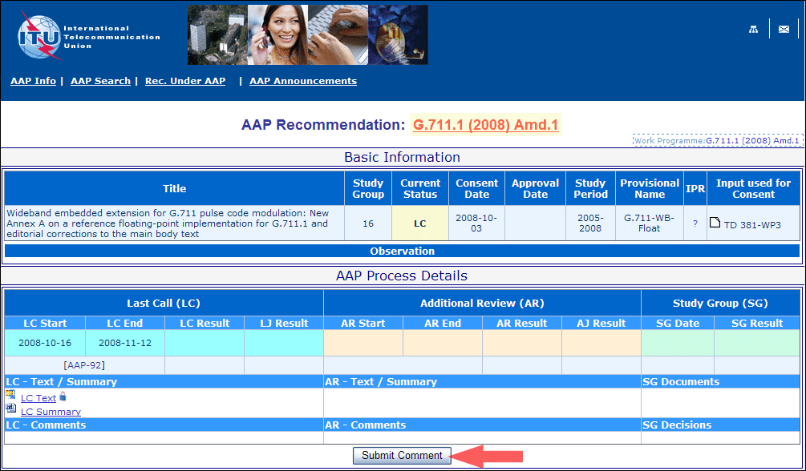
4) Complete the on-line form and click on "Submit"
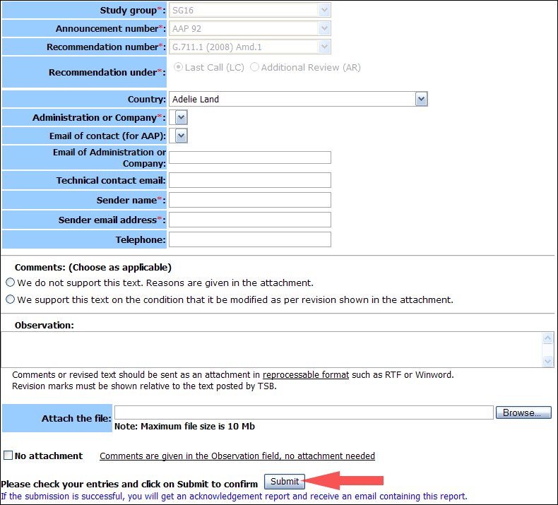
For more information, read the AAP tutorial on:
http://www.itu.int/ITU-T/aapinfo/files/AAPTutorial.pdf
Annex 3
(to TSB AAP-72)
Recommendations under LC/AR – Comment submission form
(Separate form for each Recommendation being commented upon)
ITU-T AAP comment submission form for the period 2009-2012
Study Group:
Announcement number:
Recommendation number:
Recommendation under: | Last call (LC)  Additional Review (AR)
Country:
Administration/Company:
Name of AAP Contact Person:
Email of AAP Contact Person:
Sender name:
(if different from AAP Contact Person)
Sender email address:
Telephone:
Comments:  (Choose as applicable) | We do not support this text. Reasons are given in the attachment.  We support this text on the condition that it be modified as per revision shown in the attachment.
Observations:
No attachment: Comments are given in the Observation field, no attachment needed
To be returned to: email: tsbsg....@itu.int
[or fax +41 22 730 5853]
Comments or revised text should be sent as an attachment in RTF or WinWord format.
Revision marks must be shown relative to the text posted by TSB.

