|  |  |
| --- | --- |
|  | الا تحــاد الــدولي للاتصــالات  *مكتب تقييس الاتصالات* |

|  |  |  |
| --- | --- | --- |
|  |  | جنيف، 1 ديسمبر 2011 |
| المرجع:    الهاتف:  الفاكس:  البريد الإلكتروني: | **TSB AAP-72**  AAP/MJ  +41 22 730 5860  +41 22 730 5853  tsbdir@itu.int | - إلى إدارات الدول الأعضاء في الاتحاد؛  - إلى أعضاء قطاع تقييس الاتصالات؛  - إلى المنتسبين إلى قطاع تقييس الاتصالات  **نسخة إلى:**  - رؤساء لجان الدراسات في قطاع تقييس الاتصالات ونوابهم؛  - مدير مكتب تنمية الاتصالات؛  - مدير مكتب الاتصالات الراديوية |

الموضوع: **حالة التوصيات الخاضعة لعملية الموافقة البديلة (AAP)**

حضرات السادة والسيدات،

تحية طيبة وبعد،

تنطبق عملية الموافقة البديلة (AAP) المعرفة في التوصية ITU‑T A.8 على التوصيات التي لا تنطوي على بعد سياسي أوتنظيمي ولا تتطلب بالتالي استشارة الدول الأعضاء رسمياً (انظر الرقم 246B من اتفاقية الاتحاد).

ويتضمن **الملحق 1** لائحة بالنصوص التي تغيرت حالتها مقارنة بما جاء في إعلانات عملية الموافقة البديلة السابقة.

إذا رغبتم في تقديم تعليق بشأن توصية ما خاضعة لعملية الموافقة البديلة، فنرجو منكم استعمال استمارة التعليق على الخط المتوفّرة على موقع قطاع تقييس الاتصالات على صفحة عملية الموافقة البديلة [http://www.itu.int/ITU-T/aap](http://www.itu.int/ITU-T/aap/) على المدخل الخاص بالتوصية المعنية (انظر **الملحق** (**2**. وبديلاً من ذلك، يمكنكم تقديم التعليقات باستكمال الاستمارة الواردة في **الملحق 3** وإرسالها إلى أمانة لجنة الدراسات المعنية بالأمر.

وتجدر الإشارة إلى أنه يفضّل عدم إرسال تعليقات تقتصر على تأييد اعتماد النص قيد النظر.

نظراً لإغلاق مكاتب الاتحاد في نهاية ديسمبر، يرجى الإحاطة علماً بأنه لن ينشر إعلان AAP في 1 يناير 2012. ونظراً لتزامن الموعد النهائي لبعض النصوص المعلنة مع فترة العطلة هذه، فقد تم تمديد موعدها بصفة استثنائية.

وتفضلوا بقبول فائق الاحترام والتقدير.

مالكولم جونسون  
مدير مكتب تقييس الاتصالات

**الملحقات:** 3

Annex 1

(to TSB AAP-72)

Status codes used in the AAP announcements:

LC = Last Call

LJ = Last Call Judgment (includes comment resolution)

AR = Additional Review

AJ = Additional Review Judgment (includes comment resolution)

SG = For Study Group approval

A = Approved

AT = Approved with typographic corrections

AC = Approved after Additional Review of Comments

NA = Not approved

TAP = Moved to TAP (ITU-T A.8 / § 5.2)

ITU-T website entry page:

[http://www.itu.int/ITU-T](http://www.itu.int/ITU-T/)

Alternative approval process (AAP) welcome page:

[http://www.itu.int/ITU-T/aapinfo](http://www.itu.int/ITU-T/aapinfo/)

Note – A tutorial on the ITU-T AAP application is available under the AAP welcome page

ITU-T website AAP Recommendation search page:

<http://www.itu.int/ITU-T/aap/>

Study Group web pages and contacts:

|  |  |  |
| --- | --- | --- |
| SG 2 | <http://www.itu.int/ITU-T/studygroups/com02> | [tsbsg2@itu.int](mailto:tsbsg2@itu.int) |
| SG 3 | <http://www.itu.int/ITU-T/studygroups/com03> | [tsbsg3@itu.int](mailto:tsbsg3@itu.int) |
| SG 5 | <http://www.itu.int/ITU-T/studygroups/com05> | [tsbsg5@itu.int](mailto:tsbsg5@itu.int) |
| SG 9 | <http://www.itu.int/ITU-T/studygroups/com09> | [tsbsg9@itu.int](mailto:tsbsg9@itu.int) |
| SG 11 | <http://www.itu.int/ITU-T/studygroups/com11> | [tsbsg11@itu.int](mailto:tsbsg11@itu.int) |
| SG 12 | <http://www.itu.int/ITU-T/studygroups/com12> | [tsbsg12@itu.int](mailto:tsbsg12@itu.int) |
| SG 13 | <http://www.itu.int/ITU-T/studygroups/com13> | [tsbsg13@itu.int](mailto:tsbsg13@itu.int) |
| SG 15 | <http://www.itu.int/ITU-T/studygroups/com15> | [tsbsg15@itu.int](mailto:tsbsg15@itu.int) |
| SG 16 | <http://www.itu.int/ITU-T/studygroups/com16> | [tsbsg16@itu.int](mailto:tsbsg16@itu.int) |
| SG 17 | <http://www.itu.int/ITU-T/studygroups/com17> | [tsbsg17@itu.int](mailto:tsbsg17@itu.int) |

Situation concerning Study Group 5 Recommendations under AAP

| **Rec #** | **Title** | **Last Call (LC) Period** | | | | **Additional Review (AR) Period** | | | | Status |
| --- | --- | --- | --- | --- | --- | --- | --- | --- | --- | --- |
| **LC Start** | **LC End** | **LC Result** | **LJ Result** | **AR Start** | **AR End** | **AR Result** | **AJ Result** |
| [L.1300 (L.DC)](http://www.itu.int/itu-t/aap/AAPRecDetails.aspx?AAPSeqNo=2397) | Best practices for green data centers | 2011-11-01 | 2011-11-28 | A |  |  |  |  |  | A |

Situation concerning Study Group 11 Recommendations under AAP

| **Rec #** | **Title** | **Last Call (LC) Period** | | | | **Additional Review (AR) Period** | | | | Status |
| --- | --- | --- | --- | --- | --- | --- | --- | --- | --- | --- |
| **LC Start** | **LC End** | **LC Result** | **LJ Result** | **AR Start** | **AR End** | **AR Result** | **AJ Result** |
| [Q.3303.3 v2 (Q.RwDiameterv2)](http://www.itu.int/itu-t/aap/AAPRecDetails.aspx?AAPSeqNo=2400) | Resource control protocol no.3 (rcp3) Protocol at the interface between Policy Decision Physical Entity (PD-PE) and Policy Enforcement Physical Entity (PE-PE) (Rw interface): Diameter Profile version 2 | 2011-11-01 | 2011-11-28 | LJ |  |  |  |  |  | LJ |
| [Q.3313 (Q.Flowstatesig)](http://www.itu.int/itu-t/aap/AAPRecDetails.aspx?AAPSeqNo=2399) | Signalling protocols and procedures relating to Flow State Aware QoS control in a bounded sub-network of a NGN | 2011-11-01 | 2011-11-28 | LJ |  |  |  |  |  | LJ |
| [Q.3909 (Q.NGN interoperability)](http://www.itu.int/itu-t/aap/AAPRecDetails.aspx?AAPSeqNo=2401) | The framework and overview of NGN conformance and interoperability testing | 2011-11-01 | 2011-11-28 | LJ |  |  |  |  |  | LJ |
| [Q.3945](http://www.itu.int/itu-t/aap/AAPRecDetails.aspx?AAPSeqNo=2402) | The types and list of NGN services testing on the model networks. Test set I | 2011-11-01 | 2011-11-28 | LJ |  |  |  |  |  | LJ |
| [Q.3950  (Q.nid-test-arch)](http://www.itu.int/itu-t/aap/AAPRecDetails.aspx?AAPSeqNo=2412) | Testing and model network architecture for tag-based identification systems and functions | 2011-11-01 | 2011-11-28 | LJ |  |  |  |  |  | LJ |

Situation concerning Study Group 12 Recommendations under AAP

| **Rec #** | **Title** | **Last Call (LC) Period** | | | | **Additional Review (AR) Period** | | | | Status |
| --- | --- | --- | --- | --- | --- | --- | --- | --- | --- | --- |
| **LC Start** | **LC End** | **LC Result** | **LJ Result** | **AR Start** | **AR End** | **AR Result** | **AJ Result** |
| [P.501](http://www.itu.int/itu-t/aap/AAPRecDetails.aspx?AAPSeqNo=2419) | Test signals for use in telephonometry | 2011-12-01 | 2012-01-12 |  |  |  |  |  |  | LC |

Situation concerning Study Group 13 Recommendations under AAP

| **Rec #** | **Title** | **Last Call (LC) Period** | | | | **Additional Review (AR) Period** | | | | Status |
| --- | --- | --- | --- | --- | --- | --- | --- | --- | --- | --- |
| **LC Start** | **LC End** | **LC Result** | **LJ Result** | **AR Start** | **AR End** | **AR Result** | **AJ Result** |
| [Q.1741.7](http://www.itu.int/itu-t/aap/AAPRecDetails.aspx?AAPSeqNo=2407) | IMT 2000 references to Release 9 of GSM-evolved UMTS core network | 2011-11-01 | 2011-11-28 | A |  |  |  |  |  | A |
| [Q.1742.9](http://www.itu.int/itu-t/aap/AAPRecDetails.aspx?AAPSeqNo=2408) | IMT 2000 References (approved as of 31 December 2010) to ANSI-41 evolved Core Network with cdma2000 Access Network | 2011-11-01 | 2011-11-28 | A |  |  |  |  |  | A |
| [Y.2057 (Y.ipv6split)](http://www.itu.int/itu-t/aap/AAPRecDetails.aspx?AAPSeqNo=2405) | Framework of Identifiers and Locators Separation in IPv6-based Next Generation Networks | 2011-11-01 | 2011-11-28 | LJ |  |  |  |  |  | LJ |
| [Y.2058 (Y.ipv6migration)](http://www.itu.int/itu-t/aap/AAPRecDetails.aspx?AAPSeqNo=2406) | Roadmap for IPv6 Migration from Next Generation Networks Operators' Perspectives | 2011-11-01 | 2011-11-28 | A |  |  |  |  |  | A |
| [Y.2111](http://www.itu.int/itu-t/aap/AAPRecDetails.aspx?AAPSeqNo=2403) | Resource and admission control functions in Next Generation Networks | 2011-11-01 | 2011-11-28 | AT |  |  |  |  |  | AT |
| [Y.2122 (2009) Amd. 1](http://www.itu.int/itu-t/aap/AAPRecDetails.aspx?AAPSeqNo=2404) | Flow Aggregate Information Exchange Functions in Next Generation Networks - Amendment 1 - Information model | 2011-11-01 | 2011-11-28 | AT |  |  |  |  |  | AT |
| [Y.2809 (Y.SMF)](http://www.itu.int/itu-t/aap/AAPRecDetails.aspx?AAPSeqNo=2411) | Framework of Mobility Management in Service Stratum for Next Generation Networks | 2011-11-01 | 2011-11-28 | AT |  |  |  |  |  | AT |
| [Y.3021 (Y.FNenergy)](http://www.itu.int/itu-t/aap/AAPRecDetails.aspx?AAPSeqNo=2410) | Framework of energy saving for Future Networks | 2011-11-01 | 2011-11-28 | LJ |  |  |  |  |  | LJ |

Situation concerning Study Group 17 Recommendations under AAP

| **Rec #** | **Title** | **Last Call (LC) Period** | | | | **Additional Review (AR) Period** | | | | Status |
| --- | --- | --- | --- | --- | --- | --- | --- | --- | --- | --- |
| **LC Start** | **LC End** | **LC Result** | **LJ Result** | **AR Start** | **AR End** | **AR Result** | **AJ Result** |
| [Z.100](http://www.itu.int/itu-t/aap/AAPRecDetails.aspx?AAPSeqNo=2350) | Specification and description language: Overview of SDL-2010 | 2011-09-16 | 2011-10-13 | LJ | AR | 2011-12-01 | 2011-12-21 |  |  | AR |
| [Z.101](http://www.itu.int/itu-t/aap/AAPRecDetails.aspx?AAPSeqNo=2351) | Specification and description language: Basic SDL-2010 | 2011-09-16 | 2011-10-13 | LJ | AR | 2011-12-01 | 2011-12-21 |  |  | AR |
| [Z.102](http://www.itu.int/itu-t/aap/AAPRecDetails.aspx?AAPSeqNo=2352) | Specification and description language: Comprehensive SDL-2010 | 2011-09-16 | 2011-10-13 | LJ | AR | 2011-12-01 | 2011-12-21 |  |  | AR |
| [Z.103](http://www.itu.int/itu-t/aap/AAPRecDetails.aspx?AAPSeqNo=2353) | Specification and description language: Shorthand notation and annotation in SDL-2010 | 2011-09-16 | 2011-10-13 | LJ | AR | 2011-12-01 | 2011-12-21 |  |  | AR |
| [Z.104](http://www.itu.int/itu-t/aap/AAPRecDetails.aspx?AAPSeqNo=2354) | Specification and description language: Data and action language in SDL-2010 | 2011-09-16 | 2011-10-13 | LJ | AR | 2011-12-01 | 2011-12-21 |  |  | AR |
| [Z.105](http://www.itu.int/itu-t/aap/AAPRecDetails.aspx?AAPSeqNo=2355) | Specification and description language: SDL-2010 combined with ASN.1 modules | 2011-09-16 | 2011-10-13 | LJ | AR | 2011-12-01 | 2011-12-21 |  |  | AR |
| [Z.106](http://www.itu.int/itu-t/aap/AAPRecDetails.aspx?AAPSeqNo=2356) | Specification and description language: Common interchange format for SDL-2010 | 2011-09-16 | 2011-10-13 | LJ | AR | 2011-12-01 | 2011-12-21 |  |  | AR |

Annex 2

(to TSB AAP-72)

Using the on-line comment submission form

Comment submission

1) Go to AAP search Web page at <http://www.itu.int/ITU-T/aap/>

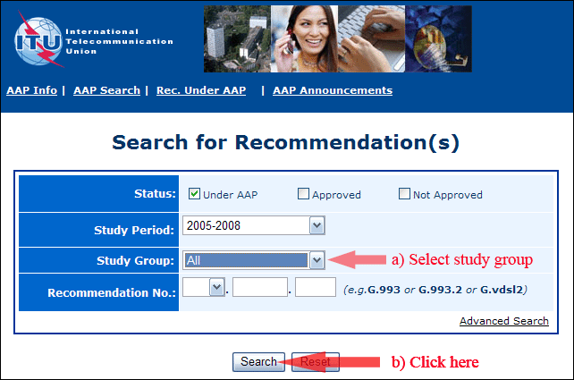

2) Select your Recommendation

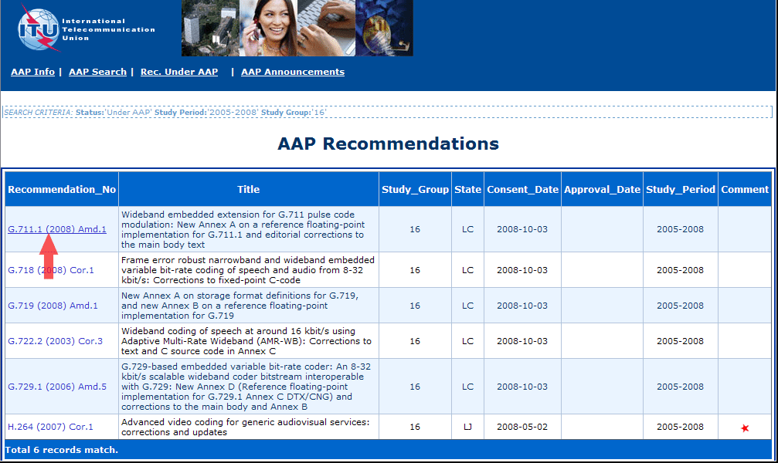

3) Click the "Submit Comment" button

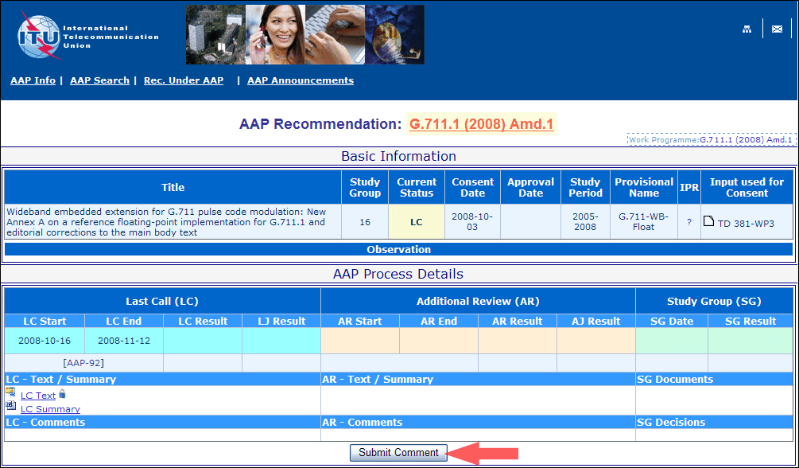

4) Complete the on-line form and click on "Submit"

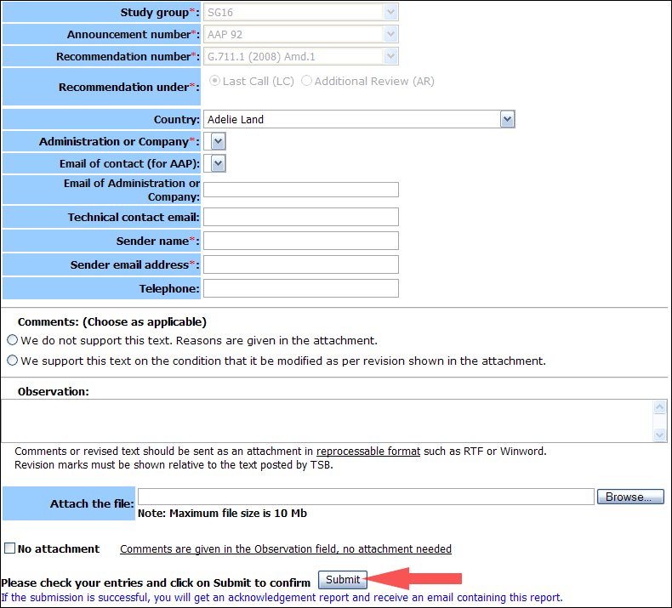

For more information, read the AAP tutorial on:   
<http://www.itu.int/ITU-T/aapinfo/files/AAPTutorial.pdf>

Annex 3

(to TSB AAP-72)

Recommendations under LC/AR – Comment submission form

*(Separate form for each Recommendation being commented upon)*

|  |  |
| --- | --- |
| ITU-T AAP comment submission form for the period 2009-2012 | |
| **Study Group:** |  |
| **Announcement number:** |  |
| **Recommendation number:** |  |
| **Recommendation under:** | Last call (LC)   Additional Review (AR) |
| **Country:** |  |
| **Administration/Company:** |  |
| **Name of AAP Contact Person:** |  |
| **Email of AAP Contact Person:** |  |
| **Sender name: (if different from AAP Contact Person)** |  |
| **Sender email address:** |  |
| **Telephone:** |  |
| **Comments: (Choose as applicable)** | We do not support this text. Reasons are given in the attachment.   We support this text on the condition that it be modified as per revision shown in the attachment. |
| **Observations:** |  |

**No attachment:** Comments are given in the Observation field, no attachment needed

*To be returned to: email:* [*tsbsg....@itu.int*](mailto:tsbsg....@itu.int) *[or fax +41 22 730 5853]  
Comments or revised text should be sent as an attachment in RTF or WinWord format.  
Revision marks must be shown relative to the text posted by TSB.*