International Telecommunication Union
Telecommunication Standardization Bureau

Geneva, 16 October 2011

Ref:  Tel:  Fax:  E-mail: | TSB AAP-69  AAP/MJ  +41 22 730 5860  +41 22 730 5853  tsbdir@itu.int | – To Administrations of Member States of the Union;  – To ITU-T Sector Members;  – To ITU-T Associates  Copy:  – To the ITU-T Study Group Chairmen and Vice-Chairmen;  – To the Director of the Telecommunication Development Bureau;  – To the Director of the Radiocommunication Bureau

Subject: | Situation concerning Recommendations under the Alternative Approval Process (AAP)

Dear Sir/Madam,
The Alternative Approval Process (AAP) defined in Rec. ITU-T A.8 applies to Recommendations which do not have policy or regulatory implications and which, therefore, do not require formal consultation of Member States (see ITU Convention 246B).
Annex 1 lists those texts whose status has changed compared with previous TSB AAP Announcements.
If you wish to submit a comment relative to a Recommendation under AAP, you are encouraged to use the on-line AAP comment submission form available on the page of the Recommendation in the AAP area of the ITU-T website at http://www.itu.int/ITU-T/aap (see Annex 2). Alternatively, comments can be submitted by completing the form in Annex 3 and sending it to the secretariat of the concerned study group.
Please note that comments that simply support adoption of the text in question are not encouraged.
Yours faithfully,
Malcolm Johnson
Director of the Telecommunication Standardization Bureau
Annexes: 3

Annex 1
(to TSB AAP-69)

Status codes used in the AAP announcements:
LC = Last Call
LJ = Last Call Judgment (includes comment resolution)
AR = Additional Review
AJ = Additional Review Judgment (includes comment resolution)
SG = For Study Group approval
A = Approved
AT = Approved with typographic corrections
AC = Approved after Additional Review of Comments
NA = Not approved
TAP = Moved to TAP (ITU-T A.8 / § 5.2)
ITU-T website entry page:
http://www.itu.int/ITU-T
Alternative approval process (AAP) welcome page:
http://www.itu.int/ITU-T/aapinfo
Note – A tutorial on the ITU-T AAP application is available under the AAP welcome page
ITU-T website AAP Recommendation search page:
http://www.itu.int/ITU-T/aap/
Study Group web pages and contacts:
SG 2 | http://www.itu.int/ITU-T/studygroups/com02 | tsbsg2@itu.int
SG 3 | http://www.itu.int/ITU-T/studygroups/com03 | tsbsg3@itu.int
SG 5 | http://www.itu.int/ITU-T/studygroups/com05 | tsbsg5@itu.int
SG 9 | http://www.itu.int/ITU-T/studygroups/com09 | tsbsg9@itu.int
SG 11 | http://www.itu.int/ITU-T/studygroups/com11 | tsbsg11@itu.int
SG 12 | http://www.itu.int/ITU-T/studygroups/com12 | tsbsg12@itu.int
SG 13 | http://www.itu.int/ITU-T/studygroups/com13 | tsbsg13@itu.int
SG 15 | http://www.itu.int/ITU-T/studygroups/com15 | tsbsg15@itu.int
SG 16 | http://www.itu.int/ITU-T/studygroups/com16 | tsbsg16@itu.int
SG 17 | http://www.itu.int/ITU-T/studygroups/com17 | tsbsg17@itu.int

Situation concerning Study Group 5 Recommendations under AAP
Rec # | Title | Last Call (LC) Period |  |  |  | Additional Review (AR) Period |  |  |  | Status
 |  | LC Start | LC End | LC  Result | LJ  Result | AR Start | AR End | AR  Result | AJ  Result
K.20 | Resistibility of telecommunication equipment installed in a telecommunications centre to overvoltages and overcurrents | 2011-10-16 | 2011-11-12 |  |  |  |  |  |  | LC
K.21 | Resistibility of telecommunication equipment installed in customer premises to overvoltages and overcurrents | 2011-10-16 | 2011-11-12 |  |  |  |  |  |  | LC
K.44 | Resistibility tests for telecommunication equipment exposed to overvoltages and overcurrents – Basic Recommendation | 2011-10-16 | 2011-11-12 |  |  |  |  |  |  | LC
K.45 | Resistibility of telecommunication equipment installed in the access and trunk networks to overvoltages and overcurrents | 2011-10-16 | 2011-11-12 |  |  |  |  |  |  | LC
K.85 (K.hnwr) | Requirements for the mitigation of lightning effects on home networks installed in customer premises | 2011-10-16 | 2011-11-12 |  |  |  |  |  |  | LC
K.86 (K.lcl) | Method for measuring Longitudinal Conversion Loss (9kHz - 30MHz) | 2011-10-16 | 2011-11-12 |  |  |  |  |  |  | LC
K.87 (K.sec) | Guide for the application of electromagnetic security requirements - Basic Recommendation | 2011-10-16 | 2011-11-12 |  |  |  |  |  |  | LC
K.88 (K.NGN) | EMC requirements for Next Generation Network equipment | 2011-10-16 | 2011-11-12 |  |  |  |  |  |  | LC
L.1100 (L.raremetals) | A method to provide recycling information of rare metals in ICT products | 2011-10-16 | 2011-11-12 |  |  |  |  |  |  | LC
L.1410 (L.GNS) | Methodology for environmental impact assessment of information and communication technologies goods, networks and services | 2011-10-16 | 2011-11-12 |  |  |  |  |  |  | LC
L.1420 (L.ORG) | Methodology for energy consumption and greenhouse gas emissions impact assessment of Information and Communication Technologies in organizations | 2011-10-16 | 2011-11-12 |  |  |  |  |  |  | LC
Situation concerning Study Group 9 Recommendations under AAP
Rec # | Title | Last Call (LC) Period |  |  |  | Additional Review (AR) Period |  |  |  | Status
 |  | LC Start | LC End | LC  Result | LJ  Result | AR Start | AR End | AR  Result | AJ  Result
J.380.1 (J.dpi-asi.1) | Digital Program Insertion – Advertising Systems Interfaces: Part 1 – Advertising Systems Overview | 2011-10-16 | 2011-11-12 |  |  |  |  |  |  | LC
J.380.2 (J.dpi-asi.2) | Digital Program Insertion–Advertising Systems Interfaces: Part 2 - Core data elements | 2011-10-16 | 2011-11-12 |  |  |  |  |  |  | LC
J.380.3 (J.dpi-asi.3) | Digital Program Insertion – Advertising Systems Interfaces: Part 3 – Ad Management Service Interface | 2011-10-16 | 2011-11-12 |  |  |  |  |  |  | LC
J.380.4 (J.dpi-asi.4) | Digital Program Insertion–Advertising Systems Interfaces: Part 4 – Content Information Service (CIS) | 2011-10-16 | 2011-11-12 |  |  |  |  |  |  | LC
J.380.5 (J.dpi-asi.5) | Digital Program Insertion–Advertising Systems Interfaces: Part 5 – Placement Opportunity Information Service | 2011-10-16 | 2011-11-12 |  |  |  |  |  |  | LC
J.380.6 (J.dpi-asi.6) | Digital Program Insertion – Advertising Systems Interfaces: Part 6 – Subscriber Information Service | 2011-10-16 | 2011-11-12 |  |  |  |  |  |  | LC
J.380.7 (J.dpi-asi.7) | Digital Program Insertion–Advertising Systems Interfaces: Part 7 – Message Transport | 2011-10-16 | 2011-11-12 |  |  |  |  |  |  | LC
J.380.8 (J.dpi-asi.8) | Digital Program Insertion–Advertising Systems Interfaces: Part 8 – General Information Service | 2011-10-16 | 2011-11-12 |  |  |  |  |  |  | LC
Situation concerning Study Group 15 Recommendations under AAP
Rec # | Title | Last Call (LC) Period |  |  |  | Additional Review (AR) Period |  |  |  | Status
 |  | LC Start | LC End | LC  Result | LJ  Result | AR Start | AR End | AR  Result | AJ  Result
G.8110.1/Y.1370.1 | Architecture of MPLS Transport Profile (MPLS-TP) layer network | 2011-09-01 | 2011-09-28 | LJ |  |  |  |  |  | LJ
G.8113.2/Y.1372.2 (G.tpoam G.mplstpoam) | Operations, administration and maintenance mechanisms for MPLS-TP networks using the tools defined for MPLS | 2011-10-16 | 2011-11-12 |  |  |  |  |  |  | LC
G.9956 (G.hnem) | Narrow-band OFDM power line communication transceivers - Data link layer specification | 2011-03-16 | 2011-04-12 | LJ | AR | 2011-10-16 | 2011-11-05 |  |  | AR
Situation concerning Study Group 17 Recommendations under AAP
Rec # | Title | Last Call (LC) Period |  |  |  | Additional Review (AR) Period |  |  |  | Status
 |  | LC Start | LC End | LC  Result | LJ  Result | AR Start | AR End | AR  Result | AJ  Result
X.680 (2008) Cor.1 | Draft Technical Corrigendum X.680 | ISO/IEC 8824-1:2008/Cor.1: 2011 Information technology - Abstract Syntax Notation One (ASN.1): Specification of basic notation | 2011-09-16 | 2011-10-13 | A |  |  |  |  |  | A
X.681 (2008) Cor.1 | Draft Technical Corrigendum X.681 | ISO/IEC 8824-2:2008/Cor.1:2011 Information technology - Abstract Syntax Notation One (ASN.1): Information object specification | 2011-09-16 | 2011-10-13 | A |  |  |  |  |  | A
X.690 (2008) Cor.1 | Draft Technical Corrigendum X.690 | ISO/IEC 8825-1:2008/Cor.1:2011 Information technology - ASN.1 encoding rules: Specification of Basic Encoding Rules (BER), Canonical Encoding Rules (CER) and Distinguished Encoding Rules (DER) | 2011-09-16 | 2011-10-13 | A |  |  |  |  |  | A
X.691 (2008) Cor.1 | Draft Technical Corrgiendum X.691 | ISO/IEC 8825-2:2008/Cor.1:2011 Information technology - ASN.1 encoding rules: Specification of Packed Encoding Rules (PER) | 2011-09-16 | 2011-10-13 | A |  |  |  |  |  | A
X.692 (2008) Cor.1 | Draft Techcial Corrgendum X.692 | ISO/IEC 8825-3:2008/Cor.1:2011 Information technology - ASN.1 encoding rules: Specification of Encoding Control Notation (ECN) | 2011-09-16 | 2011-10-13 | A |  |  |  |  |  | A
X.693 (2008) Cor.1 | Draft Technical Corrigendum X.693 | ISO/IEC 8825-4:2008/Cor.1:2011 Information technology - ASN.1 encoding rules: XML Encoding Rules (XER) | 2011-09-16 | 2011-10-13 | A |  |  |  |  |  | A
X.694 (2008) Cor.1 | Draft Technical Corrigendum X.694 | ISO/IEC 8825-5:2008/Cor.1:2011 Information technology - ASN.1 encoding rules: Mapping W3C XML schema definitions into ASN.1 | 2011-09-16 | 2011-10-13 | A |  |  |  |  |  | A
X.891 (2005) Cor.1 | Draft Technical Corrigendum X.891 | ISO/IEC 24824-1:2005/Cor.1:2011 Information technology - Generic applications of ASN.1: Fast Infoset | 2011-09-16 | 2011-10-13 | A |  |  |  |  |  | A
X.1080.1 (X.th1) | e-Health and world-wide telemedicines - Generic telecommunication protocol | 2011-09-16 | 2011-10-13 | A |  |  |  |  |  | A
X.1081 (2004) Amd.3 | The telebiometric multimodal model - A framework for the specification of security and safety aspects of telebiometrics - Amendment 3: Enhancement to support a new modality (ELECTRO) | 2011-09-16 | 2011-10-13 | A |  |  |  |  |  | A
X.1193 (X.iptvsec-3) | Key management framework for secure internet protocol television (IPTV) services | 2011-09-16 | 2011-10-13 | A |  |  |  |  |  | A
Z.100 | Specification and description language: Overview of SDL-2010 | 2011-09-16 | 2011-10-13 | LJ |  |  |  |  |  | LJ
Z.101 | Specification and description language: Basic SDL-2010 | 2011-09-16 | 2011-10-13 | LJ |  |  |  |  |  | LJ
Z.102 | Specification and description language: Comprehensive SDL-2010 | 2011-09-16 | 2011-10-13 | LJ |  |  |  |  |  | LJ
Z.103 | Specification and description language: Shorthand notation and annotation in SDL-2010 | 2011-09-16 | 2011-10-13 | LJ |  |  |  |  |  | LJ
Z.104 | Specification and description language: Data and action language in SDL-2010 | 2011-09-16 | 2011-10-13 | LJ |  |  |  |  |  | LJ
Z.105 | Specification and description language: SDL-2010 combined with ASN.1 modules | 2011-09-16 | 2011-10-13 | LJ |  |  |  |  |  | LJ
Z.106 | Specification and description language: Common interchange format for SDL-2010 | 2011-09-16 | 2011-10-13 | LJ |  |  |  |  |  | LJ

Annex 2
(to TSB AAP-69)
Using the on-line comment submission form
Comment submission
1) Go to AAP search Web page at http://www.itu.int/ITU-T/aap/
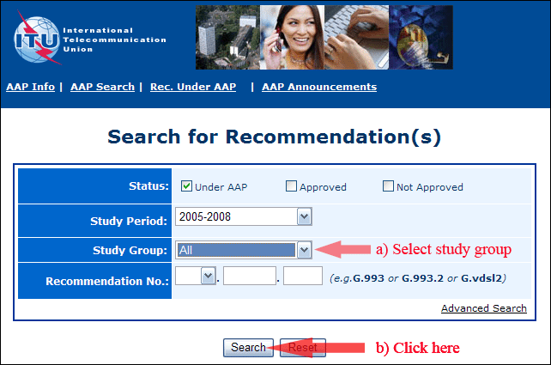
2) Select your Recommendation
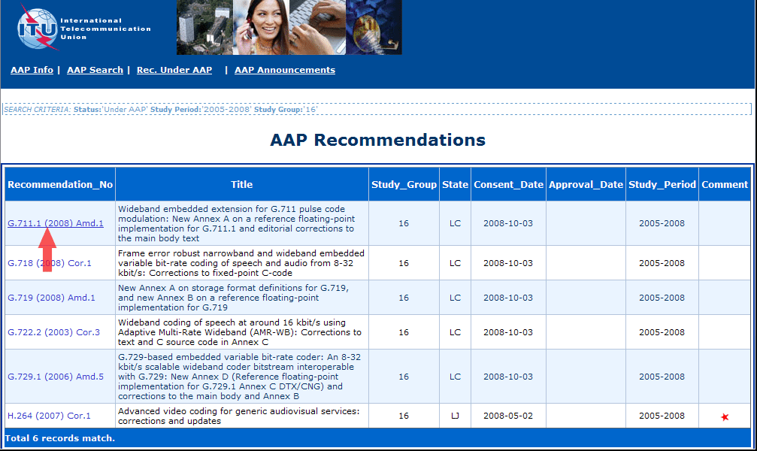
3) Click the "Submit Comment" button
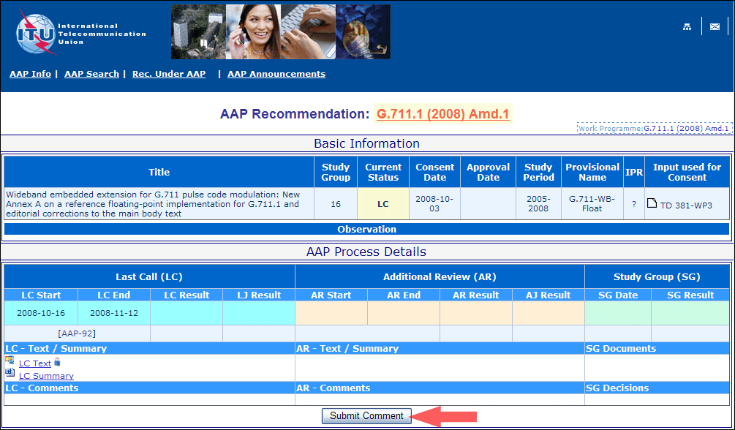
4) Complete the on-line form and click on "Submit"
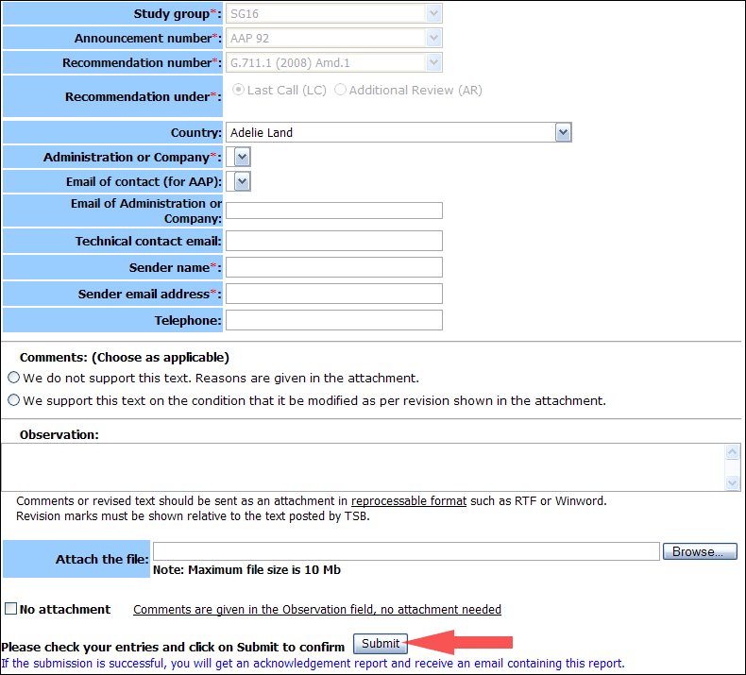
For more information, read the AAP tutorial on:
http://www.itu.int/ITU-T/aapinfo/files/AAPTutorial.pdf
Annex 3
(to TSB AAP-69)
Recommendations under LC/AR – Comment submission form
(Separate form for each Recommendation being commented upon)
ITU-T AAP comment submission form for the period 2009-2012
Study Group:
Announcement number:
Recommendation number:
Recommendation under: | Last call (LC)  Additional Review (AR)
Country:
Administration/Company:
Name of AAP Contact Person:
Email of AAP Contact Person:
Sender name:
(if different from AAP Contact Person)
Sender email address:
Telephone:
Comments:  (Choose as applicable) | We do not support this text. Reasons are given in the attachment.  We support this text on the condition that it be modified as per revision shown in the attachment.
Observations:
No attachment: Comments are given in the Observation field, no attachment needed
To be returned to: email: tsbsg....@itu.int
[or fax +41 22 730 5853]
Comments or revised text should be sent as an attachment in RTF or WinWord format.
Revision marks must be shown relative to the text posted by TSB.

