国 际 电 信 联 盟  电信标准化局 | 
2011年9月16日 ，日内瓦

参考号:  电话:  传真:  电子邮件: | 电信标准化局AAP-67  AAP/MJ  +41 22 730 5860  +41 22 730 5853  tsbdir@itu.int | – 致国际电联成员国各主管部门；  – 致ITU-T各部门成员；  – 致ITU-T 部门准成员  抄送：  – 电信标准化局研究组主席和副主席  – 电信发展局主任  – 无线电通信局主任

事由: | 有关采用替换批准程序（AAP）处理的建议书的情况

先生/女士，
ITU-T A.8 建议书中规定的建议书替换批准程序 (AAP) 适用于那些不会产生政策或 监管影响、因而不需与成员国正式协商的建议书（见国际电联《公约》第246B款）。
附件1列出了那些在以往电信标准化局AAP预告后地位发生变化的案文。
如您希望针对某个适用AAP的建议书提出意见，请使用可在ITU-T网站AAP区域 （http://www.itu.int/ITU-T/aap）的“建议书”网页上获取的《AAP意见在线提交表格》 （见附件2）。或者，可填妥附件3 中的表格并将意见发送给相关研究组的秘书处。
敬请留意，我们不鼓励提交仅支持通过所涉案文而没有实质内容的意见。

顺致敬意！

马尔科姆•琼森
电信标准化局主任

附件：3件

Annex 1
(to TSB AAP-67)

Status codes used in the AAP announcements:
LC = Last Call
LJ = Last Call Judgment (includes comment resolution)
AR = Additional Review
AJ = Additional Review Judgment (includes comment resolution)
SG = For Study Group approval
A = Approved
AT = Approved with typographic corrections
AC = Approved after Additional Review of Comments
NA = Not approved
TAP = Moved to TAP (ITU-T A.8 / § 5.2)
ITU-T website entry page:
http://www.itu.int/ITU-T
Alternative approval process (AAP) welcome page:
http://www.itu.int/ITU-T/aapinfo
Note – A tutorial on the ITU-T AAP application is available under the AAP welcome page
ITU-T website AAP Recommendation search page:
http://www.itu.int/ITU-T/aap/
Study Group web pages and contacts:
SG 2 | http://www.itu.int/ITU-T/studygroups/com02 | tsbsg2@itu.int
SG 3 | http://www.itu.int/ITU-T/studygroups/com03 | tsbsg3@itu.int
SG 5 | http://www.itu.int/ITU-T/studygroups/com05 | tsbsg5@itu.int
SG 9 | http://www.itu.int/ITU-T/studygroups/com09 | tsbsg9@itu.int
SG 11 | http://www.itu.int/ITU-T/studygroups/com11 | tsbsg11@itu.int
SG 12 | http://www.itu.int/ITU-T/studygroups/com12 | tsbsg12@itu.int
SG 13 | http://www.itu.int/ITU-T/studygroups/com13 | tsbsg13@itu.int
SG 15 | http://www.itu.int/ITU-T/studygroups/com15 | tsbsg15@itu.int
SG 16 | http://www.itu.int/ITU-T/studygroups/com16 | tsbsg16@itu.int
SG 17 | http://www.itu.int/ITU-T/studygroups/com17 | tsbsg17@itu.int

Situation concerning Study Group 15 Recommendations under AAP
Rec # | Title | Last Call (LC) Period |  |  |  | Additional Review (AR) Period |  |  |  | Status
Rec # | Title | LC Start | LC End | LC  Result | LJ  Result | AR Start | AR End | AR  Result | AJ  Result | Status
G.972 | Definition of terms relevant to optical fibre submarine cable systems | 2011-03-16 | 2011-04-12 | LJ | AR | 2011-08-16 | 2011-09-05 | AC |  | AC
Situation concerning Study Group 16 Recommendations under AAP
Rec # | Title | Last Call (LC) Period |  |  |  | Additional Review (AR) Period |  |  |  | Status
Rec # | Title | LC Start | LC End | LC  Result | LJ  Result | AR Start | AR End | AR  Result | AJ  Result | Status
H.264 (H.264 (2010) Amd. 1) | Advanced video coding for generic audiovisual services | 2011-06-01 | 2011-06-28 | LJ | AT |  |  |  |  | AT
Situation concerning Study Group 17 Recommendations under AAP
Rec # | Title | Last Call (LC) Period |  |  |  | Additional Review (AR) Period |  |  |  | Status
Rec # | Title | LC Start | LC End | LC  Result | LJ  Result | AR Start | AR End | AR  Result | AJ  Result | Status
X.680 (2008) Cor.1 | Draft Technical Corrigendum X.680 | ISO/IEC 8824-1:2008/Cor.1: 2011 Information technology - Abstract Syntax Notation One (ASN.1): Specification of basic notation | 2011-09-16 | 2011-10-13 |  |  |  |  |  |  | LC
X.681 (2008) Cor.1 | Draft Technical Corrigendum X.681 | ISO/IEC 8824-2:2008/Cor.1:2011 Information technology - Abstract Syntax Notation One (ASN.1): Information object specification | 2011-09-16 | 2011-10-13 |  |  |  |  |  |  | LC
X.690 (2008) Cor.1 | Draft Technical Corrigendum X.690 | ISO/IEC 8825-1:2008/Cor.1:2011 Information technology - ASN.1 encoding rules: Specification of Basic Encoding Rules (BER), Canonical Encoding Rules (CER) and Distinguished Encoding Rules (DER) | 2011-09-16 | 2011-10-13 |  |  |  |  |  |  | LC
X.691 (2008) Cor.1 | Draft Technical Corrgiendum X.691 | ISO/IEC 8825-2:2008/Cor.1:2011 Information technology - ASN.1 encoding rules: Specification of Packed Encoding Rules (PER) | 2011-09-16 | 2011-10-13 |  |  |  |  |  |  | LC
X.692 (2008) Cor.1 | Draft Techcial Corrgendum X.692 | ISO/IEC 8825-3:2008/Cor.1:2011 Information technology - ASN.1 encoding rules: Specification of Encoding Control Notation (ECN) | 2011-09-16 | 2011-10-13 |  |  |  |  |  |  | LC
X.693 (2008) Cor.1 | Draft Technical Corrigendum X.693 | ISO/IEC 8825-4:2008/Cor.1:2011 Information technology - ASN.1 encoding rules: XML Encoding Rules (XER) | 2011-09-16 | 2011-10-13 |  |  |  |  |  |  | LC
X.694 (2008) Cor.1 | Draft Technical Corrigendum X.694 | ISO/IEC 8825-5:2008/Cor.1:2011 Information technology - ASN.1 encoding rules: Mapping W3C XML schema definitions into ASN.1 | 2011-09-16 | 2011-10-13 |  |  |  |  |  |  | LC
X.891 (2005) Cor.1 | Draft Technical Corrigendum X.891 | ISO/IEC 24824-1:2005/Cor.1:2011 Information technology - Generic applications of ASN.1: Fast Infoset | 2011-09-16 | 2011-10-13 |  |  |  |  |  |  | LC
X.1080.1 (X.th1) | e-Health and world-wide telemedicines - Generic telecommunication protocol | 2011-09-16 | 2011-10-13 |  |  |  |  |  |  | LC
X.1081 (2004) Amd.3 | The telebiometric multimodal model - A framework for the specification of security and safety aspects of telebiometrics - Amendment 3: Enhancement to support a new modality (ELECTRO) | 2011-09-16 | 2011-10-13 |  |  |  |  |  |  | LC
X.1193 (X.iptvsec-3) | Key management framework for secure internet protocol television (IPTV) services | 2011-09-16 | 2011-10-13 |  |  |  |  |  |  | LC
Z.100 | Specification and description language: Overview of SDL-2010 | 2011-09-16 | 2011-10-13 |  |  |  |  |  |  | LC
Z.101 | Specification and description language: Basic SDL-2010 | 2011-09-16 | 2011-10-13 |  |  |  |  |  |  | LC
Z.102 | Specification and description language: Comprehensive SDL-2010 | 2011-09-16 | 2011-10-13 |  |  |  |  |  |  | LC
Z.103 | Specification and description language: Shorthand notation and annotation in SDL-2010 | 2011-09-16 | 2011-10-13 |  |  |  |  |  |  | LC
Z.104 | Specification and description language: Data and action language in SDL-2010 | 2011-09-16 | 2011-10-13 |  |  |  |  |  |  | LC
Z.105 | Specification and description language: SDL-2010 combined with ASN.1 modules | 2011-09-16 | 2011-10-13 |  |  |  |  |  |  | LC
Z.106 | Specification and description language: Common interchange format for SDL-2010 | 2011-09-16 | 2011-10-13 |  |  |  |  |  |  | LC

Annex 2
(to TSB AAP-67)
Using the on-line comment submission form
Comment submission
1) Go to AAP search Web page at http://www.itu.int/ITU-T/aap/
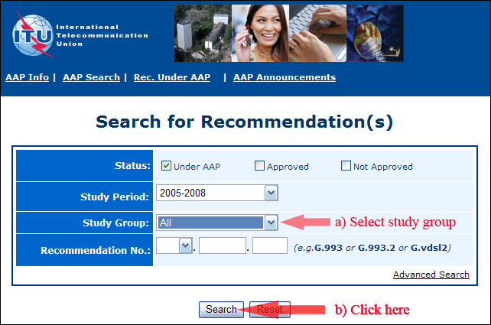
2) Select your Recommendation
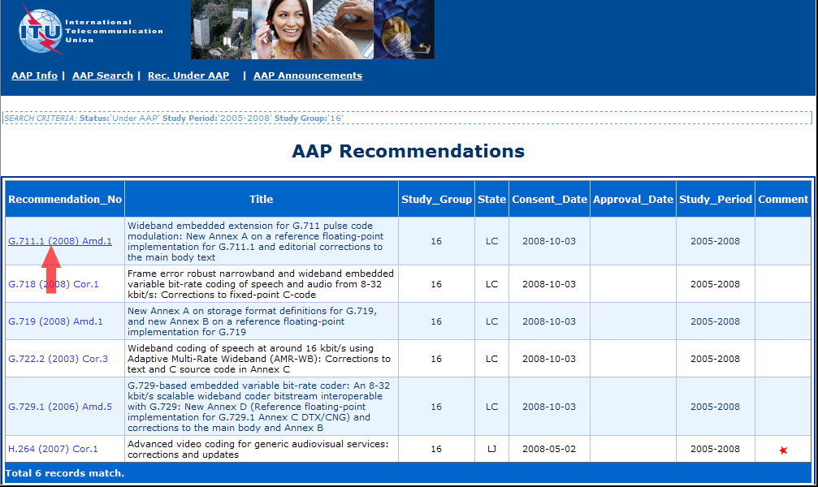
3) Click the "Submit Comment" button
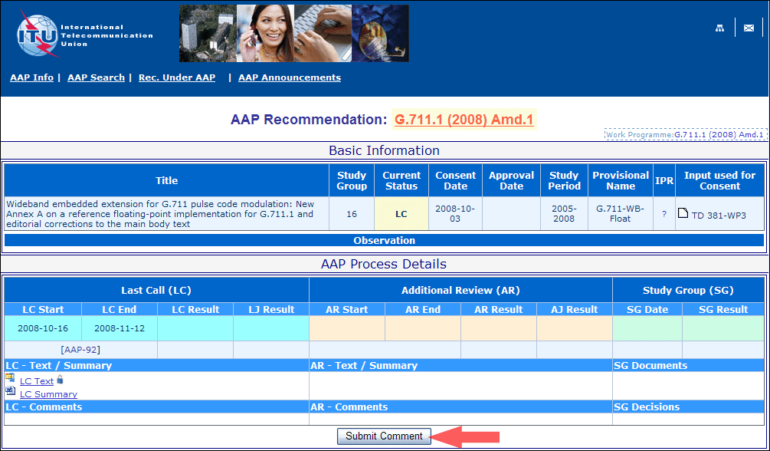
4) Complete the on-line form and click on "Submit"
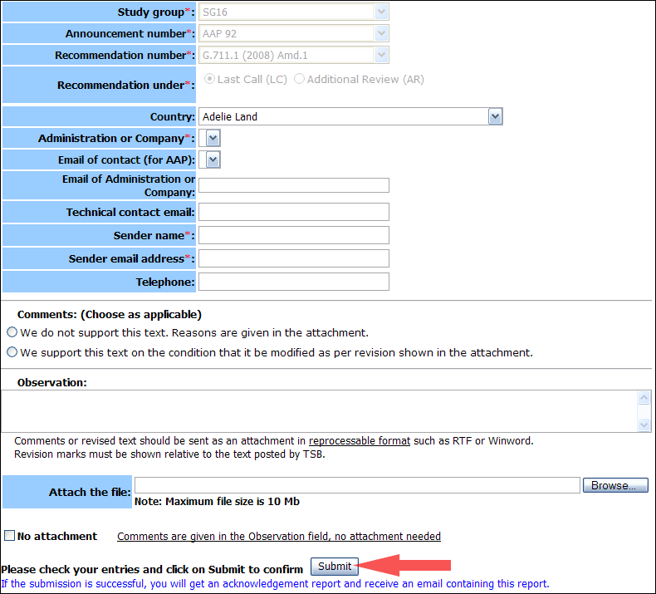
For more information, read the AAP tutorial on:
http://www.itu.int/ITU-T/aapinfo/files/AAPTutorial.pdf
Annex 3
(to TSB AAP-67)
Recommendations under LC/AR – Comment submission form
(Separate form for each Recommendation being commented upon)
ITU-T AAP comment submission form for the period 2009-2012
Study Group:
Announcement number:
Recommendation number:
Recommendation under: | Last call (LC)  Additional Review (AR)
Country:
Administration/Company:
Name of AAP Contact Person:
Email of AAP Contact Person:
Sender name:
(if different from AAP Contact Person)
Sender email address:
Telephone:
Comments:  (Choose as applicable) | We do not support this text. Reasons are given in the attachment.  We support this text on the condition that it be modified as per revision shown in the attachment.
Observations:
No attachment: Comments are given in the Observation field, no attachment needed
To be returned to: email: tsbsg....@itu.int
[or fax +41 22 730 5853]
Comments or revised text should be sent as an attachment in RTF or WinWord format.
Revision marks must be shown relative to the text posted by TSB.

