Union Internationale des Telecommunications
Bureau de la normalisation des télécommunications

Genève, le 16 juillet 2011

Réf:  Tél:  Fax:  E-mail: | TSB AAP-63  AAP/MJ  +41 22 730 5860  +41 22 730 5853  tsbdir@itu.int | – Aux administrations des Etats Membres de l'Union;  – Aux Membres du Secteur UIT-T;  – Aux Associés de l'UIT-T  Copie:  – Aux Présidents et Vice-Présidents des Commissions d'études de l'UIT-T;  – Au Directeur du Bureau de développement des télécommunications;  – Au Directeur du Bureau des radiocommunications

Objet: | Etat des Recommandations auxquelles s'applique la variante de la procédure d'approbation (AAP)

Madame, Monsieur,

La variante de la procédure d'approbation (AAP), définie dans la Recommandation UIT-T A.8, s'applique aux Recommandations qui n'ont pas d'incidence politique ou réglementaire et ne nécessitent donc pas une consultation formelle des Etats Membres (voir le numéro 246B de la Convention de l'UIT).
L'Annexe 1 énumère les textes dont le statut a changé par rapport aux annonces TSB AAP antérieures.
Si vous souhaitez soumettre des observations sur une Recommandation ayant fait l'objet de la procédure AAP, vous êtes encouragés à utiliser le formulaire en ligne de soumission des observations AAP, disponible dans l'espace AAP du site web de l'UIT-T à l'adresse http://www.itu.int/ITU-T/aap/, à la page de la Recommandation concernée (voir l'Annexe 2). Vous pouvez aussi soumettre vos observations en remplissant le formulaire figurant à l'Annexe 3 et en l'envoyant au secrétariat de la Commission d'études concernée.
Veuillez noter que les observations ayant simplement pour objet d'appuyer l'adoption du texte en question ne sont pas encouragées.
Veuillez agréer, Madame, Monsieur, l'assurance de ma considération distinguée.
Malcolm Johnson
Directeur du Bureau de la normalisation des télécommunications

Annexes: 3

Annex 1
(to TSB AAP-63)

Status codes used in the AAP announcements:
LC = Last Call
LJ = Last Call Judgment (includes comment resolution)
AR = Additional Review
AJ = Additional Review Judgment (includes comment resolution)
SG = For Study Group approval
A = Approved
AT = Approved with typographic corrections
AC = Approved after Additional Review of Comments
NA = Not approved
TAP = Moved to TAP (ITU-T A.8 / § 5.2)
ITU-T website entry page:
http://www.itu.int/ITU-T
Alternative approval process (AAP) welcome page:
http://www.itu.int/ITU-T/aapinfo
Note – A tutorial on the ITU-T AAP application is available under the AAP welcome page
ITU-T website AAP Recommendation search page:
http://www.itu.int/ITU-T/aap/
Study Group web pages and contacts:
SG 2 | http://www.itu.int/ITU-T/studygroups/com02 | tsbsg2@itu.int
SG 3 | http://www.itu.int/ITU-T/studygroups/com03 | tsbsg3@itu.int
SG 5 | http://www.itu.int/ITU-T/studygroups/com05 | tsbsg5@itu.int
SG 9 | http://www.itu.int/ITU-T/studygroups/com09 | tsbsg9@itu.int
SG 11 | http://www.itu.int/ITU-T/studygroups/com11 | tsbsg11@itu.int
SG 12 | http://www.itu.int/ITU-T/studygroups/com12 | tsbsg12@itu.int
SG 13 | http://www.itu.int/ITU-T/studygroups/com13 | tsbsg13@itu.int
SG 15 | http://www.itu.int/ITU-T/studygroups/com15 | tsbsg15@itu.int
SG 16 | http://www.itu.int/ITU-T/studygroups/com16 | tsbsg16@itu.int
SG 17 | http://www.itu.int/ITU-T/studygroups/com17 | tsbsg17@itu.int

Situation concerning Study Group 2 Recommendations under AAP
Rec # | Title | Last Call (LC) Period |  |  |  | Additional Review (AR) Period |  |  |  | Status
 |  | LC Start | LC End | LC  Result | LJ  Result | AR Start | AR End | AR  Result | AJ  Result
M.3016.1 (2005) Amd. 1 | Authentication extension | 2011-06-16 | 2011-07-13 | A |  |  |  |  |  | A
M.3016.3 (2005) Amd. 1 | Redundant authentication extension | 2011-06-16 | 2011-07-13 | A |  |  |  |  |  | A
M.3016.4 (2005) Amd. 1 | Authentication extension | 2011-06-16 | 2011-07-13 | A |  |  |  |  |  | A
M.3020 | Management interface specification methodology | 2011-06-16 | 2011-07-13 | A |  |  |  |  |  | A
Situation concerning Study Group 11 Recommendations under AAP
Rec # | Title | Last Call (LC) Period |  |  |  | Additional Review (AR) Period |  |  |  | Status
 |  | LC Start | LC End | LC  Result | LJ  Result | AR Start | AR End | AR  Result | AJ  Result
Q.3203  (Q.NGN-nacf-mob2) | Signalling requirements and architecture of NACF for IP mobility | 2011-06-01 | 2011-06-28 | LJ | AR | 2011-07-16 | 2011-08-05 |  |  | AR
Q.3931.1  (Q.Bench-IMS-PES A) | IMS/PES Performance Benchmark Part 1: Core concepts | 2011-02-16 | 2011-03-15 | LJ | AT |  |  |  |  | AT
Q.3931.2  (Q.Bench-IMS-PES B) | IMS/PES Performance Benchmark Part 2: Subsystem configurations and benchmarks | 2011-02-16 | 2011-03-15 | LJ | AT |  |  |  |  | AT
Situation concerning Study Group 13 Recommendations under AAP
Rec # | Title | Last Call (LC) Period |  |  |  | Additional Review (AR) Period |  |  |  | Status
 |  | LC Start | LC End | LC  Result | LJ  Result | AR Start | AR End | AR  Result | AJ  Result
Y.2022  (Y.FAid-loc-split) | Functional architecture for the support of host-based ID/locator separation in NGN | 2011-06-01 | 2011-06-28 | LJ | AR | 2011-07-16 | 2011-08-05 |  |  | AR
Y.2056  (Y.ipv6-vmh) | Framework of vertical multi-homing in IPv6-based NGN | 2011-06-01 | 2011-06-28 | LJ | AR | 2011-07-16 | 2011-08-05 |  |  | AR
Y.2614  (Y.PTDN-reliability) | Network reliability in PTDN | 2011-06-01 | 2011-06-28 | LJ | AR | 2011-07-16 | 2011-08-05 |  |  | AR
Y.2621  (Y.iSCP-req) | Requirements of independent Scalable Control Plane (iSCP) in FPBN | 2011-06-01 | 2011-06-28 | LJ | AR | 2011-07-16 | 2011-08-05 |  |  | AR
Situation concerning Study Group 15 Recommendations under AAP
Rec # | Title | Last Call (LC) Period |  |  |  | Additional Review (AR) Period |  |  |  | Status
 |  | LC Start | LC End | LC  Result | LJ  Result | AR Start | AR End | AR  Result | AJ  Result
G.806 (2009) Amd.1 | Characteristics of transport equipment – Description methodology and generic functionality: Amendment 1 | 2011-03-16 | 2011-04-12 | LJ | AR | 2011-06-01 | 2011-06-21 | AJ | AC | AC
G.992.3 (2009) Cor.2 | Asymmetric digital subscriber line transceivers 2 (ADSL2): Corrigendum 2 | 2011-03-16 | 2011-04-12 | LJ | AR | 2011-06-01 | 2011-06-21 | AJ | AC | AC
G.993.2 (2006) Amd.7 | Very high speed digital subscriber line transceivers 2 (VDSL2): Amendment 7 | 2011-03-16 | 2011-04-12 | LJ | AR | 2011-06-01 | 2011-06-21 | AJ | AC | AC
G.993.5 (2010) Cor.1 (G.vector) | Self-FEXT cancellation (vectoring) for use with VDSL2 transceivers: Corrigendum 1 | 2011-03-16 | 2011-04-12 | LJ | AR | 2011-06-01 | 2011-06-21 | AJ | AC | AC
G.997.1 (2009) Amd.3 | Physical layer management for digital subscriber line (DSL) transceivers: Amendment 3 | 2011-03-16 | 2011-04-12 | LJ | AR | 2011-06-01 | 2011-06-21 | AJ | AC | AC
G.998.4 (2010) Amd.1 | Improved impulse noise protection for DSL transceivers: Amendment 1 | 2011-03-16 | 2011-04-12 | LJ | AR | 2011-06-01 | 2011-06-21 | AJ | AC | AC
G.8001/Y.1354 | Terms and definitions for Ethernet frames over Transport | 2011-03-16 | 2011-04-12 | LJ | AR | 2011-06-16 | 2011-07-06 | AC |  | AC
G.8031/Y.1342 | Ethernet linear protection switching | 2011-03-16 | 2011-04-12 | LJ | AR | 2011-06-01 | 2011-06-21 | AJ | AC | AC

Annex 2
(to TSB AAP-63)
Using the on-line comment submission form
Comment submission
1) Go to AAP search Web page at http://www.itu.int/ITU-T/aap/
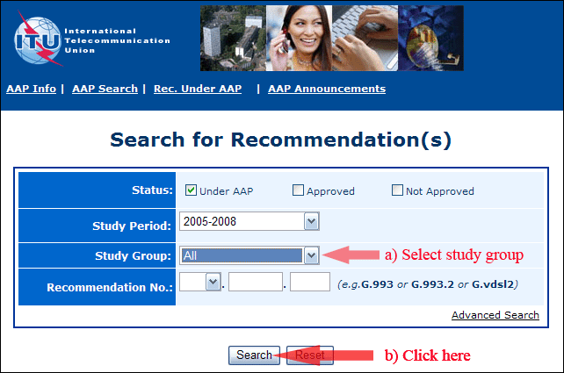
2) Select your Recommendation
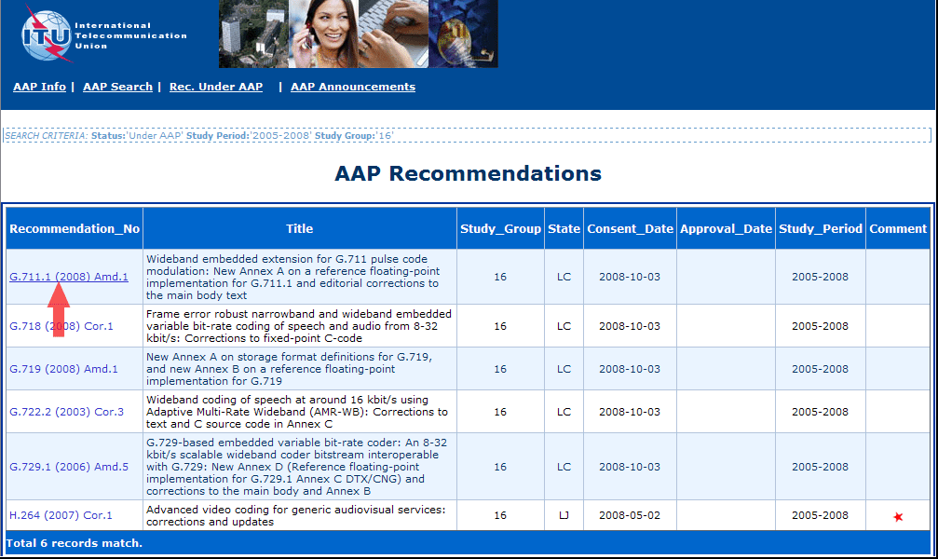
3) Click the "Submit Comment" button
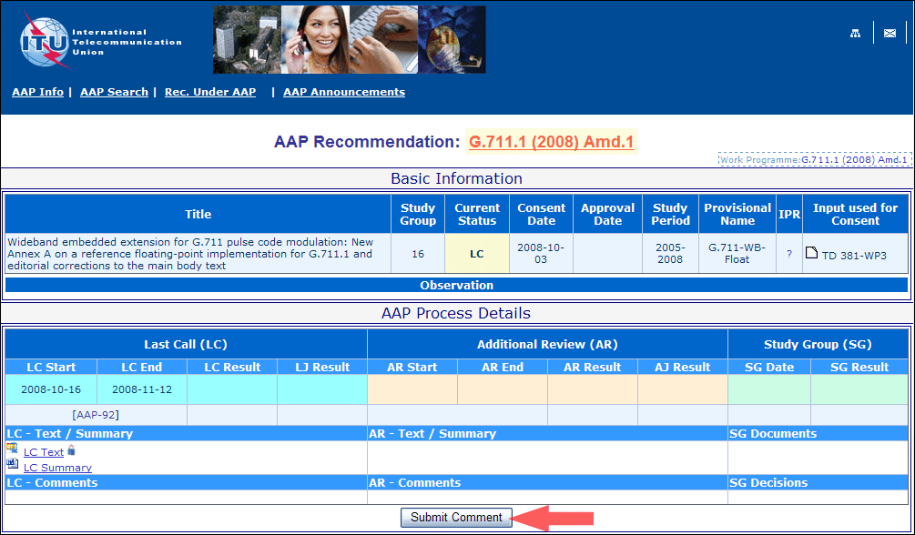
4) Complete the on-line form and click on "Submit"
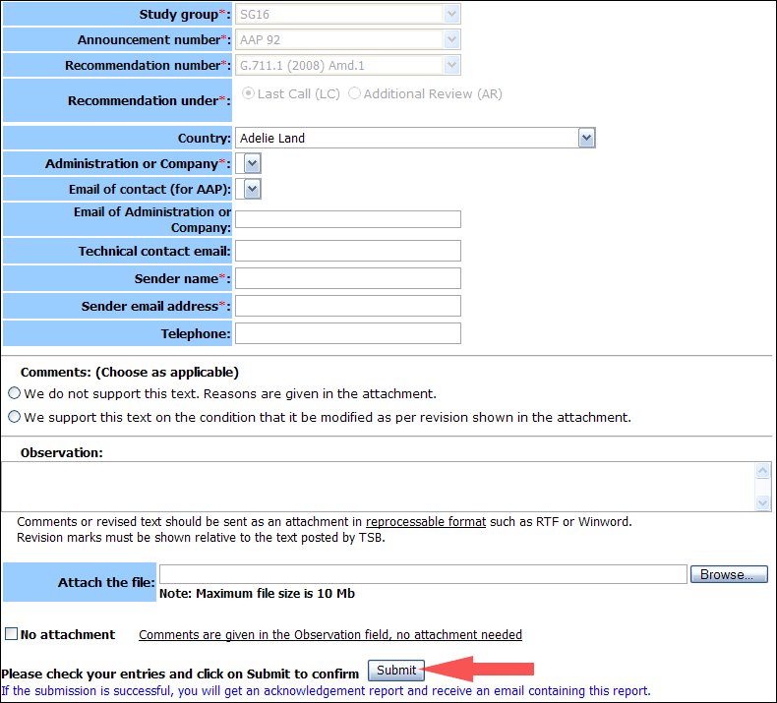
For more information, read the AAP tutorial on:
http://www.itu.int/ITU-T/aapinfo/files/AAPTutorial.pdf
Annex 3
(to TSB AAP-63)
Recommendations under LC/AR – Comment submission form
(Separate form for each Recommendation being commented upon)
ITU-T AAP comment submission form for the period 2009-2012
Study Group:
Announcement number:
Recommendation number:
Recommendation under: | Last call (LC)  Additional Review (AR)
Country:
Administration/Company:
Name of AAP Contact Person:
Email of AAP Contact Person:
Sender name:
(if different from AAP Contact Person)
Sender email address:
Telephone:
Comments:  (Choose as applicable) | We do not support this text. Reasons are given in the attachment.  We support this text on the condition that it be modified as per revision shown in the attachment.
Observations:
No attachment: Comments are given in the Observation field, no attachment needed
To be returned to: email: tsbsg....@itu.int
[or fax +41 22 730 5853]
Comments or revised text should be sent as an attachment in RTF or WinWord format.
Revision marks must be shown relative to the text posted by TSB.

