国 际 电 信 联 盟
电信标准化局
2011年6月1日 ，日内瓦

参考号:  电话:  传真:  电子邮件: | 电信标准化局AAP-60  AAP/MJ  +41 22 730 5860  +41 22 730 5853  tsbdir@itu.int | – 致国际电联成员国各主管部门；  – 致ITU-T各部门成员；  – 致ITU-T 部门准成员  抄送：  – 电信标准化局研究组主席和副主席  – 电信发展局主任  – 无线电通信局主任

事由: | 有关采用替换批准程序（AAP）处理的建议书的情况

先生/女士，
ITU-T A.8 建议书中规定的建议书替换批准程序 (AAP) 适用于那些不会产生政策或 监管影响、因而不需与成员国正式协商的建议书（见国际电联《公约》第246B款）。
附件1列出了那些在以往电信标准化局AAP预告后地位发生变化的案文。
如您希望针对某个适用AAP的建议书提出意见，请使用可在ITU-T网站AAP区域 （http://www.itu.int/ITU-T/aap）的“建议书”网页上获取的《AAP意见在线提交表格》 （见附件2）。或者，可填妥附件3 中的表格并将意见发送给相关研究组的秘书处。
敬请留意，我们不鼓励提交仅支持通过所涉案文而没有实质内容的意见。

顺致敬意！

马尔科姆•琼森
电信标准化局主任

附件：3件

Annex 1
(to TSB AAP-60)

Status codes used in the AAP announcements:
LC = Last Call
LJ = Last Call Judgment (includes comment resolution)
AR = Additional Review
AJ = Additional Review Judgment (includes comment resolution)
SG = For Study Group approval
A = Approved
AT = Approved with typographic corrections
AC = Approved after Additional Review of Comments
NA = Not approved
TAP = Moved to TAP (ITU-T A.8 / § 5.2)
ITU-T website entry page:
http://www.itu.int/ITU-T
Alternative approval process (AAP) welcome page:
http://www.itu.int/ITU-T/aapinfo
Note – A tutorial on the ITU-T AAP application is available under the AAP welcome page
ITU-T website AAP Recommendation search page:
http://www.itu.int/ITU-T/aap/
Study Group web pages and contacts:
SG 2 | http://www.itu.int/ITU-T/studygroups/com02 | tsbsg2@itu.int
SG 3 | http://www.itu.int/ITU-T/studygroups/com03 | tsbsg3@itu.int
SG 5 | http://www.itu.int/ITU-T/studygroups/com05 | tsbsg5@itu.int
SG 9 | http://www.itu.int/ITU-T/studygroups/com09 | tsbsg9@itu.int
SG 11 | http://www.itu.int/ITU-T/studygroups/com11 | tsbsg11@itu.int
SG 12 | http://www.itu.int/ITU-T/studygroups/com12 | tsbsg12@itu.int
SG 13 | http://www.itu.int/ITU-T/studygroups/com13 | tsbsg13@itu.int
SG 15 | http://www.itu.int/ITU-T/studygroups/com15 | tsbsg15@itu.int
SG 16 | http://www.itu.int/ITU-T/studygroups/com16 | tsbsg16@itu.int
SG 17 | http://www.itu.int/ITU-T/studygroups/com17 | tsbsg17@itu.int

Situation concerning Study Group 11 Recommendations under AAP
Rec # | Title | Last Call (LC) Period |  |  |  | Additional Review (AR) Period |  |  |  | Status
 |  | LC Start | LC End | LC  Result | LJ  Result | AR Start | AR End | AR  Result | AJ  Result
Q.3203  (Q.NGN-nacf-mob2) | Signalling requirements and architecture of NACF for IP mobility | 2011-06-01 | 2011-06-28 |  |  |  |  |  |  | LC
Q.3325 (Q.3325.1) | Resource control protocol no.5 (rcp5) - Protocol at the interface between transport resource control physical entity and policy decision physical entity (Rt interface): Diameter-based | 2011-06-01 | 2011-06-28 |  |  |  |  |  |  | LC
Q.3612 (Q.centreSig) | Signalling Requirements and Protocol Profiles for IP Centrex service | 2011-06-01 | 2011-06-28 |  |  |  |  |  |  | LC
Q.3941.1  (Q.SIP-ISDN-IT C (integration tests)) | Network Integration Testing between SIP and ISDN/PSTN network signalling protocols Part 1: Test Suite Structure and Test Purposes (TSS&TP) for SIP-ISDN | 2011-06-01 | 2011-06-28 |  |  |  |  |  |  | LC
Q.3941.2  (Q.SIP-ISDN-IT D (integration tests)) | Network Integration Testing between SIP and ISDN/PSTN network signalling protocols Part 2: Abstract Test Suite (ATS) and partial protocol Implementation eXtra Information for Testing (PIXIT) proformaspecification for SIP-ISDN | 2011-06-01 | 2011-06-28 |  |  |  |  |  |  | LC
Q.3941.3 | Network Integration Testing between SIP and ISDN/PSTN network signalling protocols Part 3: Test Suite Structure and Test Purposes (TSS&TP) for SIP-SIP | 2011-06-01 | 2011-06-28 |  |  |  |  |  |  | LC
Q.3941.4 | Network Integration Testing between SIP and ISDN/PSTN network signalling protocols Part 4: Abstract Test suite (ATS) and partical Protocol Implementation eXtra Information for Testing (PIXIT) proforma specification for SIP-SIP | 2011-06-01 | 2011-06-28 |  |  |  |  |  |  | LC
Q.3948 | Service testing framework for VoIP at NGN UNI | 2011-06-01 | 2011-06-28 |  |  |  |  |  |  | LC
Situation concerning Study Group 13 Recommendations under AAP
Rec # | Title | Last Call (LC) Period |  |  |  | Additional Review (AR) Period |  |  |  | Status
 |  | LC Start | LC End | LC  Result | LJ  Result | AR Start | AR End | AR  Result | AJ  Result
Y.2020 (Y.OSE-arch) | Open Service Environment Functional Architecture for NGN | 2011-02-16 | 2011-03-15 | SG |  |  |  |  |  | AC
Y.2022  (Y.FAid-loc-split) | Functional architecture for the support of host-based ID/locator separation in NGN | 2011-06-01 | 2011-06-28 |  |  |  |  |  |  | LC
Y.2056 (Y.ipv6-vmh) | Framework of vertical multi-homing in IPv6-based NGN | 2011-06-01 | 2011-06-28 |  |  |  |  |  |  | LC
Y.2614  (Y.PTDN-reliability) | Network reliability in PTDN | 2011-06-01 | 2011-06-28 |  |  |  |  |  |  | LC
Y.2621 (Y.iSCP-req) | Requirements of independent Scalable Control Plane (iSCP) in FPBN | 2011-06-01 | 2011-06-28 |  |  |  |  |  |  | LC
Situation concerning Study Group 15 Recommendations under AAP
Rec # | Title | Last Call (LC) Period |  |  |  | Additional Review (AR) Period |  |  |  | Status
 |  | LC Start | LC End | LC  Result | LJ  Result | AR Start | AR End | AR  Result | AJ  Result
G.806 (2009) Amd.1 | Characteristics of transport equipment – Description methodology and generic functionality: Amendment 1 | 2011-03-16 | 2011-04-12 | LJ | AR | 2011-06-01 | 2011-06-21 |  |  | AR
G.992.3 (2009) Cor.2 | Asymmetric digital subscriber line transceivers 2 (ADSL2): Corrigendum 2 | 2011-03-16 | 2011-04-12 | LJ | AR | 2011-06-01 | 2011-06-21 |  |  | AR
G.993.2 (2006) Amd.7 | Very high speed digital subscriber line transceivers 2 (VDSL2): Amendment 7 | 2011-03-16 | 2011-04-12 | LJ | AR | 2011-06-01 | 2011-06-21 |  |  | AR
G.993.5 (2010) Cor.1 (G.vector) | Self-FEXT cancellation (vectoring) for use with VDSL2 transceivers: Corrigendum 1 | 2011-03-16 | 2011-04-12 | LJ | AR | 2011-06-01 | 2011-06-21 |  |  | AR
G.997.1 (2009) Amd.3 | Physical layer management for digital subscriber line (DSL) transceivers: Amendment 3 | 2011-03-16 | 2011-04-12 | LJ | AR | 2011-06-01 | 2011-06-21 |  |  | AR
G.998.4 (2010) Amd.1 | Improved impulse noise protection for DSL transceivers: Amendment 1 | 2011-03-16 | 2011-04-12 | LJ | AR | 2011-06-01 | 2011-06-21 |  |  | AR
G.8031/Y.1342 | Ethernet linear protection switching | 2011-03-16 | 2011-04-12 | LJ | AR | 2011-06-01 | 2011-06-21 |  |  | AR
Situation concerning Study Group 16 Recommendations under AAP
Rec # | Title | Last Call (LC) Period |  |  |  | Additional Review (AR) Period |  |  |  | Status
 |  | LC Start | LC End | LC  Result | LJ  Result | AR Start | AR End | AR  Result | AJ  Result
G.169 (V2) | Automatic level control devices | 2011-04-16 | 2011-05-13 | A |  |  |  |  |  | A
G.799.3 (G.IP2IP) | Signal processing functionality and performance of an IP-to-IP voice gateway optimised for the transport of voice and voiceband data | 2011-04-16 | 2011-05-13 | A |  |  |  |  |  | A
H.222.0 (2006) Amd.5 (H.222.0-J2k-video) | Information technology - Generic coding of moving pictures and associated audio information: Systems: Transport of JPEG 2000 Part 1 (ITU-T T.800 | ISO/IEC 15444-1) video over ITU-T H.222.0 | ISO/IEC 13818-1 | 2011-04-16 | 2011-05-13 | A |  |  |  |  |  | A
H.222.0 (2006) Amd.6 (H.222.0-MVC-ext) | Information technology - Generic coding of moving pictures and associated audio information: Systems: Extension to AVC video descriptor and signaling of operation points for MVC | 2011-04-16 | 2011-05-13 | A |  |  |  |  |  | A
H.241 (2006) Cor.1 | Extended video procedures and control signals for H.300-series terminals: Corrections to CustomMaxDPB capability parameter | 2011-04-16 | 2011-05-13 | A |  |  |  |  |  | A
H.245 (V16) | Control protocol for multimedia communication | 2011-04-16 | 2011-05-13 | A |  |  |  |  |  | A
H.248.75 (H.248.PIPA) | Gateway control protocol: Package identifier publishing and application package | 2011-04-16 | 2011-05-13 | A |  |  |  |  |  | A
H.248.81 (H.248.ETS) | Gateway Control Protocol: Guidelines on the Use of the International Emergency Preference Scheme (IEPS) Call Indicator and Priority Indicator in H.248 Profiles | 2011-04-16 | 2011-05-13 | A |  |  |  |  |  | A
H.264  (H.264 (2010) Amd. 1) | Advanced video coding for generic audiovisual services | 2011-06-01 | 2011-06-28 |  |  |  |  |  |  | LC
H.350 | Directory services architecture for multimedia conferencing | 2011-04-16 | 2011-05-13 | A |  |  |  |  |  | A
H.350.1 | Directory services architecture for H.323 | 2011-04-16 | 2011-05-13 | A |  |  |  |  |  | A
H.350.2 | Directory services architecture for H.235 | 2011-04-16 | 2011-05-13 | A |  |  |  |  |  | A
H.350.3 | Directory services architecture for H.320 | 2011-04-16 | 2011-05-13 | A |  |  |  |  |  | A
H.350.4 | Directory services architecture for SIP | 2011-04-16 | 2011-05-13 | A |  |  |  |  |  | A
H.350.5 | Directory services architecture for non-standard protocols | 2011-04-16 | 2011-05-13 | A |  |  |  |  |  | A
H.350.6 | Directory services architecture for call forwarding and preferences | 2011-04-16 | 2011-05-13 | A |  |  |  |  |  | A
H.450.1 | Generic functional protocol for the support of supplementary services in H.323 | 2011-04-16 | 2011-05-13 | A |  |  |  |  |  | A
H.450.2 | Call transfer supplementary service for H.323 | 2011-04-16 | 2011-05-13 | A |  |  |  |  |  | A
H.450.3 | Call diversion supplementary service for H.323 | 2011-04-16 | 2011-05-13 | A |  |  |  |  |  | A
H.460.23 (2009) Amd.1 | Network address translator and firewall device determination in H.323 systems: Support for ITU-T H.460.24 Annex B | 2011-04-16 | 2011-05-13 | A |  |  |  |  |  | A
H.460.24 (2009) Amd.1 | Point to point media through network address translators and firewalls within H.323 systems: Improvements for NAT traversal without intermediary entities | 2011-04-16 | 2011-05-13 | A |  |  |  |  |  | A
H.626 (H.VSarch) | Architectural requirements for visual surveillance | 2011-04-16 | 2011-05-13 | A |  |  |  |  |  | A
H.762 | Lightweight interactive multimedia environment (LIME) for IPTV services | 2011-04-16 | 2011-05-13 | A |  |  |  |  |  | A
H.771  (H.IPTV-SBSD) | SIP-based IPTV Service Discovery | 2011-04-16 | 2011-05-13 | A |  |  |  |  |  | A
T.88 (2000) Amd.3 | Information technology - Lossy/lossless coding of bi-level images: Extension to color coding | 2011-04-16 | 2011-05-13 | A |  |  |  |  |  | A
T.800 (2002) Amd.3(*) | Information technology - JPEG 2000 image coding system: Core coding system: Guidelines for digital cinema applications | 2011-04-16 | 2011-05-13 | A |  |  |  |  |  | A
T.808 (2005) Cor.3 | Information technology - JPEG 2000 image coding system: Interactivity tools, APIs and protocols: Corrections to clause J.4.3.4 | 2011-04-16 | 2011-05-13 | A |  |  |  |  |  | A
T.809 (2007) Cor.1 | Information technology - JPEG 2000 image coding system: Extensions for three-dimensional data: Minor corrections plus clarifications on code stream CAP marker segments and quantization of JP3D images | 2011-04-16 | 2011-05-13 | LJ |  |  |  |  |  | LJ
T.832 (2009) Cor.2 | JPEG XR image coding system - Image coding specification: Corrections and clarifications | 2011-04-16 | 2011-05-13 | A |  |  |  |  |  | A
T.871 (T.JFIF) | Information technology - Digital compression and coding of continuous-tone still images: JPEG File Interchange Format (JFIF) | 2011-04-16 | 2011-05-13 | A |  |  |  |  |  | A
Situation concerning Study Group 17 Recommendations under AAP
Rec # | Title | Last Call (LC) Period |  |  |  | Additional Review (AR) Period |  |  |  | Status
 |  | LC Start | LC End | LC  Result | LJ  Result | AR Start | AR End | AR  Result | AJ  Result
X.1052 (X.ismf) | Information security management framework | 2011-05-01 | 2011-05-28 | A |  |  |  |  |  | A
X.1057 (X.amg) | Asset management guidelines in telecommunication organizations | 2011-05-01 | 2011-05-28 | A |  |  |  |  |  | A
X.1090 (X.ott) | Authentication framework with one-time telebiometric template | 2011-05-01 | 2011-05-28 | A |  |  |  |  |  | A
X.1192 (X.iptvsec-2) | Functional requirements and mechanisms for the secure transcodable scheme of IPTV | 2011-05-01 | 2011-05-28 | A |  |  |  |  |  | A

Annex 2
(to TSB AAP-60)
Using the on-line comment submission form
Comment submission
1) Go to AAP search Web page at http://www.itu.int/ITU-T/aap/
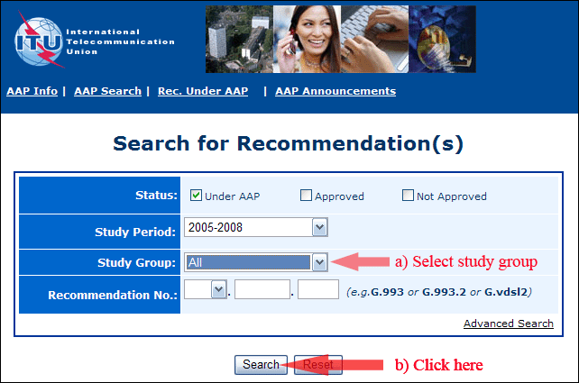
2) Select your Recommendation
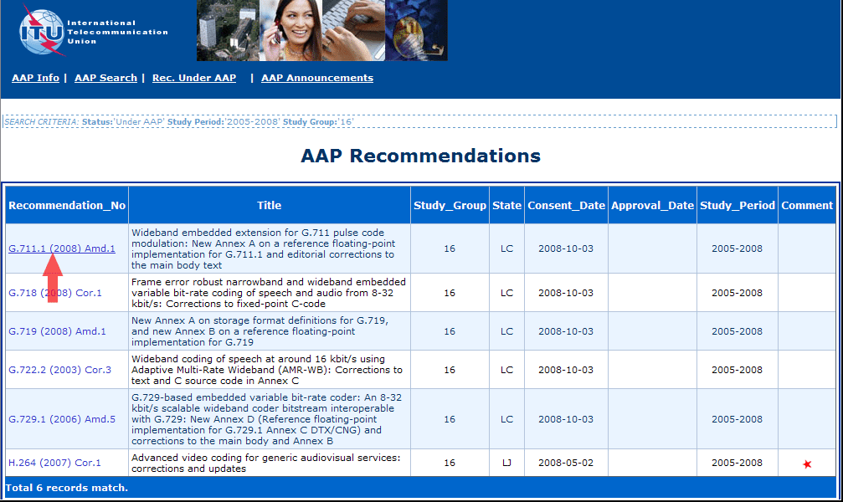
3) Click the "Submit Comment" button
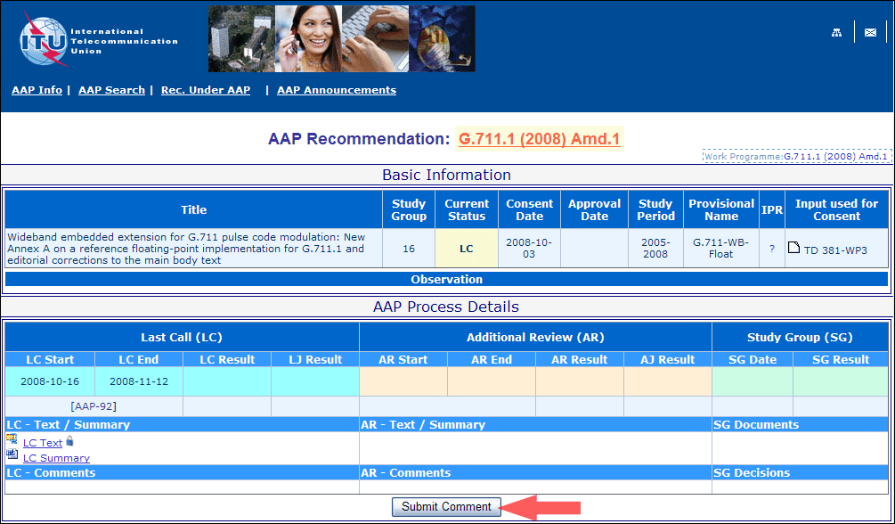
4) Complete the on-line form and click on "Submit"
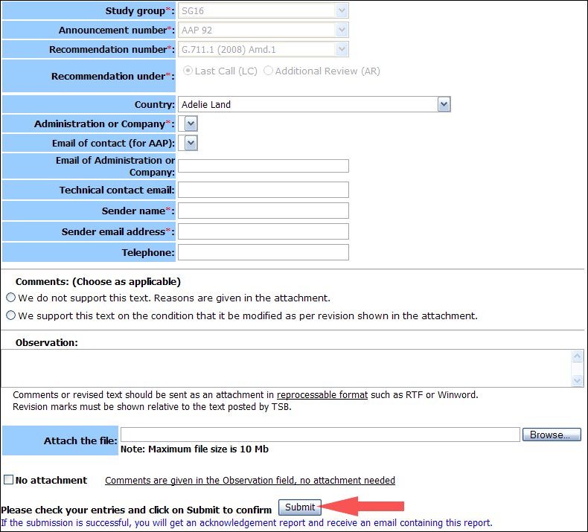
For more information, read the AAP tutorial on:
http://www.itu.int/ITU-T/aapinfo/files/AAPTutorial.pdf
Annex 3
(to TSB AAP-60)
Recommendations under LC/AR – Comment submission form
(Separate form for each Recommendation being commented upon)
ITU-T AAP comment submission form for the period 2009-2012
Study Group:
Announcement number:
Recommendation number:
Recommendation under: | Last call (LC)  Additional Review (AR)
Country:
Administration/Company:
Name of AAP Contact Person:
Email of AAP Contact Person:
Sender name:
(if different from AAP Contact Person)
Sender email address:
Telephone:
Comments:  (Choose as applicable) | We do not support this text. Reasons are given in the attachment.  We support this text on the condition that it be modified as per revision shown in the attachment.
Observations:
No attachment: Comments are given in the Observation field, no attachment needed
To be returned to: email: tsbsg....@itu.int
[or fax +41 22 730 5853]
Comments or revised text should be sent as an attachment in RTF or WinWord format.
Revision marks must be shown relative to the text posted by TSB.

(*)For edition history consistency, this text will be published as T.800 (2002) Amd. 4 (05/2011).

